Supplementary Figures

Biochar's dual impact on soil acidity management and crop yield enhancement: a meta-analysis

Weina Zhang ^{1,2}, Jiayin Pang ², Junfeng Qi ¹, Yang Lu ⁵, Junhe Liu ^{1*}, Mingfu Yu ¹, Haigang Li ³, Enli Wang ⁴, Hans Lambers ²

¹School of Biological and Food Processing Engineering, Huanghuai University, Zhumadian 463000, China
² The UWA Institute of Agriculture and School of Biological Sciences, University of Western Australia, Perth, WA 6009, Australia
³College of Grassland, Resources and Environment, Inner Mongolia Agricultural University, Hohhot 010018, China
⁴CSIRO Agriculture and Food, Canberra, ACT 2601, Australia
⁵College of Geography Science, Hebei Normal University, Shijiazhuang 050024, China

*Corresponding author. Email: liujunhe79@126.com; Tel: +86 13653961072.

Supplementary Figure S1. Screening of biochar dataset, using a PRISMA flow diagram to illustrate the procedure for selecting publications.

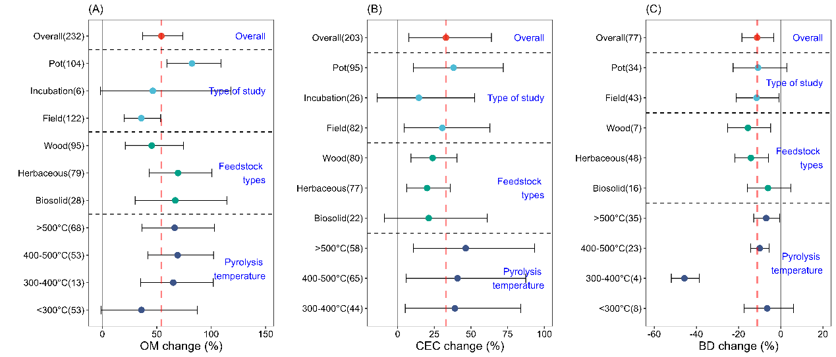
Supplementary Figure S2. Percentage change in soil organic matter (A), cation exchange capacity (B) and bulk density (C) in response to type of study and biochar properties. Symbols represent the mean % change of effect size with a 95% confidence interval (CI), with effects being significant if the CI does not overlap with the 0 line (P < 0.05). The numbers in parentheses indicate the number of observations, and the red dotted line is a reference for the zero line.

