This file contains Supplemental Figs S1-S4 for: “Historical contingencies linked to past drought-wetting cycles as a driver of bacterial–not fungal–community assembly processes in an arid desert”

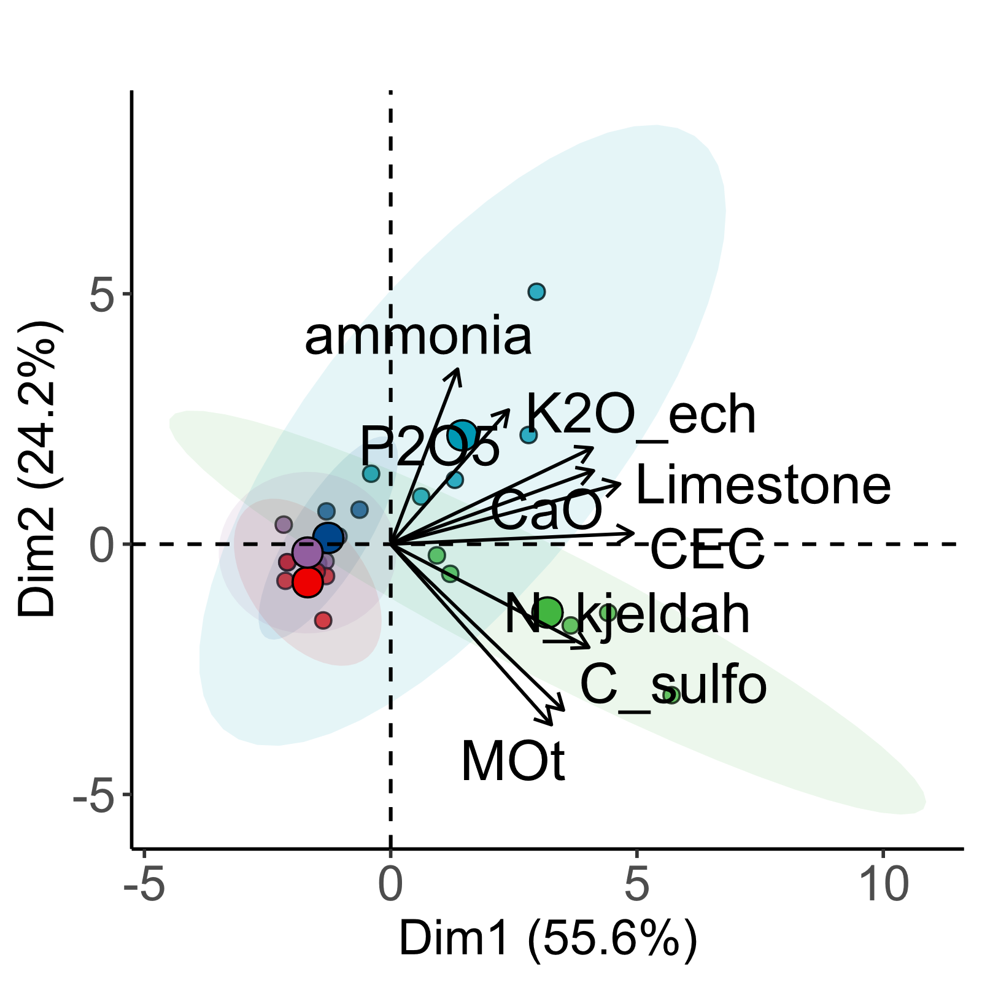
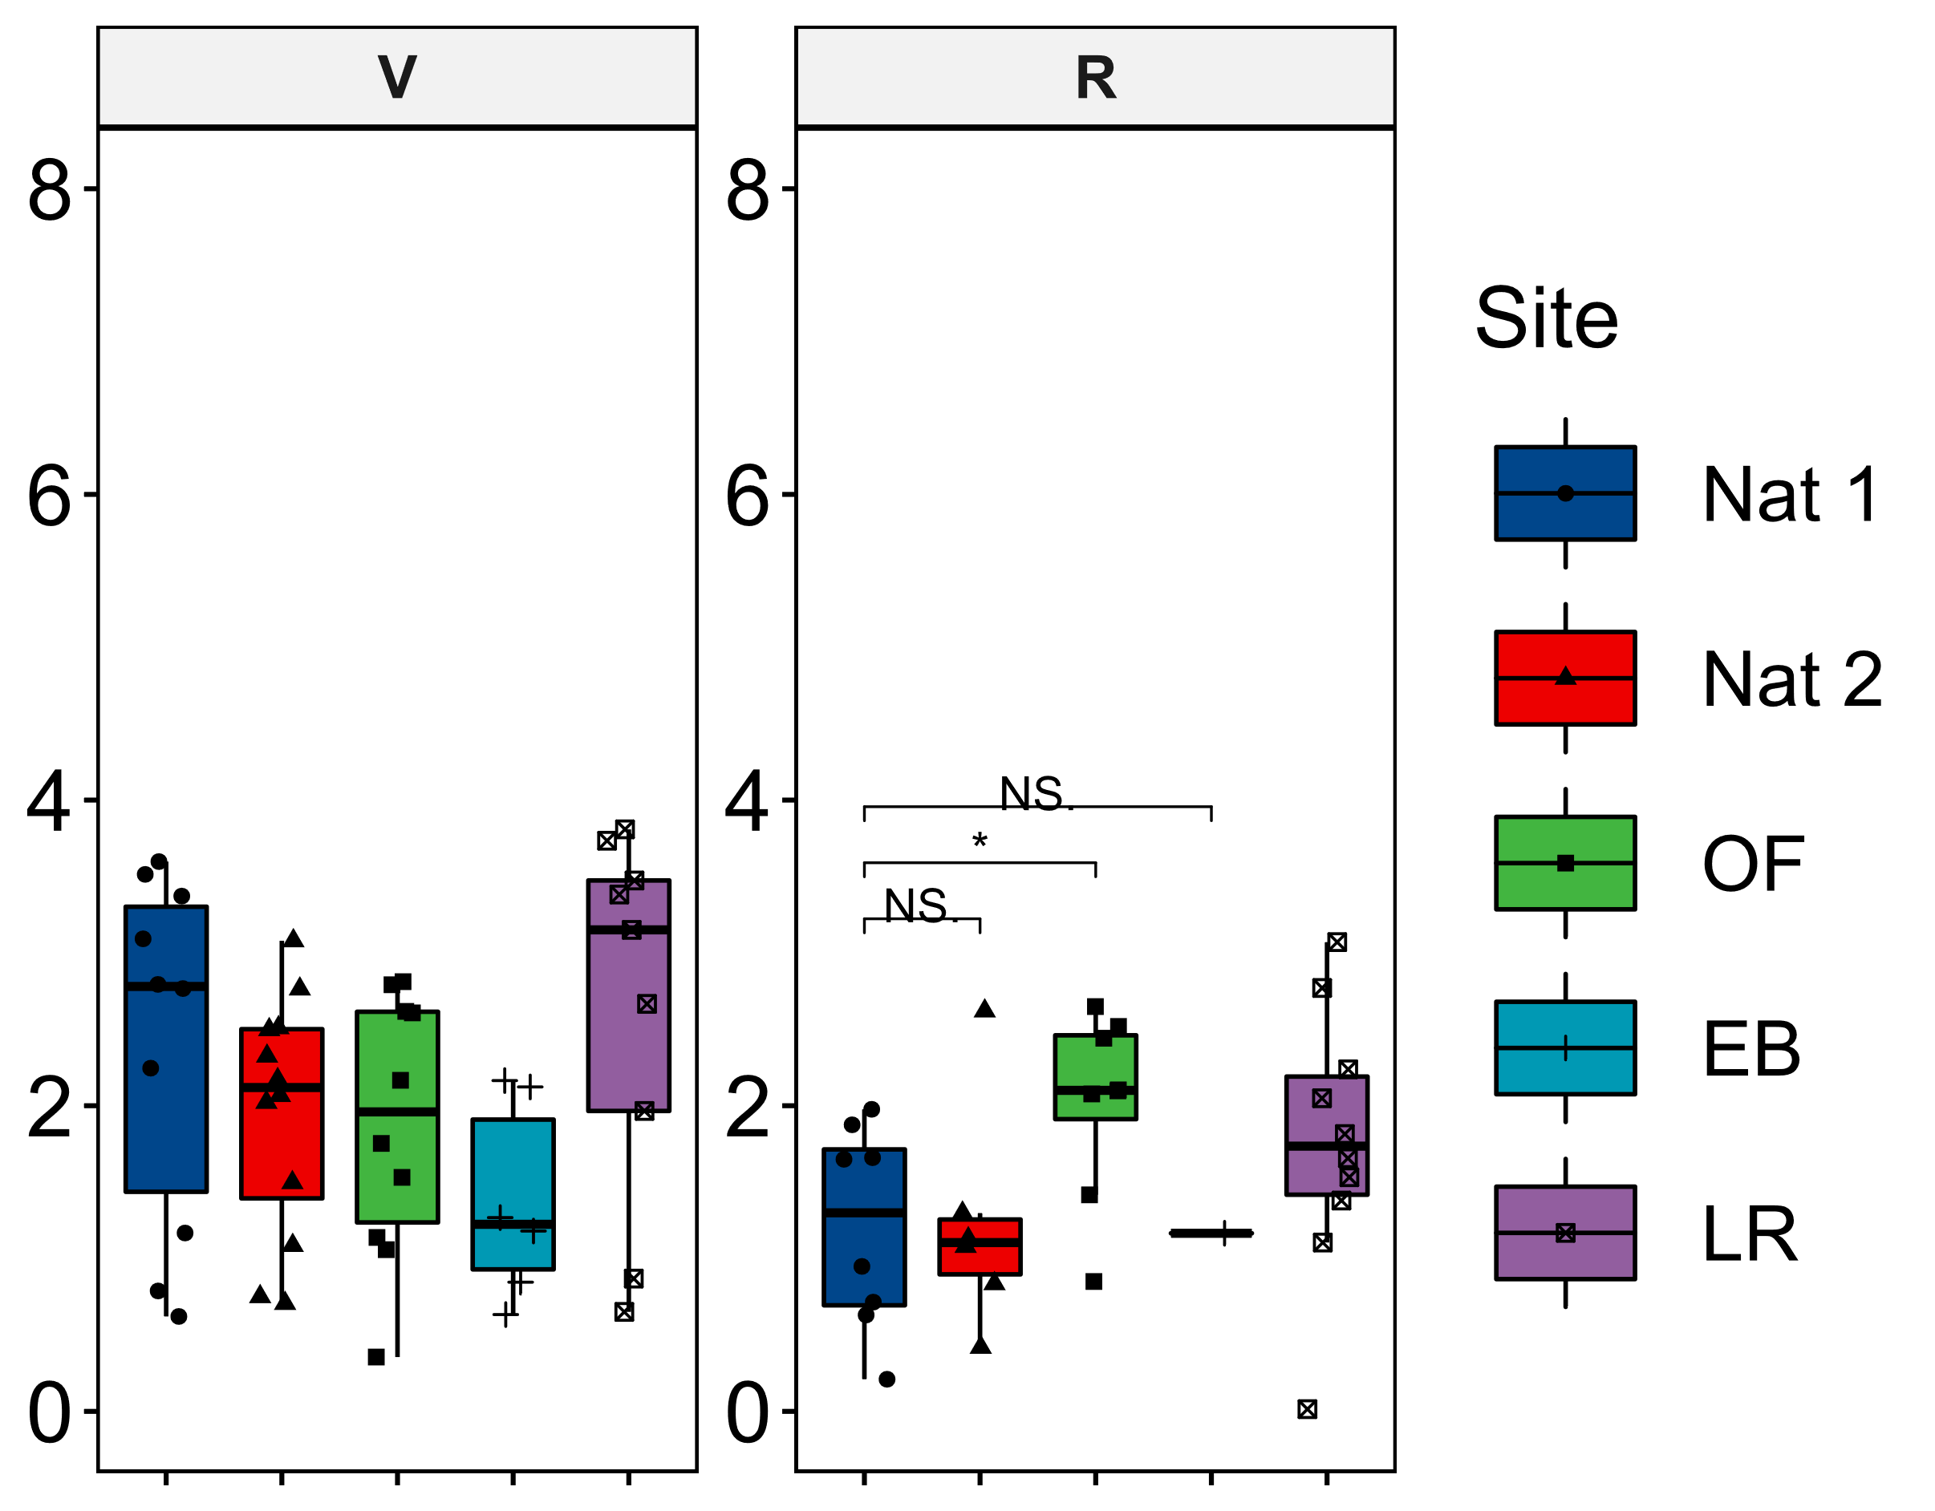
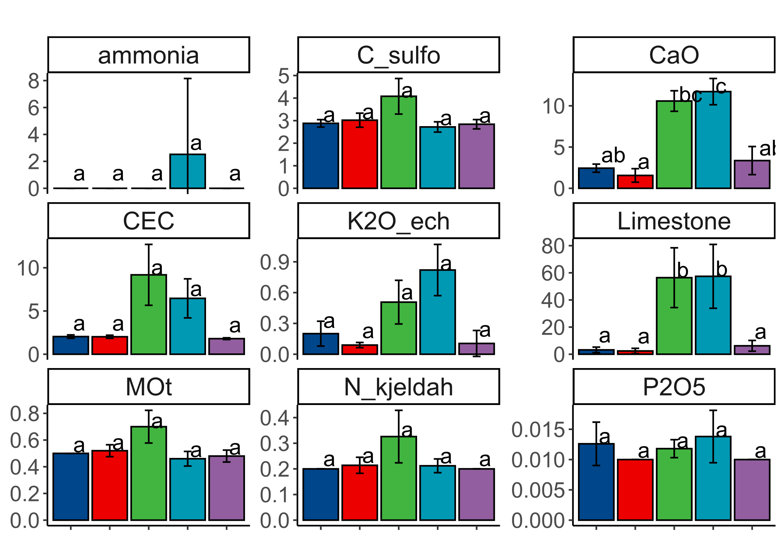
a
b

Fig.S1: Differences of soil composition in the rhizosphere is mainly drive by the content of limestone and CaO in the old farm (OF) and the evaporation basin (EB). (A) Principal Component Analysis revealed a low concentration of elements in the natural sites (Nat 1, Nat 2) and the restored farm (LR) when compared to the OF and EB sites. (B) Differences of elements according to each site where different letters represent significant differences estimated by an estimated marginal means analysis. Error bars are represented as the standard deviation of each elements in each site.

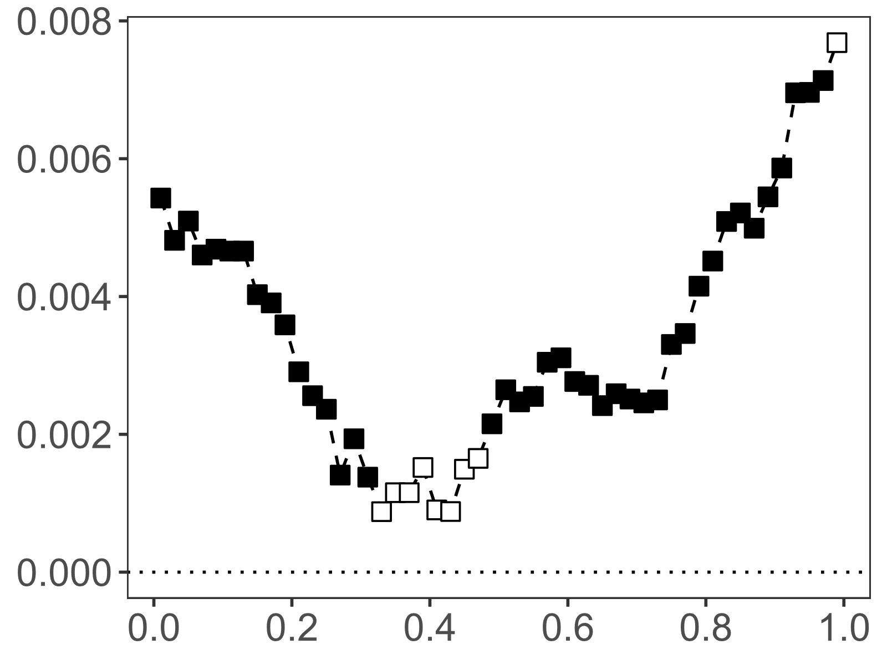
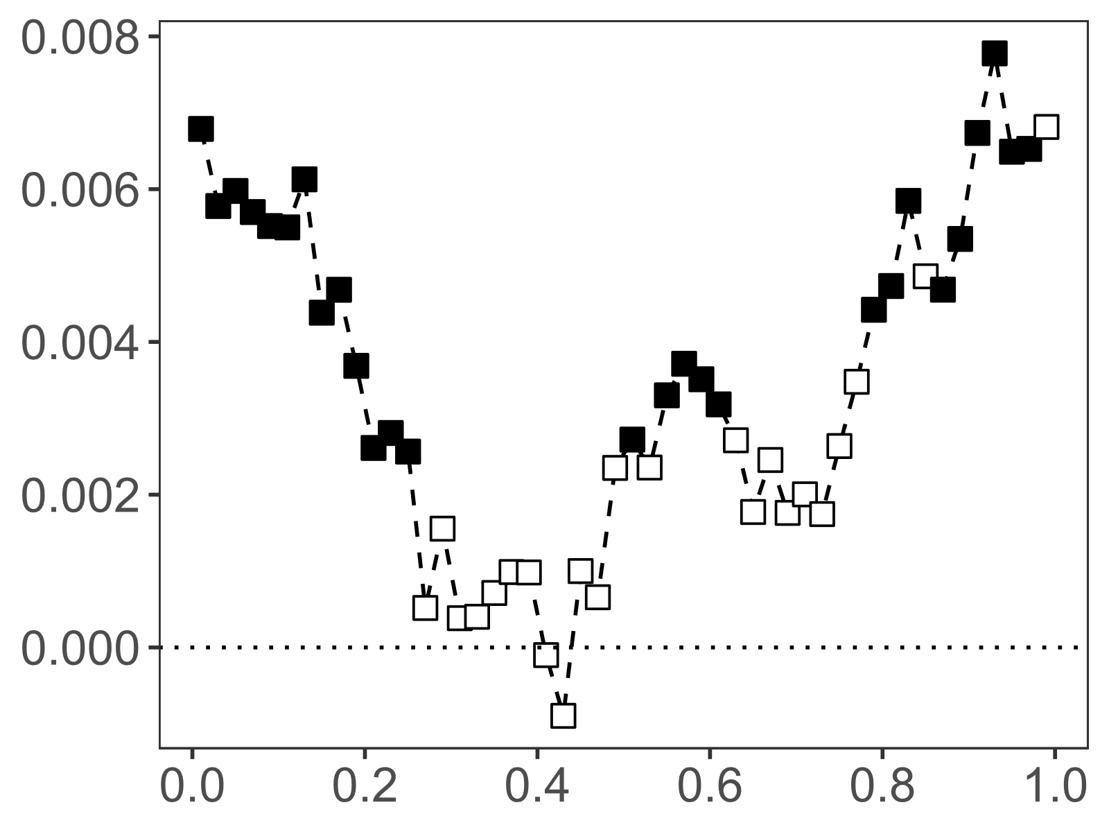
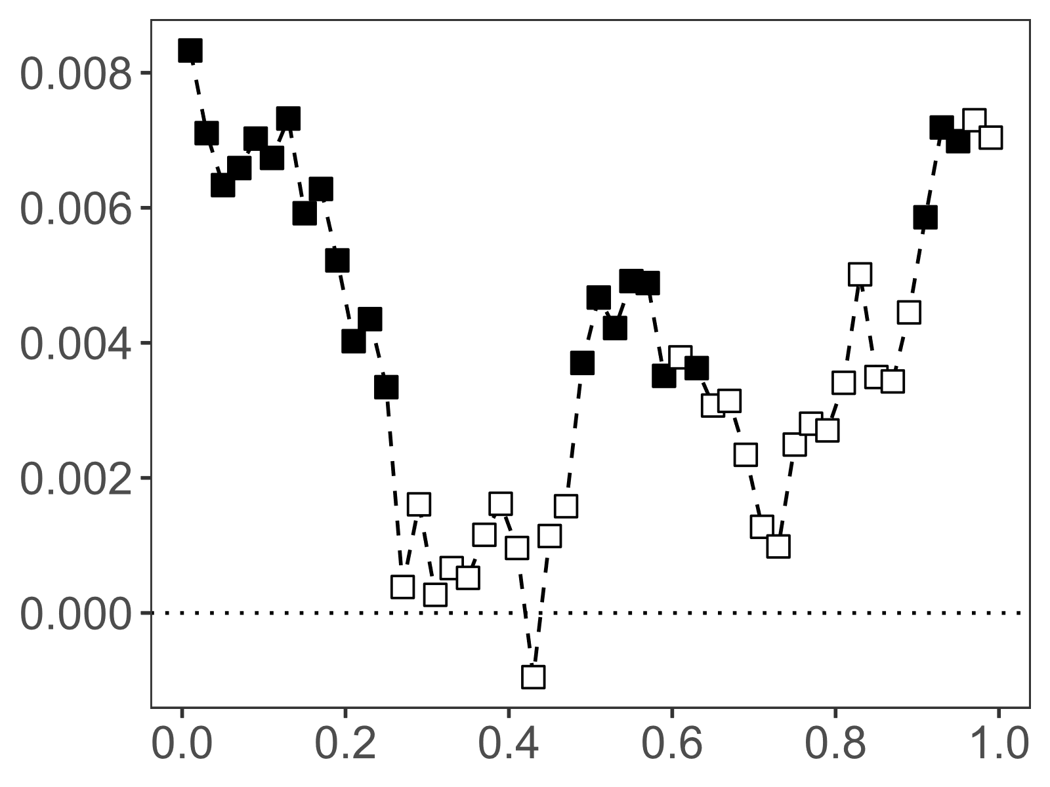
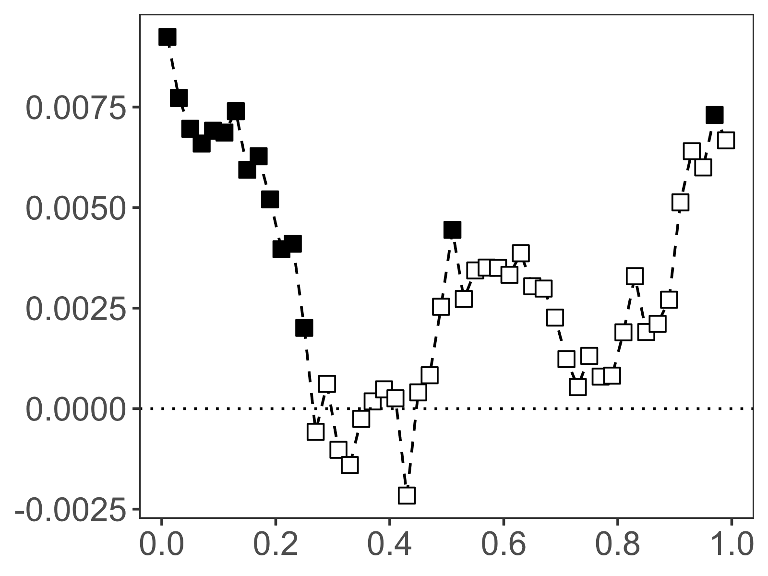
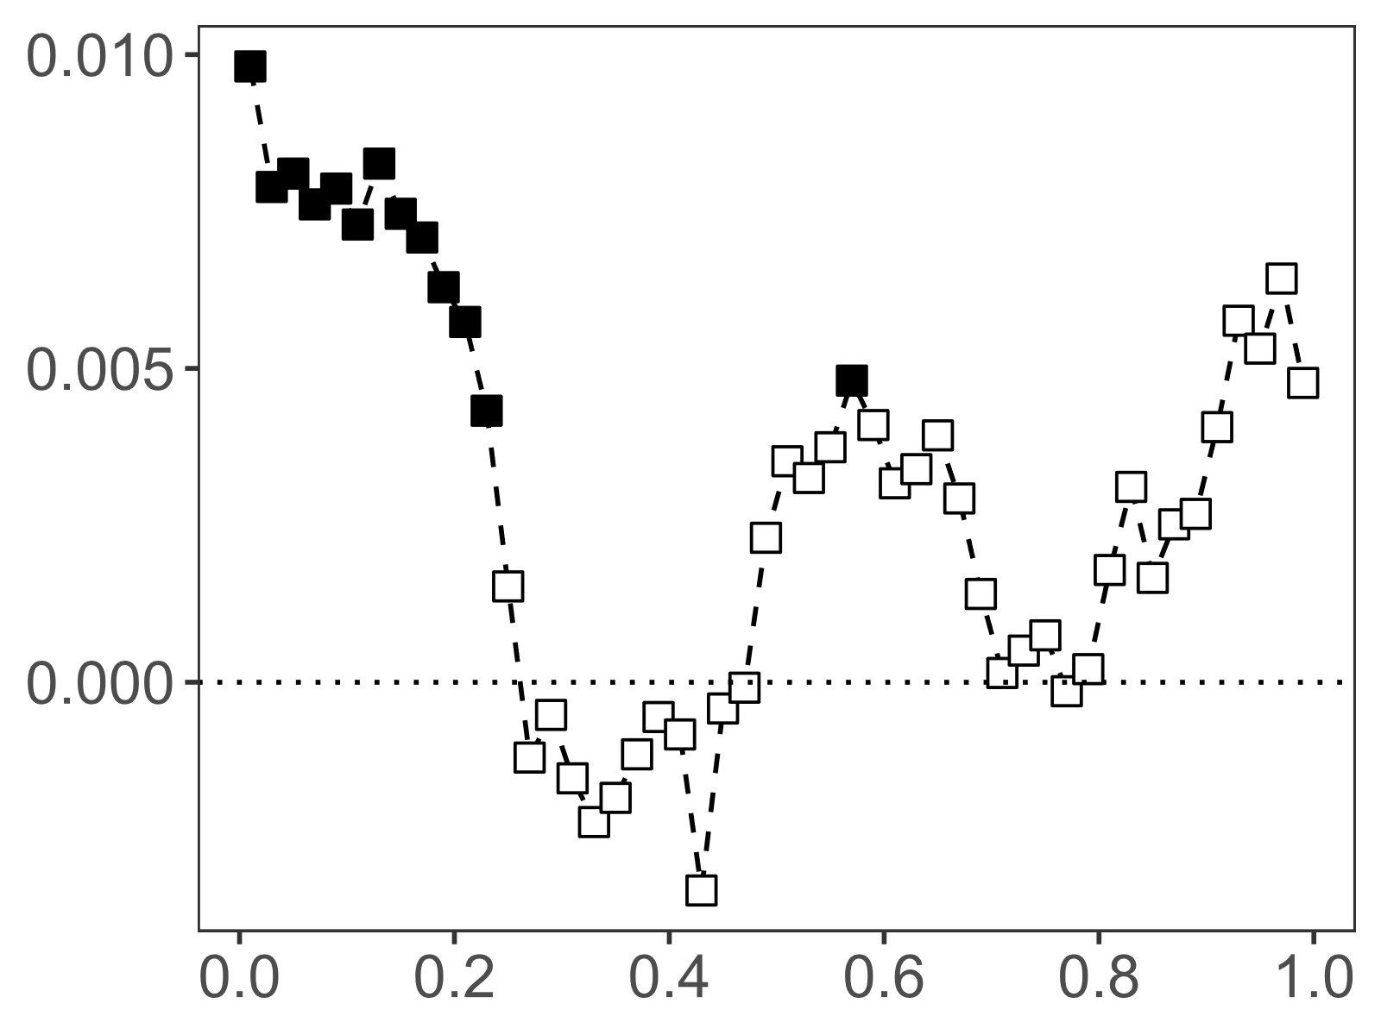
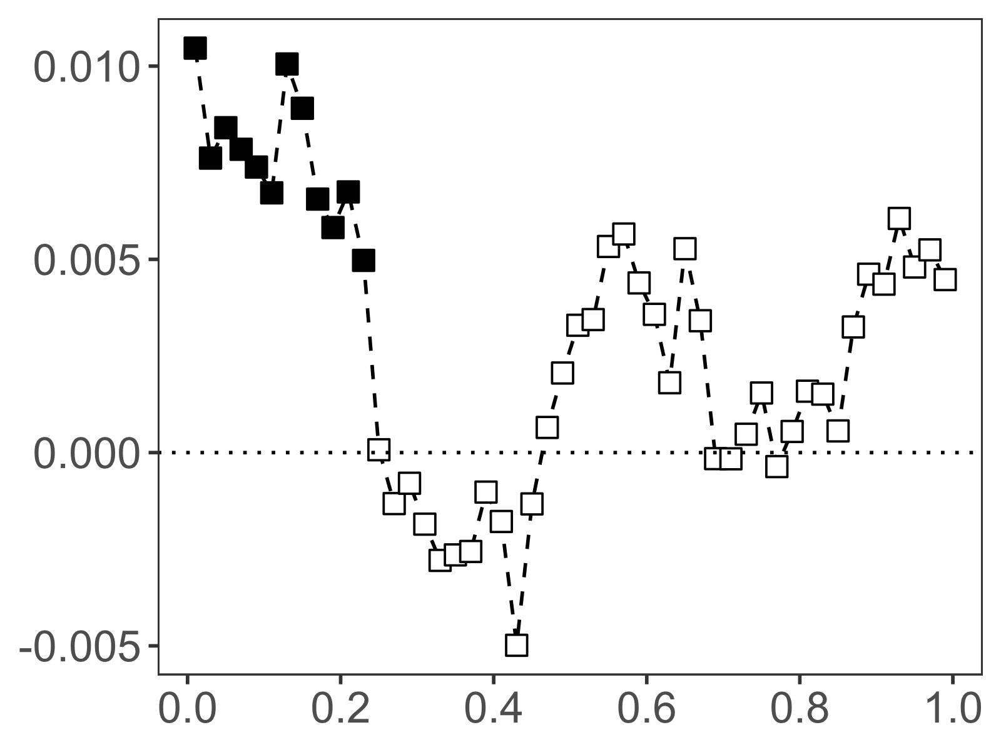
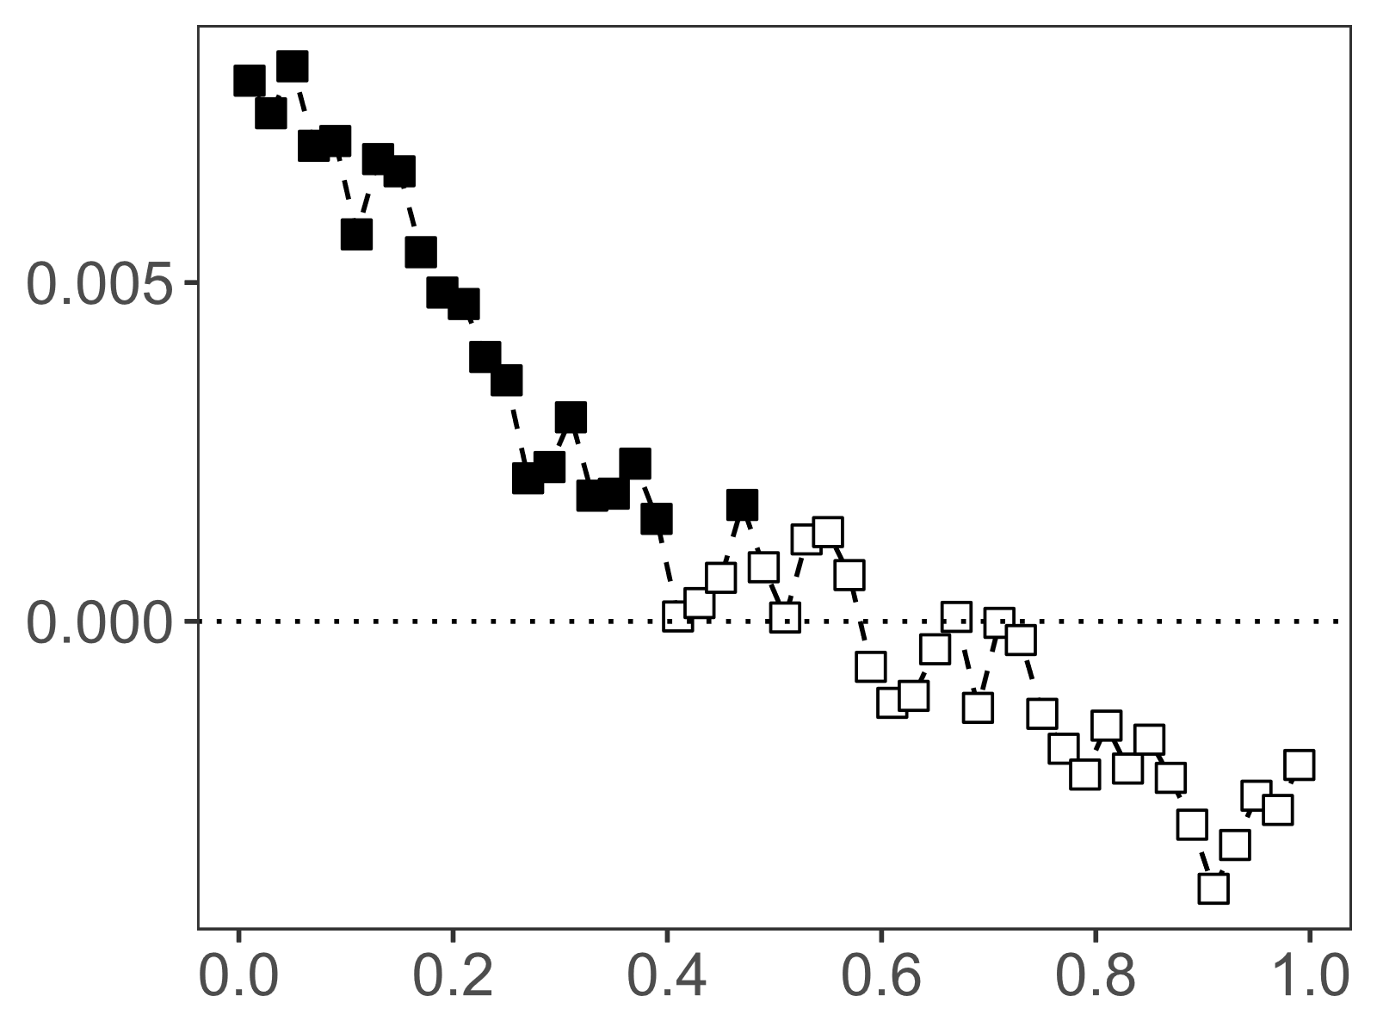
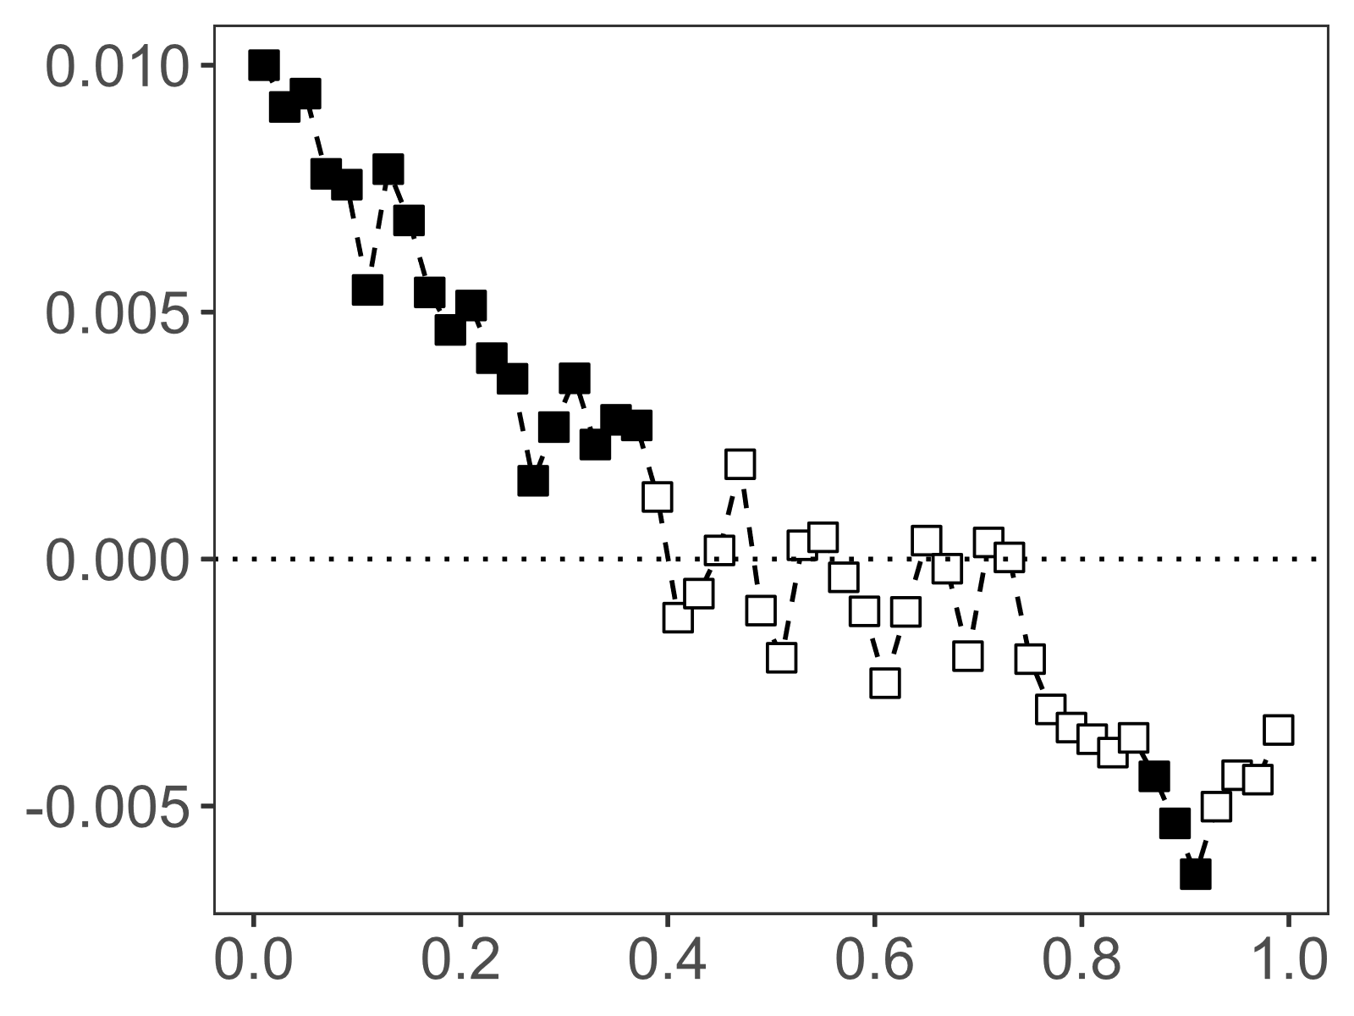
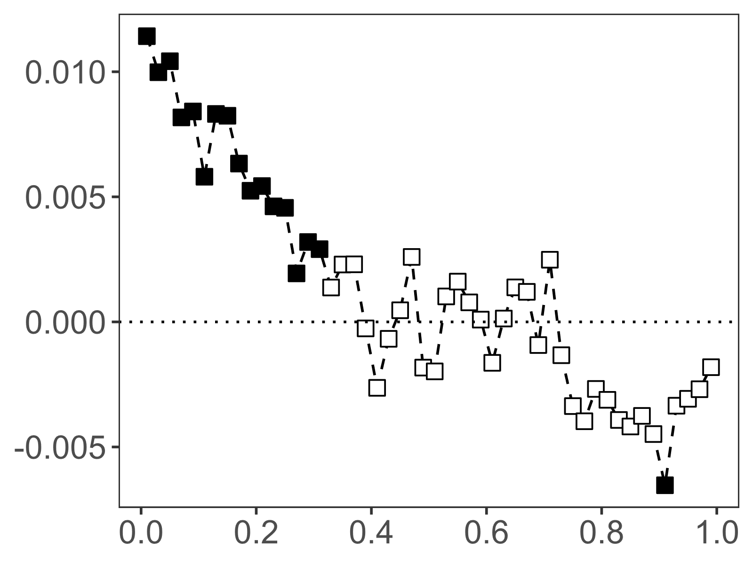
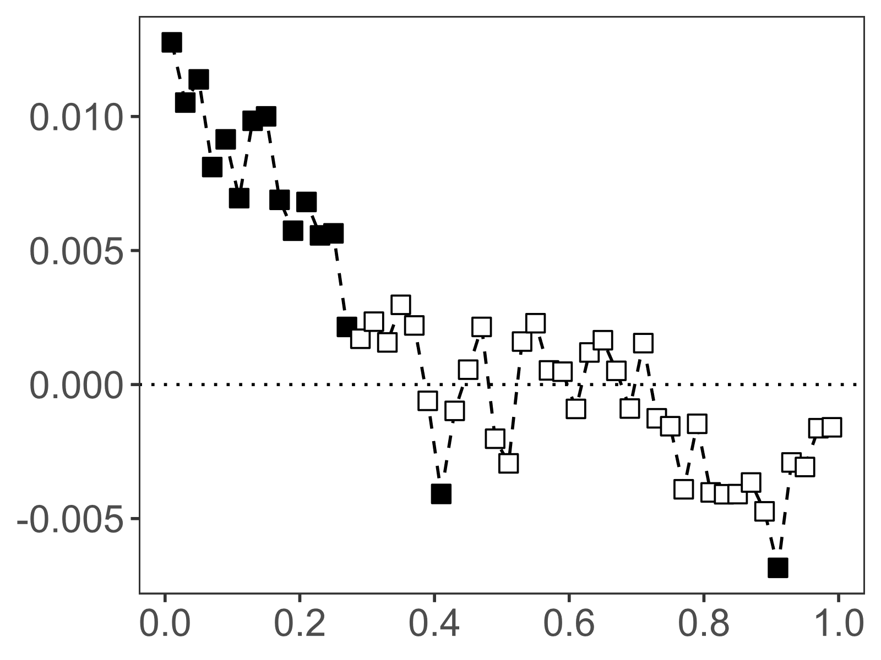
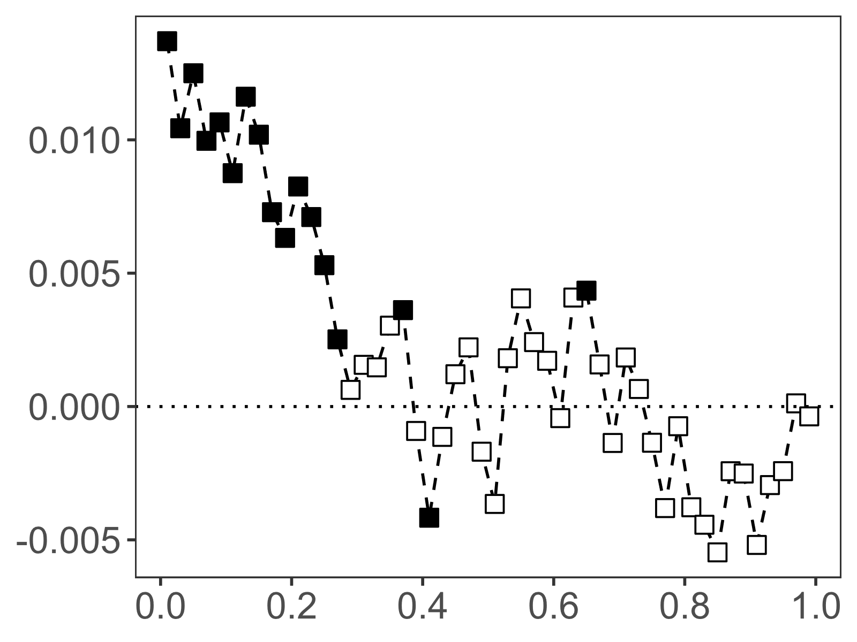
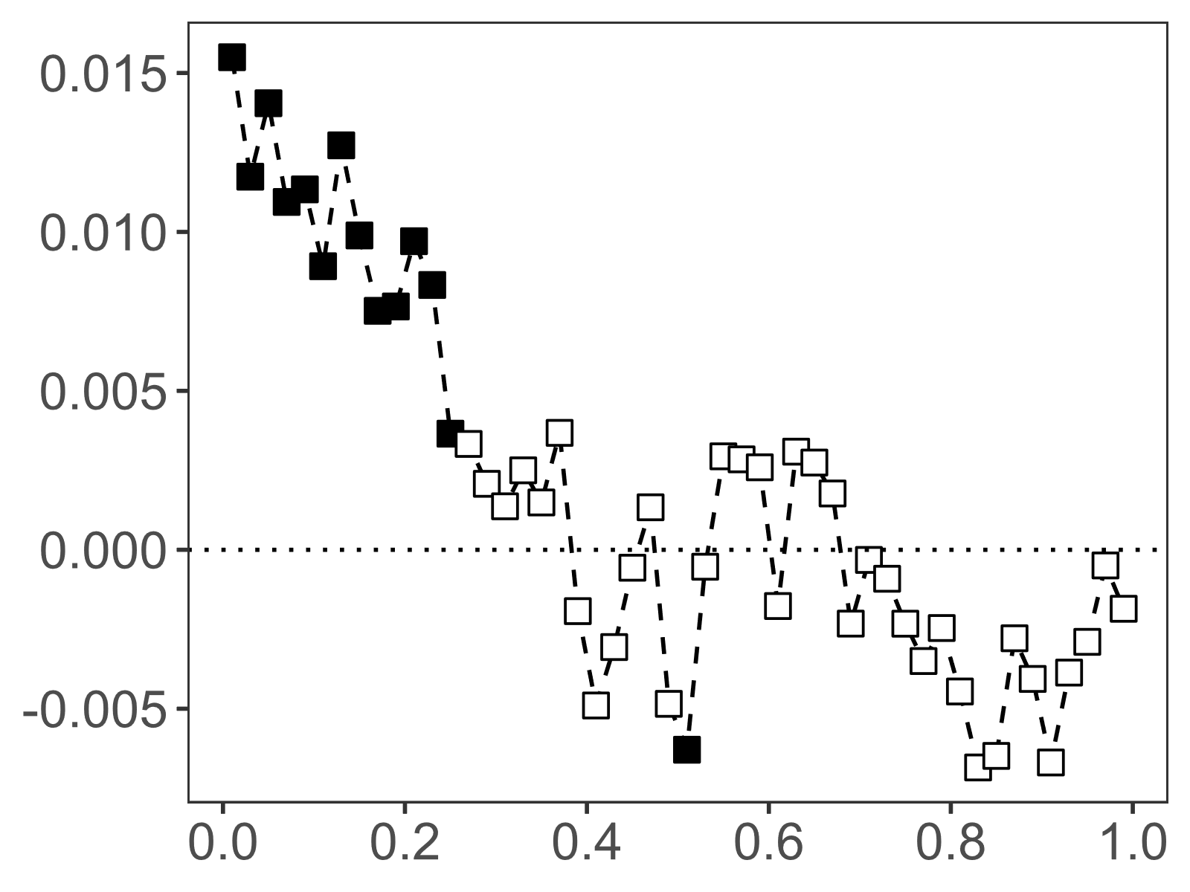
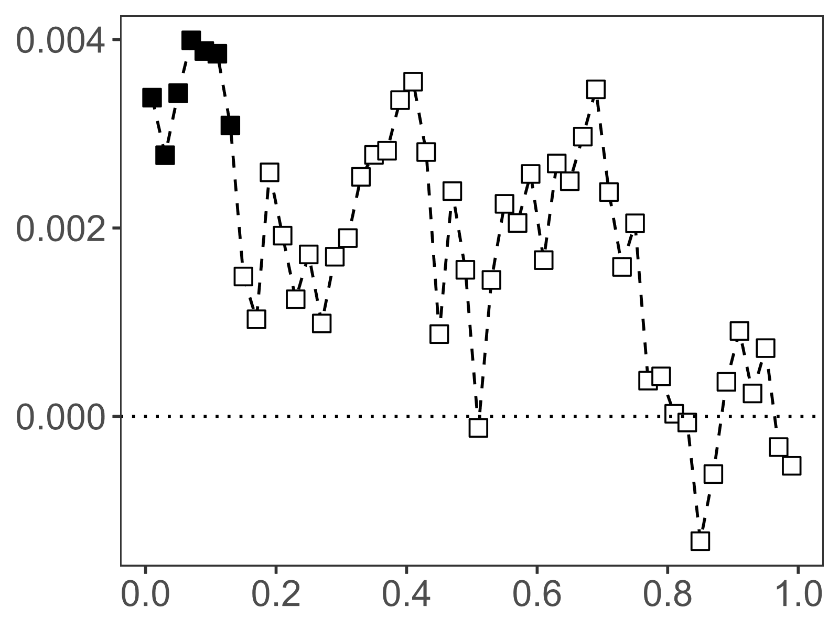
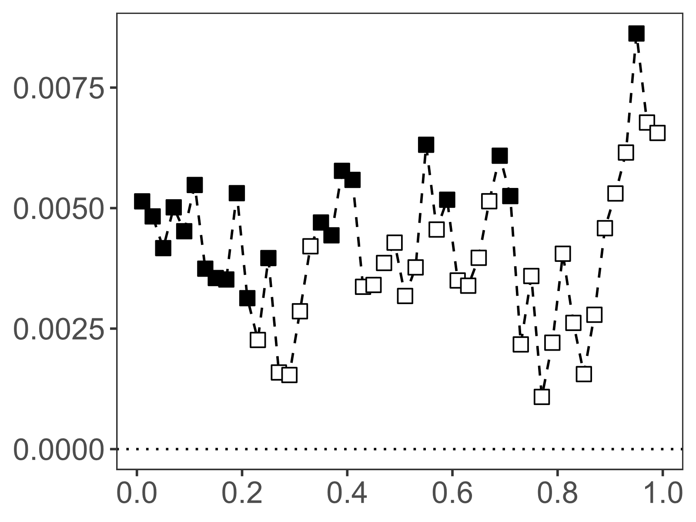
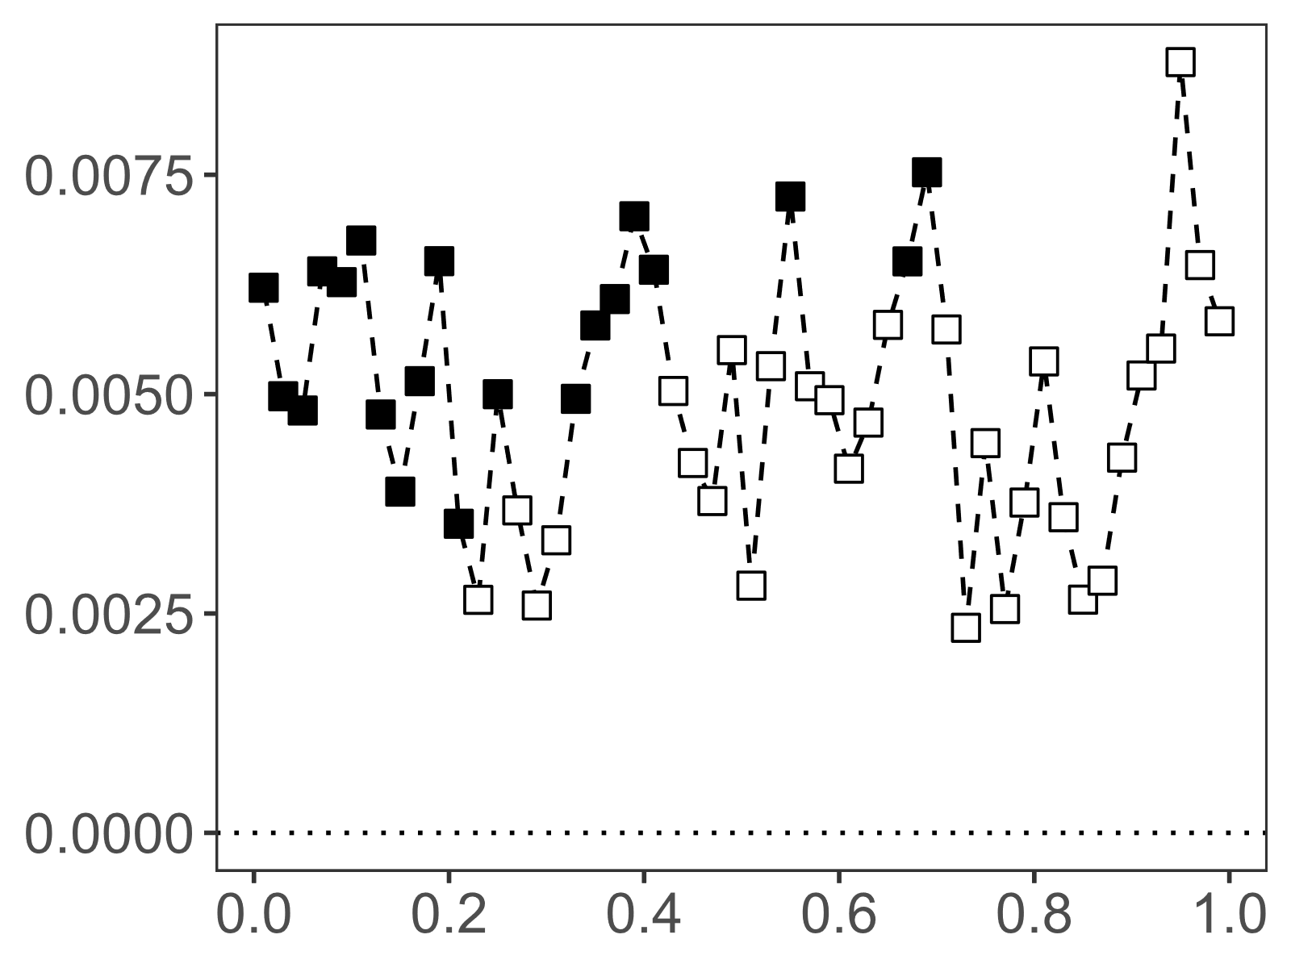
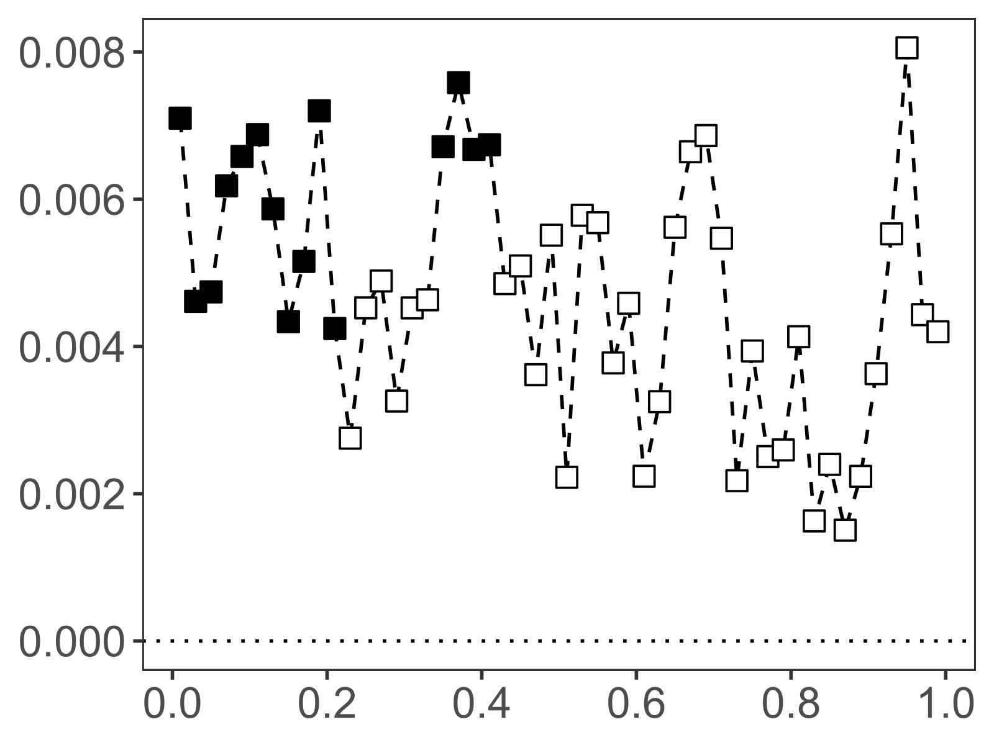
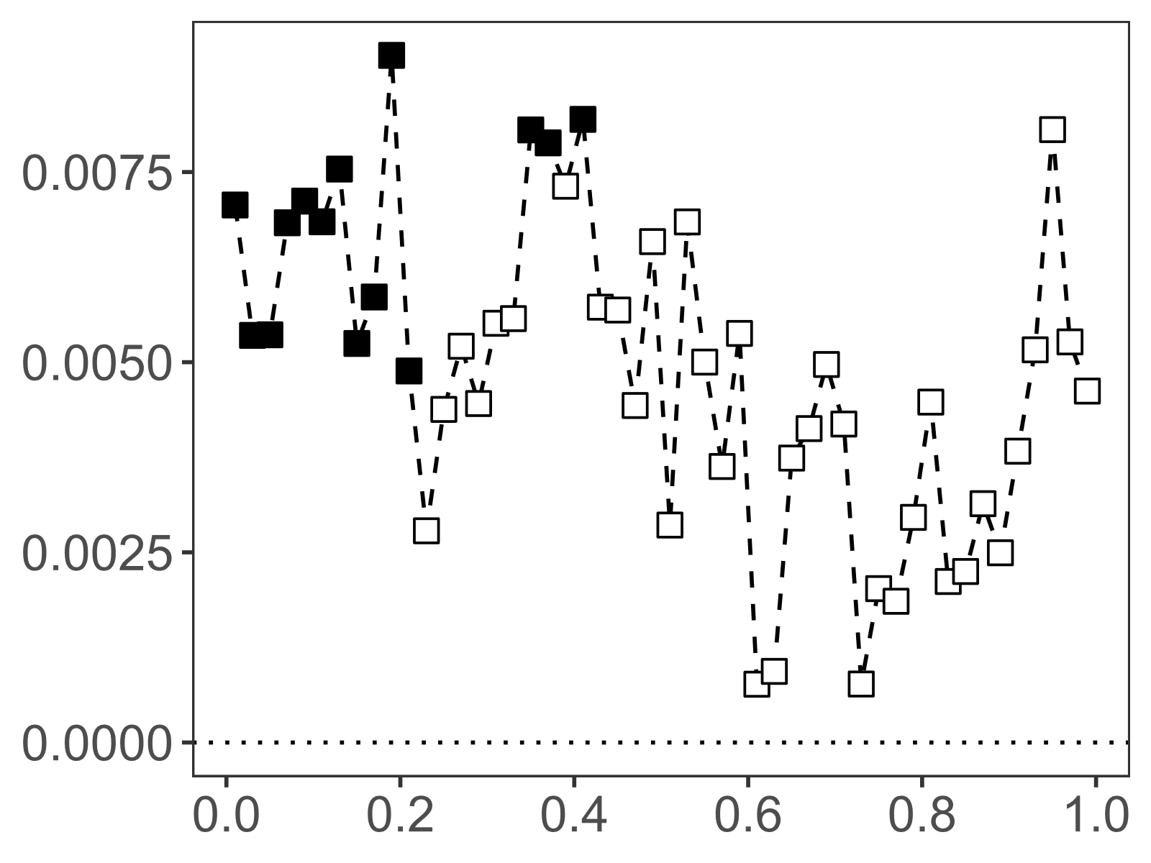
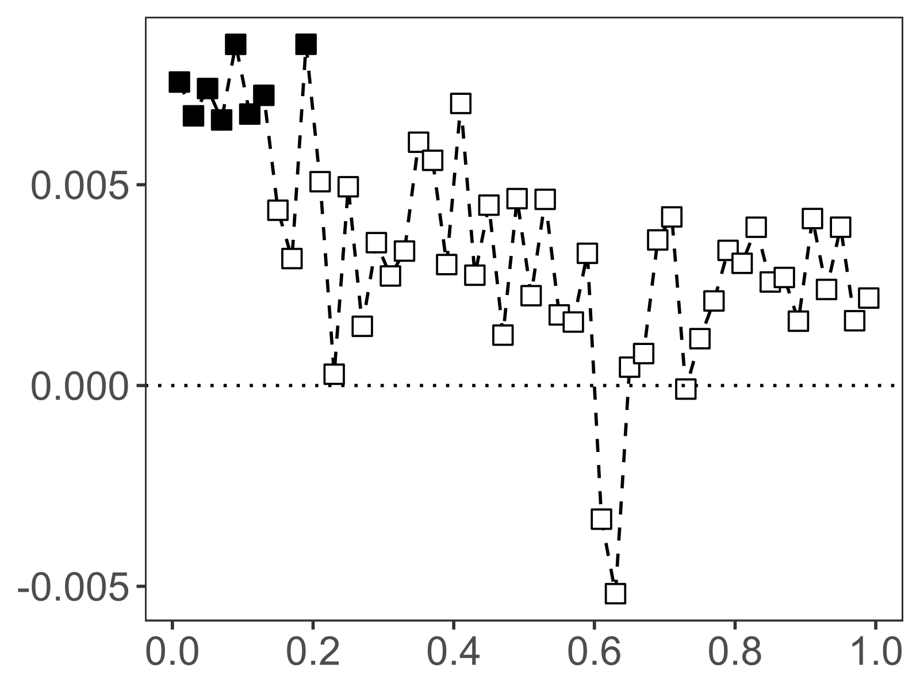
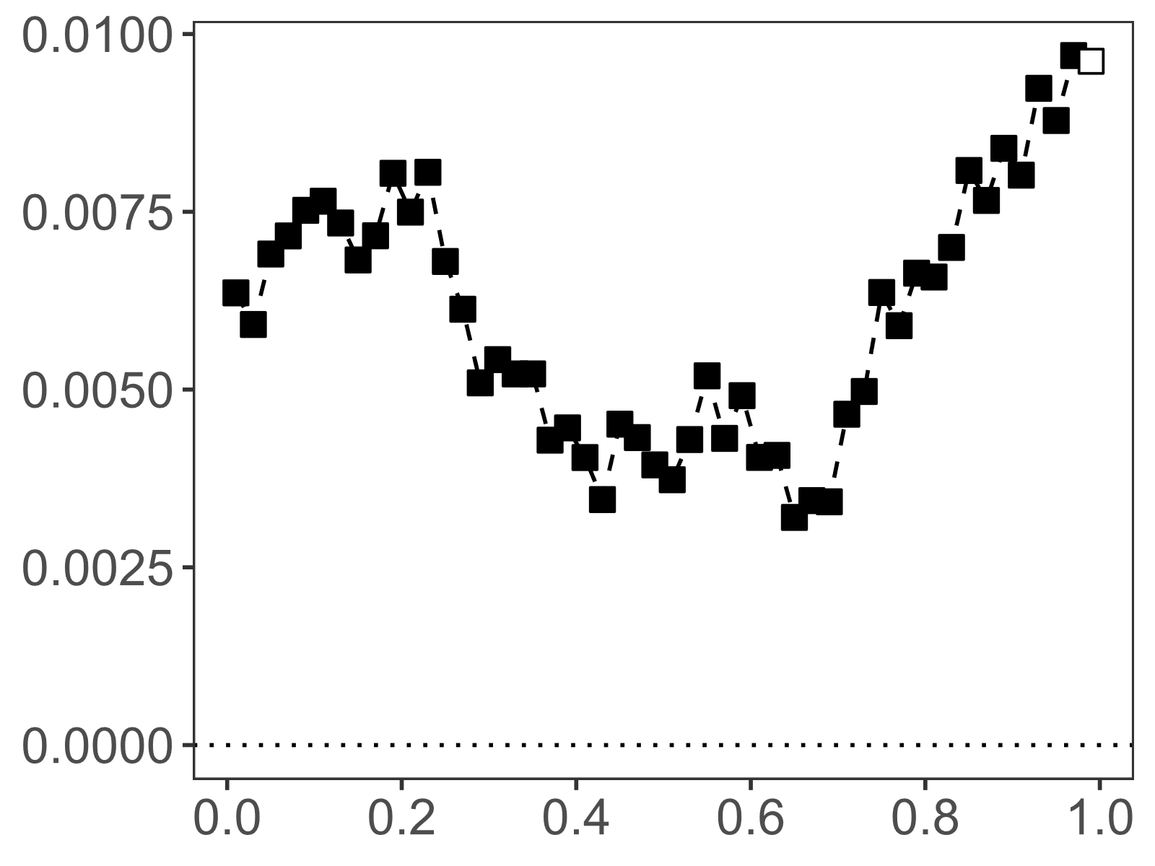
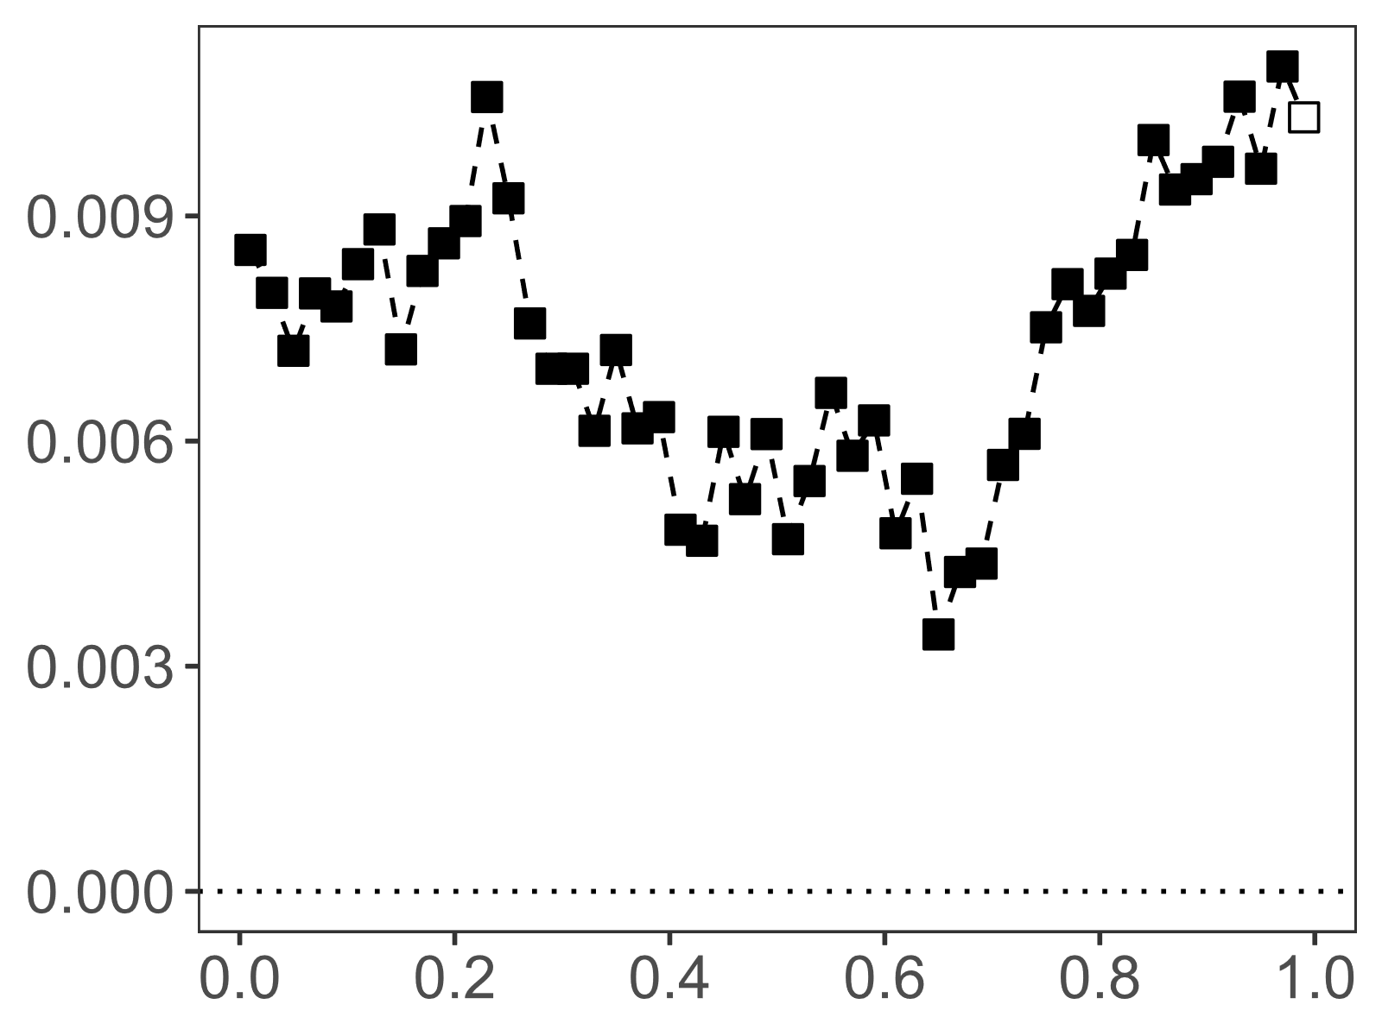
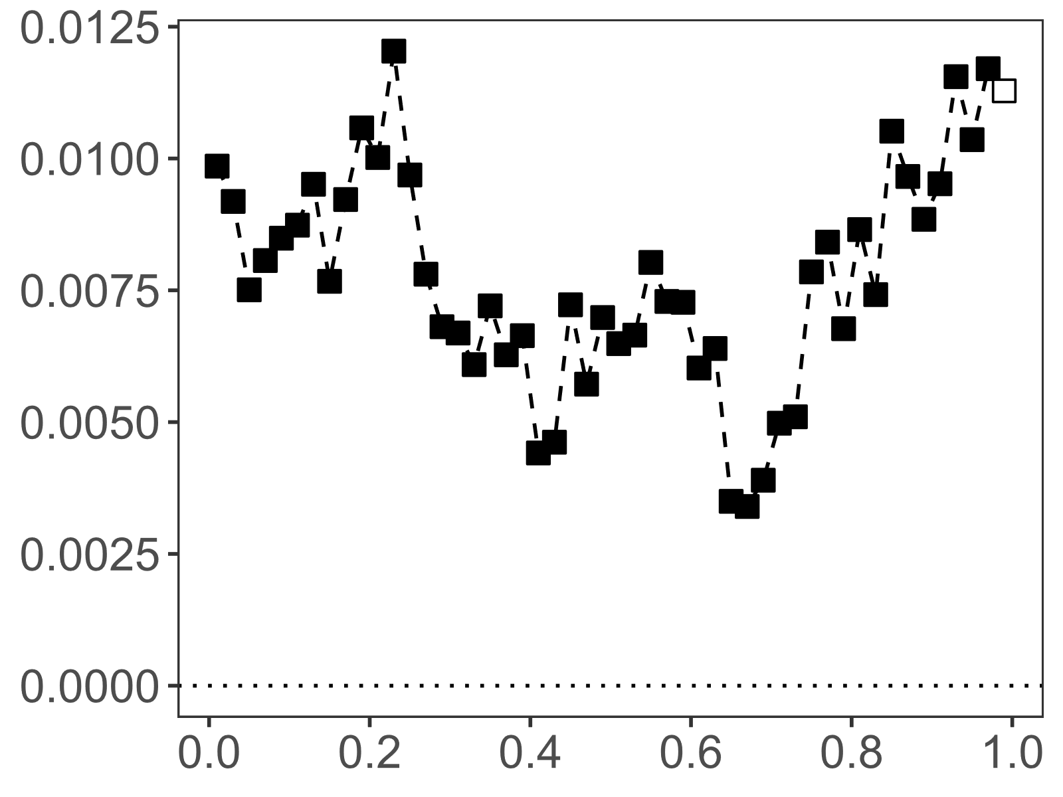
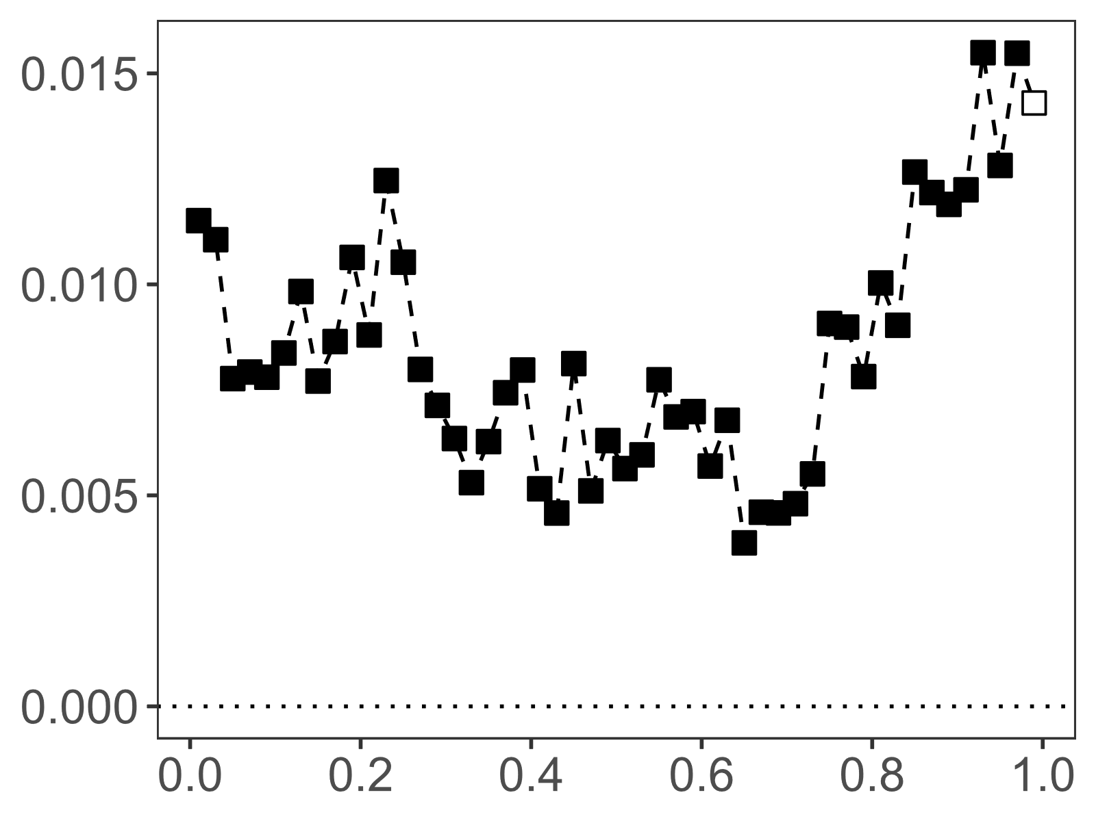
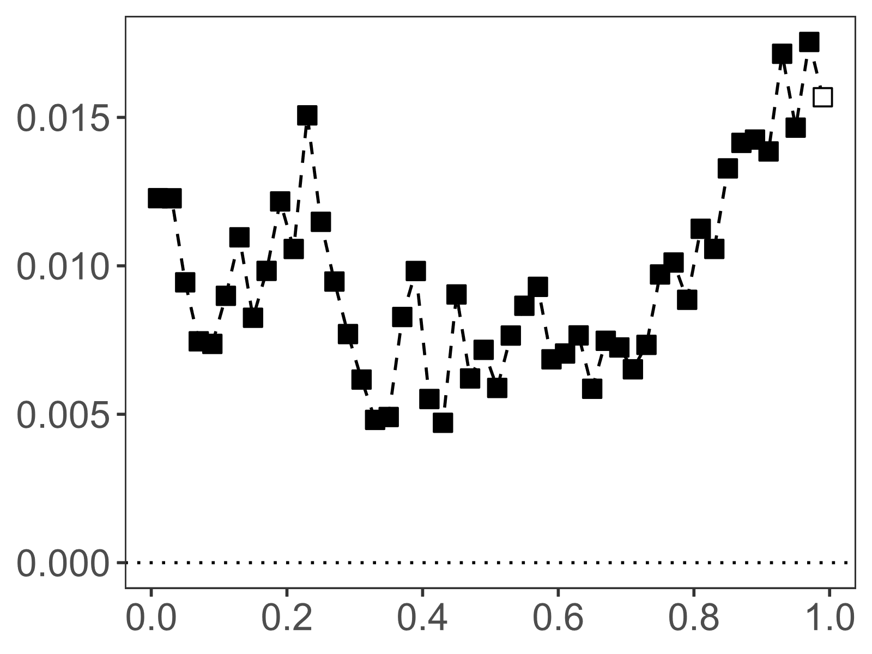
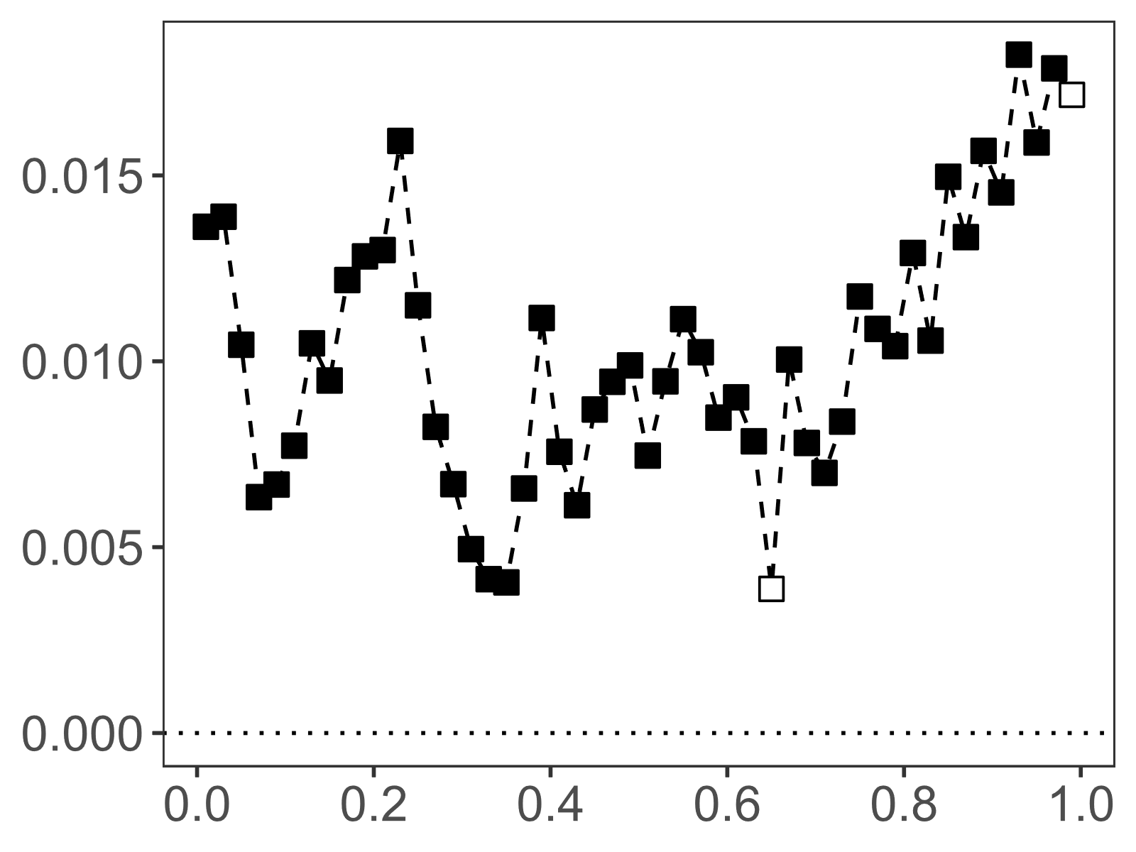
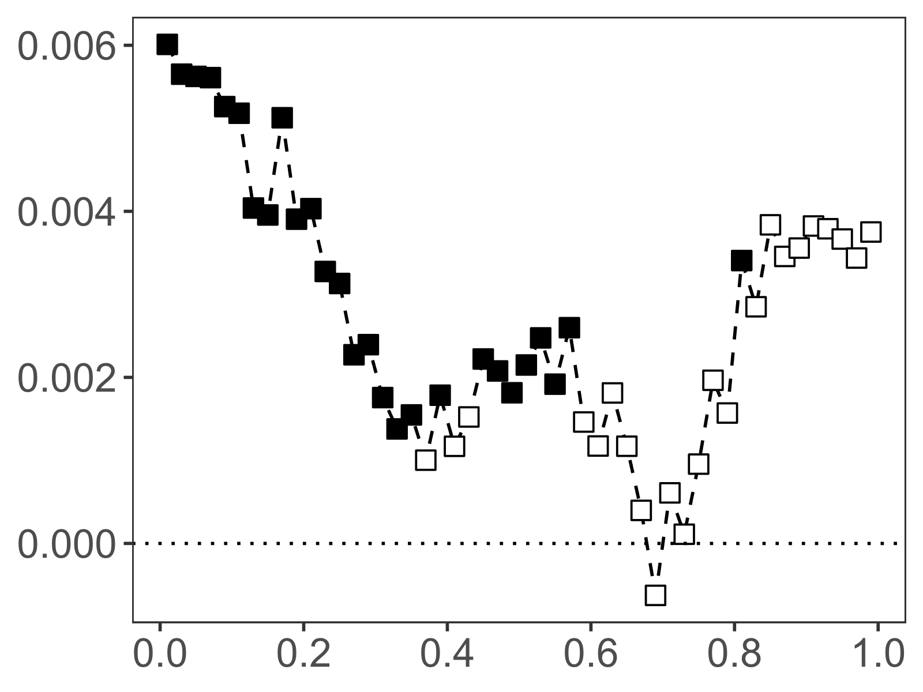
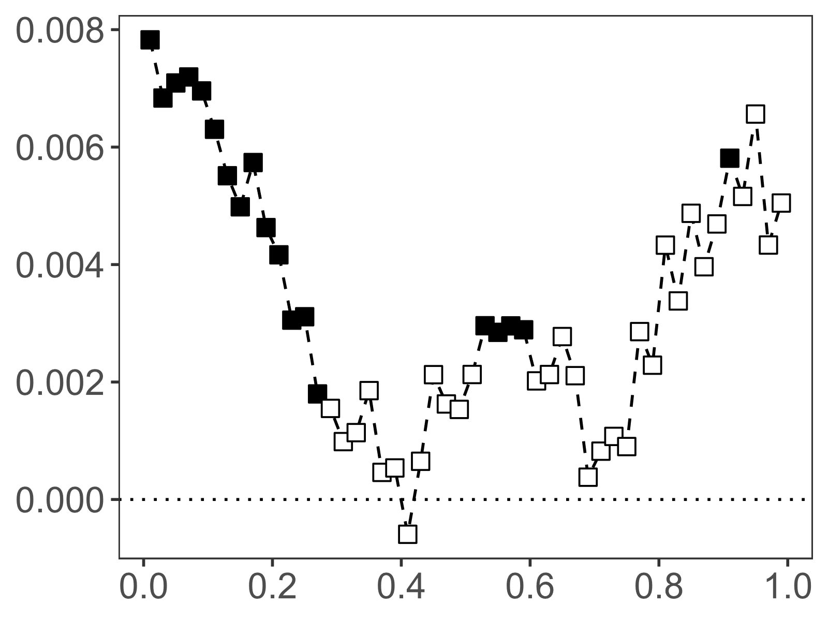
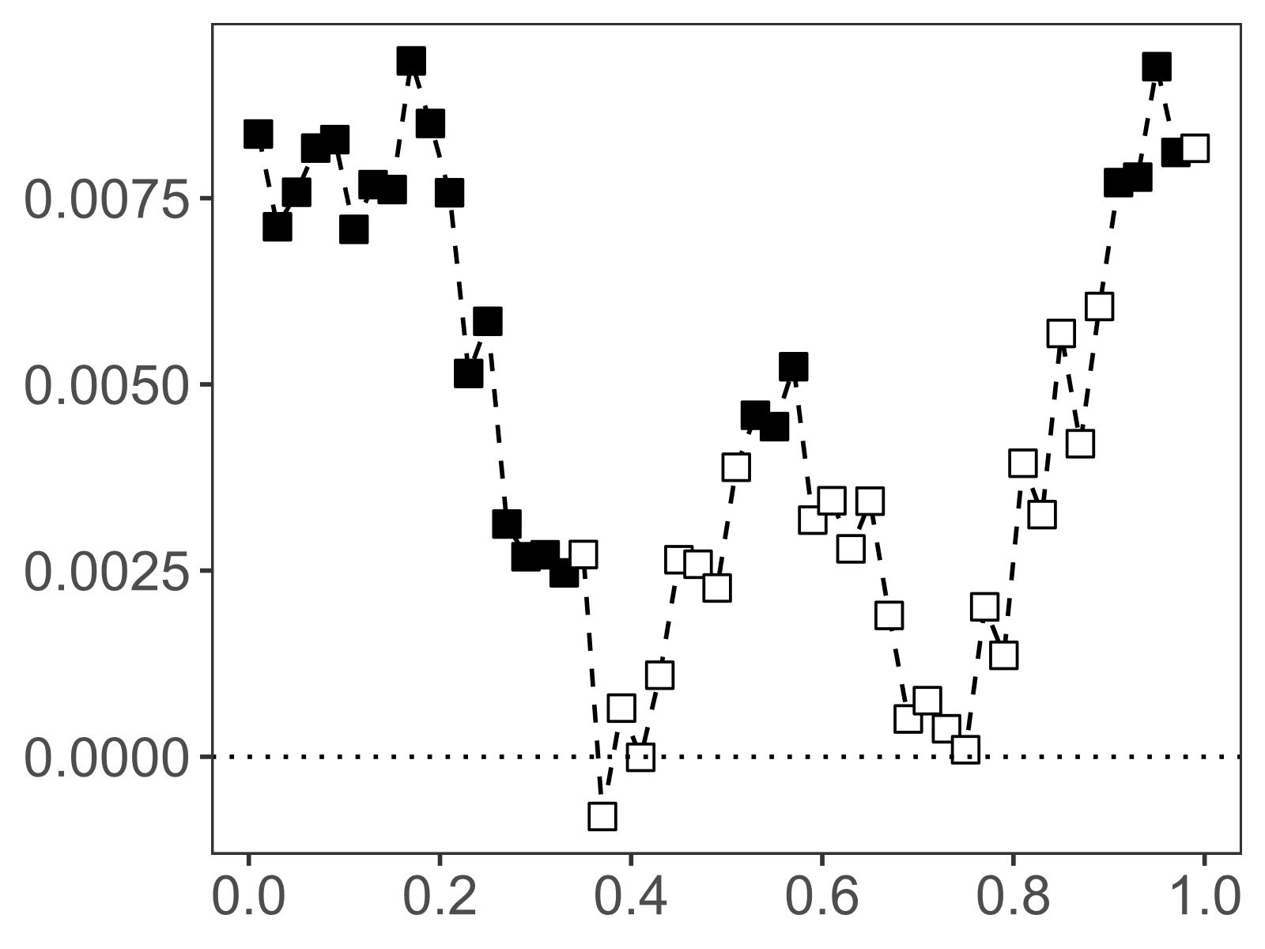
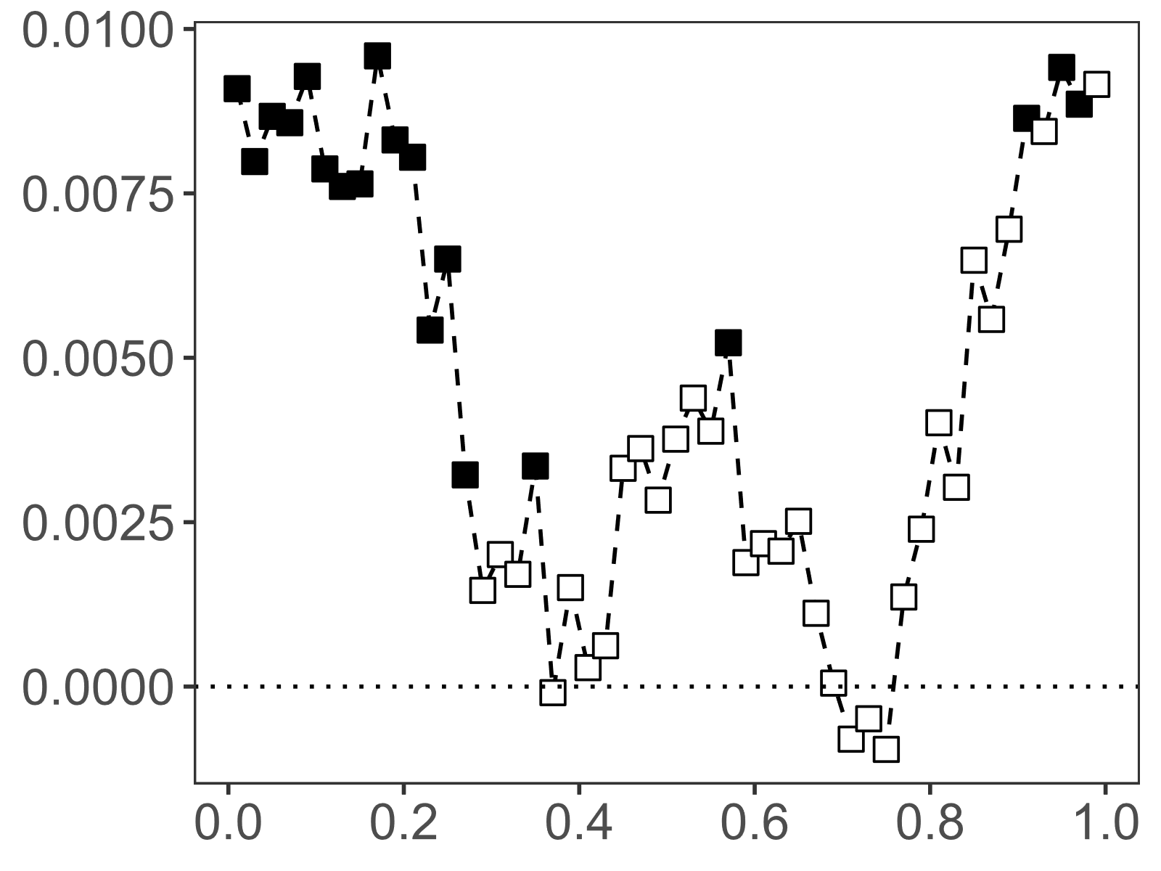
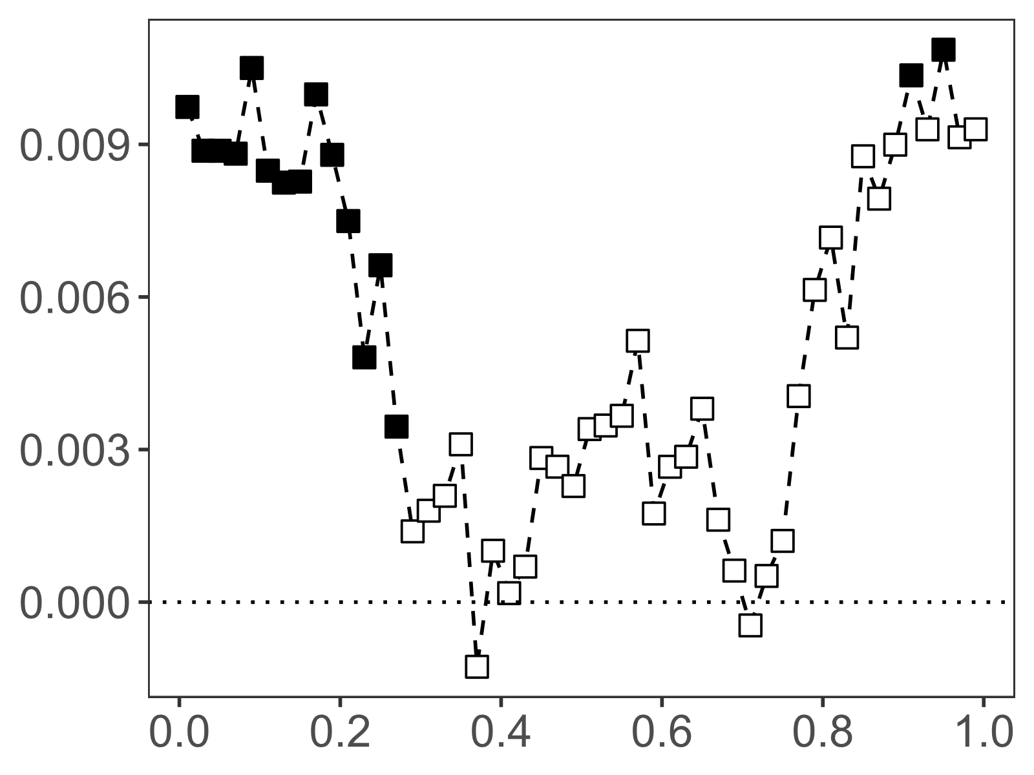
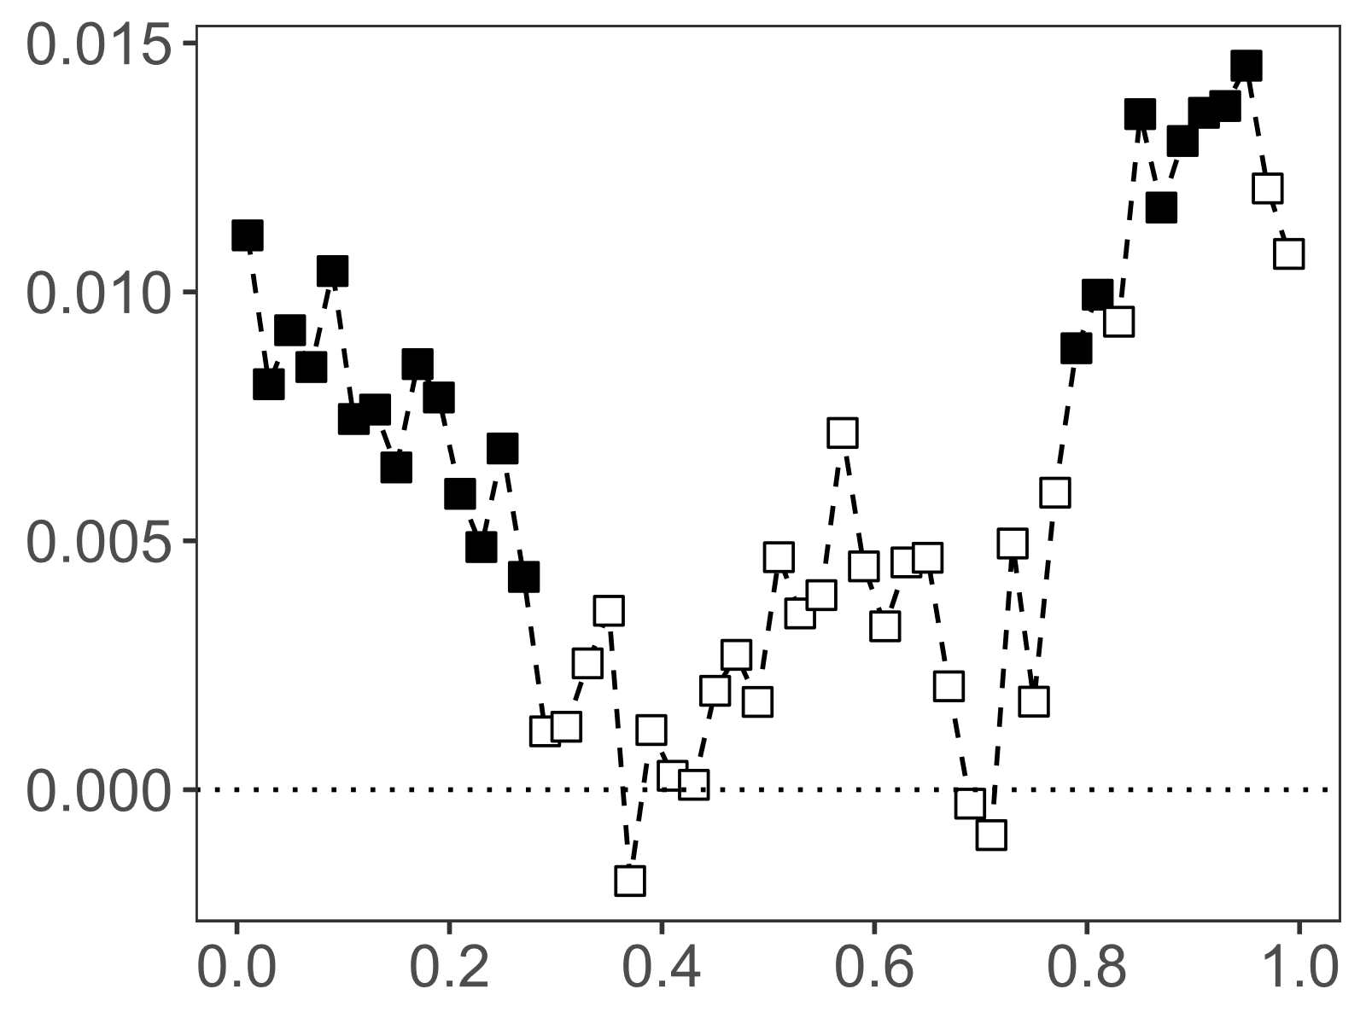
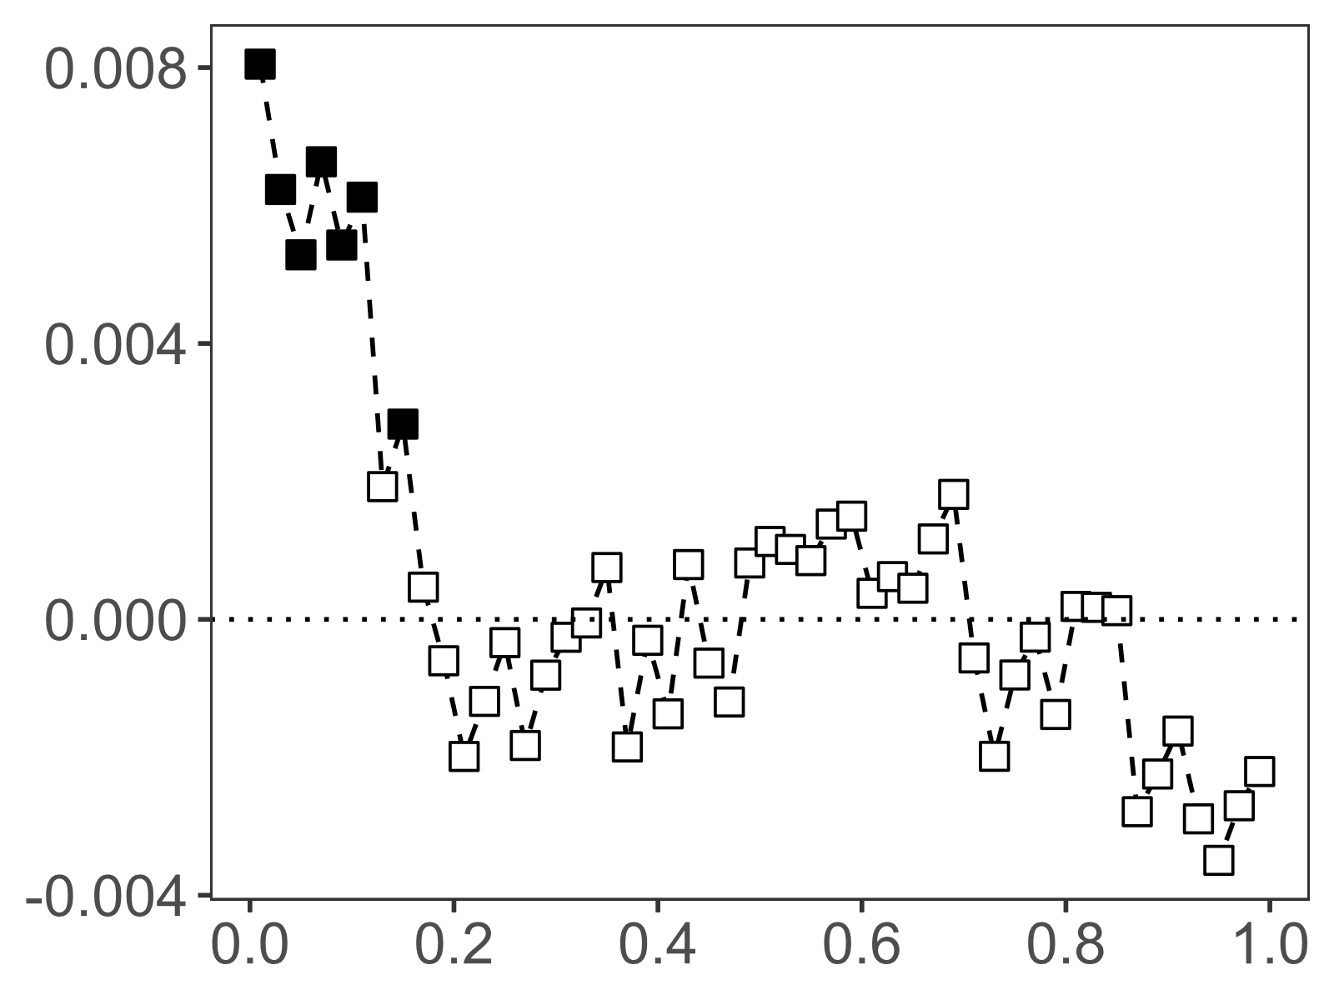
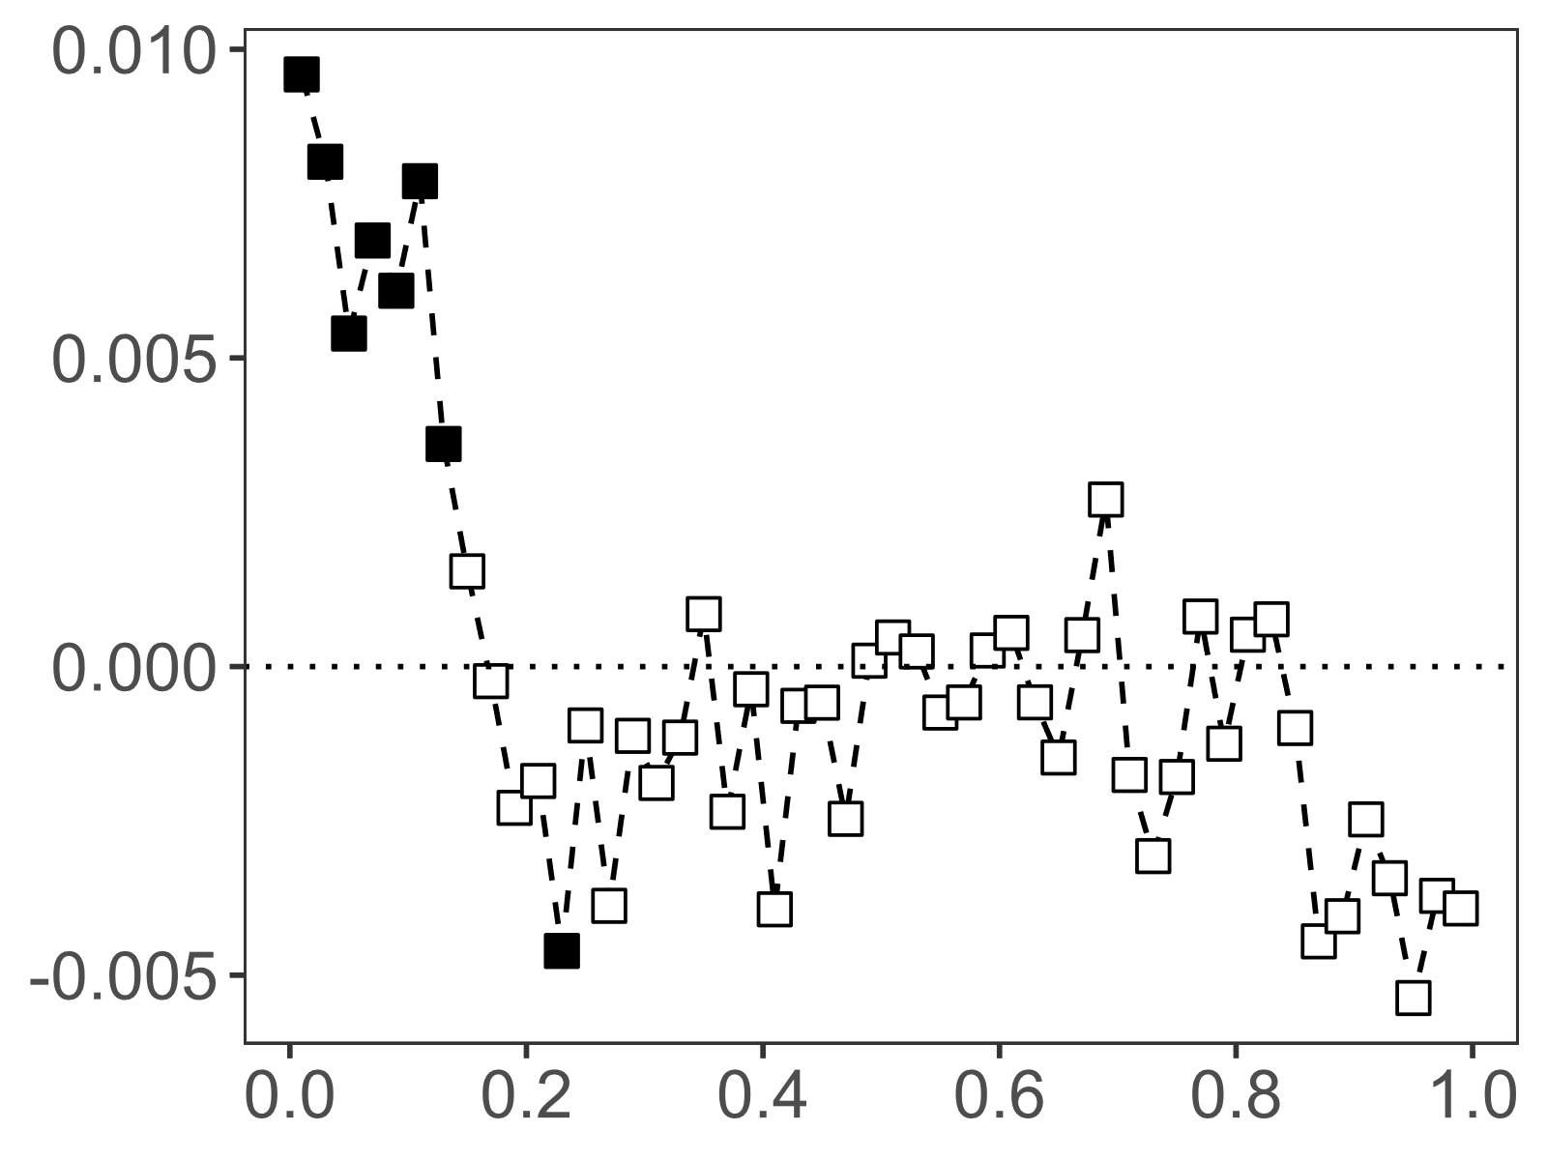
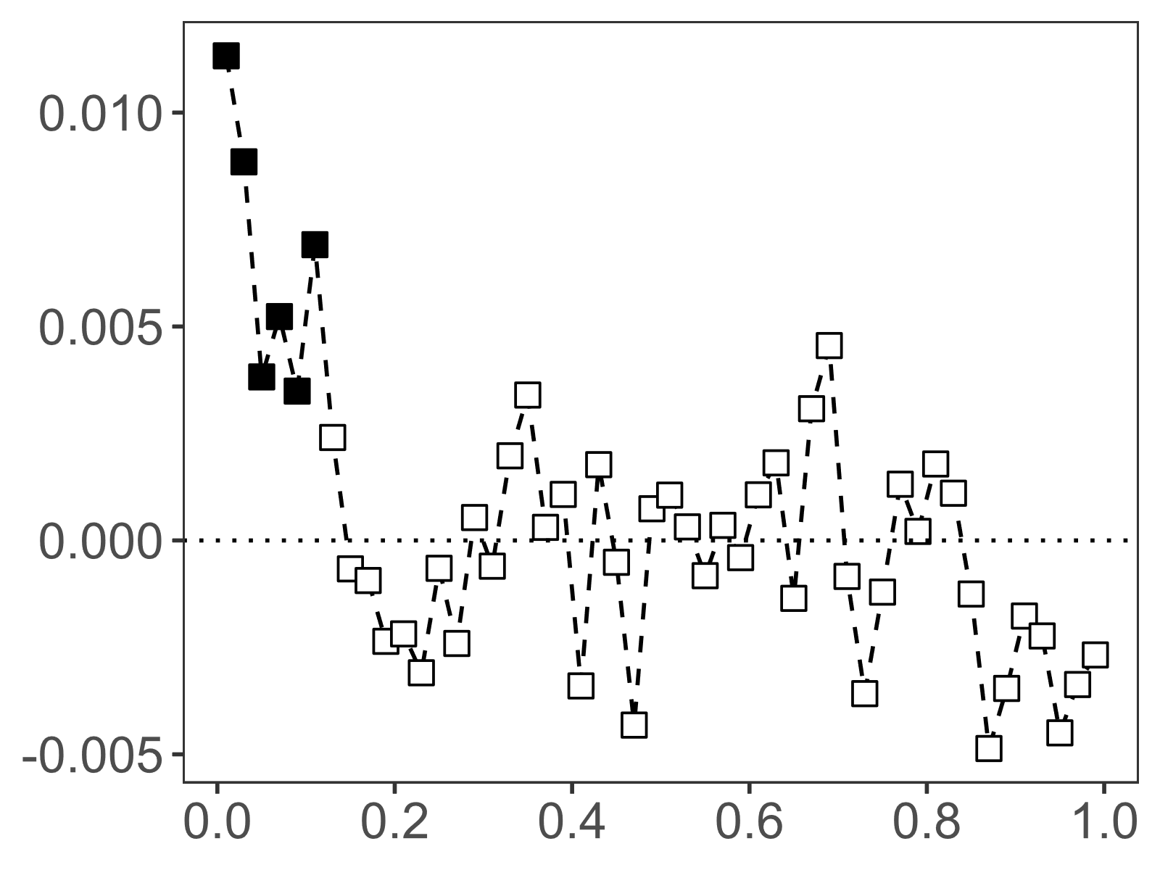
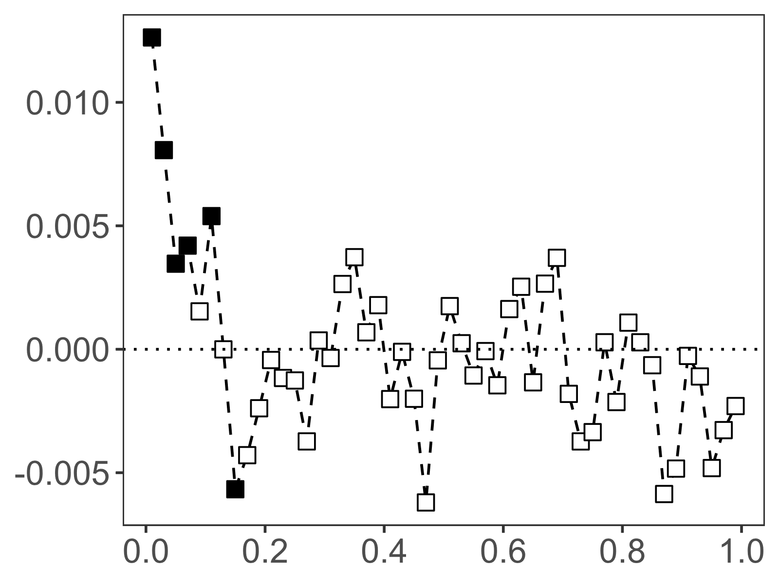
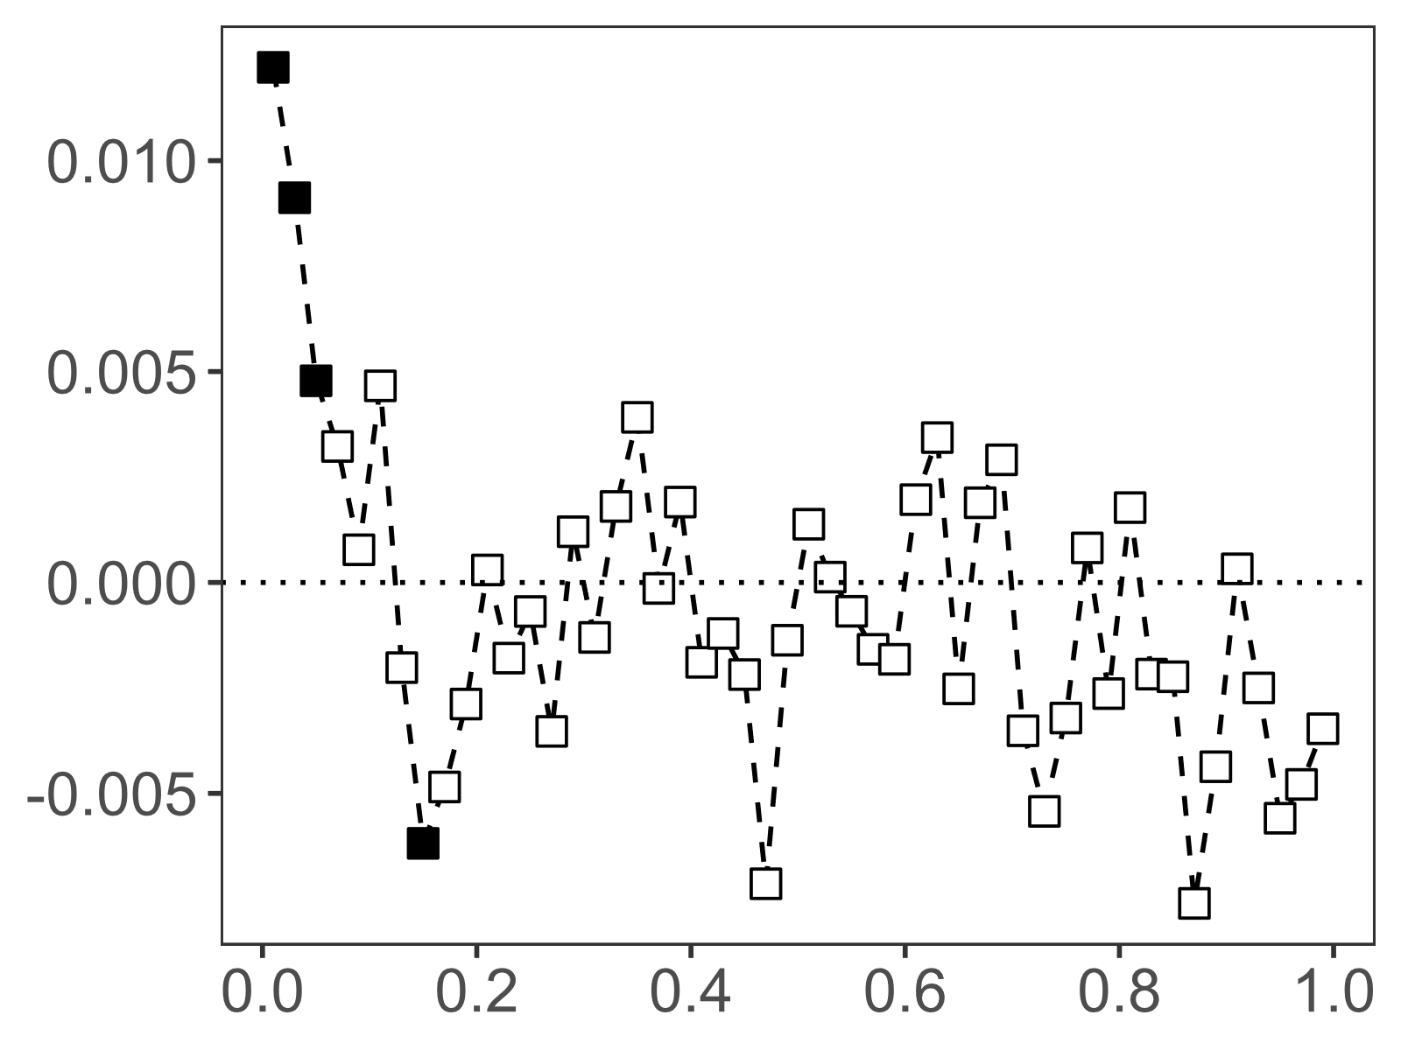
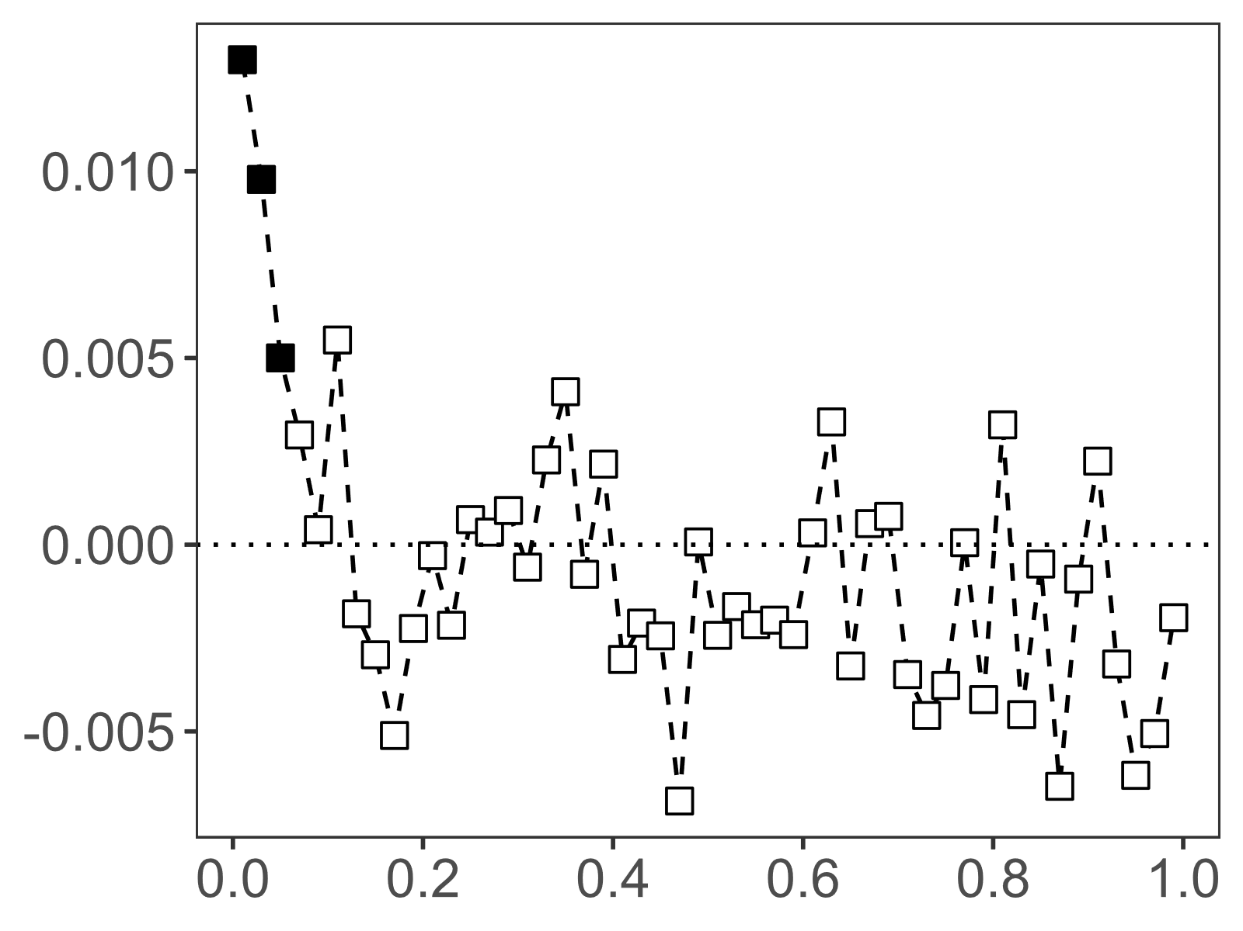
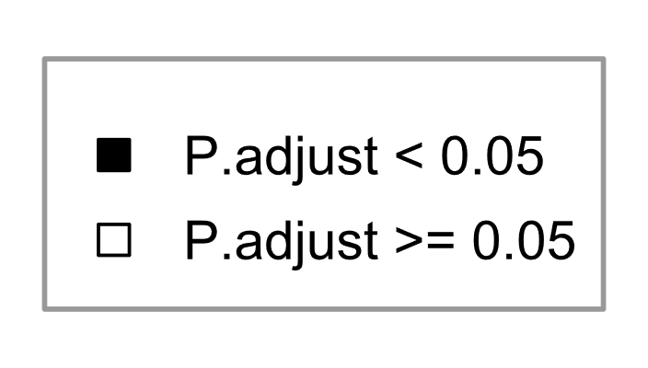
Nat 1
Nat 2
OF
LR
EB
All sites
>10
>20
>30
>40
>50
>70
Fig.S2: Phylogenetic mantel correlograms of phylogenetic distances for rhizosphere bacterial communities according to pH values for all sites and for each individual site. Solid symbols represent significant correlations, open symbols represent non significant correlations. Phylogenetic correlograms were performed for different levels of abundance threshold of minimum reads number for each ASV (from 10 to 70 reads per ASV). Positive significant correlations among short phylogenetic distances related to the phylogenetic signal in ASV environmental niche.

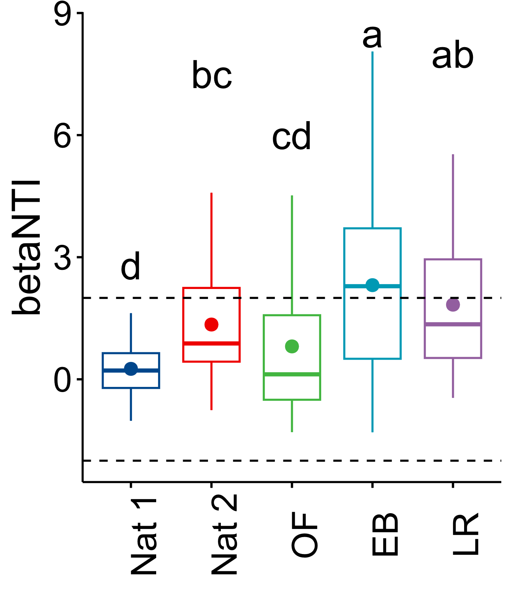
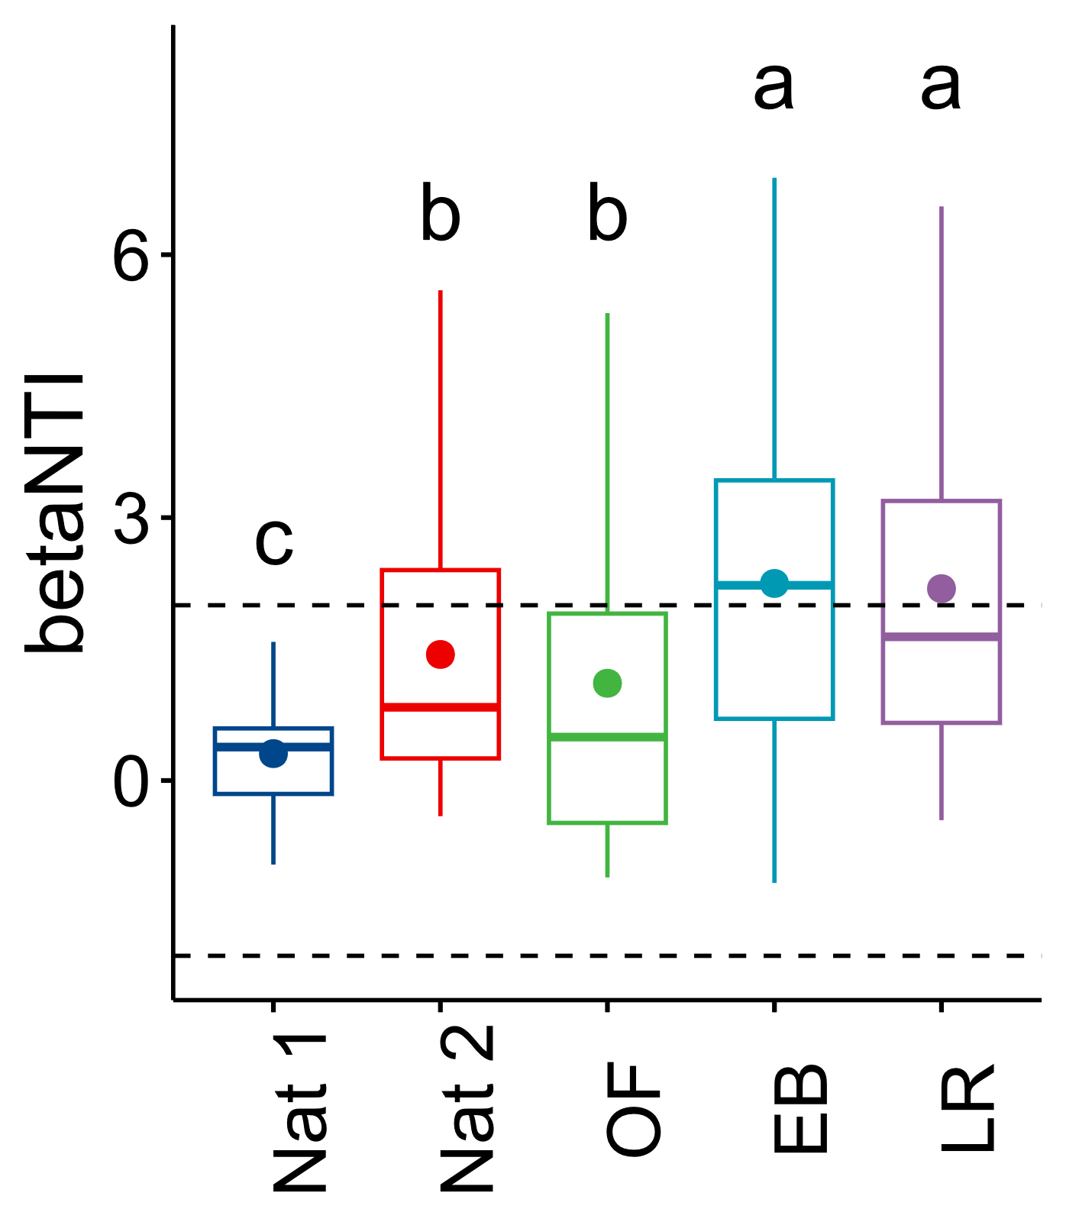
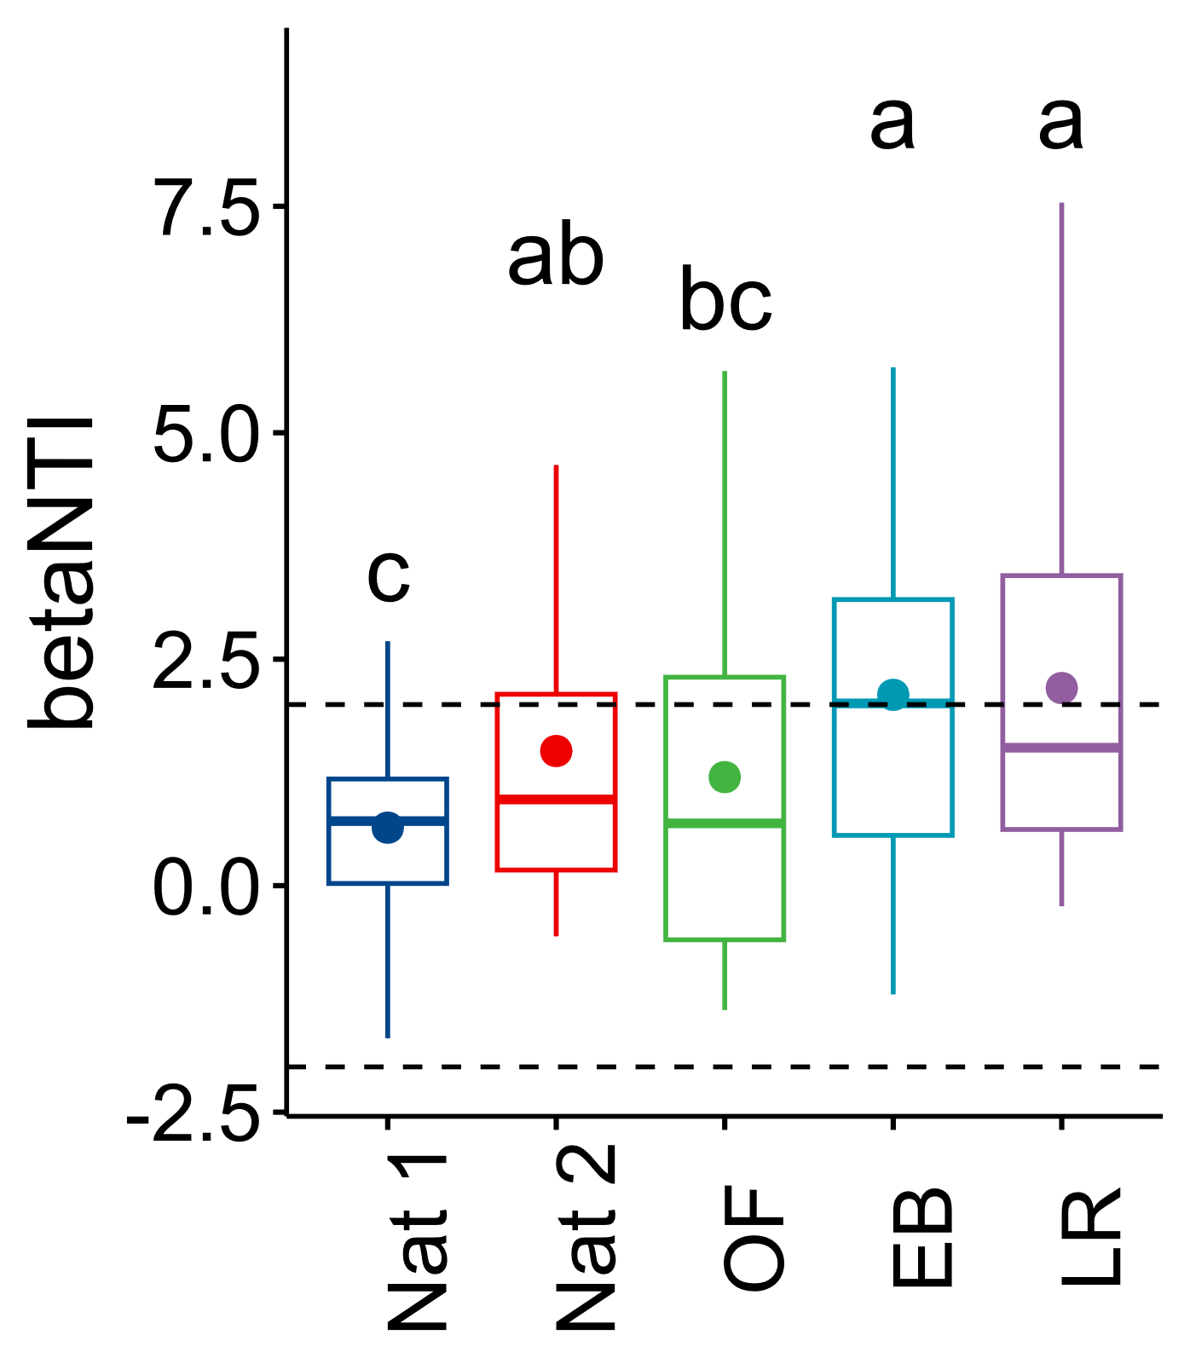
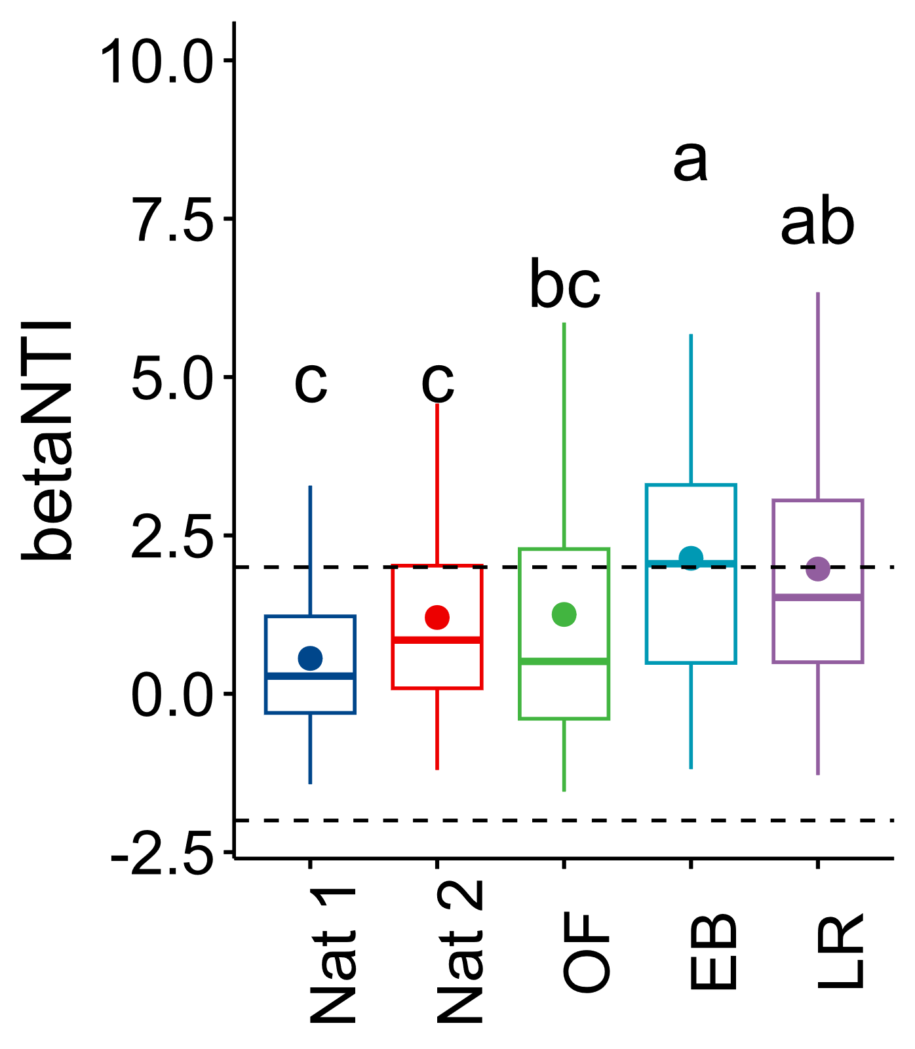
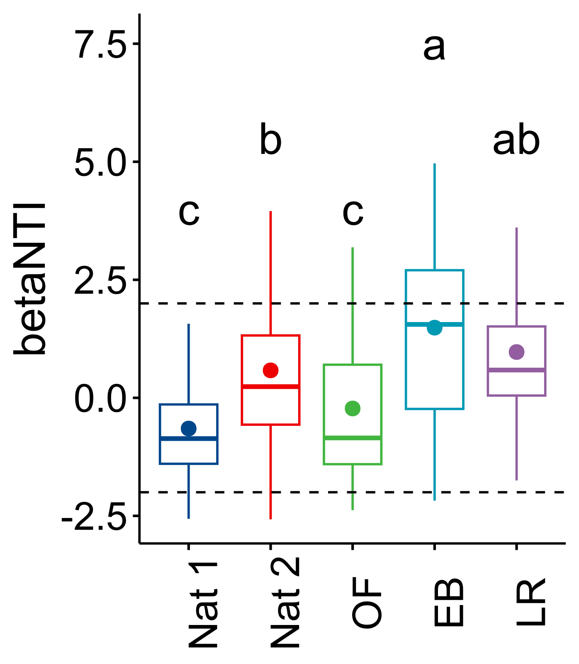
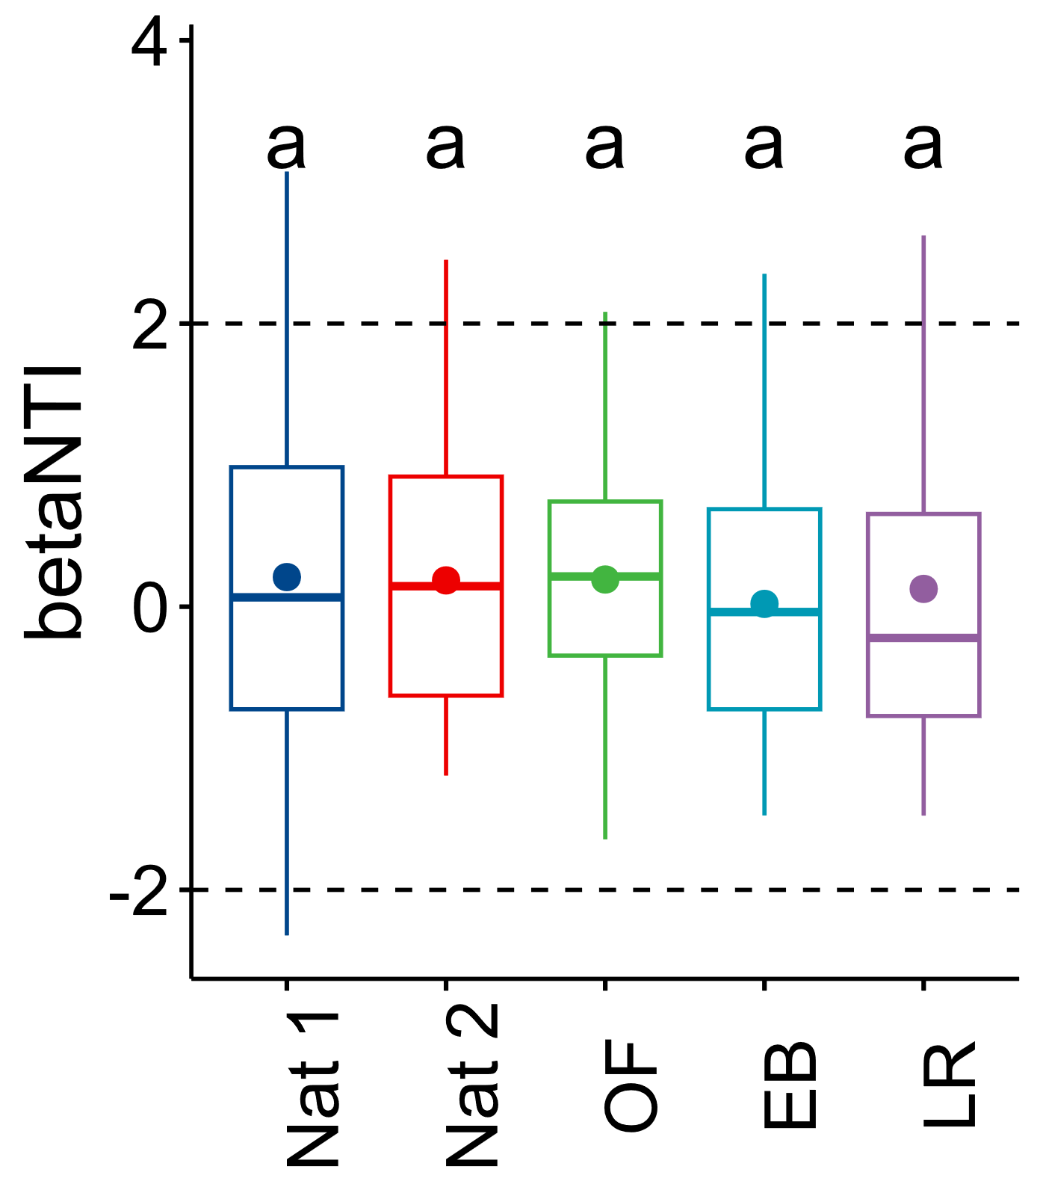
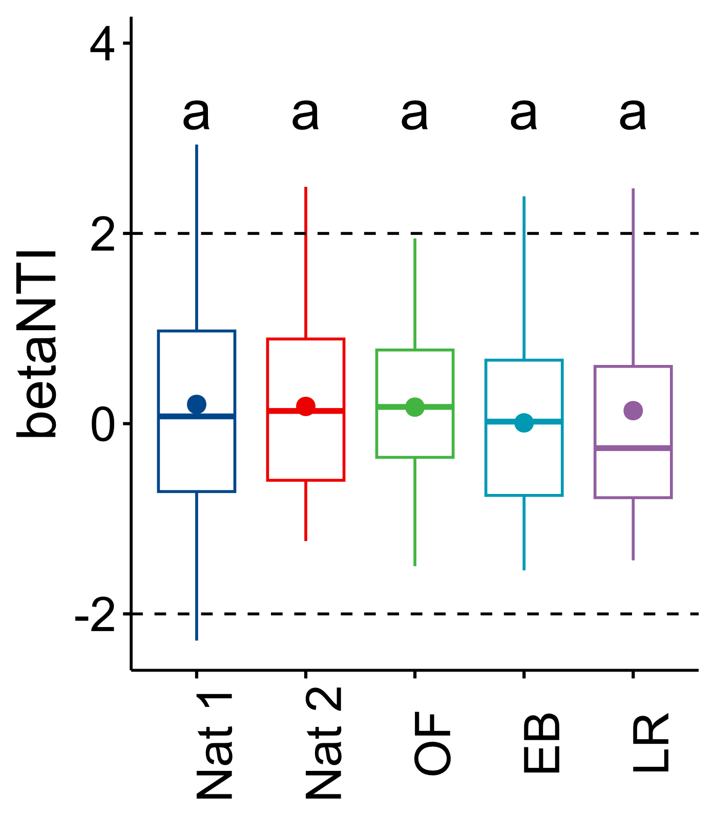
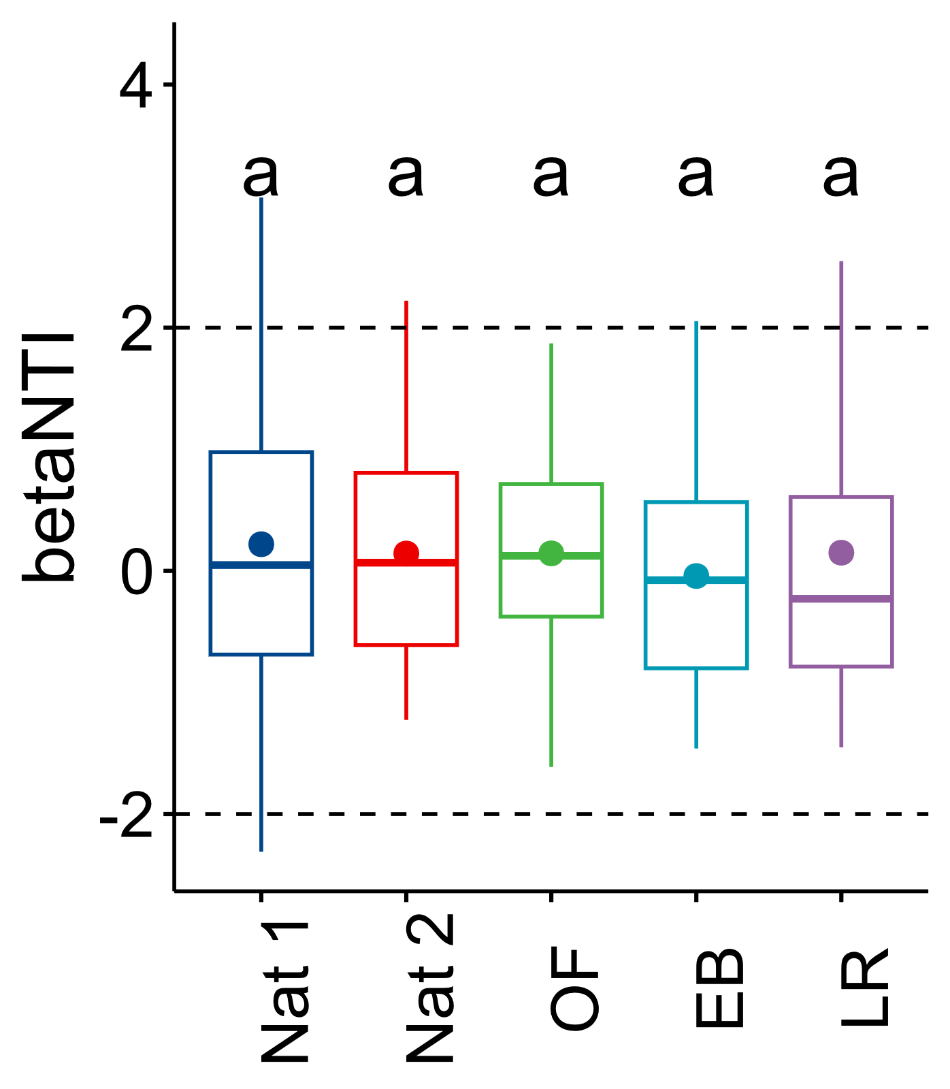
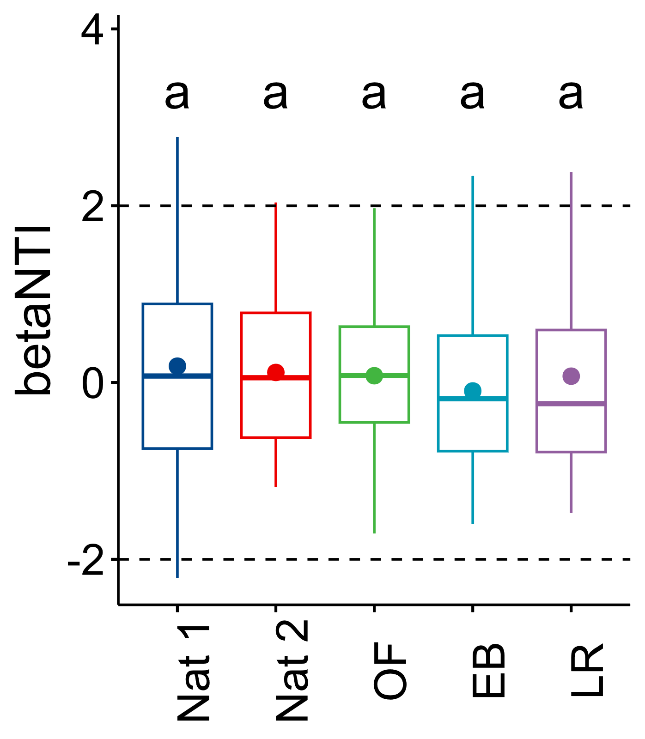
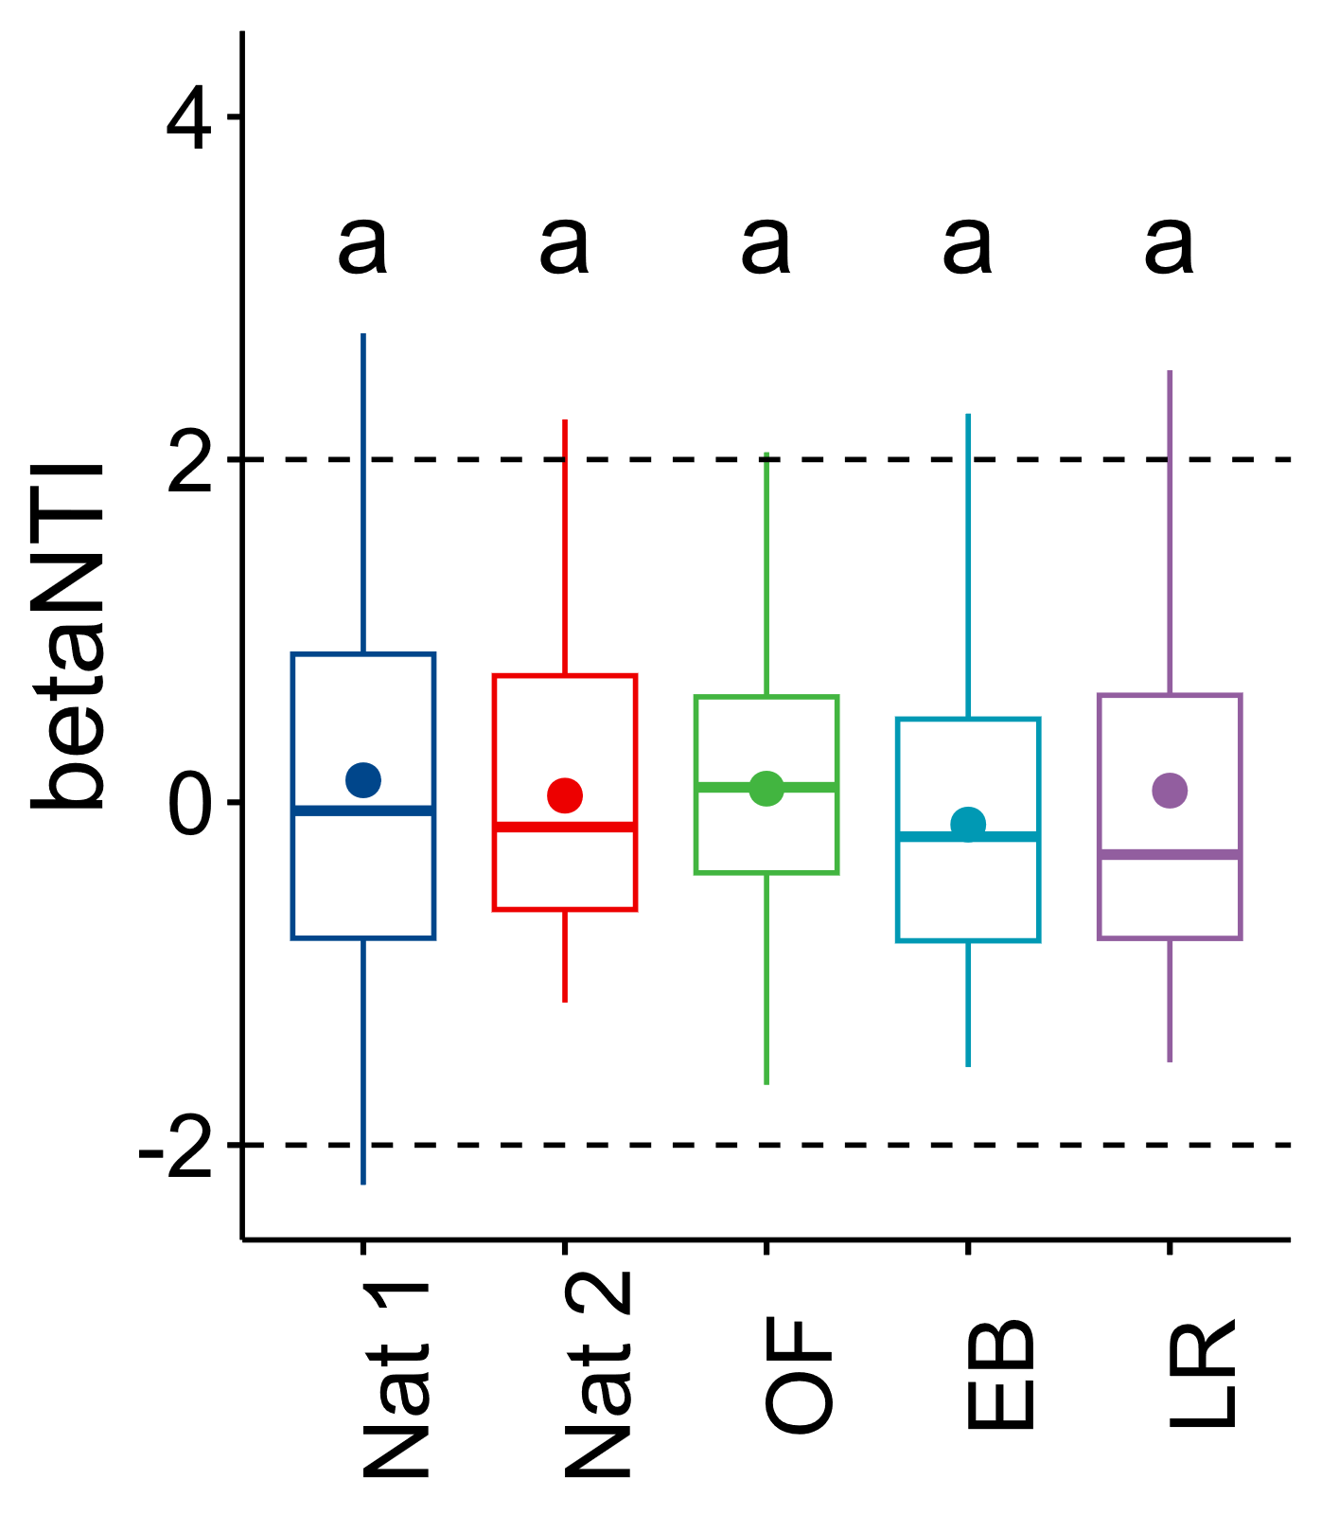
>10
>20
>30
>40
>50
Abundance threshold
Fig.S3: Changes of the Beta NTI values for both bacteria and fungi across sites (Natural environment = Nat 1, Nat 2; Evaporation basin = EB; Old farm = OF; Restored farm = LR) for different levels of abundance threshold. Significant differences performed with ANOVA followed by a TukeyHSD test are represented by different letters. Beta NTI values are represented either as all sites as one species pool (All sites), or as sites as specific species pool (By sites) for both bacteria and fungi.

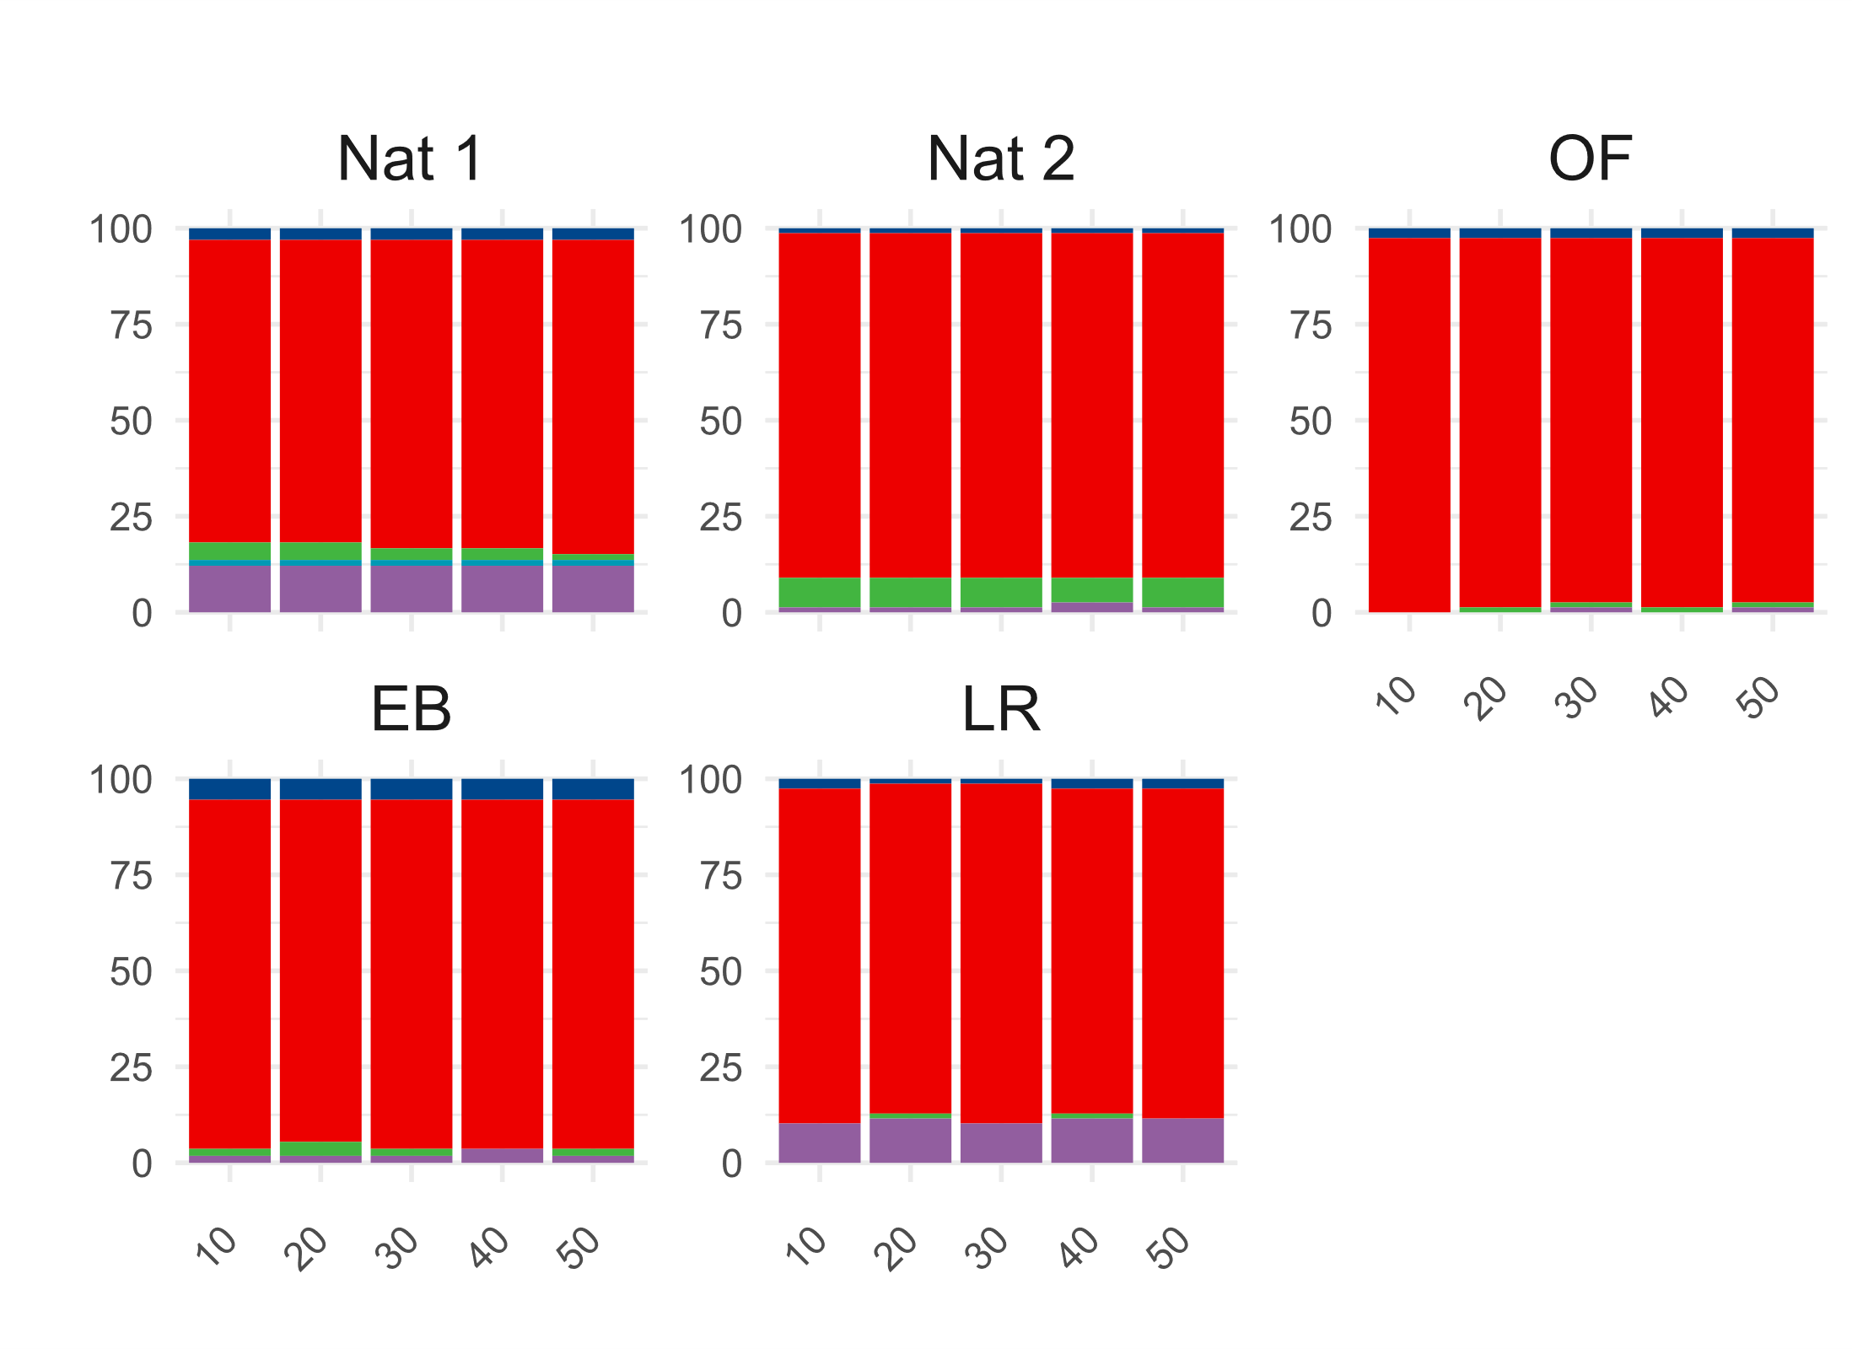
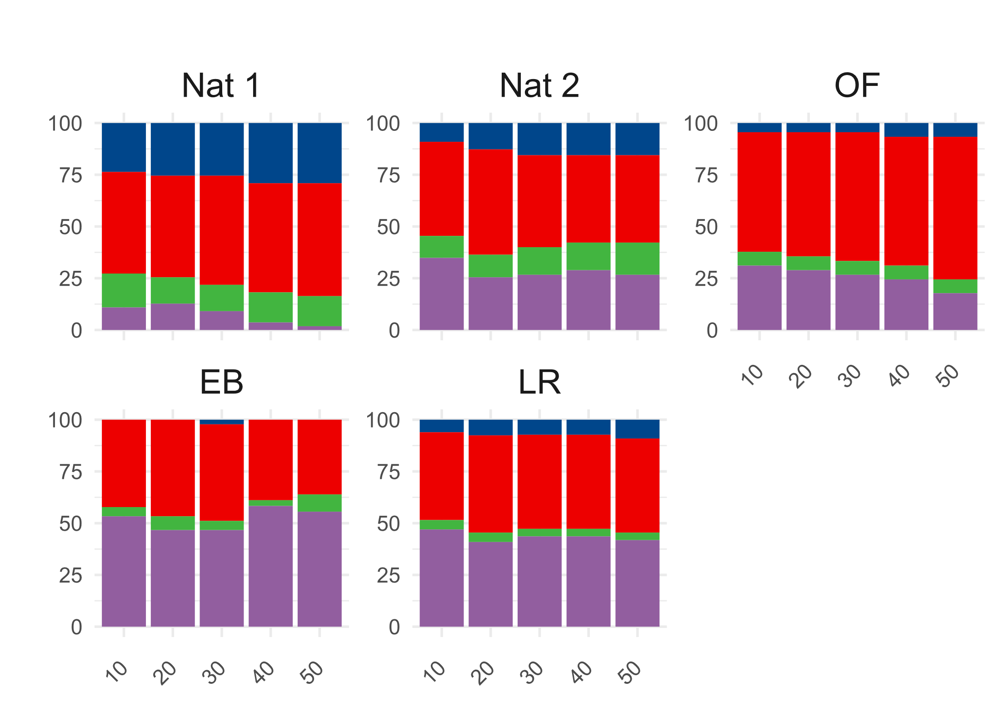
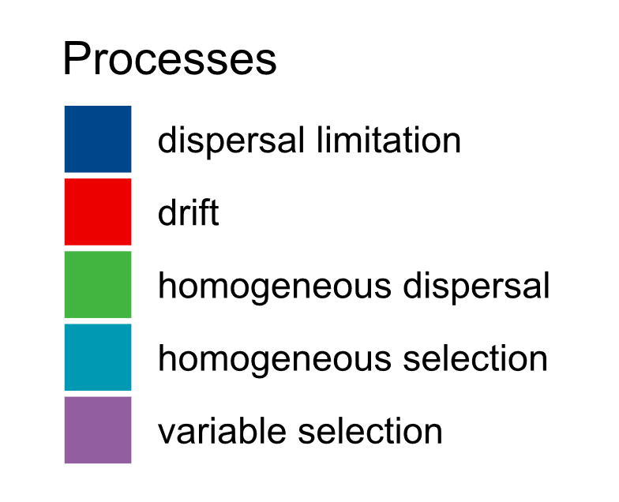
Fig.S4: Community assembly processes of bacteria and fungi across abundance threshold for each sites (Natural environment = Nat 1, Nat 2; Evaporation bassin = EB; Old farm = PF; Restored farm = LR). The proportion of each processes (dispersal limitation, drift, homogeneous dispersal, homogeneous selection and variable selection) are expressed as relative abundance summing to 100% for each combination of site and abundance threshold.
BACTERIA
FUNGI

