Supporting information for

Research on carbon black and Cerium co-doped Ti4O7-CB-Ce electrocatalytic oxidation of tetracycline-based antibiotics

Junxia Chen ª, Xinyi He ª, Chongtian Lei ª, Weigang Li ª, Zhenzhen Yang ª, Qing Zhou ^{a*}.

a State Key Laboratory of Pollution Control and Resource Reuse, School of Environment, Nanjing University, Nanjing210023, China.

State Key Laboratory of Pollution Control and Resource Reuse, School of Environment, Nanjing University, Nanjing210023, China.

*Corresponding author:
zhouqing@nju.edu.cn

Page S3 Figure S1
Page S4 Figure S2
Page S5 Figure S3
Page S6 Figure S4
Page S7 Figure S5
Page S8 Figure S6
Page S9 Table S1
Page S10 Table S2
Page S11 Table S3
Page S12 Table S4
Page S13 Table S5

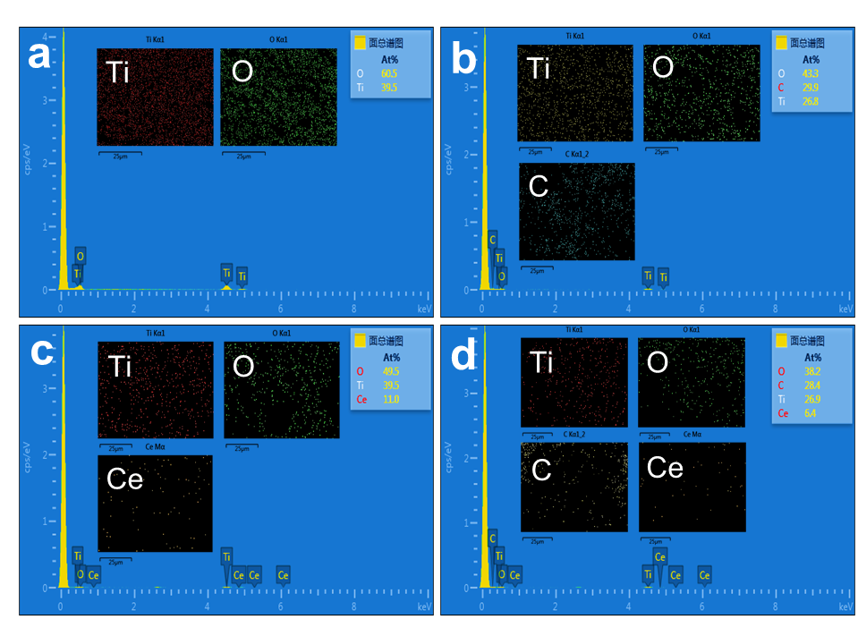
Figure S1 EDS elemental analysis of (a) Ti₄O₇, (b) Ti₄O₇-CB, (c) Ti₄O₇-Ce, (d) Ti₄O₇-CB-Ce.

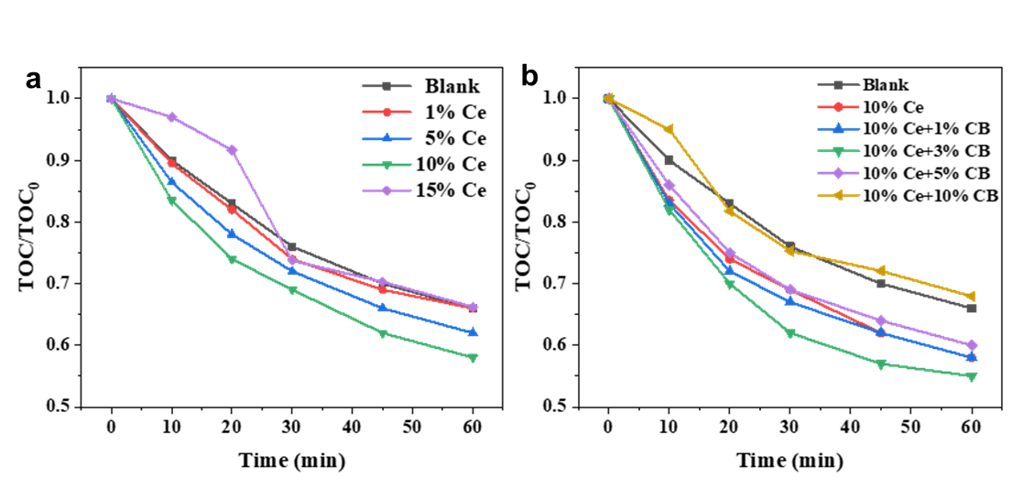
Figure S2 TOC removal of MNC degradation. (a) Ce doping, (b) Ce and CB co-doping.

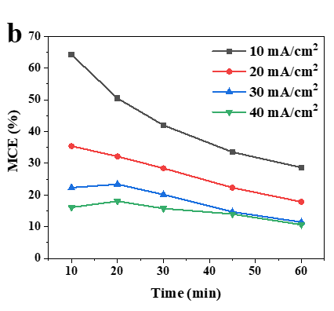
Figure S3 Mineralization current efficiency at different current densities.

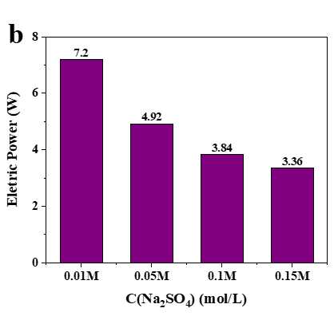
Figure S4. Electrical power at different electrolyte concentrations.

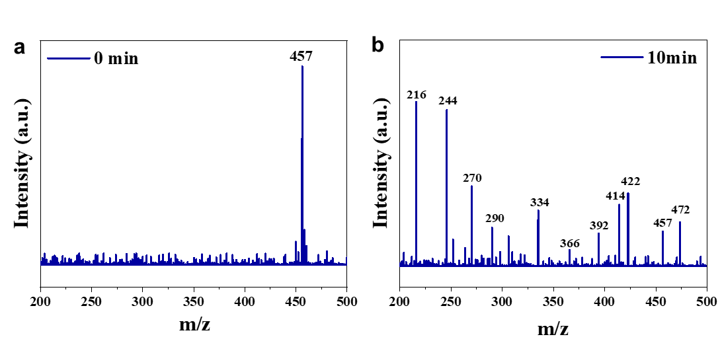
Figure S5. (a) raw MNC mass spectra; (b) MNC mass spectra at 10 min of reaction.

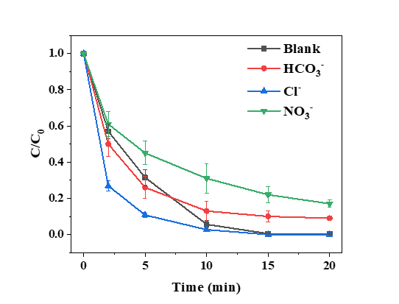
Figure S6. Degradation profile of MNC under the interference of inorganic anions (HCO₃⁻, Cl⁻ and NO₃⁻).

Table S1 Electrochemical characterization information for Ti4O7, Ti4O7-CB, Ti4O7-Ce and Ti4O7-CB-Ce, OEP: oxygen precipitation potential; AP: anodic potential; j0: current density; RΩ: internal resistance; Rct: charge transfer resistance
Anode | OEP  (V vs SHE) | AP at j₀ = 6 mA/cm² (V vs SHE) | R_{Ω}/Ω | R_{ct}/Ω
Ti/Ti₄O₇ | 1.76 | 2.42 | 9.65 | 1.76
Ti/Ti₄O₇-Ce | 1.90 | 2.37 | 9.55 | 2.04
Ti/Ti₄O₇-CB | 1.68 | 2.30 | 8.30 | 1.28
Ti/Ti₄O₇-CB-Ce | 2.10 | 2.15 | 7.25 | 1.05

Table S2 Kinetic parameters of the MNC degradation fitting curve
Doping condition | K（min⁻¹） | R²
None | 0.0711 | 0.8693
1% Ce | 0.1202 | 0.9567
5% Ce | 0.2867 | 0.9694
10% Ce | 0.3870 | 0.9896
15% Ce | 0.2414 | 0.9540
10% Ce+1% CB | 0.4236 | 0.9678
10% Ce+3% CB | 0.4623 | 0.9723
10% Ce+5% CB | 0.3633 | 0.9933
10% Ce+10% CB | 0.3005 | 0.9748

Table S3 EE/O and related parameters in the electrocatalytic oxidation of MNC by Ti/Ti₄O₇-CB-Ce at different current densities (at 50% MNC removal rate)
current densities  mA/cm² | Volt  V | Current  A | T  min | Volume  L | C₀/C | EE/O  KWh·m⁻³
10 | 8 | 0.08 | 5 | 0.15 | 2 | 1.181
20 | 13 | 0.16 | 3.75 | 0.15 | 2 | 2.879
30 | 16 | 0.24 | 3.3 | 0.15 | 2 | 4.677
40 | 25 | 0.32 | 2.5 | 0.15 | 2 | 7.382

Table S4 Endpoint pH of the reaction and its variation under different initial pH conditions
Initial pH | End pH | Difference
3 | 2.9 | 0.1
5 | 4.1 | 0.9
7 | 4.3 | 2.7
9 | 4.5 | 4.5
11 | 6.4 | 4.6

Table S5 Pharmaceutical wastewater quality indicators
quality indicators | unit
pH | - | 5.47
COD | mg/L | 5850
BOD₅ | mg/L | 1460
NH₃-N | mg/L | 56
TN | mg/L | 145
conductivity | mS/cm | 5.78

