Deciphering the Immunotoxicity of Titanium Dioxide Nanoparticles in Mouse Leukocytes through Single-Cell RNA Sequencing

Haribalan Perumalsamy^{1,2,3}, Xiao Xiao³, Hyoung-Yun Han⁴, Jung-Hwa Oh⁴, Seokjoo Yoon⁴, Min Beom Heo⁵, Tae Geol Lee⁵, Hyun-Yi Kim^{6,} Tae-Hyun Yoon^{2, 3, 7*}
¹Center for Creative Convergence Education, Hanyang University, Seoul 04763, Republic of Korea
²Research Institute for Convergence of Basic Science, Hanyang University, Seoul 04763, South Korea
³Department of Chemistry, College of Natural Sciences, Hanyang University, Seoul 04763, Republic of Korea
⁴Department of Predictive Toxicology, Korea Institute of Toxicology, Daejeon, Republic of Korea
⁵Nanosafety Metrology Center, Korea Research Institute of Standards and Science (KRISS), Daejeon, Republic of Korea
⁶NGeneS Inc.362, Gwangdeok 1-ro, Sangnok-gu, Ansan-si, Gyeonggi-do, Republic of Korea. 15495
⁷Department of Medical and Digital Engineering, Hanyang University, Seoul 04763, Republic of Korea

*Corresponding author
Prof. Tae Hyun Yoon
Professor
Department of Chemistry
Hanyang University
Korea
E-mail: taeyoon@hanyang.ac.kr

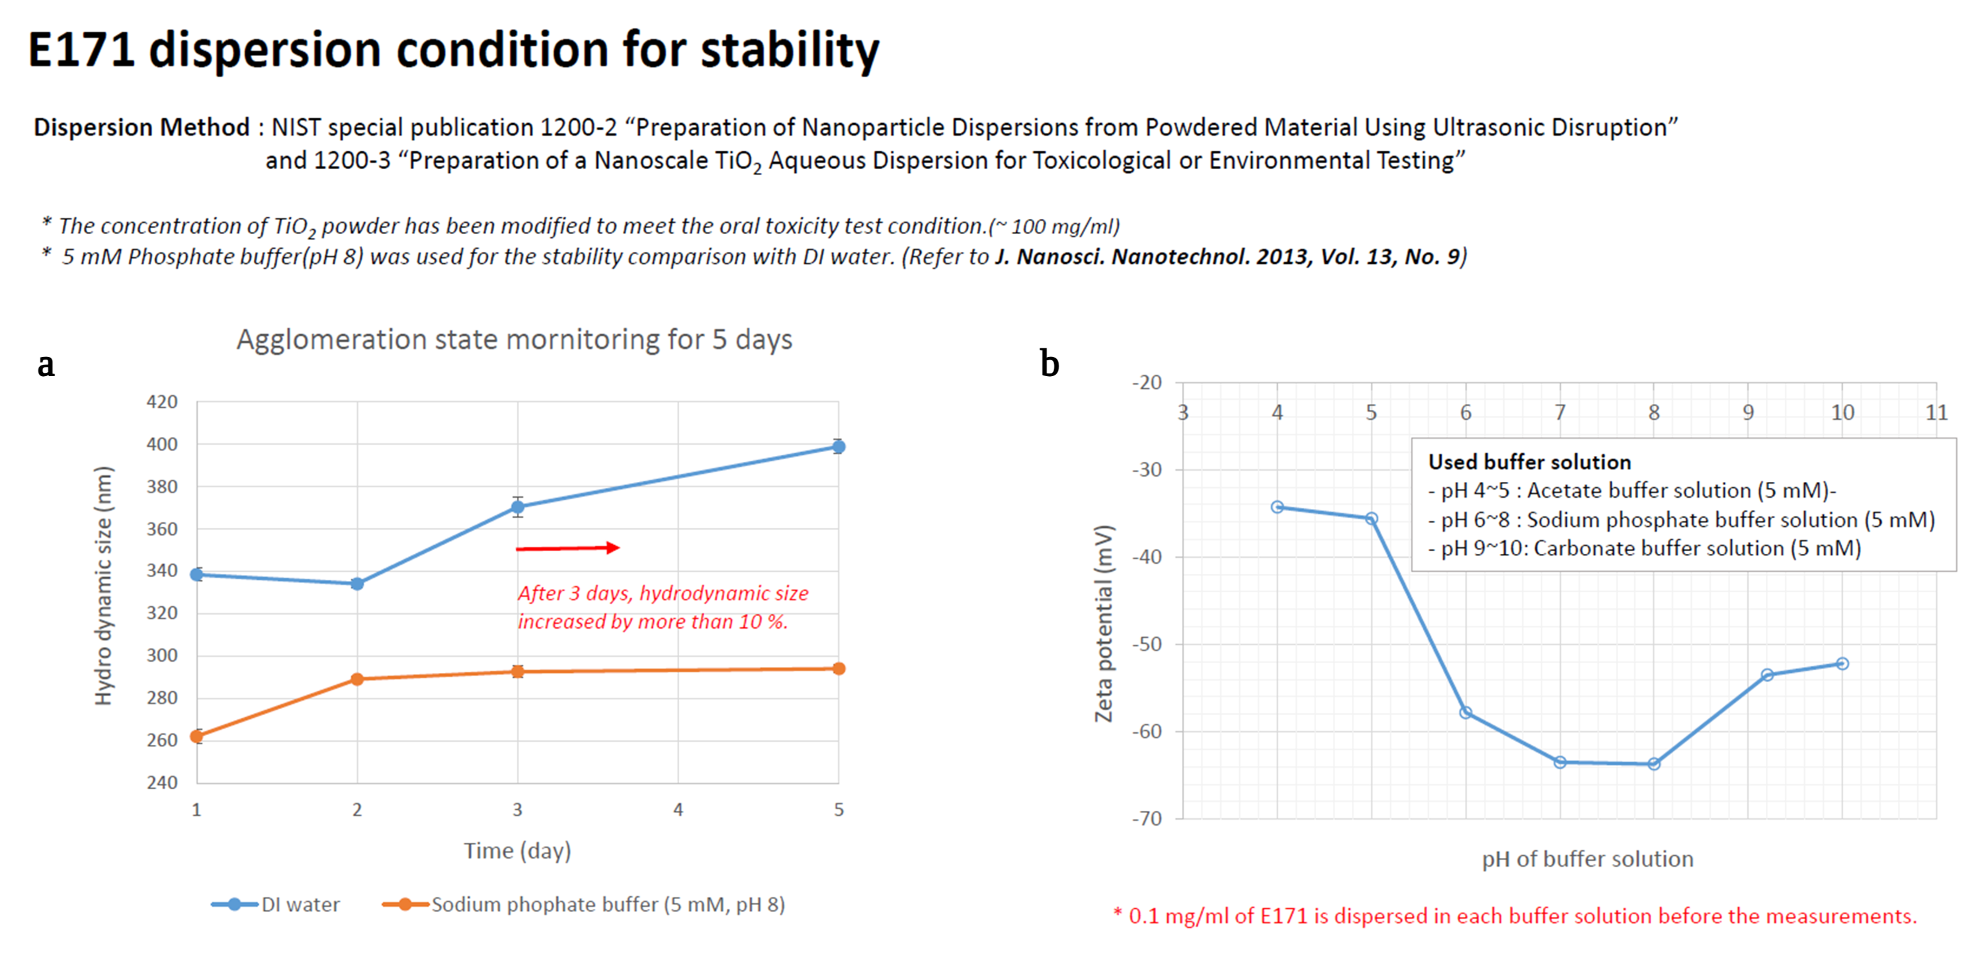
Figure S1. Physiochemical characteristics of TiO₂ E171. a. Hydrodynamic size measurement of TiO₂ E171in DI water and sodium phosphate buffer. b. Zeta potential (mV) measurement of TiO₂ E171 in different buffer solution.

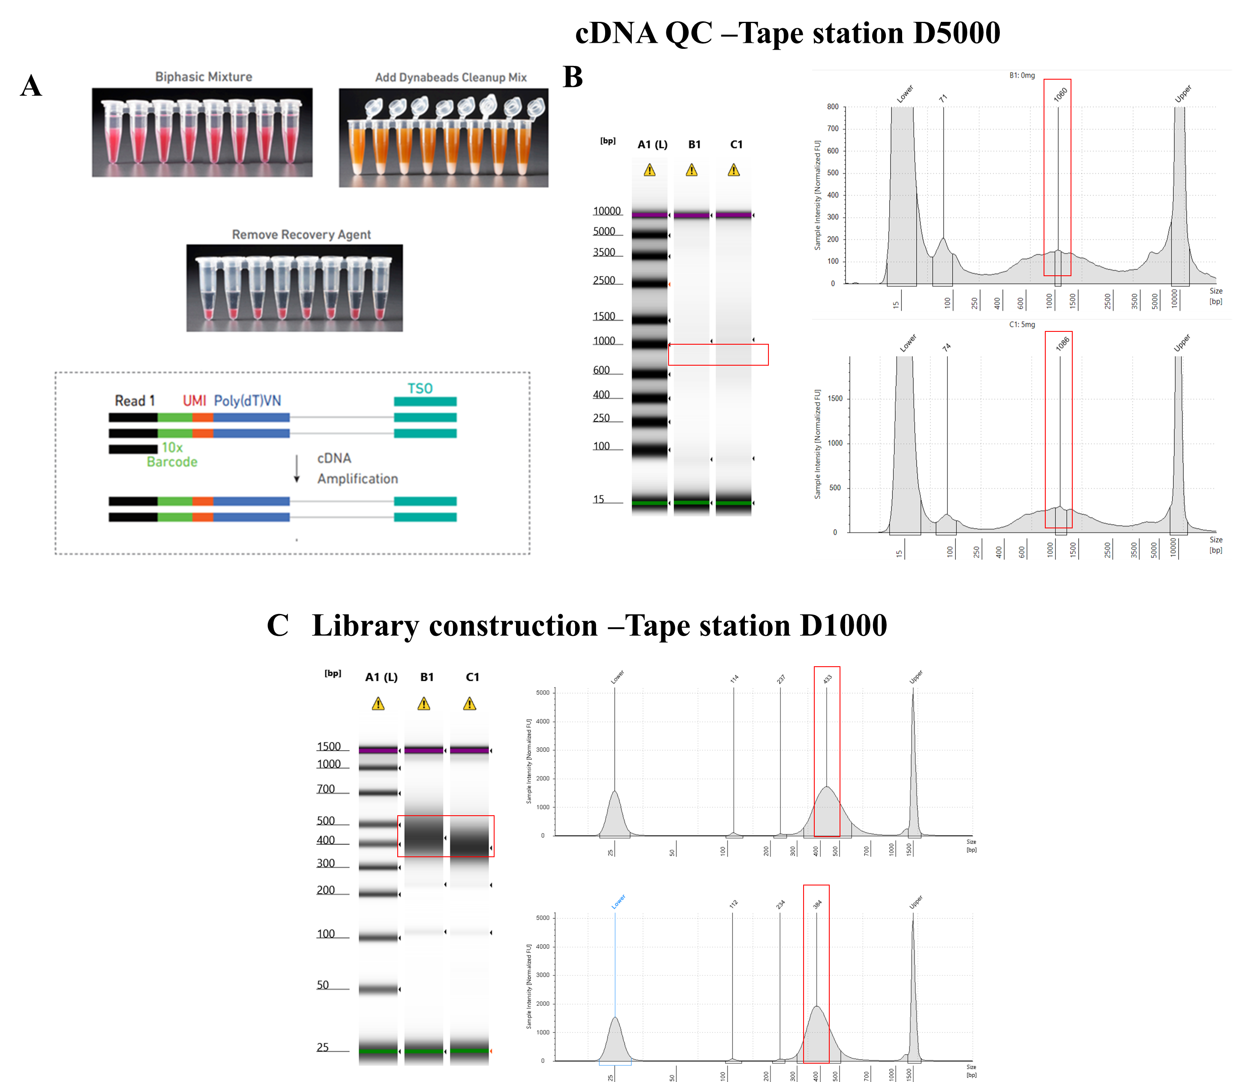

Figure S2. Quality control analysis was performed using a tape station equipped with D1000 and D5000 markers.

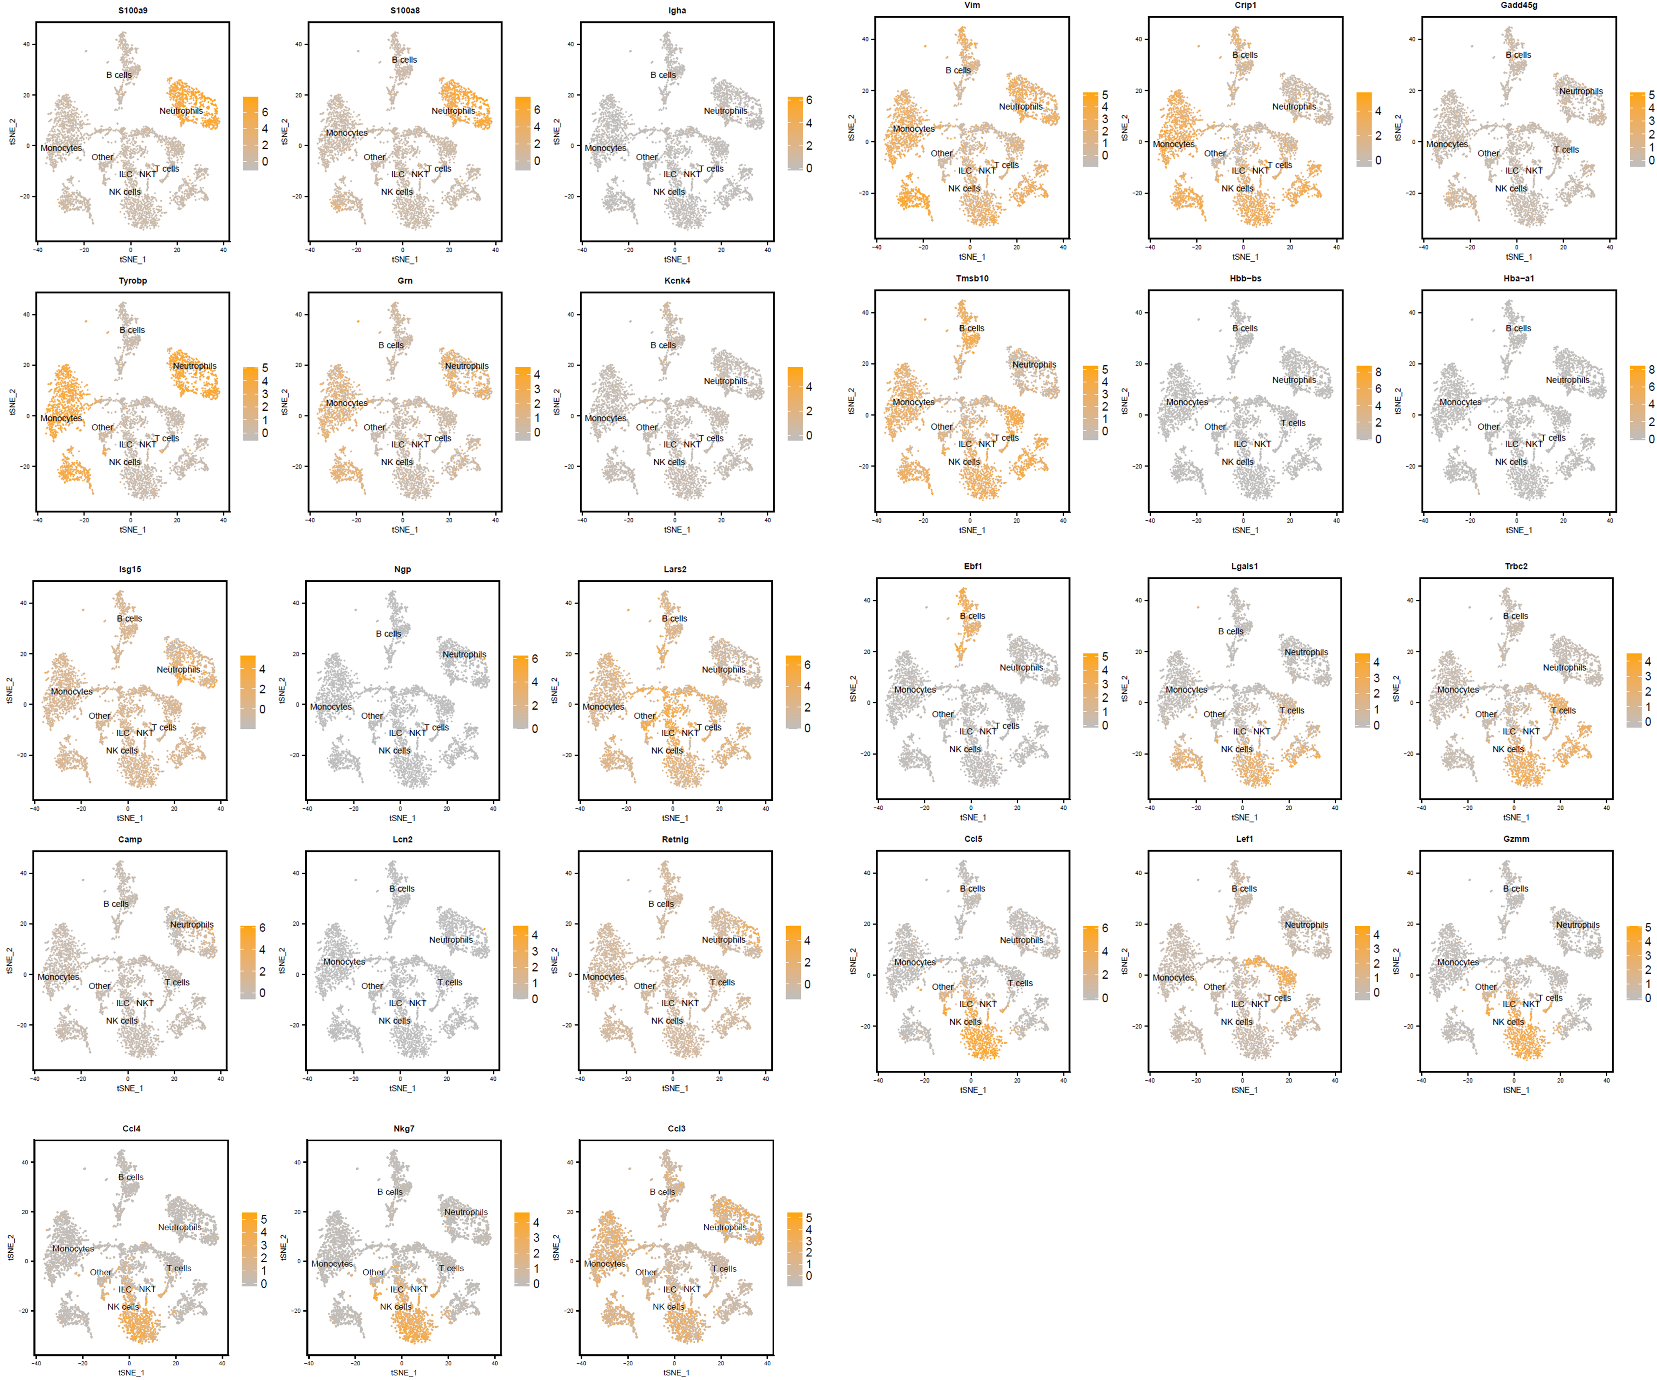

Figure S3. Identification of heterogeneous immune cell types based on the expression of reference marker genes

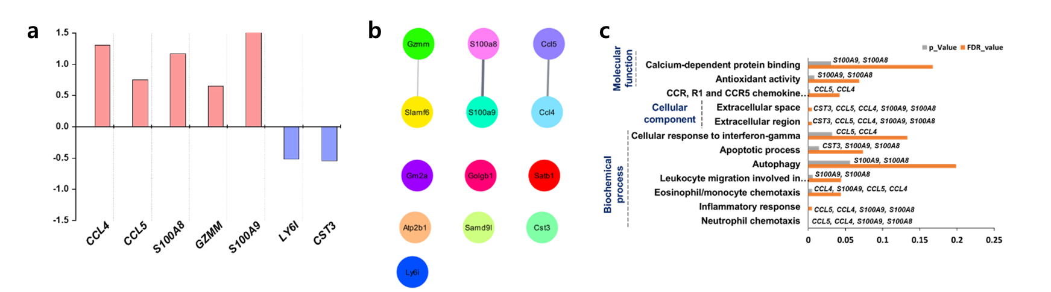
Figure S4. DEG expression of NKT cell subsets a-c. DEG, network, and gene ontology performance of the NKT_4

The subset NKT_4 showed a higher number of upregulated genes, such as CCL4, CCL5, S100A8, S100A9, and GZMM, than downregulated genes LY6I and CST3 (Figure S3d). The upregulation of genes from the NKT_4 subset indicates the release of pro-inflammatory cytokines that aid in the activation of cytotoxic killer T cells, such as NKT cells [64,65]. In contrast, the downregulation of LY61 and CST3 indicates the inhibition of CD8+T cell maturation [66], regardless of the activation of pro-inflammatory cytokines in NKT cells. The NKT_3 subset exhibited active involvement of chemokines (CCL4 and CCL5) and inflammatory proteins (S100A8 and S100A9) [67], which play important roles in the inflammatory response by sharing a common network functional annotation (Figure S3e), including neutrophil, eosinophil, and monocyte chemotaxis by inducing autophagy and apoptosis-mediated cell death (Figure S3f). These genes were also found to be involved in extracellular space and antioxidant activity. The CST3 gene was discovered in both cellular component and molecular functional enrichment analyses (Figure S3f; Table S8).

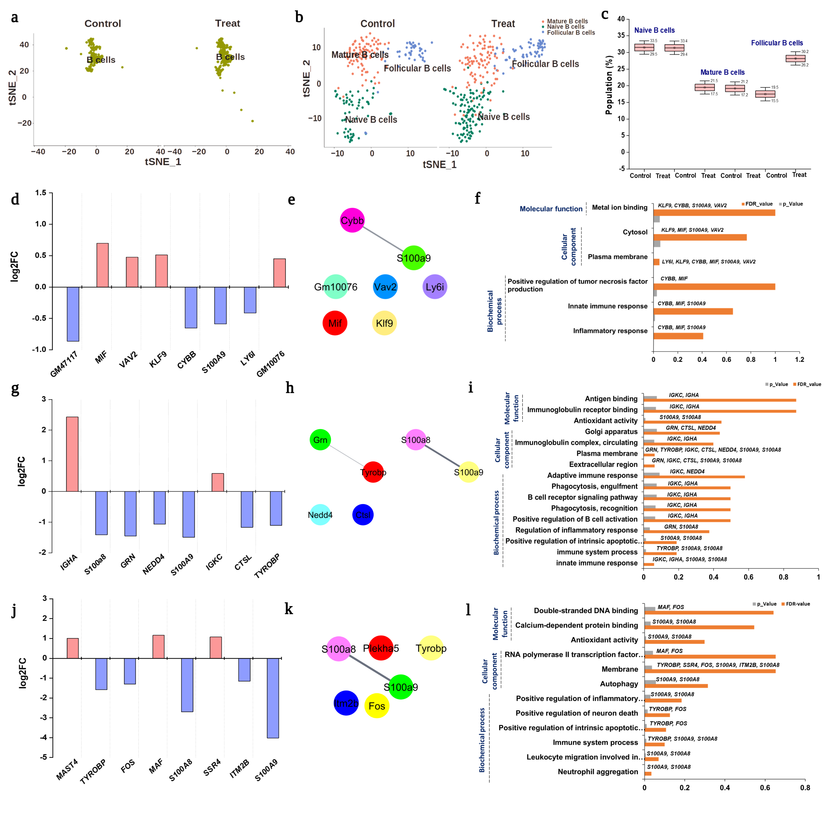
Figure S5. Profiling of B cells and their subsets. a. tSNE visualization of total B cells from treated and untreated groups; b. Subset identification from B cells by PhenoGraph clustering analysis; c. Population differences of each subset from B cells between treated and untreated groups; d, e, f. DEGs, network and gene ontology analysis from naïve B cells; g, h, i. DEGs with log2fold changes, network analysis and gene ontology of mature B cells were observed; j, k, l. log2fold changes with upregulated and downregulated genes, network analysis, and gene ontology enrichment analysis were observed for follicular B cells.

Interestingly, we identified three distinct B cell subsets: naïve, mature, and follicular (Figure 8b). Figure 8c depicts the comparison of population differences between each B cell subset and among the B cell subsets. Follicular B cells increased significantly in the treated group compared to the untreated group. Systemic exposure to antigens elicits B cell receptors to activate the humoral immune response, resulting in an increase in follicular B cells that encounter the antigen [51,80]. DEG analysis of each B cell subset was performed, and none showed a significant response. However, we identified a few genes that were actively involved in the network and gene ontology performance. Additionally, DEG analysis of mature B cells revealed that MIF, VAV2, KLF9, and GM10076 were upregulated, whereas other genes such as GM47117, CYBB, S100A9, and LY6I were downregulated (Figure 8d). Most of the genes from mature B cells showed innate immune response by secreting TNF-α to induce an inflammatory response in treated groups (Figure 8e and f; Table S16). Similarly, in naive B cells, IGHA and IGKC genes were upregulated, while other genes, such as S100A8, GRN, NEDD4, S100A9, CTSL, and TRYOEP were downregulated (Figure 7g). Network and gene ontology analyses revealed that most of these were involved in the activation of B cell-mediated immune responses via antigen recognition (Figure 7h and 7i; Table S17). Finally, although the follicular B cells showed an active increment in the B cell population, there was not much impact on the expression of DEGs, except for well-studied genes such as S100A8 and S100A9 which showed significant downregulation (Figure 7j). The activation of B cells mediated neutrophil aggregation and facilitated immune system activation (Figure 7k and 7l; Table S18). Overall, in contrast to other studies, our study demonstrated that the treated group showed minimal toxicity in B cells compared to other major immune cell types. However, it can also actively facilitate humoral-mediated immune responses by activating follicular B cells.

Table S1. Gene ontology enrichment analysis of granulocyte subset G1
Category | Term | Gene count | % | Genes | p-value | Fold enrichment | Bonferroni | FDR
Biochemical Process | GO:0071347~cellular response to interleukin-1 | 3 | 30 | FN1, CCL3, CAMP | 0.001 | 73.51 | 0.085 | 0.06
Biochemical Process | GO:0009615~response to virus | 3 | 30 | ISG15, IFITM7, IFIT3 | 0.001 | 60.89 | 0.121 | 0.06
Biochemical Process | GO:0051607~defense response to virus | 3 | 30 | ISG15, IFITM7, IFIT3 | 0.005 | 25.44 | 0.515 | 0.24
Biochemical Process | GO:0001775~cell activation | 2 | 20 | FN1, CCL3 | 0.007 | 267.92 | 0.642 | 0.25
Biochemical Process | GO:0046597~negative regulation of viral entry into host cell | 2 | 20 | FCNB, IFITM7 | 0.014 | 125.59 | 0.889 | 0.38
Biochemical Process | GO:0018149~peptide cross-linking | 2 | 20 | CSTA1, FN1 | 0.015 | 118.20 | 0.903 | 0.38
Biochemical Process | GO:0045071~negative regulation of viral genome replication | 2 | 20 | ISG15, IFITM7 | 0.022 | 80.38 | 0.968 | 0.46
Biochemical Process | GO:0032757~positive regulation of interleukin-8 production | 2 | 20 | FCNB, CAMP | 0.027 | 65.88 | 0.985 | 0.46
Biochemical Process | GO:0035458~cellular response to interferon-beta | 2 | 20 | IFITM7, IFIT3 | 0.027 | 65.88 | 0.985 | 0.46
Biochemical Process | GO:0045087~innate immune response | 3 | 30 | FCNB, IFIT3, CAMP | 0.038 | 8.49 | 0.997 | 0.58
Biochemical Process | GO:0007229~integrin-mediated signaling pathway | 2 | 20 | FN1, ISG15 | 0.047 | 37.56 | 0.999 | 0.65
Biochemical Process | GO:0071356~cellular response to tumor necrosis factor | 2 | 20 | CCL3, CAMP | 0.064 | 27.53 | 1.000 | 0.79
Biochemical Process | GO:0008360~regulation of cell shape | 2 | 20 | FN1, CCL3 | 0.068 | 25.76 | 1.000 | 0.79
Cellular component | GO:0005576~extracellular region | 5 | 50 | FCNB, FN1, CCL3, ISG15, CAMP | 0.005 | 5.70 | 0.171 | 0.12
Cellular component | GO:0005615~extracellular space | 5 | 50 | FCNB, CSTA1, FN1, CCL3, CAMP | 0.006 | 5.38 | 0.206 | 0.12
Cellular component | GO:0070062~extracellular exosome | 2 | 20 | AHNAK, FN1 | 0.045 | 39.59 | 0.806 | 0.53
Molecular function | GO:0043394~proteoglycan binding | 2 | 20 | FCNB, FN1 | 0.011 | 159.94 | 0.420 | 0.54
Molecular function | GO:0042802~identical protein binding | 4 | 40 | AHNAK, FN1, CCL3, IFIT3 | 0.043 | 4.24 | 0.884 | 0.81
Molecular function | GO:0005178~integrin binding | 2 | 20 | FN1, ISG15 | 0.064 | 27.00 | 0.961 | 0.81
Molecular function | GO:0002020~protease binding | 2 | 20 | CSTA1, FN1 | 0.066 | 25.99 | 0.965 | 0.81

Table S2. Gene ontology enrichment analysis of a granulocyte subset G2
Category | Term | Gene count | % | Genes | p-value | Fold enrichment | Bonferroni | FDR
Biochemical Process | GO:0018149~peptide cross-linking | 3 | 0.724638 | CSTA3, CSTDC6, CSTDC5 | 0.000 | 354.6 | 0.000 | 0.000
Biochemical Process | GO:0045861~negative regulation of proteolysis | 3 | 0.724638 | CSTA3, CSTDC6, CSTDC5 | 0.000 | 317.3 | 0.000 | 0.000
Biochemical Process | GO:0030216~keratinocyte differentiation | 3 | 0.724638 | CSTA3, CSTDC6, CSTDC5 | 0.000 | 165.2 | 0.001 | 0.000
Biochemical Process | GO:0010466~negative regulation of peptidase activity | 3 | 0.724638 | CSTA3, CSTDC6, CSTDC5 | 0.000 | 93.5 | 0.004 | 0.001
Biochemical Process | GO:0098609~cell-cell adhesion | 3 | 0.724638 | CSTA3, CSTDC6, CSTDC5 | 0.001 | 58.5 | 0.011 | 0.002
Cellular component | GO:1904090~peptidase inhibitor complex | 3 | 0.724638 | CSTA3, CSTDC6, CSTDC5 | 0.000 | 977 | 0.000 | 0.00
Cellular component | GO:0001533~cornified envelope | 3 | 0.724638 | CSTA3, CSTDC6, CSTDC5 | 0.000 | 195 | 0.001 | 0.00
Cellular component | GO:0005615~extracellular space | 4 | 0.966184 | CSTA3, RETNLG, STDC6, CSTDC5 | 0.003 | 9 | 0.038 | 0.01
Cellular component | GO:0005654~nucleoplasm | 4 | 0.966184 | CSTA3, IFITM7, CSTDC6, CSTDC5 | 0.015 | 5 | 0.180 | 0.04
Cellular component | GO:1904090~peptidase inhibitor complex | 3 | 0.724638 | CSTA3, CSTDC6, CSTDC5 | 0.000 | 977 | 0.000 | 0.00
Molecular function | GO:0004869~cysteine-type endopeptidase inhibitor activity | 3 | 0.724638 | CSTA3, CSTDC6, CSTDC5 | 0.000 | 292.4 | 0.000 | 0.00
Molecular function | GO:0002020~protease binding | 3 | 0.724638 | CSTA3, CSTDC6, CSTDC5 | 0.000 | 87.7 | 0.001 | 0.00

Table S3. Gene ontology enrichment analysis of the NK_1 subset
Category | Term | Gene count | % | Genes | p-value | Fold enrichment | Bonferroni | FDR
Biochemical Process | GO:0002376~immune system process | 4 | 33.33333 | TYROBP, FCER1G, CD3G, S100A9 | 0.003 | 12.7 | 0.430 | 0.43
Biochemical Process | GO:0002283~neutrophil activation involved in immune response | 2 | 16.66667 | TYROBP, FCER1G | 0.004 | 478.4 | 0.575 | 0.43
Biochemical Process | GO:0006915~apoptotic process | 3 | 25 | LGALS1, PRF1, S100A9 | 0.048 | 7.7 | 1.000 | 1.00
Biochemical Process | GO:0050729~positive regulation of inflammatory response | 2 | 16.66667 | LGALS1, S100A9 | 0.053 | 33.8 | 1.000 | 1.00
Biochemical Process | GO:0007229~integrin-mediated signaling pathway | 2 | 16.66667 | TYROBP, FCER1G | 0.057 | 31.3 | 1.000 | 1.00
Biochemical Process | GO:0032755~positive regulation of interleukin-6 production | 2 | 16.66667 | TYROBP, FCER1G | 0.059 | 30.2 | 1.000 | 1.00
Biochemical Process | GO:0032760~positive regulation of tumor necrosis factor production | 2 | 16.66667 | TYROBP, FCER1G | 0.063 | 28.4 | 1.000 | 1.00
Cellular component | GO:0009986~cell surface | 4 | 33.33333 | TYROBP, LGALS1, FCER1G, SELL | 0.006 | 977 | 0.211 | 0.24
Cellular component | GO:0005886~plasma membrane | 8 | 66.66667 | TYROBP, FCER1G, SELL, BASP1, PRF1, KCNE1L, CD3G, S100A9 | 0.015 | 195 | 0.439 | 0.29
Cellular component | GO:0016020~membrane | 8 | 66.66667 | TYROBP, FCER1G, SELL, BASP1, PRF1, KCNE1L, CD3G, S100A9 | 0.030 | 9 | 0.680 | 0.37
Cellular component | GO:0009897~external side of plasma membrane | 3 | 25 | FCER1G, SELL, CD3G | 0.048 | 5 | 0.839 | 0.44
Cellular component | GO:0005576~extracellular region | 4 | 33.33333 | LGALS1, GZMA, PRF1, S100A9 | 0.065 | 977 | 0.918 | 0.48
Molecular function | GO:0042802~identical protein binding | 5 | 41.66667 | TYROBP, LGALS1, FCER1G, PRF1, CD3G | 0.015 | 4.3 | 0.430 | 0.56
Molecular function | GO:0005509~calcium ion binding | 3 | 25 | SELL, PRF1, S100A9 | 0.056 | 7.0 | 0.879 | 0.58
Molecular function | GO:0042803~protein homodimerization activity | 3 | 25 | TYROBP, FCER1G, GZMA | 0.067 | 6.3 | 0.923 | 0.58
Molecular function | GO:0044325~ion channel binding | 2 | 16.66667 | ID2, KCNE1L | 0.078 | 22.5 | 0.950 | 0.58

Table S4. Gene ontology enrichment analysis of the NK_2 subset
Category | Term | Gene count | % | Genes | p-value | Fold enrichment | Bonferroni | FDR
Biochemical Process | GO:0098869~cellular oxidant detoxification | 3 | 27.3 | HBB-BT, HBA-A1, HBB-BS | 0.000 | 274.0 | 0.013 | 0.013
Biochemical Process | GO:0042744~hydrogen peroxide catabolic process | 3 | 27.3 | HBB-BT, HBA-A1, HBB-BS | 0.000 | 189.0 | 0.027 | 0.014
Biochemical Process | GO:0001782~B cell homeostasis | 2 | 18.2 | MEF2C, BCL2 | 0.017 | 107.5 | 0.994 | 0.859
Biochemical Process | GO:0030890~positive regulation of B cell proliferation | 2 | 18.2 | MEF2C, BCL2 | 0.023 | 77.7 | 0.999 | 0.927
Biochemical Process | GO:0030217~T cell differentiation | 2 | 18.2 | BCL11A, BCL2 | 0.026 | 70.3 | 1.000 | 0.927
Biochemical Process | GO:0042542~response to hydrogen peroxide | 2 | 18.2 | BCL2, HBA-A1 | 0.031 | 58.0 | 1.000 | 0.927
Biochemical Process | GO:0042100~B cell proliferation | 2 | 18.2 | MEF2C, BCL2 | 0.036 | 49.4 | 1.000 | 0.927
Biochemical Process | GO:0030183~B cell differentiation | 2 | 18.2 | BCL11A, BCL2 | 0.051 | 35.1 | 1.000 | 1.000
Biochemical Process | GO:0043524~negative regulation of neuron apoptotic process | 2 | 18.2 | MEF2C, BCL2 | 0.090 | 19.3 | 1.000 | 1.000
Cellular component | GO:0005833~hemoglobin complex | 3 | 27.3 | HBB-BT, HBA-A1, HBB-BS | 0.000 | 444.3 | 0.001 | 0.000
Cellular component | GO:0031838~haptoglobin-hemoglobin complex | 3 | 27.3 | HBB-BT, HBA-A1, HBB-BS | 0.000 | 412.6 | 0.001 | 0.000
Cellular component | GO:0005654~nucleoplasm | 5 | 45.5 | MEF2C, BCL11A, BHLHE40, EBF1, BCL2 | 0.065 | 2.8 | 0.940 | 0.905
Cellular component | GO:0043209~myelin sheath | 2 | 18.2 | FCER1G, SELL, CD3G | 0.087 | 20.1 | 0.978 | 0.914
Molecular function | GO:0005344~oxygen transporter activity | 3 | 27.3 | HBB-BT, HBA-A1, HBB-BS | 0.000 | 319.0 | 0.002 | 0.001
Molecular function | GO:0046982~protein heterodimerization activity | 4 | 36.4 | MEF2C, BCL11A, BHLHE40, BCL2 | 0.001 | 17.7 | 0.049 | 0.010
Molecular function | GO:0020037~heme binding | 3 | 27.3 | HBB-BT, HBA-A1, HBB-BS | 0.004 | 27.1 | 0.207 | 0.025
Molecular function | GO:0044877~macromolecular complex binding | 4 | 36.4 | BCL2, HBB-BT, HBA-A1, HBB-BS | 0.005 | 10.1 | 0.224 | 0.025
Molecular function | GO:0030492~hemoglobin binding | 2 | 18.2 | HBB-BT, HBB-BS | 0.005 | 340.2 | 0.251 | 0.025
Molecular function | GO:0004601~peroxidase activity | 2 | 18.2 | HBB-BT, HBA-A1 | 0.021 | 85.1 | 0.685 | 0.076
Molecular function | GO:0005515~protein binding | 7 | 63.6 | MEF2C, BCL11A, BHLHE40, EBF1, BCL2, RRBP1, SRGAP3 | 0.037 | 2.2 | 0.872 | 0.123
Molecular function | GO:0003700~transcription factor activity, sequence-specific DNA binding | 3 | 27.3 | MEF2C, BCL11A, EBF1 | 0.043 | 8.1 | 0.905 | 0.131

Table S5. Gene ontology enrichment analysis of the NK_3 subset
Category | Term | Gene count | % | Genes | p-value | Fold enrichment | Bonferroni | FDR
Biochemical Process | GO:0006955~immune response | 5 | 45.5 | LGALS1, PRF1, CD3G, TRDC, VIM | 0.016 | 4.25 | 1.0 | 1
Biochemical Process | GO:0045321~leukocyte activation | 4 | 36.4 | LGALS1, PRF1, CD3G, TRDC | 0.020 | 5.89 | 1.0 | 1
Biochemical Process | GO:0002250~adaptive immune response | 3 | 27.3 | PRF1, CD3G, TRDC | 0.054 | 7.07 | 1.0 | 1
Biochemical Process | GO:0009605~response to external stimulus | 5 | 45.5 | LGALS1, TRAC, PRF1, TRDC, VIM | 0.057 | 2.91 | 1.0 | 1
Biochemical Process | GO:0002376~immune system process | 5 | 45.5 | LGALS1, PRF1, CD3G, TRDC, VIM | 0.066 | 2.77 | 1.0 | 1
Biochemical Process | GO:0006952~defense response | 4 | 36.4 | LGALS1, PRF1, TRDC, VIM | 0.069 | 3.66 | 1.0 | 1
Biochemical Process | GO:0071333~cellular response to glucose stimulus | 2 | 18.2 | LGALS1, CACNA1D | 0.083 | 21.00 | 1.0 | 1
Cellular component | GO:0009986~cell surface | 4 | 36.4 | LGALS1, CACNA1D, CD3G, TRDC | 0.016 | 6.34 | 0.9 | 1
Cellular component | GO:0016363~nuclear matrix | 2 | 18.2 | BASP1, VIM | 0.054 | 32.33 | 1.0 | 1
Cellular component | GO:0005615~extracellular space | 4 | 36.4 | LGALS1, PRF1, CTSW, TRDC | 0.056 | 3.92 | 1.0 | 1
Cellular component | GO:0032991~macromolecular complex | 6 | 54.5 | LGALS1, BASP1, CACNA1D, CD3G, TRDC, VIM | 0.097 | 2.01 | 1.0 | 1
Molecular function | GO:0019904~protein domain specific binding | 3 | 27.3 | BASP1, CACNA1D, VIM | 0.048 | 7.34 | 1.0 | 1
Molecular function | GO:0042802~identical protein binding | 4 | 36.4 | LGALS1, PRF1, CD3G, VIM | 0.074 | 3.42 | 1.0 | 1

Table S6. Gene ontology enrichment analysis of NKT_1 subset
Category | Term | Gene Count | % | Genes | p-value | Fold Enrichment | Bonferroni | FDR
Biochemical Process | GO:0071404~cellular response to low-density lipoprotein particle stimulus | 2 | 28.6 | ITGB1, FCER1G | 0.007 | 249.6 | 0.646 | 1
Biochemical Process | GO:0031623~receptor internalization | 2 | 28.6 | ITGB1, FCER1G | 0.014 | 119.6 | 0.885 | 1
Biochemical Process | GO:0007229~integrin-mediated signaling pathway | 2 | 28.6 | ITGB1, FCER1G | 0.032 | 53.7 | 0.992 | 1
Biochemical Process | GO:0006911~phagocytosis, engulfment | 2 | 28.6 | FCER1G, TRDC | 0.064 | 25.9 | 1.000 | 1
Cellular component | GO:0009897~external side of plasma membrane | 4 | 57.1 | ITGB1, EPHA5, FCER1G, TRDC | 0.000 | 0.019 | 0.9 | 0.02
Cellular component | GO:0001669~acrosomal vesicle | 2 | 28.6 | ITGB1, SPINK2 | 0.036 | 0.883 | 1.0 | 0.71
Cellular component | GO:0005912~adherens junction | 2 | 28.6 | ITGB1, EPHA5 | 0.037 | 0.888 | 1.0 | 0.71
Cellular component | GO:0043235~receptor complex | 2 | 28.6 | ITGB1, EPHA5 | 0.053 | 0.957 | 1.0 | 0.76
Cellular component | GO:0045121~membrane raft | 2 | 28.6 | ITGB1, FCER1G | 0.074 | 0.989 |  | 0.86

Table S7. Gene ontology enrichment analysis of the NKT_2 subset
Category | Term | Gene count | % | Genes | p-value | Fold enrichment | Bonferroni | FDR
Biochemical Process | GO:0002376~immune system process | 4 | 40 | CD74, TYROBP, H2-AA, S100A9 | 0.001 | 15.3 | 0.224 | 0.25
Biochemical Process | GO:0034341~response to interferon-gamma | 2 | 20 | CD74, H2-AA | 0.014 | 125.6 | 0.935 | 0.62
Biochemical Process | GO:0019882~antigen processing and presentation via MHC class II | 2 | 20 | CD74, H2-AA | 0.019 | 93.5 | 0.974 | 0.62
Biochemical Process | GO:0045582~positive regulation of T cell differentiation | 2 | 20 | CD74, H2-AA | 0.020 | 91.3 | 0.976 | 0.62
Biochemical Process | GO:0006915~apoptotic process | 3 | 30 | CST3, PRF1, S100A9 | 0.033 | 9.2 | 0.998 | 0.88
Biochemical Process | GO:0032755~positive regulation of interleukin-6 production | 2 | 20 | CD74, TYROBP | 0.049 | 36.2 | 1.000 | 1.00
Biochemical Process | GO:0006952~defense response | 2 | 20 | CST3, CD74 | 0.059 | 29.6 | 1.000 | 1.00
Cellular component | GO:0005764~lysosome | 4 | 40 | CST3, CD74, PRF1, H2-AA | 0.001 | 18.3 | 0.045 | 0.05
Cellular component | GO:0042613~MHC class II protein complex | 2 | 20 | CD74, H2-AA | 0.007 | 264.7 | 0.331 | 0.20
Cellular component | GO:0005886~plasma membrane | 7 | 70 | CST3, CD74, TYROBP, PRF1, PLCG1, H2-AA, S100A9 | 0.019 | 2.5 | 0.674 | 0.37
 | GO:0009897~external side of plasma membrane | 3 | 30 | CD74, TRBC2, H2-AA | 0.033 | 9.2 | 0.861 | 0.39
Cellular component | GO:0005615~extracellular space | 4 | 40 | CST3, CD74, PRF1, S100A9 | 0.044 | 4.3 | 0.930 | 0.43
Molecular function | GO:0023026~MHC class II protein complex binding | 2 | 20 | CD74, H2-AA | 0.006 | 287.9 | 0.250 | 0.29
Molecular function | GO:0001540~beta-amyloid binding | 2 | 20 | CST3, CD74 | 0.032 | 55.9 | 0.774 | 0.70
 | GO:0005509~calcium ion binding | 3 | 30 | PRF1, PLCG1, S100A9 | 0.046 | 7.7 | 0.883 | 0.70

Table S8. Gene ontology enrichment analysis of the NKT_3 subset
Category | Term | Gene count | % | Genes | p-value | Fold enrichment | Bonferroni | FDR
Biochemical Process | GO:0030593~neutrophil chemotaxis | 4 | 57.1 | CCL5, CCL4, S100A9, S100A8 | 0.000 | 141.8 | 0.00 | 0.000
Biochemical Process | GO:0006954~inflammatory response | 4 | 57.1 | CCL5, CCL4, S100A9, S100A8 | 0.000 | 29.4 | 0.02 | 0.005
Biochemical Process | GO:0030595~eosinophil/monocyte chemotaxis | 2 | 28.6 | CCL4, S100A9, CCL5, CCL4 | 0.005 | 319.0 | 0.49 | 0.044
Biochemical Process | GO:0002523~leukocyte migration involved in inflammatory response | 2 | 28.6 | S100A9, S100A8 | 0.006 | 287.1 | 0.53 | 0.044
Biochemical Process | GO:0006914~autophagy | 2 | 28.6 | S100A9, S100A8 | 0.056 | 29.7 | 1.00 | 0.199
Biochemical Process | GO:0006915~apoptotic process | 3 | 42.9 | CST3, S100A9, S100A8 | 0.014 | 13.2 | 0.84 | 0.073
Biochemical Process | GO:0071346~cellular response to interferon-gamma | 2 | 28.6 | CCL5, CCL4 | 0.032 | 52.7 | 0.98 | 0.133
Cellular component | GO:0005576~extracellular region | 5 | 71.4 | CST3, CCL5, CCL4, S100A9, S100A8 | 0.000 | 9.5 | 0.01 | 0.004
Cellular component | GO:0005615~extracellular space | 5 | 71.4 | CST3, CCL5, CCL4, S100A9, S100A8 | 0.000 | 9.0 | 0.01 | 0.004
Molecular function | GO:0031726~CCR, R1 and CCR5 chemokine receptor binding | 2 | 28.6 | CCL5, CCL4 | 0.002 | 763.8 | 0.08 | 0.042
Molecular function | GO:0016209~antioxidant activity | 2 | 28.6 | S100A9, S100A8 | 0.008 | 205.6 | 0.26 | 0.069
Molecular function | GO:0048306~calcium-dependent protein binding | 2 | 28.6 | S100A9, S100A8 | 0.030 | 55.7 | 0.67 | 0.167

Table S9. Gene ontology enrichment analysis of the NKT_4 subset
Category | Term | Gene count | % | Genes | p-value | Fold enrichment | Bonferroni | FDR
Biochemical Process | GO:0098869~cellular oxidant detoxification | 3 | 30 | HBA-A2, HBA-A1, HBB-BS | 0.000 | 301.4 | 0.004 | 0.00
Biochemical Process | GO:0042744~hydrogen peroxide catabolic process | 2 | 20 | HBA-A1, HBB-BS | 0.013 | 138.6 | 0.741 | 0.49
Biochemical Process | GO:0048821~erythrocyte development | 2 | 20 | HBA-A2, HBA-A1 | 0.014 | 125.6 | 0.775 | 0.49
Biochemical Process | GO:0019882~antigen processing and presentation | 2 | 20 | IGHM, H2-EB1 | 0.019 | 93.5 | 0.865 | 0.50
Cellular component | GO:0031838~haptoglobin-hemoglobin complex | 3 | 30 | HBA-A2, HBA-A1, HBB-BS | 0.000 | 453.8 | 0.001 | 0.00
 | GO:0022627~cytosolic small ribosomal subunit | 2 | 20 | HBA-A2, HBA-A1 | 0.021 | 86.4 | 0.632 | 0.33
 | GO:0005615~extracellular space | 4 | 40 | IGHM, HBA-A2, HBA-A1, HBB-BS | 0.044 | 4.3 | 0.884 | 0.53
Cellular component | GO:0005829~cytosol | 5 | 50 | IGHM, AHNAK, RPL15, FOS, SMC4 | 0.083 | 2.5 | 0.984 | 0.80
Molecular function | GO:0043177~organic acid binding | 3 | 30 | HBA-A2, HBA-A1, HBB-BS | 0.000 | 401.0 | 0.001 | 0.00
Molecular function | GO:0005344~oxygen transporter activity | 3 | 30 | HBA-A2, HBA-A1, HBB-BS | 0.000 | 350.9 | 0.001 | 0.00
Molecular function | GO:0044877~macromolecular complex binding | 4 | 40 | HBA-A2, HBA-A1, HBB-BS, FOS | 0.003 | 11.1 | 0.149 | 0.03
 | GO:0020037~heme binding | 3 | 30 | HBA-A2, HBA-A1, HBB-BS | 0.003 | 29.9 | 0.153 | 0.03
 | GO:0005506~iron ion binding | 2 | 20 | HBA-A2, HBA-A1 | 0.087 | 19.8 | 0.988 | 0.57

Table S10. Gene ontology enrichment analysis of classical monocytes
Category | Term | Gene count | % | Genes | p-value | Fold enrichment | Bonferroni | FDR
Biochemical Process | GO:0034341~response to interferon-gamma | 3 | 60 | H2-EB1, CCL5, H2-AA | 0.000 | 377.6 | 0.002 | 0.001
Biochemical Process | GO:0002376~immune system process | 4 | 80 | H2-EB1, H2-AA, S100A9, S100A8 | 0.000 | 30.6 | 0.007 | 0.003
Biochemical Process | GO:0030593~neutrophil chemotaxis | 3 | 60 | CCL5, S100A9, S100A8 | 0.000 | 149.2 | 0.010 | 0.003
Biochemical Process | GO:0018119~peptidyl-cysteine S-nitrosylation | 2 | 40 | S100A9, S100A8 | 0.001 | 1342.4 | 0.118 | 0.013
Biochemical Process | GO:0035425~autocrine signaling | 2 | 40 | S100A9, S100A8 | 0.002 | 894.9 | 0.171 | 0.017
Biochemical Process | GO:0002503~peptide antigen assembly with MHC class II protein complex | 2 | 40 | H2-EB1, H2-AA | 0.002 | 732.2 | 0.205 | 0.017
Biochemical Process | GO:0006954~inflammatory response | 3 | 60 | CCL5, S100A9, S100A8 | 0.002 | 30.9 | 0.206 | 0.017
Biochemical Process | GO:0002504~antigen processing and presentation of peptide or polysaccharide antigen via MHC class II | 2 | 40 | H2-EB1, H2-AA | 0.002 | 671.2 | 0.222 | 0.017
Biochemical Process | GO:0006955~immune response | 3 | 60 | H2-EB1, CCL5, H2-AA | 0.003 | 24.5 | 0.307 | 0.020
Biochemical Process | GO:0002381~immunoglobulin production involved in immunoglobulin mediated immune response | 2 | 40 | H2-EB1, H2-AA | 0.004 | 447.5 | 0.313 | 0.020
Biochemical Process | GO:0002523~leukocyte migration involved in inflammatory response | 2 | 40 | S100A9, S100A8 | 0.004 | 402.7 | 0.341 | 0.020
Biochemical Process | GO:0019886~antigen processing and presentation of exogenous peptide antigen via MHC class II | 2 | 40 | H2-EB1, H2-AA | 0.004 | 402.7 | 0.341 | 0.020
Biochemical Process | GO:0050870~positive regulation of T cell activation | 2 | 40 | H2-EB1, H2-AA | 0.007 | 217.7 | 0.538 | 0.034
Cellular component | GO:0022625~cytosolic large ribosomal subunit | 2 | 20 | RPL31, RPLP0 | 0.029 | 62.3 | 0.889 | 0.84
Cellular component | GO:0016020~membrane | 7 | 70 | CD79B, H2-EB1, CCND2, DST, ARRDC3, RPLP0, SORL1 | 0.034 | 2.2 | 0.929 | 0.84
Cellular component | GO:0005654~nucleoplasm | 5 | 50 | CD79B, CCND2, DST, RPL31, FOSB | 0.044 | 2.5 | 0.520 | 0.73
Molecular function | GO:0005515~protein binding | 7 | 70 | CD79B, H2-EB1, CCND2, DST, RPL31, SRGAP3, SORL1 | 0.020 | 20.1 | 0.964 | 1.00
Molecular function | GO:0003735~structural constituent of ribosome | 2 | 20 | RPL31, RPLP0 | 0.086 | 415.8 | 0.132 | 0.07

Table S11. Gene ontology enrichment analysis of intermediate monocytes
Category | Term | Gene count | % | Genes | p-value | Fold enrichment | Bonferroni | FDR
Biochemical Process | GO:0070374~positive regulation of ERK1 and ERK2 cascade | 3 | 42.9 | CD74, CCL5, APOE | 0.001 | 42.8 | 0.30 | 0.36
Biochemical Process | GO:2000343~positive regulation of chemokine (C-X-C motif) ligand 2 production | 2 | 28.6 | CD74, CCL5 | 0.004 | 447.5 | 0.64 | 0.51
Biochemical Process | GO:1901214~regulation of neuron death | 2 | 28.6 | CCL5, APOE | 0.006 | 291.8 | 0.79 | 0.52
Biochemical Process | GO:0034341~response to interferon-gamma | 2 | 28.6 | CD74, CCL5 | 0.008 | 209.8 | 0.89 | 0.54
Biochemical Process | GO:0030593~neutrophil chemotaxis | 2 | 28.6 | CCL5, S100A9 | 0.020 | 82.9 | 1.00 | 0.92
Biochemical Process | GO:1901215~negative regulation of neuron death | 2 | 28.6 | CCL5, APOE | 0.020 | 81.9 | 1.00 | 0.92
Biochemical Process | GO:0050728~negative regulation of inflammatory response | 2 | 28.6 | SOCS3, APOE | 0.028 | 59.4 | 1.00 | 0.96
Biochemical Process | GO:0006874~cellular calcium ion homeostasis | 2 | 28.6 | CCL5, APOE | 0.028 | 58.4 | 1.00 | 0.96
Biochemical Process | GO:0006935~chemotaxis | 2 | 28.6 | CCL5, S100A9 | 0.033 | 49.4 | 1.00 | 1.00
Biochemical Process | GO:0010976~positive regulation of neuron projection development | 2 | 28.6 | APOE, S100A9 | 0.044 | 37.5 | 1.00 | 1.00
Biochemical Process | GO:0006954~inflammatory response | 2 | 28.6 | CCL5, S100A9 | 0.093 | 17.2 | 1.00 | 1.00
Cellular component | GO:0005615~extracellular space | 4 | 57.1 | CD74, CCL5, APOE, S100A9 | 0.013 | 6.2 | 0.44 | 0.48
Cellular component | GO:0005737~cytoplasm | 6 | 85.7 | CD74, SOCS3, CCL5, APOE, FILIP1L, S100A9 | 0.022 | 2.5 | 0.62 | 0.48
Cellular component | GO:0005770~late endosome | 2 | 28.6 | CD74, APOE | 0.044 | 38.4 | 0.87 | 0.66
Cellular component | GO:0005783~endoplasmic reticulum | 3 | 42.9 | CD74, EBPL, APOE | 0.072 | 5.6 | 0.97 | 0.81
Cellular component | GO:0005576~extracellular region | 3 | 42.9 | CCL5, APOE, S100A9 | 0.091 | 4.9 | 0.99 | 0.82
Molecular function | GO:0016209~antioxidant activity | 2 | 28.6 | APOE, S100A9 | 0.007 | 240.2 | 0.29 | 0.34
Molecular function | GO:0001540~beta-amyloid binding | 2 | 28.6 | CD74, APOE | 0.018 | 93.2 | 0.58 | 0.44
Molecular function | GO:0008201~heparin binding | 2 | 28.6 | CCL5, APOE | 0.045 | 36.1 | 0.90 | 0.74

Table S12. Gene ontology enrichment analysis of non-classical monocytes
Category | Term | Gene count | % | Genes | p-value | Fold enrichment | Bonferroni | FDR
Biochemical Process | GO:0050729~positive regulation of inflammatory response | 3 | 25.0 | IL1B, S100A9, S100A8 | 0.001 | 50.7 | 0.22 | 0.1
Biochemical Process | GO:0009615~response to virus | 3 | 25.0 | ISG15, IFIT3, IFIT2 | 0.001 | 50.7 | 0.22 | 0.1
Biochemical Process | GO:0045087~innate immune response | 4 | 33.3 | S100A9, IFIT3, S100A8, IFIT2 | 0.006 | 9.4 | 0.67 | 0.1
Biochemical Process | GO:0098869~cellular oxidant detoxification | 2 | 16.7 | HBA-A1, HBB-BS | 0.011 | 167.5 | 0.88 | 0.1
Biochemical Process | GO:0035457~cellular response to interferon-alpha | 2 | 16.7 | IFIT3, IFIT2 | 0.011 | 159.5 | 0.89 | 0.1
Biochemical Process | GO:0006954~inflammatory response | 3 | 25.0 | IL1B, S100A9, S100A8 | 0.018 | 12.9 | 0.97 | 0.1
Biochemical Process | GO:0032729~positive regulation of interferon-gamma production | 2 | 16.7 | IL1B, ISG15 | 0.047 | 38.5 | 1.00 | 0.3
Biochemical Process | GO:0006915~apoptotic process | 3 | 25.0 | S100A9, S100A8, IFIT2 | 0.048 | 7.7 | 1.00 | 0.3
Cellular component | GO:0005615~extracellular space | 7 | 58.3 | LRG1, IL1B, FGL2, HBA-A1, HBB-BS, S100A9, S100A8 | 0.000 | 6.3 | 0.01 | 0.0
Cellular component | GO:0005833~hemoglobin complex | 2 | 16.7 | HBA-A1, HBB-BS | 0.007 | 271.5 | 0.17 | 0.1
Cellular component | GO:0022627~cytosolic small ribosomal subunit | 2 | 16.7 | ISG15, HBA-A1 | 0.025 | 72.0 | 0.50 | 0.1
Cellular component | GO:0005829~cytosol | 6 | 50.0 | IL1B, S100A9, IFIT3, S100A8, NUDT4, IFIT2 | 0.048 | 2.5 | 0.74 | 0.2
Molecular function | GO:0005344~oxygen transporter activity | 2 | 16.7 | HBA-A1, HBB-BS | 0.009 | 194.9 | 0.36 | 0.2
Molecular function | GO:0016209~antioxidant activity | 2 | 16.7 | S100A9, S100A8 | 0.015 | 120.0 | 0.52 | 0.2
Molecular function | GO:0019825~oxygen binding | 2 | 16.7 | HBA-A1, HBB-BS | 0.015 | 120.0 | 0.52 | 0.2
 | GO:0005178~integrin binding | 2 | 16.7 | IL1B, ISG15 | 0.087 | 20.3 | 0.99 | 0.5
Table S13. Gene ontology enrichment analysis of T1 cells
Category | Term | Gene count | % | Genes | p-value | Fold enrichment | Bonferroni | FDR
Biochemical Process | GO:0051347~positive regulation of transferase activity | 3 | 30 | CCND2, ARRDC3, SORL1 | 0.028 | 10.0 | 1 | 1
Biochemical Process | GO:0060612~adipose tissue development | 2 | 20 | ARRDC3, SORL1 | 0.030 | 60.0 | 1 | 1
Biochemical Process | GO:0050896~response to stimulus | 9 | 90 | CD79B, H2-EB1, CCND2, DST, ARRDC3, RPLP0, FOSB, SRGAP3, SORL1 | 0.040 | 1.6 | 1 | 1
Biochemical Process | GO:0040011~locomotion | 4 | 40 | DST, ARRDC3, SRGAP3, SORL1 | 0.057 | 3.9 | 1 | 1
Biochemical Process | GO:0002181~cytoplasmic translation | 2 | 20 | RPL31, RPLP0 | 0.067 | 25.9 | 1 | 1
Biochemical Process | GO:0006518~peptide metabolic process | 3 | 30 | RPL31, RPLP0, SORL1 | 0.071 | 6.0 | 1 | 1
Biochemical Process | GO:0040012~regulation of locomotion | 3 | 30 | ARRDC3, SRGAP3, SORL1 | 0.091 | 5.2 | 1 | 1
Cellular component | GO:0022625~cytosolic large ribosomal subunit | 2 | 20 | RPL31, RPLP0 | 0.029 | 62.3 | 0.889 | 0.84
Cellular component | GO:0016020~membrane | 7 | 70 | CD79B, H2-EB1, CCND2, DST, ARRDC3, RPLP0, SORL1 | 0.034 | 2.2 | 0.929 | 0.84
Cellular component | GO:0005654~nucleoplasm | 5 | 50 | CD79B, CCND2, DST, RPL31, FOSB | 0.044 | 2.5 | 0.520 | 0.73
Molecular function | GO:0005515~protein binding | 7 | 70 | CD79B, H2-EB1, CCND2, DST, RPL31, SRGAP3, SORL1 | 0.020 | 20.1 | 0.964 | 1.00
Molecular function | GO:0003735~structural constituent of ribosome | 2 | 20 | RPL31, RPLP0 | 0.086 | 415.8 | 0.132 | 0.07

Table S14. Gene ontology enrichment analysis of T3 cells
Category | Term | Gene Count | % | Genes | p-value | Fold Enrichment | Bonferroni | FDR
Biochemical Process | GO:0006955~immune response | 5 | 55.6 | GZMM, CD8A, CD8B1, S100A9, S100A8 | 0.006 | 5.2 | 0.923 | 0.41
Biochemical Process | GO:2001244~positive regulation of intrinsic apoptotic signaling pathway | 2 | 22.2 | S100A9, S100A8 | 0.028 | 62.0 | 1.000 | 0.68
Biochemical Process | GO:0002250~adaptive immune response | 3 | 33.3 | GZMM, CD8A, CD8B1 | 0.036 | 8.6 | 1.000 | 0.68
Biochemical Process | GO:0010646~regulation of cell communication | 5 | 55.6 | DUSP2, CD8A, S100A4, S100A9, S100A8 | 0.042 | 3.0 | 1.000 | 0.68
Biochemical Process | GO:0071621~granulocyte chemotaxis | 2 | 22.2 | S100A9, S100A8 | 0.053 | 33.1 | 1.000 | 0.73
Biochemical Process | GO:0002456~T cell mediated immunity | 2 | 22.2 | GZMM, CD8A | 0.059 | 29.2 | 1.000 | 0.77
Biochemical Process | GO:0050729~positive regulation of inflammatory response | 2 | 22.2 | S100A9, S100A8 | 0.065 | 26.6 | 1.000 | 0.77
Cellular component | GO:0043235~receptor complex | 2 | 22.2 | CD8A, CD8B1 | 0.073 | 23.2 | 0.871 | 1.00
Molecular function | GO:0048306~calcium-dependent protein binding | 3 | 33.3 | S100A4, S100A9, S100A8 | 0.001 | 65.0 | 0.023 | 0.02
Molecular function | GO:0050786~RAGE receptor binding | 2 | 22.2 | S100A4, S100A8 | 0.004 | 415.8 | 0.132 | 0.07
Molecular function | GO:0016209~antioxidant activity | 2 | 22.2 | S100A9, S100A8 | 0.011 | 159.9 | 0.307 | 0.12
Molecular function | GO:0005515~protein binding | 6 | 66.7 | DUSP2, GZMM, CD8A, CD8B1, S100A4, NEB | 0.047 | 2.3 | 0.797 | 0.31

Table S15. Gene ontology enrichment analysis of mature B cells
Category | Term | Gene count | % | Genes | p-value | Fold enrichment | Bonferroni | FDR
Biochemical Process | GO:0070488~neutrophil aggregation | 2 | 25 | S100A9, S100A8 | 0.001 | 1678.0 | 0.17 | 0.06
Biochemical Process | GO:0045087~innate immune response | 4 | 50 | IGKC, IGHA, S100A9, S100A8 | 0.001 | 14.2 | 0.22 | 0.06
Biochemical Process | GO:0002790~peptide secretion | 2 | 25 | S100A9, S100A8 | 0.001 | 1258.5 | 0.22 | 0.06
Biochemical Process | GO:0002282~microglial cell activation involved in immune response | 2 | 25 | GRN, TYROBP | 0.002 | 1006.8 | 0.27 | 0.06
Biochemical Process | GO:0002793~positive regulation of peptide secretion | 2 | 25 | S100A9, S100A8 | 0.002 | 1006.8 | 0.27 | 0.06
Biochemical Process | GO:0018119~peptidyl-cysteine S-nitrosylation | 2 | 25 | S100A9, S100A8 | 0.002 | 839.0 | 0.31 | 0.06
Biochemical Process | GO:0035425~autocrine signaling | 2 | 25 | S100A9, S100A8 | 0.003 | 559.3 | 0.43 | 0.08
Biochemical Process | GO:0014002~astrocyte development | 2 | 25 | S100A9, S100A8 | 0.006 | 279.7 | 0.67 | 0.12
Biochemical Process | GO:0002523~leukocyte migration involved in inflammatory response | 2 | 25 | S100A9, S100A8 | 0.007 | 251.7 | 0.71 | 0.12
Biochemical Process | GO:0007041~lysosomal transport | 2 | 25 | GRN, NEDD4 | 0.007 | 251.7 | 0.71 | 0.12
Biochemical Process | GO:0002376~immune system process | 3 | 37.5 | TYROBP, S100A9, S100A8 | 0.013 | 14.4 | 0.91 | 0.19
Biochemical Process | GO:2001244~positive regulation of intrinsic apoptotic signaling pathway | 2 | 25 | S100A9, S100A8 | 0.013 | 132.5 | 0.91 | 0.19
Biochemical Process | GO:0006919~activation of cysteine-type endopeptidase activity involved in apoptotic process | 2 | 25 | S100A9, S100A8 | 0.027 | 62.9 | 0.99 | 0.34
Biochemical Process | GO:0030593~neutrophil chemotaxis | 2 | 25 | S100A9, S100A8 | 0.028 | 62.1 | 0.99 | 0.34
Biochemical Process | GO:0050729~positive regulation of inflammatory response | 2 | 25 | S100A9, S100A8 | 0.034 | 50.8 | 1.00 | 0.38
Biochemical Process | GO:0050727~regulation of inflammatory response | 2 | 25 | GRN, S100A8 | 0.035 | 49.4 | 1.00 | 0.38
Biochemical Process | GO:0006935~chemotaxis | 2 | 25 | S100A9, S100A8 | 0.046 | 37.0 | 1.00 | 0.47
Biochemical Process | GO:0010976~positive regulation of neuron projection development | 2 | 25 | GRN, S100A9 | 0.061 | 28.1 | 1.00 | 0.50
Biochemical Process | GO:0032496~response to lipopolysaccharide | 2 | 25 | S100A9, S100A8 | 0.063 | 26.9 | 1.00 | 0.50
Biochemical Process | GO:0006914~autophagy | 2 | 25 | S100A9, S100A8 | 0.066 | 25.9 | 1.00 | 0.50
Biochemical Process | GO:0050821~protein stabilization | 2 | 25 | GRN, TYROBP | 0.066 | 25.7 | 1.00 | 0.50
Biochemical Process | GO:0050871~positive regulation of B cell activation | 2 | 25 | IGKC, IGHA | 0.067 | 25.6 | 1.00 | 0.50
Biochemical Process | GO:0006910~phagocytosis, recognition | 2 | 25 | IGKC, IGHA | 0.068 | 24.9 | 1.00 | 0.50
Biochemical Process | GO:0050853~B cell receptor signaling pathway | 2 | 25 | IGKC, IGHA | 0.075 | 22.7 | 1.00 | 0.50
Biochemical Process | GO:0006911~phagocytosis, engulfment | 2 | 25 | IGKC, IGHA | 0.075 | 22.7 | 1.00 | 0.50
Biochemical Process | GO:0006958~complement activation, classical pathway | 2 | 25 | IGKC, IGHA | 0.075 | 22.6 | 1.00 | 0.50
Biochemical Process | GO:0002250~adaptive immune response | 2 | 25 | IGKC, NEDD4 | 0.091 | 18.5 | 1.00 | 0.58
Cellular component | GO:0005576~extracellular region | 5 | 62.5 | GRN, IGKC, CTSL, S100A9, S100A8 | 0.002 | 7.1 | 0.08 | 0.06
Cellular component | GO:0005886~plasma membrane | 7 | 87.5 | GRN, TYROBP, IGKC, CTSL, NEDD4, S100A9, S100A8 | 0.003 | 3.1 | 0.13 | 0.06
Cellular component | GO:0009897~external side of plasma membrane | 3 | 37.5 | IGKC, IGHA, CTSL | 0.020 | 11.5 | 0.63 | 0.24
Cellular component | GO:0005615~extracellular space | 4 | 50 | GRN, CTSL, S100A9, S100A8 | 0.021 | 5.4 | 0.65 | 0.24
Cellular component | GO:0005902~microvillus | 2 | 25 | CTSL, NEDD4 | 0.029 | 59.6 | 0.76 | 0.27
Cellular component | GO:0016020~membrane | 6 | 75 | GRN, TYROBP, CTSL, NEDD4, S100A9, S100A8 | 0.037 | 2.4 | 0.84 | 0.28
Cellular component | GO:0042571~immunoglobulin complex, circulating | 2 | 25 | IGKC, IGHA | 0.061 | 28.1 | 0.95 | 0.40
Cellular component | GO:0005794~Golgi apparatus | 3 | 37.5 | GRN, CTSL, NEDD4 | 0.076 | 5.6 | 0.98 | 0.43
Molecular function | GO:0016209~antioxidant activity | 2 | 25 | S100A9, S100A8 | 0.010 | 180.1 | 0.36 | 0.45
Molecular function | GO:0048306~calcium-dependent protein binding | 2 | 25 | S100A9, S100A8 | 0.035 | 48.8 | 0.81 | 0.81
Molecular function | GO:0034987~immunoglobulin receptor binding | 2 | 25 | IGKC, IGHA | 0.071 | 24.0 | 0.97 | 0.87
Molecular function | GO:0003823~antigen binding | 2 | 25 | IGKC, IGHA | 0.076 | 22.3 | 0.97 | 0.87

Table S16. Gene ontology enrichment analysis of naïve B cells
Category | Term | Gene count | % | Genes | p-value | Fold enrichment | Bonferroni | FDR
Biochemical Process | GO:0006954~inflammatory response | 3 | 42.9 | CYBB, MIF, S100A9 | 0.004 | 25.7 | 0.34 | 0.41
Biochemical Process | GO:0045087~innate immune response | 3 | 42.9 | CYBB, MIF, S100A9 | 0.012 | 14.2 | 0.73 | 0.65
Biochemical Process | GO:0032760~positive regulation of tumor necrosis factor production | 2 | 28.6 | CYBB, MIF | 0.029 | 56.9 | 0.96 | 1.00
Cellular component | GO:0005886~plasma membrane | 6 | 85.7 | LY6I, KLF9, CYBB, MIF, S100A9, VAV2 | 0.002 | 3.5 | 0.05 | 0.05
Cellular component | GO:0005829~cytosol | 4 | 57.1 | KLF9, MIF, S100A9, VAV2 | 0.057 | 3.4 | 0.79 | 0.77
Molecular function | GO:0046872~metal ion binding | 4 | 57.1 | KLF9, CYBB, S100A9, VAV2 | 0.051 | 3.5 | 0.81 | 1.0

Table S17. Gene ontology enrichment analysis of follicular B cells
Category | Term | Gene count | % | Genes | p-value | Fold enrichment | Bonferroni | FDR
Biochemical Process | GO:0070488~neutrophil aggregation | 2 | 25 | S100A9, S100A8 | 0.001 | 1917.7 | 0.09 | 0.03
Biochemical Process | GO:0002790~peptide secretion | 2 | 25 | S100A9, S100A8 | 0.001 | 1438.3 | 0.12 | 0.03
Biochemical Process | GO:0032496~response to lipopolysaccharide | 3 | 37.5 | FOS, S100A9, S100A8 | 0.001 | 46.1 | 0.12 | 0.03
Biochemical Process | GO:0002793~positive regulation of peptide secretion | 2 | 25 | S100A9, S100A8 | 0.001 | 1150.6 | 0.15 | 0.03
Biochemical Process | GO:0018119~peptidyl-cysteine S-nitrosylation | 2 | 25 | S100A9, S100A8 | 0.002 | 958.9 | 0.17 | 0.03
Biochemical Process | GO:0035425~autocrine signaling | 2 | 25 | S100A9, S100A8 | 0.003 | 639.2 | 0.25 | 0.04
Biochemical Process | GO:0014002~astrocyte development | 2 | 25 | S100A9, S100A8 | 0.005 | 319.6 | 0.43 | 0.07
Biochemical Process | GO:0002523~leukocyte migration involved in inflammatory response | 2 | 25 | S100A9, S100A8 | 0.006 | 287.7 | 0.47 | 0.07
Biochemical Process | GO:0002376~immune system process | 3 | 37.5 | TYROBP, S100A9, S100A8 | 0.010 | 16.4 | 0.64 | 0.10
Biochemical Process | GO:2001244~positive regulation of intrinsic apoptotic signaling pathway | 2 | 25 | S100A9, S100A8 | 0.011 | 151.4 | 0.70 | 0.11
Biochemical Process | GO:0030316~osteoclast differentiation | 2 | 25 | TYROBP, FOS | 0.014 | 122.4 | 0.77 | 0.12
Biochemical Process | GO:1901216~positive regulation of neuron death | 2 | 25 | TYROBP, FOS | 0.016 | 106.5 | 0.82 | 0.13
Biochemical Process | GO:0006919~activation of cysteine-type endopeptidase activity involved in apoptotic process | 2 | 25 | S100A9, S100A8 | 0.024 | 71.9 | 0.92 | 0.16
Biochemical Process | GO:0030593~neutrophil chemotaxis | 2 | 25 | S100A9, S100A8 | 0.024 | 71.0 | 0.92 | 0.16
Biochemical Process | GO:0050729~positive regulation of inflammatory response | 2 | 25 | S100A9, S100A8 | 0.029 | 58.1 | 0.96 | 0.18
Biochemical Process | GO:0006935~chemotaxis | 2 | 25 | S100A9, S100A8 | 0.040 | 42.3 | 0.99 | 0.24
Biochemical Process | GO:0006914~autophagy | 2 | 25 | S100A9, S100A8 | 0.056 | 29.7 | 1.00 | 0.32
Cellular component | GO:0016020~membrane | 6 | 75 | TYROBP, SSR4, FOS, S100A9, ITM2B, S100A8 | 0.037 | 2.4 | 0.69 | 0.65
Cellular component | GO:0090575~RNA polymerase II transcription factor complex | 2 | 25 | MAF, FOS | 0.042 | 40.8 | 0.74 | 0.65
Molecular function | GO:0016209~antioxidant activity | 2 | 25 | S100A9, S100A8 | 0.008 | 205.9 | 0.26 | 0.30
Molecular function | GO:0048306~calcium-dependent protein binding | 2 | 25 | S100A9, S100A8 | 0.030 | 55.8 | 0.67 | 0.55
Molecular function | GO:0003690~double-stranded DNA binding | 2 | 25 | MAF, FOS | 0.054 | 31.3 | 0.86 | 0.64
Molecular function | GO:0046872~metal ion binding | 4 | 50 | TYROBP, MAST4, S100A9, S100A8 | 0.088 | 3.0 | 0.96 | 0.69

