Supplementary Materials
Title: Summer temperature and emergency room visits due to urinary tract infection in South Korea: a national time-stratified case-crossover study
Authors: Jiwoo Park, Whanhee Lee, Dukhee Kang, Jieun Min, Hyemin Jang, Cinoo Kang, Dohoon Kwon, Youngrin Kwag, and Eunhee Ha³

Table S1. Associations between Heat and Urinary Track Infection by sub-populations for different time scale in each total aged group and elderly group. Associations were expressed with Odds Ratio and its confidence interval. Additionally, p-value and number of each population is provided.
 |  | Total Aged group |  |  | Elderly group
 |  | Lag0-1 | Lag0-2 | Lag0-3 | Lag0-1 | Lag0-2 | Lag0-3
Total | OR (LCL, UCL) | 1.04 (1.01, 1.08) | 1.05 (1.02, 1.09) | 1.01 (1, 1.02) | 1.08 (1.03, 1.14) | 1.09 (1.04, 1.15) | 1.02 (1.01, 1.04)
 | P-value | 0.01 | 0.004 | 0.004 | 0.002 | 0.001 | 0.001
 | N | 4450 |  |  | 1784
Female | OR (LCL, UCL) | 1.06 (1.02, 1.1) | 1.07 (1.03, 1.11) | 1.02 (1.01, 1.03) | 1.1 (1.03, 1.16) | 1.1 (1.04, 1.17) | 1.03 (1.01, 1.04)
 | P-value | 0.003 | 0.001 | 0.001 | 0.002 | 0.001 | 0.001
 | N | 3383 |  |  | 1388
Male | OR (LCL, UCL) | 1 (0.93, 1.06) | 1 (0.93, 1.07) | 1 (0.98, 1.02) | 1.04 (0.94, 1.15) | 1.05 (0.94, 1.17) | 1.01 (0.98, 1.04)
 | P-value | 0.921 | 0.983 | 0.93 | 0.46 | 0.403 | 0.409
 | N | 1067 |  |  | 396
Low-income | OR (LCL, UCL) | 1.04 (0.97, 1.1) | 1.05 (0.98, 1.12) | 1.01 (0.99, 1.03) | 1.15 (1.05, 1.27) | 1.15 (1.04, 1.27) | 1.03 (1.01, 1.06)
 | P-value | 0.297 | 0.185 | 0.186 | 0.004 | 0.007 | 0.009
 | N | 1046 |  |  | 436
Middle-income | OR (LCL, UCL) | 1.03 (0.97, 1.09) | 1.02 (0.96, 1.09) | 1.01 (0.99, 1.02) | 0.96 (0.86, 1.08) | 0.97 (0.86, 1.09) | 0.99 (0.96, 1.02)
 | P-value | 0.386 | 0.499 | 0.47 | 0.516 | 0.594 | 0.602
 | N | 1457 |  |  | 415
High-income | OR (LCL, UCL) | 1.06 (1.01, 1.12) | 1.08 (1.02, 1.14) | 1.02 (1, 1.03) | 1.11 (1.03, 1.2) | 1.12 (1.04, 1.21) | 1.03 (1.01, 1.05)
 | P-value | 0.025 | 0.011 | 0.011 | 0.008 | 0.004 | 0.005
 | N | 1640 |  |  | 772
Diabetes history = Yes | OR (LCL, UCL) | 1.08 (1.03, 1.14) | 1.1 (1.04, 1.16) | 1.02 (1.01, 1.04) | 1.11 (1.04, 1.18) | 1.12 (1.05, 1.19) | 1.03 (1.01, 1.05)
 | P-value | 0.002 | 0.001 | 0.001 | 0.001 | 0.001 | 0.001
 | N | 1748 |  |  | 1164
Diabetes history = No | OR (LCL, UCL) | 1.02 (0.97, 1.06) | 1.02 (0.98, 1.07) | 1.01 (0.99, 1.02) | 1.03 (0.95, 1.12) | 1.04 (0.95, 1.14) | 1.01 (0.99, 1.03)
 | P-value | 0.449 | 0.367 | 0.357 | 0.45 | 0.388 | 0.411
 | N | 2702 |  |  | 620

Figure S1. Sensitivity analysis: different degree of freedoms for a natural cubic spline function.
Natural cubic spline | Degree of Freedom = 3 | Degree of Freedom = 4 | Degree of Freedom = 5
Total population | 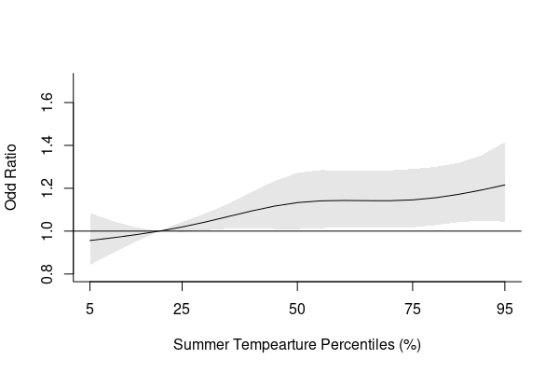 | 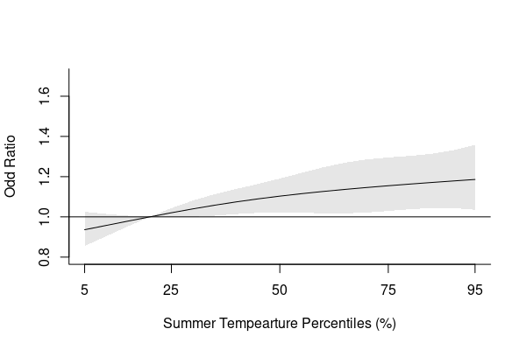 | 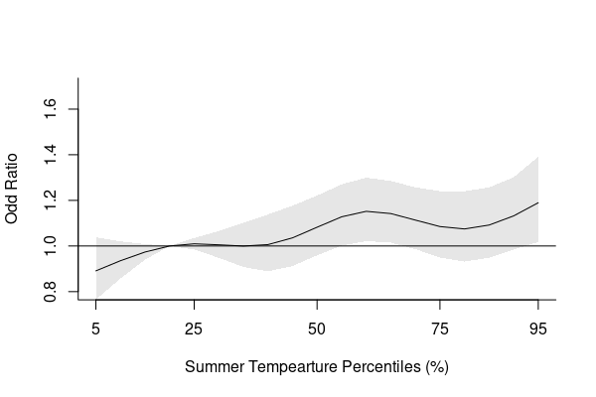
Elderly population | 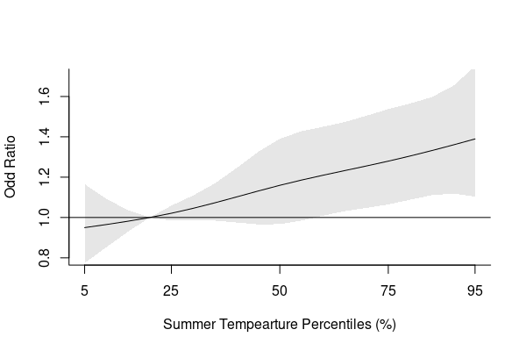 | 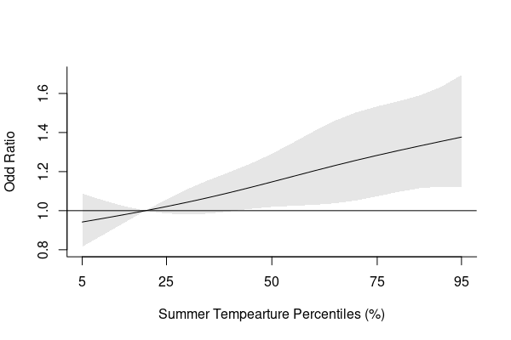 | 