Supplementary Fig. 1 Funnel plots of estimates from genetically predicted temporomandibular disorders on neurodegenerative diseases.
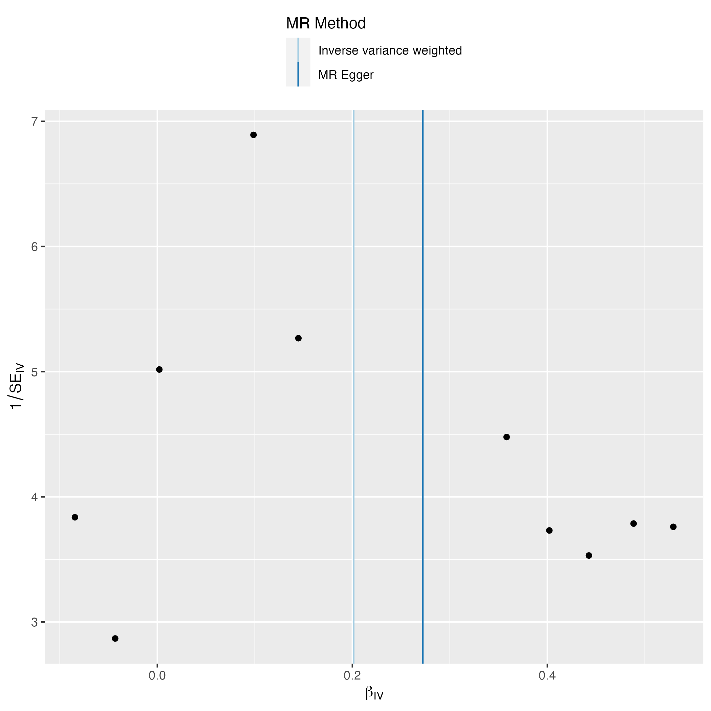
A B
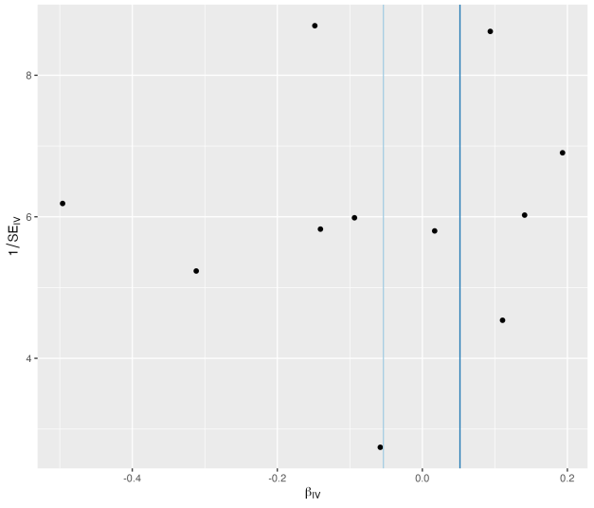
C D
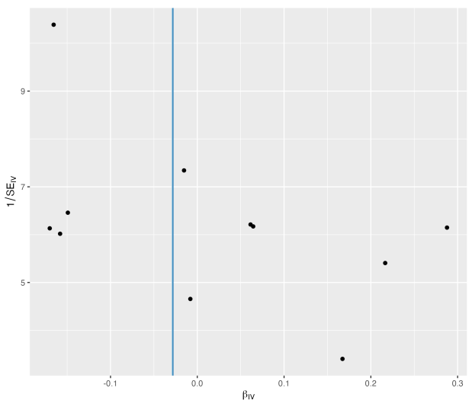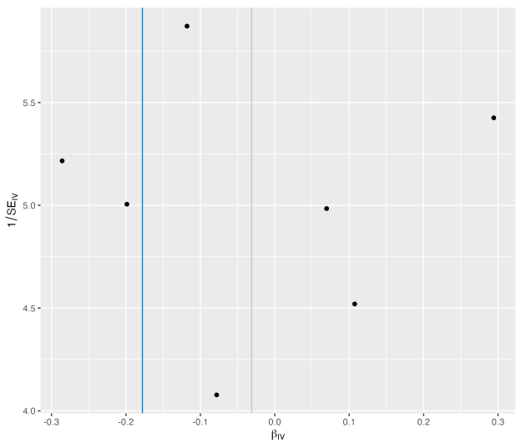
Funnel plots of estimates from TMD（temporomandibular disorders） on (A) AD（Alzheimer's disease）, (B) PD（Parkinson's disease）, (C) ALS（Amyotrophic Lateral Sclerosis）, (D) MS（Multiple Sclerosis）.

Supplementary Fig. 2 Leave-one-out plots of estimates from genetically predicted temporomandibular disorders on neurodegenerative diseases.

A B
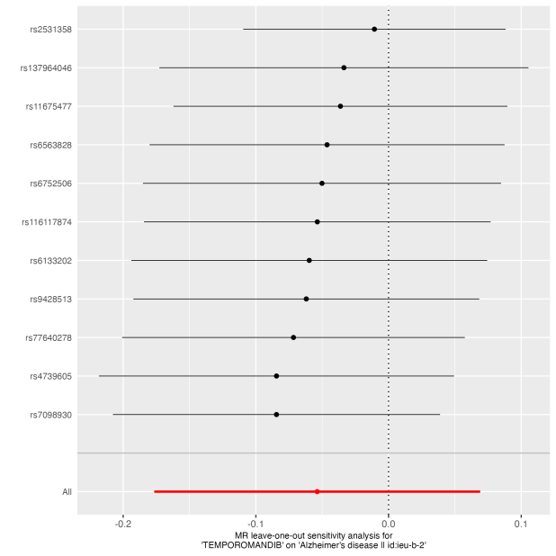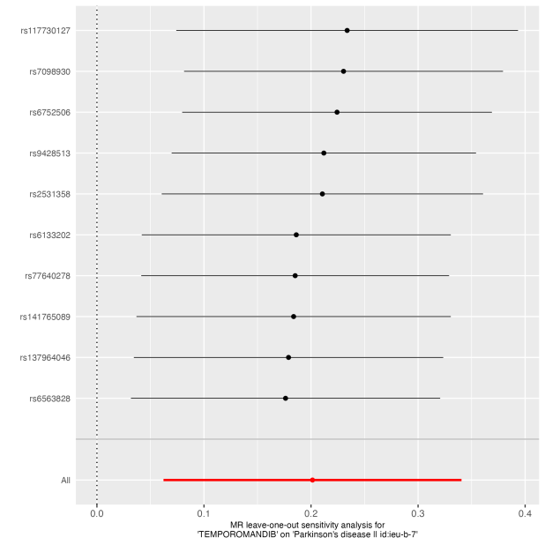
MR effect size for TMD on AD MR effect size for TMD on PD
C D
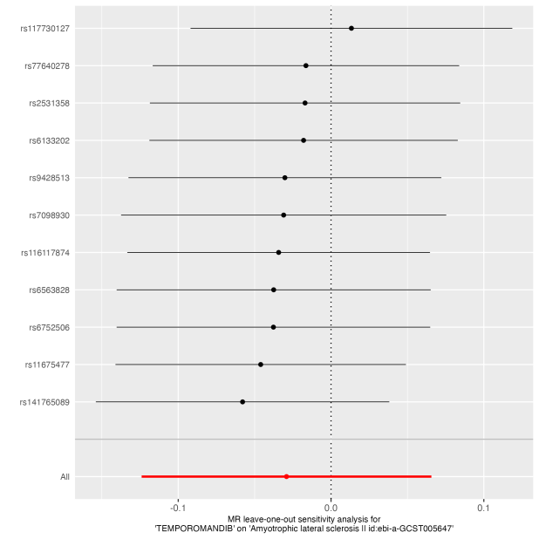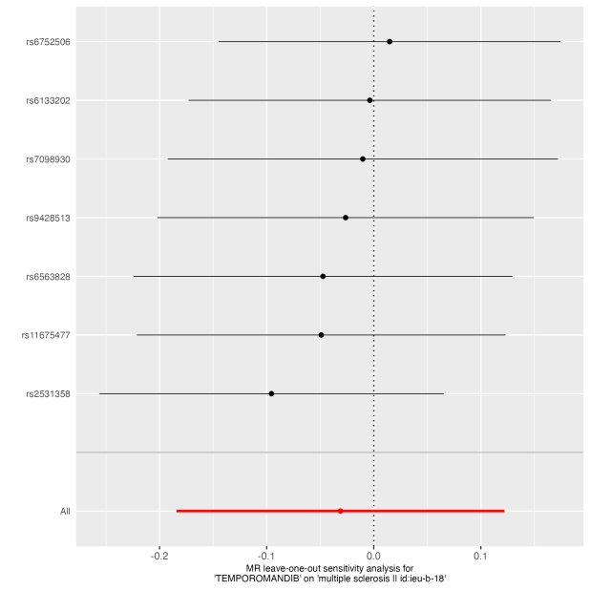
MR effect size for TMD on ALS MR effect size for TMD on MS

Funnel plots of estimates from TMD（temporomandibular disorders） on (A) AD（Alzheimer's disease）, (B) PD（Parkinson's disease）, (C) ALS（Amyotrophic Lateral Sclerosis）, (D) MS（Multiple Sclerosis）.

Supplementary Fig. 3 The forest plot showed results of the causal associations between NDs and TMD.
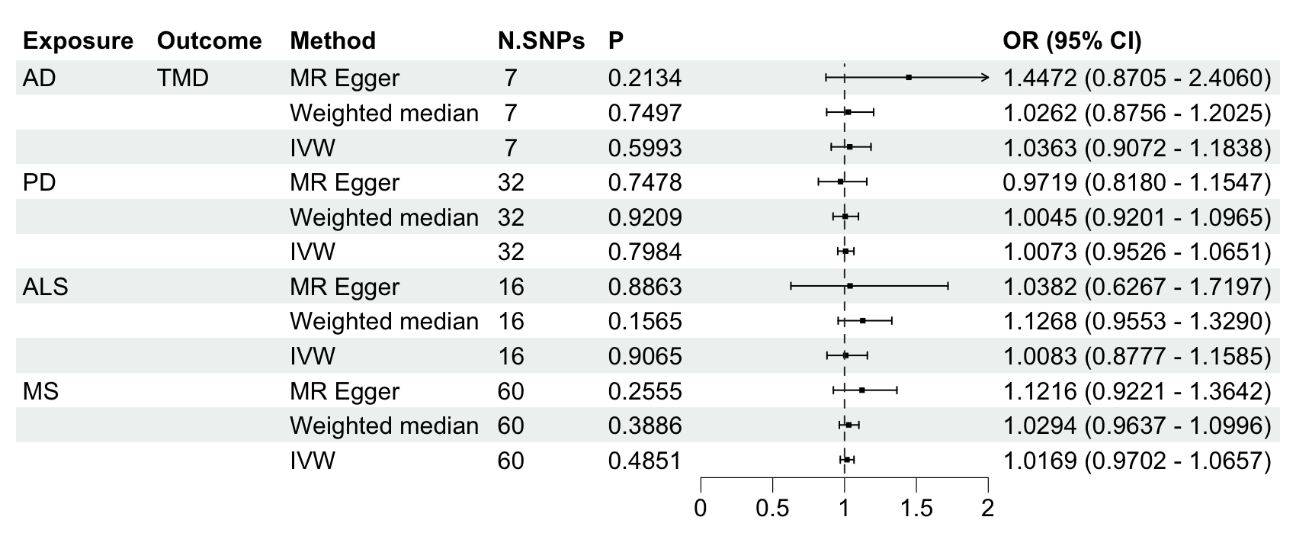

NDs, neurodegenerative diseases; TMD, temporomandibular disorders; AD, Alzheimer's disease; PD, Parkinson's disease; ALS, Amyotrophic Lateral Sclerosis; MS, Multiple Sclerosis.

