Supplementary data

Supplementary table 1. Numeric range of cognitive function score change from 2011 to 2015.
 | Total cognitive function | Orienting attention | Visuoconstruction | Episodic memory
Average | 1.64 | 1.09 | 0.06 | 0.50
Median | 2.00 | 1.00 | 0.00 | 1.00
Standard deviation | 4.95 | 2.53 | 0.55 | 3.89
Numerical range | 40.00 | 18.00 | 2.00 | 32.00
Minimum value | -20.00 | -8.00 | -1.00 | -17.00
Maximum value | 20.00 | 10.00 | 1.00 | 15.00

Supplementary table 2. Numeric range of delta air pollutants from 2011 to 2015.
 | ΔPM_{2.5} | ΔPM₁ | ΔPM₁₀ | ΔO₃ | ΔNO₂
Average | -0.2928 | 1.5001 | 15.137 | 6.8796 | -1.0153
Median | -0.4868 | 1.1408 | 14.2245 | 7.0261 | -1.3439
Standard deviation | 5.27562 | 4.87103 | 10.0623 | 5.82774 | 3.84122
Numerical range | 30.69 | 25.16 | 56.75 | 39.48 | 18.33
Minimum value | -14.65 | -10.87 | -13.62 | -10.64 | -9.48
Maximum value | 16.04 | 14.29 | 43.13 | 28.84 | 8.85
PM₁: Particulate matter with a diameter <1 μm. PM_{2.5}: Particulate matter with a diameter < 2.5 μm. PM₁₀: Particulate matter with a diameter <10 μm. O₃: Ozone. NO2：nitrogen dioxide.
ΔPM equals the number of PM₂₀₁₁ minus PM₂₀₁₅. ΔNO2 equals the number of NO2₂₀₁₁ minus NO2₂₀₁₅

Supplementary table 3. The Spearman’s correlation analysis among hs-CRP and changes of ambient air pollutants exposure from 2011 to 2015.
 | ΔPM_{2.5} | ΔPM₁ | ΔPM₁₀ | ΔO₃ | ΔNO2 | Δ2011-2015
hs-CRP | -0.008 | 0.005 | -0.013 | -0.001 | 0.023 | Correlation coefficient
 | 0.497 | 0.679 | 0.284 | 0.938 | 0.067 | P-value (two-tailed)
PM₁: Particulate matter with a diameter <1 μm. PM_{2.5}: Particulate matter with a diameter < 2.5 μm. PM₁₀: Particulate matter with a diameter <10 μm. O₃: Ozone. NO2：nitrogen dioxide.

Supplementary table 4. The mediating role of hs-CRP (≥3mg/L) on the relationship between air pollution and cognitive decline.
hs-CRP≥3mg/L | OR-(95%CI) | P-value
ΔPM_{2.5}*hs-CRP
Indirect | 1.000 ( 1.000, 1.000 ) | 0.990
Direct | 0.984 ( 0.981, 0.990 ) | <0.001
ΔPM₁*hs-CRP
Indirect | 1.000 ( 1.000, 1.000 ) | 0.920
Direct | 0.987 ( 0.984, 0.990 ) | <0.001
ΔPM₁₀*hs-CRP
Indirect | 1.000 ( 1.000, 1.000 ) | 0.930
Direct | 0.995 ( 0.994, 1.000 ) | <0.001
ΔO₃*hs-CRP
Indirect | 1.000 ( 1.000, 1.000 ) | 0.950
Direct | 1.000 ( 0.998, 1.000 ) | 0.960
ΔNO₂*hs-CRP
Indirect | 1.000 ( 1.000, 1.000 ) | 0.960
Direct | 0.991 ( 0.987, 0.990 ) | <0.001
PM₁: Particulate matter with a diameter <1 μm. PM_{2.5}: Particulate matter with a diameter < 2.5 μm. PM₁₀: Particulate matter with a diameter <10 μm. O₃: Ozone. NO2：nitrogen dioxide.

Total cognitive function | Orienting attention
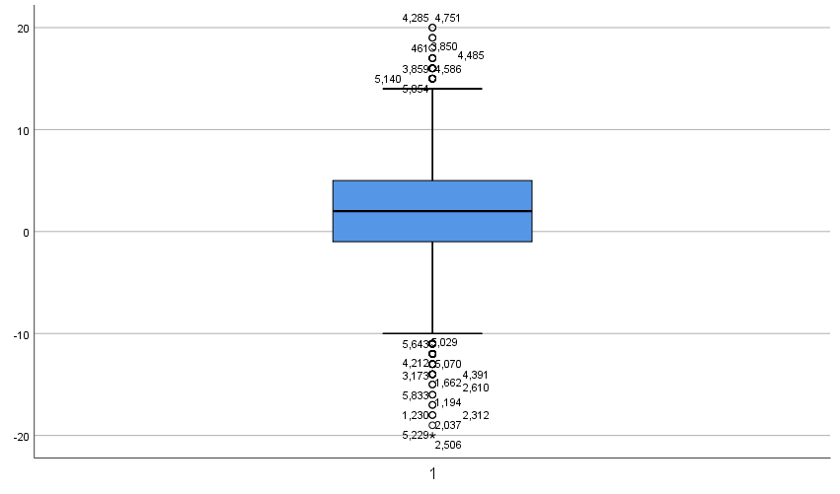 | 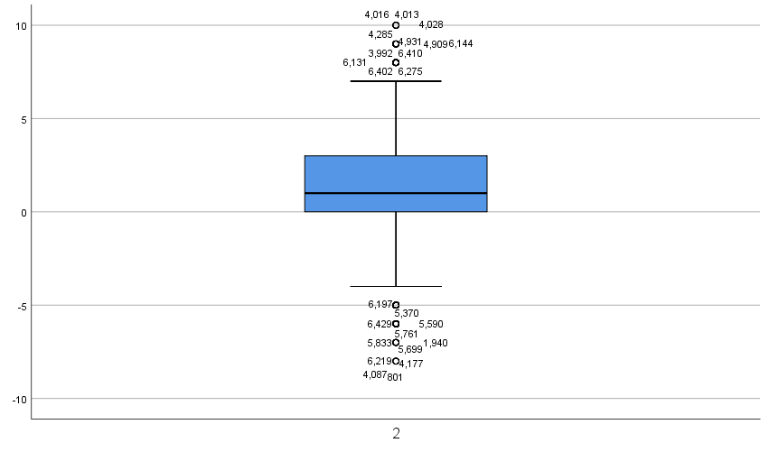
Visuoconstruction | Episodic memory
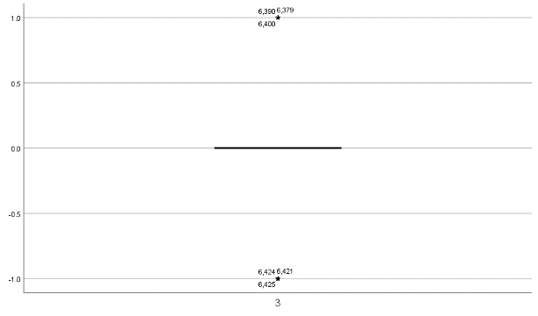 | 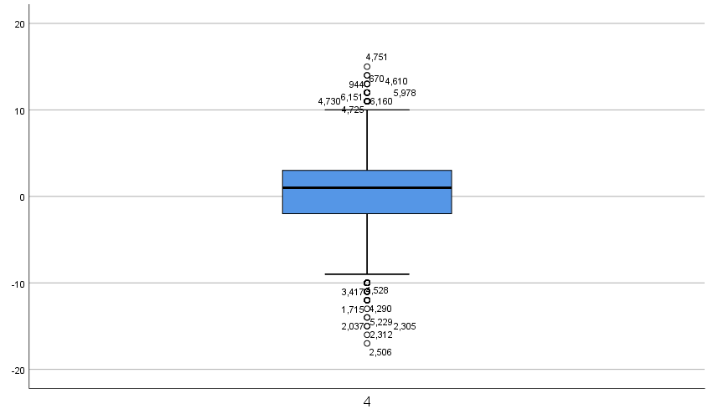

Supplementary figure 1. The distribution of cognitive function score change from 2011 to 2015.
A box plot showing the distribution of cognitive function scores. The boxes show the upper- and lower-quartile values, the horizontal lines indicate the median. The outliers, which fall outside the first and third quartiles by > 1.5 times the interquartile range, are marked by a circle symbol. The outliers, which are outside of > 3 times IRQ, are indicated by a star symbol. Numbers next to symbol correspond to line numbers.

