Supplementary Information

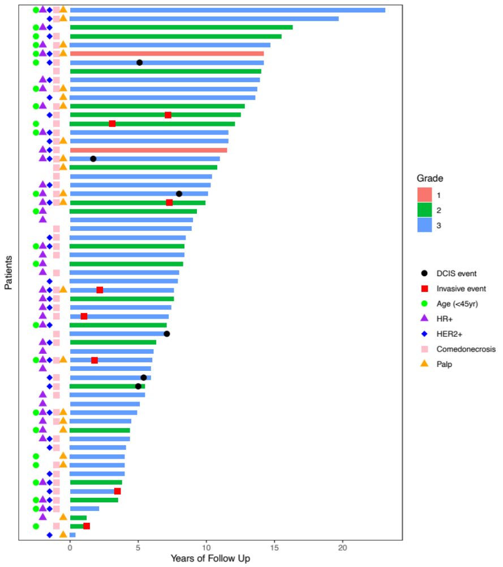 Supplementary Figure S1. Swimmer plot showing clinical characteristics of DCIS patients in the DEFENSE cohort. Patients are ordered by years of follow-up relative to original DCIS diagnosis. Clinical characteristics are shown along the y axis. Bars are color coded according to grade. Timing of subsequent DCIS or invasive events are also denoted.
Supplementary Table S1. Antibodies used in mIF and IHC assays.
Marker | Clone | Antibody source | Fluorophore
mIF Panel IP2.2
PD-L1; immune checkpoint | E1L3N | Cell Signaling | Opal520
PD-1; immune checkpoint | EPR4877 | Abcam | Opal620
CD8; cytotoxic T cell marker | 4B11 | Leica | Opal570
pan-cytokeratin; epithelial cell marker | AE1/AE3 | Dako | Opal690
CD68; macrophage marker | PG-M1 | Dako | AlexaFluor750
CD3; T cell marker | 2GV6 | Ventana/Roche | Opal480
mIF Panel SP1.1
CD3 | LN10 | Leica | Opal520
aSMA | ASM1 | Leica | Opal650
p63 | D9L7L | Cell Signaling | Opal540
CD90 | EPR3133 | Abcam | OPal570
CD34 | QBEND/10 | Leica | Opal620
CD68 | 514H12 | Leica | Opal690
Single-plex IHC stains
AR | SP107 | Cellmarque
BAG1 | Y166 | Abcam
COX2 | CX294 | DAKO
ER | SP1 | Abcam
PgR | pgr636 | DAKO
Ki67 | MIB-1 | DAKO
p16 | E6H4 | Ventana
p53 | DO-7 | DAKO

Supplementary Table S2. Expression array based biomarkers evaluated in this study.
Biomarker | Type | Description | Genes
TIL_sig | cell population | Tumor infiltrating lymphocytes | PTPRC
Tcell_sig | cell population | T cells | CD3D, CD3E, CD3G, CD6, SH2D1A, TRAT1
Tc_sig | cell population | cytotoxic T cells | CD8A, CD8B
ExhTc_sig | cell population | exhausted Tc cells | CD244, EOMES, LAG3, PTGER4
Th1_sig | cell population | type 1 helper T cells | TBX21
Treg_sig | cell population | regulatory T cells | FOXP3
Cyto_sig | cell population | cytotoxic cells | CTSW, GNLY, GZMA, GZMB, GZMH, KLRB1, KLRD1, KLRK1, NKG7, PRF1
NK_sig | cell population | Natural killer cells | NCR1, XCL1, XCL2
NK56d_sig | cell population | CD56dim natural killer cells | IL21R, KIR3DL1, KIR3DL2
Bcell_sig | cell population | B cells | BLK, CD19, FCRL2, KIAA0125, MS4A1, PNOC, SPIB, TCL1A, TNFRSF17
DC_sig | cell population | Dendritic cells | CCL13, CD209, HSD11B1
Mac_sig | cell population | Macrophages | CD163, CD68, CD84, MS4A4A
Neut_sig | cell population | Neutrophils | CEACAM3, CSF3R, FCAR, FCGR3B, FPR1, S100A12, SIGLEC5
Mast_sig | cell population | Mast cells | CPA3, HDC, MS4A2, TPSAB1, TPSB2
TcClassII_sig | Immune signaling | Activated Tc signature | CD2, CD3G, CD8A, IFNG, TNF, GZMB, GZMH, PRF1, ZAP70, HLA-DMA, HLA-DOA, HLA-DOB, HLA-DPA1, HLA-DPB1, HLA-DQA1, HLA-DQB1, HLA-DQB2, HLA-DRA, HLA-DRB1, HLA-DRB2, HLA-DRB3, HLA-DRB4, HLA-DRB5, HLA-DRB6, CIITA, CD74
Mod4_TB | Immune signaling | T and B cell immune module | CD96, CD52, SEMA4D, CXCL13, SP140, CCR7, CTSW, DOCK2, EVI2B, FCN1, KLRK1, FLI1, PLCL2, FYB, IPCEF1, PPP1R16B, CCDC69, STAP1, GPR18, ICOS,GPR171, GZMA, GZMB, GZMK, IGJ, IL2RB, IL2RG, IL7R, ITGA4, ITK, KLRB1, LCK, LGALS2, LRMP, LTB, SH2D1A, CXCL9, NCF4, GIMAP6, IL21R, TRAT1, PLAC8, UBASH3A, POU2AF1, RHOF, LAX1, BANK1, SIRPG, PRF1, DOCK10, PRKCB, CRTAM, PTGDS, PTPRC, PTPRCAP, TNFRSF17, CCL19, SELL, BCL11B, SLAMF1, TNFRSF1B, CCR2, TRAF3IP3, TCL1A, VNN2, PSTPIP1, CD2, CD3G, CD247, CD7, CD8A, CD19, MS4A1, CD27, AIM2, CD37, CYTIP, CD69, CD79A, FAM65B, KIAA0125, P2RY14
PDCD1 | immune checkpoint | PD-1 gene | PDCD1
CD274 | immune checkpoint | PD-L1 gene | CD274
ICS5 | Immune signaling | Integrated Cytokine Score | CXCL13, CLIC5, HLA-F, TNFRSF17, XCL2
Mod3_IFN | Immune signaling | Interferon module | IFI44, IFI44L, DDX58, IFI6, IFI27, IFIT2, IFIT1, IFIT3, CXCL10, MX1, OAS1, OAS2, OAS3, HERC5, SAMD9, HERC6, DDX60, RTP4, IFIH1, STAT1, TAP1, OASL, RSAD2, ISG15
TGFB_sig | Immune signaling | Transforming growth factor b signature | MMP3, MARCKSL1, IGF2R, LAMB1, SPARC, FN1, ITGA4, SMO, MMP19, ITGB8, ITGA5, NID1, TIMP1, SEMA3F, RHOQ, CTNNB1, MMP2, SERPINE1, EPHB2, COL16A1, EPHA2, TNC, JUP, ITGA3, TCF7L2, COL3A1, CDH6, WNT2B, ADAM9, DSP, HSPG2, ARHGAP1, ITGB5, IGFBP5, ARHGDIA, LRP1, IGFBP2, CTNNA1, LRRC17, MMP14, NEO1, EFNA5, ITGB3, EPHB3, CD44, IGFBP4, TNFRSF1A, RAC1, PXN, PLAT, COL8A1, WNT8B, IGFBP3, RHOA, EPHB4, MMP1, PAK1, MTA1, THBS2, CSPG2, MMP17, CD59, DVL3, RHOB, COL6A3, NOTCH2, BSG, MMP11, COL1A2, ZYX, RND3, THBS1, RHOG, ICAM1, LAMA4, DVL1, PAK2, ITGB2, COL6A1, FGD1,
CSR_Act | Immune signaling | Core serum response signature | ACAS2, ACINUS, ADAMTS1, ADD3, AIP1, ALEX3, APOD, APP, ARHC, ARHGAP12, ARHGEF3, ATP6V0A1, AXIN2, BAF53A, BBC3, BCCIP, BCL6, BF, BHC80, BHLHB2, BM039, BOCT, BRCA2, BRIP1, C11ORF14, C11ORF24, C13ORF1, C1ORF33, C1S, C20ORF108, C5ORF4, C6ORF55, C8ORF13, CAMLG, CBX1, CCNG2, CCNL2, CCT5, CDC14B, CDCA4, CDK2, CDKN1A, CDKN1C, CENPJ, CGI-121, CHEK1, CKLF, CL640, CLCN6, CLIC2, CNTNAP1, COPS6, CORO1C, COTL1, COX17, CPR8, CRTAP, CSF1, CST3, CTNS, CTSF, CYP27A1, DC13, DCK, DCLRE1B, DEPP, DHFR, DHRS6, DKFZP434B103, DKFZP434L142, DKFZP434O1427, DKFZP586A0522, DKFZP727G051, DKFZP761L1417, DKFZP762H185, DLEU1, DLEU2, DNM1, DPP7, DPYSL2, DUSP22, DUT, EBNA1BP2, EEF1E1, EIF4EBP1, EIF4G1, EMP2, ENIGMA, ENO1, EPHB1, ERP70, ESDN, F10, F3, FABP3, FACL3, FADS1, FADS2, FARSL, FCGRT, FDPS, FLJ10036, FLJ10292, FLJ10407, FLJ10618, FLJ10849, FLJ10948, FLJ10983, FLJ11286, FLJ12643, FLJ12953, FLJ14525, FLJ20059, FLJ20154, FLJ20331, FLJ21016, FLJ21986, FLJ23462, FLJ23468, FLJ30532, FLJ30574, FLJ31033, FLJ32731, FLJ32915, FLJ90754, FLJ90798, FLNC, FRSB, FYCO1, GABARAPL1, GABBR1, GATM, GG2-1, GGH, GLS, GNG11, GPLD1, GPR124, GSN, H2AFZ, H2AV, HAS2, HDAC5, HECA, HMGB1, HMGCS1, HMGN2, HN1L, HNRPA2B1, HNRPR, HRB2, HRI, HSPC111, HSU79274, ID2, ID3, IDI1, IFRD2, IGBP1, IL1R1, IL6ST, IL7R, IMP4, INSIG1, IPO4, ITGA6, ITPKB, JAG1, JTV1, KAI1, KEO4, KIAA0090, KIAA0095, KIAA0323, KIAA0342, KIAA0367, KIAA0874, KIAA1036, KIAA1109, KIAA1228, KIAA1268, KIAA1305, KIAA1363, KIAA1536, KIAA1554, KIAA1720, KIAA1946, KIT, KLHL5, LDB1, LDLR, LIPA, LMNB2, LOC115106, LOC115294, LOC129401, LOC153222, LOC169611, LOC201562, LOC201895, LOC221810, LOC253263, LOC284018, LOC284436, LOC285362, LOC339924, LOC51128, LOC51279, LOC51668, LOC56757, LOC56902, LOC56926, LOC93081, LOXL2, LPIN1, LRIG2, LRP1, LSM3, LSM4, LSS, LUM, LYAR, MAF, MAN1A1, MAP3K8, MAPRE1, MBP, MCM3, MCM7, MCP, MCT-1, MEF2D, MEP50, MET, MFGE8, MGC10200, MGC10500, MGC10974, MGC11266, MGC13047, MGC13170, MGC14480, MGC15429, MGC17330, MGC3101, MGC39820, MGC4170, MGC4308, MGC4825, MIG-6, MKKS, MNAT1, MRF2, MRPL12, MRPL37, MRPS16, MRPS28, MSN, MT1F, MT3, MTH2, MTHFD1, MVD, MXI1, MYBL1, MYBL2, MYCBP, MYL6, NCOA3, NIFU, NLN, NME1, NOLA2, NUDT1, NUP107, NUPL1, NUTF2, OIP2, OSBPL8, P8, PA26, PA2G4, PAICS, PBXIP1, PCNT1, PCSK7, PDAP1, PDK2, PFKP, PFN1, PGCP, PHACS, PITPNC1, PKIG, PLA2R1, PLAUR, PLD3, PLG, PLOD2, PLU-1, PLXNB1, PNN, POLE2, POLR3K, POR, PPIH, PROL2, PSMA7, PSMC3, PSMD12, PSMD14, PSMD2, PTPRU, PTS, RAB11-FIP2, RARRES3, RBM14, RBMX, REV3L, RFC3, RNASEH2A, RNASEP1, RNF138, RNF41, RPN1, RRM2B, RUVBL1, SATB1, SBP1, SC4MOL, SCD, SDC1, SDFR1, SELENBP1, SEMACAP3, SERPING1, SES2, SFRS10, SFRS2, SFTPB, SLC16A1, SLC25A5, SLC35E2, SLC40A1, SLC5A3, SLPI, SMC2L1, SMS, SMURF2, SNRP70, SNRPA, SNRPA1, SNRPB, SNRPC, SNRPD1, SNRPE, SQLE, SQRDL, SRM, SSR3, SSSCA1, STK17A, STK18, SVIL, TAGLN, TBRG1, TCEB1, TCTEL1, TFPI2, TIM50L, TIMP2, TNFAIP2, TNFRSF12A, TNFSF12, TNXB, TOMM40, TP53INP1, TPI1, TPM1, TPM2, TRIM22, TSC22, TUBA1, TUBG1, TXNL2, UAP1, UBE2J1, UMPK, UMPS, VAMP4, VDAC1, VIL2, WBP2, WDHD1, WSB1, WSB2, WTAP, ZFP106, ZNF151, ZNF219, ZNF36, ZNF83
STAT1_sig | Immune signaling | signal transducer and activator of transcription 1 signature | TAP1, GBP1, IFIH1, PSMB9, CXCL9, IRF1, CXCL11, CXCL10, IDO1, STAT1
Chemokine12 | Immune signaling | Signature of 12 chemokines | CCL2, CCL3, CCL4, CCL5, CCL8, CCL18, CCL19, CCL21, CXCL9, CXCL10, CXCL11, CXCL13
TIS | Immune signaling | Tumor inflammatory signature | TIGIT, CD27, CD8A, PDCD1LG2, CXCR6, LAG3, CD274, CMKLR1, NKG7, CCL5, PSMB10, ID01, PPBP, HLA-DQA1, CD276, STAT1, HLA-DRB1, HLA-E
Geparsixto | Immune signaling | GeparSixto TRIAL immune activation signature | CXCL9, CCL5, CD8A, CD80, CXCL13, IDO1, PDCD1, CD274, CTLA4, FOXP3
ER_PR_sig | hormone receptor | Estrogen and progesterone receptor expression | ESR1, PGR
Mitototic_sig | proliferation | Proliferation/cell cycle signature | PLK1, CDK1, BUB1B, NEK2, TTK, MELK, PLK4, CHEK1, AURKA, AURKB, BUB1, PBK

Supplementary Table S3. Immune biomarkers evaluated in this study via IHC and mIF.
Biomarker | Staining Panel | Description
Cell population (% of total cell count
Tcell | IP1.2 | T cells (CD3+)
Treg | IP1.2 | Regulatory T cells (Foxp3+CD3+)
Bcell | IP1.2 | B cells (CD20+)
TIL | IP1.2 | Tumor infiltrating lymphocytes (T cells + B cells)
CD8pT | IP2.2 | Cytotoxic T cells (CD8+CD3+)
CD8nT | IP2.2 | CD8-negative T cells (CD8-CD3+)
Mac | IP2.2 | Macrophages (CD68+CK-)
Ki67pT | IP1.2 | proliferating T cells (Ki67+CD3+)
Ki67pTreg | IP1.2 | proliferating Treg cells (Ki67+Foxp3+CD3+)
Ki67pB | IP1.2 | proliferating B cells (Ki67+CD20+)
Ki67pTum | IP1.2 | proliferating tumor cells (Ki67+CK+)
HLADRpT | IP1.2 | MHC ClassII positive T cells (HLADR+ CD3+)
HLADRpB | IP1.2 | MHC ClassII positive B cells (HLADR+ CD20+)
HLADRpTum | IP1.2 | MHC ClassII positive tumor cells (HLADR+ CK+)
PD1pCD8pT | IP2.2 | PD-1 positive cytotoxic T cells (PD-1+ CD8+ CD3+)
PD1pCD8nT | IP2.2 | PD-1 positive CD8 negative T cells (PD-1+ CD8- CD3+)
PD1pT | IP2.2 | PD-1 positiveT cells (PD-1+ CD3+)
PDL1pMac | IP2.2 | PD-L1 positive macrophages (PD-L1+ CD68+ CK-)
PDL1pImm | IP2.2 | PD-L1 positive immune cells (PD-L1+ CK-)
PDL1pTum | IP2.2 | PD-L1 positive tumor cells (PD-L1+ CK+)
AnyPDL1 | IP2.2 | Any PD-L1 positive cell
Cell population (cells/mm²)
aSMA_Density | SP1.1 | stromal firbroblasts, myofibroblast or ductal epithelial cells
CD3_Density | SP1.1 | T cells
CD34_Density | SP1.1 | hematopoietic stem cells, mesenchymal stem cells
CD68_Density | SP1.1 | macrophages
p63_Density | SP1.1
CD34_CD68_Density | SP1.1 | CD34+CD68+ cells
p63_aSMA_Density | SP1.1
aSMA_Density_DCIS | SP1.1 | aSMA+ cell density within DCIS regions
CD3_Density_DCIS | SP1.1 | CD3+ cell density within DCIS regions
CD34_Density_DCIS | SP1.1 | CD34+ cell density within DCIS regions
CD68_Density_DCIS | SP1.1 | CD68+ cell density within DCIS regions
p63_Density_DCIS | SP1.1 | p63+ cell density within DCIS regions
aSMA_Density_Stroma | SP1.1 | aSMA+ cell density within stromal areas
CD3_Density_Stroma | SP1.1 | CD3+ cell density within stromal areas
CD34_Density_Stroma | SP1.1 | CD34+ cell density within stromal areas
CD68_Density_Stroma | SP1.1 | CD68+ cell density within stromal areas
p63_Density_Stroma | SP1.1 | p63+ cell density within stromal areas
Tumor cells
BAG1_cyto_nuc | single-plex IHC | BAG1+ nuclear (1) or cytoplasmic&nuclear (2) staining in tumor cells
BAG1_lvl | single-plex IHC | BAG1+ tumor cells (1-low, 2-intermediate, 3-high)
COX2_Allred | single-plex IHC | COX2+ tumor cells (Allred scored 0,1,2)
ER H-score | single-plex IHC | ER+ tumor cells (H-score)
IHC4 | single-plex IHC | composite ER, PR, HER2, Ki67 score
Ki67pct | single-plex IHC | proliferating (Ki67+) tumor cells (percentage)
p53_lvl | single-plex IHC | p53+ tumor cells (scored 0, 0.5, 1, 2, or 3)
p53pct_nuc | single-plex IHC | percent nuclear positive p53 staining in tumor cells
Immune checkpoint score
CPS | IP2.2 | PDL1 combined positive score: [(PDL1Im + PDL1Tum) / (tumor cell count)] * 100
TPS | IP2.2 | PDL1 tumor proportion score: [(PDL1Tum) / (tumor cell count)] * 100
Cell ratio
Treg-T ratio | IP1.2 | CD3+Foxp3+ Treg counts divided by CD3+ T cell counts
Mac-T ratio | IP2.2 | CD68+ macrophage counts divided by CD3+ T cell counts
Mac-Tc ratio | IP2.2 | CD68+ macrophage counts divided by CD3+CD8+ T cell counts
CD8nT-CD8pT ratio | IP2.2 | CD3+CD8- T cell counts divided by CD3+CD8+ T cell counts
Spatial metric: Morisita-Horn index
TIL_Tum.MHI | IP1.2 | cellA_cellB.MHI: colocalization of cell type A & cell type B
TIL_Treg.MHI | IP1.2 | example: TIL_Tum.MHI - colocalization of TIL and tumor cells
T_B.MHI | IP1.2
T_Tum.MHI | IP2.2
Tum_B.MHI | IP1.2
Treg_Foxp3nT.MHI | IP1.2
Treg_B.MHI | IP1.2
CD8pT_CD8nT.MHI | IP2.2
Tum_CD8nT.MHI | IP2.2
Tum_CD8pT.MHI | IP2.2
Mac_Tum.MHI | IP2.2
Mac_CD8nT.MHI | IP2.2
Mac_CD8pT.MHI | IP2.2
Mac_Tcell.MHI | IP2.2
PDL1Tum_PD1T.MHI | IP2.2
PDL1Tum_PD1pCD8pT.MHI | IP2.2
PDL1Tum_PD1pCD8nT.MHI | IP2.2
PDL1Imm_PD1T.MHI | IP2.2
PDL1Imm_PD1pCD8pT.MHI | IP2.2
PDL1Imm_PD1pCD8nT.MHI | IP2.2
AnyPDL1_PD1T.MHI | IP2.2
AnyPDL1_PD1pCD8pT.MHI | IP2.2
AnyPDL1_PD1pCD8nT.MHI | IP2.2
Spatial metric: Spatial Proximity Score
TIL_Tum.SPS | IP1.2 | cellA_cellB.SPS: spatial proximity score for fraction of cell type A
Tum_TIL.SPS | IP1.2 | with a cell of type B within 20 um
B_T.SPS | IP1.2 | example: Tum_TIL.SPS is the SPS score for tumor cells with a TIL within 20 um
T_B.SPS | IP1.2
B_Treg.SPS | IP1.2
Treg_B.SPS | IP1.2
B_Tum.SPS | IP1.2
Tum_B.SPS | IP1.2
T_Mac.SPS | IP2.2
Mac_T.SPS | IP2.2
T_Tum.SPS | IP2.2
Tum_T.SPS | IP2.2
Treg_Foxp3nT.SPS | IP1.2
Foxp3nT_Treg.SPS | IP1.2
CD8pT_CD8nT.SPS | IP2.2
CD8nT_CD8pT.SPS | IP2.2
CD8pT_Mac.SPS | IP2.2
Mac_CD8pT.SPS | IP2.2
CD8pT_Tum.SPS | IP2.2
Tum_CD8pT.SPS | IP2.2
CD8nT_Mac.SPS | IP2.2
Mac_CD8nT.SPS | IP2.2
CD8nT_Tum.SPS | IP2.2
Tum_CD8nT.SPS | IP2.2
Mac_Tum.SPS | IP2.2
Tum_Mac.SPS | IP2.2
PD1pT_PDL1p.SPS | IP2.2
PD1pT_PDL1pImm.SPS | IP2.2
PD1pT_PDL1pTum.SPS | IP2.2
PD1pCD8pT_PDL1p.SPS | IP2.2
PD1pCD8pT_PDL1pImm.SPS | IP2.2
PD1pCD8pT_PDL1pTum.SPS | IP2.2
PD1pCD8nT_PDL1p.SPS | IP2.2
PD1pCD8nT_PDL1pImm.SPS | IP2.2
PD1pCD8nT_PDL1pTum.SPS | IP2.2
PDL1p_PD1pT.SPS | IP2.2
PDL1p_PD1pCD8pT.SPS | IP2.2
PDL1p_PD1pCD8nT.SPS | IP2.2
PDL1pImm_PD1pT.SPS | IP2.2
PDL1pImm_PD1pCD8pT.SPS | IP2.2
PDL1pImm_PD1pCD8nT.SPS | IP2.2
PDL1pTum_PD1pT.SPS | IP2.2
PDL1pTum_PD1pCD8pT.SPS | IP2.2
PDL1pTum_PD1pCD8nT.SPS | IP2.2
Spatial metric: nearest neighbor
aSMA_DistFromEpithelium | SP1.1 | average distance of aSMA+ cells to nearest p63+a-SMA+ cell
CD3_DistFromEpithelium | SP1.1 | average distance of CD3+ cells to nearest p63+a-SMA+ cell
CD34_DistFromEpithelium | SP1.1 | average distance of CD34+ cells to nearest p63+a-SMA+ cell
CD68_DistFromEpithelium | SP1.1 | average distance of CD68+ cells to nearest p63+a-SMA+ cell
Spatial metric: myoepithelial continuity score
MyoEpiContinuity | SP1.1 | Average nearest neighbor distance between p63+a-SMA+ cells within the myoepithelium of DCIS regions (reverse scored)

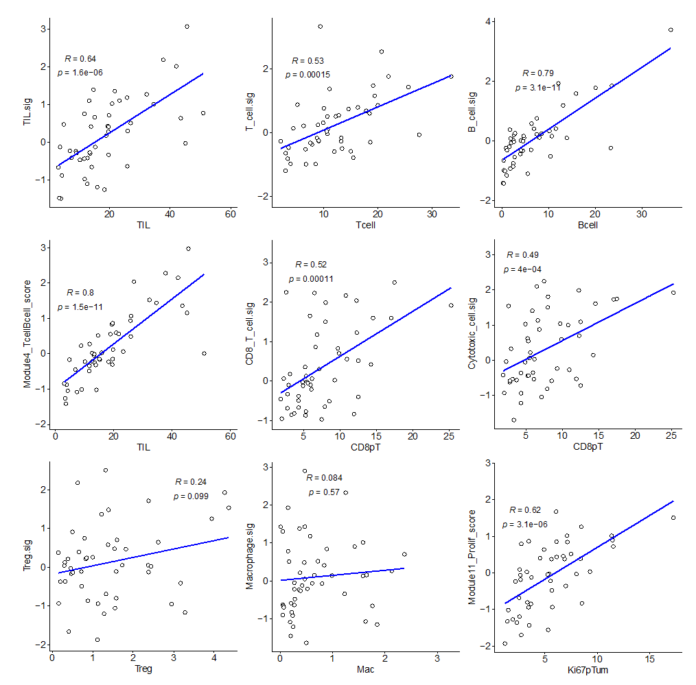
Supplementary Figure S2. Correlations between cell populations identified by mIF staining (x-axes) and corresponding gene expression signatures (y-axes). Pearson R and p values

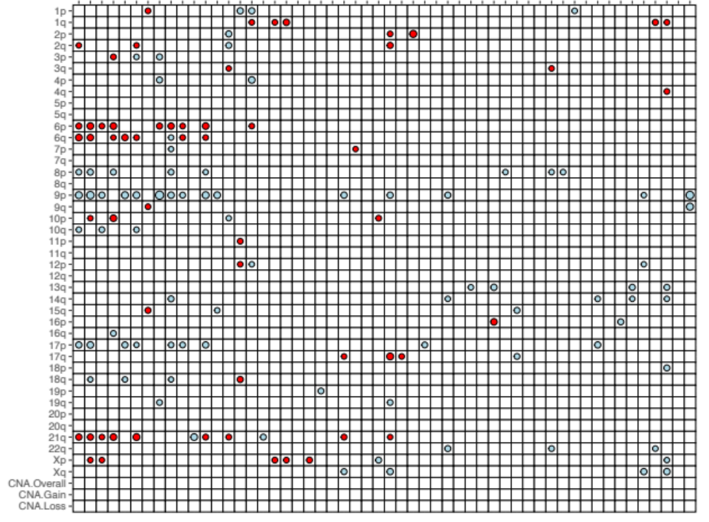
TIL
T cells
CD8⁺ T cells
CD8⁻ T cells
B cells
Ki67⁺ T cells
Ki67⁺ Treg
Ki67⁺ B cells
HLA-DR⁺ T cells
HLA-DR⁺ B cells
PD-1⁺ T cells
PD-1⁺CD8⁺ T cells
Any PD-L1⁺ cell
PD-L1⁺ immune cells
CPS
CD68⁺ cells
CD68⁺ cells (DCIS)
CD3⁺ cells (DCIS)
CD3⁺ cells (stroma)
CD68⁺ cells (stroma)
TIL
T cell
CD8⁺ T cell
Th1 cell
B cell
Exhausted Tc cell
Cytotoxic cell
Dendritic cell
Neutrophil
CD56dim NK cell
NK cell
Tc/ClassII score
Tcell/Bcell Module 4
PD-1 gene
TGF-β score
CSR activated
Treg
Macrophages
Ki67⁺ tumor cells
HLA-DR⁺ tumor cells
PD-1⁺CD8⁻ T cells
PD-L1⁺ tumor cells
TPS
CD3⁺ cells
Treg
Macrophage
Mast cell
ICS5 score
Chemokine 12 score
Interferon Module 3 score
STAT1 gene
PD-L1 gene
CTLA4 gene
PD-L1⁺ macrophages
Cell percentage
PD-L1 score
Cell density
Immune signatures/genes
STAT1 gene
Immune checkpoint genes
TGF-β
Common serum response
Supplementary Figure S3. Associations of chromosomal aberrations with immune biomarkers. Color of dot indicates association with gains (red) or losses (blue). Size of dot is proportional to significance (larger dot smaller p-value). Dots are only shown for significant associations (p<0.05; Kruskal-Wallis test).
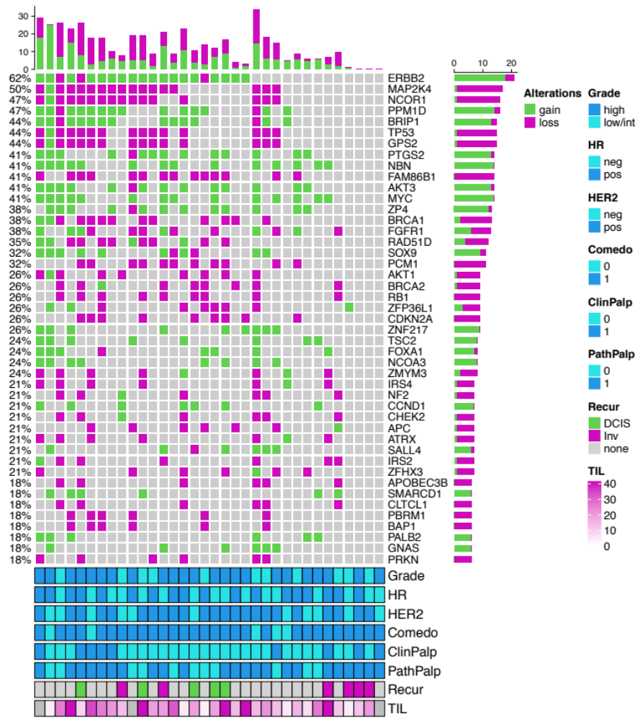Supplementary Figure S4. Oncoprint diagram displaying copy number status of driver genes commonly altered in breast cancer. Each column represents a case of DCIS. Clinical characteristics and percent TILs are indicated in the bottom annotations.

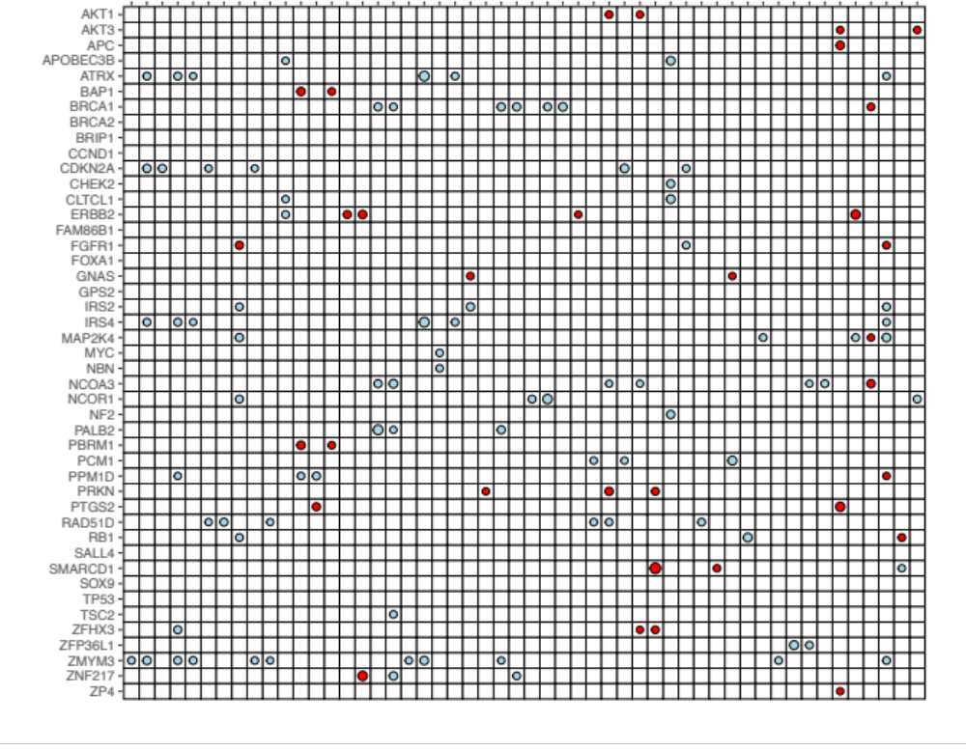
TIL
T cells
CD8⁺ T cells
CD8⁻ T cells
B cells
HLA-DR⁺ T cells
HLA-DR⁺ B cells
PD-1⁺ T cells
PD-1⁺CD8⁺ T cells
PD-L1⁺ immune cells
CPS
CD68⁺ cells
CD68⁺ cells (DCIS)
CD3⁺ cells (DCIS)
CD3⁺ cells (stroma)
CD68⁺ cells (stroma)
TIL
T cell
CD8⁺ T cell
B cell
Exhausted Tc cell
Cytotoxic cell
Dendritic cell
NK cell
Tc/ClassII score
Tcell/Bcell Module 4
PD-1 gene
TGF-β score
CSR activated
Treg
Macrophages
Ki67⁺ tumor cells
HLA-DR⁺ tumor cells
PD-1⁺CD8⁻ T cells
CD3⁺ cells
Treg
Mast cell
ICS5 score
Chemokine 12 score
Interferon Module 3 score
STAT1 gene
PD-L1 gene
CD34⁺ cells
CD34⁺CD68⁺ cells
CD34⁺ cells (DCIS)
TP63⁺ cells (DCIS)
CD34⁺ cells (stroma)
αSMA⁺ cells (stroma)
TP63⁺ cells (stroma)
ERB2 amp genes
ER_PR ave
Proliferation Module 11
Cell percentage
PD-L1 score
Cell density
Immune signatures/genes
Proliferation
TGF-β
Common serum response
STAT1 gene
Immune checkpoint genes
HER2
ER & PR
Supplementary Figure S5. Associations of driver gene copy number alterations with immune biomarkers. Color of dot indicates association with gains (red) or losses (blue). Size of dot is proportional to significance (larger dot smaller p-value). Only those biomarkers that were significant (p<0.05) with at least one chromosomal aberration are shown. Dots are only shown for significant associations (p<0.05; Kruskal-Wallis test).
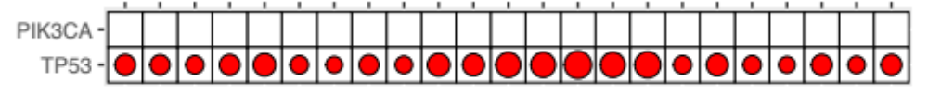
TIL
T cells
CD8⁺ T cells
Treg
B cells
Ki67⁺ B cells
HLA-DR⁺ T cells
HLA-DR⁺ B cells
CPS
CD3⁺ cells
CD3⁺ cells (stroma)
T cell
CD8⁺ T cell
B cell
Cytotoxic cell
CD56dim NK cell
NK cell
Tc/ClassII score
Tcell/Bcell Module 4
PD-1 gene
Treg
Neutrophil
Chemokine 12 score
Cell percentage
PD-L1 score
Cell density
Immune signatures/genes
Immune checkpoint genes
Supplementary Figure S6. Associations of PIK3CA and TP53 mutations with immune biomarkers. Color of dot indicates direction of association (red: positive, blue: negative). Size of dot is proportional to significance (larger dot smaller p-value). Dots are only shown for significant associations (p<0.05; Wilcoxon test).

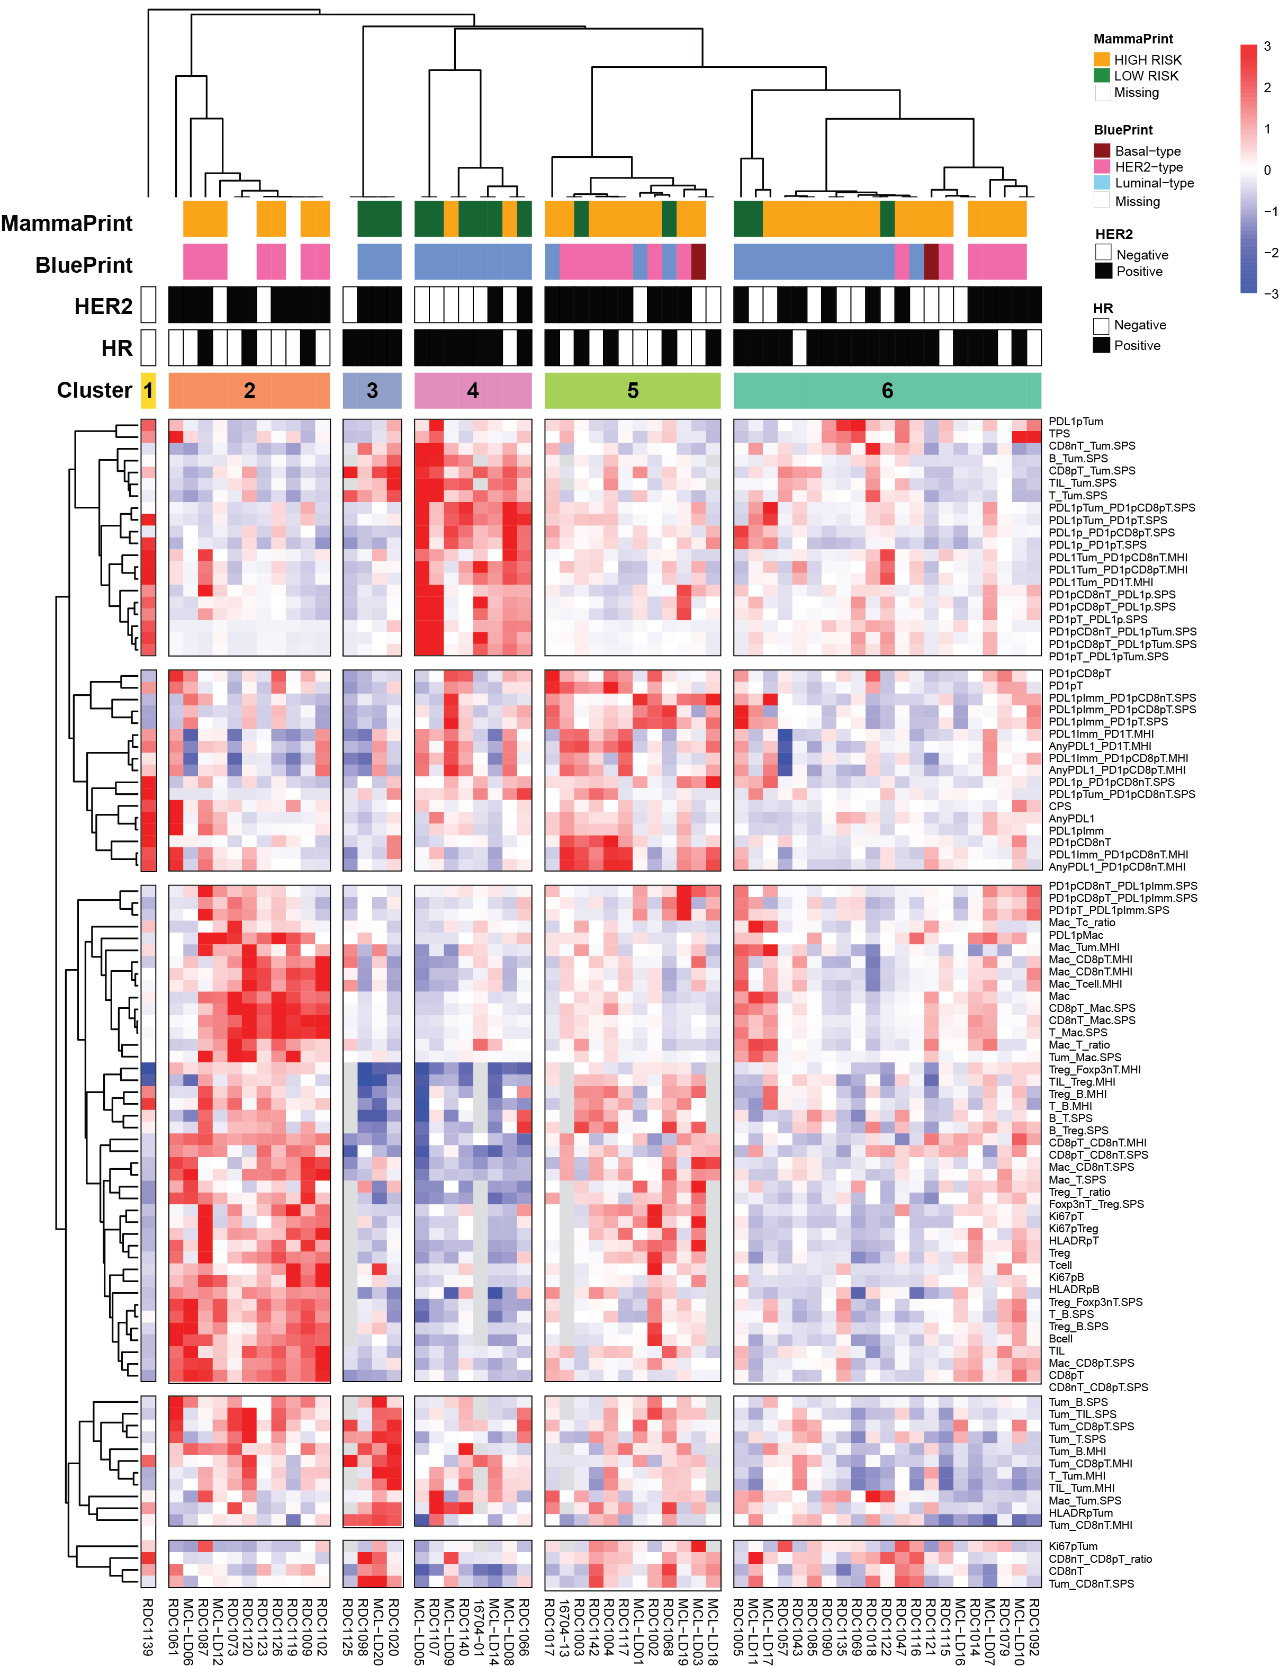
Supplementary Figure S7. Unsupervised clustering of immune biomarker profiles. Heatmap of median-centered, scaled levels (red: positive, blue: negative) of 94 immune biomarkers assayed on IP1.1 and IP1.2 across 57 samples. Samples are organized along the columns and biomarkers along the rows. Samples are ordered based on consensus clustering (k=6); biomarkers are organized by hierarchical clustering (of median-centered levels) with correlation as distance and average linkage (k=5). Column annotation indicates the MammaPrint Result (Low Risk: Dark green, High Risk: Orange), the BluePrint Subtyping Result (Basal: Dark red ; HER2: hotpink ; Luminal: cornflowerblue), HR/HER2 status (Positive: black, Negative: white) and consensus cluster membership.

Supplemental Table S4. Comparison of immune biomarkers generated on IP1.1 and IP1.2 between DCIS subtypes
Biomarker Name | Subtype | Biomarker OnHeat-map | Difference in Means (Subtype vs. others) | Wilcoxon Rank Sum test p | BH-corrected p | Significant
PDL1pTum | C2 | 1 | -0.13 | 2.41E-02 | 8.20E-02 | FALSE
TPS | C2 | 2 | -0.01 | 7.46E-01 | 8.16E-01 | FALSE
CD8nT_Tum.SPS | C2 | 3 | -0.90 | 3.02E-04 | 2.68E-03 | TRUE
B_Tum.SPS | C2 | 4 | -0.92 | 3.76E-03 | 1.98E-02 | TRUE
CD8pT_Tum.SPS | C2 | 5 | -1.46 | 3.74E-03 | 1.98E-02 | TRUE
TIL_Tum.SPS | C2 | 6 | -0.95 | 6.42E-03 | 2.85E-02 | TRUE
T_Tum.SPS | C2 | 7 | -1.03 | 2.04E-03 | 1.26E-02 | TRUE
PDL1pTum_PD1pCD8pT.SPS | C2 | 8 | -0.46 | 1.47E-02 | 5.52E-02 | FALSE
PDL1pTum_PD1pT.SPS | C2 | 9 | -0.66 | 3.03E-03 | 1.69E-02 | TRUE
PDL1p_PD1pCD8pT.SPS | C2 | 10 | -0.34 | 5.47E-02 | 1.50E-01 | FALSE
PDL1p_PD1pT.SPS | C2 | 11 | -0.48 | 3.21E-02 | 9.98E-02 | FALSE
PDL1Tum_PD1pCD8nT.MHI | C2 | 12 | -0.01 | 9.44E-01 | 9.57E-01 | FALSE
PDL1Tum_PD1pCD8pT.MHI | C2 | 13 | -0.04 | 3.17E-01 | 4.74E-01 | FALSE
PDL1Tum_PD1T.MHI | C2 | 14 | -0.03 | 4.30E-01 | 5.74E-01 | FALSE
PD1pCD8nT_PDL1p.SPS | C2 | 15 | -0.15 | 1.75E-01 | 3.14E-01 | FALSE
PD1pCD8pT_PDL1p.SPS | C2 | 16 | -0.39 | 1.29E-01 | 2.59E-01 | FALSE
PD1pT_PDL1p.SPS | C2 | 17 | -0.28 | 1.75E-01 | 3.14E-01 | FALSE
PD1pCD8nT_PDL1pTum.SPS | C2 | 18 | -0.37 | 5.54E-04 | 4.50E-03 | TRUE
PD1pCD8pT_PDL1pTum.SPS | C2 | 19 | -0.46 | 5.56E-04 | 4.50E-03 | TRUE
PD1pT_PDL1pTum.SPS | C2 | 20 | -0.41 | 2.04E-04 | 2.04E-03 | TRUE
PD1pCD8pT | C2 | 21 | 0.07 | 3.17E-01 | 4.74E-01 | FALSE
PD1pT | C2 | 22 | -0.02 | 8.95E-01 | 9.26E-01 | FALSE
PDL1pImm_PD1pCD8nT.SPS | C2 | 23 | -0.12 | 2.98E-01 | 4.56E-01 | FALSE
PDL1pImm_PD1pCD8pT.SPS | C2 | 24 | -0.21 | 3.47E-01 | 5.01E-01 | FALSE
PDL1pImm_PD1pT.SPS | C2 | 25 | -0.29 | 2.06E-01 | 3.40E-01 | FALSE
PDL1Imm_PD1T.MHI | C2 | 26 | -0.10 | 1.44E-01 | 2.78E-01 | FALSE
AnyPDL1_PD1T.MHI | C2 | 27 | -0.05 | 5.03E-01 | 6.34E-01 | FALSE
PDL1Imm_PD1pCD8pT.MHI | C2 | 28 | -0.10 | 9.98E-02 | 2.21E-01 | FALSE
AnyPDL1_PD1pCD8pT.MHI | C2 | 29 | -0.05 | 5.16E-01 | 6.43E-01 | FALSE
PDL1p_PD1pCD8nT.SPS | C2 | 30 | -0.18 | 6.57E-02 | 1.65E-01 | FALSE
PDL1pTum_PD1pCD8nT.SPS | C2 | 31 | -0.25 | 2.68E-03 | 1.56E-02 | TRUE
CPS | C2 | 32 | 3.11 | 4.09E-03 | 2.11E-02 | TRUE
AnyPDL1 | C2 | 33 | 0.15 | 5.99E-01 | 7.14E-01 | FALSE
PDL1pImm | C2 | 34 | 0.28 | 2.14E-01 | 3.50E-01 | FALSE
PD1pCD8nT | C2 | 35 | -0.09 | 6.34E-01 | 7.36E-01 | FALSE
PDL1Imm_PD1pCD8nT.MHI | C2 | 36 | 0.01 | 7.27E-01 | 8.04E-01 | FALSE
AnyPDL1_PD1pCD8nT.MHI | C2 | 37 | 0.04 | 3.95E-01 | 5.42E-01 | FALSE
PD1pCD8nT_PDL1pImm.SPS | C2 | 38 | 0.22 | 2.98E-01 | 4.56E-01 | FALSE
PD1pCD8pT_PDL1pImm.SPS | C2 | 39 | 0.07 | 1.99E-01 | 3.35E-01 | FALSE
PD1pT_PDL1pImm.SPS | C2 | 40 | 0.12 | 1.48E-01 | 2.82E-01 | FALSE
Mac_Tc_ratio | C2 | 41 | 0.03 | 1.17E-01 | 2.46E-01 | FALSE
PDL1pMac | C2 | 42 | 0.04 | 1.84E-03 | 1.17E-02 | TRUE
Mac_Tum.MHI | C2 | 43 | 0.12 | 7.01E-03 | 3.08E-02 | TRUE
Mac_CD8pT.MHI | C2 | 44 | 0.15 | 3.02E-04 | 2.68E-03 | TRUE
Mac_CD8nT.MHI | C2 | 45 | 0.17 | 2.34E-06 | 1.07E-04 | TRUE
Mac_Tcell.MHI | C2 | 46 | 0.17 | 3.54E-05 | 6.49E-04 | TRUE
Mac | C2 | 47 | 1.11 | 7.57E-04 | 5.87E-03 | TRUE
CD8pT_Mac.SPS | C2 | 48 | 0.39 | 9.84E-05 | 1.28E-03 | TRUE
CD8nT_Mac.SPS | C2 | 49 | 0.35 | 7.57E-06 | 2.37E-04 | TRUE
T_Mac.SPS | C2 | 50 | 0.38 | 1.92E-05 | 4.42E-04 | TRUE
Mac_T_ratio | C2 | 51 | 0.04 | 2.17E-02 | 7.54E-02 | FALSE
Tum_Mac.SPS | C2 | 52 | 0.38 | 7.91E-05 | 1.09E-03 | TRUE
Treg_Foxp3nT.MHI | C2 | 53 | 0.16 | 2.52E-06 | 1.07E-04 | TRUE
TIL_Treg.MHI | C2 | 54 | 0.05 | 3.80E-01 | 5.28E-01 | FALSE
Treg_B.MHI | C2 | 55 | 0.08 | 1.29E-01 | 2.59E-01 | FALSE
T_B.MHI | C2 | 56 | 0.13 | 5.13E-03 | 2.40E-02 | TRUE
B_T.SPS | C2 | 57 | 0.59 | 4.68E-01 | 6.08E-01 | FALSE
B_Treg.SPS | C2 | 58 | 0.19 | 3.34E-01 | 4.89E-01 | FALSE
CD8pT_CD8nT.MHI | C2 | 59 | 0.26 | 2.96E-07 | 1.99E-05 | TRUE
CD8pT_CD8nT.SPS | C2 | 60 | 1.80 | 2.49E-04 | 2.34E-03 | TRUE
Mac_CD8nT.SPS | C2 | 61 | 1.16 | 1.16E-03 | 8.40E-03 | TRUE
Mac_T.SPS | C2 | 62 | 1.92 | 6.33E-05 | 9.60E-04 | TRUE
Treg_T_ratio | C2 | 63 | 0.03 | 1.27E-01 | 2.59E-01 | FALSE
Foxp3nT_Treg.SPS | C2 | 64 | 1.32 | 1.20E-05 | 2.96E-04 | TRUE
Ki67pT | C2 | 65 | 0.39 | 7.19E-03 | 3.13E-02 | TRUE
Ki67pTreg | C2 | 66 | 0.07 | 3.80E-03 | 1.98E-02 | TRUE
HLADRpT | C2 | 67 | 3.88 | 1.93E-04 | 1.97E-03 | TRUE
Treg | C2 | 68 | 1.34 | 2.72E-04 | 2.50E-03 | TRUE
Tcell | C2 | 69 | 9.48 | 2.41E-05 | 5.15E-04 | TRUE
Ki67pB | C2 | 70 | 0.66 | 1.60E-04 | 1.78E-03 | TRUE
HLADRpB | C2 | 71 | 2.32 | 8.06E-06 | 2.37E-04 | TRUE
Treg_Foxp3nT.SPS | C2 | 72 | 2.10 | 2.11E-07 | 1.65E-05 | TRUE
T_B.SPS | C2 | 73 | 2.69 | 5.16E-08 | 8.09E-06 | TRUE
Treg_B.SPS | C2 | 74 | 2.45 | 2.11E-07 | 1.65E-05 | TRUE
Bcell | C2 | 75 | 13.79 | 1.10E-05 | 2.86E-04 | TRUE
TIL | C2 | 76 | 23.27 | 5.16E-08 | 8.09E-06 | TRUE
Mac_CD8pT.SPS | C2 | 77 | 1.77 | 2.73E-06 | 1.07E-04 | TRUE
CD8pT | C2 | 78 | 8.12 | 6.99E-08 | 8.21E-06 | TRUE
CD8nT_CD8pT.SPS | C2 | 79 | 3.10 | 1.51E-09 | 7.08E-07 | TRUE
Tum_B.SPS | C2 | 80 | 0.22 | 1.71E-04 | 1.78E-03 | TRUE
Tum_TIL.SPS | C2 | 81 | 0.69 | 3.76E-03 | 1.98E-02 | TRUE
Tum_CD8pT.SPS | C2 | 82 | 0.47 | 3.15E-02 | 9.87E-02 | FALSE
Tum_T.SPS | C2 | 83 | 0.34 | 1.68E-01 | 3.08E-01 | FALSE
Tum_B.MHI | C2 | 84 | 0.05 | 3.61E-04 | 3.14E-03 | TRUE
Tum_CD8pT.MHI | C2 | 85 | 0.03 | 1.81E-01 | 3.18E-01 | FALSE
T_Tum.MHI | C2 | 86 | 0.04 | 1.29E-01 | 2.59E-01 | FALSE
TIL_Tum.MHI | C2 | 87 | 0.04 | 1.40E-01 | 2.73E-01 | FALSE
Mac_Tum.SPS | C2 | 88 | -0.53 | 3.95E-01 | 5.42E-01 | FALSE
HLADRpTum | C2 | 89 | -0.86 | 5.09E-02 | 1.42E-01 | FALSE
Tum_CD8nT.MHI | C2 | 90 | -0.01 | 9.92E-01 | 9.93E-01 | FALSE
Ki67pTum | C2 | 91 | -1.74 | 2.53E-02 | 8.49E-02 | FALSE
CD8nT_CD8pT_ratio | C2 | 92 | -1.38 | 4.50E-03 | 2.30E-02 | TRUE
CD8nT | C2 | 93 | 1.74 | 3.52E-01 | 5.06E-01 | FALSE
Tum_CD8nT.SPS | C2 | 94 | -0.05 | 6.11E-01 | 7.23E-01 | FALSE
PDL1pTum | C3 | 1 | -0.09 | 2.74E-01 | 4.28E-01 | FALSE
TPS | C3 | 2 | -0.29 | 1.51E-01 | 2.83E-01 | FALSE
CD8nT_Tum.SPS | C3 | 3 | 0.63 | 9.47E-02 | 2.15E-01 | FALSE
B_Tum.SPS | C3 | 4 | 1.22 | 3.27E-02 | 1.01E-01 | FALSE
CD8pT_Tum.SPS | C3 | 5 | 3.53 | 5.17E-03 | 2.40E-02 | TRUE
TIL_Tum.SPS | C3 | 6 | 1.58 | 6.19E-02 | 1.60E-01 | FALSE
T_Tum.SPS | C3 | 7 | 1.61 | 8.30E-03 | 3.48E-02 | TRUE
PDL1pTum_PD1pCD8pT.SPS | C3 | 8 | -0.57 | 4.87E-02 | 1.39E-01 | FALSE
PDL1pTum_PD1pT.SPS | C3 | 9 | -0.51 | 3.73E-01 | 5.22E-01 | FALSE
PDL1p_PD1pCD8pT.SPS | C3 | 10 | -0.59 | 2.71E-03 | 1.56E-02 | TRUE
PDL1p_PD1pT.SPS | C3 | 11 | -0.69 | 2.26E-02 | 7.80E-02 | FALSE
PDL1Tum_PD1pCD8nT.MHI | C3 | 12 | -0.03 | 4.44E-01 | 5.87E-01 | FALSE
PDL1Tum_PD1pCD8pT.MHI | C3 | 13 | -0.07 | 2.06E-01 | 3.40E-01 | FALSE
PDL1Tum_PD1T.MHI | C3 | 14 | -0.07 | 1.18E-01 | 2.47E-01 | FALSE
PD1pCD8nT_PDL1p.SPS | C3 | 15 | -0.44 | 6.09E-02 | 1.58E-01 | FALSE
PD1pCD8pT_PDL1p.SPS | C3 | 16 | -0.51 | 3.11E-02 | 9.82E-02 | FALSE
PD1pT_PDL1p.SPS | C3 | 17 | -0.44 | 8.02E-02 | 1.92E-01 | FALSE
PD1pCD8nT_PDL1pTum.SPS | C3 | 18 | -0.16 | 5.80E-01 | 6.97E-01 | FALSE
PD1pCD8pT_PDL1pTum.SPS | C3 | 19 | -0.37 | 1.50E-01 | 2.83E-01 | FALSE
PD1pT_PDL1pTum.SPS | C3 | 20 | -0.23 | 5.63E-01 | 6.86E-01 | FALSE
PD1pCD8pT | C3 | 21 | -0.27 | 7.89E-03 | 3.37E-02 | TRUE
PD1pT | C3 | 22 | -0.32 | 5.66E-02 | 1.52E-01 | FALSE
PDL1pImm_PD1pCD8nT.SPS | C3 | 23 | -0.30 | 1.08E-01 | 2.32E-01 | FALSE
PDL1pImm_PD1pCD8pT.SPS | C3 | 24 | -0.48 | 2.98E-02 | 9.52E-02 | FALSE
PDL1pImm_PD1pT.SPS | C3 | 25 | -0.71 | 2.35E-02 | 8.05E-02 | FALSE
PDL1Imm_PD1T.MHI | C3 | 26 | -0.10 | 4.82E-01 | 6.17E-01 | FALSE
AnyPDL1_PD1T.MHI | C3 | 27 | -0.12 | 1.55E-01 | 2.89E-01 | FALSE
PDL1Imm_PD1pCD8pT.MHI | C3 | 28 | -0.14 | 1.46E-01 | 2.81E-01 | FALSE
AnyPDL1_PD1pCD8pT.MHI | C3 | 29 | -0.13 | 1.30E-01 | 2.59E-01 | FALSE
PDL1p_PD1pCD8nT.SPS | C3 | 30 | -0.16 | 2.35E-01 | 3.77E-01 | FALSE
PDL1pTum_PD1pCD8nT.SPS | C3 | 31 | 0.01 | 9.37E-01 | 9.54E-01 | FALSE
CPS | C3 | 32 | -1.74 | 7.00E-02 | 1.72E-01 | FALSE
AnyPDL1 | C3 | 33 | -0.42 | 9.75E-02 | 2.18E-01 | FALSE
PDL1pImm | C3 | 34 | -0.33 | 1.84E-01 | 3.18E-01 | FALSE
PD1pCD8nT | C3 | 35 | -0.05 | 3.02E-01 | 4.59E-01 | FALSE
PDL1Imm_PD1pCD8nT.MHI | C3 | 36 | -0.11 | 2.81E-01 | 4.36E-01 | FALSE
AnyPDL1_PD1pCD8nT.MHI | C3 | 37 | -0.14 | 4.26E-01 | 5.74E-01 | FALSE
PD1pCD8nT_PDL1pImm.SPS | C3 | 38 | -0.29 | 9.45E-02 | 2.15E-01 | FALSE
PD1pCD8pT_PDL1pImm.SPS | C3 | 39 | -0.14 | 2.29E-01 | 3.68E-01 | FALSE
PD1pT_PDL1pImm.SPS | C3 | 40 | -0.22 | 4.38E-02 | 1.27E-01 | FALSE
Mac_Tc_ratio | C3 | 41 | -0.04 | 6.28E-01 | 7.35E-01 | FALSE
PDL1pMac | C3 | 42 | -0.01 | 4.44E-01 | 5.87E-01 | FALSE
Mac_Tum.MHI | C3 | 43 | 0.02 | 9.38E-01 | 9.54E-01 | FALSE
Mac_CD8pT.MHI | C3 | 44 | -0.03 | 6.51E-01 | 7.53E-01 | FALSE
Mac_CD8nT.MHI | C3 | 45 | -0.07 | 1.74E-01 | 3.14E-01 | FALSE
Mac_Tcell.MHI | C3 | 46 | -0.05 | 4.44E-01 | 5.87E-01 | FALSE
Mac | C3 | 47 | -0.44 | 1.89E-01 | 3.25E-01 | FALSE
CD8pT_Mac.SPS | C3 | 48 | -0.16 | 1.01E-01 | 2.22E-01 | FALSE
CD8nT_Mac.SPS | C3 | 49 | -0.14 | 3.78E-02 | 1.12E-01 | FALSE
T_Mac.SPS | C3 | 50 | -0.15 | 5.09E-02 | 1.42E-01 | FALSE
Mac_T_ratio | C3 | 51 | -0.02 | 1.84E-01 | 3.18E-01 | FALSE
Tum_Mac.SPS | C3 | 52 | -0.10 | 3.73E-01 | 5.22E-01 | FALSE
Treg_Foxp3nT.MHI | C3 | 53 | -0.29 | 1.05E-02 | 4.24E-02 | TRUE
TIL_Treg.MHI | C3 | 54 | -0.29 | 1.17E-02 | 4.66E-02 | TRUE
Treg_B.MHI | C3 | 55 | -0.23 | 1.45E-02 | 5.50E-02 | FALSE
T_B.MHI | C3 | 56 | -0.19 | 2.97E-02 | 9.52E-02 | FALSE
B_T.SPS | C3 | 57 | -3.05 | 1.05E-02 | 4.24E-02 | TRUE
B_Treg.SPS | C3 | 58 | -0.87 | 1.61E-02 | 5.95E-02 | FALSE
CD8pT_CD8nT.MHI | C3 | 59 | -0.22 | 8.30E-03 | 3.48E-02 | TRUE
CD8pT_CD8nT.SPS | C3 | 60 | -1.92 | 3.78E-02 | 1.12E-01 | FALSE
Mac_CD8nT.SPS | C3 | 61 | -0.34 | 6.06E-01 | 7.20E-01 | FALSE
Mac_T.SPS | C3 | 62 | -0.80 | 1.95E-01 | 3.31E-01 | FALSE
Treg_T_ratio | C3 | 63 | 0.00 | 6.58E-01 | 7.56E-01 | FALSE
Foxp3nT_Treg.SPS | C3 | 64 | -1.00 | 7.35E-02 | 1.80E-01 | FALSE
Ki67pT | C3 | 65 | -0.33 | 1.23E-01 | 2.56E-01 | FALSE
Ki67pTreg | C3 | 66 | -0.03 | 6.85E-01 | 7.70E-01 | FALSE
HLADRpT | C3 | 67 | -1.95 | 1.78E-01 | 3.17E-01 | FALSE
Treg | C3 | 68 | -0.66 | 3.26E-01 | 4.82E-01 | FALSE
Tcell | C3 | 69 | -5.22 | 1.60E-01 | 2.95E-01 | FALSE
Ki67pB | C3 | 70 | 0.27 | 4.30E-01 | 5.74E-01 | FALSE
HLADRpB | C3 | 71 | -0.40 | 9.23E-01 | 9.45E-01 | FALSE
Treg_Foxp3nT.SPS | C3 | 72 | -1.78 | 2.69E-02 | 8.84E-02 | FALSE
T_B.SPS | C3 | 73 | -1.27 | 1.19E-01 | 2.48E-01 | FALSE
Treg_B.SPS | C3 | 74 | -0.87 | 3.26E-01 | 4.82E-01 | FALSE
Bcell | C3 | 75 | -0.98 | 8.02E-01 | 8.57E-01 | FALSE
TIL | C3 | 76 | -6.20 | 3.86E-01 | 5.33E-01 | FALSE
Mac_CD8pT.SPS | C3 | 77 | -0.94 | 2.17E-02 | 7.54E-02 | FALSE
CD8pT | C3 | 78 | -2.96 | 1.74E-01 | 3.14E-01 | FALSE
CD8nT_CD8pT.SPS | C3 | 79 | -2.10 | 1.88E-03 | 1.18E-02 | TRUE
Tum_B.SPS | C3 | 80 | 0.27 | 4.75E-02 | 1.36E-01 | FALSE
Tum_TIL.SPS | C3 | 81 | 0.57 | 1.72E-01 | 3.12E-01 | FALSE
Tum_CD8pT.SPS | C3 | 82 | 0.63 | 1.38E-01 | 2.69E-01 | FALSE
Tum_T.SPS | C3 | 83 | 1.15 | 5.17E-03 | 2.40E-02 | TRUE
Tum_B.MHI | C3 | 84 | 0.11 | 1.30E-02 | 5.02E-02 | FALSE
Tum_CD8pT.MHI | C3 | 85 | 0.29 | 2.85E-03 | 1.61E-02 | TRUE
T_Tum.MHI | C3 | 86 | 0.19 | 1.02E-01 | 2.22E-01 | FALSE
TIL_Tum.MHI | C3 | 87 | 0.18 | 1.30E-02 | 5.02E-02 | FALSE
Mac_Tum.SPS | C3 | 88 | -0.07 | 8.15E-01 | 8.66E-01 | FALSE
HLADRpTum | C3 | 89 | 2.19 | 3.94E-02 | 1.17E-01 | FALSE
Tum_CD8nT.MHI | C3 | 90 | 0.17 | 9.81E-04 | 7.22E-03 | TRUE
Ki67pTum | C3 | 91 | -0.44 | 9.54E-01 | 9.60E-01 | FALSE
CD8nT_CD8pT_ratio | C3 | 92 | 1.85 | 2.06E-01 | 3.40E-01 | FALSE
CD8nT | C3 | 93 | 3.07 | 3.41E-01 | 4.96E-01 | FALSE
Tum_CD8nT.SPS | C3 | 94 | 0.59 | 9.47E-02 | 2.15E-01 | FALSE
PDL1pTum | C4 | 1 | 0.09 | 2.55E-01 | 4.03E-01 | FALSE
TPS | C4 | 2 | 0.03 | 4.62E-01 | 6.03E-01 | FALSE
CD8nT_Tum.SPS | C4 | 3 | 1.30 | 1.22E-03 | 8.54E-03 | TRUE
B_Tum.SPS | C4 | 4 | 2.79 | 2.35E-06 | 1.07E-04 | TRUE
CD8pT_Tum.SPS | C4 | 5 | 2.49 | 2.25E-04 | 2.16E-03 | TRUE
TIL_Tum.SPS | C4 | 6 | 2.52 | 3.19E-06 | 1.15E-04 | TRUE
T_Tum.SPS | C4 | 7 | 1.99 | 3.59E-05 | 6.49E-04 | TRUE
PDL1pTum_PD1pCD8pT.SPS | C4 | 8 | 1.56 | 1.98E-05 | 4.42E-04 | TRUE
PDL1pTum_PD1pT.SPS | C4 | 9 | 1.72 | 3.32E-05 | 6.49E-04 | TRUE
PDL1p_PD1pCD8pT.SPS | C4 | 10 | 1.16 | 3.73E-05 | 6.49E-04 | TRUE
PDL1p_PD1pT.SPS | C4 | 11 | 1.18 | 1.43E-04 | 1.64E-03 | TRUE
PDL1Tum_PD1pCD8nT.MHI | C4 | 12 | 0.07 | 6.03E-03 | 2.70E-02 | TRUE
PDL1Tum_PD1pCD8pT.MHI | C4 | 13 | 0.16 | 1.24E-03 | 8.56E-03 | TRUE
PDL1Tum_PD1T.MHI | C4 | 14 | 0.16 | 7.62E-04 | 5.87E-03 | TRUE
PD1pCD8nT_PDL1p.SPS | C4 | 15 | 0.86 | 2.33E-03 | 1.42E-02 | TRUE
PD1pCD8pT_PDL1p.SPS | C4 | 16 | 1.21 | 2.52E-03 | 1.52E-02 | TRUE
PD1pT_PDL1p.SPS | C4 | 17 | 1.05 | 2.72E-03 | 1.56E-02 | TRUE
PD1pCD8nT_PDL1pTum.SPS | C4 | 18 | 1.06 | 1.16E-04 | 1.37E-03 | TRUE
PD1pCD8pT_PDL1pTum.SPS | C4 | 19 | 1.35 | 1.69E-04 | 1.78E-03 | TRUE
PD1pT_PDL1pTum.SPS | C4 | 20 | 1.21 | 1.07E-04 | 1.36E-03 | TRUE
PD1pCD8pT | C4 | 21 | 0.04 | 7.05E-01 | 7.85E-01 | FALSE
PD1pT | C4 | 22 | -0.09 | 4.98E-01 | 6.29E-01 | FALSE
PDL1pImm_PD1pCD8nT.SPS | C4 | 23 | -0.06 | 6.54E-01 | 7.53E-01 | FALSE
PDL1pImm_PD1pCD8pT.SPS | C4 | 24 | 0.16 | 2.95E-01 | 4.55E-01 | FALSE
PDL1pImm_PD1pT.SPS | C4 | 25 | 0.14 | 7.22E-01 | 8.00E-01 | FALSE
PDL1Imm_PD1T.MHI | C4 | 26 | 0.10 | 1.83E-01 | 3.18E-01 | FALSE
AnyPDL1_PD1T.MHI | C4 | 27 | 0.09 | 3.24E-01 | 4.82E-01 | FALSE
PDL1Imm_PD1pCD8pT.MHI | C4 | 28 | 0.15 | 4.29E-02 | 1.25E-01 | FALSE
AnyPDL1_PD1pCD8pT.MHI | C4 | 29 | 0.14 | 1.01E-01 | 2.22E-01 | FALSE
PDL1p_PD1pCD8nT.SPS | C4 | 30 | 0.07 | 1.27E-01 | 2.59E-01 | FALSE
PDL1pTum_PD1pCD8nT.SPS | C4 | 31 | 0.26 | 1.61E-03 | 1.08E-02 | TRUE
CPS | C4 | 32 | -0.80 | 6.79E-01 | 7.66E-01 | FALSE
AnyPDL1 | C4 | 33 | -0.08 | 9.45E-01 | 9.57E-01 | FALSE
PDL1pImm | C4 | 34 | -0.17 | 6.71E-01 | 7.61E-01 | FALSE
PD1pCD8nT | C4 | 35 | -0.13 | 1.05E-01 | 2.27E-01 | FALSE
PDL1Imm_PD1pCD8nT.MHI | C4 | 36 | -0.13 | 1.54E-01 | 2.88E-01 | FALSE
AnyPDL1_PD1pCD8nT.MHI | C4 | 37 | -0.13 | 1.90E-01 | 3.25E-01 | FALSE
PD1pCD8nT_PDL1pImm.SPS | C4 | 38 | -0.18 | 6.88E-01 | 7.71E-01 | FALSE
PD1pCD8pT_PDL1pImm.SPS | C4 | 39 | -0.13 | 1.57E-01 | 2.91E-01 | FALSE
PD1pT_PDL1pImm.SPS | C4 | 40 | -0.15 | 2.28E-01 | 3.68E-01 | FALSE
Mac_Tc_ratio | C4 | 41 | -0.03 | 7.83E-01 | 8.48E-01 | FALSE
PDL1pMac | C4 | 42 | -0.02 | 8.93E-02 | 2.09E-01 | FALSE
Mac_Tum.MHI | C4 | 43 | -0.08 | 1.11E-01 | 2.38E-01 | FALSE
Mac_CD8pT.MHI | C4 | 44 | -0.10 | 1.88E-02 | 6.76E-02 | FALSE
Mac_CD8nT.MHI | C4 | 45 | -0.09 | 1.64E-02 | 5.95E-02 | FALSE
Mac_Tcell.MHI | C4 | 46 | -0.09 | 2.98E-02 | 9.52E-02 | FALSE
Mac | C4 | 47 | -0.48 | 6.60E-02 | 1.65E-01 | FALSE
CD8pT_Mac.SPS | C4 | 48 | -0.16 | 2.62E-02 | 8.68E-02 | FALSE
CD8nT_Mac.SPS | C4 | 49 | -0.12 | 6.03E-02 | 1.57E-01 | FALSE
T_Mac.SPS | C4 | 50 | -0.13 | 6.72E-02 | 1.67E-01 | FALSE
Mac_T_ratio | C4 | 51 | 0.00 | 7.30E-01 | 8.06E-01 | FALSE
Tum_Mac.SPS | C4 | 52 | -0.12 | 1.11E-01 | 2.38E-01 | FALSE
Treg_Foxp3nT.MHI | C4 | 53 | -0.25 | 5.38E-05 | 8.73E-04 | TRUE
TIL_Treg.MHI | C4 | 54 | -0.16 | 1.26E-03 | 8.56E-03 | TRUE
Treg_B.MHI | C4 | 55 | -0.11 | 1.63E-01 | 3.00E-01 | FALSE
T_B.MHI | C4 | 56 | -0.17 | 4.64E-03 | 2.32E-02 | TRUE
B_T.SPS | C4 | 57 | -0.68 | 3.73E-01 | 5.22E-01 | FALSE
B_Treg.SPS | C4 | 58 | -0.42 | 5.56E-02 | 1.51E-01 | FALSE
CD8pT_CD8nT.MHI | C4 | 59 | -0.19 | 5.26E-03 | 2.40E-02 | TRUE
CD8pT_CD8nT.SPS | C4 | 60 | -2.31 | 1.17E-04 | 1.37E-03 | TRUE
Mac_CD8nT.SPS | C4 | 61 | -1.26 | 7.37E-07 | 4.33E-05 | TRUE
Mac_T.SPS | C4 | 62 | -1.60 | 1.07E-05 | 2.86E-04 | TRUE
Treg_T_ratio | C4 | 63 | -0.07 | 5.50E-04 | 4.50E-03 | TRUE
Foxp3nT_Treg.SPS | C4 | 64 | -1.35 | 4.26E-06 | 1.43E-04 | TRUE
Ki67pT | C4 | 65 | -0.16 | 3.31E-01 | 4.87E-01 | FALSE
Ki67pTreg | C4 | 66 | -0.05 | 5.94E-02 | 1.57E-01 | FALSE
HLADRpT | C4 | 67 | -2.47 | 4.74E-03 | 2.34E-02 | TRUE
Treg | C4 | 68 | -1.29 | 1.63E-04 | 1.78E-03 | TRUE
Tcell | C4 | 69 | -6.97 | 5.64E-03 | 2.55E-02 | TRUE
Ki67pB | C4 | 70 | -0.33 | 3.67E-02 | 1.10E-01 | FALSE
HLADRpB | C4 | 71 | -1.03 | 3.25E-03 | 1.80E-02 | TRUE
Treg_Foxp3nT.SPS | C4 | 72 | -1.08 | 1.98E-01 | 3.35E-01 | FALSE
T_B.SPS | C4 | 73 | -2.01 | 5.38E-05 | 8.73E-04 | TRUE
Treg_B.SPS | C4 | 74 | -1.77 | 1.78E-03 | 1.15E-02 | TRUE
Bcell | C4 | 75 | -7.10 | 6.69E-04 | 5.33E-03 | TRUE
TIL | C4 | 76 | -14.07 | 9.84E-04 | 7.22E-03 | TRUE
Mac_CD8pT.SPS | C4 | 77 | -0.91 | 4.84E-03 | 2.37E-02 | TRUE
CD8pT | C4 | 78 | -4.31 | 3.43E-03 | 1.88E-02 | TRUE
CD8nT_CD8pT.SPS | C4 | 79 | -1.18 | 3.37E-02 | 1.03E-01 | FALSE
Tum_B.SPS | C4 | 80 | -0.08 | 2.59E-01 | 4.08E-01 | FALSE
Tum_TIL.SPS | C4 | 81 | -0.10 | 6.90E-01 | 7.72E-01 | FALSE
Tum_CD8pT.SPS | C4 | 82 | -0.10 | 7.95E-01 | 8.56E-01 | FALSE
Tum_T.SPS | C4 | 83 | -0.30 | 2.51E-01 | 3.99E-01 | FALSE
Tum_B.MHI | C4 | 84 | -0.01 | 4.95E-01 | 6.27E-01 | FALSE
Tum_CD8pT.MHI | C4 | 85 | 0.03 | 2.61E-01 | 4.09E-01 | FALSE
T_Tum.MHI | C4 | 86 | 0.07 | 2.59E-02 | 8.65E-02 | FALSE
TIL_Tum.MHI | C4 | 87 | 0.08 | 1.63E-02 | 5.95E-02 | FALSE
Mac_Tum.SPS | C4 | 88 | 0.84 | 3.71E-01 | 5.22E-01 | FALSE
HLADRpTum | C4 | 89 | 1.34 | 1.48E-01 | 2.82E-01 | FALSE
Tum_CD8nT.MHI | C4 | 90 | -0.02 | 5.05E-01 | 6.35E-01 | FALSE
Ki67pTum | C4 | 91 | -1.66 | 2.42E-01 | 3.86E-01 | FALSE
CD8nT_CD8pT_ratio | C4 | 92 | -0.68 | 1.86E-01 | 3.21E-01 | FALSE
CD8nT | C4 | 93 | -8.11 | 8.65E-04 | 6.55E-03 | TRUE
Tum_CD8nT.SPS | C4 | 94 | -0.24 | 9.63E-02 | 2.17E-01 | FALSE
PDL1pTum | C5 | 1 | -0.08 | 3.42E-01 | 4.96E-01 | FALSE
TPS | C5 | 2 | -0.21 | 3.09E-01 | 4.67E-01 | FALSE
CD8nT_Tum.SPS | C5 | 3 | -0.35 | 3.67E-01 | 5.20E-01 | FALSE
B_Tum.SPS | C5 | 4 | -0.34 | 7.12E-01 | 7.91E-01 | FALSE
CD8pT_Tum.SPS | C5 | 5 | -0.49 | 9.31E-01 | 9.51E-01 | FALSE
TIL_Tum.SPS | C5 | 6 | -0.18 | 4.94E-01 | 6.27E-01 | FALSE
T_Tum.SPS | C5 | 7 | -0.48 | 3.67E-01 | 5.20E-01 | FALSE
PDL1pTum_PD1pCD8pT.SPS | C5 | 8 | -0.15 | 4.56E-01 | 5.99E-01 | FALSE
PDL1pTum_PD1pT.SPS | C5 | 9 | -0.19 | 6.74E-01 | 7.61E-01 | FALSE
PDL1p_PD1pCD8pT.SPS | C5 | 10 | 0.04 | 1.15E-01 | 2.44E-01 | FALSE
PDL1p_PD1pT.SPS | C5 | 11 | 0.17 | 4.92E-02 | 1.39E-01 | FALSE
PDL1Tum_PD1pCD8nT.MHI | C5 | 12 | -0.04 | 7.97E-02 | 1.92E-01 | FALSE
PDL1Tum_PD1pCD8pT.MHI | C5 | 13 | -0.03 | 6.74E-01 | 7.61E-01 | FALSE
PDL1Tum_PD1T.MHI | C5 | 14 | -0.05 | 2.90E-01 | 4.49E-01 | FALSE
PD1pCD8nT_PDL1p.SPS | C5 | 15 | -0.12 | 5.64E-01 | 6.86E-01 | FALSE
PD1pCD8pT_PDL1p.SPS | C5 | 16 | -0.20 | 4.28E-01 | 5.74E-01 | FALSE
PD1pT_PDL1p.SPS | C5 | 17 | -0.17 | 3.23E-01 | 4.82E-01 | FALSE
PD1pCD8nT_PDL1pTum.SPS | C5 | 18 | -0.31 | 9.37E-02 | 2.15E-01 | FALSE
PD1pCD8pT_PDL1pTum.SPS | C5 | 19 | -0.35 | 3.99E-01 | 5.43E-01 | FALSE
PD1pT_PDL1pTum.SPS | C5 | 20 | -0.32 | 1.55E-01 | 2.89E-01 | FALSE
PD1pCD8pT | C5 | 21 | 0.16 | 5.14E-02 | 1.43E-01 | FALSE
PD1pT | C5 | 22 | 0.43 | 1.79E-03 | 1.15E-02 | TRUE
PDL1pImm_PD1pCD8nT.SPS | C5 | 23 | 0.42 | 5.48E-04 | 4.50E-03 | TRUE
PDL1pImm_PD1pCD8pT.SPS | C5 | 24 | 0.44 | 4.93E-03 | 2.38E-02 | TRUE
PDL1pImm_PD1pT.SPS | C5 | 25 | 0.74 | 2.23E-04 | 2.16E-03 | TRUE
PDL1Imm_PD1T.MHI | C5 | 26 | 0.12 | 1.36E-01 | 2.67E-01 | FALSE
AnyPDL1_PD1T.MHI | C5 | 27 | 0.17 | 2.12E-02 | 7.49E-02 | FALSE
PDL1Imm_PD1pCD8pT.MHI | C5 | 28 | 0.06 | 5.17E-01 | 6.43E-01 | FALSE
AnyPDL1_PD1pCD8pT.MHI | C5 | 29 | 0.10 | 8.69E-02 | 2.04E-01 | FALSE
PDL1p_PD1pCD8nT.SPS | C5 | 30 | 0.20 | 1.26E-02 | 4.92E-02 | TRUE
PDL1pTum_PD1pCD8nT.SPS | C5 | 31 | -0.01 | 8.20E-01 | 8.67E-01 | FALSE
CPS | C5 | 32 | -0.29 | 4.00E-01 | 5.43E-01 | FALSE
AnyPDL1 | C5 | 33 | 0.06 | 1.26E-01 | 2.59E-01 | FALSE
PDL1pImm | C5 | 34 | 0.14 | 2.90E-02 | 9.48E-02 | FALSE
PD1pCD8nT | C5 | 35 | 0.27 | 1.72E-03 | 1.14E-02 | TRUE
PDL1Imm_PD1pCD8nT.MHI | C5 | 36 | 0.25 | 7.26E-03 | 3.13E-02 | TRUE
AnyPDL1_PD1pCD8nT.MHI | C5 | 37 | 0.26 | 1.06E-02 | 4.24E-02 | TRUE
PD1pCD8nT_PDL1pImm.SPS | C5 | 38 | 0.19 | 2.29E-01 | 3.68E-01 | FALSE
PD1pCD8pT_PDL1pImm.SPS | C5 | 39 | 0.14 | 4.28E-01 | 5.74E-01 | FALSE
PD1pT_PDL1pImm.SPS | C5 | 40 | 0.15 | 4.75E-01 | 6.15E-01 | FALSE
Mac_Tc_ratio | C5 | 41 | -0.05 | 1.02E-01 | 2.22E-01 | FALSE
PDL1pMac | C5 | 42 | -0.02 | 1.94E-01 | 3.31E-01 | FALSE
Mac_Tum.MHI | C5 | 43 | -0.02 | 9.00E-01 | 9.26E-01 | FALSE
Mac_CD8pT.MHI | C5 | 44 | -0.01 | 9.00E-01 | 9.26E-01 | FALSE
Mac_CD8nT.MHI | C5 | 45 | -0.03 | 6.64E-01 | 7.57E-01 | FALSE
Mac_Tcell.MHI | C5 | 46 | -0.03 | 5.95E-01 | 7.11E-01 | FALSE
Mac | C5 | 47 | -0.38 | 2.00E-01 | 3.35E-01 | FALSE
CD8pT_Mac.SPS | C5 | 48 | -0.10 | 2.99E-01 | 4.57E-01 | FALSE
CD8nT_Mac.SPS | C5 | 49 | -0.10 | 2.81E-01 | 4.36E-01 | FALSE
T_Mac.SPS | C5 | 50 | -0.11 | 2.56E-01 | 4.03E-01 | FALSE
Mac_T_ratio | C5 | 51 | -0.02 | 5.62E-02 | 1.52E-01 | FALSE
Tum_Mac.SPS | C5 | 52 | -0.11 | 4.92E-01 | 6.27E-01 | FALSE
Treg_Foxp3nT.MHI | C5 | 53 | 0.07 | 4.80E-01 | 6.17E-01 | FALSE
TIL_Treg.MHI | C5 | 54 | 0.14 | 1.20E-03 | 8.54E-03 | TRUE
Treg_B.MHI | C5 | 55 | 0.14 | 1.20E-02 | 4.74E-02 | TRUE
T_B.MHI | C5 | 56 | 0.09 | 4.06E-02 | 1.19E-01 | FALSE
B_T.SPS | C5 | 57 | 0.93 | 1.38E-01 | 2.69E-01 | FALSE
B_Treg.SPS | C5 | 58 | 0.63 | 5.27E-03 | 2.40E-02 | TRUE
CD8pT_CD8nT.MHI | C5 | 59 | 0.00 | 8.70E-01 | 9.04E-01 | FALSE
CD8pT_CD8nT.SPS | C5 | 60 | 0.45 | 5.55E-01 | 6.80E-01 | FALSE
Mac_CD8nT.SPS | C5 | 61 | 0.55 | 1.16E-01 | 2.44E-01 | FALSE
Mac_T.SPS | C5 | 62 | 0.55 | 7.63E-02 | 1.86E-01 | FALSE
Treg_T_ratio | C5 | 63 | 0.04 | 5.19E-02 | 1.43E-01 | FALSE
Foxp3nT_Treg.SPS | C5 | 64 | 0.64 | 1.48E-02 | 5.52E-02 | FALSE
Ki67pT | C5 | 65 | 0.34 | 4.97E-03 | 2.38E-02 | TRUE
Ki67pTreg | C5 | 66 | 0.08 | 2.60E-03 | 1.55E-02 | TRUE
HLADRpT | C5 | 67 | 1.32 | 3.55E-02 | 1.08E-01 | FALSE
Treg | C5 | 68 | 0.84 | 1.65E-02 | 5.95E-02 | FALSE
Tcell | C5 | 69 | 3.58 | 6.00E-02 | 1.57E-01 | FALSE
Ki67pB | C5 | 70 | 0.05 | 2.24E-01 | 3.64E-01 | FALSE
HLADRpB | C5 | 71 | -0.11 | 3.81E-01 | 5.29E-01 | FALSE
Treg_Foxp3nT.SPS | C5 | 72 | 0.52 | 4.00E-01 | 5.43E-01 | FALSE
T_B.SPS | C5 | 73 | -0.10 | 6.62E-01 | 7.57E-01 | FALSE
Treg_B.SPS | C5 | 74 | 0.05 | 6.30E-01 | 7.35E-01 | FALSE
Bcell | C5 | 75 | -1.34 | 8.20E-01 | 8.67E-01 | FALSE
TIL | C5 | 76 | 2.24 | 3.51E-01 | 5.06E-01 | FALSE
Mac_CD8pT.SPS | C5 | 77 | 0.04 | 3.78E-01 | 5.27E-01 | FALSE
CD8pT | C5 | 78 | -0.76 | 8.09E-01 | 8.62E-01 | FALSE
CD8nT_CD8pT.SPS | C5 | 79 | -0.52 | 7.50E-01 | 8.16E-01 | FALSE
Tum_B.SPS | C5 | 80 | 0.00 | 2.02E-01 | 3.37E-01 | FALSE
Tum_TIL.SPS | C5 | 81 | 0.26 | 6.33E-02 | 1.62E-01 | FALSE
Tum_CD8pT.SPS | C5 | 82 | -0.08 | 8.24E-01 | 8.67E-01 | FALSE
Tum_T.SPS | C5 | 83 | 0.01 | 7.35E-01 | 8.07E-01 | FALSE
Tum_B.MHI | C5 | 84 | 0.00 | 6.95E-01 | 7.76E-01 | FALSE
Tum_CD8pT.MHI | C5 | 85 | -0.03 | 8.70E-01 | 9.04E-01 | FALSE
T_Tum.MHI | C5 | 86 | 0.01 | 5.83E-01 | 6.99E-01 | FALSE
TIL_Tum.MHI | C5 | 87 | 0.01 | 7.80E-01 | 8.46E-01 | FALSE
Mac_Tum.SPS | C5 | 88 | -0.07 | 8.70E-01 | 9.04E-01 | FALSE
HLADRpTum | C5 | 89 | 0.64 | 1.43E-01 | 2.76E-01 | FALSE
Tum_CD8nT.MHI | C5 | 90 | 0.00 | 9.00E-01 | 9.26E-01 | FALSE
Ki67pTum | C5 | 91 | 2.49 | 3.35E-02 | 1.03E-01 | FALSE
CD8nT_CD8pT_ratio | C5 | 92 | 0.21 | 9.04E-02 | 2.09E-01 | FALSE
CD8nT | C5 | 93 | 3.67 | 9.81E-02 | 2.19E-01 | FALSE
Tum_CD8nT.SPS | C5 | 94 | 0.08 | 5.68E-01 | 6.88E-01 | FALSE
PDL1pTum | C6 | 1 | 0.10 | 4.52E-02 | 1.30E-01 | FALSE
TPS | C6 | 2 | 0.18 | 3.09E-01 | 4.67E-01 | FALSE
CD8nT_Tum.SPS | C6 | 3 | 0.04 | 5.27E-01 | 6.52E-01 | FALSE
B_Tum.SPS | C6 | 4 | -0.74 | 8.24E-02 | 1.97E-01 | FALSE
CD8pT_Tum.SPS | C6 | 5 | -1.01 | 8.39E-02 | 1.99E-01 | FALSE
TIL_Tum.SPS | C6 | 6 | -0.74 | 6.73E-02 | 1.67E-01 | FALSE
T_Tum.SPS | C6 | 7 | -0.41 | 4.55E-01 | 5.99E-01 | FALSE
PDL1pTum_PD1pCD8pT.SPS | C6 | 8 | -0.22 | 4.81E-01 | 6.17E-01 | FALSE
PDL1pTum_PD1pT.SPS | C6 | 9 | -0.33 | 3.85E-01 | 5.32E-01 | FALSE
PDL1p_PD1pCD8pT.SPS | C6 | 10 | -0.21 | 3.17E-01 | 4.74E-01 | FALSE
PDL1p_PD1pT.SPS | C6 | 11 | -0.33 | 6.27E-02 | 1.61E-01 | FALSE
PDL1Tum_PD1pCD8nT.MHI | C6 | 12 | -0.03 | 5.46E-01 | 6.70E-01 | FALSE
PDL1Tum_PD1pCD8pT.MHI | C6 | 13 | -0.04 | 3.67E-01 | 5.20E-01 | FALSE
PDL1Tum_PD1T.MHI | C6 | 14 | -0.03 | 6.20E-01 | 7.32E-01 | FALSE
PD1pCD8nT_PDL1p.SPS | C6 | 15 | -0.19 | 9.93E-01 | 9.93E-01 | FALSE
PD1pCD8pT_PDL1p.SPS | C6 | 16 | -0.17 | 6.26E-01 | 7.35E-01 | FALSE
PD1pT_PDL1p.SPS | C6 | 17 | -0.17 | 7.47E-01 | 8.16E-01 | FALSE
PD1pCD8nT_PDL1pTum.SPS | C6 | 18 | -0.11 | 1.83E-01 | 3.18E-01 | FALSE
PD1pCD8pT_PDL1pTum.SPS | C6 | 19 | -0.15 | 2.36E-01 | 3.78E-01 | FALSE
PD1pT_PDL1pTum.SPS | C6 | 20 | -0.14 | 1.83E-01 | 3.18E-01 | FALSE
PD1pCD8pT | C6 | 21 | -0.09 | 3.58E-01 | 5.13E-01 | FALSE
PD1pT | C6 | 22 | -0.19 | 1.16E-01 | 2.44E-01 | FALSE
PDL1pImm_PD1pCD8nT.SPS | C6 | 23 | -0.08 | 6.61E-01 | 7.57E-01 | FALSE
PDL1pImm_PD1pCD8pT.SPS | C6 | 24 | -0.07 | 4.32E-01 | 5.75E-01 | FALSE
PDL1pImm_PD1pT.SPS | C6 | 25 | -0.14 | 4.82E-01 | 6.17E-01 | FALSE
PDL1Imm_PD1T.MHI | C6 | 26 | -0.06 | 3.36E-01 | 4.91E-01 | FALSE
AnyPDL1_PD1T.MHI | C6 | 27 | -0.12 | 9.01E-02 | 2.09E-01 | FALSE
PDL1Imm_PD1pCD8pT.MHI | C6 | 28 | -0.01 | 9.80E-01 | 9.85E-01 | FALSE
AnyPDL1_PD1pCD8pT.MHI | C6 | 29 | -0.09 | 1.35E-01 | 2.67E-01 | FALSE
PDL1p_PD1pCD8nT.SPS | C6 | 30 | -0.16 | 1.26E-01 | 2.59E-01 | FALSE
PDL1pTum_PD1pCD8nT.SPS | C6 | 31 | -0.14 | 6.69E-01 | 7.61E-01 | FALSE
CPS | C6 | 32 | -1.45 | 2.50E-02 | 8.45E-02 | FALSE
AnyPDL1 | C6 | 33 | -0.27 | 1.72E-01 | 3.12E-01 | FALSE
PDL1pImm | C6 | 34 | -0.37 | 2.10E-02 | 7.47E-02 | FALSE
PD1pCD8nT | C6 | 35 | -0.10 | 3.33E-01 | 4.89E-01 | FALSE
PDL1Imm_PD1pCD8nT.MHI | C6 | 36 | -0.12 | 2.02E-01 | 3.37E-01 | FALSE
AnyPDL1_PD1pCD8nT.MHI | C6 | 37 | -0.14 | 6.48E-02 | 1.64E-01 | FALSE
PD1pCD8nT_PDL1pImm.SPS | C6 | 38 | -0.08 | 7.98E-01 | 8.56E-01 | FALSE
PD1pCD8pT_PDL1pImm.SPS | C6 | 39 | -0.02 | 7.34E-01 | 8.07E-01 | FALSE
PD1pT_PDL1pImm.SPS | C6 | 40 | -0.03 | 5.68E-01 | 6.88E-01 | FALSE
Mac_Tc_ratio | C6 | 41 | 0.04 | 8.56E-01 | 8.98E-01 | FALSE
PDL1pMac | C6 | 42 | 0.00 | 5.78E-01 | 6.96E-01 | FALSE
Mac_Tum.MHI | C6 | 43 | -0.04 | 1.79E-01 | 3.18E-01 | FALSE
Mac_CD8pT.MHI | C6 | 44 | -0.03 | 6.28E-01 | 7.35E-01 | FALSE
Mac_CD8nT.MHI | C6 | 45 | -0.03 | 5.17E-01 | 6.43E-01 | FALSE
Mac_Tcell.MHI | C6 | 46 | -0.03 | 5.27E-01 | 6.52E-01 | FALSE
Mac | C6 | 47 | -0.10 | 8.23E-01 | 8.67E-01 | FALSE
CD8pT_Mac.SPS | C6 | 48 | -0.05 | 6.05E-01 | 7.20E-01 | FALSE
CD8nT_Mac.SPS | C6 | 49 | -0.06 | 9.54E-01 | 9.60E-01 | FALSE
T_Mac.SPS | C6 | 50 | -0.06 | 8.25E-01 | 8.67E-01 | FALSE
Mac_T_ratio | C6 | 51 | 0.00 | 8.95E-01 | 9.26E-01 | FALSE
Tum_Mac.SPS | C6 | 52 | -0.07 | 4.07E-01 | 5.51E-01 | FALSE
Treg_Foxp3nT.MHI | C6 | 53 | 0.06 | 9.50E-01 | 9.60E-01 | FALSE
TIL_Treg.MHI | C6 | 54 | 0.04 | 6.33E-01 | 7.36E-01 | FALSE
Treg_B.MHI | C6 | 55 | -0.05 | 1.34E-01 | 2.67E-01 | FALSE
T_B.MHI | C6 | 56 | -0.05 | 1.49E-01 | 2.83E-01 | FALSE
B_T.SPS | C6 | 57 | -0.05 | 8.64E-01 | 9.04E-01 | FALSE
B_Treg.SPS | C6 | 58 | -0.14 | 5.70E-01 | 6.89E-01 | FALSE
CD8pT_CD8nT.MHI | C6 | 59 | -0.01 | 7.87E-01 | 8.50E-01 | FALSE
CD8pT_CD8nT.SPS | C6 | 60 | 0.27 | 6.52E-01 | 7.53E-01 | FALSE
Mac_CD8nT.SPS | C6 | 61 | -0.36 | 7.49E-01 | 8.16E-01 | FALSE
Mac_T.SPS | C6 | 62 | -0.53 | 4.85E-01 | 6.20E-01 | FALSE
Treg_T_ratio | C6 | 63 | -0.01 | 7.92E-01 | 8.54E-01 | FALSE
Foxp3nT_Treg.SPS | C6 | 64 | -0.36 | 1.83E-01 | 3.18E-01 | FALSE
Ki67pT | C6 | 65 | -0.31 | 8.56E-03 | 3.56E-02 | TRUE
Ki67pTreg | C6 | 66 | -0.06 | 4.54E-03 | 2.30E-02 | TRUE
HLADRpT | C6 | 67 | -1.66 | 7.93E-02 | 1.92E-01 | FALSE
Treg | C6 | 68 | -0.61 | 1.36E-01 | 2.67E-01 | FALSE
Tcell | C6 | 69 | -3.90 | 5.22E-02 | 1.44E-01 | FALSE
Ki67pB | C6 | 70 | -0.36 | 1.03E-02 | 4.24E-02 | TRUE
HLADRpB | C6 | 71 | -0.84 | 5.86E-02 | 1.56E-01 | FALSE
Treg_Foxp3nT.SPS | C6 | 72 | -0.78 | 3.03E-02 | 9.62E-02 | FALSE
T_B.SPS | C6 | 73 | -0.43 | 5.10E-01 | 6.39E-01 | FALSE
Treg_B.SPS | C6 | 74 | -0.66 | 9.64E-02 | 2.17E-01 | FALSE
Bcell | C6 | 75 | -4.48 | 2.23E-01 | 3.64E-01 | FALSE
TIL | C6 | 76 | -8.38 | 8.58E-02 | 2.03E-01 | FALSE
Mac_CD8pT.SPS | C6 | 77 | -0.40 | 5.38E-01 | 6.64E-01 | FALSE
CD8pT | C6 | 78 | -1.50 | 3.62E-01 | 5.17E-01 | FALSE
CD8nT_CD8pT.SPS | C6 | 79 | -0.35 | 9.02E-01 | 9.26E-01 | FALSE
Tum_B.SPS | C6 | 80 | -0.17 | 6.56E-05 | 9.64E-04 | TRUE
Tum_TIL.SPS | C6 | 81 | -0.67 | 6.00E-05 | 9.39E-04 | TRUE
Tum_CD8pT.SPS | C6 | 82 | -0.37 | 1.38E-02 | 5.27E-02 | FALSE
Tum_T.SPS | C6 | 83 | -0.37 | 5.78E-02 | 1.54E-01 | FALSE
Tum_B.MHI | C6 | 84 | -0.05 | 7.84E-05 | 1.09E-03 | TRUE
Tum_CD8pT.MHI | C6 | 85 | -0.12 | 9.23E-05 | 1.24E-03 | TRUE
T_Tum.MHI | C6 | 86 | -0.10 | 1.11E-04 | 1.37E-03 | TRUE
TIL_Tum.MHI | C6 | 87 | -0.10 | 3.14E-05 | 6.41E-04 | TRUE
Mac_Tum.SPS | C6 | 88 | 0.01 | 7.99E-01 | 8.56E-01 | FALSE
HLADRpTum | C6 | 89 | -1.06 | 6.49E-02 | 1.64E-01 | FALSE
Tum_CD8nT.MHI | C6 | 90 | -0.03 | 2.14E-01 | 3.50E-01 | FALSE
Ki67pTum | C6 | 91 | 0.39 | 4.67E-01 | 6.08E-01 | FALSE
CD8nT_CD8pT_ratio | C6 | 92 | 0.34 | 4.62E-01 | 6.03E-01 | FALSE
CD8nT | C6 | 93 | -0.94 | 5.46E-01 | 6.70E-01 | FALSE
Tum_CD8nT.SPS | C6 | 94 | -0.05 | 6.28E-01 | 7.35E-01 | FALSE

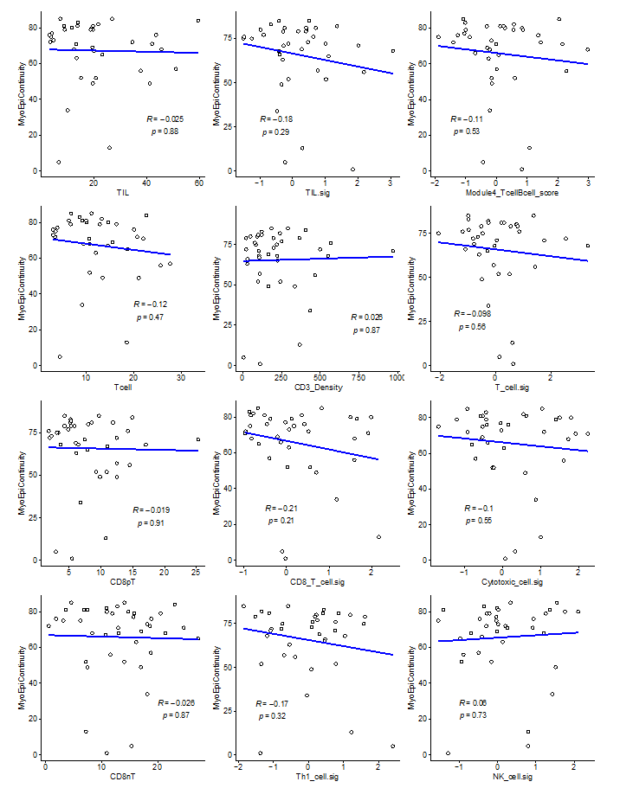
Supplementary Figure S8. Correlations between cell populations identified by mIF staining or gene expression signatures (x-axes) and myoepithelial continuity score (y-axes). Pearson R and p values
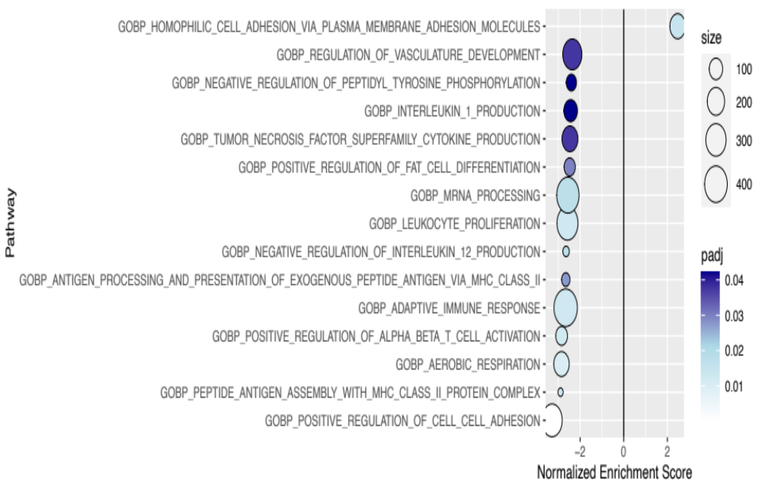Supplementary Figure S9. Gene set enrichment analysis (GSEA) identifies ontologies enriched in DCIS with low or high myoepithelial continuity. Normalized enrichment scores are given for each feature ontology. Only ontologies with adjusted p values <0.05 are shown. Size of points is related to the number of genes in each pathway. Points are colored by significance (adjusted p values).

