SUPPLEMENTARY MATERIAL
Neural Networks of the Mouse Primary Visceromotor Cortex
Houri Hintiryan^{1#}, Muye Zhu^{1#$}, Pingping Zhao², Mingmin Zhang^{3,4}, Joshua Barry⁵, Sumit Nanda¹, Mitchell Rudd¹, Angela Wong³, Samara Miller², Lin Gou¹, Jinxing Wei⁶, Brian Zingg¹, Jiandong Sun¹, Adriana Gutierrez¹, Hyun-Seung Mun¹, Yeji E. Yang¹, Ian Bowman¹, Luis Garcia¹, Darrick Lo¹, Tyler Boesen¹, Chunru Cao¹, Qiuying Zhao¹, Nicholas N. Foster¹, Keivan Moradi¹, Seita Yamashita¹, Christian Estrada¹, Aishwarya Dev¹, Jennifer Gonzalez¹, Hanpeng Xu¹, Gavin Yang¹, Chang Sin Park^{7,8}, X. William Yang^{7,8}, Michael S. Levine⁵, Li I. Zhang⁶, Paul Micevych³, Carlos Cepeda⁵, Peyman Golshani^{2,9}, Weizhe Hong^{3,4}, Hong-Wei Dong¹*
Affiliations:
1. UCLA Brain Research & Artificial Intelligence Nexus, Department of Neurobiology, David Geffen School of Medicine at UCLA, University of California Los Angeles, Los Angeles, CA 90089, USA
2. Department of Neurology, David Geffen School of Medicine at UCLA, University of California Los Angeles, Los Angeles, CA 90089, USA
3. Department of Neurobiology, David Geffen School of Medicine, University of California, Los Angeles, Los Angeles, CA, USA.
4. Department of Biological Chemistry, David Geffen School of Medicine, University of California, Los Angeles, Los Angeles, CA, USA.
5. IDDRC, Jane and Terry Semel Institute for Neuroscience and Human Behavior, Department of Psychiatry and Biobehavioral Sciences, David Geffen School of Medicine at UCLA, Los Angeles, CA 90089, USA
6. Center for Neural Circuits and Sensory Processing Disorders, Zilkha Neurogenetic Institute, Keck School of Medicine, University of Southern California, Los Angeles, CA 90033, USA
7. Center for Neurobehavioral Genetics, Semel Institute for Neuroscience & Human Behavior, University of California, Los Angeles, Los Angeles, CA, USA
8. Department of Psychiatry and Biobehavioral Sciences, David Geffen School of Medicine, University of California, Los Angeles, Los Angeles, CA, USA
9. Greater Los Angeles VA Medical Center, Los Angeles, CA, 90034 USA

# These authors made equal contributions.
$ Current address: Google, Boulder, CO, USA.

*Correspondence should be addressed to HongWeiD@mednet.ucla.edu

SUPPLEMENTARY METHODS
Calculating MPF cortical layer 1 thickness
With updated boundaries, we calculated the thickness of layer 1 in the DP and made a quantitative comparison with that of the ILA, prelimbic cortex (PL), ventral (ACAv) and dorsal anterior cingulate area (ACAd), as well as the TTd in the ARA. On each atlas level l, denote the curve intersections of cortical layer 1 pial and inner surfaces with the x-y plane C_{pial}^{l} (r_{l}(u)) and C_{inner}^{l} (r_{l}(v)), where u,v ∈ [0,1] . The cortical thickness is calculated as distance between the surfaces S_{pial} and S_{inner}.
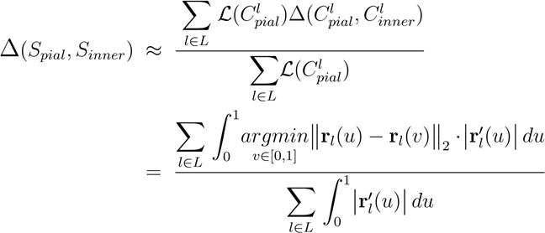
We obtained cortical layer 1 thickness for the DP, ILA, PL, ACA, and TTd as 209.15 µm, 132.98 µm, 160.98, 146.89, and 107.56 µm. Kruskal-Wallis test run on cortical thickness at points along C_{inner} showed highly significant differences among the 5 cortical areas [H(4) = 8137.11, p < 0.01]. See Extended Data Fig. 1.

Overview of connectivity data collection, analysis, and validation
We methodically investigated the brain-wide input/output connectivity of the DPd, DPs, ILA, PL, ACAv, and ACAd utilizing our data production and collection pipeline. A total of 250 anterogradely and retrogradely traced pathways with injections in the cortex, hippocampus, amygdala, thalamus, hypothalamus, and brainstem structures were examined. A select number of those anterograde (AAV, PHAL, BDA) and retrograde (CTB, FG) tracer injections made in the DPs, DPd, ILA, PL, ACAd, ACAv and TTd were chosen to be processed and annotated for quantitative analysis of their connectivity patterns: DPs (n=4 anterograde, 3 retrograde), DPd (n=2, 1), ILA (n=3, 2), PL (n=3, 3), ACAd (n=3, 3), and ACAv (n=3, 3) (Extended Data Fig. 6).
This data is also used to construct the brain-wide wiring diagram of the MPF. Additional experiments involving injections into the MPF and other structures were conducted to validate connection accuracy, investigate pathway convergence and divergence, and expand multi-synaptic circuits. Altogether, this extensive connectivity dataset (anterograde, retrograde, and transsynaptic) enables the reconstruction of comprehensive global neural networks of the MPF.

To quantitatively analyze the connectivity data, we utilized our image processing and data annotation software Outspector ^{1,2,3,4,5} (see subsection Outspector: 2D image processing pipeline below for all details regarding). Within Outspector, individual sections throughout the brain for each experimental case were matched to their corresponding ARA level. A semi-automated registration algorithm was applied to warp each section to its coupled ARA section template. The registration output was refined through an iterative process of user interaction to ensure optimal registration especially for error prone regions (e.g., cortical layers, small nuclei). This timely, yet necessary, step assures the accurate annotation of tracer label location compared to the output of more expedient, fully automated registration algorithms (Extended Data Fig. 10). In Figure 2 and Extended Data Fig. 11, note the congruency between the visualized and raw tracing results. In Extended Data Fig. 10, note the consistency between our results and well-established MPF connections reported in the literature. Tracer labels were then segmented and annotated (pixel density for axonal fibers and cell counts for labeled neurons). Further, we devised an in-house statistical pipeline to quantitatively compare the connectivity of each MPF component (see subsection Statistical model for brain connectivity below). The annotated data were averaged across cases for each ROI, normalized, and anterograde, retrograde, and reciprocal connections were analyzed. Results were visualized in bar graphs, clustermaps, and connection maps. Global projection pathways of individual MPF areas are also summarized on a mouse brain flatmap (Extended Data Fig. 9) and an online application was developed to allow users to view the brainwide input and output label patterns of each injection site (https://brain.neurobio.ucla.edu/mpf/; username: guest, password: mpfbrainmap710).

Multiple measures were implemented to guarantee data reliability. First, injection site analysis was performed to establish the precise anatomic location of each injection (see subsection Injection site analysis below). In addition, 2D hierarchical clustering, which groups together injection sites with similar label patterns, was performed to assess the consistency of labeling of repeated injections within individual MPF areas. Regardless of the anterograde or retrograde tracer used, injections in each MPF region grouped together (Extended Data Fig. 7f). Finally, anterograde tracing data was validated by placing retrograde tracers in regions with axon terminals, while retrograde tracing data was validated by placing anterograde tracers in regions with labeled cells. Additional transsynaptic and TVA receptor mediated rabies tracing experiments were conducted to expand on the network model of the MPF beyond first-order inputs and outputs, which also validated connections. These experiments are introduced in the corresponding sections of the paper (see Methods subsections TRIO tracing and AAV1-Cre-based anterograde transsynaptic tracing for details).

Outspector: our proprietary 2D image processing pipeline
To quantitatively analyze the structural connectivity of the MPF, we developed a comprehensive image processing and data analytic pipeline. Our in-house software Outspector enables seamless GUI interaction with the pipeline, which is deployed on a high-performance computing cluster.

In a standard Mouse Connectome Project (MCP) experiment (MCP, www.MouseConnectome.org), a single animal undergoes injections of up to four anterograde and/or retrograde tracers targeting distinct brain structures. Post-surgery, the animals have a survival period of 2-3 weeks, followed by sacrifice through 4% PFA transcardiac perfusion followed by brain extraction. Brains are then coronally sectioned at a thickness of 50 µm. A series of one in four sections (approximately 40-50 sections spaced 200 µm apart) along the rostrocaudal axis are processed to reveal tracer labeling with fluorescent dyes, resulting in a collection of 40 to 50 sampled sections for subsequent processing and analysis (see Methods for detailed tissue processing procedures).

We developed a high throughput pipeline that achieves high-quality image registration and tracer signal quantification. The pipeline was deployed on a high-performance computing cluster to process TB range raw image data. Furthermore, Outspector provides a friendly GUI for users to interactively fine-tune the computation results at various stages of the pipeline.

Image registration. We registered our tissue sections to the Allen Reference Atlas ⁶, which provides high-resolution Nissl stained coronal brain section images and interactive, scalable drawings of region boundaries. The ARA can be accessed freely at http://mouse.brain-map.org/static/atlas. Our registration employs a semi-automatic, diffeomorphic 2D-to-2D registration process, allowing optional user interaction to fine-tune the registration when necessary. The registration follows steps as outlined below.

(1) Assign an ARA level to each section in the series. Initially, the coronal section corresponding to ARA level 53 (at the level of Bregma point) is manually identified. All remaining sections receive a level estimation by assuming that all neighboring section pairs are 2 levels apart (see Methods subsection, Tissue preparation and immunohistochemistry). A researcher then verifies the level assignment and makes necessary corrections.
(2) Perform a coarse alignment with geometric transformations. We extract a binary tissue mask from the Nissl channel using a Gaussian Mixture Model (GMM). A set of geometric transformation parameters is derived analytically from the extracted masks of both the scanned and the reference image. The coarse alignment greatly benefits downstream non-linear registration methods with high degrees of freedom (DoF), reducing occurrence of suboptimal solutions at local minimums ^{7,8}.

Supplementary Fig. 1A below illustrates the pixel intensity histogram of a typical Nissl-stained section. Within the GMM framework, the probability of observing pixel intensity $x$is given by the following:
$$p\left(x\right)=w_{f}∙N(x|μ_{f},σ_{f}^{2})+w_{b}∙N(x|μ_{b},σ_{b}^{2})$$
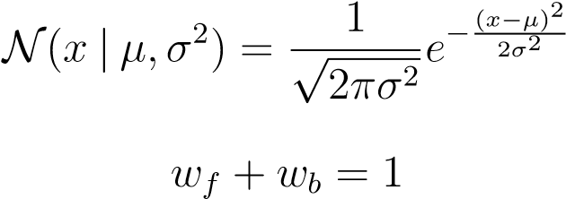

where the model parameters w_{f}, µ_{f}, σ_{f}, w_{b}, µ_{b}, σ_{b} are found with the Expectation Maximization (EM) algorithm. Background (b) or foreground (f) probability for each pixel is given by the Bayesian rule:
$${p(c|x)}_{c∈ ADDIN EN.CITE <EndNote><Cite><Author>Alexander</Author><Year>2023</Year><RecNum>911</RecNum><DisplayText><style face="superscript">9</style></DisplayText><record><rec-number>911</rec-number><foreign-keys><key app="EN" db-id="zsat25wzu9zeepes9zq52prfwd0vp5pesezz" timestamp="1679330299">911</key></foreign-keys><ref-type name="Journal Article">17</ref-type><contributors><authors><author>Alexander, L.</author><author>Wood, C. M.</author><author>Roberts, A. C.</author></authors></contributors><auth-address>St Thomas\&apos; Hospital, London, UK.\&\#xD;Department of Psychological Medicine, School of Academic Psychiatry, Institute of Psychiatry, Psychology and Neuroscience, King\&apos;s College London, London, UK.\&\#xD;Department of Physiology, Development and Neuroscience, University of Cambridge, Cambridge, UK.\&\#xD;Behavioural and Clinical Neuroscience Institute, University of Cambridge, Cambridge, UK.</auth-address><titles><title>The ventromedial prefrontal cortex and emotion regulation: lost in translation?</title><secondary-title>J Physiol</secondary-title></titles><pages>37-50</pages><volume>601</volume><number>1</number><edition>20220611</edition><keywords><keyword>Animals</keyword><keyword>Humans</keyword><keyword>*Emotional Regulation</keyword><keyword>Magnetic Resonance Imaging</keyword><keyword>Prefrontal Cortex/physiology</keyword><keyword>Emotions/physiology</keyword><keyword>Cognition</keyword><keyword>Callithrix</keyword><keyword>anhedonia</keyword><keyword>anxiety</keyword><keyword>subcallosal cingulate</keyword></keywords><dates><year>2023</year><pub-dates><date>Jan</date></pub-dates></dates><isbn>1469-7793 (Electronic)\&\#xD;0022-3751 (Linking)</isbn><accession-num>35635793</accession-num><urls><related-urls><url>https://www.ncbi.nlm.nih.gov/pubmed/35635793</url></related-urls></urls><electronic-resource-num>10.1113/JP282627</electronic-resource-num><remote-database-name>Medline</remote-database-name><remote-database-provider>NLM</remote-database-provider></record></Cite></EndNote>Error! Bookmark not defined.}=\frac{w_{c}∙N(x|μ_{c},σ_{c}^{2})}{p(x)}$$
We extract the foreground mask with a stringent intensity threshold value, x_{t} = µ_{b} +6σ_{b}. Supplementary Fig. 1A displays a typical segmentation result of the tissue mask.

We had limited success finding optimal parameters of the geometric transformation using common registration algorithms, therefore we derive these parameters analytically as described below. To obtain the rotation matrix, we identify the smallest rectangle, Rec_{section}, fully containing the binary tissue mask of the scanned image using the rotating calipers method ¹⁰. A similar rectangle, Rec_{atlas}, is identified for the atlas image. The angle θ between Rec_{section} and Rec_{atlas} determines the rotation matrix. The translation vector and scaling factor are defined as differences between the centers of masses of the binary masks (${Mask}_{section}$ and ${Mask}_{atlas}$), and the ratio of the mask areas, respectively. Supplementary Fig. 1B illustrates representative results of the geometric transformation.
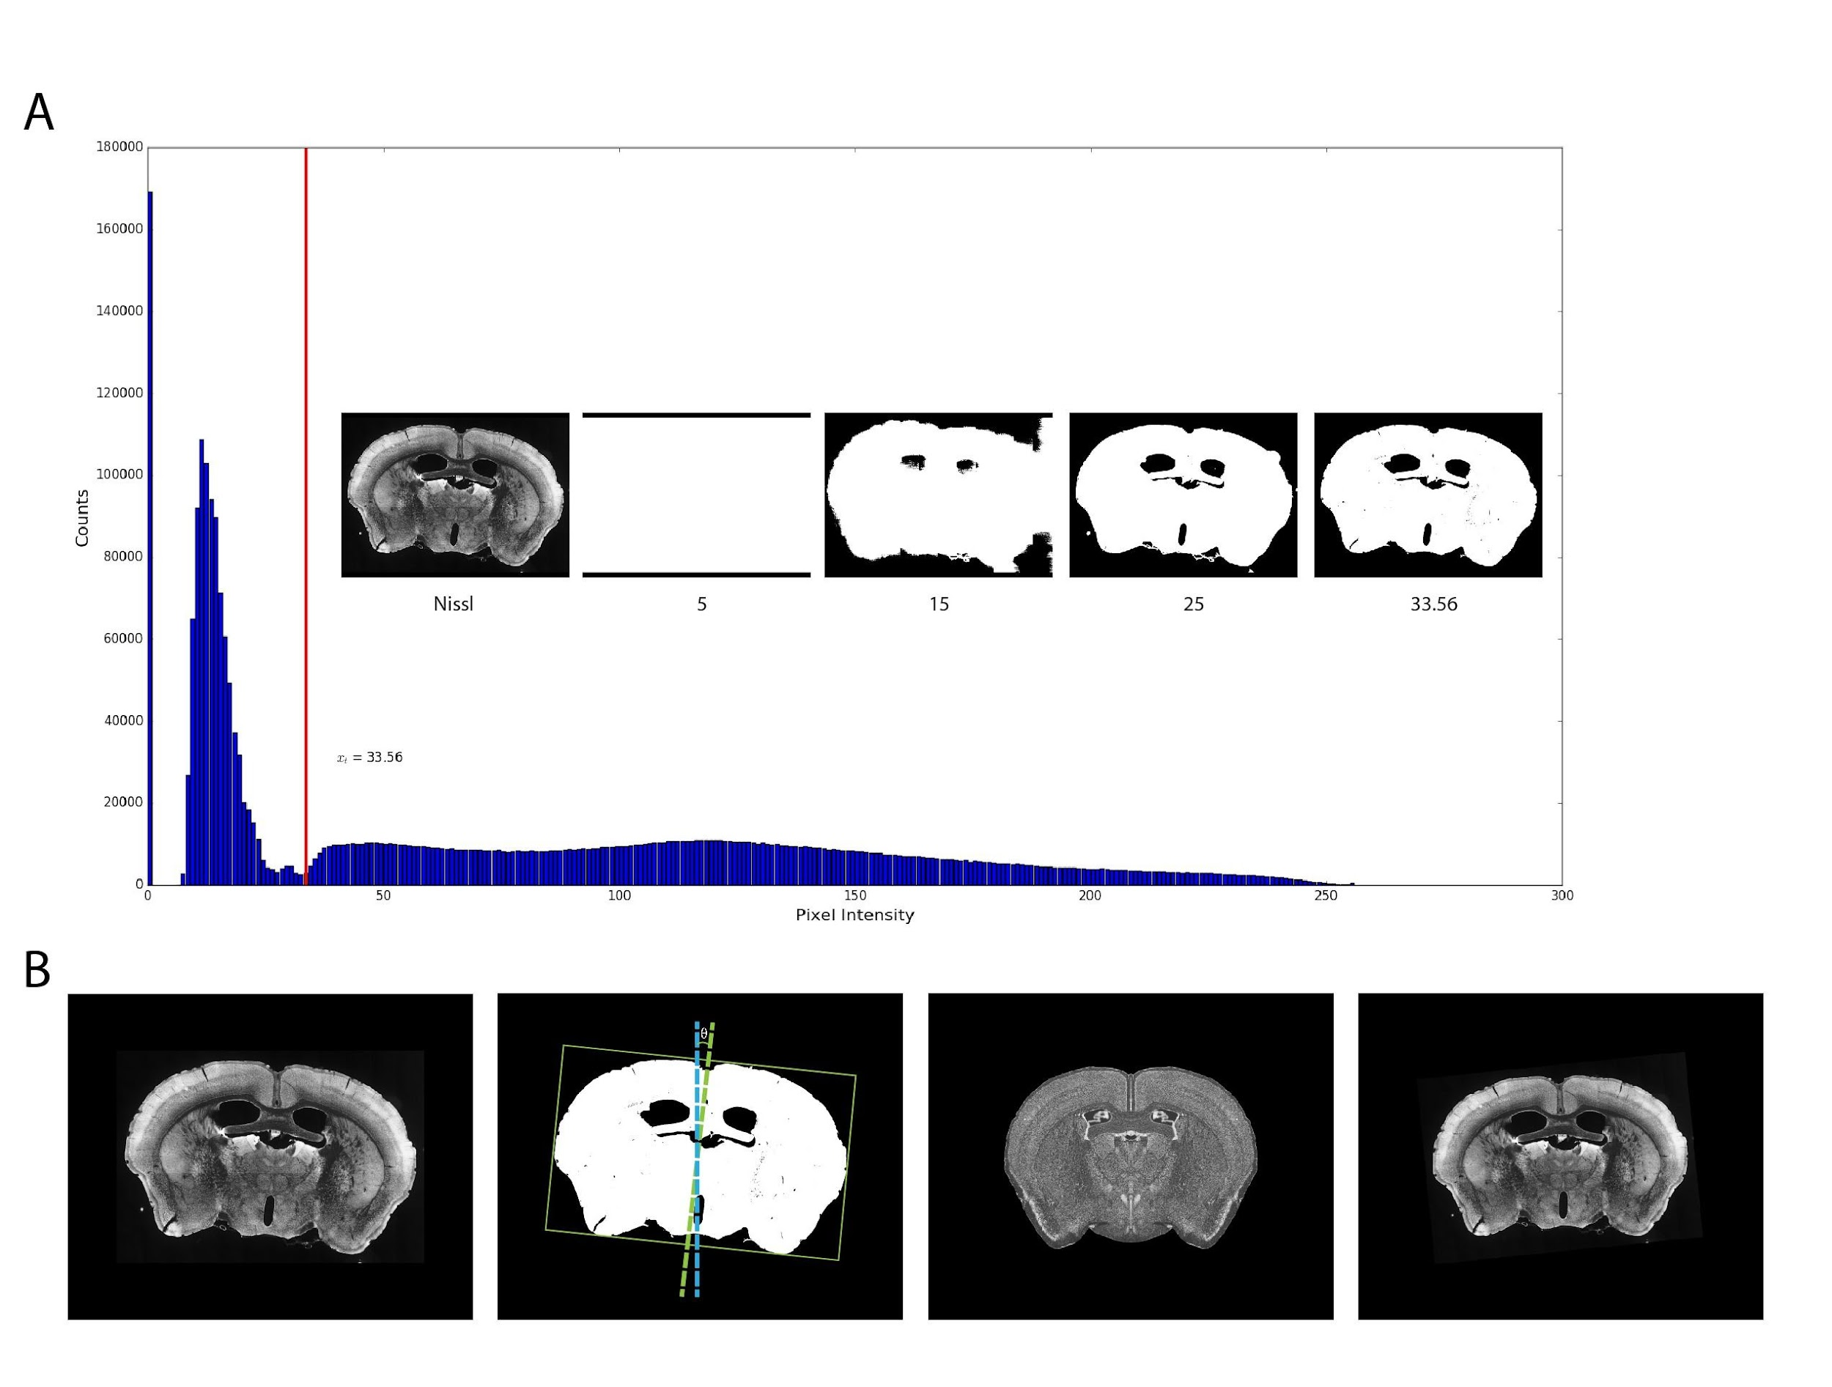
Supplementary Fig. 1. Tissue Segmentation and Initialization of Tissue Alignment by Geometric Transform. (A) Typical result of tissue mask segmentation of a Nissl-stained section. The intensity value of 33.56 found by the algorithm is shown at the red line over the image intensity histogram. Result from a range of other values is shown for comparison. (B) Geometric transformation provides an initial alignment for Nissl-stained sections. The tightest fitting bounding box and difference between desired and actual tissue angle is shown with the extracted tissue binary mask. A reference atlas image and the transformed tissue is shown in the right two figures.
(3) Minimize image energy by applying diffeomorphic non-parametric demon algorithm.

(4) Modify correspondence points and repeat step (3) if necessary. After the automatic registration process, researchers visually inspect the quality of the registration. Where needed, correspondence points between the image pair found by the algorithm are adjusted to fine-tune the registration. Certain brain regions are more susceptible to registration errors, notably the thin neocortical layer 6b, the thalamic nuclei that vary rapidly along the z-axis, and regions with subtle cyto-architectural differences from adjacent regions (e.g., claustrum). In studies where precise registration matters, human fine-tuning of correspondence points greatly mitigates registration errors in such regions.

Injection site analysis. Accurate anatomic annotation of tracer injection sites is crucial for analyzing and interpreting neuroanatomical data. In addition, we found the exceptionally high fluorescent intensities near injection sites distort overall connectivity quantification results, as they account for a significant proportion of total brain fluorescence. In anterograde tracing experiments, when care is taken to avoid overexposure during imaging, the injection site starter cell population is discernable. We extracted anterograde tracing starter cells and retrograde injection centers using techniques including multi-scale wavelet decomposition, non-linear adaptive intensity adjustment, and maximally stable extremal regions (MSER) detection.
Starter cells at anterograde tracer injection sites are surrounded by highly irregular and intense fluorescent background. To segment individual start cells, we begin by dampening signals from irrelevant frequencies with wavelet decomposition. In the wavelet decomposition, a filter bank of high and low pass filters is successively applied to the input data, giving coefficients for a sequence of frequency bands at increasingly coarse scales. For a 2D image f(x,y), its discrete wavelet decomposition with scales l ∈ {1,...,l_{m}} is as follows:
$$f\left(x,y\right)=\sum_{i∈D_{x}}{\sum_{j∈D_{y}}{C_{l_{m},ij}^{LL}∙Φ_{l_{m},ij}^{LL}\left(x,y\right)}}+\sum_{l}{\sum_{i∈D_{x}}{\sum_{j∈D_{y}}{C_{l,ij}^{LH}∙Ψ_{l,ij}^{LH}\left(x,y\right)}}}+$$
$$\sum_{l}{\sum_{i∈D_{x}}{\sum_{j∈D_{y}}{C_{l,ij}^{HL}∙Ψ_{l,ij}^{HL}\left(x,y\right)+\sum_{l}{\sum_{i∈D_{x}}{\sum_{j∈D_{y}}{C_{l,ij}^{HH}∙Ψ_{l,ij}^{HH}(x,y)}}}}}}$$
where Φ^{LL} is the scaling function, and Ψ^{LH}, Ψ^{HL}, Ψ^{HH} are the wavelet functions. Ψ^{LH} applies low pass filter along the x axis and high pass filter along the y axis, condensing horizontal details of the image into the coefficients C^{LH}. Similarly, C^{HL} and C^{HH} carry vertical and diagonal details respectively. C^{LL} is the low pass coefficients. At each level $l$, $C_{l}^{LL}$ is decomposed to${ C}_{l+1}^{LL}$, ${ C}_{l+1}^{LH}$, ${ C}_{l+1}^{HL}$, ${ C}_{l+1}^{HH}$, where the level $l+1$ coefficients array contains 1/4 the number of elements of level $l$. The image is encoded by low pass coefficients and vertical, horizontal, and diagonal detail coefficients at different scales as
$$f\left(x,y\right)⇔\{C_{l_{m}}^{LL},C_{l}^{LH},C_{l}^{HL},C_{l}^{HH}:l∈\{1,…,l_{m}\}$$
We cropped a rectangular subregion I_{inj}(x,y) that contains the injection site from the section image I(x,y). I_{inj}(x,y) is Gaussian smoothened and wavelet decomposed into 5 levels L = {1,2,3,4,5}:
$$I_{inj}\left(x,y\right)⇔\{{ C}_{5}^{LL},C_{l}^{LH},C_{l}^{HL},C_{l}^{HH}:l∈L \}$$

Detail coefficients at levels 1, 2, 3 are all dampened to suppress noise. Neuronal cell bodies are blobs within a certain range of physical dimensions. Empirically, we found their image signals well accounted for by diagonal detail coefficients $C_{4}^{HH}$ and $C_{5}^{HH}$. At these two levels, C^{HH} values large in magnitude are augmented, while C^{HL} and C^{LH} values small in magnitudes are suppressed. Specifically, for some $k_{l}^{↑}∈\left(1,∞\right),k_{l}^{↓}∈\left[0,1\right),γ∈(1,∞)$:
$$\tilde{C_{l,ij}^{HH}}=\left\{\begin{aligned}C_{l,ij}^{HH}∙k_{l}^{↑}, if \left|C_{l,ij}^{HH}\right|>γ∙\left|C_{l,ij}^{HL}\right| and C_{l,ij}^{HH}∙C_{l,ij}^{HL}>0 \\ C_{l,ij}^{HH}∙k_{l}^{↑}, if \left|C_{l,ij}^{HH}\right|>γ∙\left|C_{l,ij}^{LH}\right| and C_{l,ij}^{HH}∙C_{l,ij}^{LH}>0 \\ C_{l,ij}^{HH}, otherwise\end{aligned}\right.$$

$$\tilde{C_{l,ij}^{HL}}=\left\{\begin{aligned}C_{l,ij}^{HL}∙k_{l}^{↓}, if \left|C_{l,ij}^{HL}\right|< \frac{\left|C_{l,ij}^{HH}\right|}{γ} and C_{l,ij}^{HL}∙C_{l,ij}^{HH}>0 \\ C_{l,ij}^{HL}∙k_{l}^{↓}, if \left|C_{l,ij}^{HL}\right|< \frac{\left|C_{l,ij}^{LH}\right|}{γ} and C_{l,ij}^{HL}∙C_{l,ij}^{LH}>0 \\ C_{l,ij}^{HL}, otherwise\end{aligned}\right.$$
$$\tilde{C_{l,ij}^{LH}}=\left\{\begin{aligned}C_{l,ij}^{LH}∙k_{l}^{↓}, if \left|C_{l,ij}^{LH}\right|< \frac{\left|C_{l,ij}^{HH}\right|}{γ} and C_{l,ij}^{LH}∙C_{l,ij}^{HH}>0 \\ C_{l,ij}^{LH}∙k_{l}^{↓}, if \left|C_{l,ij}^{LH}\right|< \frac{\left|C_{l,ij}^{HL}\right|}{γ} and C_{l,ij}^{LH}∙C_{l,ij}^{HL}>0 \\ C_{l,ij}^{LH}, otherwise\end{aligned}\right.$$
The low frequency coefficients $C_{5}^{LL}$ are dampened and convolved with a Gaussian kernel to smooth image background.
$$\tilde{C_{5}^{LL}}=(C_{5}^{LL}∙k_{5}^{↓})*g(x,y)$$
The updated coefficients are used to reconstruct the injection site image
$$\tilde{I_{inj}\left(x,y\right)}=\sum_{i∈D_{x}}{\sum_{j∈D_{y}}{\tilde{C_{5,ij}^{LL}}∙Φ_{l_{m},ij}^{LL}\left(x,y\right)}}+\sum_{l=1}^{5}{\sum_{i∈D_{x}}{\sum_{j∈D_{y}}{\tilde{C_{l,ij}^{LH}}∙Ψ_{l,ij}^{LH}\left(x,y\right)}}}+$$
$$\sum_{l=1}^{5}{\sum_{i∈D_{x}}{\sum_{j∈D_{y}}{\tilde{C_{l,ij}^{HL}}∙Ψ_{l,ij}^{HL}\left(x,y\right)}}}+\sum_{l=1}^{5}{\sum_{i∈D_{x}}{\sum_{j∈D_{y}}{\tilde{C_{l,ij}^{HH}}∙Ψ_{l,ij}^{HH}\left(x,y\right)}}}$$
We then applied a non-linear local adaptive contrast enhance to I_{inj}(x,y), and finally extracted injection site cell bodies using MSER ¹¹. Supplementary Fig. 2A shows the results from anterograde tracer injection site start cell detection.

For retrograde tracer injection sites, single cell extraction is not meaningful. Instead, we focus on identifying the injection location. We employ a similar wavelet decomposition and MSER approach. Since single-cell resolution is not required, we apply stronger Gaussian smoothing to I_{inj}(x,y), and omit local adaptive contrast enhancement. The wavelet filtering sets to zero all levels 1 through 3 detail coefficients and leaves the low pass coefficients unmodified. Harsher stability parameters are used in MSER to favor large components that maintain their sizes across a wider range of threshold levels.

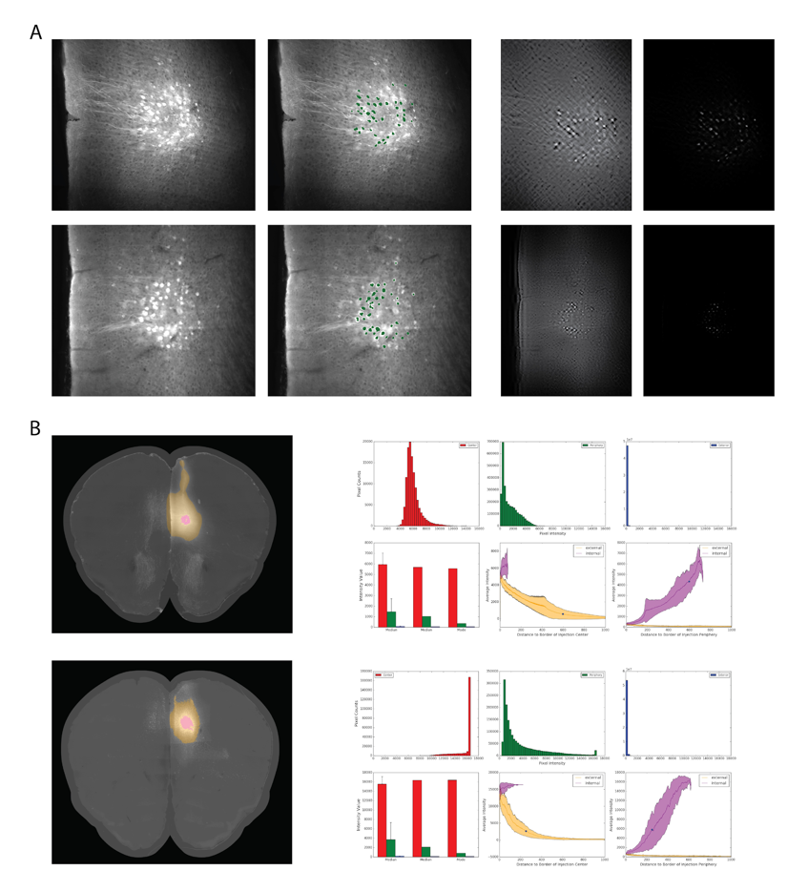
The identified injection centers are highlighted with a pink shade in Supplementary Fig. 2B's left column. These injection center pixels have intensity ranges well above signals from tracer labeling or autofluorescence (Supplementary Fig. 2B). A set of pixels adjacent to the injection center accumulate substantial intensity due to point spread function of the imaging system. These adjacent pixels provide very little connectivity information since their intensity is primarily explained by their proximity to the injection center. We consider these pixels as the injection periphery and extract it using identical methods and parameters as for the injection center, but using the entire image I(x,y) (rather than I_{inj}(x,y)) as input. We find that masking the extracted injection sites, including both the center and periphery, greatly improves segmentation outcomes.
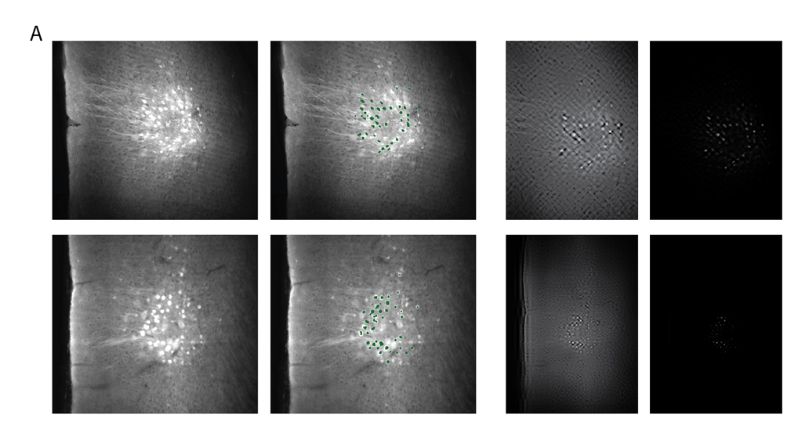
Supplementary Fig. 2. Injection site analysis. (A) Injection site starter cell detection. Original image and detected cells (green dots) are shown in the left panels. Intermediate results after wavelet filtering and intensity transform are shown in right panel. (B) Extracted injection site center and periphery. The center is shown as pink, and periphery as yellow over the original image.

Tracer segmentation and quantification. Segmenting axonal fibers from fluorescent microscopy images poses challenges attributed to factors such as high variance in true fluorescent signal intensity, image features spanning multiple scales, and strong tissue autofluorescence. To tackle these challenges, we generate a belief map based on both pixel intensity and local features in the linear Gaussian scale space. Additionally, we create a texture map by cross-referencing the Nissl channel. The segmentation of fiber pixels is accomplished by applying dual thresholds in both the belief map and the texture map.
Axonal fibers manifest as curvilinear structures. Lines in images are characterized by rapid changes in the derivatives of image intensity. Consequently, second-order image derivatives are widely utilized in line detection and enhancement filters. Since second order derivatives are sensitive to noise, often the image is smoothed by a Gaussian convolution kernel $g\left(x;σ_{g}^{2}\right)$ prior to differentiation.

The linear Gaussian scale space is a framework to represent images at multiple scales. For a 2D image f(x,y) and a set of non-negative scale parameters T, its scale space representation is a family of derived images defined by the convolution between f(x,y) and a Gaussian kernel with scale $t$¹²:
$$\left\{ I\left(x,y;t\right); t∈T \right\}=\{ f\left(x,y\right)*\frac{1}{2πt}e^{-\frac{x^{2}+y^{2}}{2t}}; t∈T \}$$

At t = 0, I(x,y;0) is defined as f(x,y) itself. By applying a sequence of Gaussian convolutions $\left[g_{0}, g_{1},…,g_{i},…\right]$ with appropriate scale parameters $σ_{g_{i}}^{2}$, one can obtain multi-scaled responses at line structures ^{13,14}. To reduce CPU and memory usage during computation, we use the Gaussian pyramids to approximate the scale space of f(x,y). For pyramid level l > 0:

$$I^{l+1}\left(x,y;σ_{g}^{2}\right)=Subsample(I^{l}\left(x,y;σ_{g}^{2}\right)*g(x,y;σ_{g}^{2}))$$

We found both the rate of changes and magnitude of image intensity important for fiber segmentation. To reflect these two aspects, at a given level l, we apply the Laplacian filter to I^{l} as a line filter:
$$∇^{2}\left(I^{l}\left(x,y;σ_{g}^{2}\right)\right)=\frac{∂^{2}I^{l}\left(x,y;σ_{g}^{2}\right)}{∂x^{2}}+\frac{∂^{2}I^{l}\left(x,y;σ_{g}^{2}\right)}{∂y^{2}}$$
An image feature map F^{l} is calculated as element-wise multiplication of the image and Laplacian of the image:
$$F^{l}\left(x,y;σ_{g}^{2}\right)=I^{l}\left(x,y;σ_{g}^{2}\right){⊙∇}^{2}\left(I^{l}\left(x,y;σ_{g}^{2}\right)\right)$$
We now define some probabilistic events used to generate belief map for axonal fibers:
${(i,j)}^{+}|l$: pixel (i,j) belongs to an axonal fiber in the level l image representation.
${(i,j)}^{+}$: pixel (i,j) belongs to an axonal fiber in some level of the image representation.
${w_{ij}\left(r\right)}^{+}|l$: some pixel within the width r square window, centered at (I, j), belongs to an axonal fiber in the level l image representation.

We are ultimately interested in the belief map B, where B_{ij} approximates the probability of the event (i,j)⁺. Let L be the set of all levels used in the scale space representation. We define B as a weighted combination of $B^{L}=\left\{B^{0},B^{1},…,B^{l},…\right\}, l∈L$, where $B^{l}$is the belief map derived from feature map at scale level $l$, and $B_{ij}^{l}$ represents the probability of the event ${(i,j)}^{+}|l$ . Let $π^{l}$ be the probability of true axonal fiber presence at scale level $l$:

$$P\left({\left(i,j\right)}^{+}\right)=\sum_{l∈L}{π_{ij}^{l}B_{ij}^{l}=\sum_{l∈L}{π_{ij}^{l}P\left({\left(i,j\right)}^{+}|l\right)=\sum_{l∈L}{π_{ij}^{l}\frac{P({w_{ij}\left(r\right)}^{+}|l)∙P({\left(i,j\right)}^{+}|({w_{ij}\left(r\right)}^{+},l)}{P({w_{ij}\left(r\right)}^{+}|{\left(i,j\right)}^{+},l)}}}}$$

By definition of the events, $P({w_{ij}\left(r\right)}^{+}|{\left(i,j\right)}^{+},l)$ is equal to 1 and can simply be dropped from the equation. $P({w_{ij}\left(r\right)}^{+}|l)$ is estimated as the probability of drawing a pixel from the image with feature value no greater than the average feature value of $w_{ij}(r)$:
$$P\left({w_{ij}\left(r\right)}^{+} | l\right)=\int_{-∞}^{u_{ij}(r)}{f(t;μ_{F^{l},}σ_{F^{l}}^{2})}dt$$
$$u_{ij}\left(r\right)=\frac{\sum_{(m,n)∈w_{ij}(r)}{F_{mn}^{l}}}{r^{2}}$$

where $f$ is a probability density function, whose parameters are estimated from $μ_{F^{l},}$ and $σ_{F^{l}}^{2}$.
$P({\left(i,j\right)}^{+}|({w_{ij}\left(r\right)}^{+},l)$ is similarly estimated with feature values within $w_{ij}(r)$:

$$P({\left(i,j\right)}^{+}|\left({w_{ij}\left(r\right)}^{+},l\right)=\int_{-∞}^{F_{ij}^{l}}{f(t;{μ_{w_{ij}\left(r\right)}}_{,}σ_{w_{ij}\left(r\right)}^{2})}dt$$

Successive upsampling is then applied to $B^{l}$ a total of l times to generate a belief map $\hat{B^{l}}$ with the same matrix dimensions as $B^{0}$.
Although B^{L} can be calculated, the values of $π^{l}$ are difficult to know a priori. Inappropriate $π^{l}$ values lead to loss of fine axonal fiber detail, or failure to capture larger fiber bundles. We simplify the problem to identifying a single level $l$ for each pixel (i, j) that sufficiently represents the fiber signal at that pixel, with a preference for the finest resolution. For l ≥ 0 and some chosen η > 1, we finalize B as

$$B_{ij}=\max_{l∈L}(1(\hat{B_{ij}^{l}}>ηB_{ij}^{0})+1(l=0))$$

Within the tissue section, both the extra-cellular matrix and cellular contents emit autofluorescence when excited by suitable wavelengths ¹⁵. In our datasets, autofluorescence can be considered as image texture and causes noise during segmentation. To quantify the amount of intensity variance in an image explained by autofluorescence, we compute a texture map T, defined as the Pearson correlation coefficients between pixel neighborhoods of two image channels f(x,y) and g(x,y):
$$T_{ij}=\frac{cov(f_{w_{ij}\left(r\right),}{ g}_{w_{ij}\left(r\right)})}{σ_{f_{w_{ij}\left(r\right)}}σ_{g_{w_{ij}\left(r\right)}}}=\frac{E\left[f_{w_{ij}\left(r\right)}∙g_{w_{ij}\left(r\right)}\right]-E[f_{w_{ij}\left(r\right)}]∙E[g_{w_{ij}\left(r\right)}]}{σ_{f_{w_{ij}\left(r\right)}}σ_{g_{w_{ij}\left(r\right)}}}$$
$$f_{w_{ij}\left(r\right)}=\left\{ f\left(m,n\right):\left(m,n\right)∈w_{ij}\left(r\right) \right\}, { g}_{w_{ij}\left(r\right)}=\{ g\left(m,n\right):(m,n)∈w_{ij}\left(r\right) \}$$
We use the tracer channel image as f(x,y) and the Nissl channel image of the same section as g(x,y). For ideal images f(x,y) and g(x,y) with no autofluorescence, since the fluorescence arise from two different markers with no intrinsic tendency of co-localization, we expect to see T_{ij} with small magnitudes. In the presence of fluorescence, regions of f(x,y) and g(x,y) where significant pixel intensities are generated by autofluorescence, the corresponding magnitudes of T_{ij} will be closer to 1. With two chosen threshold values $t_{B}$ and $t_{T}$, the pixel-wise segmentation S of anterograde tracer labeled axonal fiber is defined as:
$$S_{ij}=1(B_{ij}>t_{B})∙1(T_{ij}<t_{T})$$

Retrograde tracer labeled cell body segmentation follows the same method as axonal segmentation, with additional post processing to impose morphological constraints: (1) filling holes and convex deficits in segmented objects (2) separating touching objects with watershed algorithm and (3) removing objects that are small or eccentric.

We base our connectivity quantification on segmented anterograde and retrograde tracer pixels.
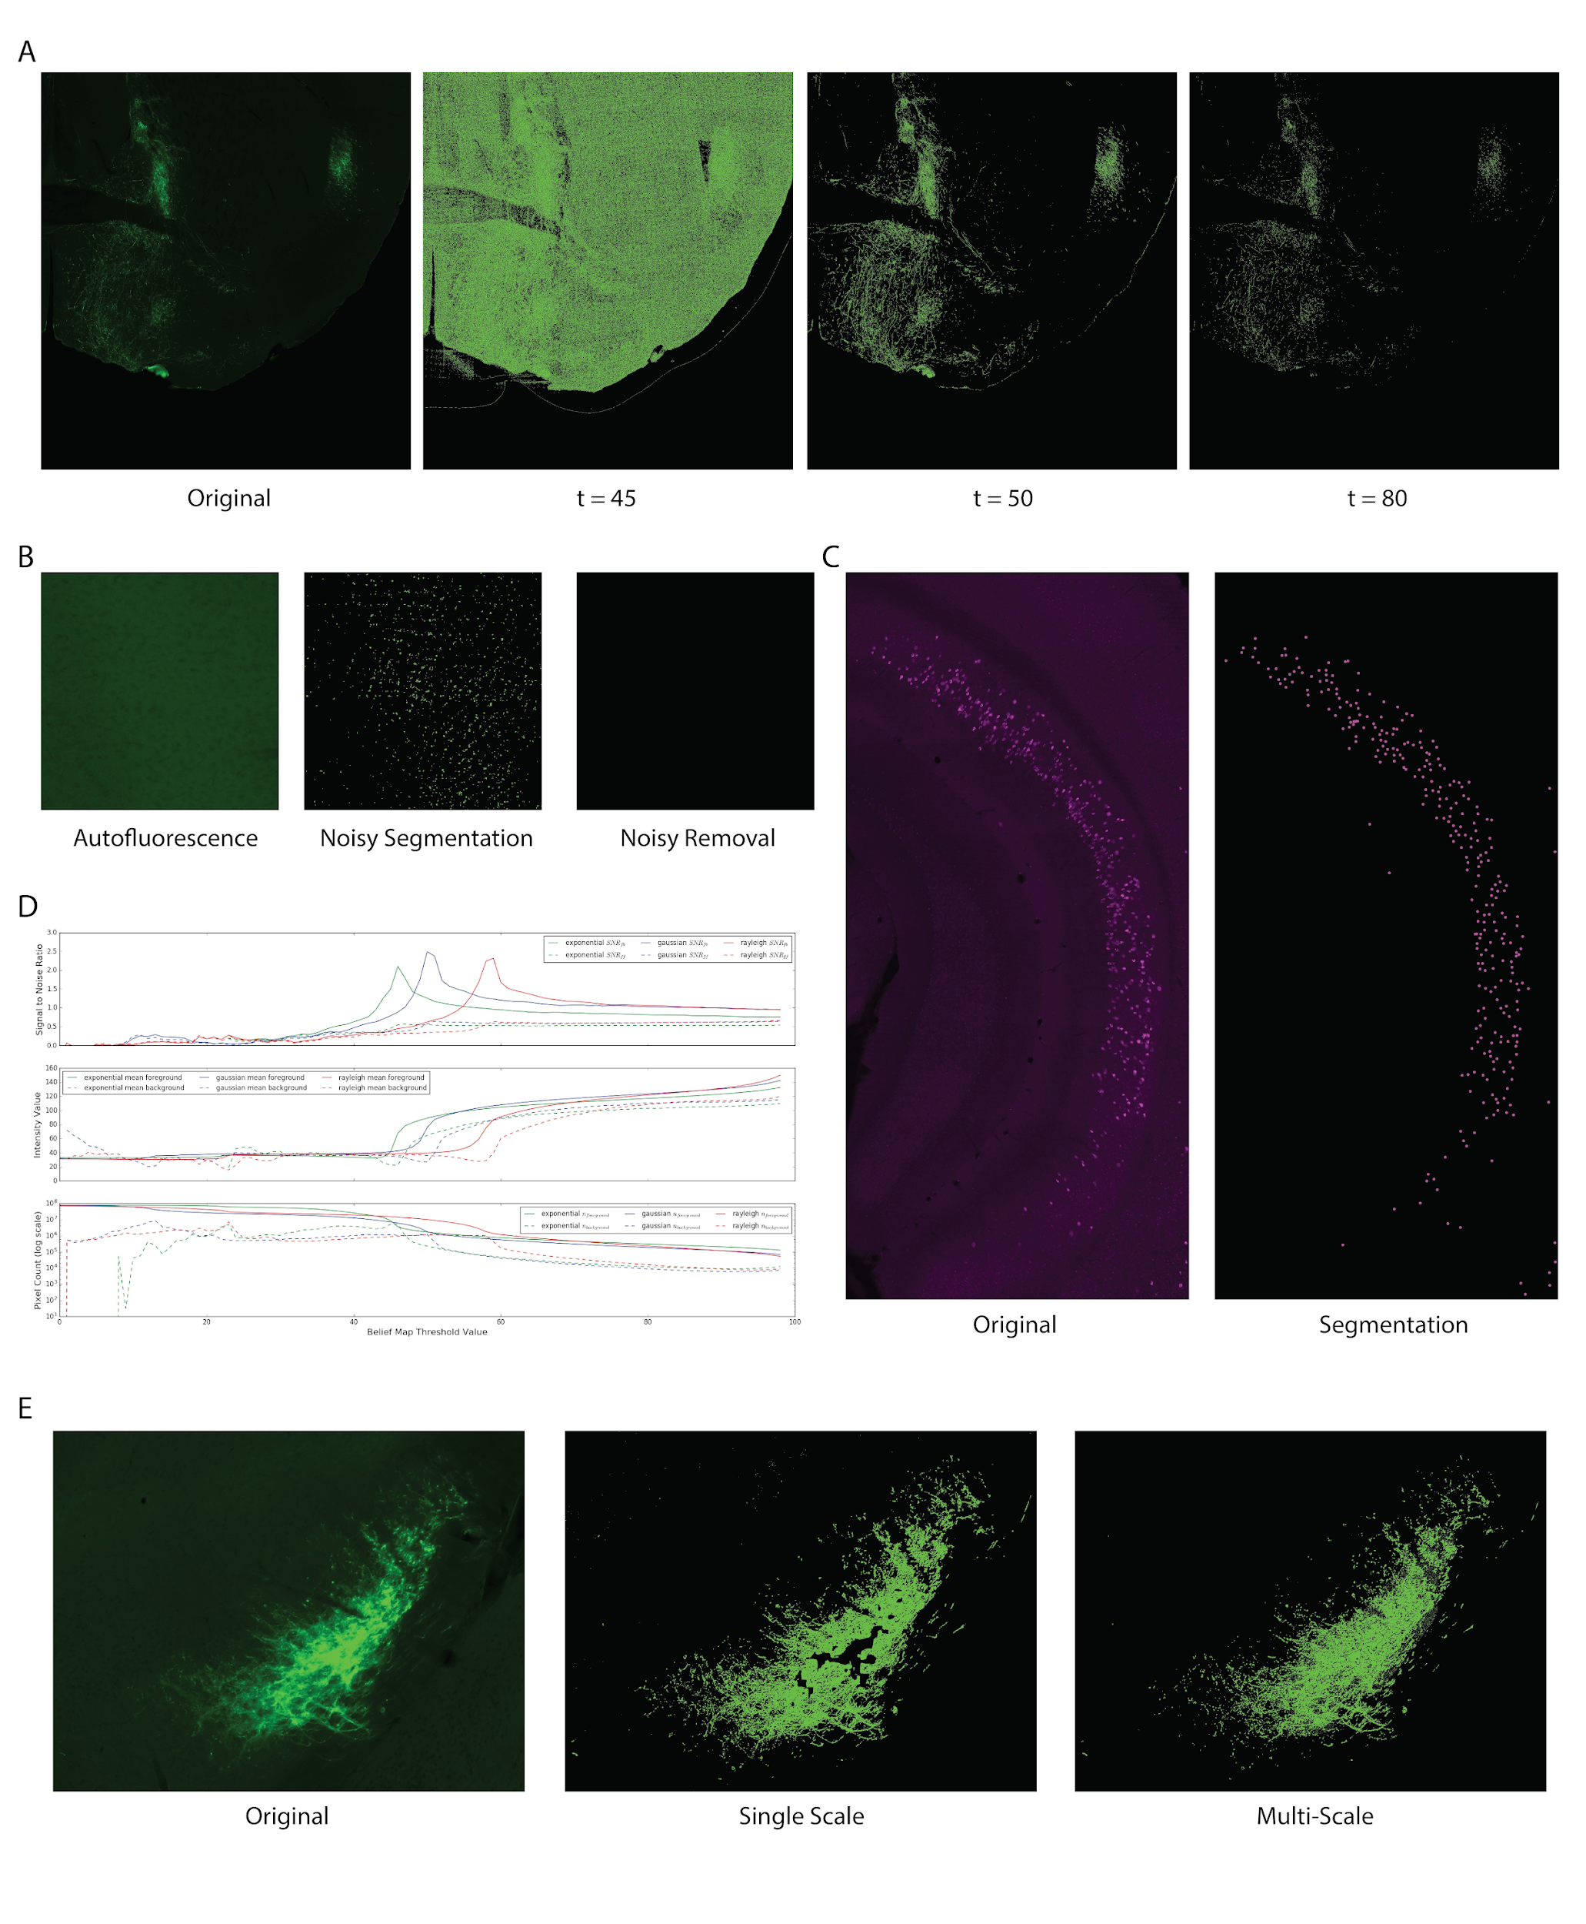
Supplementary Fig. 3. Tracer Segmentation. (A) Anterograde tracer segmentation result. The quality of segmentation rapidly improves in a narrow threshold range (between 45 and 50 in this example), corresponding to the sharp peak in SNR. (B) Autofluorescence removal by texture map. (C) Retrograde tracer segmentation result. (D) Signal to noise ratio, mean foreground intensity and number of foreground pixels are plotted as functions of belief map threshold value, averaged over 98 images. (E) Multi-scale segmentation captures fibers with a wide range of physical dimensions.

We quantified the signal to noise ratio (SNR) of the segmentation in 98 anterograde tracer images. We use the SNR definition given by NEMA (The National Electrical Manufacturers Association) ¹⁶, calculated as ${SNR}_{fb}=\frac{μ_{foreground}}{σ_{background}}$. An alternative calculation with ${SNR}_{ff}=\frac{μ_{foreground}}{σ_{foreground}}$ is simultaneously investigated. We tested three probability distributions: the gaussian distributions, the exponential distribution, and the Rayleigh distribution as the presumed distribution followed by the feature map. Parameters for each distribution are estimated from the mean ($μ_{tissue}$) and variance ($σ_{tissue}^{2}$) of the tissue feature map (only the portion of the image within the segmented tissue mask is included (see Image registration section).

The probability density function (PDF) of the gaussian distribution is
$$f\left(x;\hat{μ},{\hat{σ}}^{2}\right)=\frac{1}{\sqrt{2π{\hat{σ}}^{2}}}e^{-\frac{{(x-\hat{μ})}^{2}}{2{\hat{σ}}^{2}}}; \hat{μ}=μ_{tissue}, { \hat{σ}}^{2}=σ_{tissue}^{2}$$

PDF of the exponential distribution is
$$f\left(x;\hat{λ},\hat{b}\right)={\hat{λ}e}^{\hat{λ}(x-\hat{b})}; \hat{λ}=\frac{1}{σ_{tissue}}, \hat{b}=μ_{tissue}-\sqrt{\frac{1}{\hat{λ}}}$$

PDF of the Rayleigh distribution is
$$f\left(x;\hat{σ},\hat{b}\right)=\frac{x}{{\hat{σ}}^{2}}e^{-\frac{{(x-\hat{b})}^{2}}{2{\hat{σ}}^{2}}}; {\hat{σ}}^{2}=\sqrt{\frac{2}{4-π}}σ_{tissue}^{2}, \hat{b}=μ_{tissue}-\sqrt{\frac{π}{2}}\hat{σ}$$

Both average ${SNR}_{fb}$ and ${SNR}_{ff}$ values show a sharp peak for all three distributions as the threshold value t of the belief map increases (valid between 1 to 100) and remains steady over a wide range. The average intensities of segmented foreground tissue and number of foreground pixels also show non-linear rapid change corresponding to SNR peak. The effect on an image is shown in Supplementary Fig. 3A. Segmentation results rapidly improved within a narrow t value range ¹⁷, and remained representative of original data as t value further increases (result of t = 80 is shown). Supplementary Fig. 3B shows typical results from texture map threshold, useful for images with low signal intensity and high level of autofluorescence. Supplementary Fig. 3C shows detected cells from a retrograde tracer image. We also show the capability of our multi-scale segmentation method to capture dense fiber bundles (Supplementary Fig. 3E).
Tracer segmentation is integrated as a component of Outspector. Default belief and texture map threshold values are predefined for the user, offering empirically effective results on most images. Researchers can access pre-computed belief and texture maps and interactively adjust parameters for optimal result.

Statistical model of brain connectivity

Whole brain neuroanatomical tracing experiments involve many sources of variations, such as the volume of tracer injections, quality of tissue collection, processing, and immunostaining, precision of tissue registration against the atlas, sampling frequency and location of the coronal plane, microscopic imaging settings, etc.
To meaningfully compare data across specimens, it is necessary to normalize these experimental variations. Since tissue sections within a single specimen are subject to largely consistent experimental conditions, we employ a self-normalization approach to obtain whole-brain connectivity fractions within each brain specimen ¹⁸.

The ARA defines 688 gray matter regions. To analyze the ipsilateral and contralateral brains separately, the number of distinct regions is doubled to 1376. Denote this number as $n_{ARA}$. Given a brain specimen with sections sampled at a set of ARA levels L, we initialize an |L|×1376 matrix C of connectivity counts data. The matrix entry $C_{lr}$ is the counts of connectivity (pixel and cell count for segmented anterograde and retrograde tracers respectively) in anatomical region r at atlas level l. A length 1376 count vector $n$ can be generated by summing connectivity within the same region across levels
$$n_{r}=\sum_{l∈L}{C_{lr}}$$
We derive a fraction vector $f$ by L1 normalizing $n:$
$$f=\frac{n}{{\left\|n\right\|}_{1}}$$
where $f_{r}$, the r^{th} entry in the vector, characterizes the proportion of connectivity found in a region r out of all connectivity found in the entire specimen.

We additionally define a connectivity density vector $d$ that approximates the density of connectivity at each grey matter regions. This is done by tracking a volume vector $v$ for regions sampled in the specimen
$$v_{r}=\int_{z}{s_{r}(z)dz≈\sum_{l∈L_{r}}{s_{r}(l)∙δ}}$$
where L_{r} ⊆ L is the sampled levels where region r is present, $s_{r}(l)$ is the area of region r’s x-y plane cross section at level l, and the constant δ is section thickness (for convenience we use δ = 1). Element-wise division of f and v gives d
$$d=f⊘v$$
The fraction calculation performs a total intensity normalization within each brain specimen, effectively normalizing away the effects of certain experimental condition variations described earlier. The density vector derives from the fraction vector and can be interpreted as the projection densities at each brain region of each specimen, holding the total counts of segmented pixels (anterograde tracer)/cells (retrograde tracer) constant across all specimens. The density measure provides an intuitive insight into the connectivity data, as connectivity densities have been widely considered in neuroanatomical literature and are easily understood by human experts.

The count, fraction, and density vectors from 18 anterograde injections in MPF are organized into three 18x1376 data matrices: the count matrix N, the fraction matrix F and density matrix D. The same set of matrices are computed for 15 retrograde injections in MPF. In all $N$, $F$ and $D$ matrices, the rows represent individual brain specimens, and columns represent gray matter regions as defined by ARA. For example, the entry $N_{ij}$ corresponds to connectivity count of brain region j: $n_{j}$, of the i^{th} brain specimen.

From a probabilistic point of view, the whole brain structural projectome at a given spatial location x is defined by a non-negative probability vector $p_{x}$, such that $\sum_{r}{p_{x,r}=1}$, where the expected relative frequency of observing projection from x in region r is equal to $p_{x,r}$. For each neural tracing experiment with injection at x, its associated count vector $n_{x}$ is then a multinomial random variable whose probability mass function is
$$f\left(n_{x};{N,p}_{x}\right)=S!\prod_{r}{\frac{p_{x,r}^{n_{r}}}{n_{x,r}!}}$$

where $S=\sum_{r}{n_{x,r}}$ . Tracing experiments with injections at x in k animals give a collection
of multinomial random variables $N_{x,k}=\left\{ n_{x}^{\left(1\right)},n_{x}^{\left(2\right)},…,n_{x}^{\left(k\right)} \right\},$ with the unknown $p_{x}$ to be
estimated. The log likelihood function for $p_{x}$, given $N_{x,k}$is
$$L\left(p_{x} | N_{x,k}\right)=\sum_{k}{\log{f\left(n_{x}^{\left(k\right)};{S^{(k)},p}_{x}\right)}}=\sum_{k}{\log{S^{(k)}!}+\sum_{k}{\sum_{r}{n_{x,r}^{(k)}\log{p_{x,r}}-}}\sum_{k}{\sum_{r}{\log{n_{x,r}^{(k)}}}}}$$
Applying the constraints $\sum_{r}{p_{x,r}=1}$ with the Lagrange multiplier
$$L\left(p_{x}, λ\right)=L\left(p_{x} | N_{x,k}\right)+λ\left(1-\sum_{r}{p_{x,r}}\right)=\sum_{k}{\sum_{r}{n_{x,r}^{(k)}\log{p_{x,r}}+λ\left(1-\sum_{r}{p_{x,r}}\right)+c}}$$
The maximum likelihood estimation (MLE) of $\hat{p_{x}}=\underset{p_{x}}{argmax}{L\left(p_{x} | N_{x,k}\right)}$ is obtained by
$$\frac{∂L\left(p_{x}, λ\right)}{∂p_{x,r}}=0⟹\hat{p_{x,r}}=\frac{\sum_{k}{n_{x,r}^{(k)}}}{ λ}$$
$$\frac{∂L\left(p_{x}, λ\right)}{∂λ}=0⟹\hat{λ}=\sum_{k}{\sum_{r}{n_{x,r}^{(k)}}}$$

The simple closed form of $\hat{p_{x}}$ offers an easy solution to infer connectivity at x from multiple brain specimens: connectivity counts per brain region are summed across all specimens and normalized by a grand total of counts across all brain regions and specimens. We use this approach to aggregate our 18 anterograde and 15 retrograde experiments. We first produce an aggregated $\hat{N}$ matrix, by summing the 18x1376 $N$matrix row-wise (15x1376 for retrograde experiments), grouped by the specimens’ injection sites. The $\hat{N}$ matrix has the same number of rows as the number of unique MPF brain regions whose projection we study (by tracer injection into these regions). The aggregated fraction matrix $\hat{F}$ is derived same as before via within specimen connectivity count L1 normalization:
$$\hat{F_{i*}}=\frac{\hat{N_{i*}}}{{\left\|\hat{N_{i*}}\right\|}_{1}}$$
Connectivity differences between two brain regions $i$ and $j$is reflected by the differences between $\hat{F_{i*}}$ and $\hat{F_{j*}}$.
The aggregated density matrix $\hat{D}$ is also computed as before. Here we sum the volume of each brain region across specimens with the same injection site, producing an aggregated volume matrix $\hat{V}$. $\hat{D}$ is simply derived by

$$\hat{D}=\hat{F}⊘\hat{V}$$

Row vectors in these aggregated matrices are denoted $\hat{n}$, $\hat{f}$ and $\hat{d}$. We mostly present, describe and interpret our MPF connectivity data using the fraction matrix
Quantifying global MPF brain connectivity
For quantitative analysis, we organized the 1376 ARA grey matter regions (688 for each hemisphere) into 8 major groups according to their anatomical hierarchies: cortex (CTX), thalamus (TH), hypothalamus (HY), striatopallidal-like structures (CP, GPe, LS, BST, SI), amygdalar complex (AMY), hippocampal formation (HPF), midbrain (MB) and hindbrain (HB).
We perform a hierarchical 2D clustering with the MPF anterograde whole brain projection data Fglobal and Dglobal to observe if injections into the same anatomical location yield similar whole brain projections (Extended Data Fig. 7f). Hierarchical clustering along both axes of F (or D, although only clustering for F is shown) reorganizes its rows and columns, such that brain specimens with similar whole brain projection patterns, and target brain regions with similar input patterns from MPF are shuffled close to each other. Our data is in a 1376-dimensional space, making the cosine distance a suitable similarity measure. The cosine distance is frequently used in text mining and information retrieval, where data are distributed in high dimensional space with semantic embeddings. In the context of our connectivity matrix F (or D), its semantics lies in the brain wiring patterns that it describes, which form the foundations of complex physiological and cognitive functions of an organism.

$$The cosine distance between two vectors u and u' is defined as$$
$$δ_{cos}\left(u,u^{'}\right)=1-\frac{u∙u^{'}}{{\left\|u\right\|}_{2}∙{\left\|u^{'}\right\|}_{2}}=1-\frac{\sum_{i}{u_{i}{u'}_{i}}}{\sqrt{\sum_{i}{u_{i}^{2}}}\sqrt{\sum_{i}{{u'}_{i}^{2}}}}$$
$δ_{cos}\left(u,u^{'}\right)$ measures angular differences, and carries no information on the magnitude of
vector norms. However, the row and column norms of F also contain meaningful information
regarding strengths of connectivity. Therefore, we weigh the cosine distance with the ratio
in total connectivity between $u$ and $u'$

$${δ\left(u,u^{'}\right)=\frac{max⁡({\left\|u\right\|}_{1},{\left\|u'\right\|}_{1})}{\min\left({\left\|u\right\|}_{1},{\left\|u'\right\|}_{1}\right)+ϵ}∙δ}_{cos}\left(u,u^{'}\right)$$

$=\frac{max⁡({\left\|u\right\|}_{1},{\left\|u'\right\|}_{1})}{\min\left({\left\|u\right\|}_{1},{\left\|u'\right\|}_{1}\right)+ϵ}∙$($1-\frac{\sum_{i}{u_{i}{u'}_{i}}}{\sqrt{\sum_{i}{u_{i}^{2}}}\sqrt{\sum_{i}{{u'}_{i}^{2}}}}$)

On the global anterograde fraction matrix, $δ_{cos}\left(u,u^{'}\right)$ and δ(u,u′) have no influence on distance measures between brain specimens, represented by $F_{i,*}$ (row vectors of $F$). By definition, ∥Fi,∗​∥1​=1. For grouping target anatomical regions which receive similar input patterns from across MPF, δ(u,u′) gives more meaningful results. In a simple 2-dimensional example, suppose region A receives 20% of ILA's total projections and 20% of PL's total projections, while region B receives 1% and 1% of total projections from ILA and PL respectively. The cosine distance between A and B is zero, clearly not a reasonable interpretation. Distances between row and column vectors in D are calculated using $δ_{cos}\left(u,u'\right)$, since the division between fraction and volume removes interpretable additivity from vector elements.

SUPPLEMENTARY RESULTS

MPF connectivity with cortex
In the 8 hierarchy groups we examined, the cerebral cortex emerged as the primary projection target of MPF, while also contributing the most inputs to MPF. Cortical areas that receive MPF projections form distinct clusters (Fig. 3f). The cluster receiving the highest MPF input comprises the prefrontal cortex (PFC), including the MPF itself, three orbitofrontal areas (medial or ORBm, ventral lateral or ORBvl, and lateral or ORBl), and the dorsal and ventral agranular insular area (AId and AIv), along with primary (MOp) and secondary (MOs) motor areas. The PFC cluster significantly contributes to cortical projections from MPF. The ratios of $\frac{{\hat{f}}_{PFC}}{{\hat{f}}_{CTX}}$ are 62.07%, 53.43%, 61.21%, 51.17%, 62.84%, and 81.31% for DPs, DPd, ILA, PL, ACAv, and ACAd, respectively. PFC cluster regions also serve as substantial cortical sources of input to various MPF areas, with ratios of $\frac{{\hat{f}}_{PFC}}{{\hat{f}}_{CTX}}$ being 10.41%, 21.43%, 34.50%, 67.48%, 57.40%, and 68.92% for DPs, DPd, ILA, PL, ACAv, and ACAd, respectively. These values are likely underestimations since signals from some MPF volumes are excluded from quantification in each brain sample due to high tracer injection intensity (please refer to the last section). The MPF projection to and input from PFC is illustrated as heat maps Extended Data Fig. 15a-b). Color-coded output/input connectivity patterns of different MPF areas with other cortical areas are presented in Extended Data Fig. 13a.
We also systemically characterized regions with strong reciprocal connections with MPF. To do this, we define a measure of connection reciprocity between a given MPF area and a region $r$, ρr​ as
$$ρ_{r}=\frac{min⁡({\hat{f}}_{r}^{projection},{\hat{f}}_{r}^{input})}{max⁡({\hat{f}}_{r}^{projection},{\hat{f}}_{r}^{input})}∙\frac{({\hat{f}}_{r}^{projection}+{\hat{f}}_{r}^{input})}{2}$$
ρr penalizes regions showing significant differences in MPF input and output, as well as those with low connectivity to suppress spuriously large division ratios lacing biological significance. Hierarchical clustering results on ρ are illustrated in Extended Data Fig. 15d, consistent with our earlier discussion. In addition to robust connections with other MPF areas, ILA exhibits reciprocal connectivity with ENTl, ECT, and CLA; PL with AI and CLA; and ACAv with RSP, and VIS. We find ρ is an effective measure for gaining insight into connectivity datasets and formulating evidence-based hypotheses.
Distinctive characteristics of DP's cortical connections
Our quantitative analysis reveals intriguing features in DP's connections with other cortical areas, discussed in detail in the main text with additional insights below.
Projections to PFC. Both DPs and DPd exhibit projections to the prefrontal cortex (PFC) that surpass their input from PFC by several folds. Projections from DPs to ILA, PL, ACAv, ACAd, and its adjacent MOs constitute 51.78% of the total DPs cortical projections.
Dense inputs from three specific areas. DPs receive dense inputs from the piriform cortex (PIR), ventral auditory area (AUDv), and lateral part of the entorhinal area (ENTl), with input fractions exceeding those of any other MPF areas. However, projections from DPs to these three areas are notably less substantial, at 7.68%, 0.2%, and negligible, respectively.
Distinct laminar distribution in ENTl. Neurons from ENTl innervating DPs exhibit a different laminar distribution compared to those innervating other MPF areas. DPs has a $\frac{{\hat{f}}_{Entl_{s}}}{{\hat{f}}_{ENTl_{d}}}$ value equal to 6.84, indicating stronger inputs from the superficial layers (particularly L2/3) of ENTl (Fig. 2d). In contrast, this value ranges between 0.5 and 0.75 for other areas, suggesting distinct connectivity pathways from ENTl to other MPF areas including DPd (Fig. 2d). Consistent with this result, our previous work also demonstrated dense bi-directional connections between ILA and PL with ENTl layer 5/6 ¹⁹.
Unique cortical connections of other MPF areas
Other MPF areas exhibit unique features in their cortical connections compared to DP. Several notable examples are listed below.
Reciprocal connections of the ILA with the deep layers of temporal cortical areas and CLA. The ILA projection pattern forms a distinct cluster group, encompassing the deep layers of ENTl, ECT, TEa, claustrum (CLA), and endopiriform nucleus (EPd) (Extended Data Fig. 13b, d). Notably, ILA displays bilateral projections to layer 6 of ENTl, a unique feature among the MPF areas. In contrast, feedback projections from ENTl to ILA primarily originate from ENTl layer 5, while the DPs receives ENTl inputs primarily from its layer 2. Compared with other MPF areas, ILA sends the highest fraction of projections to ENTl, perirhinal area (PERI), ECT, and TEa (Extended Data Fig. 13d), all of which receive minor or no inputs from DP.
CLA is a notable region with dense reciprocal connections with MPF areas, except for DPs, which lacks inputs from the CLA. DPd receives significant inputs from the CLA (Fig. 2g-h) but generates only light inputs to it (Extended Data Fig. 11g-h). In contrast, ILA shares dense reciprocal connections with the CLA (Fig 2g-h; Extended Data Fig. 11g-h). The density of ILA to CLA projection ranks 3rd among all of ILA’s cortical projections. The MPF projection fractions to the claustrum (CLA) follow the order ${\hat{f}}_{CLA}^{ILA}>{\hat{f}}_{CLA}^{PL}>{\hat{f}}_{CLA}^{ACAv}>{\hat{f}}_{CLA}^{ACAd}>{\hat{f}}_{CLA}^{DPs}>{\hat{f}}_{CLA}^{DPd}≃0$. With the exception of DP, another interesting pattern is a proportion contralateral versus ipsilateral clustrum projection such that $\frac{{\hat{f}}_{CLA_{c}}^{ILA}}{{\hat{f}}_{CLA_{i}}^{ILA}}<\frac{{\hat{f}}_{CLA_{c}}^{PL}}{{\hat{f}}_{CLA_{i}}^{PL}}<\frac{{\hat{f}}_{CLA_{c}}^{ACAv}}{{\hat{f}}_{CLA_{i}}^{ACAv}}<\frac{{\hat{f}}_{CLA_{c}}^{ACAd}}{{\hat{f}}_{CLA_{i}}^{ACAd}}$. MPF inputs from CLA are also dense, ranking as the 3rd, 1st, 3rd, 6th, and 11th densest out of all cortical areas for ILA, PL, ACAv, ACAd, and DPd respectively, predominantly arising from the ipsilateral CLA. MPF-CLA inputs and outputs are depicted in Extended Data Fig. 13b.
Reciprocal connections of the PL with insular areas. The projection pattern of PL is linked to a cluster group comprising gustatory areas (GU) and agranular insular areas, specifically the dorsal and ventral parts (AId and AIv). PL demonstrates the highest projection fraction to all three regions among MPF areas. Its projection to AI is evenly distributed between the two hemispheres. MPF inputs from AId and AIv are more consistent in amounts across all areas and are primarily confined to the ipsilateral side. GU provides minimal input to the MPF (Extended Data Fig. 13b).
Reciprocal connections of the ACAv with other cortical areas within the medial cortical network. In line with our earlier study ¹⁹, our quantitative analysis has further unveiled reciprocal connections of the ACAv with a cluster of cortical areas within the medial cortical network. This cluster includes the agranular, dorsal, and ventral parts of the retrosplenial area (RSPagl, RSPd, and RSPv), as well as the anteromedial and posteromedial visual areas (VISam and VISpm). ACAv projections to the combined RSP domains and VISam are more than 10 times greater than in other MPF areas. Moreover, RSP and VIS inputs to MPF areas are at least 3 times higher in ACAv.
MPF connections with the olfactory areas. EPd receives robust inputs from DPs and DPd, comprising 7.18% and 7.22% of their total cortical input, respectively, and relatively weaker from other MPF areas, consistent with the ranking order observed in MPF to olfactory area projections. Additionally, DPd receives substantial inputs from the posterolateral and posteromedial zones of the cortical amygdalar area (COApl and COApm), contributing to 13.81% of its total cortical input.
DP as a unique network junctional node that bridges a unidirectionally predominant cortico-cortical information flow
Cortical projections from the DP primarily originate from DPs. DPs axons follow two projection pathways through layer 1 and deep layer 5, generating dense axonal terminals in ILA, PL, ACAv, and ACAd (Fig. 3f).
These projections from the DP to prefrontal areas (DP→PFC), including ILA, PL, ACAv, ACAd, but also ORB, and AId/AIv ²⁰, are several times greater than their feedback projections (PFC→DP). The ratio of fPFC$/fCTX$ (amount of projections to the PFC/amount of total CTX projection) for the DPs is 62.07%. In contrast, feedback projections from these PFC regions to the DPs and DPd have fPFC/fCTX ratios equal to 10.41% and 21.43%, respectively. This finding is consistent with retrograde tracing data, which show only scattered labeled neurons in the ACA and other MPF areas after DP retrograde tracer injections (Fig. 3f). Contrarily, the DP receives dense inputs from olfactory cortical areas (OLF→DP), such as TTd, PIR, EPd, and COAa (Fig. 2a-f), which receive feedback projections from the DP (DP→OLF) with much lesser magnitudes (7.68% and 0.2%). These olfactory areas receive very sparse inputs from DP, ILA, and PL and no inputs from ACAv and ACAd. In contrast, the TTd generates dense projections to all other olfactory areas, including AON, PIR, and MOB (Extended Data Fig. 11a-b), distinguishing its projection patterns from those of the DP. The TTd generates dense projections to the DP and ILA but not to other MPF area.
MPF connections with thalamus
Except for DPs, MPF cortices project more than 10% of their total outputs to ipsilateral thalamic nuclei and, to a lesser extent, to the contralateral thalamus as well (Extended Data Fig. 17a). All MPF areas receive nearly 10% or more of their inputs from the thalamus. Several thalamic nuclei, particularly those in the midline, exhibit robust reciprocal connections with MPF except for the DPs (Extended Data Fig. 17b). The entire dataset of MPF-thalamic connectivity from our anterograde and retrograde tracing experiments can viewed on the online map available at https://brain.neurobio.ucla.edu/mpf/ (username: guest, password: mpfbrainmap710).
This consolidated presentation of a vast and intricate dataset enables us to assimilate a wealth of information within a single page, facilitating the development of data-driven insights and hypotheses. We identify three clusters of thalamic nuclei, each differentially innervated by distinct MPF groups (Extended Data Figs. 16e, 17a). These distinct patterns are discernible through hierarchical clustering, indicated by colored boxes, utilizing both the individual fraction matrix F and the sample fraction matrix $\hat{F}$. The individual fraction matrix F reveals a clustering pattern reflecting biological variation among individual specimens, aligning well with clustering results obtained from the sample fraction matrix $\hat{F}$. $\hat{F}$ yields more robust outcomes with larger sample sizes, owing to its statistical properties.
The thalamic projection patterns from ILA and DPd exhibit high similarity, while DPs displays minimal thalamic efferents (Extended Data Figs. 16e, 17a). This alignment is in line with the known distribution of cortico-thalamic projecting neurons, predominantly found in the deeper cortical layer (layer 6). PL demonstrates similarity in its thalamic projections with both ILA and ACAd, sharing a few common nuclei as targets for robust projections. In contrast, ACAv reveals several unique projection targets in the thalamus. The three thalamic nuclei groups are outlined below.
1. The paraventricular nucleus of the thalamus (PVT), parataenial nucleus (PT), nucleus reunions (RE), and the medial part of the mediodorsal thalamic nucleus (MDm) constitute four midline thalamic nuclei that serve as major targets for ILA and DPd (Extended Data Fig. 16c-f). Collectively, these nuclei contribute to 70.82% and 60.46% of the total thalamic projections for DPd and ILA, respectively. Projections to PT from DPd and ILA are notably dense (Extended Data Fig. 16f). PT and PVT together account for 28.99% and 28.90% of the total thalamic projections for DPd and ILA. Except for DPs, all MPF areas exhibit significant RE projections, constituting 23.82%, 14.30%, 14.34%, 11.91%, and 13.35% of total thalamic projections for DPd, ILA, PL, ACAv, and ACAd, respectively. Particularly noteworthy is the substantial RE input received by DPs (Extended Figs. 16a-b), amounting to 76.79% of its total thalamic input. The fractions of RE input as a ratio of total thalamic input for other MPF areas are 28.57%, 34.81%, 5.20%, 4.47%, and 2.19% for DPd, ILA, PL, ACAv, and ACAd, respectively. Additionally, MDm receives a robust input from PL.
2. The lateral (MDl) and central parts (MDc) of the mediodorsal thalamic nucleus (MD), reticular nucleus of the thalamus (RT), ventral medial nucleus of the thalamus (VM), ventral anterior-lateral complex of the thalamus (VAL), and parafascicular nucleus (PF) constitute the second group of thalamic nuclei revealed by our hierarchical clustering. ACAd and PL predominantly innervate these thalamic nuclei, with ACAv contributing additional strong inputs to MDl and VM. Notable features of this group include:
(a) Neuroanatomically, ILA, PL, and ACA are known to have a medial-lateral shift in their connections with MD. We show this classic finding quantitatively (Extended Data Fig. 17a). For MPF-thalamic projections, $\frac{{\hat{f}}_{MD_{m}}}{{\hat{f}}_{MD_{l}}}$ equals 8.26, 3.54, 1.72, 0.16, and 0.35 for DPd, ILA, PL, ACAv, and ACAd, respectively. For MPF inputs from the thalamus, $\frac{{\hat{f}}_{MD_{m}}}{{\hat{f}}_{MD_{l}}}$ is equal to 4.44, 2.58, 0.40, 0.10, and 0.14 for above regions in the same order.
(b) According to our reciprocity measure, $ρ$, VM exhibits reciprocal connections with ILA, PL, ACAv, and ACAd (Extended Data Fig. 17b), with the highest $ρ$ observed in ACAd, followed by PL and ACAv, and a weaker connection in ILA. DPs receives input from VM but does not significantly project to it (Extended Data Figs. 16e, 17b). Additionally, MPF unilaterally projects to RT, with PL being the primary contributor. RT projections account for 8.14%, 5.42%, 2.57%, and 1.87% of total thalamic projections for PL, ACAd, ACAv, and ILA, respectively, while DPd projects minimally to RT. Lastly, MPF projections to PF exceed its inputs from PF, with PL and ACAd demonstrating the strongest projections to PF.
3. The third thalamic group comprises the anteromedial nucleus dorsal and ventral parts (AMd and AMv), central lateral (CL), lateral dorsal (LD), and lateral posterior thalamic nuclei (LP). These thalamic nuclei predominantly receive MPF input from ACAv (Extended Data Fig. 17a). Among the MPF areas, ACAv exhibits the highest number of projections to AMd and AMv, followed by ACAd and then PL, although AMv input to ACAv and ACAd is nearly identical. Reciprocal connections exist between ACAv, ACAd, and PL with CL, with the strength decreasing in that order. The connections between LD and LP with ACAv are over 10 times greater than with other MPF areas.
DP projections to hypothalamic preautonomic structures
Given the LHA's diverse neuronal cell types projecting to the cortex, thalamus, and lower brainstem (Extended Data Fig. 23a), we further investigated cell type-specific projections of LHA neurons that receive direct inputs from the DP (Extended Data Fig. 23b). We found that postsynaptic LHA neurons innervated directly by DP, in addition to their direct projections to the spinal cord, generate dense inputs to other autonomic function-regulating brain structures like CEA, BSTal, SI, PAGvl, PB, and NTS (Extended Data Fig. 23b). Further, these LHA neurons generate substantial projections to (1) the ventrolateral medulla ²¹, which contains catecholaminergic C1 pre-sympathetic neurons that regulate cardiovascular and respiratory activities ^{21,22}; and (2) the ventromedial medulla in the vicinity of the nucleus raphe magnus (RM), nucleus raphe pallidus (RPA), and nucleus raphe obscurus (RO). In rats, these raphe nuclei, along with DP/TTd and DMH, form a multi-synaptic projection pathway that drive sympathetic and behavioral activities ²³.

Topographic projections from MPF to LHA
The MPF is characterized by its projections to the hypothalamus and PAG, key regulators of autonomic function ²⁴. DPd, DPs, ILA, and PL generate dense, topographically arranged, partially overlapping projections to the hypothalamus, with DPd axons primarily targeting the periventricular zone, ILA axons the medial hypothalamic nuclei (MPN, AHN, PMd), and DPd, DPs, ILA, and PL targeting LHA. ACAv and ACAd generate dense projections to the zona incerta, dorsal to the LHA (Extended Data Fig. 21a, c). Together, axonal projections arising from these MPF areas occupy nearly the entire LHA.

MPF connections with brainstem autonomic regions like PAG
The MPF is also characterized by its projections to the PAG, which regulates autonomic function ⁴. Projection patterns from different MPF areas to the PAG are topographic (Extended Data Fig. 24a). DPd and PL generate overlapping terminals in the ventromedial division (PAGvm) and the adjacent dorsal raphe nuclei (DR); ILA to the ventrolateral (PAGvl); DPs to the lateral (PAGl); and ACAv and ACAd to the dorsal (PAGd) and dorsolateral (PAGdl). While the PAGd and PAGdl are implicated in goal-directed behavior such as prey catching ²⁵, the PAGl and PAGvl, which also receive dense inputs from CEA and LHA, regulate autonomic functions like blood pressure and respiration ^{26,27}. To characterize the neuronal outputs arising from PAG neurons receiving inputs from the DPd, DPs, and ILA, we made injections of AAV1-Cre into those MPF areas and Cre-dependent AAV-RFP into the PAGvm, PAGvl, and PAGl (Extended Data Fig. 24b-c). Note MPF→PAG connections are unidirectional (Extended Data Fig. 22c). This result reveals that while PAG neurons in these three subdivisions generate overlapping projections in the ACB, BSTal, SI, CEA, LHA, and VTA, they display distinct projection patterns in brainstem autonomic structures. The PAGvm and PAGvl neurons generate substantial projections to the PB and Barrington’s nucleus, whereas the PAGl projects densely to the raphe nuclei, such as the RM and RO, and the adjacent ventromedial medulla implicated in sympathetic function ^{23,28}. MPF input recipient neurons in these three PAG subdivisions do not generate significant projections to the DMX or NTS.
DPd connections with neuroendocrine structures
The DPd exhibits dense projections to the anteromedial (BSTam) and dorsomedial (BSTdm) parts of the BST (Extended Data Fig. 20a, e), both of which, in turn densely project to the entire hypothalamic neuroendocrine zone including the PVH (Extended Data Figs. 27a). Since BST primarily contains GABAergic projection neurons, it is presumed that the DPd may inhibit neuroendocrine outputs via its feedforward projections to the BST [DPd (Glu)→BST (GABA)→PVH]. In addition, the DPd innervates structures within the preoptic area like the anteroventral periventricular nucleus (AVPV), medial part of the medial preoptic nucleus (MPNm), ventral medial preoptic area (MPO), and dorsomedial hypothalamic nucleus (DMH) (Extended Data Fig. 25f-i), all of which generate substantial projections to the PVi, PVH, and ARH (Extended Data Fig. 27a). Because each of these structures contains either Vglut2 neurons (AVPV, MEPO) or both Vglut2 and Vgat neurons (MPO, DMH), the DPd is presumed to have either feedforward excitatory or inhibitory projections to regulate neuroendocrine outputs through these nuclei (Extended Data Fig. 27b), Notably the BST, AVPV, MPO, and DMH also generate substantial projections to other brain structures involved in behavioral and autonomic function, such as VMH, PMv, and PAG (Extended Data Figs 26f, 27a), suggesting their role in coordinating neuroendocrine, autonomic, and behavioral function.
SUPPLEMENTARY DISCUSSION
Our extensive connectivity data and quantitative analysis have, for the first time, unveiled the DPd as a component of the MPF uniquely generating direct projections to innervate hypothalamic neuroendocrine cells (Fig. 5), including CRH neurons in the PVHmpd, which controls the HPA axis. Moreover, the DPd, along with the BST and other hypothalamic structures (e.g., AVPV, MPO, and DMH), forms a network of multiple parallel feedforward excitatory and inhibitory pathways that are crucial for the regulation of neuroendocrine functions (Fig. 5e).
Purported unified MPF model synchronizing motivated behavior
Our understanding of the MPF or overall prefrontal cortex is hampered by lack of a unified working model ²⁰. Based on our comprehensive whole brain wiring diagram of the MPF (Extended Data Fig. 31), we propose a testable hypothetical network model to understand how different MPF components coordinate and synchronize into a unified entity, regulating physiological and motor actions in response to environmental and social challenges.
The DP receives extensive neural inputs from both external and internal environments, establishing the circuitry that enables DP neurons to react to a variety of social and environmental contexts. The DP is also capable of encoding fear memories and experiences related to threats ^{29,30}, enhancing the animal's ability to assess risks, make decisions, and plan subsequent actions. In turn, the DP sends the integrated information to the hypothalamus and brainstem, initiating immediate physiological and visceral motor responses, which are mostly linked to emotions. Concurrently, this information is conveyed to other MPF, including the ILA, PL, ACAv, ACAd, and the motor cortex. This transmission occurs through a primarily unidirectional flow of cortico-cortical projections, facilitating further perceptual evaluation, decision-making, and motor response (Fig. 7b). Axonal projections originating from the DP and those MPF and motor areas, along with their targeted cerebral nuclei including the CEA, MEA, BST, ACB, LS, and CP, span almost the entirety of the hypothalamus and PAG, as well as a significant portion of the basal ganglia. As a result, they can influence a wide range of motor outputs, including neuroendocrine, autonomic, and somatic motor actions that control movements of the eyes, head, neck, orofacial, and limb areas. Therefore, DP outputs potentially initiate the "temporal gestalt" necessary for coordinating goal-directed behaviors that are essential to maintain homeostasis and general well-being.
In particular, the ILA and PL as part of the vmPFC ²⁰ maintain extensive reciprocal connections with the agranular insular areas—the primary viscerosensory cortex implicated in self-awareness, and CLA, which is purported in consciousness ³¹. The ILA and PL also share extensive, yet distinct, bidirectional connections with the BLAa ², implying their role in fear expression or extinction. In addition, the ILA and PL, as well as DP, project densely to the ACB, implicated in social interactions and reward processes ³², whereas the PL also targets the "striosome" compartment of the rostral CP, influencing dopaminergic neurons and areas associated with punishment and negative emotions ³³. Collectively, these findings, along with our connectivity data, suggest a role in the emotional processing necessary for action selection as posited by the "PL-go/IL-stop" hypothesis. This hypothesis suggests that the PL facilitates the execution or expression of behaviors, while the ILA is essential for inhibiting actions ³⁴. If DP is included, this model may become “DP-go/ILA-stop/PL-go”, which requires further experimentation.
Our connectivity data suggested that DP and ILA are involved in regulation of three basic classes of social behaviors through their projections to the hypothalamus: (1) the DPs generates dense neural projections to the PVHd and LHA, areas involved in regulating ingestive behaviors essential for maintaining or restoring homeostasis ^{35,36}; (2) the DPd sends dense projections to two critical nodes in the hypothalamic network, the AVPV and MPN, responsible for controlling ovulation and reproductive behavior, including sexual and parenting behaviors ³⁵⁻³⁷; and (3) the ILA projects substantially to the AHN and PMd, belonging to the hypothalamic defensive subnetwork and involved in aggression regulation ^{35,36,39}. DPd, DPs, and ILA also send dense, topographically organized projections to cerebral nuclei like CEA, MEA, LS, SI, and BST (Extended Data Fig. 20). These structures form cortico-basal ganglia-like neural networks that regulate neuroendocrine, autonomic, and behavioral activities associated with motivation and emotion.
It has been long proposed that the MPF may regulate emotional associated behaviors following a PVA (perception-evaluation-action) model, in which input from the external or internal world is perceived, valued, and then triggers an action that alters the external or internal world ^{40,41}. According to our connectivity data, the DP occupies an important seat within this PVA model. If the DP, along with the ILA (or vmMPF in humans and primates), is affected by lesions, it can disrupt the integration of sensory information and perception of both external and internal stimuli. As a result, their connections with other components of the MPF, such as PL, ACAv, and ACAd, which control motor actions, may also be disrupted. This disconnection between perception, evaluation and action can lead to excessive, inappropriate, or insufficient emotional and behavioral responses. This is often observed in various psychiatric disorders, including classic Phineas Gage-like personality disorders, major depressive disorder (MDD), as well as PTSD ^{40,41,42}.

References

1 Hintiryan, H. et al. The mouse cortico-striatal projectome. Nat Neurosci 19, 1100-1114 (2016). https://doi.org:10.1038/nn.4332
2 Hintiryan, H. et al. Connectivity characterization of the mouse basolateral amygdalar complex. Nat Commun 12, 2859 (2021). https://doi.org:10.1038/s41467-021-22915-5
3 Bienkowski, M. S. et al. Integration of gene expression and brain-wide connectivity reveals the multiscale organization of mouse hippocampal networks. Nat Neurosci 21, 1628-1643 (2018). https://doi.org:10.1038/s41593-018-0241-y
4 Benavidez, N. L. et al. Organization of the inputs and outputs of the mouse superior colliculus. Nat Commun 12, 4004 (2021). https://doi.org:10.1038/s41467-021-24241-2
5 Foster, N. N. et al. The mouse cortico-basal ganglia-thalamic network. Nature 598, 188-194 (2021). https://doi.org:10.1038/s41586-021-03993-3
6 Dong, H. W. The Allen Reference Atlas, (Book + CD-ROM): A Digital Color Brain Atlas of the C57BL/6J Male Mouse. ( Wiley, 2007).
7 Avants, B. B., Epstein, C. L., Grossman, M. & Gee, J. C. Symmetric diffeomorphic image registration with cross-correlation: evaluating automated labeling of elderly and neurodegenerative brain. Med Image Anal 12, 26-41 (2008). https://doi.org:10.1016/j.media.2007.06.004
8 Avants, B. B., Tustison, G. & sONG, N. Advanced normalization tools (ants). Insight J 2, 1-35 (2009).
9 Alexander, L., Wood, C. M. & Roberts, A. C. The ventromedial prefrontal cortex and emotion regulation: lost in translation? J Physiol 601, 37-50 (2023). https://doi.org:10.1113/JP282627
10 Toussaint, G. APPLICATIONS OF THE ROTATING CALIPERS TO GEOMETRIC PROBLEMS IN TWO AND THREE DIMENSIONS. International Journal of Digital Information and Wireless Communications 4 (2014). https://doi.org:DOI:10.17781/P001290
11 Donoser, M. & Bischof, H. Efficient maximally stable extremal region (mser) tracking. 2006 IEEE Computer Society Conference on Computer Vision and Pattern
Recognition (CVPR'06)(CVPR) 1, 553-560 (2006).
12 Florack, M. J., ter Haar Romeny, B. M., Koenderink, J. J. & Viergever, M. A. Scale and the differential structure of images. Image and Vision Computing 10, 376-388 (1992). https://doi.org:https://doi.org/10.1016/0262-8856(92)90024-W
13 Koller, T. M., Szekely, G. G. & Dettwiler, D. in Proceedings of IEEE International Conference on Computer Vision. 864-869.
14 Sato, Y. et al. Three-dimensional multi-scale line filter for segmentation and visualization of curvilinear structures in medical images. Med Image Anal 2, 143-168 (1998). https://doi.org:10.1016/s1361-8415(98)80009-1
15 Monici, M. Cell and tissue autofluorescence research and diagnostic applications. Biotechnol Annu Rev 11, 227-256 (2005). https://doi.org:10.1016/S1387-2656(05)11007-2
16 Dietrich, O., Raya, J. G., Reeder, S. B., Reiser, M. F. & Schoenberg, S. O. Measurement of signal-to-noise ratios in MR images: influence of multichannel coils, parallel imaging, and reconstruction filters. J Magn Reson Imaging 26, 375-385 (2007). https://doi.org:10.1002/jmri.20969
17 Sporns, O. Networks of the Brain. 1st edition (October 1, 2010) edn, (The MIT Press; , 2010).
18 Markov, N. T. et al. Weight consistency specifies regularities of macaque cortical networks. Cereb Cortex 21, 1254-1272 (2011). https://doi.org:10.1093/cercor/bhq201
19 Zingg, B. et al. Neural networks of the mouse neocortex. Cell 156, 1096-1111 (2014). https://doi.org:10.1016/j.cell.2014.02.023
20 Le Merre, P., Ahrlund-Richter, S. & Carlen, M. The mouse prefrontal cortex: Unity in diversity. Neuron 109, 1925-1944 (2021). https://doi.org:10.1016/j.neuron.2021.03.035
21 Guyenet, P. G. & Stornetta, R. L. Rostral ventrolateral medulla, retropontine region and autonomic regulations. Auton Neurosci 237, 102922 (2022). https://doi.org:10.1016/j.autneu.2021.102922
22 Souza, G., Stornetta, R. L., Stornetta, D. S., Guyenet, P. G. & Abbott, S. B. G. Adrenergic C1 neurons monitor arterial blood pressure and determine the sympathetic response to hemorrhage. Cell Rep 38, 110480 (2022). https://doi.org:10.1016/j.celrep.2022.110480
23 Kataoka, N., Shima, Y., Nakajima, K. & Nakamura, K. A central master driver of psychosocial stress responses in the rat. Science 367, 1105-1112 (2020). https://doi.org:10.1126/science.aaz4639
24 Ongur, D. & Price, J. L. The organization of networks within the orbital and medial prefrontal cortex of rats, monkeys and humans. Cereb Cortex 10, 206-219 (2000). https://doi.org:10.1093/cercor/10.3.206
25 Franklin, T. B. Recent Advancements Surrounding the Role of the Periaqueductal Gray in Predators and Prey. Front Behav Neurosci 13, 60 (2019). https://doi.org:10.3389/fnbeh.2019.00060
26 Zelena, D., Menant, O., Andersson, F. & Chaillou, E. Periaqueductal gray and emotions: the complexity of the problem and the light at the end of the tunnel, the magnetic resonance imaging. Endocr Regul 52, 222-238 (2018). https://doi.org:10.2478/enr-2018-0027
27 Silva, C. & McNaughton, N. Are periaqueductal gray and dorsal raphe the foundation of appetitive and aversive control? A comprehensive review. Prog Neurobiol 177, 33-72 (2019). https://doi.org:10.1016/j.pneurobio.2019.02.001
28 Nakamura, K., Nakamura, Y. & Kataoka, N. A hypothalamomedullary network for physiological responses to environmental stresses. Nat Rev Neurosci 23, 35-52 (2022). https://doi.org:10.1038/s41583-021-00532-x
29 Cardoso, R. C. et al. The mouse dorsal peduncular cortex encodes fear memory. bioRxiv (2024). https://doi.org:10.1101/2023.07.24.550408
30 Borkar, C. D. et al. Top-down control of flight by a non-canonical cortico-amygdala pathway. Nature (2024). https://doi.org:10.1038/s41586-023-06912-w
31 Zingg, B., Dong, H. W., Tao, H. W. & Zhang, L. I. Input-output organization of the mouse claustrum. J Comp Neurol 526, 2428-2443 (2018). https://doi.org:10.1002/cne.24502
32 Zhao, P. et al. Accelerated social representational drift in the nucleus accumbens in a model of autism. bioRxiv (2023). https://doi.org:10.1101/2023.08.05.552133
33 Watabe-Uchida, M., Zhu, L., Ogawa, S. K., Vamanrao, A. & Uchida, N. Whole-brain mapping of direct inputs to midbrain dopamine neurons. Neuron 74, 858-873 (2012). https://doi.org:10.1016/j.neuron.2012.03.017
34 Gourley, S. L. & Taylor, J. R. Going and stopping: Dichotomies in behavioral control by the prefrontal cortex. Nat Neurosci 19, 656-664 (2016). https://doi.org:10.1038/nn.4275
35 Swanson, L. W. Cerebral hemisphere regulation of motivated behavior. Brain Res 886, 113-164 (2000). https://doi.org:10.1016/s0006-8993(00)02905-x
36 Simerly, R. B. Organization of the hypothalamus. 267-94 ( Elsevier, 2015).
37 Chen, P. & Hong, W. Neural Circuit Mechanisms of Social Behavior. Neuron 98, 16-30 (2018). https://doi.org:10.1016/j.neuron.2018.02.026
38 Micevych, P. E. & Meisel, R. L. Integrating Neural Circuits Controlling Female Sexual Behavior. Front Syst Neurosci 11, 42 (2017). https://doi.org:10.3389/fnsys.2017.00042
39 Lischinsky, J. E. & Lin, D. Neural mechanisms of aggression across species. Nat Neurosci 23, 1317-1328 (2020). https://doi.org:10.1038/s41593-020-00715-2
40 Fuster, J. The Prefrontal Cortex. Fifth edn, (Elsevier, 2015).
41 Etkin, A., Buchel, C. & Gross, J. J. The neural bases of emotion regulation. Nat Rev Neurosci 16, 693-700 (2015). https://doi.org:10.1038/nrn4044
42 Andrewes, D. G. & Jenkins, L. M. The Role of the Amygdala and the Ventromedial Prefrontal Cortex in Emotional Regulation: Implications for Post-traumatic Stress Disorder. Neuropsychol Rev 29, 220-243 (2019). https://doi.org:10.1007/s11065-019-09398-4

