SUPPLEMENTARY MATERIALS

Mabalane site recorded higher total dry weight (tDW) and its components (stem, branches, and leaves) than Tambara. Branch biomass displayed a high variability (coefficient of variation, CV = 227%) among the tree dry weight components in Mabalane, while tree height exhibited lower variability (CV = 52%) than DBH (CV = 92%). In Tambara, stem biomass data showed higher variability (CV = 149%) among the tree components. DBH and tree height variability followed the same trend observed in the Mabalane site. Leaf dry weight displayed the lowest variation among the tree components in both sites.

Table S1: Descriptive statistics of the trees sampled were used to construct the biomass equations and determine the biomass expansion factor in both study sites, Mabalane and Tambara districts. DBH is the diameter at breast height measured at 1.3 m, and SD is the standard error of the mean.
Site | Parameters | Min | Mean | Max | CV (%)
Mabalane  (n = 62) | DBH (cm) | 5.0 | 25.6 | 109.2 | 92
Mabalane  (n = 62) | Total tree height (m) | 4.0 | 9.3 | 21.6 | 52
Mabalane  (n = 62) | Stem dry weight (kg) | 2.8 | 351.2 | 3299.2 | 203
Mabalane  (n = 62) | Branches dry weight (kg) | 1.4 | 347.9 | 3808.4 | 227
Mabalane  (n = 62) | Leaves dry weight (kg) | 0.4 | 9.9 | 59.3 | 142
Mabalane  (n = 62) | Total dry weight (kg) | 4.7 | 708.9 | 7165.0 | 212
Tambara  (n = 58) | DBH (cm) | 5.0 | 16.9 | 44.0 | 55
Tambara  (n = 58) | Total tree height (m) | 3.8 | 8.3 | 14.6 | 32
Tambara  (n = 58) | Stem dry weight (kg) | 4.4 | 114.0 | 861.6 | 149
Tambara  (n = 58) | Branches dry weight (kg) | 1.6 | 59.9 | 423.0 | 136
Tambara  (n = 58) | Leaves dry weight (kg) | 0.6 | 7.3 | 38.3 | 88
Tambara  (n = 58) | Total dry weight (kg) | 6.6 | 181.2 | 1065.2 | 135

Figure S1: Graphical distribution of residuals of the model (tDW = aD^{b}) for each regression method.
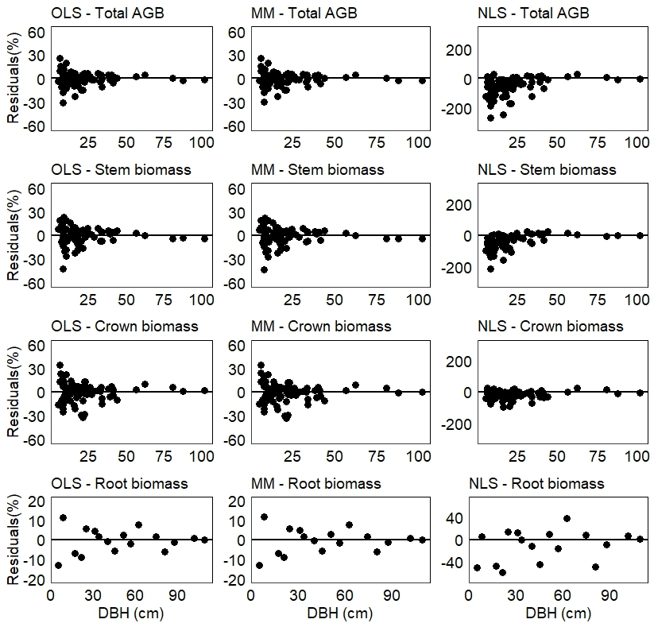

Figure S2: Residual distribution of each biomass allometric equation computed using fitting data.
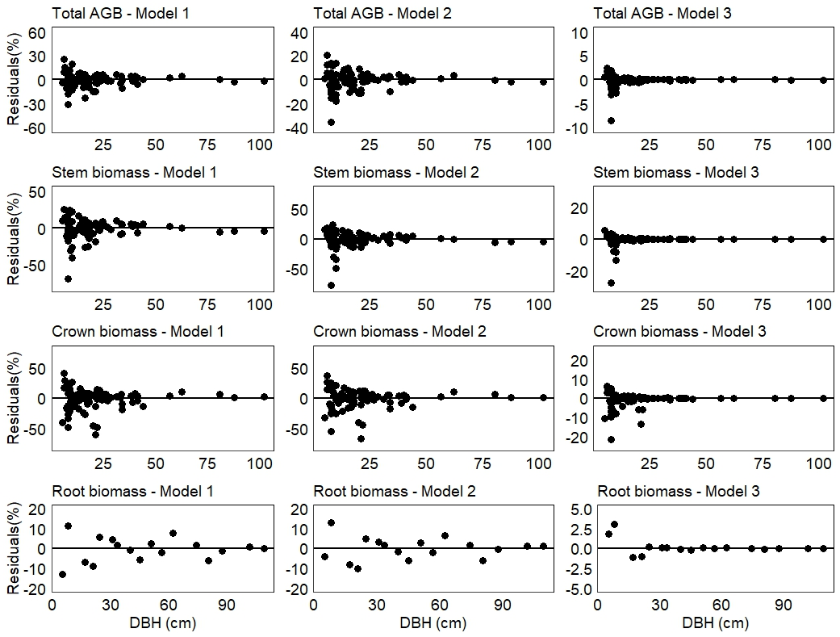

Figure S3: Evaluation of the H-D models in terms of fit to the data, models with 2 parameters and models with 3 parameters. In both cases, i.e. for the models with 2 and 3 parameters, were selected three models which their curves overlap with the fitting data.
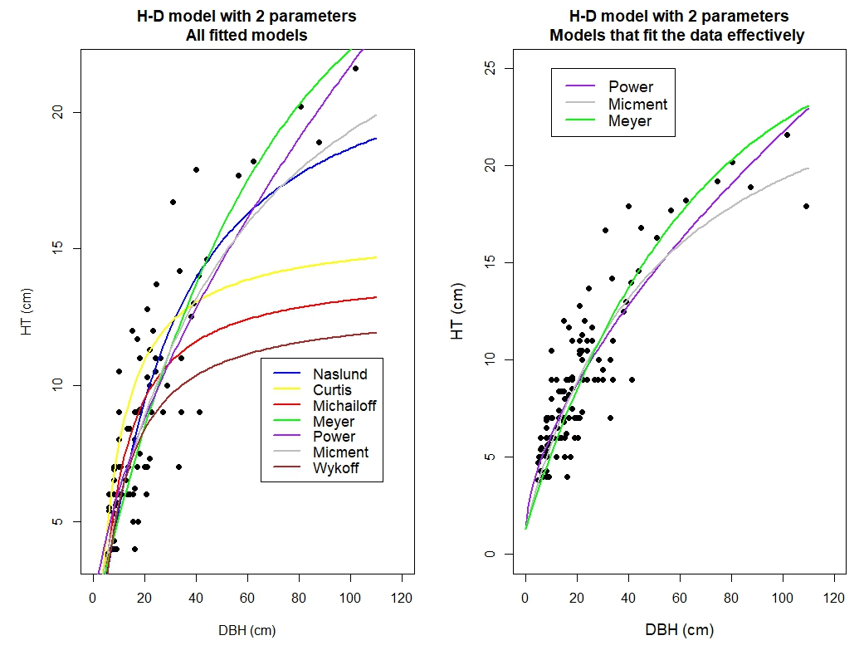
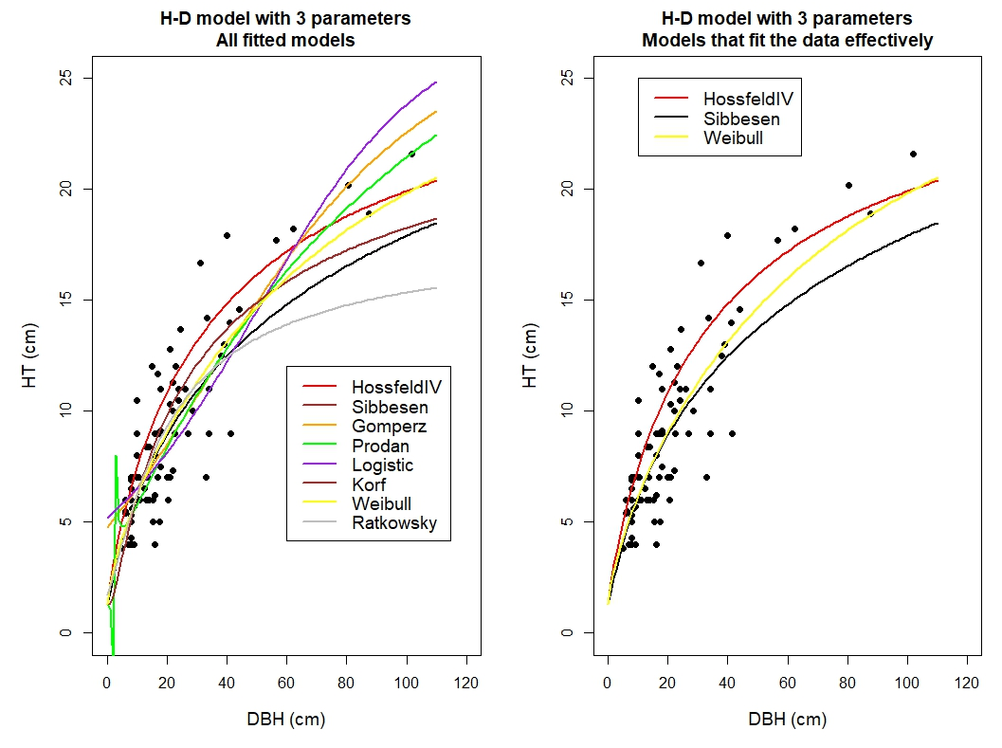
Figure S4: Residual distribution of each H-D model against D of fitting data.
