Appendix 1
Table S1.1: Bioclimatic variables legend. Variable name and associated definition from the WorldClim database (Fick and Hijmans 2017).

Variable | Definition
Clim1 | Annual Mean Temperature (°C)
Clim2 | Mean Diurnal Range (Mean of monthly (max temp - min temp)) (°C)
Clim3 | Isothermality (BIO2/BIO7) (×100)
Clim4 | Temperature Seasonality (standard deviation ×100)
Clim5 | Max Temperature of Warmest Month (°C)
Clim6 | Min Temperature of Coldest Month (°C)
Clim7 | Temperature Annual Range (BIO5-BIO6) (°C)
Clim8 | Mean Temperature of Wettest Quarter (°C)
Clim9 | Mean Temperature of Driest Quarter (°C)
Clim10 | Mean Temperature of Warmest Quarter (°C)
Clim11 | Mean Temperature of Coldest Quarter (°C)
Clim12 | Annual Precipitation (mm)
Clim13 | Precipitation of Wettest Month (mm)
Clim14 | Precipitation of Driest Month (mm)
Clim15 | Precipitation Seasonality (Coefficient of Variation)
Clim16 | Precipitation of Wettest Quarter (mm)
Clim17 | Precipitation of Driest Quarter (mm)
Clim18 | Precipitation of Warmest Quarter (mm)
Clim19 | Precipitation of Coldest Quarter (mm)

Table S1.2: NLCD variables legend
Variables in the NLCD Land Cover classification file. Variables with an asterisk are only relevant to Alaska. Bolded rows were included in this analysis.

Variable | Definition
NLCD 11 | Open Water
NLCD 12 | Perennial Ice/Snow
NLCD 21 | Developed, Open Space
NLCD 22 | Developed, Low Intensity
NLCD 23 | Developed, Medium Intensity
NLCD 24 | Developed, High Intensity
NLCD 31 | Barren Land (Rock/Sand/Clay)
NLCD 41 | Deciduous Forest
NLCD 42 | Evergreen Forest
NLCD 43 | Mixed Forest
NLCD 51 | Dwarf Scrub*
NLCD 52 | Shrub/Scrub
NLCD 71 | Grassland/Herbaceous
NLCD 72 | Sedge/Herbaceous*
NLCD 73 | Lichens*
NLCD 74 | Moss*
NLCD 81 | Pasture/Hay
NLCD 82 | Cultivated Crops
NLCD 90 | Woody Wetlands
NLCD 95 | Emergent Herbaceous Wetlands

Table S1.3: Arizona Correlation Table of Climate Variables. Pearson’s correlation coefficients for all climate variables across the state of Arizona.

 | Clim  1 | Clim  10 | Clim  11 | Clim 12 | Clim 13 | Clim 14 | Clim 15 | Clim 16 | Clim 17 | Clim 18 | Clim 19 | Clim 2 | Clim 3 | Clim 4 | Clim 5 | Clim 6 | Clim 7 | Clim 8 | Clim 9
Clim 1 | 1.00 | 0.98 | 0.98 | -0.53 | -0.39 | -0.88 | 0.35 | -0.43 | -0.86 | -0.47 | -0.33 | -0.04 | 0.09 | 0.03 | 0.96 | 0.97 | -0.17 | 0.56 | 0.99
Clim 10 |  | 1.00 | 0.93 | -0.63 | -0.53 | -0.92 | 0.23 | -0.56 | -0.89 | -0.59 | -0.43 | -0.06 | -0.05 | 0.20 | 0.99 | 0.92 | -0.03 | 0.53 | 0.99
Clim 11 |  |  | 1.00 | -0.39 | -0.24 | -0.81 | 0.45 | -0.28 | -0.79 | -0.32 | -0.20 | -0.02 | 0.22 | -0.16 | 0.89 | 0.98 | -0.32 | 0.56 | 0.96
Clim 12 |  |  |  | 1.00 | 0.90 | 0.76 | 0.12 | 0.92 | 0.81 | 0.92 | 0.94 | 0.00 | 0.41 | -0.68 | -0.67 | -0.38 | -0.50 | -0.34 | -0.59
Clim 13 |  |  |  |  | 1.00 | 0.61 | 0.49 | 0.99 | 0.59 | 0.98 | 0.75 | 0.13 | 0.60 | -0.81 | -0.58 | -0.26 | -0.56 | -0.16 | -0.45
Clim 14 |  |  |  |  |  | 1.00 | -0.23 | 0.65 | 0.94 | 0.66 | 0.61 | 0.03 | 0.12 | -0.31 | -0.91 | -0.80 | -0.10 | -0.55 | -0.91
Clim 15 |  |  |  |  |  |  | 1.00 | 0.46 | -0.34 | 0.42 | -0.02 | 0.32 | 0.70 | -0.62 | 0.17 | 0.37 | -0.42 | 0.36 | 0.34
Clim 16 |  |  |  |  |  |  |  | 1.00 | 0.63 | 0.98 | 0.77 | 0.13 | 0.58 | -0.78 | -0.62 | -0.30 | -0.54 | -0.21 | -0.48
Clim 17 |  |  |  |  |  |  |  |  | 1.00 | 0.66 | 0.72 | -0.04 | 0.05 | -0.29 | -0.88 | -0.75 | -0.12 | -0.60 | -0.89
Clim 18 |  |  |  |  |  |  |  |  |  | 1.00 | 0.77 | 0.11 | 0.56 | -0.77 | -0.64 | -0.33 | -0.53 | -0.20 | -0.52
Clim 19 |  |  |  |  |  |  |  |  |  |  | 1.00 | -0.12 | 0.30 | -0.61 | -0.47 | -0.17 | -0.54 | -0.32 | -0.41
Clim 2 |  |  |  |  |  |  |  |  |  |  |  | 1.00 | 0.71 | -0.12 | 0.06 | -0.19 | 0.48 | 0.16 | -0.02
Clim 3 |  |  |  |  |  |  |  |  |  |  |  |  | 1.00 | -0.76 | -0.04 | 0.10 | -0.28 | 0.23 | 0.04
Clim 4 |  |  |  |  |  |  |  |  |  |  |  |  |  | 1.00 | 0.28 | -0.14 | 0.79 | -0.07 | 0.11
Clim 5 |  |  |  |  |  |  |  |  |  |  |  |  |  |  | 1.00 | 0.87 | 0.11 | 0.51 | 0.97
Clim 6 |  |  |  |  |  |  |  |  |  |  |  |  |  |  |  | 1.00 | -0.40 | 0.51 | 0.94
Clim 7 |  |  |  |  |  |  |  |  |  |  |  |  |  |  |  |  | 1.00 | -0.07 | -0.09
Clim 8 |  |  |  |  |  |  |  |  |  |  |  |  |  |  |  |  |  | 1.00 | 0.56
Clim 9 |  |  |  |  |  |  |  |  |  |  |  |  |  |  |  |  |  |  | 1.00

Table S1.4: Tucson Correlation Table of Climate Variables. Pearson’s correlation coefficients for all climate variables across the city of Tucson.

 | Clim  1 | Clim  10 | Clim  11 | Clim 12 | Clim 13 | Clim 14 | Clim 15 | Clim 16 | Clim 17 | Clim 18 | Clim 19 | Clim 2 | Clim 3 | Clim 4 | Clim 5 | Clim 6 | Clim 7 | Clim 8 | Clim 9
Clim 1 | 1.00 | 1.00 | 1.00 | -0.98 | -0.98 | -0.97 | 0.32 | -0.97 | -0.98 | -0.97 | -0.95 | 0.81 | 0.68 | 0.94 | 0.99 | 0.94 | 0.86 | 1.00 | 1.00
Clim 10 |  | 1.00 | 0.99 | -0.98 | -0.98 | -0.97 | 0.33 | -0.98 | -0.99 | -0.98 | -0.96 | 0.82 | 0.69 | 0.95 | 0.99 | 0.93 | 0.88 | 1.00 | 1.00
Clim 11 |  |  | 1.00 | -0.97 | -0.96 | -0.96 | 0.33 | -0.96 | -0.97 | -0.95 | -0.95 | 0.79 | 0.68 | 0.91 | 0.98 | 0.95 | 0.83 | 0.99 | 0.99
Clim 12 |  |  |  | 1.00 | 0.98 | 0.98 | -0.40 | 0.98 | 1.00 | 0.97 | 0.99 | -0.87 | -0.73 | -0.96 | -0.99 | -0.86 | -0.92 | -0.98 | -0.98
Clim 13 |  |  |  |  | 1.00 | 0.95 | -0.22 | 1.00 | 0.98 | 1.00 | 0.94 | -0.78 | -0.63 | -0.97 | -0.96 | -0.90 | -0.86 | -0.98 | -0.98
Clim 14 |  |  |  |  |  | 1.00 | -0.49 | 0.94 | 0.99 | 0.93 | 0.98 | -0.88 | -0.77 | -0.93 | -0.98 | -0.85 | -0.92 | -0.97 | -0.98
Clim 15 |  |  |  |  |  |  | 1.00 | -0.21 | -0.40 | -0.18 | -0.54 | 0.65 | 0.72 | 0.26 | 0.42 | 0.14 | 0.56 | 0.31 | 0.34
Clim 16 |  |  |  |  |  |  |  | 1.00 | 0.98 | 1.00 | 0.94 | -0.79 | -0.63 | -0.97 | -0.96 | -0.89 | -0.86 | -0.98 | -0.98
Clim 17 |  |  |  |  |  |  |  |  | 1.00 | 0.97 | 0.98 | -0.86 | -0.73 | -0.96 | -0.99 | -0.87 | -0.91 | -0.99 | -0.99
Clim 18 |  |  |  |  |  |  |  |  |  | 1.00 | 0.92 | -0.77 | -0.60 | -0.97 | -0.96 | -0.89 | -0.85 | -0.98 | -0.97
Clim 19 |  |  |  |  |  |  |  |  |  |  | 1.00 | -0.90 | -0.79 | -0.92 | -0.98 | -0.82 | -0.94 | -0.96 | -0.96
Clim 2 |  |  |  |  |  |  |  |  |  |  |  | 1.00 | 0.95 | 0.83 | 0.89 | 0.57 | 0.98 | 0.82 | 0.82
Clim 3 |  |  |  |  |  |  |  |  |  |  |  |  | 1.00 | 0.66 | 0.77 | 0.46 | 0.88 | 0.69 | 0.69
Clim 4 |  |  |  |  |  |  |  |  |  |  |  |  |  | 1.00 | 0.96 | 0.80 | 0.92 | 0.95 | 0.95
Clim 5 |  |  |  |  |  |  |  |  |  |  |  |  |  |  | 1.00 | 0.87 | 0.93 | 0.99 | 0.99
Clim 6 |  |  |  |  |  |  |  |  |  |  |  |  |  |  |  | 1.00 | 0.63 | 0.93 | 0.93
Clim 7 |  |  |  |  |  |  |  |  |  |  |  |  |  |  |  |  | 1.00 | 0.87 | 0.87
Clim 8 |  |  |  |  |  |  |  |  |  |  |  |  |  |  |  |  |  | 1.00 | 1.00
Clim 9 |  |  |  |  |  |  |  |  |  |  |  |  |  |  |  |  |  |  | 1.00

Table S1.5: Phoenix Correlation Table of Climate Variables. Pearson’s correlation coefficients for all climate variables across the city of Phoenix.

 | Clim  1 | Clim  10 | Clim  11 | Clim 12 | Clim 13 | Clim 14 | Clim 15 | Clim 16 | Clim 17 | Clim 18 | Clim 19 | Clim 2 | Clim 3 | Clim 4 | Clim 5 | Clim 6 | Clim 7 | Clim 8 | Clim 9
Clim 1 | 1.00 | 0.97 | 0.94 | -0.89 | -0.92 | -0.85 | 0.50 | -0.91 | -0.87 | -0.87 | -0.87 | 0.31 | -0.03 | 0.62 | 0.87 | 0.57 | 0.46 | 0.52 | 0.98
Clim 10 |  | 1.00 | 0.84 | -0.91 | -0.92 | -0.84 | 0.62 | -0.92 | -0.91 | -0.88 | -0.90 | 0.40 | -0.05 | 0.78 | 0.93 | 0.41 | 0.61 | 0.59 | 0.99
Clim 11 |  |  | 1.00 | -0.77 | -0.84 | -0.74 | 0.33 | -0.80 | -0.75 | -0.80 | -0.74 | 0.13 | 0.00 | 0.32 | 0.69 | 0.75 | 0.20 | 0.33 | 0.88
Clim 12 |  |  |  | 1.00 | 0.98 | 0.91 | -0.70 | 0.99 | 0.99 | 0.91 | 0.99 | -0.36 | 0.06 | -0.69 | -0.81 | -0.32 | -0.55 | -0.72 | -0.93
Clim 13 |  |  |  |  | 1.00 | 0.89 | -0.58 | 0.99 | 0.96 | 0.93 | 0.97 | -0.36 | 0.01 | -0.62 | -0.81 | -0.38 | -0.51 | -0.63 | -0.95
Clim 14 |  |  |  |  |  | 1.00 | -0.61 | 0.93 | 0.92 | 0.78 | 0.92 | -0.36 | 0.01 | -0.61 | -0.76 | -0.32 | -0.51 | -0.71 | -0.85
Clim 15 |  |  |  |  |  |  | 1.00 | -0.65 | -0.76 | -0.60 | -0.69 | 0.28 | -0.19 | 0.67 | 0.59 | 0.04 | 0.52 | 0.57 | 0.61
Clim 16 |  |  |  |  |  |  |  | 1.00 | 0.98 | 0.90 | 0.99 | -0.36 | 0.04 | -0.67 | -0.81 | -0.34 | -0.54 | -0.71 | -0.94
Clim 17 |  |  |  |  |  |  |  |  | 1.00 | 0.89 | 0.99 | -0.34 | 0.11 | -0.71 | -0.80 | -0.31 | -0.55 | -0.73 | -0.92
Clim 18 |  |  |  |  |  |  |  |  |  | 1.00 | 0.88 | -0.35 | -0.01 | -0.59 | -0.79 | -0.38 | -0.49 | -0.51 | -0.91
Clim 19 |  |  |  |  |  |  |  |  |  |  | 1.00 | -0.35 | 0.08 | -0.69 | -0.79 | -0.29 | -0.55 | -0.77 | -0.91
Clim 2 |  |  |  |  |  |  |  |  |  |  |  | 1.00 | 0.77 | 0.55 | 0.68 | -0.50 | 0.91 | 0.21 | 0.35
Clim 3 |  |  |  |  |  |  |  |  |  |  |  |  | 1.00 | -0.09 | 0.22 | -0.40 | 0.44 | -0.22 | -0.06
Clim 4 |  |  |  |  |  |  |  |  |  |  |  |  |  | 1.00 | 0.83 | -0.14 | 0.84 | 0.64 | 0.71
Clim 5 |  |  |  |  |  |  |  |  |  |  |  |  |  |  | 1.00 | 0.15 | 0.82 | 0.51 | 0.90
Clim 6 |  |  |  |  |  |  |  |  |  |  |  |  |  |  |  | 1.00 | -0.44 | 0.03 | 0.46
Clim 7 |  |  |  |  |  |  |  |  |  |  |  |  |  |  |  |  | 1.00 | 0.45 | 0.54
Clim 8 |  |  |  |  |  |  |  |  |  |  |  |  |  |  |  |  |  | 1.00 | 0.57
Clim 9 |  |  |  |  |  |  |  |  |  |  |  |  |  |  |  |  |  |  | 1.00

Table S1.6: Correlation coefficients of environmental variables across the state of Arizona.
Pearson’s correlation coefficients for each pair of environmental files across the state of Arizona.

 | canopy | ClimPC2 | ClimPC3 | Elev | imperviousness | MedianHouseholdIncome | NLCD 11 | NLCD 31 | NLCD 41 | NLCD 42 | NLCD 52 | NLCD 71 | NLCD 81 | NLCD 82 | NLCD 91
canopy | 1 | -0.13 | 0 < 0.01 | 0.46 | -0.04 | 0.08 | -0.10 | 0.25 | -0.19 | -0.22 | 0.32 | 0.03 | 0.08 | 0.13 | -0.04
ClimPC2 |  | 1 | 0 < 0.01 | -0.45 | 0.06 | -0.04 | 0.14 | > -0.01 | 0.05 | 0.39 | 0.05 | -0.03 | -0.13 | -0.34 | 0.17
ClimPC3 |  |  | 1 | -0.37 | 0.09 | 0.17 | 0.19 | -0.02 | 0.06 | 0.24 | 0.10 | 0.28 | 0.03 | -0.35 | 0.14
Elev |  |  |  | 1 | -0.12 | 0.06 | -0.19 | 0.38 | -0.21 | -0.67 | 0.06 | -0.12 | 0.27 | 0.55 | -0.04
Imperviousness |  |  |  |  | 1 | 0.12 | -0.10 | -0.05 | 0.06 | 0.06 | 0.14 | 0.07 | -0.09 | -0.09 | -0.06
MedianHouseholdIncome |  |  |  |  |  | 1 | -0.24 | 0.11 | -0.18 | -0.22 | 0.03 | 0.04 | -0.07 | -0.01 | -0.13
NLCD 11 |  |  |  |  |  |  | 1 | -0.11 | 0.14 | 0.36 | -0.07 | 0.18 | 0.21 | 0.06 | 0.56
NLCD 31 |  |  |  |  |  |  |  | 1 | -0.17 | -0.37 | 0.04 | 0.05 | 0.06 | -0.02 | 0.01
NLCD 41 |  |  |  |  |  |  |  |  | 1 | 0.42 | -0.07 | -0.12 | 0.21 | 0.29 | 0 > - 0.01
NLCD 42 |  |  |  |  |  |  |  |  |  | 1 | 0.01 | -0.08 | -0.07 | -0.27 | 0.16
NLCD 52 |  |  |  |  |  |  |  |  |  |  | 1 | 0.07 | -0.04 | -0.02 | 0 > -0.01
NLCD 71 |  |  |  |  |  |  |  |  |  |  |  | 1 | 0 > -0.01 | -0.10 | 0.09
NLCD 81 |  |  |  |  |  |  |  |  |  |  |  |  | 1 | 0.49 | 0.33
NLCD 82 |  |  |  |  |  |  |  |  |  |  |  |  |  | 1 | 0.09
NLCD 90 |  |  |  |  |  |  |  |  |  |  |  |  |  |  | 1

Table S1.7: Correlation coefficients of environmental variables across the Tucson metropolitan area.
Pearson’s correlation coefficients for each pair of environmental files across the Tucson region.

 | canopy | ClimPC2 | ClimPC3 | Elev | imperviousness | MedianHouseholdIncome | NLCD 11 | NLCD 31 | NLCD 41 | NLCD 42 | NLCD 52 | NLCD 71 | NLCD 81 | NLCD 82 | NLCD 91
canopy | 1 | -0.60 | -0.81 | 0.32 | -0.08 | -0.42 | -0.60 | -0.74 | 0.01 | 0.58 | 0.14 | -0.12 | -0.30 | -0.70 | -0.14
ClimPC2 |  | 1 | 0.25 | -0.07 | 0.26 | 0.03 | 0.23 | 0.24 | 0.26 | -0.45 | -0.04 | 0.37 | 0.32 | 0.27 | 0.25
ClimPC3 |  |  | 1 | -0.28 | 0.04 | 0.58 | 0.51 | 0.79 | -0.28 | -0.53 | -0.12 | -0.03 | 0.03 | 0.67 | -0.04
Elev |  |  |  | 1 | -0.21 | -0.12 | -0.23 | -0.31 | -0.15 | 0.13 | 0.54 | 0.12 | -0.01 | -0.27 | -0.10
Imperviousness |  |  |  |  | 1 | 0<0.01 | -0.08 | 0.01 | 0.15 | -0.38 | -0.28 | 0.26 | 0.12 | 0>-0.01 | -0.06
MedianHouseholdIncome |  |  |  |  |  | 1 | 0.30 | 0.49 | -0.15 | -0.23 | -0.02 | -0.02 | 0<0.01 | 0.31 | -0.15
NLCD 11 |  |  |  |  |  |  | 1 | 0.69 | 0.04 | -0.23 | -0.05 | 0.03 | 0.20 | 0.57 | 0.33
NLCD 31 |  |  |  |  |  |  |  | 1 | 0<0.01 | -0.34 | -0.09 | -0.01 | 0.06 | 0.56 | 0.05
NLCD 41 |  |  |  |  |  |  |  |  | 1 | 0.39 | -0.11 | 0.17 | 0.34 | -0.22 | 0.35
NLCD 42 |  |  |  |  |  |  |  |  |  | 1 | 0.08 | -0.28 | -0.02 | -0.38 | 0.12
NLCD 52 |  |  |  |  |  |  |  |  |  |  | 1 | 0.12 | -0.04 | -0.09 | -0.01
NLCD 71 |  |  |  |  |  |  |  |  |  |  |  | 1 | 0.18 | -0.10 | 0.15
NLCD 81 |  |  |  |  |  |  |  |  |  |  |  |  | 1 | 0.36 | 0.38
NLCD 82 |  |  |  |  |  |  |  |  |  |  |  |  |  | 1 | 0.29
NLCD 90 |  |  |  |  |  |  |  |  |  |  |  |  |  |  | 1

Table S1.8: Correlation coefficients of environmental variables across the Phoenix metropolitan area.
Pearson’s correlation coefficients for each pair of environmental files across the Phoenix region.

 | canopy | ClimPC2 | ClimPC3 | Elev | imperviousness | MedianHouseholdIncome | NLCD 11 | NLCD 31 | NLCD 41 | NLCD 42 | NLCD 52 | NLCD 71 | NLCD 81 | NLCD 82 | NLCD 91
canopy | 1 | -0.32 | -0.74 | 0.47 | -0.34 | -0.01 | -0.30 | -0.12 | 0.62 | 0.63 | 0.43 | 0.06 | -0.35 | -0.75 | -0.11
ClimPC2 |  | 1 | 0.63 | 0.11 | 0.56 | 0.05 | -0.10 | 0.47 | -0.84 | -0.25 | 0.05 | 0.39 | 0.39 | 0.43 | 0.12
ClimPC3 |  |  | 1 | -0.27 | 0.49 | 0.03 | 0.34 | 0.38 | -0.68 | -0.54 | -0.27 | 0.26 | 0.47 | 0.77 | 0.32
Elev |  |  |  | 1 | -0.03 | -0.01 | -0.28 | 0.23 | 0.07 | 0.34 | 0.54 | 0.33 | -0.03 | -0.32 | -0.05
Imperviousness |  |  |  |  | 1 | 0.03 | -0.08 | 0.28 | -0.58 | -0.31 | -0.10 | 0.21 | 0.35 | 0.41 | 0.10
MedianHouseholdIncome |  |  |  |  |  | 1 | -0.05 | 0.02 | -0.06 | 0<0.01 | 0.05 | 0<0.01 | -0.04 | -0.01 | -0.03
NLCD 11 |  |  |  |  |  |  | 1 | 0.16 | 0.11 | -0.27 | -0.18 | 0.08 | 0.34 | 0.39 | 0.48
NLCD 31 |  |  |  |  |  |  |  | 1 | -0.31 | -0.14 | 0.28 | 0.60 | 0.36 | 0.36 | 0.22
NLCD 41 |  |  |  |  |  |  |  |  | 1 | 0.30 | 0.11 | -0.17 | -0.37 | -0.54 | -0.02
NLCD 42 |  |  |  |  |  |  |  |  |  | 1 | 0.37 | -0.04 | -0.29 | -0.59 | 0.02
NLCD 52 |  |  |  |  |  |  |  |  |  |  | 1 | 0.38 | -0.09 | -0.27 | -0.03
NLCD 71 |  |  |  |  |  |  |  |  |  |  |  | 1 | 0.19 | 0.16 | 0.22
NLCD 81 |  |  |  |  |  |  |  |  |  |  |  |  | 1 | 0.51 | 0.28
NLCD 82 |  |  |  |  |  |  |  |  |  |  |  |  |  | 1 | 0.19
NLCD 90 |  |  |  |  |  |  |  |  |  |  |  |  |  |  | 1

Table S1.9: Hypothesis testing for differences in range and environmental niche between northern cardinals and pyrrhuloxia.
Results of identity tests of the range and of the environmental niche of the two species. These test the null hypothesis that either the range or the niche of northern cardinals and pyrrhuloxia are similar. D, I, and rank correlation statistics test for differences in ranges, while D env, I env, and rank correlation env test for differences in environmental niche. A p-value of < 0.05 is considered significant and is represented in bold.

 | Tucson |  | Arizona
Test statistic | Value | p-value | Value | p-value
D | 0.74 | 0.02 | 0.57 | 0.01
I | 0.94 | 0.03 | 0.85 | 0.01
Rank Correlation | 0.81 | 0.05 | 0.69 | 0.01
D env | 0.43 | 0.07 | 0.47 | 0.07
I env | 0.74 | 0.08 | 0.74 | 0.05
Rank Correlation env | 0.14 | 0.20 | 0.57 | 0.22

Table S1.10: Comparison of Environmental Variable Means for Northern Cardinals Across Tucson vs. Northern Cardinals Across Phoenix
Means, standard deviations, and results of the t-test for the difference in means between the species are shown for each variable. Elevation is in meters. All units for NLDC files are in meters. Climate temperatures are in Celsius and precipitation values are in millimeters. Rows with significant p-values are bolded.

Environmental variable | Northern cardinal Tucson mean | Northern cardinal Tucson SD | Northern Cardinal Phoenix mean | Northern Cardinal Phoenix SD | T | DF | P
Canopy | 0.686 | 3.471 | 0.327 | 1.560 | 2.047 | 803 | 0.041
Elevation | 826.538 | 84.225 | 513.571 | 149.415 | 29.817 | 282 | < 0.001
Imperviousness | 22.774 | 25.811 | 20.764 | 26.114 | 0.991 | 403 | 0.322
Median Household Income | $79665.67 | $21707.97 | $96791.22 | $41259.33 | -5.950 | 275 | < 0.001
NLCD 11: Open Water | 2585.761 | 1664.41 | 2140.934 | 2211.473 | 2.750 | 328 | 0.006
NLCD 31: Barren Land | 1197.144 | 997.487 | 3302.177 | 2335.712 | -13.133 | 258 | < 0.001
NLCD 41: Deciduous Forest | 8782.485 | 7450.849 | 56988.729 | 16892.429 | -41.496 | 260 | < 0.001
NLCD 42: Evergreen Forest | 6572.557 | 5870.968 | 19709.751 | 10138.277 | -18.391 | 285 | < 0.001
NLCD 52: Shrub/Scrub | 87.329 | 204.215 | 116.990 | 207.530 | -1.842 | 402 | 0.066
NLCD 71: Grassland/Herbaceous | 2731.934 | 1590.360 | 2331.430 | 1812.115 | 2.930 | 365 | 0.004
NLCD 81: Pasture/Hay | 12400.445 | 5715.352 | 7607.657 | 5174.498 | 11.543 | 447 | < 0.001
NLCD 82: Cultivated Crops | 7445.950 | 3992.819 | 4440.339 | 4391.448 | 9.000 | 376 | < 0.001
NLCD 90: Woody Wetlands | 4358.030 | 2616.696 | 3290.193 | 2927.805 | 4.815 | 370 | < 0.001
Clim 1: Annual Mean Temperature | 20.139 | 0.552 | 21.312 | 0.820 | -19.922 | 307 | < 0.001
Clim 2: Mean Diurnal Range | 15.352 | 0.594 | 16.448 | 0.553 | -24.918 | 435 | < 0.001
Clim 3: Isothermality | 45.605 | 0.832 | 45.168 | 0.799 | 6.942 | 423 | < 0.001
Clim 4: Temperature Seasonality | 733.621 | 12.470 | 783.613 | 16.410 | -41.581 | 330 | < 0.001
Clim 5: Max Temp of Warmest Month | 37.302 | 0.796 | 40.456 | 0.857 | -48.145 | 382 | < 0.001
Clim 6: Min Temp of Coldest Month | 3.650 | 0.415 | 4.047 | 0.714 | -7.901 | 286 | < 0.001
Clim 7: Temperature Annual Range | 33.652 | 0.816 | 36.409 | 0.843 | -42.314 | 396 | < 0.001
Clim 8: Mean Temp of Wettest Quarter | 28.680 | 0.658 | 16.630 | 7.056 | 25.687 | 227 | < 0.001
Clim 9: Mean Temp of Driest Quarter | 23.434 | 0.649 | 24.310 | 1.069 | -11.555 | 291 | < 0.001
Clim 10: Mean Temp of Warmest Quarter | 29.222 | 0.676 | 31.044 | 0.933 | -26.866 | 320 | < 0.001
Clim 11: Mean Temp of Coldest Quarter | 11.496 | 0.456 | 12.145 | 0.698 | -12.985 | 302 | < 0.001
Clim 12: Annual Precipitation | 338.882 | 31.530 | 303.018 | 69.440 | 7.495 | 262 | < 0.001
Clim 13: Precipitation of Wettest Month | 60.741 | 4.707 | 39.726 | 7.594 | 38.960 | 294 | < 0.001
Clim 14: Precipitation of Driest Month | 5.586 | 0.644 | 3.580 | 1.261 | 22.874 | 272 | < 0.001
Clim 15: Precipitation Seasonality | 60.663 | 3.145 | 46.941 | 1.503 | 84.408 | 784 | < 0.001
Clim 16: Precipitation of Wettest Quarter | 154.386 | 12.749 | 102.204 | 22.151 | 33.457 | 285 | < 0.001
Clim 17: Precipitation of Driest Quarter | 21.604 | 2.212 | 20.469 | 5.957 | 2.796 | 250 | 0.006
Clim 18: Precipitation of Warmest Quarter | 125.569 | 10.693 | 72.949 | 19.720 | 38.138 | 278 | < 0.001
Clim 19: Precipitation of Coldest Quarter | 85.651 | 10.417 | 99.531 | 23.766 | -8.496 | 260 | < 0.001

Figure S1.1: Marginal Response of Species to Environmental Variables across Arizona
These plots are produced by the Maxent software and depict how each environmental variable affects the maxent prediction of occurrence of the species across the range. These plots display predicted probability of occurrence on the y-axis with all other variables set to their average value.

Variable |  | Northern Cardinal | Pyrrhuloxia
Climate PC2 |  | 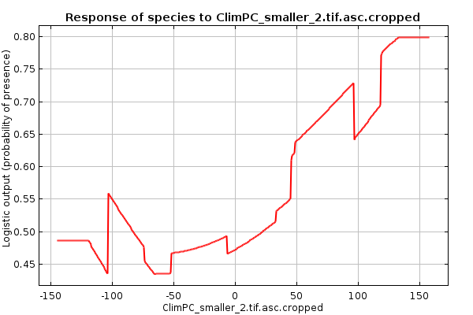 | 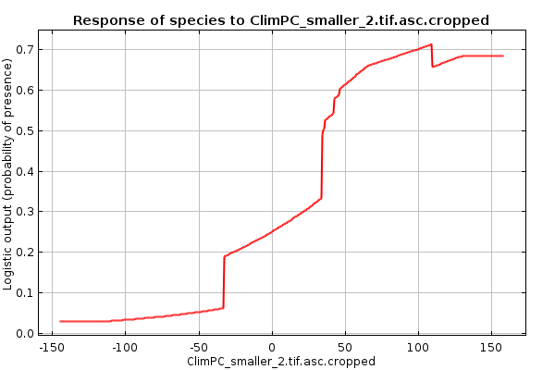
Climate PC3 |  | 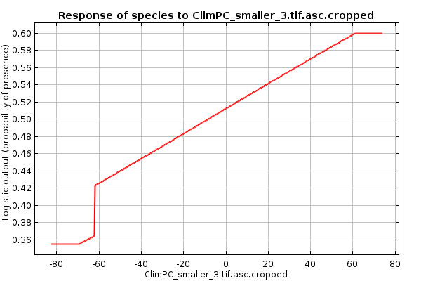 | 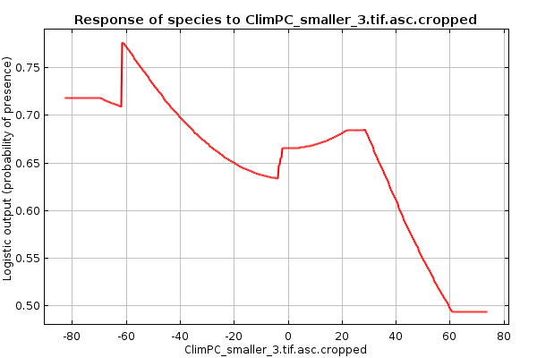
Elevation |  | 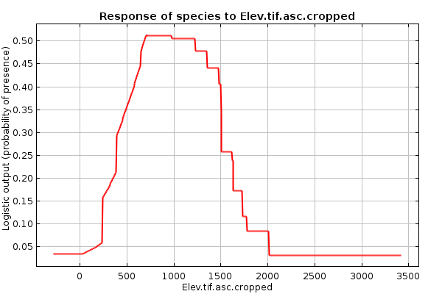 | 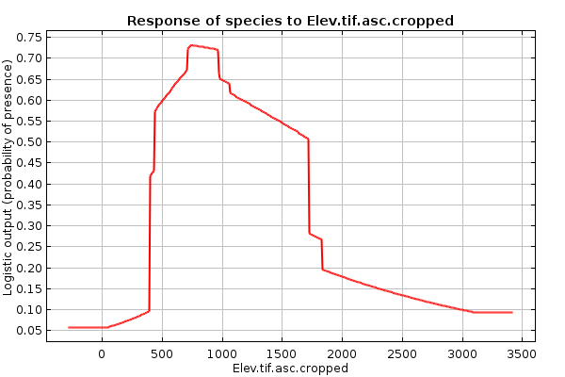
% Surface Imperviousness |  | 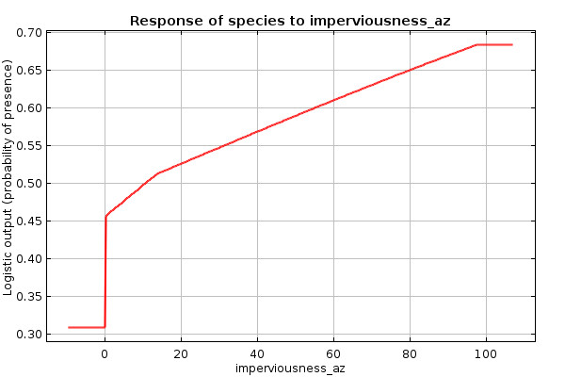 | 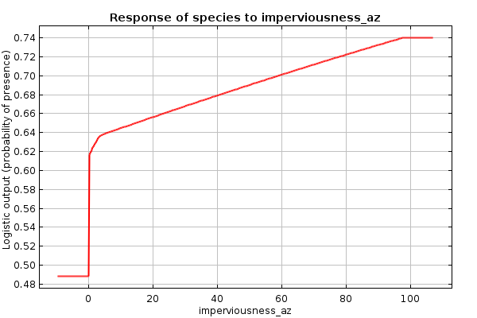
Median Household Income |  | 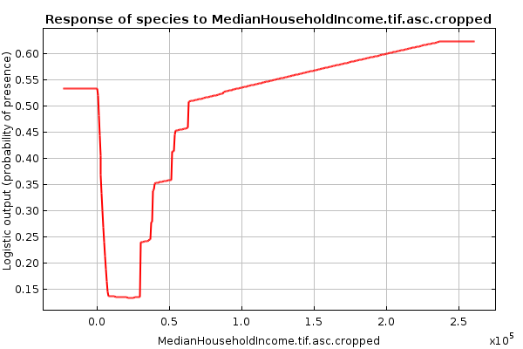 | 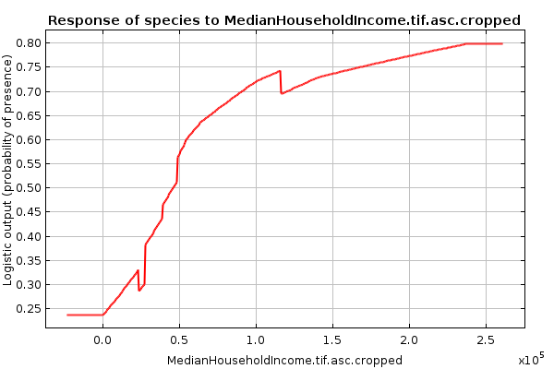
Canopy |  | 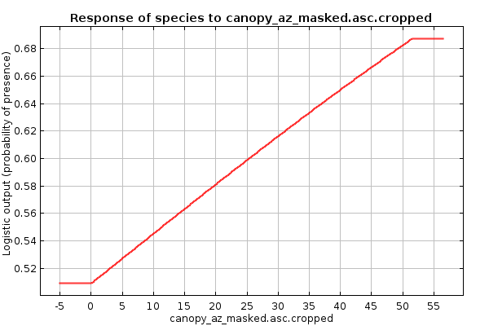 | 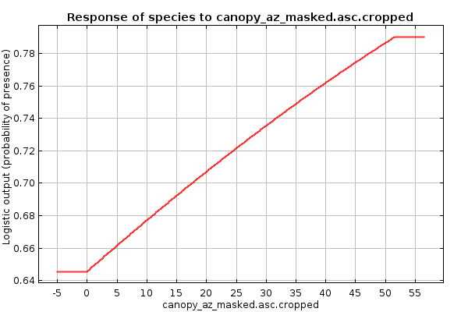
Distance from Open Water |  | 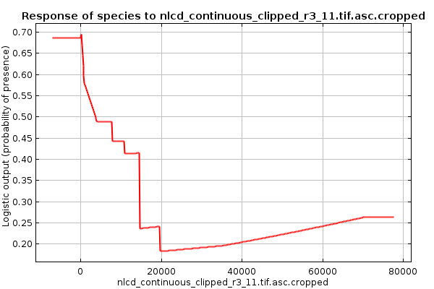 | 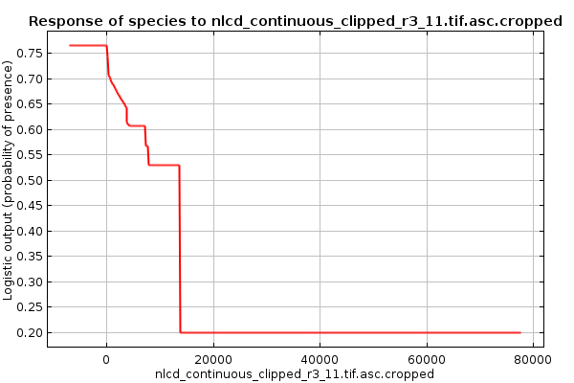
Distance from Barren Land |  | 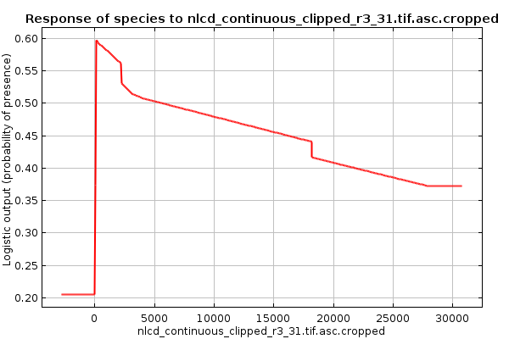 | 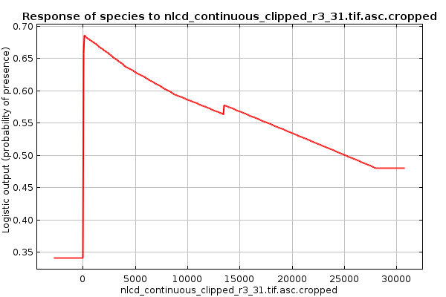
Distance from Deciduous Forest |  | 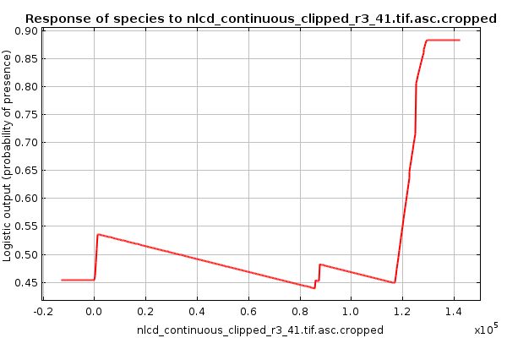 | 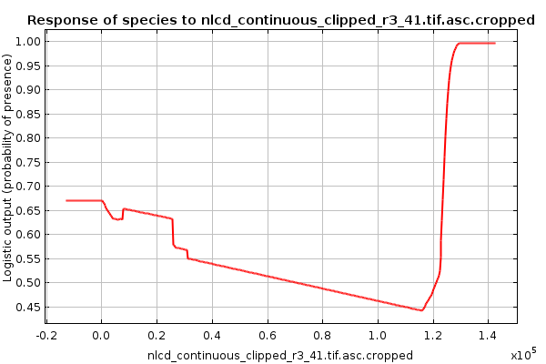
Distance from Evergreen Forest |  | 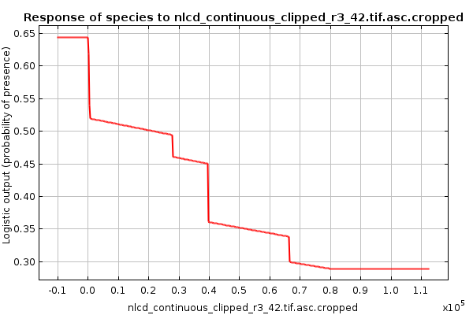 | 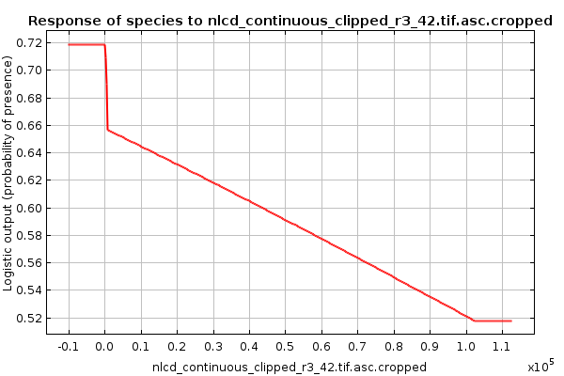
Distance from Shrub/Scrub |  | 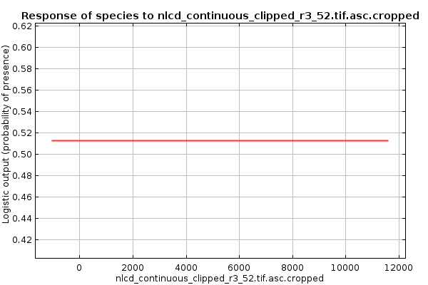 | 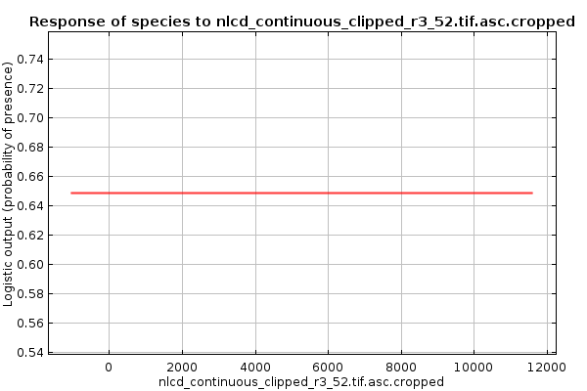
Distance from Grassland/ Herbaceous |  | 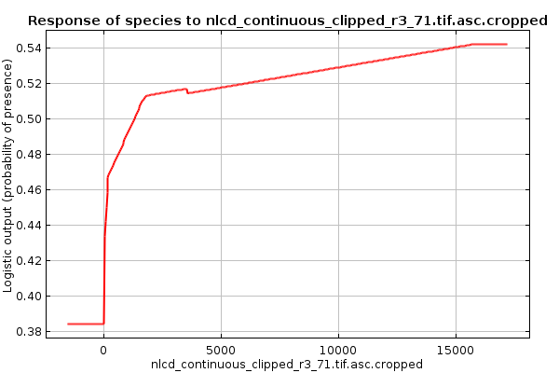 | 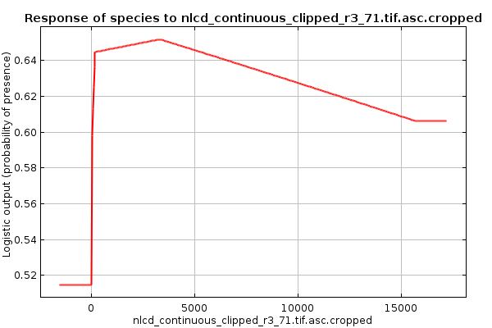
Distance from Pasture/Hay |  | 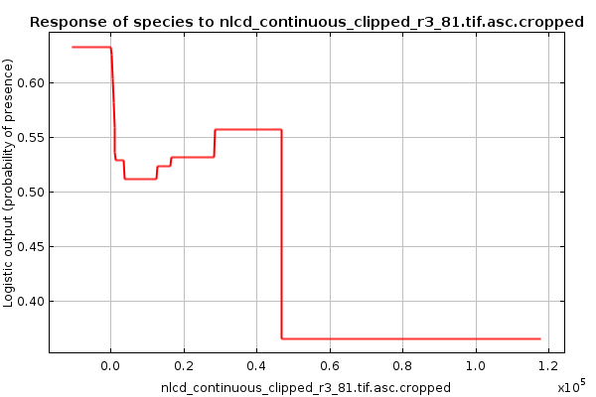 | 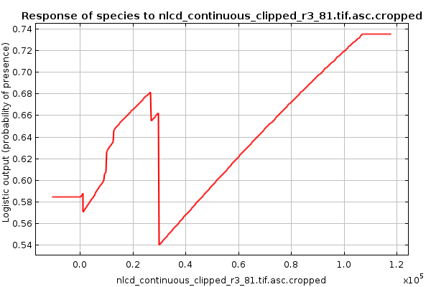
Distance from Cultivated Crops |  | 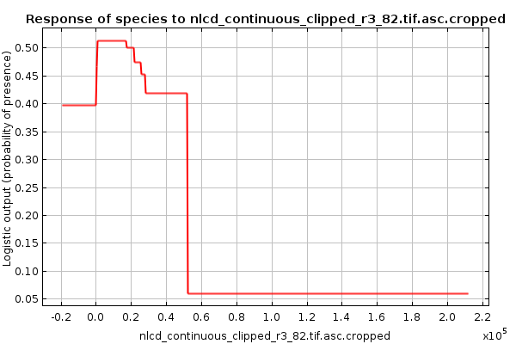 | 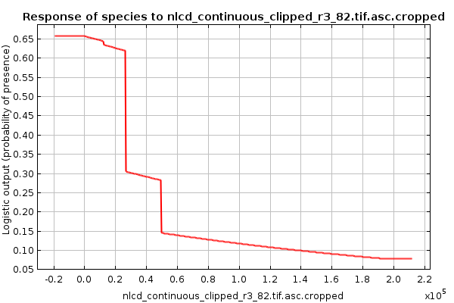
Distance from Woody Wetlands |  | 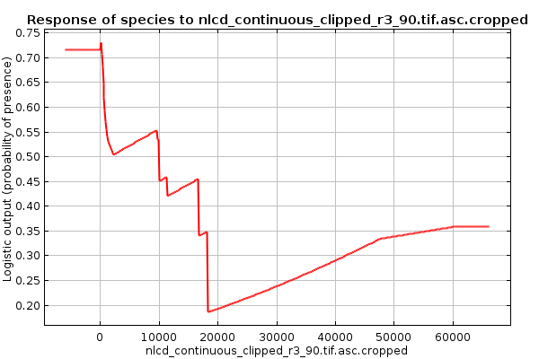 | 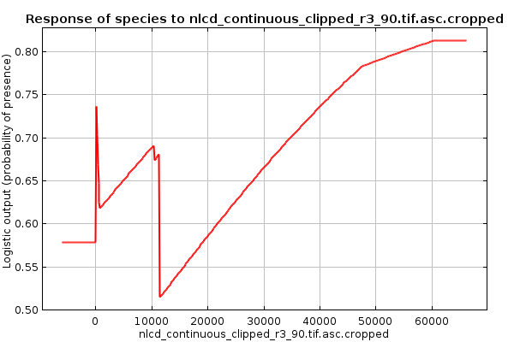

Figure S1.2: Marginal Response of Species to Environmental Variables across Tucson
These plots are produced by the Maxent software and depict how each environmental variable affects the maxent prediction of occurrence of the species across the range. These plots display predicted probability of occurrence on the y-axis with all other variables set to their average value.

Variable | Northern Cardinal | Pyrrhuloxia
Climate PC2 | 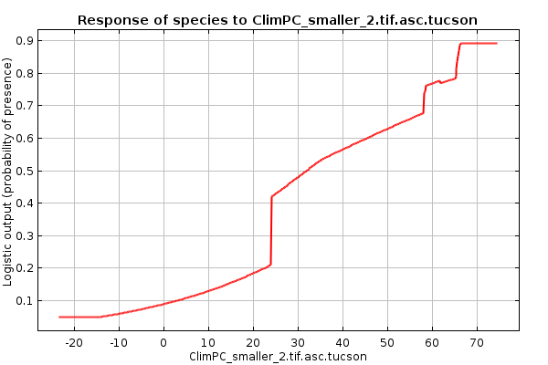 | 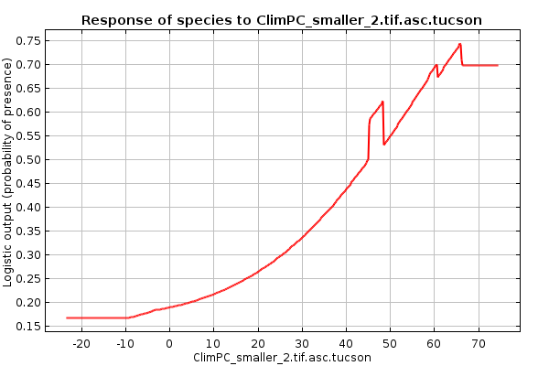
Climate PC3 | 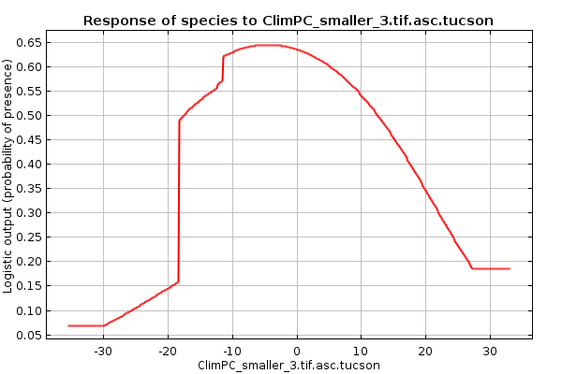 | 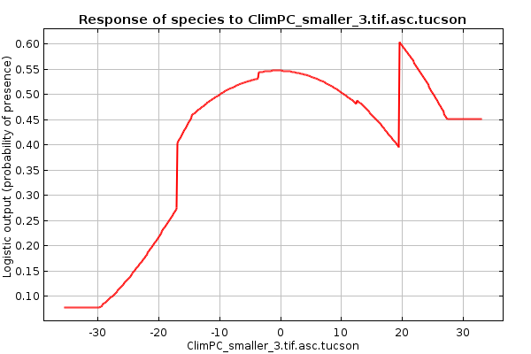
Elevation | 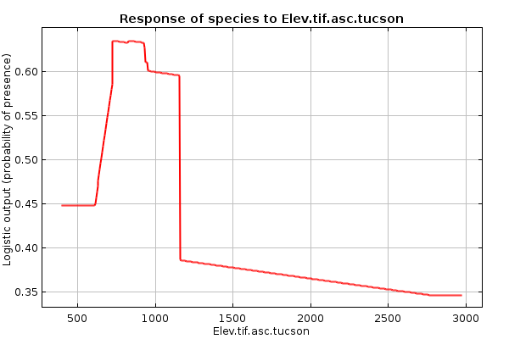 | 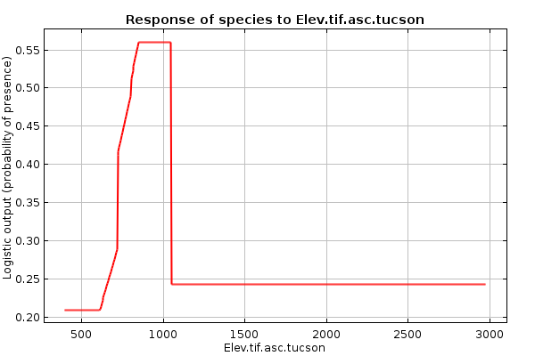
% Surface Imperviousness | 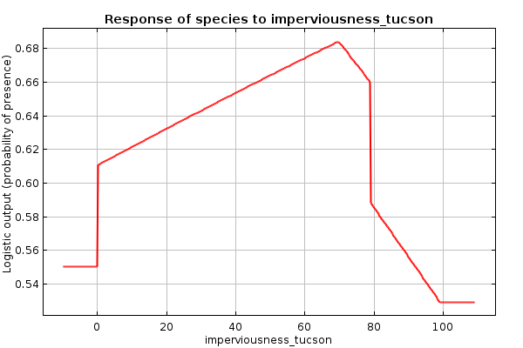 | 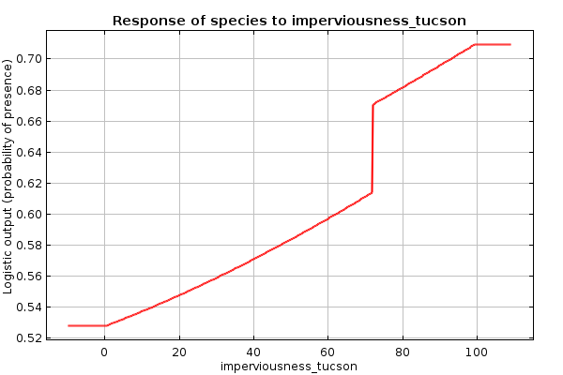
Median Household Income | 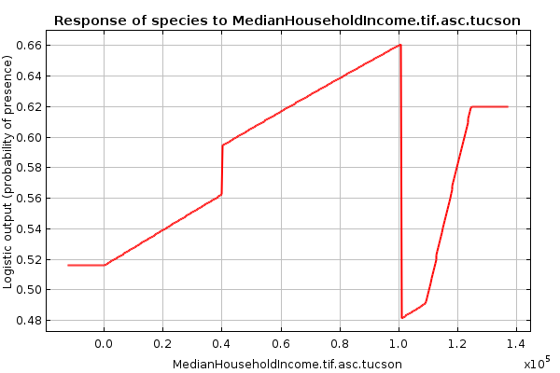 | 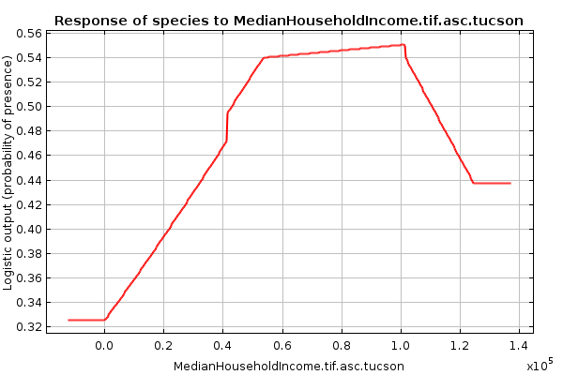
Canopy | 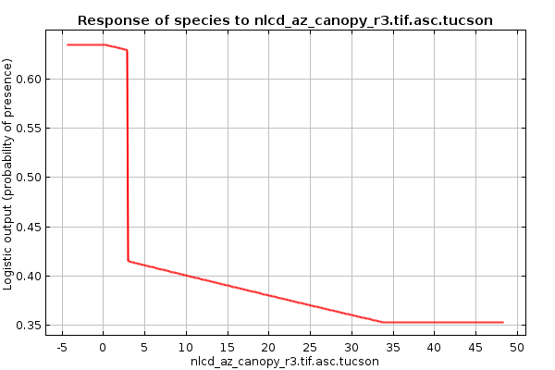 | 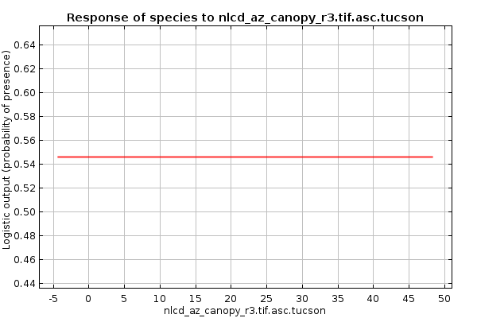
Distance from Open Water | 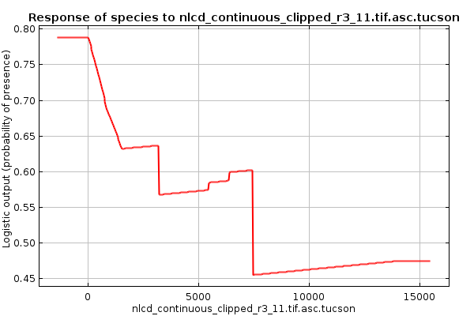 | 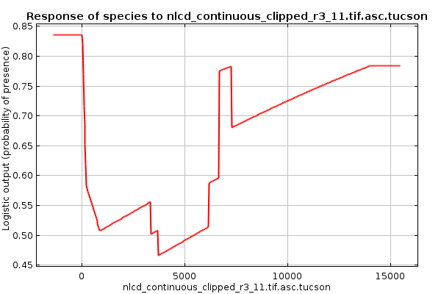
Distance from Barren Land | 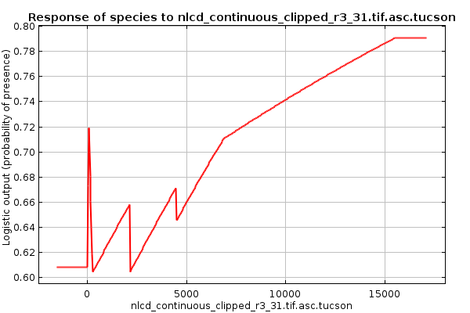 | 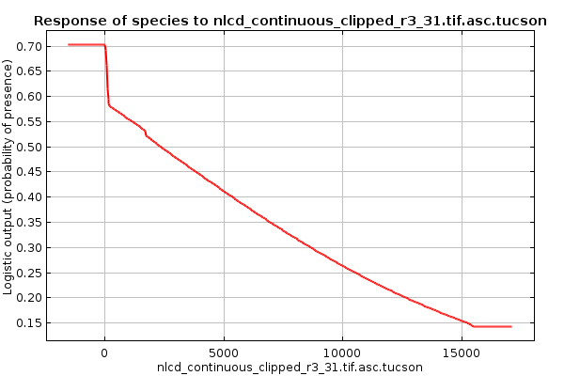
Distance from Deciduous Forest | 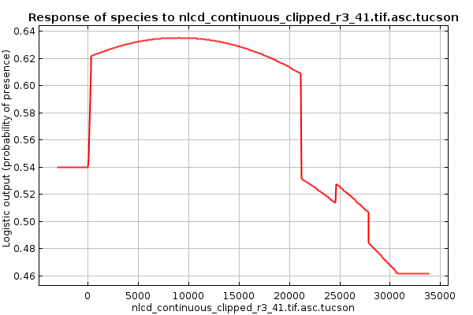 | 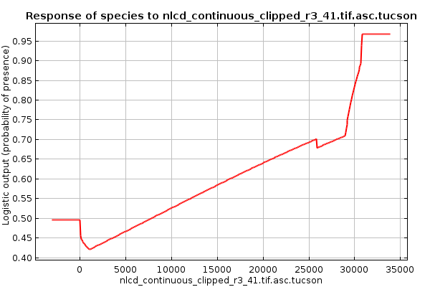
Distance from Evergreen Forest | 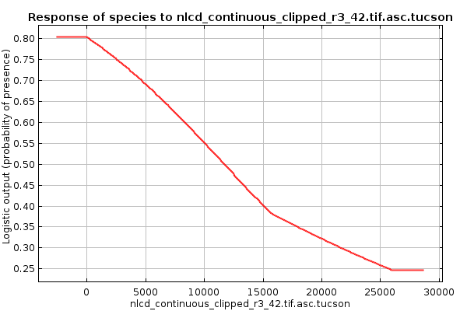 | 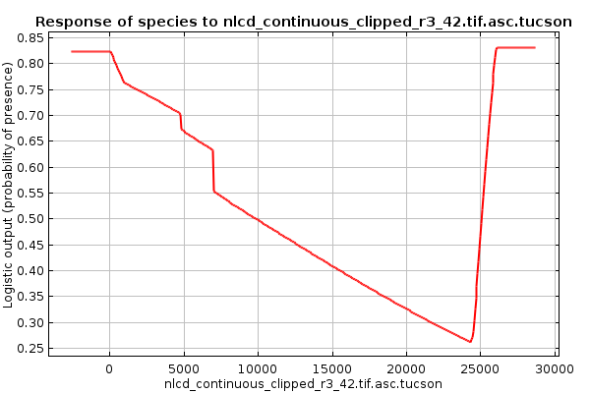
Distance from Shrub/Scrub | 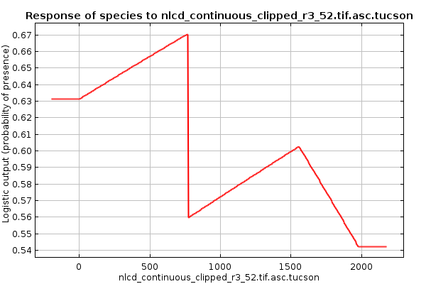 | 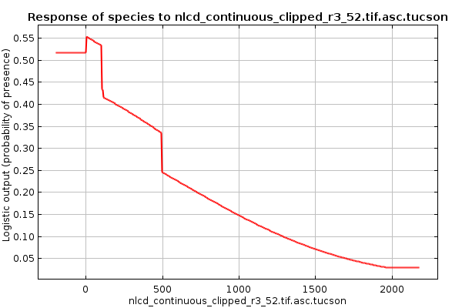
Distance from Grassland/ Herbaceous | 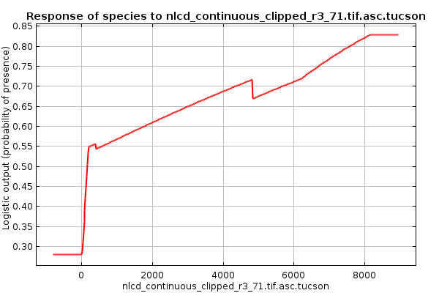 | 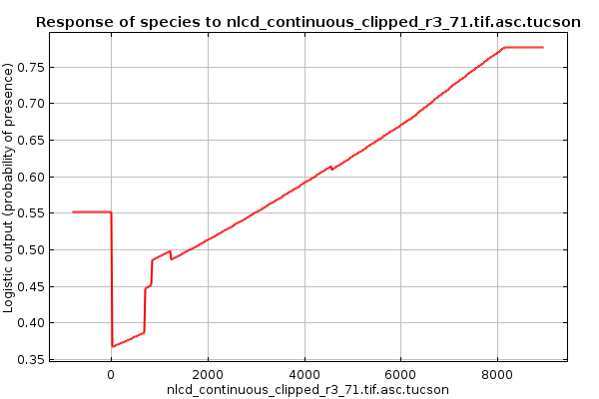
Distance from Pasture/Hay | 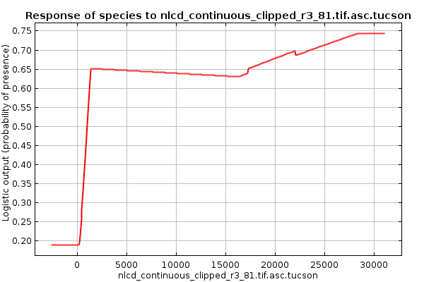 | 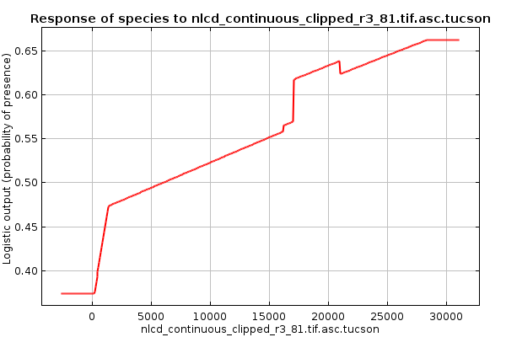
Distance from Cultivated Crops | 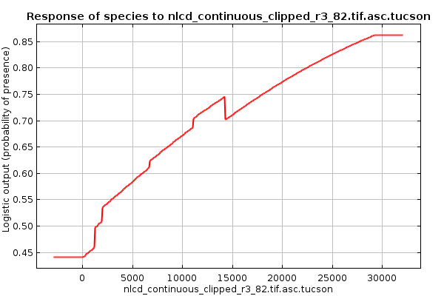 | 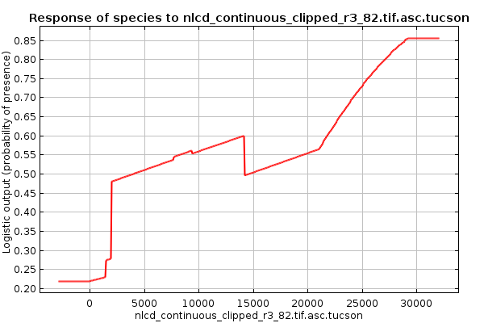
Distance from Woody Wetlands | 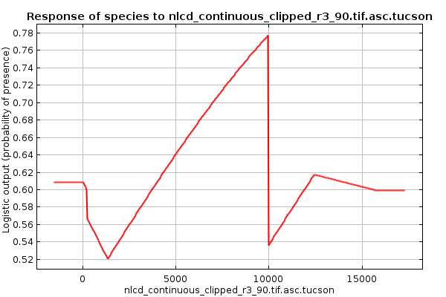 | 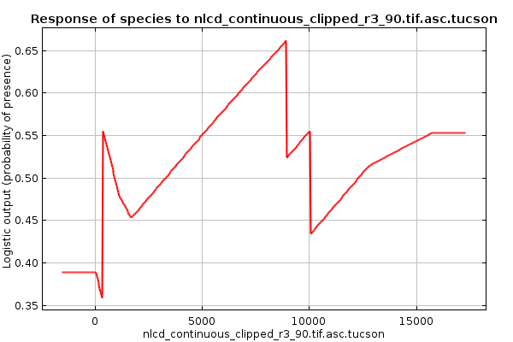

Figure S1.3: Marginal Response of Northern Cardinals to Environmental Variables across Tucson vs. Phoenix
These plots are produced by the Maxent software and depict how each environmental variable affects the maxent prediction of occurrence of the species across the range. These plots display predicted probability of occurrence on the y-axis with all other variables set to their average value. Tucson plots are identical to those presented in Fig. S1.2, but are represented here for ease of visual comparison.

Variable | Northern Cardinals: Tucson | Northern Cardinals: Phoenix
Climate PC2 |  | 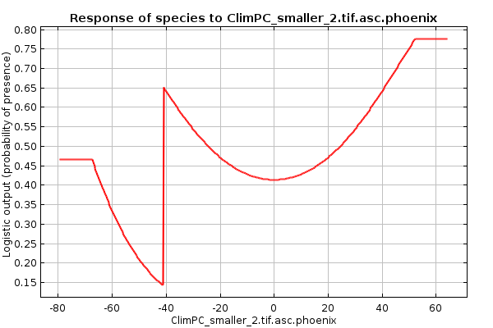
Climate PC3 |  | 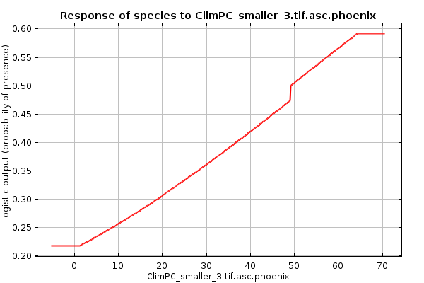
Elevation |  | 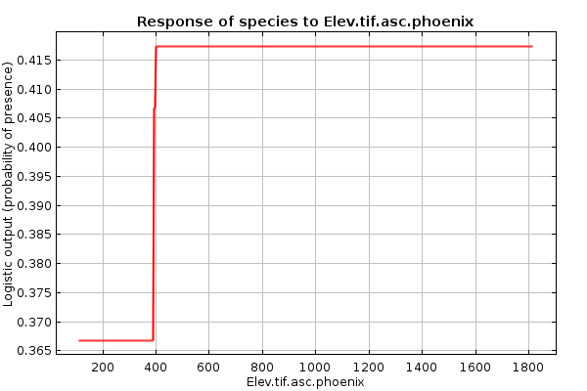
% Surface Imperviousness |  | 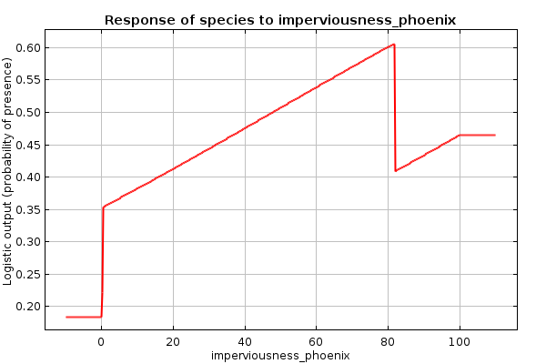
Median Household Income |  | 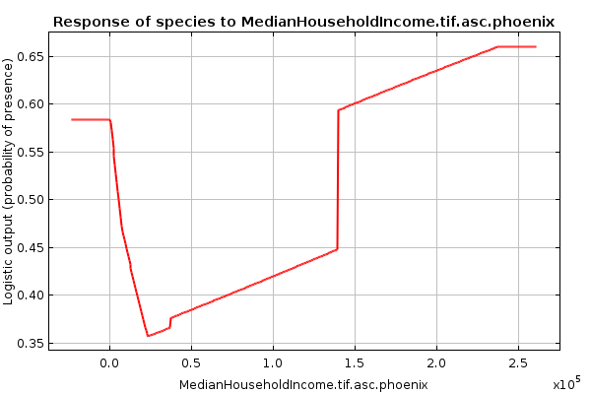
Canopy |  | 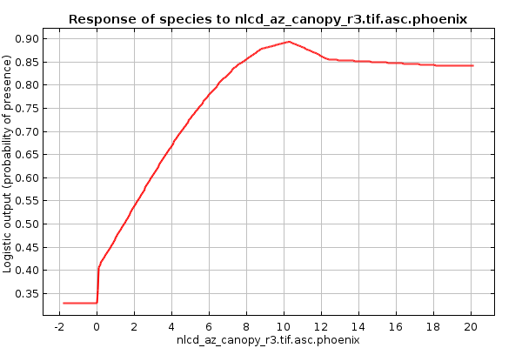
Distance from Open Water |  | 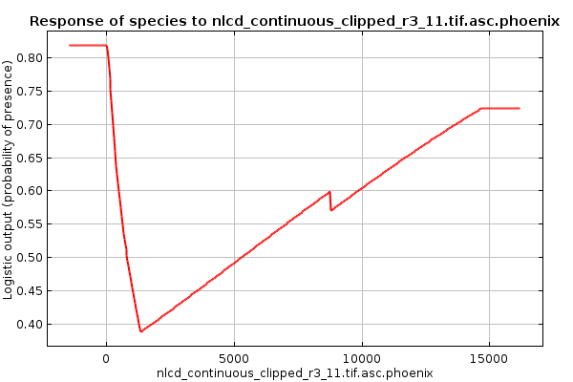
Distance from Barren Land |  | 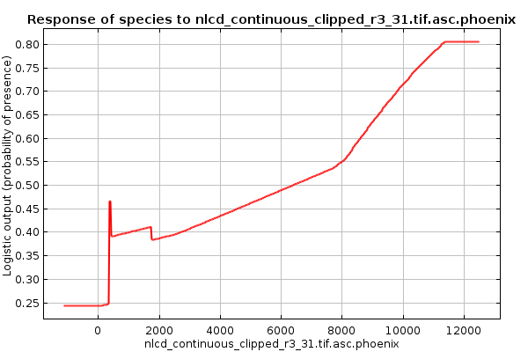
Distance from Deciduous Forest |  | 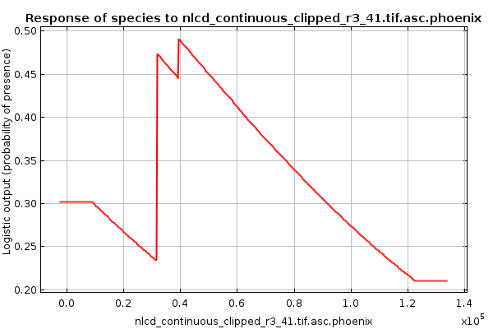
Distance from Evergreen Forest |  | 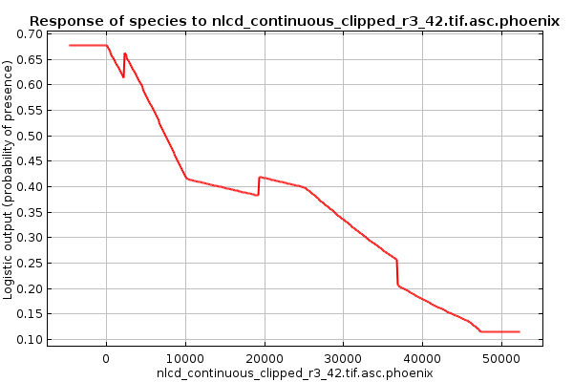
Distance from Shrub/Scrub |  | 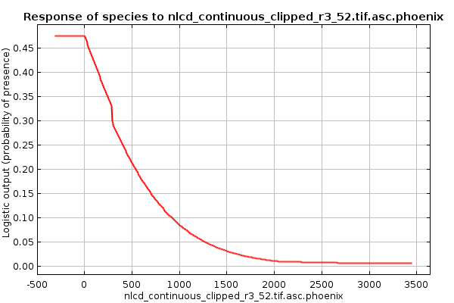
Distance from Grassland/ Herbaceous |  | 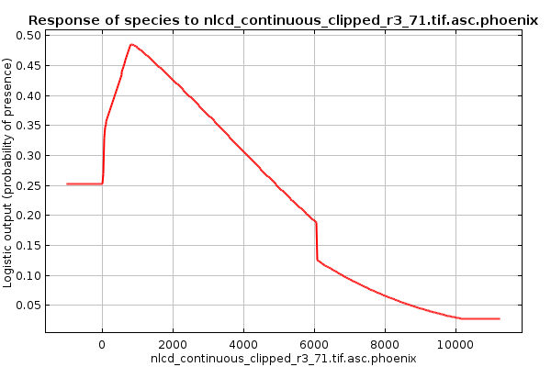
Distance from Pasture/Hay |  | 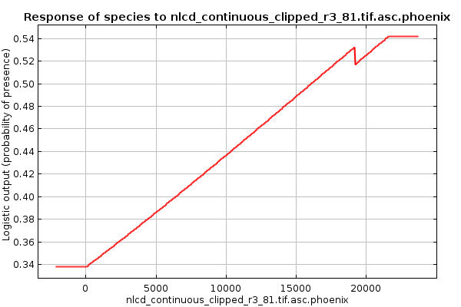
Distance from Cultivated Crops |  | 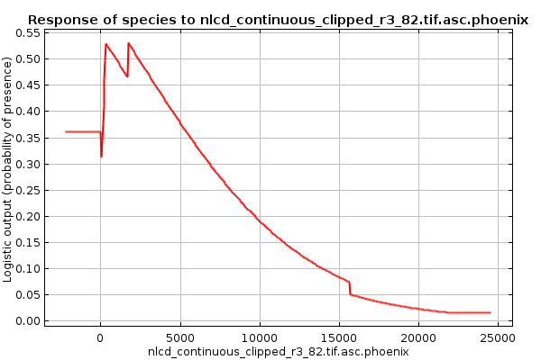
Distance from Woody Wetlands |  | 