Supplementary Files
Supplementary Table 1. qPCR primers and probes.
Target | F primer (5' -> 3') | R primer (5' -> 3') | Probe (5' -> 3')
16S | TCC TAC GGG AGG CAG CAG T | GGA CTA CCA GGG TAT CTA ATC CTG TT | [FAM] CGT ATT ACC [ZEN] GCG GCT GCT GGC AC [IABkFQ]
Gardnerella vaginalis | GCG GGC TAG AGT GCA | ACC CGT GGA ATG GGC C | [JUN] CTT CTC AGC GTC AGT AAC AGC [QSY]
Lactobacillus crispatus | CGT GGT TCA GCW TTG AAG GC | CTT CAA CTG GCA TYA AGA ATG GC | [JUN] AGG CGA CAA GGA AGC TCA AGA AC [QSY]
Lactobacillus iners | CGT GGT TCA GCW TTG AAG GC | CTT CAA CTG GCA TYA AGA ATG GC | [VIC] AGG CGA TCC AGA ACA AGA AGC AG [QSY]
Prevotella bivia | GGA TAT TTG GCA TCA TCA GTG GTA TC | ATA ACT GAT TGG AAG ATA CGC TAC CA | [FAM] TGA TTT GGG [ZEN] GGT TGG GCG ATT T [IABkFQ]

Supplementary Table 2. qPCR detectability of key vaginal bacteria
Target | qPCR detectable above LLOQ  (n=198)
L. crispatus | 45 (22.7%)
L. iners | 156 (78.8%)
G. vaginalis | 187 (94.4%)
P. bivia | 77 (38.9%)

Supplementary Table 3. Microbe-binding AUC between participants dominated (>50% relative abundance) by key vaginal bacteria.
 | Difference of G. vaginalis IgA AUC | Difference of G. vaginalis IgG AUC | Difference of P. bivia IgA AUC | Difference of P. bivia IgG AUC | Difference of L. iners IgA AUC | Difference of L. iners IgG AUC | Difference of L. crispatus IgA AUC | Difference of L. crispatus IgG AUC
G. vaginalis >50% vs. <50% | 0.147 | 0.119 | -0.063 | -0.037 | 0.292** | 0.166 | 0.209* | 0.296
L. iners >50% vs. <50% | 0.217** | 0.356**** | -0.252** | -0.299* | 0.013 | 0.246**** | 0.228** | 0.428****
L. crispatus >50% vs. <50% | -0.120 | 0.161 | -0.016 | -0.150 | 0.236 | 0.338**** | 0.056 | 0.484****
Differences of means by Welch’s T-test. Significant values are bolded and p-values are as indicated: *p<0.05, **p<0.01, ***p<0.001, ****p<0.0001.
Supplementary Table 4. Associations between absolute abundance of vaginal bacteria
 | Total bacterial abundance (log ng/mL of CVS) | G. vaginalis (log ng/mL of CVS) | P. bivia (log ng/mL of CVS) | L. iners (log ng/mL of CVS) | L. crispatus (log ng/mL of CVS)
Total bacterial abundance (log ng/mL of CVS) | 1.00 | 0.850**** | 0.267*** | 0.102 | -0.354****
G. vaginalis (log ng/mL of CVS) | 0.850**** | 1.00 | 0.313**** | 0.027 | -0.372****
P. bivia (log ng/mL of CVS) | 0.267*** | 0.313**** | 1.00 | 0.034 | -0.066
L. iners (log ng/mL of CVS) | 0.102 | 0.027 | 0.034 | 1.00 | -0.264***
L. crispatus (log ng/mL of CVS) | -0.354**** | -0.372**** | -0.066 | -0.264*** | 1.00
Spearmans’s correlation. Significant values are bolded and p-values are as indicated: *p<0.05, **p<0.01, ***p<0.001, ****p<0.0001
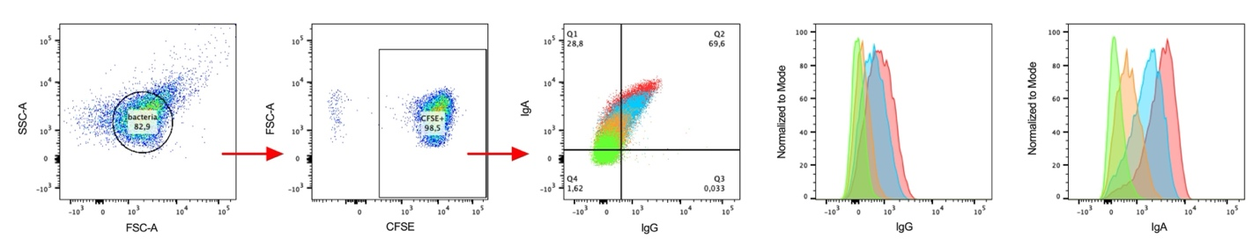
Supplementary Figure 1: Representative Flow cytometry gating strategy.
Supplementary Figure 2: Microbe-binding IgA and IgG across cohort. (File to be attached)
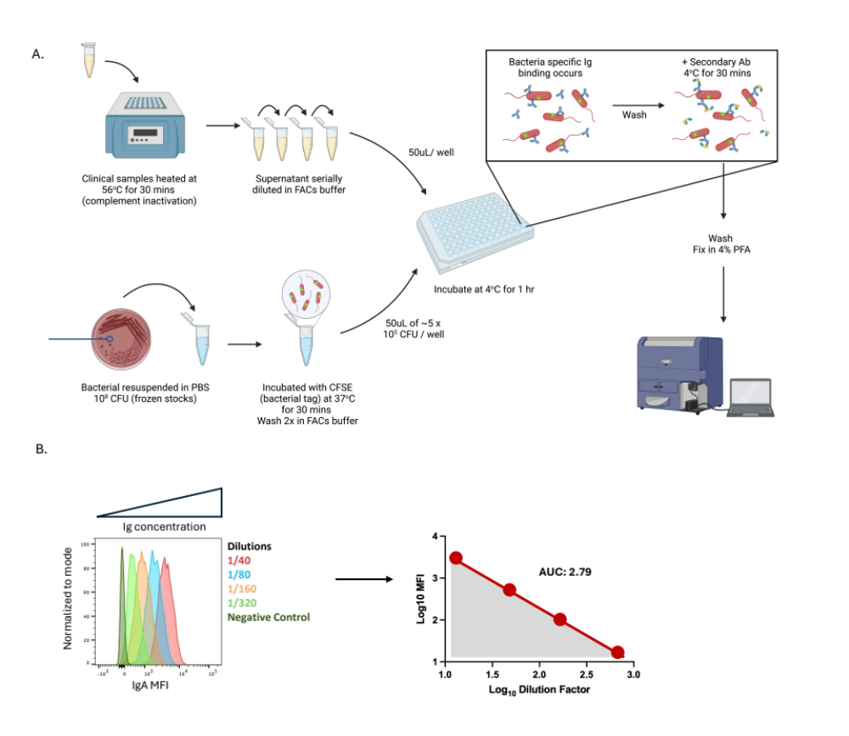
Supplementary Figure 3. Overview of the microbe-binding flow cytometry assay in the female genital tract. (A) A schematic representing the steps of the anti-bacterial antibody flow cytometry assay. Cultured laboratory bacteria are stained with CFSE and combined with equal volumes of serially diluted cervicovaginal secretion samples to allow antibody binding of bacteria. Secondary antibodies (anti-IgA and anti-IgG) are used to identify and quantify the binding of clinical IgA and IgG to the bacteria. (B) A schematic representing the analysis of clinical samples following data collection on the cytometer. The first panel demonstrates four serial dilutions overlayed with the negative control. The MFI values and dilution factors are log10 transformed and plotted as a linear regression and used to calculate the area under the curve (AUC). Figure created using BioRender.
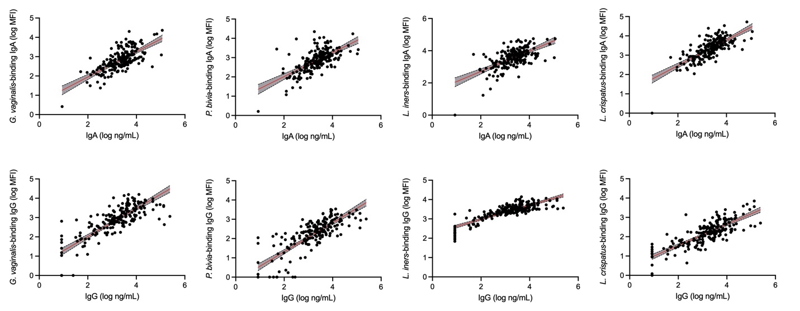
Supplementary Figure 4. Microbe-binding IgA and IgG MFI and total IgA and IgG levels. Microbe-binding MFI response for each bacterium were compared against the approximate IgA or IgG concentration. The red line represents the linear regression line with the 95% confidence intervals (black dashed lines).

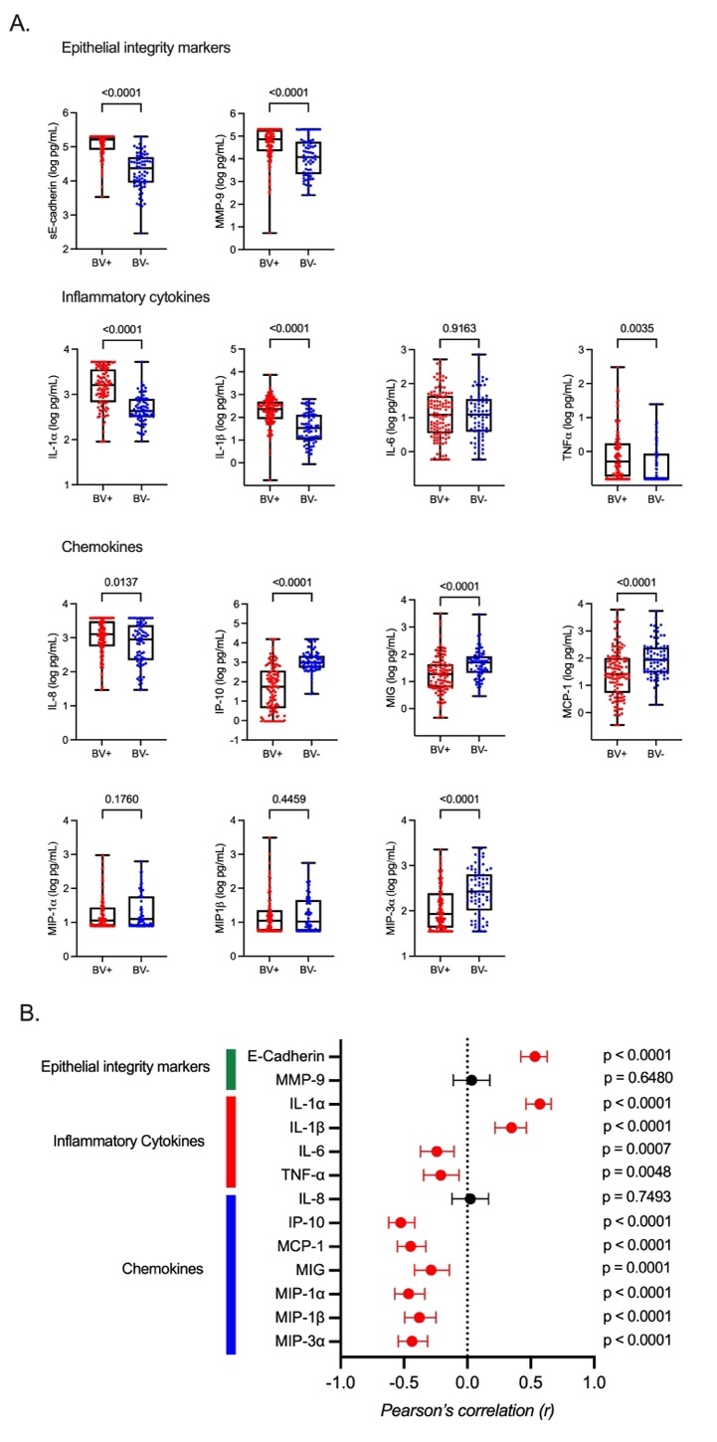
Supplementary Figure 5. Soluble immune markers associated with BV. (A) A comparison of soluble immune markers in the cervicovaginal secretion amongst women with and without BV. Statistical comparison used Welch’s T-test. (B) Correlations between total bacterial abundance (16S) and soluble immune factors. The graph depicts Pearson’s correlation r values, and the error bars denote the 95% confidence intervals. Significant correlations are shown in red.

