Supplemental Online Content

Table of Contents
Supplemental Methods 2
PASC Phenotypes across Networks 2
Data quality checks and population size by network 3
Additional Covariates 4
Sensitivity Analyses 4
eTable 1. Descriptive characteristics of COVID-19-positive patients across three electronic health record research networks 5
eFigure 1. Summary of overlap between N3C/PCORnet and raw patient counts from each network 7
eFigure 2: Consort diagram 8
References 9

Supplemental Methods

PASC Phenotypes across Networks
N3C
N3C’s machine-learning based computable phenotype looked for either:
- The earliest documented U09.9 / B94.8 diagnosis code
- Identification via a machine-learning based definition that scores EHR diagnosis and visit data within a sliding 100-day window.¹
This phenotype was applied to adult patients within 30-180 days after their index date.

PCORnet
PCORnet’s rules-based computable phenotype leveraged ICD codes corresponding with 25 Clinical Classifications Software Refined (CCSR) previously found to have a higher risk in patients with COVID-19 than without COVID-19:^{2,3}
- Abdominal pain and other digestive/abdomen signs and symptoms
- Acute phlebitis; thrombophlebitis and thromboembolism
- Acute pulmonary embolism
- Anemia
- Abnormal heartbeat
- Diabetes
- Fever
- Fluid and electrolyte disorders
- Headache
- Malaise and fatigue
- Malnutrition
- Joint pain
- Cognitive problems
- Dementia
- Chest pain
- Edema
- Encephalopathy
- Constipation
- Pulmonary fibrosis, edema, inflammation
- Hair loss
- Acute pharyngitis
- U09.9 / B94.8
- Pressure ulcer of skin
- Dyspnea (or shortness of breath)
- Sleep wake disorders

The manifestation of post-acute sequelae of SARS-CoV-2 (PASC) symptoms from the list above was observed during the post-acute phase, specifically within the time frame of 30 to 180 days following the index date, while absent during the baseline period, defined as the 7 days preceding the index date. Diagnoses made within 7 days before and 30 days after the index date, denoted as a blackout period, were not used for the determination of PASC. Individuals classified as having PASC were adult patients exhibiting at least one incident PASC-related symptom during the post-acute phase.

PEDSnet
PEDSnet’s rule-based computable phenotype leverages U09.9/B94.8/M35.81 diagnoses as well as diagnoses of PASC-associated features. Features were derived from prior work identifying pediatric diagnoses more common in PASC and COVID-19 positive patients.^{23,24} The phenotype classifies patients as PASC-conclusive and PASC-probable based on the following criteria within 30 to 180 days after the index date:
- Conclusive: MIS-C or PASC or B94.8 code on 2 separate visits
- Probable: MIS-C or PASC or B94.8 code during 1 visit, or COVID-19 diagnosis/positive viral test together with a PASC associated condition [2+ diagnoses in same cluster, 28 days apart], from the clusters of PASC-associated conditions: Abdominal pain (required to be incident), Abnormal liver enzymes, Acute kidney injury, Acute respiratory distress syndrome, Arrythmias, Cardiovascular signs and symptoms, Changes in taste and smell, Chest pain, Cognitive function, Fatigue and malaise, Fever, Fluid/electrolyte disturbance, Generalized pain, Hair loss, Headache, Heart disease (incl. pericarditis), Musculoskeletal, Myocarditis, Myositis, Respiratory signs and symptoms, Fever/chills, POTS/dysautonomia, Skin, Thrombophlebitis/thromboembolism
Conclusive and probable patients were grouped together for this analysis.

Data quality checks and population size by network
N3C analyses utilized data released September 14, 2023, representing records from 82 sites (more details at https://covid.cd2h.org). Site-level quality filters were applied prior to analysis in order to remove 13 data partners with significant and systematic missingness according to the following criteria: sites (1) should not shift dates by more than 30 days, (2) should have serum creatinine and lymphocyte count results for at least 25% of hospitalizations, (3) should not have >10% of their hospitalizations where the COVID-19 index date is more than 200 days after the visit start date, (4) should have birthdays for >90% of people and (5) should have sent data with a run date within the past one year. Analyses were restricted to data from 68 sites passing data quality checks and selected from 18,406,079 unique patient records.
PCORnet included data from 27 sites with substantial adult populations, selecting from 18,893,900 unique patient records. Although some sites contributed data to both N3C and PCORnet, patient geographic location varied by network (eFigure 1).
PEDSnet analyses included data from 40 pediatric health systems contributing data to the Amazon Warehouse Services RECOVER database Version S9, and were subsequently restricted to data from 8 PEDSnet sites and 30 non-PEDSnet sites passing data quality checks, selecting from 8,200,977 patient records.

Additional Covariates
Severity of infection
COVID-19 severity was determined by the presence of a related hospitalization record. Four categories were defined: 1) not hospitalized; 2) not hospitalized, but with an Emergency Department visit within 1 day before to 16 days post-index event; 3) hospitalized (with documented COVID-19 diagnosis within 1 day before to 16 days post-index event); 4) hospitalized with ICU-level care (evidence of invasive ventilation, ECMO, or vasopressor/inotropic support). We also identified patients who were hospitalized and had a positive COVID-19 test but no documented diagnosis during the visit, or with timing more indicative of nosocomial infection. For these patients, we could not categorize severity.
Documentation of vaccination or treatment for COVID-19
Patient vaccination status was defined as 1) having at least one COVID-19 vaccination documented prior to index event; 2) having first vaccination documented “close to” (within 90 days post-) index event, which potentially impacts PASC development;⁴ and 3) no documented vaccination. Due to challenges in vaccination ascertainment, we assumed that patients with no documented vaccination comprised both unvaccinated patients and patients with vaccinations not recorded within the EHR.
Patients were classified as treated with Paxlovid if an order for the medication was documented within 5 days of the index event.
Pre-existing conditions
Patient comorbidities documented between January 2018 and the index event date were captured via the Charlson Comorbidity Index (CCI) score for adults.⁵ Categories included 0, 1-3, 4+, or unknown for patients without at least one documented condition. We applied the Pediatric Medical Complexity Algorithm (PMCA) to classify pediatric medical conditions as non-complex chronic disease, complex chronic disease, or none.⁶

Sensitivity Analyses
We employed additional sensitivity analyses around our visit-related inclusion criteria, examining PASC incidence among patients whose most recent visit occurred within or more than a year prior to index event. This alteration did not significantly change the incidence of PASC (data not shown).

eTable 1. Descriptive characteristics of COVID-19-positive patients across three electronic health record research networks
 | N3C  (N = 3,736,427) | PCORnet  (N = 1,126,467) | PEDSnet  (N = 582,882)
 | No. (%) | No. (%) | No. (%)
Age (years), mean [SD] | 51 (17) | 53 (17) | 9 (7)
Age Group
0-5 | NA | NA | 219,664 (38)
6- 11 | NA | NA | 139,446 (24)
12- 17 | NA | NA | 152,245 (26)
18-21 | NA | NA | 71,527 (12)
22-34 | 831,737 (22) | 218,521 (19) | NA
35-44 | 1,351,002 (36) | 192,263 (17) | NA
45-64 | 670,546 (18) | 403,209 (36) | NA
65+ | 883,259 (24) | 312,474 (28) | NA
Sex
Female | 2,270,968 (61) | 695,356 (62) | 292,811 (50)
Male | 1,465,459 (39) | 431,111 (38) | 290,071 (50)
Race/Ethnicity
Hispanic | 396,689 (11) | 123,160 (11) | 142,240 (24)
Non-Hispanic Asian | 100,663 (3) | 34,806 (3) | 24,865 (4)
Non-Hispanic Black | 472,975 (13) | 178,117 (16) | 106,299 (18)
Non-Hispanic Other | 59,830 (2) | 59,740 (5) | 11,100 (2)
Non-Hispanic White | 2,494,734 (67) | 654,263 (58) | 242,183 (42)
Missing/Unknown | 211,536 (6) | 76,381 (7) | 56,195 (10)
Charlson Comorbidity Index Score
0 | 1,926,087 (52) | 785,334 (70) | NA
1-3 | 1,052,816 (28) | 313,388 (28) | NA
4+ | 391,286 (10) | 20,437 (2) | NA
Unknown | 366,238 (10) | 7,308 (1) | NA
Pediatric Medical Complexity Algorithm Category
None | NA | NA | 509,166 (87)
Non-complex Chronic | NA | NA | 30,012 (5)
Complex Chronic | NA | NA | 43,704 (8)
COVID-19 severity
Not hospitalized | 2,909,355 (78) | 841,886 (75) | 434,002 (75)
Emergency Department | 467,607 (13) | 156,875 (14) | 87,559 (15)
Hospitalized | 187,248 (5) | 79,234 (7) | 8,622 (2)
Hospitalized and COVID-19 positive | 129,285 (3) | 37,015 (3) | 51,909 (9)
Hospitalized with Intensive Care Unit-level care | 42,932 (1) | 11,457 (1) | 790 (0)
Predominant variant at index event
Ancestral | 1,014,805 (27) | 271,424 (24) | 38,972 (7)
Alpha | 457,799 (12) | 131,211 (12) | 130,492 (22)
Delta | 569,039 (15) | 147,669 (13) | 92,098 (16)
Omicron BA.1.1 - BA.2 | 949,423 (25) | 262,023 (23) | 192,356 (33)
Omicron BA.2.12.1 - BA.5 | 635,801 (17) | 263,205 (23) | 106,084 (18)
Omicron BQ.1.1 - XBB.1.5 | 113,249 (3) | 50,935 (5) | 22,880 (4)
Paxlovid ordered at index event | 147,940 (4) | 105,117 (9) | 3,296 (1)
Evidence of vaccination
None documented | 2,648,872 (71) | 789,000 (70) | 488,206 (84)
Close to index event | 190,964 (5) | 48,265 (4) | 23,268 (4)
Prior to index event | 897,010 (24) | 289,202 (26) | 71,408 (12)
Rurality
Micropolitan | 327,590 (9) | 52,757 (5) | 16,704 (3)
Missing | 545,992 (15) | 219,429 (19) | 206,671 (36)
Rural | 77,737 (2) | 14,201 (1) | 3,092 (1)
Small Town | 138,541 (4) | 23,461 (2) | 5,543 (1)
Urban | 2,646,567 (71) | 816,619 (72) | 350,872 (60)

eFigure 1. Summary of overlap between N3C/PCORnet and raw patient counts from each network
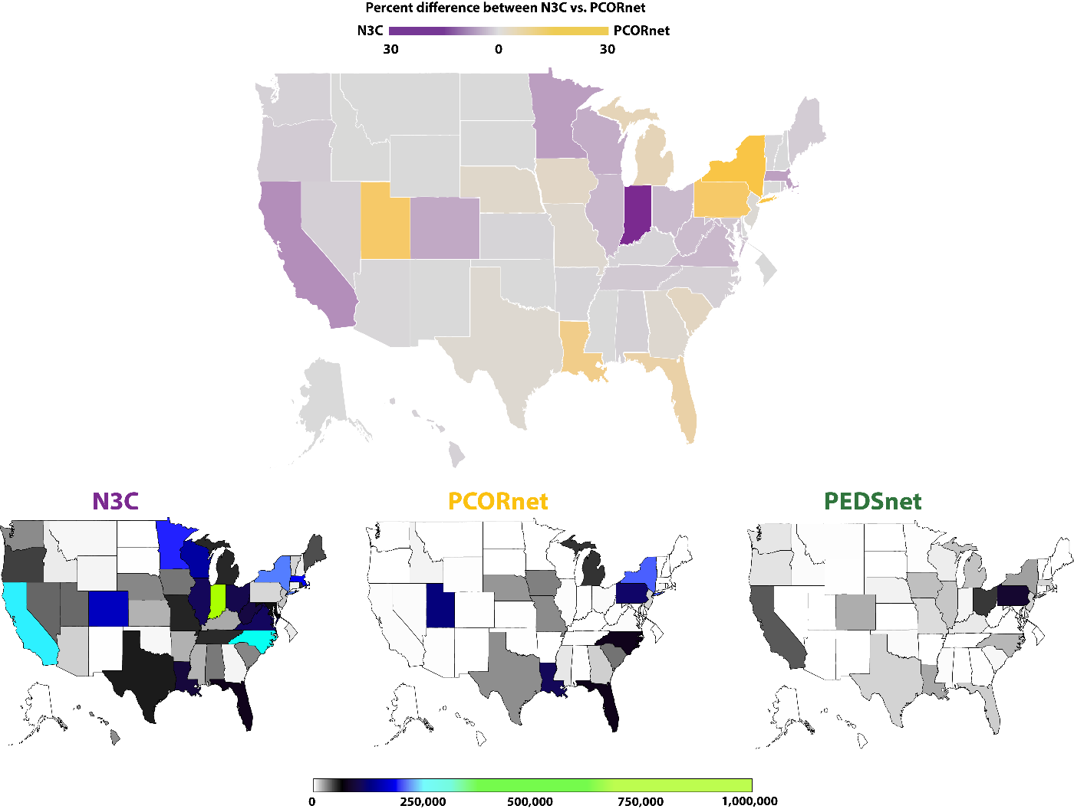

eFigure 2: Consort diagram
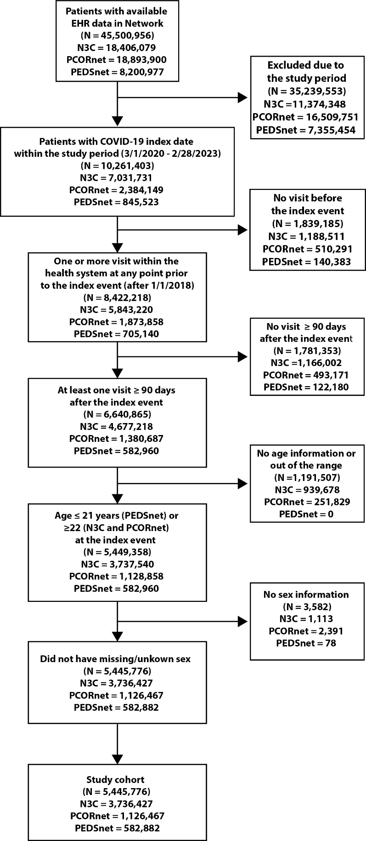

References
1. Crosskey M, McIntee T, Preiss AJ, et al. Reengineering a machine learning phenotype to adapt to the changing COVID-19 landscape: A study from the N3C and RECOVER consortia. Published online December 9, 2023:2023.12.08.23299718. doi:10.1101/2023.12.08.23299718
2. Zang C, Zhang Y, Xu J, et al. Data-driven analysis to understand long COVID using electronic health records from the RECOVER initiative. Nat Commun. 2023;14(1):1948. doi:10.1038/s41467-023-37653-z
3. Zhang H, Zang C, Xu Z, et al. Data-driven identification of post-acute SARS-CoV-2 infection subphenotypes. Nat Med. 2023;29(1):226-235. doi:10.1038/s41591-022-02116-3
4. Byambasuren O, Stehlik P, Clark J, Alcorn K, Glasziou P. Effect of covid-19 vaccination on long covid: systematic review. BMJ Med. 2023;2(1):e000385. doi:10.1136/bmjmed-2022-000385
5. Charlson ME, Pompei P, Ales KL, MacKenzie CR. A new method of classifying prognostic comorbidity in longitudinal studies: development and validation. J Chronic Dis. 1987;40(5):373-383. doi:10.1016/0021-9681(87)90171-8
6. Simon TD, Cawthon ML, Stanford S, et al. Pediatric Medical Complexity Algorithm: A New Method to Stratify Children by Medical Complexity. Pediatrics. 2014;133(6):e1647-e1654. doi:10.1542/peds.2013-3875

