Supplementary material

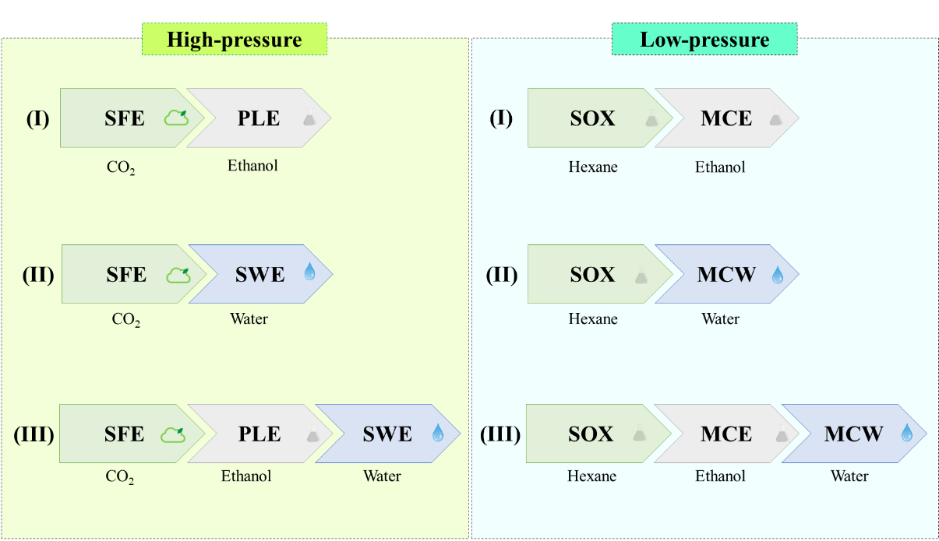

Fig S1. Extraction routes for recovering various fractions under the ascending order of solvent polarity.

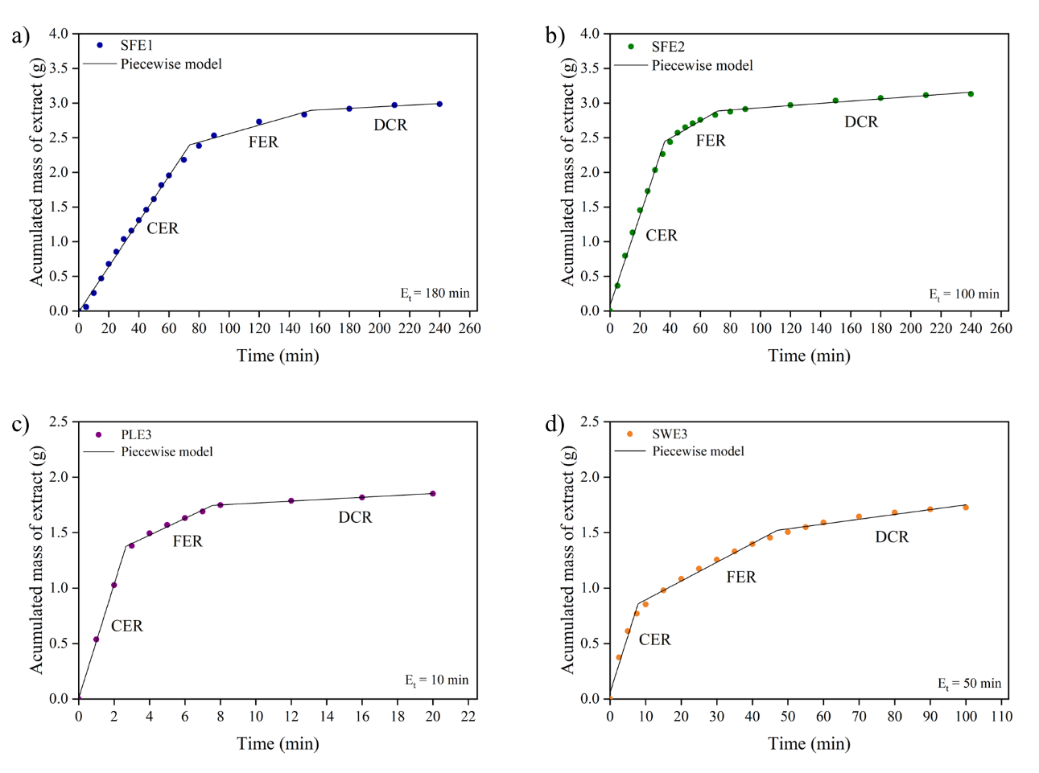
*SFE1 - 40 ºC, 15MPa, SFE2 - 40 ºC, 25MPa, PLE3 - 80°C, 10MPa, SWE3 -120°C, 10MPa.

Fig. S2. Piecewise model parameters fitted to experimental kinetics extraction curves for CNTS by a) SFE1, b) SFE2, c) PLE3, and d) SWE3.

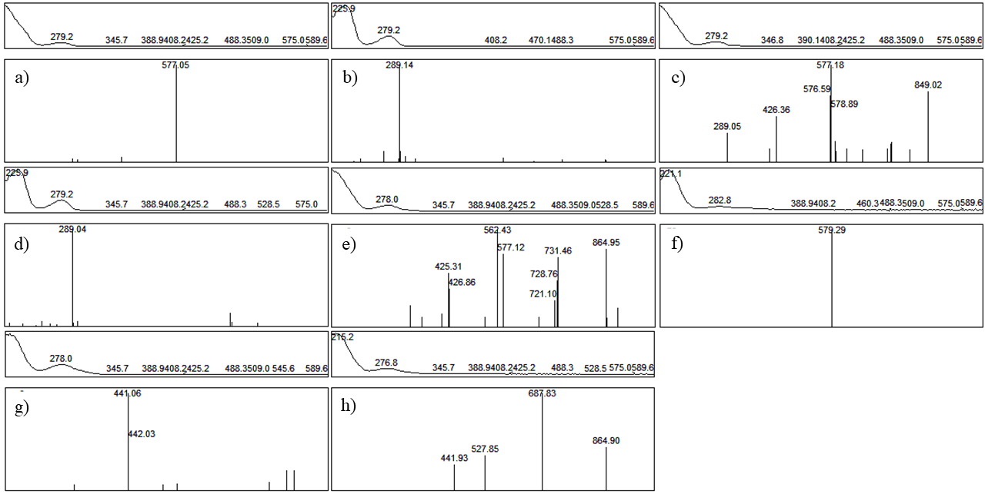
*Square above spectra indicate maximum absorption in the Uv-Vis spectrum.

Fig. S3. Mass spectrum of the identified substances: a) procyanidin B dimer, b) catechin, c) procyanidin B dimer, d) epicatechin, e) procyanidin B trimer, f) procyanidin derivative, g) catechin gallate, and h) procyanidin B trimer.

Table S1. Piecewise model parameters fitted to kinetic extraction to CNTS extracts.
Piecewise parameters | SFE1 | SFE2 | PLE3 | SWE3
a₁ | -0.0132 | 0.0831 | 0.0079 | 0.0574
k₁ (g min⁻¹) | 0.0327 | 0.0651 | 0.5133 | 0.1018
t (CER) | 73.6794 | 36.3034 | 2.6665 | 7.8638
k₂ (g min⁻¹) | 0.0062 | 0.0125 | 0.0757 | 0.0169
t (FER) | 154.2689 | 71.4403 | 7.5409 | 46.9291
k₃ (g min⁻¹) | 0.0011 | 0.0016 | 0.0086 | 0.0043
R² | 0.9981 | 0.9977 | 0.9996 | 0.9951
RMSE | 0.0160 | 0.0528 | 0.0164 | 0.0384
* Coefficients of determination (R²) and the piecewise model's root mean square error (RMSE).

Table S2. Pearson's correlation between polyphenols (TPC and TFC) and antioxidant capacity (FRAP, DPPH, and ABTS) of CNTS extracts.
 | TPC | TFC | FRAP | DPPH | ABTS
TPC | 1 | - | - | - | -
TFC | 0.95* | 1 | - | - | -
FRAP | 0.98* | 0.97* | 1 | - | -
DPPH | 0.95* | 0.95* | 0.96* | 1 | -
ABTS | 0.97* | 0.93* | 0.98* | 0.93* | 1
*Correlation is significant (p < 0.05).

