Supplementary information

Tuning Pd-Pd Atomic Distance on Ceria for Efficient Methane Combustion

Weiwei Yang^{#[a, g]}, Haohong Song^{#[b]}, Lihua Zhang^{[c]}, Junyan Zhang^{[a]}, Felipe Polo-Garzon^{[a]}, Haodong Wang^{[d]}, Harry Meyer III^{[a]}, De-en Jiang*^{[b,e]}, Zili Wu*^{[a, f]}, and Yuanyuan Li*^{[a]}

[a] Chemical Sciences Division, Oak Ridge National Laboratory, Oak Ridge, Tennessee 37831, United States
[b] Interdisciplinary Materials Science, Vanderbilt University, Nashville, Tennessee, 37235, United States
[c] Center for Functional Nanomaterials, Brookhaven National Laboratory, Upton, New York 11973, United States
[d] Department of Materials Science and Chemical Engineering, Stony Brook University, Stony Brook, New York 11794, United States
[e] Department of Chemical and Biomolecular Engineering, Vanderbilt University, Nashville, Tennessee, 37235, United States
[f] Center for Nanophase Materials Sciences, Oak Ridge National Laboratory, Oak Ridge, Tennessee 37831, United States
[g] Guangdong Key Laboratory of Environmental Catalysis and Health Risk Control, Institute of Environmental Health and Pollution Control, Guangzhou Key Laboratory of Environmental Catalysis and Pollution Control, Key Laboratory for City Cluster Environmental Safety and Green Development of the Ministry of Education, School of Environmental Science and Engineering, Guangdong University of Technology, Guangzhou 510006, P. R. China

# These authors contribute equally: Weiwei Yang and Haohong Song
* Corresponding authors
E-mails: liy4@ornl.gov; wuz1@ornl.gov; de-en.jiang@vanderbilt.edu

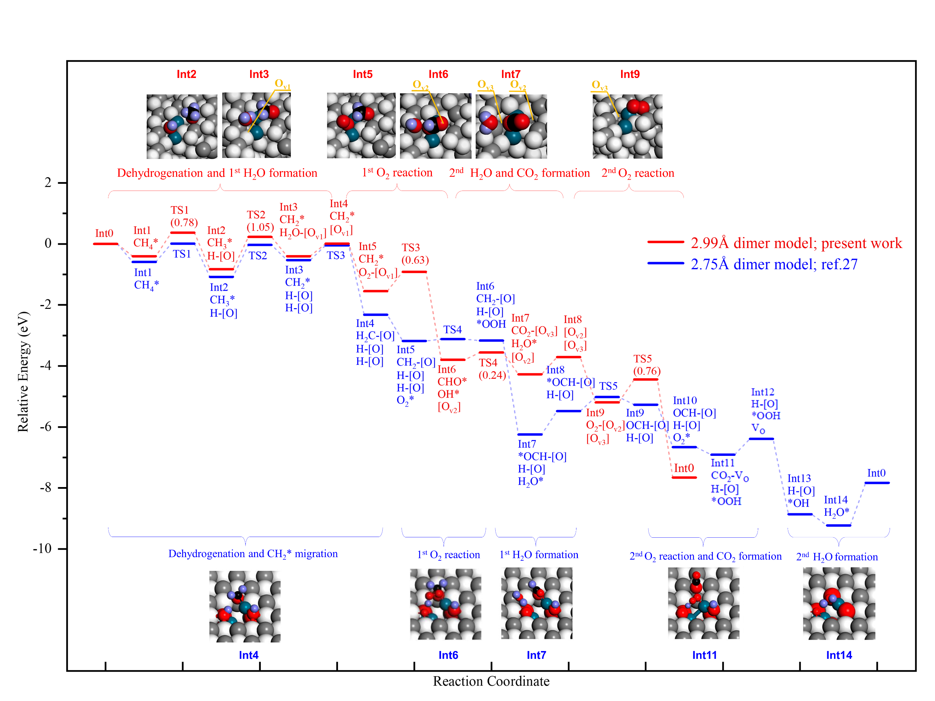
Supplementary Figure S1. DFT-calculated energy profiles for the CH₄ + 2O₂ CO₂ + 2H₂O reaction on the 2.99 Å and 2.75 Å Pd-Pd models on CeO₂(111). (Int: intermediate; TS: transition state; O_{V}: oxygen vacancy; [O]: lattice oxygen).

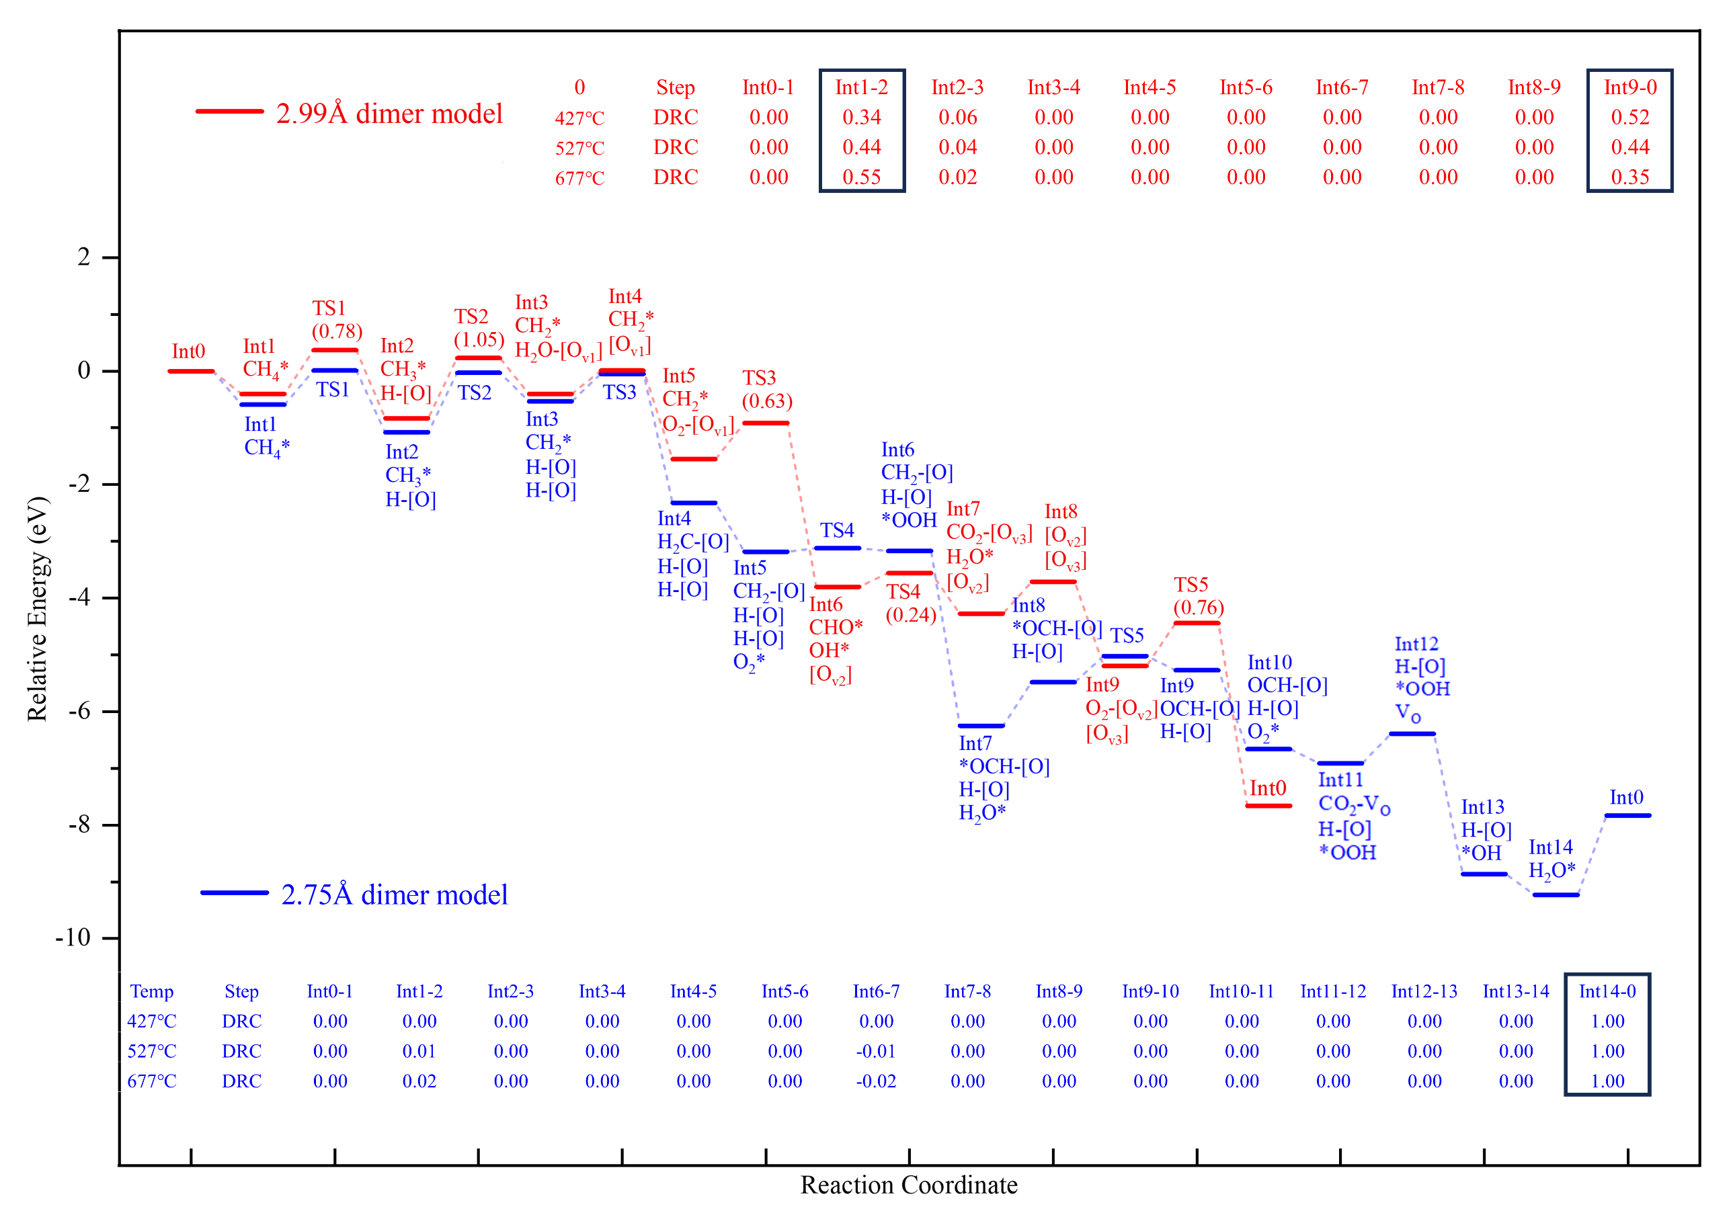
Supplementary Figure S2. Analysis of degree of rate control (DRC) from the microkinetic modeling of the CH₄ + 2O₂ CO₂ + 2H₂O reaction on the 2.99 Å and 2.75 Å Pd-Pd structure on CeO₂(111), based on the DFT energy profiles from Figure S1.

Supplementary Figure S3 Multiple selected HAADF-STEM images of spent 5Pd catalyst.

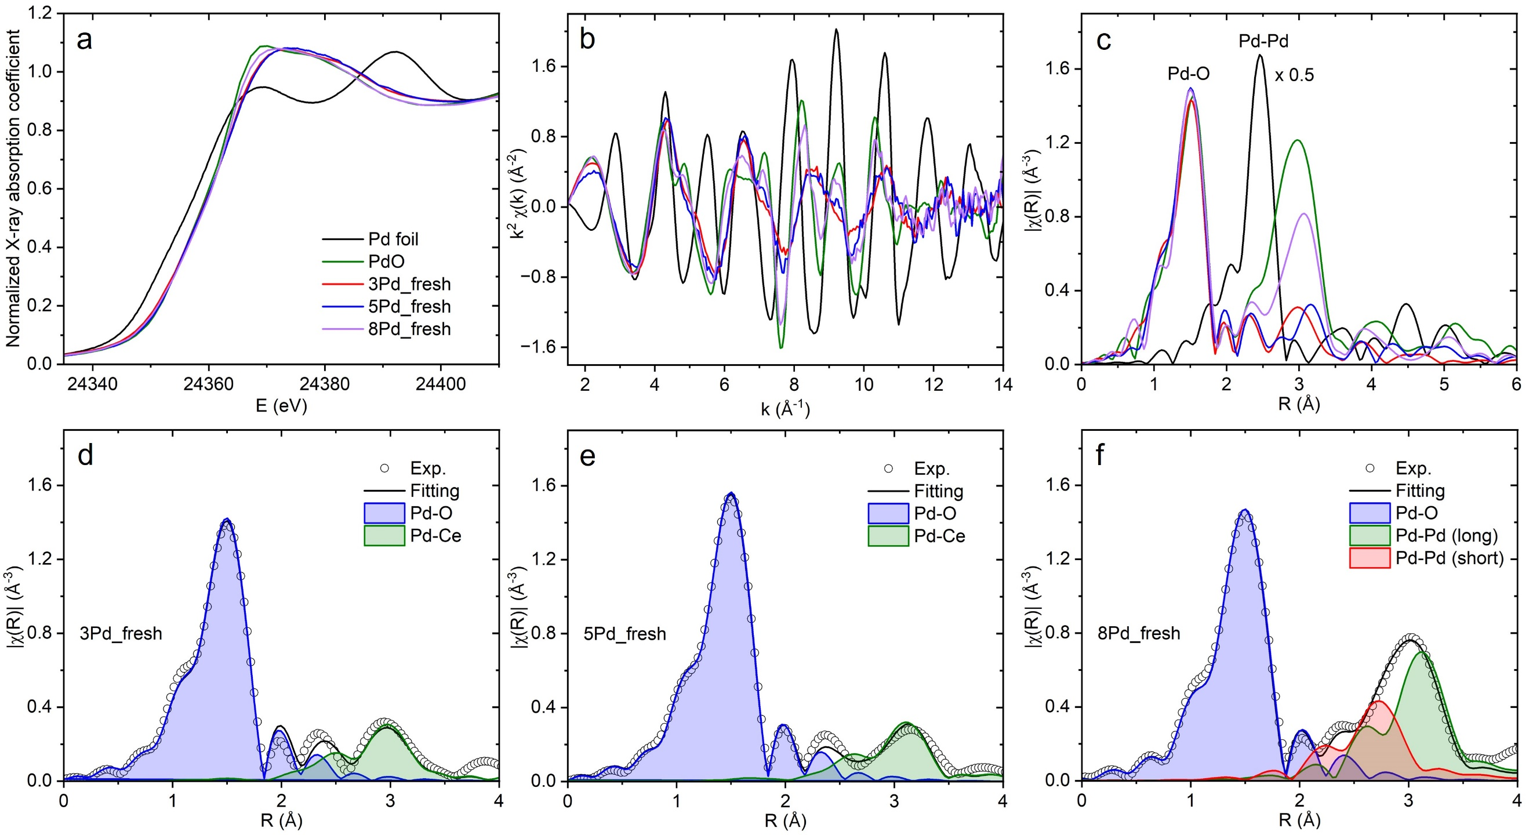
Supplementary Figure S4 (a) Pd K edge XANES, (b) k-space, and (c) R-space EXAFS spectra of the fresh 3Pd, 5Pd, and 8Pd catalysts; the Pd foil and PdO references are included for comparison. (d-f) Experimental and the fitted EXAFS spectra of fresh 3Pd, 5Pd, and 8Pd catalysts.

Supplementary Figure S5 Examples of normalized transient responses of CO₂ product and Ar tracer following a switch from labelled ¹³CH₄ to regular ¹²CH₄ over spent (a) 1Pd, (b) 3Pd, (c) 5Pd, and (d) 8Pd catalysts at different flowrates at 350 °C.

Supplementary Figure S6 Real mean surface residence time (τ₀) of CO₂ obtained by extrapolating the mean surface residence time (τ) at different flowrates at 350 °C. The τ is yielded by integrating the area between the normalized transient response of CO₂ product and that of the inert Ar tracer (see Figure S5). Each measurement is repeated four times.

Supplementary Table S1 DFT exploration of Pd₂ configurations on CeO₂(111) in the add-on mode (Ce, yellow; O, red; Pd, gray; add-on O, pink).
Composition of Added Pd₂ | Nominal Oxidation State of Pd | Top View of Optimized Structure | Pd-Pd distance(Å) | ΔE (eV)  (for same composition) | After AIMD Simulation at 700 K
Pd₂O | Pd¹⁺ | 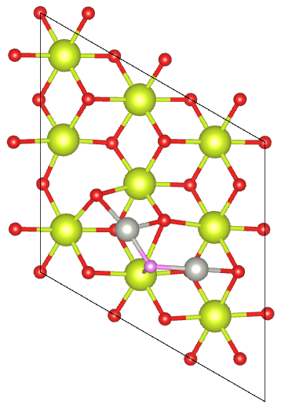 | 3.53 | 0.00 | Not stable:  Pd-O bond breakage with severe surface reconstruction
Pd₂O | Pd¹⁺ | 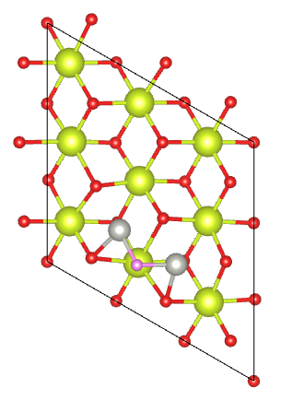 | 3.19 | 0.33 | Not stable:  Pd-O bond breakage with severe surface reconstruction
Pd₂O | Pd¹⁺ | 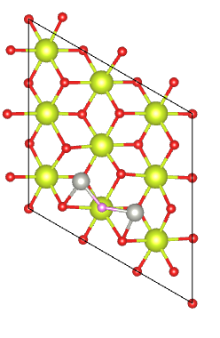 | 3.78 | 0.37 | Not stable:  Pd-O bond breakage with severe surface reconstruction
Pd₂O₂ | Pd²⁺ | 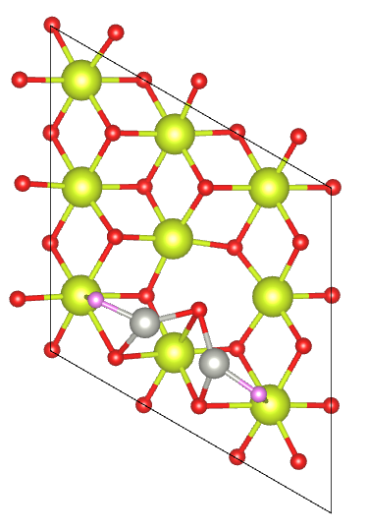 | 2.84 | 0.29 | Not stable:  Pd-O bond breakage with severe surface reconstruction
Pd₂O₂ | Pd²⁺ | 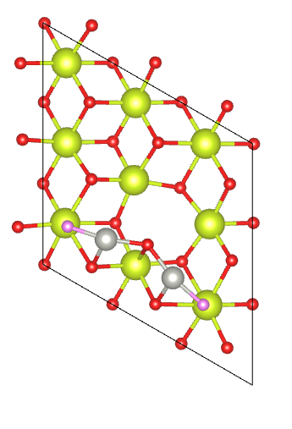 | 3.66 | 0.00 | Not stable:  Pd-O bond breakage with severe surface reconstruction
Pd₂O₃ | Pd³⁺ | 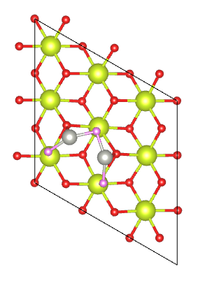 | 2.85 | 0.05 | Not stable:  Pd-O bond breakage with severe surface reconstruction
Pd₂O₃ | Pd³⁺ | 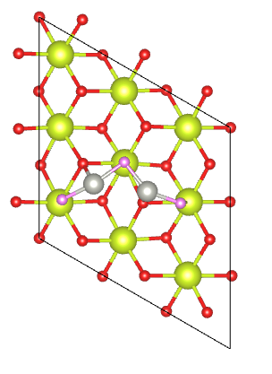 | 2.81 | 0.00 | Not stable:  Pd-O bond breakage with severe surface reconstruction
Pd₂O₄ | Pd⁴⁺ | 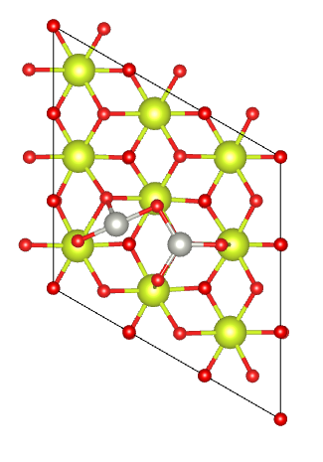 | 2.92 | 0.81 | Not stable:  Pd-O bond breakage with severe surface reconstruction
Pd₂O₄ | Pd⁴⁺ | 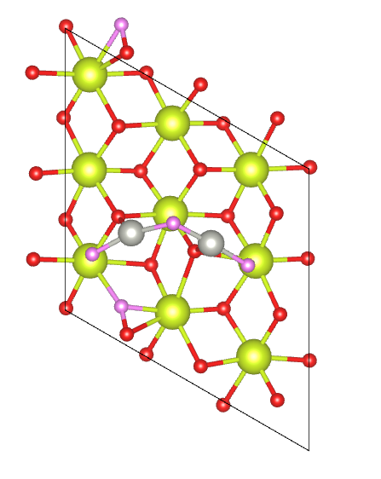 | 3.15 | 0.11 | Not stable:  Pd-O bond breakage with severe surface reconstruction
Pd₂O₄ | Pd⁴⁺ | 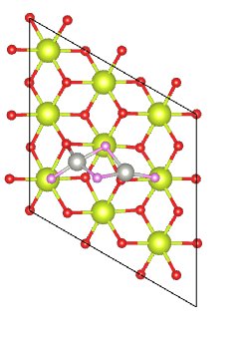 | 2.96 | 0.00 | Not stable:  Pd-O bond breakage with severe surface reconstruction

Supplementary Table S2 DFT exploration of Pd₂ configurations on CeO₂(111) in the substitution mode (Ce, yellow; O, red; Pd, gray; add-on O, pink).

Substitution Composition | Nominal Oxidation State of Pd | Top View of Optimized Structure | Pd-Pd distance (Å) | ΔE (eV)  (for same composition) | After AIMD Simulation at 700 K
2Pd for 1CeO₂ | Pd⁰ | 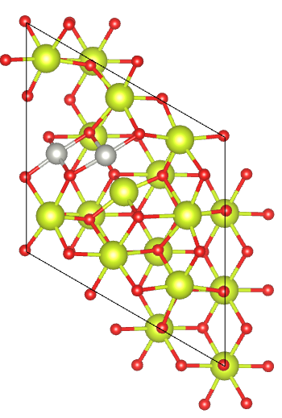 | 3.00 | 0 | Not stable:  Pd-O Bond breakage with severe surface reconstruction
2Pd for 1Ce | Pd²⁺ | 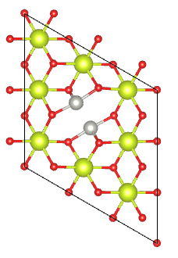 | 2.75 | 0.00 | Stable:  No significant changes observed.
2Pd for 2CeO | Pd²⁺ | 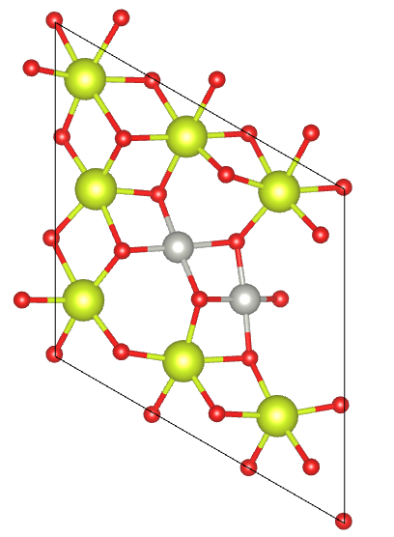 | 2.99 | 0.00 | Stable:  No significant changes observed.
2Pd for 2Ce | Pd⁴⁺ | 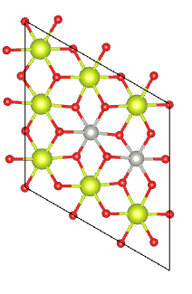 | 3.62 | 0.00 | Stable:  No significant changes observed.

Supplementary Table S3 DFT exploration of Pd₂ configurations on CeO₂(111) in the mixed add-on/substitution mode (Ce, yellow; O, red; Pd, gray; add-on O, pink).

Composition Change |  |  | Nominal Oxidation State of Pd | Top View of Optimized Structure | Pd-Pd distance (Å) | ΔE (eV)  (for same composition) | After AIMD Simulation at 700 K
 | Add 1PdO₂  Sub 1Pd for 1Ce | Pd⁴⁺ |  | 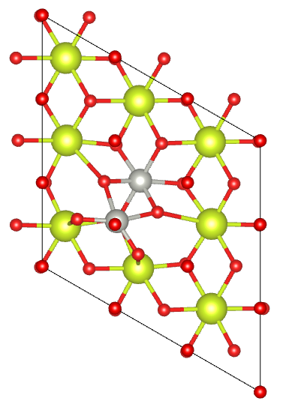 | 3 | 1.30 | Not stable:  Pd-O Bond breakage with severe surface reconstruction
 | Add 1PdO₂  Sub 1Pd for 1Ce | Pd⁴⁺ |  | 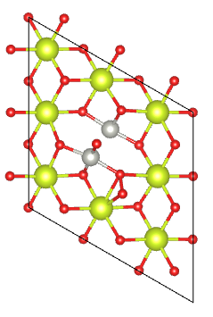 | 2.78 | 0.60 | Not stable:  Pd-O Bond breakage with severe surface reconstruction
 | Add 1PdO₂  Sub 1Pd for 1Ce | Pd⁴⁺ |  | 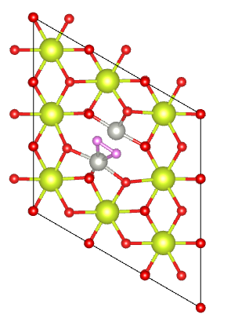 | 2.87 | 0.00 | Not stable:  Pd-O Bond breakage with severe surface reconstruction
 | Add 1PdO₂  Sub 1Pd for 1Ce | Pd⁴⁺ |  | 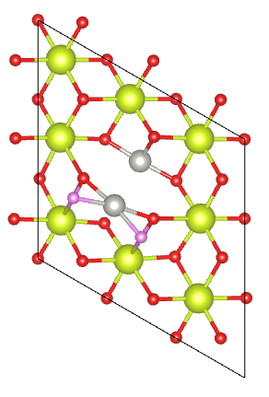 | 3.4 | 0.0 | Not stable:  Pd-O bond breakage with severe surface reconstruction
 | Add 1PdO  Sub 1Pd for 1Ce | Pd²⁺+Pd⁴⁺ |  | 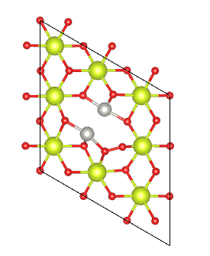 | 3.00 | 0.0 | Not stable:  Pd-O bond breakage with severe surface reconstruction

Supplementary Table S4 Bader charges on the Pd atoms for different structures.
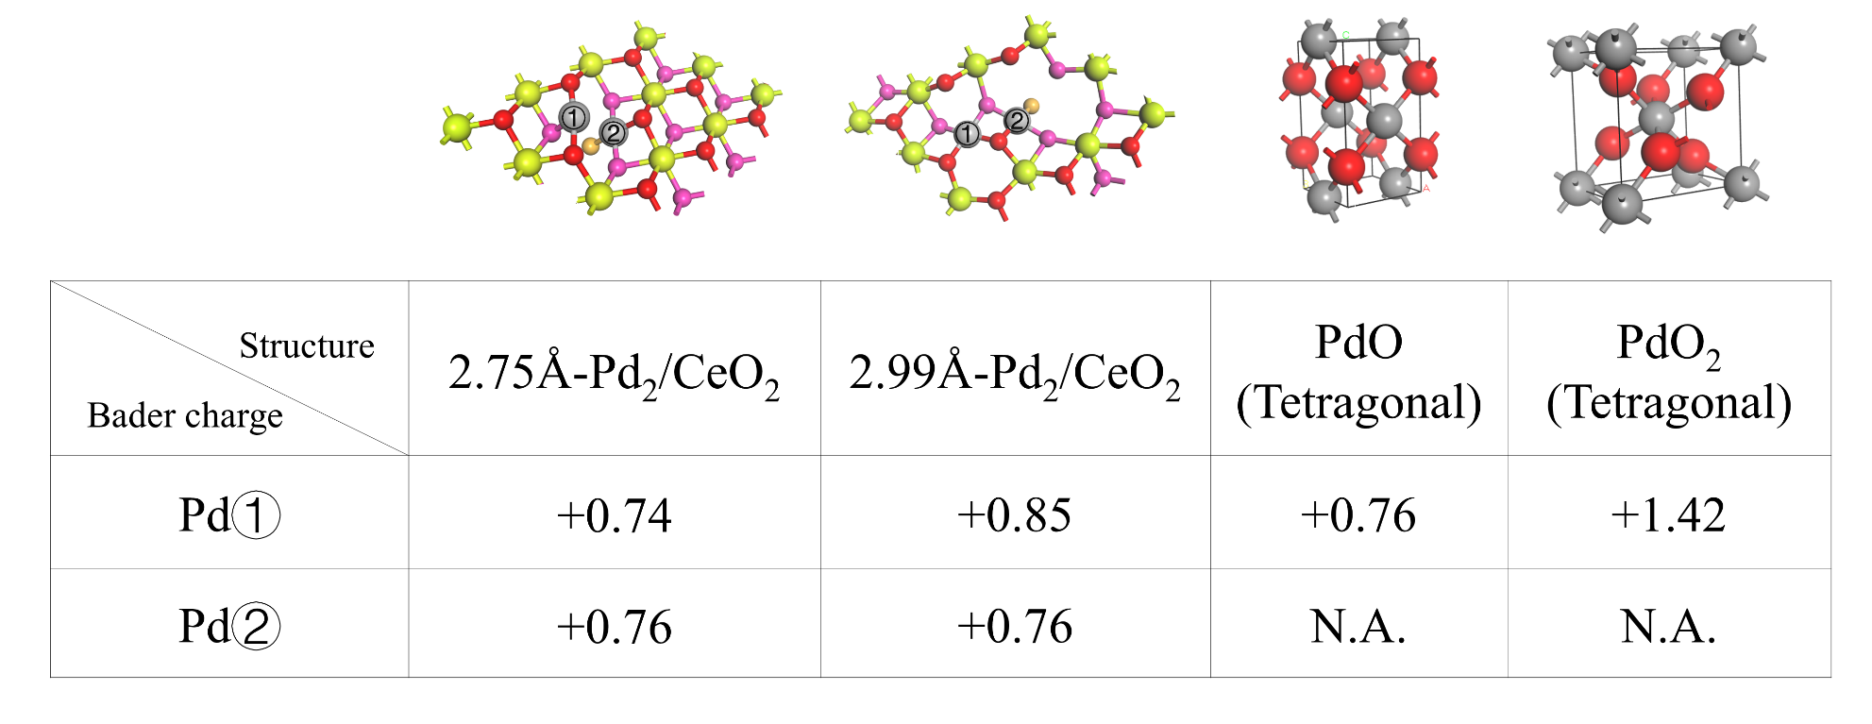
In the 2.75 Å model, the valence state of Pd closely resembles that of PdO. In the 2.99 Å model, the valence state of Pd is slightly higher than that in PdO.

Supplementary Table S5 O vacancy formation energy results for 2.75 Å model; 2.99 Å model and CeO₂(111). The dotted red circles indicate the Oxygen vacancies. These lattice oxygen sites participate in the reaction pathways described earlier. For comparison, surface O in CeO₂(111) is used as a reference. O_{V} formation energy = E_{without O} +1/2E_{O2} –E_{with O}.
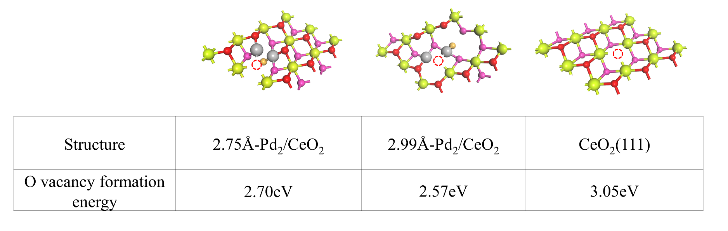
The 2.99 Å-Pd₂/CeO₂ model features the most active surface lattice oxygen, which is exceedingly easy to reduce. The energy required to form an oxygen vacancy at this site is 0.13 eV lower than that in the 2.75 Å-Pd₂/CeO₂ model and 0.48 eV lower than in CeO₂(111).

Supplementary Table S6 Best EXAFS fit results for Pd foil, and the fresh and spent catalysts. The fitting k range is 2.0-12.0 Å⁻¹, and the fitting R range is 1.0-3.5 Å.
Sample | Path | N | R (Å) | σ² (Å²) | ΔE (eV)
Pd foil | Pd-Pd | 12 | 2.740±0.002 | 0.0054±0.0002 | -5.3±0.3
3Pd_fresh | Pd-O | 3.7±0.3 | 1.995±0.006 | 0.0011±0.0008 | -0.0±0.9
 | Pd-Ce | 3.8±1.2 | 3.27±0.02 | 0.012±0.003 | 8.3±2.0
3Pd_spent | Pd-O | 3.8±0.2 | 1.985±0.004 | 0.0006±0.0005 | -0.0±0.6
 | Pd-Pd | 0.7±0.6 | 2.98±0.06 | 0.012±0.003 | 11.4±1.5
 | Pd-Ce | 3.3±1.2 | 3.32±0.02 | 0.012±0.003 | 11.4±1.5
5Pd_fresh | Pd-O | 3.9±0.2 | 1.994±0.003 | 0.0007±0.0004 | 0.4±0.5
 | Pd-Ce | 4.5±0.8 | 3.36±0.02 | 0.013±0.002 | 13.1±1.1
5Pd_spent | Pd-O | 4.0±0.2 | 1.995±0.004 | 0.0013±0.0005 | -0.1±0.6
 | Pd-Pd | 1.6±0.7 | 2.74±0.01 | 0.012±0.002 | 9.6±1.4
 | Pd-Ce | 5.8±1.6 | 3.34±0.01 | 0.012±0.002 | 9.6±1.4
8Pd_fresh | Pd-O | 3.8±0.4 | 2.010±0.007 | 0.001±0.001 | 0.2±1.1
 | Pd-Pd | 1.8±1.1 | 3.00±0.03 | 0.003±0.004 | -4.5±3.7
 | Pd-Pd | 4.2±2.4 | 3.42±0.03 | 0.003±0.004 | -4.5±3.7
8Pd_spent | Pd-O | 3.7±0.2 | 2.017±0.005 | 0.0003±0.0007 | 0.9±0.7
 | Pd-Pd | 2.3±0.7 | 3.01±0.02 | 0.002±0.002 | -5.5±1.9
 | Pd-Pd | 5.4±1.5 | 3.41±0.01 | 0.002±0.002 | -5.5±1.9

Supplementary Table S7 Sample information and the obtained TOF values for SSITKA experiments. All measurements were conducted over spent samples at 350 °C. The sample amount used for each measurement was determined by ensuring the CH₄ conversion within a similar range, like ~1-2% at a flowrate of 60mL/min.
Sample | Pd loading (%) | Sample amount (mg) | CH₄ conversion (%) at 60 mL/min | TOF (s⁻¹)
1Pd | 1.02 | 44.4 | 0.916±0.100 | 0.076±0.01
3Pd | 2.78 | 5.5 | 1.245±0.150 | 1.39±0.55
5Pd | 4.76 | 2.6 | 1.746± 0.154 | 0.69±0.13
8Pd | 7.60 | 1.0 | 2.083±0.172 | 0.39±0.02

