Supplementary Information

Supplementary Note 1: Parameters of the prototype building models.
Due to the unavailability of detailed land use or building data in the cities worldwide, some assumptions were introduced to estimate the energy demand of the urban buildings. For building type, 80% of the floor area was assumed to be residential, while 20% of the floor area was assumed as commercial. The window-to-wall ratio of each building was assumed to be 0.4. The parameters of building envelopes are shown in Supplementary Table 1. The parameters of internal loads and the schedules were determined based on the prototype building models, as shown in Supplementary Table 2 and Supplementary Table 3.
To analyze the PV self-sufficiency, a highly electrified scenario was considered. Heating/cooling demand was converted into electricity demand based on the assumed coefficient of performance (COP). The performance of heating/cooling system and the setpoint of room temperature were specified in Supplementary Table 4. The parameters not mentioned are the default parameters of DeST engine.
The study was aimed at exploring the impact of urban morphology on renewable self-sufficiency, and therefore reproducing the current state of energy consumption of the building stock was not the focus of attention. Therefore, same parameters of building models were used in the simulations of different countries to analyze the impact of urban morphology and climate on PV. And the findings could provide insight into the design of future renewable-friendly cities under different climate conditions.

Supplementary Note 2: Correlation based variable selection.
Based on common sense, experience, and previous research, many independent variables that may have a relationship with the dependent variable can be selected. To study the relationship between these indicators and determine their significance, statistical methods are commonly employed. This study selects the widely used Pearson correlation coefficient as a measure of correlation. The Pearson correlation coefficient calculates the covariance of two variables divided by the product of their standard deviations, providing a measure of bidirectional linear correlation. A value close to 1 or -1 indicates a strong linear relationship between two variables, implying that they change in tandem with each other's variations. Conversely, a value close to 0 suggests little to no linear relationship between two variables, indicating that changes in one do not significantly affect the other. Additionally, scatter plots can be drawn for various group variables to observe their distribution and gain a more intuitive understanding of their relationships.
Therefore, this study combines these two methods mentioned above to select independent variables that strongly influence the dependent variable for further analysis. There are two aspects involved in selecting relevant correlated variables in this study. The first aspect is selecting indicators that have a significant impact on self-sufficiency rate. Supplementary Figure 2 shows the heatmap of correlations between self-sufficiency rate and eight urban morphology indicators, while Supplementary Figure 3 displays scatter plots for different combinations of variables. Based on the results from heatmap and scatter plots, we were able to determine that average height among these eight indicators has the greatest impact on solar energy self-sufficiency rate. The second aspect involves selecting independent variables for fitting parameters "a" and "b". Supplementary Figure 4a presents heatmaps showing correlations among parameters, urban geographical information, climate properties and urban indicators. Based on these results, FAR and Roundness were selected as the variables for fitting parameter "a". Supplementary Figure 4b displays multiple variables associated with Parameter "b". To avoid autocorrelation of variables in the multivariate regression model, we refrained from selecting duplicate solar radiation indicators and instead chose GHI with the highest correlation along with air temperature as fitting variables.

Supplementary Note 3: Scenario simulations for African cities.
For African cities lacking 3D buildings data, we have set the FAR for estimating the parameters of the fitting curve based on the urban profiles published locally (Supplementary Table 5). Since specific density data for city blocks is lacking in these cities, we have adopted an average block roundness (0.582761) from low latitude cities that are geographically similar. Supplementary Figure 5 shows the relationship between building height and self-sufficiency rate among these cities. Furthermore, to explore the sensitivity of block roundness to self-sufficiency, we have selected four scenarios with roundness values of 0, 0.5, 0.582761, and 1 respectively and plotted the self-sufficiency rates of each city under these four planning scenarios (Supplementary Figure 6). It is worth noting that block roundness will greatly affect the self-sufficiency rates of all four cities in April and July.

Supplementary Note 4: Parameters of PV system.
This study estimated solar energy output by Pvlib python, a package for reliable, interoperable, and benchmark implementations of PV system models. Pvlib python separates data representing photovoltaic systems (such as tilt angle or module parameters) from data affecting photovoltaic systems (such as weather). Therefore, it allows modelers to easily set parameters for modules, inverters and so on. In this study, we define a PV System with modules from the SAPM (Sandia PV Array Performance Model) database and inverters from the CEC (California Energy Commission) database. The parameters for inverters, temperature modules and photovoltaic modules are shown in Supplementary Table 7-9.

Supplementary Figure 1: The rooftop shadow coverage for 32 cities.
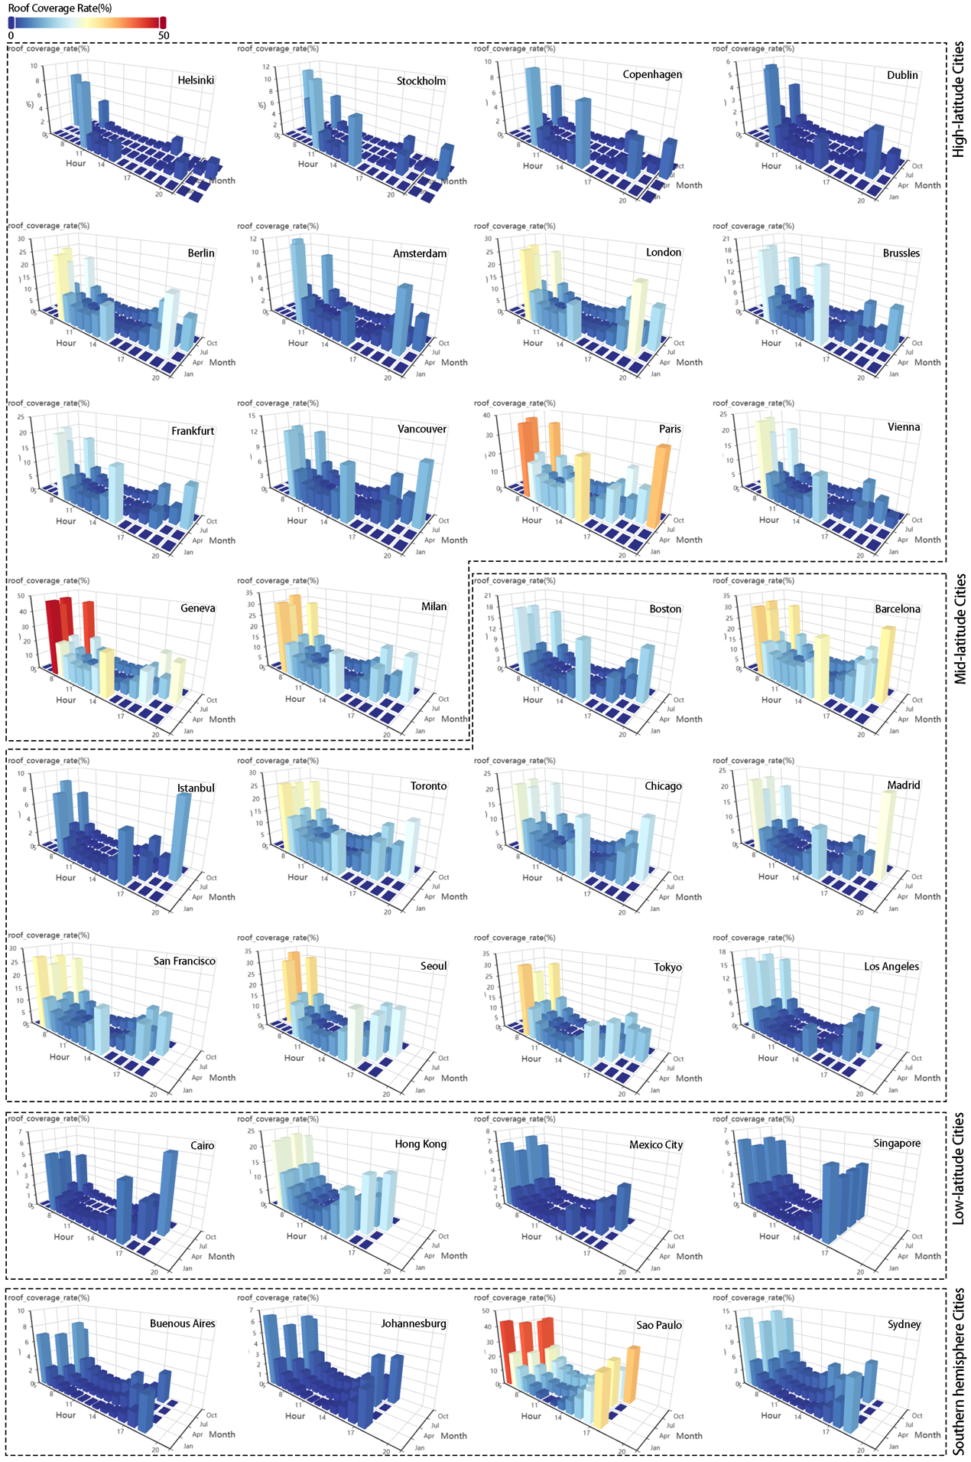

Supplementary Figure 2: Correlation heatmap between variables.
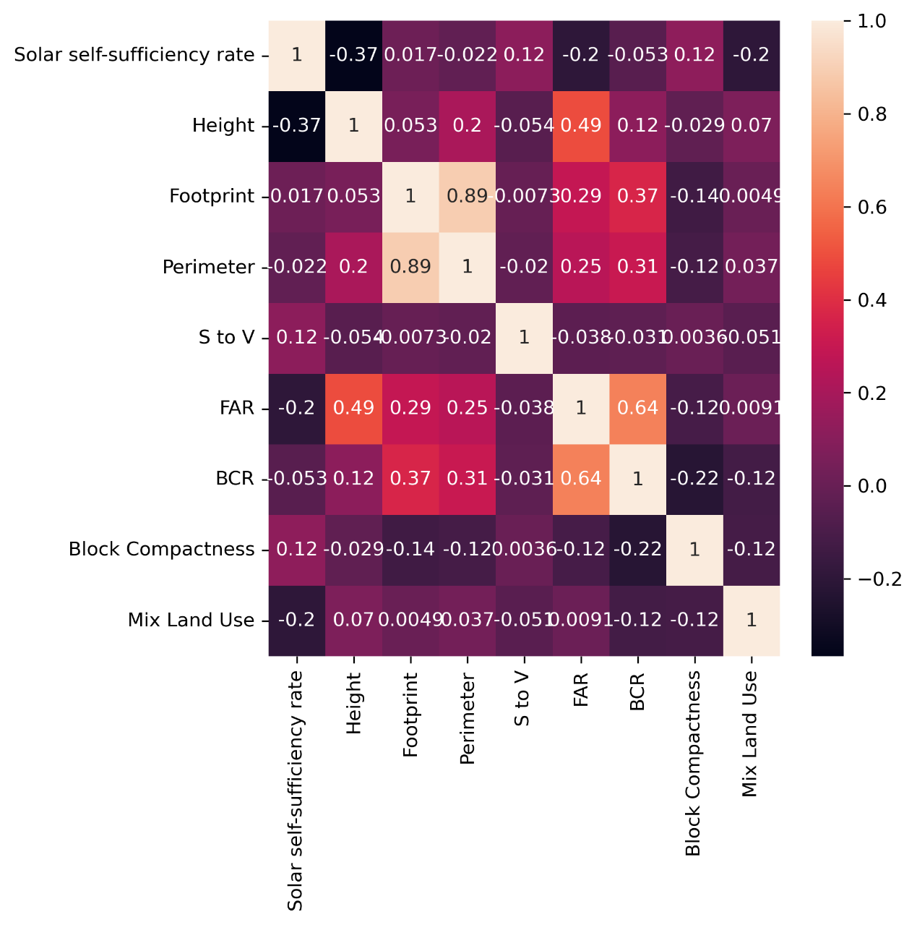
Supplementary Figure 3: Scatter plots among variable groups.
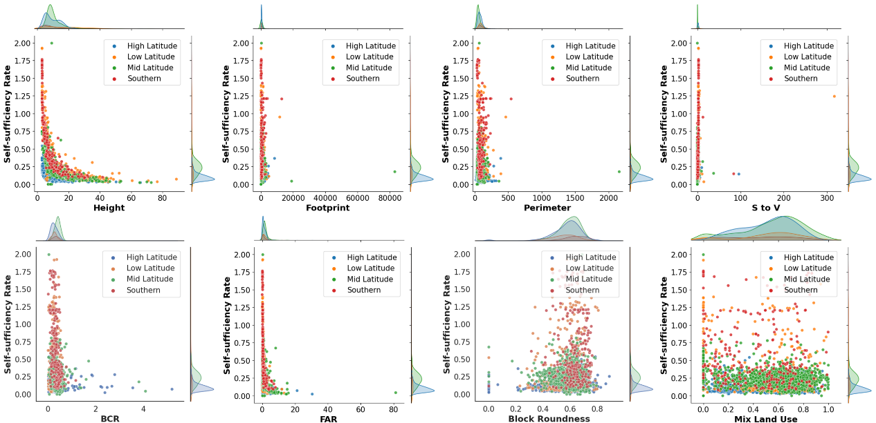

Supplementary Figure 4: Correlation heatmap between parameters and variables.
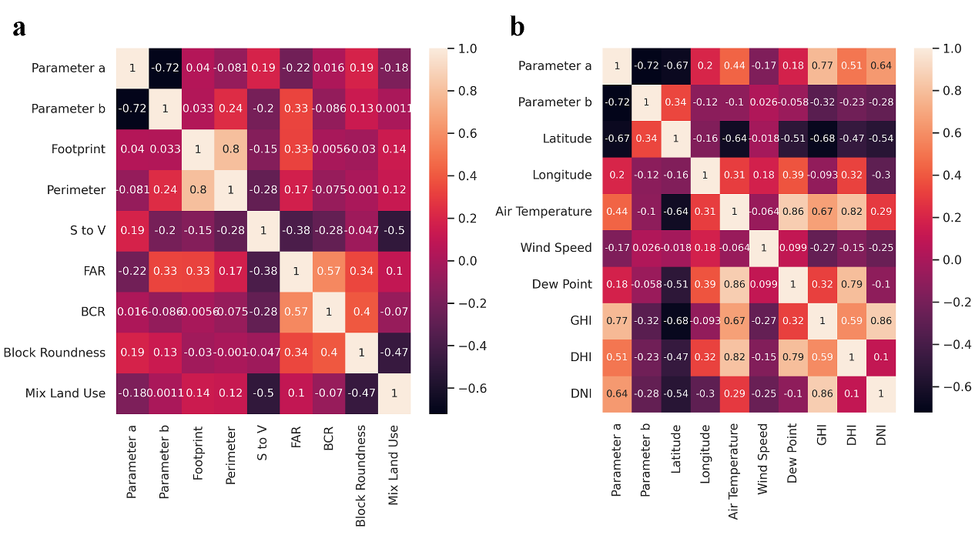
Supplementary Figure 5: The self-sufficiency rate curves of four African cities.
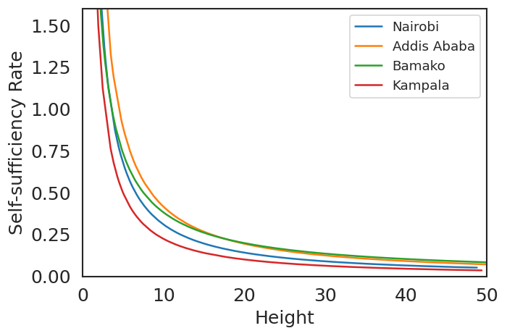

Supplementary Figure 6: The self-sufficiency rates of four African cities under different block roundness values.
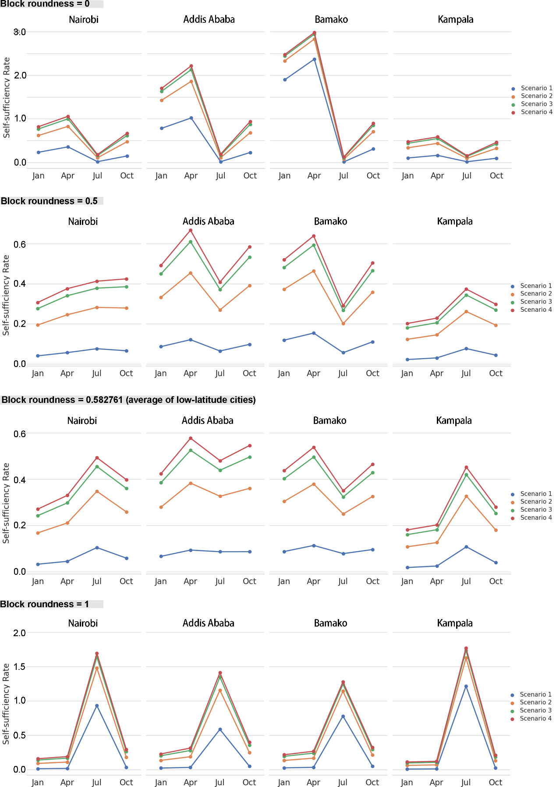

Supplementary Figure 7: Comparison of Scenarios in four months.
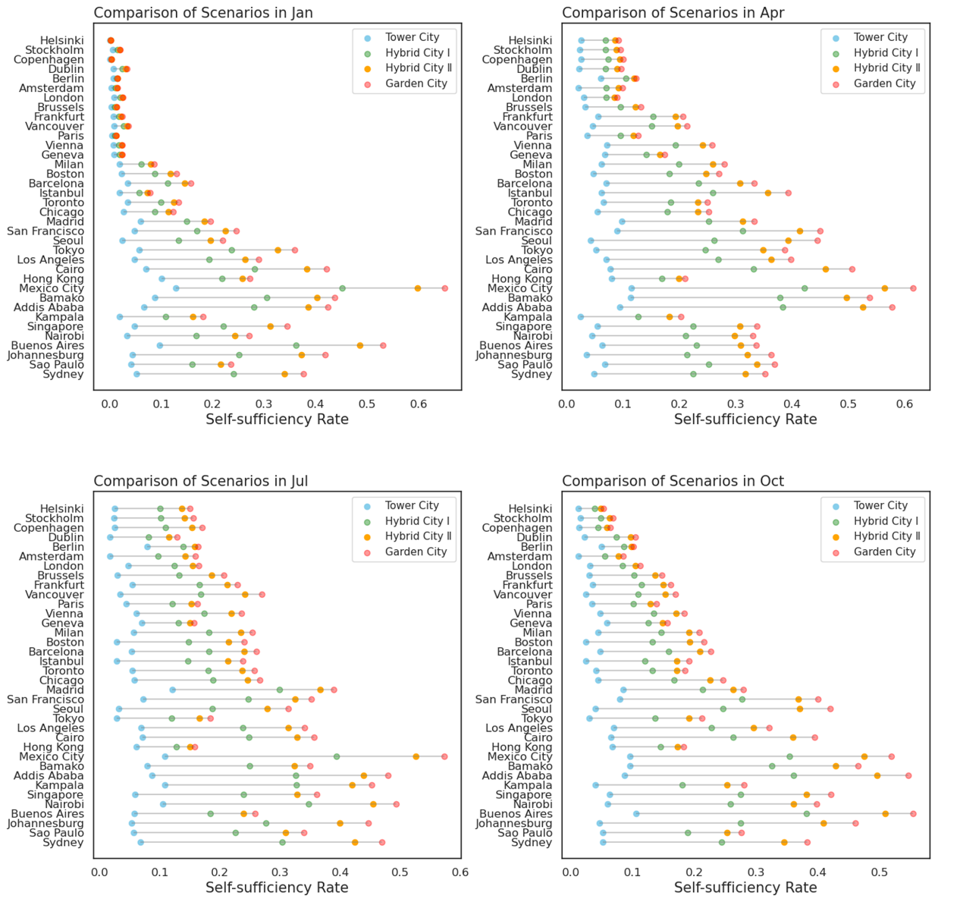

Supplementary Figure 8: Geometric shadow calculation
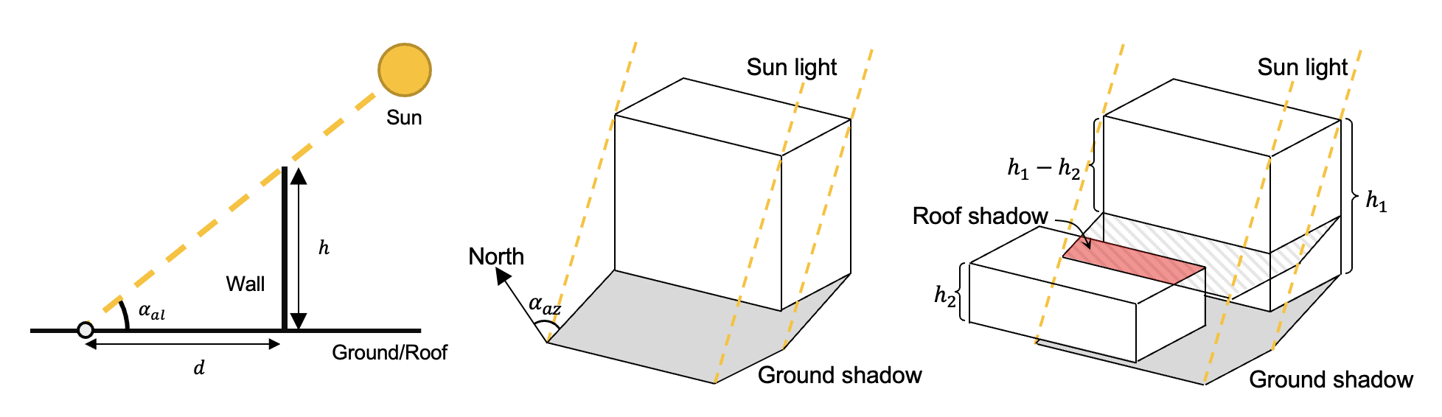

Supplementary Table 1: Parameters of building envelopes
Parameter | Value
Wall U-value [W/(m²·K)] | 0.45
Roof U-value [W/(m²·K)] | 0.4
Window U-value [W/(m²·K)] | 2.2
Window solar heat gain coefficient (SHGC) | 0.6
Supplementary Table 2: Parameters of internal loads
Parameter | Residential | Commercial
Occupant sensible heat gain (W/per) | 53 | 69
Occupant latent heat gain [g/(per·h)] | 61 | 167
Occupancy density (per/m²) | 0.037 | 0.2
Lighting power density | 3.3 | 19
Appliance power density | 4.6 | 13

Supplementary Table 3: Schedule settings of occupancy, lighting, and appliance
 | Residential | Commercial
Occupancy | 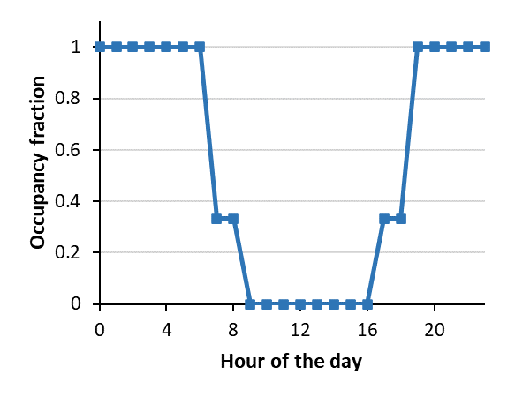 | 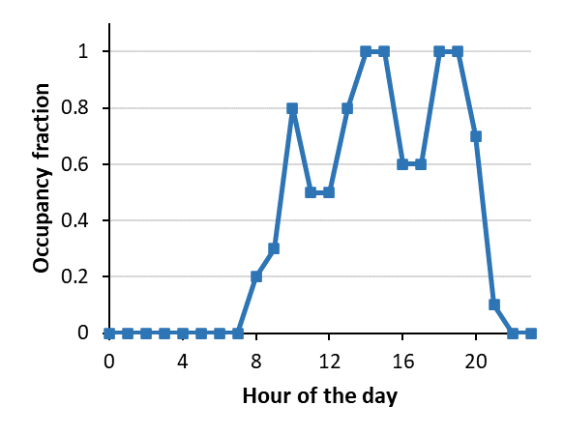
Lighting | 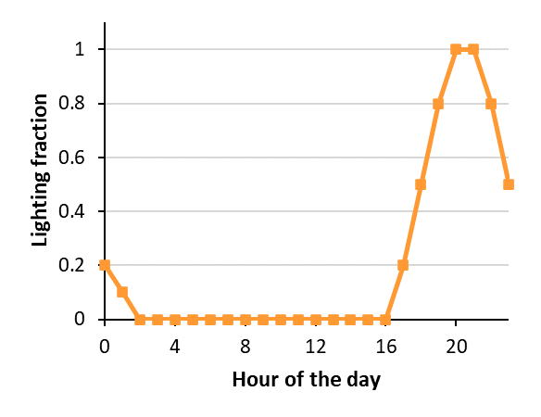 | 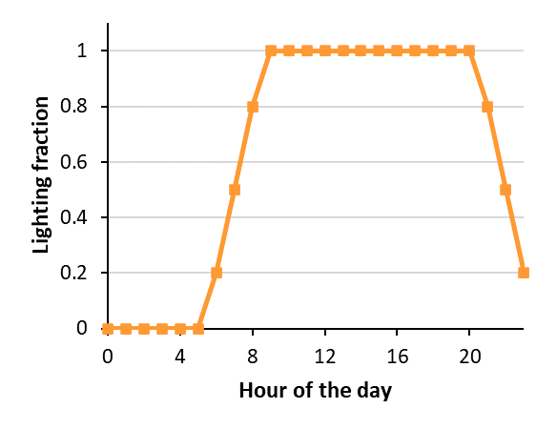
Appliance | 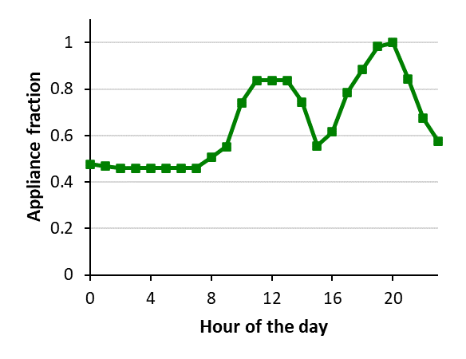 | 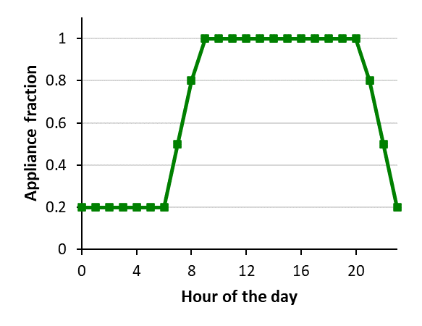

Supplementary Table 4: Parameters of heating/cooling system
Parameter | Residential | Commercial
Heating setpoint (℃) | 20 | 22
Heating COP | 3 | 3
Cooling setpoint (℃) | 26 | 28
Cooling COP | 3 | 3

Supplementary Table 5: FAR for Africa cities
Cities | FAR
Nairobi | 1.5
Addis Ababa | 1.0
Bamako | 0.7
Kampala | 0.4

Supplementary Table 6: The parameter a and b as well as R2 of fitting equation for 32 cities.
32 Cities | Parameter a | Parameter b | R²
Helsinki | 0.570995 | -0.980069 | 0.914396
Stockholm | 0.711651 | -1.021488 | 0.919731
Copenhagen | 0.776264 | -1.064753 | 0.899005
Dublin | 0.833716 | -1.066809 | 0.864599
Berlin | 0.256724 | -0.448937 | 0.313454
Amsterdam | 1.106078 | -1.207512 | 0.786581
London | 0.463587 | -0.749299 | 0.880427
Geneva | 0.416930 | -0.568658 | 0.523006
Brussels | 1.135052 | -1.061185 | 0.910135
Frankfurt | 0.951431 | -0.872725 | 0.865626
Vancouver | 1.874096 | -1.146032 | 0.947204
Paris | 0.599147 | -0.815134 | 0.470954
Vienna | 0.977842 | -0.827153 | 0.870631
Milan | 1.469675 | -0.942858 | 0.703079
Boston | 2.741155 | -1.225913 | 0.921682
Barcelona | 1.839501 | -0.971012 | 0.871607
Istanbul | 2.750730 | -1.203862 | 0.964092
Toronto | 1.335789 | -0.898081 | 0.902491
Chicago | 1.714887 | -0.983150 | 0.820146
Madrid | 1.399858 | -0.742152 | 0.862899
San Francisco | 2.902712 | -1.001566 | 0.893165
Seoul | 6.969395 | -1.439900 | 0.848583
Tokyo | 3.448068 | -1.198439 | 0.405480
Los Angeles | 2.898824 | -1.034896 | 0.849882
Cairo | 4.240845 | -1.112098 | 0.933282
Hong Kong | 0.726539 | -0.607617 | 0.328325
Mexico City | 5.044709 | -1.032450 | 0.794243
Singapore | 4.157997 | -1.168175 | 0.930132
Buenos Aires | 3.550588 | -1.026550 | 0.910665
Johannesburg | 7.792832 | -1.402000 | 0.976738
Sao Paulo | 2.850806 | -1.075198 | 0.931999
Sydney | 5.071609 | -1.227749 | 0.962549

Supplementary Table 7: Parameters of inverters in PV system
Inverter parameters | Value
Rated grid AC voltage (Vac) | 208 W
Power consumption during operation (Pso) | 2.09mw
Maximum AC power (Paco) | 250.0W
Maximum DC power (Pdco) | 260W
Nominal DC voltage (Vdco) | 40V
Curvature between AC power and DC power (C0) | -0.000041W⁻¹
Coefficient of Pdco variation with DC input voltage (C1) | -0.000091V⁻¹
Coefficient of Pso variation with DC input voltage (C2) | 0.000494V⁻¹
Coefficient of C0 variation with DC input voltage (C3) | -0.013171V⁻¹
Maximum DC voltage (Vdcmax) | 50V
Full power MPPT voltage range | 30-50V
Inverter night time loss (Pnt) | 0.075

Supplementary Table 8: Parameters of temperature modules in PV system
Parameters | Value
Empirically-determined coefficient establishing the upper limit for module temperature at low wind speeds and high solar irradiance | -3.47
Empirically-determined coefficient establishing the rate at which module temperature drops as wind speed increases | -0.0594
Temperature difference between the cell and the module back surface at an irradiance level of 1000 W/m². | 3℃

Supplementary Table 9: Parameters of photovoltaic panels
Mechanical Characteristics | Value
Length | 1,602mm
Width | 1,061mm
Depth | 40mm
Weight | 20kg
Output Cable Wire Gauge | 12 AWG
Standard Test Conditions Power Rating | 220W
PVUSA test conditions Power Rating | 200.1W
Standard Test Conditions Power per unit of area | 129.4W/m2
Peak Efficiency | 12.94%
Number of Cells | 96
open circuit voltage (Voc) | 58.8V
maximum voltage (Vmp) | 47V
short circuit current (Isc) | 5.01A
maximum power current (Imp) | 4.68A
Temp. Coefficient of Power | -0.45%/K
Temp. Coefficient of Voltage | -0.206V/K
Series Fuse Rating | 10A

Supplementary Table 10:
UMI | Definition and Calculation | Illustrative Figure
Building height  (BH) | The average height of buildings within the grid. (m)  $$BP= \frac{\sum_{i=1}^{n}{H_{i}}}{n}$$  $H_{i}$: the height of building  n: number of buildings | 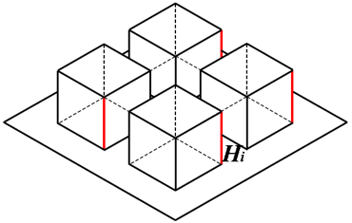
Building footprint  (BF) | The average footprint area of buildings within the grid (m²)  $$BF= \frac{\sum_{i=1}^{n}{C_{i}}}{n}$$  $C_{i}$: the footprint area of building  n: number of buildings | 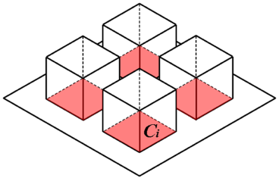
Building perimeter  (BP) | The average perimeter of buildings within the grid. (m)  $$BP=\frac{\sum_{i=1}^{n}{P_{i}}}{n}$$  $P_{i}$: the footprint area of building  n: number of buildings | 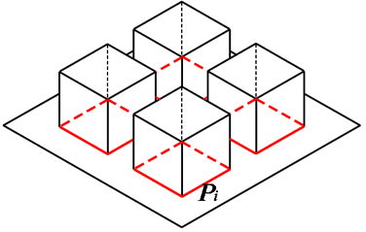
Surface area to volume ratio  (S/V) | The surface area to volume (S/V) ratio is an indicator referring to the compactness of building shape. The smaller the S/V the compacter the building shape. Meanwhile, it is also a building energy efficient indicator. Small S/V imply minimum heat loss.  $$S/V= \frac{\sum_{i=1}^{n}{\frac{S_{i}}{V_{i}}}}{n}$$  $S_{i}$: the surface area of building  $V_{i}$: the volume of building  n: number of buildings | 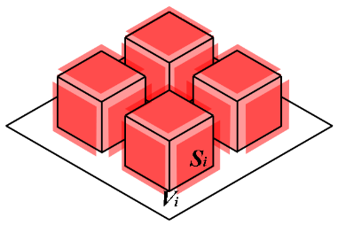
Floor area ratio  (FAR) | The floor area ratio is defined as the ratio of the area of a building's total floor space to the size of the piece of the land.  $$FAR= \frac{\sum_{i=1}^{n}{C_{i}×L}}{A}$$  $C_{i}$: building footprint area  L: the number of floors  A: the size of the land lot  n: number of buildings | 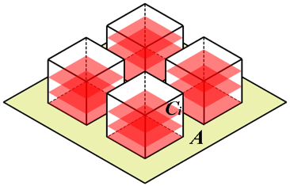
Building coverage ratio  (BCR) | The building coverage ratio is defined as the ratio of the built-up area to the area of the urban site. It reflects the area of a building’s footprint over the area of the site.  $$BCR= \frac{\sum_{i=1}^{n}{C_{i}}}{A}$$  $C_{i}$: the building coverage area  A: the size of the land lot  n: number of buildings | 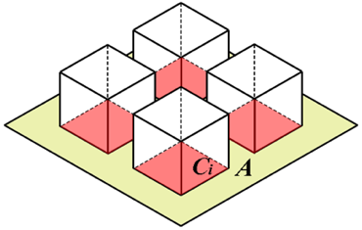
Block roundness  (BR) | The block roundness is the ratio of the block area to the area of a circle whose circumference is equal to the perimeter of the block. A block’s compactness score falls with the range of (0,1) and a score closer to 1 indicates a more compact block.  $$BC=\frac{\sum_{j=1}^{m}{(4π×\frac{A_{j}}{{P_{j}}^{2}})}}{m}$$  $A_{j}$: block area  $P_{j}$: the perimeter of block  m: number of blocks | 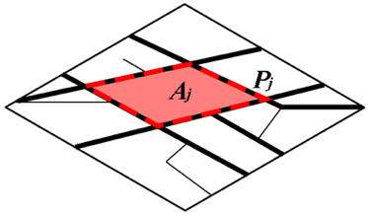
Mix land use (EI) | The mix land use is used to measure land use mix, considering the relative percentages of two or more types of land use within an area. An improved version of the "Shannon Entropy" formula is used for calculation, so mixed land use is also referred to as Entropy Index (EI). A higher entropy index corresponds to a greater land use mixture. The Entropy Index varies from 0 to 1.  $$EI=-\frac{\sum_{k=1}^{z}{{[P}_{k}ln(P_{k)}]}}{ln(k)}$$  $P_{k}$: the percentage of land use type  k: number of land use types | 