Additional file 1
Fig. 1S ¹H NMR spectrum (400 MHz) of (A) MeOH in methanol-d₄ and KH₄PO₄ solution in D₂O; pH 6; (B) EtOAc in CDCl₃ and (C) CH₂Cl₂ in CDCl₃. The signals at δ 1.60 and δ 2.30 ppm are characteristics of β-CH₂ and α-CH₂ of saturated fatty acids. Signals of unsaturated fats acids at δ 2.07 and δ 5.35 ppm. The aromatic compounds appeared between δ 7.0 and 8.0 ppm.

Fig. 2S Chemical structure of ketamine.

Table 1S ¹H and ¹³C NMR spectral data and ¹H-¹H COSY; ¹H-¹³C HSQC and ¹H-¹³C HMBC of F5 and its correlations to structure ketamine.
Position | δ ¹Hª | δ ¹³C^{b} | COSY | HMBC
1 | - | 208.9 | - | -
2 | - | 70.6 | - | -
3 | 1.83, 2.93 | 38.4 | H-4 | C-4’, C-5’, NCH₃
4 | 1.74 | 21.8 | H-3 | C-5’
5 | 1.86, 2.04 | 28.7 | H-6 | C-4’
6 | 2.52 | 39.8 | H-5 | C-1
1’ | - | 135.6 | - | -
2’ | - | 134.0 | - | -
3’ | 7.38 | 131.4 | H-4’ | C-5’
4’ | 7.29 | 129.4 | H-4’ | C-2’, C-6’
5’ | 7.35 | 127.0 | H-6’ | C-1’, C-3’
6’ | 7.60 | 129.8 | H-5’ | C-4’,C-2’
NCH₃ | 2.14 | 28.8 | - | C-2
ª ¹H determined from HSQC experiment.
^{b} ¹³C determined from HSQC and HMBC experiments.

Fig. 3S The ¹H–¹H COSY spectrum of F5 in CDCl₃ at 400 MHz.
Fig. 4S The ¹H-¹³C HSQC spectrum of F5 in CDCl₃ at 400 and 100 MHz.

Fig. 5S The ¹H-¹³C HMBC spectrum of F5 in CDCl₃ at 400 and 100 MHz.
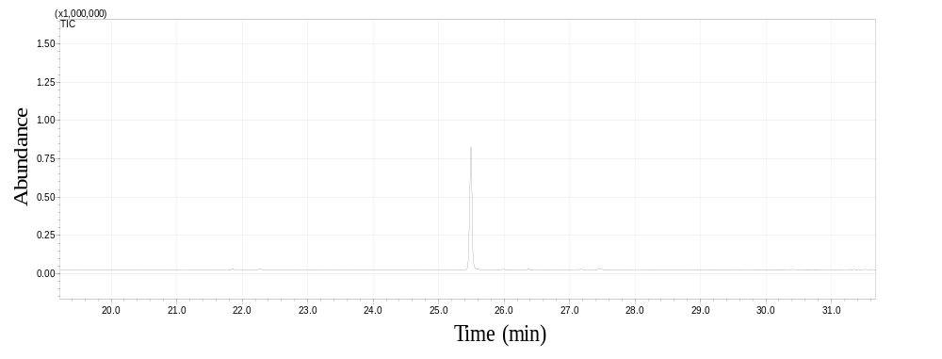
Fig. 6S Chromatogram of the F5 which was obtained by gas chromatography coupled to mass spectrometry. The main substance, identified as ketamine, was ionized by electron impact at 70 eV.

Fig. 7S Chromatogram of EtOAcF5, obtained by UHPLC / MS monitored by ultraviolet light (A) and monitored by positive mode electrospray ionization (B). Spotlight figure spectral profiles fragments obtained in MS/MS mode positive ionization for ions m/z = 238 Da (A- EtOAc fraction and B- Ketamine reference) and m/z = 240 (C- EtOAc fraction and D- Ketamine reference). m/z = 238 Da [M + H]⁺, m/z = 240.10 Da [M + ³⁷Cl]⁺

Fig. 8S Proposal of ions after fragmentation the ion m/z 238.17 Da, monitored by positive mode electrospray ionization at retention time 2.24 min.

