A Flexible Electron-blocking Interfacial Shield for
Dendrite-free Solid Lithium Metal Batteries
Hanyu Huo^{a,b}, Jian Gao^{c}, Ning Zhao^{d}, Dongxing Zhang^{e}, Xiaona Liª, Yipeng Sunª, Jiamin Fuª, Ruying Liª, Xiangxin Guo^{e *}, Xueliang Sun^{a *}

ª Department of Mechanical and Materials Engineering, University of Western Ontario, Ontario N6A 5B9, Canada
^{b} State Key Laboratory of High Performance Ceramics and Superfine Microstructure,
Shanghai Institute of Ceramics, Chinese Academy of Sciences, Shanghai 200050, China
^{c} Beijing Advanced Innovation Center for Soft Matter Science and Engineering, State Key Laboratory of Organic-Inorganic Composites, Beijing University of Chemical Technology, Beijing, China
^{d} College of Physics, Qingdao University, Qingdao 266071, China
^{e} Department of Chemistry, University of Western Ontario, Ontario N6A 5B9, Canada

* Corresponding authors.
Email address: xxguo@qdu.edu.cn, xsun9@uwo.ca

Fig. S1 a) Cross-sectional SEM image, and b) EIS spectrum of the LLZTO pellet with a relative density over 99.5%. c) Cross-sectional SEM image, and d) EIS spectrum of a LLZTO pellet with a relative density of 96%.

Fig. S2 XRD patterns of a LLZTO pellet, PAA polymer, and LLZTO powder mixed with PAA.

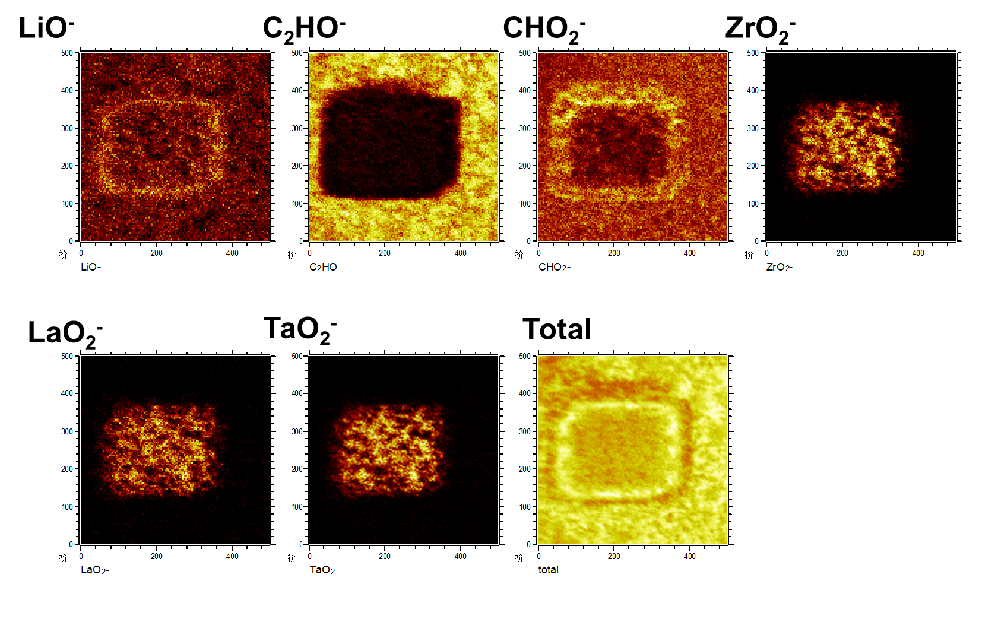
Fig. S3 TOF-SIMS chemical mappings of LLZTO@PAA after sputtering.

Fig. S4 Force-distance curves of a) LLZTO, and b) LLZTO@PAA.

Fig. S5 Partial PAA structures with single chain bonding with Li in Li metal by a) a recombination reaction, and b) a substitution reaction. c) The electrostatic potential profiles for fully relaxed Li(001)/PAA with different reactions. The vacuum slab is not entirely presented

Fig. S6 a) The structure and charge transfer, b) the electrostatic potential profiles, and c,d) the DOS for fully relaxed Li(001)/Li₂CO₃(001).

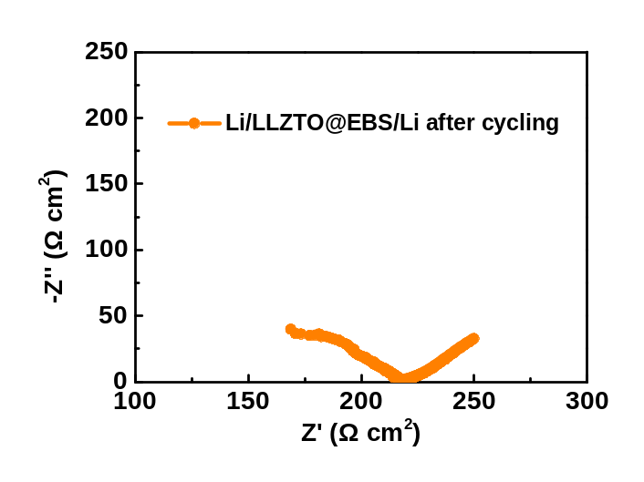
Fig S7 EIS spectrum of a Li/LLZTO@EBS/Li cell after cycling at 0.2 mA cm⁻² (0.2 mAh cm⁻²) for 1000 h.

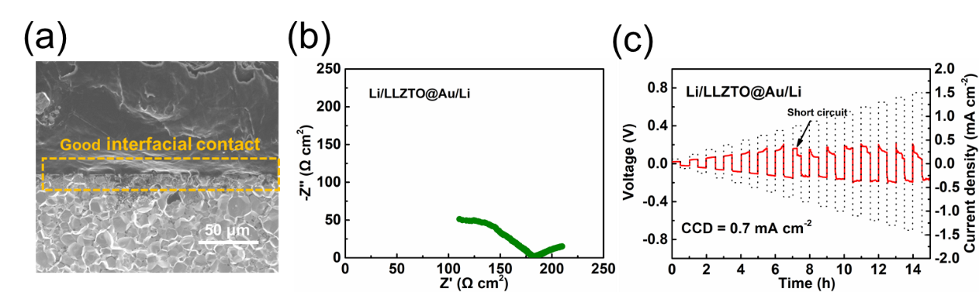
Fig. S8 SEM image of the LLZTO@Au/Li interface. b) EIS spectrum, and c) CCD of a Li/LLZTO@Au/Li cell at 25 ºC.

Fig. S9 a) Galvanostatic cycling performance of the Li/LLZTO@Au/Li and Li/LLZTO@EBS/Li cells at 0.5 mA cm⁻² (0.1 mAh cm⁻²) at 25 ºC. Magnified images for b) 0-10 h, and c) 255-265 h.

Fig. S10 a) Galvanostatic cycling performance of the Li/LLZTO(96%)@Au/Li and Li/LLZTO(98%)@EBS/Li cells at 0.2 mA cm⁻² (0.1 mAh cm⁻²) at 25 ºC. Magnified images for b) 0-10 h, and c) 15-25 h.

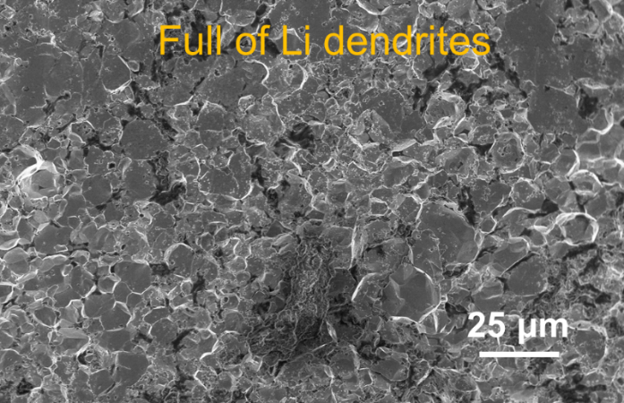
Fig. S11 Cross-sectional SEM image of LLZTO(96%)@Au after short circuiting.

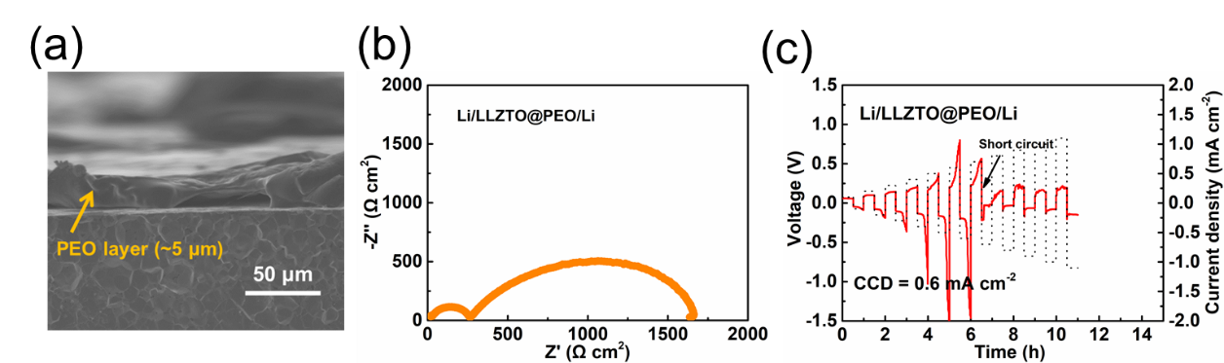
Fig. S12 a) SEM image of the PEO electrolyte layer on the surface of a LLZTO pellet. b) EIS spectrum, and c) CCD of a Li/LLZTO@PEO/Li cell at 60 ºC

Fig. S13 a) Galvanostatic cycling performance of the Li/LLZTO@PEO/Li and Li/LLZTO@PEO/Li cells under 0.5 mA cm⁻² (0.25 mAh cm⁻²). Magnified images for b) 0-10 h, and c) 50-60 h. The working temperatures for the Li/LLZTO@PEO/Li and Li/LLZTO@PEO/Li cells are 60 and 25 ºC, respectively.

Fig. S14 a) Schematic representation of SSBs with a Li metal anode, an LLZTO@EBS electrolyte, and an LFP cathode. Charge/discharge curves of the b) LFP/LLZTO@EBS/Li, and c) LFP/LLZTO/Li cells at various current rates. d) Rate performance of the LFP/LLZTO@EBS/Li and LFP/LLZTO/Li cells. e) Cycle performance of the LFP/LLZTO@EBS/Li and LFP/LLZTO/Li cells under e) 0.2 C, and f) 0.5 C at room temperature.

Fig. S15 a) Cycling performance of a LFP/LLZTO@Au/Li cell at a) 0.5 C at room temperature. b) LFP/LLZTO@PEO/Li cells at 0.2 C at 60 ºC.

Table. S1 Comparison of critical current density (CCD) and cycling stability between our work and recent publications.

Interfacial modification | Interfacial resistance  (Ω cm²) | CCD  (mA cm⁻²) | Stability (RT)  (mA cm⁻² /lifetime in h) | Ref
Bare LLZTO | 1104.3 | 0.2 | 0.2/2
Sputtering  Au | 101.6/167.8 | 0.5 | 0.08/150 | ¹
ALD  Al₂O₃ | 34 | N/A | 0.2/90 | ²
PECVD  Si | 127 | 0.2 | 0.1/225 | ³
ALD  Al | 75 | 0.2 | 0.2/42 | ⁴
Drawing  Soft graphite | 105 | N/A | 0.3/1000 | ⁵
Co-sputtering  Cu₆Sn₅ | 236 | N/A | 0.25/300 | ⁶
Polishing  MoS₂ | 14@100 ºC | 2.2@100 ºC | 0.8/240@100 ºC | ⁷
PECVD  Li₃N | 175 | N/A | 0.1/210 | ⁸
Sputtering  Cu₃N | 83.4 | 1.2 | 0.5/400 | ⁹
Dip-casting  PAA | 54.5 | 1.2 | 1/400 | This work

References
1 Tsai, C.-L. et al. Li₇La₃Zr₂O₁₂ Interface Modification for Li Dendrite Prevention. ACS Applied Materials & Interfaces 8, 10617-10626 (2016).
2 Han, X. et al. Negating interfacial impedance in garnet-based solid-state Li metal batteries. Nat Mater 16, 572-579 (2017).
3 Luo, W. et al. Transition from Superlithiophobicity to Superlithiophilicity of Garnet Solid-State Electrolyte. J. Am. Chem. Soc. 138, 12258-12262 (2016).
4 Fu, K. K. et al. Toward garnet electrolyte–based Li metal batteries: An ultrathin, highly effective, artificial solid-state electrolyte/metallic Li interface. Science Advances 3, e1601659 (2017).
5 Shao, Y. et al. Drawing a Soft Interface: An Effective Interfacial Modification Strategy for Garnet-Type Solid-State Li Batteries. ACS Energy Lett. 3, 1212-1218 (2018).
6 Feng, W. L. et al. Building an Interfacial Framework: Li/Garnet Interface Stabilization through a Cu₆Sn₅ Layer. Acs Energy Letters 4, 1725-1731 (2019).
7 Fu, J. M. et al. In situ formation of a bifunctional interlayer enabled by a conversion reaction to initiatively prevent lithium dendrites in a garnet solid electrolyte. Energy Environ. Science 12, 1404-1412 (2019).
8 Xu, H. et al. Li₃N-Modified Garnet Electrolyte for All-Solid-State Lithium Metal Batteries Operated at 40 degrees C. Nano Lett. 18, 7414-7418 (2018).
9 Huo, H. Y. et al. Design of a mixed conductive garnet/Li interface for dendrite-free solid lithium metal batteries. Energy Environ. Science 13, 127-134 (2020).

