Figure S1. Study flowchart.
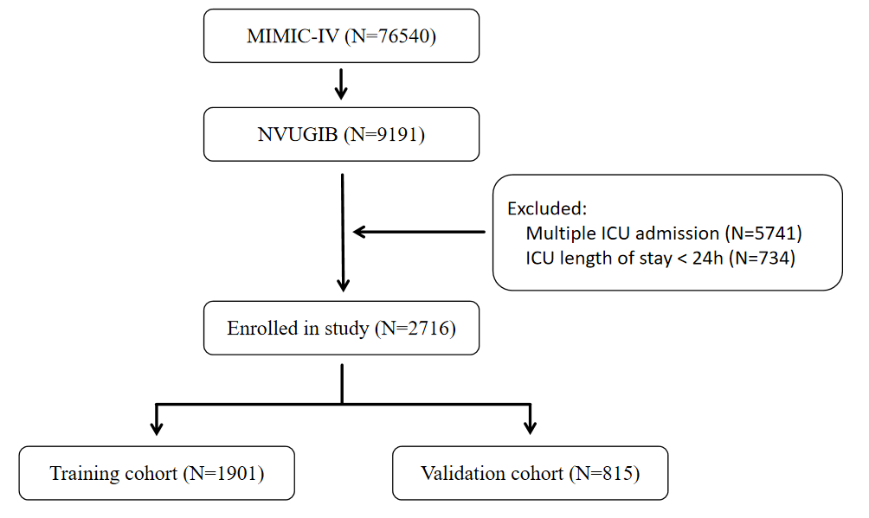

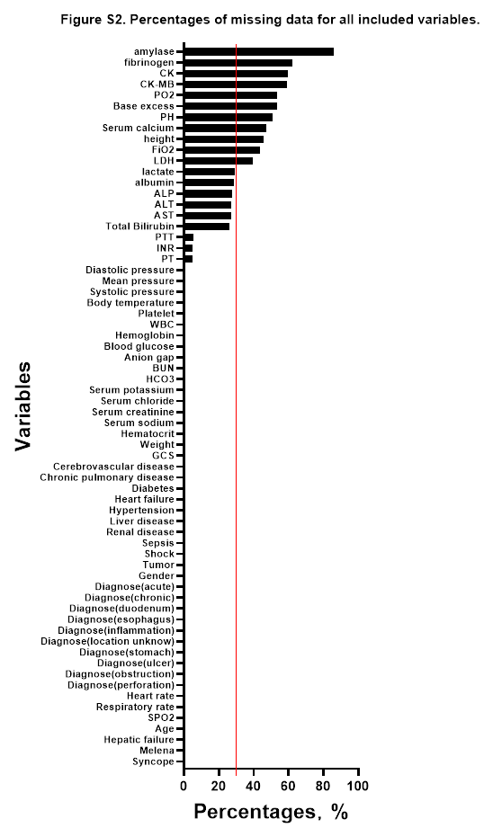
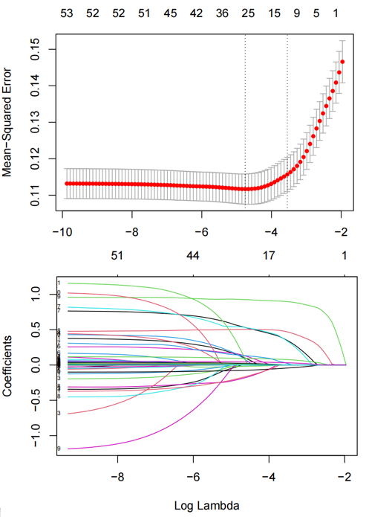
Figure S4. Feature selection using the LASSO regression model.
(A) LASSO coefficient profiles of the 47 baseline features.
(B) Tuning parameter (λ) selection in the LASSO model used 5-fold cross-validation via minimum criteria. LASSO, least absolute shrinkage and selection operator.

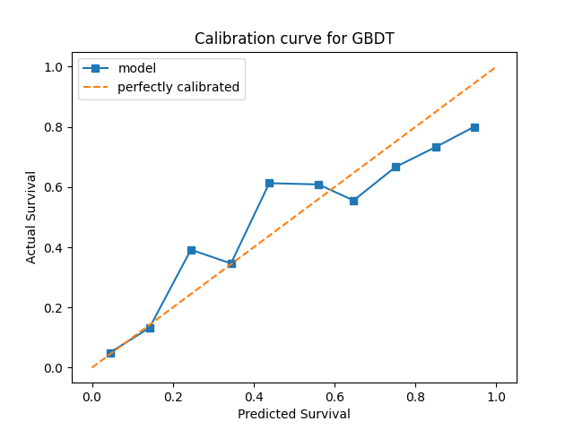
Figure S5. Calibration curve for in-hospital mortality for validation cohort in GBDT.

