Supplementary Files
Table S1 Nutrient solution ingredients for wheat seedling growth.
Ingredient | Concentration (mmol/L) | Ingredient | Concentration (mmol/L)
K₂SO₄ | 0.75 | MnSO₄.H₂O | 0.001
Ca(NO₃)₂.4H₂O | 0.25 | ZnSO₄.7H₂O | 0.001
MgSO₄ | 0.60 | CuSO₄.5H₂O | 0.0001
FeEDTA | 0.04 | Na₂MoO₄.2H₂O | 0.000005
H₃BO₃ | 0.001 | KH₂PO₄ | 0/0.005/0.25
 |  | KCl | 0.35/0.345/0.10

Table S2: QTLs with corresponded candidate genes and putative proteins.
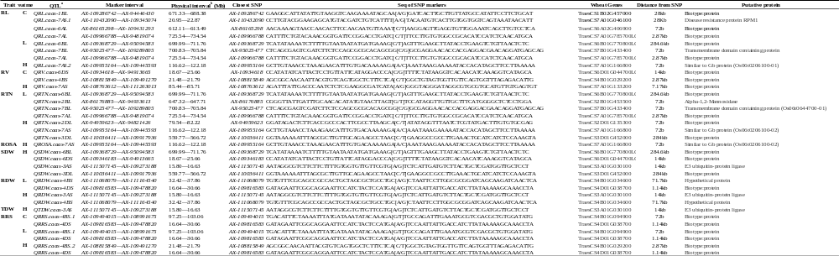
ª Quantitative trait loci
^{b}Physical positions of SNP markers based on wheat genome sequences from the International Wheat Genome Sequencing Consortium (IWGSC, http://www.wheatgenome.org/).
Abbr: C, control; L, low P treatment; H, high P treatment; RL, Root length; RV, Root volume; RD, Root diameter; RTN, Root tip number; ROSA, Root surface area; SDW, Shoot dry weight; RDW, Root dry weight; TDW, Total dry weight; RRS, Ratio of root to shoot dry weight.

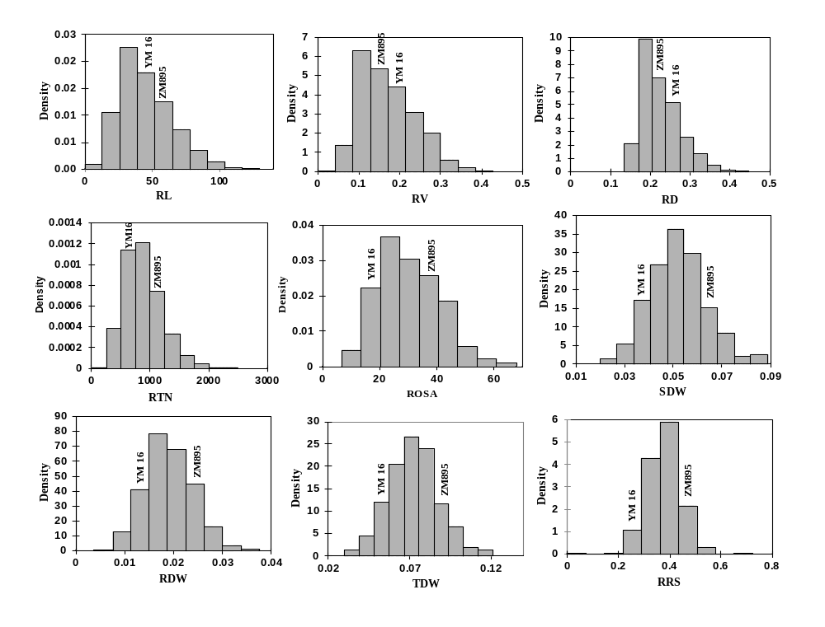
Fig. S1 Distribution of line and parent means for each trait in three levels of P treatments
Abbr: ZM895, Zhongmai 895; YM16, Yangmai 16; RL, Root length; RV, Root volume; RD, Root diameter; RTN, Root tip number; ROSA, Root surface area; SDW, Shoot dry weight; RDW, Root dry weight; TDW, Total dry weight; RRS, Ratio of root to shoot dry weight.
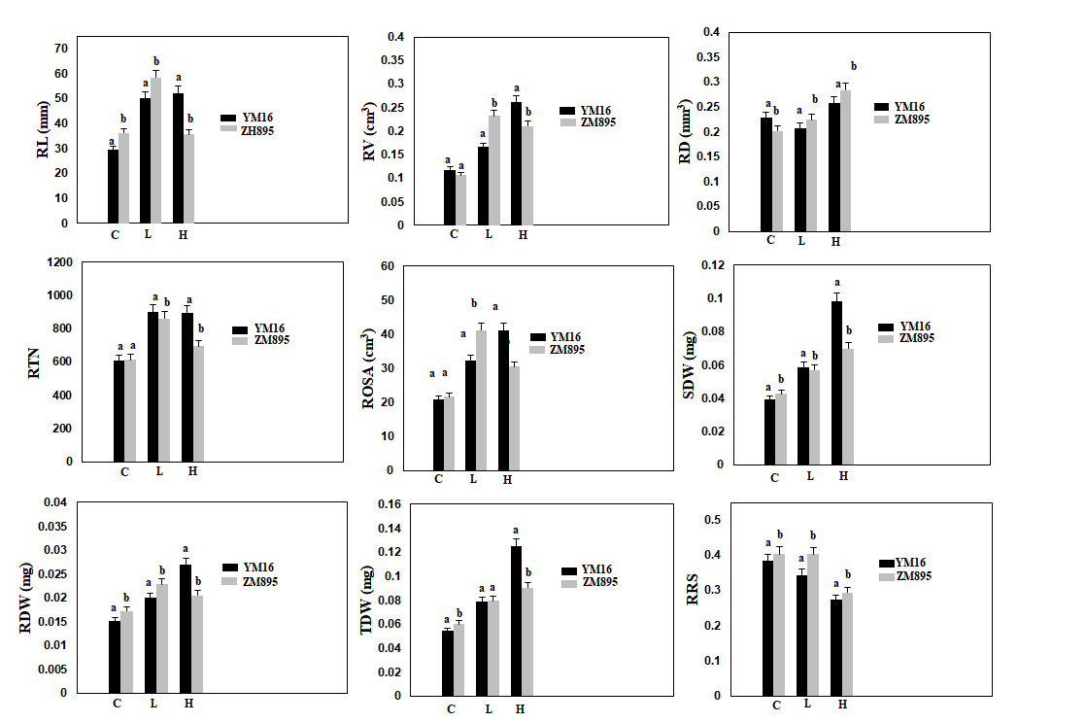
Fig. S2 The phenotypic difference between parents Yangmai 16 and Zhongmai 895 under P treatments. Error bars represent standards deviation for each proportion; letters indicate significant differences between the genotypes determined by Duncan tests
Abbr: ZM895, Zhongmai 895; YM16, Yangmai 16; C, control; L, low P treatment; H, high P treatment; RL, Root length; RV, Root volume; RD, Root diameter; RTN, Root tip number; ROSA, Root surface area; SDW, Shoot dry weight; RDW, Root dry weight; TDW, Total dry weight; RRS, Ratio of root to shoot dry weight.

