Supplementary Information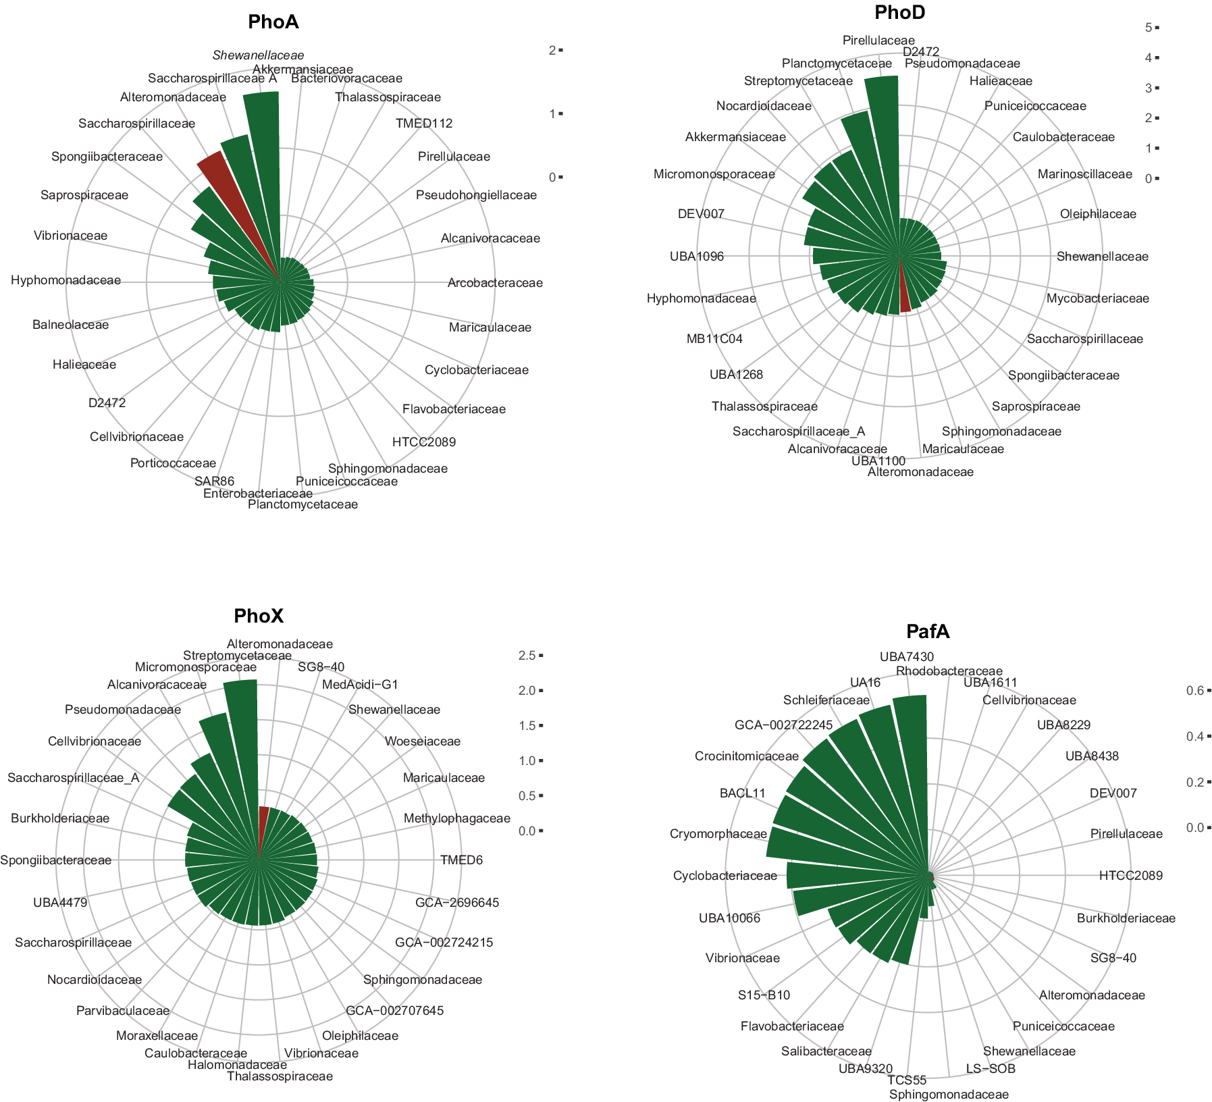
Extended Data Fig. 1. Number of alkaline phosphatase genes in marine genomes. Radial plot shows the number of alkaline phosphatase genes predicted in the genome database by the methods detailed in the main text. Brick red color indicates the family Alteromonadaceae. Only families with more than 100 genomes were considered in the analysis (133 total families). The first 30 families are shown.
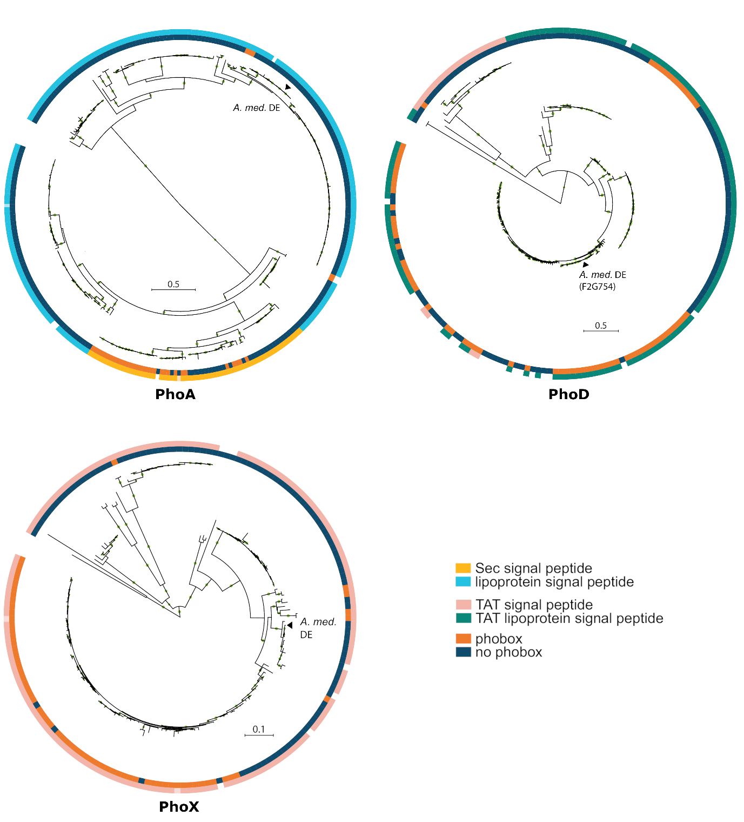
Extended Data Fig. 2. Signal peptide and phobox predictions for the alkaline phosphatases, PhoA, PhoD and PhoX, and their genes in Alteromonas. Each of the peptides were predicted in 573 genomes classified as belonging to the Alteromonas in our database and the methods described in the main text. Duplicated peptides sequences were removed. The phylogenetic trees were constructed by maximum-likelihood with FastTree version 2.1.11 ⁶⁰, with default settings, after alignment with MUSCLE version 3.8 ⁵⁹. The tree was rooted at midpoint. Inner circle represents the presence or absence of a phobox regulatory signal 500 nucleotides upstream of the gene and in the same direction. The outer ring shows the signal peptide prediction and type. There were too few Alteromonas genomes in our genome database to represent a phylogenetic reconstruction of PafA and is not represented. All 25 pafA genes had no phobox and, their corresponding peptides, have a Sec signal peptide signature. Triangles indicate the sequences of Alteromonas mediterranea DE peptides.
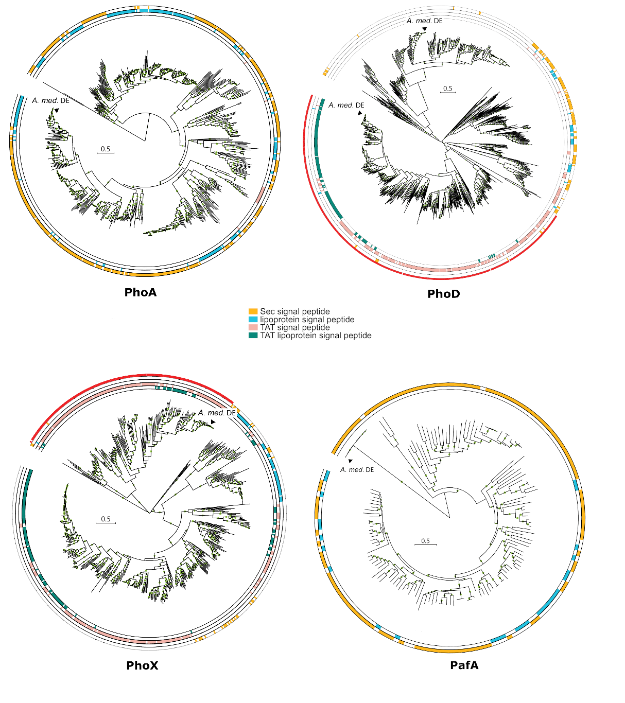
Extended Data Fig. 3. Phylogenetic trees of predicted PhoA, PhoD, PhoX and PafA in the complete genome of marine prokaryotes. The peptides were retrieved with the methods described in the main text from a dataset that included 1270 complete genomes. Duplicated peptide sequences were removed. The corresponding Alteromonas mediterranea DE sequences are highlighted as triangles. The peptides were aligned with MUSCLE version 3.8 ⁵⁹ and the phylogenetic trees were predicted with FastTree version 2.1.11 ⁶⁰ and default settings. The trees were rooted at midpoint. The PhoD tree includes all peptides that were retrieved with the Pfam PF09423 (PhoD-like phosphatase). In this study, only the sequences that are spanned by the red arch are considered PhoD since they cluster closer to A. mediterranea DE PhoD and had mostly a TAT or a TAT lipoprotein signal peptide. The HMM was designed to retrieve the sequences that met this criterium to quantify the expression in the Tara Ocean dataset. Likewise, the PhoX includes peptides that could be retrieved with K07093, corresponding to COG3211 (PhoX Secreted phosphatase, PhoX family) and the red arch shows the sequences targeted by the HMM specific for sequences closer to A. mediterranea DE PhoX and had also mostly a TAT or TAT lipoprotein signal peptide.

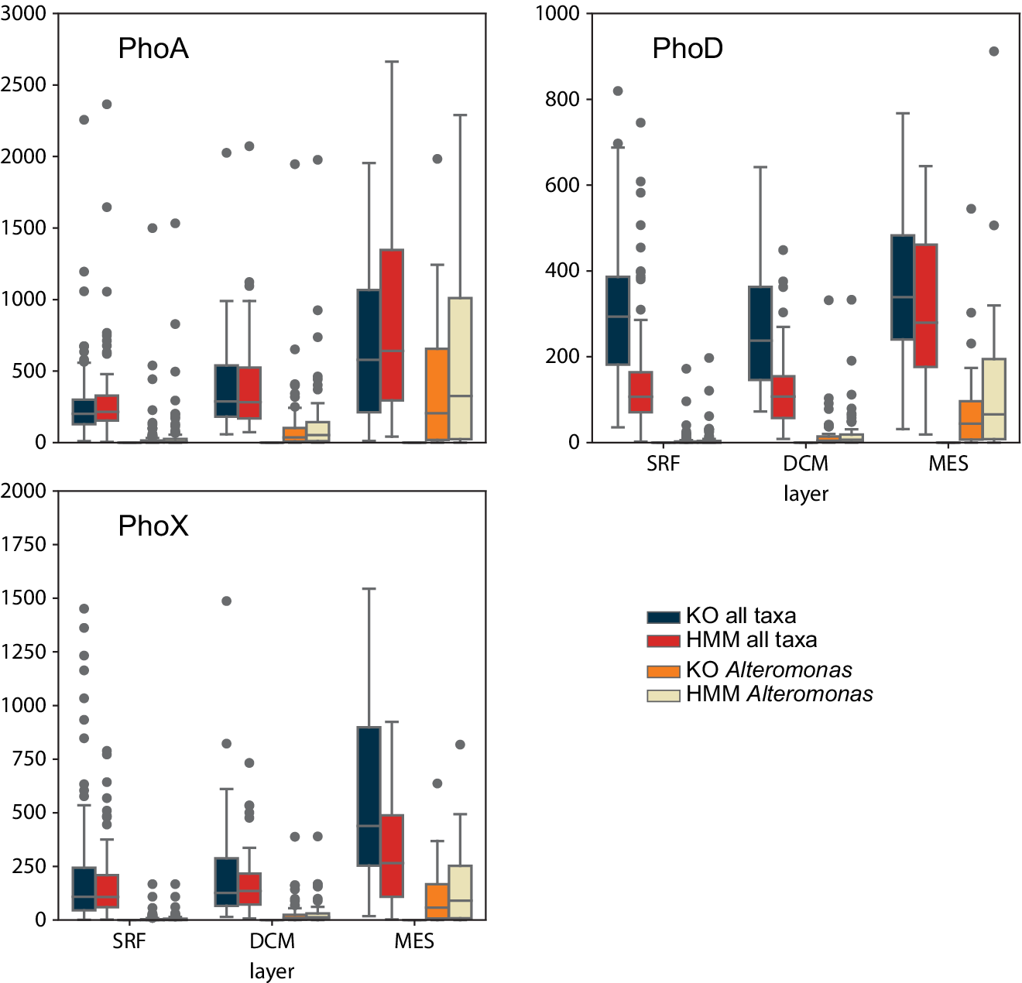
Extended Data Fig. 4. Comparison between quantification methods in Tara Ocean metatranscriptomes. Bar plots show the comparison between the expression of each of the genes in the Tara Ocean metatranscriptomes, directly obtained by their corresponding KO (K01077, PhoA; K01113, PhoD; K07093, PhoX) and the table of abundances (https://www.ocean-microbiome.org; KO in the panels) and the methods described in the main text and in Baltar et al., 2023 (https://doi.org/10.1038/s41564-023-01374-2; HMM), for all taxa and for only the genus Alteromonas. PafA does not correspond to any KO and therefore is not represented.

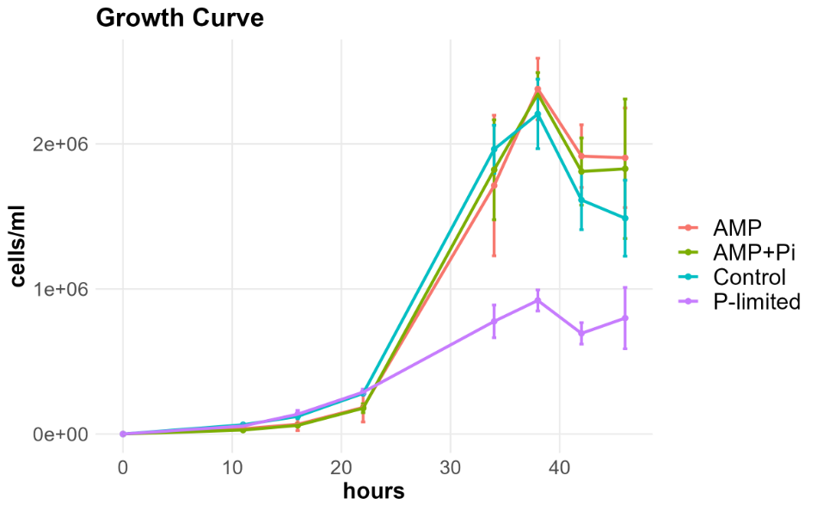
Extended Data Figure 5. Growth curves of Alteromonas mediterranea under different phosphorus substrate conditions. AMP: 1 µM Adenosine monophosphate, AMP+Pi: 1 µM Adenosine monophosphate and 1 µM phosphate, Control: 1 µM phosphate, P-limited: 0.1 µM phosphate.

Enzymatic parameters of Alteromonas mediterranea culture experiments
 | Control | AMP | AMP+Pi | P-limited
V_{max} amol cell⁻¹ h⁻¹  P-monoesterase | 119 ± 38 | 73 ± 25 | 73 ± 24 | 1332 ± 302*
V_{max} amol cell⁻¹ h⁻¹  P-diesterase | 29 ± 5 | 23 ± 5 | 19 ± 8 | 568 ± 160*
V_{max} fmol cell⁻¹ h⁻¹  P-triesterase | 66 ± 42 | 33 ± 23 | 3 ± 2 | 35 ± 24
K_{M} µmol L⁻¹  P-monoesterase | 26.7 ± 7.6 | 35.5 ± 6.4 | 36.2 ± 6.7 | 3.4 ± 0.3*
K_{M} µmol L⁻¹  P-diesterase | 133.7 ± 57.4 | 103.4 ± 42.4 | n.d. | 254 ± 32*

Extended Data Table 1. Enzymatic parameters of Alteromonas mediterranea culture experiments under different phosphorus substrate conditions. AMP: 1 µM Adenosine monophosphate, AMP+Pi: 1 µM Adenosine monophosphate and 1 µM phosphate, Control: 1 µM phosphate, P-limited: 0.1 µM phosphate. Data are presented as the mean ± standard deviation for cell specific V_{max} turnover rate (V_{max} divided by cell abundance) and K_{M} Michaelis–Menten constant. The asterisk (*) represents a significant difference compared to all other treatments, as determined by ANOVA and Tukey post hoc test (p-values < 0.005).

