Scalable Ammonia Synthesis in Fermentors Using Quantum Dot-Azotobacter vinelandii Hybrids

Jayeong Kim^{1,2}, Byunghyun Lee^{1,2}, Gui-Min Kim^{1,2}, Ilsong Lee^{1,2}, Sang Yup Lee^{1,3,4} and Kyeong Rok Choi^{1,3}* and Doh C. Lee^{1,2}*

¹Department of Chemical and Biomolecular Engineering, Korea Advanced Institute of Science and Technology (KAIST), 291 Daehak-ro, Yuseong-gu, Daejeon 34141, Republic of Korea
²KAIST Institute for the Nanocentury (KINC), Energy & Environmental Research Center (EERC), KAIST, Daejeon, Republic of Korea
³Metabolic and Biomolecular Engineering National Research Laboratory, Systems Metabolic Engineering and Systems Healthcare Cross Generation Collaborative Laboratory, BioProcess Engineering Research Center, KAIST, Daejeon, Republic of Korea
⁴BioInformatics Research Center, KAIST, Daejeon, Republic of Korea
Corresponding Authors. Email: choikr@kaist.ac.kr (K.R.C) and dclee@kaist.edu (D.C.L)

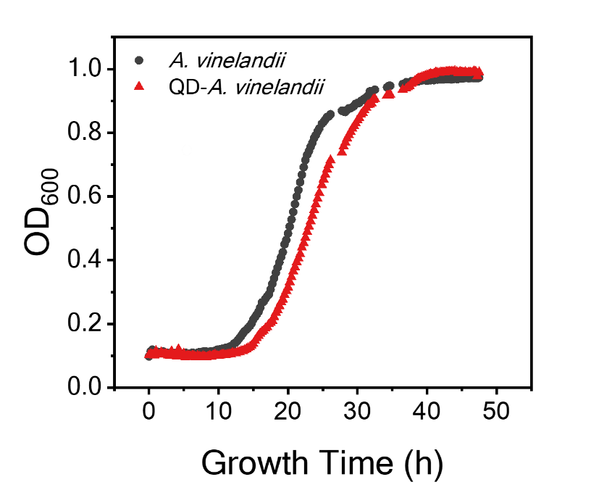
Fig. S1. Bacterial growth curve of A. vinelandii and QD-A. vinelandii hybrid. The QDs concentration in the QD-A. vinelandii hybrid was 50 nM.

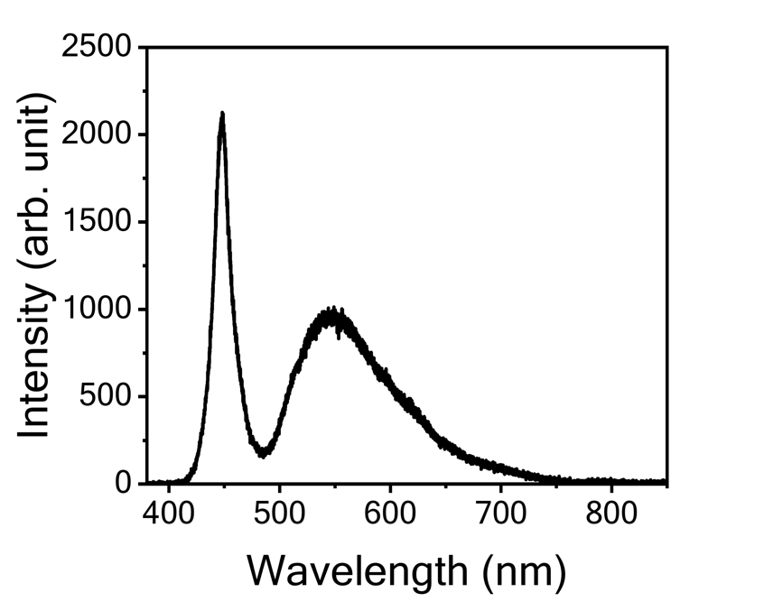
Fig. S2. Spectrum data of white light used in the fermentation experiments.

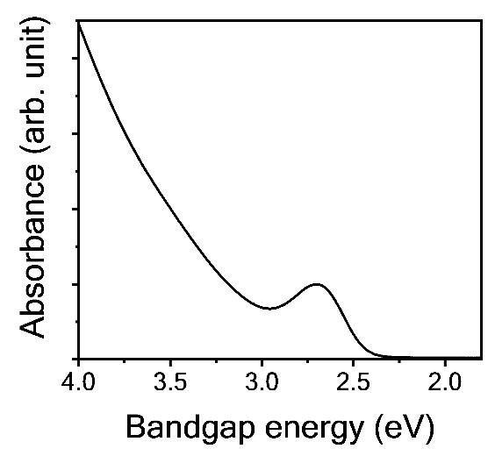
Fig. S3. Absorption spectrum of InP QDs.

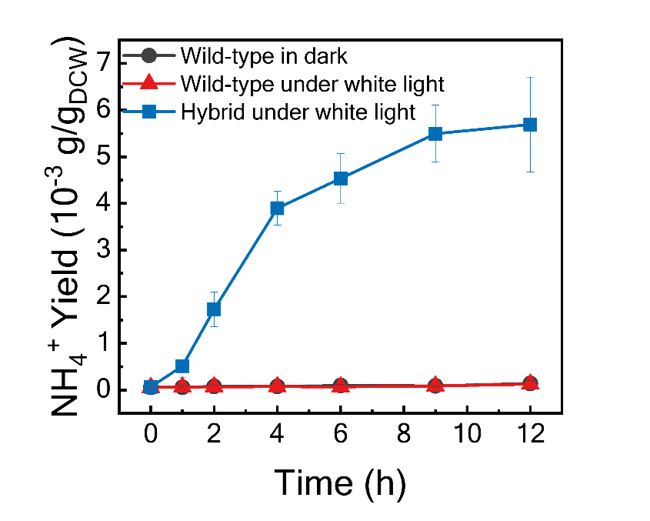
Fig. S4. Ammonia production of wild-type A. vinelandii and QD-A. vinelandii hybrid cells under dark and white light irradiation conditions. The experiment was conducted in a volume of 2 mL.

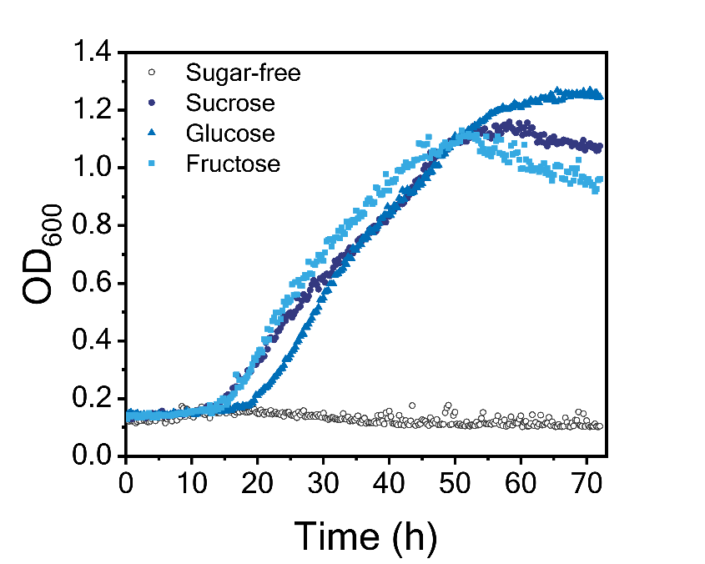
Fig. S5. Comparison of bacterial growth under conditions of different carbon sources in Burk’s medium.

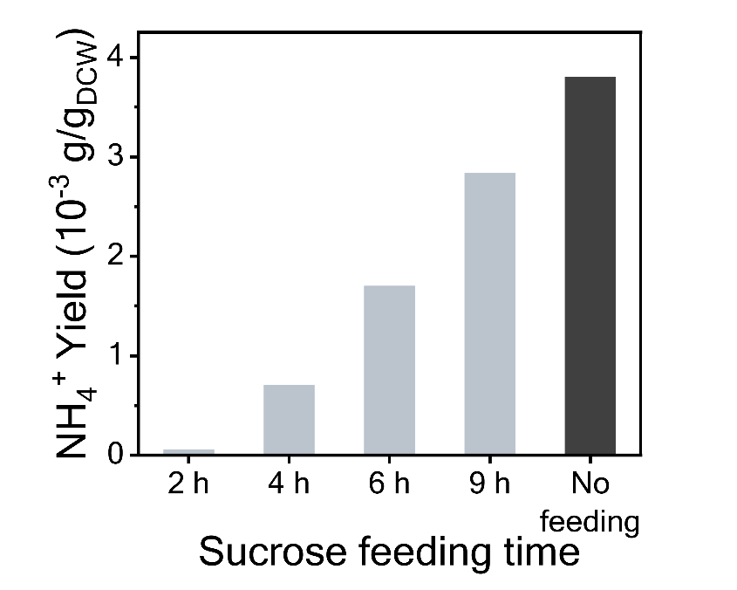
Fig. S6. Ammonia production influenced by time of sucrose addition.

Supplementary Note 1. Dry cell weight of A. vinelandii
To compare the ammonia productivity of QD-A.vinelandii on a scale before fermentation, the grown bacteria were adjusted to an OD₆₀₀ of 2.0. The dry cell weight (DCW) of A. vinelandii, measured at an optical density OD₆₀₀ of 2 using a TECAN Infinite 200PRO, was 8.43 g/L. Based on this, we described the ammonia production in terms of ammonium ions g/g_{DCW}.

Supplementary Note 2. Calculation of the turnover frequency (TOF) for ammonia production by QD-A. vinelandii hybrid through fermentation
The turnover frequency (TOF) was calculated by dividing the moles of ammonia produced per unit time by the moles of MoFe protein. Ammonia concentrations were determined using the indophenol blue colorimetric assay as described in the experimental section. To calculate MoFe protein moles, we measured the dry cell weight per reaction volume and calculated nitrogenase moles per unit dry cell weight (DCW). The number of nitrogenase molecules per cell and dry should be noticed. It is noted that the nitrogenase complex (consisting of MoFe protein and Fe protein) under ATP-supplying conditions, produces 119 moles of NH₃ per moles MoFe protein per minute, resulting in a TOF of 1.98 s⁻¹ [1]. Assuming similar conditions for whole cell, wild-type A. vinelandii, the amount of MoFe protein per cell or DCW can be estimated. The ammonium yield for wild-type A. vinelandii was observed to be 0.1395 ${\text{mg}}_{{\text{NH}}_{\text{4}}^{\text{+}}}\text{/}{\text{g}}_{\text{DCW}}$ over a 12-hour reaction period. Thus, the moles of MoFe proteins per DCW are calculated to be 9.0247$\text{×}{ 10}^{-11}$. The ammonia productivity of QD-A. vinelandii hybrids by fermentation reached 7.8127 ${\text{mg}}_{{\text{NH}}_{\text{4}}^{\text{+}}}\text{/L}$ at a 45-hour reaction period, leading to a calculated TOF for QD-A. vinelandii of 11.96 s⁻¹. Therefore, the production in the QD-A. vinelandii hybrid was six times higher than with the MoFe enzyme.

References
1. K.A. Brown, D.F. Harris, M.B. Wilker, A. Rasmussen, N. Khadka, H. Hamby, S. Keable, G. Dukovic, J.W. Peters, L.C. Seefeldt, P.W. King, Science 352, 448-450 (2016).

