Supplementary
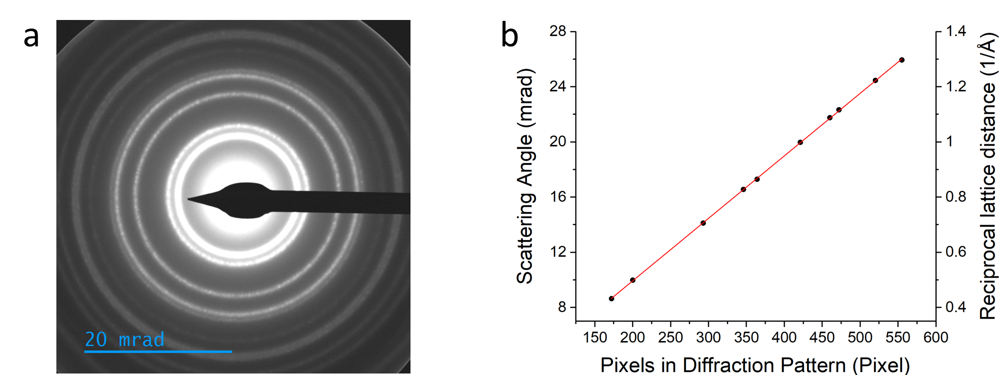
Figure S1: (a) Diffraction pattern of a standard cross-grating sample in LA-Ltz-4D-STEM mode with reduced C3 lens for creating a large beam size and enough sampling of Au nanoparticles. (b) The diameter of the Au diffraction rings measured on the camera in units of number of pixels versus their theoretical scattering angle for 300 keV electron. The black dots are experimental data and the red line is a linear fit to the experimental data.
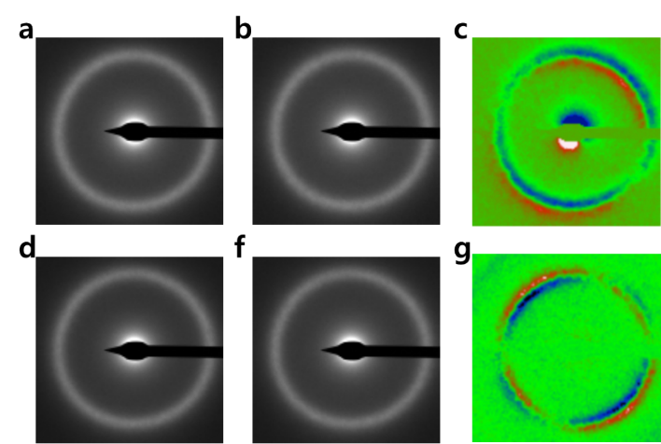
Figure S2: Diffraction patterns acquired by LA-Ltz-4D-STEM from different sample locations. (a) From a domain pointing left-up direction and (b) right-down direction. (c) Subtraction of both (a) and (b) diffraction patterns. (d) Unstrained case, and (f) strained case. (g) Subtraction of both (d) and (f) diffraction patterns
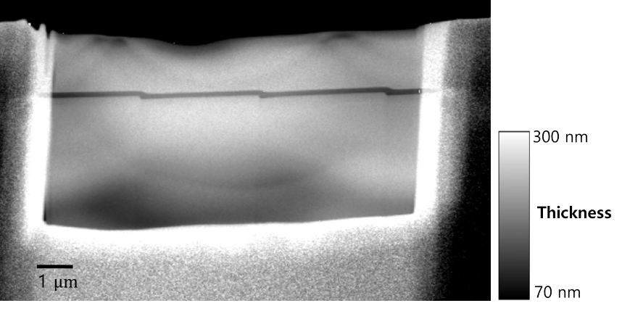
Figure S3: Thickness map of the FIB-prepared lamella from the deformed Fe_{85.2}Si_{0.5}B_{9.5}P₄Cu_{0.8} amorphous metallic alloy obtained using energy-filtered transmission electron microscopy (EFTEM). The mean free path (MFP) of an electron for the material was estimated to be ~75 nm for the thickness estimation.
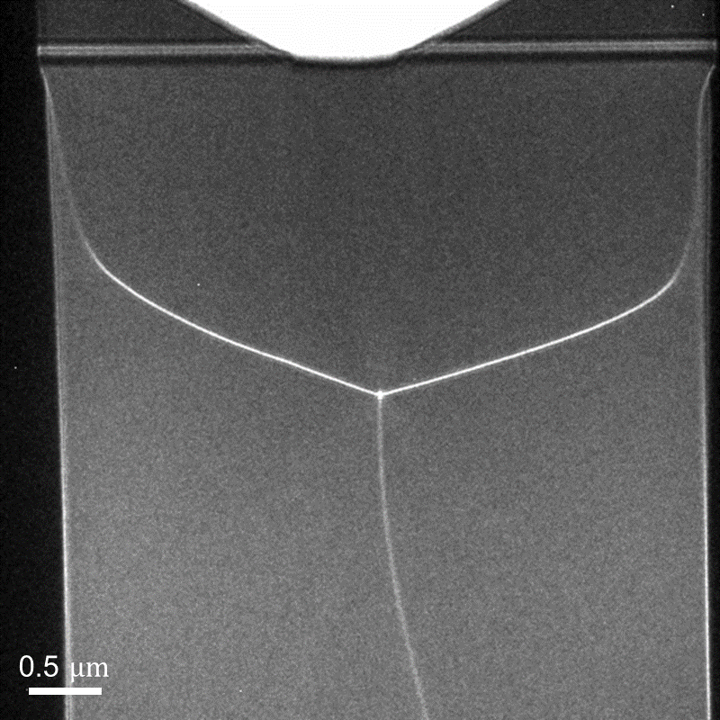
Figure S4: Ltz-TEM images of two TEM lamellae of the undeformed Fe_{85.2}Si_{0.5}B_{9.5}P₄Cu_{0.8} amorphous metallic alloy showing the domain structure of the soft ferromagnetic material. Notably, the undeformed sample may also possess some degree of residual stress anisotropy from fast melt-spin quenching, leading to the observed variation of the magnetic domain structure from a regular Landau-like domain structures, reflected in the curvature of the domain walls and their variation from a regular closure domain angle.
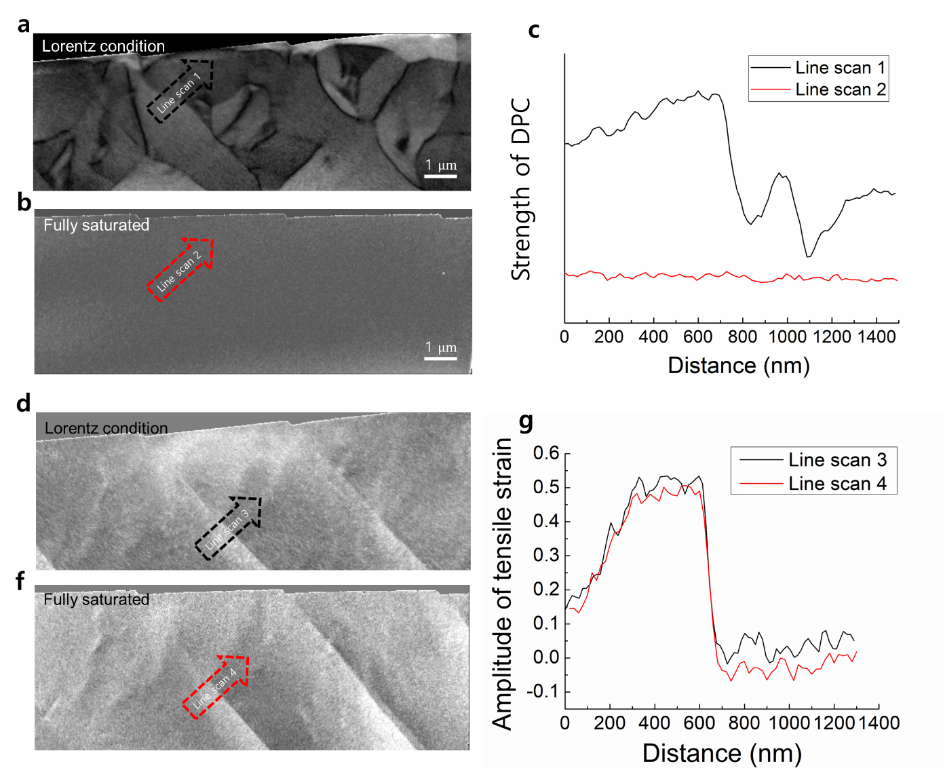
Figure S5: Map of the amplitude of the in-plane magnetization of the deformed amorphous Fe_{85.2}Si_{0.5}B_{9.5}P₄Cu_{0.8} metallic alloy at a unmagnetized state (field-free condition), and b fully vertically magnetized state (conventional microprobe STEM condition with objective excited about 2 T). c Line profiles taken across the shear band. Line scan 1: From the image of a along the black dash arrow. Line scan 2: From b along the red dash arrow. Map of the amplitude of the tensile strain at d unmagnetized state (field-free condition), and f fully vertically magnetized state. g Line profiles taken across the shear band. Line scan 3: From the image of d along the black dash arrow. Line scan 4: From f along the red dash arrow.
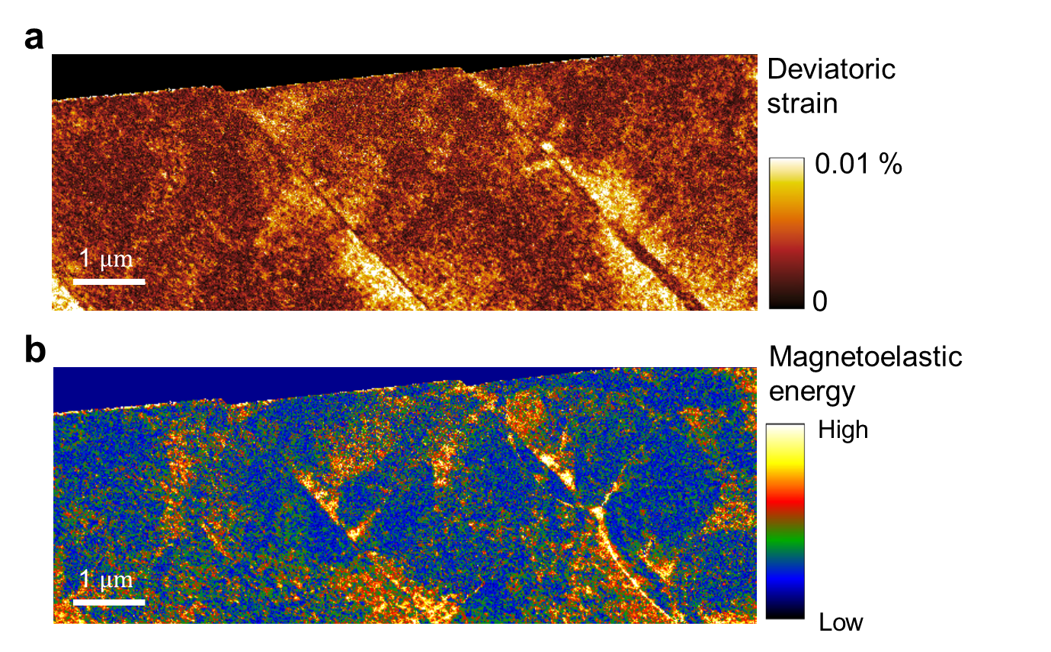
Figure S6: a Map of the deviatoric strain of the plastically deformed amorphous metallic alloy. b Map of magnetoelastic energy.

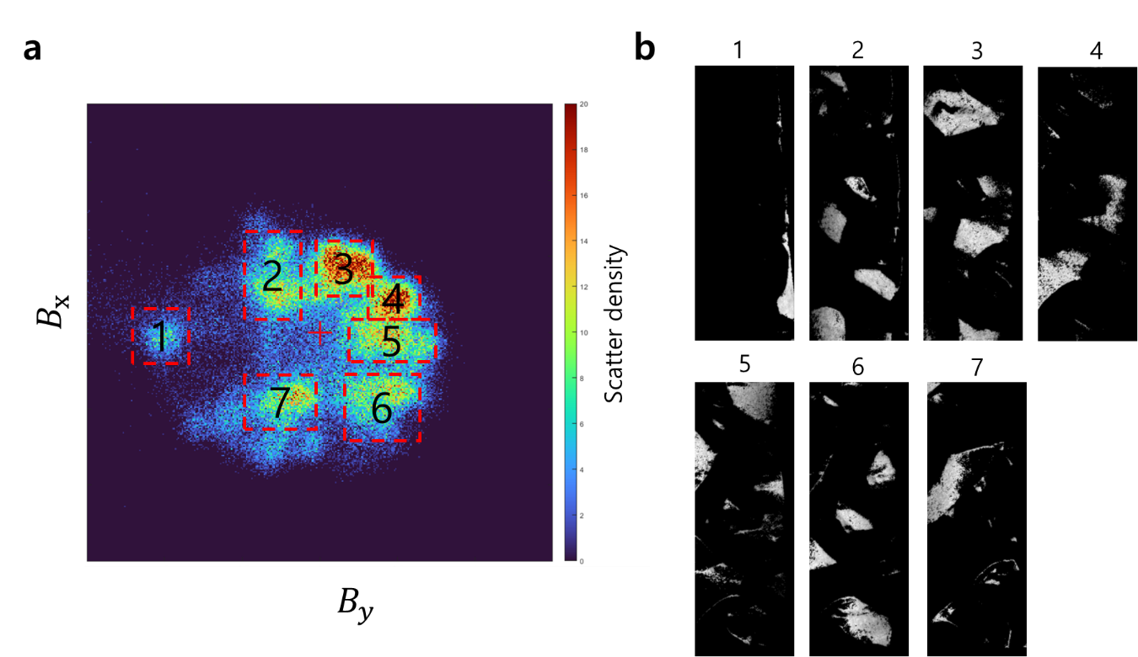
Figure S7: a 2D Histogram plot of vector components of the magnetic field ($B_{x}$ vs. $B_{y}$). over the whole mapping area. The dash rectangles with numbers 1 to 7 are used for mapping. b Corresponding maps from the selections in a are shown.
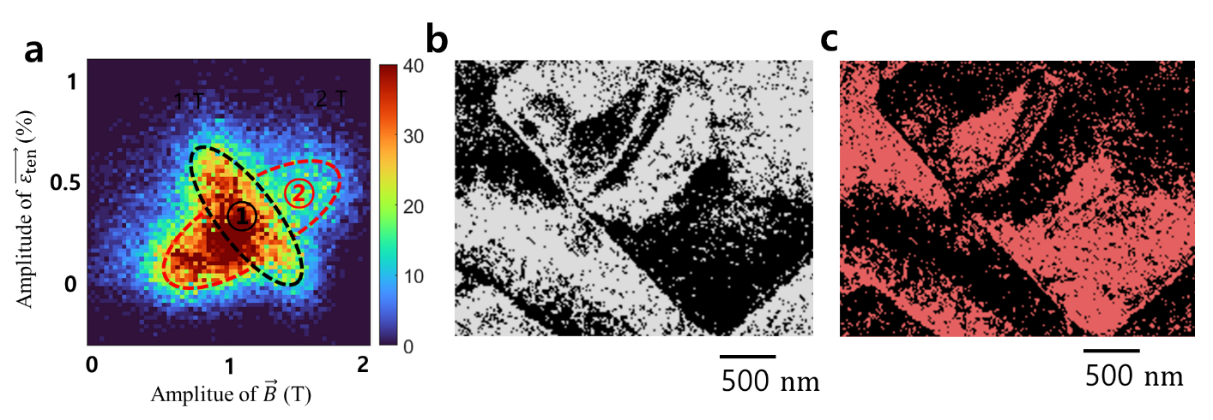
Figure S8: Correlative analysis of local strain and magnetization for a plastically deformed amorphous metallic alloy. a 2D distribution map of pixels according to $\left|\vec{B}\right|$ and $\left|{\vec{ε}}_{ten}\right|$. It shows an interesting star-shaped feature with proportional (region ②) and inverse proportional (region ①) correlations. b and c Spatial distribution of map pixels contained in the components ① and ② in a.
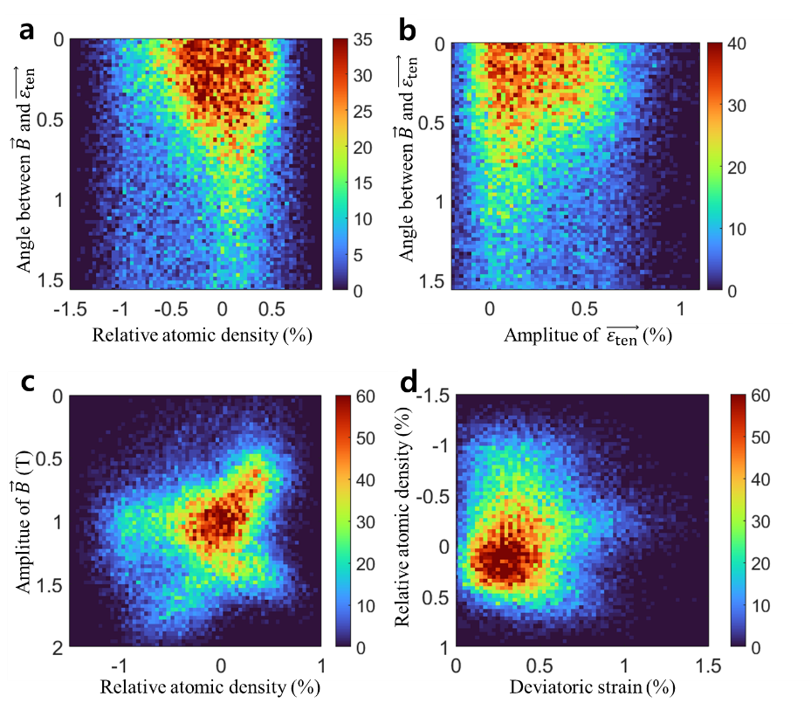
Figure S9: Exemplary density plots (2D histogram analysis) of (a) misorientation angle of ${\vec{ε}}_{ten}$ and $\vec{B}$ and relative atomic density, (b) misorientation angle of ${\vec{ε}}_{ten}$ and $\vec{B}$ and amplitude of ${\vec{ε}}_{ten}$, (c) amplitude of $\vec{B}$ and relative atomic density, and (d) relative atomic density and deviatoric strain.

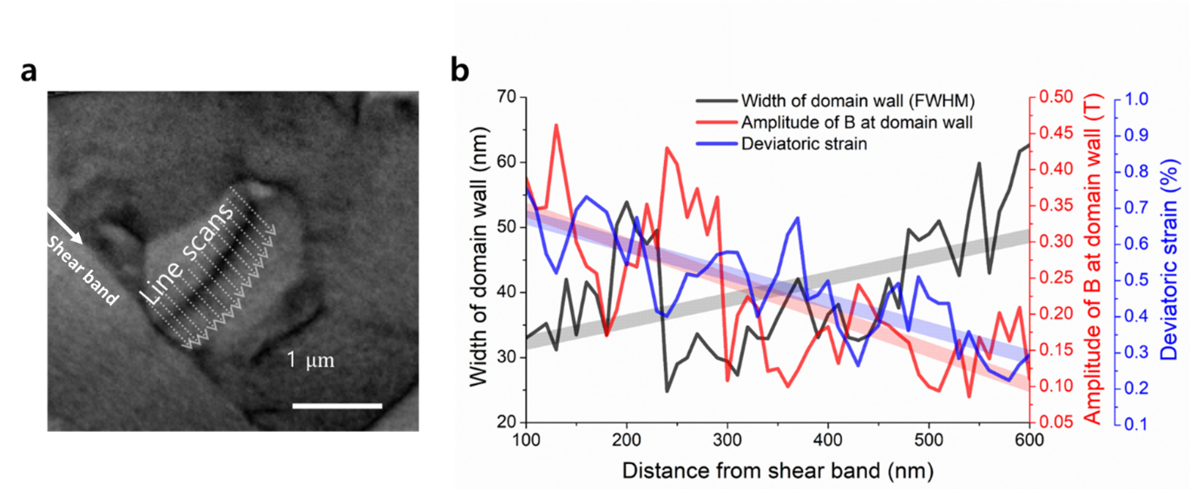
Figure S10: Correlative analysis across a domain wall. (a) An area of interest in $\left|\vec{B}\right|$ map. (b) Line profiles of the quantities of $\left|\vec{B}\right|$, $\left|\vec{ε}\right|$ and deviatoric strain, taken across the domain wall.

