Supplemental Figure 1: Evidence of HLD linkage regions (grey) with genome-wide non-parametric two-point linkage analysis with ordered subset analysis performed using percentage of ever-smokers per-family (red), packs-per-day (blue) with overlapping OSA results (magenta).
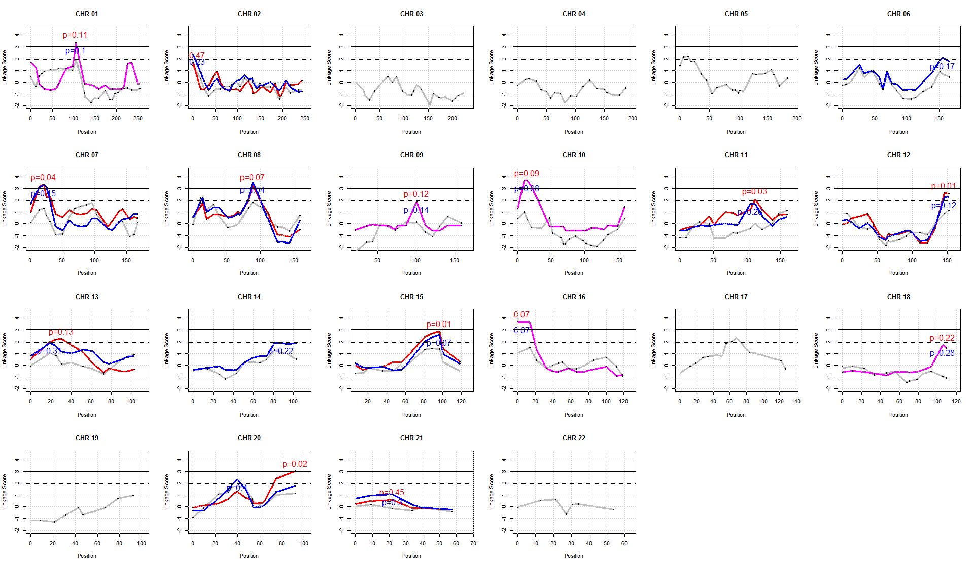

To evaluate the presence of HLD linkage, the solid line black horizontal indicates LOD=3 (for significant HLD linkage), and the dotted black horizontal line indicates LOD=1.9 (for suggestive HLD linkage). To determine the significance of GxE, the OSA p-values for the specific covariate ranking are noted in the specified color and as “p=”. For chromosomes 01, 03, 09, 10, 16, 17, and 18, the magenta line indicates that both covariate rankings obtained the same OSA linkage results. However, chromosomes 3, 4, 5, 17, 19, and 22 did not have evidence of GxE associations with increasing smoking levels (percentage of ever-smoking and packs-per-day) and HLD linkage; thus, there was an independence of HLD linkage and increasing smoking levels. Additionally, for chromosomes 6 and 14, there was no evidence of GxE for percentage of ever-smoking and HLD linkage. Therefore, no OSA linkage results are shown for these chromosomes with no evidence of GxE.

Supplementary Figure 2: Evidence of GxE (genes by smoking packs per day) interaction (circle points of -log10(p-values) on left-hand vertical axis) with underlying recombination rate (blue lines with right hand vertical axis) on chromosome 8. The linkage disequilibrium (LD) or correlation between each SNV and the SNV with the highest evidence of GxE (i.e., highest -log10(p-value) and denoted by a purple dot) is described by r² with legend in the box located in the right upper corner. The red demotes high LD/correlation and dark blue denotes low LD/correlation. Here most of the variants located between 80 and 85Mbp are mostly intergenic (except for one variant in ZBTB10 and one variant in PAG1 genes, which are highlighted within dark blue boxes); all variants in this region are independent and in low LD. In contrast, the SNVs located in the PDE7A and MTFR1 genes (which are highlighted within red box) are in high LD with greater evidence of being involved with GxE in HLD.
