Supplement 1-7

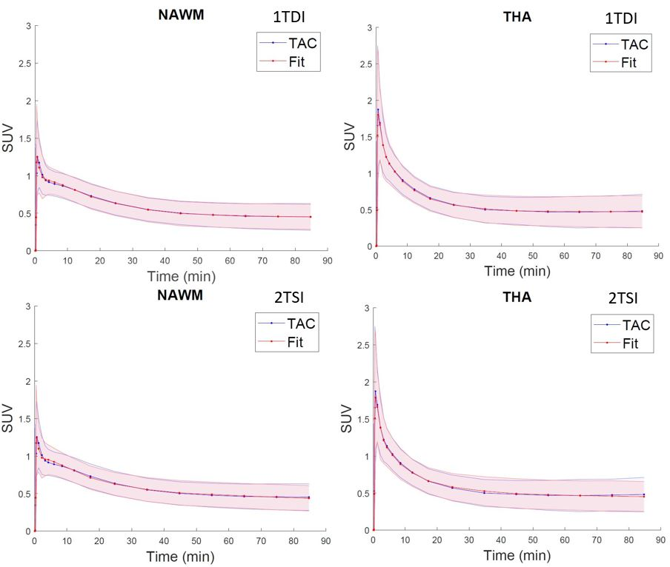
Supplement 1. Mean fits across all subjects with the dual-input one-compartment (1TDI; upper row) and single-input two-compartment (2TSI; lower row) models. NAWM = Normal appearing white matter. THA = Thalamus. SUV = Standardized uptake value. TAC = time activity curve

Supplement 2. 1TDI and 2TCM 90 min and 60 min AIC and log(mean residual) for all subjects (HC and MS)
 | N | Min. | Max. | Mean | SD | CoV
Brain_1TDI_90_AIC | 24 | -62.21 | 111.25 | -10.1680 | 49.24198 | NA
Brain_1TDI_90_CoV | 24 | NA | NA | NA | NA | 0.35136
NAWM_1TDI_90_AIC | 24 | -82.40 | 111.24 | -9.1166 | 50.94148 | NA
NAWM_1TDI_90_CoV | 24 | NA | NA | NA | NA | 0.29970
Tha_1TDI_90_AIC | 24 | -67.22 | 111.68 | -5.5173 | 49.38296 | NA
Brain_1TDI_60_AIC | 24 | -53.72 | 101.13 | -5.9888 | 43.46122 | NA
Brain_1TDI_60_CoV | 24 | NA | NA | NA | NA | 0.33677
NAWM_1TDI_60_AIC | 24 | -66.66 | 101.12 | -3.1746 | 44.59499 | NA
NAWM_1TDI_60_CoV | 24 | NA | NA | NA | NA | 0.29527
Tha_1TDI_60_AIC | 24 | -51.47 | 101.50 | .1169 | 42.68589 | NA
Brain_1TDI_90_log_residual | 24 | -3.63 | 4.63 | -1.1509 | 2.34486 | NA
NAWM_1TDI_90_log_residual | 24 | -4.59 | 4.63 | -1.1008 | 2.42578 | NA
Tha_1TDI_90_log_residual | 24 | -3.87 | 4.65 | -.9294 | 2.35157 | NA
Brain_1TDI_60_log_residual | 24 | -3.82 | 4.78 | -1.1660 | 2.41451 | NA
NAWM_1TDI_60_log_residual | 24 | -4.54 | 4.78 | -1.0097 | 2.47750 | NA
Tha_1TDI_60_log_residual | 24 | -3.69 | 4.81 | -.8268 | 2.37144 | NA
Brain_2TCM_90_AIC | 24 | -66.21 | 107.25 | -14.1680 | 49.24198 | NA
Brain_2TCM_90_CoV | 24 | NA | NA | NA | NA | 0.63014
NAWM_2TCM_90_AIC | 24 | -86.40 | 107.24 | -13.1166 | 50.94148 | NA
NAWM_2TCM_90_CoV | 24 | NA | NA | NA | NA | 0.65529
Tha_2TCM_90_AIC | 24 | -71.22 | 107.68 | -9.5173 | 49.38296 | NA
Brain_2TCM_60_AIC | 24 | -58.72 | 96.13 | -10.9888 | 43.46122 | NA
Brain_2TCM_60_CoV | 24 | NA | NA | NA | NA | 0.78752
NAWM_2TCM_60_AIC | 24 | -71.66 | 96.12 | -8.1746 | 44.59499 | NA
NAWM_2TCM_60_CoV | 24 | NA | NA | NA | NA | 0.82852
Tha_2TCM_60_AIC | 24 | -56.47 | 96.50 | -4.8831 | 42.68589 | NA
Brain_2TCM_90_log_residual | 24 | -3.63 | 4.63 | -1.1509 | 2.34486 | NA
NAWM_2TCM_90_log_residual | 24 | -4.59 | 4.63 | -1.1008 | 2.42578 | NA
Tha_2TCM_90_log_residual | 24 | -3.87 | 4.65 | -.9294 | 2.35157 | NA
Brain_2TCM_60_log_residual | 24 | -3.82 | 4.78 | -1.1660 | 2.41451 | NA
NAWM_2TCM_60_log_residual | 24 | -4.54 | 4.78 | -1.0097 | 2.47750 | NA
Tha_2TCM_60_log_residual | 24 | -3.69 | 4.81 | -.8268 | 2.37144 | NA
NAWM = Normal appearing white matter, Tha = thalamus, AIC = Aikaike information criterion, CoV = Coefficient of variation, log_residual = logarithm of mean residual sum of squares.

Supplement 3. 1TDI AIC and CoV among all MS, PMS and RMS with 0-60 min and 0-40 min fits
 | N | Min. | Max. | Mean | SD | CoV
Brain_1TDI_60_AIC_MS | 15 | -53.72 | 11.76 | -22.8424 | 20.24445 | NA
Brain_1TDI_60_CoV_MS | 15 | NA | NA | NA | NA | 0.36462
NAWM_1TDI_60_AIC_MS | 15 | -66.66 | 32.43 | -13.6393 | 24.95961 | NA
NAWM_1TDI_60_CoV_MS | 15 | NA | NA | NA | NA | 0.27110
Tha_1TDI_60_AIC_MS | 15 | -41.91 | 14.76 | -14.2919 | 16.81169 | NA
Tha_1TDI_60_CoV_MS | 15 | NA | NA | NA | NA | 0.30766
Brain_1TDI_60_AIC_PMS | 9 | -53.72 | 11.76 | -26.1549 | 21.94664 | NA
NAWM_1TDI_60_AIC_PMS | 9 | -66.66 | 32.43 | -14.7823 | 29.00347 | NA
Tha_1TDI_60_AIC_PMS | 9 | -41.91 | 14.76 | -19.4912 | 17.02978 | NA
Brain_1TDI_60_AIC_RMS | 6 | -42.62 | 8.05 | -17.8735 | 18.09749 | NA
NAWM_1TDI_60_AIC_RMS | 6 | -27.15 | 24.30 | -11.9248 | 19.81287 | NA
Tha_1TDI_60_AIC_RMS | 6 | -26.90 | 8.14 | -6.4929 | 14.34236 | NA
Brain_1TDI_40_AIC_MS | 15 | -52.40 | 8.97 | -22.8511 | 18.67182 | NA
Brain_1TDI_40_CoV_MS | 15 | NA | NA | NA | NA | 0.39615
NAWM_1TDI_40_AIC_MS | 15 | -61.03 | 27.37 | -13.9037 | 22.65610 | NA
NAWM_1TDI_40_CoV_MS | 15 | NA | NA | NA | NA | 0.27089
Tha_1TDI_40_AIC_MS | 15 | -39.54 | 11.58 | -15.1526 | 14.66424 | NA
Tha_1TDI_40_CoV_MS | 15 | NA | NA | NA | NA | 0.30801
Brain_1TDI_40_AIC_PMS | 9 | -52.40 | 8.97 | -26.1649 | 20.43276 | NA
NAWM_1TDI_40_AIC_PMS | 9 | -61.03 | 27.37 | -14.9964 | 26.39051 | NA
Tha_1TDI_40_AIC_PMS | 9 | -39.54 | 11.58 | -20.1893 | 14.62004 | NA
Brain_1TDI_40_AIC_RMS | 6 | -39.40 | 5.61 | -17.8804 | 16.08640 | NA
NAWM_1TDI_40_AIC_RMS | 6 | -25.45 | 20.25 | -12.2646 | 17.81937 | NA
Tha_1TDI_40_AIC_RMS | 6 | -25.07 | 2.85 | -7.5976 | 12.08145 | NA
NAWM = Normal appearing white matter, Tha = thalamus, AIC = Aikaike information criterion, CoV = Coefficient of variation

Supplement 4. 2TCM (0 – 90 min) HC vs. MS V_{T2T} comparison
 |  | N | Mean | SD | Mean Difference | p
Brain V_{T2T} | MS | 15 | 0.5785 | 0.3614 | -0.1122 | 0.514
Brain V_{T2T} | HC | 9 | 0.6906 | 0.4616 | -0.1122 | 0.514
NAWM V_{T2T} | MS | 15 | 0.4942 | 0.2561 | -0.2121 | 0.204
NAWM V_{T2T} | HC | 9 | 0.7064 | 0.5398 | -0.2121 | 0.204
Thalamus V_{T2T} | MS | 15 | 1.0003 | 0.6117 | -0.1991 | 0.535
Thalamus V_{T2T} | HC | 9 | 1.1994 | 0.9414 | -0.1991 | 0.535
cGM V_{T2T} | MS | 15 | 0.7613 | 0.5221 | -0.0444 | 0.836
cGM V_{T2T} | HC | 9 | 0.8056 | 0.4634 | -0.0444 | 0.836
cGM = cortical grey matter. NAWM = normal appearing white matter.

Supplement 5. 2TCM (0 – 90 min) RMS vs. PMS V_{T2T} comparison
 | MS Type | N | Mean | SD | Mean Difference | p
NAWM V_{T2V} | RMS | 6 | 0.5252 | 0.2479 | 0.0516 | 0.717
NAWM V_{T2V} | PMS | 9 | 0.4736 | 0.2742 | 0.0516 | 0.717
Thalamus V_{T2V} | RMS | 6 | 1.3354 | 0.6528 | 0.5585 | 0.082
Thalamus V_{T2V} | PMS | 9 | 0.7769 | 0.4981 | 0.5585 | 0.082
cGM V_{T2V} | RMS | 6 | 1.0613 | 0.5804 | 0.5001 | 0.066
cGM V_{T2V} | PMS | 9 | 0.5612 | 0.3925 | 0.5001 | 0.066
T1 lesional V_{T2V} | RMS | 6 | 0.9161 | 0.6483 | 0.0756 | 0.810
T1 lesional V_{T2V} | PMS | 9 | 0.8405 | 0.5414 | 0.0756 | 0.810
T1 perilesional 3mm rim V_{T2V} | RMS | 6 | 0.5483 | 0.2210 | 0.0315 | 0.837
T1 perilesional 3mm rim V_{T2V} | PMS | 9 | 0.5167 | 0.3142 | 0.0315 | 0.837
cGM = cortical grey matter. NAWM = normal appearing white matter. RMS = Relapsing MS. PMS = Progressive MS.

Supplement 6. Lesional, perilesional and NAWM [¹¹C]SMW139 V_{T2T} (2TCM 0 - 90 min)
Comparison | Mean | SD | p
T1 lesions - NAWM | 0.3765 | 0.5470 | 0.018
T1 lesions - T1 3mm rim | 0.3414 | 0.4656 | 0.013
T1 3mm rim - NAWM | 0.0351 | 0.1293 | 0.311
T1 lesions PMS - NAWM PMS | 0.3669 | 0.5286 | 0.071
T1 lesions PMS - T1 3mm rim PMS | 0.3238 | 0.4641 | 0.070
T1 3mm rim PMS - NAWM PMS | 0.0431 | 0.1378 | 0.376
T1 lesions RMS - NAWM RMS | 0.3909 | 0.6247 | 0.186
T1 lesions RMS - T1 3mm rim RMS | 0.3678 | 0.5109 | 0.138
T1 3mm rim RMS - NAWM RMS | 0.0231 | 0.1270 | 0.675
T1 3mm rim = T1 perilesional 3 mm rim, NAWM = Normal appearing white matter
RMS = Relapsing MS. PMS = Progressive MS.

Supplement 7. |  |  | Sex differences among all subjects
 | Sex |  |  | N | Mean | SD | Mean Difference | p
Age | M |  |  | 15 | 48.9267 | 12.2733 | 1.6933 | 0.739
Age | F |  |  | 9 | 47.2333 | 11.2278 | 1.6933 | 0.739
Time from Dg | M |  |  | 9 | 7.3422 | 8.6391 | -7.0694 | 0.146
Time from Dg | F |  |  | 6 | 14.4117 | 8.7451 | -7.0694 | 0.146
EDSS | M |  |  | 9 | 3.8333 | 2.4109 | -.58333 | 0.616
EDSS | F |  |  | 6 | 4.4167 | 1.6558 | -.58333 | 0.616
Brain volume (cm³) | M |  |  | 15 | 1204.7093 | 86.7725 | 191.8237 | <.001
Brain volume (cm³) | F |  |  | 9 | 1012.8856 | 103.1303 | 191.8237 | <.001
T1 lesion voluime (cm³) | M |  |  | 9 | 19.5891 | 17.3728 | 6.8607 | 0.391
T1 lesion voluime (cm³) | F |  |  | 6 | 12.7283 | 8.7613 | 6.8607 | 0.391
SMW V_{TDI} brain | M |  |  | 15 | 0.1105 | 0.0342 | 0.0334 | 0.015
SMW V_{TDI} brain | F |  |  | 9 | 0.0771 | 0.0208 | 0.0334 | 0.015
SMW V_{TDI} NAWM | M |  |  | 15 | 0.1187 | 0.0243 | 0.0344 | 0.007
SMW V_{TDI} NAWM | F |  |  | 9 | 0.0842 | 0.0325 | 0.0344 | 0.007
SMW V_{TDI} thalamus | M |  |  | 15 | 0.1460 | 0.0618 | 0.0542 | 0.025
SMW V_{TDI} thalamus | F |  |  | 9 | 0.0918 | 0.0344 | 0.0542 | 0.025
NAWM = Normal appearing white matter. EDSS = Expanded disability status scale

