Supplementary Information
Lin et al.

Supplemental Figures

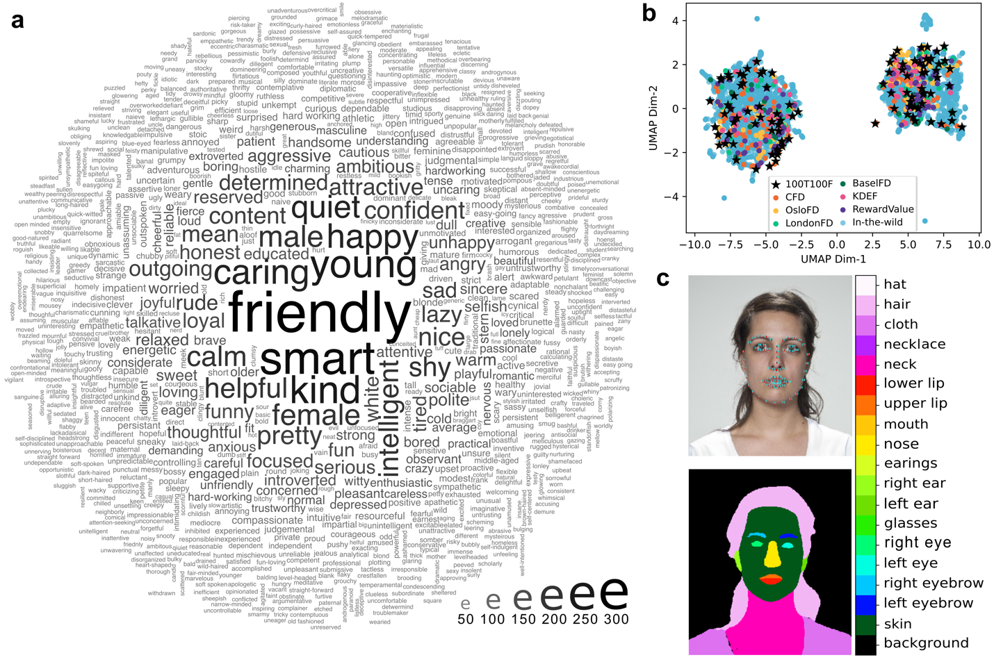
Supplementary Figure 1: Verifying the representativeness of the 100 selected traits and face images.
a, Word cloud of the 973 freely generated descriptions of the 100 selected face images during spontaneous face judgments (see Methods). All words that appeared at least twice are shown in the figure (words that appeared only once were excluded, as they were comprised mainly of misspelled words or words not included in the FastText vocabulary¹). The scale indicates the frequency the word was mentioned (ranging from 2 to 306 times). b, Uniform Manifold Approximation and Projection (UMAP², a dimensionality reduction technique similar to t-SNE but applicable also to nonlinear cases) of the 100 selected face images (stars), frontal, neutral, white face images from multiple databases (dots that are not light blue, N = 632), and ambient face images in the wild^{3,4} (light blue dots; with various angles, gazes, facial expressions, lighting, backgrounds, etc.; N = 5376). All faces were represented by the 128 computationally extracted features used by a state-of-the-art neural network for facial recognition⁵. c, Automatic annotation of facial keypoints and facial parts, for automatically measuring 30 facial metrics⁶ (e.g., pupillary distance, eye width, eye length, eye size, eye shape, nose width, nose length, nose shape, lip thickness, lip fullness, cheekbone height, cheekbone prominence, various face width measures, various face height measures, face roundness, median luminance).

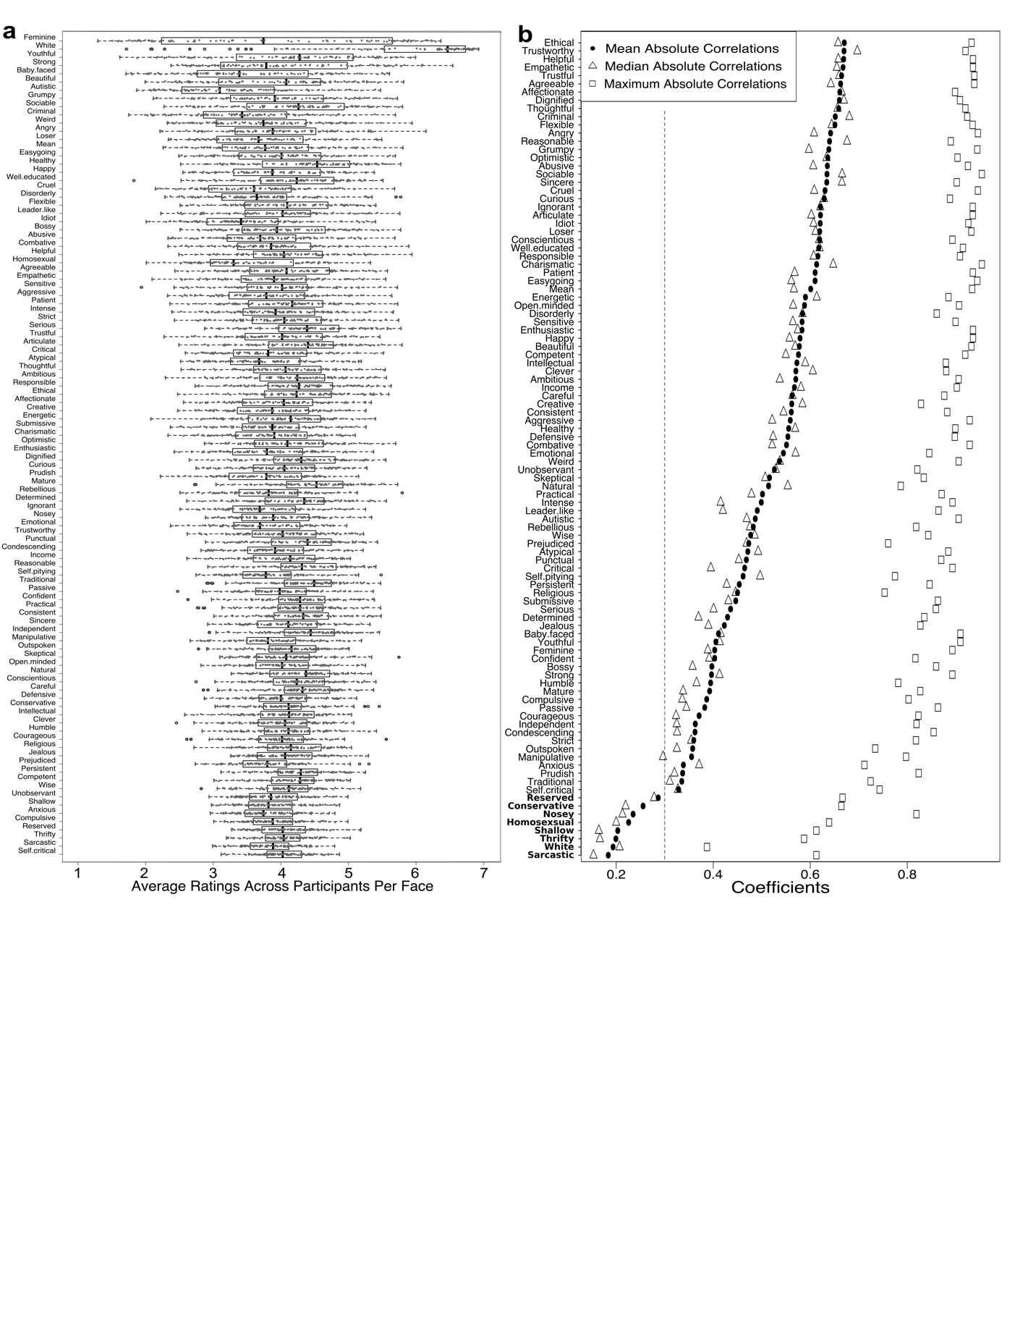
Supplementary Figure 2: Variance and factorizability of ratings across 100 traits.
a, Distribution of aggregate-level trait ratings. Each row plots the average ratings across participants for the 100 faces on a trait (grey dots), with the median (line in the box), the first quartile (left edge of the box), the third quartile (right edge of the box), and outliers that are more extreme than 3/2 times of the quartiles (open dots). b, Factorability of aggregate-level trait ratings. Each row plots the mean (dot), median (triangle), and maximum (square) absolute correlations a trait has with all the other 99 traits (across faces, averaged over participants). The vertical dashed line indicates r = 0.30, which describes an inflection point in the curve of mean absolute correlations. The eight traits at the bottom (in bold) were excluded from EFA because of their low average correlations with all other traits (i.e. low factorizability); including these eight traits did not change the dimensions we eventually found.
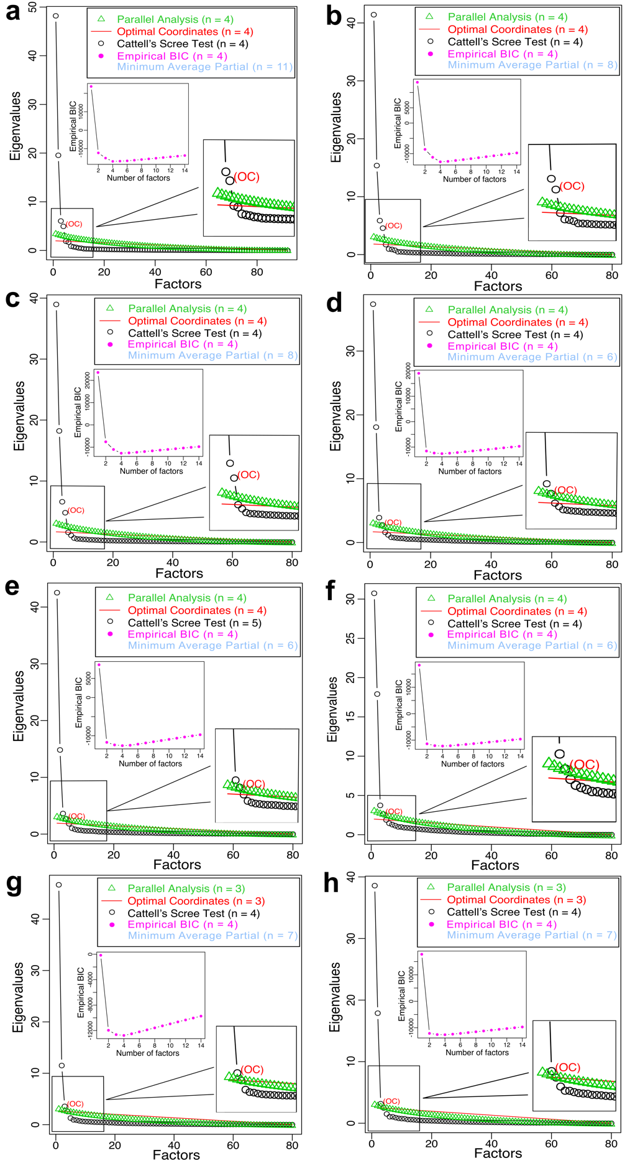
Supplementary Figure 3: Scree plots of data across eight samples.
a, Study 1 sample. b-h, Study 2 samples from North America (b), Latvia (c), Peru (d), the Philippines (e), India (f), Kenya (g), and Gaza (h). Circles plot the eigenvalues (the fraction of total common variance in the data as explained by each factor) of the original data across factors, ordered from the largest to the smallest. Triangles plot the 95th percentile of the eigenvalues of the simulated data from parallel analysis. The optimal number of factors to retain as recommended by each of the five methods is shown. Parallel analysis retains factors with eigenvalues (circles) greater than those from the simulated data (triangles) from 5,000 Monte Carlo simulations (see the close-up image for a clearer comparison). Cattell’s scree test retains factors to the left of the point from which the plotted ordered eigenvalues could be approximated with a straight line (i.e., “above the elbow”). The optimal coordinates index provides a non-graphical solution to Cattell’s scree test based on linear extrapolation. Empirical Bayesian information criterion (eBIC) retains factors that minimize the overall discrepancy between the population’s and the model’s predicted covariance matrices while penalizing model complexity (purple dots in inset graphs). Velicer’s minimum average partial (MAP) test is “most appropriate when component analysis is employed as an alternative to, or a first-stage solution for, factor analysis”⁷. It is also included in our present study due to its popularity. MAP retains components by partialing those that resulted in the lowest average squared partial correlation. The MAP test gave variable numbers of components greater than 4; it is not plotted but the results are numerically provided in the legend inset.

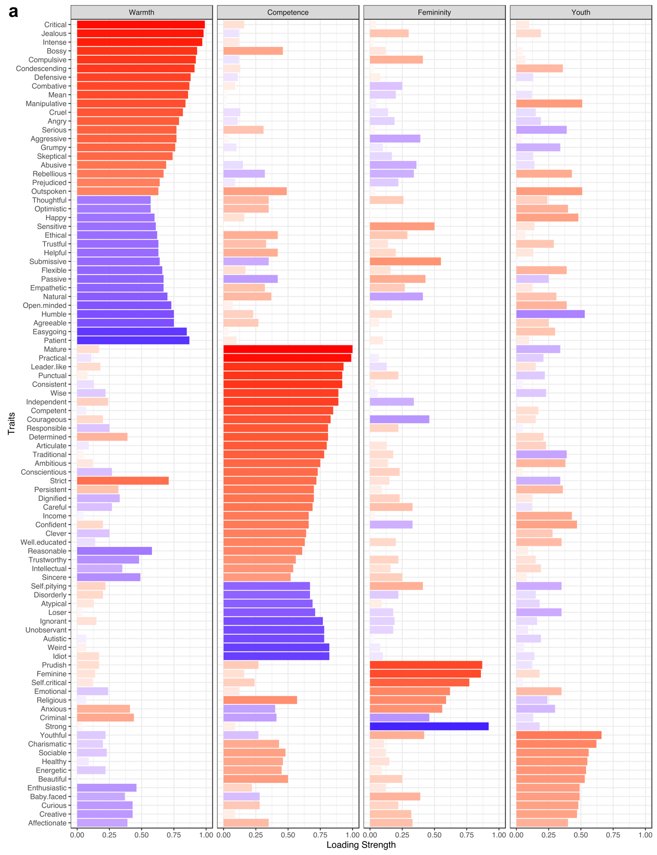
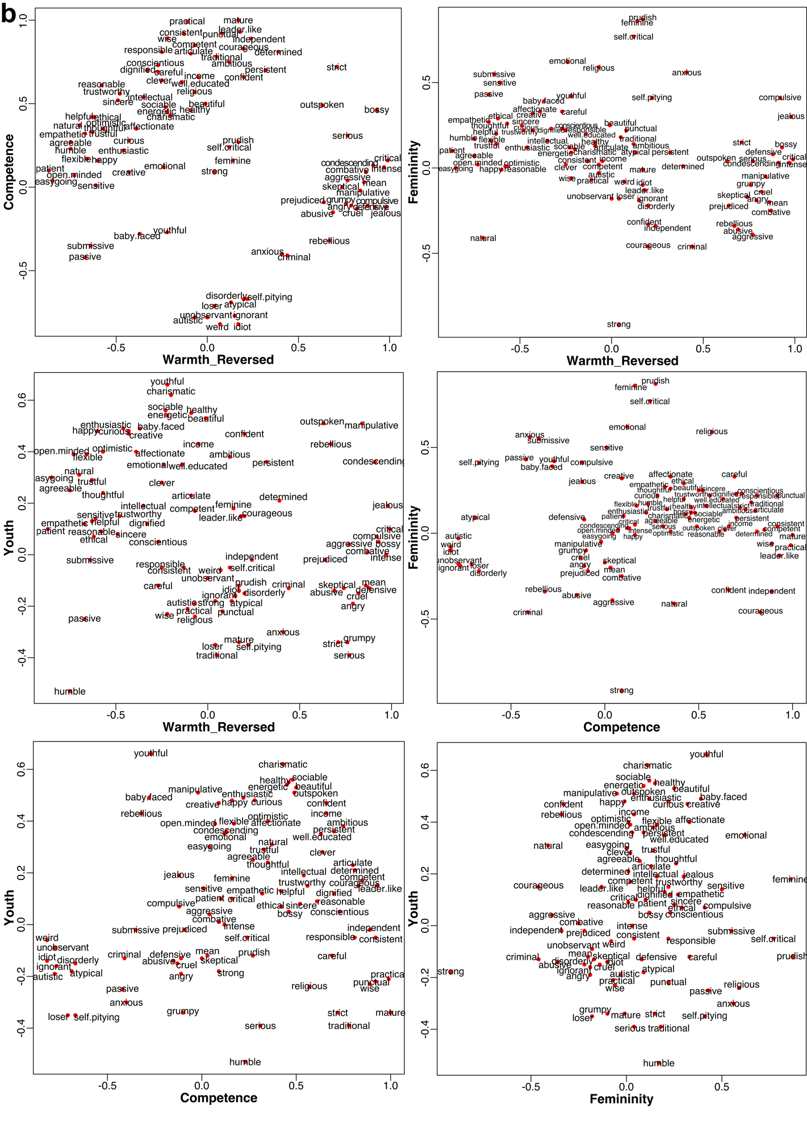
Supplementary Figure 4: Four dimensions from EFA in Study 1.
a, Factor loadings of trait ratings on the four dimensions from EFA. Each column plots the strength of the factor loadings (x-axis, absolute value) across traits (y-axis). Color indicates the sign of the loading (red for positive and blue for negative); more saturated colors for higher absolute values. b, Distributions of the 92 traits along each pair of dimensions based on their factor loadings on the four dimensions.

a
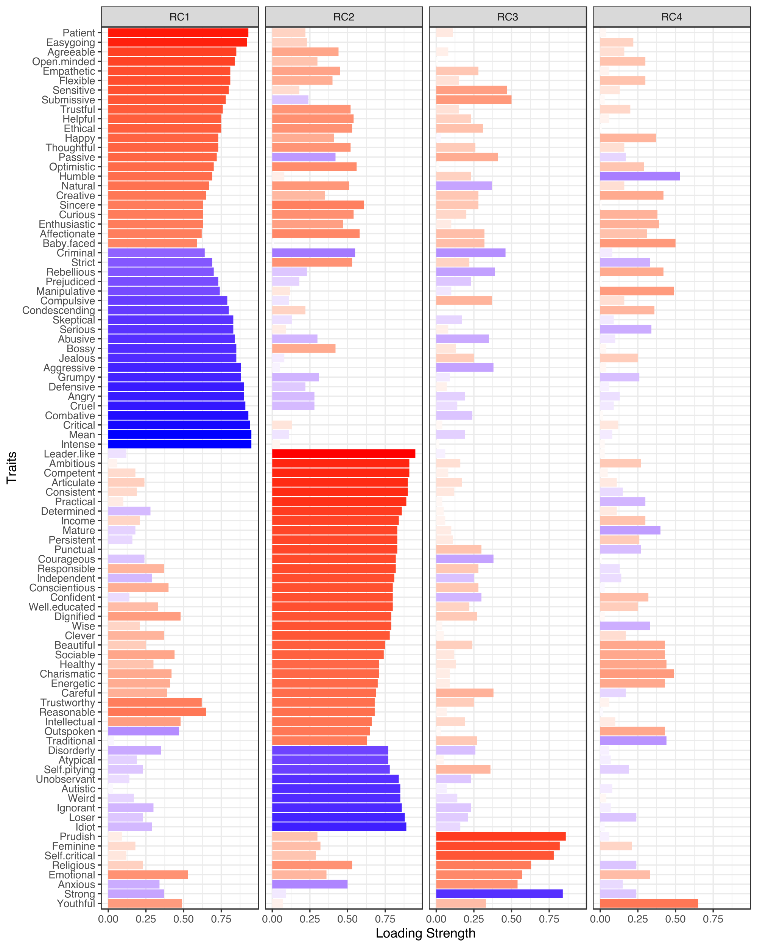

b
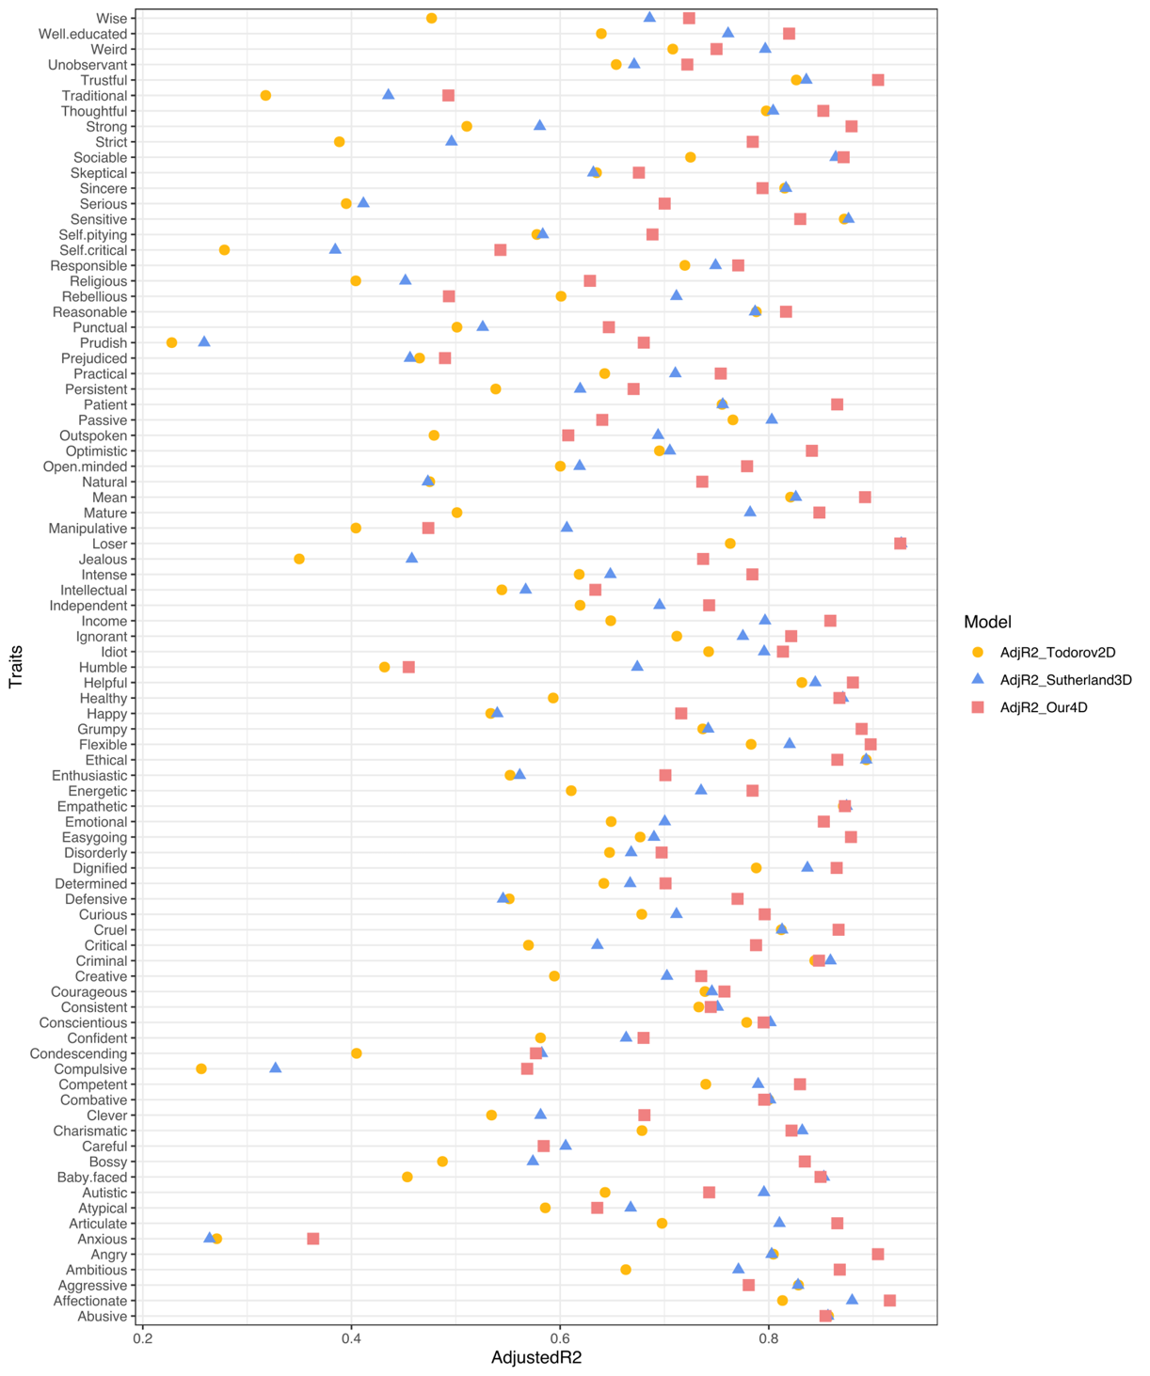
Supplementary Figure 5: Comparison with existing dimensional frameworks.
a, Four dimensions from PCA in Study 1. Columns plot the strength of the loadings (x-axis, absolute value) on the first four varimax rotated principal components across all 92 traits (y-axis). Colors indicate the sign of the loading (red for positive and blue for negative); more saturated colors for higher absolute values. The first four principal components without rotation accounted for 52%, 21%, 7%, and 5% of the variance in our data, 86% in total; the fifth accounted for 2%. b, Predicting trait judgments using different dimensional frameworks. Regressors were linear combinations of the traits that showed highest loadings in each dimensional framework (two traits for each dimension because there were only two traits that loaded highest on one of the 3D-framework’s dimensions⁸; for example, for our 4D-framework, the model consisted of eight regressors). Each row indicates three different models that regressed the ratings of a targeted trait (row name; which was not one of the regressors) on the three different sets of regressors from the three frameworks, and plots the adjusted R².

a
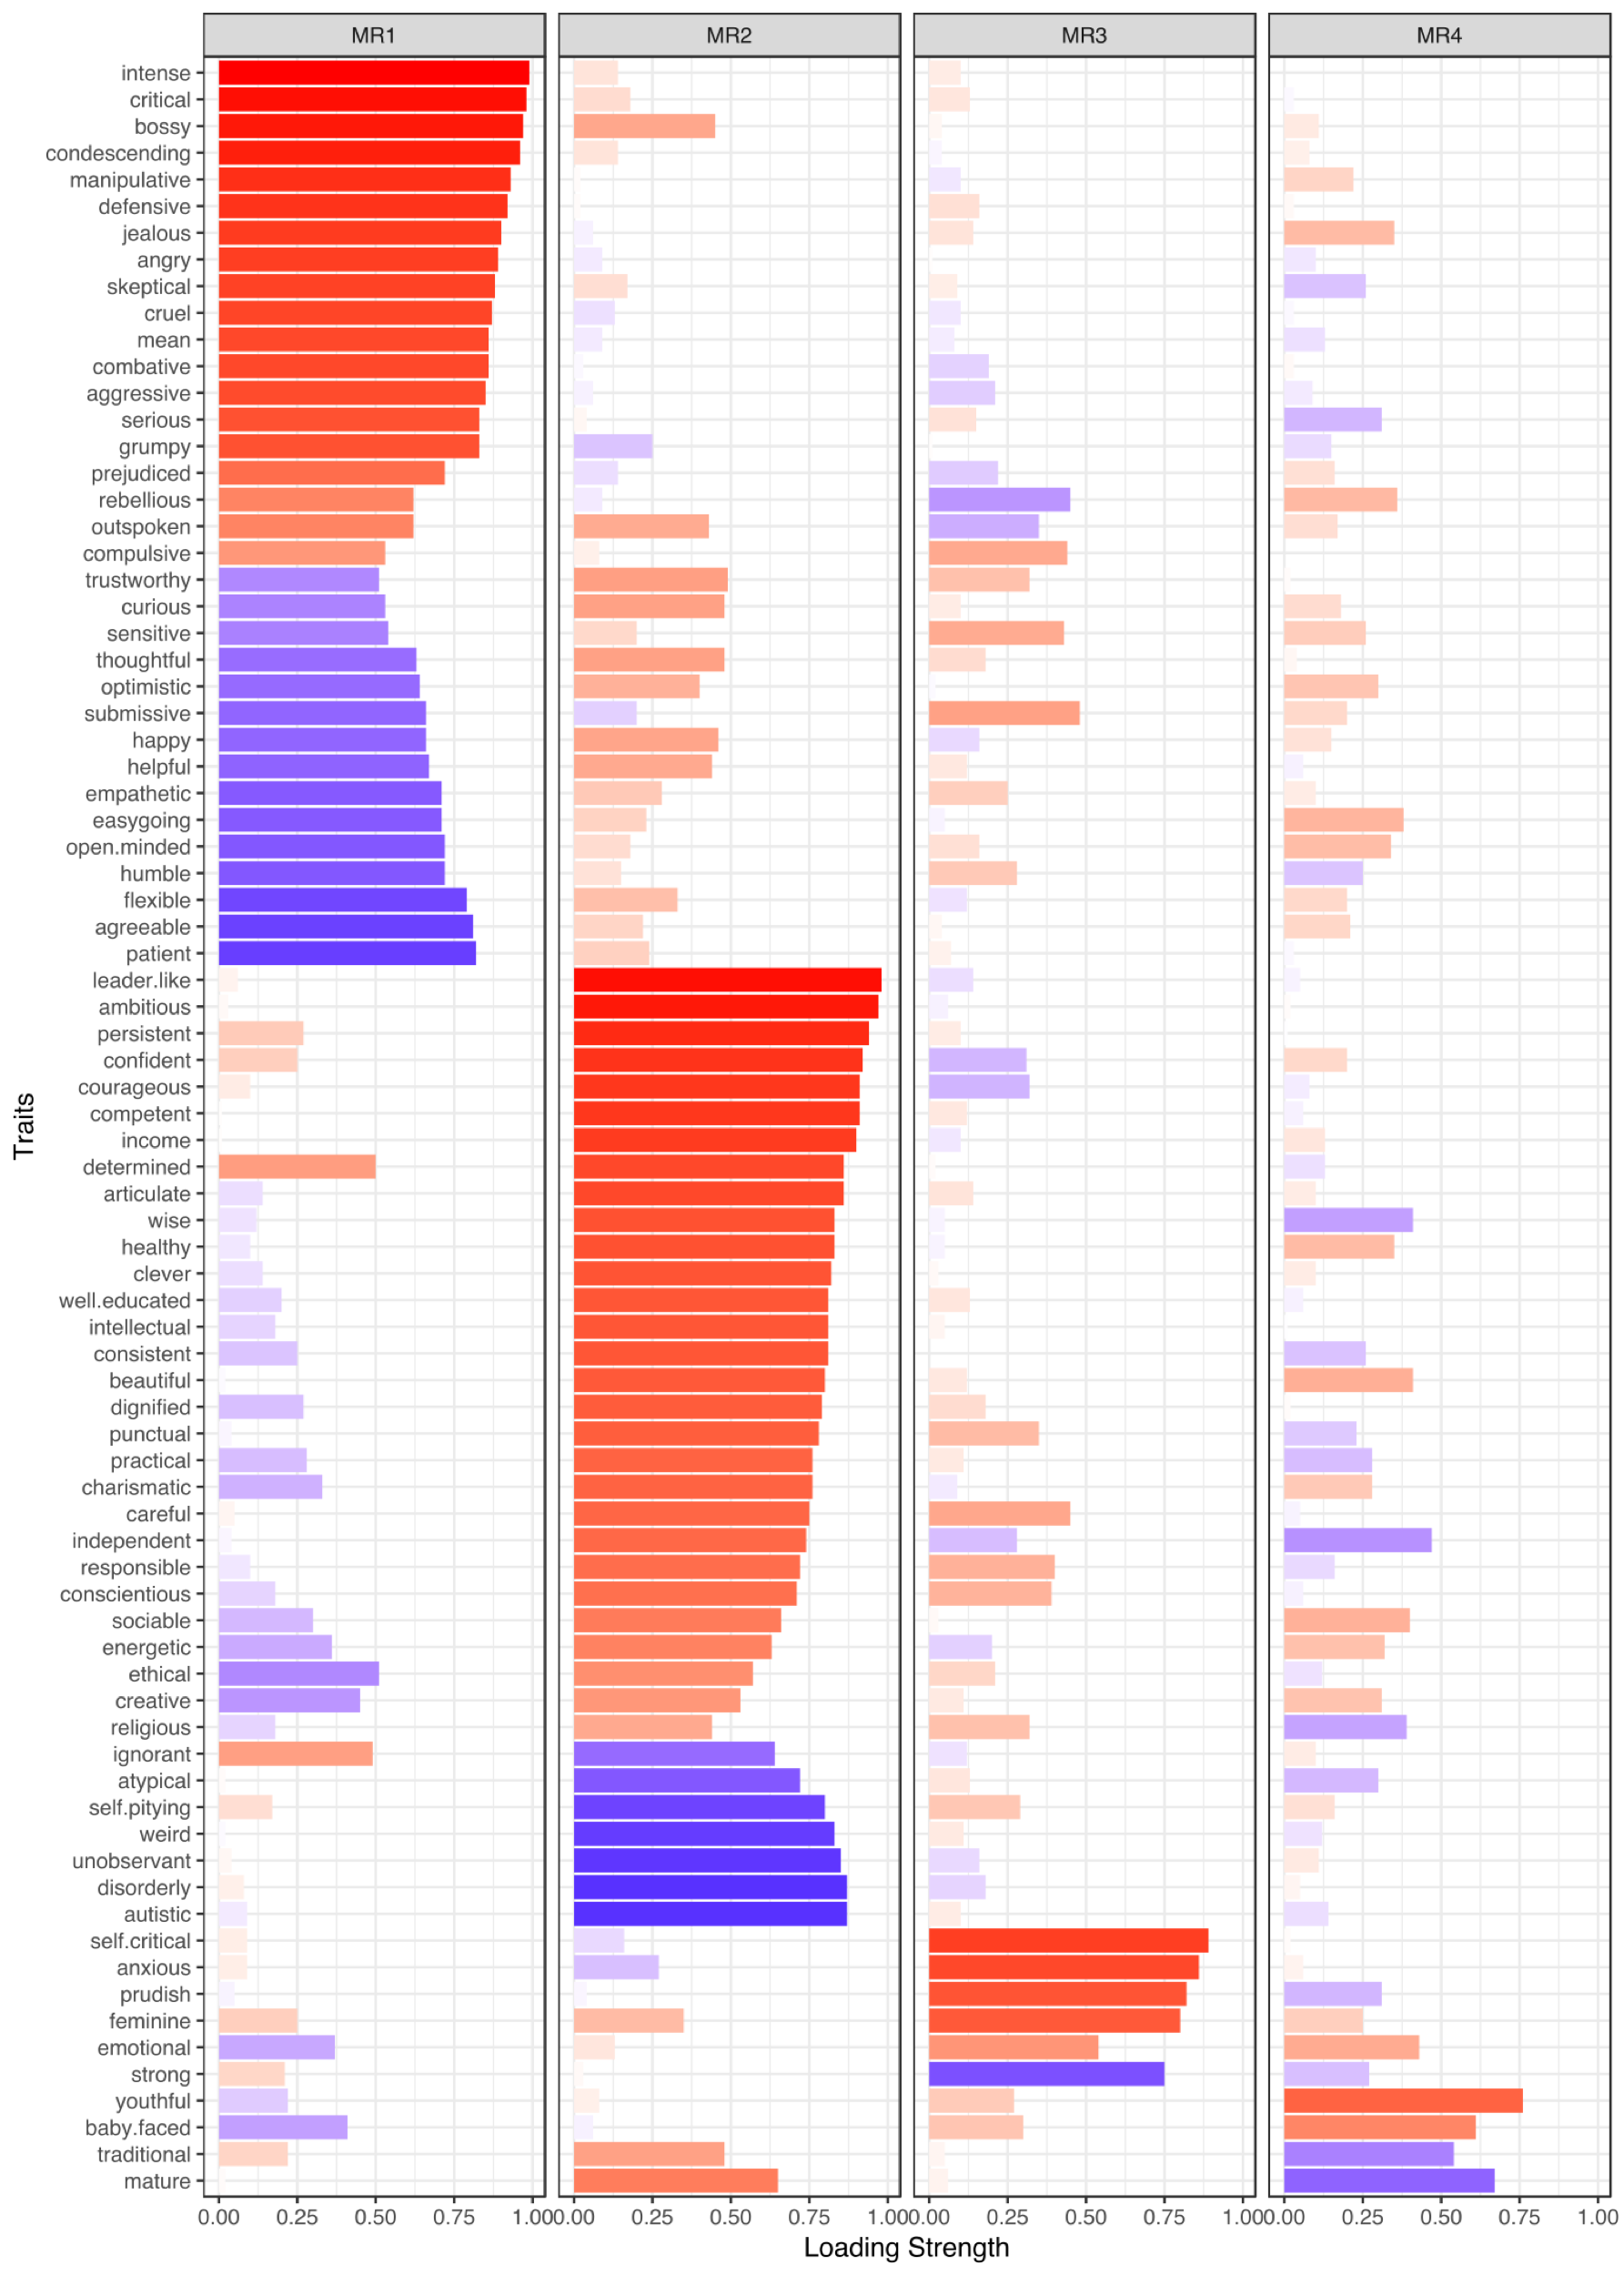

b
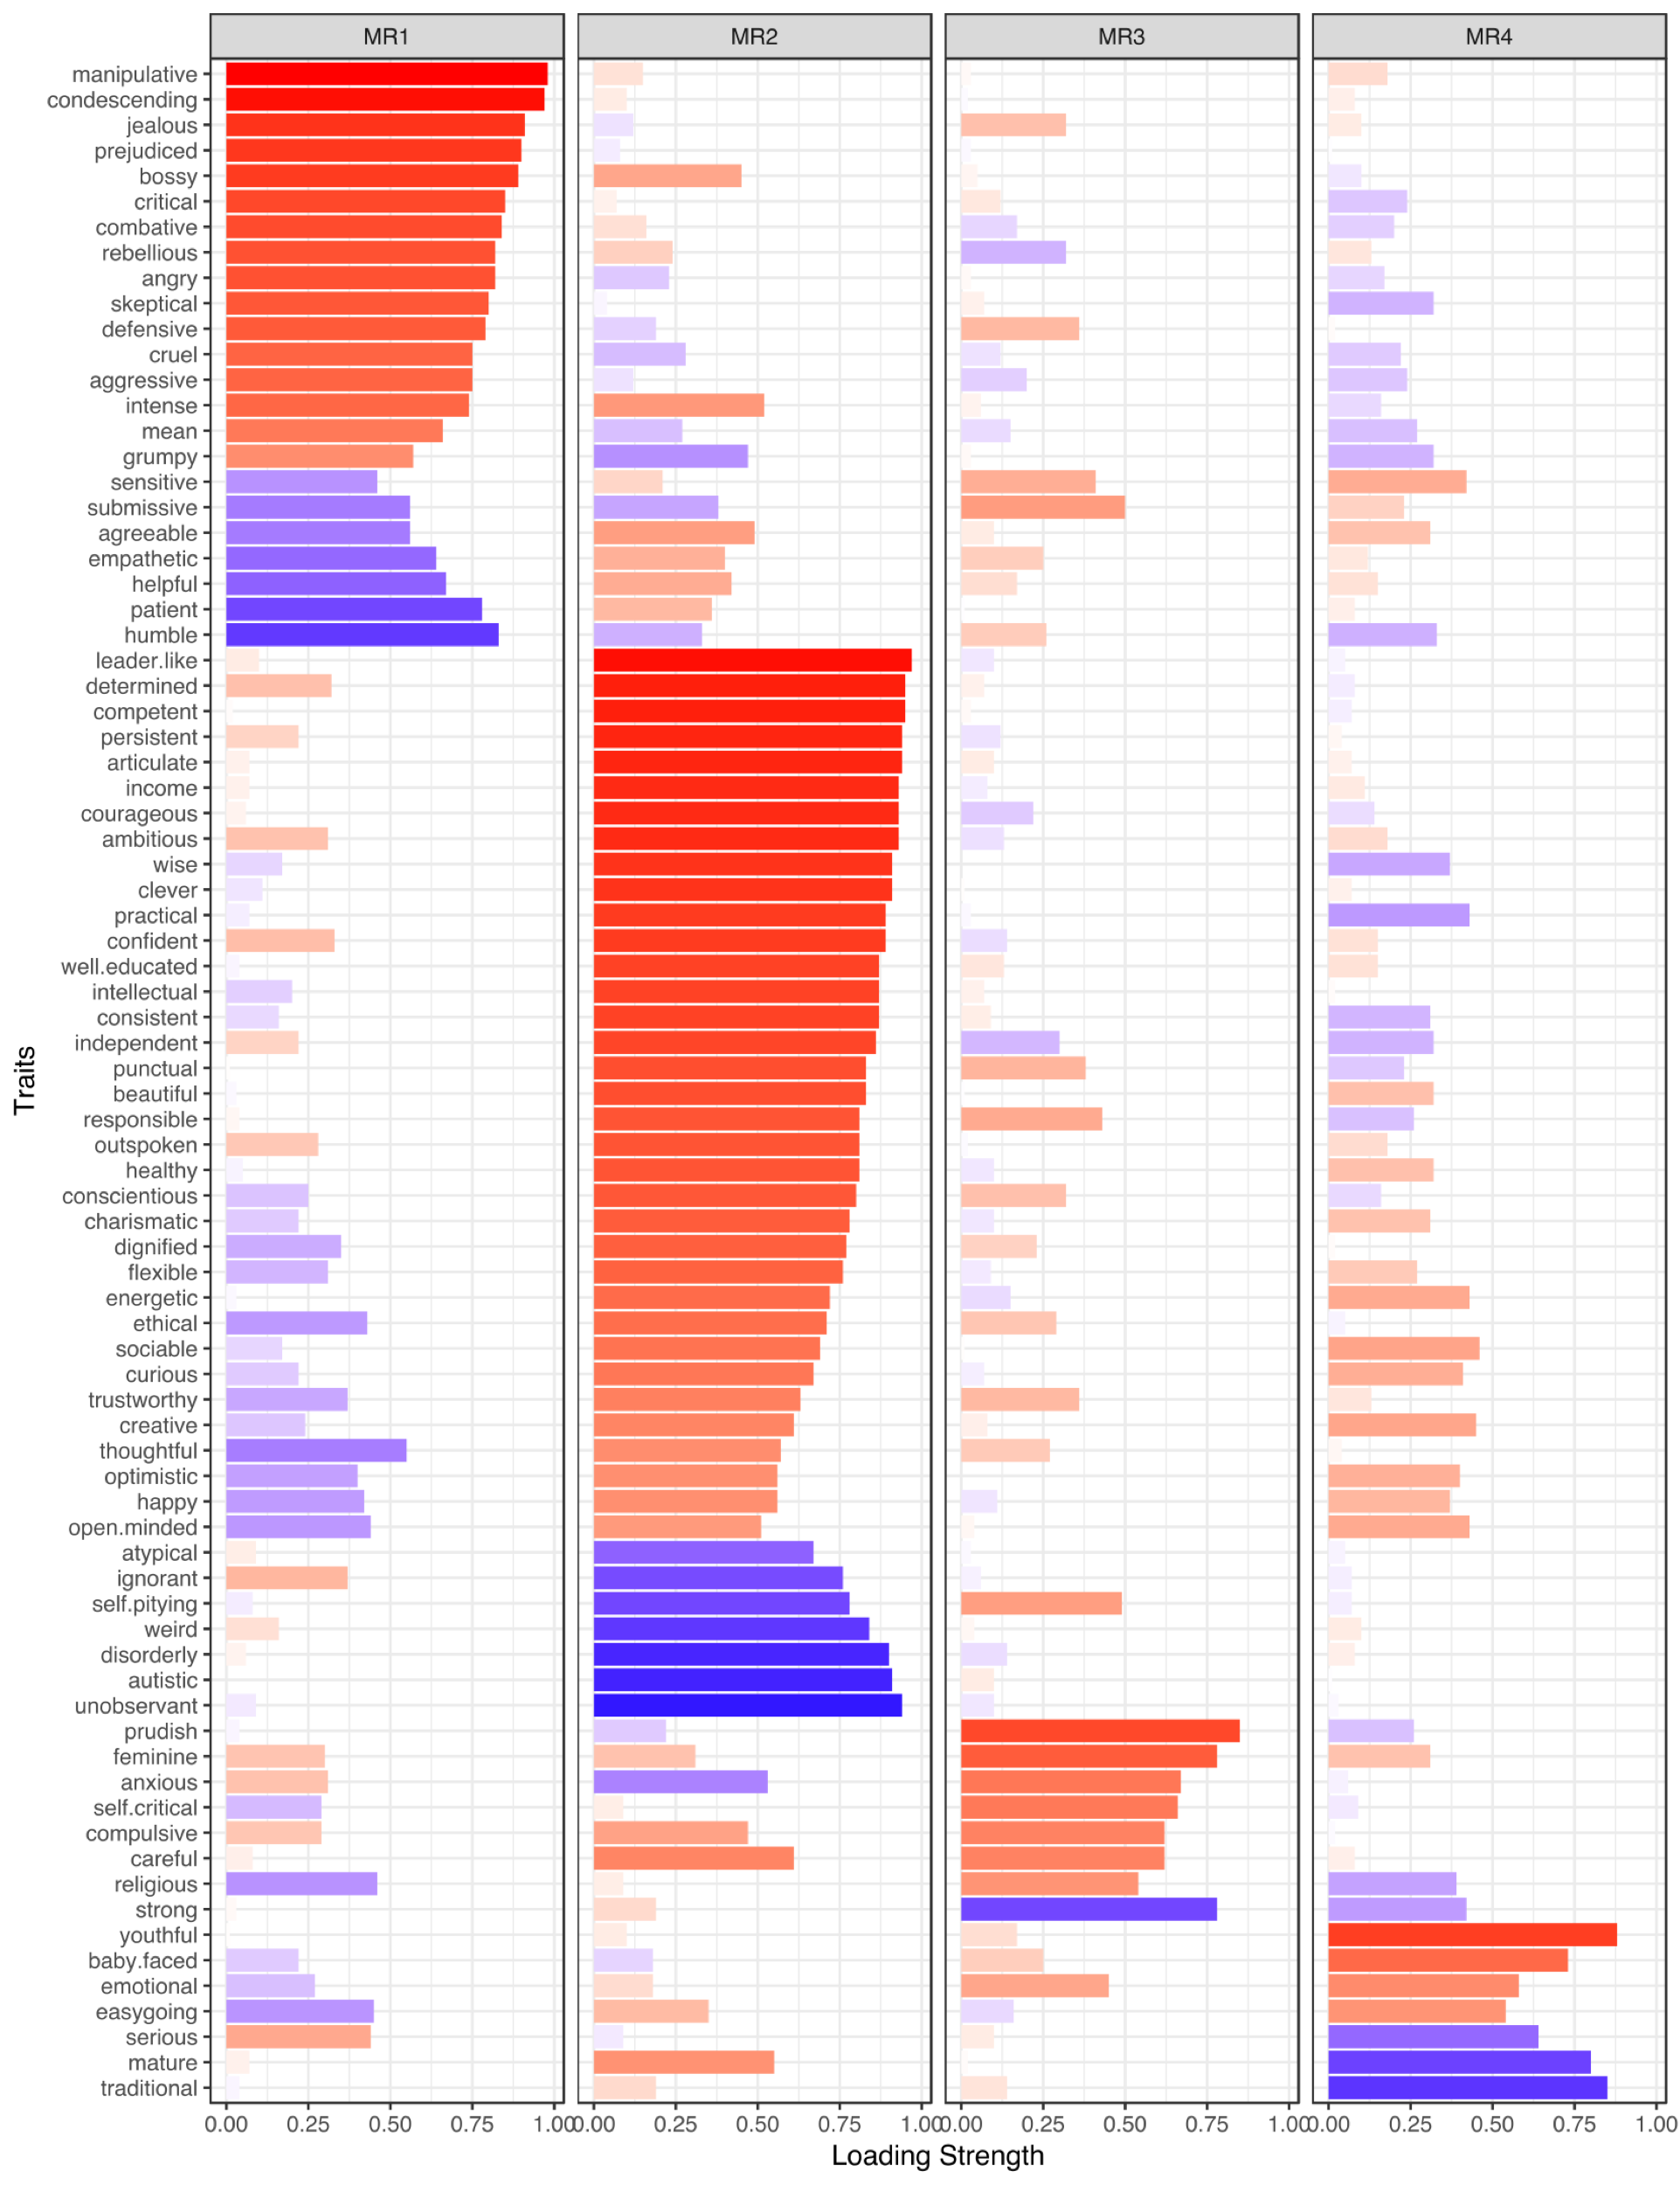
c
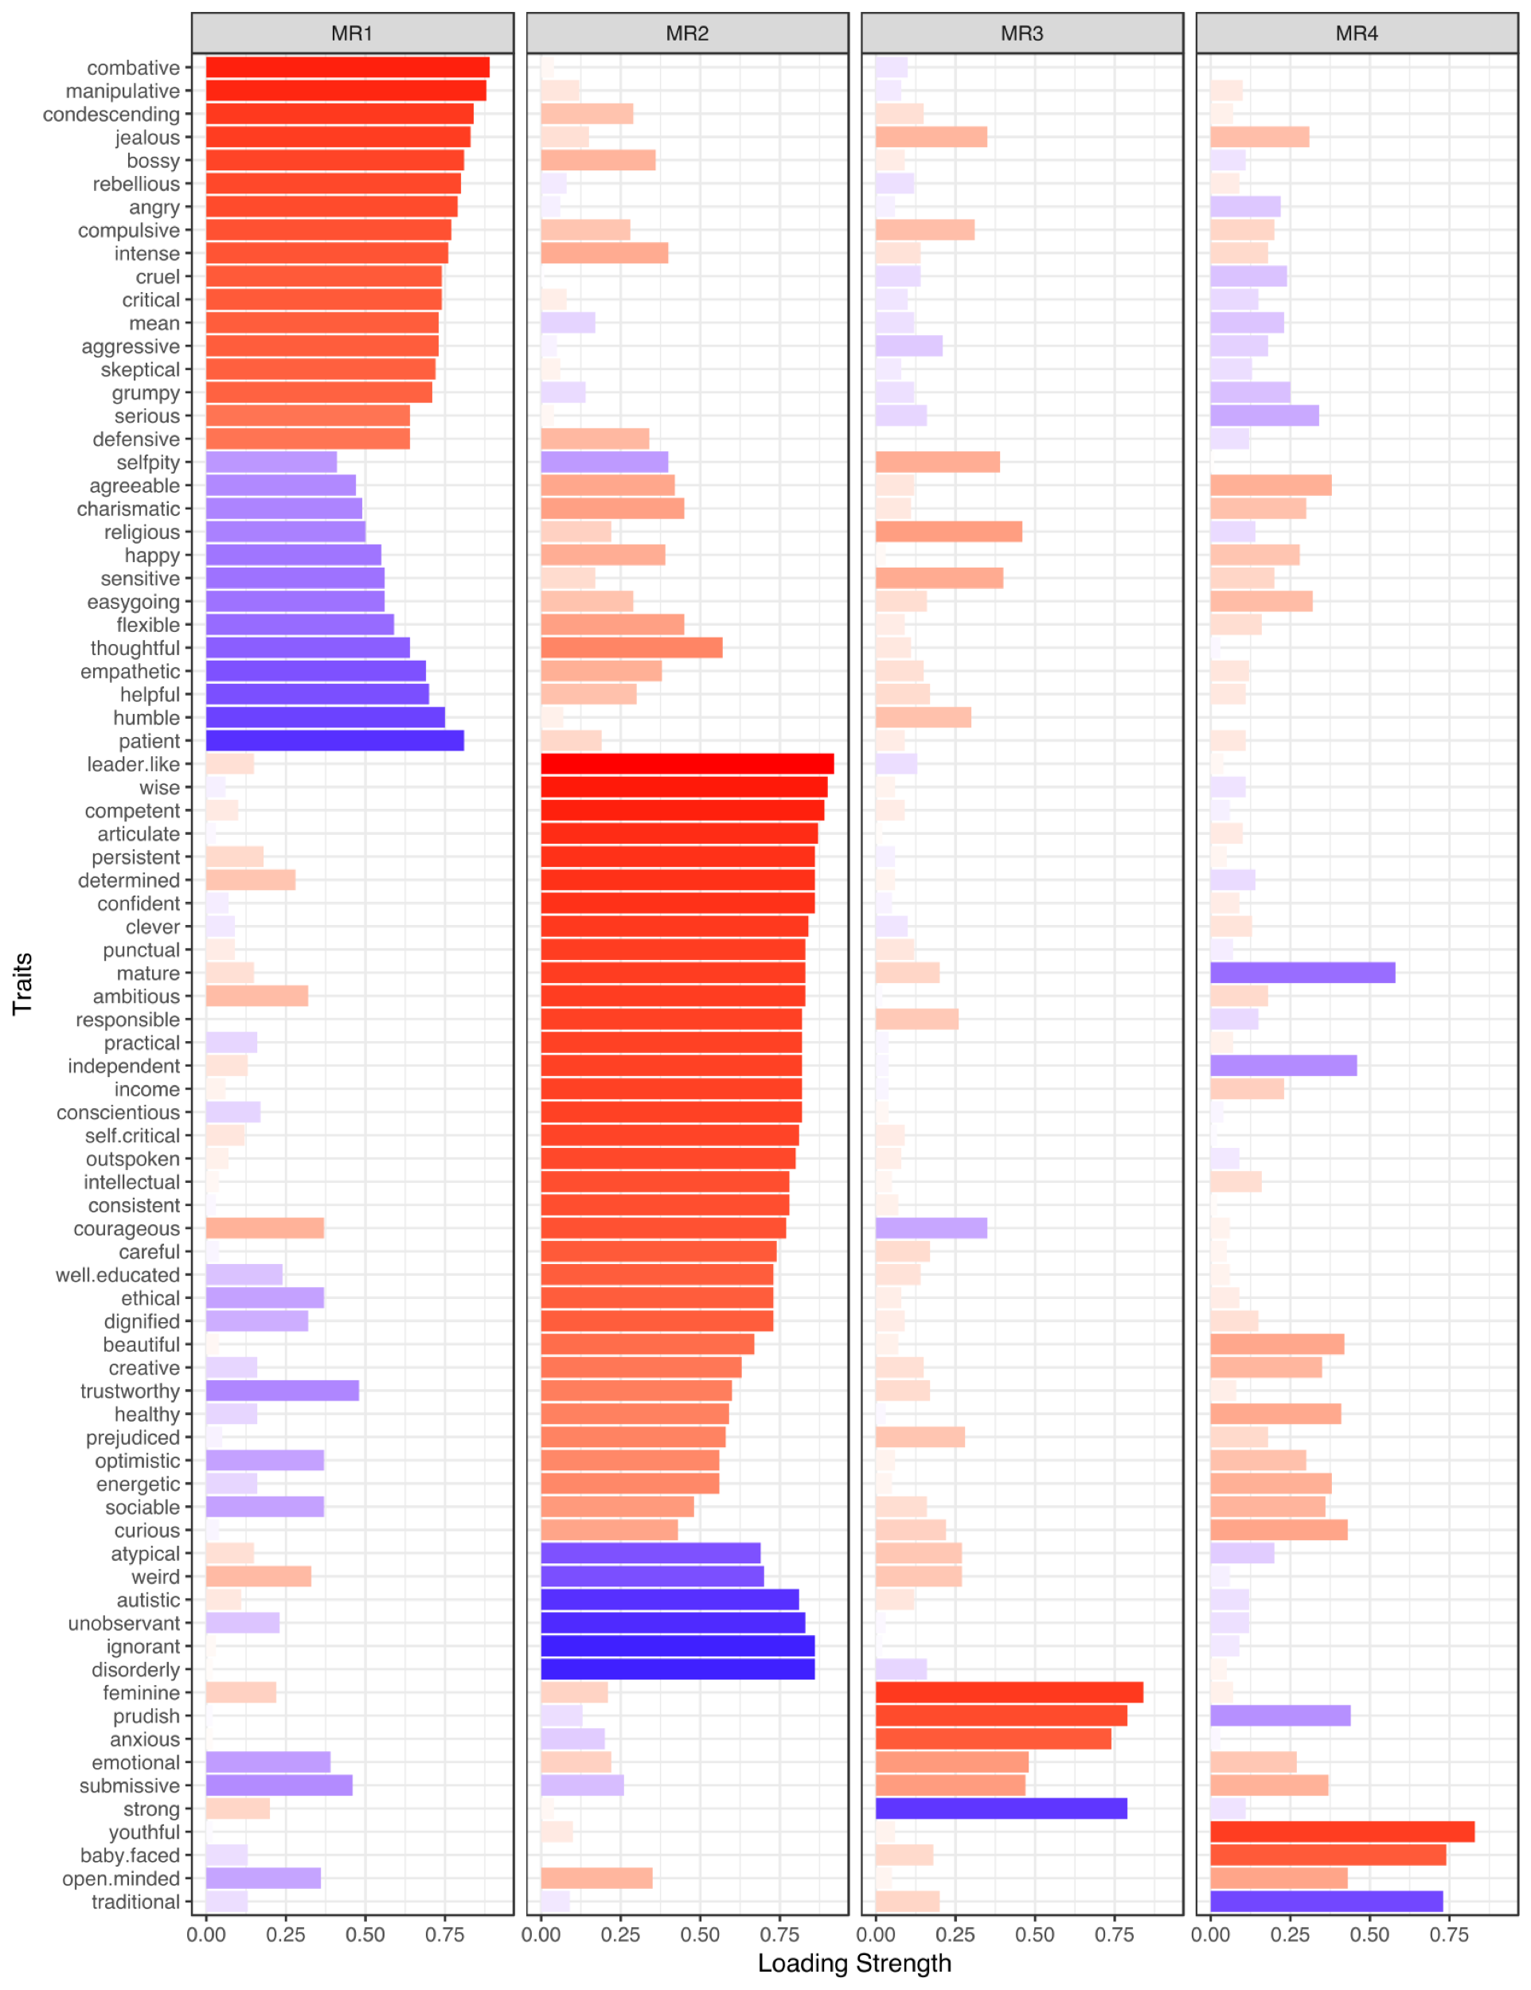
d
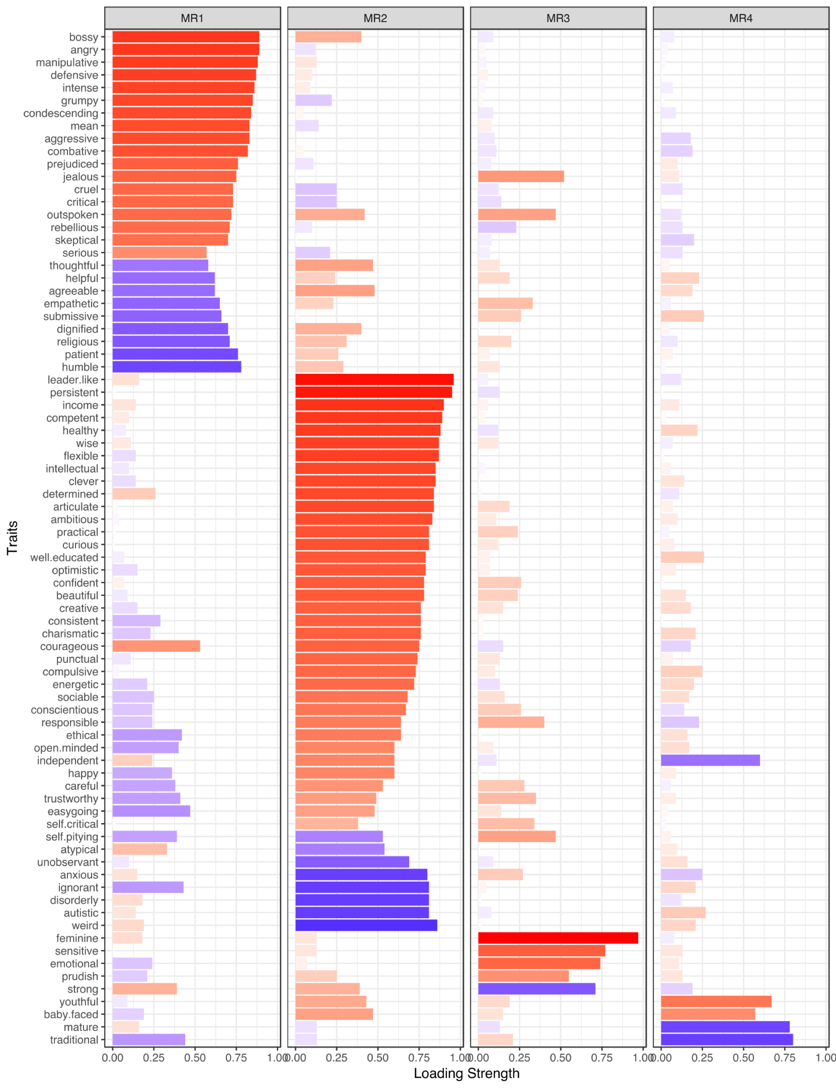
e
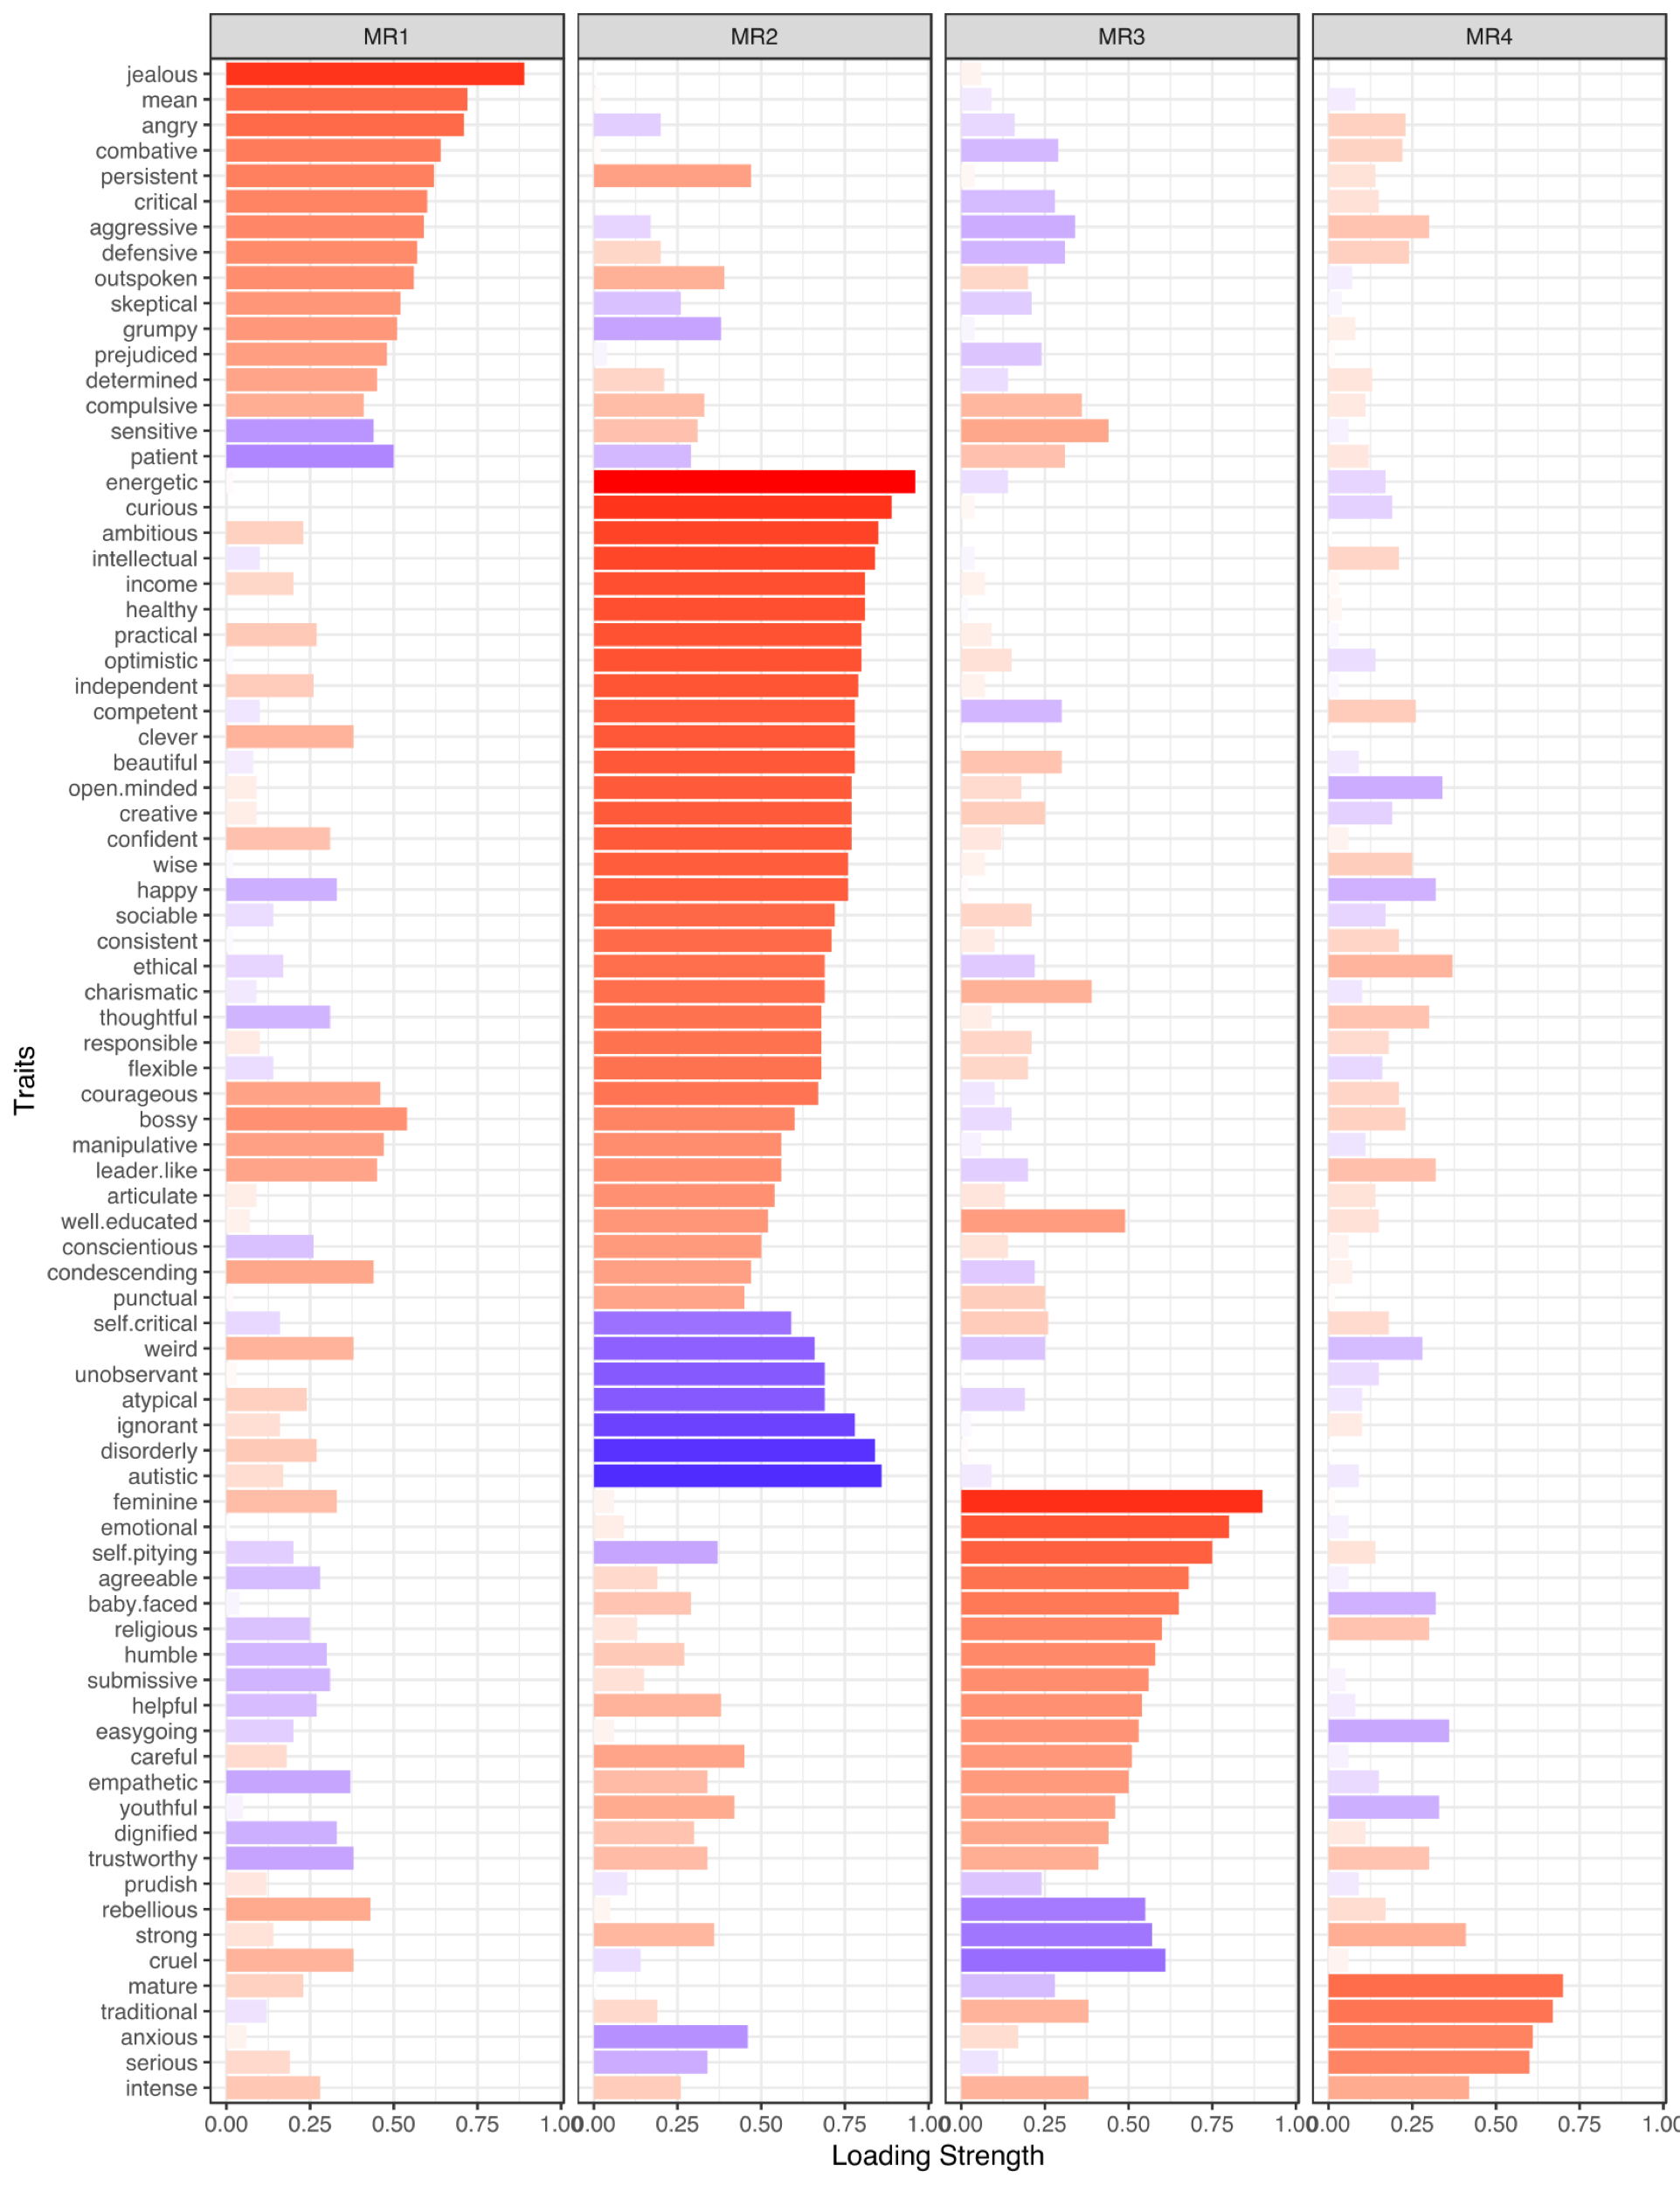
f
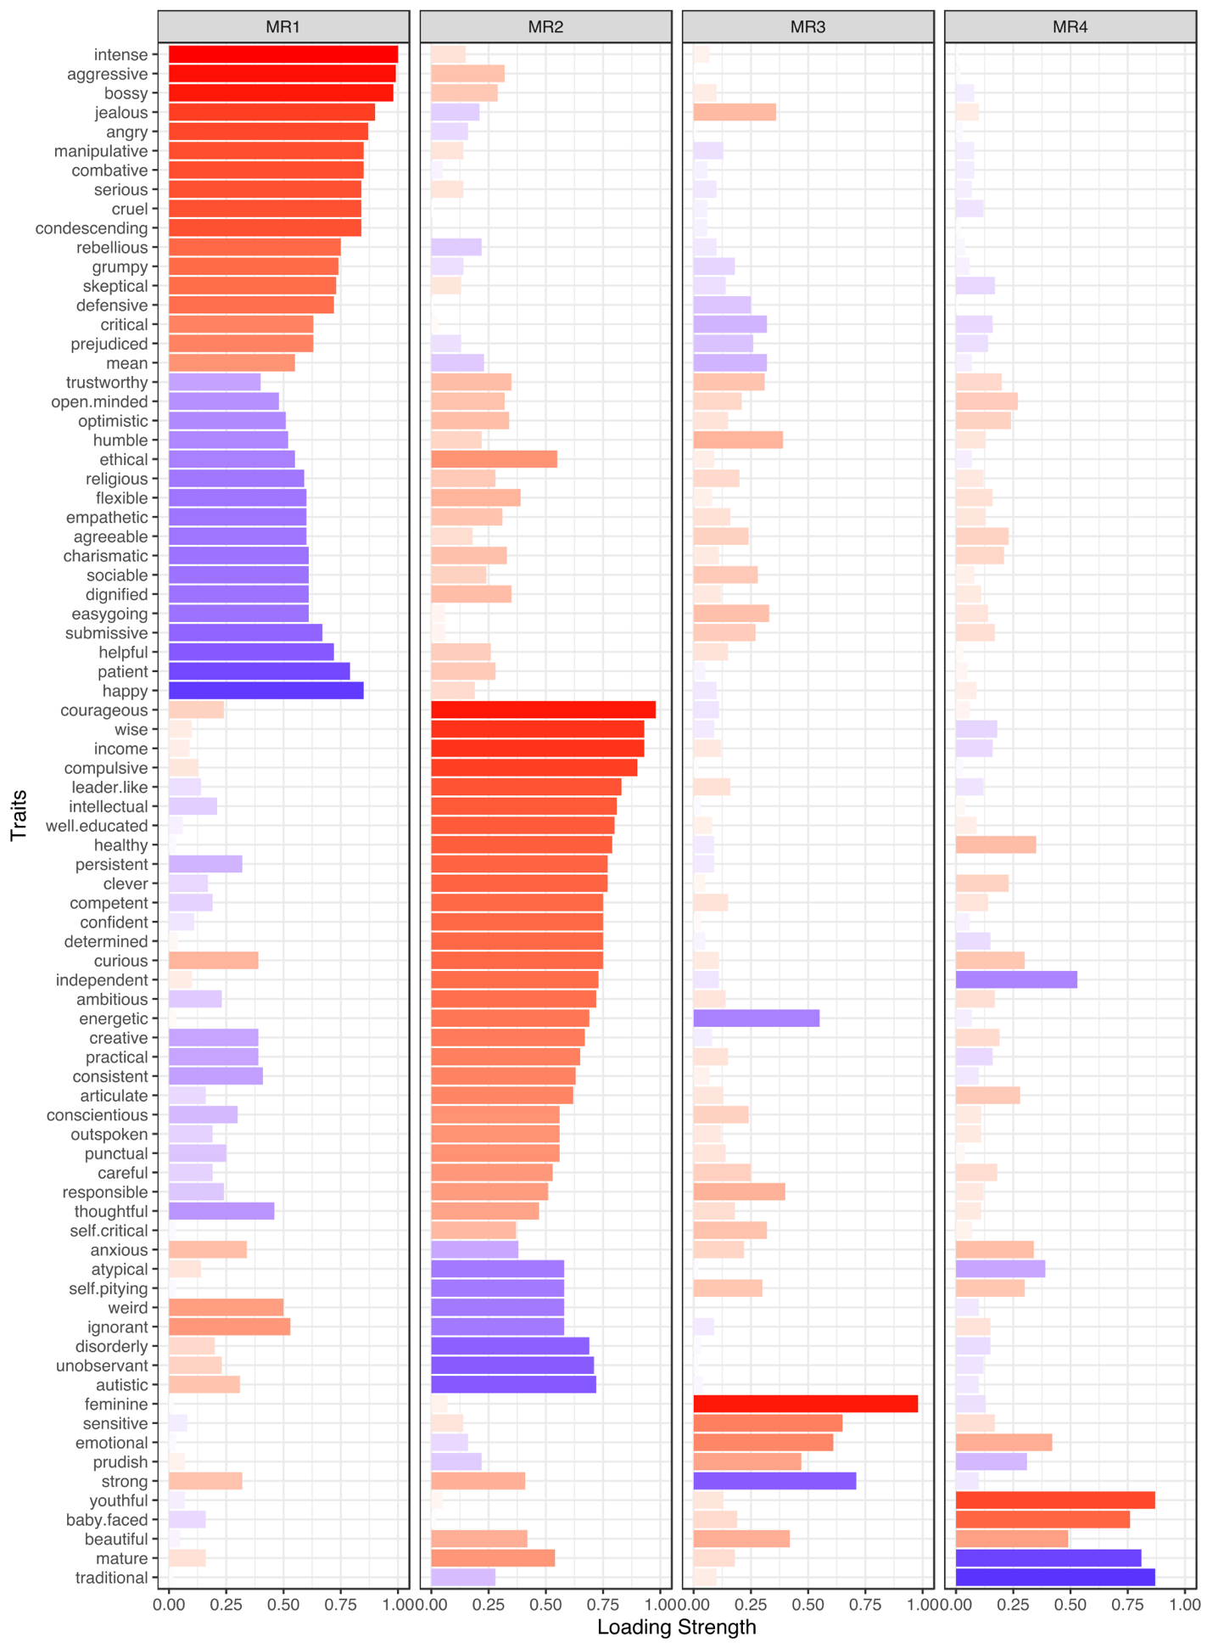
g
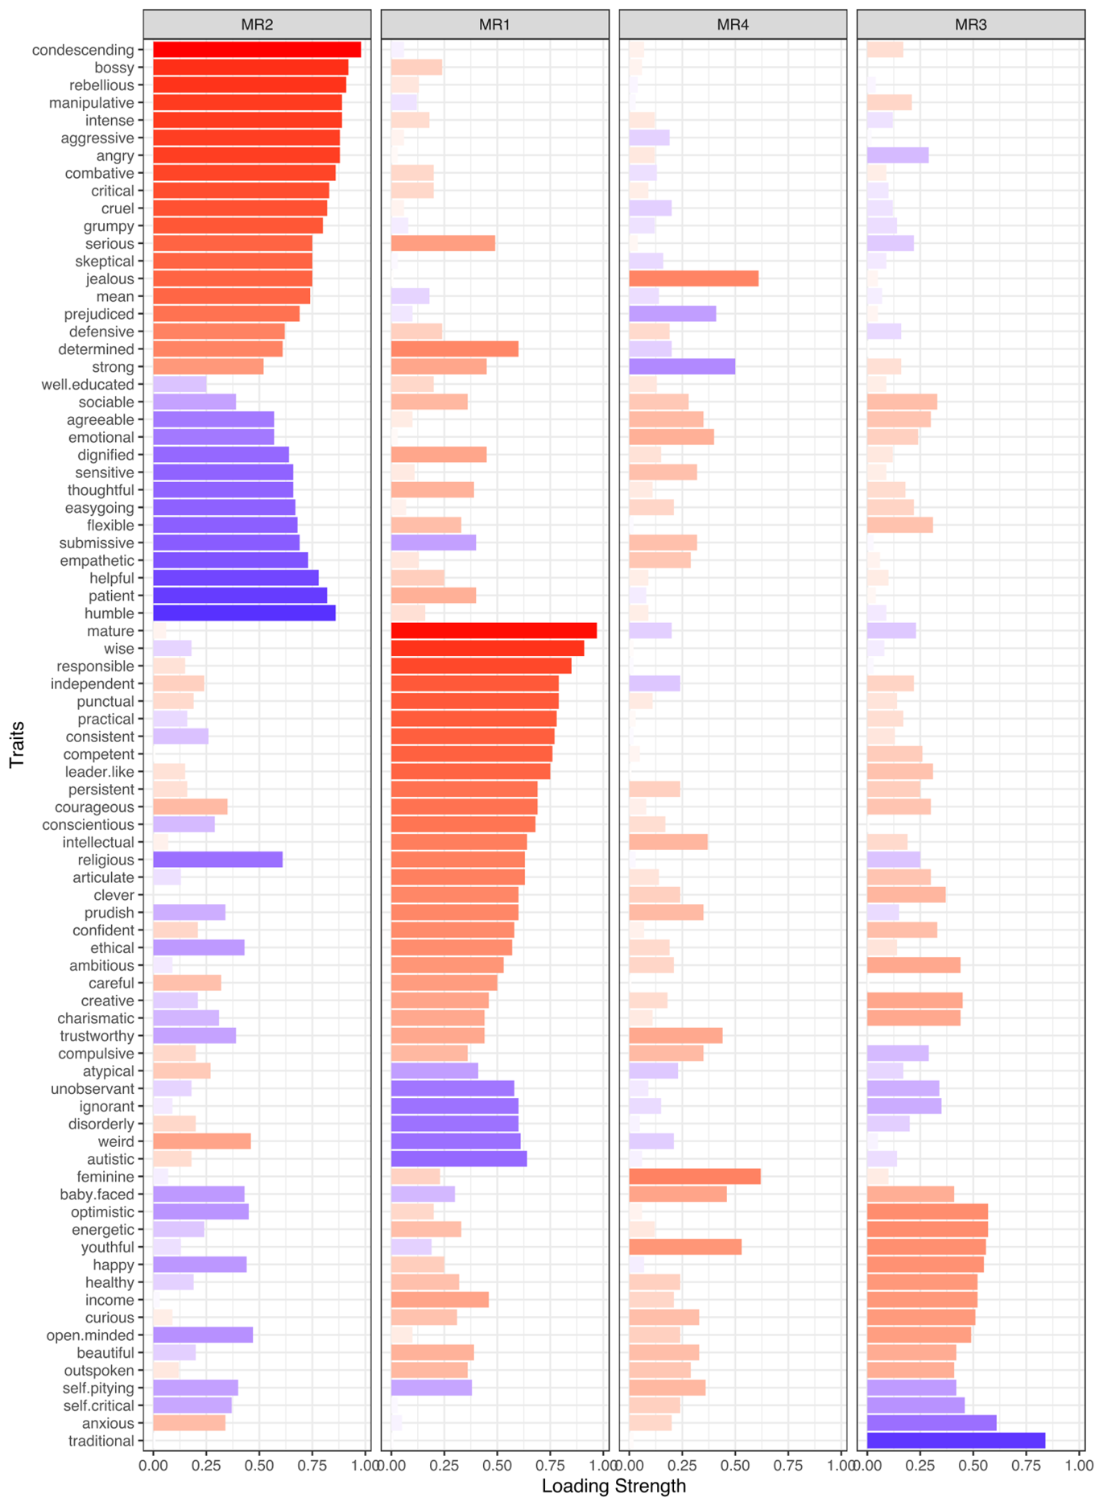
Supplementary Figure 6: Four factors extracted from aggregated data in Study 2.
The seven panels plot results for samples from a, North America, b, Latvia, c, Peru, d, the Philippines, e, India, f, Kenya, and g, Gaza. Each column plots the strength of the factor loadings across the 80 traits. The color of the bar indicates the sign of the loading (red: positive; blue: negative); the length and saturation of the bar indicates the magnitude of the loading.

a1
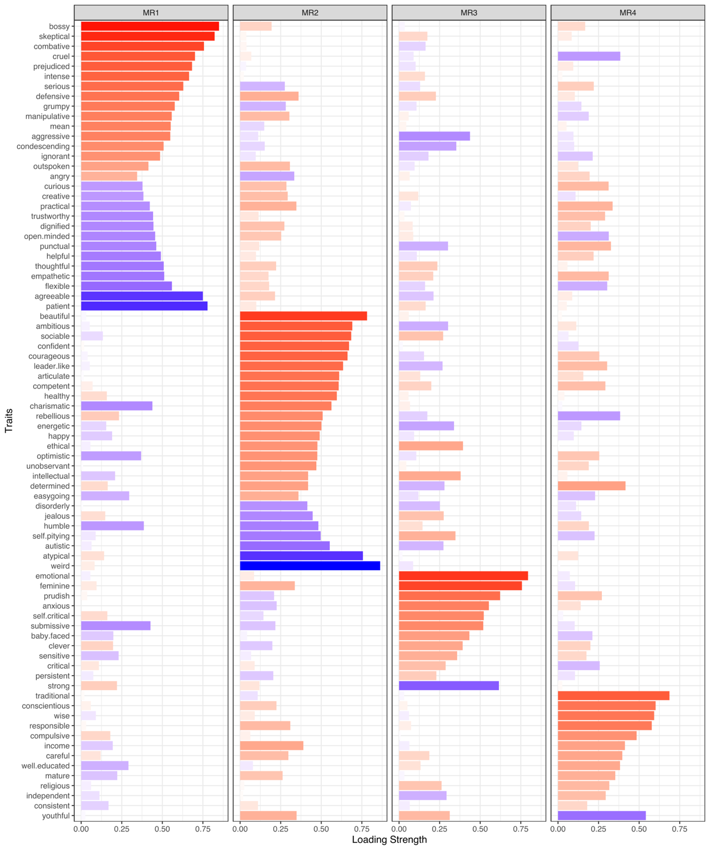

a2
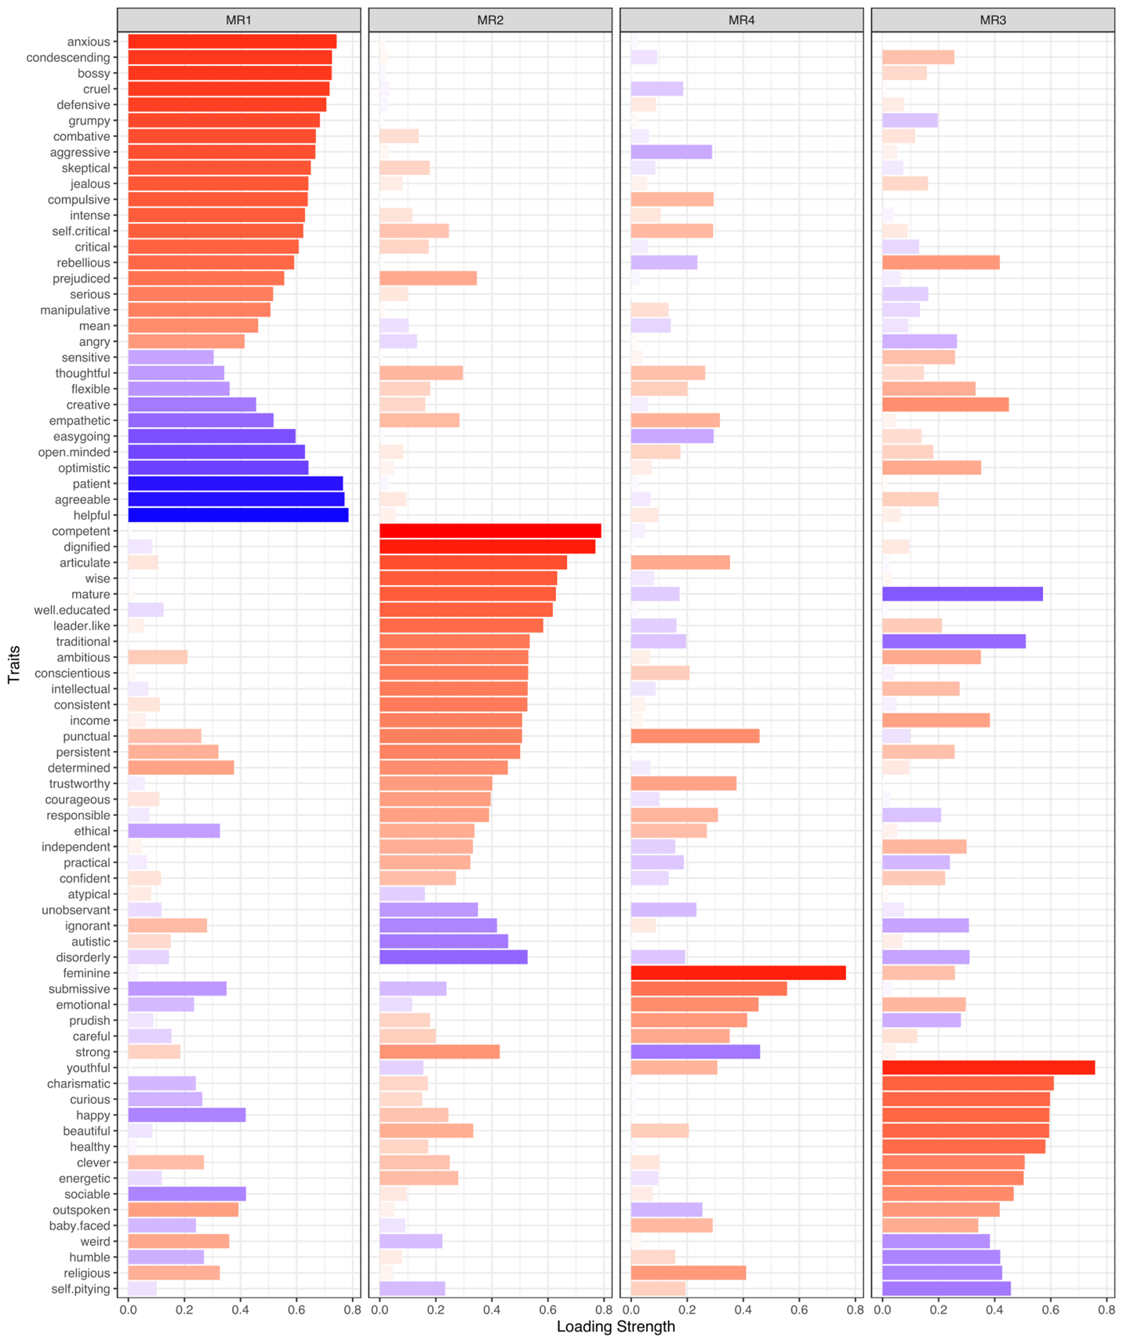

a3
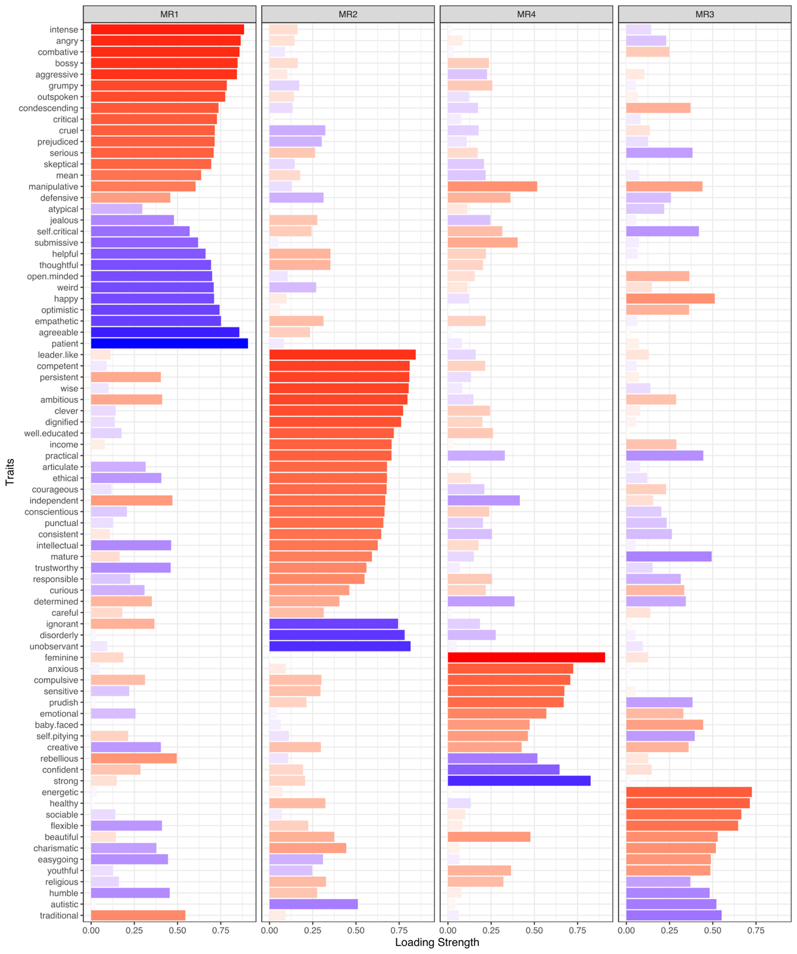

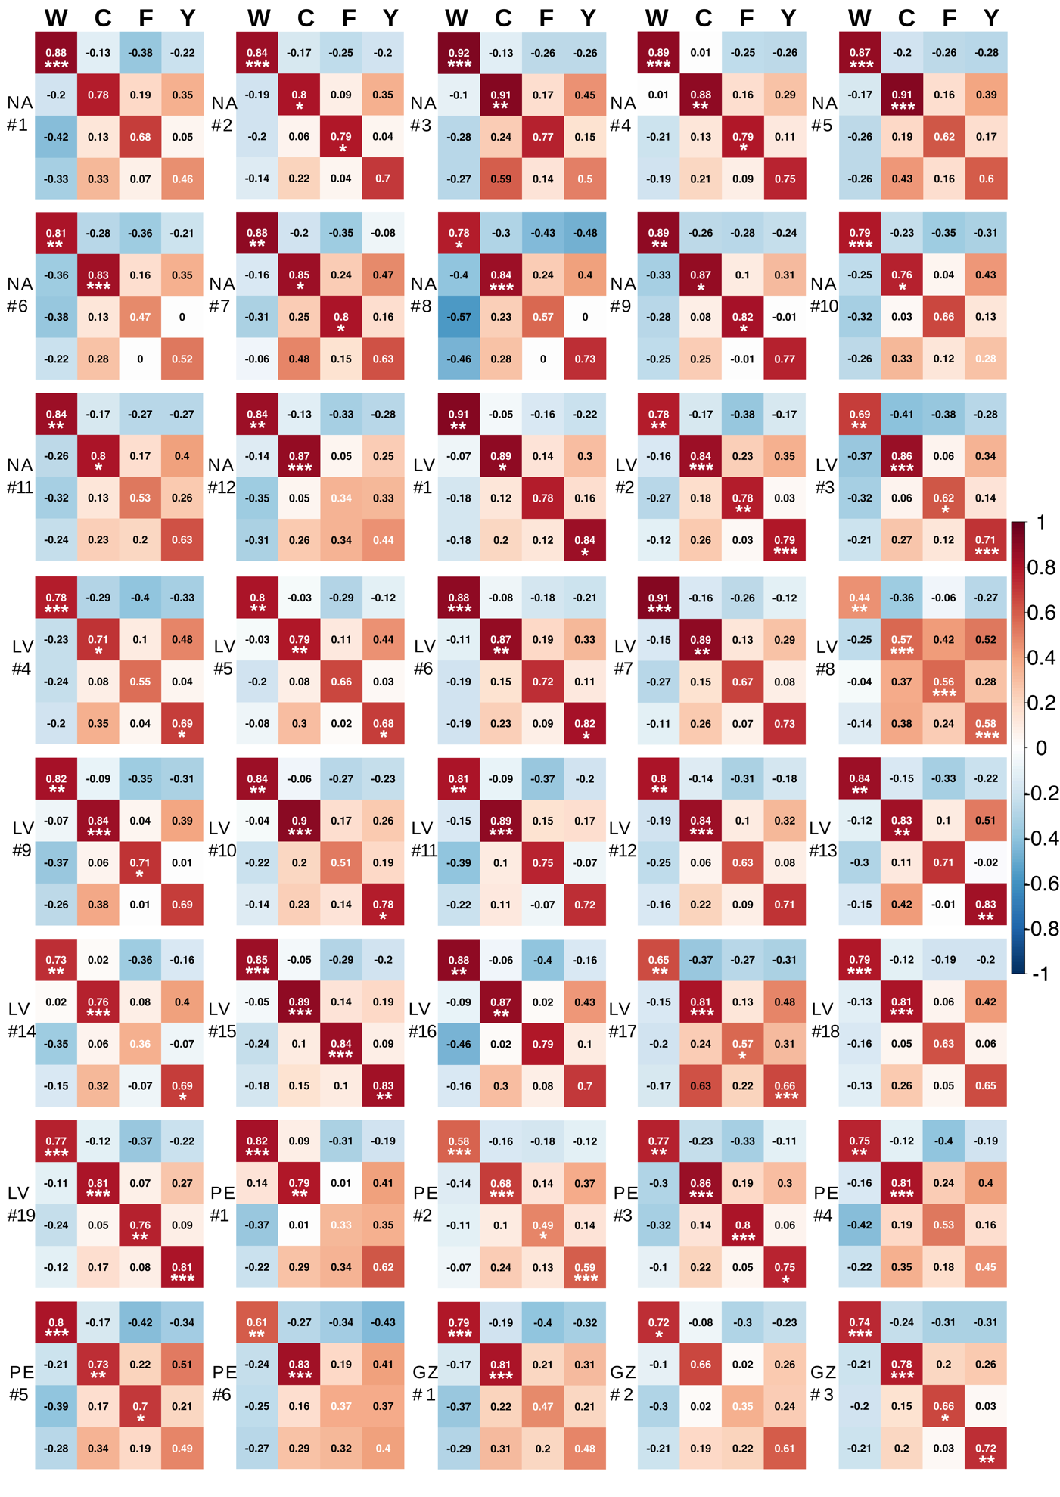
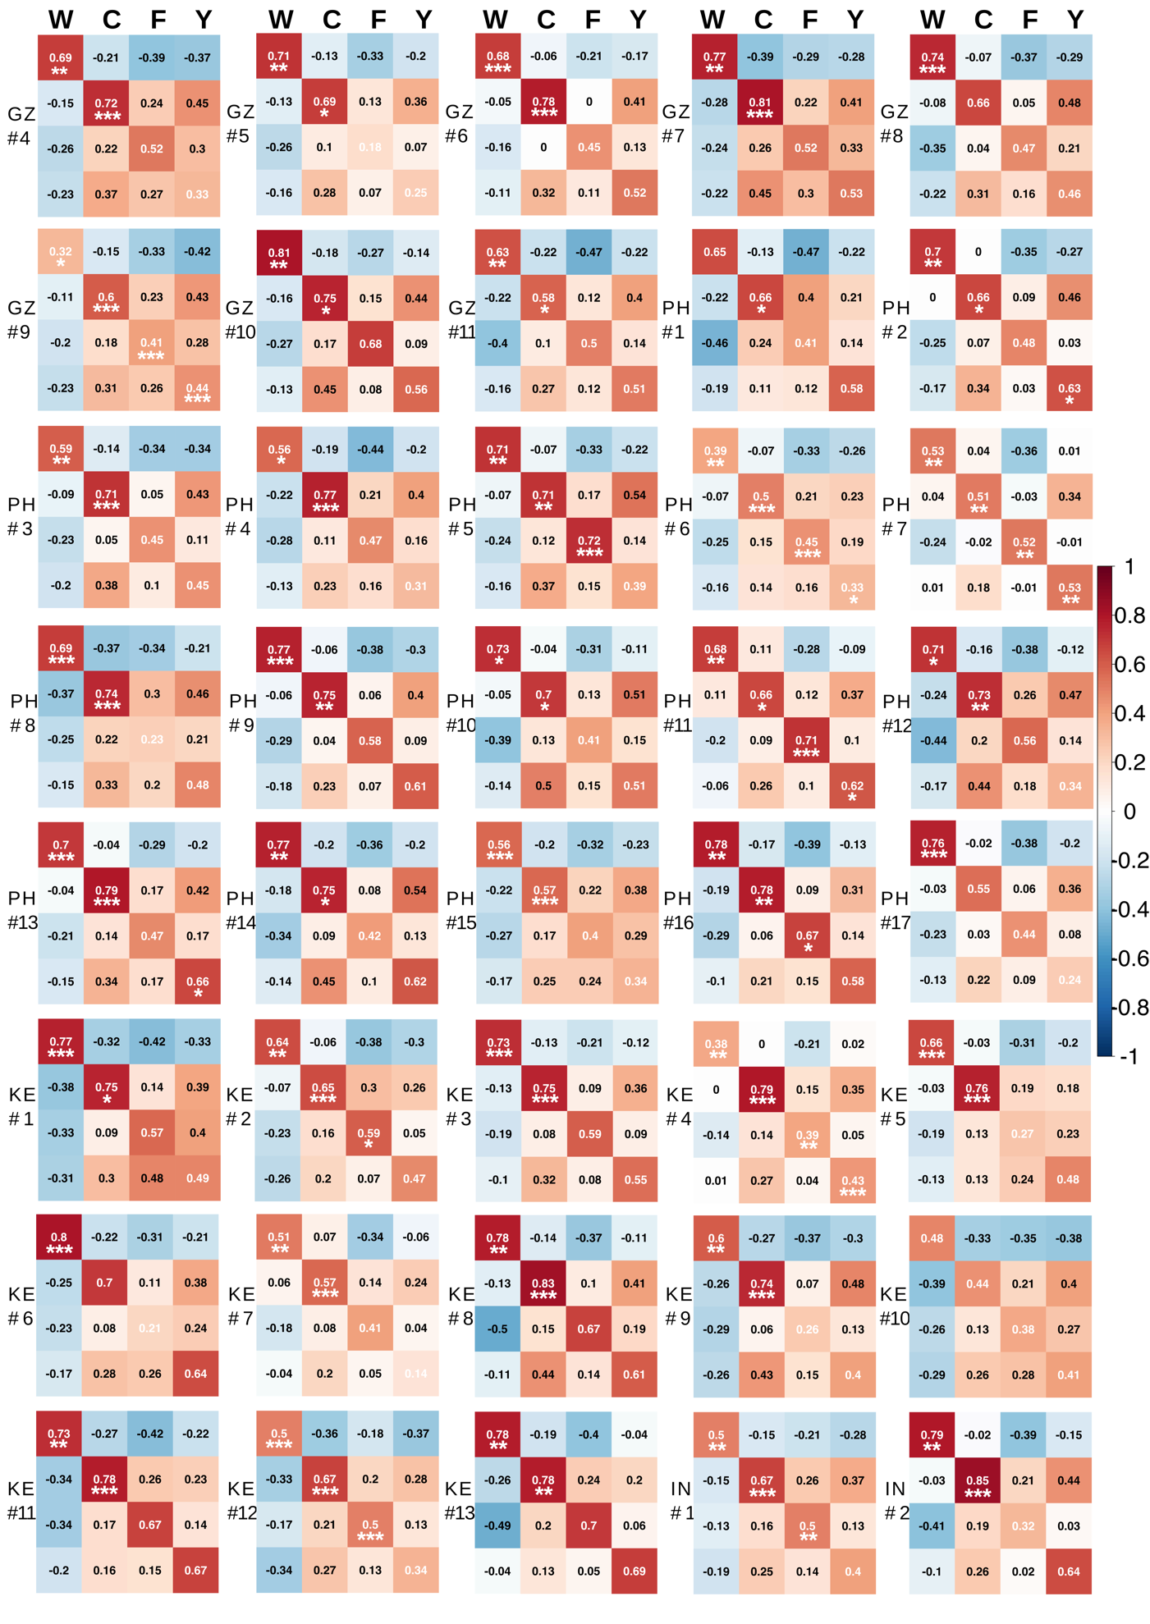
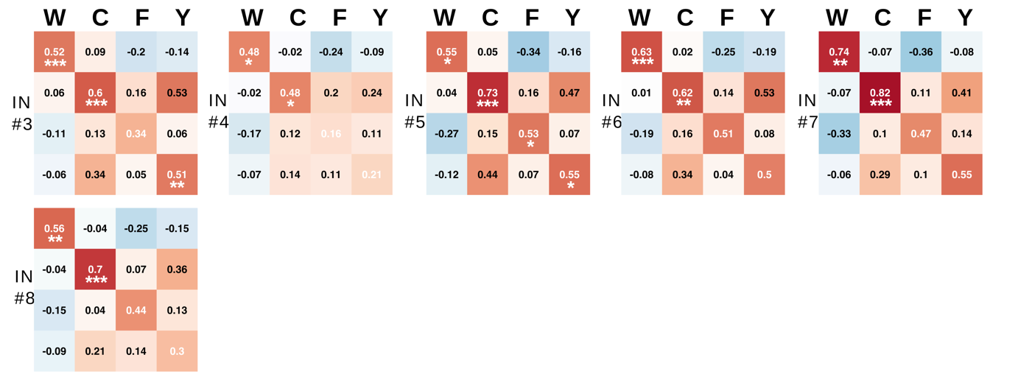
Supplementary Figure 7: Four factors extracted from individual data in Study 2.
a, Examples of the factor loadings from EFA on individual data (a1 North America participant #2, a2 Latvia participant #1, a3 Latvia participant #15). b, Factor congruence between Study 1 sample and each individual participant who had a complete dataset in Study 2 (n = 86, who had data for all 80 traits after data exclusion according to preregistered criteria). Each panel plots the Tucker indices of factor congruence (with orthogonal Procrustes rotation) between the four dimensions found in aggregate-level data in Study 1 (columns; W: warmth, C: competence, F: femininity, Y: youth) and those found in individual-level data in Study 2 (rows). The row label of each panel indicates the location (NA for North America, LV for Latvia, PE for Peru, GZ for Gaza, PH for the Philippines, KE for Kenya, IN for India) and the ID of the participant. The numbers report the Tucker indices. The color scale shows the sign and strength of the indices. Statistical significance was obtained using permutation test (with orthogonal Procrustes rotation, and permuting both the rows and columns of the compared factor loading matrix⁹ over 1000 iterations): *** p < 0.001, ** p < 0.01, * p < 0.05.

Supplementary Tables
Supplementary Table 1: Definitions of 100 trait words.
The definition of each trait word was provided to participants in our study to eliminate possible heterogeneity in how each individual understands the meaning of a trait word. These definitions were obtained from Google dictionary, with necessary modifications to make the definition easy to understand and fit the context of describing a person.
TRAITS | DEFINITIONS
abusive | A person who is extremely offensive and insulting
affectionate | A person who is comfortable showing his/her love, warmth, and kindness
aggressive | A person who pursues his/her aims and interests forcefully, sometimes with physical force
agreeable | A person who is kind, cooperative, and sympathetic
ambitious | A person who has a strong desire and determination to succeed in their goals
angry | A person who is usually angry
anxious | A person who stresses and worries about things
articulate | A person who speaks fluently and clearly, and who can express their ideas well
atypical | The structure, texture, shape or other aspects of the appearance of the face is unusual or rare
autistic | A person who has autism spectrum disorder—a developmental disorder characterized by troubles with social interaction and communication, and by restricted and repetitive behavior
baby-faced | A person who has facial features resembling a baby
beautiful | A person who looks appealing and physically attractive
bossy | A person who likes giving people orders and wants things his/her own way
careful | A person who works and thinks in a cautious, thorough, or thoughtful way to avoid potential danger
charismatic | A person who is interesting and likeable because they have a charming personality
clever | A person who is quick to understand and learn, and who can figure things out quickly
combative | A person who likes to argue or pick a fight
competent | A person who is efficient and capable to do things in general
compulsive | A person who has to do things in a certain way and often checks and does things over and over again to make sure they are done exactly right
condescending | A person who thinks he/she is better than others and puts other people down
confident | A person who is sure about his/her own abilities, correctness, and successfulness
conscientious | A person who does his/her work or duty thoroughly and responsibly
conservative | A person who sticks to traditional values, especially in politics or religion, and who does not like new ideas or changes
consistent | A person who behaves or responds in the same way over time; reliable
courageous | A person who is not afraid to do the right thing, even if it is dangerous to them
creative | A person who has good imagination or original ideas
criminal | A person who looks like they could commit a crime
critical | A person who judges others harshly, and often makes disapproving comments
cruel | A person who willfully causes pain or suffering to other people or to animals, and feels no concern about it
curious | A person who is eager to learn about or experience new things
defensive | A person who is easily offended and always guards themselves against criticism
determined | A person who is able to make firm decisions and is resolved not to change them
dignified | A person who is polite and composed, and always shows good and respected manners
disorderly | A person who is untidy and not organized
easygoing | A person who is relaxed, tolerant, and not prone to rigid rules or bouts of temper
emotional | A person who shows his/her feelings and laughs and cries easily
empathetic | A person who is able to understand and share the feelings of others
energetic | A person who is very active and full of energy
enthusiastic | A person who is filled with eager enjoyment and interest
ethical | A person who is careful to do things that are morally right to do
feminine | A person whose facial appearance looks like a woman
flexible | A person who is ready and able to change so as to adapt to different circumstances
grumpy | A person who is bad-tempered and always complaining
happy | A person who is usually cheerful
healthy | A person who is in good health
helpful | A person who gives help when others are in need
homosexual | A person who is sexually attracted to people of his/her own sex
humble | A person who is modest and does not boast
idiot | A person who is stupid
ignorant | A person who doesn't know anything, and is also usually unaware of that
income | A person’s income level
independent | A person who is able to think and act without being influenced by others
intellectual | A person who thinks a lot about the deeper meaning of things and likes to analyze things
intense | A person who is very serious and expresses strong feelings
jealous | A person who feels resentment about what other people have
leader-like | A person who can take charge and help a group accomplish a goal
loser | A person who fails frequently or is generally unsuccessful in life
manipulative | A person who likes to control people in order to meet his/her own needs
mature | A person who thinks and behaves like a responsible adult
mean | A person who is unkind, inconsiderate, and doesn't share things
natural | A person who is relaxed and spontaneous
nosey | A person who is overly curious about other people's business
open-minded | A person who is willing to try new things or to hear and consider new ideas
optimistic | A person who is hopeful and confident about the future
outspoken | A person who is frank in stating his/her opinions especially if they are critical or controversial
passive | A person who allows things to happen or accepts what others do, without resistance or trying to change anything
patient | A person who is able to accept or tolerate delays or problems and is very relaxed about getting things done
persistent | A person who is able to continue in a course of action in spite of difficulty or opposition
practical | A person who is sensible and realistic in dealing with a situation or problem
prejudiced | A person who holds biased judgments about other people; bigoted
prudish | A person who is overly proper and cannot stand hearing any sexual reference
punctual | A person who is always on time
reasonable | A person who makes sense and whose opinions most people would agree with
rebellious | A person who resists authority, control, or convention and wants to have their own way
religious | A person who practices religion and believes in their faith
reserved | A person who tends not to show their emotions or opinions and is quiet
responsible | A person who accepts the consequences of his or her own actions and decisions
sarcastic | A person who likes using irony in order to mock others
self-critical | A person who holds himself/herself responsible for any failures, always questioning if they did the right thing or not
self-pitying | A person who feels sorry for themselves
sensitive | A person who is aware of or careful about others' attitudes, feelings, or circumstances
serious | A person who shows deep thoughts and who doesn't smile or laugh easily
shallow | A person who is concerned only about silly or inconsequential things; superficial
sincere | A person who says what he/she genuinely feels or believes
skeptical | A person who questions things and is not easily convinced
sociable | A person who is friendly and enjoys talking and engaging in activities with other people
strict | A person who follows rules exactly, and expects others to follow rules exactly
strong | A person who is physically vigorous and is able to exert great bodily or muscular power
submissive | A person who shows a willingness to be controlled by others or conforms to the authority or will of others
thoughtful | A person who is considerate of others' needs
thrifty | A person who uses money and other resources carefully and not wastefully
traditional | A person who likes to do things the way they have always been done and accepted in the past
trustful | A person who tends to trust other people easily (note: this is different from being trustworthy)
trustworthy | A person who can be relied on as honest and truthful
unobservant | A person who does not notice things
weird | A person who does strange or bizarre things
well-educated | A person who has completed a high level of education, such as bachelor's, master’s and doctorate degrees
white | A person whose face looks like they are Caucasian
wise | A person who has mature experience, knowledge, and good judgments
youthful | A person who looks young
Supplementary Table 2: Robustness check of the four dimensions.
a, Pearson’s correlations between our four dimensions (Fig. 3) and the four factors extracted from subsets of traits as a function of their similarity and meaning clarity. All pairs of traits were ranked according to their semantic similarity (using FastText¹, see Methods); for each pair of traits, we removed the one with the lower clarity ratings given by an independent set of participants; we removed traits one by one starting from the pair with the highest similarity to the pairs with lowest similarity. A four-factor solution was extracted from each subset of traits (using the same EFA method as for the full set of traits). To obtain the relations between the factors found in these subsets and those from the full dataset, we assessed the value of every face on each factor (i.e., factor scores, computed using R function factor.scores with method “tenBerge”) and then correlated the faces’ scores between different factors. b, Factor loadings from EFA on the subset of data corresponding to the smallest subset of specific traits that still yields our four dimensions. The largest absolute loading across four factors for each trait is highlighted in bold. The four dimensions accounted for 88% of the common variance in this subset of data.
a
# traits remaining in the model | Factor1 and Warmth | Factor2  and Competence | Factor3  and  Femininity | Factor4 and Youth | PC1  and Warmth | PC2  and Competence | PC3  and Femininity | PC4  and Youth
91 | 1.00** | 1.00** | 1.00** | 0.99** | 1.00** | 1.00** | 1.00** | 1.00**
90 | 1.00** | 1.00** | 0.98** | 0.99** | 1.00** | 1.00** | 1.00** | 1.00**
89 | 1.00** | 1.00** | 0.98** | 0.99** | 1.00** | 1.00** | 1.00** | 1.00**
88 | 1.00** | 1.00** | 0.98** | 0.99** | 1.00** | 1.00** | 0.99** | 0.99**
87 | 1.00** | 1.00** | 0.97** | 0.98** | 1.00** | 1.00** | 0.99** | 0.99**
86 | 1.00** | 1.00** | 0.97** | 0.98** | 1.00** | 1.00** | 0.99** | 0.99**
85 | 0.99** | 0.99** | 0.97** | 0.98** | 1.00** | 1.00** | 1.00** | 0.99**
84 | 0.99** | 0.99** | 0.97** | 0.97** | 1.00** | 1.00** | 1.00** | 0.99**
83 | 0.99** | 0.99** | 0.96** | 0.97** | 1.00** | 1.00** | 0.99** | 0.99**
82 | 0.99** | 0.99** | 0.96** | 0.97** | 1.00** | 1.00** | 0.99** | 0.99**
81 | 0.99** | 0.99** | 0.96** | 0.96** | 1.00** | 1.00** | 1.00** | 1.00**
80 | 0.99** | 0.99** | 0.96** | 0.96** | 1.00** | 1.00** | 0.99** | 0.99**
79 | 0.99** | 0.99** | 0.96** | 0.96** | 1.00** | 1.00** | 0.99** | 0.99**
78 | 0.99** | 0.99** | 0.96** | 0.97** | 1.00** | 1.00** | 0.99** | 0.99**
77 | 0.99** | 0.99** | 0.96** | 0.97** | 1.00** | 1.00** | 0.99** | 0.99**
76 | 0.99** | 0.99** | 0.96** | 0.97** | 1.00** | 1.00** | 0.99** | 0.99**
75 | -0.98** | 0.99** | 0.95** | 0.95** | 1.00** | 1.00** | 1.00** | 1.00**
74 | -0.98** | 0.98** | 0.95** | 0.94** | 1.00** | 1.00** | 1.00** | 1.00**
73 | -0.98** | 0.98** | 0.95** | 0.94** | 1.00** | 1.00** | 1.00** | 1.00**
72 | -0.96** | 0.98** | 0.95** | 0.84** | 1.00** | 1.00** | 1.00** | 0.99**
71 | -0.96** | 0.98** | 0.95** | 0.83** | 1.00** | 1.00** | 0.99** | 0.99**
70 | -0.95** | 0.98** | 0.94** | 0.78** | 1.00** | 1.00** | 1.00** | 0.99**
69 | -0.97** | 0.97** | 0.95** | 0.83** | 1.00** | 1.00** | 1.00** | 0.99**
68 | -0.97** | 0.98** | 0.95** | 0.83** | 1.00** | 1.00** | 1.00** | 0.99**
67 | -0.96** | 0.98** | 0.94** | 0.81** | 1.00** | 1.00** | 0.99** | 0.99**
66 | -0.95** | 0.98** | 0.94** | 0.77** | 1.00** | 1.00** | 0.99** | 0.99**
65 | -0.94** | 0.98** | 0.94** | 0.72** | 1.00** | 1.00** | 0.99** | 0.99**
64 | -0.93** | 0.98** | 0.94** | 0.69** | 1.00** | 1.00** | 0.94** | 0.94**
63 | -0.86** | 0.98** | 0.93** | 0.51** | 1.00** | 1.00** | 0.92** | 0.92**
62 | -0.85** | 0.97** | 0.93** | 0.49** | 1.00** | 1.00** | 0.93** | 0.93**
61 | -0.80** | 0.98** | 0.92** | 0.37** | 1.00** | 1.00** | 0.92** | 0.93**
60 | -0.77** | 0.97** | 0.92** | 0.31* | 0.99** | 0.99** | 0.92** | 0.93**
59 | -0.76** | 0.98** | 0.92** | 0.28* | 0.99** | 1.00** | 0.94** | 0.94**
58 | -0.76** | 0.98** | 0.92** | 0.29* | 0.99** | 1.00** | 0.94** | 0.94**
57 | -0.66** | 0.98** | 0.93** | 0.15 | 0.99** | 0.99** | 0.98** | 0.97**
56 | -0.80** | 0.98** | 0.92** | 0.39** | 0.99** | 0.99** | 0.97** | 0.97**
55 | -0.98** | 0.99** | 0.94** | 0.91** | 0.99** | 0.99** | 0.98** | 0.97**
54 | -0.97** | 0.98** | 0.94** | 0.88** | 0.99** | 0.99** | 0.98** | 0.97**
53 | -0.98** | 0.98** | 0.94** | 0.92** | 0.99** | 0.99** | 0.98** | 0.97**
52 | -0.82** | 0.98** | 0.92** | 0.39** | 0.99** | 0.99** | 0.99** | 0.97**
51 | -0.82** | 0.98** | 0.92** | 0.37** | 0.99** | 0.99** | 0.99** | 0.97**
50 | -0.97** | 0.97** | 0.94** | 0.82** | 0.99** | 0.99** | 0.99** | 0.98**
49 | -0.97** | 0.96** | 0.94** | -0.73** | 0.99** | 0.99** | 0.98** | 0.98**
48 | -0.94** | 0.96** | 0.93** | 0.69** | 0.99** | 0.98** | 0.98** | 0.97**
47 | -0.95** | 0.96** | 0.93** | -0.70** | 0.98** | 0.98** | 0.98** | 0.97**
46 | -0.93** | 0.96** | 0.92** | 0.72** | 0.99** | 0.98** | 0.98** | 0.97**
45 | -0.96** | 0.96** | 0.93** | 0.76** | 0.99** | 0.98** | 0.98** | 0.97**
44 | -0.93** | 0.95** | 0.92** | 0.69** | 0.99** | 0.99** | 0.98** | 0.97**
43 | -0.94** | 0.95** | 0.92** | -0.66** | 0.99** | 0.99** | 0.98** | 0.97**
42 | -0.94** | 0.94** | 0.92** | -0.65** | 0.99** | 0.99** | 0.98** | 0.97**
41 | -0.94** | 0.95** | 0.90** | 0.67** | 0.99** | 0.99** | 0.97** | 0.95**
40 | -0.96** | 0.94** | 0.92** | -0.62** | 0.99** | 0.98** | 0.98** | 0.93**
39 | -0.96** | 0.93** | 0.92** | -0.60** | 0.99** | 0.98** | 0.98** | 0.93**
38 | -0.96** | 0.93** | 0.92** | -0.55** | 0.99** | 0.98** | 0.98** | 0.93**
37 | -0.96** | 0.92** | 0.93** | -0.52** | 0.99** | 0.98** | 0.98** | 0.93**
36 | -0.96** | 0.93** | 0.92** | -0.60** | 0.98** | 0.97** | 0.98** | 0.93**
35 | -0.95** | 0.93** | 0.92** | -0.62** | 0.98** | 0.96** | 0.98** | 0.93**
34 | -0.95** | 0.93** | 0.92** | -0.60** | 0.98** | 0.96** | 0.98** | 0.93**
33 | -0.94** | 0.93** | 0.90** | -0.61** | 0.98** | 0.96** | 0.98** | 0.91**
32 | -0.94** | 0.93** | 0.88** | -0.63** | 0.97** | 0.94** | 0.97** | 0.91**
31 | -0.94** | 0.93** | 0.86** | -0.63** | 0.97** | 0.94** | 0.88** | 0.83**
30 | -0.95** | 0.93** | 0.84** | -0.63** | 0.96** | 0.94** | 0.68** | 0.62**
29 | 0.93** | 0.90** | 0.42** | 0.64** | 0.96** | 0.94** | 0.39** | 0.26*
28 | 0.94** | 0.89** | 0.42** | 0.64** | 0.97** | 0.94** | 0.40** | 0.29*
27 | -0.95** | 0.87** | 0.40** | 0.57** | 0.98** | 0.95** | 0.40** | 0.30*
26 | -0.95** | 0.86** | 0.38** | 0.66** | 0.97** | 0.94** | 0.38** | 0.29*
25 | -0.95** | 0.85** | 0.38** | 0.63** | 0.98** | 0.94** | 0.37** | 0.25*
24 | 0.95** | 0.87** | 0.39** | 0.63** | 0.99** | 0.96** | 0.33** | 0.20*
23 | 0.95** | 0.82** | 0.32* | 0.65** | 0.99** | 0.96** | -0.31* | 0.19
22 | 0.94** | 0.89** | 0.45** | 0.63** | 0.99** | 0.97** | -0.32* | 0.20*
21 | 0.93** | 0.92** | 0.49** | 0.49** | 0.99** | 0.97** | 0.41** | 0.31*
20 | 0.96** | 0.87** | 0.38** | 0.60** | 0.99** | 0.97** | 0.41** | 0.31*
** p < 0.001, * p < 0.05.
b
Traits | Warmth | Competence | Femininity | Youth
Jealous | -0.98 | -0.12 | 0.19 | 0.18
Critical | -0.96 | 0.18 | 0.00 | 0.11
Patient | 0.88 | 0.02 | 0.18 | 0.08
Easygoing | 0.81 | -0.05 | 0.05 | 0.29
Agreeable | 0.75 | 0.16 | 0.10 | 0.31
Mature | -0.06 | 0.99 | 0.13 | -0.22
Practical | 0.16 | 0.88 | 0.04 | 0.02
Leader-like | -0.16 | 0.83 | -0.11 | 0.38
Weird | -0.07 | -0.67 | -0.11 | -0.34
Idiot | -0.18 | -0.67 | -0.14 | -0.34
Strong | -0.11 | 0.20 | -0.95 | -0.06
Prudish | -0.07 | 0.17 | 0.91 | -0.15
Feminine | -0.07 | 0.06 | 0.91 | 0.11
Self-critical | -0.02 | 0.18 | 0.76 | -0.06
Healthy | 0.02 | 0.27 | 0.02 | 0.81
Youthful | 0.11 | -0.45 | 0.23 | 0.77
Charismatic | 0.18 | 0.29 | 0.09 | 0.69
Sociable | 0.22 | 0.33 | 0.11 | 0.65

Supplementary References
1. Bojanowski, P., Grave, E., Joulin, A. & Mikolov, T. Enriching Word Vectors with Subword Information. Transactions of the Association for Computational Linguistics 135–146 (2017).
2. McInnes, L., Healy, J. & Melville, J. UMAP: Uniform Manifold Approximation and Projection for Dimension Reduction. arXiv:1802.03426 [cs, stat] (2018).
3. Bainbridge, W. A., Isola, P. & Oliva, A. The intrinsic memorability of face photographs. Journal of Experimental Psychology: General 142, 1323–1334 (2013).
4. Zhang, Z., Song, Y. & Qi, H. Age Progression/Regression by Conditional Adversarial Autoencoder. in 2017 IEEE Conference on Computer Vision and Pattern Recognition (CVPR) 4352–4360 (IEEE, 2017). doi:10.1109/CVPR.2017.463.
5. King, D. E. Dlib-ml: A Machine Learning Toolkit. Journal of Machine Learning Research 41755–1758 (2009).
6. Ma, D. S., Correll, J. & Wittenbrink, B. The Chicago face database: A free stimulus set of faces and norming data. Behavior Research Methods 47, 1122–1135 (2015).
7. Velicer, W. F. Determining the number of components from the matrix of partial correlations. Psychometrika 41, 321–327 (1976).
8. Sutherland, C. A. M. et al. Social inferences from faces: Ambient images generate a three-dimensional model. Cognition 127, 105–118 (2013).
9. Paunonen, S. V. On Chance and Factor Congruence Following Orthogonal Procrustes Rotation. Educational and Psychological Measurement 57, 33–59 (1997).

