Supplemental Material
Table S1-The means and standard deviations (Means ± SD (n)) of dentin MTBSs of the control and experimental groups
Adhesive system | Storage time
Adhesive system | 24 hrs | 6 mths
Control (SB) | 57.07 ± 4.58 (10) ^{Aa} | 48.71 ± 6.67 (10) ^{Aa}
0 wt% MDP-Na | 51.89 ± 6.77 (10) ^{Aa} | 32.1 ± 7.93 (10) ^{Bb}
20 wt% MDP-Na | 85.25 ± 4.95 (10) ^{Ba} | 61.41 ± 6.67 (10) ^{Cb}

The effects of bonding strategies and aging time on the dentin MTBS of the control and experimental adhesives. Mean values are presented as ± SD (N) in MPa, with N representing the number of specimens. Distinct uppercase letters in columns denote significant differences among various bonding groups (p < 0.05). Varied lowercase letters within rows signify significant differences in storage times within each bonding group (p < 0.05).

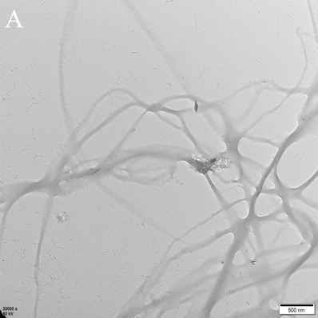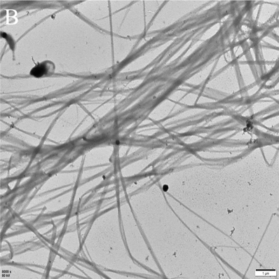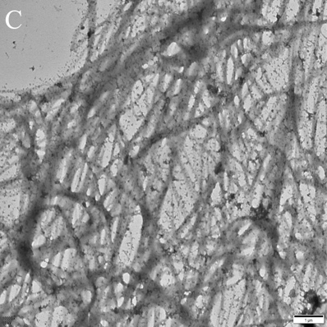
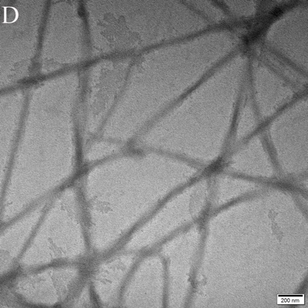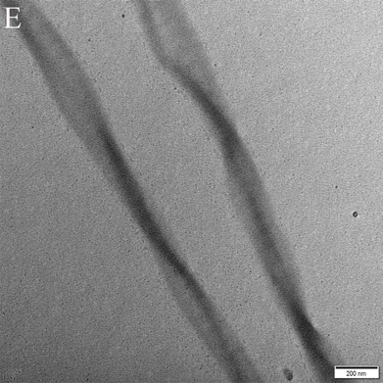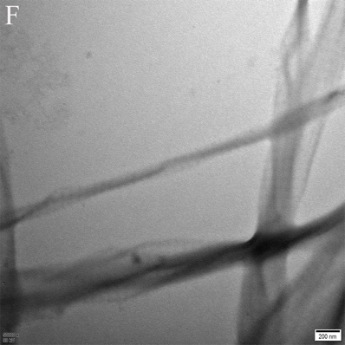

Fig. S1-TEM images of the reconstituted type I collagen fibrils in the control (A, B, C) and 0-wt % MDP-Na (D, E, F) group. No hydroxyapatite crystal was observed in the collagen after incubation in AS for 7 d (A, D), 14 d (B, E) and 28 d (C, F).

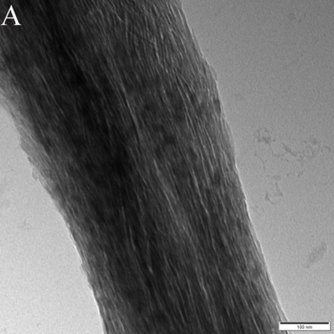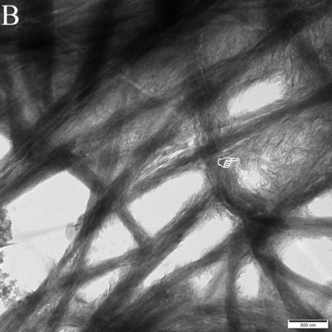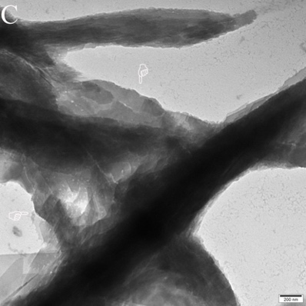
Fig. S2-TEM images of the reconstituted type I collagen fibrils in the 20-wt% MDP-Na group after incubation in AS for 28 d. The needle-like crystals aligned along the longitudinal axis of the collagen fibrils indicate the intrafibrillar mineralization of collagen (A). In addition, interfibrillar mineralization could also be observed (B, C). Some collagen fibers were linked by the crystal growth on the fiber surfaces (pointers in B and C).

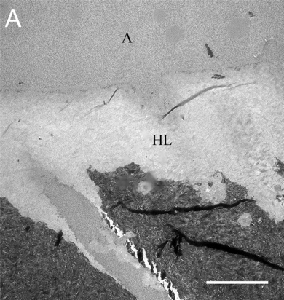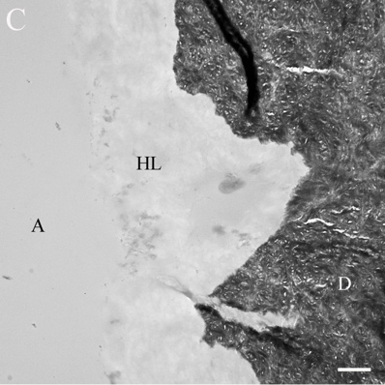
Fig. S3-Representative TEM images obtained from the control (A, bar=5 μm), 0-wt% MDP-Na (B, bar=2 μm) and 20-wt% MDP-Na (C, bar=2 μm) group before remineralization. The entire hybrid layers of the all the groups apeared electron-lucent (i.e., devoid of minerals). A: adhesive layer, HL: hybrid layer, D: intertubular dentin.
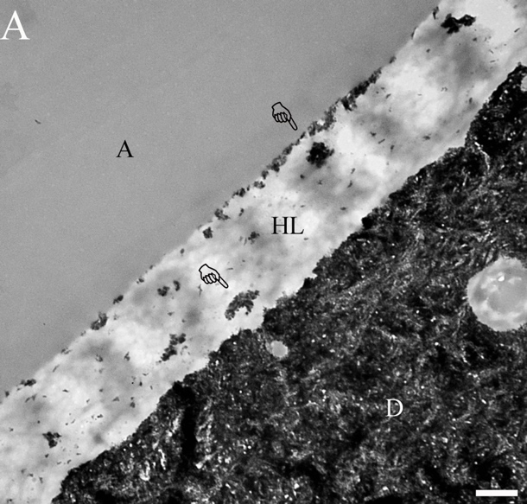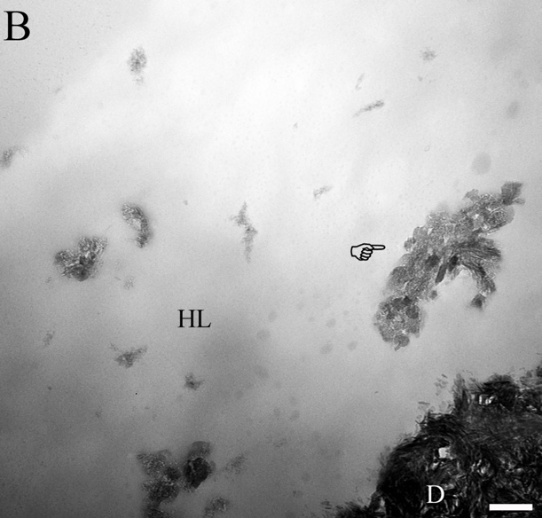
Fig. S4 - TEM images of the resin-dentin interfaces of the 20 wt% MDP-Na group after 28-day incubation in the AS. (A) Newly formed scattered crystals could be detected in the hybrid layer (pointers, bar=2 μm). (B) A high-magnification view of (A), showing the density of apatite platelets within a remineralized collagen fibril at the base of the hybrid layer (pointer, bar=0.5 μm). A: adhesive layer, HL: hybrid layer, D: intertubular dentin.

