Appendix 1

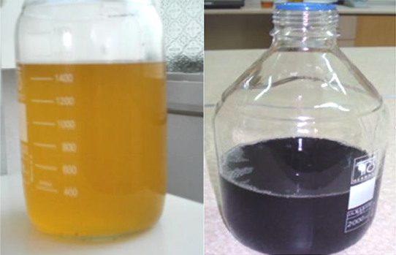
Figure A1: Al₂O₃ (left) and Fe₃O₄ (right) nanoparticle-diesel fuel blends
Table A1: Properties of nanoparticle-diesel fuel blends
Diesel fuel | D+ AL30 | D+ AL60 | D+ AL90 | D+ Fe30 | D+ Fe60 | D+ Fe90 | D+ Fe30+AL30 | Method | Range | unit | Property
58 | 66 | 67 | 69 | 63 | 64 | 67 | 64 | D93 | 52> | °C | Flash point
-3 | -5 | -6 | -6 | -4 | -4 | -5 | -4 | D2500 | - | °C | Cloud point
3.5 | 3.6 | 3.8 | 3.9 | 3.6 | 3.7 | 3.8 | 3.6 | D445 | 1.9-4.1 | Mm²/s | Kinematic viscosity (40℃)
0.816 | 0.824 | 0.825 | 0.827 | 0.817 | 0.821 | 0.823 | 0.820 | D4052 | - | g/cm³ | Density
42929 | 43365 | 43502 | 43685 | 43442 | 43657 | 43729 | 43453 | D 3338 | - | kJ/kg | Heating value
51 | 54.7 | 55.3 | 55.6 | 55.3 | 55.9 | 56.4 | 55.2 | D613 | - | - | Cetane number

