Supporting information

Performance optimization of GaAs NCFET with a complex oxide ferroelectric gate
Tingting Jia^{1,2*}, Henghui Li^{2,3}, Ziwei Yu², Chong Zhang^{1,2}, Hongyang Zhao⁴, Quansheng Guo^{1*}
- School of materials science and engineering, Hubei University, Wuhan 430205, China.
- Shenzhen Institute of Advanced Electronic Materials, Shenzhen Institutes of Advanced Technology, Chinese Academy of Sciences, Guangdong 518055, China.
- School of Microelectronics, Southeastern University, Nanjing 10286, China.
- Hubei Key Laboratory of Plasma Chemistry and Advanced Materials, Department of Materials Science and Engineering, Wuhan Institute of Technology, Wuhan 430205, China.

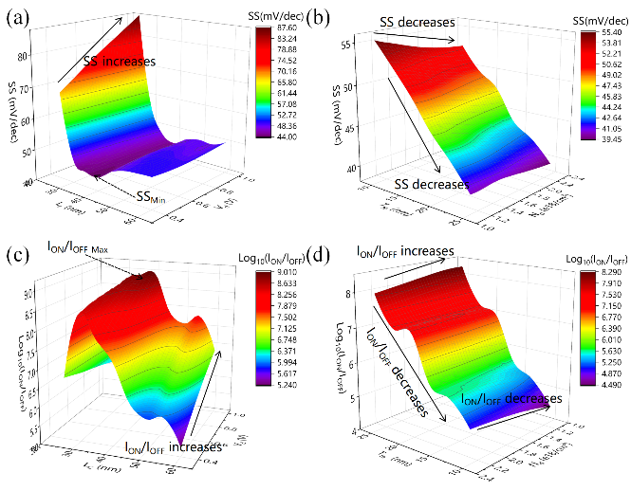
Figure S1. Transfer performance of the NCFET: (a) SS with V_{d} varied from 0.4 V to 1 V and L_{C} varied from 25 nm to 60 nm; (b) SS with T_{fe} varied from 10 nm to 25 nm and N_{d} varied from 1×10¹⁸ /cm³ to 2×10¹⁸ /cm³; (c) I_{ON}/I_{OFF} with V_{d} varied from 0.4 V to 1 V and L_{C} varied from 25 nm to 60 nm; (d) I_{ON}/I_{OFF} with T_{fe} varied from 10 nm to 25 nm and N_{d} varied from 1×10¹⁸ /cm³ to 2×10¹⁸ /cm³.

