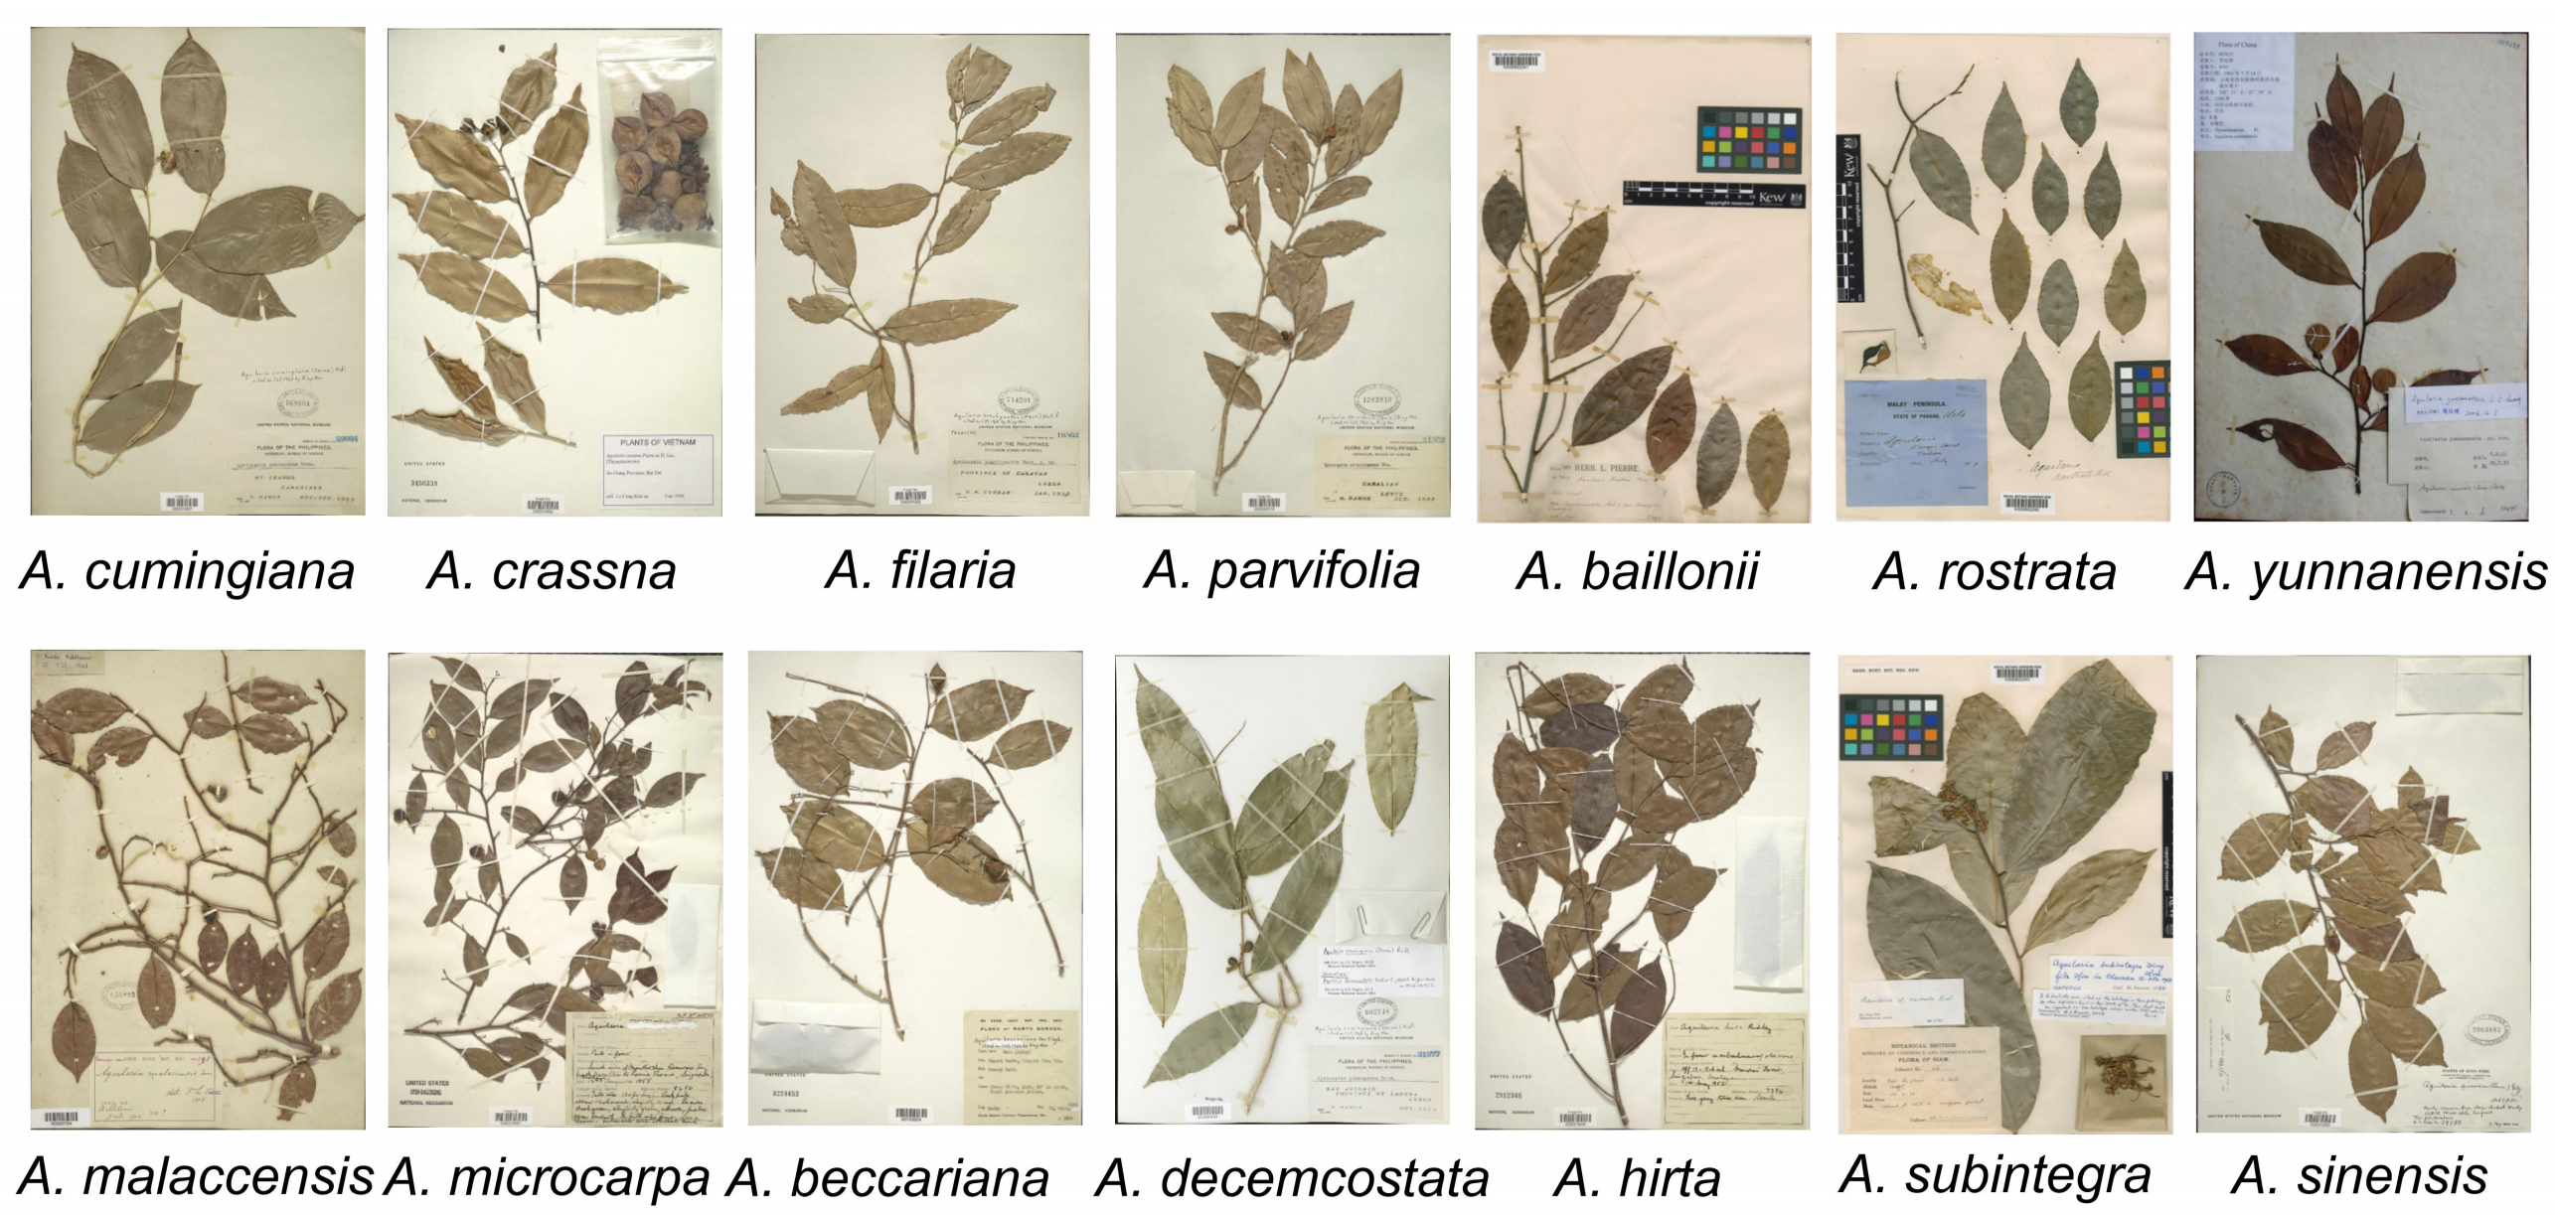
Figure S1. The plant specimens of 14 major agarwood producers in the genus Aquilaria.

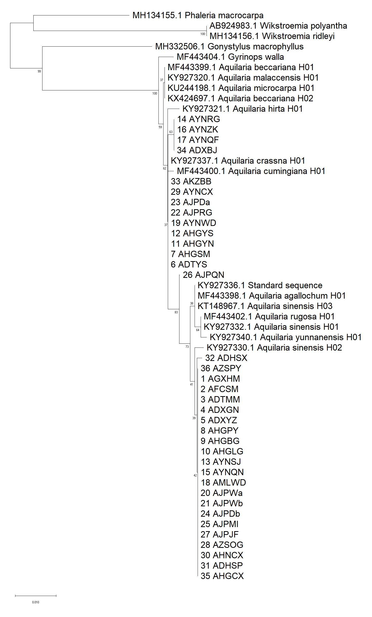
Chinese Mainland
Indochina
Malaysia
0.01

Figure S2. Phylogenetic analysis and systematic cluster analysis for agarwood products and Aquilaria using matK sequence only.
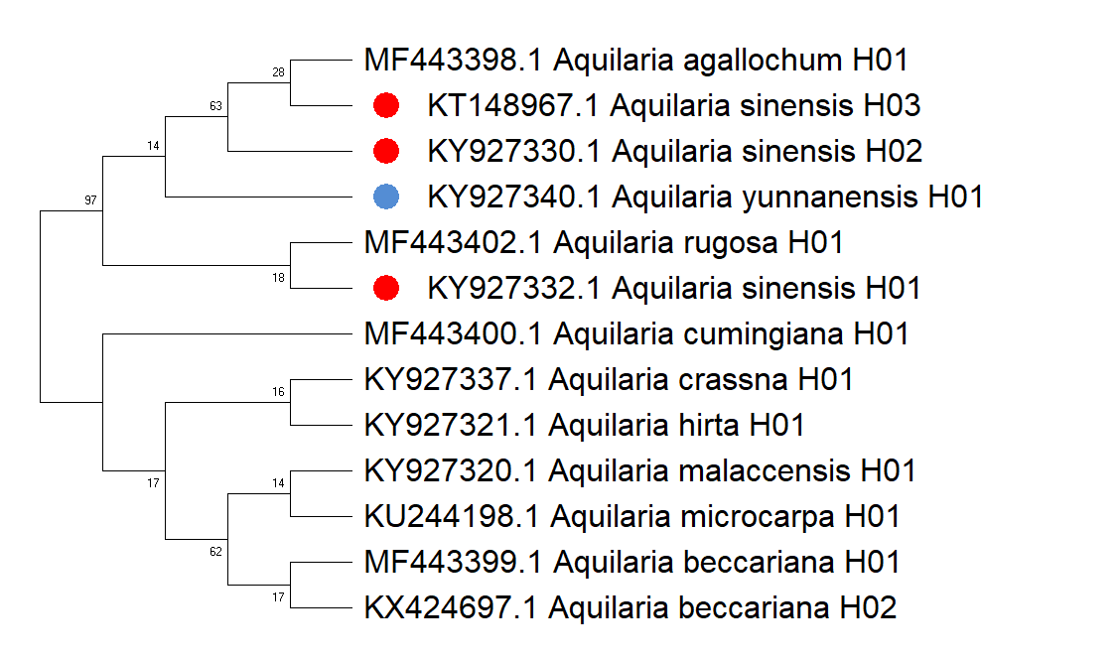
Figure S3. Evolutionary tree analysis on different haplotypes of the genus Aquilaria.

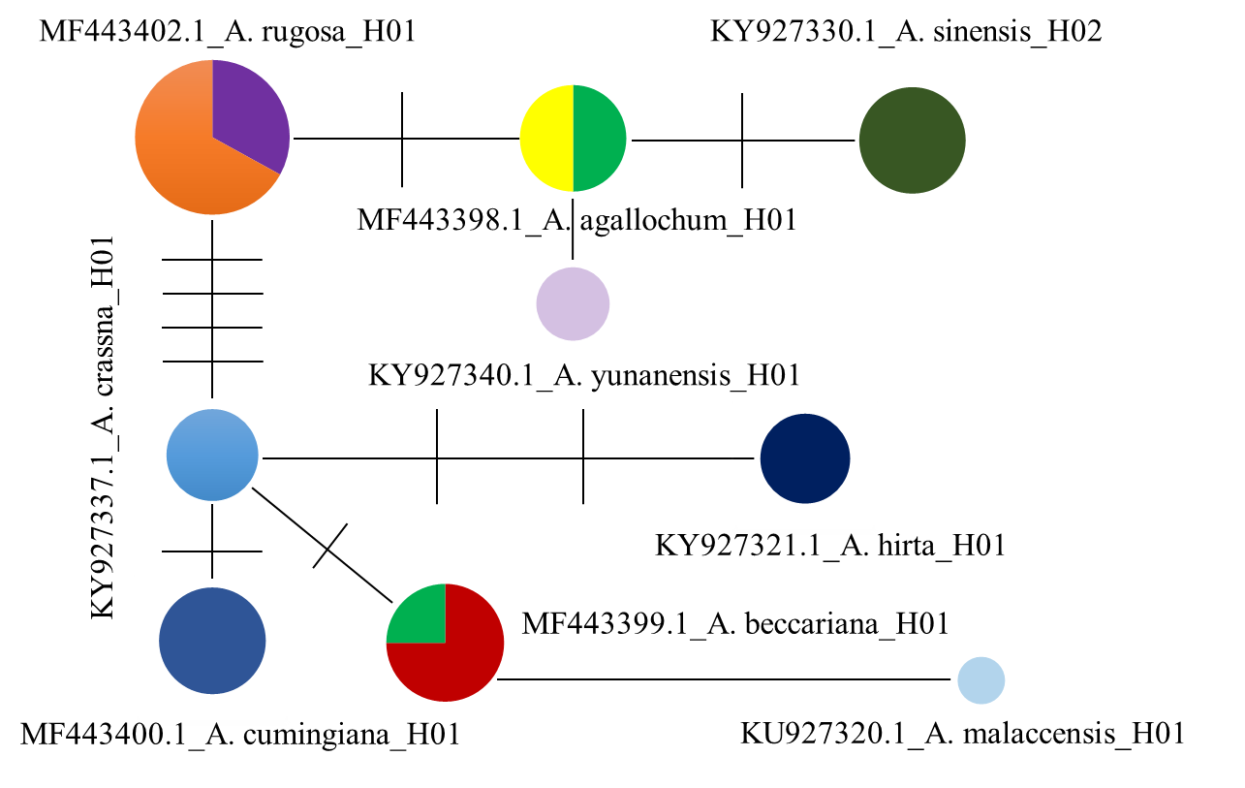
Figure S4. The Median-Joining network map on different haplotypes of the genus Aquilaria.

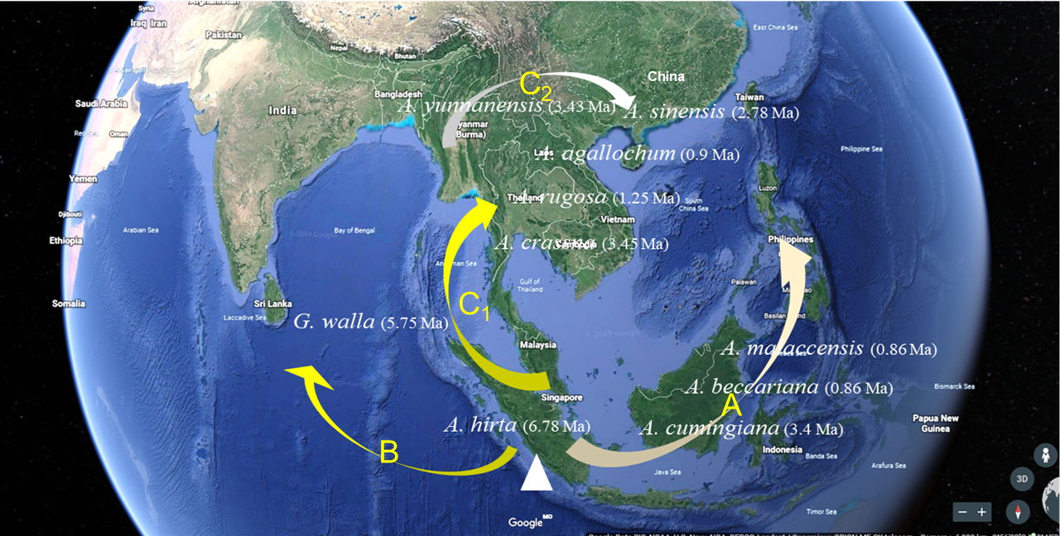
Figure S5. Map of species distribution and lineage characteristics of Aquilaria under the hypothesis of Malacca origin center before tailoring.

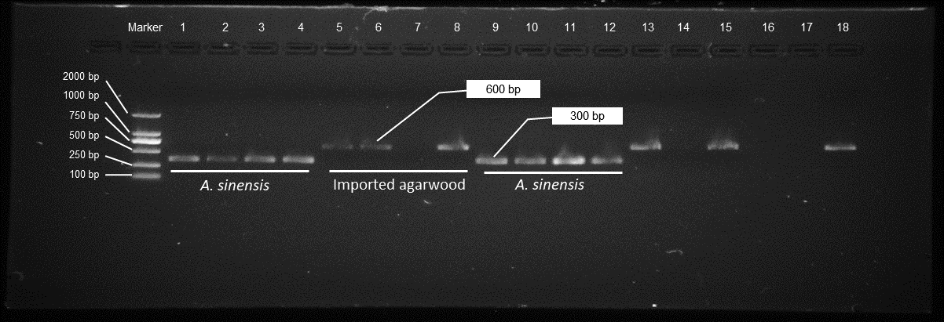
Figure S6. The original image of amplified fragments for Aquilaria identification with full length membranes.

