Supplementary Files

Table S1: List of the variables included in the prediction model
Table S2: Interpretation of the model performance metrics
Figure S1: Contribution levels of all variables to incident coronary heart disease based on SHAP values
Figure S2: The heat plot of all variables for incident coronary heart disease based on SHAP values

Table S1: List of the variables included in the prediction model
 | Variable names | Definition
1 | Age | Age (Years)
2 | Sex | Sex (Male or Female)
3 | SBP | Systolic blood pressure (mmHg)
4 | DBP | Diastolic blood pressure (mmHg)
5 | pulse | Heart rate (Pulse/min)
6 | Smstatus | Smoking status (Current, Quit, Never)
7 | Drkstatus | Drinking status (Current, Quit, Never)
8 | TG | Triglycerides (mg/dL)
9 | Total Cho | Total cholesterol (mg/dL)
10 | HDL-c | High density lipoprotein cholesterol (mg/dL)
11 | Glucose | Blood glucose (mg/dL)
12 | Alb | Albumin (g/dL)
13 | Total Pro | Serum total protein (g/dL)
14 | Ca | Serum calcium (mg/dL)
15 | Frct | Fructosamine (μmol/L)
16 | CPK | Creatine phosphokinase (mg/dL)
17 | waist | Waist circumference (cm)
18 | hip | Hip circumference (cm)
19 | wt20 | Weight at age 20 (kg)
20 | bf | Body fat percentage (%)
21 | GOT | Serum glutamic-oxaloacetic transaminase (U/I)
22 | GPT | Serum glutamic-pyruvic transaminase (U/I)
23 | exer | Exercise (1: Yes, 0: No)
24 | RBC | Red blood cell (×103 /mm3 )
25 | Hb | Hemoglobin (g/dL)
26 | WBC | White blood cell (/mm3 )
27 | Elbow | Elbow joint thickness (mm)
28 | gGTP | γ − Glutamyl TransPeptidase (U/I)
29 | stairs | Use of stairs (Stair use 1. ≥ 80%, 2. 6-80%, 3. 4-60%, 4. 2-40%, 5. < 20%)
30 | Uric acid | Uric acid (mg/dL)
31 | uPr | Proteinuria (Yes/No)
32 | uPH | UrinepH(1:pH<7,0:pH≥7)
33 | uob | Urinary occult blood (Yes/No/Trace)
34 | ztt | Kunkel (U)
35 | sleep | Time of sleeping (1. ≤ 6hr, 2. 7hr range, 3. 8hr range, 4. ≥ 9hr, 5. Unknown, shift system)
36 | stress | Stress (1: No, 2: Yes, 3: Don’t know)
37 | unhappy | Unhappy (Unfortunate events: 1. No, 2. One, 3. Two or more, 4. Unknown)
38 | social | Socializing (1. Like, 2. Normal, 3. Dislike, 4. Don’t know)
39 | drug | Tranquilizer (1. Never, 2. Occasionally, 3. Almost every day, 4. Don’t know)
40 | satisf | Satisfaction (1. Very satisfied, 2. Slightly satisfied, 3. Dissatisfied, 4. Don’t know)
41 | strength | Physical strength (1. Excellent, 2. Good, 3. Average, 4. Poor, 5. Unknown)
42 | MetS | Metabolic syndrome (1: Yes, 0: No)
43 | Hypertension | Hypertension (1: Yes, 0: No)
44 | Diabetes | Diabetes mellitus (1: Yes, 0: No)
45 | eGFR | Estimated Glomerular filtration rate (mL/min/1.73m2)
46 | non-HDL-c | Non-high density lipoprotein cholesterol (mg/dL)
47 | BMI | Body mass index (kg/m2)
48 | fh-hyper | Family history of hypertension (1: Yes, 0: No)
49 | fh-CVD | Family history of stroke, myocardial infarction, and sudden death (1: Yes, 0: No)
50 | fh-diabetes | Family history of diabetes (1: Yes, 0: No)
51 | fh-cancer f | Family history of cancer (1: Yes, 0: No)
52 | h-oth | Family history of other diseases (1: Yes, 0: No)
53 | target | Coronary Heart Disease (1: Yes, 0: No)

Table S2: Interpretation of the model performance metrics

Performance metrics | Definition | Formula | Interpretation
Accuracy | Accuracy is a measure of how many of the total predictions made by the model are correct | Accuracy =  (TP+TN)/ (TP+TN+FP+FN) | Accuracy tells us the overall correctness of predictions. However, a highly imbalanced dataset can lead to misleadingly high accuracy if the model predicts the majority class most of the time.
AUC | Area under a receiver operating characteristic (AUC-ROC) measures the ability of a model to distinguish between the positive and negative classes by varying the classification threshold |  | The ROC curve plots the True Positive Rate (Recall) against the False Positive Rate at various threshold values, and AUC-ROC calculates the area under this curve.  AUC = 1: Perfect classifier  0.9 < AUC < 1: Excellent classifier  0.8 < AUC < 0.9: Good classifier  0.7 < AUC < 0.8: Fair classifier  0.6 < AUC < 0.7: Poor classifier  AUC = 0.5: Random chance (no discrimination between classes)  AUC < 0.5: Worse than random chance (inverse discrimination)
Recall | Recall (or Sensitivity) measures the ability of the model to correctly identify positive instances out of all actual positive instances | Recall = TP/(TP+FN) | Recall quantifies the model’s ability to avoid missing positive cases. It’s crucial in scenarios where false negatives (missing actual positive cases) are costly or problematic.
Precision | Precision (or Positive Predictive Value) measures the accuracy of positive predictions made by the model | Precision = TP/(TP+FP) | Precision focuses on the accuracy of positive predictions.
F1-score | The F1-score is the harmonic mean of precision and recall. It provides a single metric that balances both precision and recall. | F1-score = 2(Precision*Recall)/(Precision+Recall) | The F1-score combines the strengths of precision and recall into a single metric.
True Positives (TP) are the number of patients who are correctly diagnosed with the disease by the test.
False Positives (FP) are the number of patients who are incorrectly diagnosed with the disease by the test, when they do not actually have the disease.
False Negatives (FN) are the number of patients who are incorrectly diagnosed as not having the disease by the test, when they actually do have the disease.
True Negatives (TN) are the number of patients who are correctly diagnosed as not having the disease by the test.

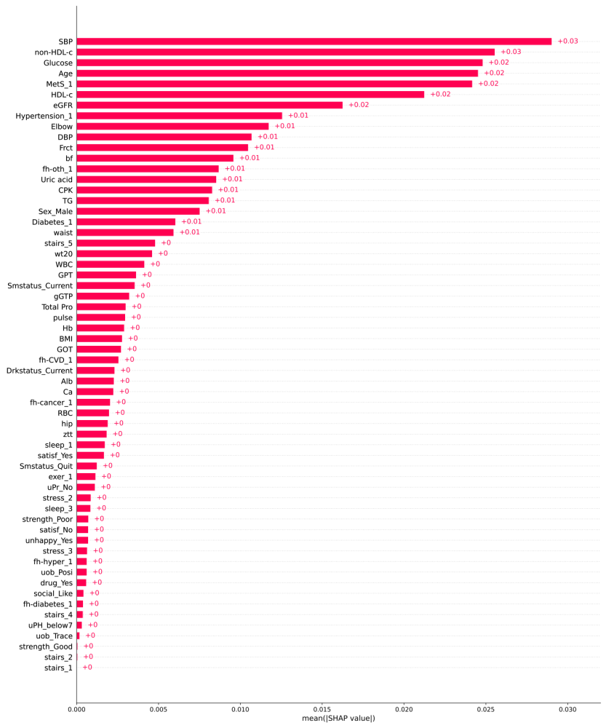
Figure S1: Contribution levels of all variables to incident coronary heart disease based on SHAP values
The SHAP (red) bar plot shows the global importance of each feature in the model. It displays the mean absolute SHAP value for each feature, providing an overview of the features' impact on the model's output. Each bar in the plot represents a feature (variable), and the length of the bar indicates the magnitude of the feature's contribution for CHD incidence

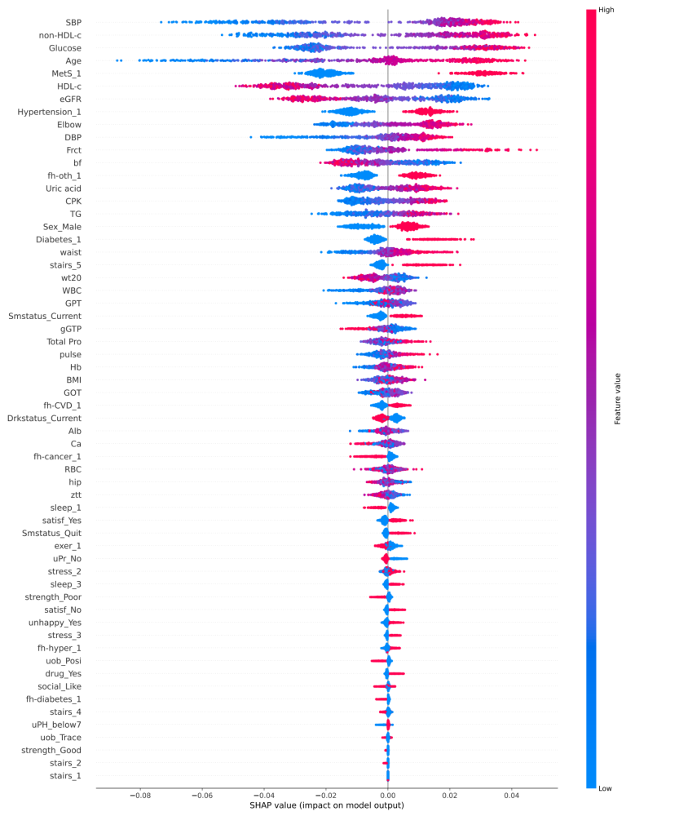
Figure S2:The heat plot of all variables to incident coronary heart disease based on SHAP values
The heat plot of SHAP values reveals the relationships between the feature (variable) and incident coronary heart disease: red indicates a positive relationship, while blue indicates a negative relationship. Through it, we can obtain a basic understanding of the relationship between the value of a particular feature and its influence on prediction. Each data point corresponds to a certain participant and their corresponding Shapley value for a particular feature. The position of a data point on this plot is defined by the feature's importance, which is represented on the y-axis, and the Shapley value, which is represented on the x-axis.

