Value shift in response to aging: A longitudinal study based on healthy aging

Supplement
Content
Appendix 1: Variables about Intrinsic capacity obtained from CHARLS 2
Appendix 2 Factor analysis scree plot 4
Appendix 3: Construct the index of intrinsic capacity 5
Appendix 4: Weight of common factors in calculating IC 6
Appendix 5: Correlation between control variables and IC 7
Appendix 6: Indicators of the fit of the econometric model 8
Appendix 7: Econometric model with control variables 9

Appendix 1: Variables about Intrinsic capacity obtained from CHARLS
Walk speed
In the survey, every participant aged 60 and above was eligible to take the timed walking test. It is important to note that only people over the age of 60 who are willing to do this test and are able to walk (with a walker allowed) are asked to walk 2.5 meters twice at their usual walking pace. The time of the two walks was recorded separately. In our analysis, we used the average time (seconds) between the two trials.
Chair-stand test
Chair standing tests are used to measure physical performance. It refers to the time required for the subject to stand up from the chair five times with his arms crossed over his chest. Slower time reflects poorer functionality. The time spent standing up is recorded in seconds. If participants are unable to stand without assistance, they are deemed ineligible. Walking AIDS such as walkers or canes are not allowed during the test. The test will be stopped in three situations: (1) the subject feels too tired or short of breath; (2) The subject uses their hands; (3) The nurse evaluator is concerned about the safety of the test subjects.
Grip
The grip test is used to test upper body strength. Subjects were asked to assess the commonly used hand grip strength (kg) using a hand-held dynamometer. There are two measurements for each active hand. The average of the commonly used hands was calculated for analysis (if both hands were reported as commonly used, we chose the larger measurement). Any measurement that is incorrect or the participant refuses to perform the test is not included.
Sleep
Sleep quality and duration were considered to reflect water sleep status. For sleep duration, participants were asked about their actual sleep duration per night (an average night's sleep, which may be less than the time spent in bed) and their average nap time (minutes) after lunch over the past month. For sleep quality, participants were asked to report the frequency of restless sleep in the previous week (from the Sleep Quality entry in CES-D10), with four types of answers: little or no time (< 1 day), some or a little time (1-2 days), occasional or moderate time (3-4 days), and most or all of the time (5-7 days).
Cognition
Two tests were used to assess the subjects' cognitive function. First, the subjects were asked to accurately answer the date of the day they were interviewed. Second, a simple picture is shown to the interviewee. Respondents were required to redraw within a certain amount of time. Correct answers are assigned a value of 1, and incorrect answers are assigned a value of 0.
Affection
The Depression Assessment Scale CES-D was used to comprehensively assess patients' mood. Six of the nine CES-D items (i.e., was bothered, felt hopeful, felt depressed, was happy, felt lonely, felt fearful) were considered to be depressed mood items, while the remaining three (i.e., everything was an effort, had trouble keeping mind, and could not get going) were regarded as somatic complaints items. Each question corresponds to four categorical answers, little or no time (< 1 day), some or very little time (1-2 days), occasional or medium time (3-4 days), most or all time (5-7 days). In which feeling happy and hopeful is coded in reverse. The sum of the nine items acts as a mood indicator.
Sensory
Self-reported measures of hearing and vision impairment were used to reflect the respondents' senses. Hearing status was assessed by asking participants to rate their hearing (or, if using a hearing aid, a hearing aid) as excellent, very good, good, fair or poor. In terms of vision, participants were also asked "how good your vision is at seeing things from a distance, such as recognizing a friend across the street (if you wear glasses or corrective lenses)" and "how good your vision is at seeing things up close, such as reading ordinary newspaper prints." The answer options (Excellent/Very good/Good/medium poor) are described above.

Appendix 2 Factor analysis scree plot
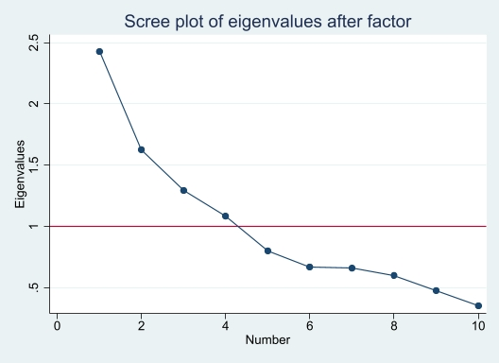
Figure 1s Factor eigenvalues distribution in Wave1
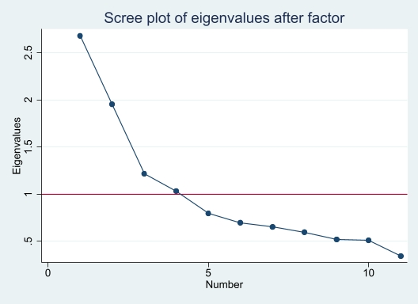
Figure 2s Factor eigenvalues distribution in Wave2
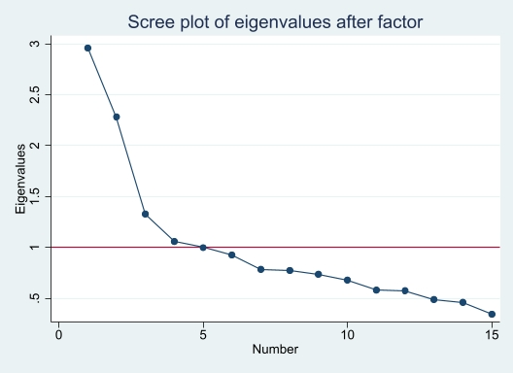
Figure 3s Factor eigenvalues distribution in Wave3

Appendix 3: Construct the index of intrinsic capacity
Table 1s Factor loading distribution of each variable on common factors in Wave1
Variables | F1 | F2 | F3 | F4 | Uniqueness
Walk speed | 0.025 | 0.806 | 0.017 | 0.005 | 0.350
Chair-stand | 0.058 | 0.808 | 0.070 | 0.040 | 0.337
Grip | 0.083 | 0.429 | 0.485 | 0.170 | 0.545
Cognition-date | 0.194 | -0.058 | 0.725 | -0.053 | 0.431
Cognition-draw | -0.001 | 0.114 | 0.782 | 0.086 | 0.369
Affection | -0.956 | -0.041 | -0.069 | -0.009 | 0.079
Sleep-quality | 0.301 | 0.007 | 0.053 | 0.789 | 0.284
Sleep-time | -0.236 | 0.052 | 0.019 | 0.830 | 0.079
Vision-far | 0.956 | 0.041 | 0.069 | 0.009 | 0.341
Vision-close | 0.812 | -0.007 | -0.004 | -0.008 | 0.252

Table 2s Factor loading distribution of each variable on common factors in Wave2
Variables | F1 | F2 | F3 | F4 | Uniqueness
Walk speed | -0.021 | 0.807 | 0.009 | -0.005 | 0.348
Chair-stand | 0.036 | 0.799 | 0.026 | 0.077 | 0.355
Grip | -0.047 | 0.493 | 0.179 | 0.430 | 0.537
Cognition-date | 0.227 | -0.088 | -0.008 | 0.745 | 0.387
Cognition-draw | -0.084 | 0.198 | 0.059 | 0.742 | 0.400
Affection | 0.450 | 0.027 | 0.576 | 0.142 | 0.445
Sleep-quality | 0.221 | 0.002 | 0.824 | 0.009 | 0.272
Sleep-time | -0.503 | 0.125 | 0.614 | 0.021 | 0.354
Vision-far | 0.824 | 0.039 | 0.124 | 0.079 | 0.298
Vision-close | 0.817 | -0.028 | -0.079 | 0.025 | 0.325

Table 3s Factor loading distribution of each variable on common factors in Wave3
Variables | F1 | F2 | F3 | F4 | Uniqueness
Walk speed | -0.059 | 0.749 | 0.041 | 0.037 | 0.433
Chair-stand | -0.042 | 0.743 | 0.083 | 0.054 | 0.437
Grip | -0.037 | 0.497 | 0.193 | 0.397 | 0.557
Cognition-date | 0.190 | -0.049 | 0.002 | 0.781 | 0.352
Cognition-draw | -0.112 | 0.216 | 0.117 | 0.702 | 0.435
Affection | 0.390 | 0.018 | 0.619 | 0.201 | 0.425
Sleep-quality | 0.180 | 0.002 | 0.764 | 0.020 | 0.384
Sleep-time | -0.507 | 0.168 | 0.554 | -0.111 | 0.396
Vision-far | 0.826 | -0.007 | 0.158 | 0.049 | 0.291
Vision-close | 0.814 | -0.026 | 0.126 | 0.008 | 0.321

Appendix 4: Weight of common factors in calculating IC
Table 4s Variance proportion and weight of common factors
 | Wave1 |  | Wave2 |  | Wave3
Factor | Proportion | Weight | Proportion | Weight | Proportion | Weight
F1 | 0.268 | 0.39 | 0.228 | 0.36 | 0.196 | 0.34
F2 | 0.151 | 0.22 | 0.145 | 0.23 | 0.143 | 0.25
F3 | 0.139 | 0.20 | 0.132 | 0.22 | 0.137 | 0.23
F4 | 0.135 | 0.19 | 0.120 | 0.19 | 0.103 | 0.18
Sum | 0.693 | 1 | 0.626 | 1 | 0.579 | 1

Appendix 5: Correlation between control variables and IC
Table 5s correlation analysis between IC and control variables in Wave1
Variables | (1) | (2) | (3) | (4) | (5) | (6) | (7) | (8)
(1) IC1 | 1.000
(2) multimorbidity | -0.128* | 1.000
(3) age1 | -0.213* | -0.026 | 1.000
(4) gender | -0.348* | 0.034* | 0.021 | 1.000
(5) education | 0.330* | 0.051* | -0.133* | -0.295* | 1.000
(6) mstat_1 | -0.129* | -0.026 | 0.277* | 0.197* | -0.146* | 1.000
(7) location | -0.111* | -0.027 | -0.035* | -0.019 | -0.254* | 0.016 | 1.000
(8) income_1 | 0.119* | 0.090* | -0.054* | -0.033* | 0.252* | -0.036* | -0.271* | 1.000
* shows significance at p<.05

Table 6s correlation analysis between IC and control variables in Wave2
Variables | (1) | (2) | (3) | (4) | (5) | (6) | (7) | (8)
(1) IC 2 | 1.000
(2) multimorbidity | -0.146* | 1.000
(3) age2 | -0.119* | -0.029 | 1.000
(4) gender | -0.284* | 0.036* | 0.021 | 1.000
(5) education | 0.284* | 0.055* | -0.134* | -0.295* | 1.000
(6) mstat_2 | -0.116* | -0.011 | 0.294* | 0.221* | -0.153* | 1.000
(7) location | -0.129* | -0.034* | -0.034* | -0.019 | -0.254* | 0.014 | 1.000
(8) income_2 | 0.102* | 0.055* | -0.034* | -0.011 | 0.168* | 0.001 | -0.182* | 1.000
* shows significance at p<.05

Table 7s correlation analysis between IC and control variables in Wave3
Variables | (1) | (2) | (3) | (4) | (5) | (6) | (7) | (8)
(1) IC 3 | 1.000
(2) multimorbidity | -0.162* | 1.000
(3) age3 | -0.104* | -0.012 | 1.000
(4) gender | -0.308* | 0.049* | 0.021 | 1.000
(5) education | 0.290* | 0.038* | -0.133* | -0.295* | 1.000
(6) mstat_3 | -0.137* | 0.014 | 0.297* | 0.234* | -0.162* | 1.000
(7) location | -0.144* | -0.044* | -0.034* | -0.019 | -0.254* | 0.018 | 1.000
(8) income_3 | 0.082* | 0.052* | 0.008 | 0.002 | 0.135* | 0.043* | -0.149* | 1.000
* shows significance at p<.05

Appendix 6: Indicators of the fit of the econometric model
Table 8s Fit index of the econometric model
Indicators | Cross-lagged model
SRMR | 0.025
 | Cross-lagged model -multimorbidity as a mediating variable
CFI | 0.916
TLI | 0.789
SRMR | 0.030
RMSEA | 0.046
 | Cross-lagged model -SP as a mediating variable
CFI | 0.737
TLI | 0.342
SRMR | 0.062
RMSEA | 0.113

Appendix 7: Econometric model with control variables
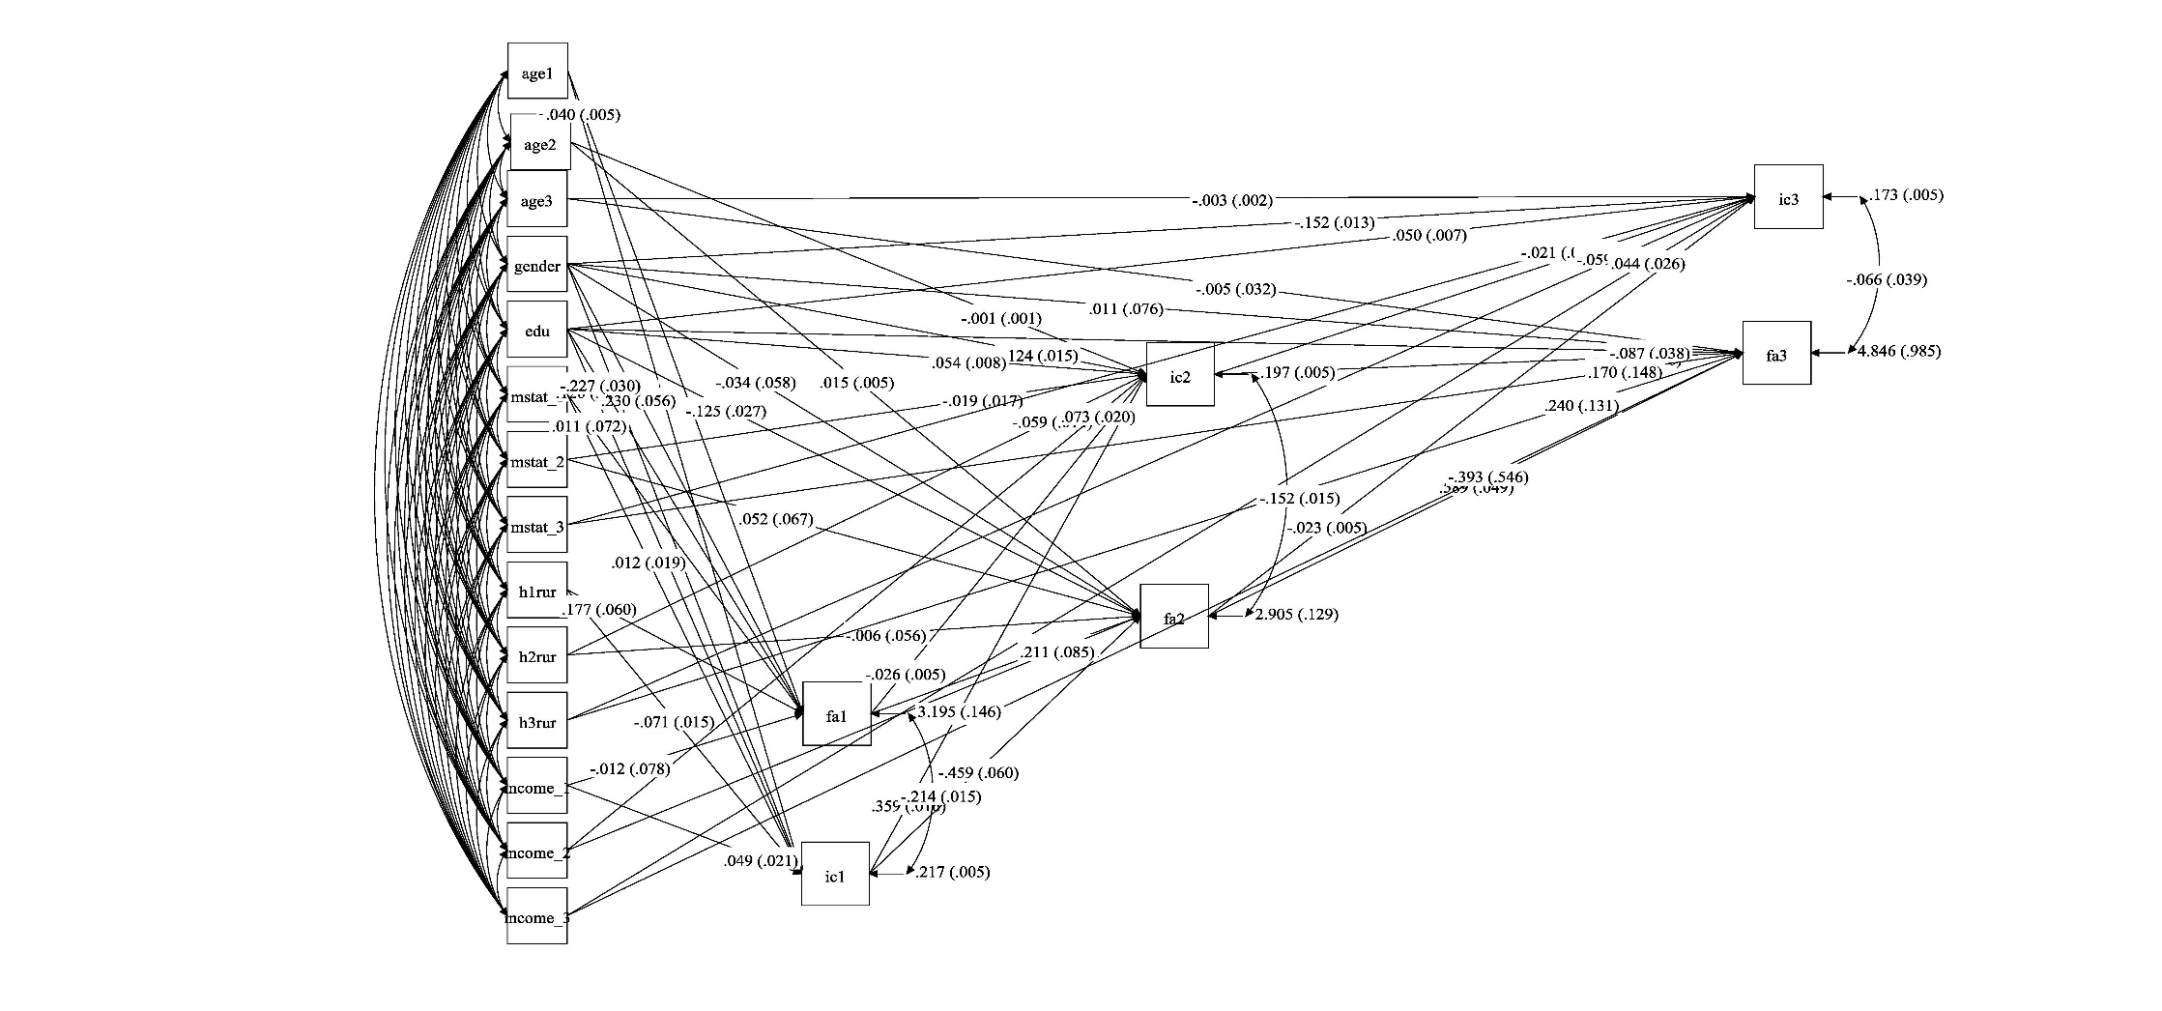

Figure 4s Cross-lagged model with control variables

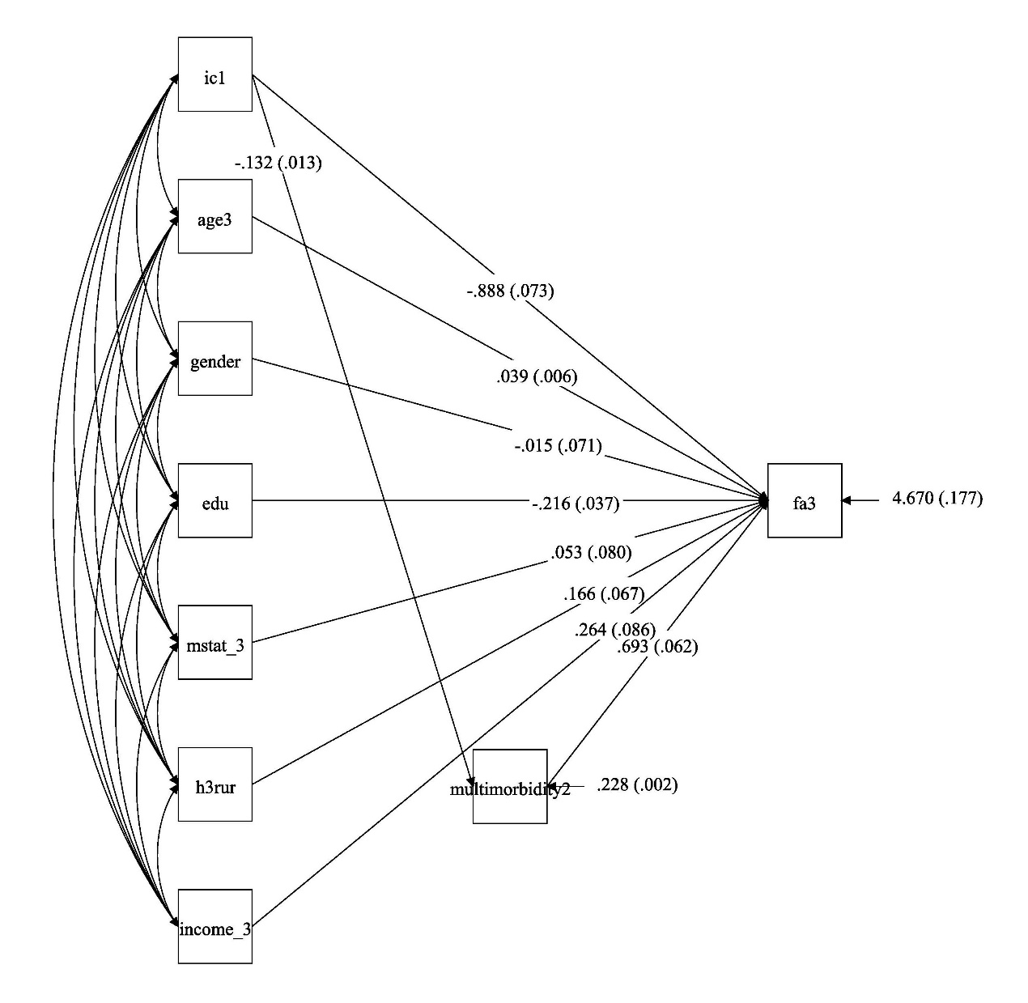
Figure 5s: An econometric model mediated by multimorbidity

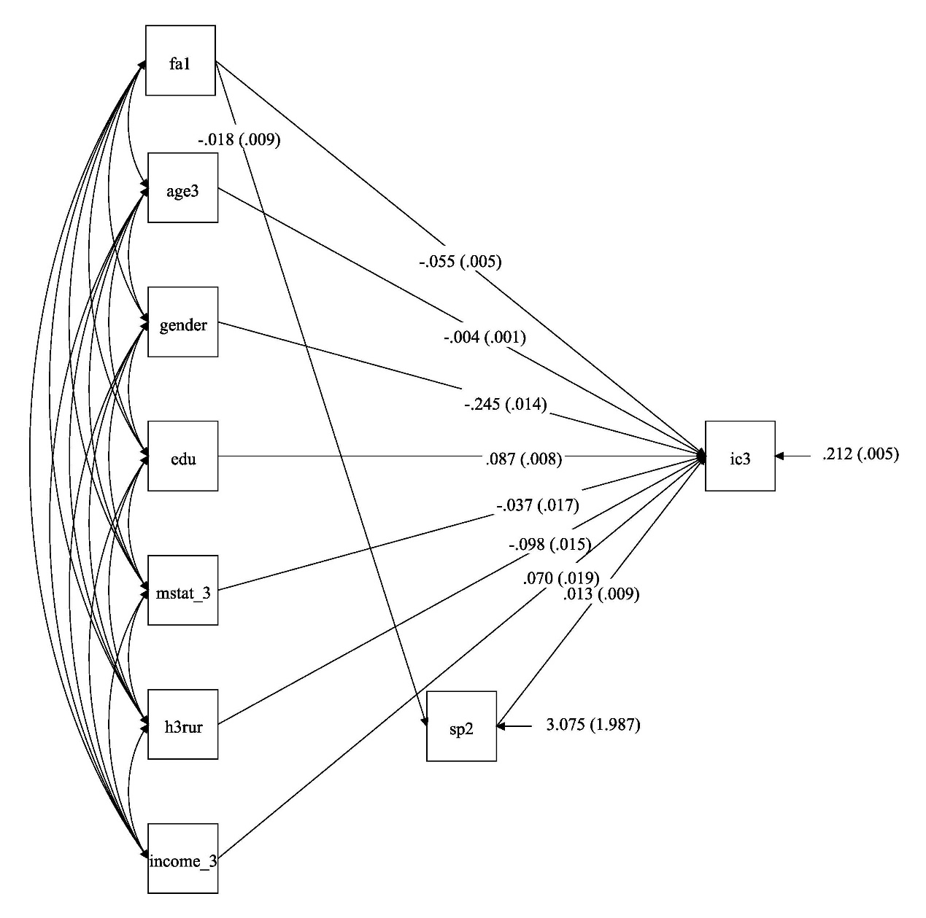
Figure 6s: An econometric model mediated by SP

