S Figure 1 Leave-one-out regression analysis of (A) childhood obesity and (B) age at menarche on ovarian dysfunction
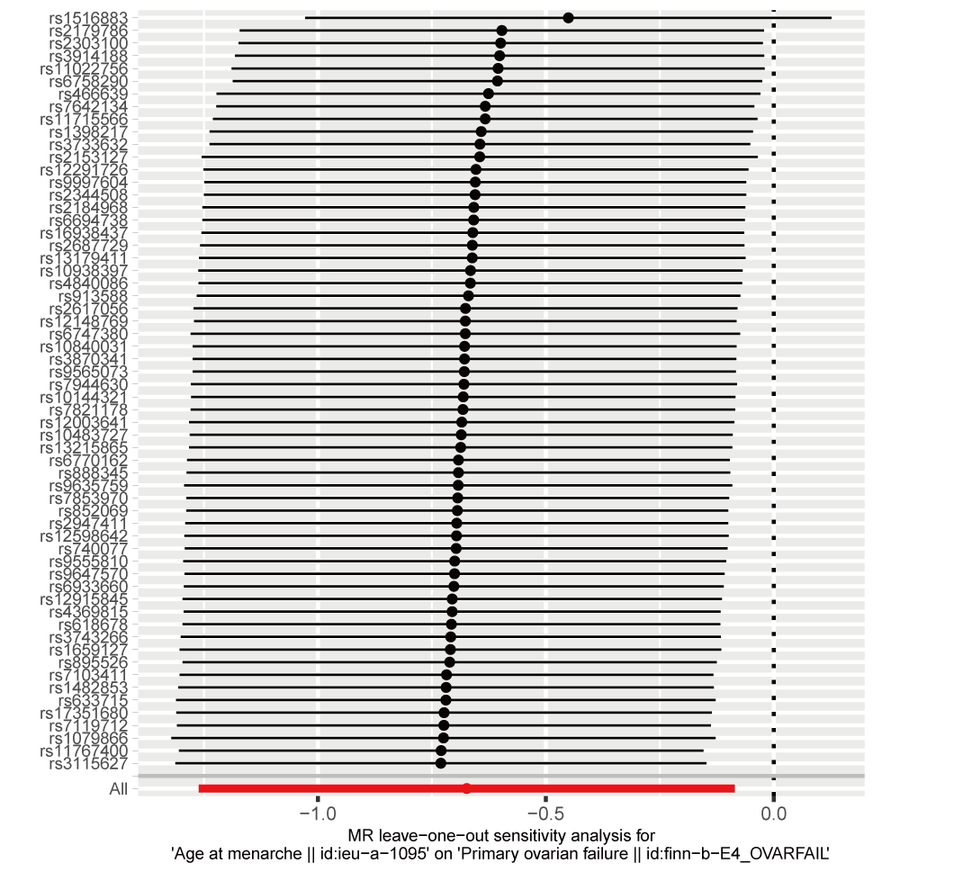
S Figure 2 Leave-one-out regression analysis of age at menarche on primary ovarian failure

S Figure 3 Forrest plot for causal associations of birth weighe, childhood obesity and age at menarche with related indicators of ovarian function

S Figure 4 Leave-one-out regression analysis of birth weight on E₂ levels

