Supplementary Information

Functional characterization of light sensing LOV1 protein in virulence and lifestyles of Pseudomonas cichorii JBC1
Nguyen Van Khanh¹, Yong Hoon Lee^{1, 2,*}

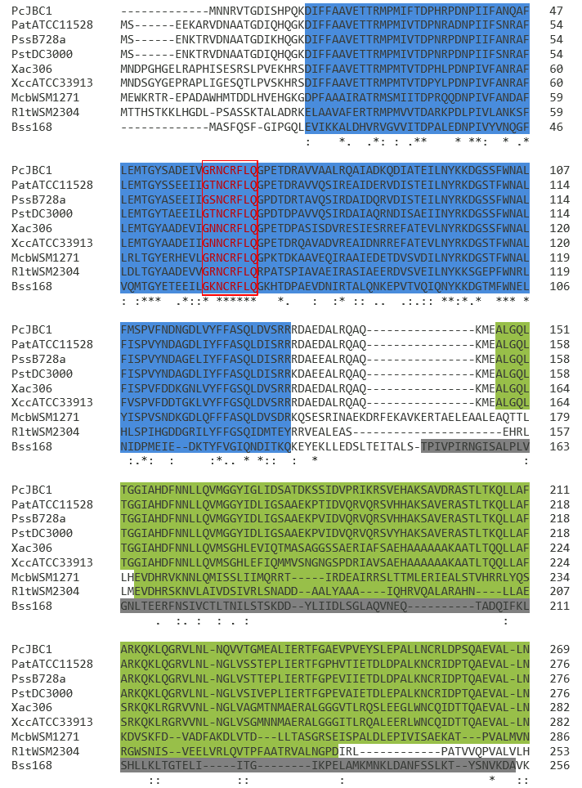
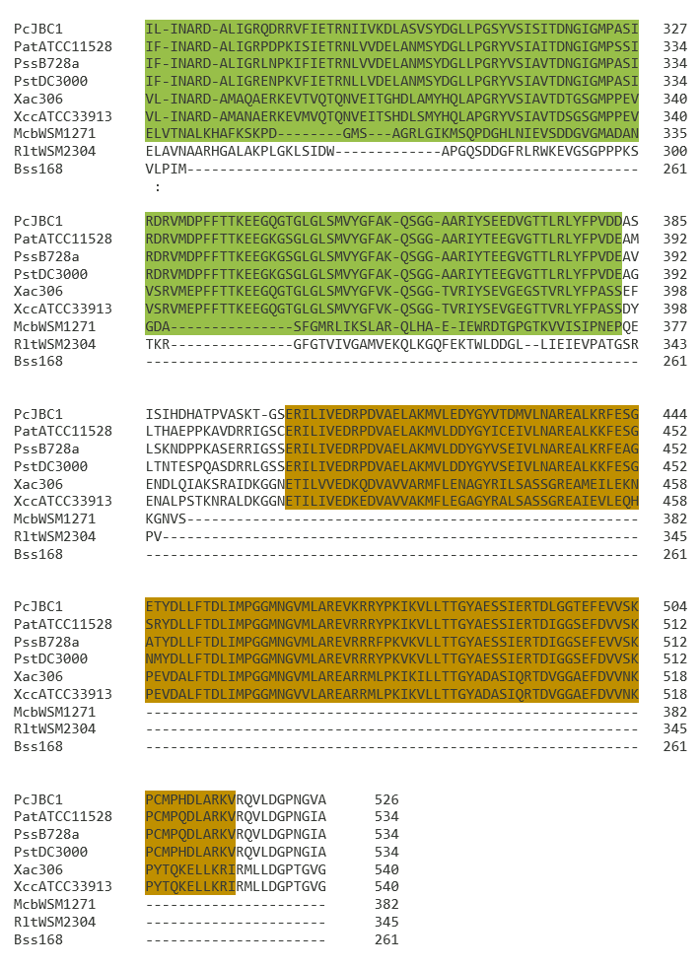
Supplementary Figure S1. Multiple sequence alignment of the deduced LOV amino acid sequences. The deduced amino acid sequences of LOV proteins from Pseudomonas cichorii JBC1 (PcJBC1), P. amygdali pv. tabaci ATCC 11528 (PatATCC11528), P. syringae pv. syringae B728a (PssB728a), P. syringae pv. tomato DC3000 (PstDC3000), Xanthomonas axonopodis pv. citri 306 (Xac306), X. campestris pv. campestris str. ATCC 33913 (XccATCC33913), Mesorhizobium ciceri bv. biserrulae WSM1271 (McbWSM1271), Rhizobium leguminosarum bv. trifolii WSM2304 (RltWSM2304), and Bacillus subtilis subsp. subtilis 168 (Bss168) aligned with Clustal Omega. Light, Oxygen, or Voltage (LOV), histidine kinase (HK), response regulator (RR), and Sulphate Transporter and AntiSigma factor antagonist (STAS) domains are highlighted in blue, green, brown, and gray, respectively. An asterisk indicates complete residue conservation, a colon indicates strong group conservation, a period indicates weak group conservation, and a blank space indicates no conservation of residues.

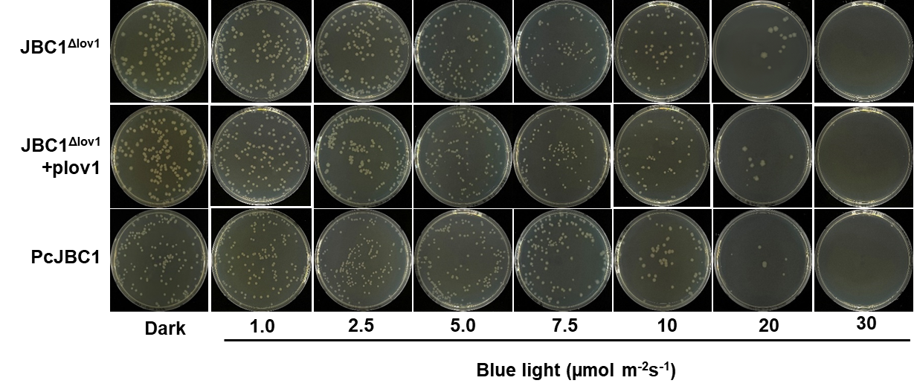
Supplementary Figure S2. Survival of Pseudomonas cichorii JBC1 cells after exposure to various intensities of blue light. The overnight cultures of each strain (PcJBC1, JBC1^{Δlov1}, and JBC1^{Δlov1}+plov1) were serially diluted and spread onto LB agar plates. The plates were incubated under blue light with various intensities (1, 2.5, 5.0, 7.5, 10, 20, and 50 µmol/m²s) and dark conditions. The number of colonies was counted 48 h after incubation at 28°C.

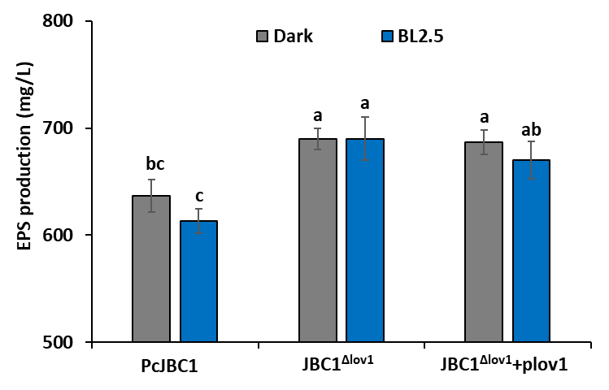
Supplementary Figure S3. Effects of Pc-LOV1 and blue light on exopolysaccharide production of Pseudomonas cichorii JBC1. PcJBC1, JBC1^{Δlov1}, and JBC1^{Δlov1}+plov1 were cultured in LB for 72 h under BL-illuminated (2.5 µmol/m²s) and dark conditions. The cell-free supernatant obtained by centrifugation was supplemented with KCl and 95% ethanol and the precipitated crude EPS was harvested via centrifugation, dried overnight, and weighed. Each bar represents means ± standard deviation from two independent experiments in triplicate. Means with the same letter are not significantly different at p>0.05 according to Tukey’s test.

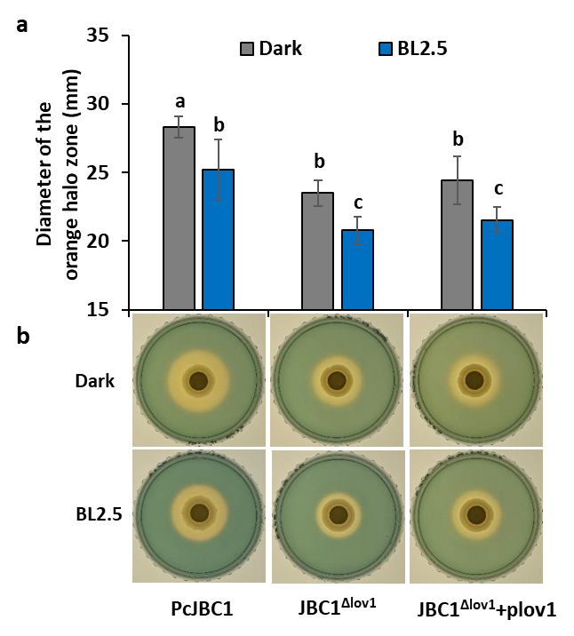
Supplementary Figure S4. Influence of Pc-LOV1 and blue light on siderophore production of Pseudomonas cichorii JBC1. (a) Overnight cultures of PcJBC1, JBC1^{Δlov1} and JBC1^{Δlov1}+plov1 were spot-inoculated (20 µL) onto the sterile paper disks laid on the CAS plates, and the plates were incubated at 28°C for three days under blue light (2.5 µmol/m²s) and dark conditions, and then diameter of orange halo zone was measured. (b) Photos were taken three days after incubation.

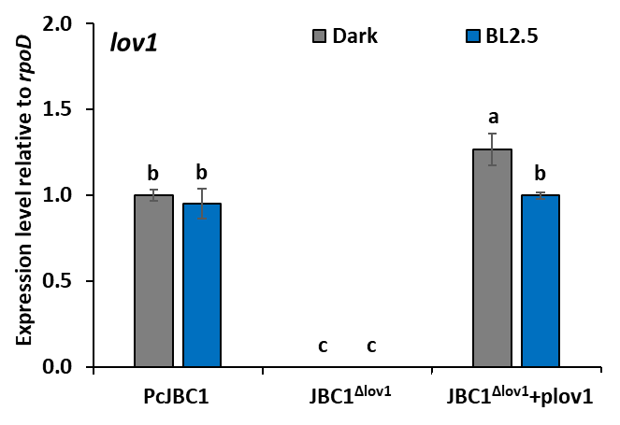
Supplementary Figure S5. Expression of lov1 under the influence of blue light treatment. The PcJBC1, PcJBC1^{Δlov1}, and PcJBC1^{Δlov1}+plov1 strains were cultured in minimal media under blue light and dark conditions. After 12 h of incubation, total RNA was isolated and qPCR analysis was performed for the expression of lov1. The housekeeping gene rpoD was used as an internal control. Fold differences were calculated using the ΔΔCT method with CT values obtained from qPCR and were normalized to the expression of genes in PcJBC1 grown in the dark. Expression values indicate average ± SD of three independent experiments.

Supplementary Table S1. Characteristics of Pc-LOV1-encoding genes identified in Pseudomonas cichorii JBC1 and other plant-associated bacteria
Species | Gene locus tag | Gene length (bp) | Identitiesª | MW (kDa)^{b} | pI^{b} | GRAVY^{b}
PcJBC1 | PCH70_11150 | 1581 | 526/526 (100%) | 58.09 | 5.28 | -0.174
PatATCC11528 | PSYTB_RS14855 | 1605 | 421/529 (80%) | 59.12 | 5.27 | -0.224
PssB728a | Psyr_2700 | 1605 | 419/527 (80%) | 59.02 | 5.35 | -0.202
PstDC3000 | PSPTO_2896 | 1605 | 419/527 (80%) | 58.94 | 5.11 | -0.205
Xac306 | XAC2555 | 1623 | 313/519(60%) | 58.92 | 5.30 | -0.198
XccATCC33913 | XCC2421 | 1623 | 320/523(61%) | 59.02 | 5.24 | -0.208
McbWSM1271 | Mesci_3196 | 1149 | 96/216(44%) | 42.79 | 5.67 | -0.461
RltWSM2304 | Rleg2_5263 | 1038 | 73/162(45%) | 37.91 | 8.56 | -0.154
Bss168 | BSU_30340 | 786 | 53/130(41%) | 29.19 | 4.88 | -0.140
ªThe deduced amino acid sequence of the Pc-LOV1 protein of Pseudomonas cichorii JBC1 (PcJBC1) was compared to that of P. amygdali pv. tabaci ATCC 11528 (PatATCC11528), P. syringae pv. syringae B728a (PssB728a), P. syringae pv. tomato DC3000 (PstDC3000), Xanthomonas axonopodis pv. citri 306 (Xac306), X. campestris pv. campestris str. ATCC 33913 (XccATCC33913) and Mesorhizobium ciceri bv. biserrulae WSM1271 (McbWSM1271) and Rhizobium leguminosarum bv. trifolii WSM2304 (RltWSM2304) and Bacillus subtilis Ytva (BsYtva) using ClustalW2.
^{b}The Molecular weight (MW, kDa), isoelectric point (pI), and grand average of hydropathy value (GRAVY) were predicted using ExPaSy-ProtParam.

Supplementary Table S2. Proteins predicted to interact with LOV1 of Pseudomonas cichorii JBC1
Candidate proteins | Interaction probability prediction tools |  |  |  | Putative function of candidate proteins
Candidate proteins | STRING (combined score)ª |  | SPRING  (score)^{b} | PEPPI  (log(LR))^{c} | Putative function of candidate proteins
Candidate proteins | functional interaction | physical interaction | SPRING  (score)^{b} | PEPPI  (log(LR))^{c} | Putative function of candidate proteins
AlgB | 0.417 | NI | 16.246 | 0.257 | Alginate biosynthesis transcriptional regulatory protein
BdlA | 0.770 | 0.658 | 19.273 | 2.525 | Biofilm dispersion protein
BphP | 0.801 | 0.640 | 23.272 | 5.253 | Bacteriophytochrome
FlhA | 0.562 | NI^{d} | NI | NI | Flagellar biosynthesis protein
FlhB | 0.514 | NI | NI | NI | Flagellar biosynthesis protein
FlhF | 0.476 | NI | NI | NI | Flagellar biosynthesis regulator.
FliA | 0.564 | NI | NI | NI | RNA polymerase sigma factor
FliD | 0.484 | NI | NI | NI | Flagellar hook-associated protein
FliG | 0.585 | NI | NI | NI | Flagellar motor switch protein
FliM | 0.542 | 0.456 | NI | NI | Flagellar motor switch protein
PilH | 0.679 | 0.564 | 17.139 | 2.308 | Type IV pilus response regulator
PilJ | NI | NI | 17.379 | NI | Type IV pilus biogenesis protein
HrcQ | 0.821 | 0.709 | NI | NI | T3SS cytoplasmic ring protein
FtsZ | 0.442 | NI | NI | NI | Cell division protein
GroEL | 0.473 | 0.461 | NI | NI | Heat shock protein 60 family chaperone
HtpG | 0.408 | NI | 14.097 | NI | Heat shock protein 90
PCH70_07230 | 0.884 | 0.800 | 15.564 | 4.012 | GAF domain protein.
PCH70_07200 | 0.795 | 0.585 | 16.66 | NI | GAF domain/GGDEF domain/EAL domain-containing protein
PCH70_20760 | 0.411 | 0.188 | 16.586 | NI | GGDEF domain protein
PCH70_03070 | 0.719 | 0.626 | 19.481 | 3.886 | PAS:GGDEF protein.
PCH70_04320 | 0.887 | 0.802 | 16.66 | 3.081 | response regulator/sensory box/GGDEF domain/EAL domain-containing protein
PCH70_11970 | 0.772 | 0.635 | 16.856 | 3.061 | EAL domain protein
ªThe combined score was calculated by integrating the probabilities from various evidence channels and adjusting for the probability of an interaction.
^{b}A Scoring function consisting of a weighted sum of the threading Z-score, model superposition TM-score, and interface energy.
^{c}PEPPI integrated method log-transformed likelihood ratio (log(LR) with greater than 0.
^{d}NI, non-interaction.

Supplementary Tables S3. Primers used in this study
Name | Primer Sequence (5′→3′)ª | Use
sgLOV1-F | GTGGGCGTTTCGATGAACACCCGA | Generation of target sequence to edit lov1
sgLOV1-R | AAACTCGGGTGTTCATCGAAACGC | Generation of target sequence to edit lov1
R_Amp | CAAGGCGAGTTACATGATCCCCCA | Checking presence of pACRISPR-sgRNA- lov1
LOV1_Us_F | TTTTGAGATCTGTCCATACCCATGGTCTAGAGGTGGCCCCCCAACCCAGAC | Amplification of the upstream region of the lov1 gene (500 bp)
LOV1_Us_R | CTGTTGCACGTAGCCGCAACAGGCACTGTCACCCGGACTTTACTATCGCTCACACACCC
LOV1_Ds_F | GGTGGGTGTGTGAGCGATAGTAAAGTCCGGGTGACAGTGCCTGTTGCGGCTAC | Amplification of the downstream region of the lov1 gene (500 bp)
LOV1_Ds_R | TCTGAATGGCGGGAGTATGAAAAGTCTCGAGTAGGCACTGCTTGAACAACAACGCAC
LOV1_HindIII_500Us_F | AGTGACAAGCTTGGTGGCCCCCCAACCCAG | Clone lov1 gene including its promoter regions into pUCP18 vector
LOV1_BamHI_500Us_F | GTATAGGATCCGGTGGCCCCCCAACCCAG
LOV1_BamHI_R | ACCCGTGGATCCTCAGGCTACGCCGTTGG
BamHI_Lov1_1F | CTAGGATCCGTGAATAACCGGGTAACGG | To clone lov1 gene into pET28a vector
HindIII_Lov1_1581R | CATGAAGCTTTCAGGCTACGCCGTTG | To clone lov1 gene into pET28a vector
T7_Promoter_F | GCGAAATTAATACGACTCACTATAGGG | To confirm recombinant plasmid pET28a_lov1
T7_Terminator_R | GTTATGCTAGTTATTGCTCAGCGG | To confirm recombinant plasmid pET28a_lov1
Lov1_F | TGTCCCTCGCATCAAACGAA | RT-PCR for lov1
Lov1_R | TTCTGCACCGAAAGTACGCT | RT-PCR for lov1
FliA-F | TGAAACCTATGCCGGTATCC | RT-PCR for fliA
FliA-R | CTTAACTGGAGTTCGGCAGC | RT-PCR for fliA
FliG_F | TGTCGGTGCAGATCGAAGAC | RT-PCR for fliG
FliG_R | TTTCCTTGATCGCCTCGTCC | RT-PCR for fliG
FlgJ_F | CGGCTGGGGTAAATCCATCA | RT-PCR for fliJ
FlgJ_R | CTCCTTGACCATCTTGCCGT | RT-PCR for fliJ
CifA-F | CCTATGCCGAATCGATGCCT | RT-PCR for cifA
CifA-R | CATCCAGTGGTGGTCTTCCC | RT-PCR for cifA
CifB-F | CTTTGCCACCACCAACGAAG | RT-PCR for cifB
CifB-R | ACGGTTCAGATAACCCTGCG | RT-PCR for cifB
HrpA-F | CTGATGGACTCTACTGCTGCTG | RT-PCR for hrpA
HrpA-R | CGTTGATGGTATCTGTCTGCAT | RT-PCR for hrpA
HrpL-F | CAGCGAGAAAAAGCTGCGAG | RT-PCR for hrpL
HrpL-R | GATTGGCTGCAATCCCGAAC | RT-PCR for hrpL
ª Restriction enzyme sites are underlined

Supplementary Table S4. Bacterial strains and plasmids used in this study
Strain or plasmid | Description and/or relevant genotype or phenotype | Reference or source
Strains
PcJBC1 | Pseudomonas cichorii JBC1, wild type | Ramkumar et al. (2015)
PcJBC1^{Δlov1} | lov1 – deletion mutant of PcJBC1 | This study
PcJBC1^{Δlov1}+plov1 | Complementary strains PcJBC1^{Δlov1} contains pUCP18_lov1 | This study
PcJBC1-pCasPA | PcJBC1 contains pCasPA plasmid | This study
E. coli TOP10 PACrispr_SgRNA^{lov1} | E. coli TOP10 contains PACrispr_SgRNA^{lov1} | This study
E. coli TOP10  PACrispr_SgRNAlov1_Us_Ds | E. coli TOP10 contains PACrispr_SgRNA^{lov1}_Us_Ds | This study
E. coli TOP10_lov1 | E. coli TOP10 contains recombinant plasmid pET28a_lov1, Kanamycin | This study
E. coli BL21_lov1 | E. coli BL21 contains recombinant plasmid pET28a_lov1, Kanamycin | This study
Plasmids
pCasPA | pCasPA plasmid, Tetracyclin | This study
PACrispr | PACrispr plasmid, Ampicillin | This study
PACrispr_SgRNA^{lov1} | PACrispr with single guide of lov1 gene, Ampicillin | This study
PACrispr_SgRNA^{lov1}_Us_Ds | PACrispr_SgRNA^{lov1}with upstream and downstream fragments of lov1 gene, Ampicillin | This study
pUCP18 | pUCP18 vector, Ampicillin | This study
pUCP18_lov1 | pUCP18 with lov1 genes and its natural promoter, Ampicillin | This study
pET28a | pET28a vector, Kanamycin | This study
pET28a_lov1 | pET28a with lov1 gene, Kanamycin | This study

