NeuDen: A Framework for the Integration of Neuromorphic Evolving Spiking Neural Networks with Dynamic Evolving Neuro-Fuzzy Systems for Predictive and Explainable Modelling of Streaming Data

SUPPLEMENTARY MATERIALS

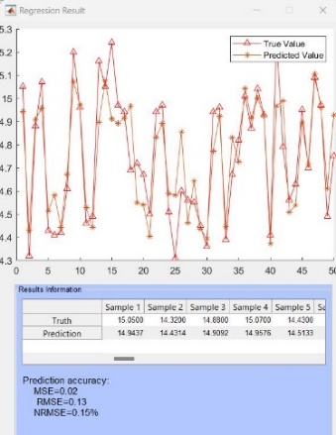  (a) | 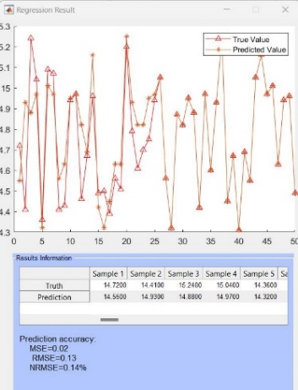  (b) |  | 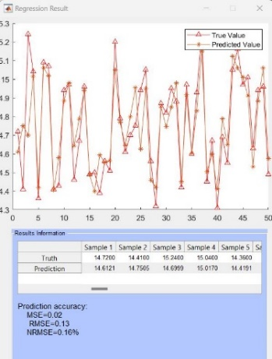  (c)
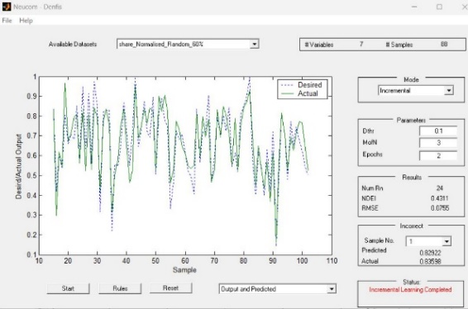  (d) |  | 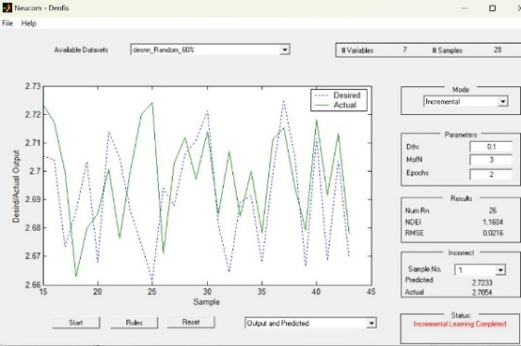  (e)
Fig.S1. Stock Price prediction modelling test results: (a) NeuCube - deSNN regressor with cross-validation optimization of 2 rounds, (b) NeuCube – Linear regressor with cross-validation optimization of 2 rounds, (c) NeuCube - SVM regressor with cross-validation optimization of 2 rounds, (d) DENFIS incremental validation, (e) NeuDen incremental validation.

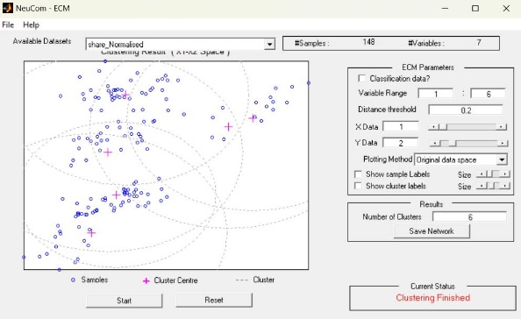  (a) | 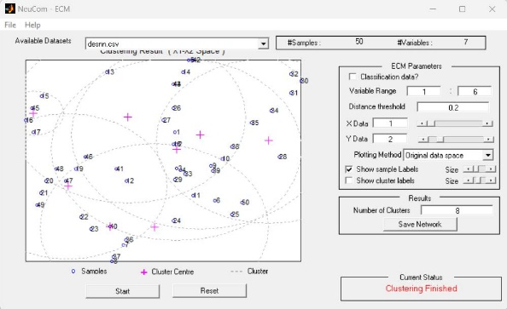  (b)
Fig.S2. (a) clustering of real data in DENFIS model; (b) clustering of feature-vectors in the NeuDen model.

