Supplementary Material

Global epidemiology and implications of PNPLA3 I148M variant in MASLD: a systematic review and meta-analysis

Matheus Souza (1), Lubna Al-Sharif (2), Ivanna Diaz (3), Alessandro Mantovani (4), Cristiane Alves Villela-Nogueira (1)

- Department of Internal Medicine, Federal University of Rio de Janeiro, Rio de Janeiro, Brazil
- An-Najah National University, Nablus, Palestine
- Department of Internal Medicine, SUNY Downstate Health Sciences University, Brooklyn, NY, United States
- Section of Endocrinology, Diabetes and Metabolism, University and Azienda Ospedaliera Universitaria Integrata of Verona, Verona, Italy

Table of contents

Supplementary Methods 2
Supplementary Tables 6
Supplementary References 38
Supplementary Figures 46

Supplementary Methods

Search strategy and study selection

The search strategy was as follows: (("PNPLA3" OR "patatin-like phospholipase domain-containing protein3" OR rs738409) OR genomic OR "molecular profiling" OR "molecular characterization") AND (NAFLD OR "non-alcoholic fatty liver" OR "nonalcoholic fatty liver" OR "nonalcoholic steatohepatitis" OR "fatty liver").

Based on recommendations of the Cochrane Collaboration,² we systematically managed overlapping studies. Initially, we identified studies sharing populations based on location, authorship, study setting, and study period. Subsequently, we recorded the outcomes that could be extracted from each study using a standardized format. To prioritize data comprehensiveness, we selected the study with the most extensive information for each outcome and subgroup, not necessarily the one with the largest sample size. Finally, studies lacking a sufficient population for any outcome were excluded.

Data extraction

Six studies included data from subgroups separately.^{3–8} We extracted data including: (i) study characteristics: first author, location, publication year, study design, population source, study period, follow-up (if applicable), MASLD diagnosis modality, genotyping method, and sample size; (ii) PNPLA3 genotype distribution: number of individuals for each PNPLA3 genotype or PNPLA3 G allele frequency; (iii) population characteristics: 1) demographics: age and sex; 2) adiposity: body mass index (BMI) and waist circumference (WC); 3) metabolic health: presence of hypertension, serum triglycerides (TG), total cholesterol (TC), low-density lipoprotein (LDL), high-density lipoprotein (HDL), presence of diabetes mellitus (DM), homeostatic model assessment for insulin resistance (HOMA-IR), serum fasting blood glucose (FBG), hemoglobin A1c (Hb1Ac) and insulin; 4) liver damage: alanine aminotransaminase (ALT), aspartate aminotransferase (AST), and gamma-glutamyl transferase (GGT); 5) histological characteristics: fibrosis stage and histological features of the NAFLD activity score (NAS) (steatosis, hepatocyte ballooning, and lobular inflammation), presence of metabolic dysfunction-associated steatohepatitis (MASH; defined by biopsy or fatty liver inhibition of progression algorithm⁹), significant fibrosis (defined as ≥F2 in biopsy) and advanced fibrosis (defined as ≥F3 in biopsy or liver stiffness ≥15 kPa); (iv) long-term outcomes: overall mortality, liver outcomes (liver-related events [LREs], cirrhosis and liver-related mortality), and cardiovascular outcomes (cardiovascular disease and cardiovascular mortality); and their adjustment and confounding factors included in multivariable regression analyses.

Quality assessment

For observational studies, we judged the risk of bias using the Newcastle-Ottawa Scale (NOS) and its modified versions according to study type.¹⁰ NOS uses a star system and involves three domains: selection of participants, comparability of study groups, and ascertainment of outcomes of interest.¹⁰ Moreover, we also added a fourth domain: the Hardy-Weinberg equilibrium (HWE) test and assigned a 1-star rating to studies in HWE. We considered case-control/cohort studies with a rating of ≥9 stars, 8-7 stars, and ≤6 stars to have a low, moderate, and high risk of bias, respectively; in cross-sectional studies, rates of ≥10 stars, 9–8 stars, and ≤7 stars were considered to have a low, moderate, and high risk of bias, respectively.¹⁰ For genome-wide association studies (GWAS), we assessed the risk of bias using the Quality of Genetic association studies (Q-Genie) tool.¹¹ Q-Genie evaluates the following aspects: study rationale, sample selection, exposure and outcome classifications, sources of bias, presentation of statistical plan, quality of statistical methods, test of assumptions, and interpretation of results.¹¹ We considered scores ≥46, 45-35, and ≤35 to have a low, moderate, and high risk of bias, respectively.¹¹

Data synthesis and analysis

Laboratory values originally reported in mmol/L were standardized to mg/L using the molar masses of the specific components, as described in Table S2. When there were missing values and the mean and standard deviation (SD) were not reported, we used the Box-Cox method described by McGrath et al. to convert continuous variables from median and range/interquartile range (range/IQR) to mean and SD.¹² For studies reporting the number of patients for each grading of each histological feature, if the average values of each feature were not available, we synthesized the histological scores by calculating the mean and SDs of the fibrosis stage and NAS histological features. Both values were estimated using the following formulas:
$$Mean of histological score \left(x\right)= \frac{∑\left(G_{i}*n_{i}\right)}{∑n_{i}}$$
$$SD of histological score=\sqrt{\frac{1}{∑n_{i}-1}*∑\left({\left(G_{i}-x\right)}^{2}*n_{i}\right)}$$

where $G_{i}$ is the grade of one histological feature (Fibrosis grade: 0-4; Steatosis grade: 0-3; Inflammation grade: 0-3 and Ballooning grade: 0-3); and $n_{i}$ is the number of patients classified in each grade of the corresponding histological feature. We were unable to calculate the SD of NAS from the values of their histological features because we had no enough information on the distribution of NAS values in each study population.

We performed subgroup analyses to examine how different factors related to both study characteristics (such as location, setting, MASLD diagnosis method, sample size, risk of bias) and population characteristics (such as age, sex, BMI, DM, MASLD severity) influenced the minor allele frequency (MAF) of the G allele at PNPLA3 rs738409 in MASLD patients. Studies focusing on subgroups of interest (e.g., male, lean, diabetic, with HCC) were excluded from the overall analysis, and included in our subgroup analyses. For clinical and histological outcomes, we conducted subgroup analyses by world region. To explore the sources of heterogeneity across included studies and examine associations between PNPLA3 gene expression and potential moderators, univariate meta-regression analyses were conducted. These analyses tested the association of specific moderator variables - such as age, sex, BMI, WC, and DM - and mean differences in liver damage (ALT, AST), lipid metabolism (TG), and fibrosis stage in both PNPLA3 genotype comparisons. To ensure the robustness of our results, we also conducted sensitivity analyses. For the primary outcome, we excluded studies with HWE deviation and those without biopsy-proven MASLD patients. For the clinical and histological analyses, we excluded studies without biopsy-proven MASLD patients. Publication bias was evaluated by visual analysis of funnel plots and Egger's regression test for analyses involving ≥10 studies.¹³ Trim-and-fill method was performed to adjust any potential publication bias.¹⁴

Supplementary Tables

Table S1 – PRISMA checklist
Section and Topic | Item # | Checklist item | Location where item is reported
TITLE
Title | 1 | Identify the report as a systematic review. | Page 1
ABSTRACT
Abstract | 2 | See the PRISMA 2020 for Abstracts checklist. | Page 3
INTRODUCTION
Rationale | 3 | Describe the rationale for the review in the context of existing knowledge. | Page 5
Objectives | 4 | Provide an explicit statement of the objective(s) or question(s) the review addresses. | Page 5
METHODS
Eligibility criteria | 5 | Specify the inclusion and exclusion criteria for the review and how studies were grouped for the syntheses. | Page 6 and Supplementary methods
Information sources | 6 | Specify all databases, registers, websites, organisations, reference lists and other sources searched or consulted to identify studies. Specify the date when each source was last searched or consulted. | Page 6
Search strategy | 7 | Present the full search strategies for all databases, registers and websites, including any filters and limits used. | Supplementary methods
Selection process | 8 | Specify the methods used to decide whether a study met the inclusion criteria of the review, including how many reviewers screened each record and each report retrieved, whether they worked independently, and if applicable, details of automation tools used in the process. | Page 6
Data collection process | 9 | Specify the methods used to collect data from reports, including how many reviewers collected data from each report, whether they worked independently, any processes for obtaining or confirming data from study investigators, and if applicable, details of automation tools used in the process. | Page 6 and Supplementary methods
Data items | 10a | List and define all outcomes for which data were sought. Specify whether all results that were compatible with each outcome domain in each study were sought (e.g. for all measures, time points, analyses), and if not, the methods used to decide which results to collect. | Supplementary methods
Data items | 10b | List and define all other variables for which data were sought (e.g. participant and intervention characteristics, funding sources). Describe any assumptions made about any missing or unclear information. | Supplementary methods
Study risk of bias assessment | 11 | Specify the methods used to assess risk of bias in the included studies, including details of the tool(s) used, how many reviewers assessed each study and whether they worked independently, and if applicable, details of automation tools used in the process. | Page 6 and Supplementary methods
Effect measures | 12 | Specify for each outcome the effect measure(s) (e.g. risk ratio, mean difference) used in the synthesis or presentation of results. | Page 7
Synthesis methods | 13a | Describe the processes used to decide which studies were eligible for each synthesis (e.g. tabulating the study intervention characteristics and comparing against the planned groups for each synthesis (item #5)). | Page 7
Synthesis methods | 13b | Describe any methods required to prepare the data for presentation or synthesis, such as handling of missing summary statistics, or data conversions. | Supplementary methods
Synthesis methods | 13c | Describe any methods used to tabulate or visually display results of individual studies and syntheses. | Page 7
Synthesis methods | 13d | Describe any methods used to synthesize results and provide a rationale for the choice(s). If meta-analysis was performed, describe the model(s), method(s) to identify the presence and extent of statistical heterogeneity, and software package(s) used. | Page 7
Synthesis methods | 13e | Describe any methods used to explore possible causes of heterogeneity among study results (e.g. subgroup analysis, meta-regression). | Page 7 and Supplementary methods
Synthesis methods | 13f | Describe any sensitivity analyses conducted to assess robustness of the synthesized results. | Supplementary methods
Reporting bias assessment | 14 | Describe any methods used to assess risk of bias due to missing results in a synthesis (arising from reporting biases). | Page 7
Certainty assessment | 15 | Describe any methods used to assess certainty (or confidence) in the body of evidence for an outcome. | NA
RESULTS
Study selection | 16a | Describe the results of the search and selection process, from the number of records identified in the search to the number of studies included in the review, ideally using a flow diagram. | Figure S1, Page 8
Study selection | 16b | Cite studies that might appear to meet the inclusion criteria, but which were excluded, and explain why they were excluded. | Figure S1, Page 8
Study characteristics | 17 | Cite each included study and present its characteristics. | Tables S4-8
Risk of bias in studies | 18 | Present assessments of risk of bias for each included study. | Page 8, Figure S2
Results of individual studies | 19 | For all outcomes, present, for each study: (a) summary statistics for each group (where appropriate) and (b) an effect estimate and its precision (e.g. confidence/credible interval), ideally using structured tables or plots. | Tables 1-2, Tables S9-18, Figures S3-16
Results of syntheses | 20a | For each synthesis, briefly summarise the characteristics and risk of bias among contributing studies. | Page 8
Results of syntheses | 20b | Present results of all statistical syntheses conducted. If meta-analysis was done, present for each the summary estimate and its precision (e.g. confidence/credible interval) and measures of statistical heterogeneity. If comparing groups, describe the direction of the effect. | Pages 8-12
Results of syntheses | 20c | Present results of all investigations of possible causes of heterogeneity among study results. | Pages 8-12
Results of syntheses | 20d | Present results of all sensitivity analyses conducted to assess the robustness of the synthesized results. | Pages 9-12
Reporting biases | 21 | Present assessments of risk of bias due to missing results (arising from reporting biases) for each synthesis assessed. | Pages 9-12, Figures S4, S7
Certainty of evidence | 22 | Present assessments of certainty (or confidence) in the body of evidence for each outcome assessed. | Tables 1-2, Tables S9-18, Figures S3-16
DISCUSSION
Discussion | 23a | Provide a general interpretation of the results in the context of other evidence. | Pages 12-16
Discussion | 23b | Discuss any limitations of the evidence included in the review. | Pages 15
Discussion | 23c | Discuss any limitations of the review processes used. | Pages 15
Discussion | 23d | Discuss implications of the results for practice, policy, and future research. | Pages 12-16
OTHER INFORMATION
Registration and protocol | 24a | Provide registration information for the review, including register name and registration number, or state that the review was not registered. | Page 6, Supplementary methods
Registration and protocol | 24b | Indicate where the review protocol can be accessed, or state that a protocol was not prepared. | Page 6, Supplementary methods
Registration and protocol | 24c | Describe and explain any amendments to information provided at registration or in the protocol. | NA
Support | 25 | Describe sources of financial or non-financial support for the review, and the role of the funders or sponsors in the review. | Page 2
Competing interests | 26 | Declare any competing interests of review authors. | Page 2
Availability of data, code and other materials | 27 | Report which of the following are publicly available and where they can be found: template data collection forms; data extracted from included studies; data used for all analyses; analytic code; any other materials used in the review. | NA

From: Page MJ, McKenzie JE, Bossuyt PM, Boutron I, Hoffmann TC, Mulrow CD, et al. The PRISMA 2020 statement: an updated guideline for reporting systematic reviews. BMJ 2021;372:n71. doi: 10.1136/bmj.n71

Table S2 – Common units adopted and their respective conversions

Laboratory parameter | Common unit | Conversions
TG | mg/dL | 1 mmol/L = 88.57 mg/dL
TC | mg/dL | 1 mmol/L = 38.67 mg/dL
LDL | mg/dL | 1 mmol/L = 38.67 mg/dL
HDL | mg/dL | 1 mmol/L = 38.67 mg/dL
FBG | mg/dL | 1 mmol/L = 18.018 mg/dL
TG, triglycerides; TC, total cholesterol; LDL, low-density lipoprotein; HDL, high-density lipoprotein; FBG, fasting blood glucose.

Table S3 - Studies excluded during PRISMA eligibility step

First author | Year | DOI (for published articles) | Reason for exclusion
Kozlitina et al. | 2023 | 10.1016/j.eclinm.2023.10235 | Unsatisfactory population
Wajsbrot et al. | 2023 | 10.1007/s10620-023-08214-7 | Unsatisfactory population
Tai et al. | 2023 | 10.1111/cas.16042 | Unsatisfactory population
Niltwat et al. | 2023 | 10.1111/liv.15758 | Unsatisfactory population
Meroni et al. | 2023 | 10.3390/ijms24201504 | Overlapping population
Yoshimura et al. | 2023 | 10.1590/S0004-2803.202301000-13 | Overlapping population
Gellert-Kristensen et al. | 2023 | 10.1111/liv.15629 | Unsatisfactory population
Miller et al. | 2023 | 10.1097/HC9.0000000000000148 | Overlapping population
Trejo et al. | 2023 | 10.1016/j.aohep.2023.101120 | Unsatisfactory population
Sun et al. | 2023 | 10.1016/j.jhepr.2023.100744 | Unsatisfactory outcome
Castañé et al. | 2023 | - | Abstract
Kawanaka et al. | 2023 | 10.1111/hepr.13911 | Unsatisfactory outcome
del Campo et al. | 2023 | - | Abstract
Rosoff et al. | 2023 | - | Abstract
Rosso et al. | 2023 | - | Abstract
Villavicencio et al. | 2023 | 10.3389/fpubh.2022.1090101 | Unsatisfactory outcome
Armisen et al. | 2023 | - | Abstract
Motta et al. | 2023 | - | Abstract
Lavrado et al. | 2023 | - | Abstract
Wang et al. | 2023 | - | Abstract
Wijarnpreecha et al. | 2023 | - | Abstract
Ito et al. | 2023 | 10.2169/internalmedicine | Unsatisfactory outcome
Kogiso et al. | 2023 | - | Abstract
Seko et al. | 2023 | 10.1111/liv.15678 | Unsatisfactory population
Yu et al. | 2023 | 10.3389/fendo.2023.1156381 | Unsatisfactory outcome
Kim et al. | 2023 | 10.1007/s13258-023-01391-9 | Unsatisfactory outcome
Koo et al. | 2023 | 10.1016/j.cgh.2022.02.026 | Research letter
Ge et al. | 2023 | 10.1111/liv.15588 | Unsatisfactory outcome
Li et al. | 2023 | 10.1016/j.ebiom.2023.104543 | Unsatisfactory outcome
Nádasdi et al. | 2023 | 10.1186/s12933-023-01792-w | Unsatisfactory population
Zheng et al. | 2023 | 10.1016/j.jhepr.2023.100692 | Unsatisfactory outcome
Ajmera et al. | 2023 | 10.1111/apt.17452 | Unsatisfactory outcome
Son et al. | 2023 | 10.1016/j.ajcnut.2023.02.024. | Overlapping population
Fernandes Silva et al. | 2023 | 10.3390/metabo13020267 | Unsatisfactory outcome
Di Sessa et al. | 2023 | 10.1007/s40618-023-02041-3 | Unsatisfactory population
Li et al. | 2023 | 10.1186/s12902-022-01234-w | Unsatisfactory outcome
Choe et al. | 2023 | 10.1002/jcsm.13125 | Overlapping population
Rutledge et al. | 2023 | 10.1016/j.cgh.2022.12.025 | Unsatisfactory population
Tong et al. | 2023 | 10.1111/1751-2980.13163 | Unsatisfactory outcome
Wang et al. | 2023 | 10.1016/j.immuni.2022.11.013 | Unsatisfactory outcome
Käräjämäki et al. | 2023 | 10.1097/FPC.0000000000000489 | Unsatisfactory outcome
Zhang et al. | 2023 | 10.1186/s12957-022-02828-3 | Unsatisfactory outcome
Rivera-Iñiguez et al. | 2023 | 10.1016/j.aohep.2022.100874 | Unsatisfactory study design
Yeung et al. | 2023 | 10.1093/ije/dyac212 | Unsatisfactory outcome
Sheng et al. | 2023 | 10.4103/sjg.sjg_297_22 | Unsatisfactory outcome
Machida et al. | 2023 | 10.1016/j.aohep.2022.100761 | Unsatisfactory population
Paolini et al. | 2023 | 10.3389/fnut.2023.1101341 | Overlapping population
Zhao et al. | 2022 | 10.3389/fnut.2022.971913 | Unsatisfactory outcome
Mantovani et al. | 2022 | 10.1007/s42000-022-00387-6 | Overlapping population
Sabotta et al. | 2022 | 10.3389/fgene.2022.995488 | Unsatisfactory outcome
Näslund-Koch et al. | 2022 | 10.3389/fimmu.2022.1022460 | Unsatisfactory outcome
Seko et al. | 2022 | 10.1038/s41598-022-22729-5 | Overlapping population
Torres-Reyes et al. | 2022 | 10.1016/j.aohep.2022.100767 | Unsatisfactory outcome
Pennisi et al. | 2022 | 10.1002/hep4.1877 | Overlapping population
Larsson et al. | 2022 | 10.1016/j.metabol.2022.155329 | Unsatisfactory outcome
Chahal et al. | 2022 | 10.1007/s12072-022-10304-z | Unsatisfactory outcome
Kubilin et al. | 2022 | 10.1111/liv.15322 | Unsatisfactory population
Gabriel-Medina et al. | 2022 | 10.3390/biomedicines10051015 | Unsatisfactory outcome
Iwaki et al. | 2022 | 10.1002/jgh3.12808 | Unsatisfactory outcome
Vilar-Gomez et al. (2022) | 2022 | 10.1002/hep.32491 | Overlapping population
Kasai et al. | 2022 | 10.14309/ctg.0000000000000503 | Unsatisfactory outcome
Thomas et al. | 2022 | 10.1002/hep4.1976 | Unsatisfactory outcome
Cheng et al. | 2022 | 10.1016/j.jprot.2022.104556 | Unsatisfactory outcome
Liu et al. | 2022 | 10.1016/j.cgh.2020.12.033 | Unsatisfactory outcome
Miller et al. | 2022 | - | Abstract
Rosqvist et al. | 2022 | 10.1016/j.clnu.2022.02.005 | Unsatisfactory population
Baratta et al. | 2022 | 10.3390/biomedicines10030720 | Unsatisfactory outcome
Luukkonen et al. | 2022 | 10.1016/j.jhep.2021.10.013 | Unsatisfactory population
Chakravorty et al. | 2022 | - | Abstract
Meritsi et al. | 2022 | 10.1089/met.2021.0098 | Unsatisfactory population
Pirola et al. | 2022 | 10.1016/j.ebiom.2022.103858 | Unsatisfactory outcome
Cinque et al. | 2022 | 10.3390/nu14030556 | Overlapping population
Näslund-Koc et al. | 2022 | 10.3389/fimmu.2022.1022460 | Overlapping population
Ma et al. | 2021 | 10.1111/jgh.15554 | Unsatisfactory outcome
Lang et al. | 2021 | 10.1111/liv.14899 | Overlapping population
Wang et al. | 2021 | 10.1002/hep4.1751 | Unsatisfactory outcome
Vilar-Gomez et al. | 2021 | 10.14309/ctg.0000000000000400 | Overlapping population
Pennisi et al. | 2021 | 10.1016/j.cgh.2020.09.009 | Overlapping population
Zhang et al. | 2021 | 10.3748/wjg.v27.i25.3863 | Overlapping population
Ma et al. | 2021 | 10.5152/tjg.2021.20522 | Unsatisfactory outcome
Kogiso et al. | 2021 | 10.1016/j.aohep.2020.09.004 | Overlapping population
Vilar-Gomez et al. | 2021 | 10.14309/ajg.0000000000001072 | Overlapping population
Bianco et al. | 2021 | 10.1016/j.jhep.2020.11.024 | Unsatisfactory outcome
Kogiso et al. | 2021 | 10.1016/j.nut.2020.111080 | Overlapping population
Semmler et al. | 2021 | 10.3390/jpm11030165 | Unsatisfactory population
Tsai et al. | 2021 | - | Abstract
Dallio et al. | 2021 | 10.3389/fmed.2021.734847 | Unsatisfactory study design
Iacob et al. | 2021 | 10.3389/fnut.2021.787430 | Overlapping population
Al-Qarni et al. | 2020 | 10.1097/MD.0000000000021463 | Unsatisfactory outcome
Chung et al. | 2020 | - | Abstract
Mann et al. | 2020 | 10.1093/hmg/ddaa162 | Unsatisfactory population
Azevedo Foinquinos et al. | 2020 | 10.1016/j.orcp.2020.07.004 | Unsatisfactory population
Bruschi et al. | 2020 | 10.1111/liv.14402 | Unsatisfactory outcome
Zeng et al. | 2020 | 10.3748/wjg.v26.i15.1792 | Unsatisfactory outcome
Kallwitz et al. | 2020 | 10.1111/liv.14387 | Unsatisfactory outcome
Unalp-Arida et al. | 2020 | 10.1002/hep.31032 | Unsatisfactory population
Seko et al. | 2020 | 10.1111/liv.14495 | Overlapping population
Monga Kravetz et al. | 2020 | 10.1210/clinem/dgaa382 | Unsatisfactory population
Iritani et al.* | 2020 | 10.1186/s12876-020-01509-3 | Overlapping population
Wu et al. | 2020 | 10.1186/s12944-020-01207-9 | Overlapping population
Chen et al. | 2020 | 10.1515/biol-2020-0081 | Unsatisfactory population
Walker et al. | 2020 | 10.1016/j.jhep.2020.01.029 | Unsatisfactory outcome
Muto et al. | 2020 | 10.2147/DMSO.S217597 | Overlapping population
Wijarnpreecha et al. | 2020 | - | Abstract
Serper et al. | 2020 | 10.1371/journal.pone.0237430 | Unsatisfactory population
Sun et al. | 2019 | 10.1111/liv.14251 | Unsatisfactory population
Seko et al. | 2019 | 10.3390/ijms21010171 | Overlapping population
Wang et al. | 2019 | 10.1007/s12072-019-09982-z | Unsatisfactory outcome
Bellan et al. | 2019 | 10.4093/dmj.2018.0201 | Unsatisfactory population
Seko et al. | 2019 | 10.1111/hepr.13321 | Overlapping population
Xu et al. | 2019 | 10.1016/j.aohep.2018.10.005 | Unsatisfactory outcome
Tobari et al. | 2019 | 10.1111/jgh.14585 | Unsatisfactory outcome
Nadasdi et al. | 2018 | - | Abstract
Koo et al. | 2018 | 10.1111/jgh.14056 | Overlapping population
Petta et al. | 2018 | 10.1111/liv.13743 | Overlapping population
Denkmayr et al.* | 2018 | 10.3390/jcm7120562 | Overlapping population
Seko et al. | 2018 | 10.1007/s00535-017-1372-8 | Overlapping population
Aller et al | 2018 | 10.17235/reed.2018.5602/2018 | Unsatisfactory outcome
Tepper et al. | 2018 | 10.1002/cncr.31122 | Unsatisfactory population
Chinchilla-López et al. | 2018 | 10.5604/01.3001.0010.8644 | Unsatisfactory outcome
Younes et al. | 2018 | - | Abstract
Rosso et al. | 2018 | - | Abstract
Kleinstein et al. | 2018 | 10.1002/hep4.1227 | Unsatisfactory population
Krawczyk et al. | 2017 | 10.1194/jlr.P067454 | Overlapping population
Carpino et al. | 2017 | 10.1038/s41598-017-15943-z | Overlapping population
Stender et al. | 2017 | 10.1038/ng.3855 | Unsatisfactory outcome
Fracanzani et al. | 2017 | 10.1016/j.cgh.2017.04.045 | Unsatisfactory outcome
Isokuortti et al. | 2017 | 10.1007/s00125-017-4340-1 | Unsatisfactory outcome
Kantartzis et al. | 2017 | 10.1016/j.diabet.2016.11.006 | Unsatisfactory outcome
Donati et al. | 2017 | 10.1038/s41598-017-04991-0 | Overlapping population
Seko et al. | 2017 | 10.1111/hepr.12840 | Unsatisfactory population
Petta et al. | 2017 | 10.1002/hep.29395 | Overlapping population
Wood et al. | 2017 | 10.1038/srep43238 | Unsatisfactory population
Kawamura et al. | 2017 | 10.2169/internalmedicine.56.7830 | Unsatisfactory population
Käräjämäki et al. | 2017 | 10.1016/j.metabol.2016.06.009 | Unsatisfactory outcome
Feldman et al. | 2017 | 10.1038/ajg.2016.318 | Unsatisfactory outcome
Krawczy et al. | 2017 | 10.1194/jlr.P067454 | Unsatisfactory outcome
Nakajima et al. | 2017 | - | Abstract
Di Costanzo et al. | 2017 | 10.1016/j.atherosclerosis.2016.12.018 | Overlapping population
Fracanzani et al. | 2016 | 10.1371/journal.pone.0162473 | Unsatisfactory outcome
Song et al. | 2016 | 10.1097/MD.0000000000004569 | Unsatisfactory outcome
Zhou et al. | 2016 | 10.1016/j.cgh.2016.05.046 | Unsatisfactory population
Zhang et al. | 2016 | 10.1007/s10620-016-4120-7 | Overlapping population
Tai et al. | 2016 | 10.1097/MD.0000000000003120 | Unsatisfactory population
Mancina et al. | 2016 | 10.1053/j.gastro.2016.01.032 | Overlapping population
Luukkonen et al. | 2016 | 10.1016/j.jhep.2016.01.002 | Unsatisfactory population
Akuta et al. | 2016 | 10.5009/gnl15163 | Overlapping population
Donati et al. | 2016 | 10.1002/hep.28370 | Overlapping population
Cheng et al. | 2016 | - | Abstract
Ueyama et al. | 2016 | 10.1007/s00535-015-1116-6 | Unsatisfactory population
Krawczy et al. | 2016 | 10.1159/000441185 | Unsatisfactory outcome
Wei et al. | 2015 | 10.1038/ajg.2015.235 | Overlapping population
Dongiovanni et al.* | 2015 | 10.1002/hep.27490 | Overlapping population
Dongiovanni et al. | 2015 | 10.1016/j.jhep.2015.05.006 | Unsatisfactory outcome
León-Mimila et al. | 2015 | 10.1016/j.yexmp.2015.01.012 | Unsatisfactory population
Zhou et al. | 2015 | 10.1016/j.jhep.2014.10.010 | Overlapping population
Oniki et al. | 2015 | 10.1371/journal.pone.0132640 | Overlapping population
Musso et al* | 2015 | 10.1002/hep.27643 | Comment
Kitamoto et al. | 2015 | 10.1016/j.jhep.2015.02.049 | Overlapping population
Dongiovanni et al. | 2015 | 10.1002/hep.27490 | Unsatisfactory outcome
Tai et al. | 2015 | 10.1016/j.soard.2014.07.016 | Unsatisfactory population
Scorletti et al. | 2015 | 10.1016/j.jhep.2015.07.036 | Unsatisfactory study design
Cavalcante et al. | 2015 | 10.4254/wjh.v7.i10.1433 | Unsatisfactory outcome
Zhang et al. | 2014 | 10.1371/journal.pone.0108381 | Overlapping population
Rametta et al. | 2014 | 10.1111/eci.12280 | Overlapping population
Hyysalo et al. | 2014 | 10.1016/j.jhep.2013.12.009 | Unsatisfactory population
Niu et al. | 2014 | 10.3748/wjg.v20.i13.3655 | Overlapping population
Petta et al. | 2014 | 10.1371/journal.pone.0087523 | Overlapping population
Lin et al. | 2014 | 10.3945/ajcn.113.079749 | Unsatisfactory population
Shen et al. | 2014 | 10.1111/apt.12609 | Overlapping population
Xu et al. | 2013 | 10.3760/cma.j.issn.1007-3418.2013.08.013 | Unsatisfactory outcome
Petta et al. | 2013 | 10.1371/journal.pone.0074089 | Overlapping population
Guichelaar et al. | 2013 | 10.1002/oby.20327 | Unsatisfactory population
Guider et al. | 2013 | - | Abstract
Petäjä et al. | 2013 | 10.1002/oby.20114 | Unsatisfactory outcome
Avanthi et al. | 2013 | - | Abstract
Dunn et al. | 2012 | 10.1038/ajg.2012.285 | Unsatisfactory population
Krarup et al. | 2012 | 10.1371/journal.pone.0040376 | Unsatisfactory population
Al-Serri et al. | 2012 | 10.1016/j.jhep.2011.05.029 | Unsatisfactory population
Argo et al. | 2012 | - | Abstract
Petta et al. | 2012 | 10.1016/j.jhep.2012.01.007 | Overlapping population
Wagenknecht et al. | 2011 | 10.1111/j.1478-3231.2010.02444.x | Unsatisfactory outcome
Takeuchi et al. | 2011 | - | Abstract
Zain et al. | 2011 | - | Abstract
Falleti et al. | 2011 | 10.1111/j.1478-3231.2011.02534.x | Unsatisfactory population
Perez-Luque et al. | 2011 | - | Abstract
Rotman et al. | 2010 | 10.1002/hep.23759 | Overlapping population
Speliotes et al. | 2010 | 10.1002/hep.23768 | Unsatisfactory outcome
Valenti et al. | 2010 | 10.1002/hep.23622 | Overlapping population
Krawczyk et al. | 2010 | - | Abstract
Kantartzis et al. | 2009 | 10.2337/db09-0279 | Unsatisfactory population
Kotronen et al. | 2009 | 10.1007/s00125-009-1285-z | Unsatisfactory outcome
Kotronen et al. | 2009 | 10.1053/j.gastro.2009.06.005 | Unsatisfactory outcome
Romeo et al. | 2008 | 10.1038/ng.257 | Unsatisfactory outcome
*Studies excluded in citation searching's screening way

Table S4 – Main characteristics of the eligible studies

First author | Year | Study period | Country | Study type | Study setting | Diagnosis | Genotyping method | Risk of bias
Jarasvaraparn et al.¹⁵ | 2023 | 2004-2020 | United States | CSC | HC | Biopsy | TaqMan | Moderate
Kirchmeyer et al.¹⁶ | 2023 | - | Germany | CSC | HC | - | TaqMan | Moderate
Lombardi et al.¹⁷ | 2023 | 1990-2021 | Italy | RC | HC | Biopsy | TaqMan | Low
Park et al.¹⁸ | 2023 | 2014-2015 | South Korea | CSC | HC | Ultrasound | - | High
Rosso et al.¹⁹ | 2023 | 1995-2015 | Italy, UK, Spain | RC | HC | Biopsy | TaqMan | Moderate
Semmler et al.²⁰ | 2023 | 2010-2014 | Austria | RC | HC | Ultrasound | TaqMan | Low
Wijarnpreecha et al.²¹ | 2023 | 2012-2021 | United States | RC | HC | Ultrasound | Microarray | Low
Chen et al.²² | 2023 | 2006-2010 | United Kingdom | PC | PB | Serum liver enzymes/ICD codes | Mixed | Moderate
Kim et al.²³ | 2023 | 2016 | South Korea | PC | HC | Ultrasound | TaqMan | Low
Oh et al.²⁴ | 2023 | 2004-2012 | South Korea | CC | PB | - | - | Low
Wu et al.²⁵ | 2022 | 2017 | China | CC | PB | Ultrasound | Mass spectrometry | Low
Seko et al.²⁶ | 2022 | 2013-2020 | Japan | RC | HC | Biopsy | TaqMan | Moderate
Holmer et al.²⁷ | 2022 | 1974-2019 | Sweden | RC | HC | Mixed | TaqMan | Low
Li et al.²⁸ | 2022 | 2017-2019 | China | CSC | HC | Biopsy | Mass spectrometer | Moderate
Yang et al.²⁹ | 2022 | 2020-2021 | China | CSC | HC | Ultrasound | TaqMan | Moderate
Cavalcante et al.³⁰ | 2022 | - | Brazil | CSC | HC | Biopsy | TaqMan | High
Mana et al.³¹ | 2022 | 2018-2020 | Brazil | RC | HC | Ultrasound | TaqMan | Low
Xu et al.³² | 2022 | 2016-2018 | China | RC | HC | Biopsy | Mass spectrometry | Low
Adnan et al.³³ | 2022 | 2019-2020 | Pakistan | CSC | PB | Ultrasound | TaqMan | High
Lazo et al.³⁴ | 2022 | 2016 | Guatemala | RC | PB | Serum liver enzymes | Mass spectrometry | Moderate
Yuan et al.³⁵ | 2022 | 2015-2016 | China | CC | PB | Ultrasound | Mass spectrometry | Moderate
Fridén et al.³⁶ | 2022 | - | Sweden | CSC | HC | Biopsy | TaqMan | High
Garcia et al.³⁷ | 2022 | 2019-2020 | United States | CSC | PB | VCTE | TaqMan | Moderate
Maleki et al. (clinical based cohort)³ | 2022 | - | Iran | CC | HC | Ultrasound | PCR-RFLP | Moderate
Maleki et al. (PB cohort)³ | 2022 | 2010-2011 | Iran | CC | PB | Ultrasound | PCR-RFLP | Moderate
Pan et al.³⁸ | 2022 | - | China | CSC | HC | Biopsy | Mass spectrometry | Moderate
Bale et al.³⁹ | 2022 | - | India | CC | HC | Ultrasound | Real-time PCR | Moderate
Najafi et al.⁴⁰ | 2022 | 2017-2018 | Iran | CC | HC | Biopsy/Ultrasound | PCR-SSCP | High
Gavril et al.⁴¹ | 2021 | - | Romania | CSC | HC | Ultrasound | HRM | Low
Akuta et al.⁴² | 2021 | 1976-2021 | Japan | RC | HC | Biopsy | TaqMan | High
Villani et al.⁴³ | 2021 | 2016-2020 | Italy | RC | HC | Ultrasound | - | Moderate
Flores et al.⁴⁴ | 2021 | 2004-2018 | Mexico | CC | PB | Ultrasound | TaqMan | Low
Lin et al.⁴⁵ | 2021 | 2008-2010 | Hong Kong | CSC | PB | MRS | Real-time PCR | Low
Zhang et al.⁴⁶ | 2021 | 2012-2013 | China | RC | HC | Biopsy | NGS | Low
Akkiz et al.⁴⁷ | 2021 | - | Turkey | RC | HC | Biopsy | Real-time PCR | Moderate
Paternostro et al.⁴⁸ | 2021 | - | Austria, Switzerland, Germany | RC | HC | Biopsy | TaqMan | Moderate
Seko et al.⁴⁹ | 2021 | 2002-2019 | Japan | RC | HC | Biopsy | TaqMan | Low
Meroni et al.⁵⁰ | 2021 | - | Italy | RC | HC | Ultrasound | TaqMan | Moderate
Moon et al. (GENIE)⁴ | 2021 | 2014 | South Korea | CSC | PB | Ultrasound | Axiom | Moderate
Moon et al. (Boramae)⁴ | 2021 | - | South Korea | CSC | PB | Biopsy | TaqMan | Moderate
Gao et al.⁵ | 2021 | 2016-2019 | China | CSC | HC | Biopsy | Mixed | Moderate
Younes et al.⁵¹ | 2021 | 1990-2016 | Italy, UK, Spain, Australia | RC | HC | Biopsy | TaqMan | Low
Lee et al.⁵² | 2021 | - | Singapore | CC | HC | CT/MRI/VCTE/Biopsy | TaqMan | Moderate
Lisboa et al.⁵³ | 2021 | - | Brazil | CSC | HC | Biopsy | TaqMan | Moderate
Idilman et al.⁵⁴ | 2020 | 2010-2014 | Turkey | RC | HC | Biopsy | Real-time PCR | Moderate
Wijarnpreecha et al.⁵⁵ | 2020 | 1991-2015 | United States | RC | PB | Ultrasound | Mass spectrometry | Low
Delik et al.⁵⁶ | 2020 | 2016-2018 | Turkey | CC | HC | Biopsy | TaqMan | High
Mantovani et al.⁵⁷ | 2020 | - | Italy | CSC | HC | Ultrasound | TaqMan | Low
Koo et al.⁵⁸ | 2020 | - | South Korea | PC | PB | Biopsy | TaqMan | Moderate
Narayanasamy et al.⁵⁹ | 2020 | 2016-2018 | India | CC | HC | Ultrasound | TaqMan | Moderate
Wijarnpreecha et al.⁶⁰ | 2020 | 1991-2015 | United States | RC | PB | Ultrasound | Mass spectrometry | Low
Yüksel et al.⁶¹ | 2020 | - | Turkey | RC | HC | Ultrasound | Real-time PCR | High
Delik et al.⁶² | 2020 | - | Turkey | CC | HC | Biopsy | - | High
Nikitin et al.⁶³ | 2020 | 2007-2019 | Russia | CC | HC | Ultrasound | TRFLP | Moderate
Käräjämäki et al.⁶⁴ | 2019 | - | Finland | PC | PB | Ultrasound | TaqMan | Low
Karamfilova et al.⁶⁵ | 2019 | - | Bulgaria | CC | HC | Ultrasound | PCR-RFLP | Moderate
Arai et al.⁶⁶ | 2019 | 2013-2018 | Japan | RC | HC | Biopsy | TaqMan | High
Liu et al.⁶⁷ | 2019 | 2017-2019 | China | CSC | PB | Biopsy | Mass spectrometry | Moderate
Kim et al.⁶⁸ | 2019 | 2013-2018 | South Korea | CSC | PB | Biopsy | TaqMan | Moderate
Grimaudo et al.⁶⁹ | 2019 | 2004-2018 | Italy | PC | HC | Biopsy | TaqMan | Low
Karoli et al.⁷⁰ | 2019 | 2015-2016 | India | CC | HC | Ultrasound | TaqMan | Moderate
Mazo et al.⁷¹ | 2019 | - | Brazil | CSC | HC | Biopsy | TaqMan | Moderate
Chen et al.⁷² | 2019 | - | China | RC | HC | Ultrasound | Real-time PCR | Moderate
Niriella et al.⁷³ | 2018 | 2007-2014 | Sri Lanka | CC | PB | Ultrasound | - | Moderate
Vespasiani-Gentilucci et al.⁷⁴ | 2018 | - | Italy | CC | HC | Biopsy | TaqMan | Moderate
Yang et al.⁷⁵ | 2018 | 2016 | China | CSC | PB | Ultrasound | - | Low
Di Costanzo et al.⁷⁶ | 2018 | - | Italy | RC | HC | Ultrasound | TaqMan | Moderate
Krawczyk et al.⁷⁷ | 2018 | - | Germany | RC | HC | Ultrasound/MRI/CT/Biopsy | TaqMan | High
Larrieta-Carrasco et al.⁷⁸ | 2018 | 2004-2013 | Mexico | CC | PB | Serum liver enzymes | - | Low
Chung et al.⁶ | 2018 | 2014 | South Korea | GWAS | PB | Ultrasound | Axiom | Low
Alam et al.⁷⁹ | 2017 | 2014-2016 | India | CC | HC | Ultrasound | TaqMan | Moderate
Niriella et al.⁸⁰ | 2017 | 2007-2014 | Sri Lanka | CC | PB | Ultrasound | - | High
Jiang et al.⁷ | 2017 | 2009-2015 | United States | PC | HC | Biopsy | TaqMan | Low
Uygun et al.⁸¹ | 2017 | 2012-2015 | Turkey | CC | HC | Biopsy | LightSNiP | Moderate
Kantartzis et al.⁸² | 2017 | - | Germany | CSC | PB | MRI | TaqMan | Moderate
Martínez et al.⁸³ | 2017 | - | Mexico | CC | PB | Ultrasound | TaqMan | High
Stättermayer et al.⁸⁴ | 2017 | - | Austria | RC | HC | Biopsy | TaqMan | High
Leung et al.⁸⁵ | 2017 | - | Hong Kong | PC | HC | Biopsy | TaqMan | Low
Vernekar et al.⁸⁶ | 2016 | - | India | CC | HC | Ultrasound/Serum liver enzymes/Biopsy | PCR | Moderate
Wang et al.⁸⁷ | 2016 | - | China | RC | HC | Ultrasound | TaqMan | Moderate
Vespasiani-Gentilucci et al.⁸⁸ | 2016 | - | Italy | CC | HC | Biopsy | Pyrosequencing | Moderate
Xia et al.⁸⁹ | 2016 | 2010-2012 | China | CSC | PB | Ultrasound | Mass spectrometry | High
Honda et al.⁹⁰ | 2016 | - | Japan | CSC | HC | Biopsy | - | High
Krawczyk et al.⁹¹ | 2016 | 2010-2014 | Poland | PC | PB | Ultrasound | TaqMan | Moderate
Edelman et al.⁹² | 2016 | - | United States | CC | PB | Biopsy | Mass spectrometry | Moderate
Akuta et al.⁹³ | 2016 | 1980-2015 | Japan | RC | HC | Biopsy | TaqMan | High
Amzolini et al.⁹⁴ | 2015 | - | Romania | CC | HC | Ultrasound | TaqMan | Moderate
Park et al.⁹⁵ | 2015 | 2009-2012 | South Korea | RC | HC | Ultrasound | TaqMan | Moderate
Oniki et al.⁹⁶ | 2015 | 2003-2012 | Japan | CSC | PB | Ultrasound | TaqMan | Moderate
Kan et al.⁹⁷ | 2015 | - | Japan | RC | HC | Biopsy | TaqMan | High
Hsieh et al.⁹⁸ | 2015 | - | Taiwan | CC | HC | VCTE | TaqMan | High
Nishioji et al.⁹⁹ | 2015 | 2012-2014 | Japan | CSC | HC | Ultrasound | TaqMan | Moderate
Zhou et al.¹⁰⁰ | 2014 | - | Finland | CC | HC | MRI | TaqMan | Moderate
Baclig et al.¹⁰¹ | 2014 | 2012-2013 | Philippines | CC | HC | Biopsy | Real-time PCR | Moderate
Lee et al.¹⁰² | 2014 | 2004-2005 | South Korea | CSC | HC | Ultrasound | TaqMan | Moderate
Islek et al.¹⁰³ | 2014 | - | Turkey | CC | HC | Biopsy | PCR-RFLP | Moderate
Petta et al.¹⁰⁴ | 2014 | - | Italy | PC | HC | Biopsy/Clinical | TaqMan | Moderate
Shen et al.⁸ | 2014 | - | Hong Kong | PH | PB | MRI | TaqMan | -
Liu et al. (discovery cohort)¹⁰⁵ | 2014 | - | UK | CC | HC | Biopsy | TaqMan | Low
Liu et al. (HCC)¹⁰⁶ | 2014 | - | UK, Switzerland | CC | HC | Biopsy | TaqMan | Low
Liu et al. (NAFLD cohort)¹⁰⁶ | 2014 | - | UK
Kitamoto et al.¹⁰⁷ | 2013 | - | Japan | GWAS | HC | Biopsy/MRI/CT | Mixed | Low
Bhatt et al.¹⁰⁸ | 2013 | 2009-2012 | India | CC | HC | Ultrasound | PCR-RFLP | Moderate
Peng et al.¹⁰⁹ | 2012 | 2008-2011 | China | CC | HC | Ultrasound | Mass spectrometry | Low
Li et al.¹¹⁰ | 2012 | 2010-2011 | China | CC | HC | Ultrasound | TaqMan | Moderate
Valenti et al.¹¹¹ | 2012 | 2008-2010 | Italy | CC | HC | Biopsy | TaqMan | Low
Kawaguchi et al.¹¹² | 2012 | 2008 | Japan | GWAS | HC | Biopsy | TaqMan | Low
Zain et al.¹¹³ | 2012 | - | Malaysia | CC | HC | Biopsy | TaqMan | Low
Verrijken et al.¹¹⁴ | 2013 |  | Belgium | CSC | HC | Biopsy | TaqMan | Moderate
Wang et al.¹¹⁵ | 2011 | 2009-2010 | Taiwan | CC | PB | Ultrasound | TaqMan | Low
Hotta et al.¹¹⁶ | 2010 | - | Japan | CC | HC | Biopsy | TaqMan | Moderate
Sookoian et al.¹¹⁷ | 2009 | - | Argentina | CC | HC | Biopsy | Real-time PCR | Low
CC, case-control; CSC, cross-sectional; PC, prospective cohort; RC, retrospective cohort; RPC, retro-prospective cohort; PH, post-hoc analysis; GWAS, genome-wide association study; HC, health-care center; PB, population-based; ICD, International Classification of Diseases; VCTE, vibration-controlled transient elastography; CT, computed tomography; MRI, magnetic resonance imaging; PCR, polymerase chain reaction; PCR-RFLP, PCR–restriction fragment length polymorphism; PCR-SSCP, PCR single-strand conformation polymorphism; HRM, high resolution melting; NGS, next-generation sequencing; TRFLP, terminal restriction fragment length polymorphism.

Table S5 – Population characteristics of the studies included in frequency analysis.

First author | Year | MASLD patients | PNPLA3 distribution |  |  | HWE, χ2 (p) | Age, years | Female, n (%) | BMI, kg/m²
First author | Year | MASLD patients | CC | CG | GG
Jarasvaraparn et al.¹⁵ | 2023 | 2075 | 665 | 916 | 494 | 25.599 (0.000) | 50.4 (12) | 1298 (62.5) | 34.4 (6.5)
Kirchmeyer et al.¹⁶ | 2023 | 91 | 45 | 35 | 11 | 1.022 (0.3121) | 56.9 (12.5) | 46 (50.5) | 29.5 (6)
Lombardi et al.¹⁷ | 2023 | 422 | 136 | 154 | 84 | 9.603 (0.0019) | 53 (13) | 108 (25.6) | 29 (5)
Park et al.¹⁸ | 2023 | 483 | 136 | 230 | 117 | 1.028 (0.3105) | 50.5 (9.4) | 170 (35.2) | 21.6 (1.1)
Semmler et al.²⁰ | 2023 | 1742 | 923 | 673 | 146 | 2.186 (0.139) | 59 (10) | 844 (48.4) | 27.5 (4.6)
Wijarnpreecha et al.²¹ | 2023 | 3689 | 1897 | 1423 | 369 | 17.434 (0) | - | - | -
Kim et al.²³ | 2023 | 266 | 61 | 130 | 71 | 0.010 (0.920) | 49.6 (14.3) | 108 (40.6) | 27.2 (3.6)
Oh et al.²⁴ | 2023 | 2923 | 840 | 1458 | 652 | 0.166 (0.684) | 55.8 (7.6) | 1442 (49.3) | 25.5 (2.9)
Rosso et al.¹⁹ | 2023 | 756 | 235 | 328 | 193 | 12.696 (0.0004) | 48 [38-57] | 267 (35.3) | 30 [27-34]
Wu et al.²⁵ | 2022 | 106 | 46 | 43 | 16 | 1.228 (0.2678) | 72.5 (6) | 68 (64.1) | 21.8 (1)
Seko et al.²⁶ | 2022 | 346 | 66 | 145 | 135 | 5.593 (0.018) | 59 {22-84} | 176 (50.9) | 27.1 {17.6-45.2}
Holmer et al.²⁷ | 2022 | 546 | 231 | 230 | 85 | 4.685 (0.030) | 51 [39-59] | 206 (37.7) | 27.4 [25-30.1]
Li et al.²⁸ | 2022 | 523 | 144 | 252 | 127 | 0.652 (0.419) | 42.5 (12) | 142 (27.1) | 26.9 (3.7)
Yang et al.²⁹ | 2022 | 189 | 60 | 66 | 63 | 17.170 (0) | - | - | -
Cavalcante et al. (NAFL)³⁰ | 2022 | 34 | 15 | 13 | 6 | 1.073 (0.300) | 51.7 (11.4) | 24 (70.6) | -
Mana et al.³¹ | 2022 | 135 | 65 | 55 | 15 | 0.418 (0.518) | - | - | -
Xu et al. (NAFL)³² | 2022 | 169 | 65 | 78 | 26 | 0.106 (0.7452) | 45 [37-52] | 35 (20.7) | 25.4 [23.4-27.3]
Xu et al. (NASH)³² | 2022 | 246 | 61 | 112 | 73 | 1.873 (0.1711) | 39 [29-48] | 65 (26.4) | 27.4 [25-29.2]
Adnan et al.³³ | 2022 | 34 | 15 | 7 | 12 | 11.636 (0.001) | - | 28 (82.3) | -
Lazo et al.³⁴ | 2022 | 126 | 8 | 37 | 81 | 1.694 (0.193) | 53.9 (9.1) | 96 (76.2) | 29.4 (5.0)
Yuan et al.³⁵ | 2022 | 733 | - | - | - | 0.175 (0.655) | 71.5 (6.7) | 437 (59.6) | 26.1 (3.3)
Fridén et al.³⁶ | 2022 | 60 | 27 | 22 | 11 | 2.659 (0.1029) | - | 24 (40) | 30.5 (3.5)
Garcia et al.³⁷ | 2022 | 155 | 38 | 70 | 47 | 1.361 (0.243) | 44.8 (10.7) | 101 (65.2) | 34.5 (5.7)
Maleki et al. (clinical-based cohort)³ | 2022 | 73 | 32 | 27 | 14 | 3.293 (0.0696) | 52 (12.3) | 28 (38.4) | 29.6 (4.3)
Maleki et al. (population-based cohort)³ | 2022 | 108 | 65 | 36 | 7 | 0.430 (0.5118) | 47.6 (11.2) | 47 (43.5) | 28.9 (4.3)
Pan et al.³⁸ | 2022 | 401 | 114 | 188 | 79 | 0.009 (0.926) | 38.8 (11.9) | 0 (0) | 27.1 (3.4)
Bale et al.³⁹ | 2022 | 355 | 160 | 112 | 83 | 40.524 (0.0000) | 37.8 (9.4) | 44 (12.4) | 26.7 (4.6)
Najafi et al.⁴⁰ | 2022 | 100 | 16 | 34 | 50 | 5.342 (0.021) | 46.8 (8) | 50 (50) | 31.4 (3.2)
Gavril et al.⁴¹ | 2021 | 62 | 35 | 19 | 8 | 2.627 (0.105) | - | - | -
Akuta et al.⁴² | 2021 | 329 | 55 | 137 | 135 | 3.866 (0.049) | - | - | -
Villani et al.⁴³ | 2021 | 301 | 131 | 135 | 33 | 0.041 (0.840) | - | - | -
Flores et al.⁴⁴ | 2021 | 98 | 14 | 40 | 44 | 0.966 (0.326) | 59.9 | 62 (63.3) | 29.9 (27.6-31)
Lin et al.⁴⁵ | 2021 | 259 | 80 | 125 | 54 | 0.161 (0.688) | 50.8 (9.6) | 119 (45.9) | -
Zhang et al.⁴⁶ | 2021 | 59 | 12 | 27 | 20 | 0.270 (0.604) | 38.2 (13.8) | 16 (27.1) | 27.3 (3.3)
Akkiz et al.⁴⁷ | 2021 | 200 | 57 | 63 | 80 | 26.145 (0.0000) | 47.0 (12.2) | - | 33.3 (6.2)
Paternostro et al.⁴⁸ | 2021 | 703 | 358 | 267 | 78 | 6.639 (0.010) | 47 (14) | 338 (48.1) | 43.1 [30.6-50.4]
Seko et al.⁴⁹ | 2021 | 140 | 30 | 58 | 52 | 3.169 (0.0751) | - | 69 (49.3) | -
Meroni et al. (HCC)⁵⁰ | 2021 | 131 | 33 | 60 | 38 | 0.894 (0.3443) | 68 (10) | 30 (22.9) | 28.7 (5.1)
Moon et al. (GENIE cohort)⁴ | 2021 | 1572 | 443 | 770 | 359 | 0.484 (0.4865) | - | 325 (20.7) | 25.1 (2.5)
Moon et al. (Boramae cohort)⁴ | 2021 | 581 | 124 | 276 | 181 | 0.962 (0.3268) | 51.7 (15.7) | 288 (49.6) | 28.1 (3.9)
Gao et al. (Chinese cohort - Training set)⁵ | 2021 | 402 | 117 | 187 | 98 | 1.835 (0.1755) | 42 [32-51] | 101 (25.1) | 26.2 [24.3-28.8]
Gao et al. (Chinese cohort - Validation set)⁵ | 2021 | 136 | 41 | 66 | 29 | 0.065 (0.7994) | 43 [31-51] | 45 (33.1) | 27.4 [24.3-29.1]
Younes et al.⁵¹ | 2021 | 799 | 253 | 344 | 202 | 14.648 (0.0001) | 48 [38-57] | 475 (35.5) | 29.8 [26.5-34.5]
Lee et al.⁵² | 2021 | 72 | 30 | 10 | 32 | 37.533 (0.0000) | 57 (46-68) | 29 (40.3) | 27 (23-31)
Lisboa et al.⁵³ | 2021 | 148 | 55 | 65 | 28 | 1.236 (0.266) | 57 [46.3-63] | 111 (75) | 32.8 (4.8)
Idilman et al.⁵⁴ | 2020 | 174 | 48 | 43 | 83 | 40.913 (0.000) | 47.9 (10.5) | 85 (48.8) | 30 (5.5)
Wijarnpreecha et al.⁵⁵ | 2020 | 1952 | 886 | 755 | 311 | 45.655 (0.0000) | - | - | -
Delik et al.⁵⁶ | 2020 | 248 | 76 | 83 | 89 | 26.811 (0.000) | 46.1 (10) | 125 (50.4) | 29.2 {26-41}
Mantovani et al.⁵⁷ | 2020 | 112 | 60 | 44 | 8 | 0.000 (0.986) | - | - | -
Koo et al. (Cohorts 1 and 2)⁵⁸ | 2020 | 453 | 100 | 207 | 146 | 2.656 (0.1032) | 52.5 (15.4) | 224 (49.5) | 27.8 (4.2)
Narayanasamy et al.⁵⁹ | 2020 | 105 | 19 | 50 | 36 | 0.051 (0.8218) | 43.1 (9.2) | - | 27.9 (5)
Yüksel et al.⁶¹ | 2020 | 152 | 49 | 70 | 33 | 0.716 (0.3975) | 48.4 (10.6) | 80 (52.6) | 29.6 (4.3)
Delik et al.⁶² | 2020 | 40 | 8 | 15 | 17 | 1.764 (0.1841) | 46.3 (10.1) | 18 (45) | 29.2 {26-41}
Nikitin et al.⁶³ | 2020 | 72 | 27 | 36 | 9 | 0.320 (0.5716) | - | - | -
Käräjämäki et al.⁶⁴ | 2019 | 245 | 141 | 84 | 20 | 2.122 (0.1452) | 51.7 (6) | 105 (42.8) | 31.1 (4.6)
Karamfilova et al.⁶⁵ | 2019 | 208 | 121 | 77 | 10 | 0.0176 (0.1452) | 50.2 (10.9) | 176 (84.6) | 37.5 (6.3)
Arai et al.⁶⁶ | 2019 | 142 | 57 | 57 | 28 | 3.738 (0.0532) | 57 {18-84} | 79 (55.6) | 28.8 {18.1-44.9}
Liu et al.⁶⁷ | 2019 | 349 | 94 | 152 | 85 | 2.166 (0.1411) | 40.2 (12.5) | 82 (23.5) | 26.8 (3.3)
Kim et al.⁶⁸ | 2019 | 559 | 95 | 159 | 98 | 3.280 (0.071) | 53.3 (14.4) | 285 (51) | 27.2 (2.8)
Grimaudo et al.⁶⁹ | 2019 | 471 | 150 | 215 | 106 | 2.940 (0.0864) | 49.4 (14.1) | 182 (38.6) | 30.3 (5.2)
Karoli et al.⁷⁰ | 2019 | 100 | 20 | 55 | 25 | 1.056 (0.3042) | 45 (8.2) | 54 (54) | -
Mazo et al.⁷¹ | 2019 | 248 | 77 | 117 | 54 | 0.578 (0.4472) | 55.3 (9.8) | 186 (75) | 31.4 (5.1)
Chen et al.⁷² | 2019 | 512 | 114 | 236 | 162 | 2.505 (0.1135) | - | - | 26.7 (2.8)
Niriella et al.⁷³ | 2018 | 84 | 42 | 37 | 5 | 0.727 (0.3939) | - | - | -
Vespasiani-Gentilucci et al.⁷⁴ | 2018 | 200 | 50 | 80 | 70 | 7.367 (0.0066) | 59.4 (11.5) | 86 (43) | 30.4 (4.7)
Yang et al.⁷⁵ | 2018 | 97 | 27 | 40 | 30 | 2.953 (0.0857) | 70.9 (4.7) | 72 (74.2) | -
Di Costanzo et al.⁷⁶ | 2018 | 218 | 92 | 91 | 35 | 2.352 (0.1251) | 54 [46-60] | 66 (30.3) | 29.2 [26.5-32.5]
Larrieta-Carrasco et al.⁷⁸ | 2018 | 178 | 21 | 73 | 83 | 0.632 (0.4264) | 46.8 (11.2) | 102 (57.3) | 29.4 (4.5)
Chung et al. (Discovery set)⁶ | 2018 | 1593 | - | - | - | - | - | - | -
Chung et al. (Validation set)⁶ | 2018 | 744 | - | - | - | - | - | - | -
Alam et al.⁷⁹ | 2017 | 99 | 37 | 43 | 19 | 1.022 (0.3120) | 39.6 (8.7) | 72 (72.7) | 27.5 (3.8)
Niriella et al.⁸⁰ | 2017 | 1360 | 794 | 471 | 94 | 4.343 (0.0372) | - | - | -
Jiang et al.⁷ | 2017 | 170 | 63 | 71 | 36 | 3.481 (0.0621) | 50.5 (12.6) | 68 (40) | 34.3 (6.5)
Uygun et al.⁸¹ | 2017 | 216 | 64 | 90 | 62 | 5.995 (0.0143) | 42.1 (11.4) | 68 (31.5) | 29.6 (3.9)
Kantartzis et al.⁸² | 2017 | 105 | 51 | 41 | 13 | 1.078 (0.2990) | 48.2 (1.1) | 50 (47.6) | 32 (0.4)
Martínez et al.⁸³ | 2017 | 211 | 23 | 73 | 115 | 4.475 (0.0344) | 47.3 (10.7) | 137 (64.9) | 34.2 (7.4)
Stättermayer et al.⁸⁴ | 2017 | 174 | 70 | 76 | 28 | 0.912 (0.3396) | 49.1 [47.1-51.1] | 54 (31) | 30.2 [28.9-31.5]
Leung et al.⁸⁵ | 2017 | 296 | 89 | 139 | 68 | 0.930 (0.3348) | 51.4 (11.4) | 134 (45.3) | 28 (4.1)
Vernekar et al.⁸⁶ | 2016 | 113 | 64 | 37 | 12 | 3.235 (0.0721) | 42 | - | 26.6
Wang et al.⁸⁷ | 2016 | 376 | 122 | 191 | 63 | 0.651 (0.4198) | - | - | -
Vespasiani-Gentilucci et al.⁸⁸ | 2016 | 121 | 45 | 35 | 41 | 21.431 (0.0000) | 58.2 (11.2) | 62 (51.2) | 27.8 (5.3)
Xia et al.⁸⁹ | 2016 | 1385 | 486 | 684 | 215 | 1.013 (0.3141) | 60 [55-67] | - | 25.9 (3.2)
Honda et al.⁹⁰ | 2016 | 540 | 101 | 227 | 212 | 8.060 (0.0045) | 50.5 (13.8) | 255 (47.2) | 28.1 (4)
Krawczyk et al.⁹¹ | 2016 | 143 | 71 | 53 | 19 | 3.039 (0.0813) | 48 {18-74} | 55 (38.5) | 32 {23-48}
Edelman et al.⁹² | 2016 | 40 | 9 | 17 | 14 | 0.745 (0.3879) | - | - | -
Amzolini et al.⁹⁴ | 2015 | 138 | 82 | 45 | 11 | 1.764 (0.1842) | - | - | 34.4 (7.3)
Park et al.⁹⁵ | 2015 | 602 | 172 | 293 | 137 | 0.326 (0.5679) | 48.9 (7) | - | 25.7 (2.5)
Oniki et al.⁹⁶ | 2015 | 119 | 23 | 69 | 27 | 3.084 (0.0791) | 61.9 (11.4) | 36 (30.2) | 25.6 (3)
Kan et al.⁹⁷ | 2015 | 41 | 13 | 16 | 12 | 1.967 (0.1607) | 60.5 (9.9) | 24 (58.5) | 27.5 (4.2)
Hsieh et al.⁹⁸ | 2015 | 327 | 114 | 131 | 82 | 11.933 (0.0006) | - | - | -
Nishioji et al.⁹⁹ | 2015 | 272 | 54 | 142 | 76 | 0.707 (0.4003) | 54.4 (9.7) | 42 (15.4) | 25.5 (1.9)
Zhou et al.¹⁰⁰ | 2014 | 292 | 138 | 125 | 29 | 0.008 (0.9289) | - | - | -
Baclig et al.¹⁰¹ | 2014 | 32 | 14 | 5 | 13 | 15.112 (0.0001) | - | 16 (50) | 28.5 (6)
Lee et al.¹⁰² | 2014 | 155 | 31 | 75 | 49 | 0.056 (0.8127) | 44.1 (15.5) | 54 (34.8) | 27.5 (3.7)
Islek et al.¹⁰³ | 2014 | 80 | 23 | 43 | 14 | 0.631 (0.4272) | - | - | -
Petta et al. (Rome and Torino cohorts)¹⁰⁴ | 2014 | 169 | 54 | 79 | 36 | 0.499 (0.4798) | 42.2 (11.2) | 39 (23.1) | 27.8 (4.1)
Liu et al. (discovery cohort)¹⁰⁵ | 2014 | 349 | 152 | 148 | 49 | 1.756 (0.1851) | 51.5 (12) | 147 (42.1) | 34.5 (5.7)
Liu et al. (HCC)¹⁰⁶ | 2014 | 100 | 28 | 43 | 29 | 1.958 (0.1618) | 70.3 (8) | 18 (18) | 31.9 (6.7)
Kitamoto et al.¹⁰⁷ | 2013 | 564 | 96 | 241 | 227 | 5.269 (0.0217) | - | - | -
Bhatt et al.¹⁰⁸ | 2013 | 162 | 112 | 35 | 15 | 17.259 (0.0000) | 38.2 (7) | - | 28.1 (3.2)
Verrijken et al.¹¹⁴ | 2013 | 391 | 224 | 143 | 24 | 0.034 (0.8534) | - | - | -
Peng et al.¹⁰⁹ | 2012 | 552 | 183 | 276 | 93 | 0.412 (0.5211) | 45.4 (12.6) | - | 25.4 (2.9)
Li et al.¹¹⁰ | 2012 | 203 | 70 | 84 | 49 | 5.424 (0.0199) | - | - | -
Kawaguchi et al.¹¹² | 2012 | 529 | 88 | 236 | 203 | 1.871 (0.1714) | 54.8 (14.9) | 280 (52.9) | 27.4 (4.9)
Zain et al.¹¹³ | 2012 | 144 | 48 | 63 | 33 | 1.918 (0.1661) | 51.2 (12) | 67 (46.5) | 28.7 (4.4)
Wang et al.¹¹⁵ | 2011 | 156 | 40 | 80 | 36 | 0.108 (0.7424) | 48.1 (13) | 63 (40.4) | 26.9 (3.3)
Hotta et al.¹¹⁶ | 2010 | 253 | 45 | 111 | 97 | 1.778 (0.182) | 51.7 (15) | 131 (51.8) | 27.7 (5.3)
Sookoian et al.¹¹⁷ | 2009 | 103 | 18 | 40 | 45 | 2.838 (0.092) | - | - | -
MASLD, metabolic dysfunction-associated steatotic liver disease; HWE, Hardy-Weinberg equilibrium; BMI, body mass index. Data expressed in mean (standard deviation or 95%CI), median [interquartile range] or median {range}.

Table S6 – Population characteristics of the studies included in clinical analyses

First author | Year | MASLD patients | PNPLA3 distribution |  |  | HWE, χ2 (p) | Age, years | Female, n (%) | BMI, kg/m² | Diabetes, n (%)
First author | Year | MASLD patients | CC | CG | GG
Jarasvaraparn et al.¹⁵ | 2023 | 2075 | 665 | 916 | 494 | 25.599 (0.000) | 50.4 (12) | 1298 (62.5) | 34.4 (6.5) | 750 (36.1)
Rosso et al.¹⁹ | 2023 | 756 | 235 | 328 | 193 | 12.696 (0.0004) | 48 [38-57] | 267 (35.3) | 30 [27-34] | 205 (27.1)
Li et al.²⁸ | 2022 | 523 | 144 | 252 | 127 | 0.652 (0.419) | 42.5 (12) | 142 (27.1) | 26.9 (3.7) | 135 (25.8)
Moon et al. (GENIE cohort)⁴ | 2021 | 1572 | 443 | 770 | 359 | 0.484 (0.4865) | - | 325 (20.7) | 25.1 (2.5) | -
Seko et al.⁴⁹ | 2021 | 140 | 30 | 58 | 52 | 3.169 (0.0751) | - | 69 (49.3) | - | 63 (45)
Paternostro et al.⁴⁸ | 2021 | 703 | 358 | 267 | 78 | 6.639 (0.010) | 47 (14) | 338 (44.1) | 43.1 [30.6-50.4] | 224 (31.9)
Wijarnpreecha et al.⁵⁵ | 2020 | 1952 | 886 | 755 | 311 | 45.655 (0.0000) | - | - | - | -
Mazo et al. (NASH)⁷¹ | 2019 | 214 | 62 | 104 | 48 | 0.122 (0.7271) | 55.9 (9.5) | 162 (75.7) | 31.8 (5.1) | 140 (66)
Jiang et al.⁷ | 2017 | 170 | 63 | 71 | 36 | 3.481 (0.0621) | 50.5 (12.6) | 68 (40) | 34.3 (6.5) | 35 (20.6)
Uygun et al.⁸¹ | 2017 | 216 | 64 | 90 | 62 | 5.995 (0.0143) | 42.1 (11.4) | 68 (31.5) | 29.6 (3.9) | 45 (20.8)
Leung et al.⁸⁵ | 2017 | 296 | 89 | 139 | 68 | 0.930 (0.3348) | 51.4 (11.4) | 134 (45.3) | 28 (4.1) | 165 (55.7)
Krawczyk et al.⁹¹ | 2016 | 143 | 71 | 53 | 19 | 3.039 (0.0813) | 48 {18-74} | 55 (38.5) | 32 {23-48} | -
Shen et al.⁸ | 2014 | 154 | - | - | - | - | - | - | - | -
Liu et al.¹⁰⁶ | 2014 | 275 | 125 | 117 | 33 | 0.482 (0.4876) | 50.9 (12.4) | 114 (41.4) | 34.4 (5.2) | 117 (42.5)
Li et al.¹¹⁰ | 2012 | 203 | 70 | 84 | 49 | 5.424 (0.0199) | - | - | - | -
Valenti et al.¹¹¹ | 2012 | 144 | 55 | 68 | 21 | 0.000 (0.9980) | 49.5 (12) | 32 (22.2) | 26.8 (3.3) | 17 (11.8)
Zain et al.¹¹³ | 2012 | 144 | 48 | 63 | 33 | 1.918 (0.1661) | 51.2 (12) | 67 (46.5) | 28.7 (4.4) | -
Peng et al.¹⁰⁹ | 2012 | 552 | 183 | 276 | 93 | 0.412 (0.5211) | 45.4 (12.6) | - | 25.4 (2.9) | -
Hotta et al.¹¹⁶ | 2010 | 253 | 45 | 111 | 97 | 1.778 (0.182) | 51.7 (15) | 131 (51.8) | 27.7 (5.3) | -
MASLD, metabolic dysfunction-associated steatotic liver disease; HWE, Hardy-Weinberg equilibrium; BMI, body mass index. Data expressed in mean (standard deviation), median [interquartile range] or median {range}.

Table S7 – Population characteristics of the studies included in histological analyses

First author | Year | MASLD patients | PNPLA3 distribution |  |  | HWE, χ2 (p) | Age, years | Female, n (%) | BMI, kg/m² | MASH, n (%) | Advanced fibrosis, n (%)
First author | Year | MASLD patients | CC | CG | GG
Jarasvaraparn et al.¹⁵ | 2023 | 2075 | 665 | 916 | 494 | 25.599 (0.000) | 50.4 (12) | 1298 (62.5) | 34.4 (6.5) | - | 612 (29.5)
Rosso et al.¹⁹ | 2023 | 756 | 235 | 328 | 193 | 12.696 (0.0004) | 48 [38-57] | 267 (35.3) | 30 [27-34] | 501 (66.4) | 171 (22.6)
Holmer et al.²⁷ | 2022 | 546 | 231 | 230 | 85 | 4.685 (0.030) | 51 [39-59] | 206 (37.7) | 27.4 [25-30.1] | 288 (65.2) | 72 (14.5)
Li et al.²⁸ | 2022 | 523 | 144 | 252 | 127 | 0.652 (0.419) | 42.5 (12) | 142 (27.1) | 26.9 (3.7) | 202 (38.6) | -
Paternostro et al.⁴⁸ | 2021 | 703 | 358 | 267 | 78 | 6.639 (0.010) | 47 (14) | 338 (44.1) | 43.1 [30.6-50.4] | - | 81 (11.5)
Seko et al.⁴⁹ | 2021 | 140 | 30 | 58 | 52 | 3.169 (0.0751) | - | 69 (49.3) | - | - | 26 (18.6)
Mazo et al.⁷¹ | 2019 | 248 | 77 | 117 | 54 | 0.578 (0.4472) | 55.9 (9.5) | 162 (75.7) | 31.8 (5.1) | - | -
Uygun et al.⁸¹ | 2017 | 216 | 64 | 90 | 62 | 5.995 (0.0143) | 42.1 (11.4) | 68 (31.5) | 29.6 (3.9) | - | -
Leung et al.⁸⁵ | 2017 | 296 | 89 | 139 | 68 | 0.930 (0.3348) | - | 134 (45.3) | 28 (4.1) | 145 (49) | 78 (26.3)
Akuta et al.⁹³ | 2016 | 140 | 21 | 60 | 59 | 0.781 (0.3769) | - | - | 25.9 {18.1-40.4} | - | 55 (39.3)
Zain et al.¹¹³ | 2012 | 144 | 48 | 63 | 33 | 1.918 (0.1661) | 51.2 (12) | 67 (46.5) | 28.7 (4.4) | 111 (77.1) | -
Hotta et al.¹¹⁶ | 2010 | 253 | 45 | 111 | 97 | 1.778 (0.182) | 51.7 (15) | 131 (51.8) | 27.7 (5.3) | 189 (74.7) | -
MASLD, metabolic dysfunction-associated steatotic liver disease; HWE, Hardy-Weinberg equilibrium; BMI, body mass index; MASH, metabolic dysfunction-associated steatohepatitis. Data expressed in mean (standard deviation), median [interquartile range] or median {range}.

Table S8 – Population characteristics of the studies included in long-term outcome analyses.

First author | Year | MASLD patients | PNPLA3 distribution |  |  | HWE, χ2 (p) | Follow-up, years | Age, years | Female, n (%) | BMI, kg/m² | Outcomes included | Covariate adjustments
First author | Year | MASLD patients | CC | CG | GG
Wijarnpreecha et al.²¹ | 2023 | 3689 | 1897 | 1423 | 369 | 17.434 (0) | - | - | - | - | Overall mortality, cirrhosis, liver-related events, and cardiovascular events | Age, sex, and genetic principal components 1-10 to account for race/ethnicity
Chen et al. (UK Biobank)²² | 2023 | 49751 | - | - | - | - | 8.9 [8.1-9.5] | - | - | - | Cirrhosis | Age, sex, diabetes, BMI, ALT, TRIB1-rs28601761, and genetic principal components 1–10 to account for ethnic variation
Holmer et al.²⁷ | 2022 | 546 | 231 | 230 | 85 | 4.685 (0.030) | 19.6 {0.1-40.0} | 51 [39-59] | 206 (37.7) | 27.4 [25-30.1] | Overall mortality, liver-related events, and cardiovascular events | Age, sex, type 2 diabetes mellitus and BMI
Wijarnpreecha et al.⁵⁵ | 2020 | 1952 | 886 | 755 | 311 | 45.655 (0.0000) | 20.06 (5.36) | - | - | - | Overall mortality and cardiovascular mortality | Age, sex, race/ethnicity, smoking status, body mass index, the presence of hypertension, the presence of diabetes, and total cholesterol
Wijarnpreecha et al.⁶⁰ | 2020 | 1952 | 886 | 755 | 311 | 45.655 (0.0000) | 20.1 | - | - | - | Liver-related mortality | Age, sex, race/ethnicity, smoking status, body mass index, presence of hypertension, presence of diabetes, and total cholesterol.
MASLD, metabolic dysfunction-associated steatotic liver disease; HWE, Hardy-Weinberg equilibrium; BMI, body mass index. Data expressed in mean (standard deviation), median [interquartile range] or median {range}.

Table S9 – Sensitivity analysis of the PNPLA3 variant frequency

 | Studies, n | Patients, n | MAF(G) (95% CI) | P value | I², %
Overallᵃ | 20 | 5375 | 0.46 (0.42; 0.50) | - | 94
Sexᵇ
Female | 5 | 546 | 0.50 (0.46; 0.53) | 0.14 | 49
Male | 6 | 1088 | 0.47 (0.45; 0.49) | 0.14 | 26
BMIᶜ
Lean | 3 | 365 | 0.48 (0.45; 0.52) | 0.13 | 0
Overweight/obese | 6 | 1540 | 0.40 (0.30; 0.50) | 0.13 | 97
Diabetes mellitusᵈ
Yes | 6 | 661 | 0.46 (0.40; 0.52) | 0.88 | 78
No | 5 | 902 | 0.47 (0.40; 0.53) | 0.88 | 86
MASLD severityᵉ
MAFL | 6 | 867 | 0.45 (0.42; 0.49) | 0.22 | 62
MASH | 9 | 1635 | 0.55 (0.48; 0.62) | 0.22 | 94
Significant fibrosis | 5 | 343 | 0.51 (0.39; 0.62) | 0.22 | 88
Advanced fibrosis | 3 | 127 | 0.50 (0.32; 0.69) | 0.22 | 88
Cirrhosis | 4 | 126 | 0.51 (0.39; 0.63) | 0.22 | 75
HCC | 2 | 231 | 0.51 (0.47; 0.56) | 0.22 | 0
Countryᵃ
Argentina | 1 | 103 | 0.63 (0.56; 0.70) | < 0.0001 | -
Austria | 1 | 174 | 0.38 (0.33; 0.43) | < 0.0001 | -
Belgium | 1 | 391 | 0.24 (0.21; 0.28) | < 0.0001 | -
Brazil | 2 | 396 | 0.44 (0.40; 0.47) | < 0.0001 | 34
China | 4 | 1451 | 0.48 (0.46; 0.50) | < 0.0001 | 8
Hong Kong | 1 | 296 | 0.46 (0.42; 0.51) | < 0.0001 | -
Italy | 1 | 471 | 0.45 (0.42; 0.49) | < 0.0001 | -
Japan | 2 | 669 | 0.51 (0.36; 0.65) | < 0.0001 | 97
Malaysia | 1 | 144 | 0.45 (0.39; 0.51) | < 0.0001 | -
South Korea | 1 | 581 | 0.55 (0.52; 0.58) | < 0.0001 | -
Sweden | 1 | 60 | 0.37 (0.28; 0.46) | < 0.0001 | -
Turkey | 1 | 80 | 0.44 (0.37; 0.52) | < 0.0001 | -
United Kingdom | 1 | 349 | 0.35 (0.32; 0.39) | < 0.0001 | -
United States | 2 | 210 | 0.47 (0.38; 0.57) | < 0.0001 | 81
World regionᵃ
East Asia | 8 | 2997 | 0.50 (0.46; 0.54) | 0.01 | 90
Southeast Asia | 1 | 144 | 0.45 (0.39; 0.51) | 0.01 | -
Europe | 6 | 1525 | 0.37 (0.31; 0.43) | 0.01 | 94
Anglo-Saxon America | 2 | 210 | 0.47 (0.38; 0.57) | 0.01 | 81
Latin America | 3 | 499 | 0.50 (0.39; 0.60) | 0.01 | 92
Sample sizeᵃ
30-300 | 13 | 1800 | 0.46 (0.42; 0.50) | 0.94 | 78
>300 | 8 | 3575 | 0.45 (0.38; 0.53) | 0.94 | 98
Study settingᵃ
Health-care center | 17 | 4423 | 0.45 (0.40; 0.49) | <0.01 | 95
Population-based | 3 | 952 | 0.53 (0.49; 0.56) | <0.01 | 72
Risk of biasᵃ
Low | 8 | 2119 | 0.49 (0.43; 0.56) | 0.18 | 95
Moderate/High | 12 | 3256 | 0.44 (0.39; 0.48) | 0.18 | 94
CI, confidence interval; BMI, body mass index; MASLD, metabolic dysfunction-associated steatotic liver disease; MASH, metabolic dysfunction-associated steatohepatitis; HCC, hepatocellular carcinoma; MRS, magnetic resonance spectroscopy; CAP, controlled attenuation parameter. ᵃOne study included in the analysis presented data separately for subgroups; consequently, we incorporated them individually (Fig.S5A and S5F-I). ᵇTwo studies incorporated data specifically focused on either men or women; these data were exclusively utilized in subgroup analyses based on sex (Fig.S5B).ᶜThree studies incorporated data specifically focused on either lean or overweight/obese; these data were exclusively utilized in subgroup analyses based on BMI cutoff (25 kg/m² or 23 kg/m² in Asians) (Fig.S5C).ᵈThree studies incorporated data specifically focused on diabetics or non-diabetics; these data were exclusively utilized in subgroup analysis based on presence of diabetes mellitus (Fig.S5D).ᵉEight studies incorporated data specifically focused on certain MASLD stages; these data were exclusively utilized in subgroup analyses based on MASLD severity (Fig.S5E).

Table S10 – Subgroup analysis of the clinical characteristics of the PNPLA3 variant.

PNPLA3 CC (Reference) | PNPLA3 CG |  |  |  |  | PNPLA3 GG
PNPLA3 CC (Reference) | Studies, n | Patients, n | Effect size (95% CI) | P value | I², % | Studies, n | Patients, n | Effect size (95% CI) | P value | I², %
Adiposity
BMI, kg/m² ᵃ | 18 | 6635 | MD -0.26 (-0.55; 0.03) | 0.08 | 36.8 | 19 | 5886 | MD -0.63 (-1.08; -0.17) | 0.01 | 77
Asia | 9 | 2925 | MD -0.09 (-0.31; -0.13) | 0.12 | 11.4 | 9 | 2008 | MD -0.41 (-0.93; 0.10) | 0.65 | 43
Europe | 6 | 1831 | MD -0.17 (-0.98; 0.64) | 0.12 | 53.9 | 6 | 1313 | MD -1.00 (-2.32; 0.32) | 0.65 | 69
Americas | 3 | 1879 | MD -0.75 (-1.34; -0.16) | 0.12 | 0 | 4 | 2565 | MD -0.77 (-1.92; 0.37) | 0.65 | 78
WC, cm ᵃ | 7 | 2889 | MD -2.18 (-3.12; -1.23) | <0.01 | 0 | 7 | 2127 | MD -2.30 (-4.36; -0.24) | 0.03 | 57
Asia | 3 | 459 | MD -1.81 (-4.29; 0.68) | 0.94 | 35.5 | 3 | 316 | MD -2.10 (-6.37; 2.18) | 0.34 | 67
Europe | 2 | 717 | MD -2.20 (-4.27; -0.13) | 0.94 | 30.5 | 2 | 553 | MD -1.24 (-5.58; 3.10) | 0.34 | 78
Americas | 2 | 1713 | MD -2.30 (-3.68; -0.91) | 0.94 | 0 | 1 | 1258 | MD -4.22 (-5.89; -2.55) | 0.34 | 0
Metabolic health
TG, mg/dL ᵃ | 14 | 5521 | MD -12.04 (-22.17; -1.90) | 0.02 | 50.2 | 15 | 5126 | MD -21.32 (-39.91; -2.73) | 0.02 | 91
Asia | 9 | 2925 | MD -4.83 (-15.40; 5.73) | 0.03 | 26 | 9 | 2008 | MD -23.14 (-35.96; -10.31) | 0.34 | 31
Europe | 2 | 717 | MD -34.80 (-54.39; -15.20) | 0.03 | 17.3 | 2 | 553 | MD -35.10 (-52.40; -18.44) | 0.34 | 0
Americas | 3 | 1879 | MD -16.32 (-29.38; -3.26) | 0.03 | 0 | 4 | 2565 | MD -9.70 (-45.56; 26.15) | 0.34 | 90
TC, mg/dL ᵃ | 11 | 4000 | MD 1.50 (-1.29; 4.30) | 0.29 | 0 | 12 | 4079 | MD 0.53 (-1.53; 2.60) | 0.61 | 9
Asia | 7 | 1558 | MD 0.41 (-4.03; 4.86) | 0.76 | 0 | 7 | 1087 | MD -0.43 (-6.82; 5.96) | 0.16 | 23
Europe | 1 | 563 | MD 3.62 (-3.82; 11.06) | 0.76 | - | 1 | 427 | MD 8.92 (-0.12; 17.96) | 0.16 | -
Americas | 3 | 1879 | MD 1.79 (-2.32; 5.89) | 0.76 | 0 | 4 | 2565 | MD 0.10 (-0.28; 0.47) | 0.16 | 0
LDL, mg/dL ᵃ | 12 | 4802 | MD 2.73 (0.20; 5.26) | 0.03 | 9.9 | 12 | 3360 | MD 1.46 (-2.47; 5.39) | 0.47 | 36
Asia | 8 | 2769 | MD 1.64 (-2.47; 5.75) | 0.72 | 35.6 | 7 | 1866 | MD -1.51 (-8.28; 5.26) | 0.6 | 57
Europe | 1 | 154 | MD -0.60 (-13.96; 12.76) | 0.72 | - | 1 | 126 | MD 3.30 (-10.15; 16.75) | 0.6 | -
Americas | 3 | 1879 | MD 3.61 (-0.44; 7.67) | 0.72 | 0 | 3 | 1368 | MD 2.38 (-1.56; 6.31) | 0.6 | 0
HDL, mg/dL ᵃ | 14 | 5521 | MD -0.01 (-1.13; 1.15) | 0.99 | 44.4 | 15 | 5548 | MD 0.22 (0.08; 0.35) | <0.01 | 0
Asia | 9 | 2925 | MD 0.55 (-1.09; 2.20) | 0.44 | 42.5 | 9 | 2008 | MD 1.06 (-0.05; 2.17) | 0.32 | 0
Europe | 2 | 717 | MD -0.51 (-4.60; 3.57) | 0.44 | 73.4 | 2 | 553 | MD -0.07 (-2.25; 2.11) | 0.32 | 0
Americas | 3 | 1879 | MD -1.86 (-5.23; 1.52) | 0.44 | 0 | 4 | 2987 | MD 0.21 (0.07; 0.34) | 0.32 | 0
HOMA-IR | 4 | 797 | MD 0.03 (-0.53; 0.59) | 0.92 | 27.2 | 4 | 563 | MD 0.20 (-0.33; 0.72) | 0.47 | 0
Asia | 1 | 396 | MD -0.17 (-0.74; 0.40) | 0.5 | 0 | 1 | 271 | MD -0.14 (-0.83; 0.55) | 0.14 | -
Europe | 3 | 401 | MD 0.31 (-0.96; 1.59) | 0.5 | 43.6 | 3 | 292 | MD 0.67 (-0.15; 1.48) | 0.14 | 0
Americas | - | - | - | 0.5 | - | - | - | - | 0.14 | -
FBG, mg/dL ᵇ | 13 | 5401 | MD -1.22 (-2.63; 0.19) | 0.09 | 13 | 14 | 5022 | MD -2.46 (-3.65; -1.26) | <0.01 | 28
Asia | 8 | 2814 | MD -0.34 (-1.38; 0.71) | 0.42 | 0 | 8 | 1927 | MD -2.70 (-3.95; -1.44) | 0.96 | 0
Europe | 3 | 840 | MD -0.56 (-7.25; 6.14) | 0.42 | 56 | 3 | 629 | MD -3.42 (-8.43; 1.59) | 0.96 | 26
Americas | 2 | 1747 | MD -2.81 (-6.34; 0.72) | 0.42 | 0 | 3 | 2466 | MD -2.74 (-7.28; 1.80) | 0.96 | 71
Insulin, mU/ml | 4 | 839 | MD 1.06 (-1.28; 3.41) | 0.37 | 42.5 | 4 | 583 | MD 0.53 (-2.27; 3.32) | 0.71 | 59
Asia | 1 | 396 | MD 1.48 (-0.50; 3.46) | 0.51 | - | 1 | 271 | MD 0.73 (-1.26; 2.72) | 0.1 | -
Europe | 2 | 277 | MD 2.99 (-4.49; 10.47) | 0.51 | 75.7 | 2 | 202 | MD 2.42 (-1.97; 6.80) | 0.1 | 56
Americas | 1 | 166 | MD -1.33 (-6.17; 3.51) | 0.51 | - | 1 | 110 | MD -4.29 (-9.10; 0.52) | 0.1 | -
Hb1Ac, % | 5 | 3149 | MD -0.08 (-0.20; 0.04) | 0.21 | 49.4 | 5 | 2266 | MD -0.20 (-0.42; 0.02) | 0.07 | 81
Asia | 4 | 1568 | MD -0.09 (-0.29; 0.12) | 0.78 | 38.6 | 4 | 1107 | MD -0.06 (-0.16; 0.03) | <0.01 | 6
Europe | - | - | - | 0.78 | - | - | - | - | <0.01 | -
Americas | 1 | 1581 | MD -0.12 (-0.24; 0.00) | 0.78 | - | 1 | 1159 | MD -0.35 (-0.48; -0.22) | <0.01 | -
Hypertension | 7 | 3995 | OR 0.94 (0.82; 1.08) | 0.39 | 43.7 | 8 | 4105 | OR 0.85 (0.67; 1.07) | 0.16 | 46
Asia | 4 | 2144 | OR 1.22 (0.61; 2.42) | 0.38 | 69 | 4 | 1560 | OR 1.13 (0.88; 1.46) | <0.01 | 0
Europe | - | - | - | 0.38 | - | - | - | - | <0.01 | -
Americas | 3 | 1851 | OR 0.89 (0.74; 1.07) | 0.38 | 0 | 4 | 2545 | OR 0.70 (0.59; 0.84) | <0.01 | 0
Diabetes mellitus | 13 | 4790 | OR 0.91 (0.81; 1.03) | 0.15 | 0 | 14 | 4661 | OR 0.81 (0.66; 0.98) | 0.03 | 26
Asia | 5 | 1232 | OR 0.97 (0.75; 1.25) | 0.4 | 0 | 5 | 893 | OR 0.89 (0.67; 1.19) | 0.74 | 0
Europe | 5 | 1707 | OR 0.99 (0.80; 1.23) | 0.4 | 25 | 5 | 1223 | OR 0.85 (0.64; 1.13) | 0.74 | 0
Americas | 3 | 1851 | OR 0.83 (0.68; 1.00) | 0.4 | 0 | 4 | 2545 | OR 0.73 (0.48; 1.11) | 0.74 | 52
Liver damage
AST, U/L ᵇ | 14 | 6014 | MD 2.83 (0.99; 4.68) | <0.01 | 64.7 | 15 | 5463 | MD 5.76 (4.17; 7.35) | <0.01 | 67
Asia | 9 | 2925 | MD 2.12 (-0.24; 4.48) | 0.29 | 66.2 | 9 | 2008 | MD 8.04 (4.05; 12.04) | 0.16 | 72
Europe | 3 | 1342 | MD 4.47 (2.16; 6.79) | 0.29 | 0.0 | 3 | 989 | MD 6.69 (0.02; 13.36) | 0.16 | 75
Americas | 2 | 1747 | MD 4.71 (1.44; 7.97) | 0.29 | 0.0 | 3 | 2466 | MD 4.40 (4.28; 4.53) | 0.16 | 0
ALT, U/L ᵇ | 16 | 6261 | MD 5.99 (2.57; 9.42) | <0.01 | 60.9 | 17 | 5629 | MD 11.40 (7.99; 14.81) | <0.01 | 73
Asia | 9 | 2925 | MD 4.33 (-0.34; 9.00) | 0.03 | 57.0 | 9 | 2008 | MD 9.98 (2.82; 17.14) | <0.01 | 77
Europe | 5 | 1589 | MD 11.14 (7.17; 15.11) | 0.03 | 0.0 | 5 | 1155 | MD 19.81 (14.65; 24.97) | <0.01 | 0
Americas | 2 | 1747 | MD 4.17 (-0.38; 8.71) | 0.03 | 0.0 | 3 | 2466 | MD 8.70 (8.52; 8.89) | <0.01 | 0
GGT, U/L | 10 | 3259 | MD -0.16 (-9.09; 8.78) | 0.97 | 68.1 | 11 | 3471 | MD -0.36 (-9.84; 9.11) | 0.94 | 90
Asia | 6 | 2190 | MD -0.41 (-8.81; 7.99) | 0.91 | 47.3 | 6 | 1512 | MD -5.22 (-12.89; 2.44) | 0.57 | 34
Europe | 3 | 903 | MD -1.82 (-32.54; 28.91) | 0.91 | 86.2 | 3 | 652 | MD 14.36 (-21.29; 50.00) | 0.57 | 70
Americas | 1 | 166 | MD -6.91 (-36.01; 22.19) | 0.91 | - | 2 | 1307 | MD -4.74 (-44.21; 34.74) | 0.57 | 82
CI, confidence interval; MD, mean difference; OR, odds ratio; BMI, body mass index; WC, waist circumference; TG, triglycerides; TC, total cholesterol; LDL, low-density lipoprotein; HDL, high-density lipoprotein; HOMA-IR, homeostatic model assessment for insulin resistance; FBG, fasting blood glucose; AST, aspartate aminotransferase; ALT, alanine aminotransaminase; GGT, gamma-glutamyl transferase ᵃTwo studies included in both analyses presented data separately for subgroups; consequently, we incorporated them individually (Fig.S6A-F). ᵇOne study included in both analyses presented data separately for subgroups; consequently, we incorporated them individually (Fig.S6H and Fig.S6M-N).

Table S11 – Sensitivity analysis of the clinical characteristics of the PNPLA3 variant.

PNPLA3 CC (Reference) | PNPLA3 CG |  |  |  |  | PNPLA3 GG
PNPLA3 CC (Reference) | Studies, n | Patients, n | Effect size (95% CI) | P value | I², % | Studies, n | Patients, n | Effect size (95% CI) | P value | I², %
Adiposity
BMI, kg/m² ᵃ | 13 | 4565 | MD -0.28 (-0.71; 0.15) | 0.21 | 33 | 13 | 3324 | MD -0.81 (-1.50; -0.13) | 0.02 | 59
WC, cm ᵃ | 6 | 2769 | MD -1.98 (-2.98; -0.98) | <0.01 | 0 | 6 | 2049 | MD -1.62 (-3.93; 0.69) | 0.17 | 63
Metabolic health
TG, mg/dL ᵃ | 10 | 3575 | MD -17.14 (-29.87; -4.41) | 0.01 | 48 | 10 | 2654 | MD -32.73 (-41.97; -23.48) | <0.01 | 0
TC, mg/dL ᵃ | 9 | 3421 | MD 1.40 (-1.67; 4.48) | 0.37 | 0 | 9 | 2528 | MD 0.47 (-3.03; 3.96) | 0.79 | 0
LDL, mg/dL ᵃ | 8 | 2856 | MD 3.88 (-0.10; 7.87) | 0.06 | 18 | 8 | 2085 | MD 2.22 (-1.56; 6.01) | 0.25 | 5
HDL, mg/dL ᵃ | 10 | 3575 | MD -0.28 (-1.98; 1.42) | 0.75 | 61 | 10 | 3076 | MD 0.55 (-0.36; 1.46) | 0.24 | 0
HOMA-IR | 3 | 673 | MD 0.09 (-0.52; 0.71) | 0.77 | 42 | 3 | 473 | MD 0.24 (-0.35; 0.83) | 0.43 | 15
FBG, mg/dL | 10 | 4668 | MD -1.96 (-3.97; 0.05) | 0.06 | 35 | 9 | 2550 | MD -4.37 (-6.57; -2.16) | <0.01 | 0
Insulin, mU/ml | 4 | 839 | MD 1.06 (-1.28; 3.41) | 0.37 | 42 | 4 | 583 | MD 0.53 (-2.27; 3.32) | 0.71 | 59
Hb1Ac, % | 4 | 1936 | MD -0.14 (-0.25; -0.03) | 0.02 | 0 | 4 | 1464 | MD -0.33 (-0.45; -0.21) | <0.01 | 0
Hypertension | 6 | 3875 | OR 0.96 (0.79; 1.05) | 0.2 | 0 | 6 | 2830 | OR 0.82 (0.61; 1.10) | 0.19 | 54
Diabetes mellitus | 11 | 4547 | OR 0.90 (0.79; 1.02) | 0.09 | 0 | 11 | 3310 | OR 0.76 (0.62; 0.93) | <0.01 | 14
Liver damage
AST, U/L | 10 | 4068 | MD 4.53 (1.67; 7.39) | <0.01 | 58 | 10 | 2991 | MD 9.06 (4.95; 13.17) | <0.01 | 69
ALT, U/L | 11 | 4191 | MD 9.16 (4.70; 13.61) | <0.01 | 47 | 11 | 3067 | MD 14.12 (8.07; 20.17) | <0.01 | 61
GGT, U/L | 7 | 1768 | MD 2.76 (-10.96; 16.48) | 0.69 | 68 | 7 | 1263 | MD -1.82 (-16.85; 13.21) | 0.81 | 69
CI, confidence interval; MD, mean difference; OR, odds ratio; BMI, body mass index; WC, waist circumference; TG, triglycerides; TC, total cholesterol; LDL, low-density lipoprotein; HDL, high-density lipoprotein; HOMA-IR, homeostatic model assessment for insulin resistance; FBG, fasting blood glucose; Hb1Ac, hemoglobin A1c; AST, aspartate aminotransferase; ALT, alanine aminotransaminase; GGT, gamma-glutamyl transferase. ᵃOne study included in both analyses presented data separately for subgroups; consequently, we incorporated them individually (Fig.S8A-F).

Table S12 - Comparison of histological characteristics in MASLD patients with PNPLA3 variant vs. PNPLA3 CC genotype
PNPLA3 CC (Reference) | PNPLA3 CG |  |  |  |  | PNPLA3 GG
PNPLA3 CC (Reference) | Studies, n | Patients, n | Effect size (95% CI) | P value | I², % | Studies, n | Patients, n | Effect size (95% CI) | P value | I², %
NAS
Steatosis grade | 7 | 2719 | MD 0.17 (0.11; 0.23) | <0.01 | 0 | 7 | 2000 | MD 0.11 (-0.10; 0.31) | 0.32 | 84
Inflammation grade | 6 | 2563 | MD 0.09 (0.03; 0.14) | <0.01 | 0 | 6 | 1858 | MD 0.21 (0.08; 0.33) | <0.01 | 56
Ballooning grade | 6 | 2563 | MD 0.02 (-0.04; 0.09) | 0.55 | 0 | 6 | 1858 | MD 0.04 (-0.03; 0.11) | 0.23 | 0
MASH | 4 | 1563 | OR 1.32 (1.07; 1.62) | 0.01 | 0 | 4 | 1113 | OR 1.80 (1.27; 2.55) | <0.01 | 46
Significant fibrosis | 7 | 3103 | OR 1.27 (1.03; 1.57) | 0.02 | 19 | 7 | 2286 | OR 1.69 (1.16; 2.46) | <0.01 | 63
Advanced fibrosis | 7 | 3615 | OR 1.15 (0.98; 1.35) | 0.1 | 33 | 7 | 2649 | OR 1.56 (1.03; 2.37) | 0.04 | 62
Fibrosis stage | 8 | 2957 | MD 0.11 (-0.05; 0.26) | 0.19 | 55 | 8 | 2250 | MD 0.26 (0.10; 0.43) | <0.01 | 50
CI, confidence interval; MD, mean difference; OR, odds ratio; MASH, metabolic dysfunction-associated steatohepatitis; NAS, NAFLD activity score.

Table S13 – Subgroup analysis of the histological characteristics of the PNPLA3 variant.

PNPLA3 CC (Reference) | PNPLA3 CG |  |  |  |  | PNPLA3 GG
PNPLA3 CC (Reference) | Studies, n | Patients, n | Effect size (95% CI) | P value | I², % | Studies, n | Patients, n | Effect size (95% CI) | P value | I², %
NAS
Steatosis grade | 7 | 2719 | MD 0.17 (0.11; 0.23) | <0.01 | 0 | 7 | 2000 | MD 0.11 (-0.10; 0.31) | 0.32 | 84
Asia | 5 | 972 | MD 0.16 (0.05; 0.27) | 0.93 | 13 | 5 | 731 | MD 0.05 (-0.30; 0.40) | 0.38 | 89
Europe | - | - | - | 0.93 | - | - | - | - | 0.38 | -
Americas | 2 | 1747 | MD 0.17 (0.09; 0.24) | 0.93 | 0 | 2 | 1269 | MD 0.21 (0.12; 0.31) | 0.38 | 0
Inflammation grade | 6 | 2563 | MD 0.09 (0.03; 0.14) | <0.01 | 0 | 6 | 1858 | MD 0.21 (0.08; 0.33) | <0.01 | 56
Asia | 4 | 816 | MD 0.06 (-0.03; 0.16) | 0.55 | 0 | 4 | 589 | MD 0.13 (0.02; 0.24) | 0.29 | 0
Europe | - | - | - | 0.55 | - | - | - | - | 0.29 | -
Americas | 2 | 1747 | MD 0.10 (0.03; 0.16) | 0.55 | 0 | 2 | 1269 | MD 0.36 (-0.05; 0.77) | 0.29 | 88
Ballooning grade | 6 | 2563 | MD 0.02 (-0.04; 0.09) | 0.55 | 0 | 6 | 1858 | MD 0.04 (-0.03; 0.11) | 0.23 | 0
Asia | 4 | 816 | MD 0.05 (-0.03; 0.14) | 0.31 | 0 | 4 | 589 | MD 0.08 (-0.02; 0.18) | 0.25 | 0
Europe | - | - | - | 0.31 | - | - | - | - | 0.25 | -
Americas | 2 | 1747 | MD -0.01 (-0.08; 0.07) | 0.31 | 0 | 2 | 1269 | MD 0.01 (-0.08; 0.09) | 0.25 | 0
MASH | 4 | 1563 | OR 1.32 (1.07; 1.62) | 0.01 | 0 | 4 | 1113 | OR 1.80 (1.27; 2.55) | <0.01 | 46
Asia | 2 | 624 | OR 1.24 (0.89; 1.73) | 0.6 | 0 | 2 | 428 | OR 1.49 (0.90; 2.45) | 0.33 | 37
Europe | 2 | 939 | OR 1.37 (1.05; 1.79) | 0.6 | 0 | 2 | 685 | OR 2.26 (1.14; 4.46) | 0.33 | 65
Americas | - | - | - | 0.6 | - | - | - | - | 0.33 | -
Significant fibrosis | 7 | 3103 | OR 1.27 (1.03; 1.57) | 0.02 | 19 | 7 | 2286 | OR 1.69 (1.16; 2.46) | <0.01 | 63
Asia | 4 | 793 | OR 1.06 (0.69; 1.63) | 0.29 | 14 | 4 | 590 | OR 1.97 (0.92; 4.22) | 0.9 | 70
Europe | 1 | 563 | OR 1.61 (1.14; 2.27) | 0.29 | - | 1 | 427 | OR 1.69 (1.14; 2.49) | 0.9 | -
Americas | 2 | 1747 | OR 1.25 (1.03; 1.51) | 0.29 | 0 | 2 | 1269 | OR 1.54 (0.75; 3.18) | 0.9 | 70
Advanced fibrosis | 7 | 3615 | OR 1.15 (0.98; 1.35) | 0.1 | 33 | 7 | 2649 | OR 1.56 (1.03; 2.37) | 0.04 | 62
Asia | 3 | 397 | OR 0.80 (0.37; 1.75) | 0.54 | 47 | 3 | 319 | OR 1.77 (0.57; 5.51) | 0.49 | 72
Europe | 3 | 1637 | OR 1.28 (0.97; 1.68) | 0.54 | 0 | 3 | 1171 | OR 1.77 (0.96; 3.29) | 0.49 | 69
Americas | 1 | 1581 | OR 1.19 (0.95; 1.48) | 0.54 | - | 1 | 1159 | OR 1.23 (0.95; 1.59) | 0.49 | -
Fibrosis stage | 8 | 2957 | MD 0.11 (-0.05; 0.26) | 0.19 | 55 | 8 | 2250 | MD 0.26 (0.10; 0.43) | <0.01 | 50
Asia | 5 | 659 | MD 0.10 (-0.23; 0.43) | 0.89 | 69 | 5 | 538 | MD 0.40 (0.12; 0.67) | 0.24 | 44
Europe | 2 | 717 | MD 0.07 (-0.21; 0.35) | 0.89 | 58 | 2 | 553 | MD 0.17 (-0.13; 0.48) | 0.24 | 59
Americas | 1 | 1581 | MD 0.14 (0.01; 0.27) | 0.89 | - | 1 | 1159 | MD 0.13 (-0.02; 0.28) | 0.24 | -
CI, confidence interval; MD, mean difference; OR, odds ratio; MASH, metabolic dysfunction-associated steatohepatitis; NAS, NAFLD activity score.

Table S14 – Sensitivity analysis of the histological characteristics of the PNPLA3 variant.

PNPLA3 CC (Reference) | PNPLA3 CG |  |  |  |  | PNPLA3 GG
PNPLA3 CC (Reference) | Studies, n | Patients, n | Effect size (95% CI) | P value | I², % | Studies, n | Patients, n | Effect size (95% CI) | P value | I², %
NAS
Steatosis grade | 7 | 2719 | MD 0.17 (0.11; 0.23) | <0.01 | 0 | 7 | 2000 | MD 0.11 (-0.10; 0.31) | 0.32 | 84
Inflammation grade | 6 | 2563 | MD 0.09 (0.03; 0.14) | <0.01 | 0 | 6 | 1858 | MD 0.21 (0.08; 0.33) | <0.01 | 56
Ballooning grade | 6 | 2563 | MD 0.02 (-0.04; 0.09) | 0.55 | 0 | 6 | 1858 | MD 0.04 (-0.03; 0.11) | 0.23 | 0
MASH | 3 | 1187 | OR 1.34 (1.05; 1.71) | 0.02 | 0 | 3 | 855 | OR 1.60 (1.21; 2.12) | <0.01 | 0
Significant fibrosis | 7 | 3103 | OR 1.27 (1.03; 1.57) | 0.02 | 19 | 7 | 2286 | OR 1.69 (1.16; 2.46) | <0.01 | 63
Advanced fibrosis | 6 | 3166 | OR 1.09 (0.82; 1.46) | 0.54 | 44 | 6 | 2341 | OR 1.63 (0.98; 2.72) | 0.06 | 69
Fibrosis stage | 8 | 2957 | MD 0.11 (-0.05; 0.26) | 0.19 | 55 | 8 | 2250 | MD 0.26 (0.10; 0.43) | <0.01 | 50
CI, confidence interval; MD, mean difference; OR, odds ratio; MASH, metabolic dysfunction-associated steatohepatitis; NAS, NAFLD activity score.

Table S15 – Subgroup analysis of the proportions of histological features according to PNPLA3 genotype.

 | PNPLA3 CC |  |  |  |  | PNPLA3 CG |  |  |  |  |  | PNPLA3 GG
 | Studies, n | Patients, n | Proportion (95% CI) | P value | I², % | Studies, n | Patients, n | Proportion (95% CI) | P value | I², % | Studies, n |  | Patients, n | Proportion (95% CI) | P value | I², %
MASH | 4 | 660 | 49.60 (38.43; 60.82) | <0.01 | 90 | 4 | 903 | 55.73 (43.34; 67.45) | <0.01 | 95 | 4 |  | 453 | 63.89 (47.11; 77.84) | <0.01 | 91
Asia | 2 | 233 | 38.48 (29.67; 48.12) | <0.01 | 76 | 2 | 391 | 43.72 (34.72; 53.16) | <0.01 | 85 | 2 |  | 195 | 47.69 (40.77; 54.70) | <0.01 | 0
Europe | 2 | 427 | 59.48 (54.76; 64.04) | <0.01 |  | 2 | 512 | 66.99 (62.80; 70.93) | <0.01 | 0 | 2 |  | 258 | 75.93 (65.95; 83.71) | <0.01 | 72
Americas | - | - | - | <0.01 | - | - | - | - | <0.01 | - | - |  | - | - | <0.01 | -
Significant fibrosis | 7 | 1246 | 31.65 (23.61; 40.96) | <0.01 | 87 | 7 | 1857 | 36.77 (28.68; 45.68) | <0.01 | 93 | 7 |  | 1040 | 46.05 (35.47; 56.99) | <0.01 | 86
Asia | 4 | 284 | 25.96 (16.01; 39.20) | <0.01 | 85 | 4 | 509 | 28.30 (21.33; 36.48) | <0.01 | 78 | 4 |  | 306 | 42.86 (25.83; 61.76) | 0.79 | 91
Europe | 1 | 235 | 35.74 (29.88; 42.08) | <0.01 | - | 1 | 328 | 47.26 (41.91; 52.67) | <0.01 | - | 1 |  | 192 | 48.44 (41.45; 55.49) | 0.79 | -
Americas | 2 | 727 | 44.15 (40.58; 47.79) | <0.01 | 74 | 2 | 1020 | 49.51 (46.45; 52.58) | <0.01 | 22 | 2 |  | 542 | 49.45 (45.25; 53.65) | 0.79 | 0
Advanced fibrosis | 7 | 1625 | 18.40 (12.11; 26.96) | <0.01 | 91 | 7 | 1990 | 20.46 (15.87; 25.96) | <0.01 | 88 | 7 |  | 1024 | 28.28 (21.67; 35.98) | <0.01 | 77
Asia | 3 | 140 | 27.86 (21.06; 35.85) | <0.01 | 70 | 3 | 257 | 21.79 (17.16; 27.25) | <0.01 | 0 | 3 |  | 179 | 35.15 (22.10; 50.89) | 0.01 | 84
Europe | 3 | 820 | 13.17 (11.02; 15.66) | <0.01 | 87 | 3 | 817 | 16.66 (11.66; 23.25) | <0.01 | 87 | 3 |  | 351 | 22.51 (18.44; 27.17) | 0.01 | 0
Americas | 1 | 665 | 26.92 (23.68; 30.42) | <0.01 | - | 1 | 916 | 30.46 (27.56; 33.52) | <0.01 | - | 1 |  | 494 | 31.17 (27.24; 35.40) | 0.01 | -
CI, confidence interval; MASH, metabolic dysfunction-associated steatohepatitis.

Table S16 – Sensitivity analysis of the proportions of histological features according to PNPLA3 genotype.

 | PNPLA3 CC |  |  |  |  | PNPLA3 CG |  |  |  |  |  | PNPLA3 GG
 | Studies, n | Patients, n | Proportion (95% CI) | P value | I², % | Studies, n | Patients, n | Proportion (95% CI) | P value | I², % | Studies, n |  | Patients, n | Proportion (95% CI) | P value | I², %
MASH | 3 | 468 | 49.60 (38.43; 60.82) | <0.01 | 92 | 3 | 719 | 52.65 (37.90; 66.95) | <0.01 | 96 | 3 |  | 387 | 56.63 (42.92; 69.40) | <0.01 | 91
Significant fibrosis | 7 | 1246 | 31.65 (23.61; 40.96) | <0.01 | 87 | 7 | 1857 | 36.77 (28.68; 45.68) | <0.01 | 93 | 7 |  | 1040 | 46.05 (35.47; 56.99) | <0.01 | 86
Advanced fibrosis | 6 | 1398 | 19.53 (12.14; 29.88) | <0.01 | 91 | 6 | 1768 | 21.40 (16.23; 27.67) | <0.01 | 88 | 6 |  | 943 | 30.27 (23.46; 38.07) | <0.01 | 76

Table S17 - Comparison of long-term outcomes in MASLD patients with PNPLA3 variant vs. PNPLA3 CC genotype
PNPLA3 CC (Reference) | PNPLA3 CG |  |  |  |  | PNPLA3 GG
PNPLA3 CC (Reference) | Studies, n | Patients, n | Effect size (95% CI) | P value | I², % | Studies, n | Patients, n | Effect size (95% CI) | P value | I², %
Overall mortality | 3 | 5422 | HR 1.06 (0.88; 1.29) | 0.52 | 0 | 3 | 3779 | HR 1.18 (1.02; 1.36) | 0.02 | 0
Liver outcomes
Liver-related events ᵃ | 2 | 3781 | HR 1.12 (0.79; 1.59) | 0.53 | 0 | 2 | 2582 | HR 2.03 (1.31; 3.16) | <0.01 | 0
Cirrhosis | 2 | -* | HR 1.06 (0.83; 1.33) | 0.65 | 0 | 2 | -* | HR 2.06 (1.51; 2.81) | <0.001 | 0
Liver-related mortality | 1 | 1641 | HR 3.55 (0.68; 18.63) | 0.13 | - | 1 | 1197 | HR 5.59 (1.08; 28.79) | 0.04 | -
Cardiovascular outcomes
Cardiovascular disease | 2 | 3781 | HR 1.05 (0.86; 1.29) | 0.63 | 0 | 2 | 2582 | HR 0.78 (0.54; 1.14) | 0.21 | 10
Cardiovascular mortality | 1 | 1641 | HR 1.28 (0.85; 1.92) | 0.22 | - | 1 | 1197 | HR 0.89 (0.55; 1.42) | 0.6 | -
CI, confidence interval; HR, hazard ratio. *One study did not provide the genotype distribution of PNPLA3 in its MASLD patients.²² ᵃ We considered liver-related events as a composite outcome of ascites, variceal bleeding, hepatic encephalopathy or HCC, also including the study by Holmer et al.²⁷ where it is defined as severe liver disease (composite outcome of diagnosis of cirrhosis, decompensation with ascites, oesophageal varices, hepatic encephalopathy, portal hypertension, hepatorenal syndrome or HCC).

Table S18 – Correlation matrix showing univariate meta-regression analyses regarding the influence of BMI, WC, age, sex, diabetes mellitus percentage, and FBG on PNPLA3 expression parameters in MASLD patients

 |  | Mean difference (PNPLA3 CG vs PNPLA3 CC) |  |  |  |  |  | Mean difference (PNPLA3 GG vs PNPLA3 CC)
 |  | BMI, kg/m² | WC, cm | Age, years | Female, % | DM, % | FBG, mg/dL | BMI, kg/m² | WC, cm | Age, years | Female, % | DM, % | FBG, mg/dL
AST | β | 0.262 | 0.285 | 0.071 | 0.032 | 0.03 | 0.228 | 0.368 | 0.127 | 0.707 | 0.032 | 0.162 | 0.458
AST | 95% CI | -0.061; 0.586 | 0.033; 0.547 | -0.532; 0.674 | -0.100; 0.163 | -0.131; 0.191 | -0.068; 0.525 | -0.006; 0.742 | -0.154; 0.409 | 0.041; 1.372 | -0.134; 0.198 | 0.001; 0.323 | 0.211; 0.705
AST | P value | 0.112 | 0.026 | 0.818 | 0.637 | 0.718 | 0.132 | 0.054 | 0.376 | 0.037 | 0.707 | 0.049 | <0.001
AST | Studies, n ᵃ | 14 | 6 | 14 | 10 | 9 | 13 | 14 | 6 | 15 | 11 | 10 | 13
ALT | β | 0.440 | 0.486 | -0.719 | -0.071 | 0.050 | 0.372 | 0.829 | 0.633 | 0.225 | 0.067 | -0.020 | 0.214
ALT | 95% CI | -0.213; 1.093 | -0.385; 1.357 | -1.853; 0.414 | -0.308; 0.166 | -0.207; 0.308 | -0.169; 0.913 | 0.093; 1.565 | -0.155; 1.421 | -0.998; 1.448 | -0.175; 0.309 | -0.280; 0.239 | -0.262; 0.690
ALT | P value | 0.187 | 0.274 | 0.214 | 0.558 | 0.701 | 0.177 | 0.027 | 0.116 | 0.719 | 0.590 | 0.878 | 0.378
ALT | Studies, n ᵃ | 16 | 6 | 16 | 12 | 10 | 14 | 17 | 6 | 17 | 13 | 11 | 14
TG | β | -2.044 | -0.844 | 0.253 | -0.033 | 0.234 | 0.814 | -0.747 | 0.455 | -2.573 | -0.107 | -0.547 | -0.501
TG | 95% CI | -5.071; 0.982 | -3.305; 1.616 | -2.683; 3.189 | -0.848; 0.782 | -0.690; 1.159 | -0.709; 2.338 | -7.454; 5.960 | -1.230; 2.140 | -5.717; 0.571 | -1.695; 1.481 | -1.539; 0.446 | -3.048; 2.048
TG | P value | 0.186 | 0.501 | 0.866 | 0.936 | 0.619 | 0.295 | 0.827 | 0.597 | 0.109 | 0.895 | 0.280 | 0.700
TG | Studies, n ᵇ | 14 | 7 | 14 | 10 | 9 | 13 ᵃ | 15 | 7 | 15 | 11 | 10 | 13 ᵃ
Fibrosis stage | β | 0.005 | 0.015 | 0.019 | 0.003 | -0.006 | -0.005 | -0.033 | -0.006 | 0.038 | -0.005 | -0.001 | 0.003
Fibrosis stage | 95% CI | -0.072; 0.081 | -0.016; 0.046 | -0.029; 0.067 | -0.018; 0.025 | -0.025; 0.013 | -0.029; 0.019 | -0.103; 0.038 | -0.041; 0.030 | -0.006; 0.082 | -0.027; 0.018 | -0.019; 0.018 | -0.026; 0.031
Fibrosis stage | P value | 0.905 | 0.353 | 0.432 | 0.746 | 0.537 | 0.707 | 0.364 | 0.755 | 0.088 | 0.680 | 0.958 | 0.853
Fibrosis stage | Studies, n | 7 | 5 | 7 | 5 | 5 | 7 | 7 | 5 | 7 | 5 | 5 | 6
CI, confidence interval; BMI, body mass index; WC, waist circumference; DM, diabetes mellitus; FBG, fasting blood glucose; AST, aspartate aminotransferase; ALT, alanine aminotransaminase; TG, triglycerides; NAS, NAFLD activity score. ᵃOne study included in the analysis presented data separately for subgroups; consequently, we incorporated them individually.⁸ ᵇTwo studies included in the analysis presented data separately for subgroups; consequently, we incorporated them individually.^{7,8}

Supplementary references

1. Kleiner DE, Brunt EM, Van Natta M, et al. Design and validation of a histological scoring system for nonalcoholic fatty liver disease. Hepatology. 2005;41(6):1313-1321. doi:10.1002/HEP.20701
2. Cumpston M, Li T, Page MJ, et al. Updated guidance for trusted systematic reviews: a new edition of the Cochrane Handbook for Systematic Reviews of Interventions. Cochrane Database Syst Rev. 2019;10(10):ED000142. doi:10.1002/14651858.ED000142
3. Maleki S, Sharafi H, Honarvar B, Eslami M, Bagheri Lankarani K, Alavian SM. Association of PNPLA3 rs738409 and TM6SF2 rs58542926 Polymorphisms with Non-alcoholic Fatty Liver Disease in the Iranian Population. Hepat Mon. 2022;22(1). doi:10.5812/hepatmon-133330
4. Moon S, Chung GE, Joo SK, et al. A PNPLA3 Polymorphism Confers Lower Susceptibility to Incident Diabetes Mellitus in Subjects With Nonalcoholic Fatty Liver Disease. Clinical Gastroenterology and Hepatology. 2022;20(3):682-691.e8. doi:10.1016/j.cgh.2021.04.038
5. Gao F, Zheng KI, Chen SD, et al. Individualized Polygenic Risk Score Identifies NASH in the Eastern Asia Region: A Derivation and Validation Study. Clin Transl Gastroenterol. 2021;12(3):e00321. doi:10.14309/ctg.0000000000000321
6. Chung GE, Lee Y, Yim JY, et al. Genetic polymorphisms of PNPLA3 and SAMM50 are associated with nonalcoholic fatty liver disease in a Korean population. Gut Liver. 2018;12(3):316-323. doi:10.5009/gnl17306
7. Jiang ZG, Tapper EB, Kim M, et al. Genetic Determinants of Circulating Lipoproteins in Nonalcoholic Fatty Liver Disease. J Clin Gastroenterol. 2018;52(5):444-451. doi:10.1097/MCG.0000000000000816
8. Shen J, Wong GLH, Chan HLY, et al. PNPLA3 gene polymorphism and response to lifestyle modification in patients with nonalcoholic fatty liver disease. Journal of Gastroenterology and Hepatology (Australia). 2015;30(1):139-146. doi:10.1111/jgh.12656
9. Bedossa P, Burt AA, Gouw AHA, et al. Utility and appropriateness of the fatty liver inhibition of progression (FLIP) algorithm and steatosis, activity, and fibrosis (SAF) score in the evaluation of biopsies of nonalcoholic fatty liver disease. Hepatology. 2014;60(2):565-575. doi:10.1002/HEP.27173
10. Wells GA, O’Connell D, Peterson J, Welch V, Losos M, Tugwell P. The Newcastle-Ottawa Scale (NOS) for assessing the quality of nonrandomised studies in meta-analyses.
11. Sohani ZN, Meyre D, de Souza RJ, et al. Assessing the quality of published genetic association studies in meta-analyses: the quality of genetic studies (Q-Genie) tool. BMC Genet. 2015;16(1). doi:10.1186/S12863-015-0211-2
12. McGrath S, Zhao XF, Steele R, et al. Estimating the sample mean and standard deviation from commonly reported quantiles in meta-analysis. Stat Methods Med Res. 2020;29(9):2520-2537. doi:10.1177/0962280219889080
13. Egger M, Smith GD, Phillips AN. Meta-analysis: principles and procedures. BMJ. 1997;315(7121):1533-1537. doi:10.1136/BMJ.315.7121.1533
14. Duval S, Tweedie R. Trim and fill: A simple funnel-plot-based method of testing and adjusting for publication bias in meta-analysis. Biometrics. 2000;56(2):455-463. doi:10.1111/J.0006-341X.2000.00455.X
15. Jarasvaraparn C, Vilar-Gomez E, Yates KP, et al. Age, BMI, and Type 2 Diabetes Modify the Relationship Between PNPLA3 and Advanced Fibrosis in Children and Adults With NAFLD. Clin Gastroenterol Hepatol. Published online December 2023. doi:10.1016/J.CGH.2023.12.009
16. Kirchmeyer M, Gaigneaux A, Servais FA, et al. Altered profiles of circulating cytokines in chronic liver diseases (NAFLD/HCC): Impact of the PNPLA3I148M risk allele. Hepatol Commun. 2023;7(12). doi:10.1097/HC9.0000000000000306
17. Lombardi R, Colavolpe L, Alletto F, et al. Comparison of the severity of metabolic, liver and cardiovascular damage in NAFLD patients attending the hepatology clinic over the last three decades. Digestive and Liver Disease. Published online 2023. doi:10.1016/j.dld.2023.07.009
18. Park H, Yoon EL, Chung GE, et al. Genetic and Metabolic Characteristics of Lean Nonalcoholic Fatty Liver Disease in a Korean Health Examinee Cohort. Gut Liver. Published online August 10, 2023. doi:10.5009/gnl230044
19. Rosso C, Caviglia GP, Birolo G, et al. Impact of PNPLA3 rs738409 Polymorphism on the Development of Liver-Related Events in Patients With Nonalcoholic Fatty Liver Disease. Clin Gastroenterol Hepatol. 2023;21(13):3314-3321.e3. doi:10.1016/J.CGH.2023.04.024
20. Semmler G, Balcar L, Wernly S, et al. No association of NAFLD-related polymorphisms in PNPLA3 and TM6SF2 with all-cause and cardiovascular mortality in an Austrian population study. Wien Klin Wochenschr. Published online 2023. doi:10.1007/s00508-023-02196-2
21. Wijarnpreecha K, Li F, Lundin SK, et al. Higher mortality among lean patients with non-alcoholic fatty liver disease despite fewer metabolic comorbidities. Aliment Pharmacol Ther. 2023;57(9):1014-1027. doi:10.1111/APT.17424
22. Chen VL, Oliveri A, Miller MJ, et al. PNPLA3 Genotype and Diabetes Identify Patients With Nonalcoholic Fatty Liver Disease at High Risk of Incident Cirrhosis. Gastroenterology. 2023;164(6):966-977.e17. doi:10.1053/J.GASTRO.2023.01.040
23. Kim HY, Kim DJ, Lee HA, Cho JY, Kim W. Baseline Tyrosine Level Is Associated with Dynamic Changes in FAST Score in NAFLD Patients under Lifestyle Modification. Metabolites. 2023;13(3). doi:10.3390/metabo13030444
24. Oh S, Lee J, Chun S, et al. Interaction between the PNPLA3 Gene and Nutritional Factors on NAFLD Development: The Korean Genome and Epidemiology Study. Nutrients. 2023;15(1). doi:10.3390/nu15010152
25. Wu N, Zhai X, Yuan F, et al. Fasting glucose mediates the influence of genetic variants of SOD2 gene on lean non-alcoholic fatty liver disease. Front Genet. 2022;13. doi:10.3389/fgene.2022.970854
26. Seko Y, Yamaguchi K, Yano K, et al. The additive effect of genetic and metabolic factors in the pathogenesis of nonalcoholic fatty liver disease. Sci Rep. 2022;12(1). doi:10.1038/s41598-022-22729-5
27. Holmer M, Ekstedt M, Nasr P, et al. Effect of common genetic variants on the risk of cirrhosis in non-alcoholic fatty liver disease during 20 years of follow-up. Liver International. 2022;42(12):2769-2780. doi:10.1111/liv.15438
28. Li G, Tang LJ, Zhu PW, et al. PNPLA3 rs738409 C>G Variant Influences the Association Between Visceral Fat and Significant Fibrosis in Biopsy-proven Nonalcoholic Fatty Liver Disease. J Clin Transl Hepatol. 2022;10(3):439-448. doi:10.14218/JCTH.2021.00286
29. Yang A, Zhu X, Zhang L, et al. Non-invasive evaluation of NAFLD and the contribution of genes: an MRI-PDFF-based cross-sectional study. Hepatol Int. 2022;16(5):1035-1051. doi:10.1007/s12072-022-10355-2
30. Cavalcante LN, Porto J, Mazo D, et al. African genetic ancestry is associated with lower frequency of PNPLA3 G allele in non-alcoholic fatty liver in an admixed population. Ann Hepatol. 2022;27(6). doi:10.1016/j.aohep.2022.100728
31. Mana MF, Parisi MCR, Correa-Giannella ML, et al. Non-Alcoholic Fatty Liver Disease in Long-Term Type 2 Diabetes: Role of rs738409 PNPLA3 and rs499765 FGF21 Polymorphisms and Serum Biomarkers. Molecules. 2022;27(10). doi:10.3390/molecules27103193
32. Xu K, Zheng KI, Zhu PW, et al. Interaction of SAMM50-rs738491, PARVB-rs5764455 and PNPLA3-rs738409 Increases Susceptibility to Nonalcoholic Steatohepatitis. J Clin Transl Hepatol. 2022;10(2):219-229. doi:10.14218/JCTH.2021.00067
33. Adnan M, Wajid A, Noor W, et al. Sociodemographic and genetic determinants of nonalcoholic fatty liver disease in type 2 diabetes mellitus patients. Journal of Genetic Engineering and Biotechnology. 2022;20(1). doi:10.1186/s43141-022-00349-w
34. Lazo M, Xie J, Alvarez CS, et al. Frequency of the PNPLA3 rs738409 polymorphism and other genetic loci for liver disease in a Guatemalan adult population. Liver International. 2022;42(6):1470-1474. doi:10.1111/liv.15268
35. Yuan F, Gu Z, Bi Y, et al. The association between rs1260326 with the risk of NAFLD and the mediation effect of triglyceride on NAFLD in the elderly Chinese Han population. Aging. 2022;14(6):2736-2747. doi:10.18632/AGING.203970
36. Fridén M, Rosqvist F, Ahlström H, et al. Hepatic Unsaturated Fatty Acids Are Linked to Lower Degree of Fibrosis in Non-alcoholic Fatty Liver Disease. Front Med (Lausanne). 2022;8. doi:10.3389/fmed.2021.814951
37. Garcia DO, Morrill KE, Lopez-Pentecost M, et al. Nonalcoholic Fatty Liver Disease and Associated Risk Factors in a Community-Based Sample of Mexican-Origin Adults. Hepatol Commun. 2022;6(6):1322-1335. doi:10.1002/HEP4.1896
38. Pan XY, Liu WY, Zhu PW, et al. Low skeletal muscle mass is associated with more severe histological features of non-alcoholic fatty liver disease in male. Hepatol Int. 2022;16(5):1085-1093. doi:10.1007/S12072-022-10384-X
39. Bale G, Mitnala S, Padaki NR, et al. I148M variant of PNPLA3-gene is not associated with metabolic syndrome in patients with NAFLD in the Indian ethnicity. Human Gene. 2022;33. doi:10.1016/j.humgen.2022.201073
40. Najafi M, Rafiei A, Ghaemi A, Hosseini V. Association between rs738408, rs738409 and rs139051polymorphisms in PNPLA3 gene and non-alcoholic fatty liver disease. Gene Rep. 2022;26. doi:10.1016/j.genrep.2021.101472
41. Gavril OI, Arhire LI, Gavril RS, et al. Correlations between PNPLA3 gene polymorphisms and NAFLD in type 2 diabetic patients. Medicina (Lithuania). 2021;57(11). doi:10.3390/medicina57111249
42. Akuta N, Kawamura Y, Arase Y, et al. PNPLA3 genotype and fibrosis-4 index predict cardiovascular diseases of Japanese patients with histopathologically-confirmed NAFLD. BMC Gastroenterol. 2021;21(1). doi:10.1186/s12876-021-02020-z
43. Villani R, Magnati GP, De Girolamo G, et al. Genetic Polymorphisms and Clinical Features in Diabetic Patients With Fatty Liver: Results From a Single-Center Experience in Southern Italy. Front Med (Lausanne). 2021;8. doi:10.3389/fmed.2021.737759
44. Flores YN, Amoon AT, Su B, et al. Serum lipids are associated with nonalcoholic fatty liver disease: a pilot case-control study in Mexico. Lipids Health Dis. 2021;20(1). doi:10.1186/s12944-021-01526-5
45. Lin H, Wong GLH, Whatling C, et al. Association of genetic variations with NAFLD in lean individuals. Liver International. 2022;42(1):149-160. doi:10.1111/liv.15078
46. Zhang RN, Shen F, Pan Q, Cao HX, Chen GY, Fan JG. PPARGC1A rs8192678 G>A polymorphism affects the severity of hepatic histological features and nonalcoholic steatohepatitis in patients with nonalcoholic fatty liver disease. World J Gastroenterol. 2021;27(25):3863-3876. doi:10.3748/wjg.v27.i25.3863
47. Akkiz H, Taskin E, Karaogullarindan U, Delik A, Kuran S, Kutlu O. The influence of RS738409 I148M polymorphism of patatin-like phospholipase domain containing 3 gene on the susceptibility of non-alcoholic fatty liver disease. Medicine (United States). 2021;100(19). doi:10.1097/MD.0000000000025893
48. Paternostro R, Staufer K, Traussnigg S, et al. Combined effects of PNPLA3, TM6SF2 and HSD17B13 variants on severity of biopsy-proven non-alcoholic fatty liver disease. Hepatol Int. 2021;15(4):922-933. doi:10.1007/s12072-021-10200-y
49. Seko Y, Yamaguchi K, Tochiki N, et al. The effect of genetic polymorphism in response to body weight reduction in japanese patients with nonalcoholic fatty liver disease. Genes (Basel). 2021;12(5). doi:10.3390/genes12050628
50. Marica M, Miriam L, Erika P, et al. The rs599839 A>G variant disentangles cardiovascular risk and hepatocellular carcinoma in NAFLD patients. Cancers (Basel). 2021;13. doi:10.3390/xxxxx
51. Younes R, Govaere O, Petta S, et al. Caucasian lean subjects with non-alcoholic fatty liver disease share long-term prognosis of non-lean: time for reappraisal of BMI-driven approach? Gut. 2022;71(2):382-390. doi:10.1136/GUTJNL-2020-322564
52. Lee GH, Phyo WW, Loo WM, et al. Validation of genetic variants associated with metabolic dysfunction-associated fatty liver disease in an ethnic Chinese population. World J Hepatol. 2020;12(12):1228-1238. doi:10.4254/wjh.v12.i12.1228
53. Lisboa QC, Nardelli MJ, Pereira P de A, et al. PNPLA3 and TM6SF2 polymorphisms in Brazilian patients with nonalcoholic fatty liver disease . World J Hepatol. 2020;12(10):792-806. doi:10.4254/wjh.v12.i10.792
54. Idilman R, Karatayli SC, Kabacam G, Savas B, Elhan AH, Bozdayi AM. The role of PNPLA3 (rs738409) c>g variant on histological progression of non-alcoholic fatty liver disease. Hepatology Forum. 2020;1(3):82-87. doi:10.14744/hf.2020.2020.0023
55. Wijarnpreecha K, Scribani M, Raymond P, et al. PNPLA3 gene polymorphism and overall and cardiovascular mortality in the United States. Journal of Gastroenterology and Hepatology (Australia). 2020;35(10):1789-1794. doi:10.1111/jgh.15045
56. Delik A, Akkız H, Dinçer S. The effect of PNPLA3 polymorphism as gain in function mutation in the pathogenesis of non-alcoholic fatty liver disease. Indian J Gastroenterol. 2020;39(1):84-91. doi:10.1007/S12664-020-01026-X
57. Mantovani A, Taliento A, Zusi C, et al. PNPLA3 I148M gene variant and chronic kidney disease in type 2 diabetic patients with NAFLD: Clinical and experimental findings. Liver Int. 2020;40(5):1130-1141. doi:10.1111/LIV.14419
58. Koo BK, Joo SK, Kim D, et al. Development and Validation of a Scoring System, Based on Genetic and Clinical Factors, to Determine Risk of Steatohepatitis in Asian Patients with Nonalcoholic Fatty Liver Disease. Clinical Gastroenterology and Hepatology. 2020;18(11):2592-2599.e10. doi:10.1016/j.cgh.2020.02.011
59. Narayanasamy K, Karthick R, Panneerselvam P, et al. Association of metabolic syndrome and patatin-like phospholipase 3 – rs738409 gene variant in non-alcoholic fatty liver disease among a Chennai-based south Indian population. Journal of Gene Medicine. 2020;22(4). doi:10.1002/jgm.3160
60. Wijarnpreecha K, Scribani M, Raymond P, et al. PNPLA3 Gene Polymorphism and Liver- and Extrahepatic Cancer–Related Mortality in the United States. Clinical Gastroenterology and Hepatology. 2021;19(5):1064-1066. doi:10.1016/j.cgh.2020.04.058
61. Yüksel EB, Kilciler AG, Koyuncu B, Balantekin C, Kutluana U, Erdoǧan BD. The association between the PNPLA3 I148M polymorphism and nonalcoholic fatty liver disease. Gazi Medical Journal. 2020;31(4):636-639. doi:10.12996/GMJ.2020.145
62. Delik A, Dinçer S, Akkız H. The role of genetic and epigenetic factors in non alcoholic fatty liver disease (NAFLD) pathogenesis. Meta Gene. 2020;24. doi:10.1016/j.mgene.2020.100647
63. Nikitin IG, Tikhomirova AS, Zhinzhilo TA, et al. Liver Cirrhosis as the Outcome of Non-Alcoholic Fatty Liver Disease Associated with PNPLA3 Gene RS738409 Polymorphism. The Russian Archives of Internal Medicine. 2020;10(2):148-154. doi:10.20514/2226-6704-2020-10-2-148-154
64. Käräjämäki AJ, Hukkanen J, Kauma H, Kesäniemi YA, Ukkola O. Metabolic syndrome but not genetic polymorphisms known to induce NAFLD predicts increased total mortality in subjects with NAFLD (OPERA study). Scand J Clin Lab Invest. 2020;80(2):106-113. doi:10.1080/00365513.2019.1700428
65. Karamfilova V, Gateva A, Assyov Y, et al. Pnpla3 i148m polymorphism in patients with nonalcoholic fatty liver disease, obesity and prediabetes. Journal of Gastrointestinal and Liver Diseases. 2019;28(4):433-438. doi:10.15403/jgld-506
66. Arai T, Atsukawa M, Tsubota A, et al. Factors influencing subclinical atherosclerosis in patients with biopsy-proven nonalcoholic fatty liver disease. PLoS One. 2019;14(11). doi:10.1371/journal.pone.0224184
67. Liu WY, Zheng KI, Pan XY, et al. Effect of PNPLA3 polymorphism on diagnostic performance of various noninvasive markers for diagnosing and staging nonalcoholic fatty liver disease. Journal of Gastroenterology and Hepatology (Australia). 2020;35(6):1057-1064. doi:10.1111/jgh.14894
68. Kim D, Kim W, Joo SK, et al. Association between body size-metabolic phenotype and nonalcoholic steatohepatitis and significant fibrosis. J Gastroenterol. 2020;55(3):330-341. doi:10.1007/s00535-019-01628-z
69. Grimaudo S, Pipitone RM, Pennisi G, et al. Association Between PNPLA3 rs738409 C>G Variant and Liver-Related Outcomes in Patients With Nonalcoholic Fatty Liver Disease. Clin Gastroenterol Hepatol. 2020;18(4):935-944.e3. doi:10.1016/J.CGH.2019.08.011
70. Karoli R, Fatima J, Singh PS, et al. Association of Genetic Non-alcoholic Fatty Liver Disease with Insulin Resistance-Are we Different? J Assoc Physicians India. 2019;67(3):34-38. Accessed February 6, 2024. https://pubmed.ncbi.nlm.nih.gov/31304703/
71. Mazo DF, Malta FM, Stefano JT, et al. Validation of PNPLA3 polymorphisms as risk factor for NAFLD and liver fibrosis in an admixed population. Ann Hepatol. 2019;18(3):466-471. doi:10.1016/j.aohep.2018.10.004
72. Chen LZ, Ding HY, Liu SS, et al. Combining I148M and E167K variants to improve risk prediction for nonalcoholic fatty liver disease in Qingdao Han population, China. Lipids Health Dis. 2019;18(1). doi:10.1186/s12944-019-0992-9
73. Niriella MA, Kasturiratne A, Pathmeswaran A, et al. Lean non-alcoholic fatty liver disease (lean NAFLD): characteristics, metabolic outcomes and risk factors from a 7-year prospective, community cohort study from Sri Lanka. Hepatol Int. 2019;13(3):314-322. doi:10.1007/s12072-018-9916-4
74. Vespasiani-Gentilucci U, Dell’Unto C, De Vincentis A, et al. Combining Genetic Variants to Improve Risk Prediction for NAFLD and Its Progression to Cirrhosis: A Proof of Concept Study. Can J Gastroenterol Hepatol. 2018;2018. doi:10.1155/2018/7564835
75. Yang H, Chen G, Song C, et al. A novel index including SNPs for the screening of nonalcoholic fatty liver disease among elder Chinese. Medicine (United States). 2018;97(13). doi:10.1097/MD.0000000000010272
76. Di Costanzo A, Belardinilli F, Bailetti D, et al. Evaluation of Polygenic Determinants of Non-Alcoholic Fatty Liver Disease (NAFLD) By a Candidate Genes Resequencing Strategy. Sci Rep. 2018;8(1). doi:10.1038/s41598-018-21939-0
77. Krawczyk M, Bantel H, Rau M, et al. Could inherited predisposition drive non-obese fatty liver disease? Results from German tertiary referral centers. J Hum Genet. 2018;63(5):621-626. doi:10.1038/s10038-018-0420-4
78. Larrieta-Carrasco E, Flores YN, Macías-Kauffer LR, et al. Genetic variants in COL13A1, ADIPOQ and SAMM50, in addition to the PNPLA3 gene, confer susceptibility to elevated transaminase levels in an admixed Mexican population. Exp Mol Pathol. 2018;104(1):50-58. doi:10.1016/j.yexmp.2018.01.001
79. Alam S, Islam MS, Islam S, Mustafa G, Saleh AA, Ahmad N. Association of single nucleotide polymorphism at PNPLA3 with fatty liver, steatohepatitis, and cirrhosis of liver. Indian Journal of Gastroenterology. 2017;36(5):366-372. doi:10.1007/s12664-017-0784-y
80. Niriella MA, Pathmeswaran A, De Silva ST, et al. Incidence and risk factors for non-alcoholic fatty liver disease: A 7-year follow-up study among urban, adult Sri Lankans. Liver International. 2017;37(11):1715-1722. doi:10.1111/liv.13478
81. Uygun A, Ozturk K, Demirci H, et al. The association of nonalcoholic fatty liver disease with genetic polymorphisms: A multicenter study. Eur J Gastroenterol Hepatol. 2017;29(4):441-447. doi:10.1097/MEG.0000000000000813
82. Kantartzis K, Rettig I, Staiger H, et al. An extended fatty liver index to predict non-alcoholic fatty liver disease. Diabetes Metab. 2017;43(3):229-239. doi:10.1016/j.diabet.2016.11.006
83. Martínez LA, Larrieta E, Calva JJ, Kershenobich D, Torre A. The expression of PNPLA3 polymorphism could be the key for severe liver disease in NAFLD in hispanic population. Ann Hepatol. 2017;16(6):909-915. doi:10.5604/01.3001.0010.5282
84. Stättermayer AF, Traussnigg S, Aigner E, et al. Low hepatic copper content and PNPLA3 polymorphism in non-alcoholic fatty liver disease in patients without metabolic syndrome. Journal of Trace Elements in Medicine and Biology. 2017;39:100-107. doi:10.1016/j.jtemb.2016.08.006
85. Chung-Fai Leung J, Chi-Wang Loong T, Lok Wei J, et al. Histological Severity and Clinical Outcomes of Nonalcoholic Fatty Liver Disease in Nonobese Patients. Published online 2016. doi:10.1002/hep.28697/suppinfo
86. Vernekar M, Amarapurkar D, Joshi K, Singhal R. Gene polymorphisms of desaturase enzymes of polyunsaturated fatty acid metabolism and adiponutrin and the increased risk of nonalcoholic fatty liver disease. Meta Gene. 2017;11:152-156. doi:10.1016/j.mgene.2016.08.009
87. Wang X, Liu Z, Wang K, et al. Additive effects of the risk alleles of PNPLA3 and TM6SF2 on non-alcoholic fatty liver disease (NAFLD) in a Chinese population. Front Genet. 2016;7(AUG). doi:10.3389/fgene.2016.00140
88. Vespasiani-Gentilucci U, Gallo P, Porcari A, et al. The PNPLA3 rs738409 C > G polymorphism is associated with the risk of progression to cirrhosis in NAFLD patients. Scand J Gastroenterol. 2016;51(8):967-973. doi:10.3109/00365521.2016.1161066
89. Xia MF, Ling Y, Bian H, et al. I148M variant of PNPLA3 increases the susceptibility to non-alcoholic fatty liver disease caused by obesity and metabolic disorders. Aliment Pharmacol Ther. 2016;43(5):631-642. doi:10.1111/apt.13521
90. Honda Y, Yoneda M, Kessoku T, et al. Characteristics of non-obese non-alcoholic fatty liver disease: Effect of genetic and environmental factors. Hepatology Research. 2016;46(10):1011-1018. doi:10.1111/hepr.12648
91. Krawczyk M, Stachowska E, Milkiewicz P, Lammert F, Milkiewicz M. Reduction of Caloric Intake Might Override the Prosteatotic Effects of the PNPLA3 p.I148M and TM6SF2 p.E167K Variants in Patients with Fatty Liver: Ultrasound-Based Prospective Study. Digestion. 2016;93(2):139-148. doi:10.1159/000441185
92. Edelman D, Kalia H, Delio M, et al. Genetic analysis of nonalcoholic fatty liver disease within a caribbean–hispanic population. Mol Genet Genomic Med. 2015;3(6):558-569. doi:10.1002/mgg3.168
93. Akuta N, Kawamura Y, Arase Y, et al. Relationships between genetic variations of PNPLA3, TM6SF2 and histological features of nonalcoholic fatty liver disease in Japan. Gut Liver. 2016;10(3):437-445. doi:10.5009/gnl15163
94. AMZOLINI AM, FORTOFOIU M, TUDORICA-MICU SE, et al. Genetic Factors Involved in the Development and Progression of Nonalcoholic Fatty Liver Disease. Curr Health Sci J. 2015;41(4):297. doi:10.12865/CHSJ.41.04.01
95. Park JH, Cho B, Kwon H, et al. I148M variant in PNPLA3 reduces central adiposity and metabolic disease risks while increasing nonalcoholic fatty liver disease. Liver International. 2015;35(12):2537-2546. doi:10.1111/liv.12909
96. Oniki K, Saruwatari J, Izuka T, et al. Influence of the PNPLA3 rs738409 polymorphism on non-alcoholic fatty liver disease and renal function among normal weight subjects. PLoS One. 2015;10(7). doi:10.1371/journal.pone.0132640
97. Kan H, Hyogo H, Ochi H, et al. Influence of the rs738409 polymorphism in patatin-like phospholipase 3 on the treatment efficacy of non-alcoholic fatty liver disease with type 2 diabetes mellitus. Hepatology Research. 2016;46(3):E146-E153. doi:10.1111/hepr.12552
98. Hsieh CJ, Wang PW, Hu TH. Association of adiponectin gene polymorphism with nonalcoholic fatty liver disease in Taiwanese patients with type 2 diabetes. PLoS One. 2015;10(6). doi:10.1371/journal.pone.0127521
99. Nishioji K, Mochizuki N, Kobayashi M, et al. The impact of PNPLA3 rs738409 genetic polymorphism and weight gain ≥10 kg after age 20 on non-alcoholic fatty liver disease in non-obese Japanese individuals. PLoS One. 2015;10(10). doi:10.1371/journal.pone.0140427
100. Zhou Y, Llauradó G, Orešič M, Hyötyläinen T, Orho-Melander M, Yki-Järvinen H. Circulating triacylglycerol signatures and insulin sensitivity in NAFLD associated with the E167K variant in TM6SF2. J Hepatol. 2015;62(3):657-663. doi:10.1016/j.jhep.2014.10.010
101. Baclig MO, Lozano-Kühne JP, Mapua CA, Gopez-Cervantes J, Natividad FF. Genetic Variation I148M in Patatin-like Phospholipase 3 Gene and Risk of Non-Alcoholic Fatty Liver Disease among Filipinos. Vol 7.; 2014. www.ijcem.com/
102. Lee SS, Byoun YS, Jeong SH, et al. Role of the PNPLA3 I148M Polymorphism in Nonalcoholic Fatty Liver Disease and Fibrosis in Korea. Dig Dis Sci. 2014;59(12):2967-2974. doi:10.1007/s10620-014-3279-z
103. Islek EE, Sazci A, Ozel MD, Aygun C. Genetic variants in the PNPLA3 gene are associated with nonalcoholic steatohepatitis. Genet Test Mol Biomarkers. 2014;18(7):489-496. doi:10.1089/gtmb.2014.0019
104. Petta S, Miele L, Bugianesi E, et al. Glucokinase regulatory protein gene polymorphism affects liver fibrosis in non-alcoholic fatty liver disease. PLoS One. 2014;9(2). doi:10.1371/journal.pone.0087523
105. Liu YL, Reeves HL, Burt AD, et al. TM6SF2 rs58542926 influences hepatic fibrosis progression in patients with non-alcoholic fatty liver disease. Nat Commun. 2014;5. doi:10.1038/ncomms5309
106. Liu YL, Patman GL, Leathart JBS, et al. Carriage of the PNPLA3 rs738409 C >g polymorphism confers an increased risk of non-alcoholic fatty liver disease associated hepatocellular carcinoma. J Hepatol. 2014;61(1):75-81. doi:10.1016/j.jhep.2014.02.030
107. Kitamoto T, Kitamoto A, Ogawa Y, et al. Targeted-Bisulfite Sequence Analysis of the Methylation of CpG Islands in Genes Encoding PNPLA3, SAMM50, and PARVB of Patients with Nonalcoholic Fatty Liver Disease. https://repository.kulib.kyoto-u.ac.jp
108. Bhatt SP, Nigam P, Misra A, Guleria R, Pandey RM, Pasha MAQ. Genetic variation in the patatin-like phospholipase domain-containing protein-3 (PNPLA-3) gene in Asian Indians with nonalcoholic fatty liver disease. Metab Syndr Relat Disord. 2013;11(5):329-335. doi:10.1089/met.2012.0064
109. Peng XE, Wu YL, Lin SW, Lu QQ, Hu ZJ, Lin X. Genetic Variants in PNPLA3 and Risk of Non-Alcoholic Fatty Liver Disease in a Han Chinese Population. PLoS One. 2012;7(11). doi:10.1371/journal.pone.0050256
110. Li Y, Xing C, Tian Z, Ku HC. Genetic variant I148M in PNPLA3 is associated with the ultrasonography-determined steatosis degree in a Chinese population. BMC Med Genet. 2012;13. doi:10.1186/1471-2350-13-113
111. Valenti L, Rametta R, Ruscica M, et al. The i148m Pnpla3 polymorphism influences serum adiponectin in patients with fatty liver and healthy controls. BMC Gastroenterol. 2012;12. doi:10.1186/1471-230X-12-111
112. Kawaguchi T, Sumida Y, Umemura A, et al. Genetic polymorphisms of the human PNPLA3 gene are strongly associated with severity of non-alcoholic fatty liver disease in Japanese. PLoS One. 2012;7(6). doi:10.1371/journal.pone.0038322
113. Zain SM, Mohamed R, Mahadeva S, et al. A multi-ethnic study of a PNPLA3 gene variant and its association with disease severity in non-alcoholic fatty liver disease. Hum Genet. 2012;131(7):1145-1152. doi:10.1007/s00439-012-1141-y
114. Verrijken A, Beckers S, Francque S, et al. A gene variant of PNPLA3, but not of APOC3, is associated with histological parameters of NAFLD in an obese population. Obesity. 2013;21(10):2138-2145. doi:10.1002/oby.20366
115. Wang CW, Lin HY, Shin SJ, et al. The PNPLA3 I148M polymorphism is associated with insulin resistance and nonalcoholic fatty liver disease in a normoglycaemic population. Liver International. 2011;31(9):1326-1331. doi:10.1111/j.1478-3231.2011.02526.x
116. Hotta K, Yoneda M, Hyogo H, et al. Association of the rs738409 polymorphism in PNPLA3 with liver damage and the development of nonalcoholic fatty liver disease. BMC Med Genet. 2010;11(1). doi:10.1186/1471-2350-11-172
117. Sookoian S, Castaño GO, Burgueño AL, Gianotti TF, Rosselli MS, Pirola CJ. A nonsynonymous gene variant in the adiponutrin gene is associated with nonalcoholic fatty liver disease severity. J Lipid Res. 2009;50(10):2111-2116. doi:10.1194/jlr.P900013-JLR200

Supplementary Figures

Figure S1 – Traffic-light plots of the included studies
- Cross-sectional studies
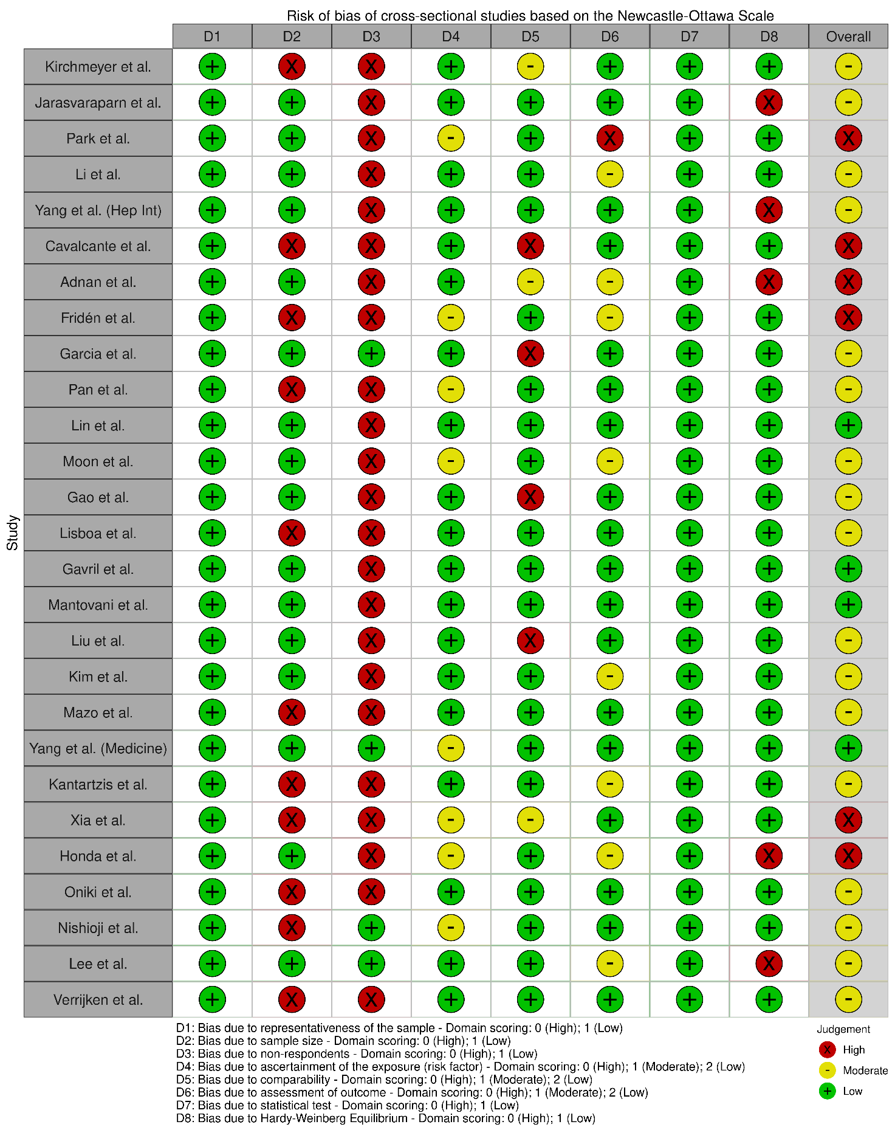

- Case-control studies
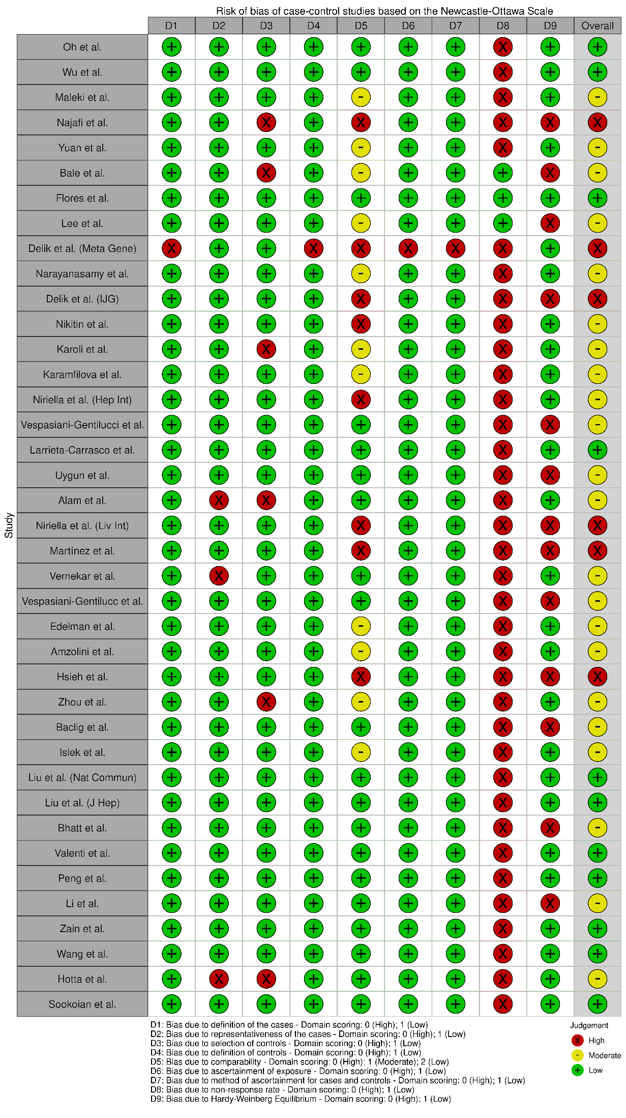
- Cohort studies
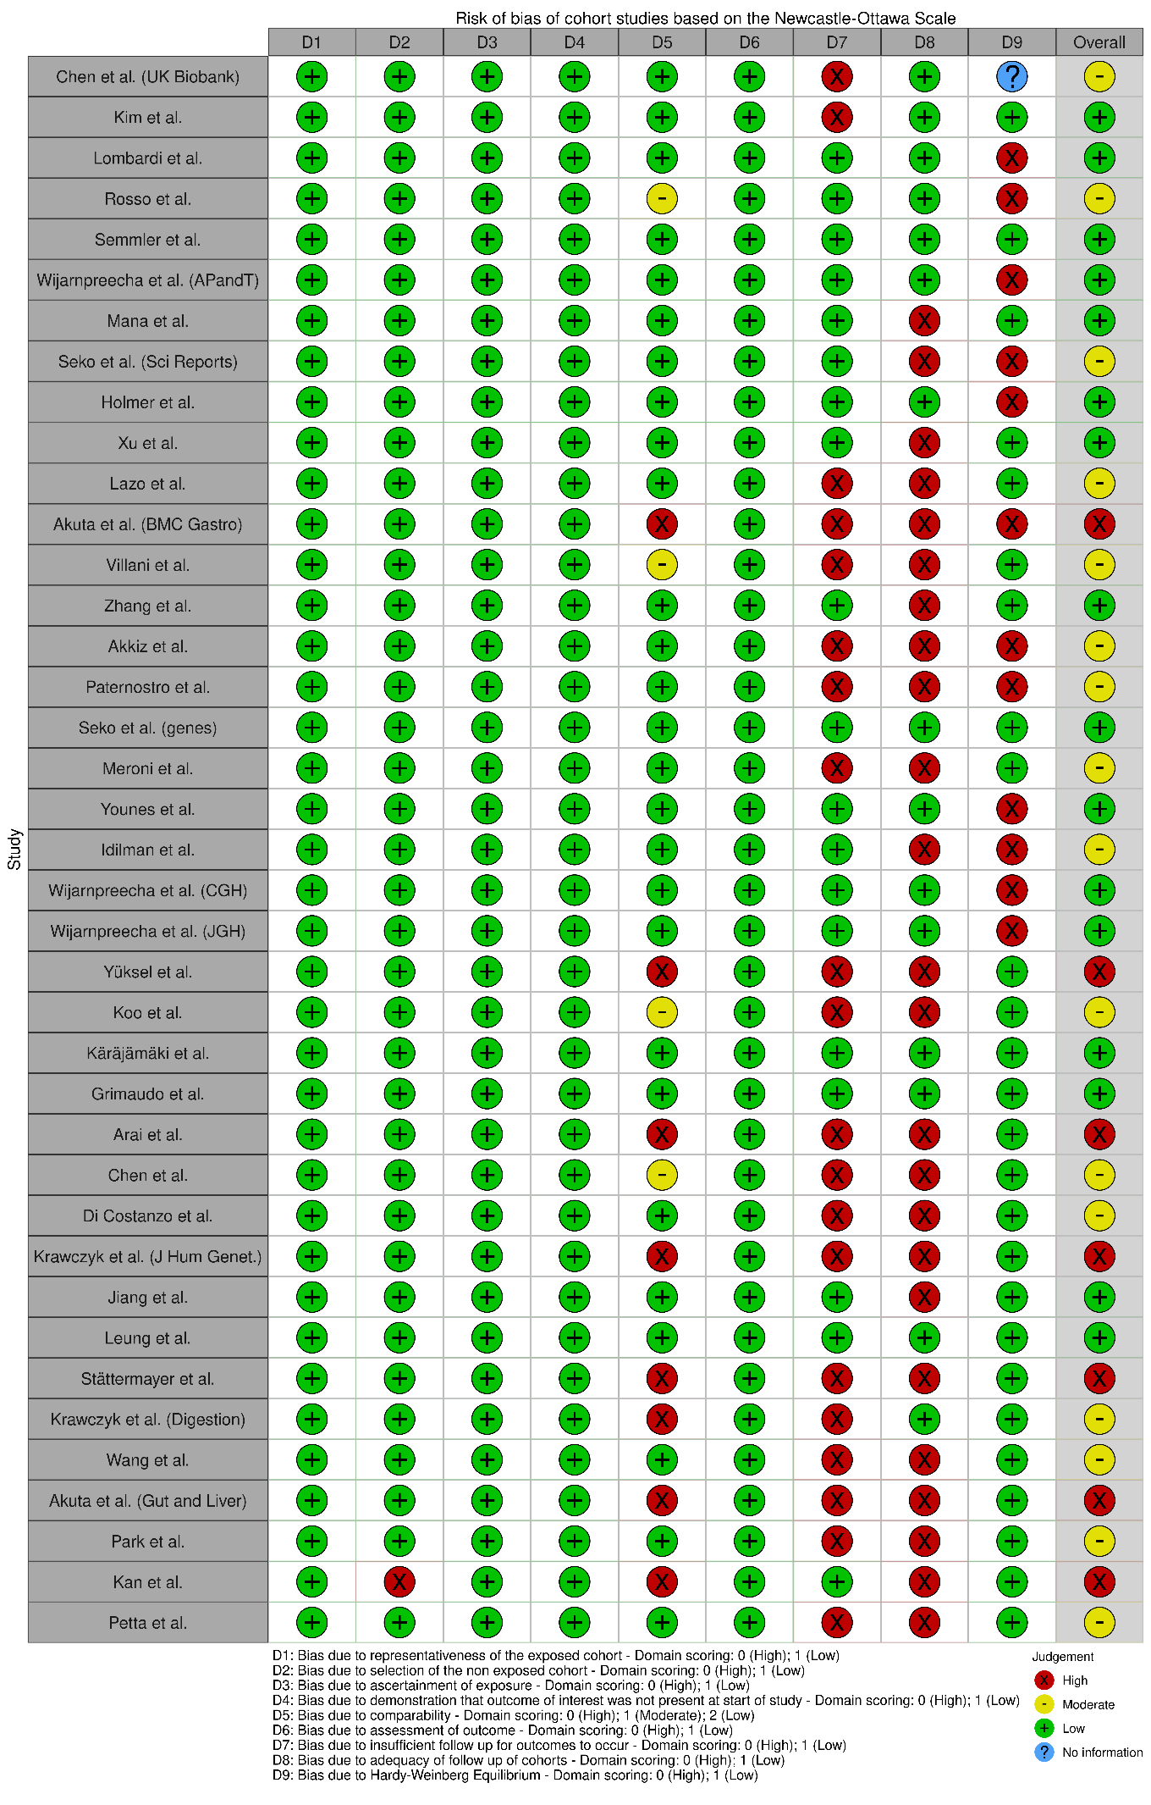
- Genome wide association studies
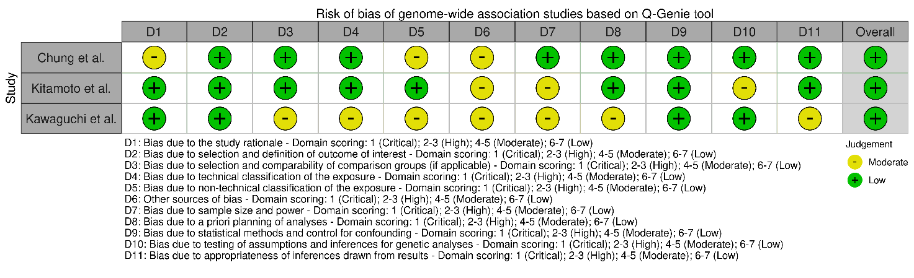

Figure S2 – Forest plots for MAF(G) in MASLD overall and subgroup
- Overall
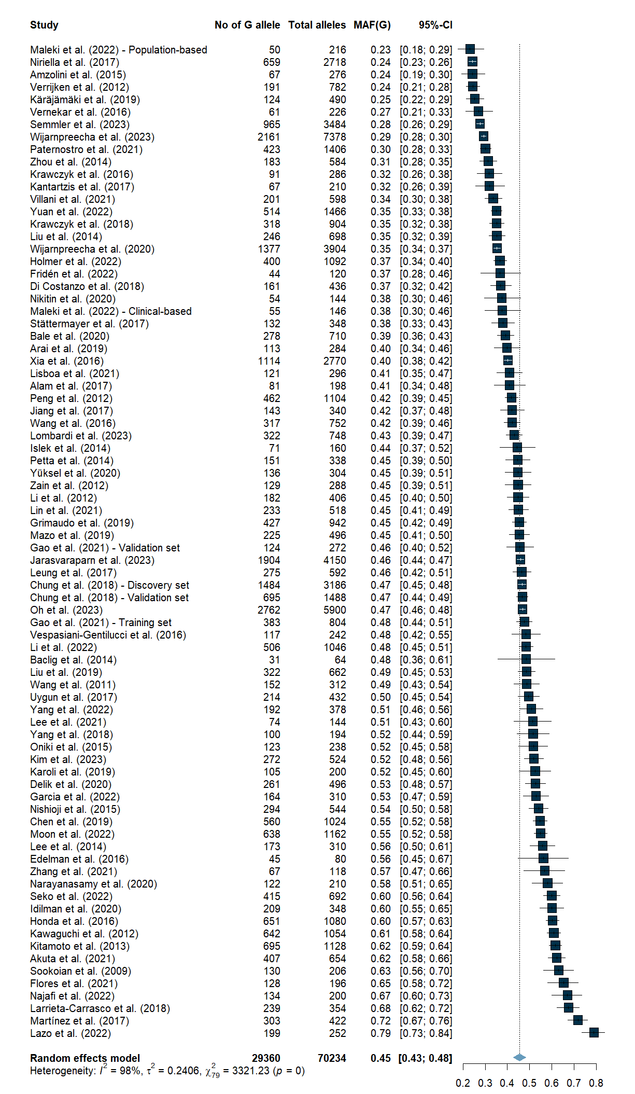
- Sex
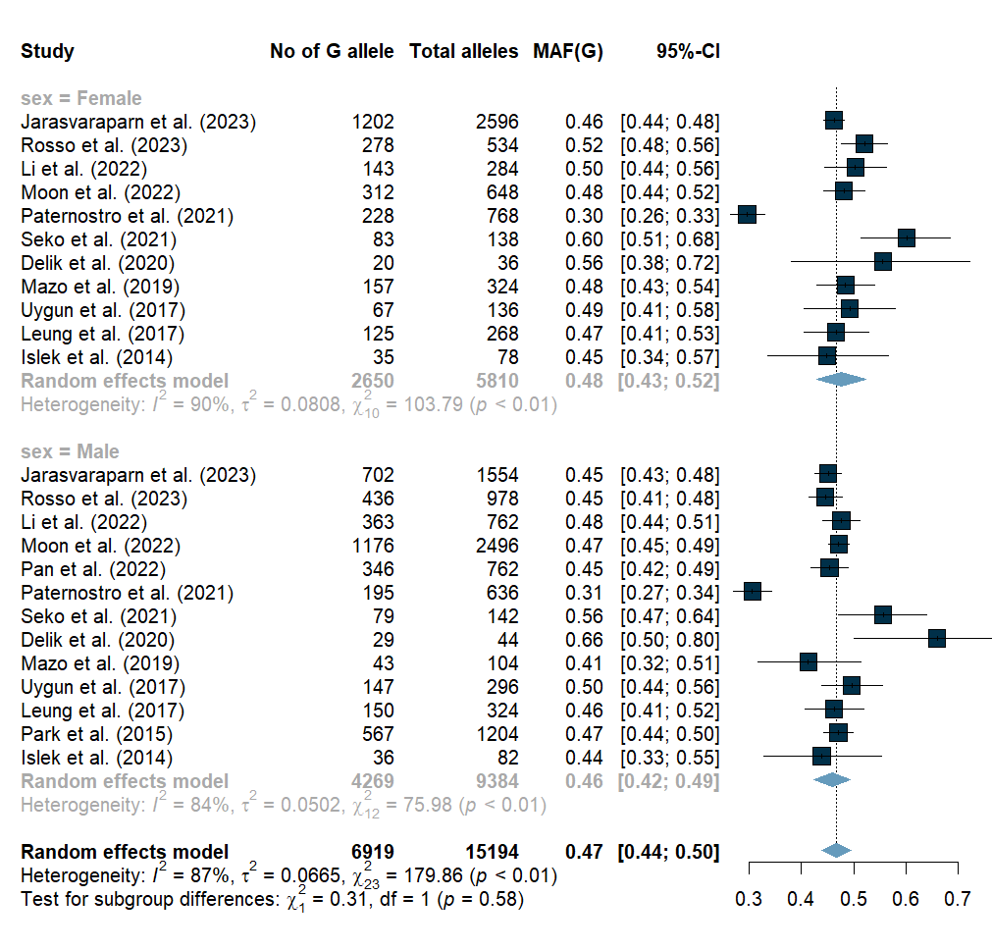

- BMI
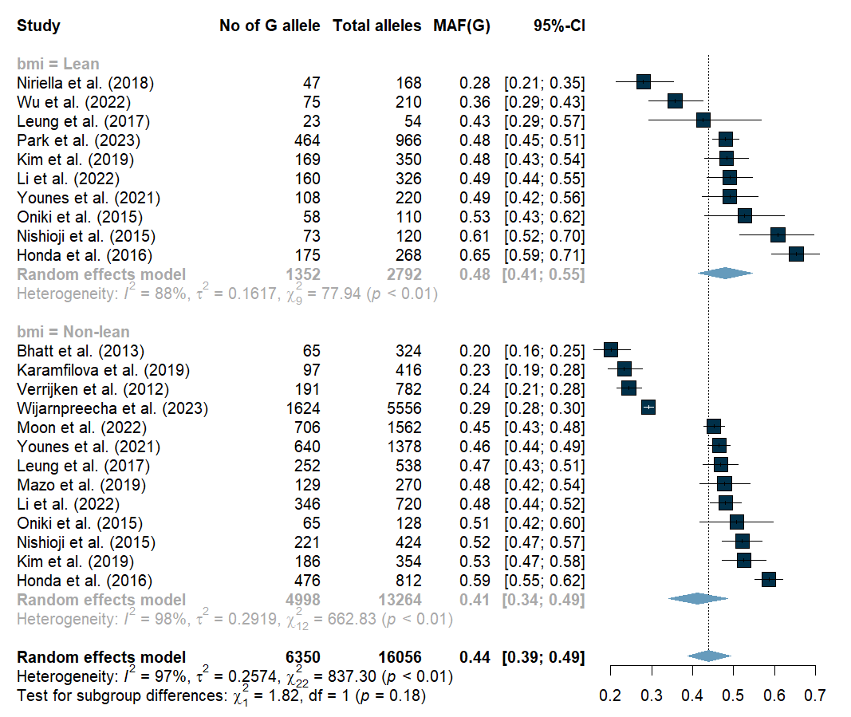

- Diabetes mellitus
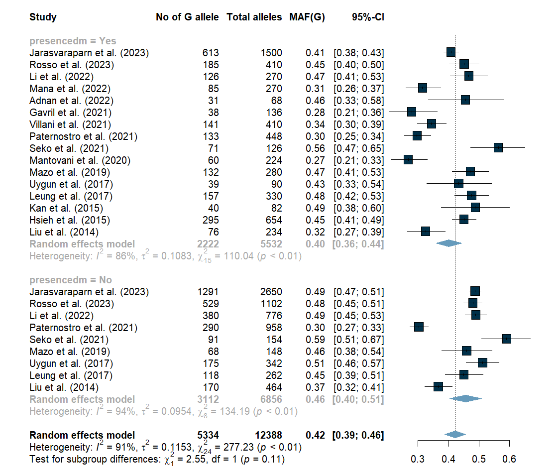

- MASLD severity
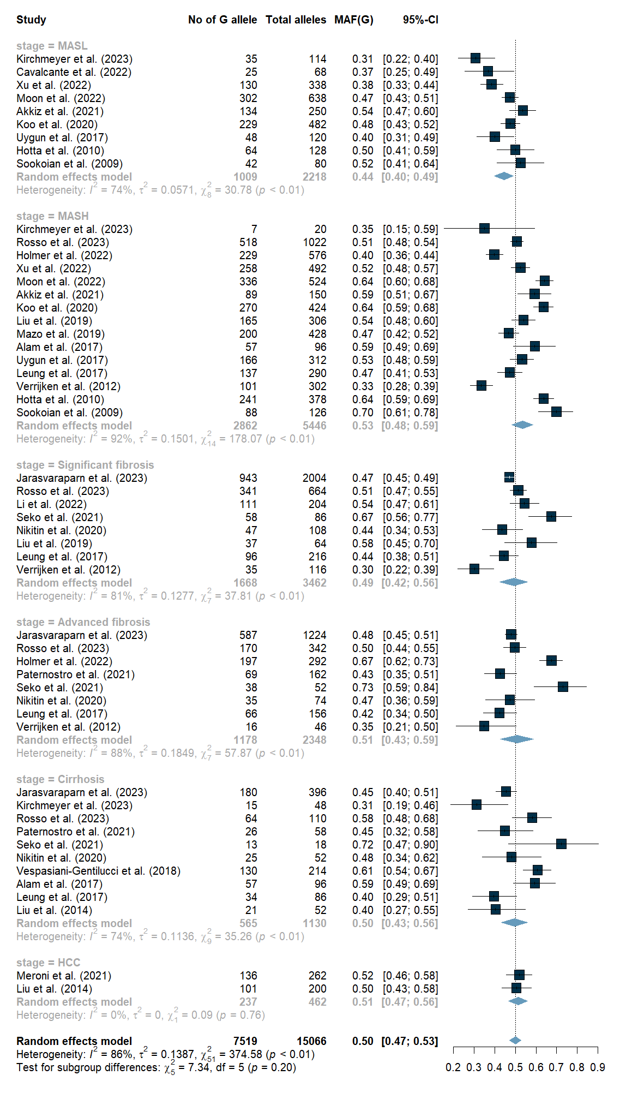
- World region
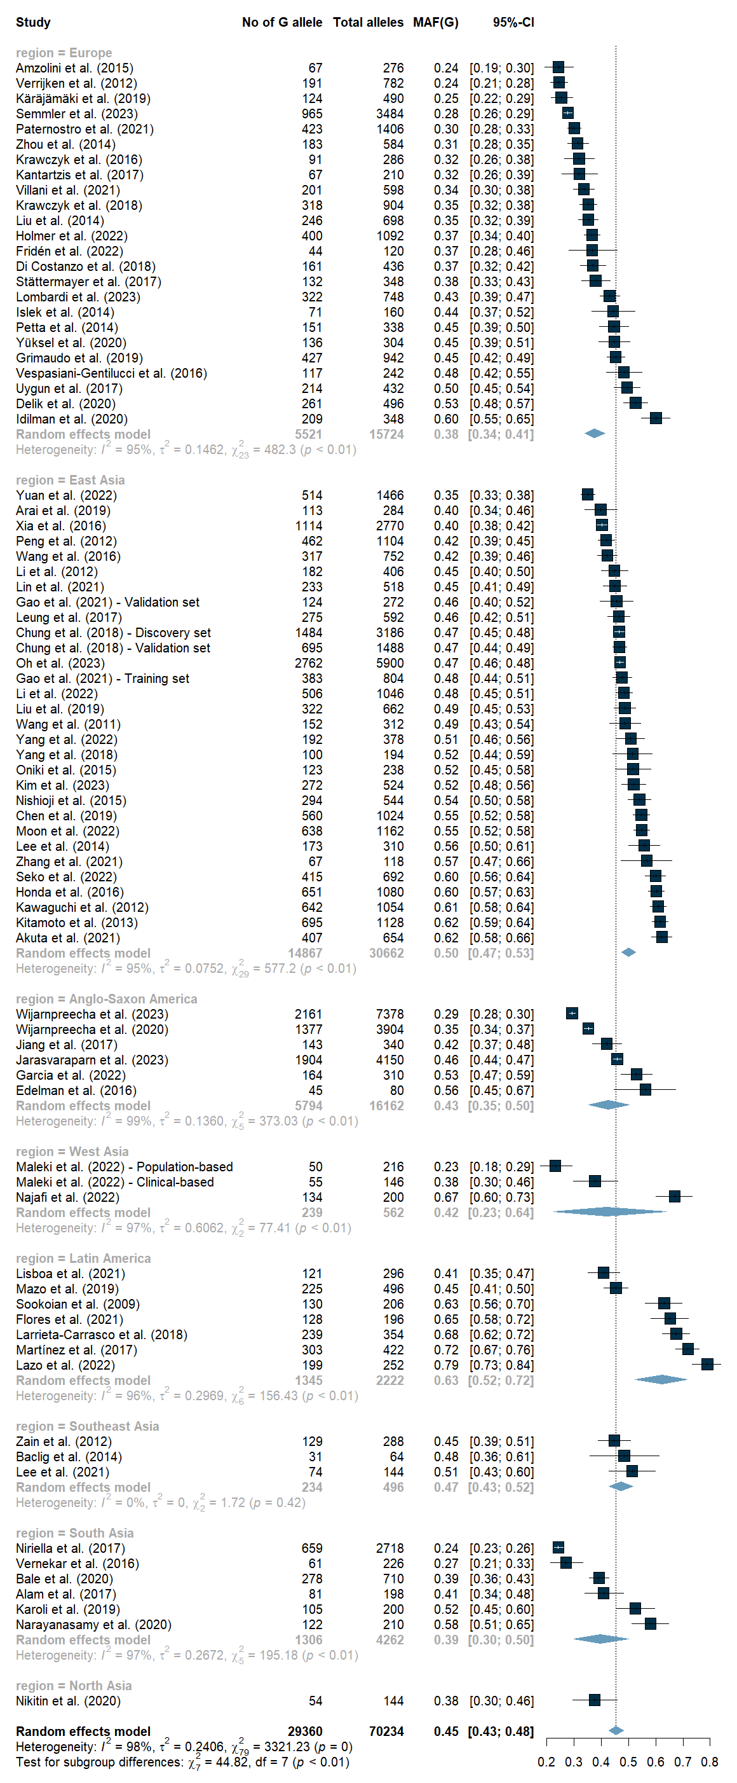
- Sample size
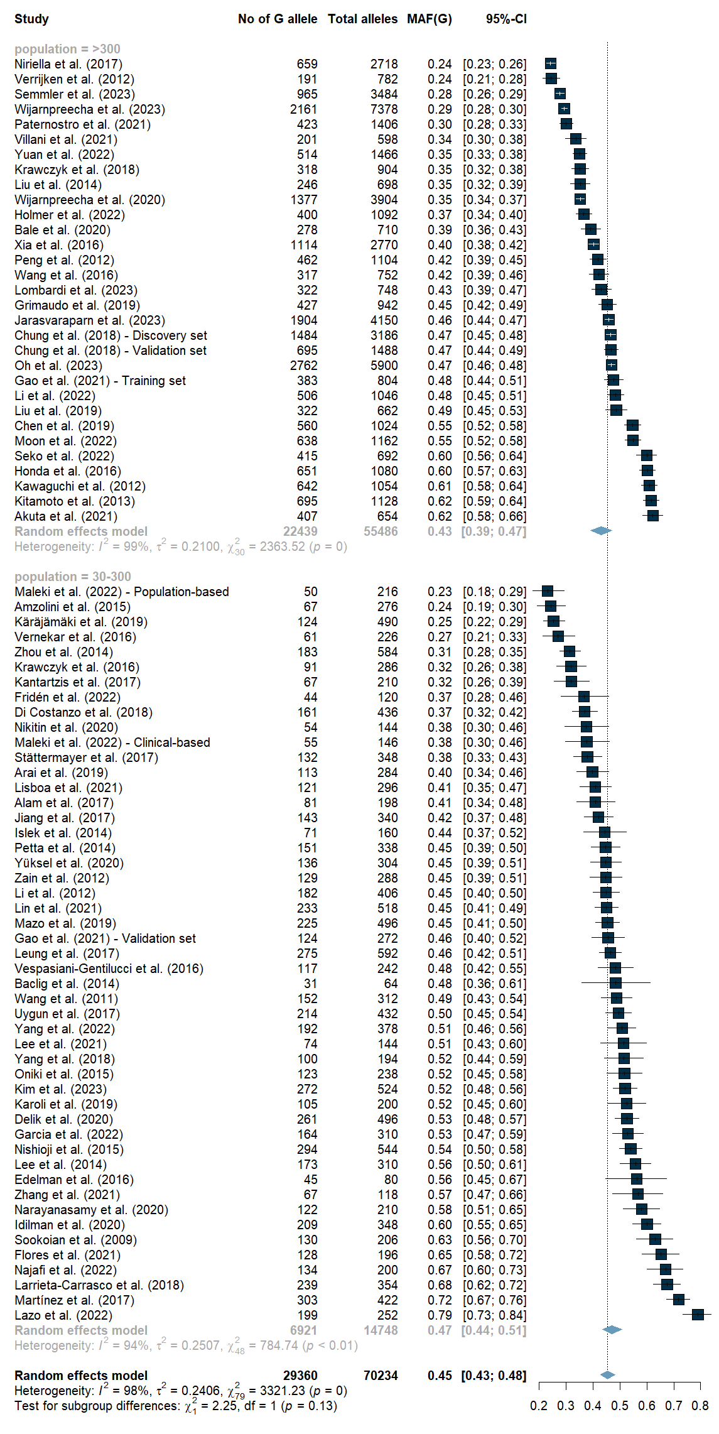
- Study setting
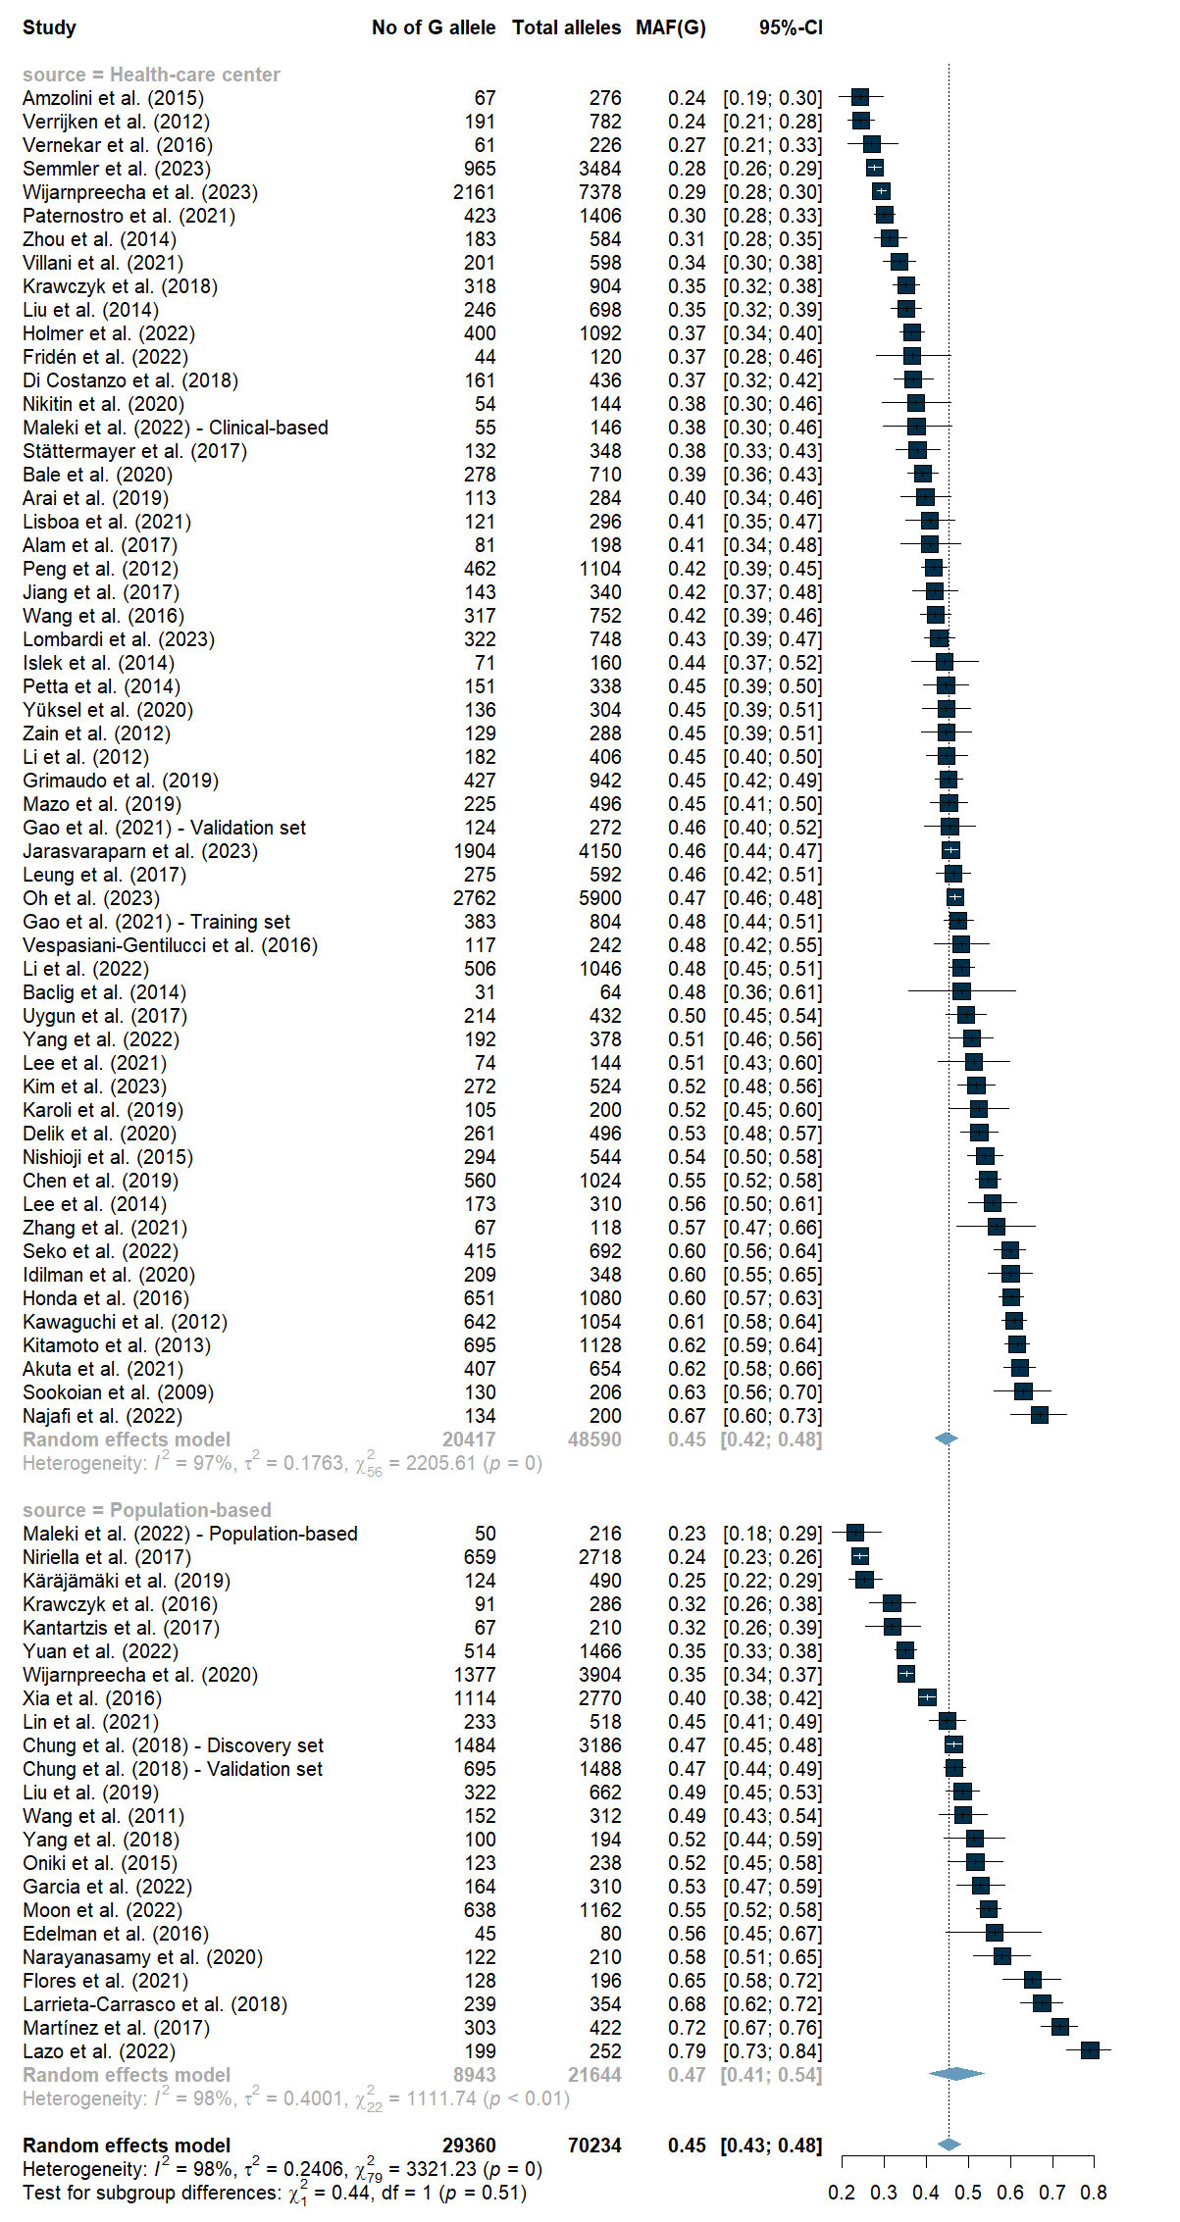

- Diagnostic method
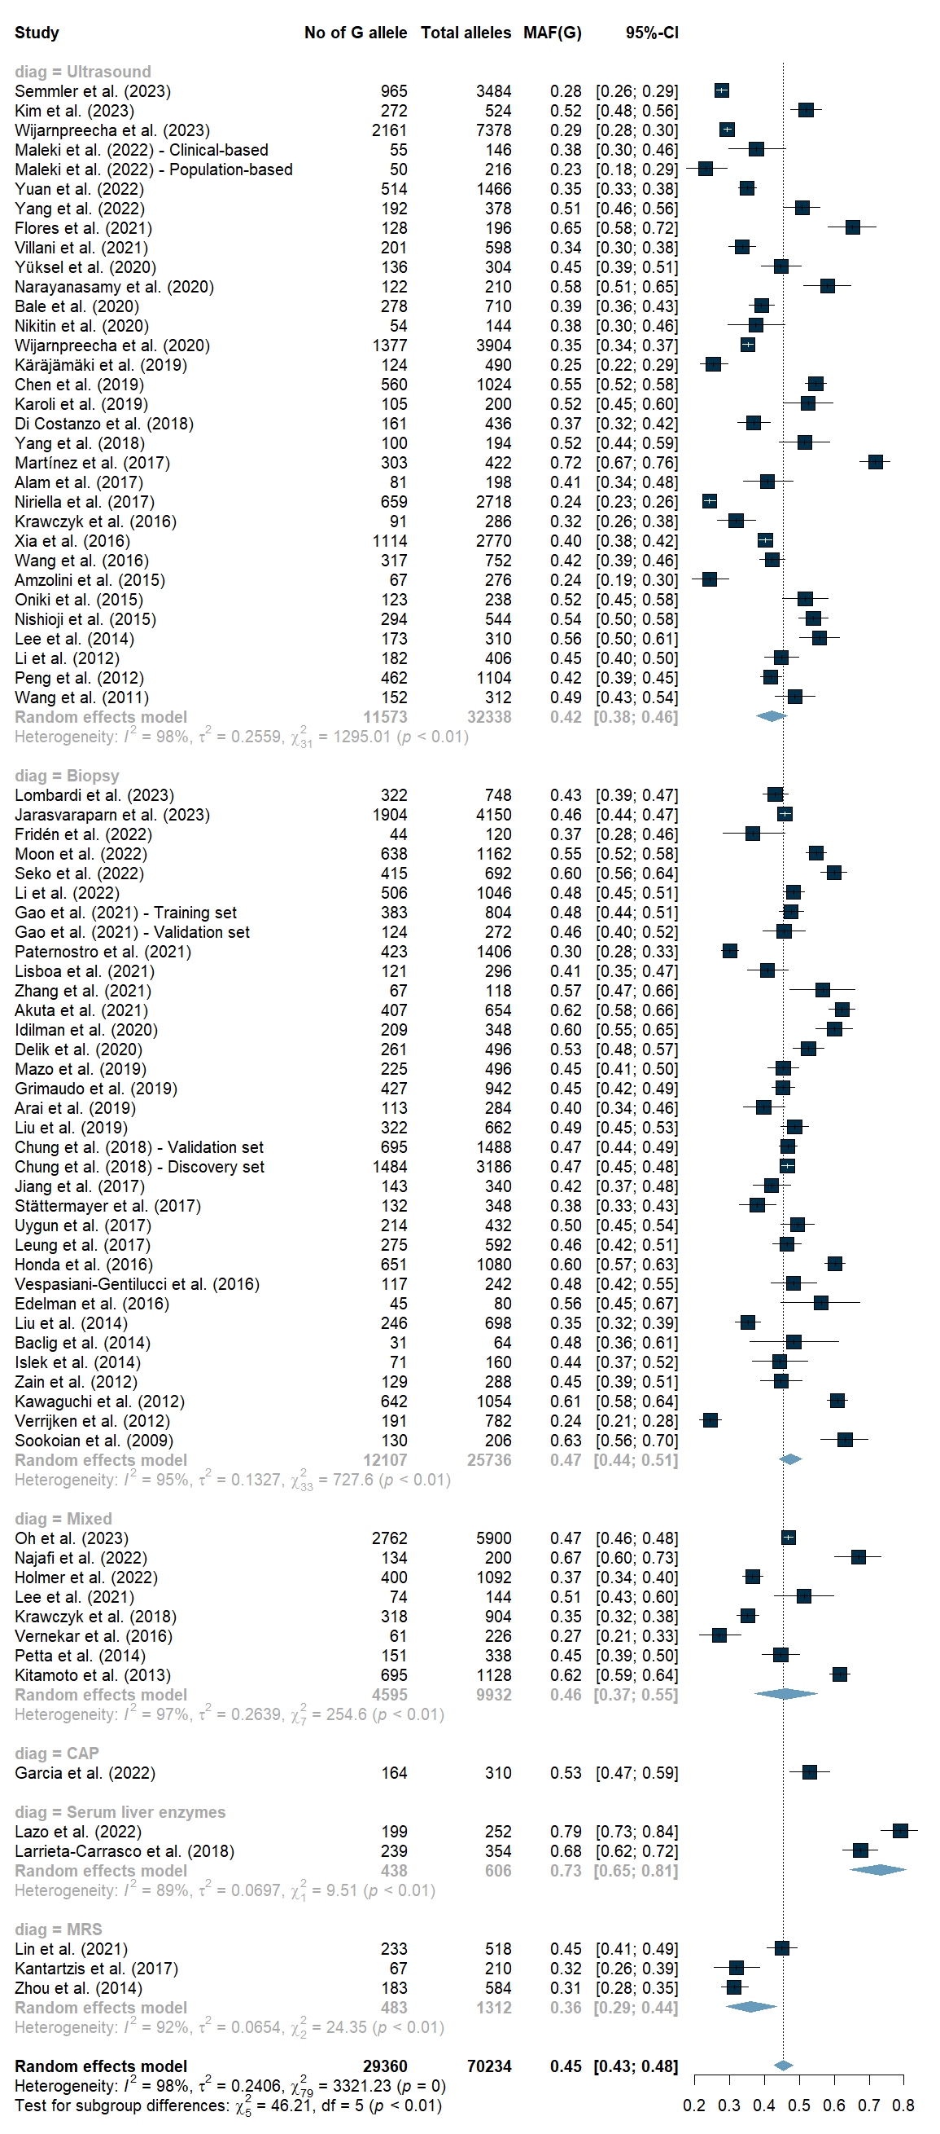
- Risk of bias
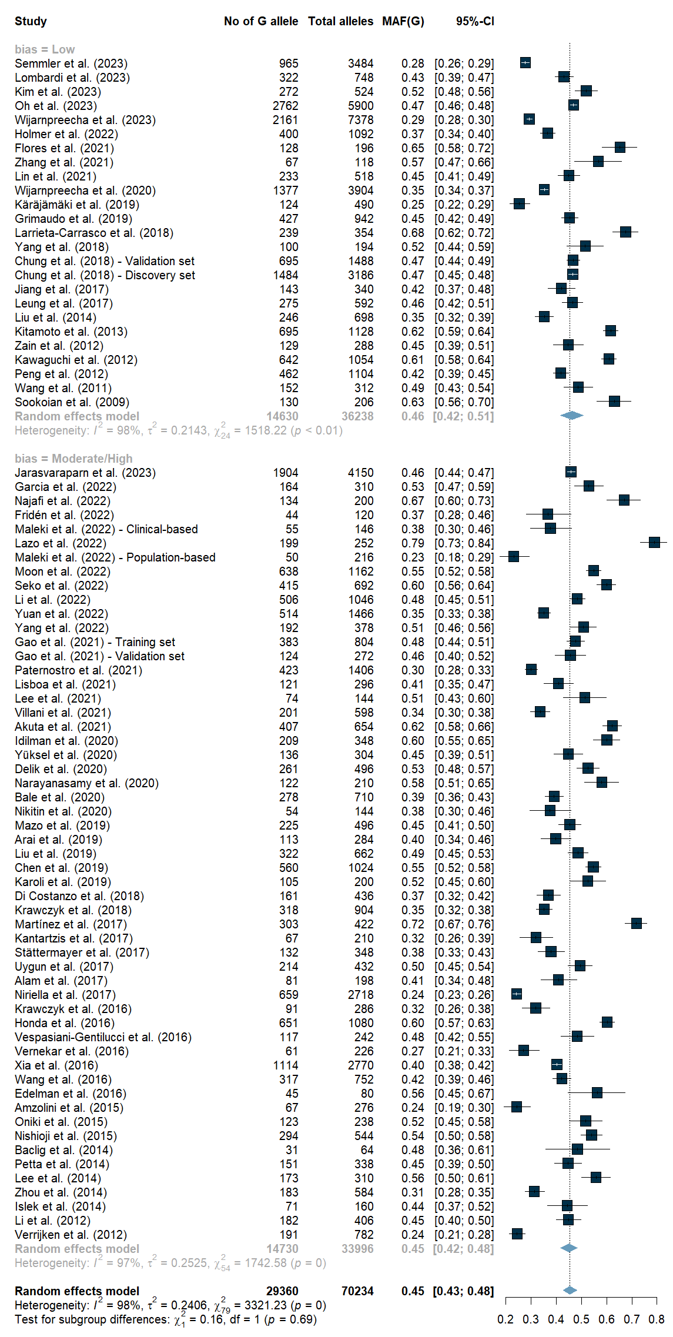
Figure S3 – Forest plots on sensitivity analysis for MAF(G) in MASLD overall and subgroup
- Overall
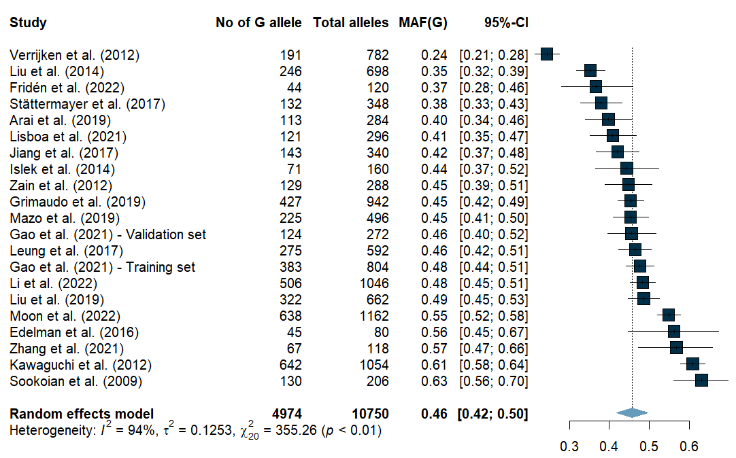

- Sex
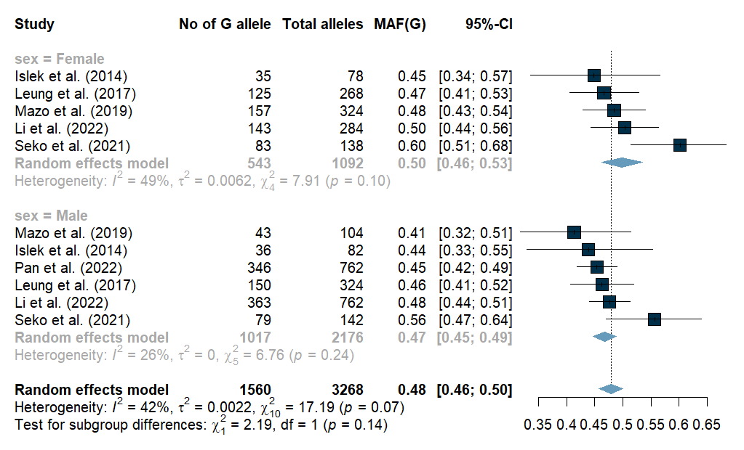

- BMI
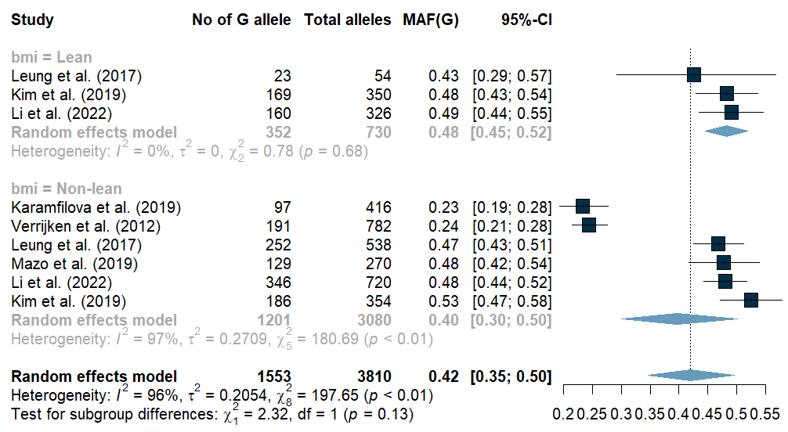

- Diabetes mellitus
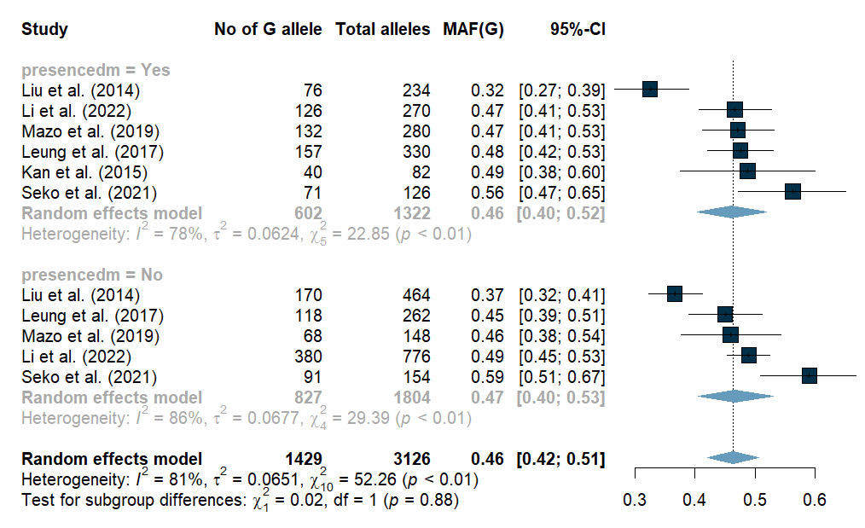

- MASLD severity
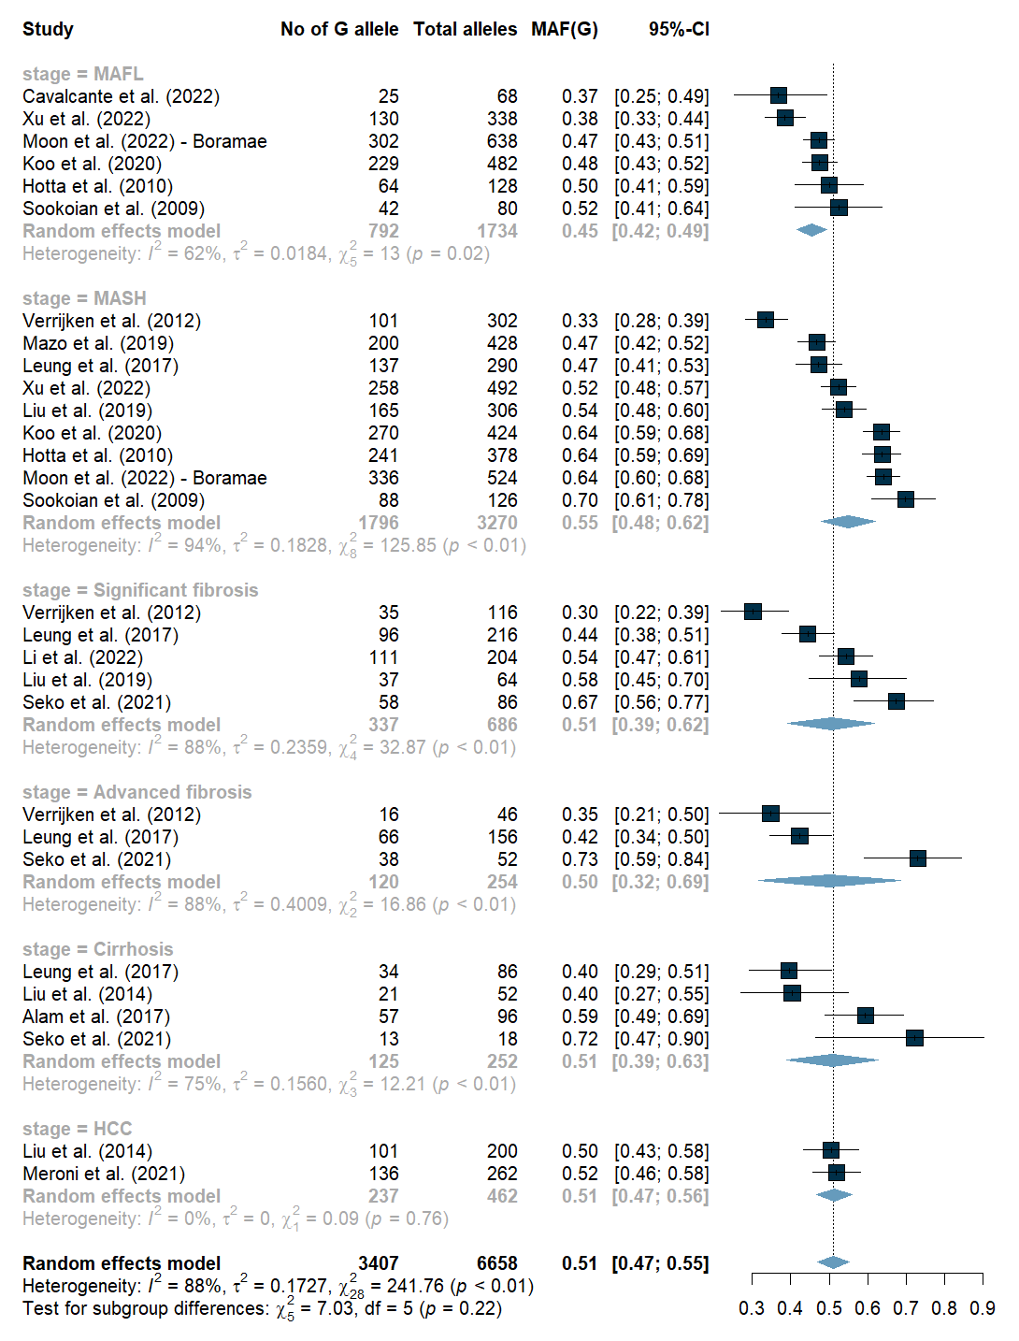

- World region
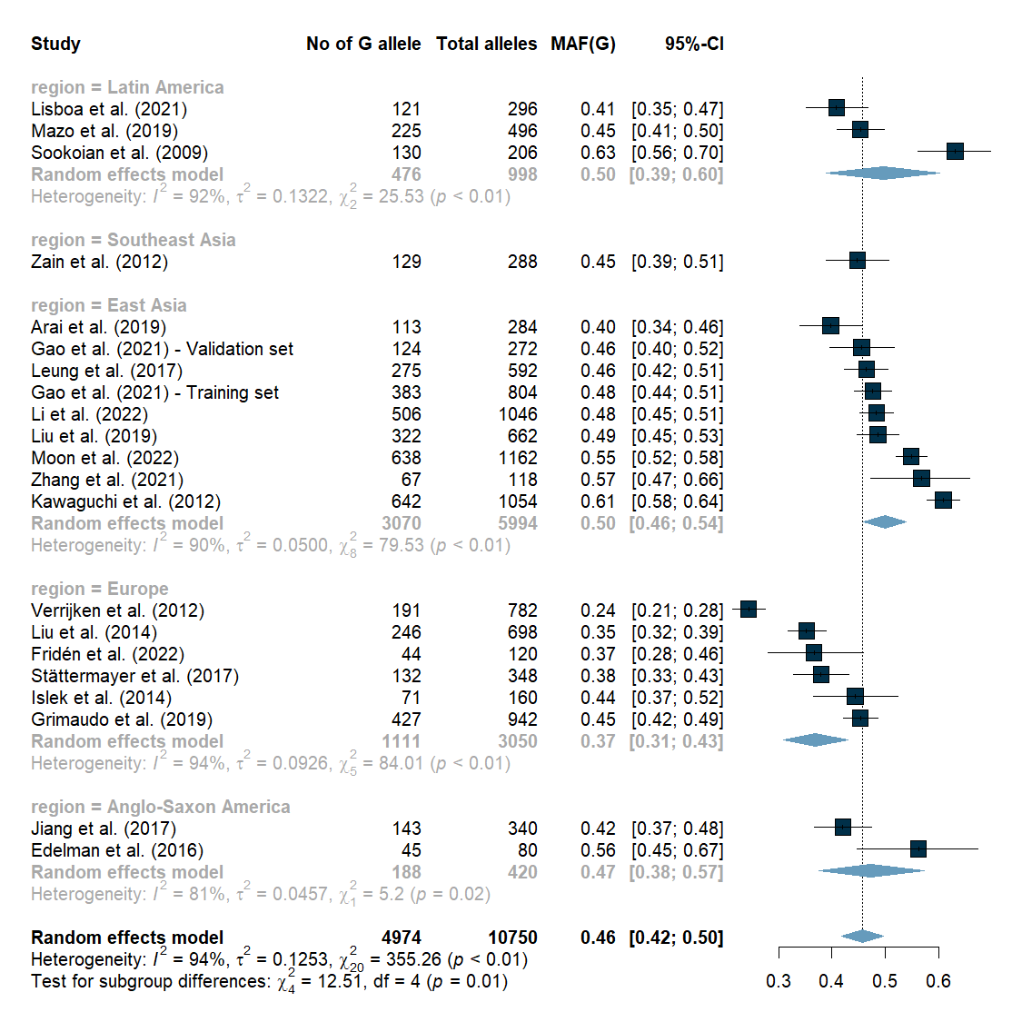

- Sample size
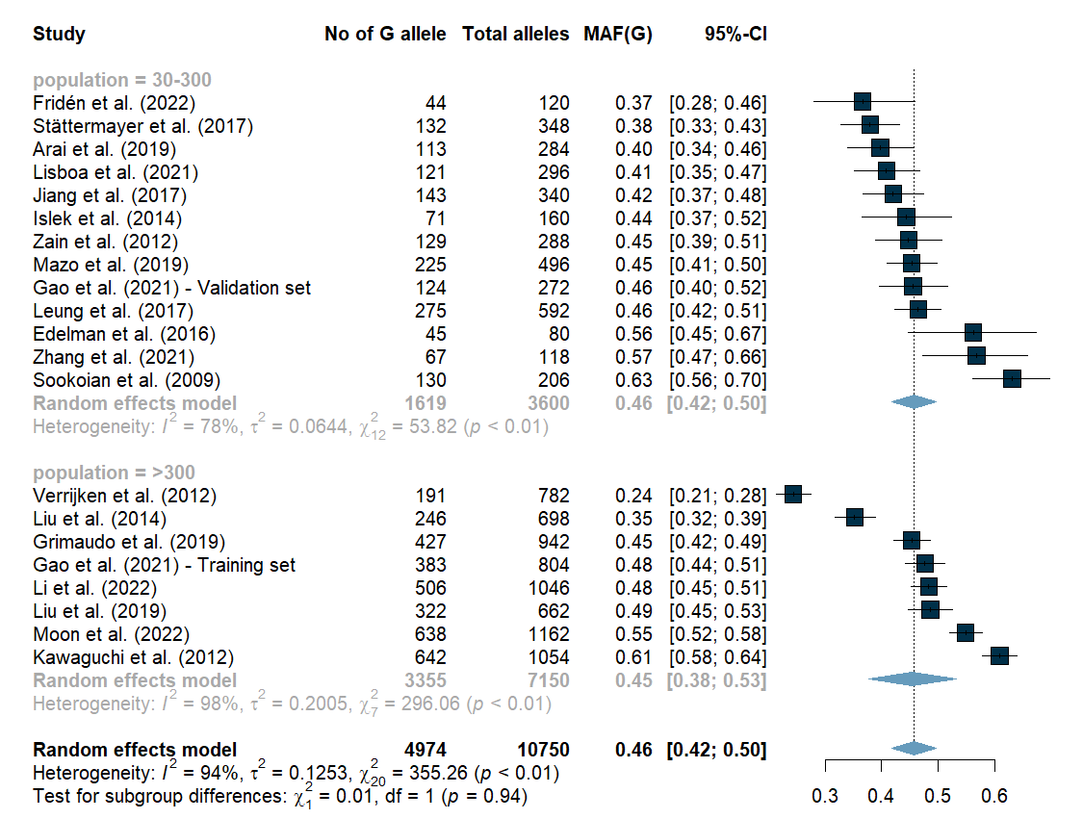

- Study setting
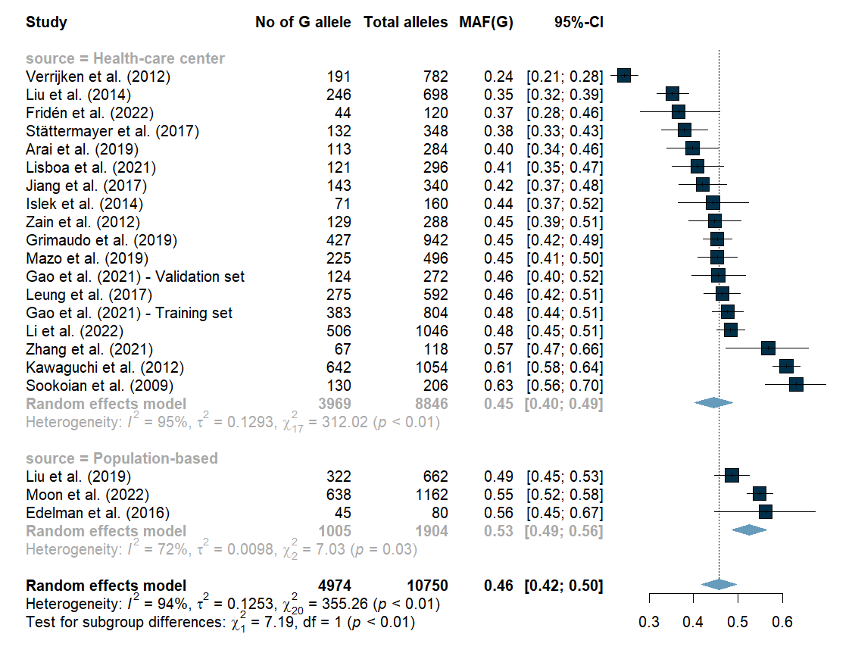

- Risk of bias
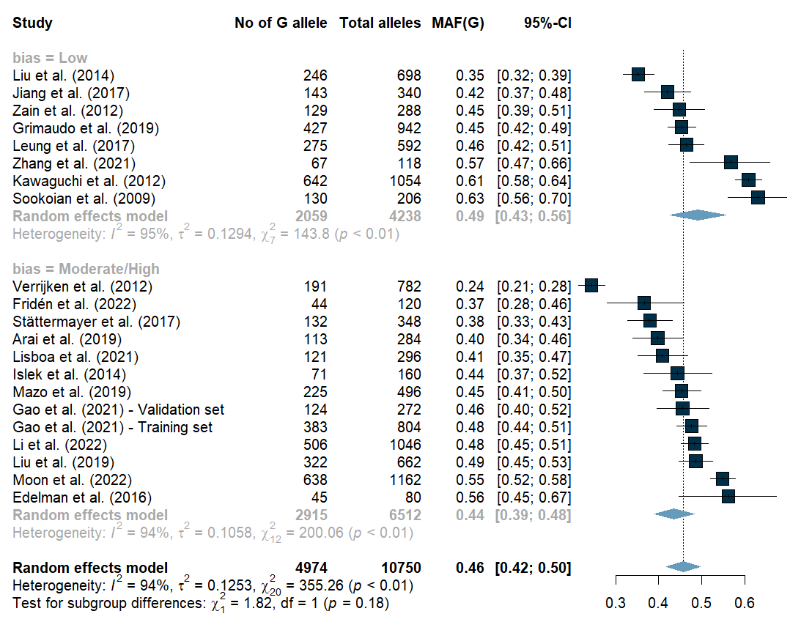

Figure S4 – Forest plots for clinical analysis
- Body mass index
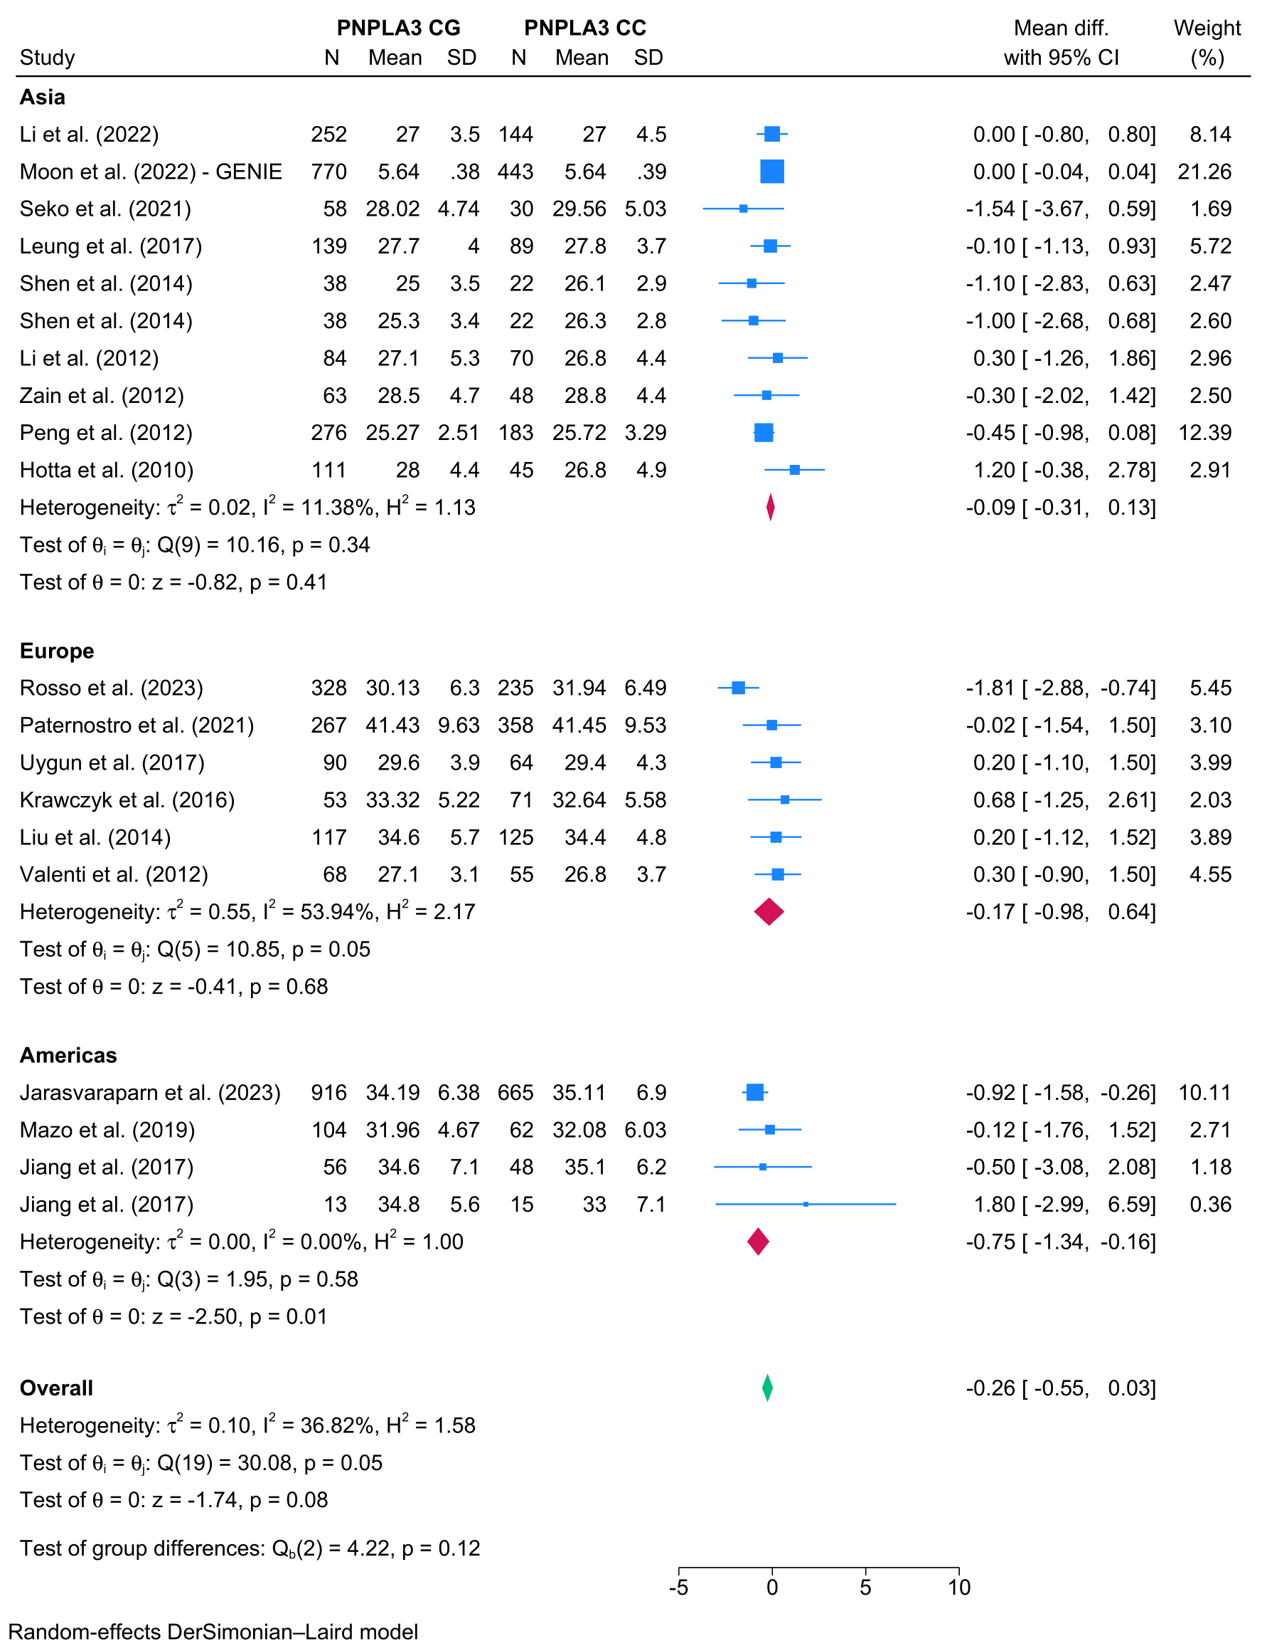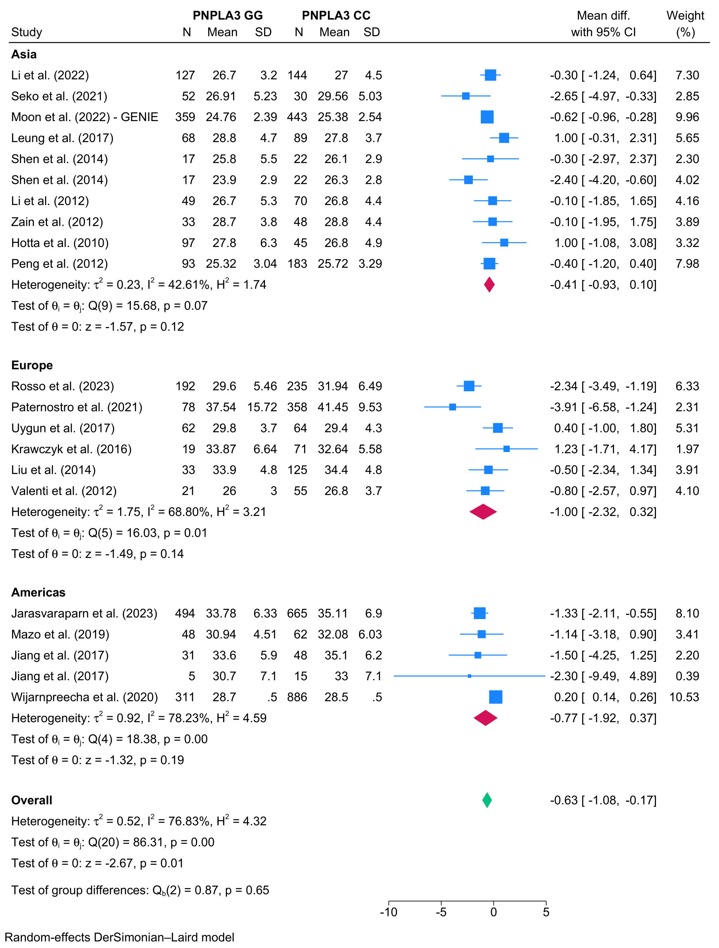

- Waist circumference
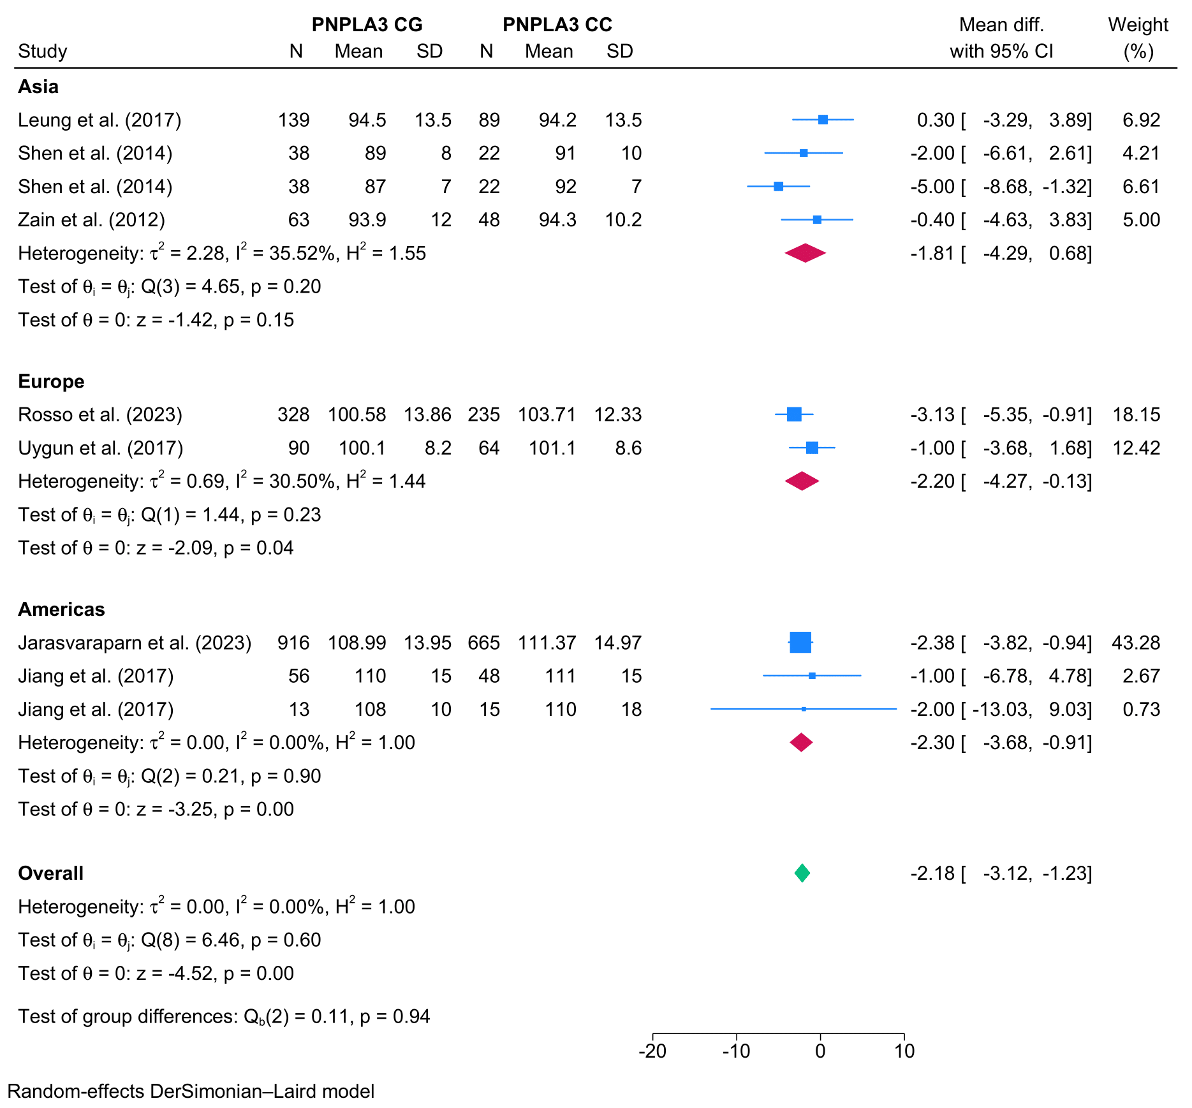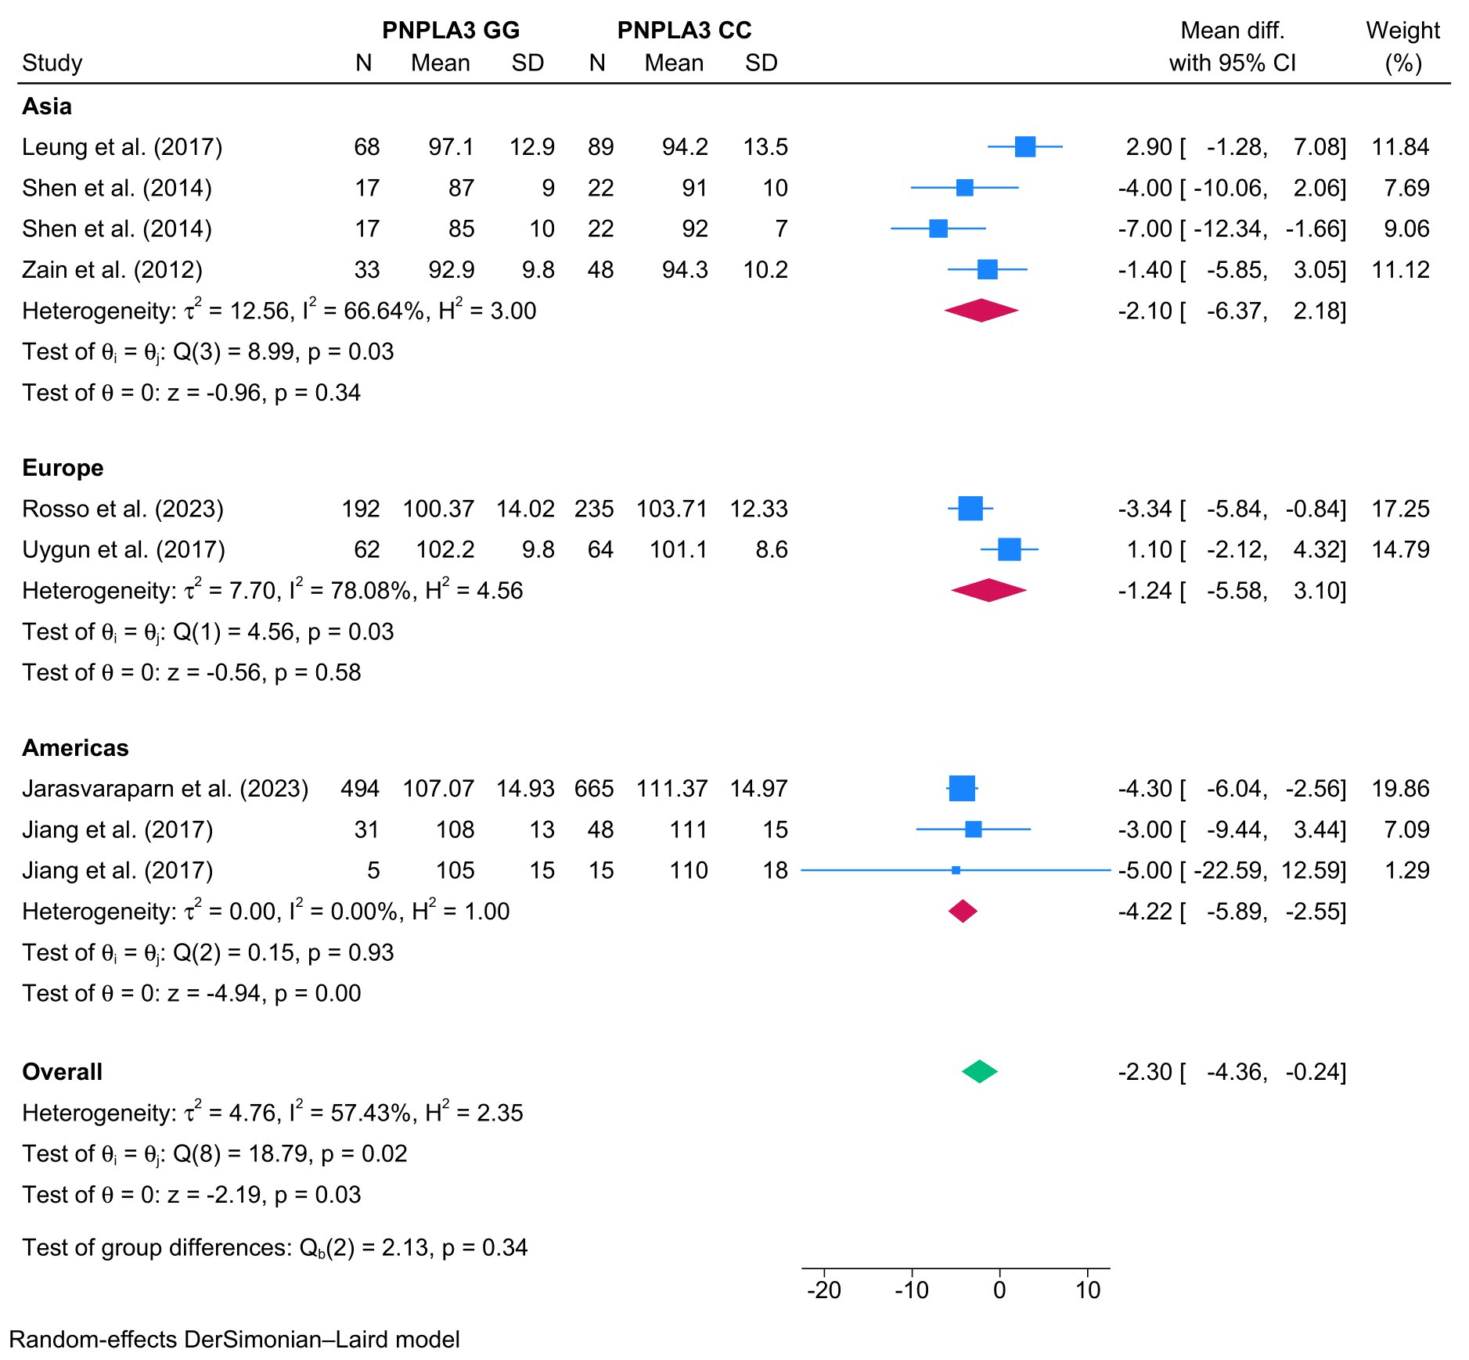

- Triglycerides
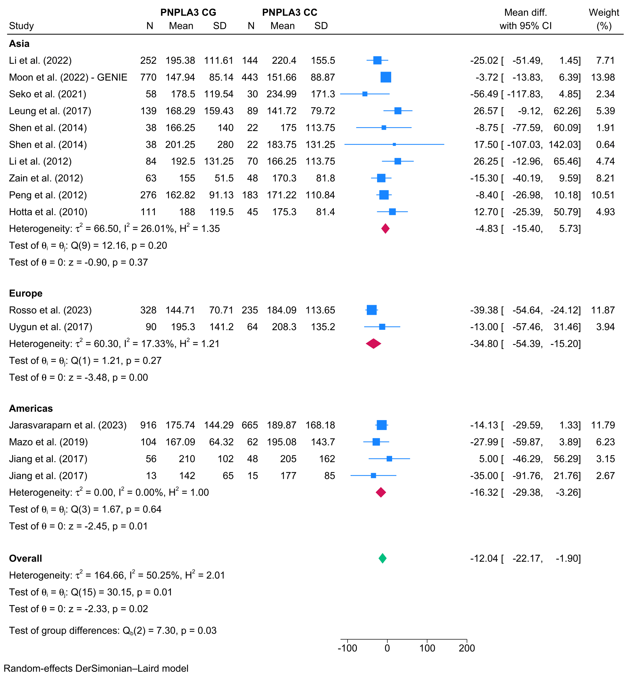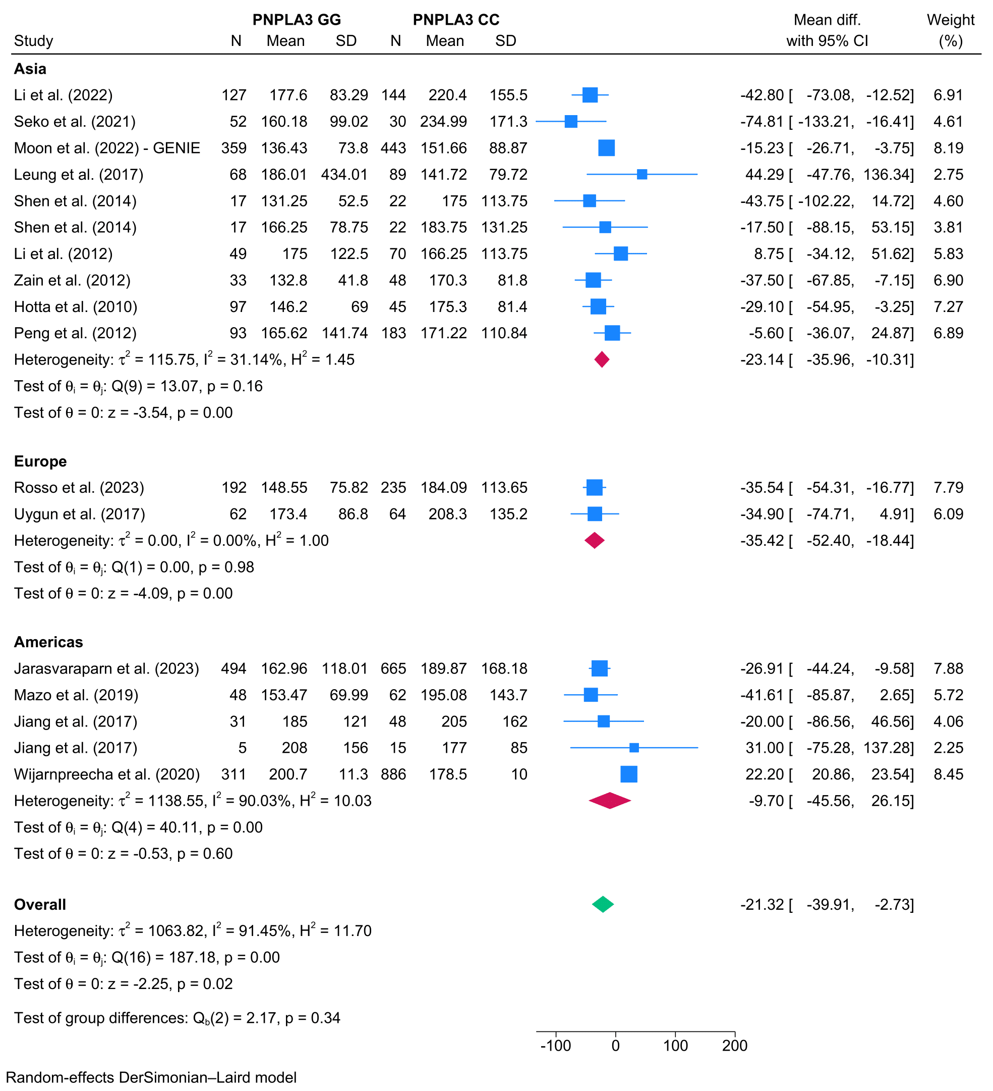

- Total cholesterol
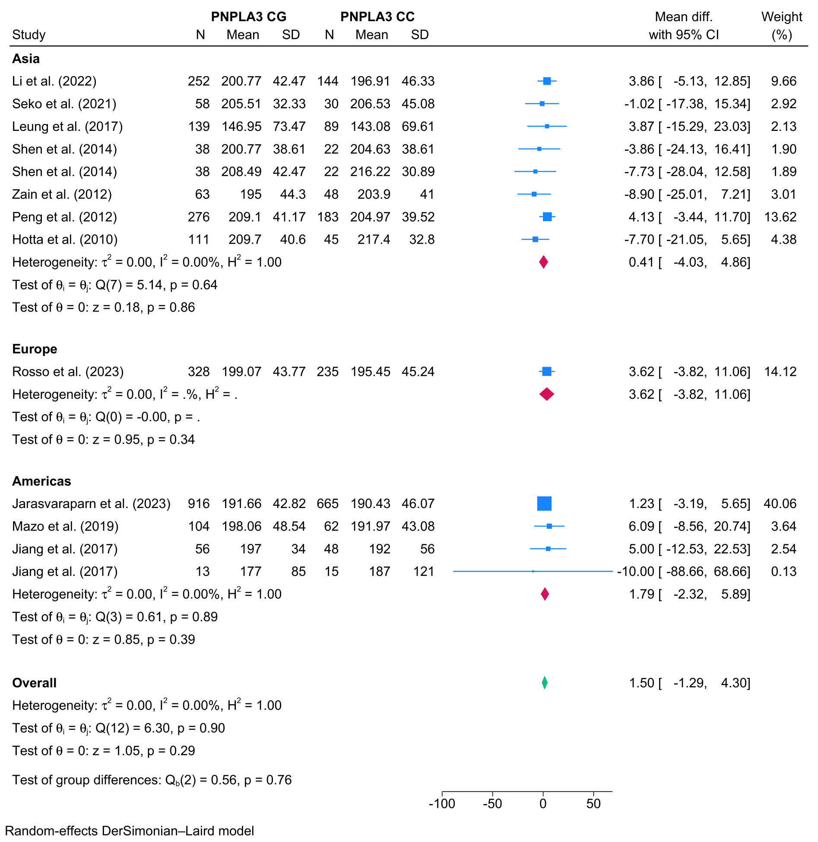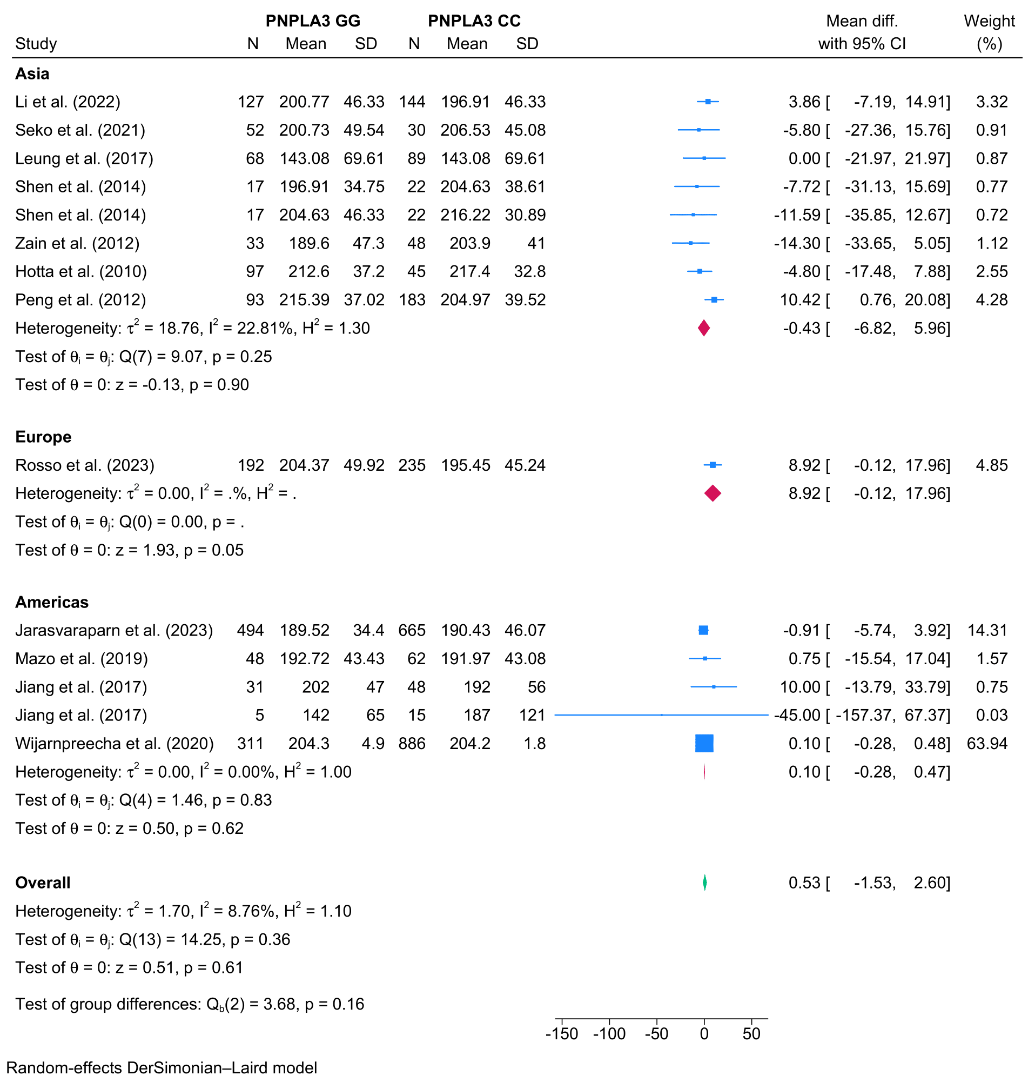

- Low-density lipoprotein
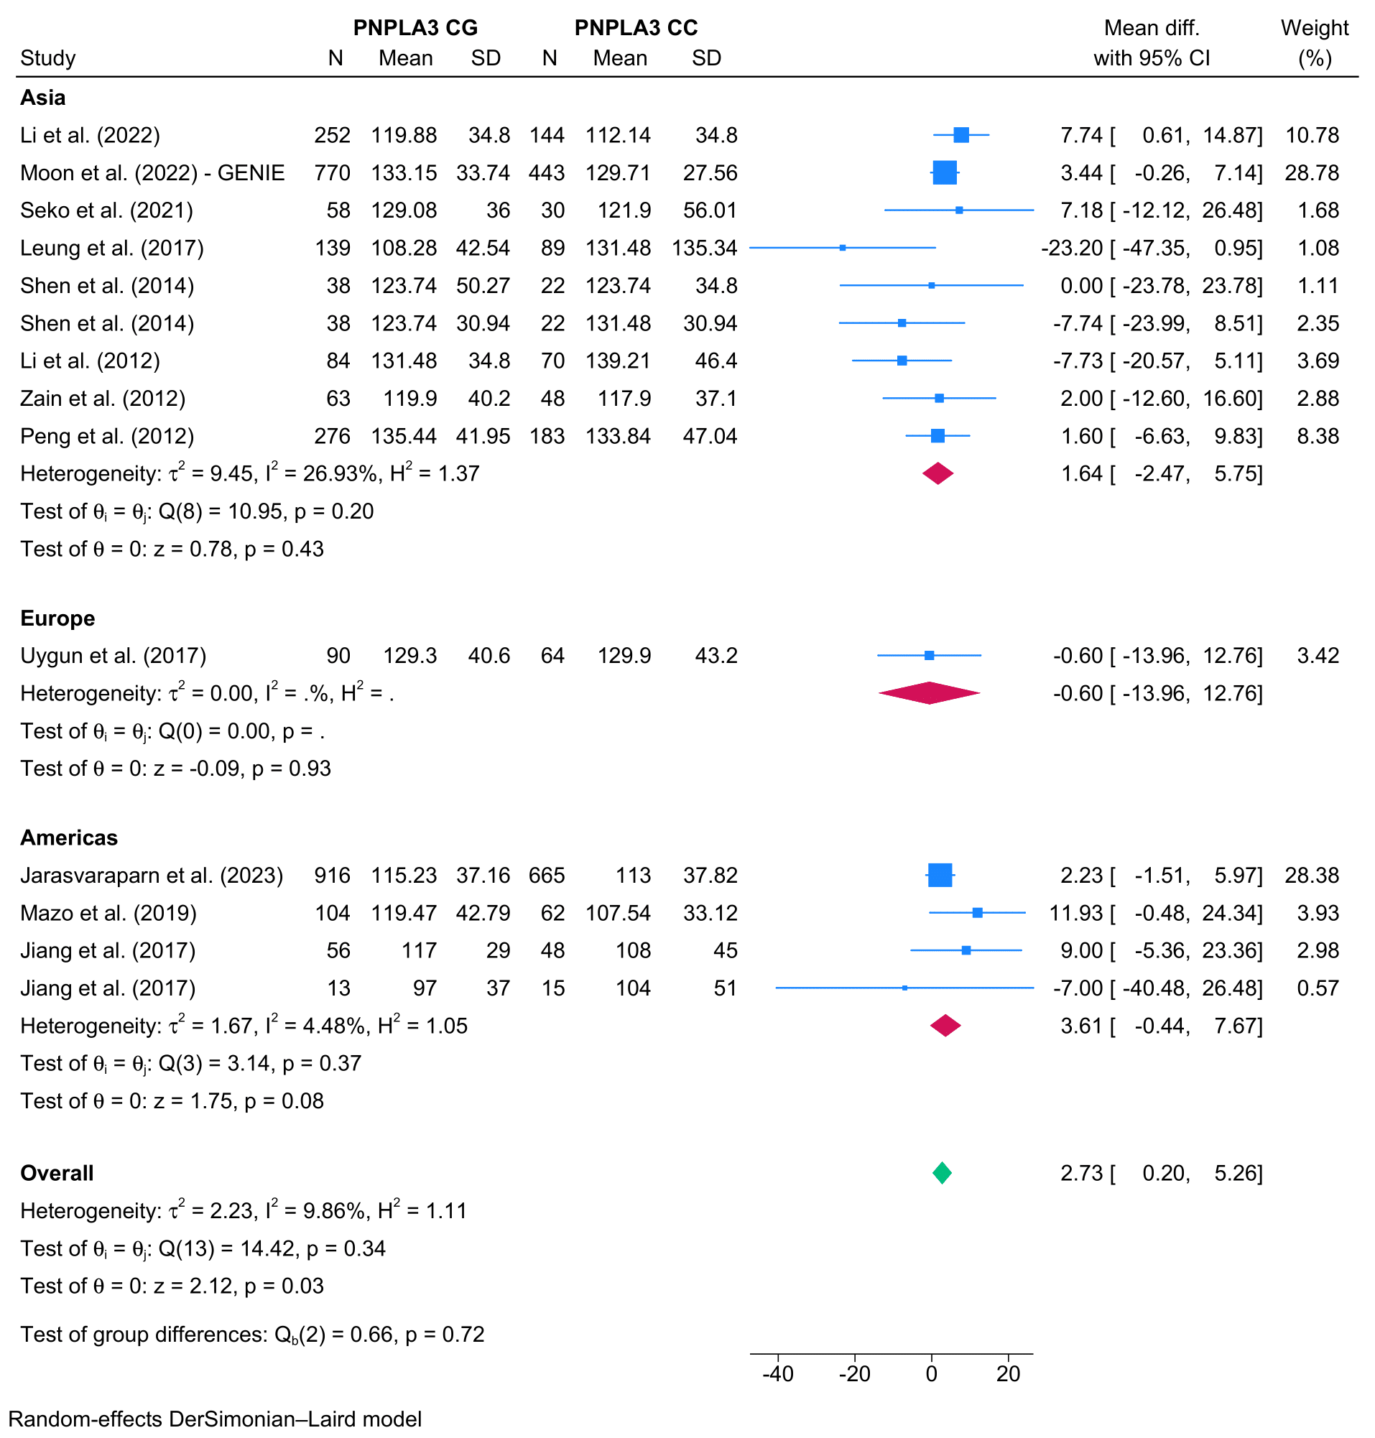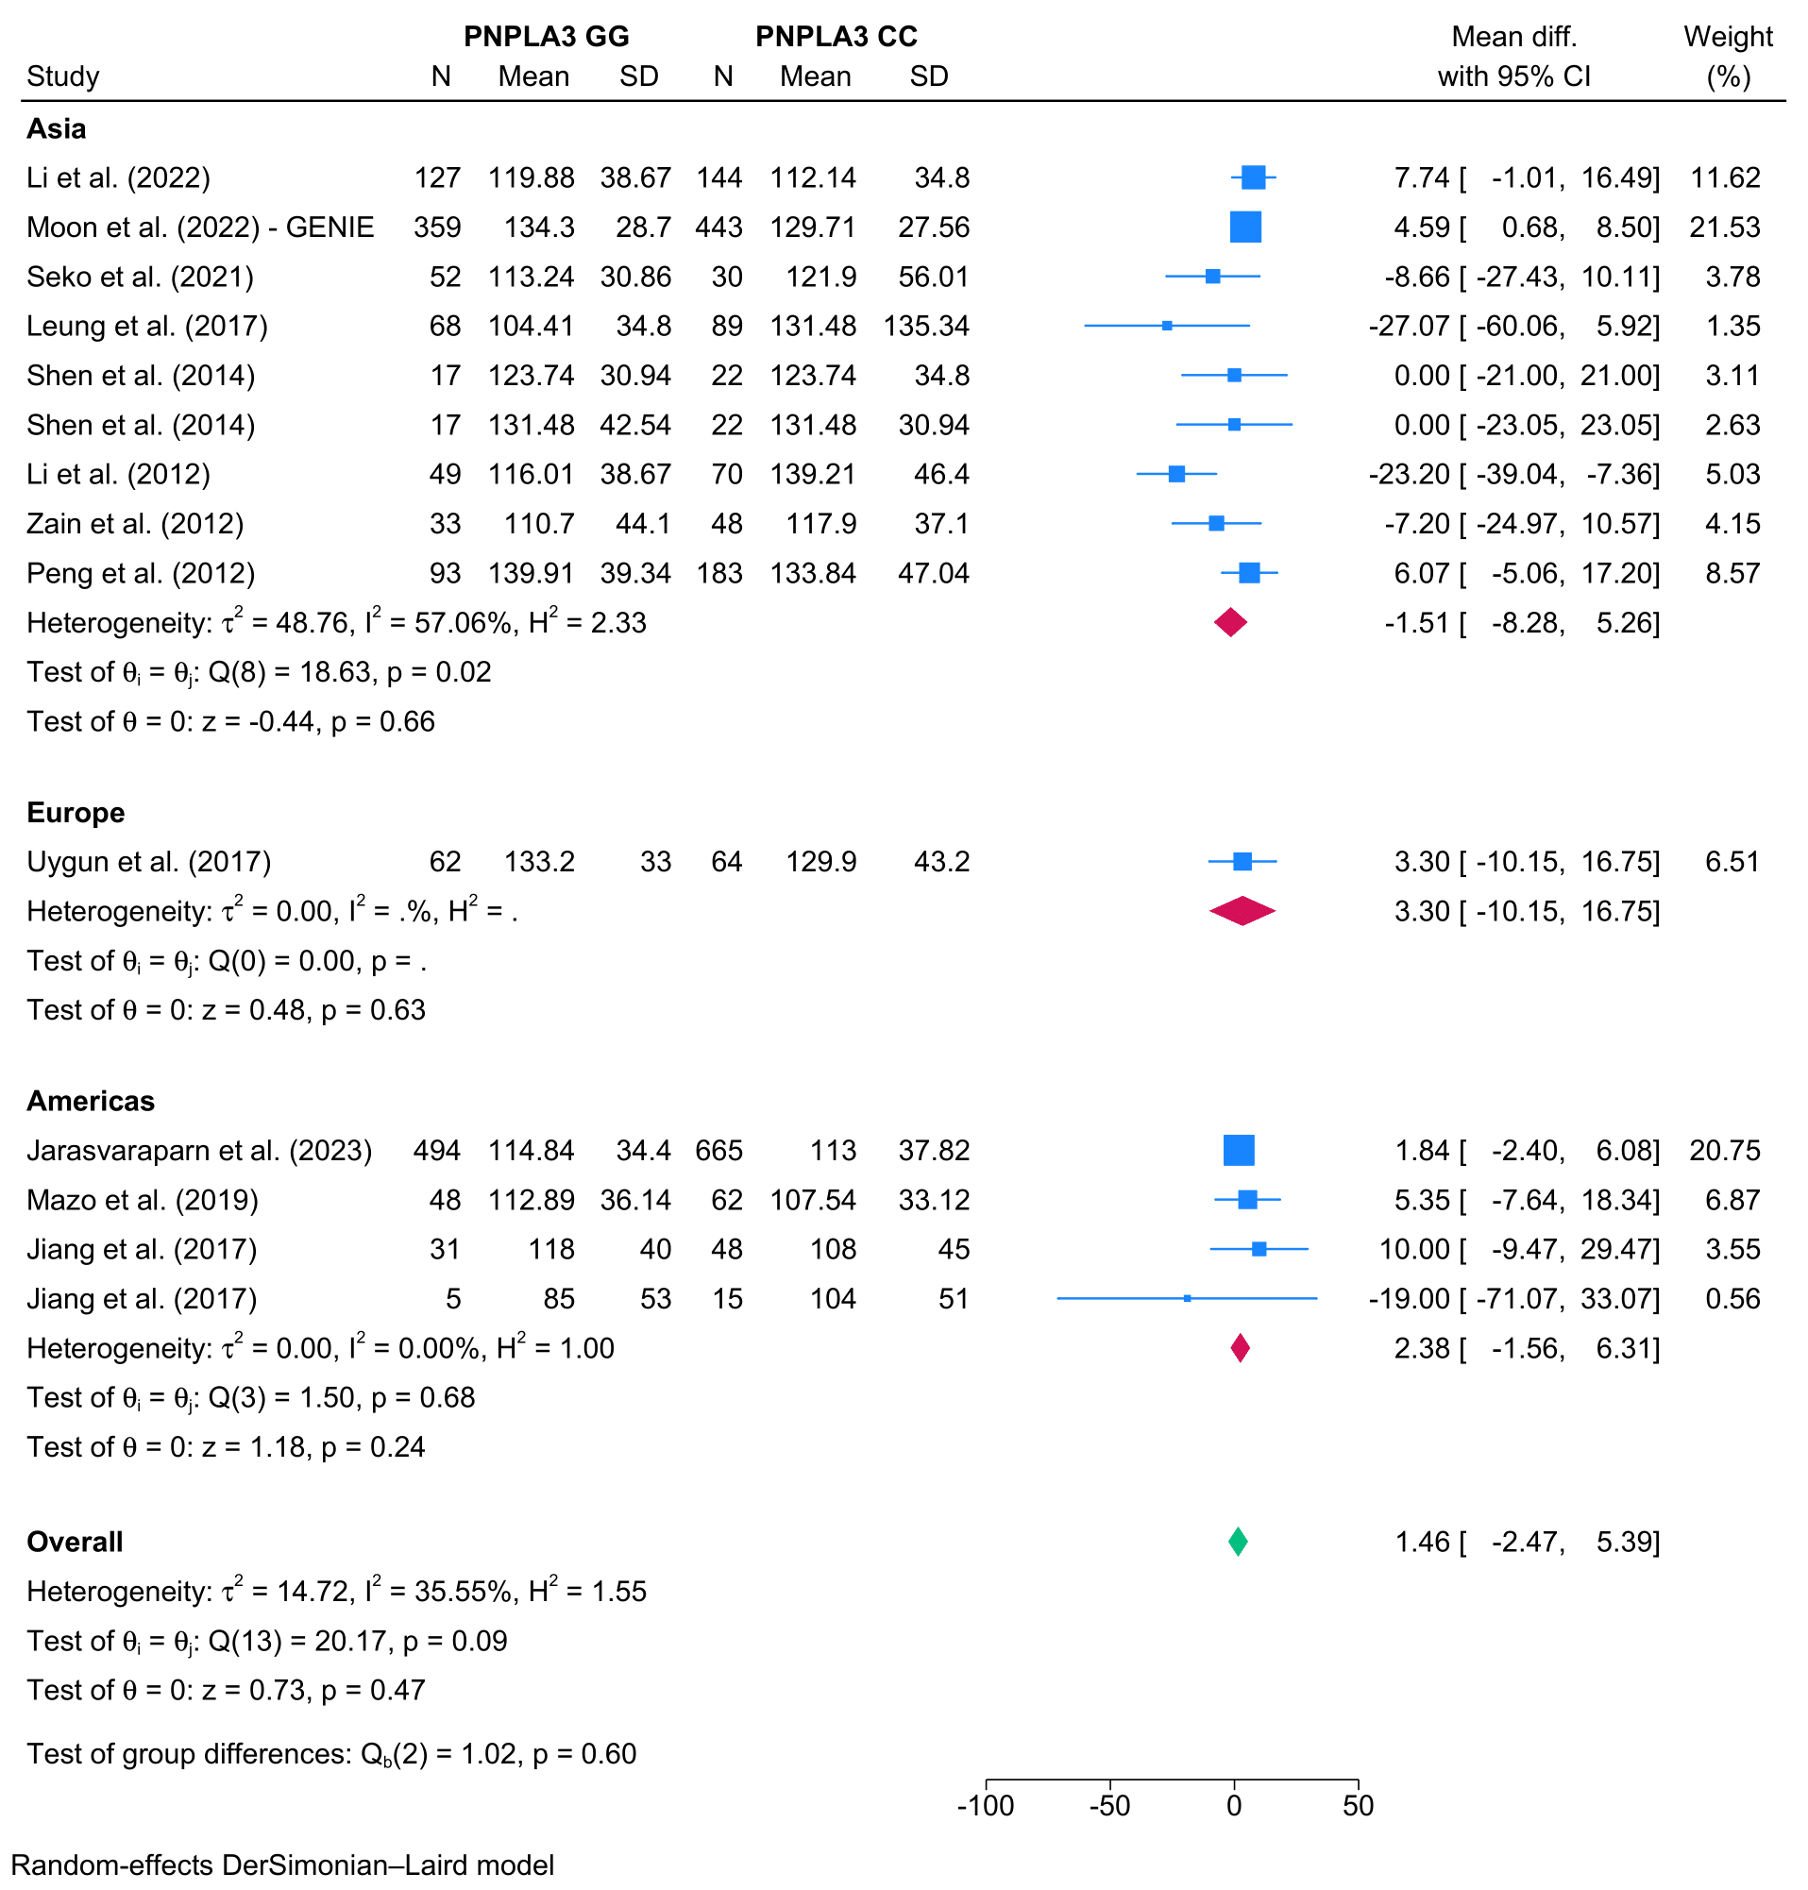

- High-density lipoprotein
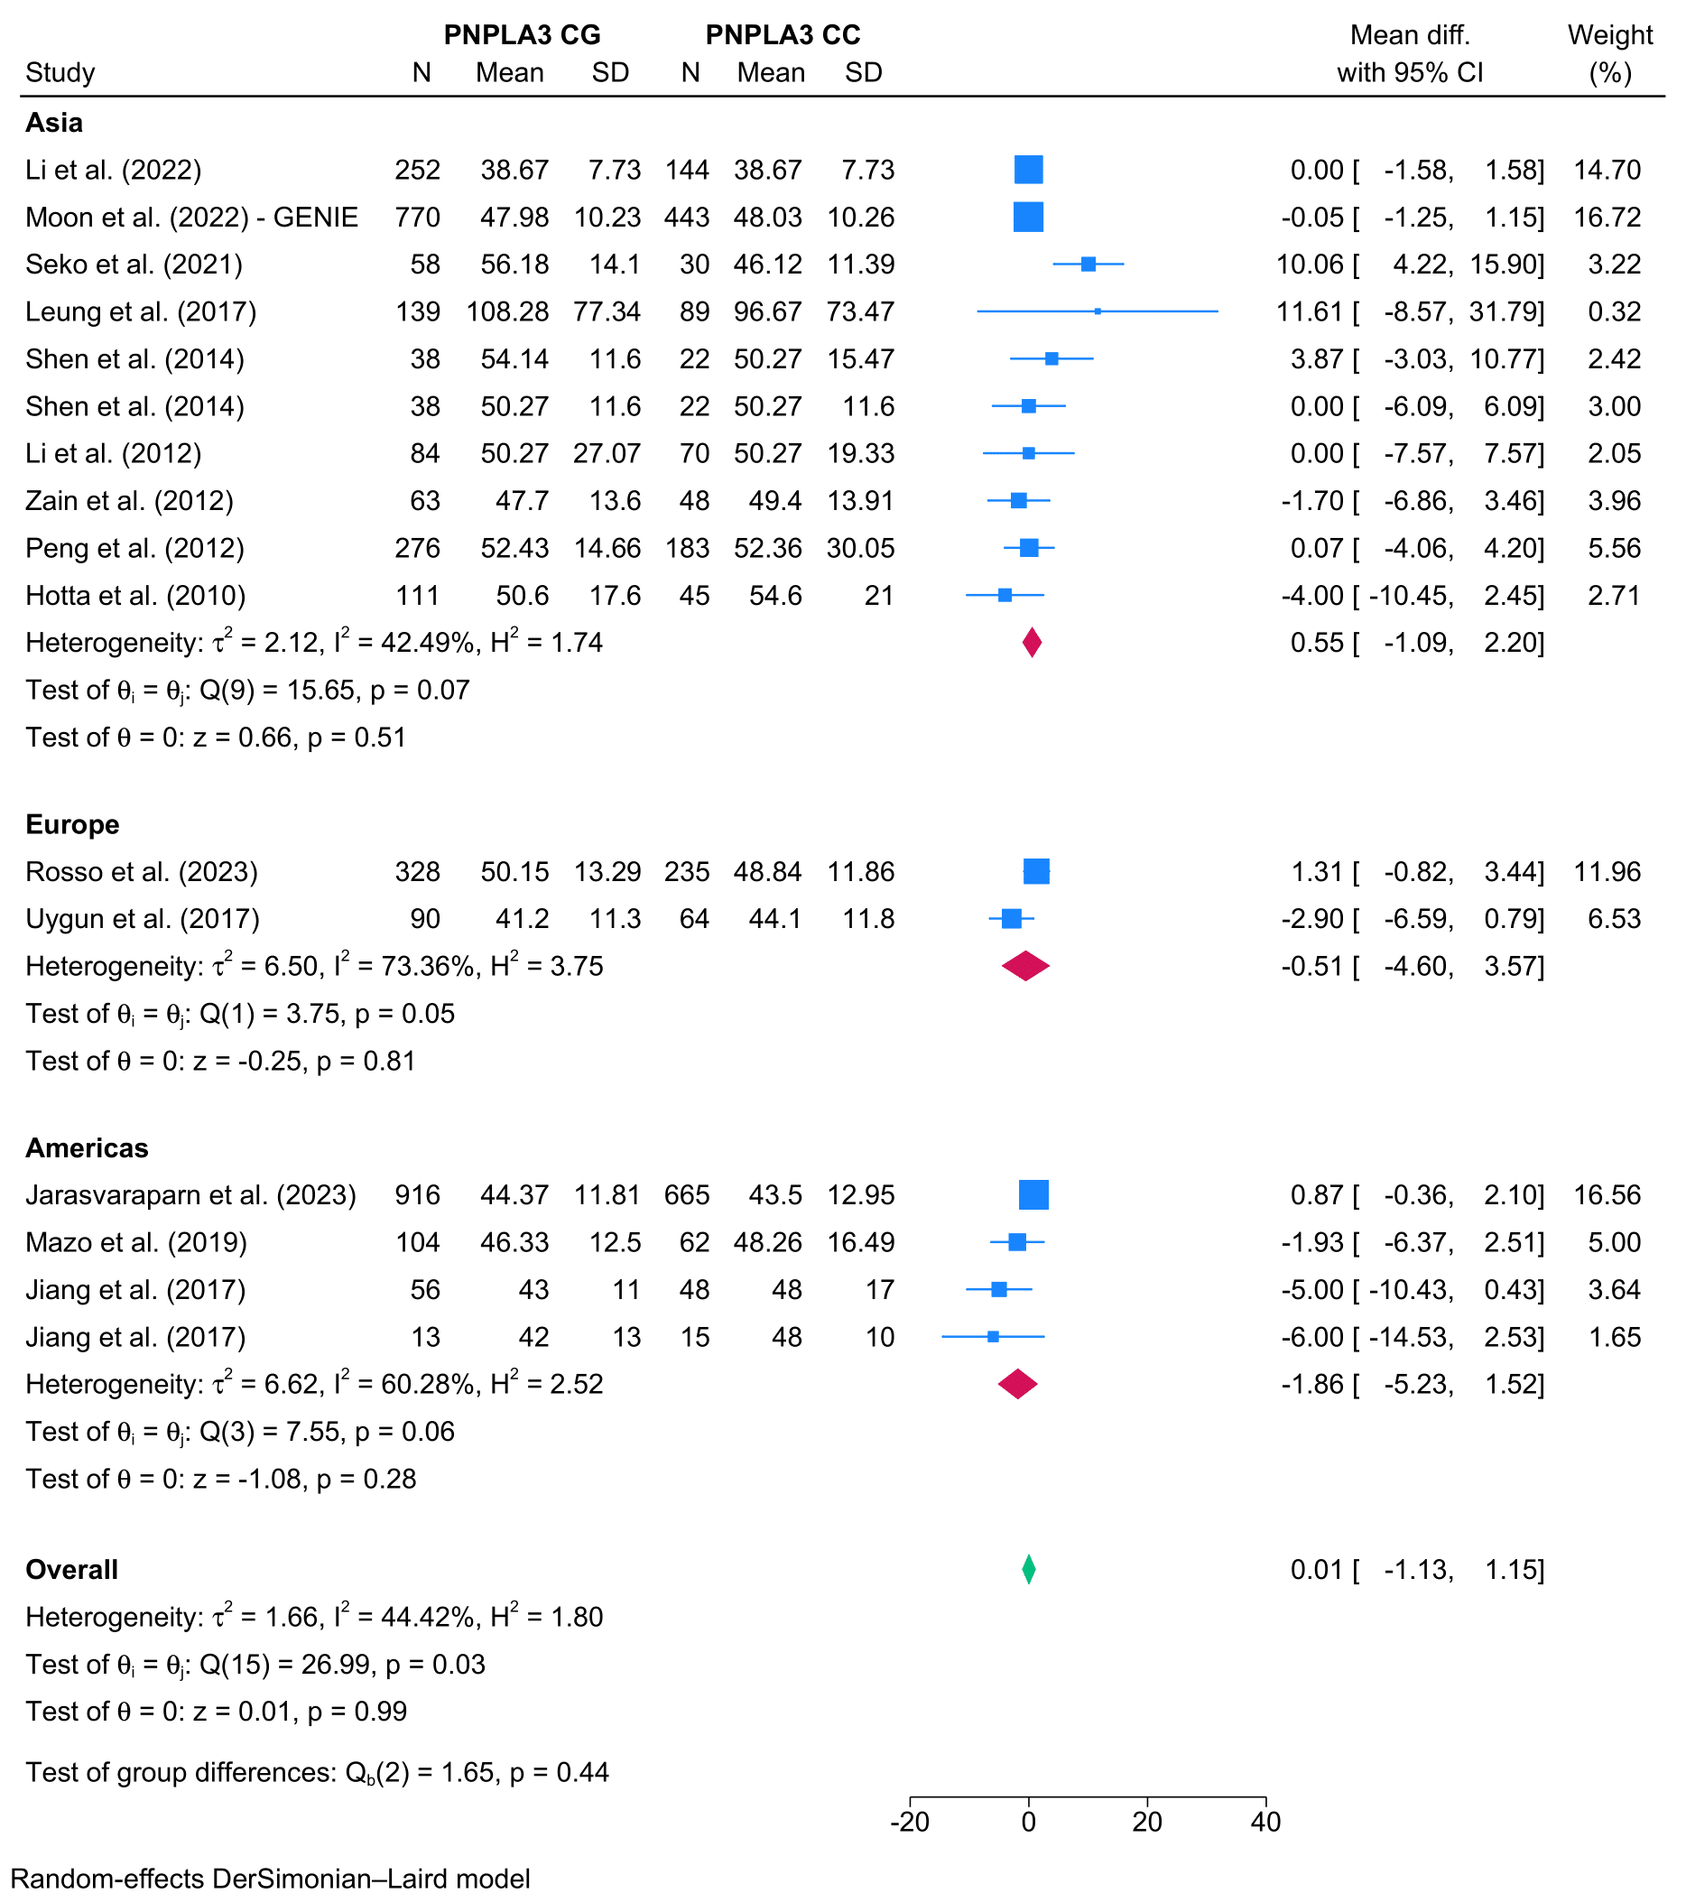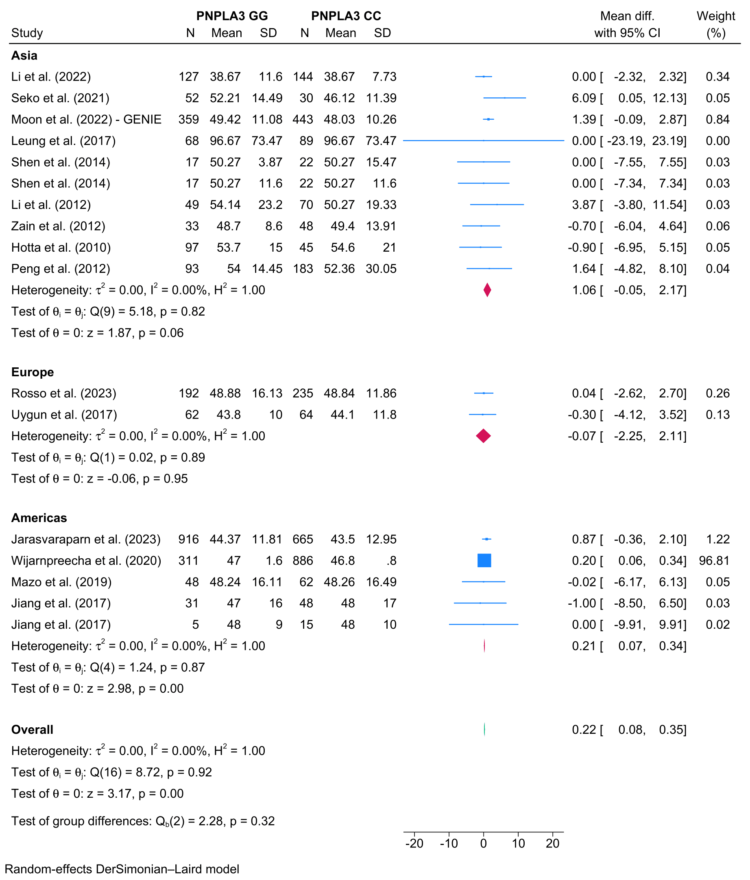

- Homeostatic model assessment for insulin resistance
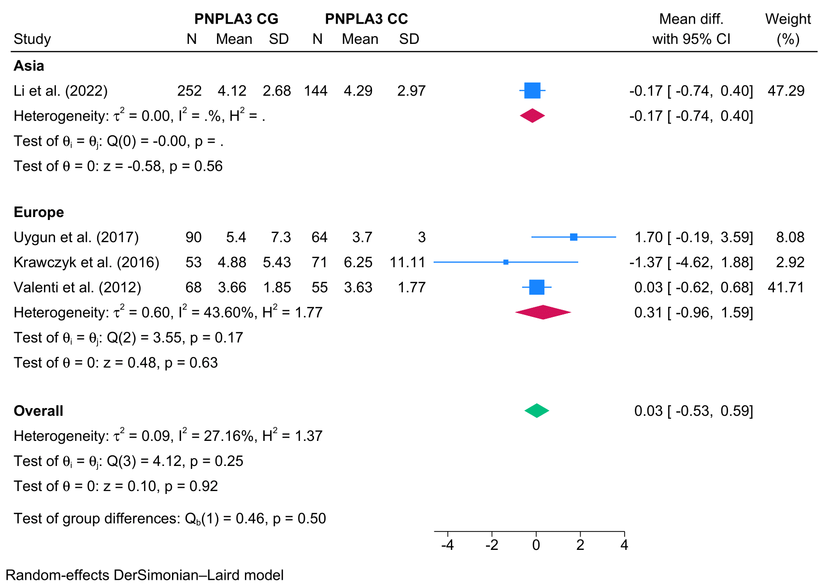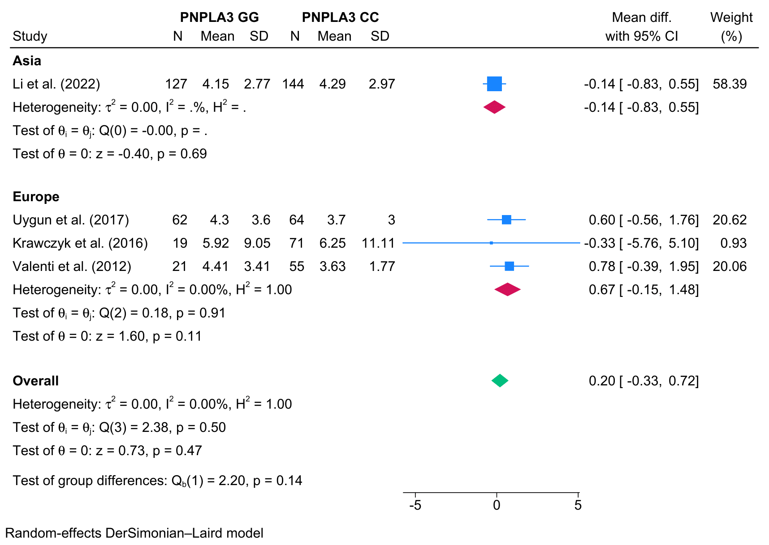

- Fasting blood glucose
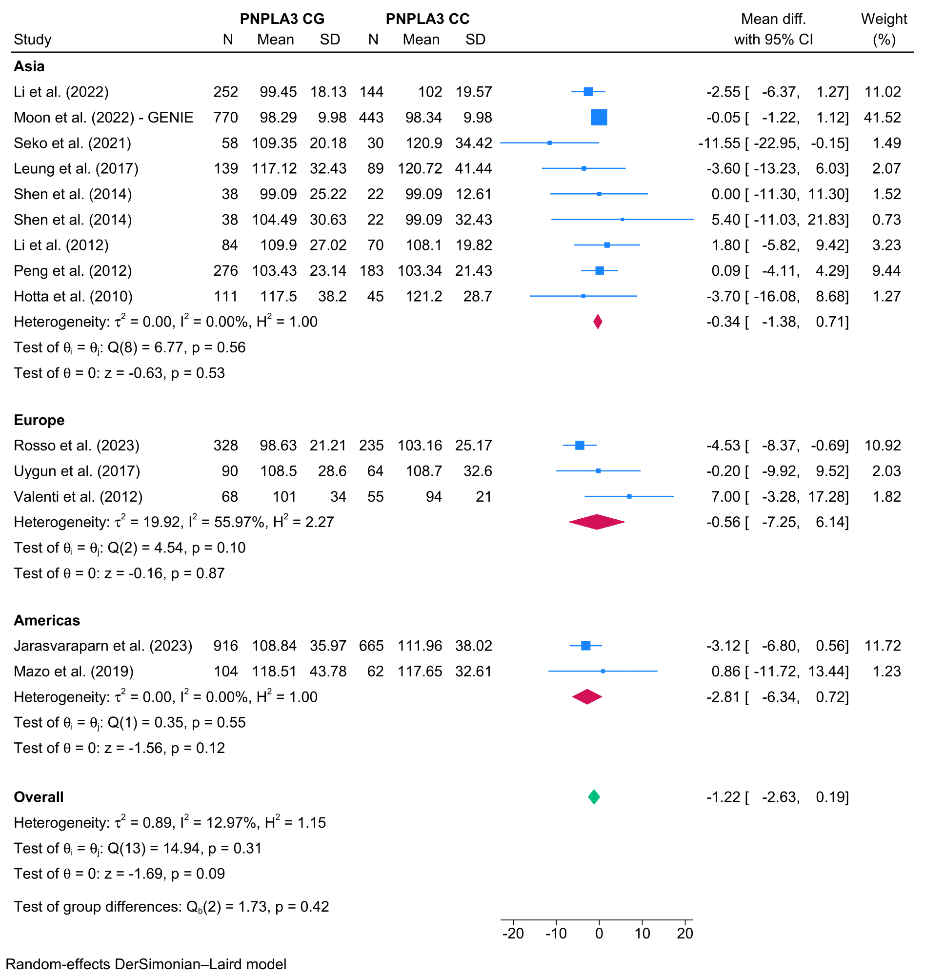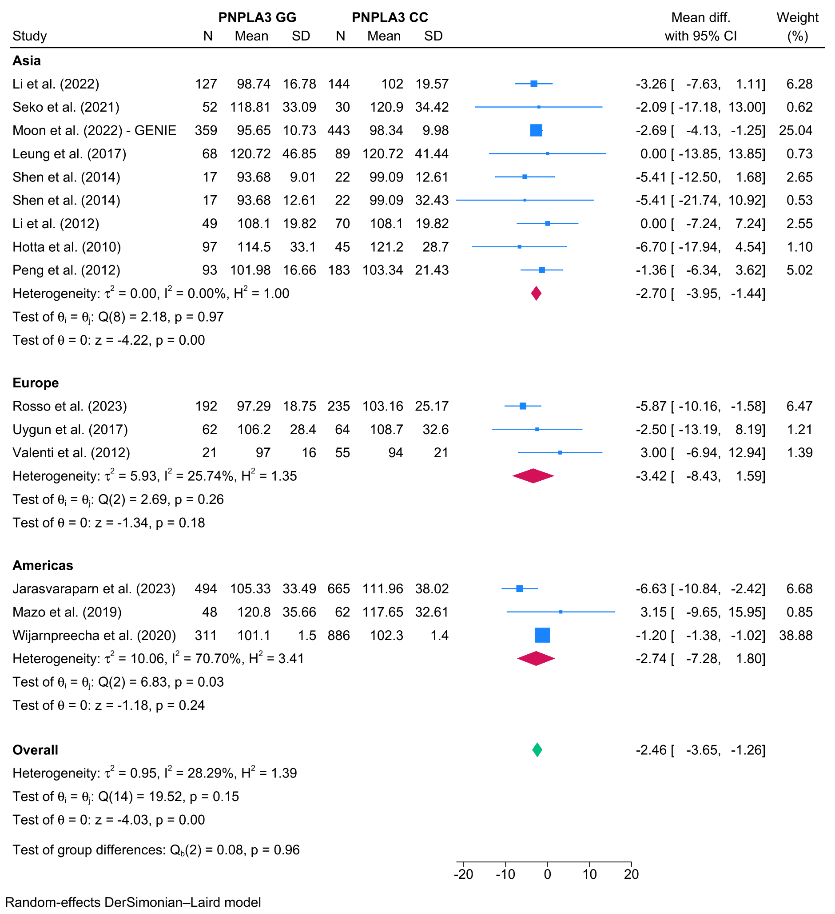

- Insulin
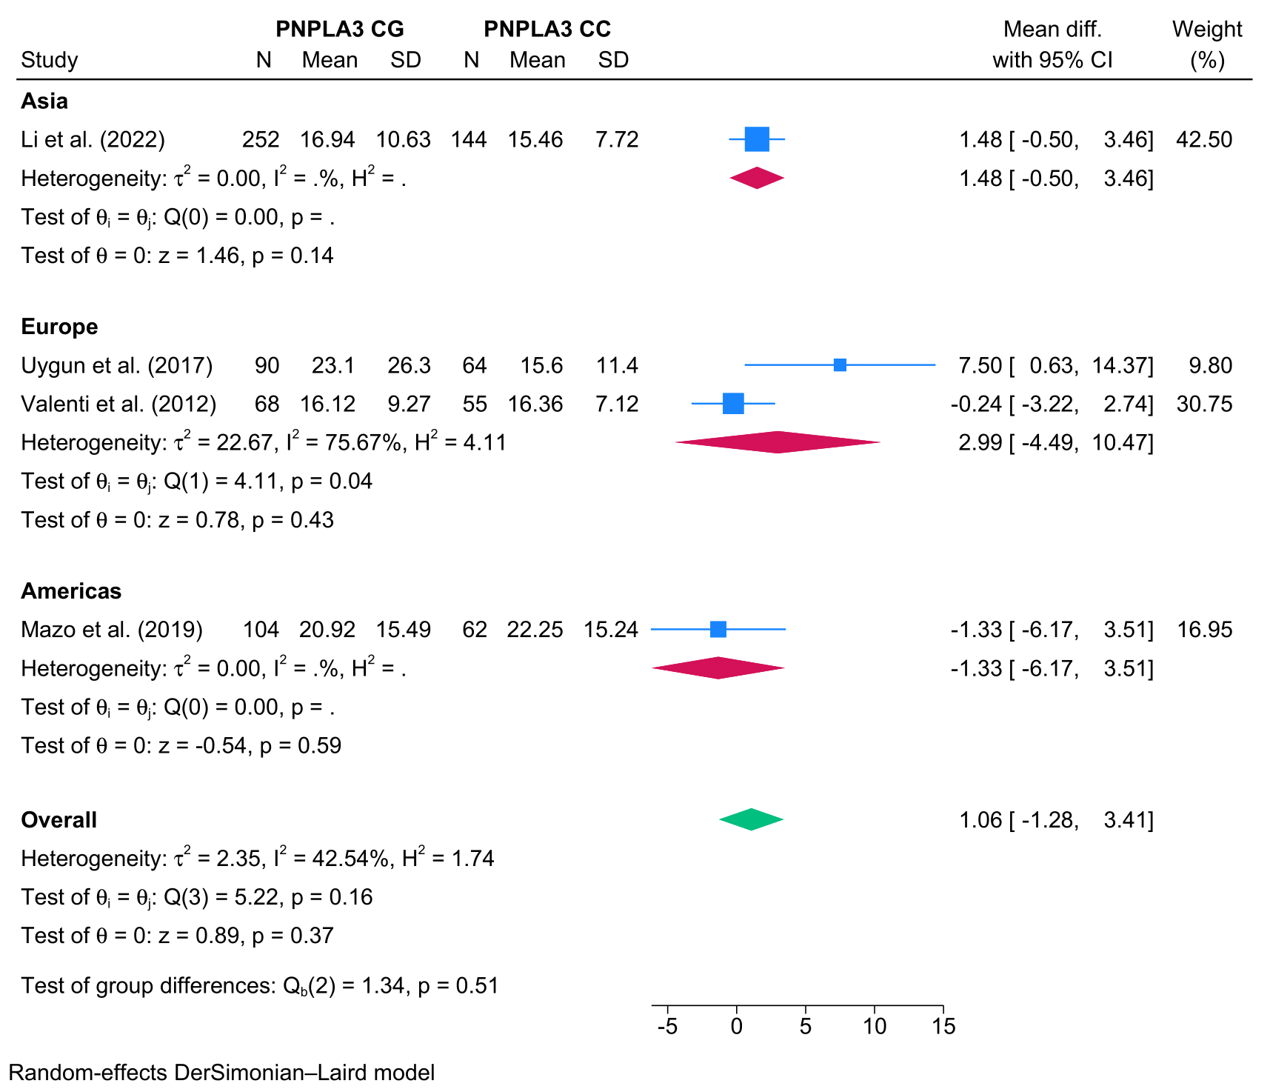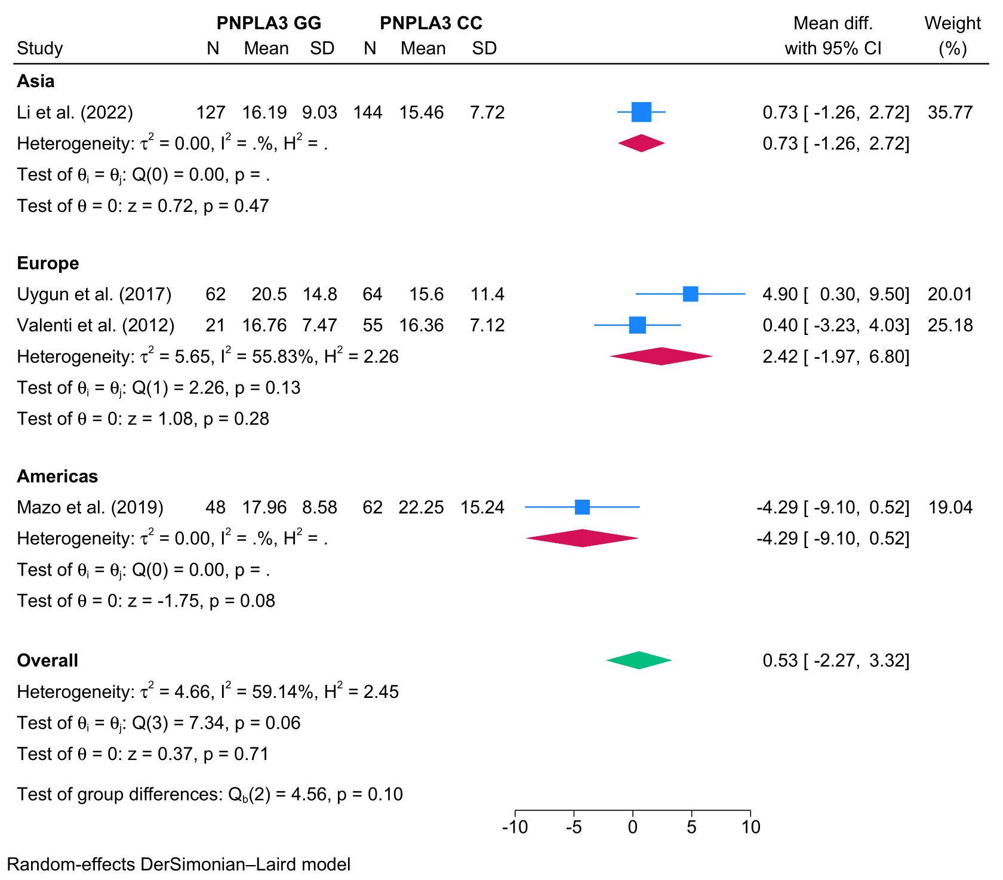

- Hemoglobin A1c
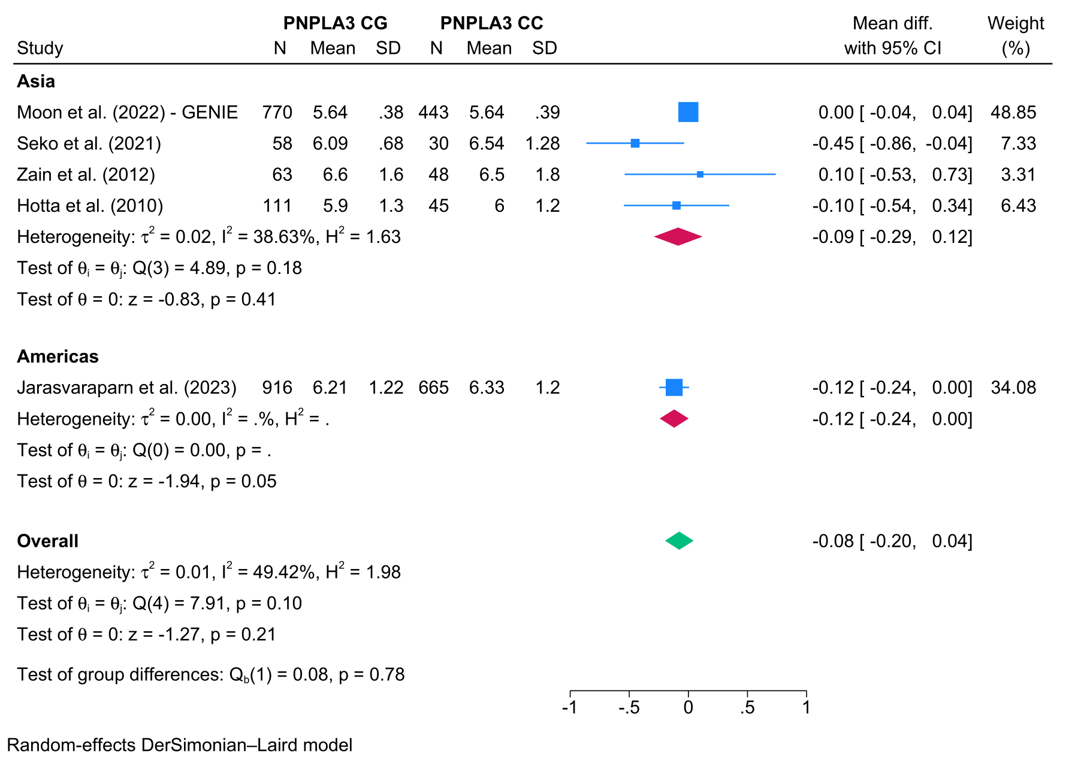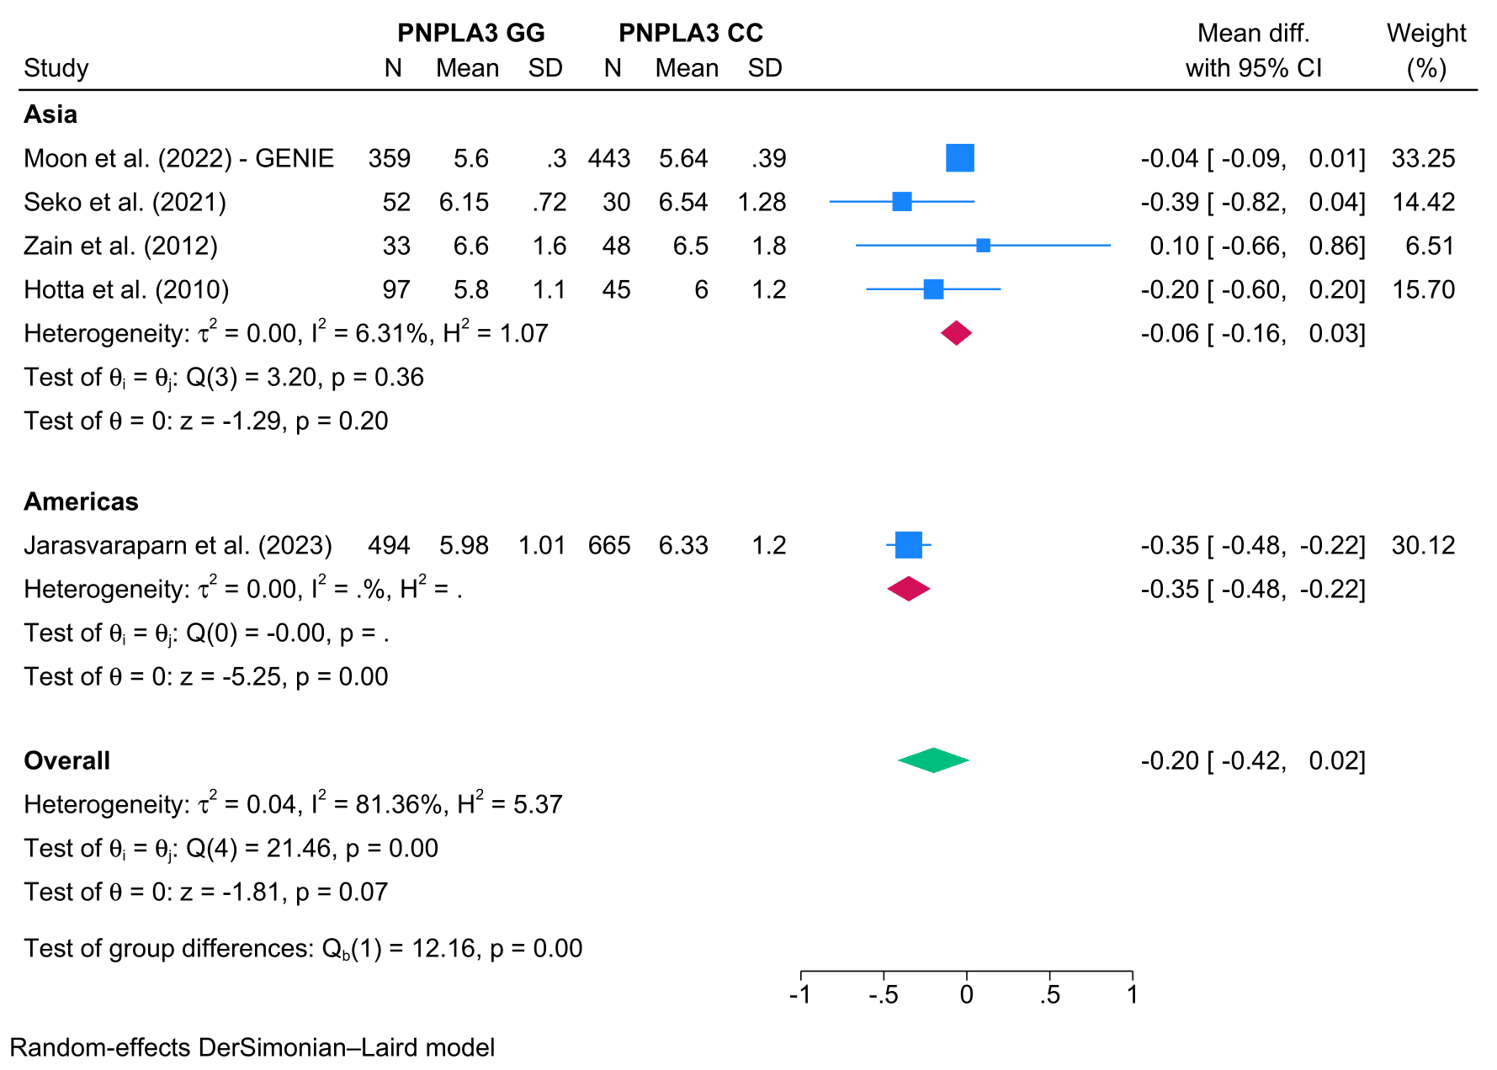

- Hypertension
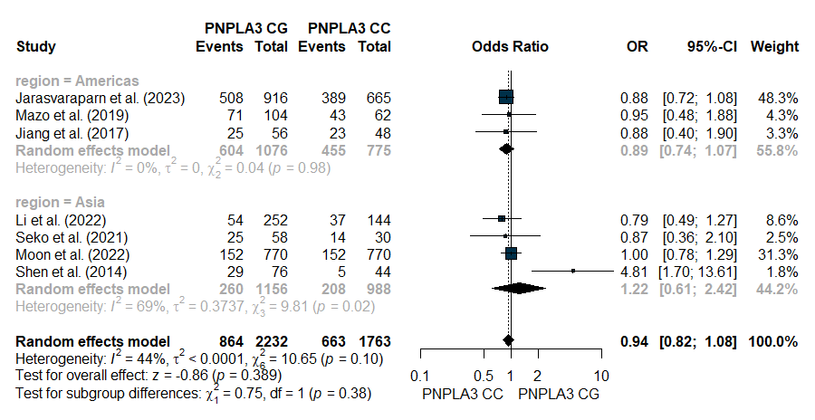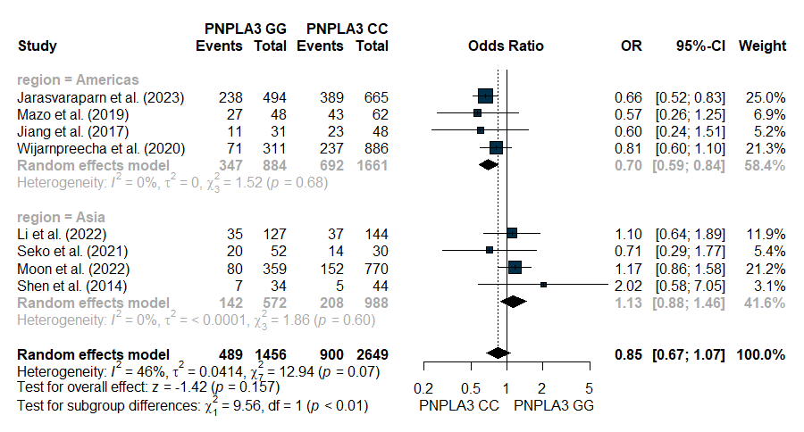

- Diabetes mellitus
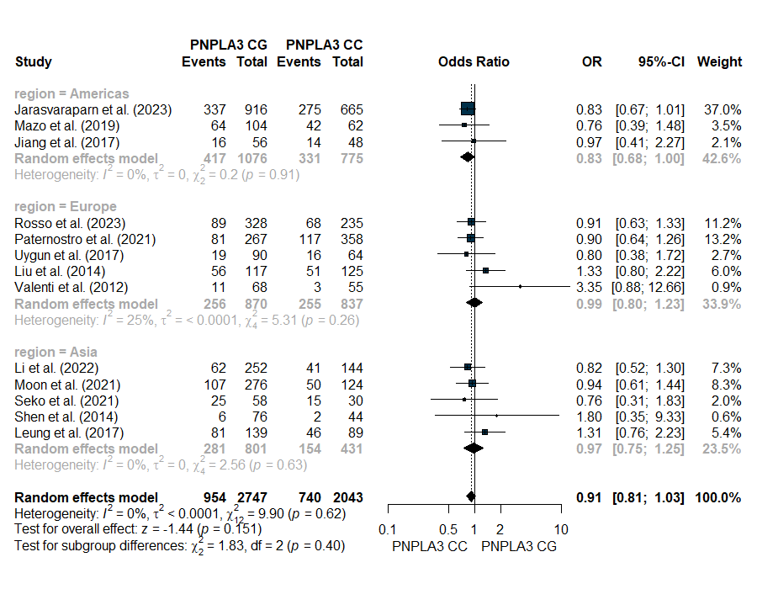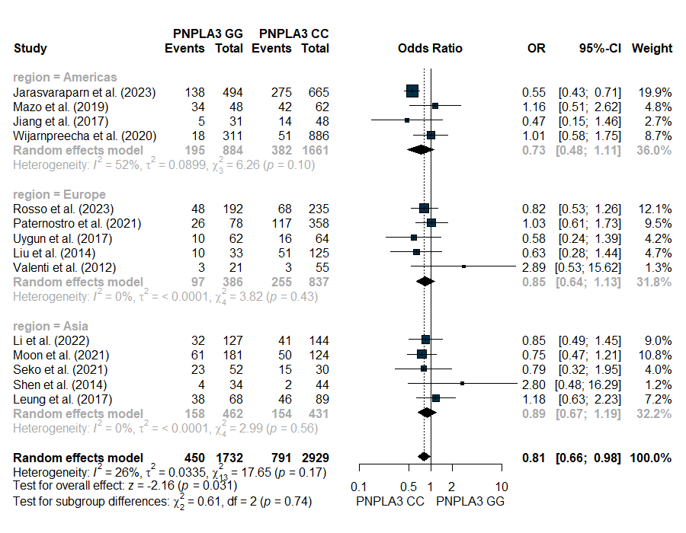

- Aspartate aminotransferase
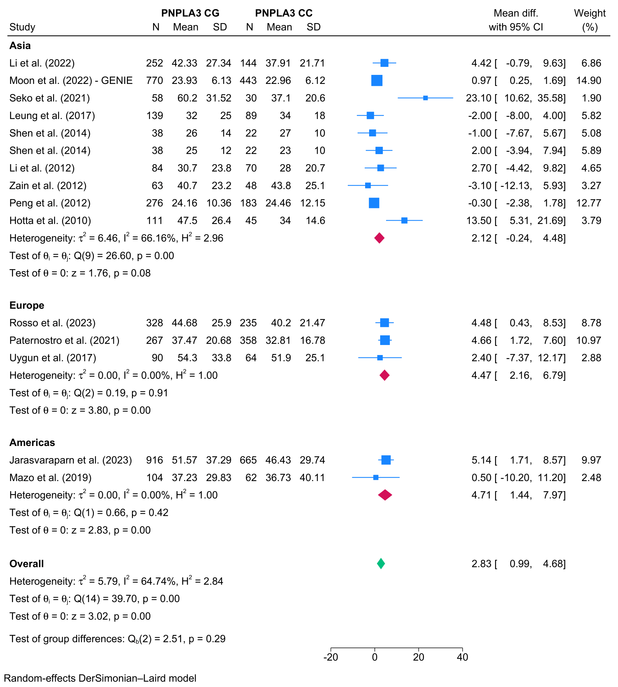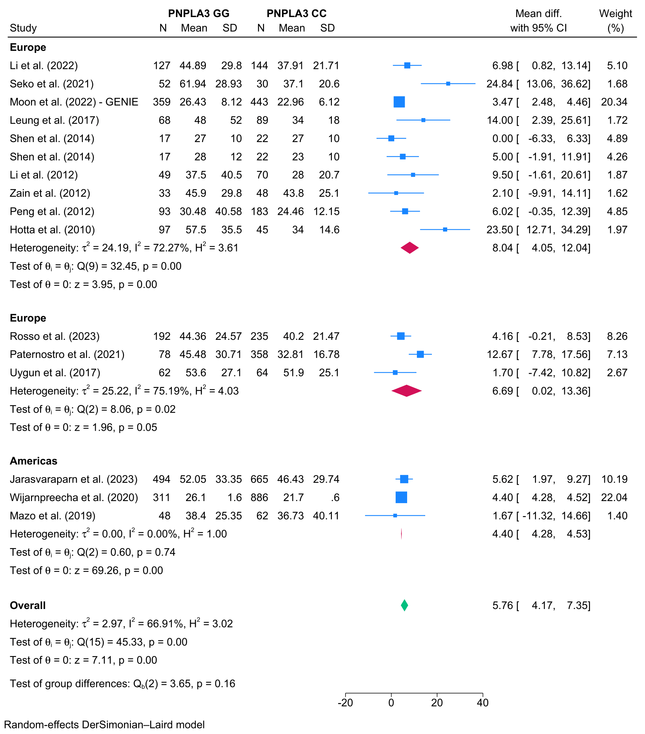

- Alanine aminotransaminase
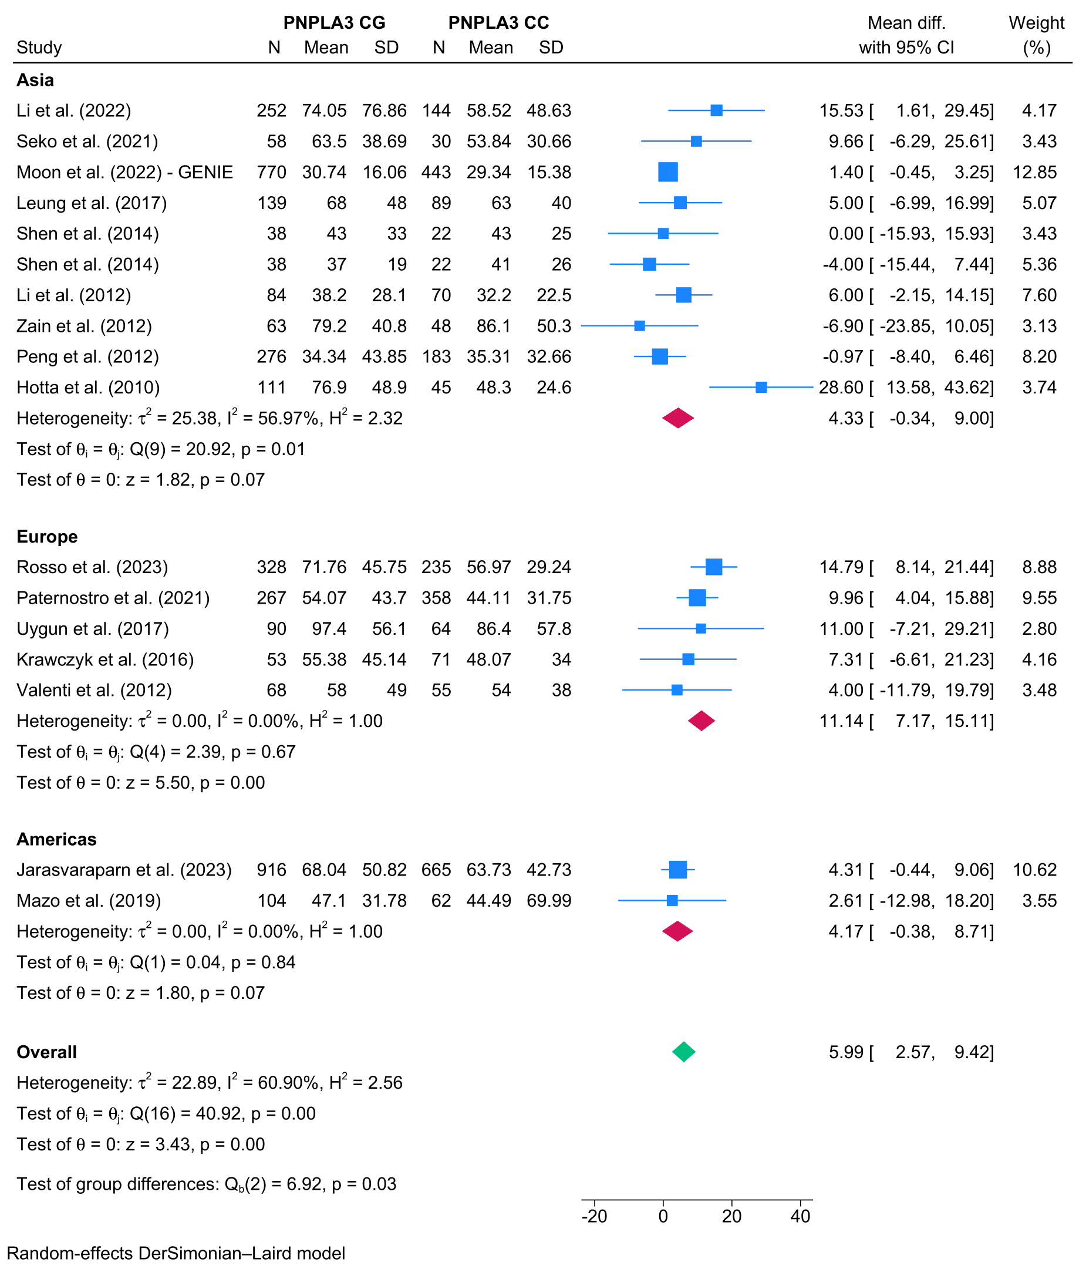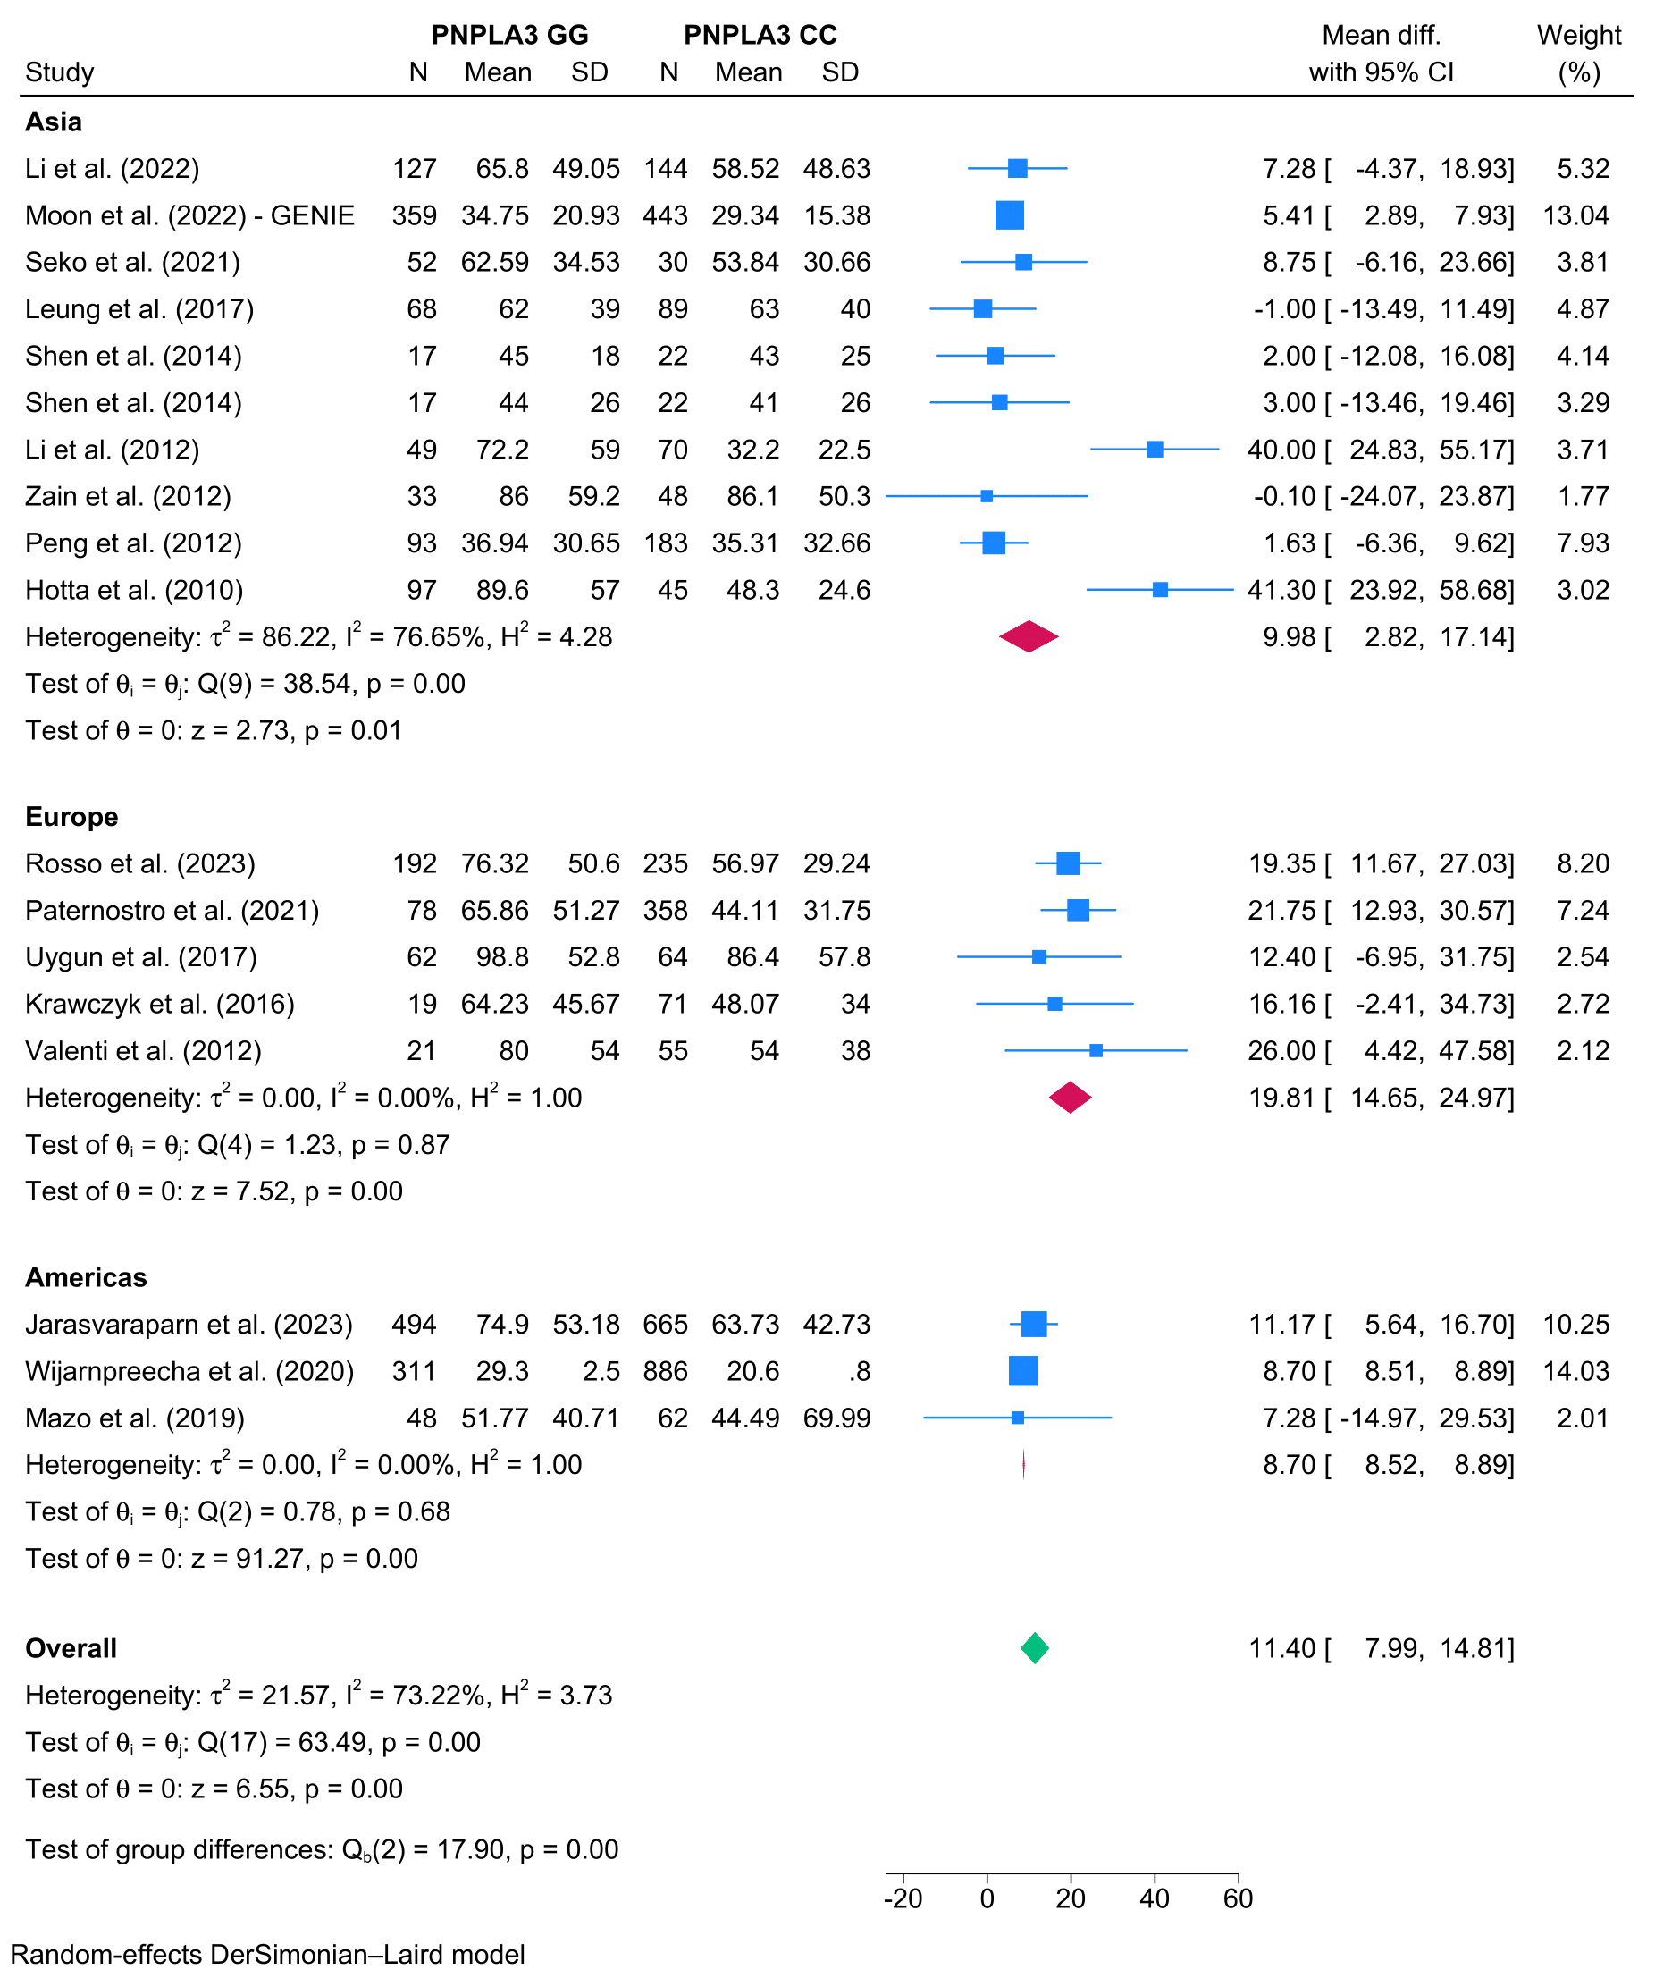

- Gamma-glutamyl transferase
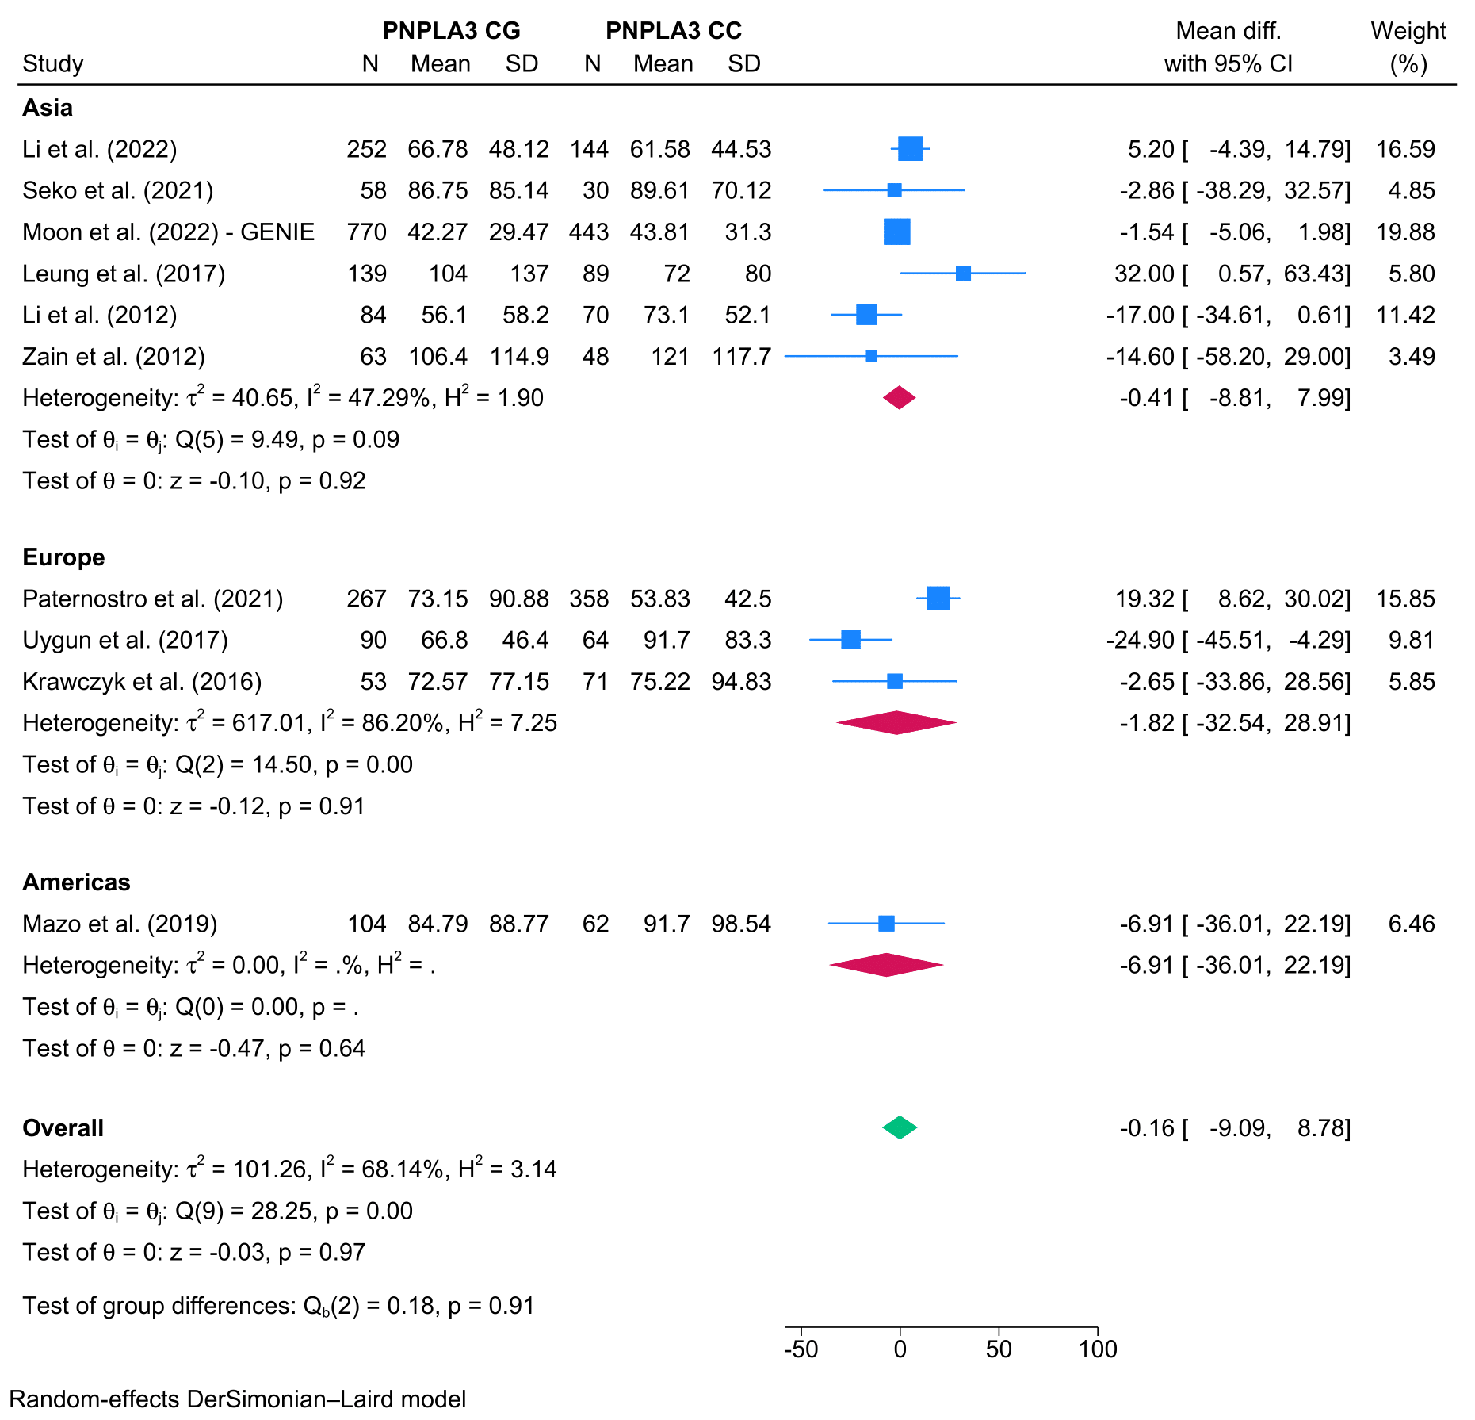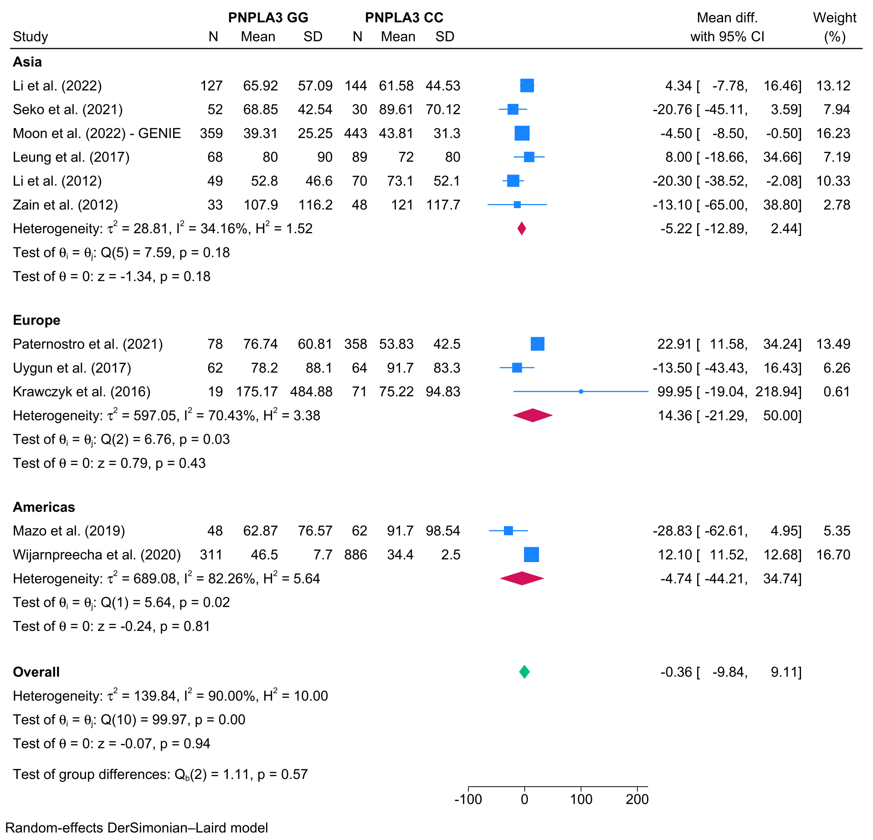
Figure S5 – Funnel plots for publication bias in clinical analysis
- Body mass index
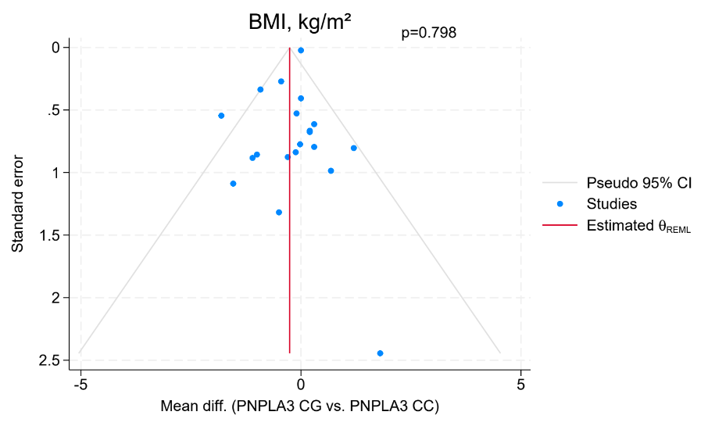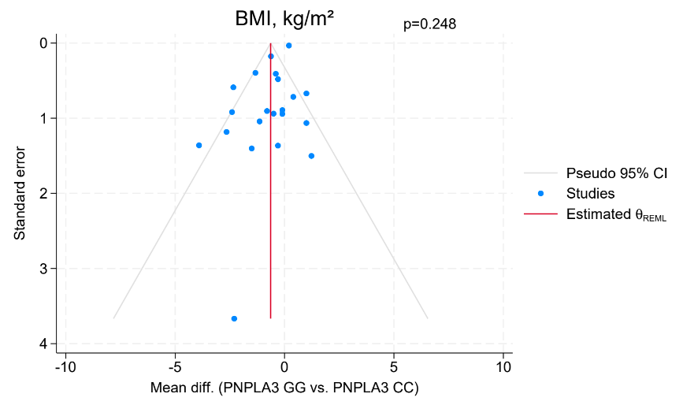
- Triglycerides
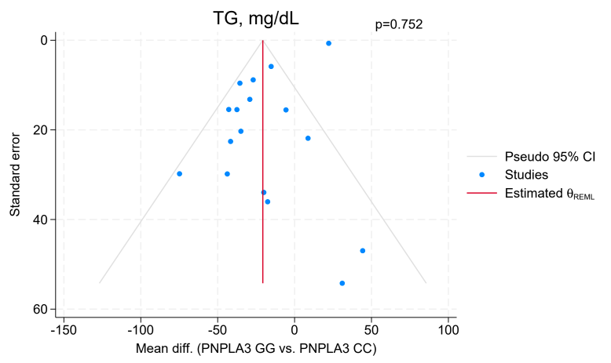
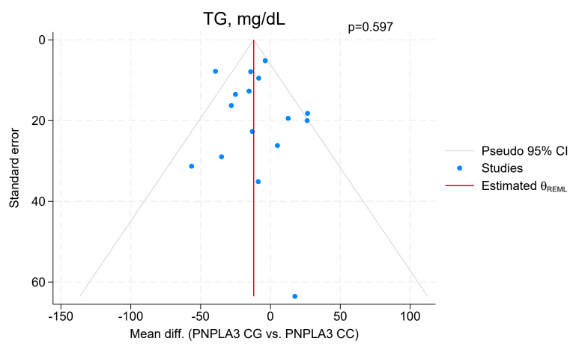

- Total cholesterol
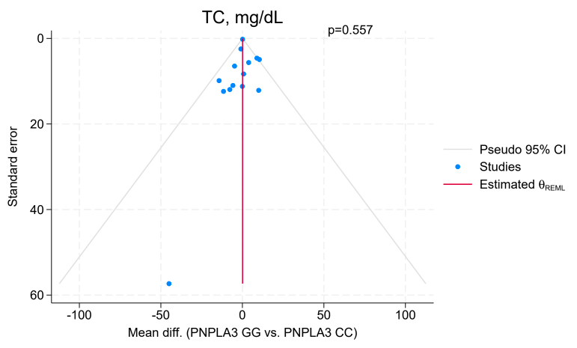
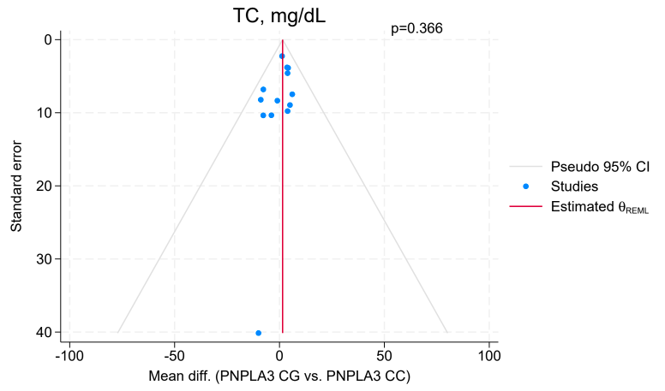
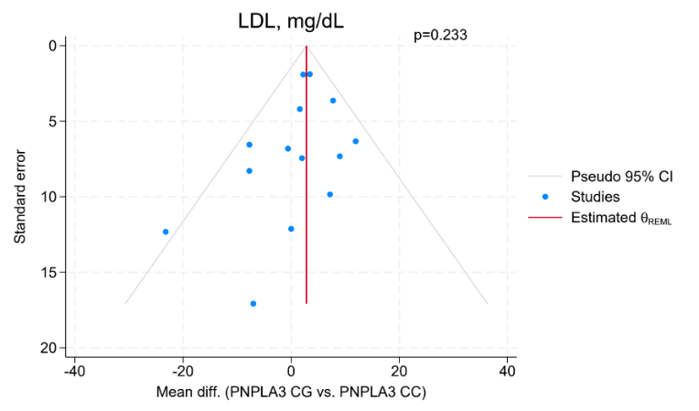
- Low-density lipoprotein
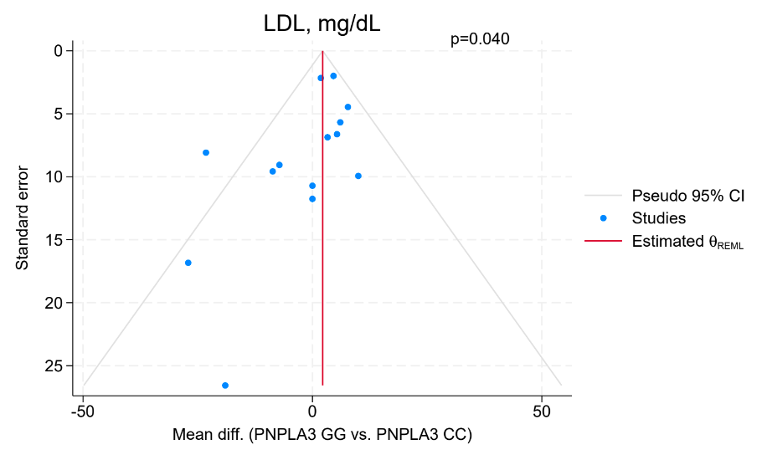

- High-density lipoprotein
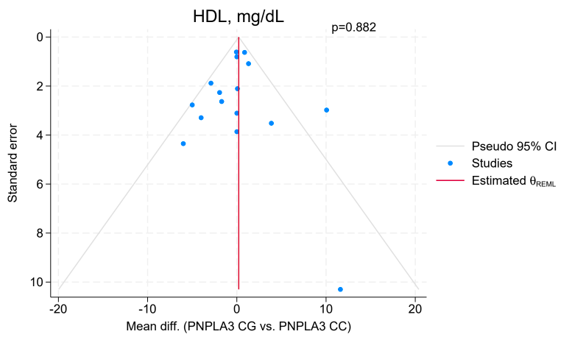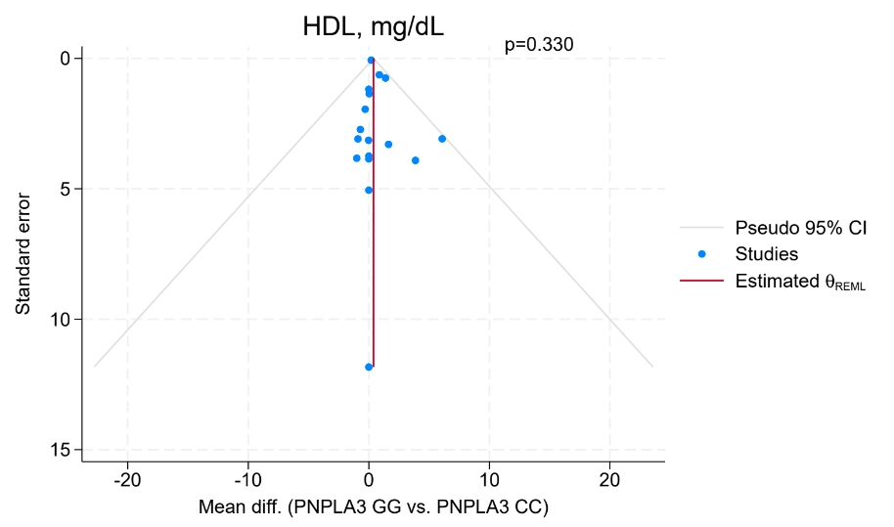
- Fasting blood glucose
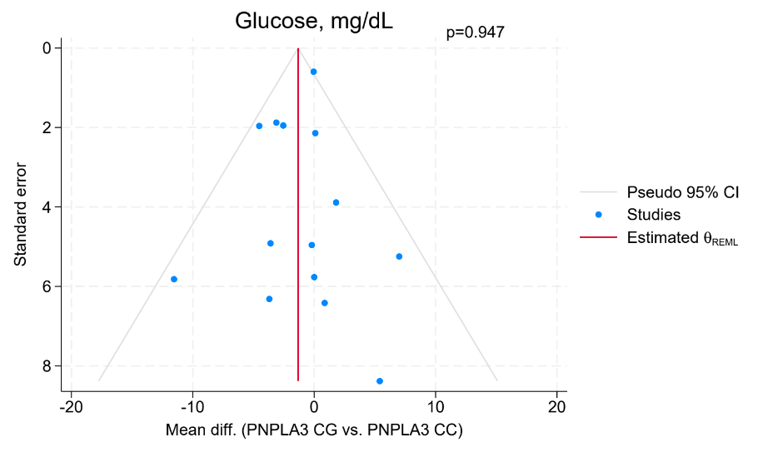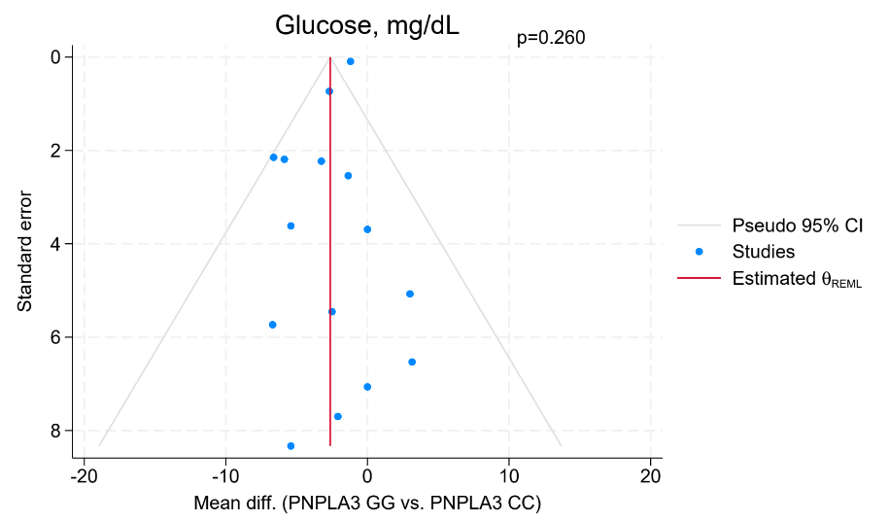
- Diabetes mellitus
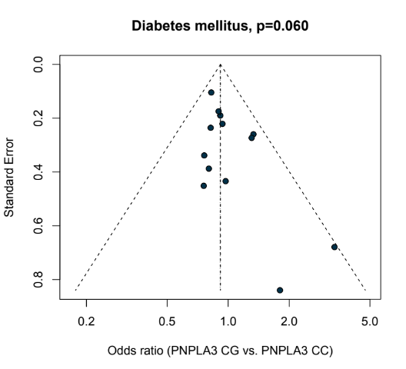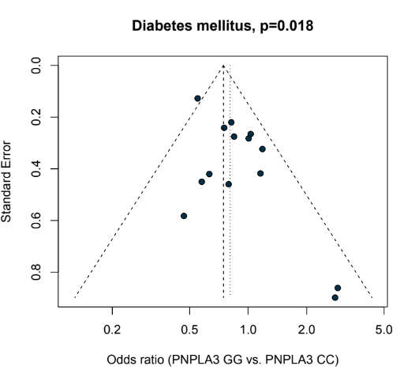
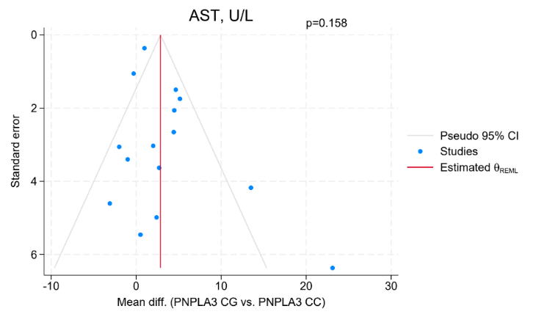
- Aspartate aminotransferase
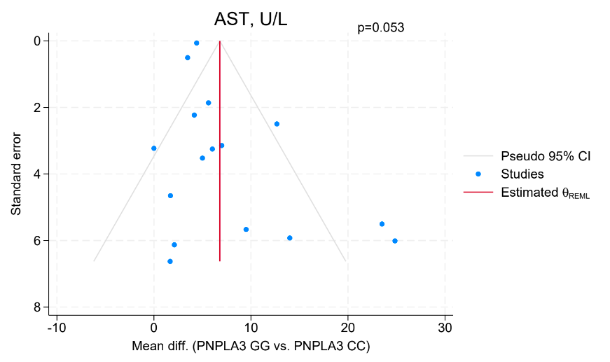
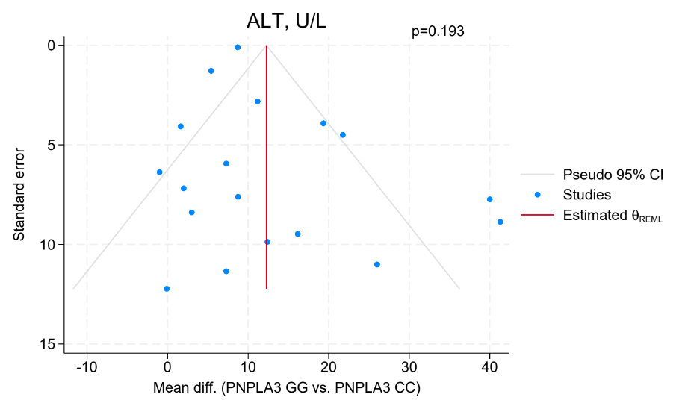
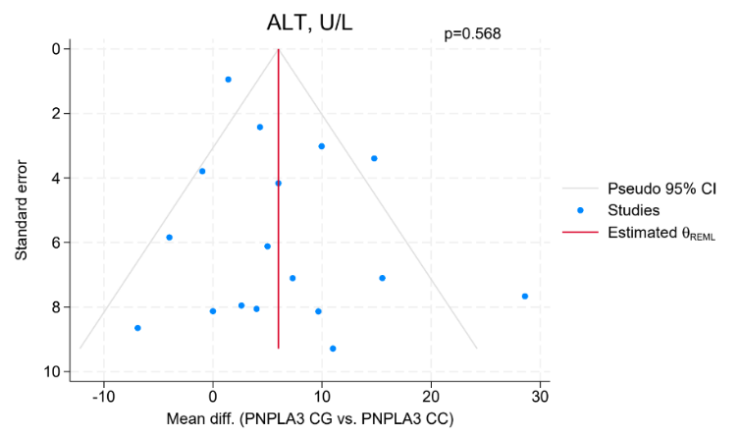
- Alanine aminotransaminase

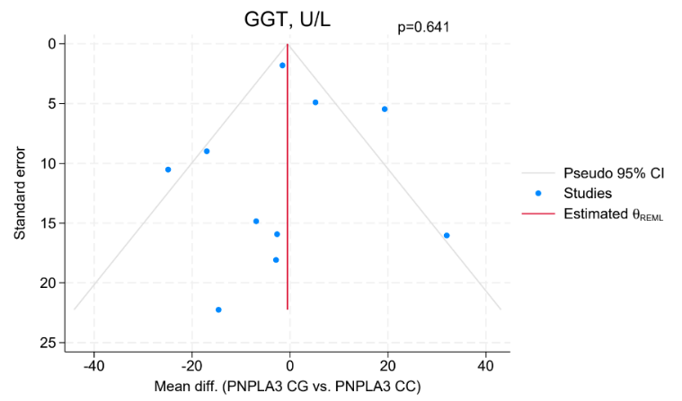
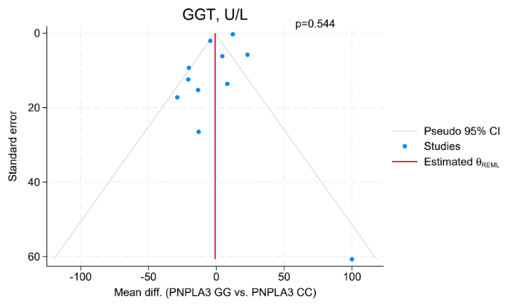
- Gamma-glutamyl transferase

Figure S6 – Funnel plots for publication bias after adjustment by trim-and-fill method in (A) LDL outcome and (B) diabetes mellitus outcome for PNPLA3 GG vs. PNPLA3 CC comparison. LDL, low-density lipoprotein.
- LDL outcome

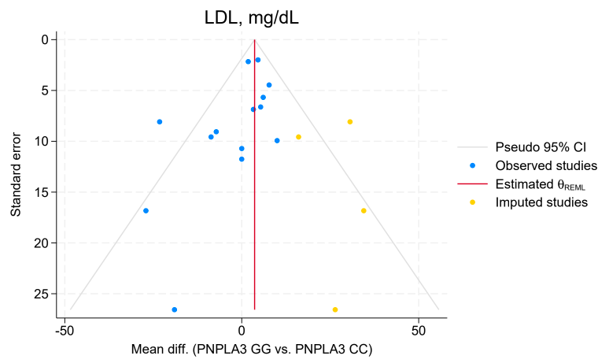

- Diabetes mellitus outcome
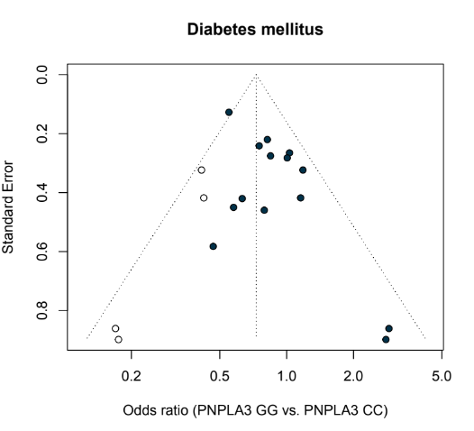

Figure S7 – Forest plots on sensitivity analysis for clinical analysis

- Body mass index
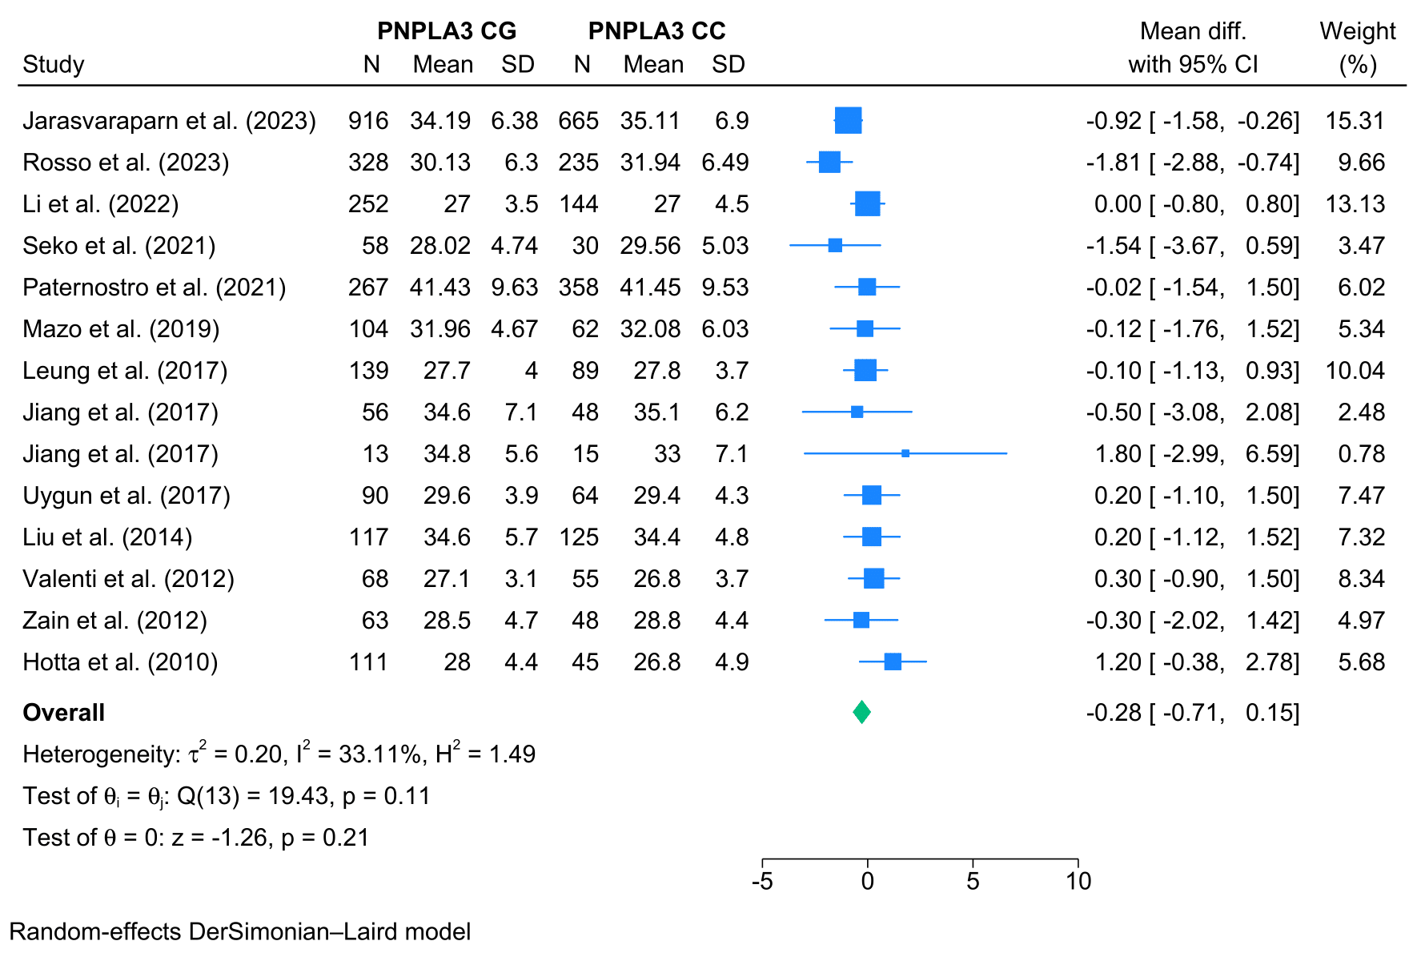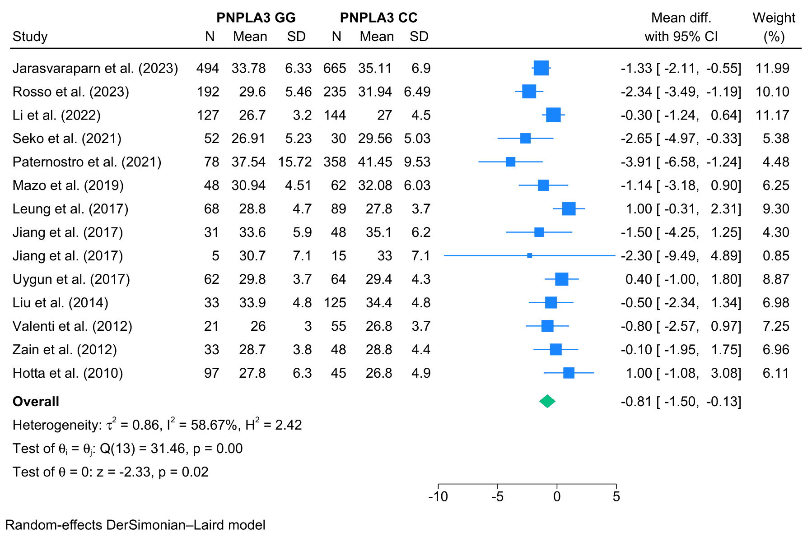

- Waist circumference
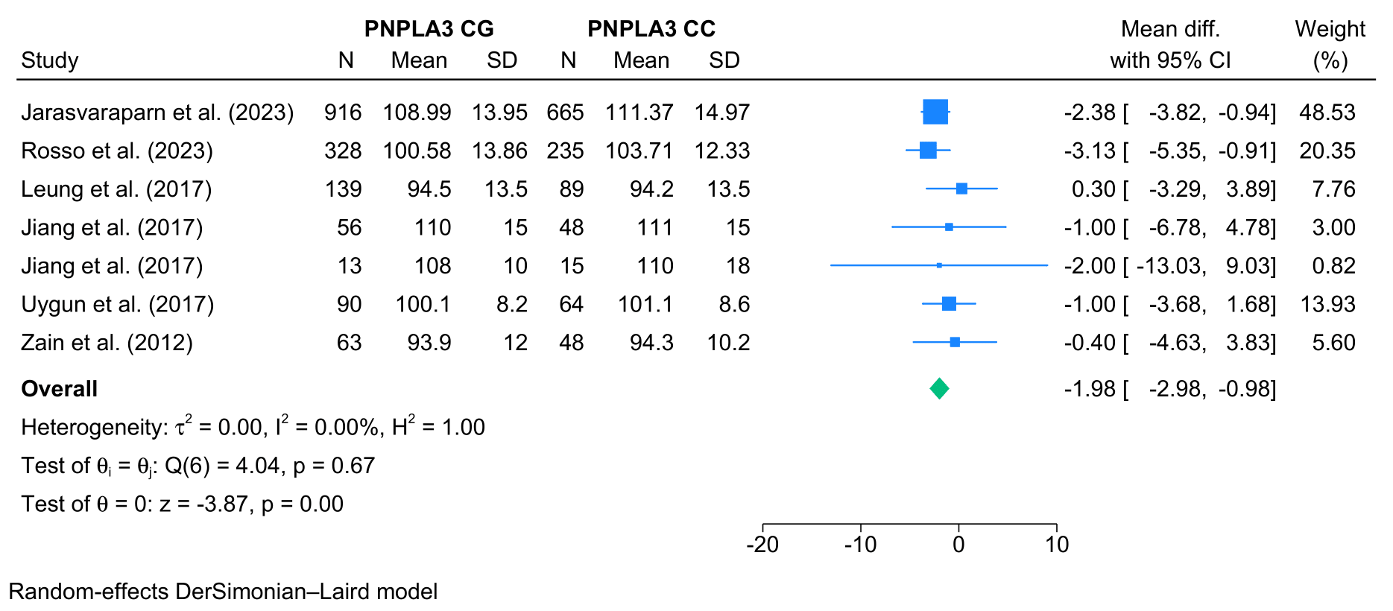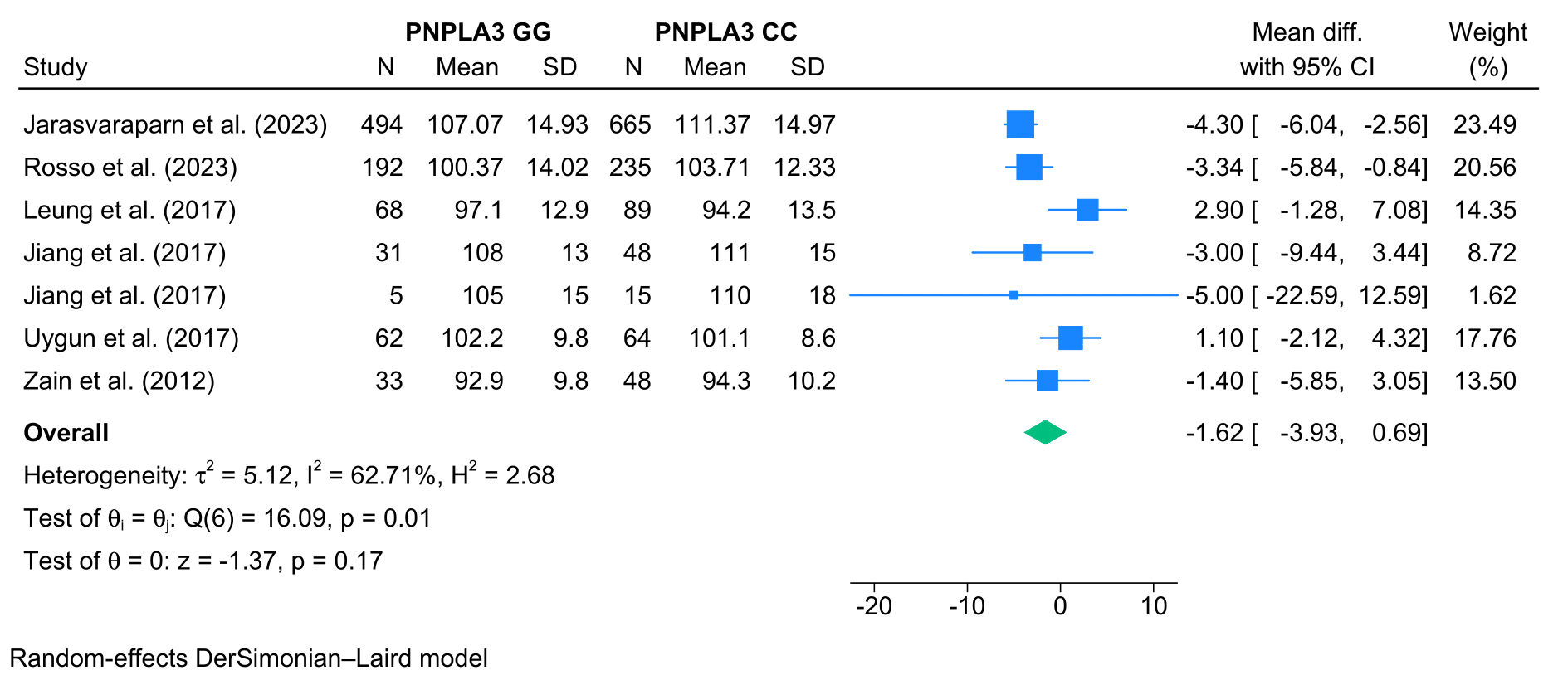

- Triglycerides
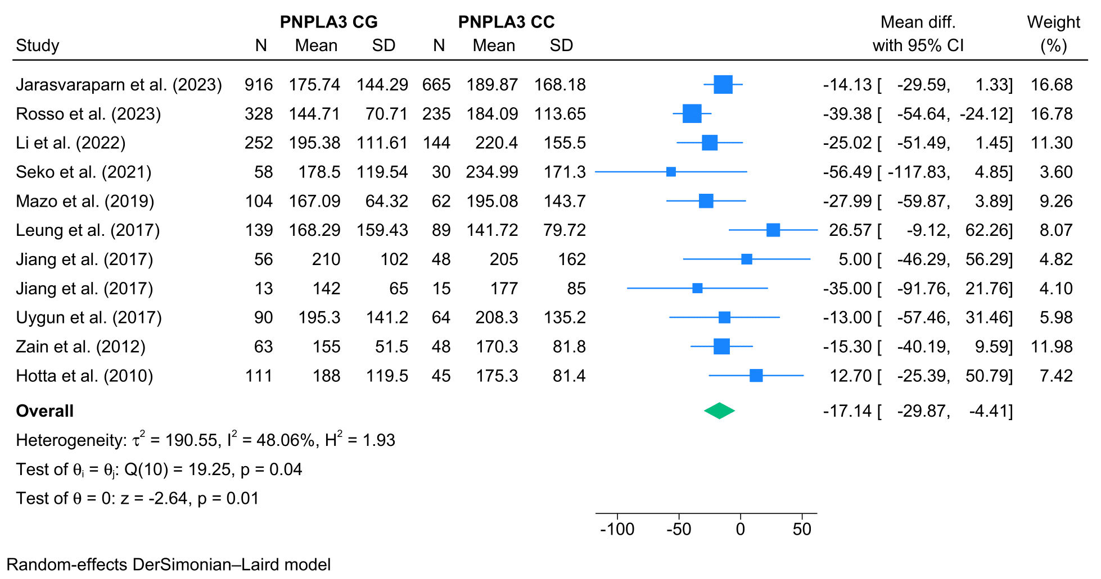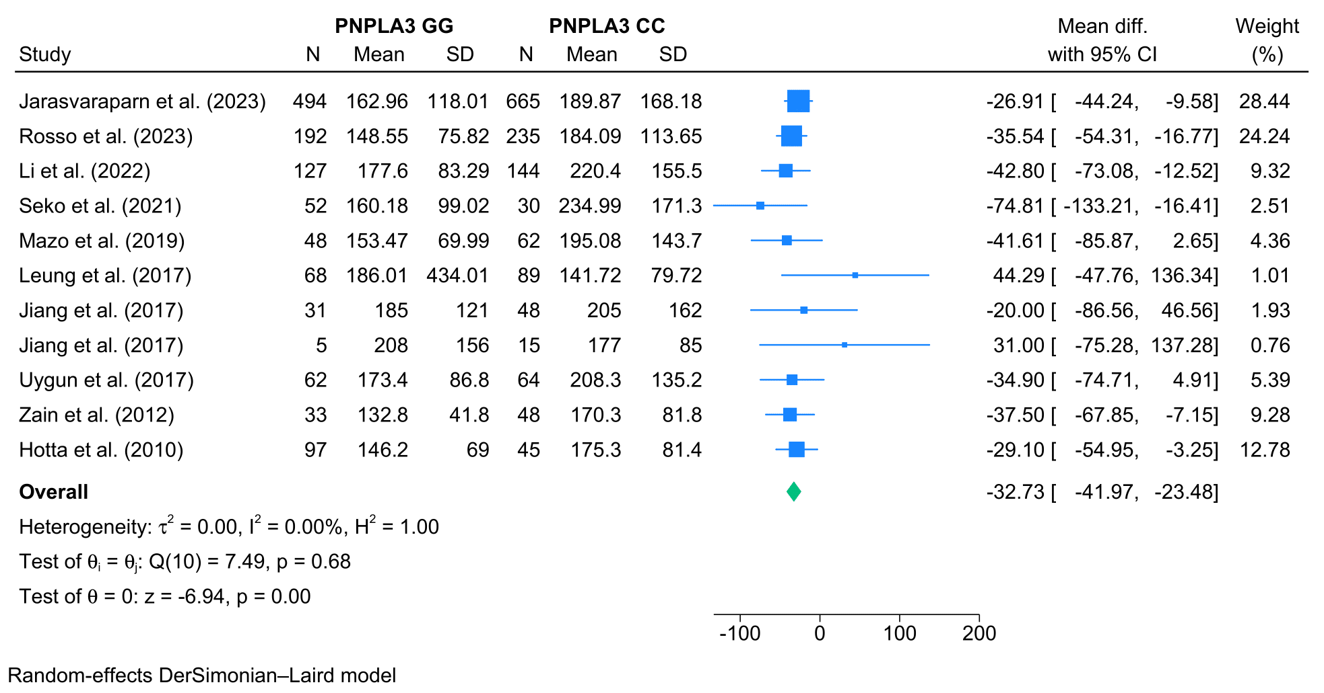

- Total cholesterol
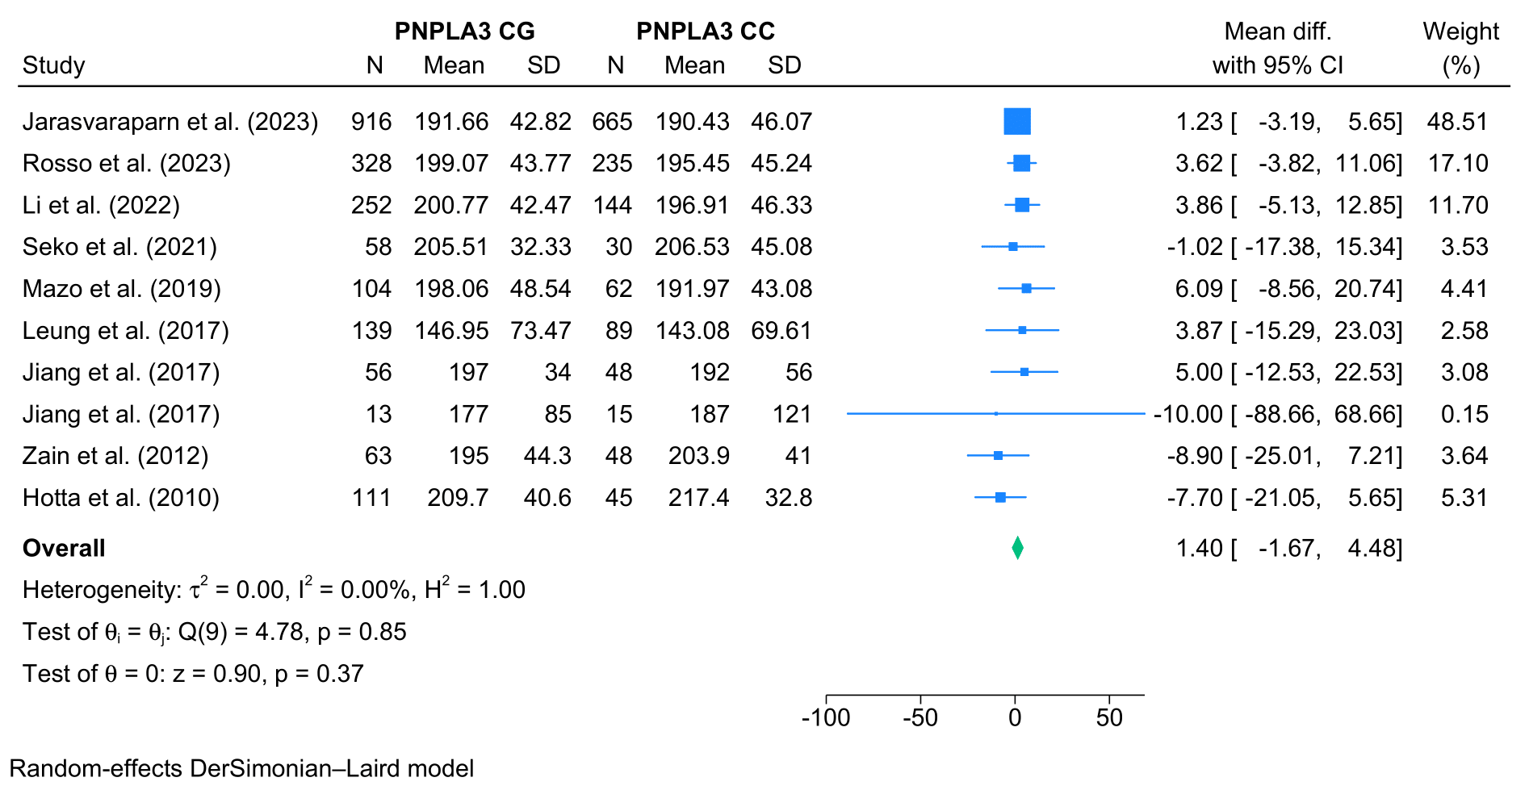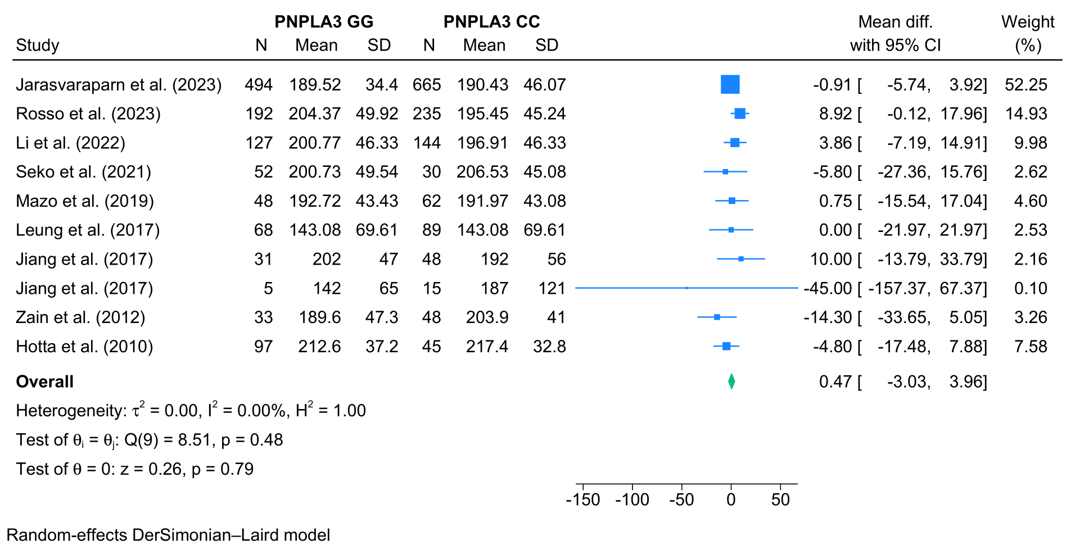

- Low-density lipoprotein
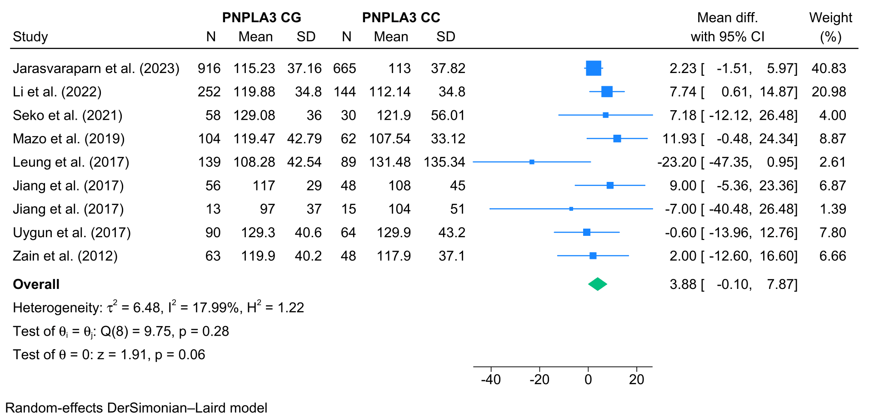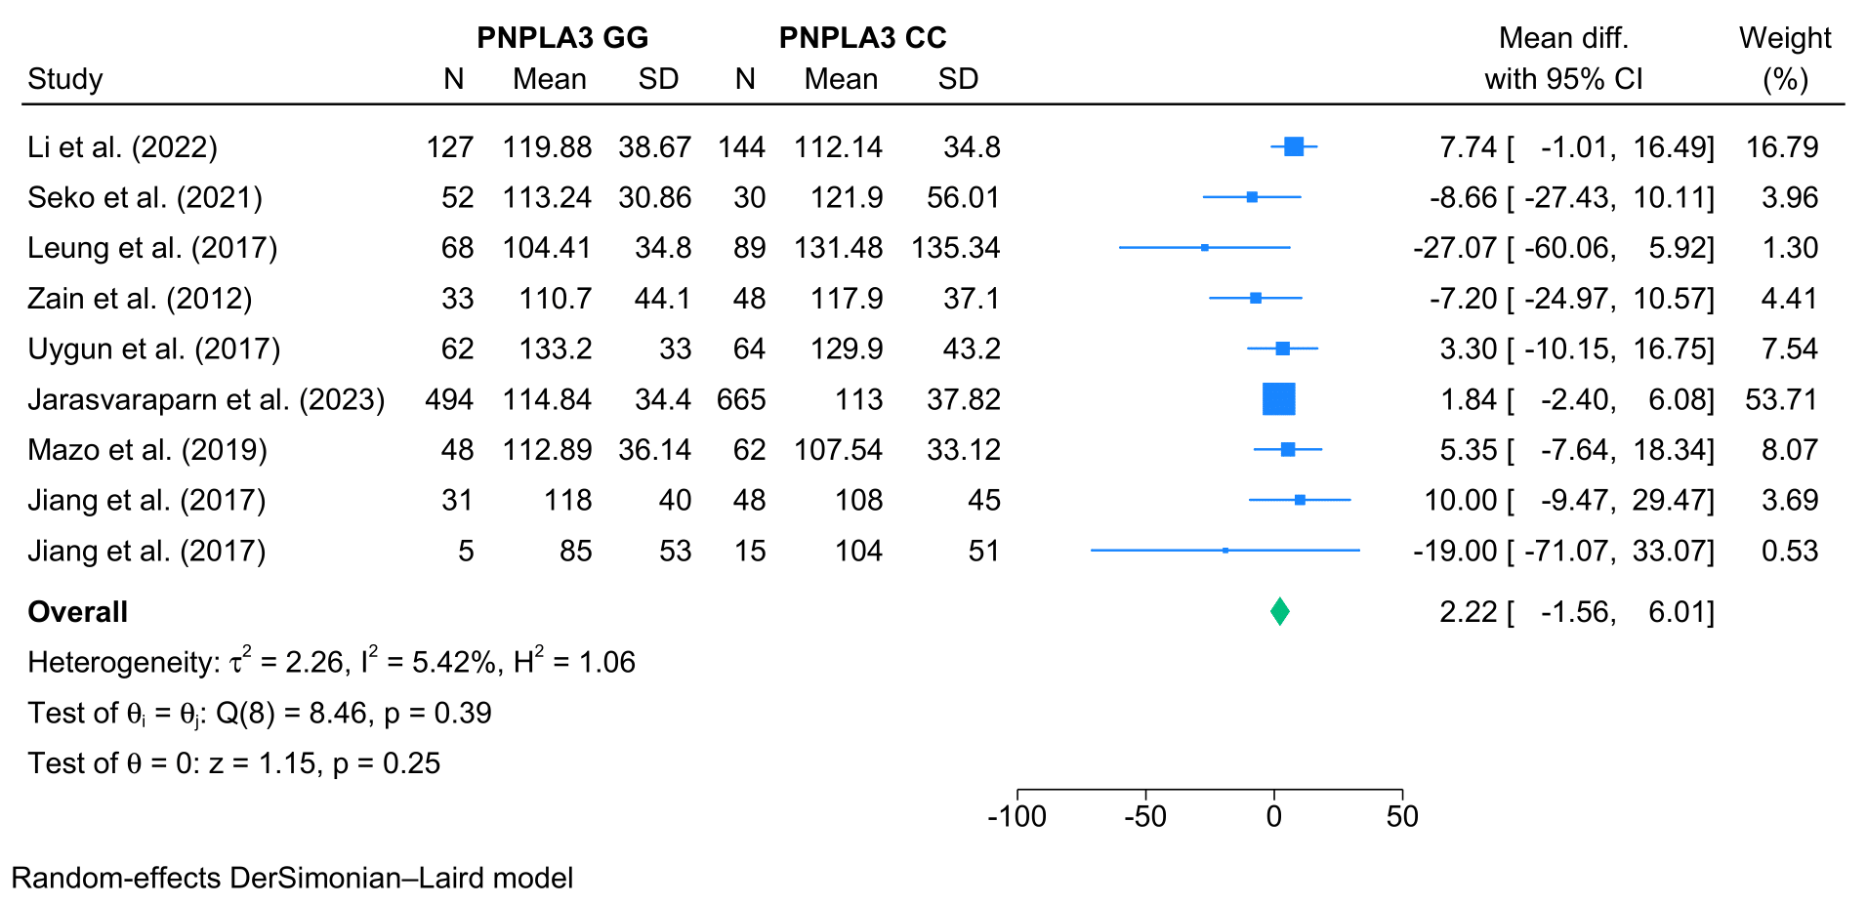

- High-density lipoprotein
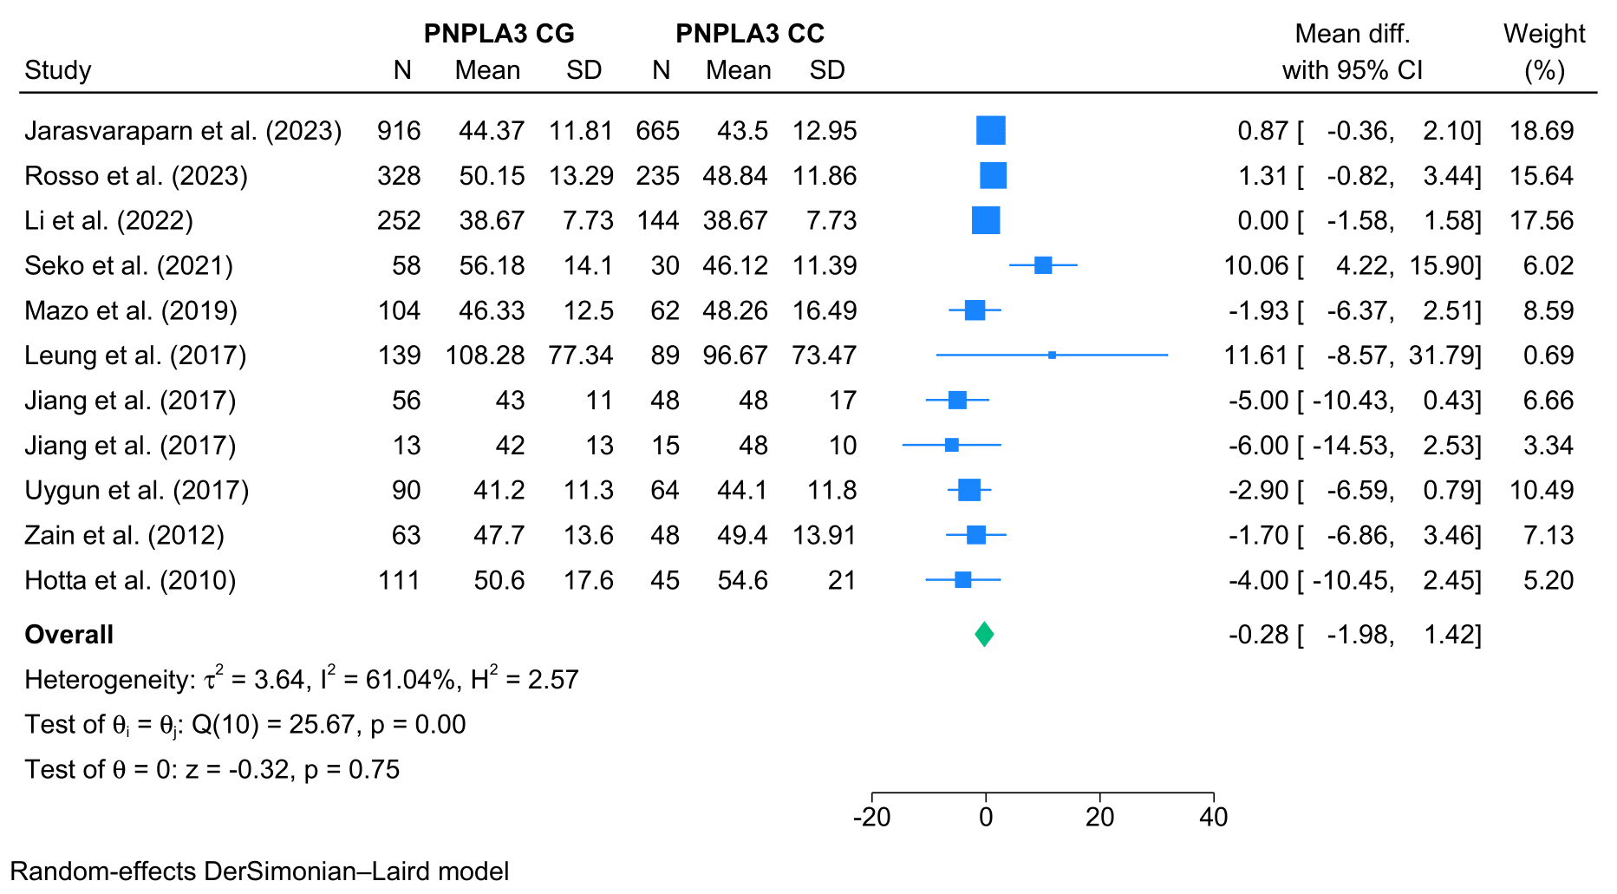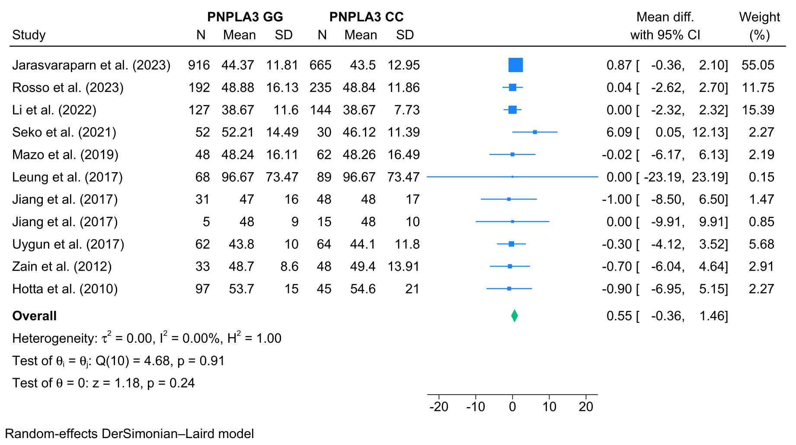

- Homeostatic model assessment for insulin resistance
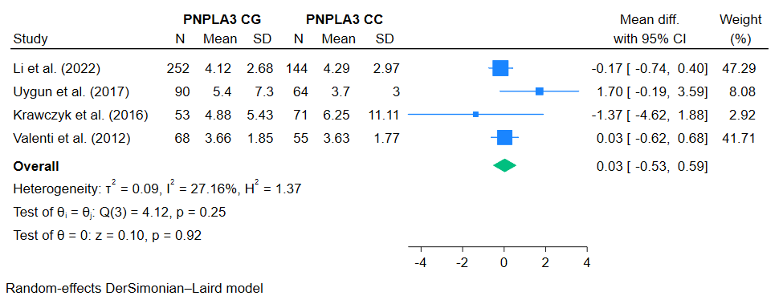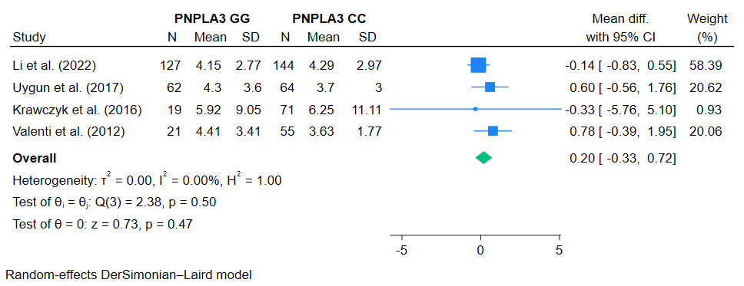

- Fasting blood glucose
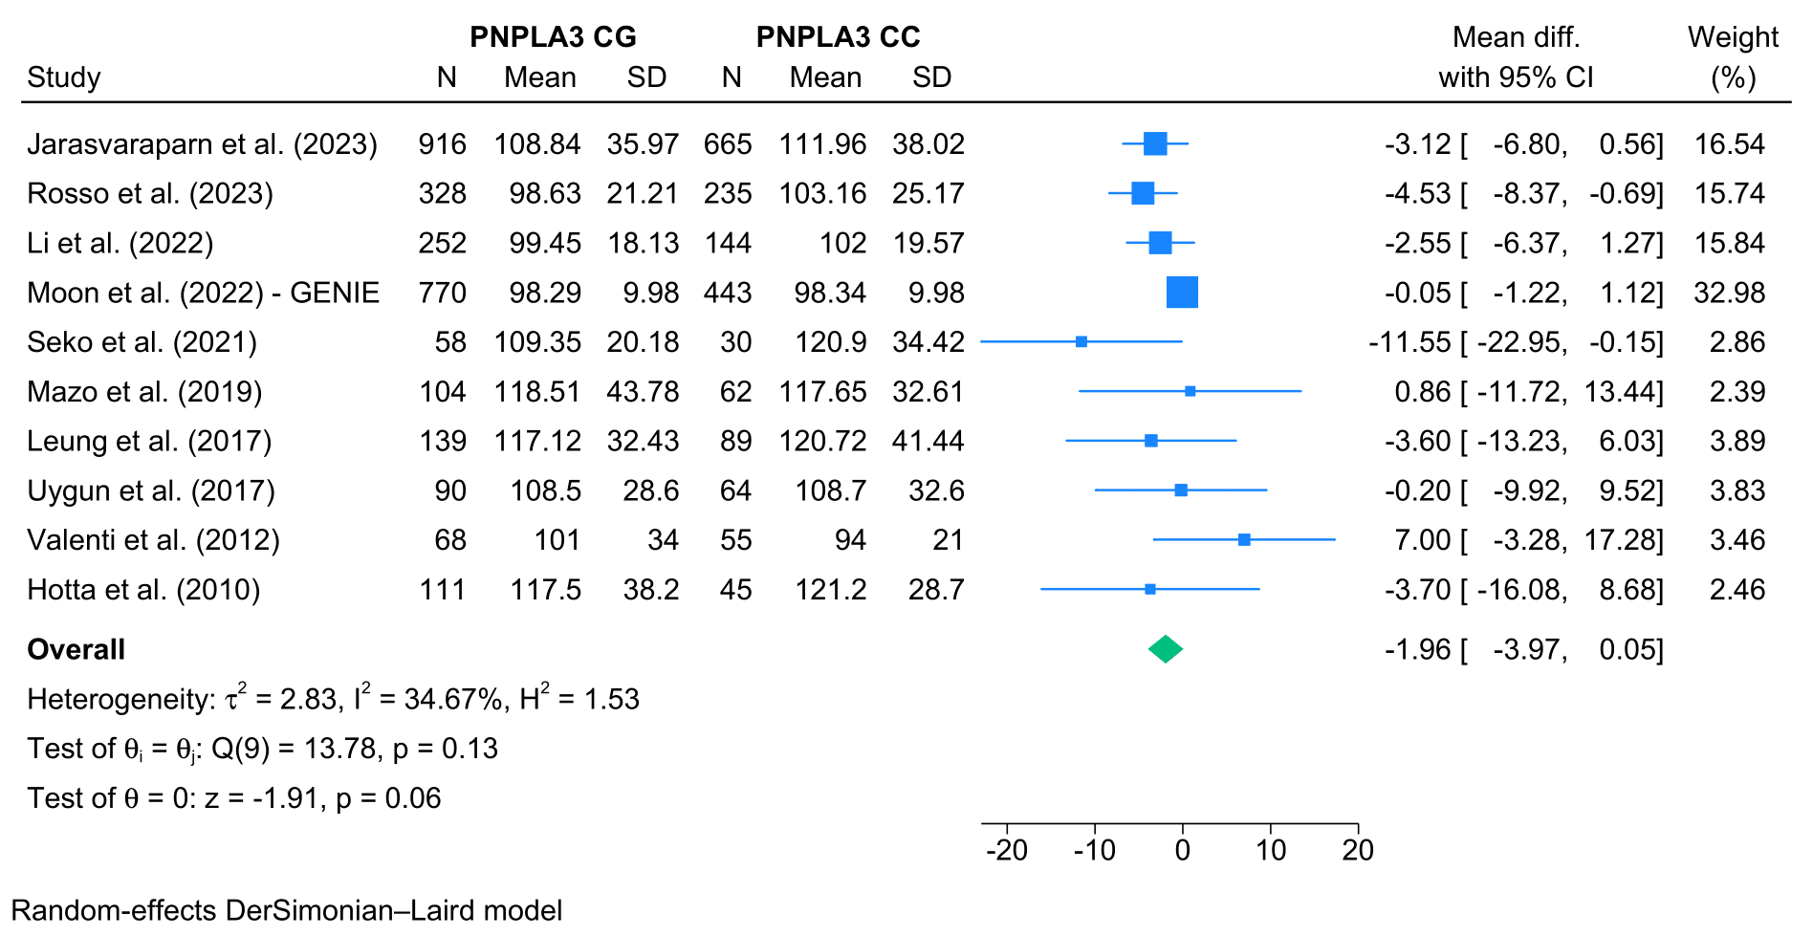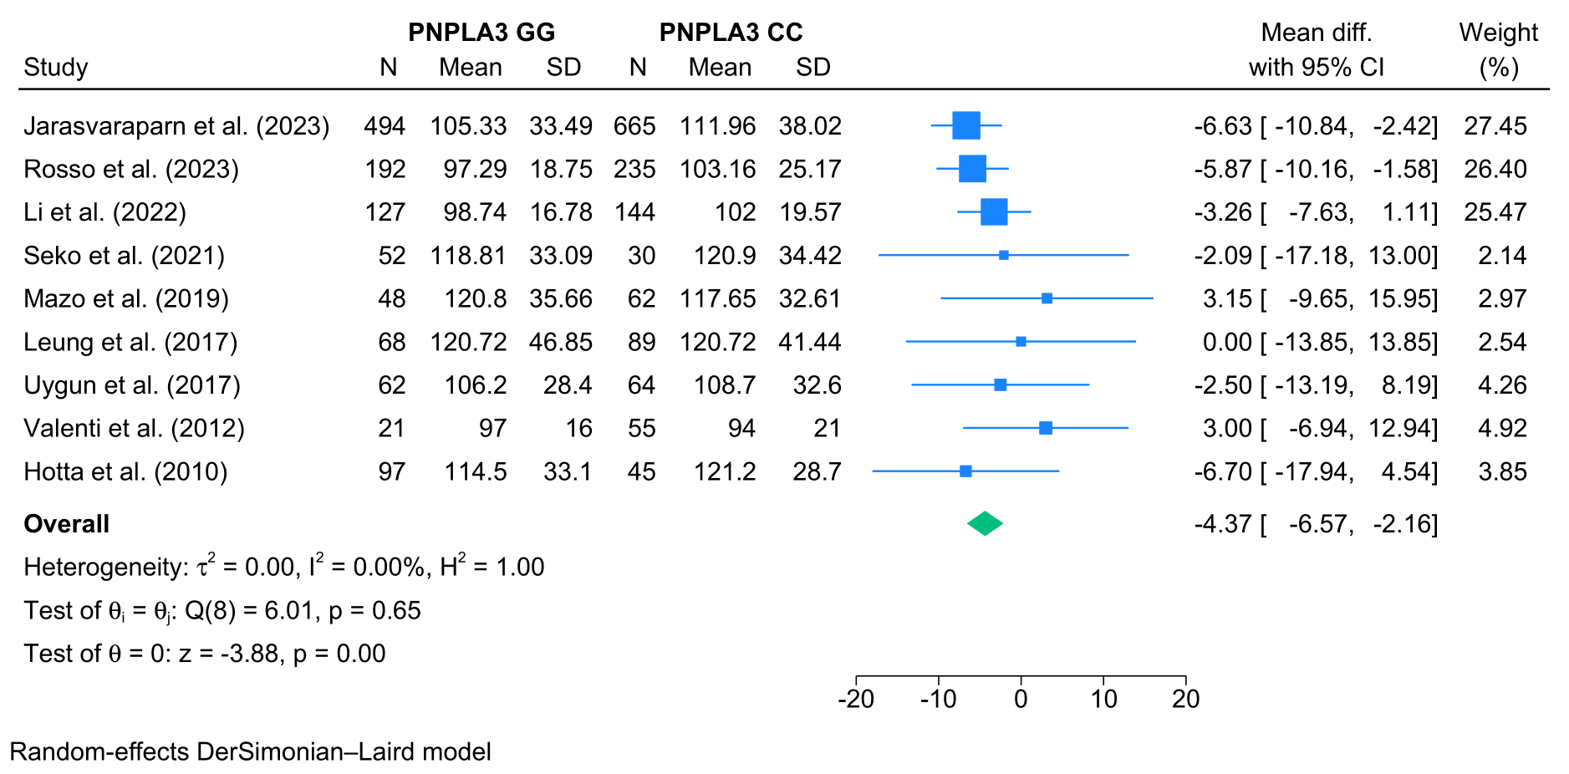

- Insulin
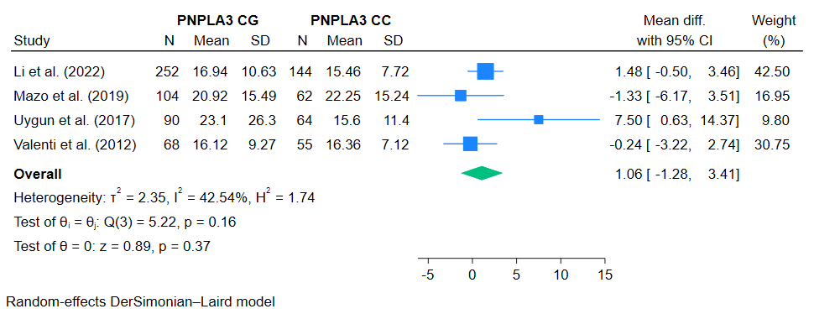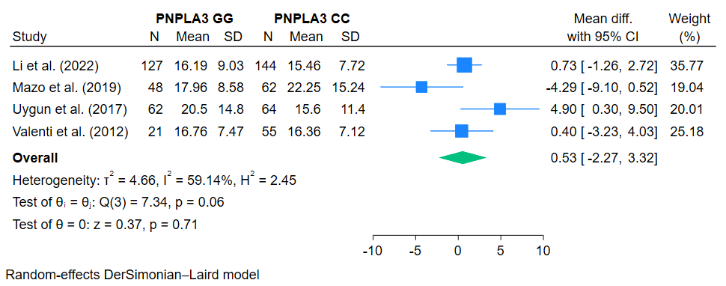

- Hemoglobin A1c
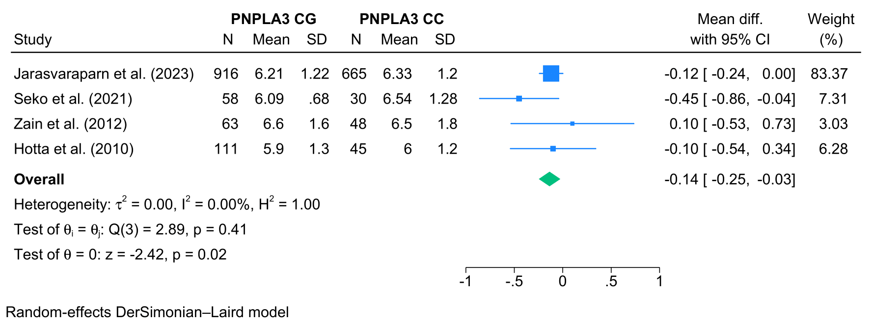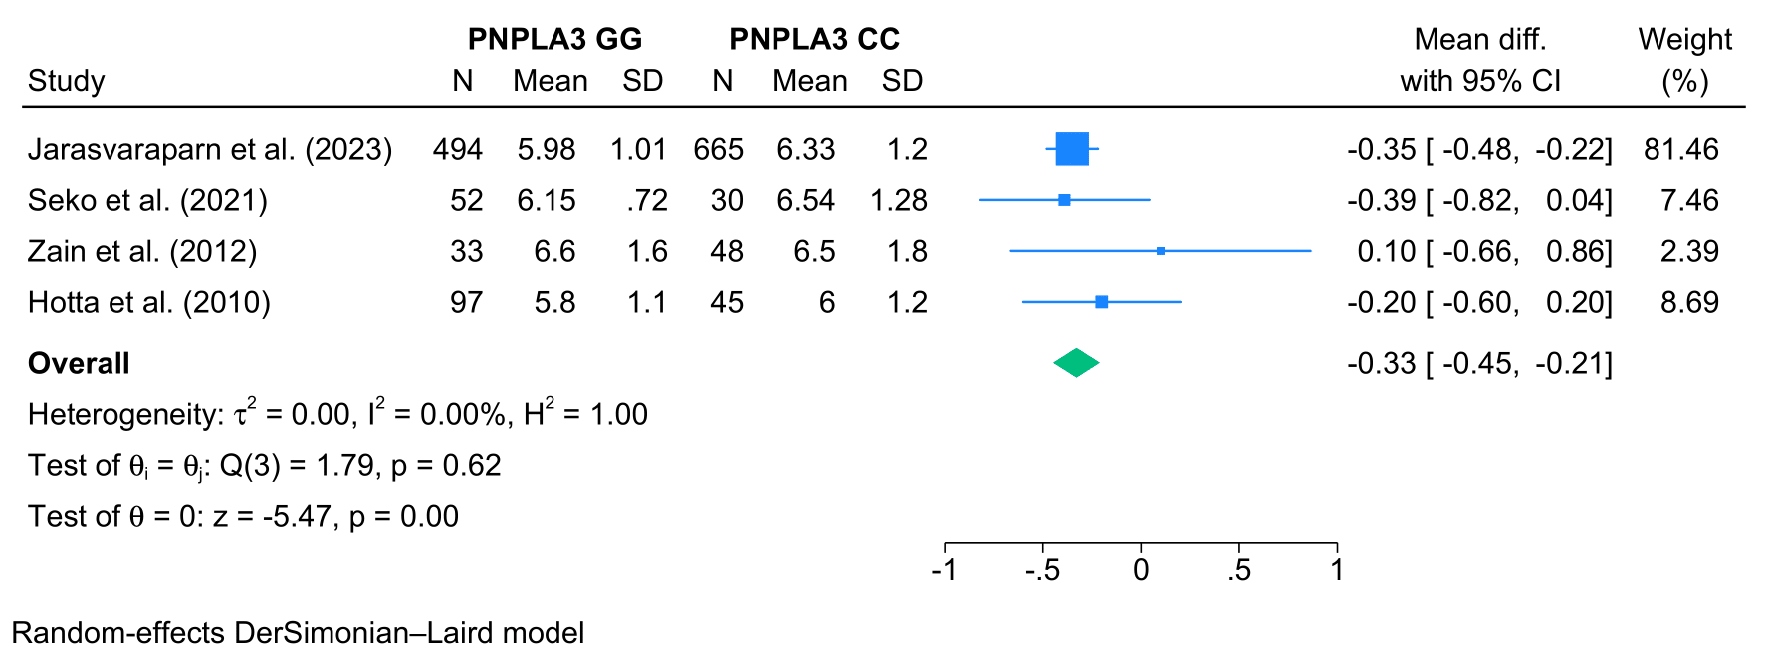

- Hypertension
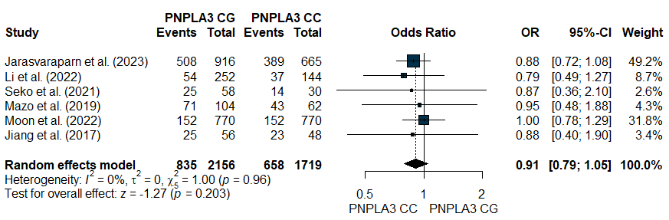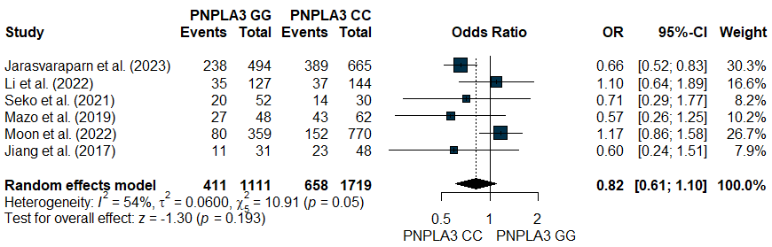

- Diabetes mellitus
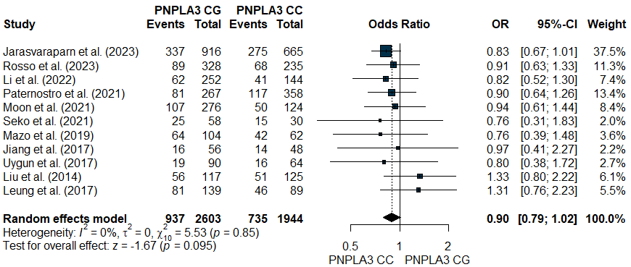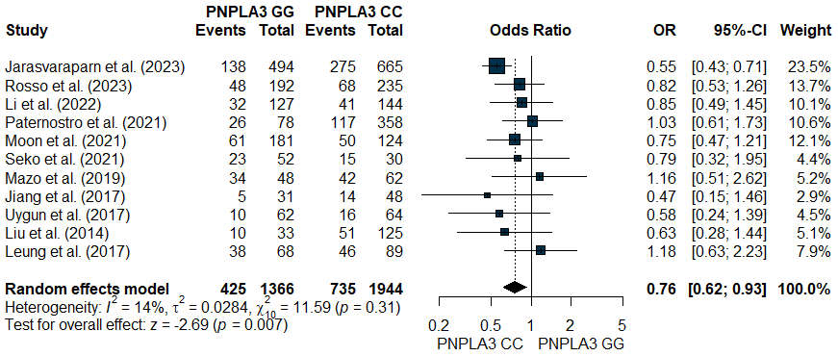

- Aspartate aminotransferase
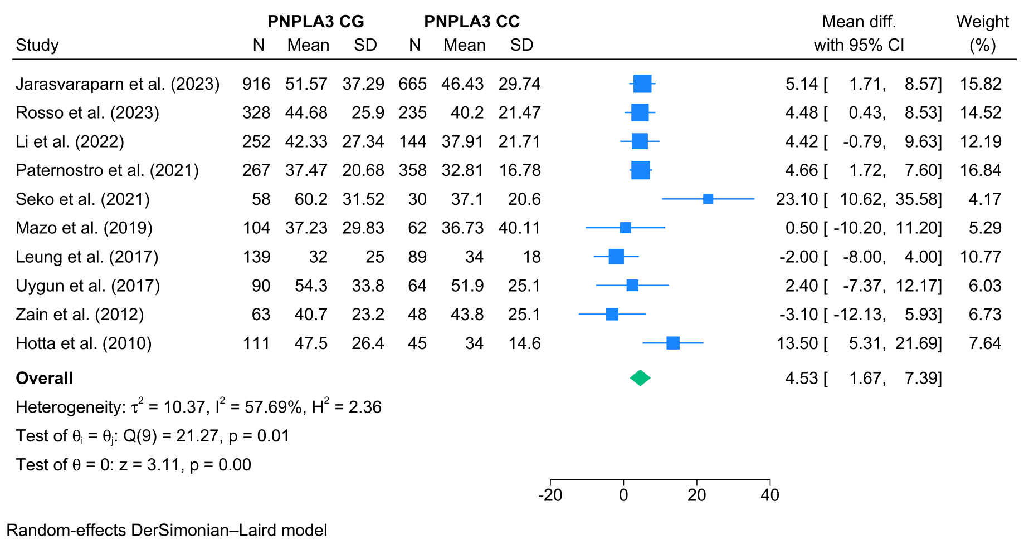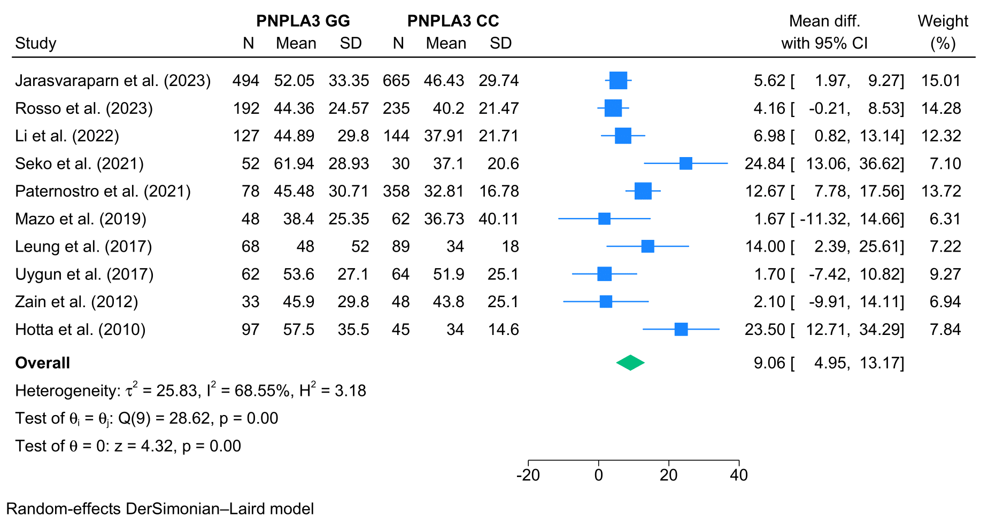
- Alanine aminotransaminase
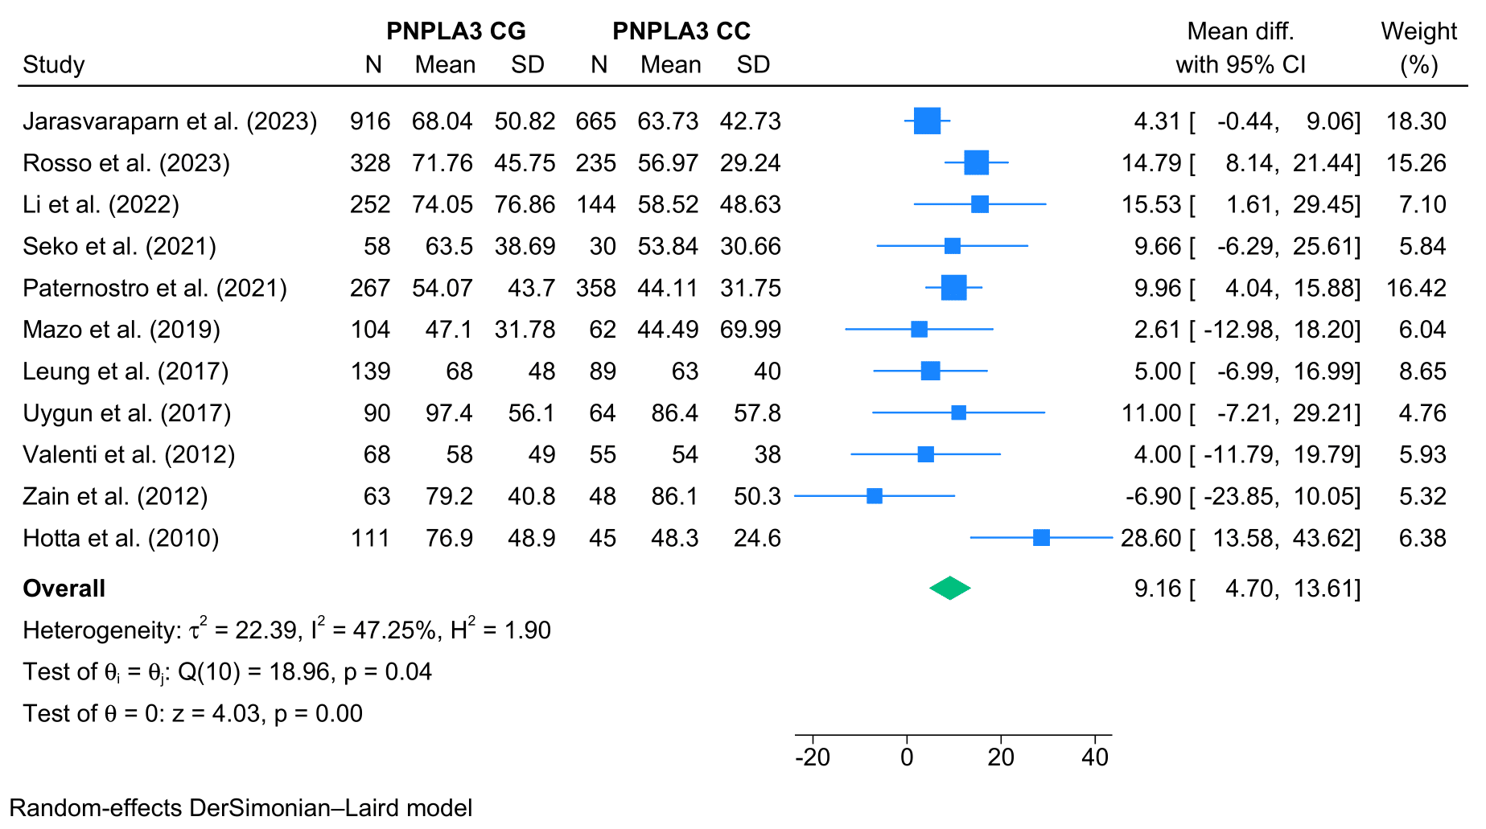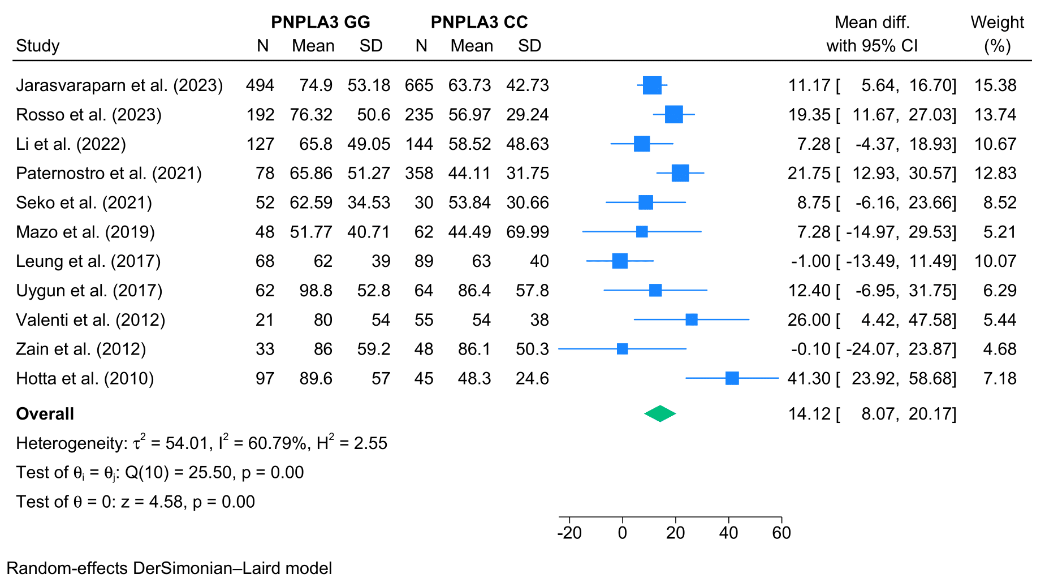

- Gamma-glutamyl transferase
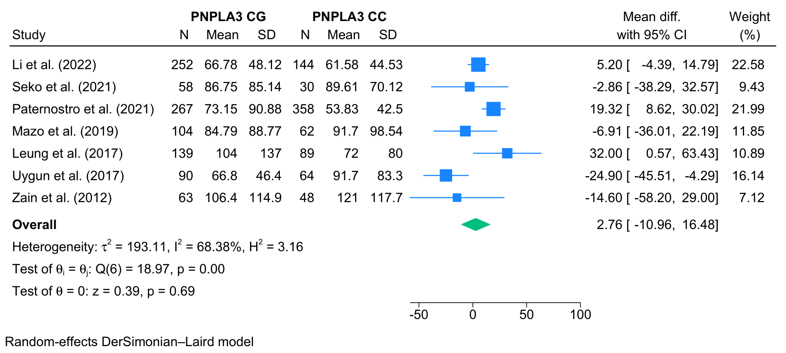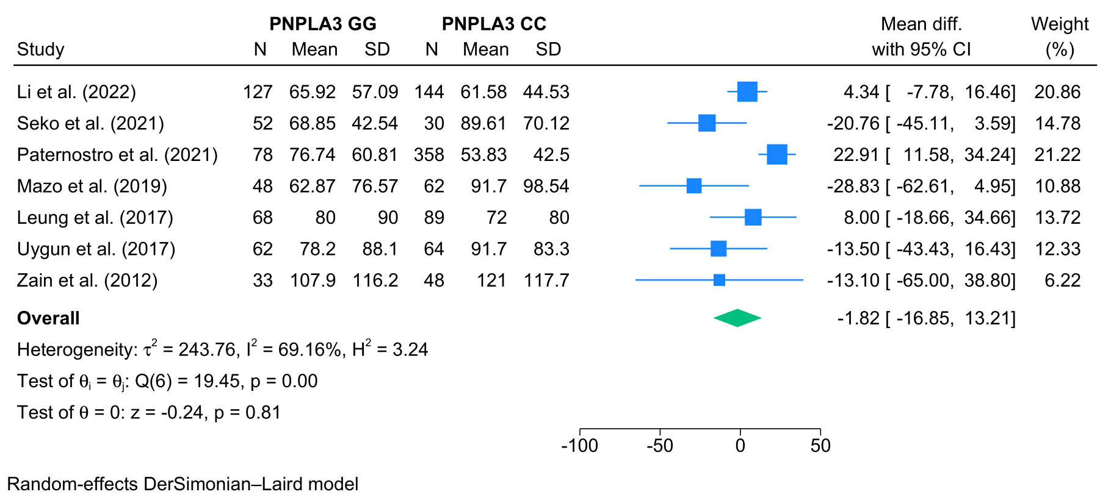
Figure S8 – Forest plots for histological analysis
- Steatosis grade
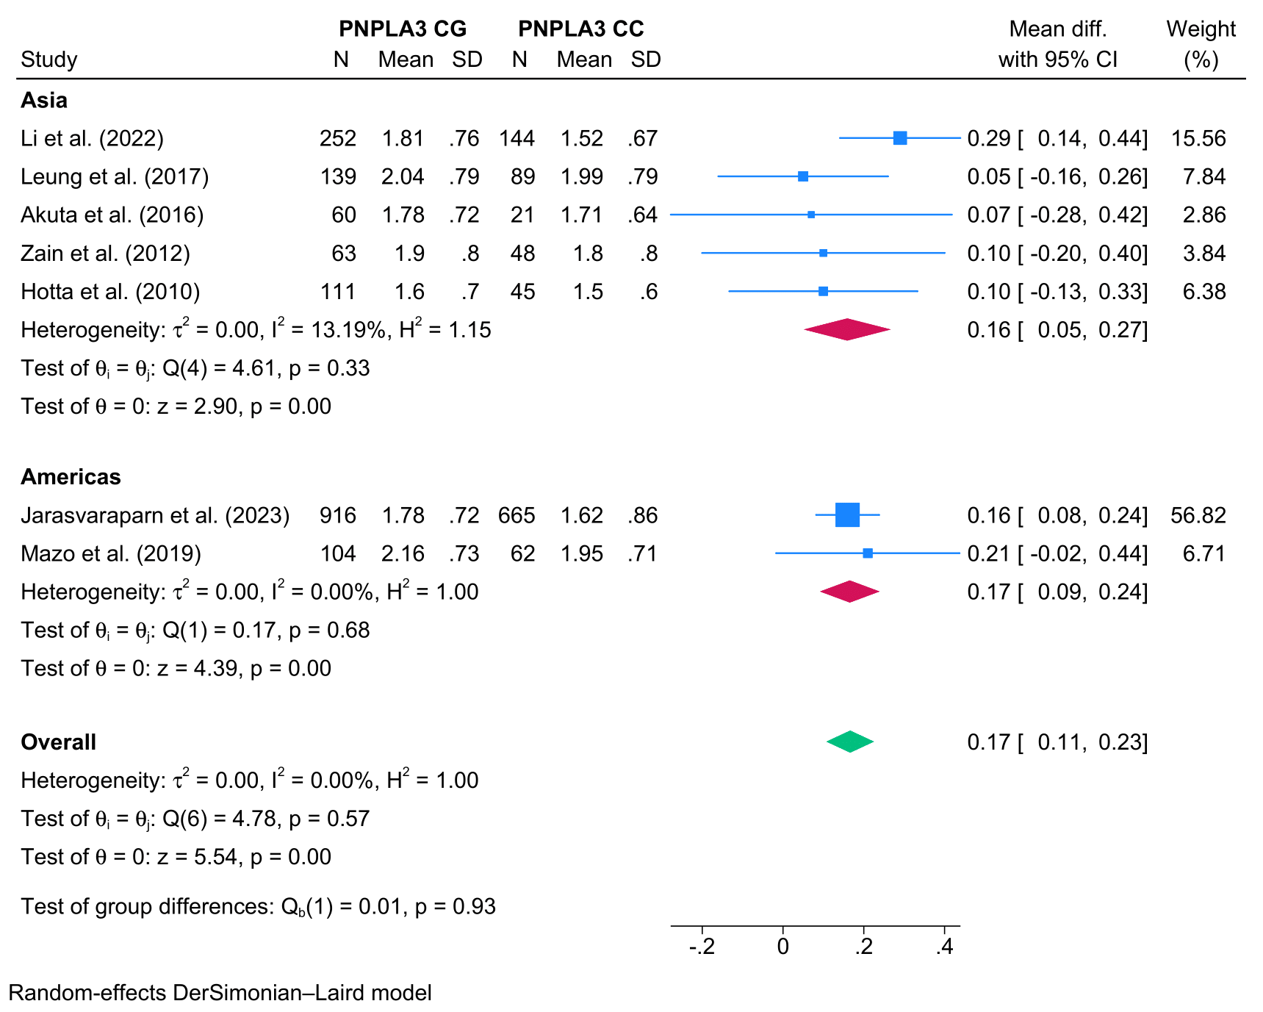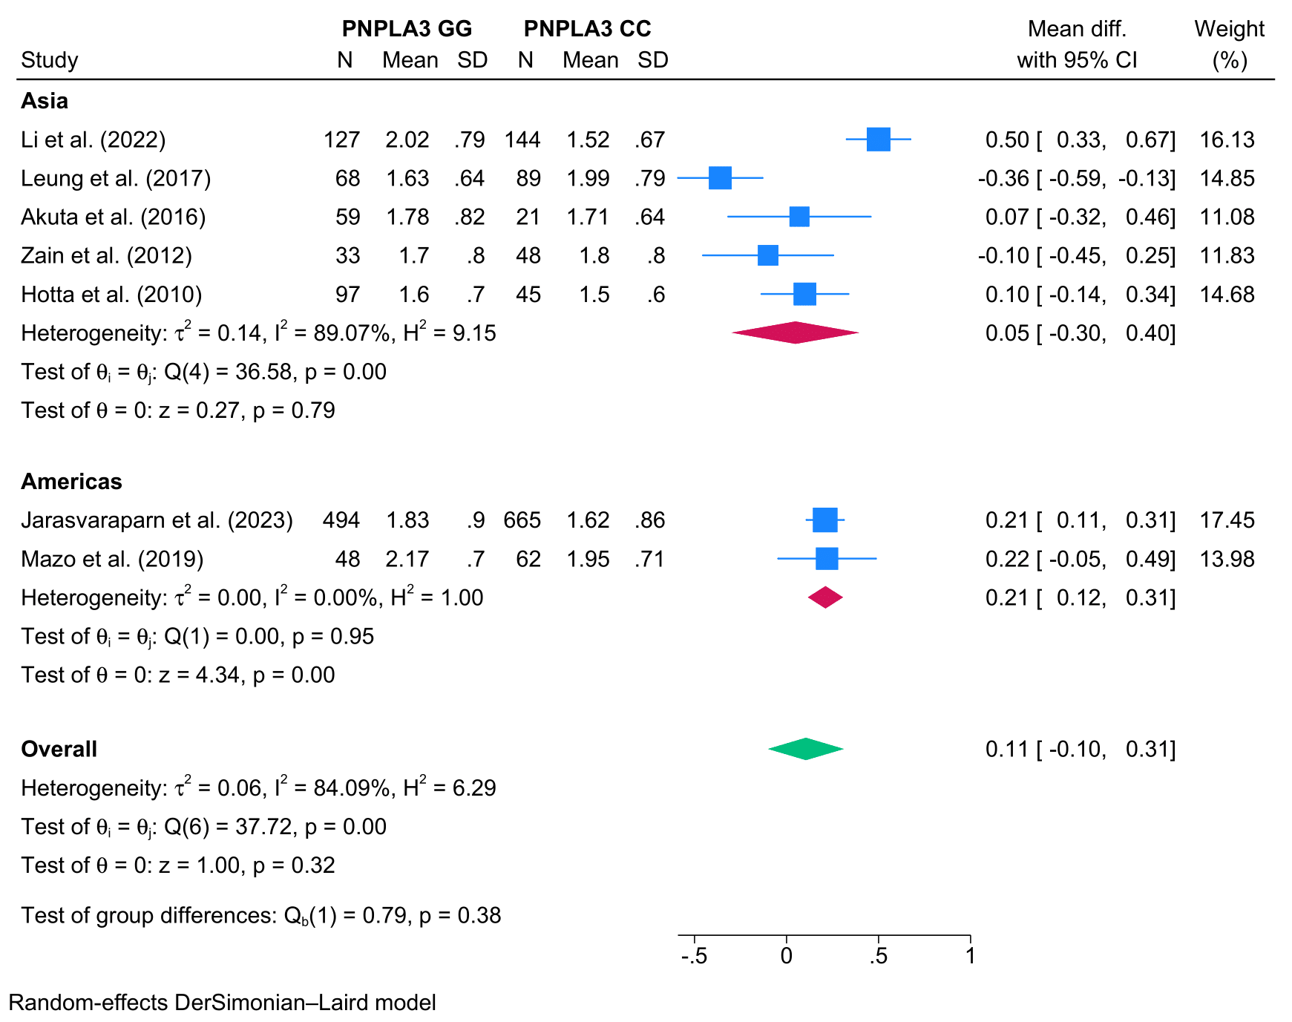
- Inflammation grade
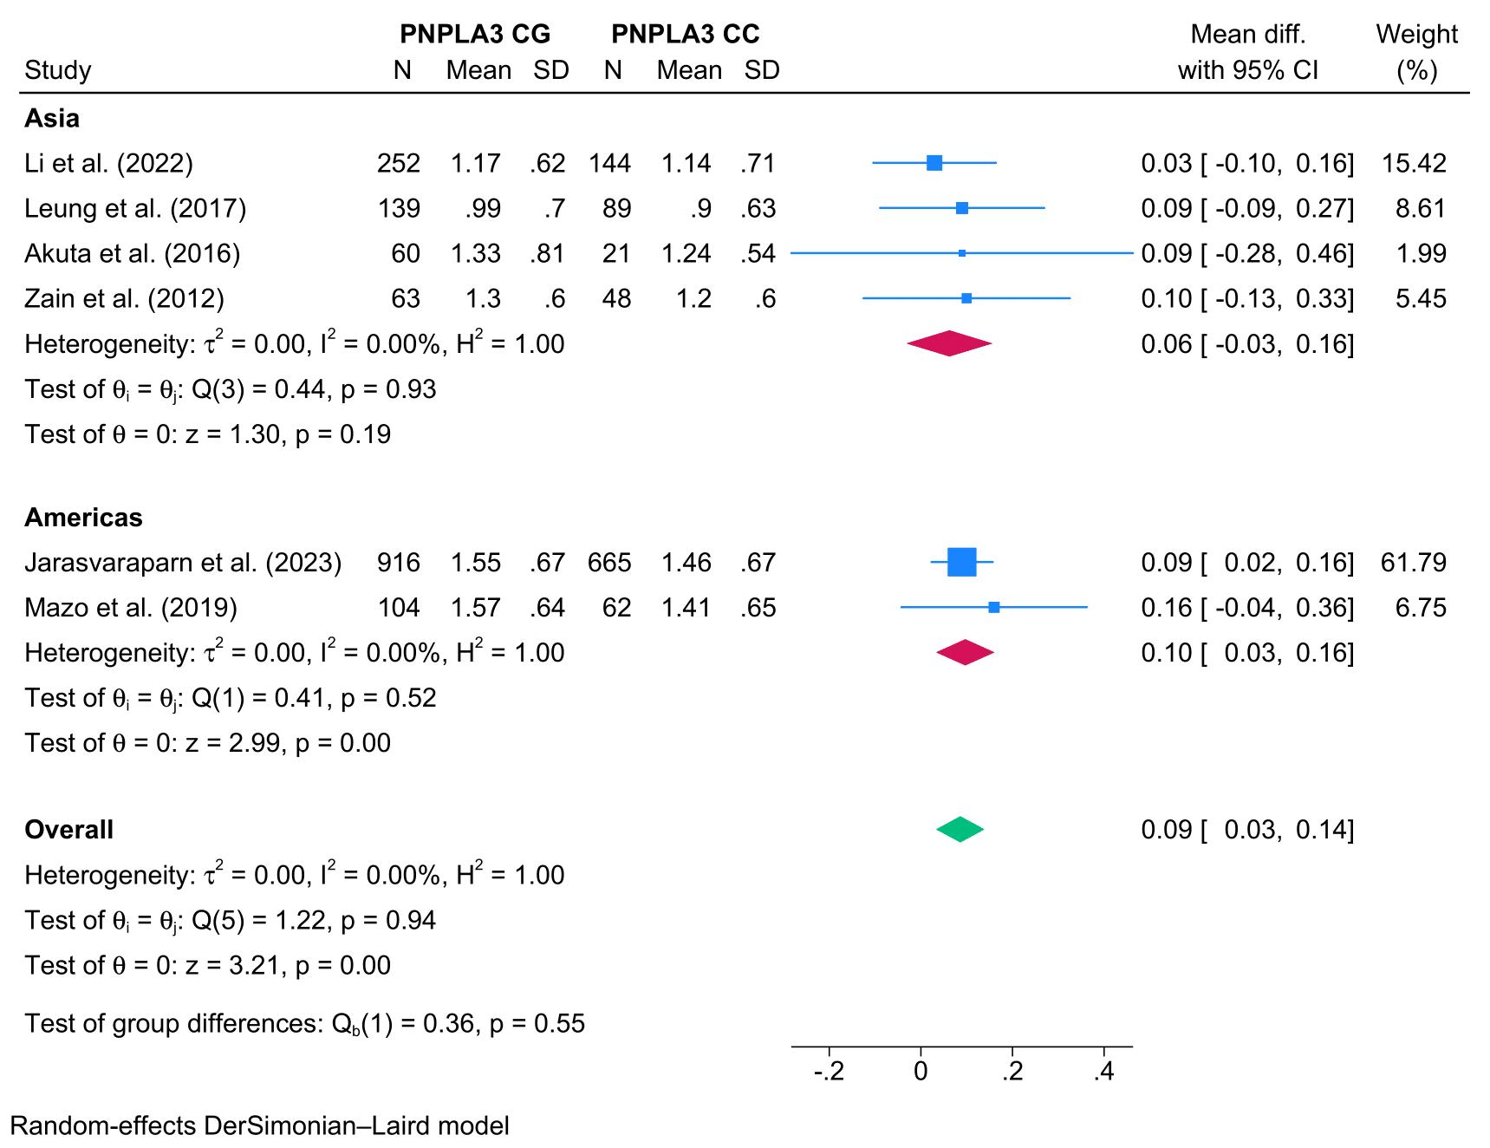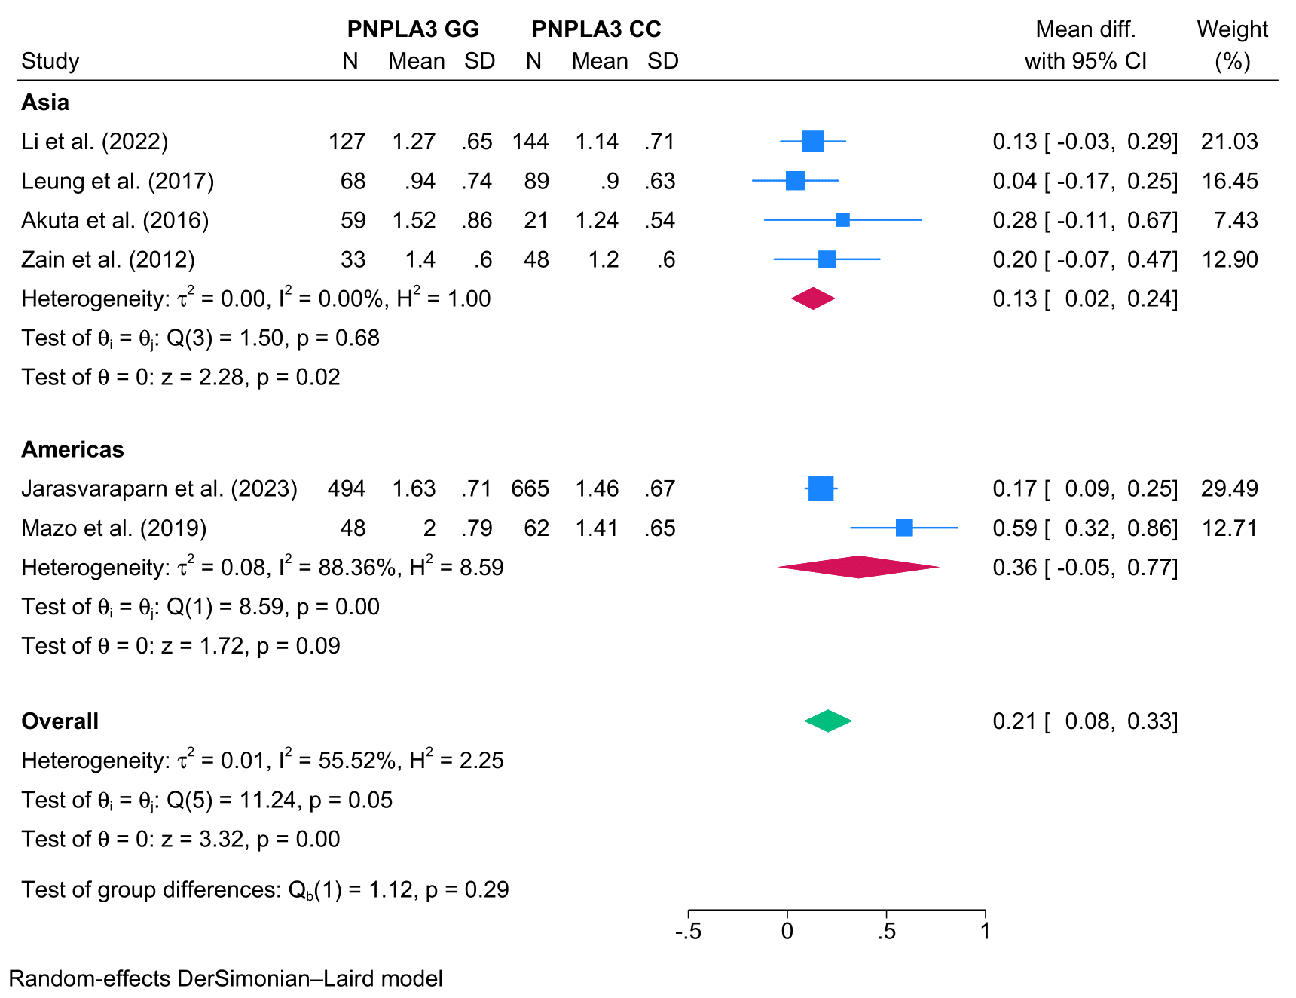

- Ballooning grade
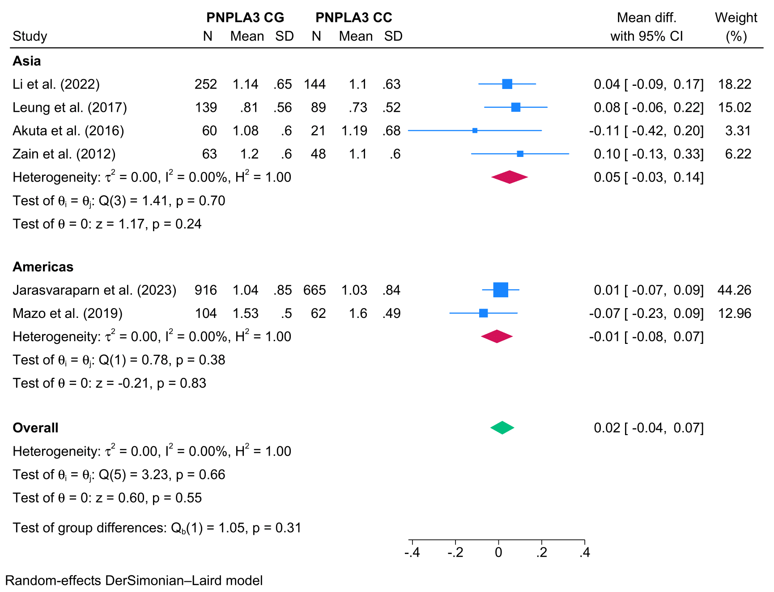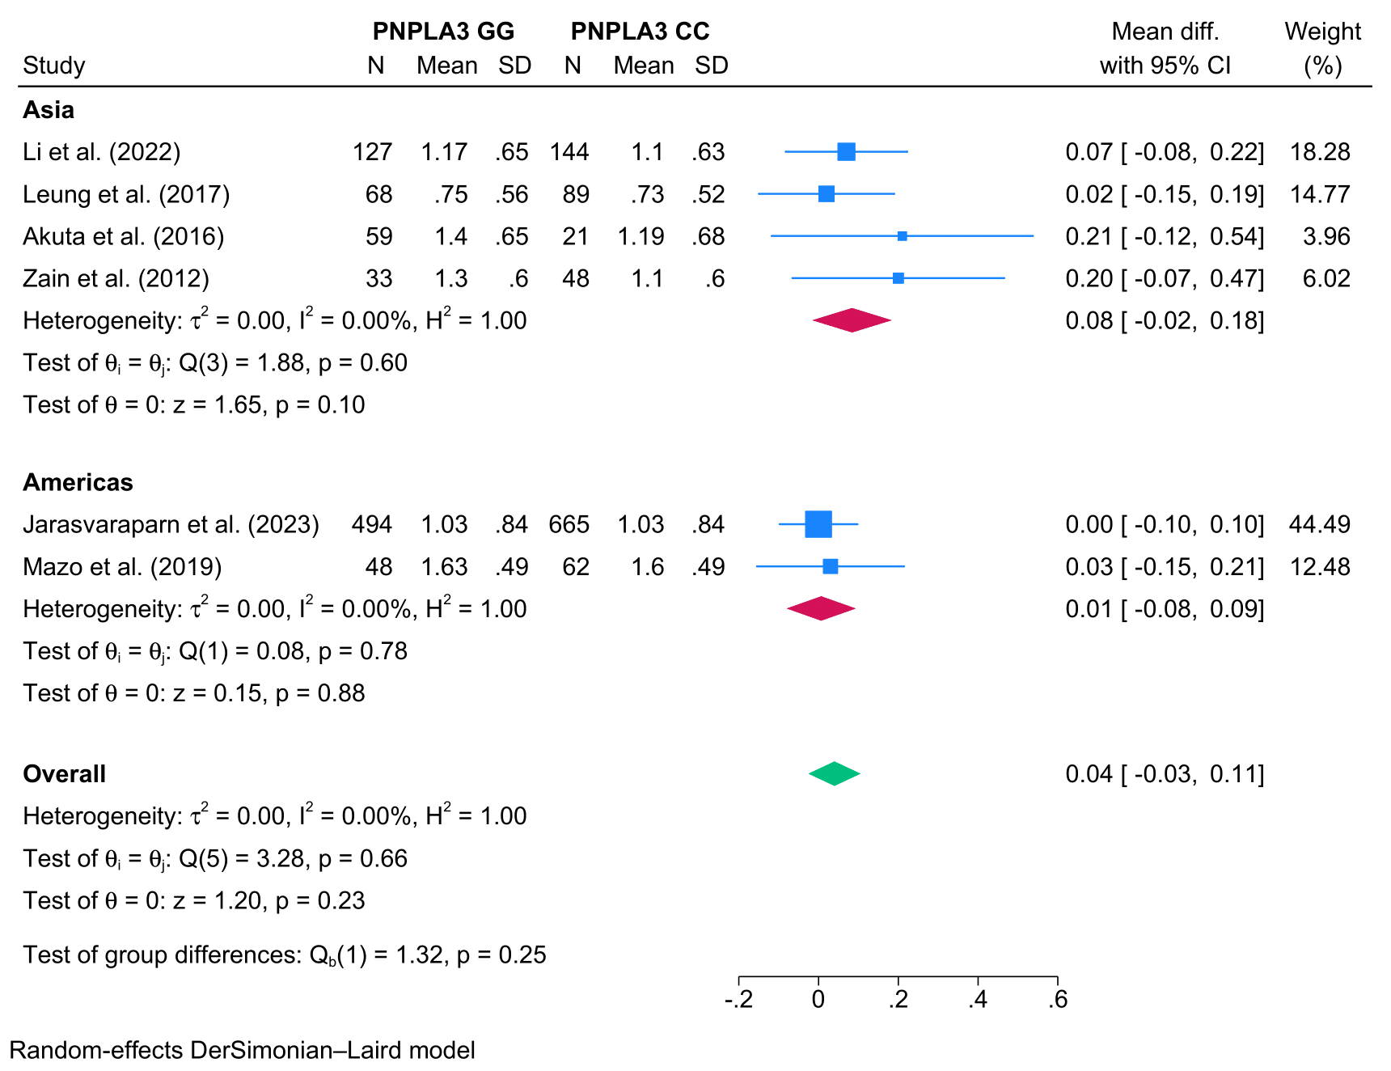
- MASH
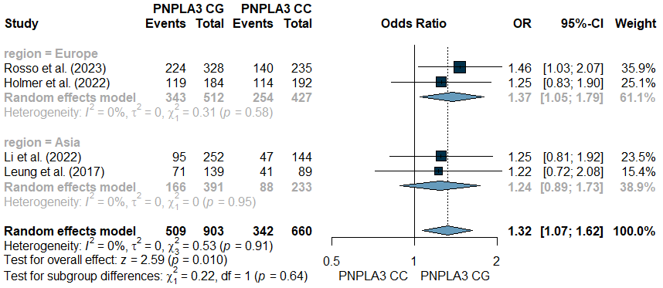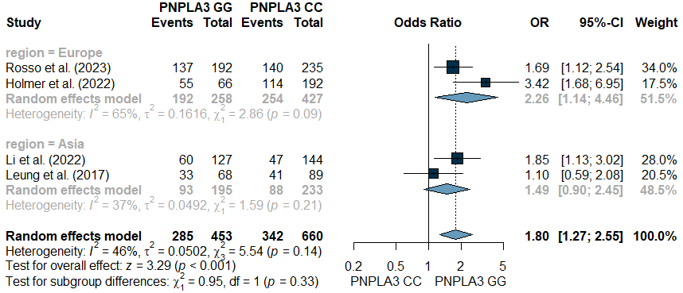
- Significant fibrosis
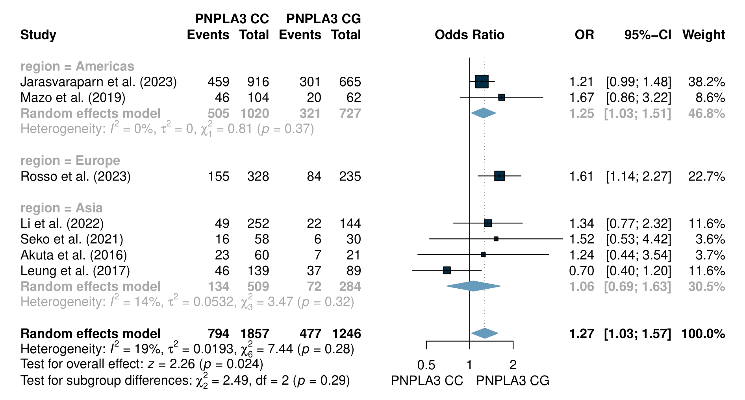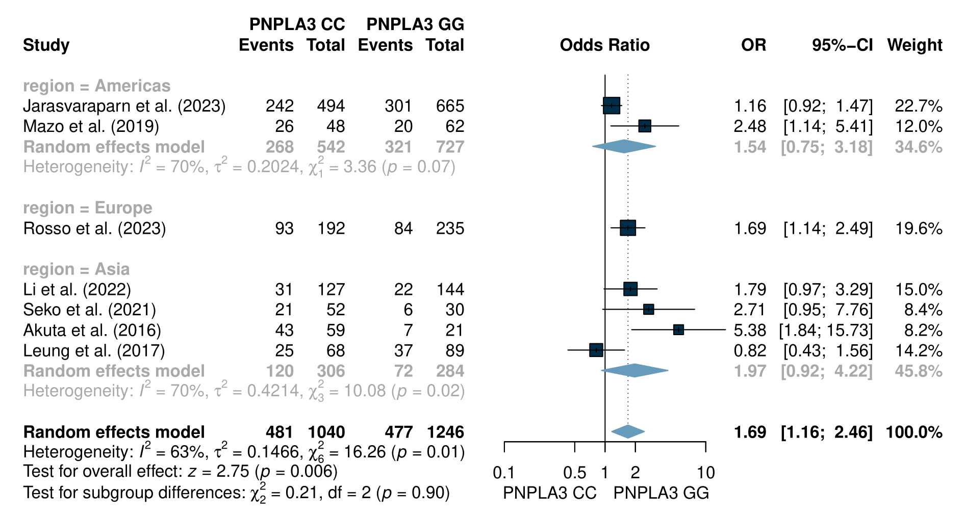
- Advanced fibrosis
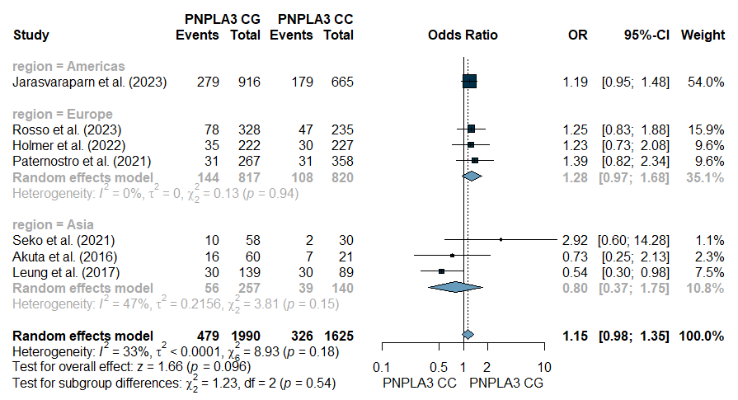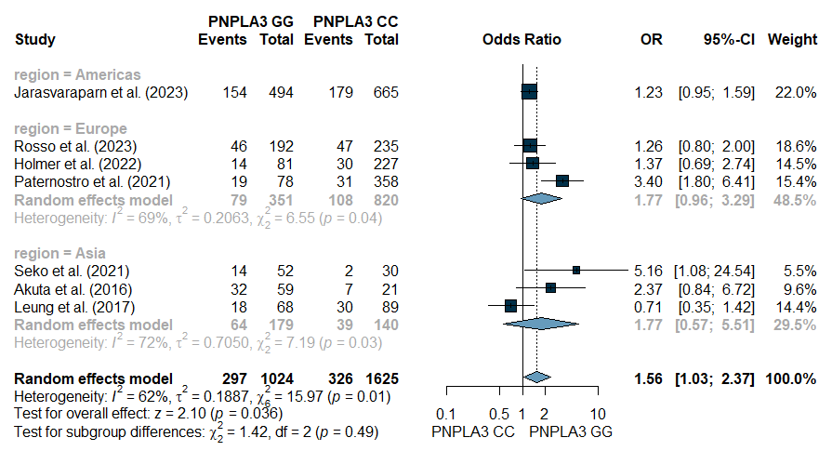
- Fibrosis stage
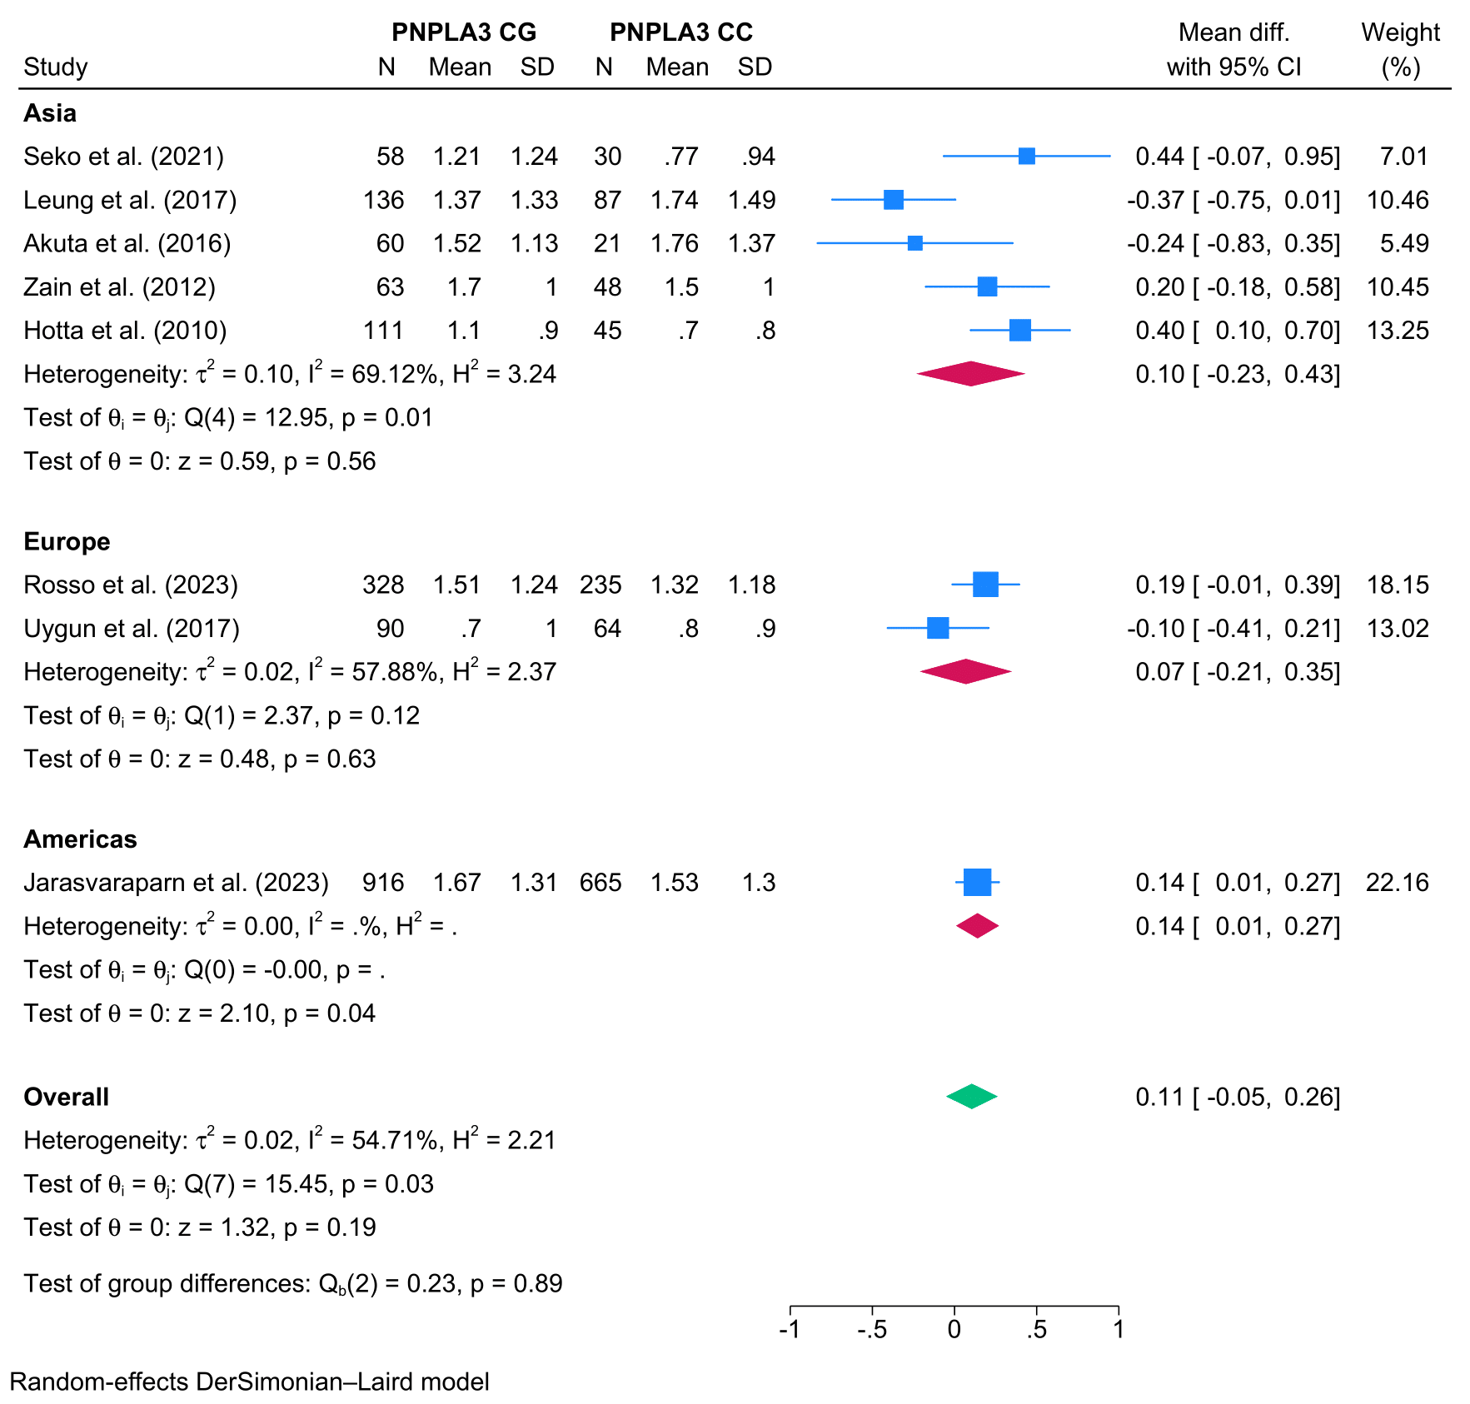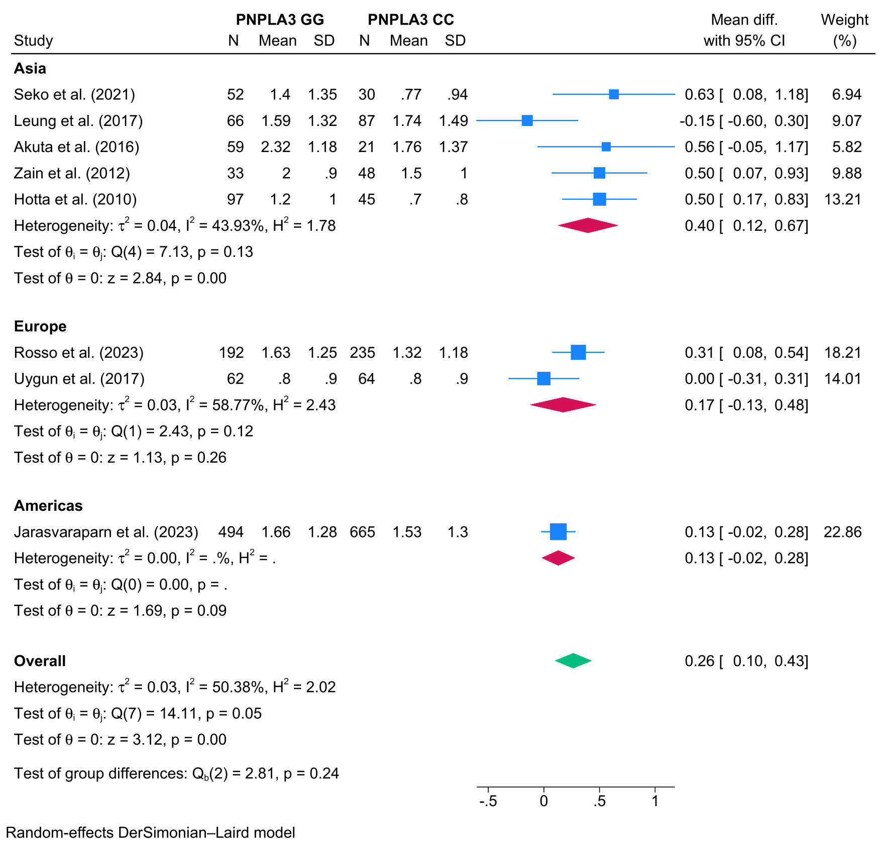
Figure S9 – Forest plots on sensitivity analysis for histological analysis
- Steatosis grade
- Inflammation grade

- Ballooning grade
- MASH
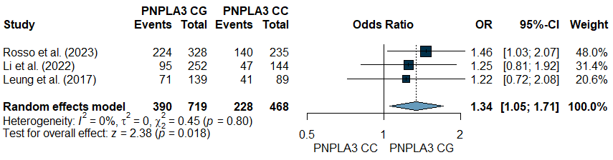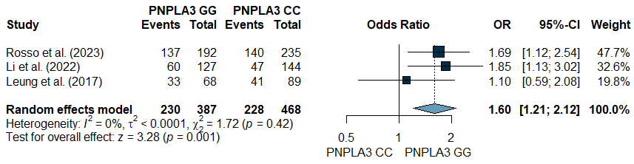

- Significant fibrosis
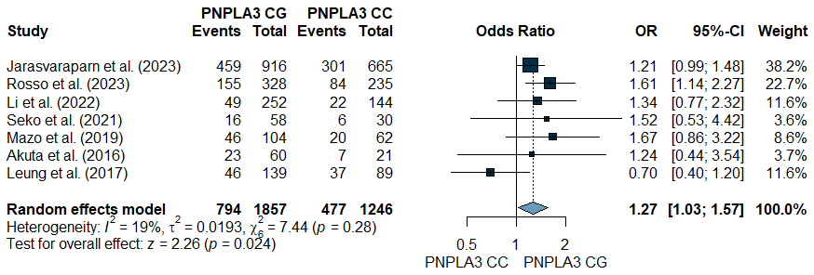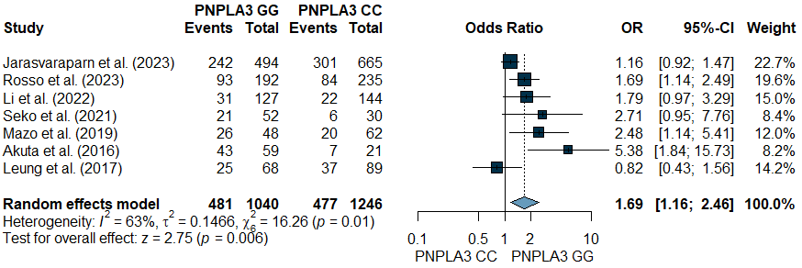

- Advanced fibrosis
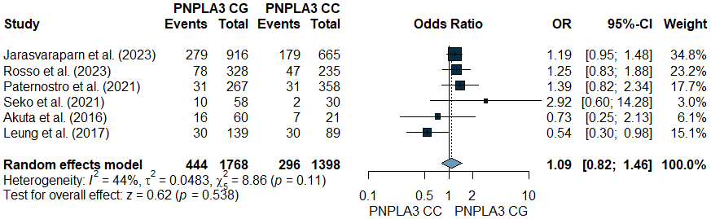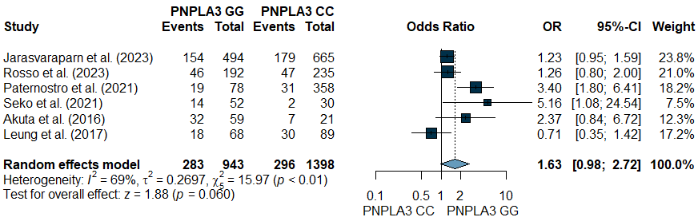

- Fibrosis stage

Figure S10 – Forest plots for proportions of histological features
- PNPLA3 CC
MASH
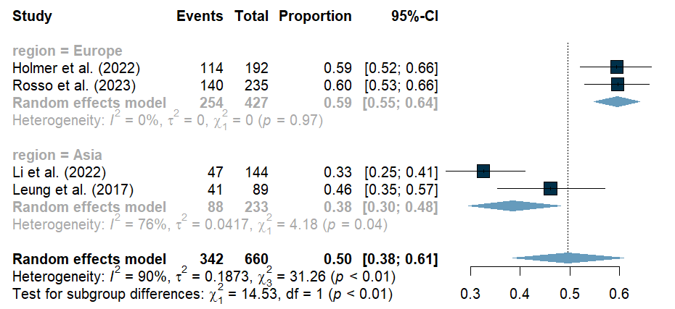
Significant fibrosis
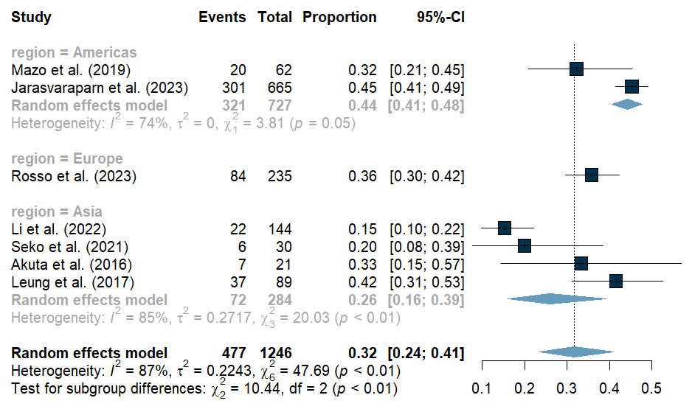
Advanced fibrosis
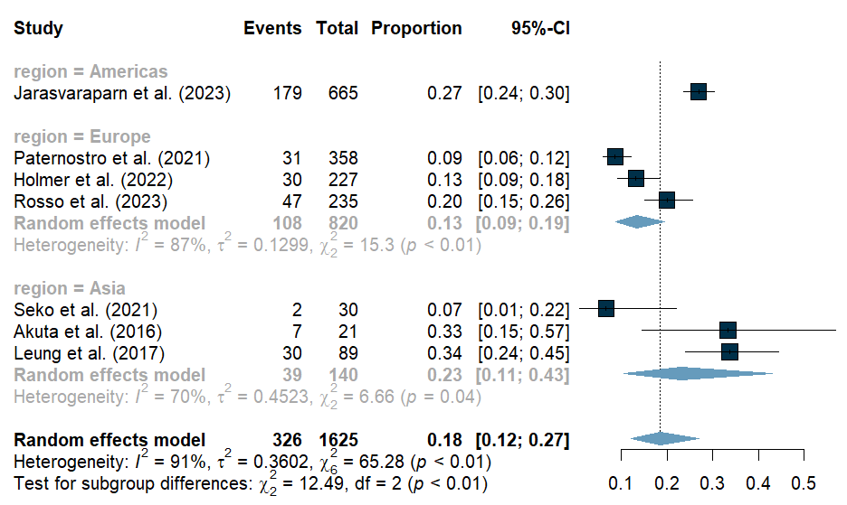
- PNPLA3 CG
MASH
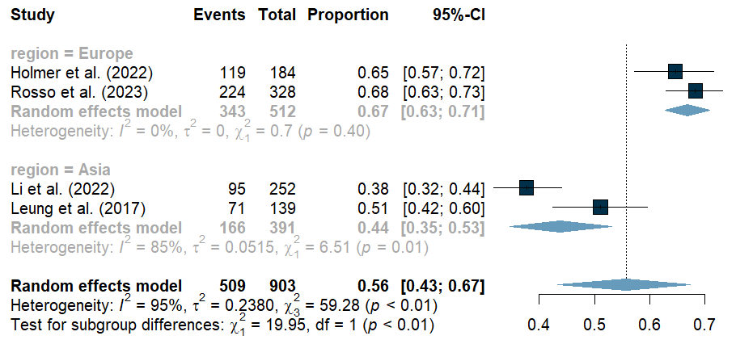
Significant fibrosis
Advanced fibrosis
- PNPLA3 GG
MASH
Significant fibrosis
Advanced fibrosis
Figure S11 – Forest plots on sensitivity analysis for proportions of histological features
- PNPLA3 CC
MASH
Significant fibrosis
Advanced fibrosis

- PNPLA3 CG
MASH
Significant fibrosis
Advanced fibrosis

- PNPLA3 GG
MASH
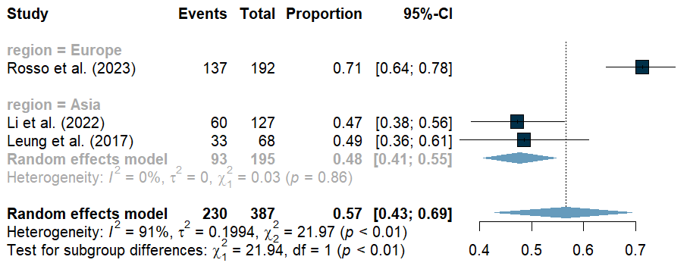
Significant fibrosis
Advanced fibrosis

Figure S12 – Forest plots for long-term outcomes analysis
- Overall mortality

- Liver-related events

- Cirrhosis

- Cardiovascular disease

Figure S13 – Bubble plots showing meta-regressions in PNPLA3 CG vs. PNPLA3 CC comparison
- AST

- ALT

- TG

- Fibrosis stage

Figure S14 – Bubble plots showing meta-regressions in PNPLA3 GG vs. PNPLA3 CC comparison
- AST

- ALT

- TG
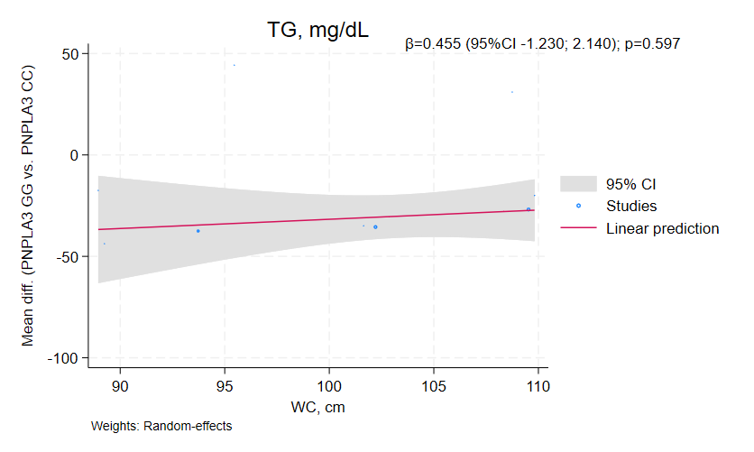

- Fibrosis stage

