Appendix A

Simulation Sickness Questionnaire (SSQ)
Circle how much each symptom below is affecting you right now.
1. General discomfort | None | Slight | Moderate | Severe
2. Fatigue | None | Slight | Moderate | Severe
3. Headache | None | Slight | Moderate | Severe
4. Eyestrain | None | Slight | Moderate | Severe
5. Difficulty focusing | None | Slight | Moderate | Severe
6. Increased salivation | None | Slight | Moderate | Severe
7. Sweating | None | Slight | Moderate | Severe
8. Nausea | None | Slight | Moderate | Severe
9. Difficulty concentrating | None | Slight | Moderate | Severe
10. Fullness of head | None | Slight | Moderate | Severe
11. Blurred vision | None | Slight | Moderate | Severe
12. Dizziness (eyes open) | None | Slight | Moderate | Severe
13. Dizziness (eyes closed) | None | Slight | Moderate | Severe
14. Vertigo | None | Slight | Moderate | Severe
15. Stomach awareness | None | Slight | Moderate | Severe
16. Burping | None | Slight | Moderate | Severe

Appendix B

System Usability Scale (SUS)
The system usability scale measures user expectations of a system regarding ease of use and comfort using a 7-point Likert scale with response options from strongly disagree (1) to strongly agree (7) for all the questions. An example is given below.
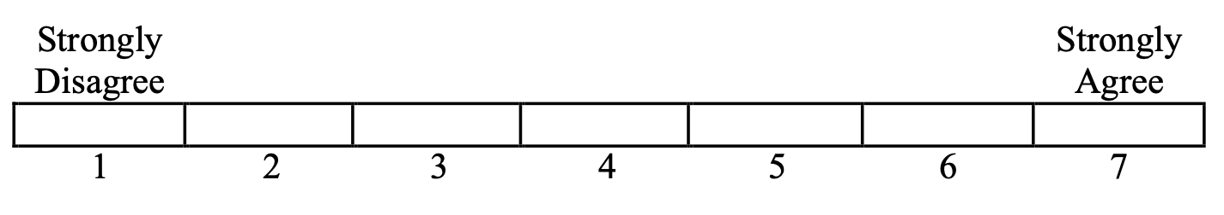
1. I think that I would like to use this learning platform frequently
2. I found the learning platform unnecessarily complex
3. I thought the learning platform was easy to use
4. I think that I would need the support of a technical person to be able to use this learning platform
5. I found the various functions in the learning platform were well-integrated
6. I thought there was too much inconsistency in this learning platform
7. I would imagine that most people would learn to use this learning platform very quickly
8. I found the learning platform very cumbersome to use
9. I felt very confident using the learning platform
10. I needed to learn a lot of things before I could start working with this learning platform

Appendix C

Nasa Task Load Index(Erogonomiesite.be, n.d.)
