Supplementary information
Additional fle 1. Additional tables

Table S1 Clustering results of the jars
NO | The number of jars | Belong to the classes | NO | The number of jars | Belong to the classes
1 | G23:2 | 1 | 32 | M40:1 | 6
2 | G32:2 | 2 | 33 | M40:3 | 2
3 | G33:1 | 3 | 34 | M41:1 | 4
4 | G34:5 | 2 | 35 | M4:4 | 2
5 | G62:3 | 2 | 36 | M4:5 | 4
6 | G63:5 | 4 | 37 | M48:4 | 7
7 | H10:4 | 4 | 38 | M49:7 | 7
8 | H3:1 | 2 | 39 | M51:1 | 8
9 | H3:2 | 2 | 40 | M51:5 | 4
10 | H7:4 | 4 | 41 | M53:1 | 2
11 | M10:3 | 4 | 42 | M54:5 | 4
12 | M12:2 | 4 | 43 | M57:7 | 2
13 | M14:6 | 5 | 44 | M57:8 | 4
14 | M16:2 | 4 | 45 | M58:1 | 4
15 | M17:1 | 4 | 46 | M58:2 | 2
16 | M18:2 | 4 | 47 | M59:2 | 4
17 | M2 | 1 | 48 | M60:13 | 4
18 | M24:2 | 2 | 49 | M61:4 | 2
19 | M24:3 | 2 | 50 | M61:5 | 4
20 | M25:11 | 2 | 51 | M61:7 | 2
21 | M25:8 | 4 | 52 | M61:8 | 4
22 | M26:7 | 2 | 53 | M62:4 | 2
23 | M27:1 | 2 | 54 | M64:1 | 2
24 | M29:2 | 1 | 55 | M64:3 | 5
25 | M29:3 | 4 | 56 | M65:5 | 2
26 | M30:2 | 4 | 57 | M6:6 | 7
27 | M30:3 | 6 | 58 | M7:12 | 4
28 | M32:1 | 2 | 59 | M7:13 | 9
29 | M32:3 | 4 | 60 | M7:9 | 1
30 | M33:1 | 4 | 61 | M8:1 | 2
31 | M33:3 | 2 | 62 | T662:2 | 2

Table S2 Elliptic Fourier coefficients of pottery model
Maximum harmonic numbers | Elliptic Fourier coefficients
Maximum harmonic numbers | an | bn | cn | dn
1 | 1.00000 | 0.00000 | 0.00000 | 0.82235
2 | -0.02549 | 0.00167 | 0.00066 | -0.02907
3 | 0.02787 | 0.00060 | 0.00093 | 0.03999
4 | -0.00432 | 0.00100 | -0.00060 | 0.03881
5 | -0.01007 | -0.00043 | -0.00106 | 0.04416
6 | -0.00136 | 0.00020 | -0.00021 | -0.01867
7 | -0.01105 | -0.00049 | 0.00027 | -0.01781
8 | 0.00995 | 0.00001 | -0.00024 | -0.01138
9 | -0.00185 | 0.00032 | 0.00043 | -0.00448
10 | 0.00348 | -0.00028 | 0.00025 | 0.00377
11 | -0.00235 | 0.00011 | -0.00013 | 0.00322
12 | 0.00055 | -0.00032 | 0.00001 | 0.00669
13 | -0.00053 | -0.00019 | -0.00023 | 0.00093
14 | -0.00125 | -0.00005 | -0.00007 | 0.00059

Table S3 Principal component scores according to the first six principal components
NO*: the number of jars
NO | NO* | PC1 | PC2 | PC3 | PC4 | PC5 | PC6
1 | G23：2 | 0.14951 | -0.02961 | 0.03450 | 0.01528 | 0.02022 | 0.00601
2 | G32：2 | 0.05740 | 0.01565 | -0.02334 | 0.02262 | -0.01983 | 0.00201
3 | G33：1 | 0.14465 | 0.06596 | 0.01210 | 0.00567 | 0.00990 | -0.01626
4 | G34：5 | -0.00806 | -0.04752 | 0.00539 | 0.01842 | -0.01880 | 0.01020
5 | G62：3 | 0.00693 | -0.09164 | 0.01772 | -0.00473 | 0.02657 | 0.03993
6 | G63：5 | -0.04400 | -0.08560 | -0.00252 | 0.01426 | -0.00552 | -0.00727
7 | H10：4 | 0.03158 | -0.07437 | -0.01797 | 0.01270 | 0.00800 | -0.00253
8 | H3：1 | 0.09021 | 0.03829 | -0.03686 | 0.01221 | -0.02833 | 0.02645
9 | H3：2 | 0.02877 | 0.00838 | -0.00255 | 0.02087 | -0.00421 | -0.00466
10 | H7：4 | 0.02001 | 0.01032 | -0.05570 | -0.00857 | 0.03917 | -0.00078
11 | M10：3 | 0.00379 | 0.01163 | -0.03117 | -0.02185 | -0.03182 | -0.03339
12 | M12：2 | -0.08028 | 0.04855 | 0.02490 | 0.00054 | -0.01805 | -0.00947
13 | M14：6 | -0.02163 | -0.05437 | -0.03657 | -0.00648 | -0.00120 | 0.00497
14 | M16：2 | -0.05773 | -0.02570 | 0.01932 | 0.01798 | 0.02829 | 0.00508
15 | M17：1 | -0.02039 | -0.01605 | 0.00836 | 0.00622 | 0.01211 | -0.01000
16 | M18：2 | -0.00887 | 0.02497 | 0.02041 | 0.00044 | 0.01312 | -0.01540
17 | M2 | 0.13619 | -0.03090 | 0.04403 | 0.01276 | 0.01334 | 0.00390
18 | M24：2 | 0.02565 | 0.05812 | 0.01557 | 0.00639 | -0.02014 | 0.00813
19 | M24：3 | -0.01545 | -0.07596 | -0.00086 | 0.01056 | 0.00841 | -0.01699
20 | M25：11 | 0.03805 | 0.07951 | -0.00429 | -0.01374 | -0.00515 | 0.02276
21 | M25：8 | -0.02573 | 0.00057 | -0.01342 | -0.01267 | 0.00786 | 0.00163
22 | M26：7 | 0.05882 | -0.08675 | -0.02914 | 0.00814 | -0.03523 | -0.02600
23 | M27：1 | 0.01616 | -0.01325 | 0.00504 | 0.00706 | 0.00598 | 0.00144
24 | M29：2 | 0.12033 | 0.02260 | -0.02106 | -0.00320 | -0.00966 | 0.02709
25 | M29：3 | -0.08845 | -0.03867 | 0.00217 | -0.00869 | 0.02681 | 0.00817
26 | M30：2 | -0.06149 | -0.03757 | 0.00667 | -0.00181 | -0.01407 | 0.01234
27 | M30：3 | -0.00082 | -0.05289 | -0.06130 | -0.05911 | -0.01092 | 0.00151
28 | M32：1 | -0.02125 | -0.01992 | 0.00640 | -0.00127 | -0.00500 | 0.00538
29 | M32：3 | -0.05783 | -0.02470 | 0.01928 | 0.01808 | 0.02828 | 0.00509
30 | M33：1 | -0.01921 | 0.04834 | 0.01843 | 0.01668 | -0.00574 | -0.00726
31 | M33：3 | -0.00579 | -0.00903 | 0.02488 | 0.00470 | -0.01721 | 0.00535
32 | M40：1 | -0.09713 | -0.03979 | 0.01441 | -0.01698 | 0.01018 | 0.01584
33 | M40：3 | 0.02485 | 0.04526 | 0.00667 | -0.00887 | -0.01173 | 0.02249
34 | M41：1 | -0.09048 | 0.04617 | 0.02196 | -0.01965 | 0.00356 | -0.00092
35 | M4：4 | 0.04303 | 0.02312 | -0.01358 | 0.00036 | -0.01044 | 0.00585
36 | M4：5 | -0.11405 | -0.03535 | 0.02237 | 0.00370 | 0.00742 | 0.00086
37 | M48：4 | 0.01812 | 0.02702 | 0.02578 | 0.00086 | -0.00690 | -0.00605
38 | M49：7 | -0.06507 | -0.01131 | -0.02787 | -0.00657 | 0.00103 | -0.00408
39 | M51：1 | 0.09295 | -0.07945 | -0.00227 | 0.00356 | -0.00015 | 0.00453
40 | M51：5 | 0.02809 | 0.05318 | -0.01566 | 0.00280 | 0.04477 | -0.02993
41 | M53：1 | -0.01444 | 0.02865 | -0.02109 | -0.00505 | 0.01253 | -0.00107
42 | M54：5 | -0.01868 | 0.01166 | -0.02193 | 0.00154 | 0.02173 | -0.01256
43 | M57：7 | 0.02407 | 0.01203 | 0.00329 | 0.01740 | 0.00095 | -0.00328
44 | M57：8 | -0.03492 | 0.06840 | 0.03869 | -0.00301 | -0.03299 | -0.00172
45 | M58：1 | -0.08807 | 0.00704 | -0.01001 | -0.00563 | -0.00947 | 0.00255
46 | M58：2 | -0.01586 | 0.00060 | 0.00047 | 0.01128 | 0.01218 | -0.00618
47 | M59：2 | -0.03849 | 0.00528 | 0.00868 | -0.00515 | -0.00551 | 0.00350
48 | M60：13 | -0.06320 | 0.06926 | 0.00350 | -0.00467 | 0.02062 | -0.00992
49 | M61：4 | -0.03347 | 0.04226 | 0.00442 | 0.01612 | -0.01002 | -0.00158
50 | M61：5 | -0.06647 | -0.00197 | -0.00253 | 0.00432 | -0.02702 | -0.02348
51 | M61：7 | 0.00811 | -0.06554 | -0.00664 | 0.03042 | -0.02882 | -0.00713
52 | M61：8 | -0.06204 | 0.06545 | 0.01246 | -0.00595 | -0.00800 | 0.01355
53 | M62：4 | 0.04407 | 0.06158 | -0.04944 | -0.02128 | 0.00245 | 0.01337
54 | M64：1 | -0.02871 | 0.00445 | 0.01093 | -0.00144 | 0.00086 | 0.00460
55 | M64：3 | 0.03148 | -0.07436 | -0.01797 | 0.01260 | 0.00800 | -0.00243
56 | M65：5 | -0.01140 | 0.02042 | 0.00831 | 0.00309 | 0.00523 | -0.00015
57 | M6：6 | -0.02125 | -0.00453 | -0.01099 | 0.01738 | -0.00095 | -0.01071
58 | M7：12 | -0.03312 | 0.03785 | -0.02875 | -0.00869 | 0.02099 | 0.00529
59 | M7：13 | 0.13532 | -0.05195 | 0.06982 | -0.09018 | -0.00608 | -0.02102
60 | M7：9 | 0.10225 | 0.03736 | -0.00231 | 0.01709 | 0.02631 | -0.01304
61 | M8：1 | -0.04005 | 0.02327 | 0.01517 | 0.00128 | 0.00222 | 0.00743
62 | T662：2 | -0.03264 | -0.04454 | 0.01706 | 0.00053 | -0.00383 | 0.01050

Table S4 K-means clustering results of jars
NO | The number of jars | Belong to the classes | NO | The number of jars | Belong to the classes
1 | G23：2 | ② | 32 | M40：1 | ④
2 | G32：2 | ② | 33 | M40：3 | ②
3 | G33：1 | ② | 34 | M41：1 | ③
4 | G34：5 | ④ | 35 | M4：4 | ②
5 | G62：3 | ④ | 36 | M4：5 | ③
6 | G63：5 | ④ | 37 | M48：4 | ②
7 | H10：4 | ④ | 38 | M49：7 | ③
8 | H3：1 | ② | 39 | M51：1 | ②
9 | H3：2 | ② | 40 | M51：5 | ②
10 | H7：4 | ② | 41 | M53：1 | ③
11 | M10：3 | ③ | 42 | M54：5 | ③
12 | M12：2 | ③ | 43 | M57：7 | ②
13 | M14：6 | ④ | 44 | M57：8 | ③
14 | M16：2 | ④ | 45 | M58：1 | ③
15 | M17：1 | ④ | 46 | M58：2 | ④
16 | M18：2 | ③ | 47 | M59：2 | ③
17 | M2 | ② | 48 | M60：13 | ③
18 | M24：2 | ② | 49 | M61：4 | ③
19 | M24：3 | ④ | 50 | M61：5 | ③
20 | M25：11 | ② | 51 | M61：7 | ④
21 | M25：8 | ③ | 52 | M61：8 | ③
22 | M26：7 | ④ | 53 | M62：4 | ②
23 | M27：1 | ④ | 54 | M64：1 | ③
24 | M29：2 | ② | 55 | M64：3 | ④
25 | M29：3 | ④ | 56 | M65：5 | ③
26 | M30：2 | ④ | 57 | M6：6 | ④
27 | M30：3 | ④ | 58 | M7：12 | ③
28 | M32：1 | ④ | 59 | M7：13 | ①
29 | M32：3 | ④ | 60 | M7：9 | ②
30 | M33：1 | ③ | 61 | M8：1 | ③
31 | M33：3 | ④ | 62 | T662：2 | ④

Additional fle 2. Additional figures
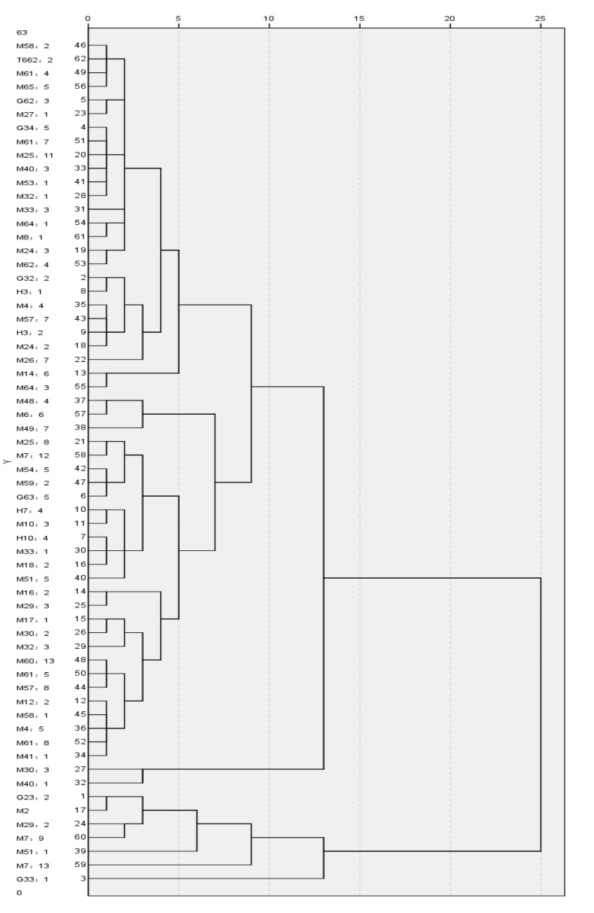
Fig. S1. Dendrogram

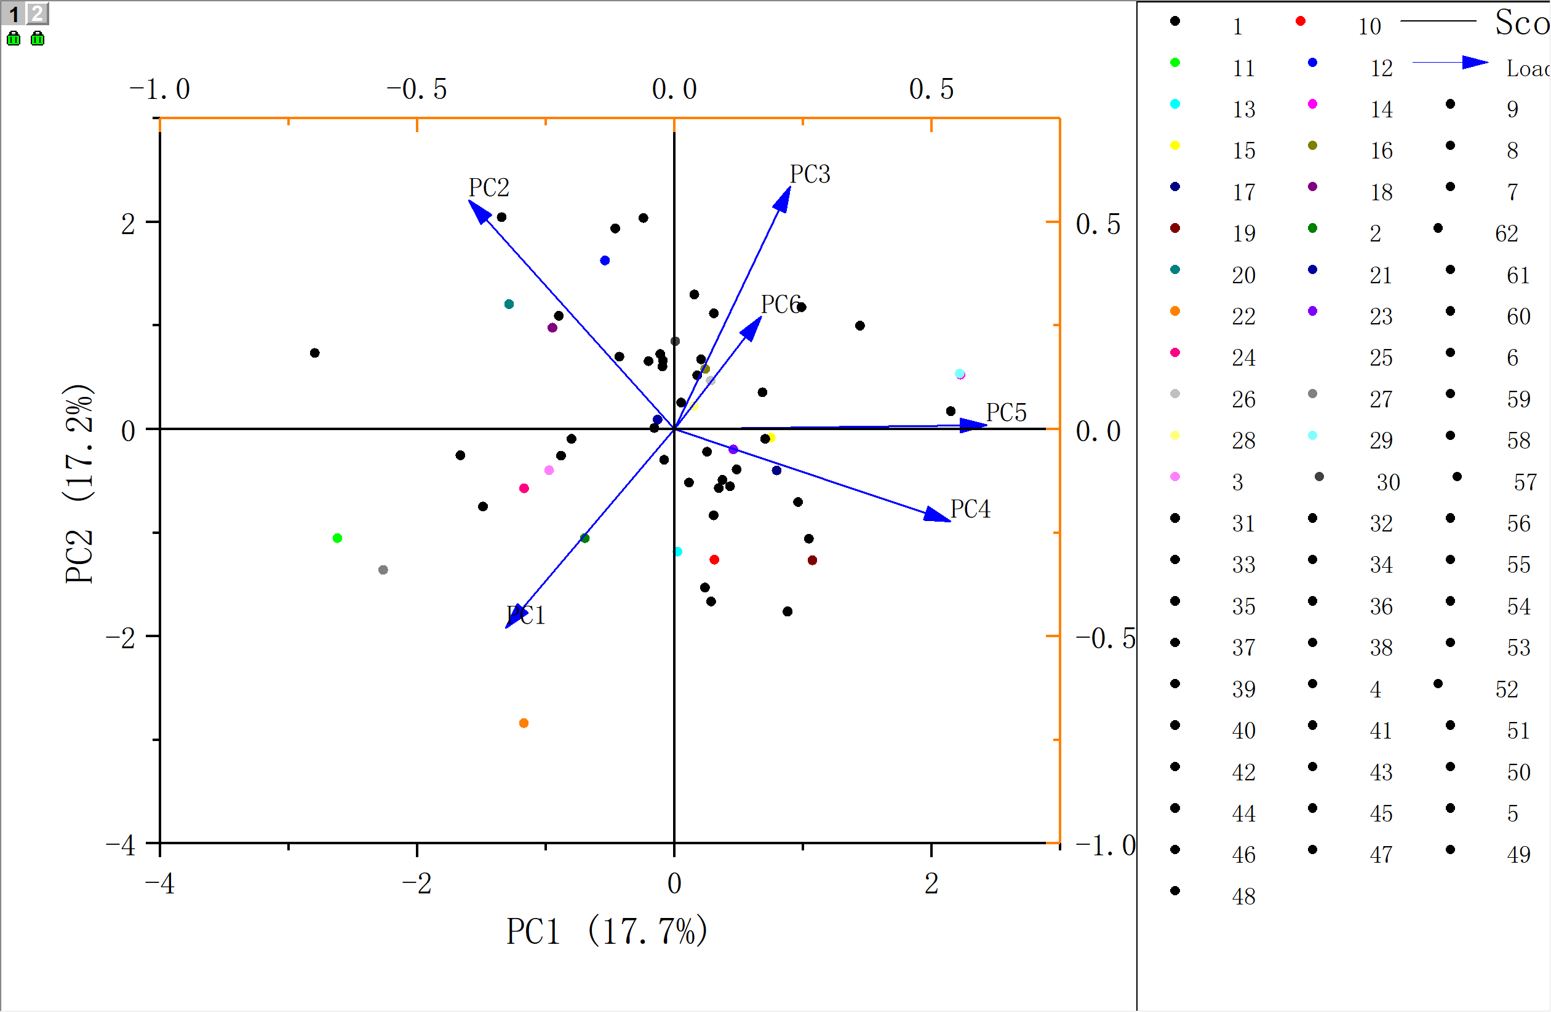
Fig. S2. PC scores plot

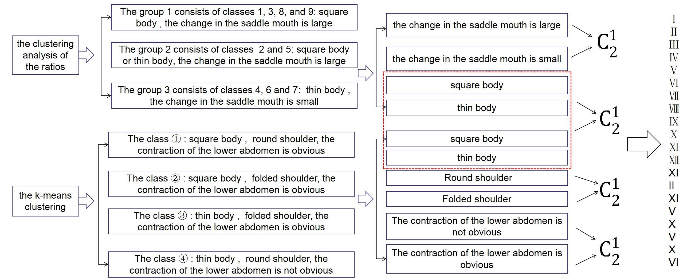
Fig. S3

