Supplementary Tables and Figures for Delenko et al

Supplementary Table 1 Primers for RT-qPCR
Gene | Forward primer (left) | Reverse primer (right)
HPRT1 | TGACCTTGATTTATTTTGCATACC | CGAGCAAGACGTTCAGTCCT
IGFBP1 | AATGGATTTTATCACAGCAGACAG | GGTAGACGCACCAGCAGAGT
PRL | CAAAGGATCGCCATGGAA | CACAGGAGCAGGTTTGACAC

Supplementary Table 2 Antibodies used for western blotting.
Target | Clone | Dilution | Species raised in | Source
Primary antibodies
p16 INK4A | Monoclonal | 1:1000 | Rabbit IgG | Cell Signalling Technologies
p21 Waf1/Cip | Monoclonal | 1:1000 | Rabbit IgG | Cell Signalling Technologies
Lamin B1 | Monoclonal | 1:1000 | Rabbit IgG | Cell Signalling Technologies
IL-6 | Monoclonal | 1:1000 | Rabbit IgG | Cell Signalling Technologies
MMP3 | Monoclonal | 1:1000 | Rabbit IgG | Cell Signalling Technologies
Phospho-AKT (S473) | Monoclonal | 1:1000 | Rabbit IgG | Cell Signalling Technologies
AKT | Polyclonal | 1:1000 | Rabbit | Cell Signalling Technologies
Phospho-PRAS40 (T246) | Monoclonal | 1:1000 | Rabbit IgG | Cell Signalling Technologies
PRAS40 | Monoclonal | 1:1000 | Rabbit IgG | Cell Signalling Technologies
Phospho-ERK1/2 (T202/Y204) | Monoclonal | 1:1000 | Rabbit IgG | Cell Signalling Technologies
ERK1/2 | Polyclonal | 1:1000 | Rabbit | Cell Signalling Technologies
p53 | Polyclonal | 1:1000 | Rabbit | Cell Signalling Technologies
GAPDH | Monoclonal | 1:1000 | Rabbit | Cell Signalling Technologies

Supplementary Figures
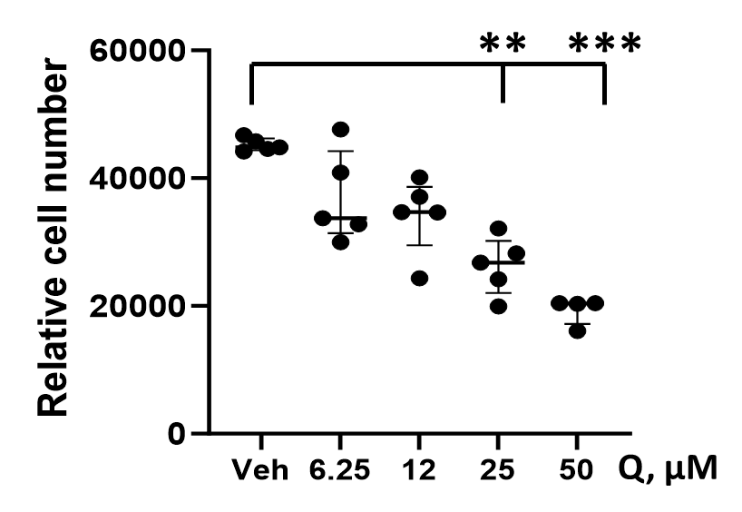
Supplementary Fig. 1 Endometrial stromal cells (eSCs) collected from patients with endometriosis were treated with vehicle (Veh) or quercetin (Q, 6.25-50 µM) for 72 hr and the relative cell number was determined. Each point represents data from one individual’s eSCs, with the group mean ± SD for vehicle and each Q dose. **p<0.01, ***p<0.001

Supplementary Figure 2A and 2B
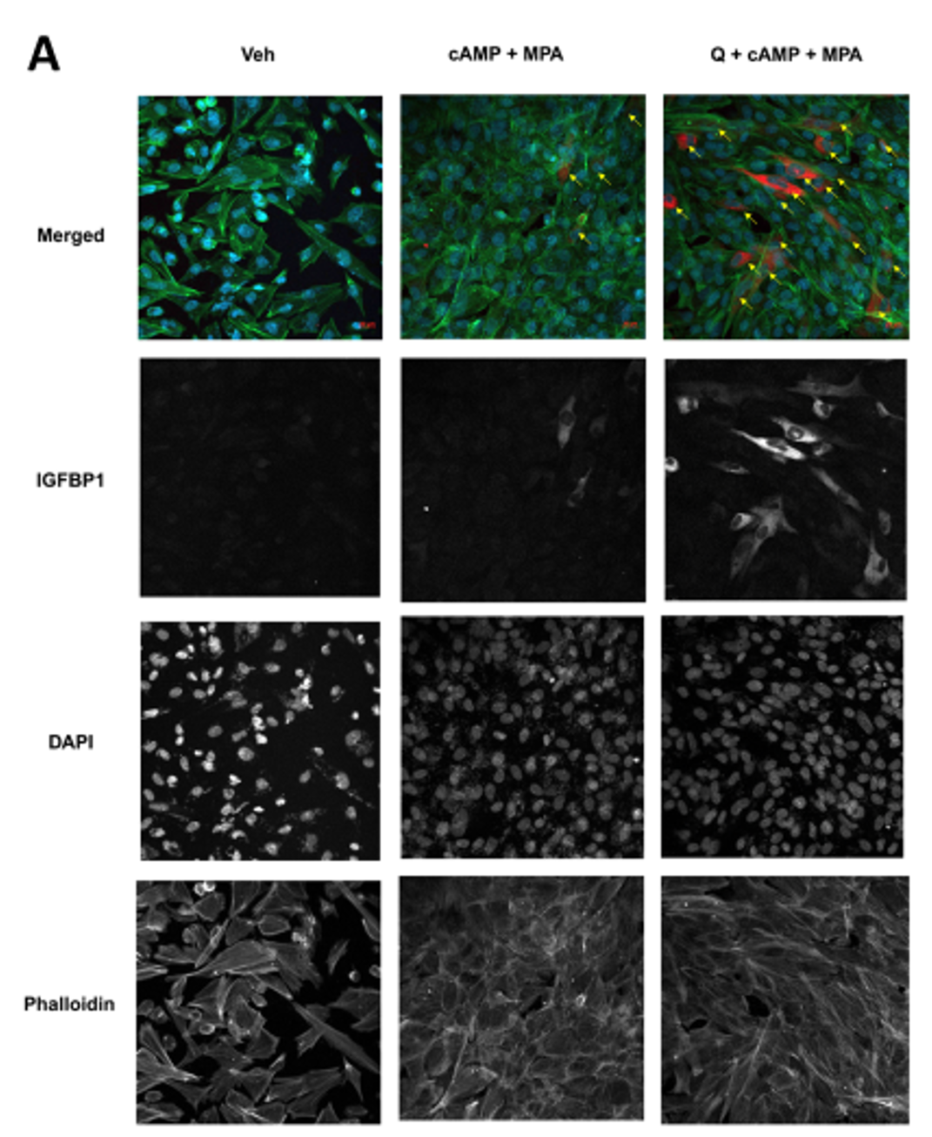

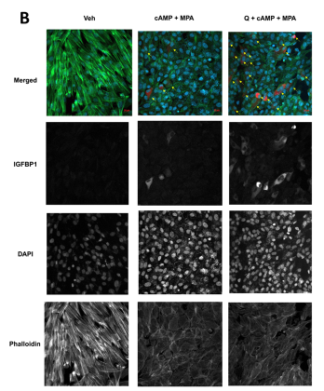
Supplementary Fig. 2. Quercetin enhances decidualization by control ME-eSCs as determined by immunofluorescence. Control-eSCs (Control #1 (A) Control #2 (B)) were treated with vehicle or quercetin for 4 hr followed by vehicle or cAMP+MPA prior to staining and confocal imaging; images show IGFBP1 (red), phalloidin (green), and DAPI (blue) staining (at 20X magnification). The scale bars (20 µm) are indicated. IGFBP1+ cells are indicated by yellow arrows in the merged images; single channel images are shown for IGFBP1, DAPI, and Phalloidin.
Supplementary Figure 3
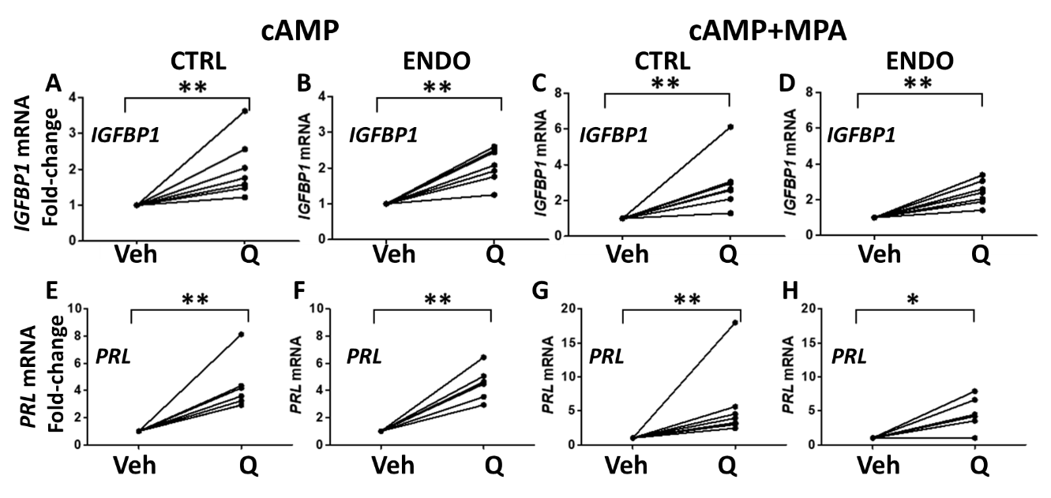

Supplementary Fig. 3. Quercetin enhances decidualization by control- eSCs and endometriosis-eSCs, as determined by IGFBP1 and PRL mRNA production. (A-H) Endometrial stromal cells (eSCs) from controls (A, C, E, and G, CTRL) and endometriosis patients (B, D, F, and H, ENDO) were treated with vehicle (Veh) or quercetin (Q, 25μM) for 4 hr prior to the addition of cAMP alone (A-B, E-F) or cAMP+MPA (C-D, G-H). After 48 hr, decidualization was analyzed by measuring IGFBP1 (A-D) or PRL (E-H) mRNA expression by qPCR (shown as fold-change in expression). Data are points connected by a line represent paired mean data points from one individual’s eSCs (±Q). *p<0.05 Veh vs. Q-treated; **p<0.01 Veh vs. Q-treated.

Supplementary Figure 4
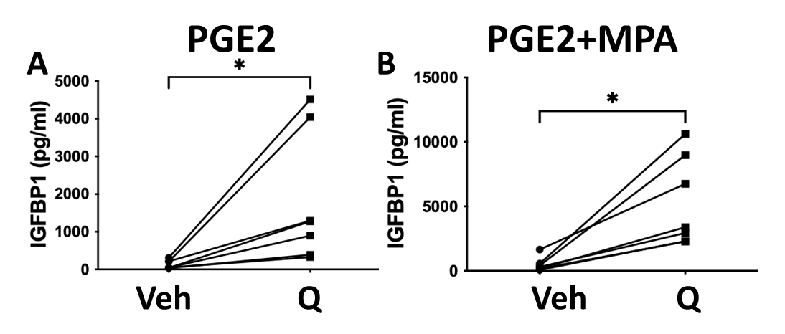
Supplementary Fig. 4. Quercetin enhances PGE2±MPA-stimulated decidualization. (A-B) Endometrial stromal cells (eSCs) from controls were treated with vehicle (Veh) or quercetin (Q, 25μM) for 4 hr prior to the addition of PGE2 alone (A) or PGE2+MPA (B). Decidualization was analyzed 48 hr later by measuring IGFBP1 protein by ELISA. Data points connected by a line represent paired mean data points from one individual’s eSCs (±Q). *p<0.05 Veh vs. Q-treated.
Supplementary Figure 5
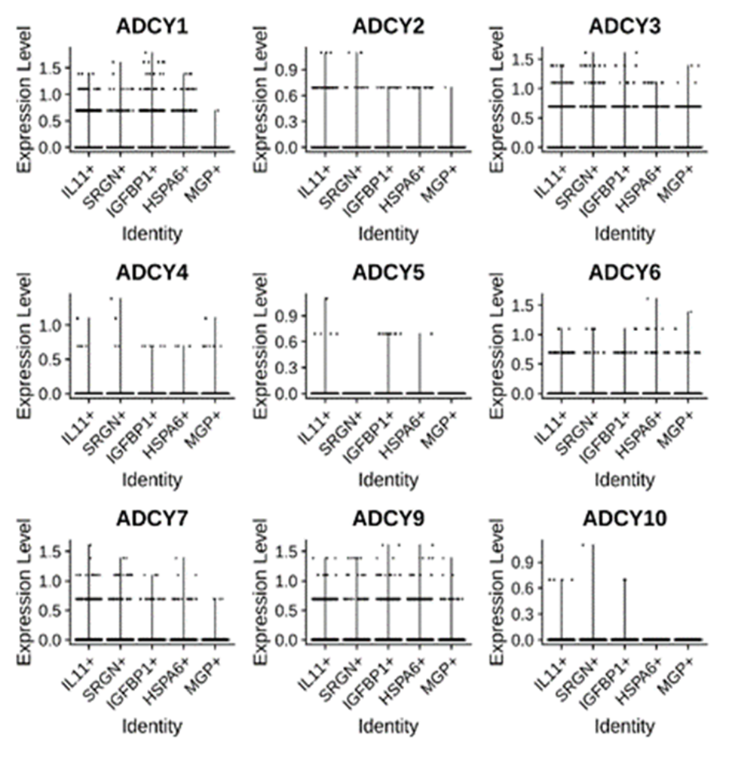
Supplementary Fig. 5. Fresh menstrual effluent (ME) tissue-derived eSCs express multiple ADCY transcripts, as shown by scRNA-Seq. ADCY gene expression is shown from five different endometrial stromal cell (eSC) clusters (IL11+, SRGN+, IGFBP1+, HSPA6+, and MGP+) found in menstrual effluent (ME) (18).

Supplementary Figure 6
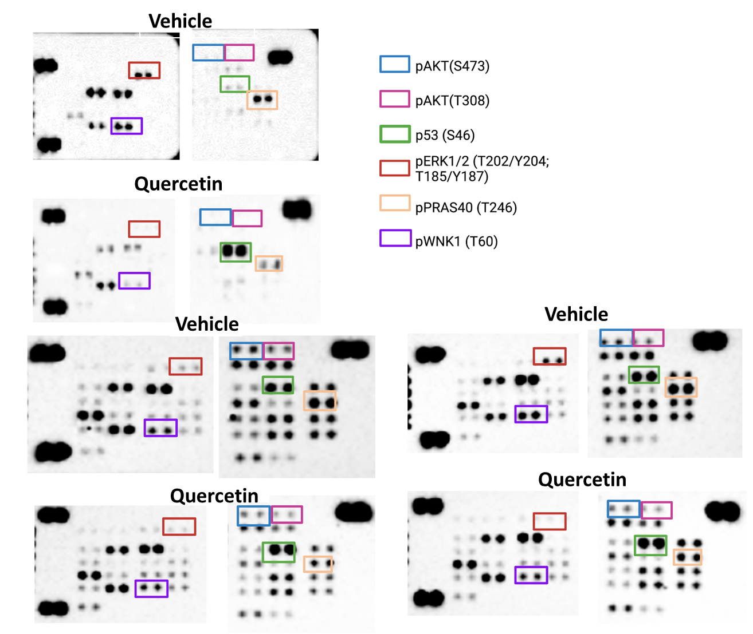

Supplementary Fig. 6. Quercetin inhibits AKT signaling and promotes p53 (Ser46) phosphorylation in eSCs. Control-eSCs were treated with vehicle (Veh) or quercetin (25μM) for 4 hr before analysis using the Phospho-Kinase Array Panel.

