Supplementary Information for
Unconventional angular dependence of spin-orbit torque-induced harmonic Hall resistances in Pt/YIG bilayers

Takayuki Shiino¹, Phuoc Cao Van², Jong-Guk Choi¹, Geunwoo Kim¹, Jong-Ryul Jeong², and Byong-Guk Park¹*

¹Department of Materials Science and Engineering, KAIST, Daejeon 34141, Republic of Korea
²Department of Material Science and Engineering, Chungnam National University, Daejeon 34134, Republic of Korea

CONTENTS
- Derivation of the equations of $R_{xy}^{1ω}$ and $R_{xy}^{2ω}$
- A possible explanation for the even/odd-number $nϕ$ symmetries in $R_{xy}^{1ω}$/$R_{xy}^{2ω}$
- X-ray diffraction data
- M-H curve
- Longitudinal harmonic resistances $R_{xx}^{1ω}$ and $R_{xx}^{2ω}$
- Anomalous Hall effect in Pt/YIG
- Supplemental data for Figures 2

S1. Derivation of the equations of $R_{xy}^{1ω}$ and $R_{xy}^{2ω}$
$$R_{xy}=R_{AHE}m_{z}+2R_{PHE}m_{x}m_{y}+α_{SSE}Im_{x}=R_{AHE}\cos{θ}+R_{PHE}\sin^{2}{θ}\sin{2ϕ}+α_{SSE}I\sin{θ}\cos{ϕ}. \left(S1\right)$$
The first and second terms represent AHE and PHE, respectively. The third term represents SSE where $α_{SSE}$ is an SSE coefficient in the unit of $Ω/A$. Here we consider the magnetization vector $m=\left(m_{x},m_{y},m_{z}\right)=\left(\cos{ϕ}\sin{θ},\sin{ϕ}\sin{θ},\cos{θ}\right)$ that is aligned along an external static magnetic field direction ($θ$, $ϕ$) in the equilibrium state, where $θ$ and $ϕ$ are the polar and azimuthal angles of an external magnetic field. Current-induced SOTs cause the deviations ($Δθ$ and $Δϕ$) of $m$ with respect to $θ$ and $ϕ$. We have performed a similar calculation as in ref. S1,2 and extended the equations to the higher-order terms [including ${\left(Δθ\right)}^{2}$, ${\left(Δθ\right)}^{3}$, ${\left(Δθ\right)}^{4}$… and ${\left(Δϕ\right)}^{2}$, ${\left(Δϕ\right)}^{3}$, ${\left(Δϕ\right)}^{4}$…]. By calculating the Taylor expansions with respect to $θ$ and $ϕ$, we obtain the following equations:
$$R_{xy}=R_{AHE}\left[\cos{θ}-\sin{θ}\left(Δθ\right)-\frac{1}{2}\cos{θ}{\left(Δθ\right)}^{2}+\frac{1}{6}\sin{θ}{\left(Δθ\right)}^{3}+\frac{1}{24}\cos{θ}{\left(Δθ\right)}^{4}-\frac{1}{120}\sin{θ}{\left(Δθ\right)}^{5}+…\right]+R_{PHE}\left[\sin{2ϕ}+2\cos{2ϕ}\left(Δϕ\right)-2\sin{2ϕ}{\left(Δϕ\right)}^{2}-\frac{4}{3}\cos{2ϕ}{\left(Δϕ\right)}^{3}+\frac{2}{3}\sin{2ϕ}{\left(Δϕ\right)}^{4}+…\right]\left[\sin^{2}{θ}+\sin{2θ}\left(Δθ\right)+\cos{2θ}{\left(Δθ\right)}^{2}-\frac{2}{3}\sin{2θ}{\left(Δθ\right)}^{3}-\frac{1}{3}\cos{2θ}{\left(Δθ\right)}^{4}+…\right]+α_{SSE}I\left[\cos{ϕ}-\sin{ϕ}\left(Δϕ\right)-\frac{1}{2}\cos{ϕ}{\left(Δϕ\right)}^{2}+\frac{1}{6}\sin{ϕ}{\left(Δϕ\right)}^{3}+\frac{1}{24}\cos{ϕ}{\left(Δϕ\right)}^{4}+…\right]\left[\sin{θ}+\cos{θ}\left(Δθ\right)-\frac{1}{2}\sin{θ}{\left(Δθ\right)}^{2}-\frac{1}{6}\cos{θ}{\left(Δθ\right)}^{3}+\frac{1}{24}\sin{θ}{\left(Δθ\right)}^{4}+…\right], \left(S2\right)$$
with
$$Δθ=-\frac{H_{DL}\cos{ϕ}}{H_{eff}}=-h_{DL}I\cos{ϕ}, \left(S3\right)$$
$$Δϕ=\frac{H_{FL}\cos{ϕ}}{H_{a}}=h_{FL}I\cos{ϕ}, \left(S4\right)$$
where $H_{DL}$ and $H_{FL}$ are effective magnetic fields of DL and FL SOTs, respectively; $H_{eff}$ is the effective field including the applied field $H_{a}$ and the demagnetization and anisotropy fields of the FM layer. Here we assume that the SOT effective fields ($H_{DL}$ and $H_{FL}$) are proportional to $I$ and define the normalized SOT effective fields $h_{DL}≡H_{DL}/IH_{eff}$ and $h_{FL}≡H_{FL}/IH_{a}$. Note that $h_{DL}$ and $h_{FL}$ are independent of current $I$ at constant $H_{a}$. In this study, we calculated up to the fifth order [${\left(Δθ\right)}^{5}$ and ${\left(Δϕ\right)}^{5}$]. Here we consider the in-plane FM under an in-plane ($θ=π/2$) magnetic field with the azimuthal angle $ϕ$. The Hall resistance can be described as follows:
$$R_{xy}=R_{AHE}\left[-\left(Δθ\right)+\frac{1}{6}{\left(Δθ\right)}^{3}-\frac{1}{120}{\left(Δθ\right)}^{5}+…\right]+R_{PHE}\left[\sin{2ϕ}+2\cos{2ϕ}\left(Δϕ\right)-2\sin{2ϕ}{\left(Δϕ\right)}^{2}-\frac{4}{3}\cos{2ϕ}{\left(Δϕ\right)}^{3}+\frac{2}{3}\sin{2ϕ}{\left(Δϕ\right)}^{4}+…\right]\left[1-{\left(Δθ\right)}^{2}+\frac{1}{3}{\left(Δθ\right)}^{4}+…\right]+α_{SSE}I\left[\cos{ϕ}-\sin{ϕ}\left(Δϕ\right)-\frac{1}{2}\cos{ϕ}{\left(Δϕ\right)}^{2}+\frac{1}{6}\sin{ϕ}{\left(Δϕ\right)}^{3}+\frac{1}{24}\cos{ϕ}{\left(Δϕ\right)}^{4}+…\right]\left[1-\frac{1}{2}\sin{θ}{\left(Δθ\right)}^{2}+\frac{1}{24}\sin{θ}{\left(Δθ\right)}^{4}+…\right]. \left(S5\right)$$
On the other hand, a (Hall) resistance can be generally described as follows:
$$R=R^{\left(0\right)}+I{\left.\frac{dR}{dI}\right|}_{I=0}+\frac{1}{2}I^{2}{\left.\frac{d^{2}R}{dI^{2}}\right|}_{I=0}+\frac{1}{6}I^{3}{\left.\frac{d^{3}R}{dI^{3}}\right|}_{I=0}+\frac{1}{24}I^{4}{\left.\frac{d^{4}R}{dI^{4}}\right|}_{I=0}+… \\ =R^{\left(0\right)}+IR^{\left(1\right)}+I^{2}R^{\left(2\right)}+I^{3}R^{\left(3\right)}+I^{4}R^{\left(4\right)}+…, \left(S6\right)$$
where
$$R^{\left(1\right)}≡{\left.\frac{dR}{dI}\right|}_{I=0}, R^{\left(2\right)}≡\frac{1}{2}{\left.\frac{d^{2}R}{dI^{2}}\right|}_{I=0}, R^{\left(3\right)}≡\frac{1}{6}{\left.\frac{d^{3}R}{dI^{3}}\right|}_{I=0}, R^{\left(4\right)}≡\frac{1}{24}{\left.\frac{d^{4}R}{dI^{4}}\right|}_{I=0}. \left(S7\right)$$
Considering an AC current $I=I_{0}\sin{ωt}$,
$$R=\left[R^{\left(0\right)}+\frac{3R^{\left(2\right)}I_{0}^{2}}{4}+…\right]\sin{ωt}+\left[\frac{R^{\left(1\right)}I_{0}}{2}+\frac{R^{\left(3\right)}I_{0}^{3}}{2}+…\right]\sin\left(2ωt-\frac{π}{2}\right)+\left[-\frac{R^{\left(2\right)}I_{0}^{2}}{4}+…\right]\sin{3ωt}+\left[-\frac{R^{\left(3\right)}I_{0}^{3}}{8}+…\right]\sin\left(4ωt-\frac{π}{2}\right)+…. \left(S8\right)$$
From this equation, in this study, we define the first and second harmonic resistances as follows:
$$R^{1ω}≡R^{\left(0\right)}+\frac{3}{4}I_{0}^{2}R^{\left(2\right)}+\frac{5}{8}I_{0}^{4}R^{\left(4\right)}+\frac{35}{64}I_{0}^{6}R^{\left(6\right)}+O\left(I_{0}^{8}\right). \left(S9\right)$$
$$R^{2ω}≡\frac{1}{2}I_{0}R^{\left(1\right)}+\frac{1}{2}I_{0}^{3}R^{\left(3\right)}+\frac{15}{32}I_{0}^{5}R^{\left(5\right)}+O\left(I_{0}^{7}\right). \left(S10\right)$$
By substituting Eqs. S3 and S4 into Eq. S5 and comparing Eq. S5 and Eq. S6 with respect to the coefficients of the current-dependent terms, we obtain the expressions of $R^{\left(p\right)}$ for the Hall resistances where $p=1,2,…,8$. By further substituting the obtained $R^{\left(p\right)}$ ($p=1,2,…,8$) into Eqs. S9 and S10, we obtain Eqs. (1) and (2) (main text) with the following coefficients:
$$c_{2ϕ}^{1ω}=R_{PHE}-I_{0}^{2}\left[R_{PHE}\left\{\frac{3}{8}h_{DL}^{2}+\frac{3}{4}h_{FL}^{2}\right\}+\frac{3}{8}α_{SSE}h_{FL}\right]+I_{0}^{4}\left[R_{PHE}\left\{\frac{25}{384}h_{DL}^{4}+\frac{25}{64}h_{DL}^{2}h_{FL}^{2}+\frac{25}{192}h_{FL}^{4}\right\}\right]+…, \left(S11\right)$$
$$c_{4ϕ}^{1ω}=-I_{0}^{2}\left[R_{PHE}\left\{\frac{3}{16}h_{DL}^{2}+\frac{3}{8}h_{FL}^{2}\right\}\right]+I_{0}^{4}\left[R_{PHE}\left\{\frac{5}{96}h_{DL}^{4}+\frac{5}{16}h_{DL}^{2}h_{FL}^{2}+\frac{5}{48}h_{FL}^{4}\right\}+α_{SSE}\left\{\frac{5}{128}h_{DL}^{2}h_{FL}+\frac{5}{384}h_{FL}^{3}\right\}\right]+…, \left(S12\right)$$
$$c_{6ϕ}^{1ω}=I_{0}^{4}\left[R_{PHE}\left\{\frac{5}{384}h_{DL}^{4}+\frac{5}{64}h_{DL}^{2}h_{FL}^{2}+\frac{5}{192}h_{FL}^{4}\right\}\right]-I_{0}^{6}\left[R_{PHE}\left\{\frac{35}{1024}h_{DL}^{4}h_{FL}^{2}+\frac{35}{1024}h_{DL}^{2}h_{FL}^{4}\right\}+α_{SSE}\left\{\frac{35}{49152}h_{DL}^{4}h_{FL}+\frac{35}{24576}h_{DL}^{2}h_{FL}^{3}+\frac{7}{49152}h_{FL}^{5}\right\}\right]+…, \left(S13\right)$$
$$c_{8ϕ}^{1ω}=-I_{0}^{6}\left[R_{PHE}\left\{\frac{35}{6144}h_{DL}^{4}h_{FL}^{2}+\frac{35}{6144}h_{DL}^{2}h_{FL}^{4}\right\}\right]+I_{0}^{8}\left[R_{PHE}\frac{7}{2048}h_{DL}^{4}h_{FL}^{4}+α_{SSE}\left\{\frac{7}{262144}h_{DL}^{4}h_{FL}^{3}+\frac{21}{1310720}h_{DL}^{2}h_{FL}^{5}\right\}\right]+…, \left(S14\right)$$
$$c_{1ϕ}^{2ω}=I_{0}\left[\frac{1}{2}R_{PHE}h_{FL}+\frac{1}{2}R_{AHE}h_{DL}+\frac{1}{2}α_{SSE}\right]-I_{0}^{3}\left[R_{PHE}\left(\frac{1}{2}h_{DL}^{2}h_{FL}+\frac{1}{3}h_{FL}^{3}\right)+\frac{1}{16}R_{AHE}h_{DL}^{3}+α_{SSE}\left\{\frac{3}{16}h_{DL}^{2}+\frac{3}{16}h_{FL}^{2}\right\}\right]+I_{0}^{5}\left[R_{PHE}\left(\frac{75}{512}h_{DL}^{4}h_{FL}+\frac{75}{256}h_{DL}^{2}h_{FL}^{3}+\frac{15}{256}h_{FL}^{5}\right)+\frac{5}{2048}R_{AHE}h_{DL}^{5}+α_{SSE}\left\{\frac{25}{2048}h_{DL}^{4}+\frac{75}{1024}h_{DL}^{2}h_{FL}^{2}+\frac{25}{2048}h_{FL}^{4}\right\}\right]+…, \left(S15\right)$$
$$c_{3ϕ}^{2ω}=I_{0}\left[\frac{1}{2}R_{PHE}h_{FL}\right]-I_{0}^{3}\left[R_{PHE}\left(\frac{3}{8}h_{DL}^{2}h_{FL}+\frac{1}{4}h_{FL}^{3}\right)+\frac{1}{48}R_{AHE}h_{DL}^{3}+α_{SSE}\left\{\frac{1}{16}h_{DL}^{2}+\frac{1}{16}h_{FL}^{2}\right\}\right]+I_{0}^{5}\left[R_{PHE}\left(\frac{55}{512}h_{DL}^{4}h_{FL}+\frac{55}{256}h_{DL}^{2}h_{FL}^{3}+\frac{11}{256}h_{FL}^{5}\right)+\frac{5}{4096}R_{AHE}h_{DL}^{5}+α_{SSE}\left\{\frac{25}{4096}h_{DL}^{4}+\frac{75}{2048}h_{DL}^{2}h_{FL}^{2}+\frac{25}{4096}h_{FL}^{4}\right\}\right]+…, \left(S16\right)$$
$$c_{5ϕ}^{2ω}=-I_{0}^{3}\left[R_{PHE}\left(\frac{1}{8}h_{DL}^{2}h_{FL}+\frac{1}{12}h_{FL}^{3}\right)\right]+I_{0}^{5}\left[R_{PHE}\left(\frac{25}{512}h_{DL}^{4}h_{FL}+\frac{25}{256}h_{DL}^{2}h_{FL}^{3}+\frac{5}{256}h_{FL}^{5}\right)+\frac{1}{4096}R_{AHE}h_{DL}^{5}+α_{SSE}\left\{\frac{5}{4096}h_{DL}^{4}+\frac{15}{2048}h_{DL}^{2}h_{FL}^{2}+\frac{5}{4096}h_{FL}^{4}\right\}\right]+…, \left(S17\right)$$
$$c_{7ϕ}^{2ω}=I_{0}^{5}\left[R_{PHE}\left(\frac{5}{512}h_{DL}^{4}h_{FL}+\frac{5}{256}h_{DL}^{2}h_{FL}^{3}+\frac{1}{256}h_{FL}^{5}\right)\right]-I_{0}^{7}\left[R_{PHE}\left(\frac{49}{4608}h_{DL}^{4}h_{FL}^{3}+\frac{49}{7680}h_{DL}^{2}h_{FL}^{5}\right)+α_{SSE}\left\{\frac{7}{49152}h_{DL}^{4}h_{FL}^{2}+\frac{7}{49152}h_{DL}^{2}h_{FL}^{4}\right\}\right]+…. \left(S18\right)$$
The SSE term ($R_{xy}^{SSE}$) in Eq. (4) (in the main text) is defined as $R_{xy}^{SSE}=\frac{1}{2}α_{SSE}I_{0}$. It is also noteworthy that the hybridization of the DL and FL SOTs (the product terms of $h_{FL}$ and $h_{DL}$: e.g., $h_{DL}^{2}h_{FL}^{3}$) becomes significant in the nonlinear current-dependent terms. Note that one can read $I_{0}→J_{0}$ (with a multiplication of geometric factors) when discussing current density. From Eq. S17, the coefficients of $c_{5ϕ}^{2ω}=-A_{1}I_{0}^{3}+A_{2}I_{0}^{5}+…$ mentioned in the main text can be expressed as follows:
$$A_{1}=R_{PHE}\left(\frac{1}{8}h_{DL}^{2}h_{FL}+\frac{1}{12}h_{FL}^{3}\right),$$
$$A_{2}=R_{PHE}\left(\frac{25}{512}h_{DL}^{4}h_{FL}+\frac{25}{256}h_{DL}^{2}h_{FL}^{3}+\frac{5}{256}h_{FL}^{5}\right)+\frac{1}{4096}R_{AHE}h_{DL}^{5}+α_{SSE}\left\{\frac{5}{4096}h_{DL}^{4}+\frac{15}{2048}h_{DL}^{2}h_{FL}^{2}+\frac{5}{4096}h_{FL}^{4}\right\}.$$

S2. A possible explanation for the even/odd-number $nϕ$ symmetries in $R_{xy}^{1ω}$/$R_{xy}^{2ω}$
Here we consider the reason why $R_{xy}^{1ω}\left(R_{xy}^{2ω}\right)$ contains only even (odd) number ($n$) terms with respect to the angle $nϕ$. The harmonic resistance $R_{xy}^{1ω}\left(R_{xy}^{2ω}\right)$ is even (odd) with respect to $I_{0}$ [see Eq. S9 (Eq. S10)]. Thus $R_{xy}^{1ω}\left(R_{xy}^{2ω}\right)$ is symmetric (antisymmetric) under the sign reversal of $I_{0}$:
$$R_{xy}^{1ω}\left(I_{0}\right)=R_{xy}^{1ω}\left(-I_{0}\right), \left(S19\right)$$
$$R_{xy}^{2ω}\left(I_{0}\right)=-R_{xy}^{2ω}\left(-I_{0}\right). \left(S20\right)$$
As seen in the schematic illustration of Fig. S1, Eqs. S19 and S20 require the following constraints with respect to $ϕ$:
$$R_{xy}^{1ω}\left(ϕ\right)=R_{xy}^{1ω}\left(ϕ+π\right), \left(S21\right)$$
$$R_{xy}^{2ω}\left(ϕ\right)=-R_{xy}^{2ω}\left(ϕ+π\right). \left(S22\right)$$
Therefore, from Eqs. S21 and S22, only $n$ = even (odd) number sin/cos($nϕ$) terms can exist in $R_{xy}^{1ω}\left(R_{xy}^{2ω}\right)$.

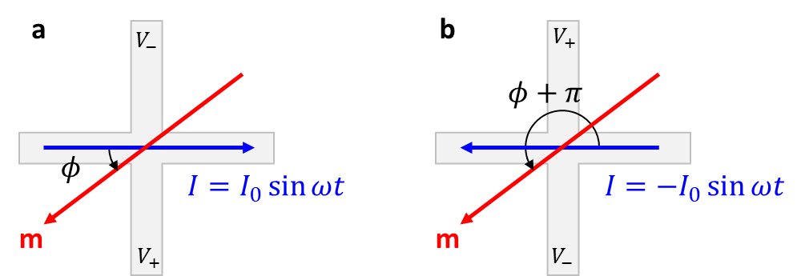
Figure S1 | Schematic illustration for the sign reversal of $I_{0}$.
Schematics for current flow at time $t$ under (a) $I=I_{0}\sin{ωt}$ and (b) $I=-I_{0}\sin{ωt}$.

S3. X-ray diffraction data
Figure S2 shows the X-ray diffraction pattern of the YIG(30)/GGG, the main sample used for magnetoresistance measurements in this study. A peak corresponding to single-crystal GGG(444) is evident, and the additional peak adjacent to the GGG peak is attributed to YIG(444), which has a small difference in lattice constants. The presence of Laue oscillation fringes indicates layer-by-layer growth and the high crystallinity of the YIG film³.

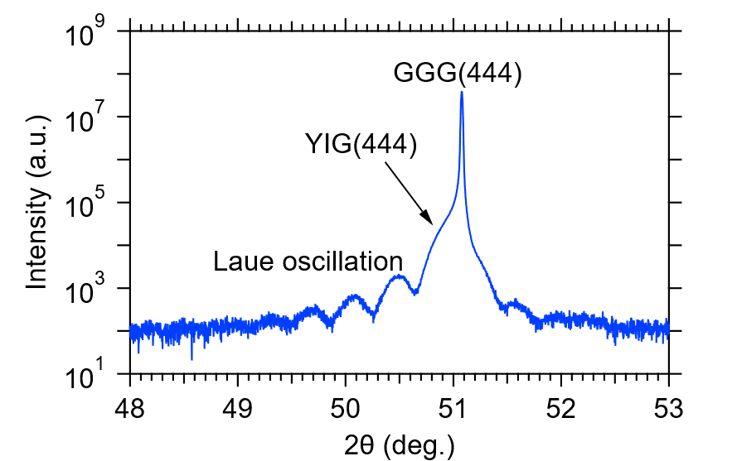
Figure S2 | X-ray diffraction pattern of 30 nm thick YIG film grown on a GGG(111) substrate.

S4. M-H curve
Figure S3 shows the in-plane magnetization ($M$) vs an applied external field ($H_{a}$) curves of the YIG(30)/GGG sample. A magnetic field was swept along $\left[\overline{1}\overline{1}2\right]$ (red) and $\left[\overline{1}10\right]$ (green), which are orthogonal to each other. The in-plane M-H curves do not indicate any significant in-plane anisotropic behavior in the present YIG sample.
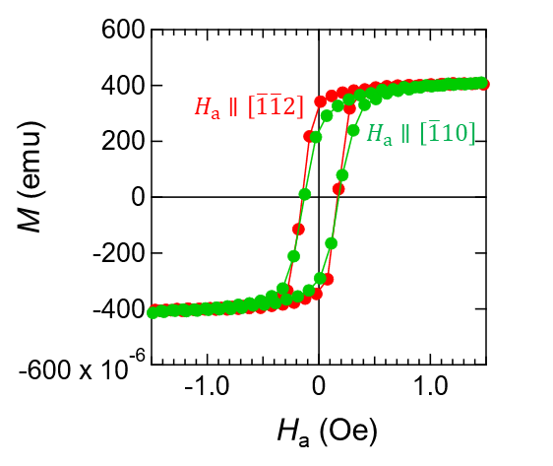
Figure S3 | In-plane M-H curves of the YIG sample used in this study.

S5. Longitudinal harmonic resistances $R_{xx}^{1ω}$ and $R_{xx}^{2ω}$
We show the longitudinal harmonic resistances ($R_{xx}^{1ω}$ and $R_{xx}^{2ω}$) of the Pt-YIG sample corresponding to SMR and magnonic unidirectional SMR (USMR)⁴. We observe typical $\cos{2ϕ}$ behavior of longitudinal SMR in $R_{xx}^{1ω}$ measured at $J_{0}=4.1×{10}^{10} A/m^{2}$ (Fig. S4a). The observed SMR ratio $R_{SMR}/R_{xx}^{1ω}\left(ϕ=0\right)$ is 0.036% where $R_{SMR}≡R_{xx}^{1ω}\left(ϕ=0\right)-R_{xx}^{1ω}\left(ϕ=π/2\right)$. Figure S4b shows the angular dependence of $R_{xx}^{2ω}$ measured at $J_{0}=4.1×{10}^{10} A/m^{2}$. The $ϕ$ dependence of $R_{xx}^{2ω}$ of the present system can be expressed as follows:⁴
$$R_{xx}^{2ω}=\left(R_{xx}^{SSE}+R_{xx}^{USMR}\right)\sin{ϕ}-2R_{SMR}\frac{H_{FL}+H_{Oe}}{H_{a}}\sin{ϕ}\cos^{2}{ϕ},$$
where $H_{FL}$ and $H_{Oe}$ indicate the effective fields of the current-induced field-like (FL) SOT and current-induced Oersted fields, respectively. By fitting with $R_{\sin{ϕ}}^{2ω}\left[≡R_{xx}^{SSE}+R_{xx}^{USMR}\right]$ and $R_{\sin{ϕ}\cos^{2}{ϕ}}^{2ω}\left[≡-2R_{SMR}\left(H_{FL}+H_{Oe}\right)/H_{a}\right]$ as the fitting parameters, we decompose $\sin{ϕ}$ and $\sin{ϕ}\cos^{2}{ϕ}$ contributions. The value of $R_{\sin{ϕ}}^{2ω}$ is plotted as a function of $H_{a}$ in Fig. S4c. The USMR component ($R_{xx}^{USMR}$), which is indicated by the decreasing behavior of $R_{\sin{ϕ}}^{2ω}$ with $H_{a}$, becomes absent above ~ 1000 Oe, where only the SSE ($R_{xx}^{SSE}$) contribution remains. The USMR ratio defined as $R_{xx}^{USMR}/R_{xx}^{1ω}\left(ϕ=0\right)$ is $2.3×{10}^{-4}$ % at $J_{0}=1×{10}^{11} A/m^{2}$ and $H_{a}=25$ Oe.
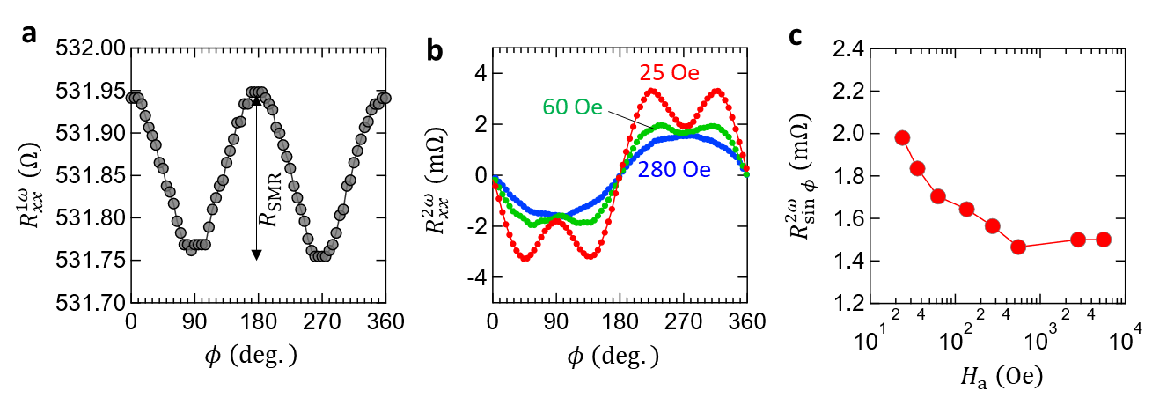
Figure S4 | Longitudinal MR signals in Pt/YIG
a, b, Angular dependences of $R_{xx}^{1ω}$ (a) and $R_{xx}^{2ω}$ (b) measured at room temperature (T $≈$ 300 K). The longitudinal SMR curve $R_{xx}^{1ω}$ (a) was obtained at $H_{a}=25$ Oe. Note that the constant offsets are subtracted in the $R_{xx}^{2ω}$ plot (b). c, Plot of $R_{\sin{ϕ}}^{2ω}\left[=R_{xx}^{SSE}+R_{xx}^{USMR}\right]$ as a function of $H_{a}$. All the data here were obtained at $J_{0}=4.1×{10}^{10} A/m^{2}$.
S6. Anomalous Hall effect in Pt/YIG
Figure S5 shows the anomalous Hall effect (AHE) measurement result of our Pt/YIG sample. Note that the contribution from the ordinary Hall effect (which is linear in the field $H_{a}$ applied in the out-of-plane direction) and a constant offset value are subtracted. The obtained value is $R_{AHE}=2.7 mΩ$. The seemingly unusual AHE behavior in the low-field region is attributed to the planar Hall effect (i.e., transverse SMR), which is significantly larger than the AHE in the present Pt/YIG system. Note that a similar behavior has been observed previously⁵.
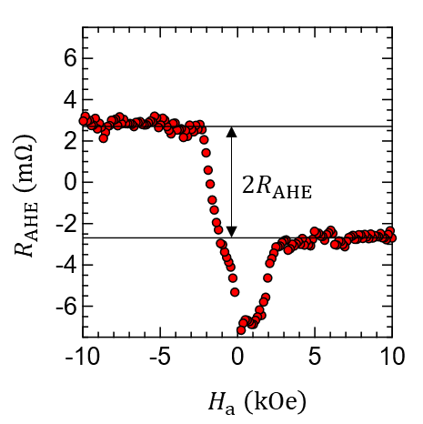
Figure S5 | Anomalous Hall effect measurement result.

S7. Supplemental data for Figures 2
Figure S6 shows the measured $R_{xy}^{1ω}$ and $R_{xy}^{2ω}$ at different fields ($25 Oe≤H_{a}≤10 kOe$) and currents ($0.5×{10}^{11}≤J_{0}≤2.2×{10}^{11} A/m^{2}$), for magnetic fields ($H_{a}$ = 25, 100 and 2600 Oe) and current densities.
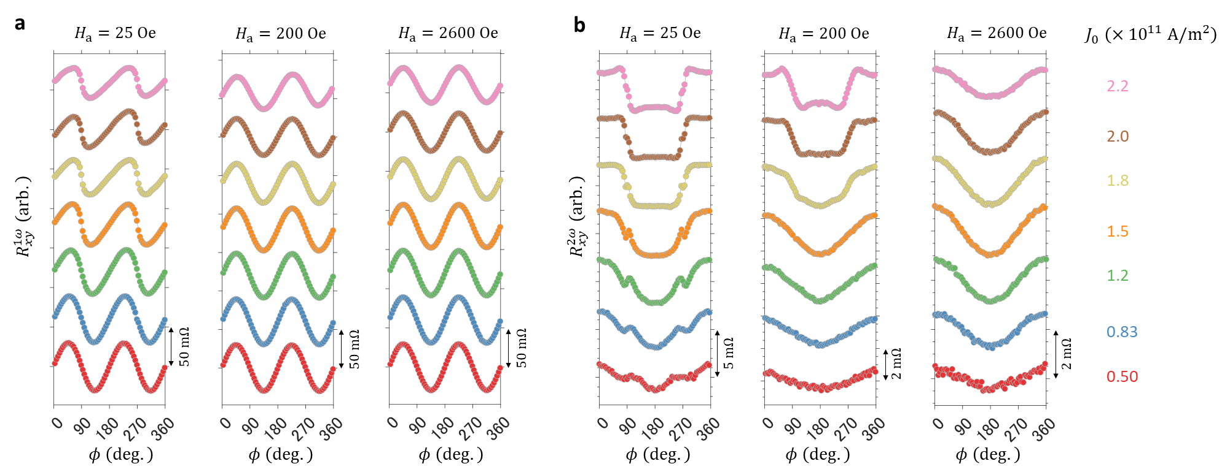
Figure S6 | Angle-dependent PHE curves for various values of magnetic fields and current density.
a, b, Angular dependences of $R_{xy}^{1ω}$ (a) and $R_{xy}^{2ω}$ (b) for various values of current density at $H_{a}$ = 25 Oe, 200 Oe, and 2600 Oe.

References
S1. Han, B. et al. Determination of the Spin-Orbit Torques in Ferromagnetic-Heavy-Metal Bilayers Using Harmonic Longitudinal Voltage Measurements. Phys Rev Appl 13, 014065 (2020).
S2. Cheng, Y. et al. Third harmonic characterization of antiferromagnetic heterostructures. Nature Communications 13, 1–6 (2022).
S3. Cao Van, P. et al. Effect of annealing temperature on surface morphology and ultralow ferromagnetic resonance linewidth of yttrium iron garnet thin film grown by rf sputtering. Appl Surf Sci 435, 377–383 (2018).
S4. Liu, G. et al. Magnonic Unidirectional Spin Hall Magnetoresistance in a Heavy-Metal-Ferromagnetic-Insulator Bilayer. Phys Rev Lett 127, 207206 (2021).
S5. Avci, C. O. et al. Nonlocal Detection of Out-of-Plane Magnetization in a Magnetic Insulator by Thermal Spin Drag. Phys Rev Lett 124, 027701 (2020).

