Supplemental Fig. S1
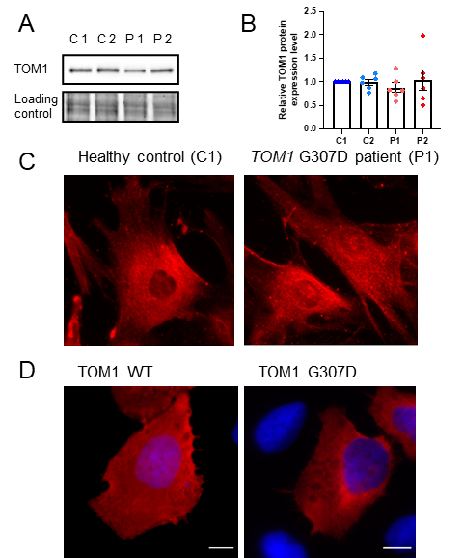

Supplemental Fig. 1 TOM1 protein levels and subcellular localization do not differ between patient and healthy control cells. (A) TOM1 protein expression levels were evaluated in primary skin fibroblasts of two patients (P1 and P2) and two healthy controls (C1 and C2) using western blot. (B) Quantification of western blots. Data represent mean ± SEM from three independent experiments with duplicate samples. Band intensities were normalized to C1. (C) Endogenous TOM1 staining in primary skin fibroblasts from a healthy control (C1) and TOM1 G307D patient (P1). (D) Transient overexpression of TOM1 WT or G307D mutant and anti-TOM1 immunostaining in U2OS cells. Scale bar: 10 $µ$m.

Supplemental Fig. S2
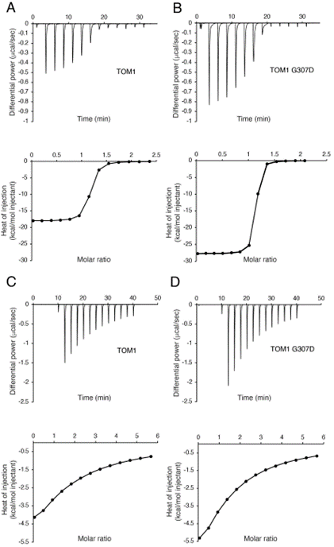

Supplemental Fig. S2 The G307D mutation in TOM1 does not alter TOLLIP nor ubiquitin binding. A-B. ITC thermograms representing the binding of TOM1 (A) and TOM1 G307D (B) to TOLLIP. Upper panels, raw titration data. Lower panels, integrated, normalized concentration, and corrected heat dilution data. The lines represent the best fit model for 1:1 binding. (C-D) ITC thermograms representing the binding of TOM1 (C) and TOM1 G307D (D) to ubiquitin. Upper panels, raw titration data. Lower panels, integrated, normalized concentration and corrected heat dilution data. The lines represent the best fit model for 1:1 binding.

Supplemental Fig. S3

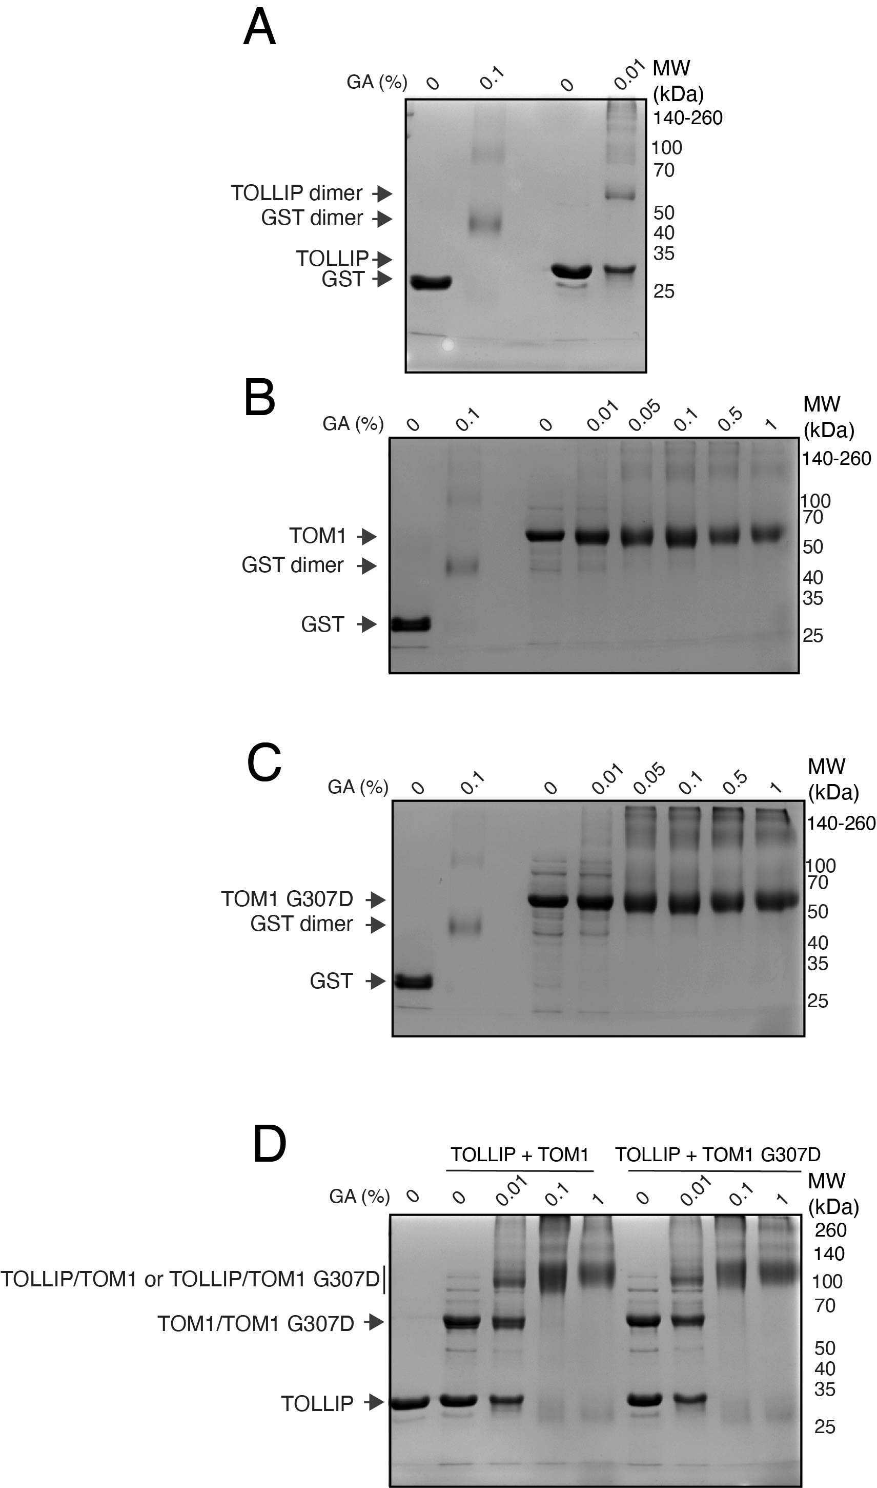
Supplemental Fig. S3 The G307D mutation in TOM1 does not cause changes in oligomerization. (A) TOLLIP and GST (control) were incubated without and with glutaraldehyde (GA) at the indicated concentrations and oligomer formation was evaluated using SDS-PAGE. (B-C) TOM1 (B) and TOM1 G307D (C) were incubated in the absence and presence of the indicated GA concentrations and oligomer formation was tracked using SDS-PAGE. GST was used as a control. (D) TOLLIP was incubated in the absence and presence of either TOM1 or TOM1 G307D at the indicated GA concentrations and the presence of the complexes detected using SDS-PAGE.

Supplemental Fig. S4

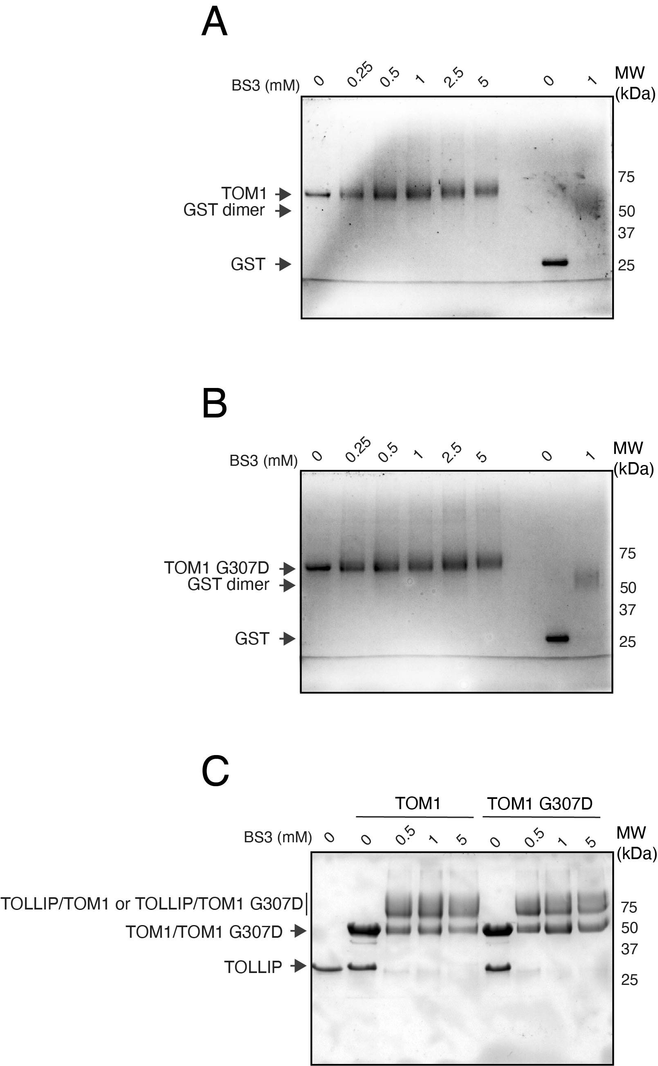
Supplemental Fig. S4 The G307D mutation in TOM1 does not cause changes in oligomerization. A-B. TOM1 (A) and TOM1 G307D (B) were incubated in the absence and presence of the indicated BS3 concentrations. Oligomer formation was tracked using SDS-PAGE. GST was used as a control. (C) TOLLIP was incubated in the absence and presence of either TOM1 or TOM1 G307D at the indicated BS3 concentrations and the presence of the complexes detected using SDS-PAGE.

Supplemental Fig. S5
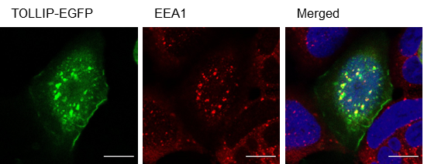

Supplemental Fig. S5 TOLLIP colocalizes with EEA1. TOLLIP-EGFP expressing HEK293 cell and endogenous anti-EEA1 (early endosomes) staining. Scale bar: 10 µm.
Supplemental Fig. S6
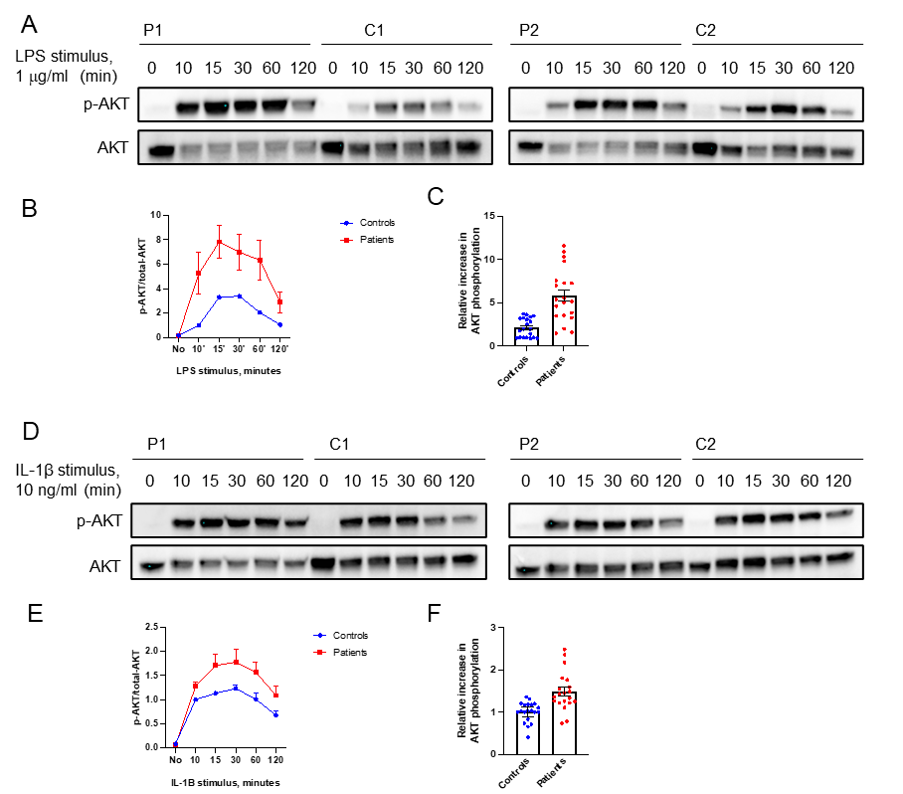
Supplemental Fig. S6 TOM1 G307D patient cells show AKT hyperphosphorylation after LPS or IL-1β stimulation compared to healthy control cells. (A) Representative western blots of fibroblasts after stimulation with LPS (1µg/ml). (B) Quantification of p-AKT ratio to total AKT after LPS stimulation. Patient samples and control samples are pooled together and normalized to control samples 10 min time point. (C) Time points from 10 to 120 min pooled together indicate that AKT phosphorylation in patient cells is more robust than in control cells. Data represent mean ± SEM from one experiment with duplicate samples (D) Representative western blot of fibroblasts after stimulation with IL-1β (10 ng/ml). (E) Quantification of p-AKT ratio to total AKT after IL-1β stimulation. Patient samples and control samples are pooled together and normalized to control samples 10 min time point. (F) Time points from 10 to 120 min pooled together indicate that AKT phosphorylation in patient cells is more robust than in controls. Data represent mean ± SEM from one experiment with duplicate samples.

Supplemental Fig. S7
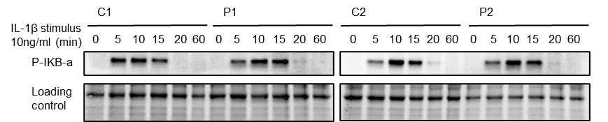

Supplemental Fig. S7 TOM1 G307D pathogenic variant does not affect IKB-a phosphorylation. Representative western blots of primary skin fibroblasts of patients and controls were stimulated with IL-1β as described previously.

Supplemental Table 1
Kinetic analysis for the binding of TOM1 and TOM1 G307D to TOLLIP using SPR. Values represent the mean of three independent experiments.

Interaction | K_{D}  (fM) | Chi²
TOM1-TOLLIP | 3.0 | 0.3
TOM1 G307D-TOLLIP | 3.5 | 0.3

Supplemental Table 2
Thermodynamic parameters for the binding of TOM1 and TOM1 G307D to ubiquitin using ITC. Values represent the mean of at least three independent experiments. Error margins are displayed as standard deviation values.

Interaction | K_{D}  (μM) | ΔG  (kcal. mol⁻¹)
TOM1-ubiquitin | 77.7±18.8 | -5.6±0.1
TOM1 G307D-ubiquitin | 104.3±17.0 | -5.4±0.1

Supplementary Materials and Methods

In-gel crosslinking
Protein oligomerization was evaluated using either bis(sulfosuccinimidyl) suberate (BS³) (ThermoFisher Scientific) or glutaraldehyde (MP Biomedicals). BS³ crosslinks e-amino groups that are 11.4 Å apart, whereas glutaraldehyde covalently associates proteins with a variety of their side chain functional groups, such as amine, phenol, thiol, and imidazole groups [19]. Proteins were incubated with the indicated concentrations of BS³ for 30 min at room temperature. The same procedure was followed when crosslinking the TOLLIP-TOM1 complexes by preincubating proteins for 30 min before the addition of BS³. Proteins were also treated with a dilution series of glutaraldehyde and the mixtures incubated for 5 min at 37ºC. All samples were run on SDS-PAGE, imaged with a GelDoc Go system (Bio-Rad) and analyzed with ImageLab 6.1 software (RRID:SCR_014210).

List of antibodies:
Lipid protein overlay assay: “Primary” rabbit anti-GST antibody (Proteintech Cat# 10000-0-AP, RRID:AB_11042316, 1:6665), “Secondary” anti-rabbit HRP-conjugated antibody (Promega Cat# W4011, RRID:AB_430833, 1:2500).

Immunofluorescence: anti-TOM1 rabbit mAb (Abcam Cat# ab170928, RRID:AB_2687908, 1:100), anti-EEA1 mouse mAb (BD Biosciences Cat# 610457, RRID:AB_397830, 1:50), anti-HA-Tag rabbit mAb (Cell Signaling Technology Cat# 3724, RRID:AB_1549585, 1:1000), anti-Lamp1 mouse mAb (DSHB Cat# H4A3, RRID:AB_2296838, 1:200).
Western blotting: anti-TOM1 rabbit mAb (Abcam Cat# ab170928, RRID:AB_2687908, 1:5000), anti-LC3 rabbit mAb (Cell Signaling Technology Cat# 3868, RRID:AB_2137707, 1:1000), anti Phospho-p44/42 MAPK (Erk1/2) rabbit polyAb (Cell Signaling Technology Cat# 9101, RRID:AB_331646, 1:1000), Phospho-Akt (Ser473) rabbit mAb (Cell Signaling Technology Cat# 4060, RRID:AB_2315049, 1:2000) Phospho-IκBα (Ser32) rabbit mAb (Cell Signaling Technology Cat# 2859, RRID:AB_561111, 1:1000), p44/42 MAPK (Erk1/2) rabbit mAb (Cell Signaling Technology Cat# 4695, RRID:AB_390779, 1:1000), Akt (pan) rabbit mAb (Cell Signaling Technology Cat# 4691, RRID:AB_915783, 1:2000).

List of reagents:
Western Blot lysis buffer 1: HEPES (pH 7.4), 1% NP40, 150 mM NaCl, 5 mM EDTA, 25 μg/ml chymostatin, 25 μg/ml leupeptin, 25 μg/ml antipain hydrochloride, 25 μg/ml pepstatin A, 10 mM sodium fluoride, 10 mM orthovanadate, and 1 mM PMSF.
Western Blot lysis buffer 2: RIPA lysis buffer containing 1x TBS, 1% NP-40, 0.1% SDS and supplemented with 10% NaDoc and 1:100 protease inhibitor cocktail (CLAP).
Western Blot lysis buffer 3: SDS boiling buffer containing 2.5% SDS, 250 mM Tris/HCl (pH 6.8), including 50 mM NaF, 10 mM, β-glycerophosphate, 0.5 mM DTT, and 0.5 mM PMSF.
Stripping solution: 10% SDS 20%, 2% 3 M Tris (pH 6.8), and 0.8% 2-mercaptoethanol.

