Supplementary Figures

Supplementary Figure S1. Forest plot, leave-one-out plot, funnel plot and scatter plot for the MR analysis inferring the causal effect of FT4 on breast cancer.
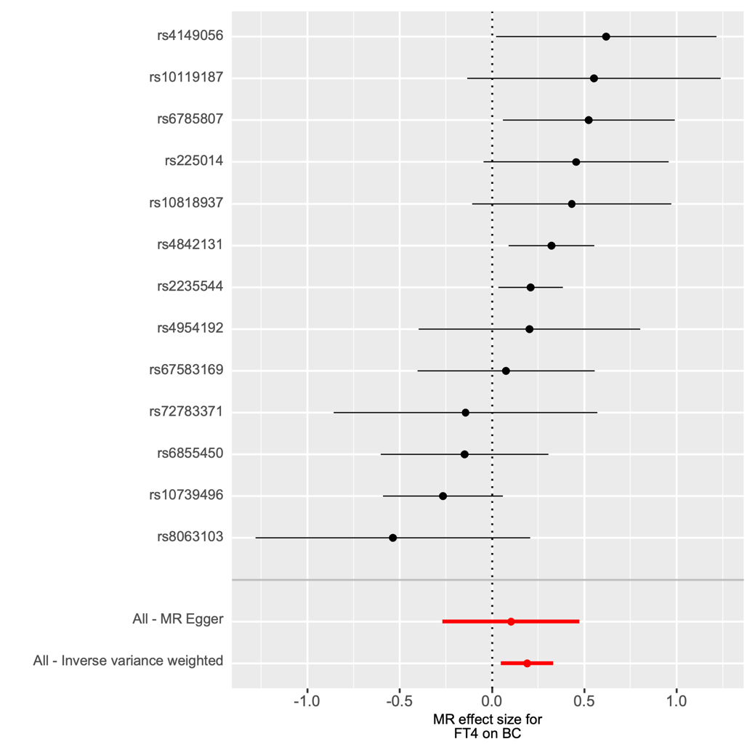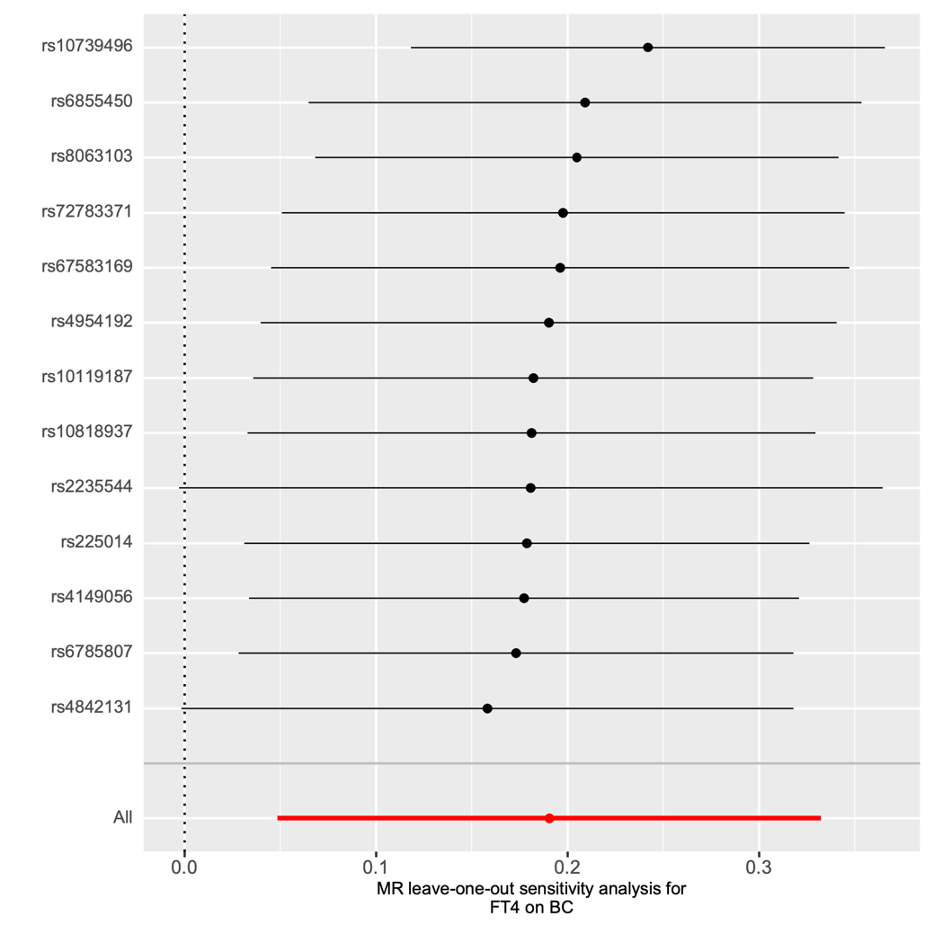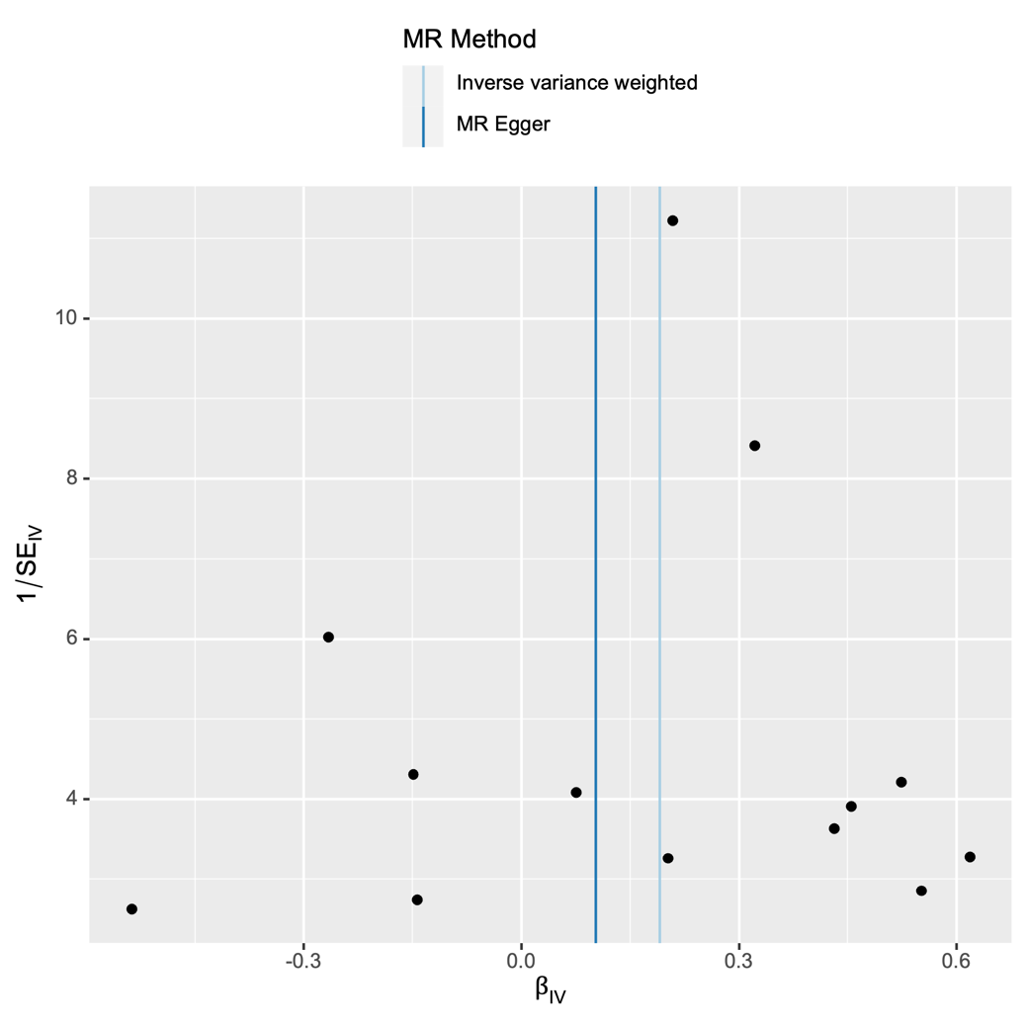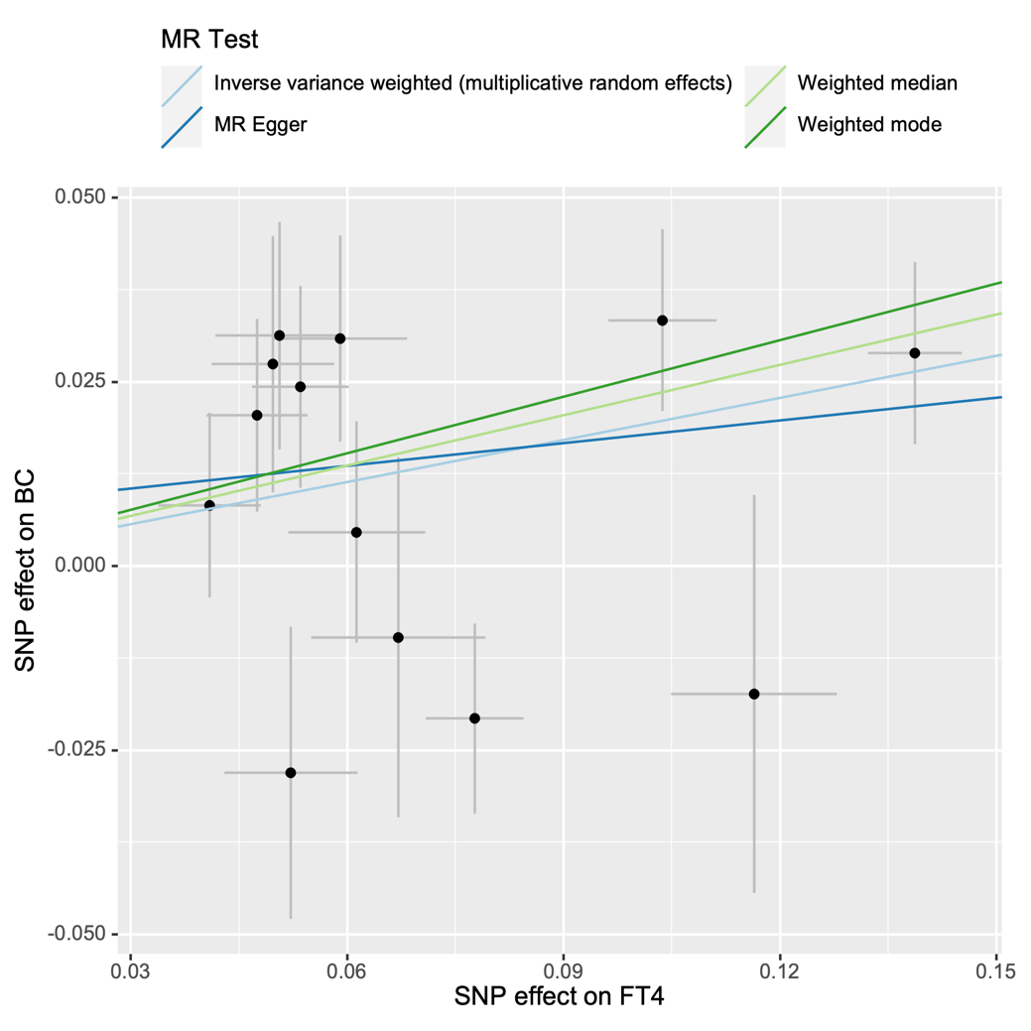

Supplementary Figure S2. Forest plot, leave-one-out plot, funnel plot and scatter plot for the MR analysis inferring the causal effect of FT4 on HER2-enriched breast cancer.

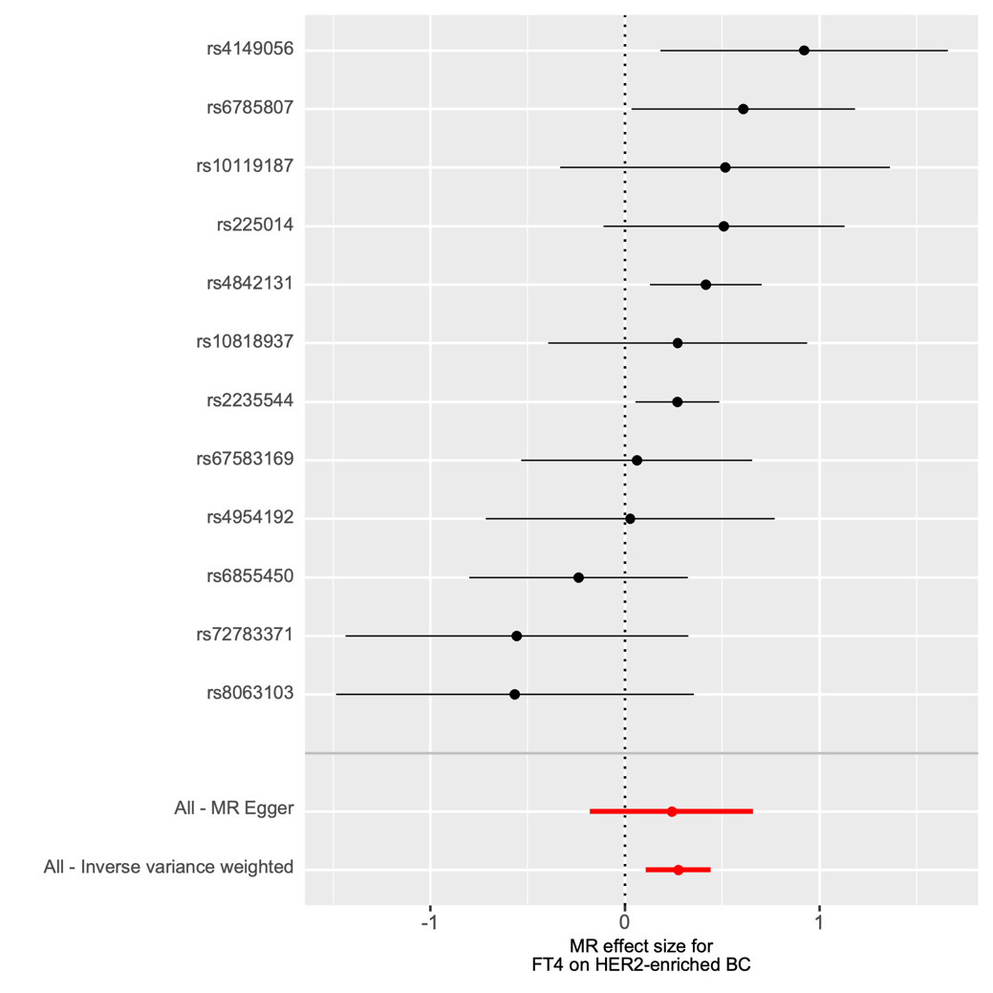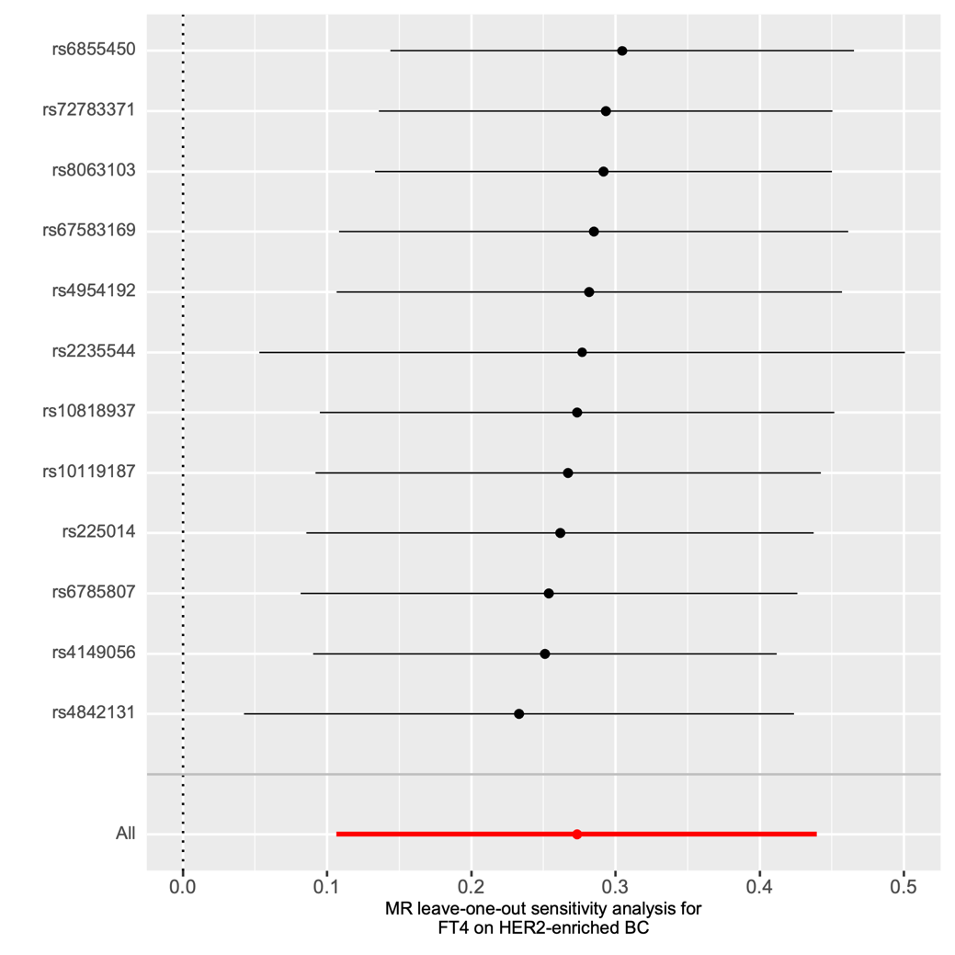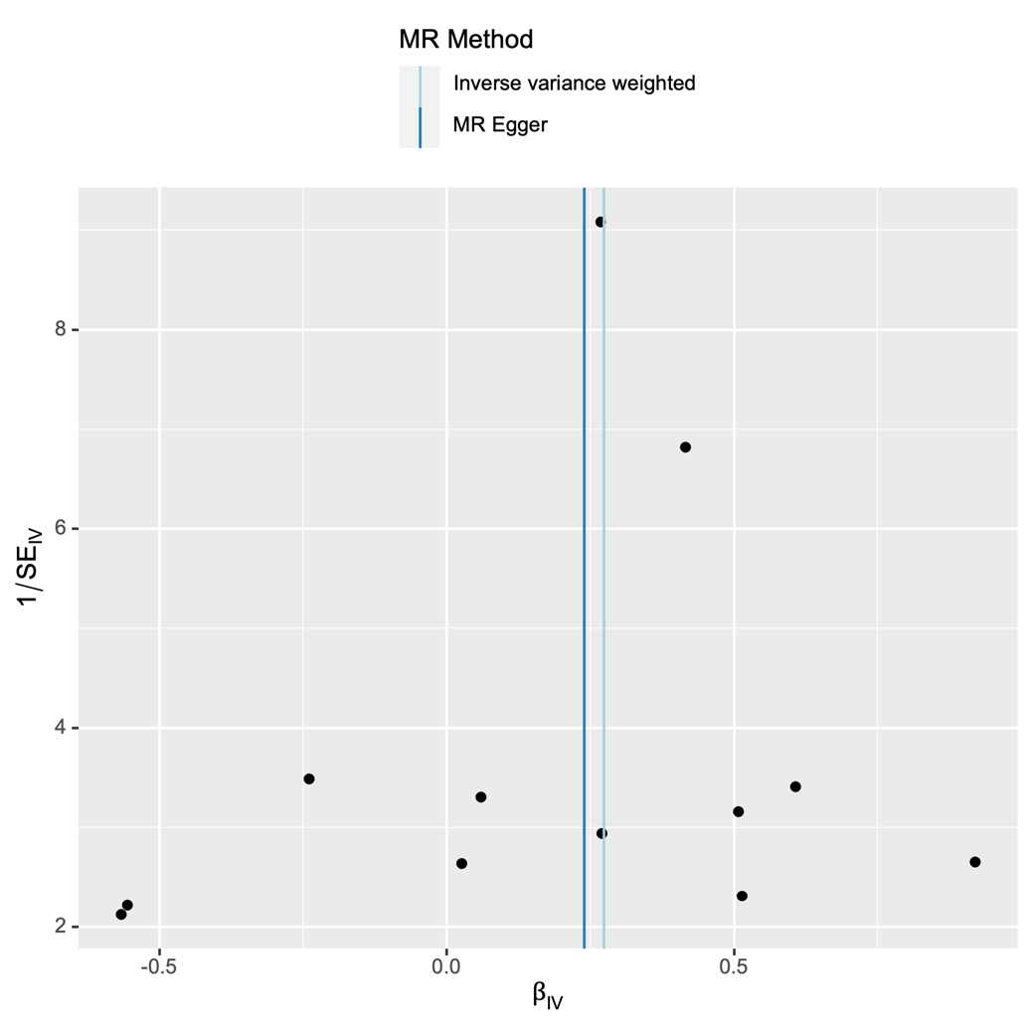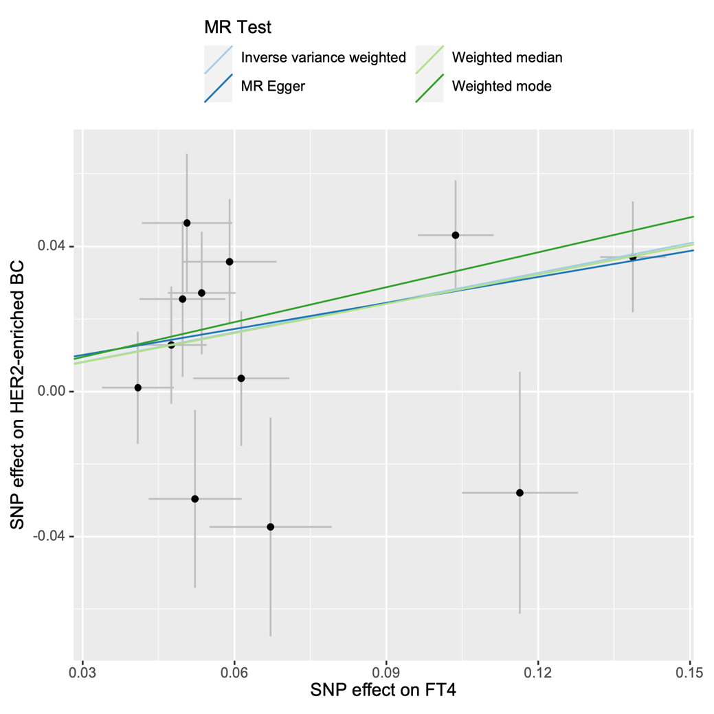

Supplementary Figure S3. Forest plot, leave-one-out plot, funnel plot and scatter plot for the MR analysis inferring the causal effect of FT4 on HER2-negative breast cancer.

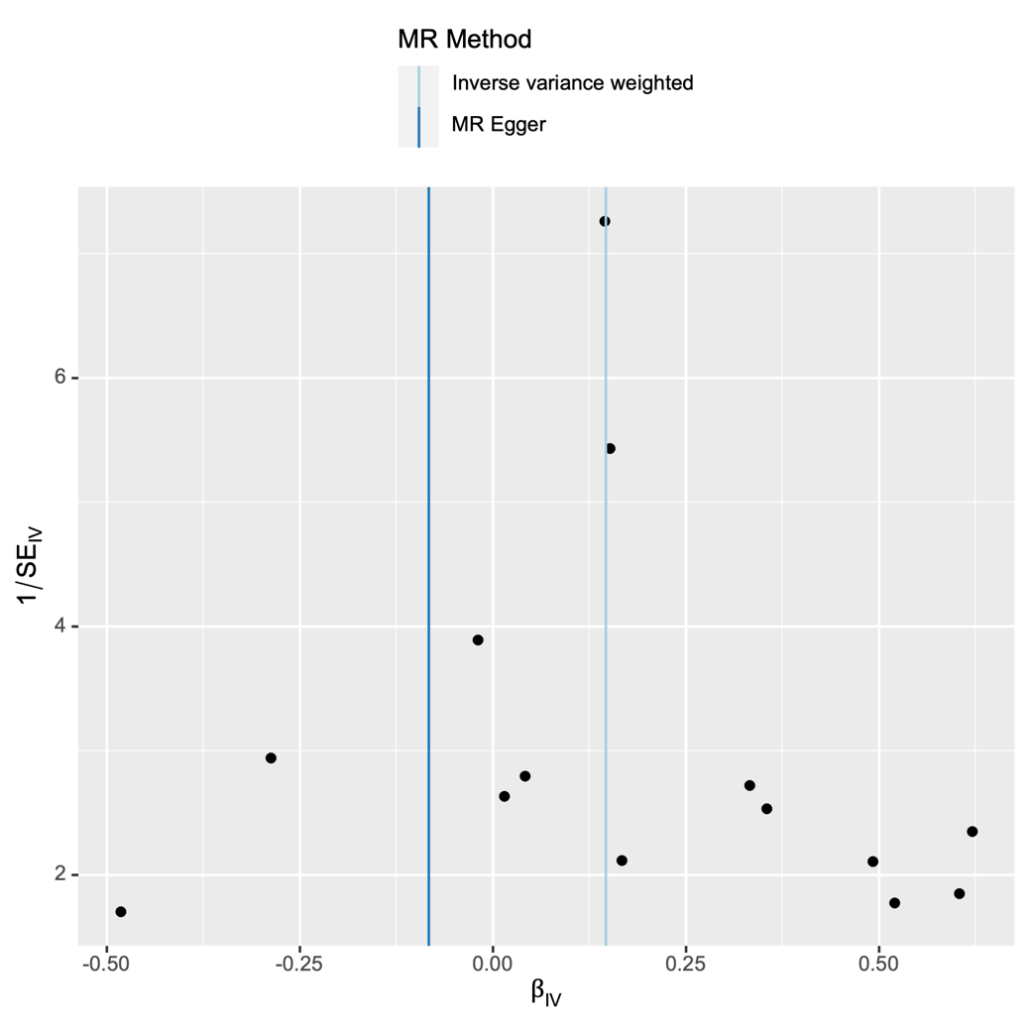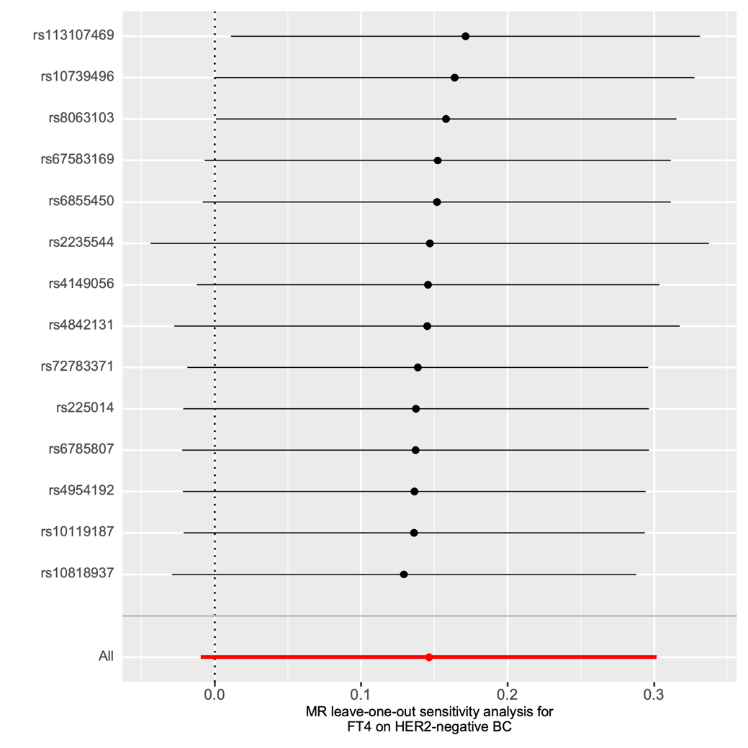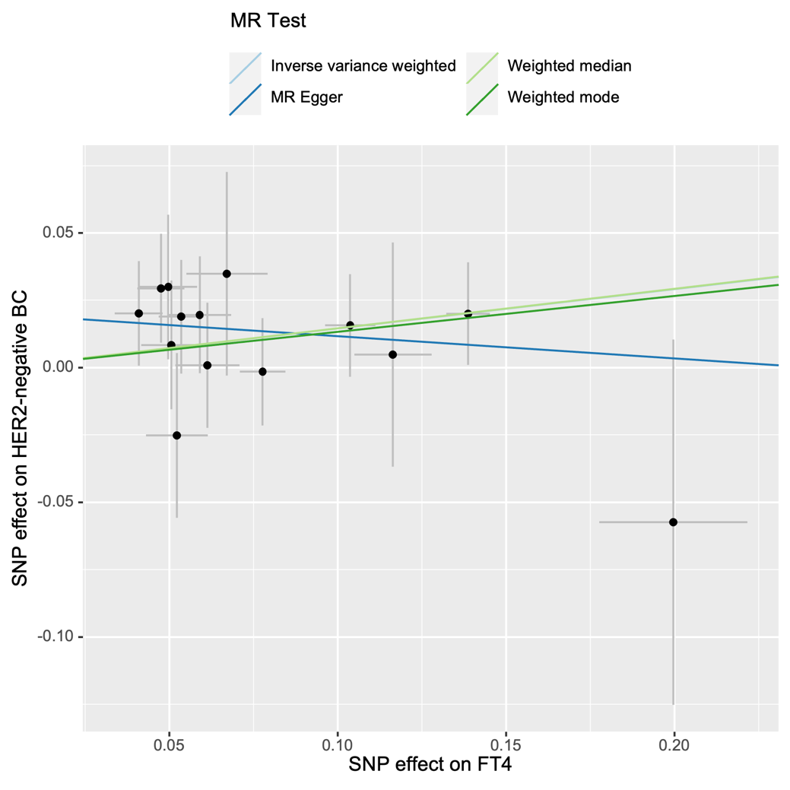

Supplementary Figure S4. Forest plot, leave-one-out plot, funnel plot and scatter plot for the MR analysis inferring the causal effect of FT4 on benign breast neoplasm.

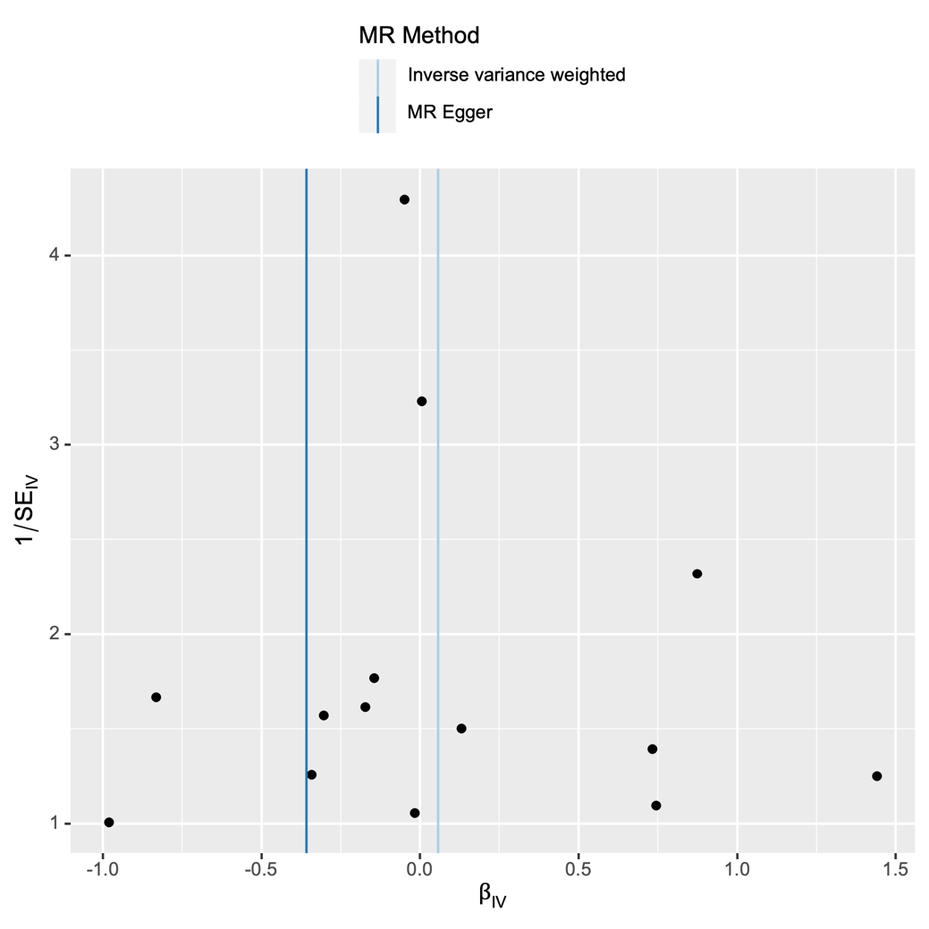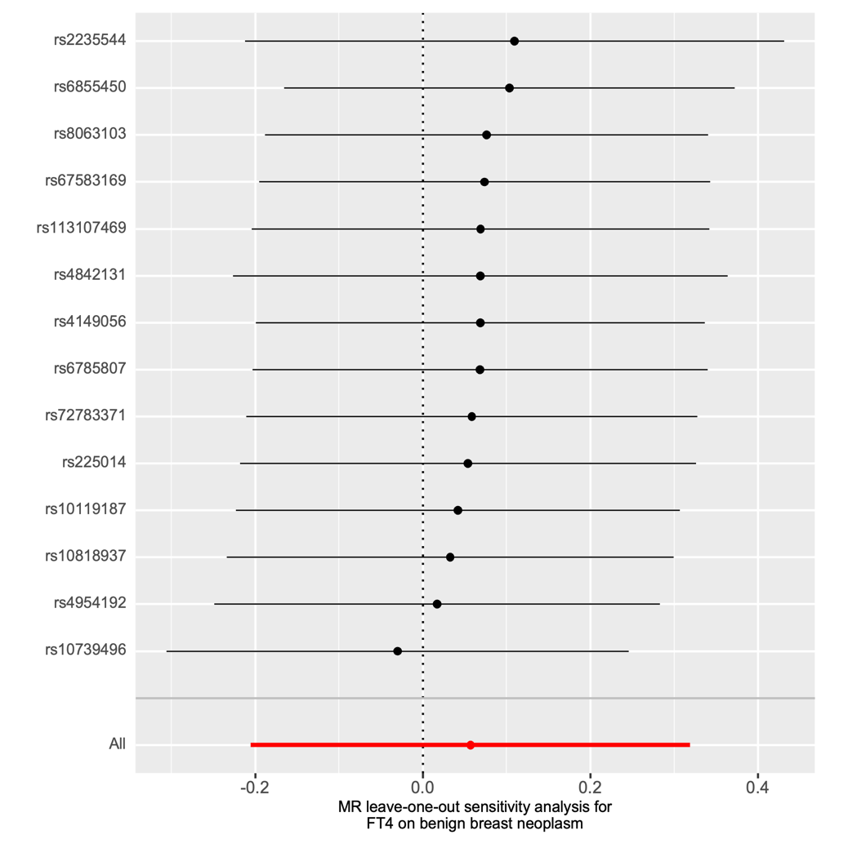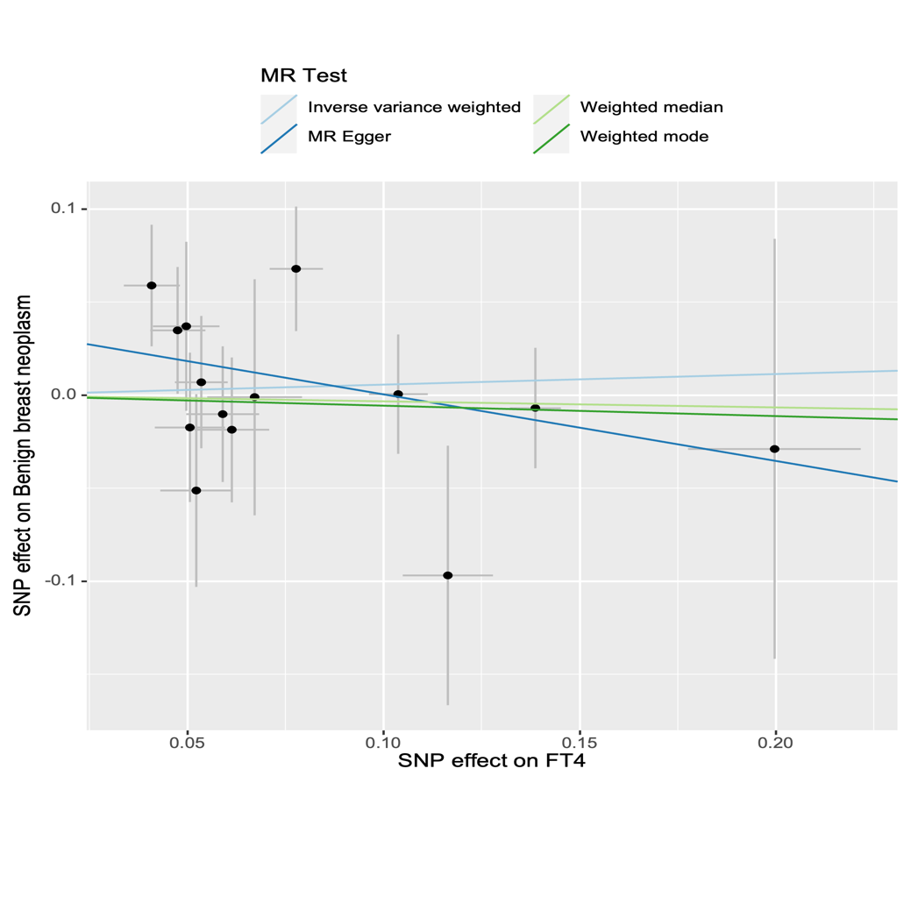

Supplementary Figure S5. Forest plot, leave-one-out plot, funnel plot and scatter plot for the MR analysis inferring the causal effect of TSH on breast cancer.

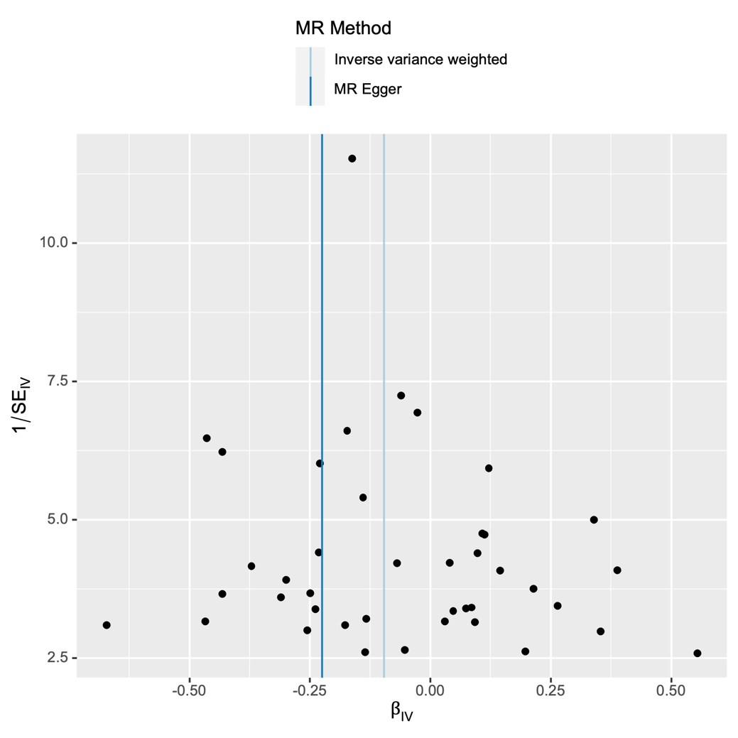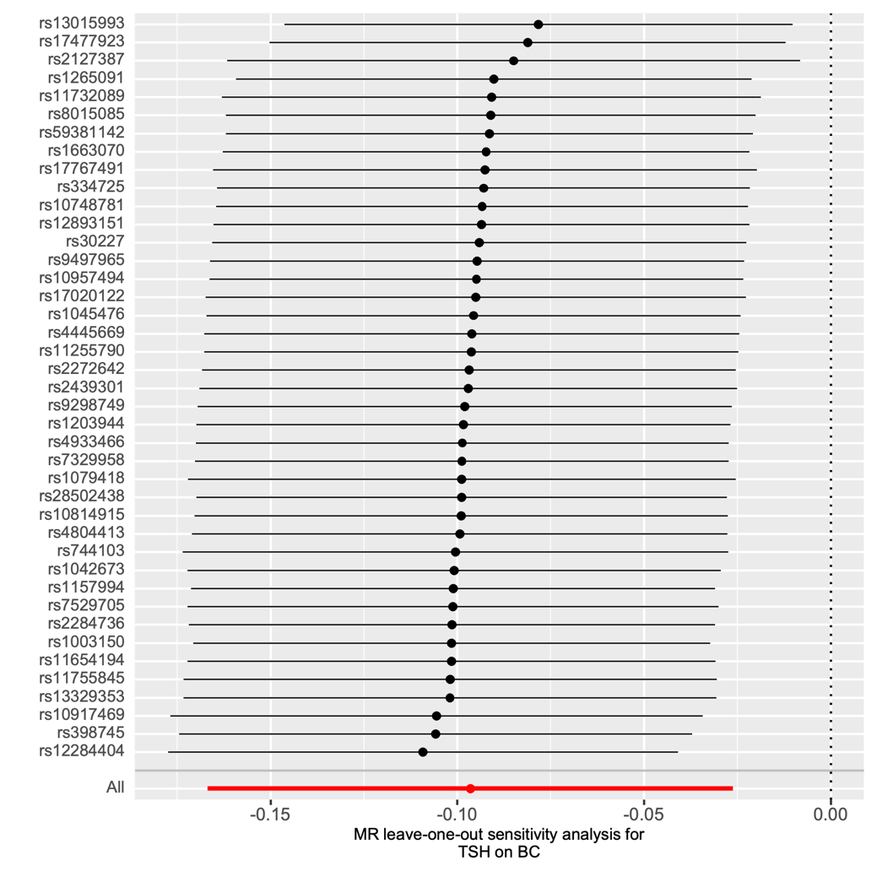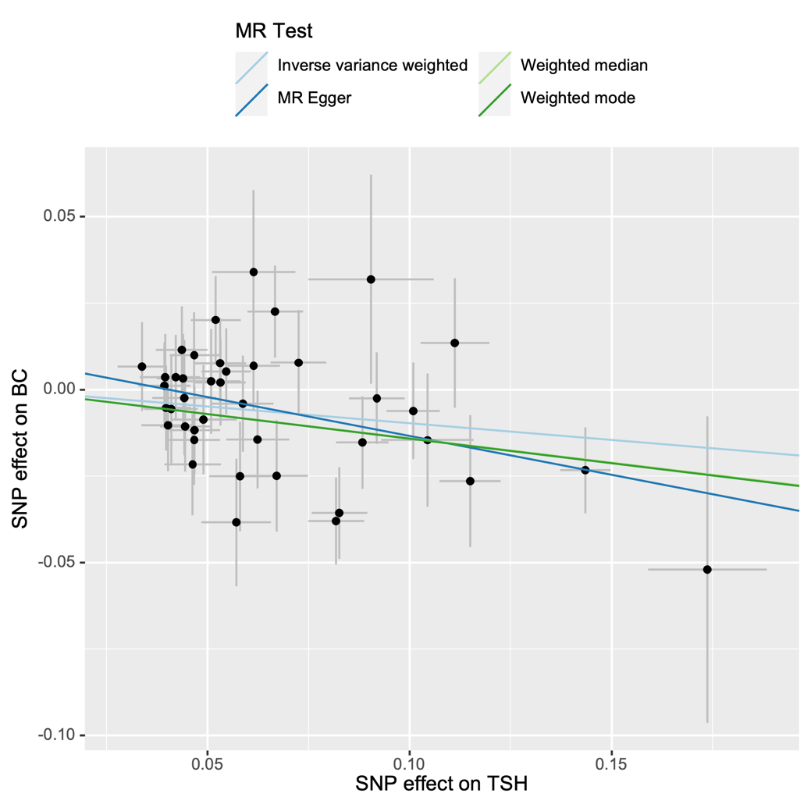

Supplementary Figure S6. Forest plot, leave-one-out plot, funnel plot and scatter plot for the MR analysis inferring the causal effect of TSH on HER2-enriched breast cancer.

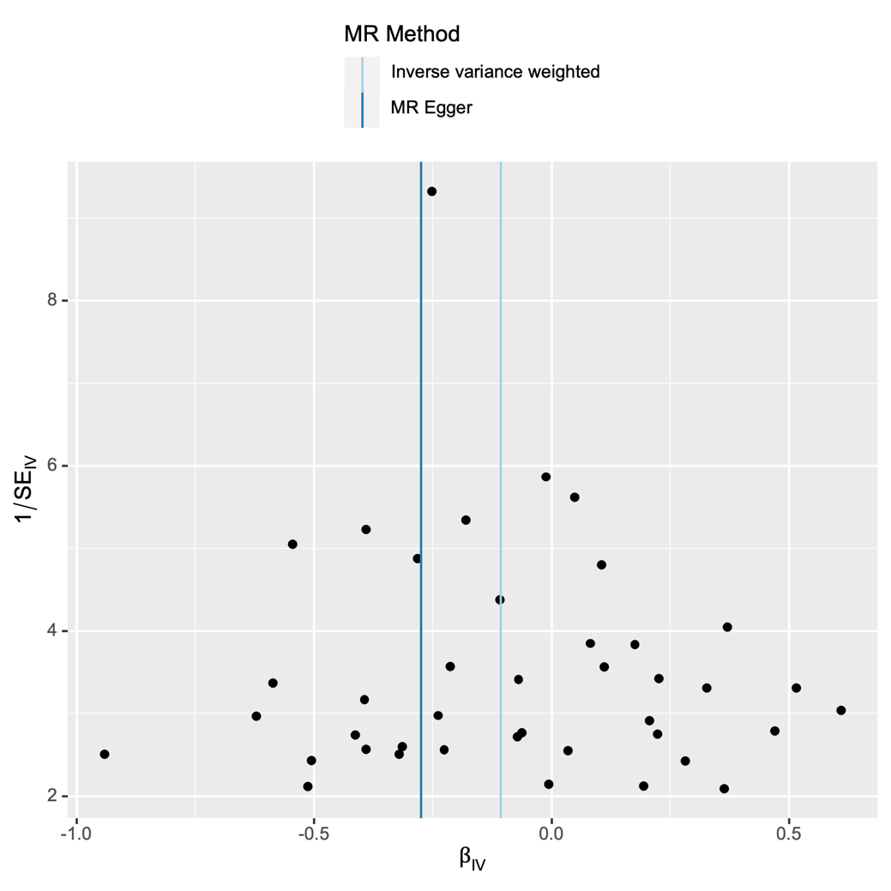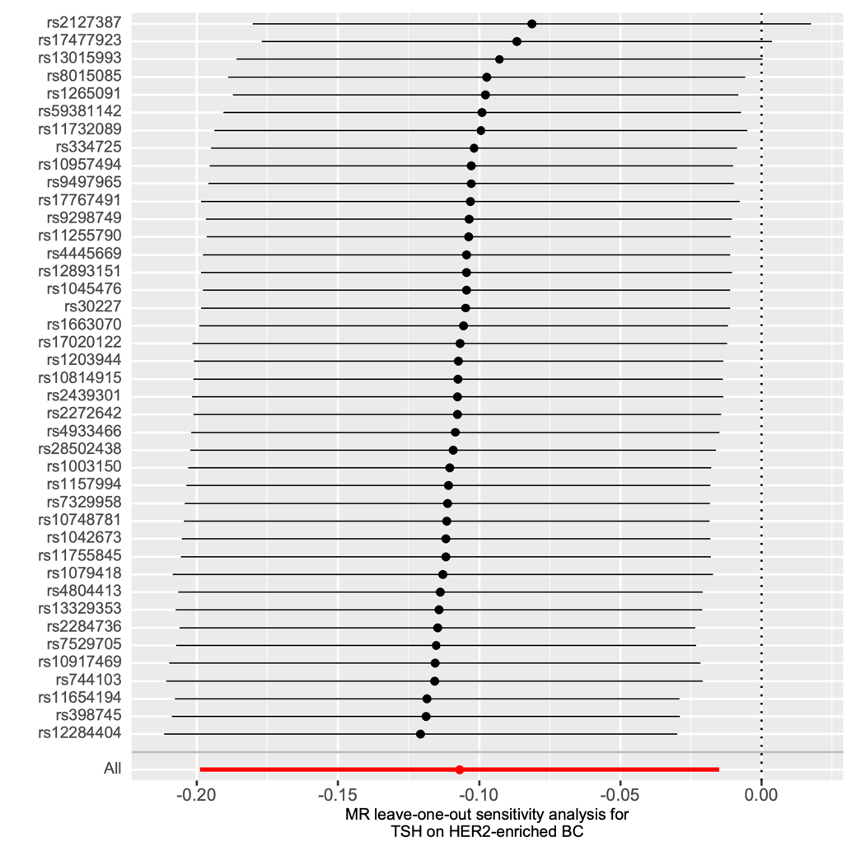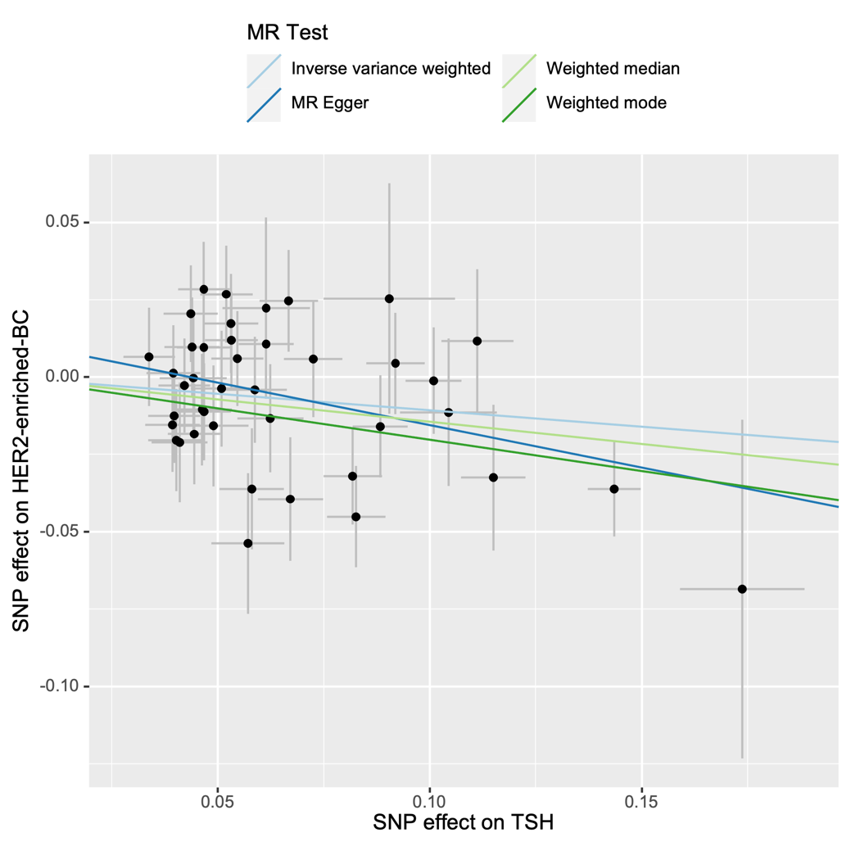

Supplementary Figure S7. Forest plot, leave-one-out plot, funnel plot and scatter plot for the MR analysis inferring the causal effect of TSH on HER2-negative breast cancer.

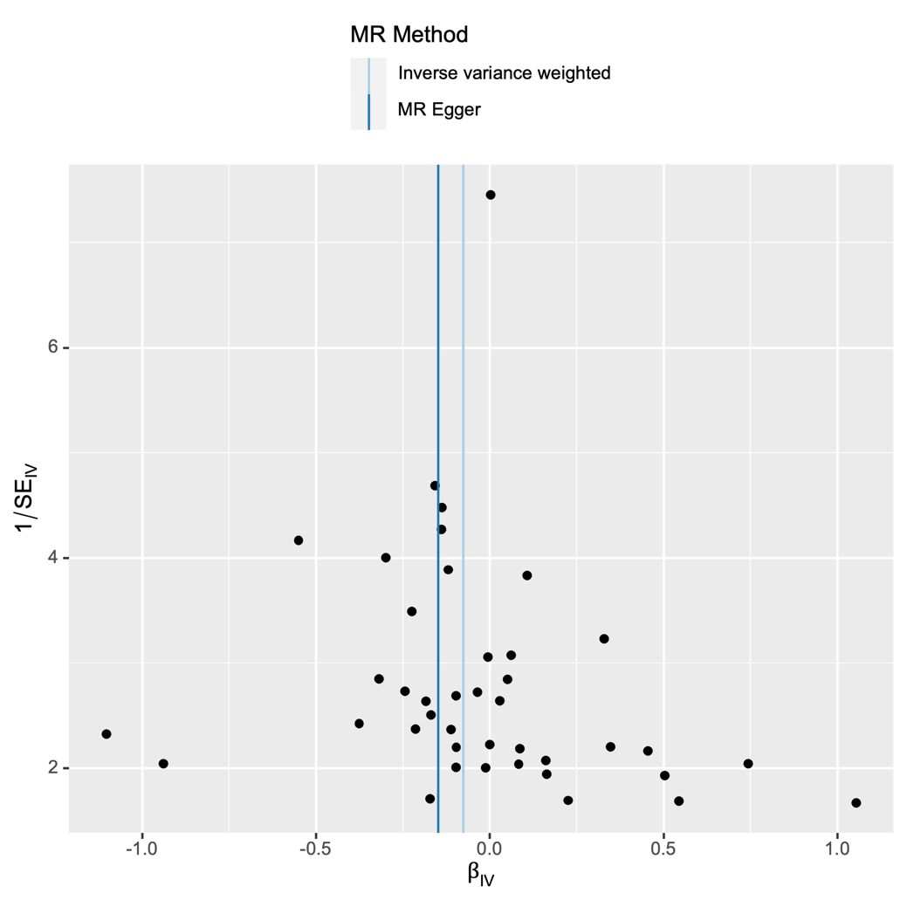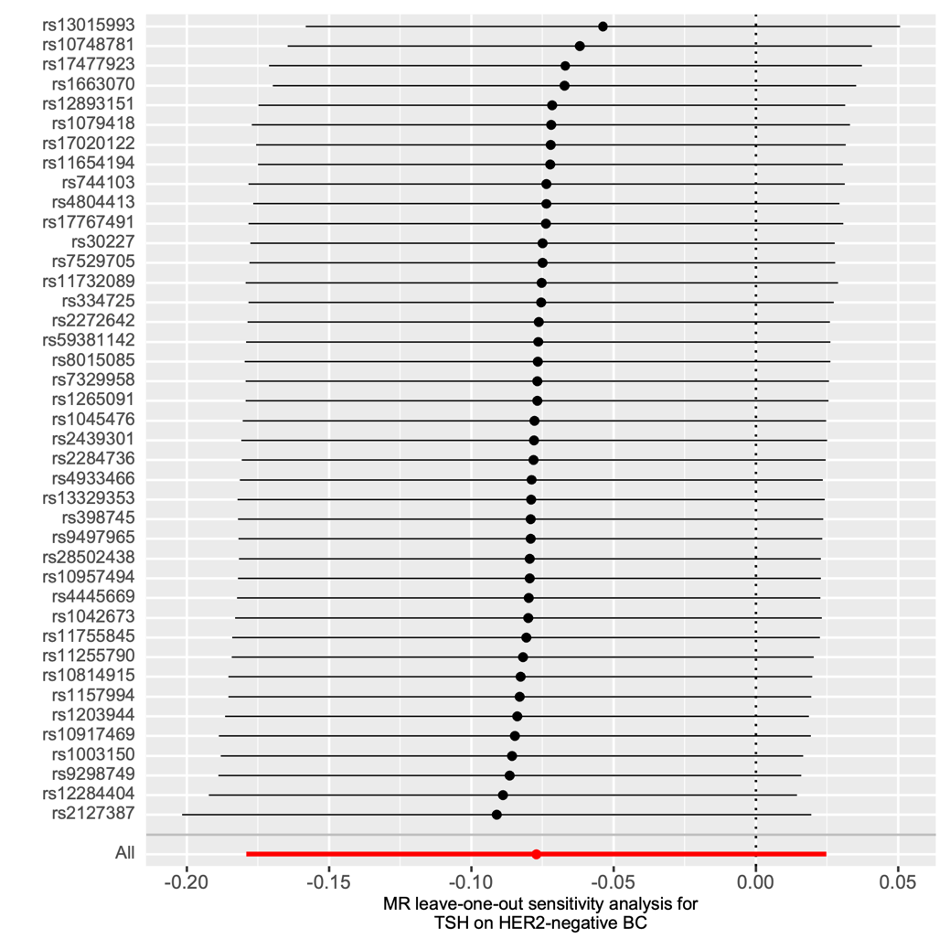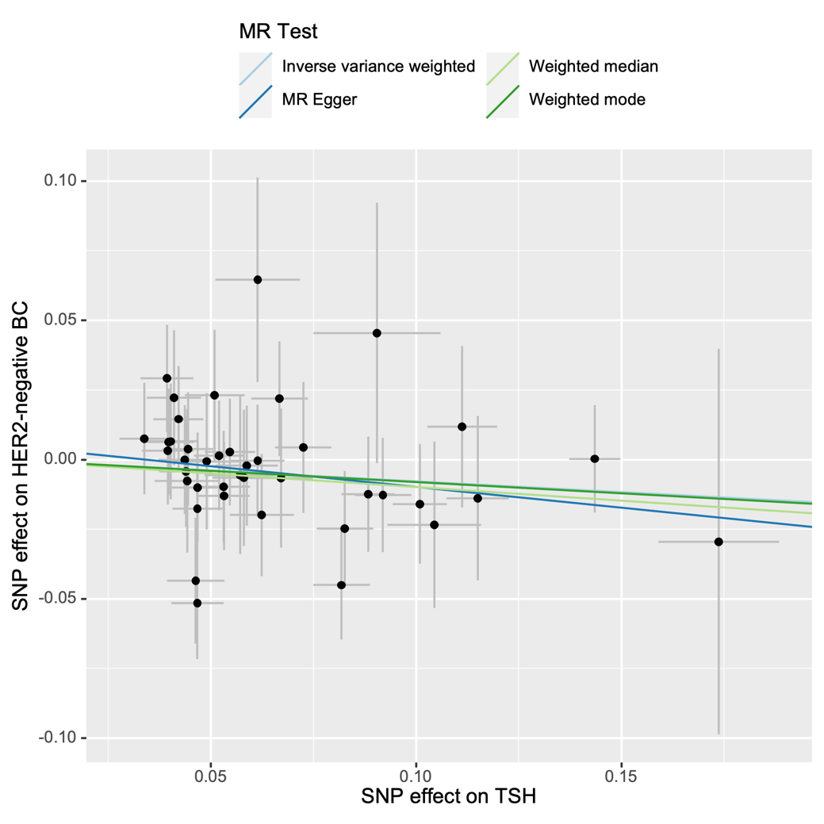

Supplementary Figure S8. Forest plot, leave-one-out plot, funnel plot and scatter plot for the MR analysis inferring the causal effect of TSH on benign breast neoplasm.

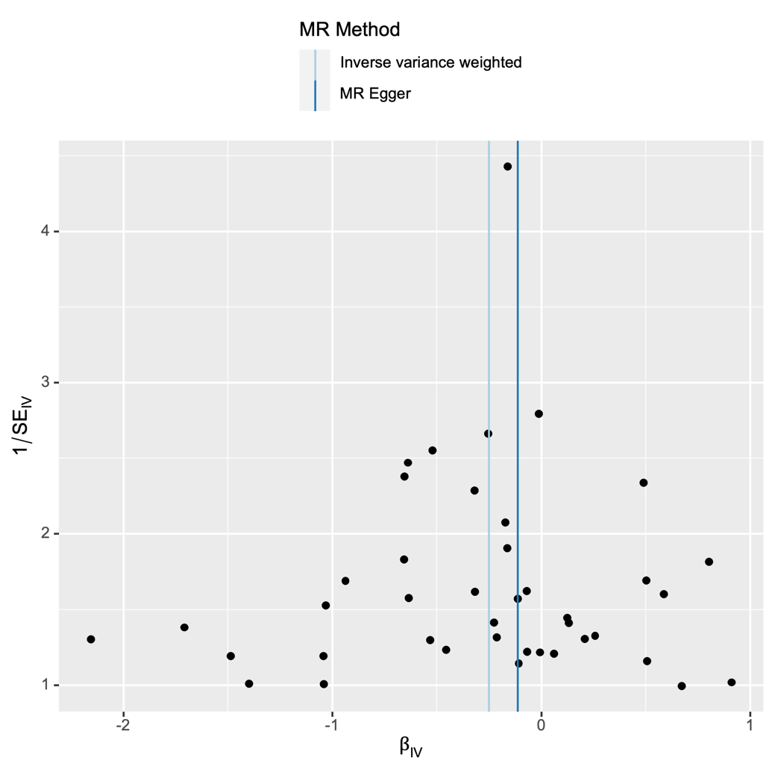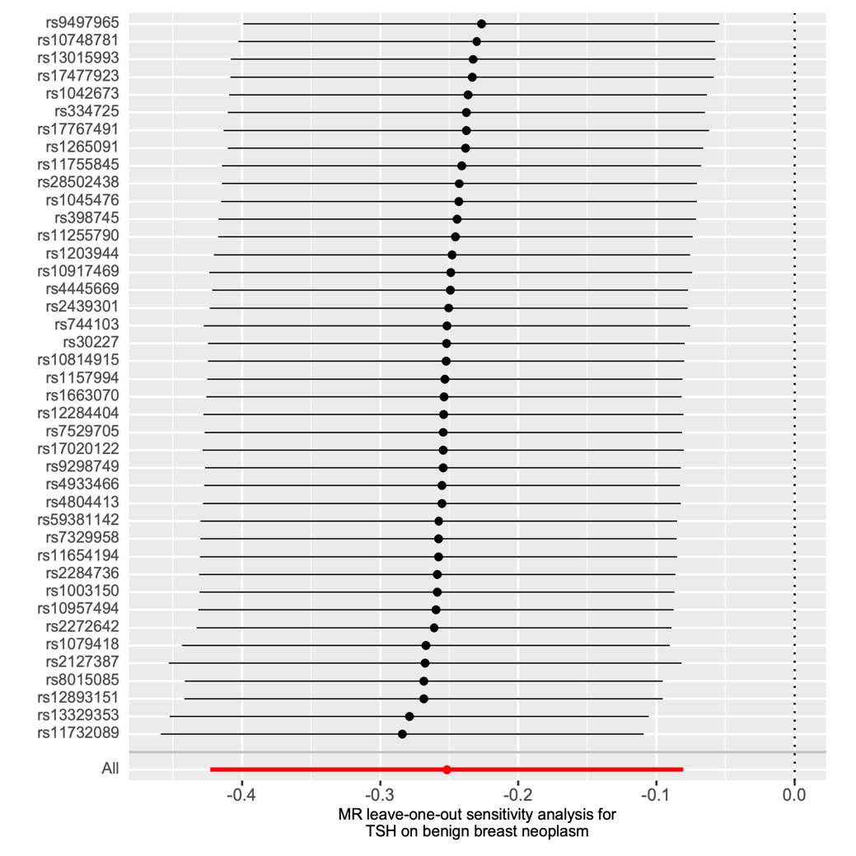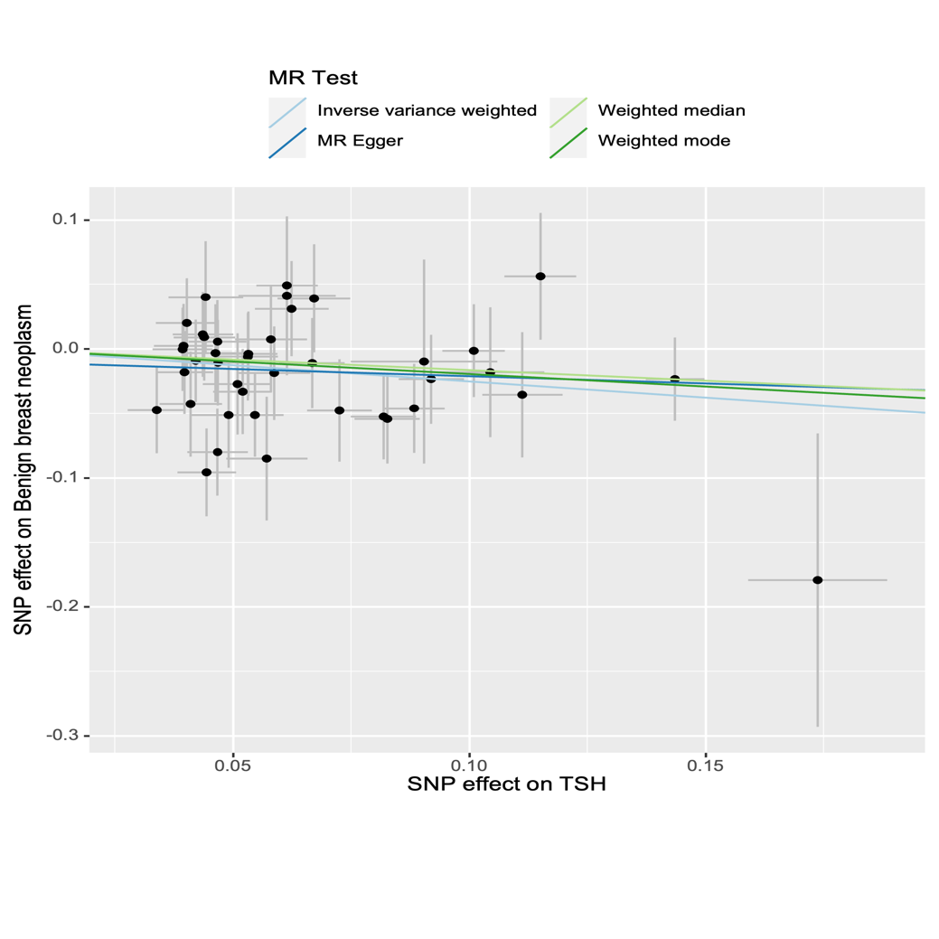

Supplementary Figure S9. Forest plot, leave-one-out plot, funnel plot and scatter plot for the MR analysis inferring the causal effect of hypothyroidism on breast cancer.

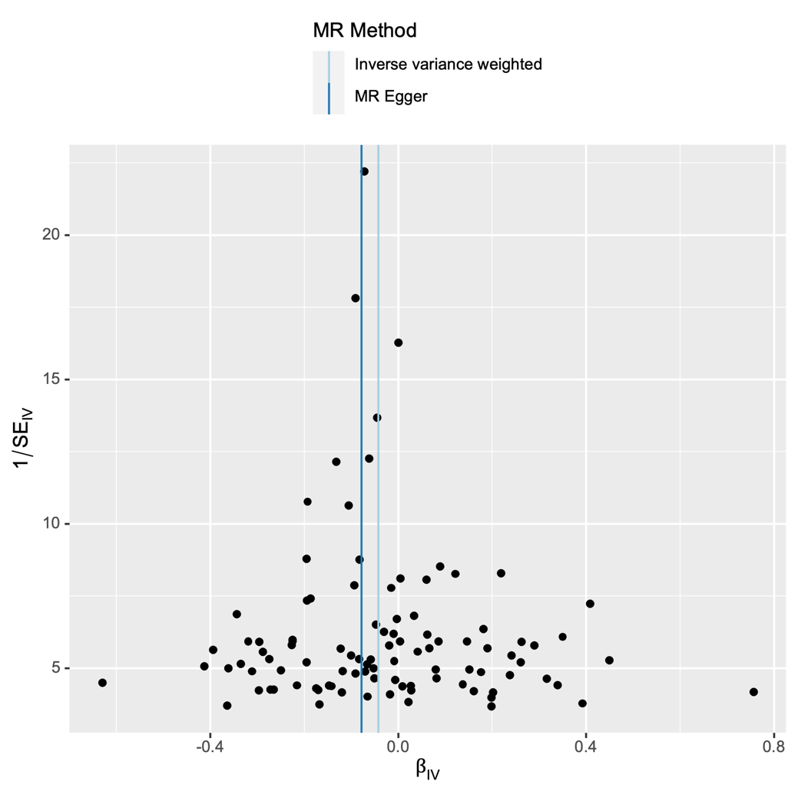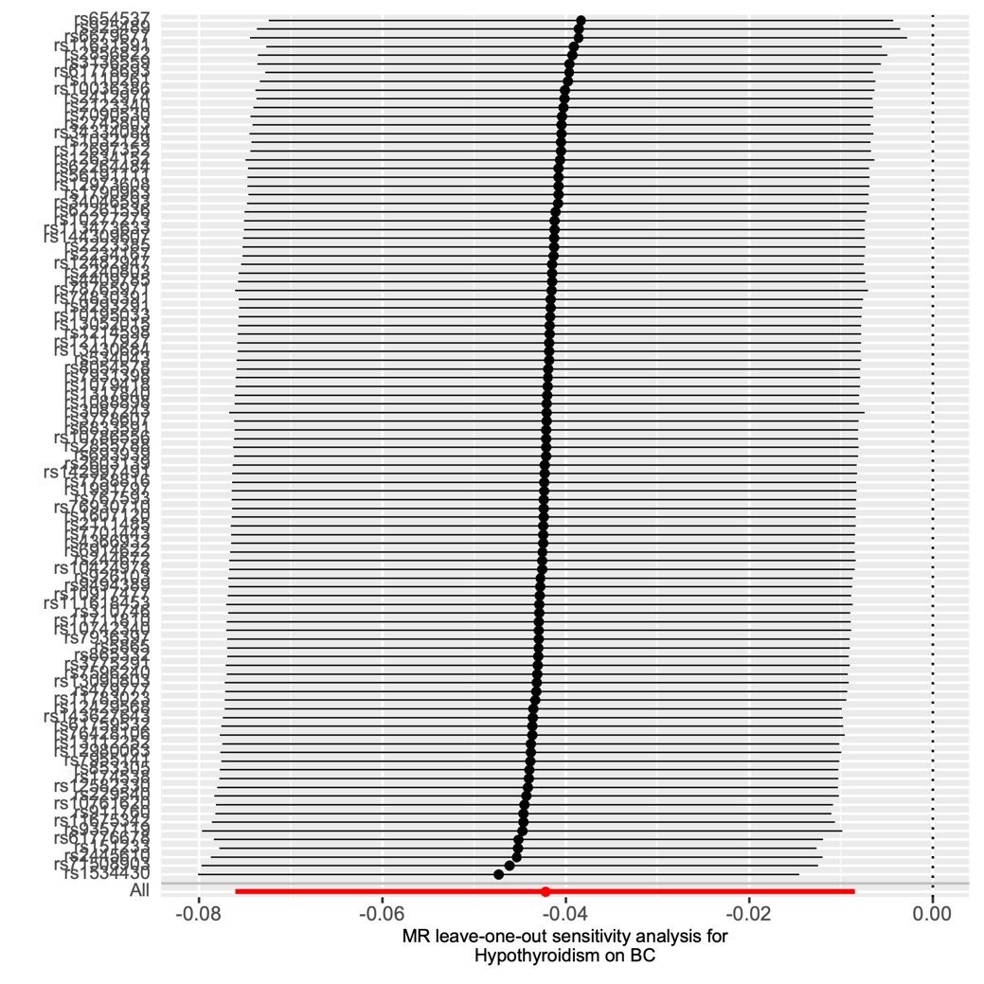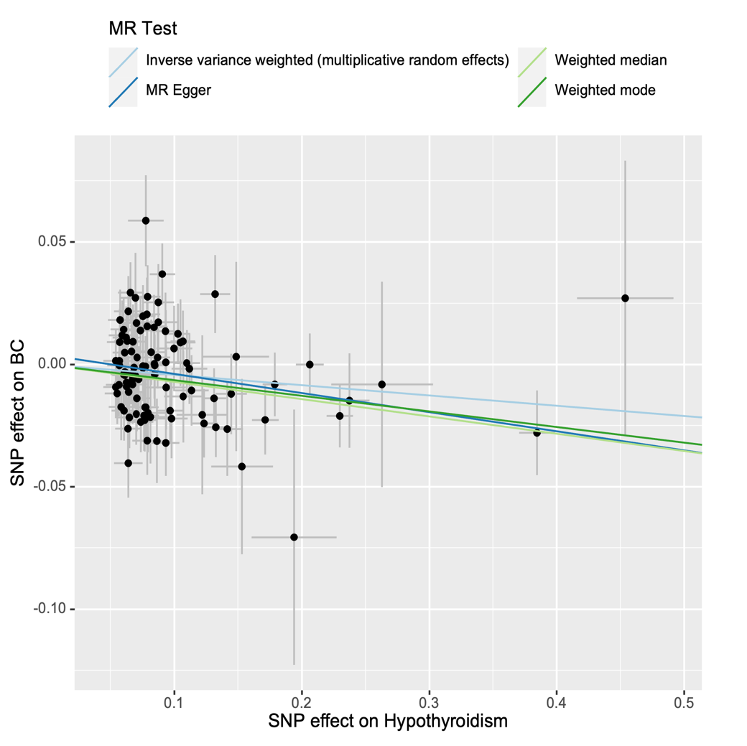

Supplementary Figure S10. Forest plot, leave-one-out plot, funnel plot and scatter plot for the MR analysis inferring the causal effect of hypothyroidism on HER2-enriched breast cancer.

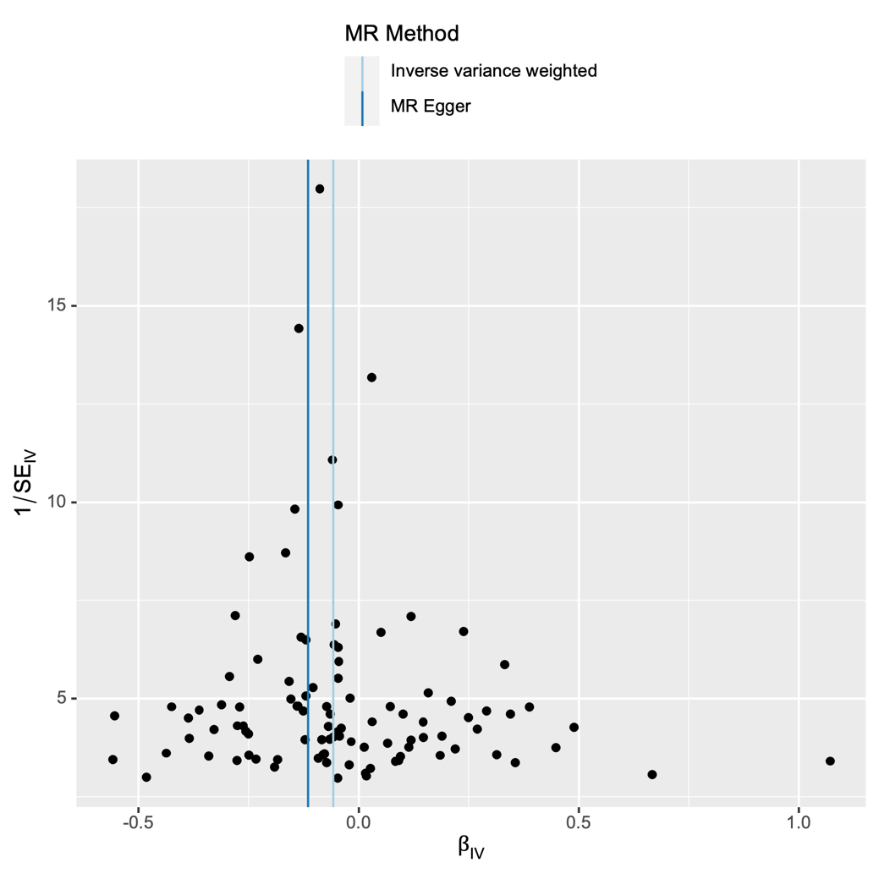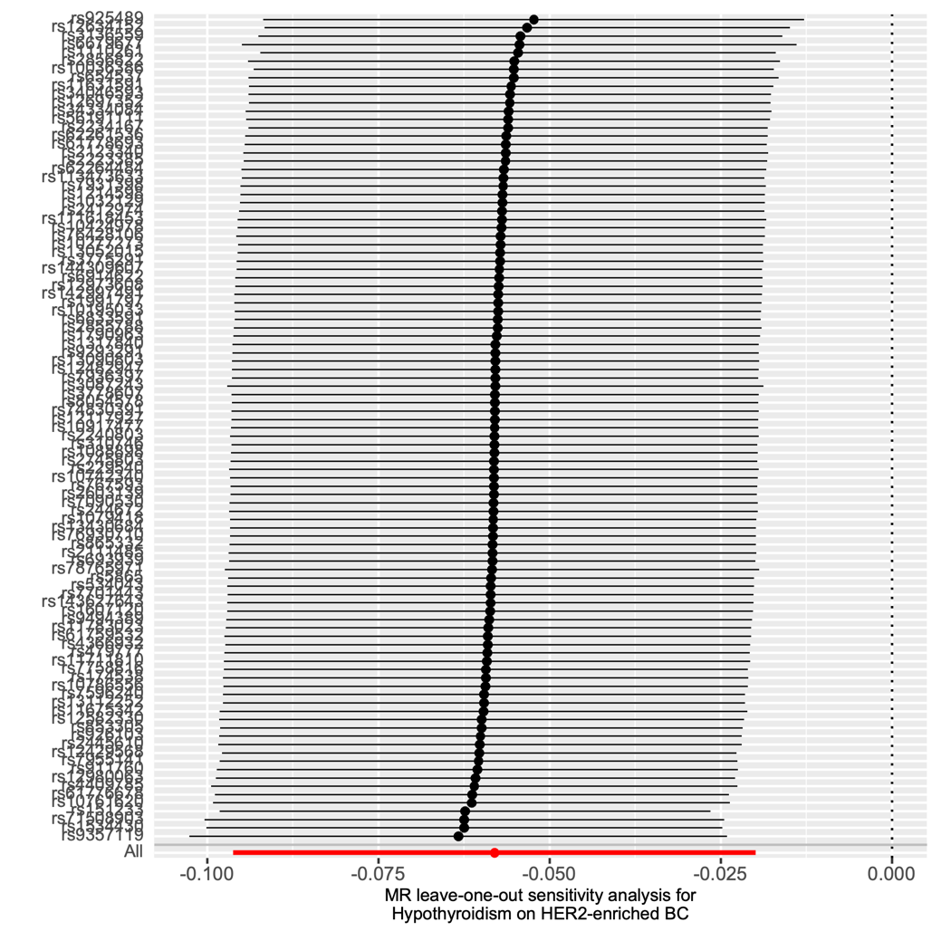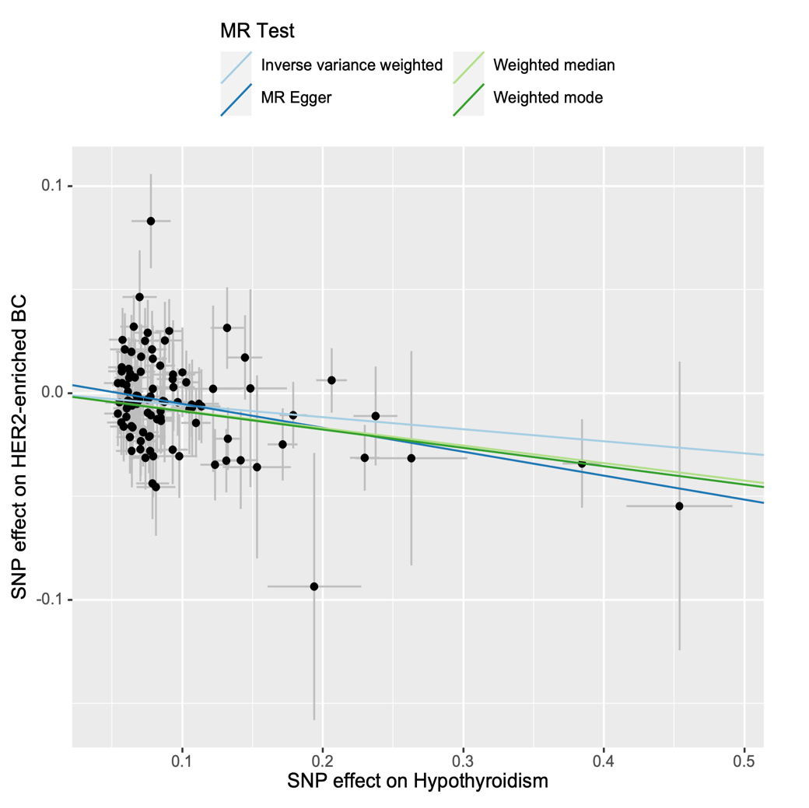

Supplementary Figure S11. Forest plot, leave-one-out plot, funnel plot and scatter plot for the MR analysis inferring the causal effect of hypothyroidism on HER2-negative breast cancer.

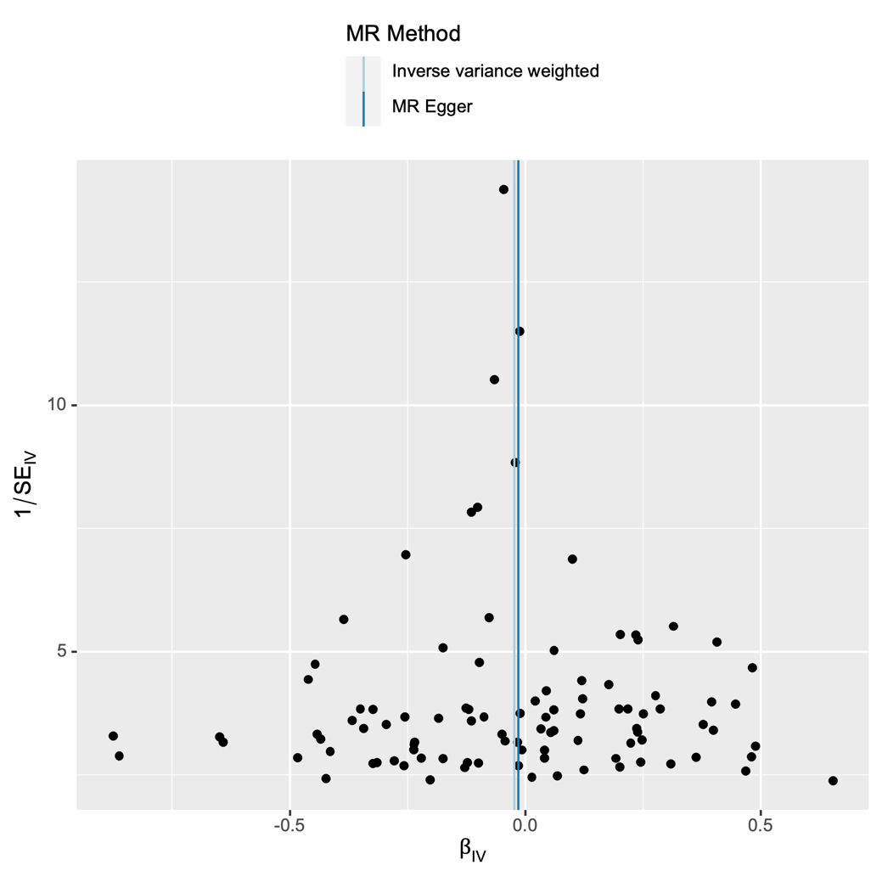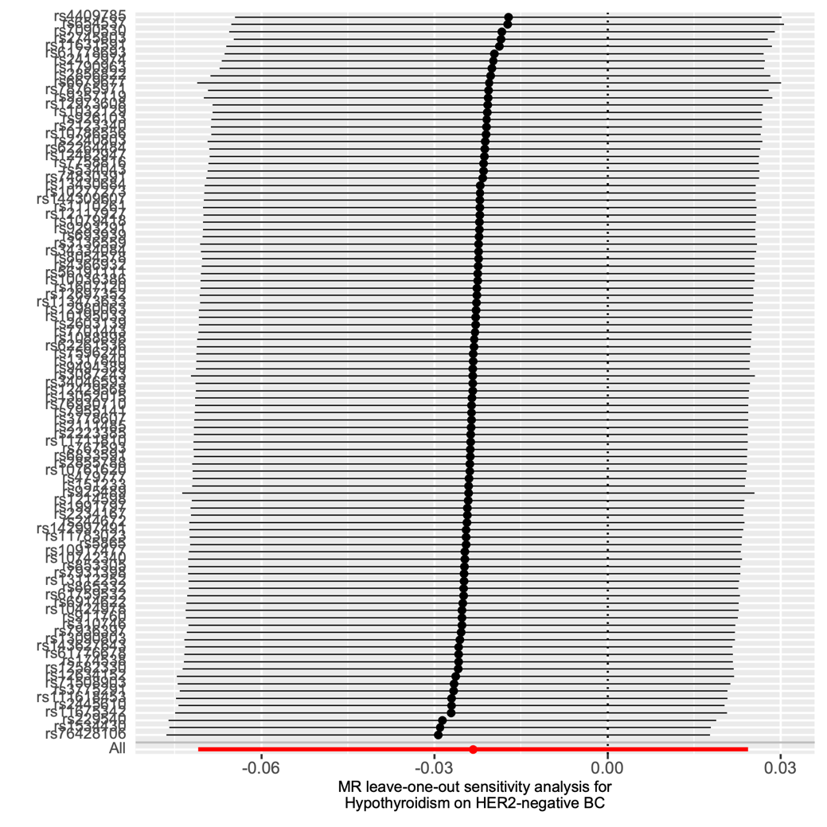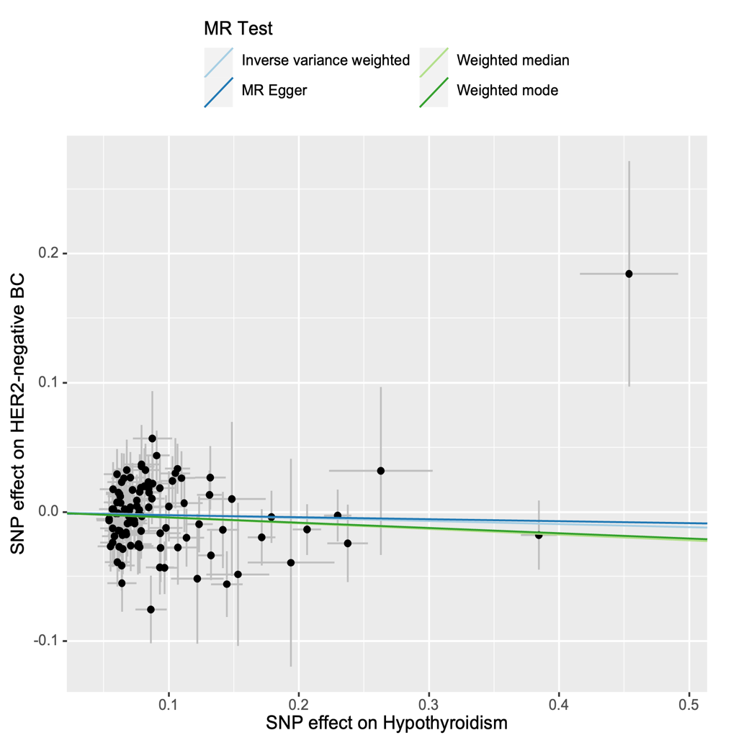

Supplementary Figure S12. Forest plot, leave-one-out plot, funnel plot and scatter plot for the MR analysis inferring the causal effect of hypothyroidism on benign breast neoplasm.

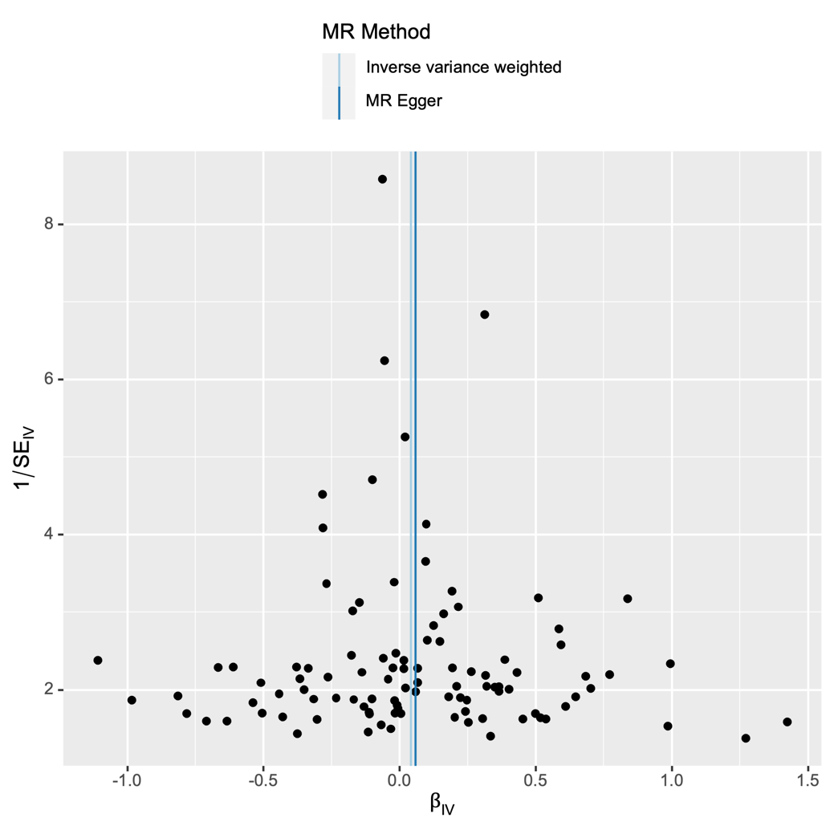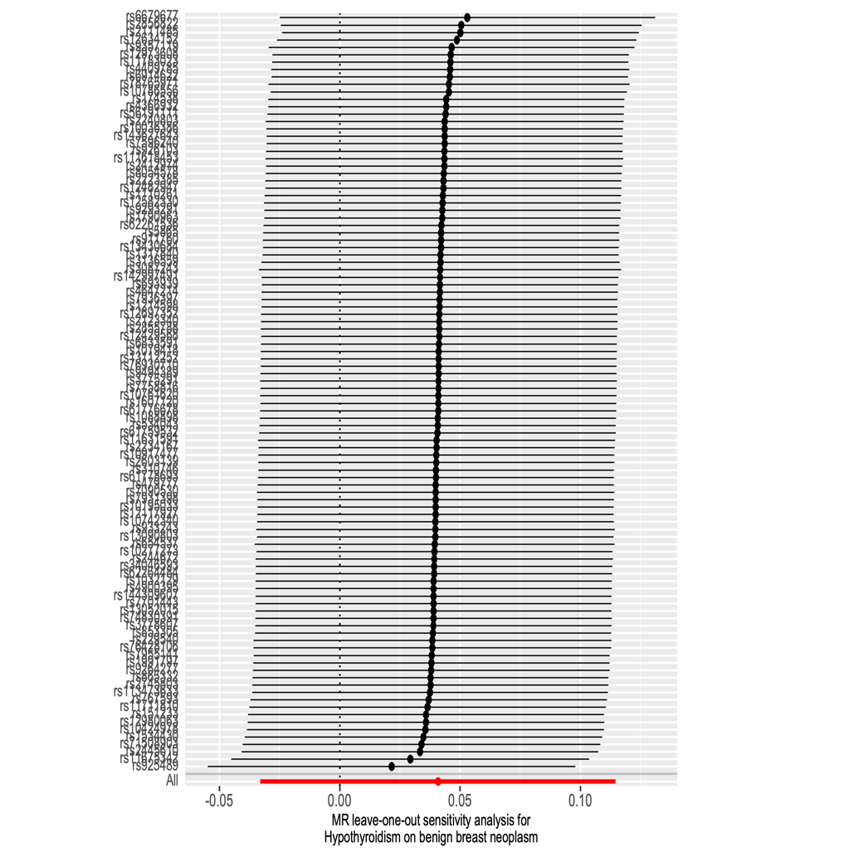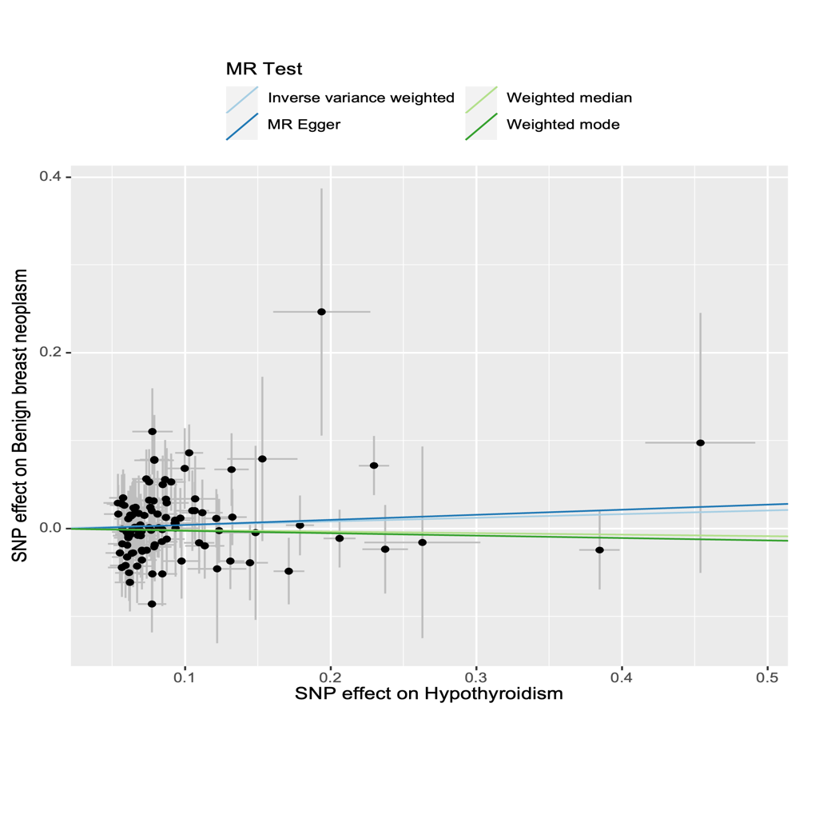

Supplementary Figure S13. Forest plot, leave-one-out plot, funnel plot and scatter plot for the MR analysis inferring the causal effect of hyperthyroidism on breast cancer.

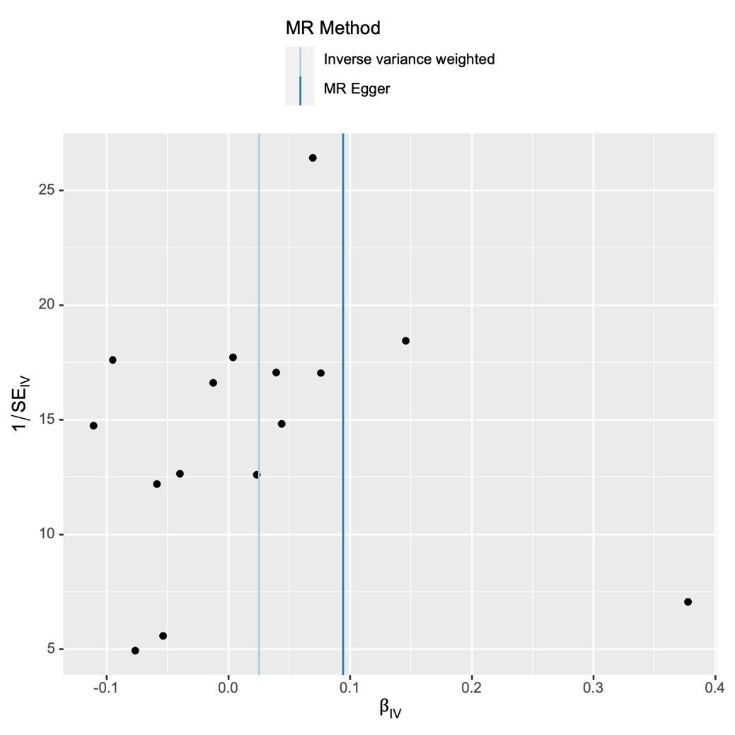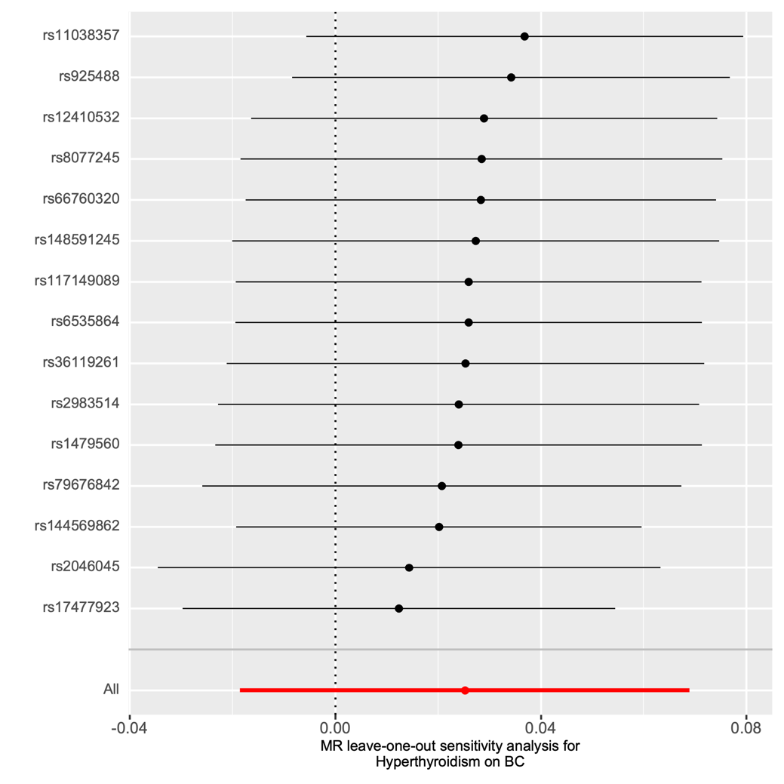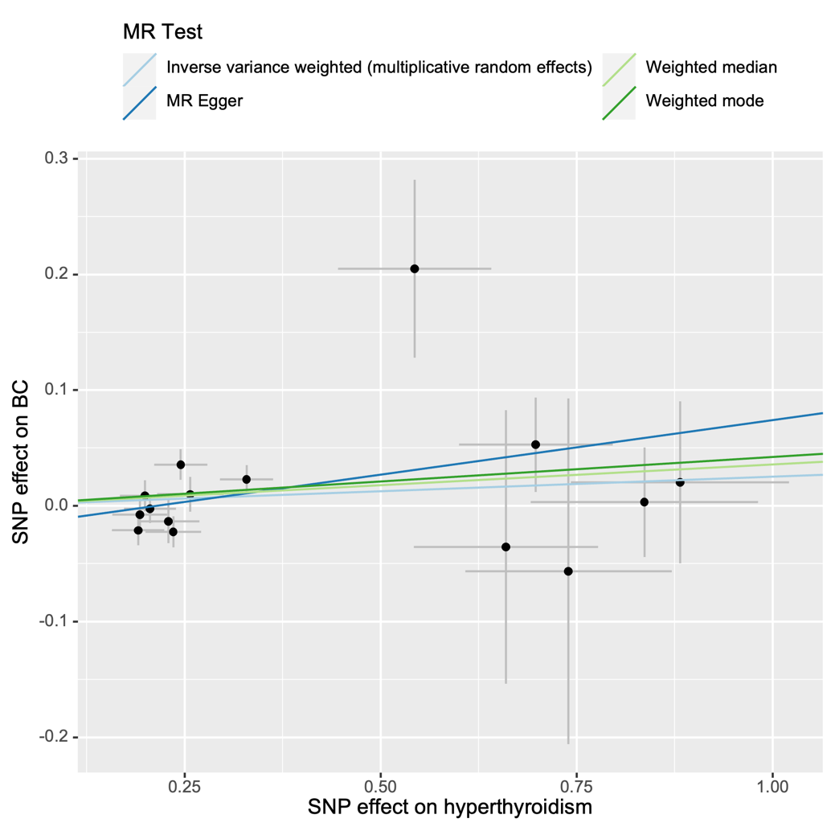

Supplementary Figure S14. Forest plot, leave-one-out plot, funnel plot and scatter plot for the MR analysis inferring the causal effect of hyperthyroidism on HER2-enriched breast cancer.

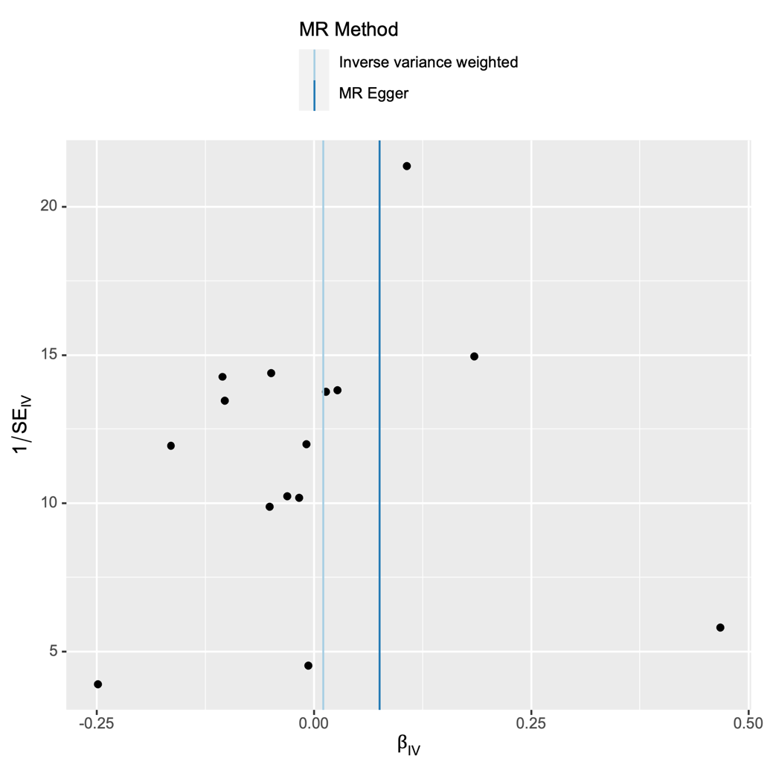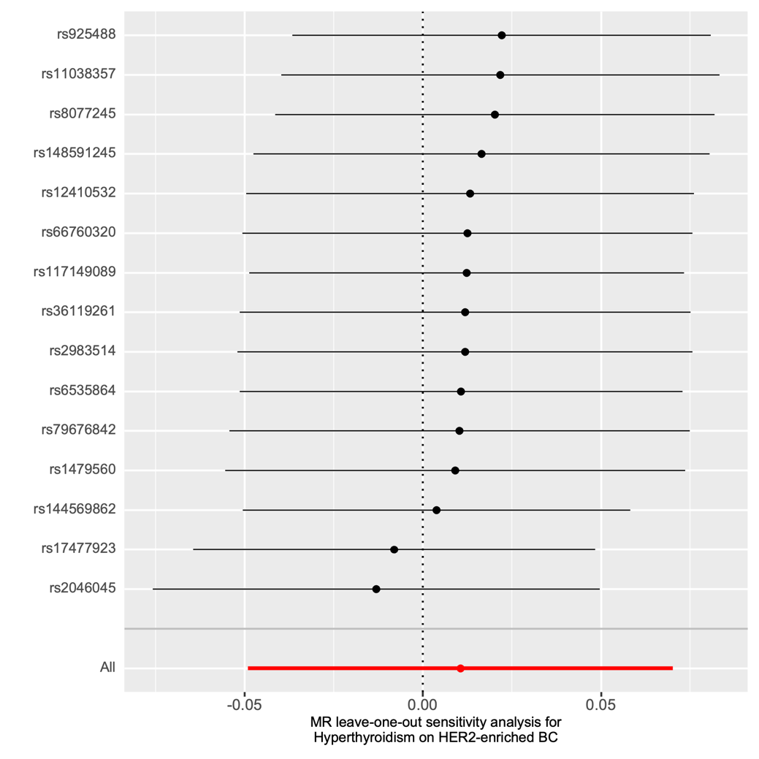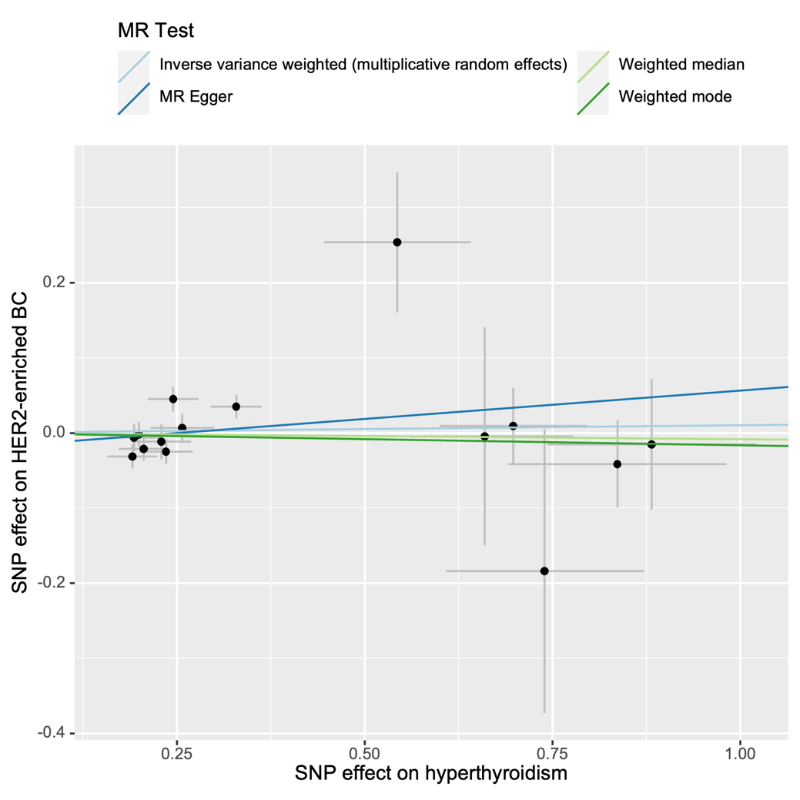

Supplementary Figure S15. Forest plot, leave-one-out plot, funnel plot and scatter plot for the MR analysis inferring the causal effect of hyperthyroidism on HER2-negative breast cancer.

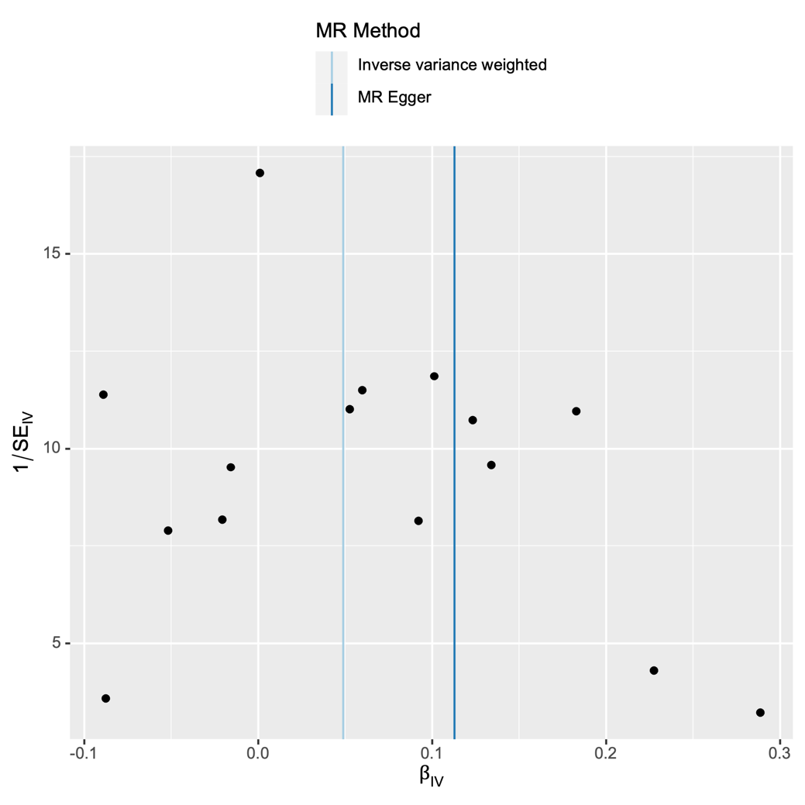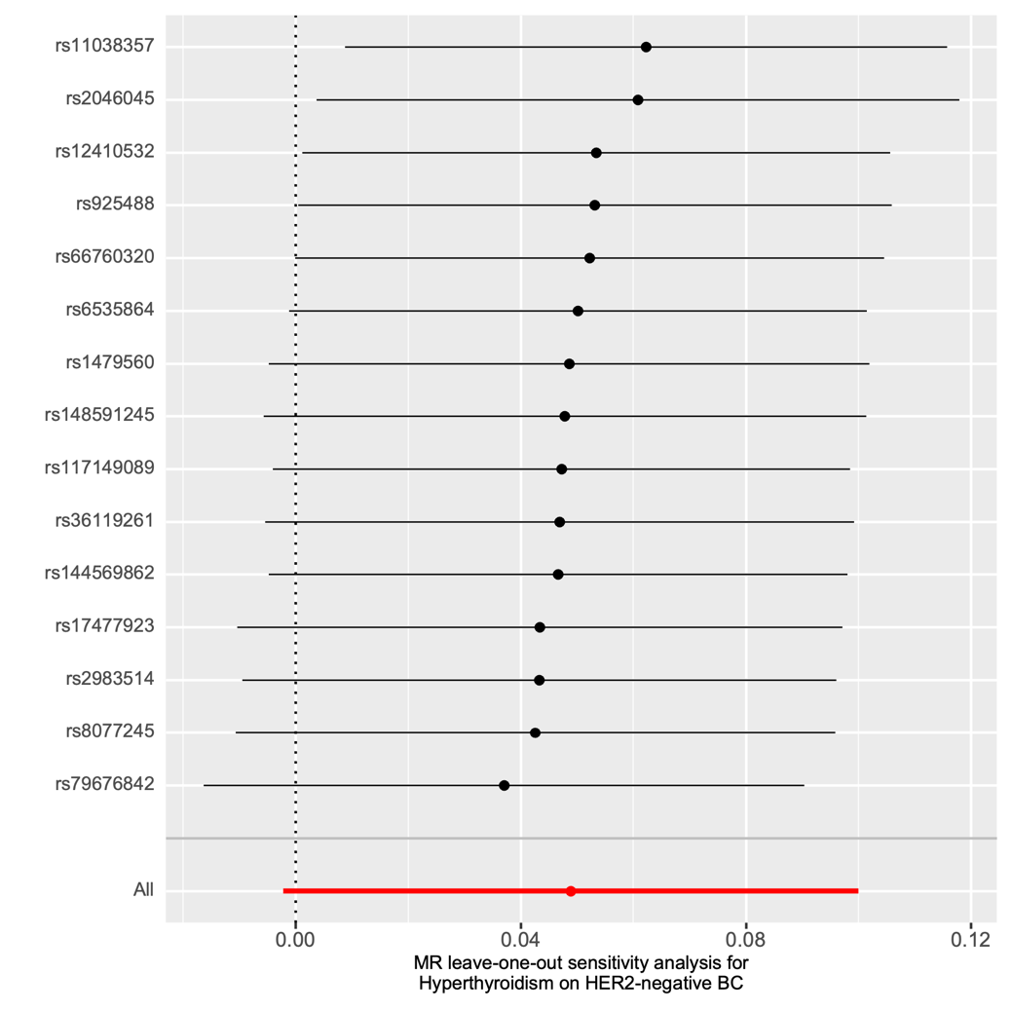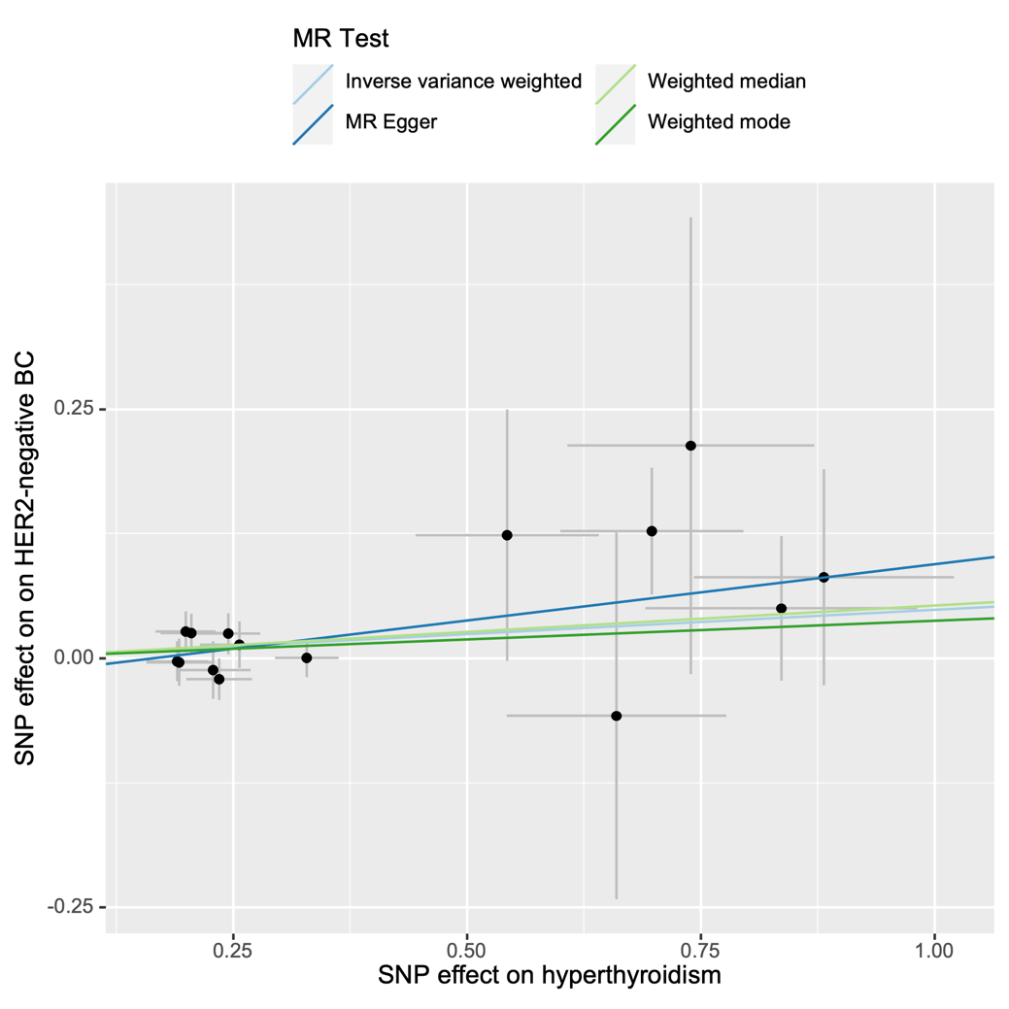

Supplementary Figure S16. Forest plot, leave-one-out plot, funnel plot and scatter plot for the MR analysis inferring the causal effect of hyperthyroidism on benign breast neoplasm.

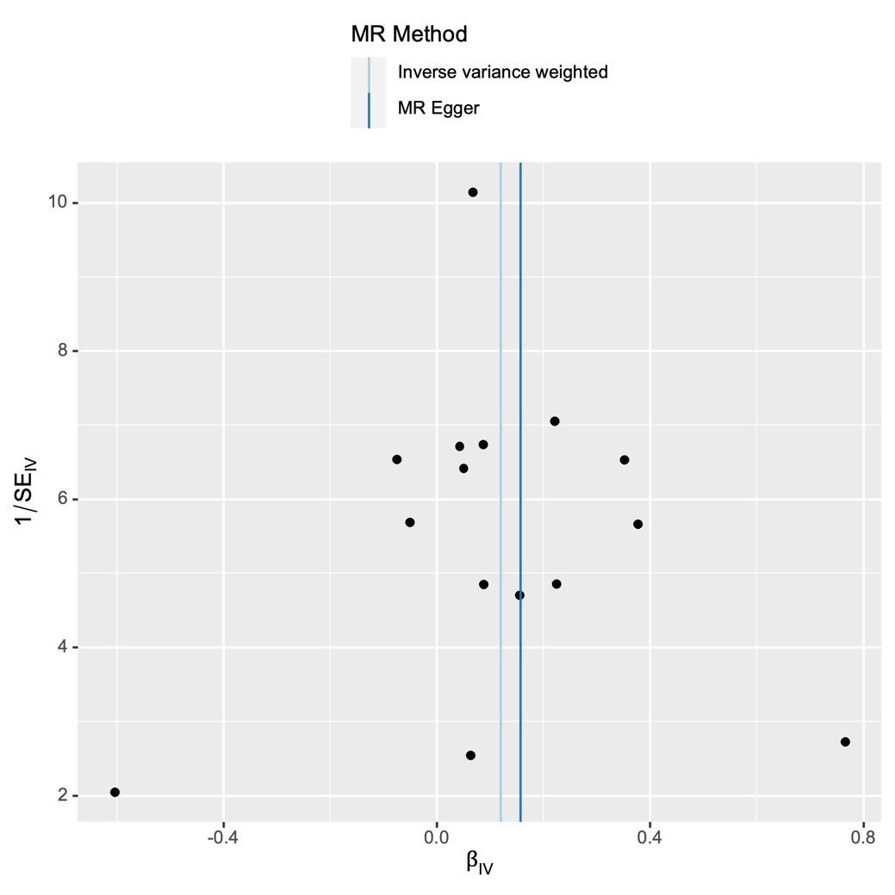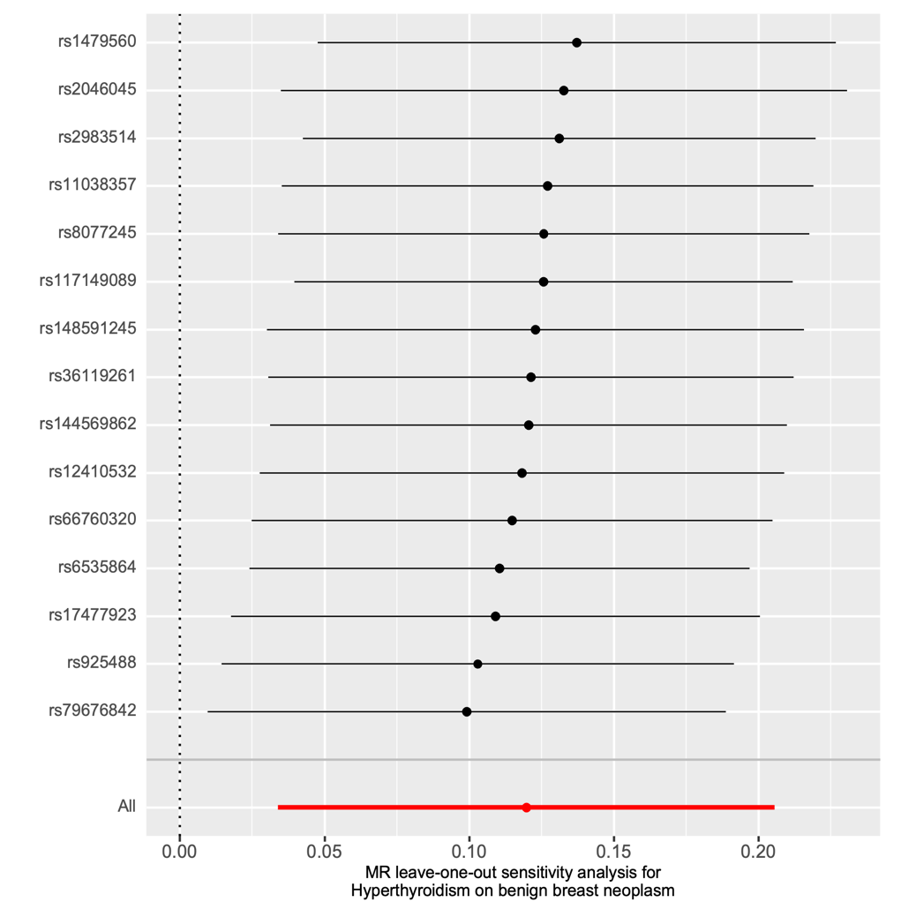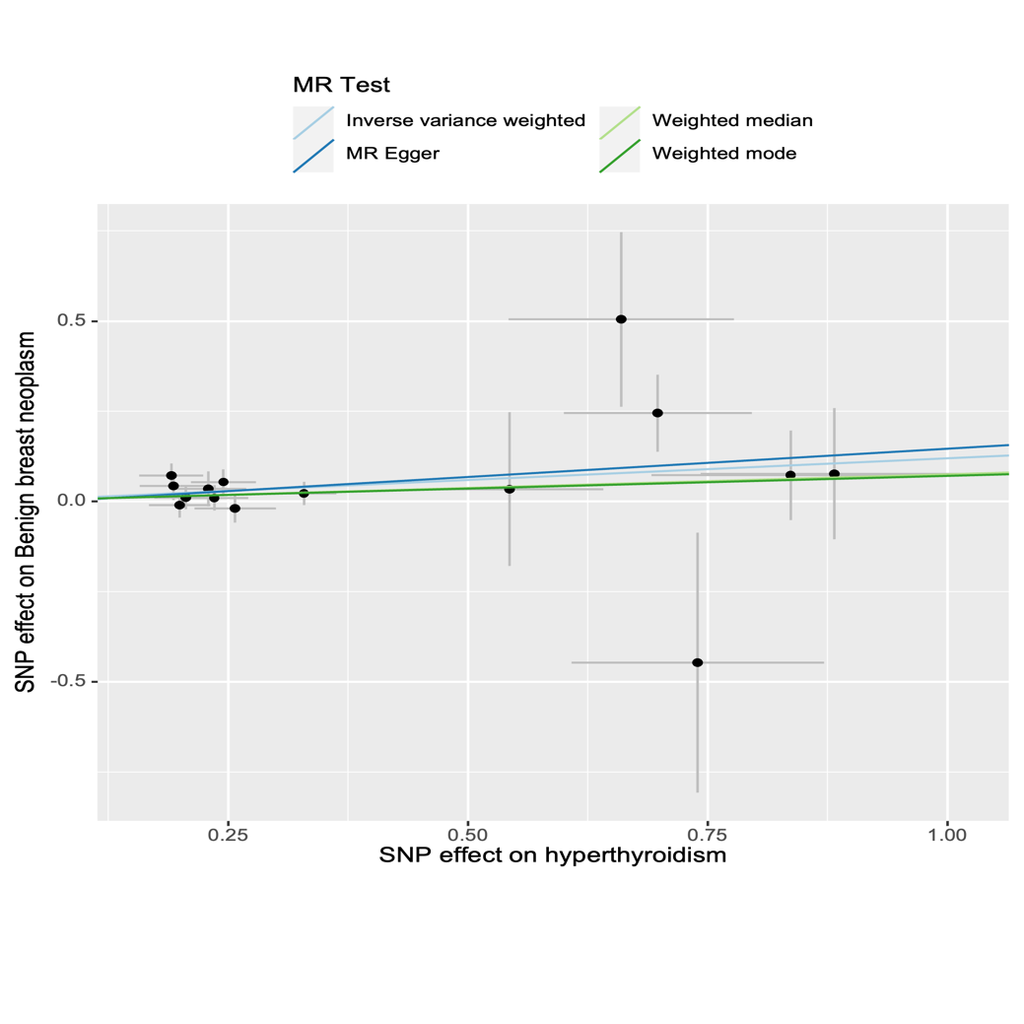

Supplementary Figure S17. Forest plot, leave-one-out plot, funnel plot and scatter plot for the MR analysis inferring the causal effect of thyroid cancer on breast cancer.

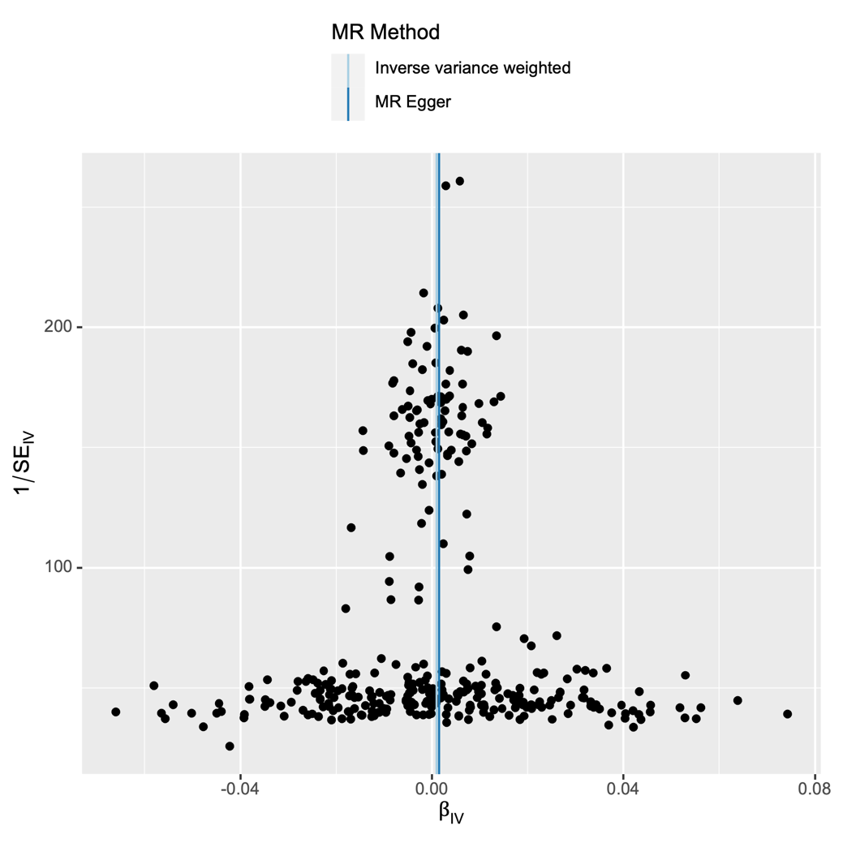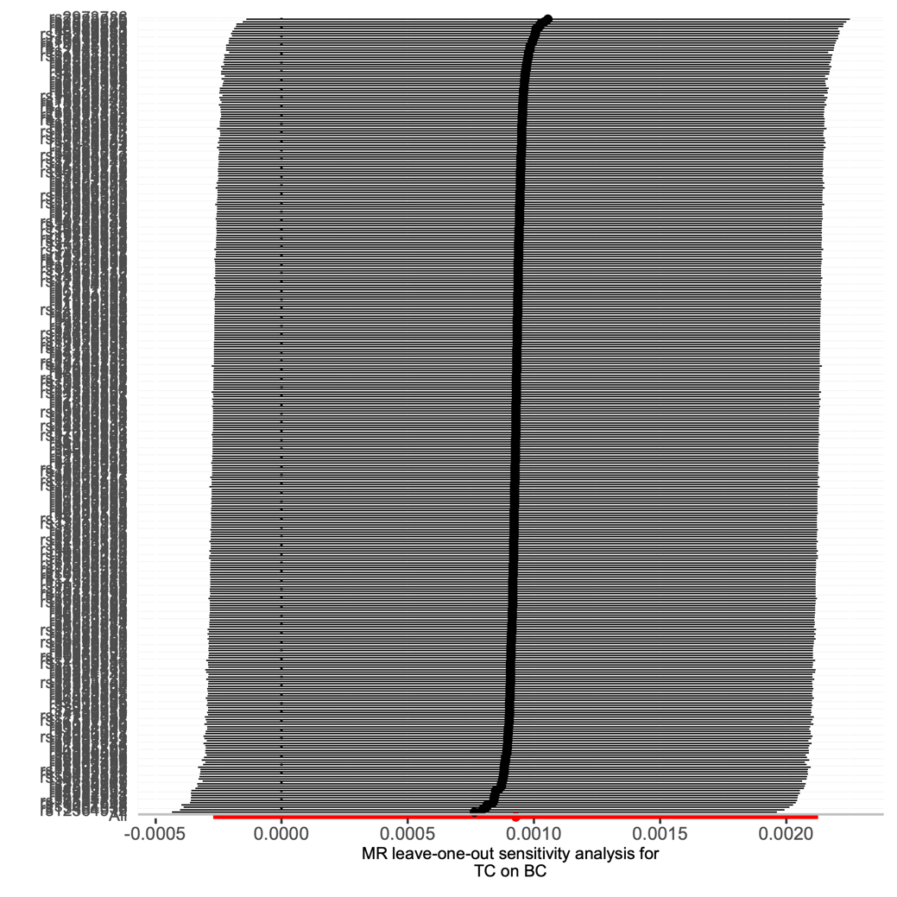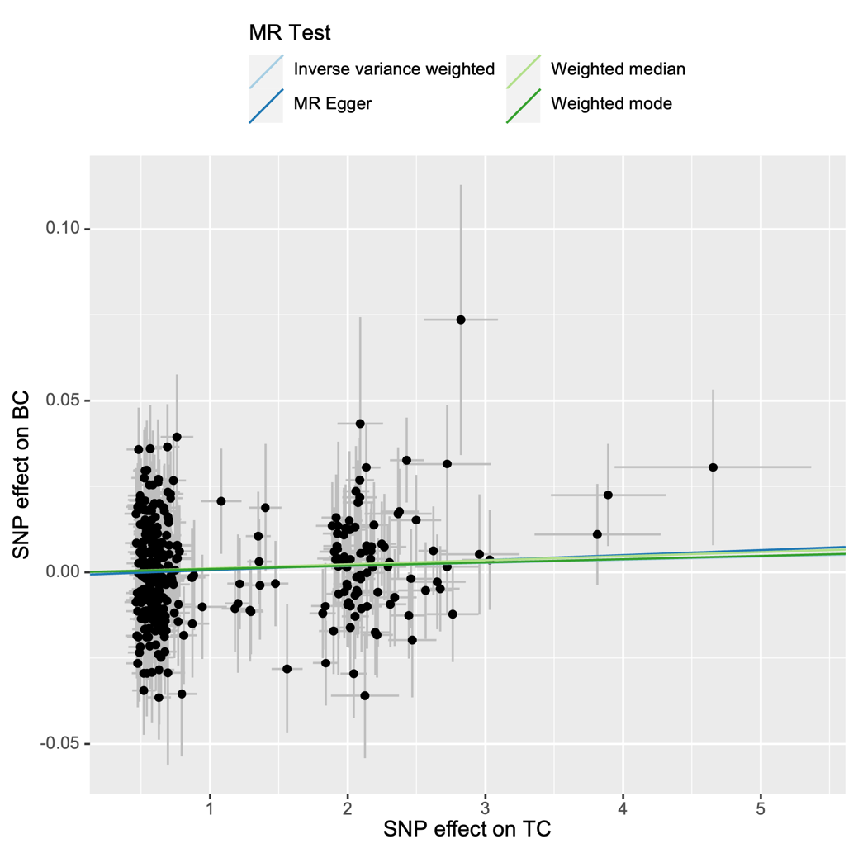

Supplementary Figure S18. Forest plot, leave-one-out plot, funnel plot and scatter plot for the MR analysis inferring the causal effect of thyroid cancer on HER2-enriched breast cancer.

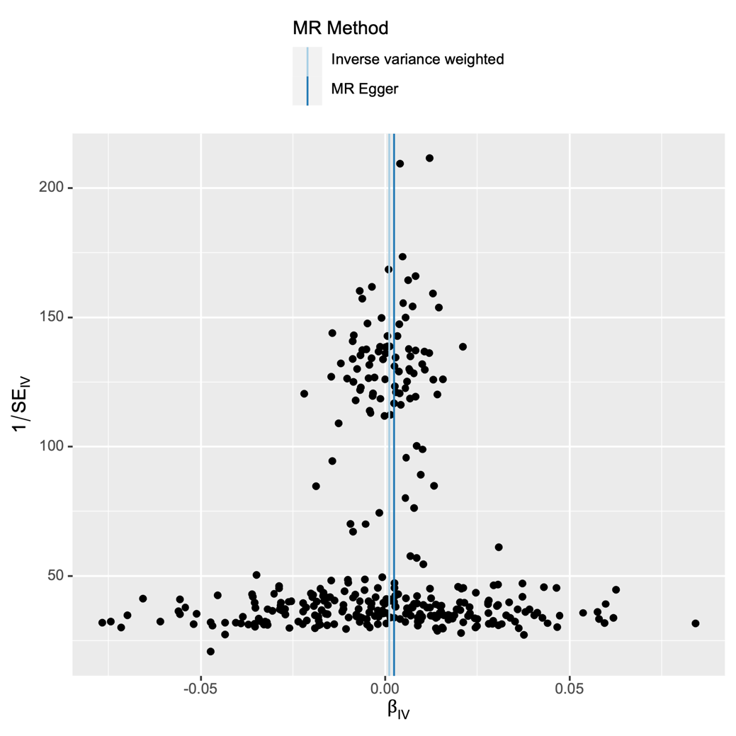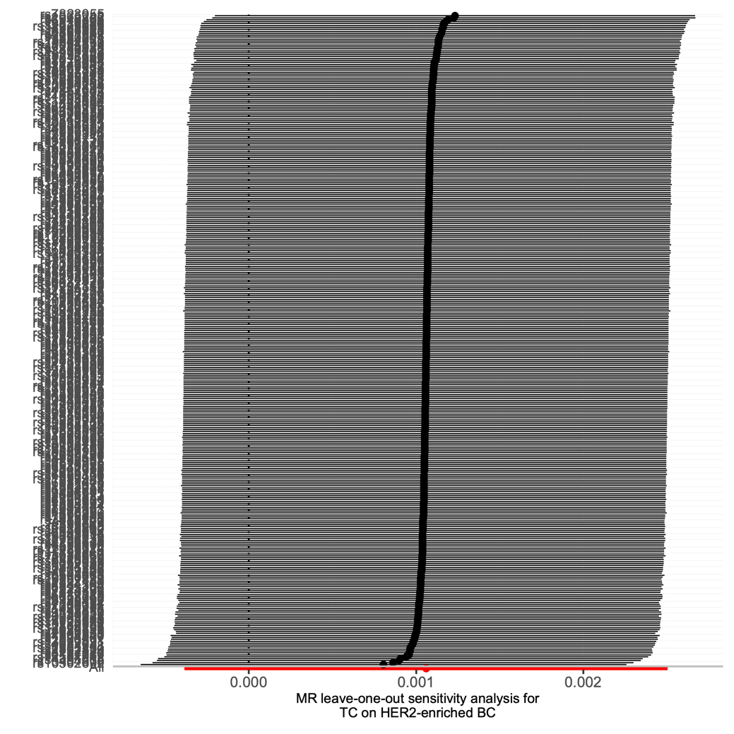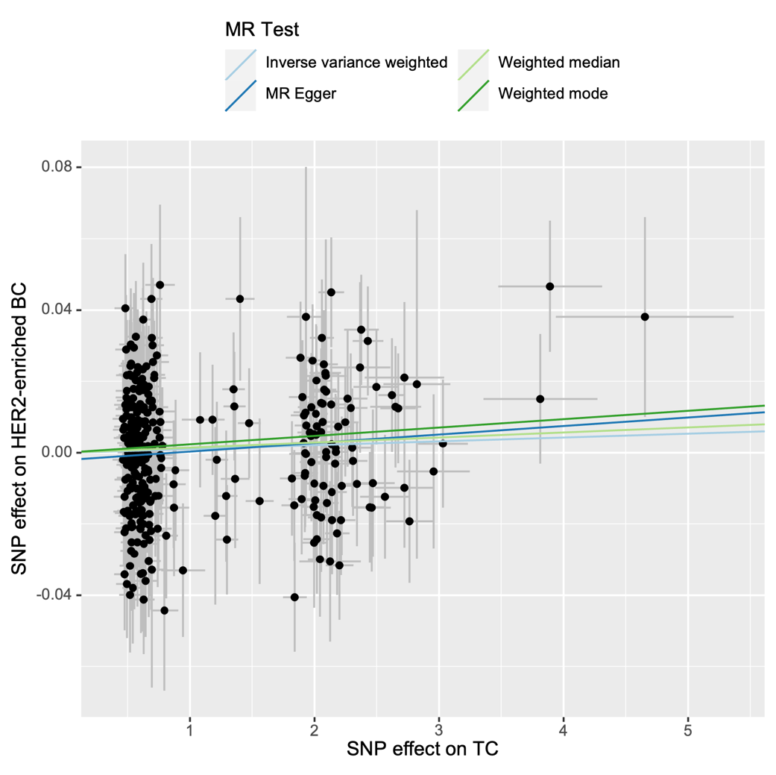

Supplementary Figure S19. Forest plot, leave-one-out plot, funnel plot and scatter plot for the MR analysis inferring the causal effect of thyroid cancer on HER2-negative breast cancer.

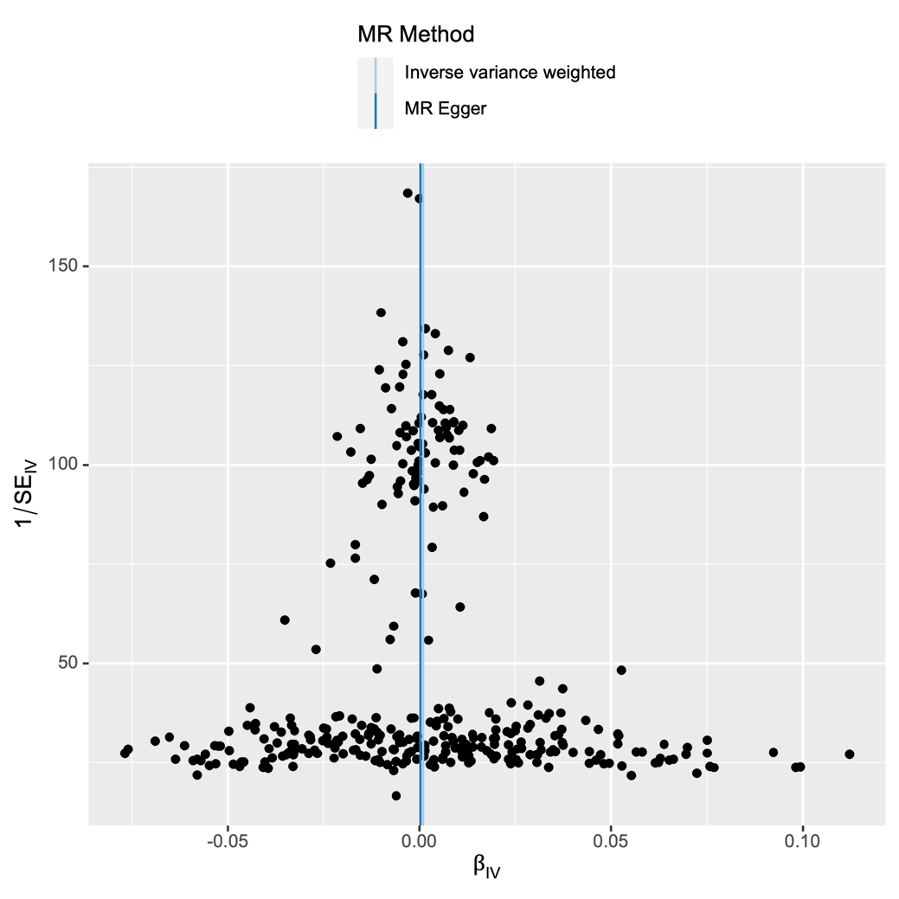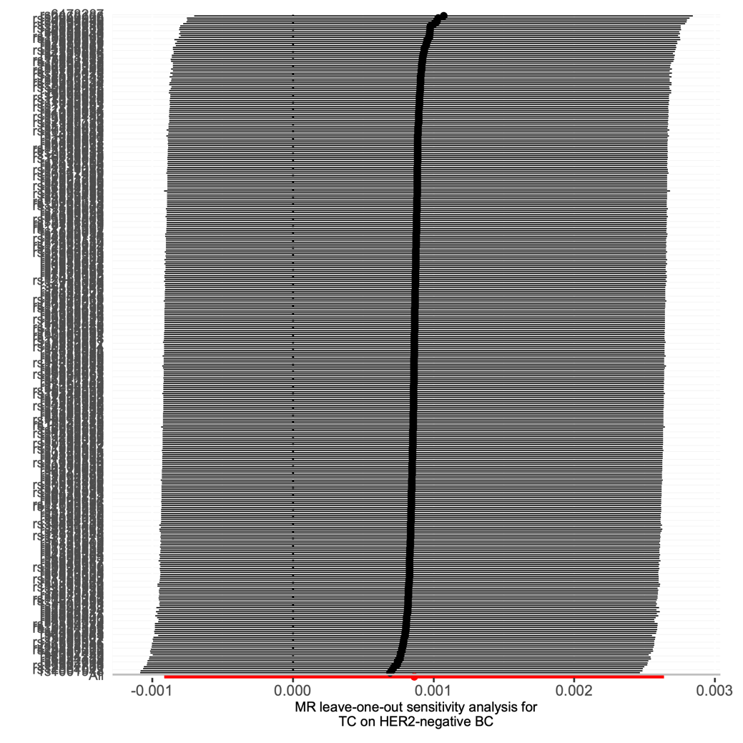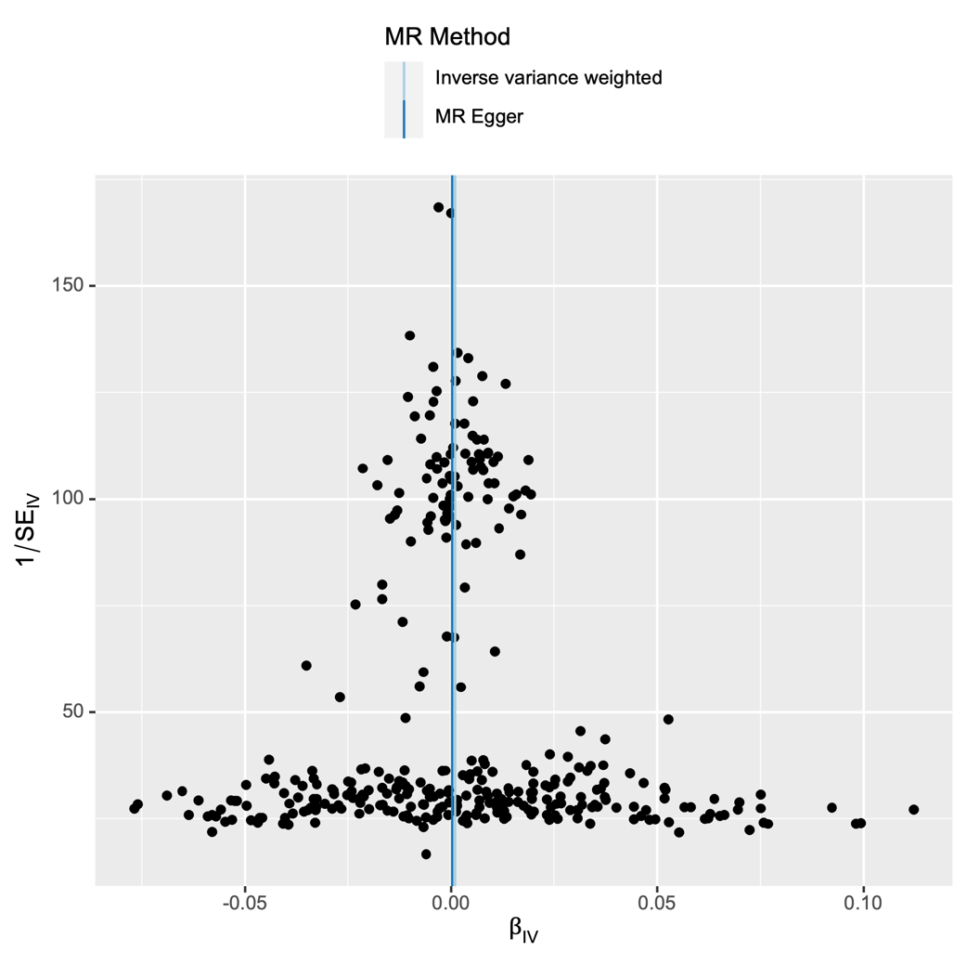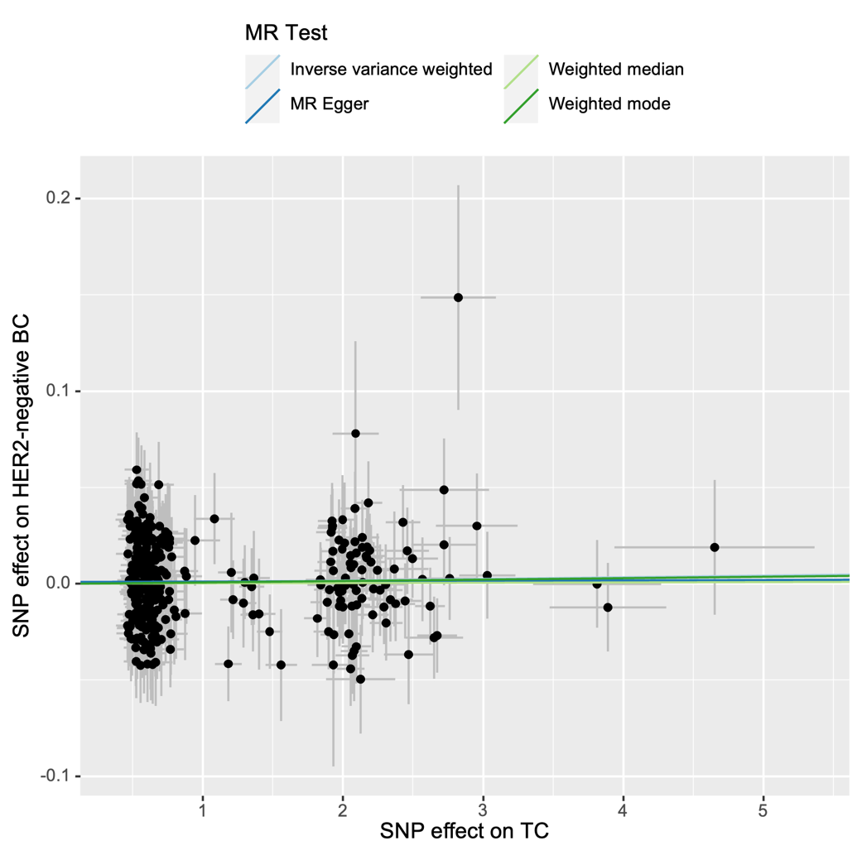

Supplementary Figure S20. Forest plot, leave-one-out plot, funnel plot and scatter plot for the MR analysis inferring the causal effect of thyroid cancer on benign breast neoplasm.
