Supplemental materials

Supplemental figure S1………………………………………………………………………………2

Supplemental figure S2………………………………………………………………………………3

Supplemental figure S3………………………………………………………………………………4

Supplemental table S1………………………………………………………………………………..5

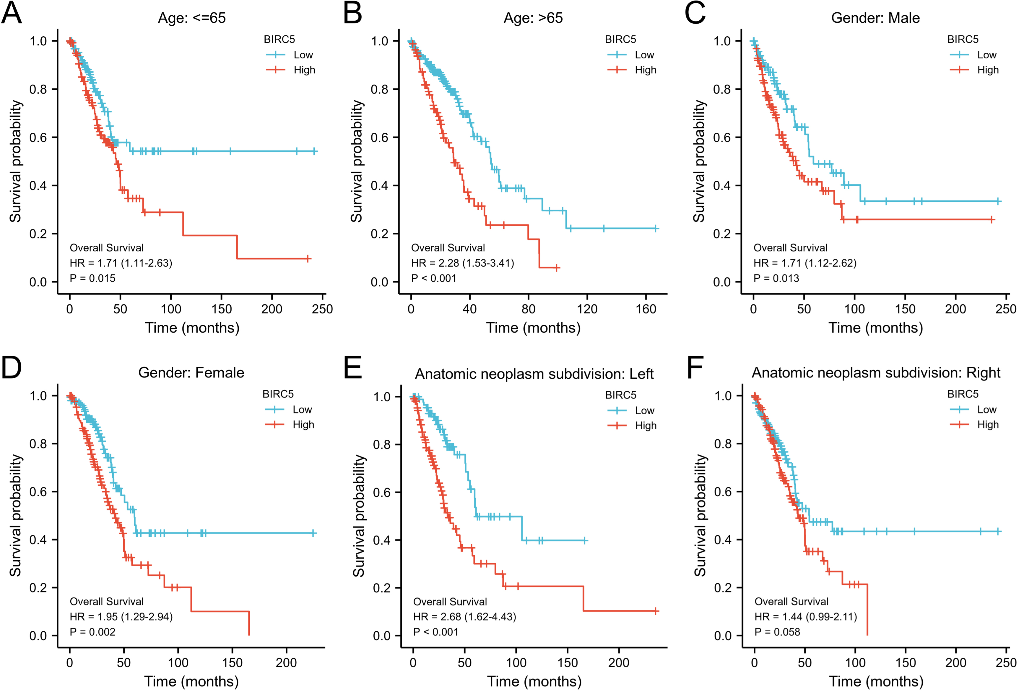
Supplemental figure S1. The Kaplan–Meier curves for subgroup analyses. A. age ≤ 65 years; B. age >65 years; C. male; D. female; E. the left of anatomic neoplasm subdivision; F. the right of anatomic neoplasm subdivision.

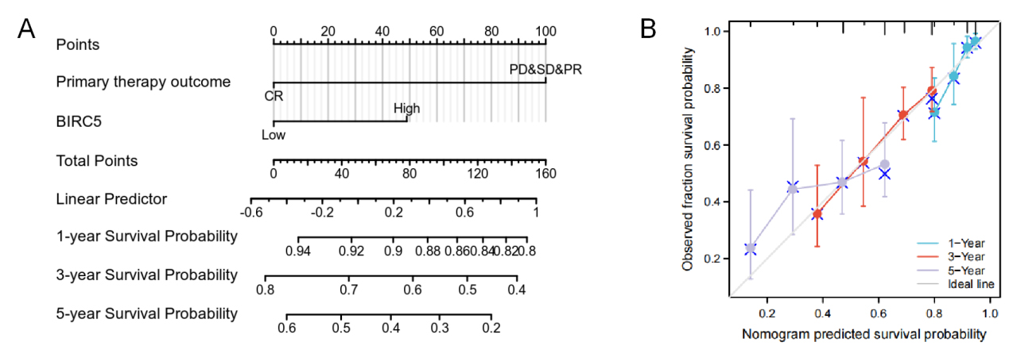
Supplemental figure S2. The role of BIRC5 in predicting the prognosis of LUAD patients. A. Terminology diagram. B. Calibration curve.

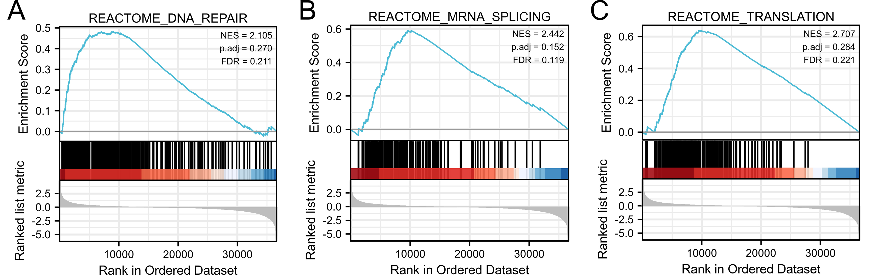
Supplemental figure S3. GSEA analyses in LUAD patients with high expression of BIRC5 compared with those with low expression. A. DNA repair pathway. B. mRNA splicing pathway. C. Translation. NES, normalized enrichment score; ADJ, adjusted; FDR, false discovery rate.

Supplemental Table S1. Univariate and multivariate analyses
Characteristics | Total (N) | Univariate analysis |  |  | Multivariate analysis
Characteristics | Total (N) | Hazard ratio (95% CI) | P value |  | Hazard ratio (95% CI) | P value
T stage
T1 | 175 | Reference
T2&T3&T4 | 348 | 1.728 (1.229-2.431) | 0.002 |  | 1.272 (0.733-2.209) | 0.392
N stage
N0 | 343 | Reference
N1&N2&N3 | 167 | 2.601 (1.944-3.480) | <0.001 |  | 1.682 (0.751-3.770) | 0.206
M stage
M0 | 352 | Reference
M1 | 25 | 2.136 (1.248-3.653) | 0.006 |  | 1.882 (0.757-4.680) | 0.173
Pathologic stage
Stage I | 290 | Reference
Stage II&Stage III&Stage IV | 228 | 2.933 (2.173-3.958) | <0.001 |  | 1.067 (0.457-2.494) | 0.881
Residual tumor
R0 | 347 | Reference
R1&R2 | 16 | 3.879 (2.169-6.936) | <0.001 |  | 3.751 (1.524-9.234) | 0.004
Gender
Male | 246 | Reference
Female | 280 | 0.934 (0.701-1.245) | 0.642
Age
<=65 | 255 | Reference
>65 | 261 | 1.223 (0.916-1.635) | 0.172
Race
Asian&Black or African American | 62 | Reference
White | 406 | 1.475 (0.902-2.411) | 0.121
Anatomic neoplasm subdivision
Left | 200 | Reference
Right | 312 | 1.037 (0.770-1.397) | 0.810
Anatomic neoplasm subdivision2
Central Lung | 62 | Reference
Peripheral Lung | 120 | 0.913 (0.570-1.463) | 0.706
Number pack years smoked
<40 | 183 | Reference
>=40 | 180 | 1.073 (0.753-1.528) | 0.697
Smoker
No | 72 | Reference
Yes | 440 | 0.894 (0.592-1.348) | 0.591
Primary therapy outcome
CR | 326 | Reference
PD&SD&PR | 113 | 2.690 (1.918-3.771) | <0.001 |  | 3.145 (1.928-5.128) | <0.001
BIRC5
Low | 265 | Reference
High | 261 | 1.666 (1.244-2.233) | <0.001 |  | 1.437 (1.007-2.277) | 0.043

