Supplementary Figure 1. Binding activities (a) and neutralizing activities (b) of the antibody panel.

Supplementary Figure 2. Binding profiles of mAbs to HPV L1 VLPs from six vaccine manufacturers. Absorbance values are indicated on the y-axis, and antigen concentrations are indicated on the x-axis.
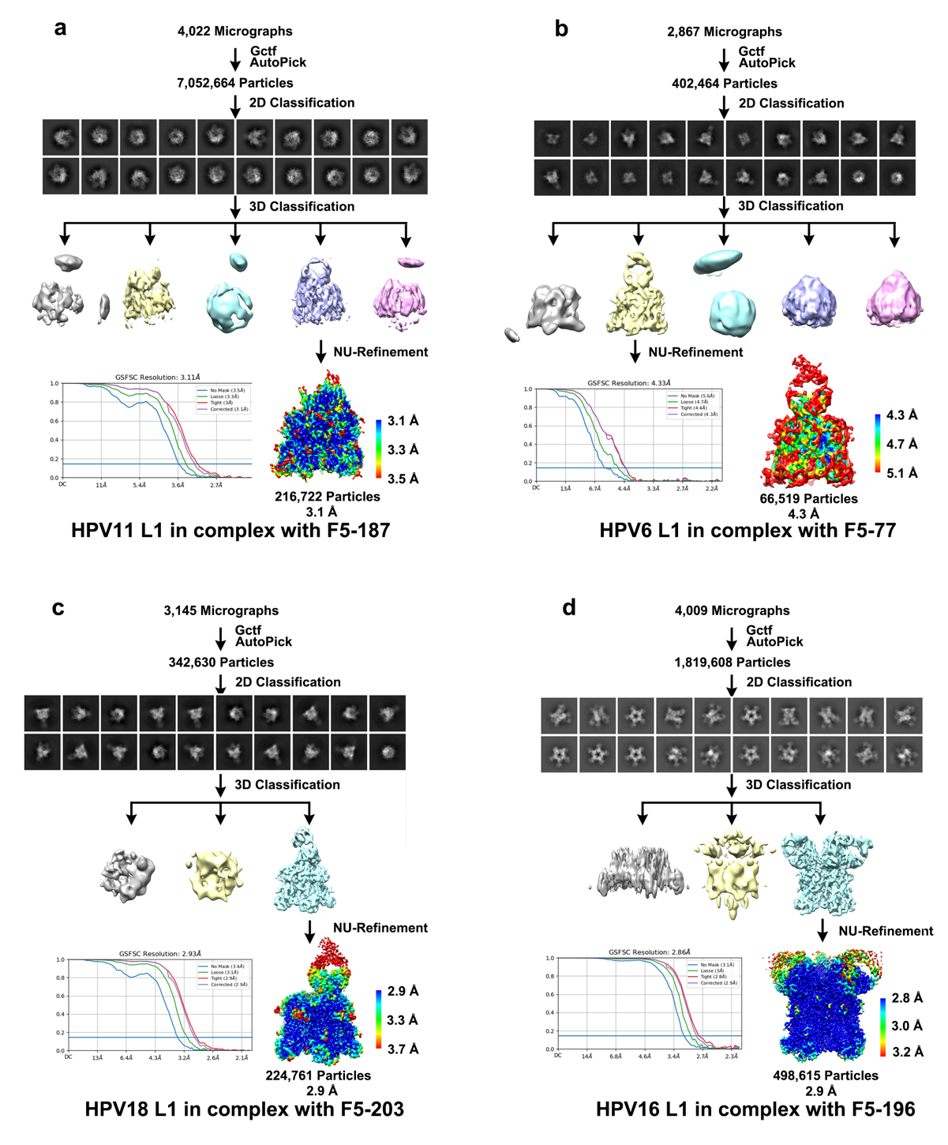
Supplementary Figure 3. Flowcharts for data processing. Flowcharts for (a) HPV11 L1 pentamer in complex with F5-187, (b) HPV6 L1 pentamer in complex with F5-77, (c) HPV18 L1 pentamer in complex with F5-203, and (d) HPV16 L1 pentamer in complex with F5-196.

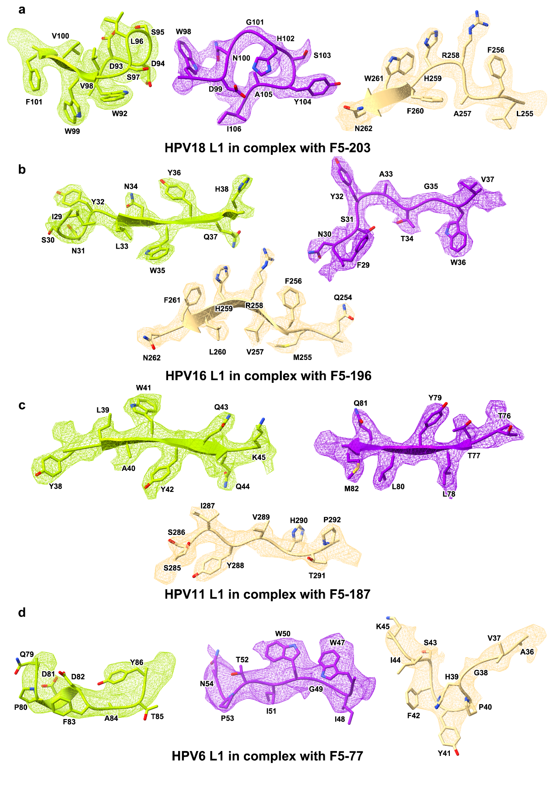
Supplementary Figure 4. Density maps and atomics models. Cryo-EM density maps of (a) HPV18 L1 pentamer in complex with F5-203, (b) HPV16 L1 pentamer in complex with F5-196, (c) HPV11 L1 pentamer in complex with F5-187, and (d) HPV6 L1 pentamer in complex with F5-77 are presented. The color scheme is identical to Fig. 3. Residues are shown as sticks, with oxygen colored red, nitrogen colored blue, and sulfur colored yellow.

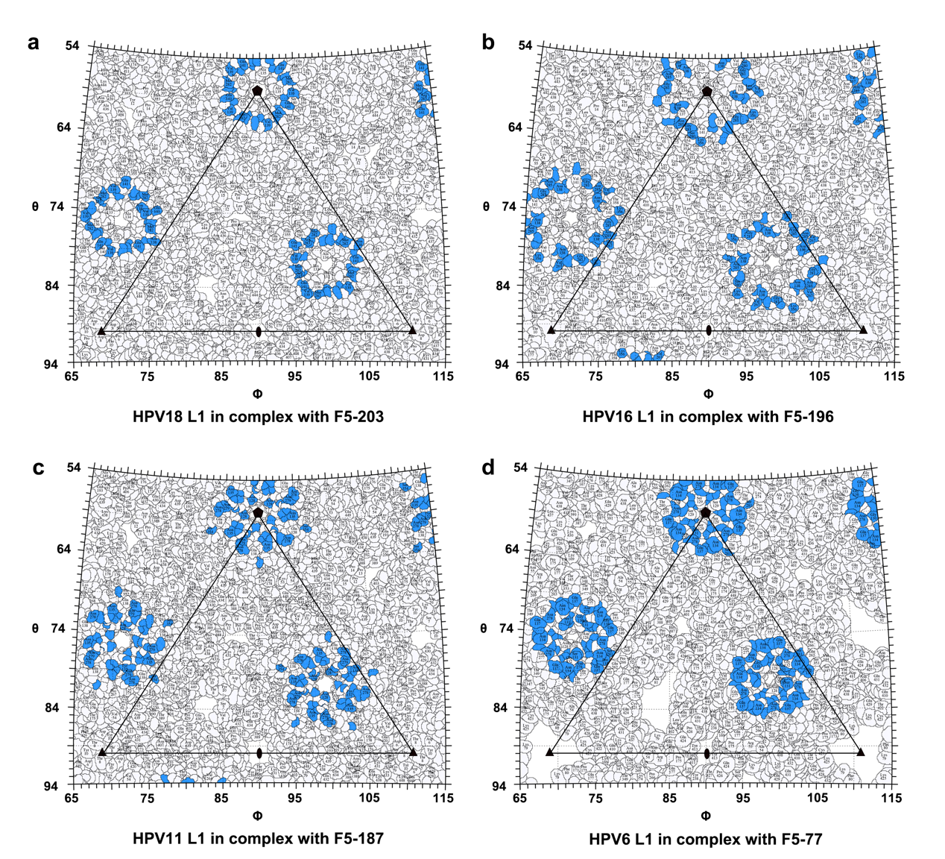
Supplementary Figure 5. Footprint of the HPV L1 VLP surface. A two-dimensional projection of the HPV L1 VLP surface produced using RIVEM. Epitopes of F5-203 (a), F5-196 (b), F5-187 (c), and F5-77 (d) are colored blue.

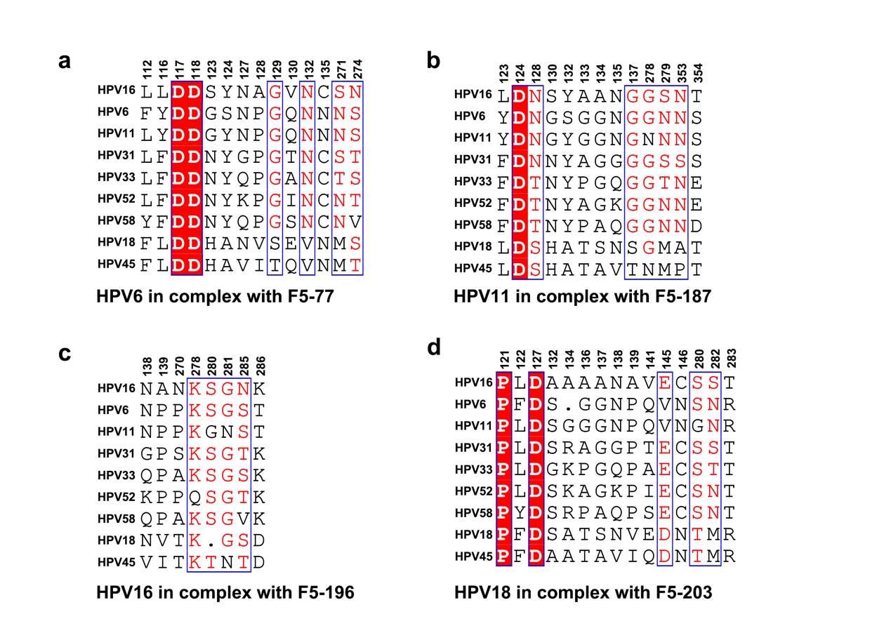
Supplementary Figure 6. Multiple sequence alignment of the binding sites of F5-77, F5-187, F5-196, and F5-203. Multiple sequence alignments of the binding sites of F5-77 (a), F5-187 (b), F5-196 (c), and F5-203 (d) were performed with the corresponding HPV 9-valent types.

Supplementary Table 1. Original results for accuracy and precision
HPV Type | Potency | Time 1 |  |  |  | Time 2
HPV Type | Potency | Person 1 | Person 2 | Person 3 | Person 4 | Person 1 | Person 2 | Person 3 | Person 4
6 | 50% | 52.4% | 41.8% | 38.2% | 42.8% | 48.2% | 40.5% | 47.1% | 42.2%
 | 75% | 70.3% | 62.6% | 73.0% | 72.9% | 62.4% | 67.5% | 62.3% | 70.1%
 | 100% | 88.2% | 88.0% | 95.8% | 110.4% | 87.9% | 97.2% | 81.5% | 126.8%
 | 150% | 126.5% | 132.4% | 137.3% | 167.8% | 124.3% | 131.5% | 121.7% | 163.2%
 | 200% | 182.3% | 269.9% | 202.5% | 273.9% | 180.0% | 211.1% | 168.7% | 272.1%
11 | 50% | 40.0% | 44.3% | 47.7% | 42.6% | 60.9% | 49.3% | 44.5% | 49.3%
 | 75% | 69.4% | 77.3% | 69.4% | 74.7% | 62.9% | 69.2% | 61.7% | 76.4%
 | 100% | 95.4% | 90.6% | 67.6% | 111.1% | 73.8% | 99.5% | 80.1% | 106.4%
 | 150% | 137.8% | 135.2% | 127.5% | 169.1% | 101.2% | 139.7% | 107.8% | 145.4%
 | 200% | 223.3% | 218.9% | 207.2% | 279.5% | 166.8% | 230.6% | 195.5% | 220.6%
16 | 50% | 47.2% | 47.1% | 49.4% | 36.1% | 44.2% | 41.6% | 43.4% | 37.0%
 | 75% | 89.2% | 86.7% | 46.2% | 52.5% | 81.2% | 69.5% | 62.9% | 57.5%
 | 100% | 103.8% | 123.3% | 80.4% | 64.6% | 100.5% | 87.5% | 72.3% | 83.2%
 | 150% | 119.4% | 144.6% | 121.3% | 91.0% | 117.8% | 114.7% | 108.9% | 108.4%
 | 200% | 181.8% | 199.3% | 184.3% | 187.4% | 237.6% | 151.7% | 169.4% | 140.7%
18 | 50% | 40.2% | 40.2% | 32.1% | 27.8% | 33.2% | 42.0% | 35.0% | 47.3%
 | 75% | 73.5% | 74.6% | 53.6% | 58.6% | 61.4% | 72.4% | 59.6% | 74.0%
 | 100% | 93.6% | 99.3% | 85.0% | 91.5% | 91.1% | 94.6% | 78.2% | 102.3%
 | 150% | 136.7% | 131.6% | 131.8% | 123.5% | 146.7% | 131.3% | 122.1% | 170.5%
 | 200% | 203.2% | 192.2% | 205.5% | 193.9% | 204.0% | 189.1% | 182.2% | 246.5%

Supplementary Table 2. List of interacting sites between Fabs and HPV L1 pentamers (d < 4 Å)
Complex | HPV L1 | Heavy chain |  |  |  | Light chain
HPV6 L1 in complex with F5-77 | PHE 112 | Y104
HPV6 L1 in complex with F5-77 | ASN 135 | Y104
HPV6 L1 in complex with F5-77 | ASP 117 | H103
HPV6 L1 in complex with F5-77 | ASP 118 | H103
HPV6 L1 in complex with F5-77 | GLY 123 | R100
HPV6 L1 in complex with F5-77 | SER 124 | R100
HPV6 L1 in complex with F5-77 | PRO 128 | Y101
HPV6 L1 in complex with F5-77 | GLY 129 | Y101
HPV6 L1 in complex with F5-77 | GLN 130 |  |  |  |  | N92
HPV6 L1 in complex with F5-77 | ASN 271 |  |  |  |  | Y49
HPV6 L1 in complex with F5-77 | SER 274 | Y104
HPV6 L1 in complex with F5-77 | TYR 116 | T55
HPV6 L1 in complex with F5-77 | ASP 117 | N54
HPV6 L1 in complex with F5-77 | SER 124 | Y33 |  | N54
HPV6 L1 in complex with F5-77 | ASN 127 | N59
HPV6 L1 in complex with F5-77 | ASN 132 | T55
HPV6 L1 in complex with F5-77 | ASN 271 | N59
HPV11 L1 in complex with F5-187 | ASP 124 | S30
HPV11 L1 in complex with F5-187 | GLY 134 | L27
HPV11 L1 in complex with F5-187 | ASN 135 | T28
HPV11 L1 in complex with F5-187 | ASN 353 |  |  |  |  | Y31
HPV11 L1 in complex with F5-187 | SER 354 |  |  |  |  | Y31 |  | S33
HPV11 L1 in complex with F5-187 | TYR 123 | R104
HPV11 L1 in complex with F5-187 | ASP 124 | R104
HPV11 L1 in complex with F5-187 | ASN 128 | S54
HPV11 L1 in complex with F5-187 | GLY 130 | S31 | G102 |  | V103
HPV11 L1 in complex with F5-187 | TYR 132 | G102
HPV11 L1 in complex with F5-187 | GLY 133 | M101
HPV11 L1 in complex with F5-187 | GLY 137 |  |  |  |  | Y31
HPV11 L1 in complex with F5-187 | ASN 128 | G55
HPV11 L1 in complex with F5-187 | TYR 132 |  |  |  |  | T100
HPV11 L1 in complex with F5-187 | ASN 278 |  |  |  |  | Q27
HPV11 L1 in complex with F5-187 | ASN 279 |  |  |  |  | S99
HPV16 L1 in complex with F5-196 | LYS 356 |  |  |  |  | D27
HPV16 L1 in complex with F5-196 | ASN 138 | Y32
HPV16 L1 in complex with F5-196 | ASN 138 | S104
HPV16 L1 in complex with F5-196 | ALA 139 | Y32 I54 F55
HPV16 L1 in complex with F5-196 | ASN 270 | G56
HPV16 L1 in complex with F5-196 | LYS 278 | D59
HPV16 L1 in complex with F5-196 | SER 280 |  |  |  |  | Y92
HPV16 L1 in complex with F5-196 | GLY 281 |  |  |  |  | Y92
HPV16 L1 in complex with F5-196 | ASN 285 | T57
HPV16 L1 in complex with F5-196 | LYS 356 | N30
HPV18 L1 in complex with F5-203 | ASP 127 | S103
HPV18 L1 in complex with F5-203 | SER 132 | R54
HPV18 L1 in complex with F5-203 | THR 136 | G101
HPV18 L1 in complex with F5-203 | ALA 134 | Y52
HPV18 L1 in complex with F5-203 | SER 137 | N100
HPV18 L1 in complex with F5-203 | ASN 138 | N100 |  |  |  | R51
HPV18 L1 in complex with F5-203 | VAL 139 |  |  |  |  | W92 | Y35 |  | W99
HPV18 L1 in complex with F5-203 | GLU 141 |  |  |  |  | N52
HPV18 L1 in complex with F5-203 | MET 282 | Y104 I106 |  |  |  | Y50
HPV18 L1 in complex with F5-203 | ARG 283 | H102
HPV18 L1 in complex with F5-203 | PRO 121 | Y104
HPV18 L1 in complex with F5-203 | PHE 122 | Y104
HPV18 L1 in complex with F5-203 | GLU 141 | Y32
HPV18 L1 in complex with F5-203 | ASP 145 | H102
HPV18 L1 in complex with F5-203 | ASN 146 | Y104
HPV18 L1 in complex with F5-203 | THR 280 |  |  |  |  | E30
HPV18 L1 in complex with F5-203 | MET 282 |  |  |  |  | F27

Supplementary Table 3. Statistics for cryo-EM data collection, refinement, and validation
 | HPV6 L1 pentamer in complex with F5-77 | HPV11 L1 pentamer in complex with F5-187 | HPV16 L1 pentamer in complex with F5-196 | HPV18 L1 pentamer in complex with F5-203
Data collection and processing
Magnification | 22,500 | 22,500 | 22,500 | 22,500
Voltage (kV) | 300 | 300 | 300 | 200
Electron exposure (e–/Å²) | 50 | 50 | 50 | 60
Defocus range (μm) | -1.2--1.8 | -1.2--1.8 | -1.2--1.8 | -1.2--1.8
Pixel size (Å) | 1.04 | 1.07 | 1.07 | 1.00
Symmetry imposed | C1 | C1 | C5 | C1
Number of used Particles | 402,464 | 7,052,664 | 1,819,608 | 342,630
Map resolution (Å) | 4.3 | 3.1 | 2.9 | 2.9
FSC threshold | 0.143 | 0.143 | 0.143 | 0.143
Map resolution range (Å) | 4.3-50 | 3.1-50 | 2.9-50 | 2.9-60
Refinement
Initial model used (PDB code) | 2R5H | 2R5H | 2R5H | 2R5H
Model resolution (Å) | 3.7 | 3.7 | 3.7 | 3.7
FSC threshold | 0.143 | 0.143 | 0.143 | 0.143
Map sharpening B factor (Å²) | 202.5 | 128.0 | 156.0 | 123.9
Model composition
Non-hydrogen atoms | 18,074 | 18,221 | 18,159 | 18,253
Protein residues | 2,307 | 2,330 | 2,309 | 2,327
Ligands | 0 | 0 | 0 | 0
B factors (Å²)
Protein | 185.56 | 38.13 | 22.70 | 42.93
Ligand |  |  |  | -
R.m.s. deviations
Bond lengths (Å) | 0.004 | 0.005 | 0.003 | 0.004
Bond angles (°) | 0.919 | 0.646 | 0.544 | 0.698
Validation
MolProbity score | 1.87 | 1.72 | 1.26 | 1.58
Clashscore | 8.98 | 5.75 | 3.52 | 6.96
Poor rotamers (%) | 0.00 | 0.00 | 0.00 | 0.00
Ramachandran plot
Favored (%) | 94.26 | 93.93 | 97.42 | 96.79
Allowed (%) | 5.69 | 6.07 | 2.58 | 3.21
Disallowed (%) | 0.04 | 0.00 | 0.00 | 0.00

