Table 1: Types of medication error for the 51,994 reports
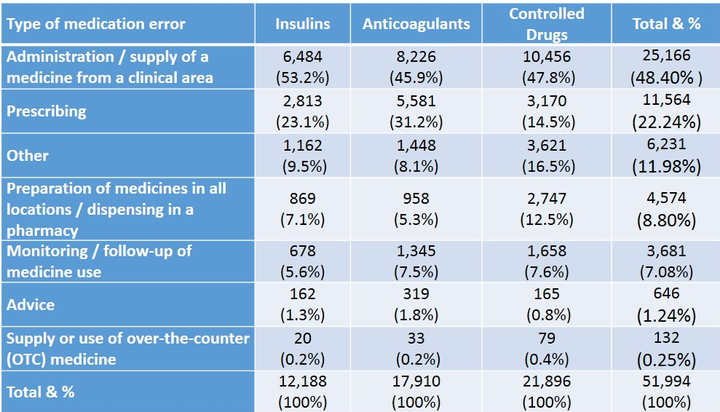
Table 2: The highest sub-types of medication error from the 51,994 reports

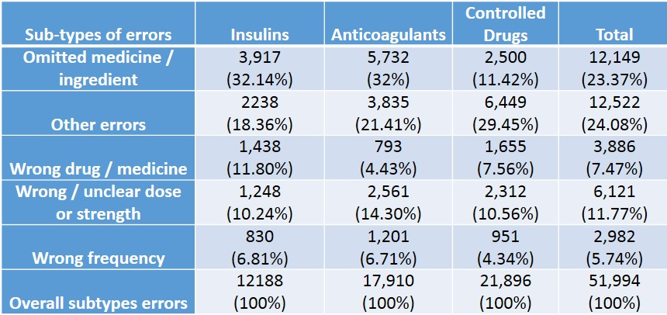

Table 3: The main drugs involved in medication errors within the studied categories of medication
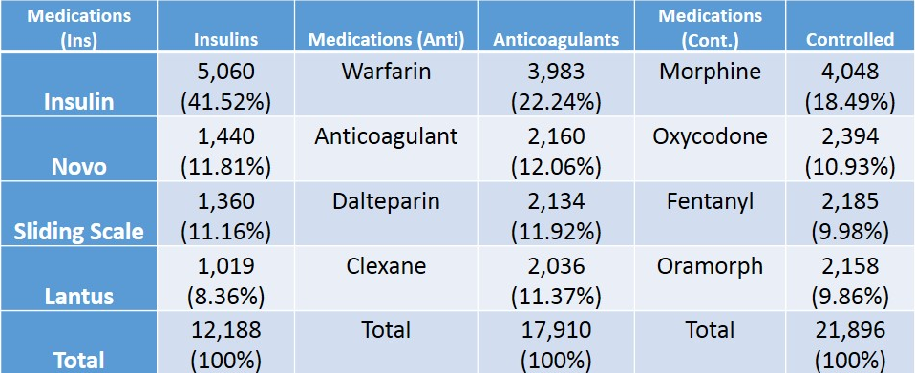
Table 4: Degree of harm for the three studied categories of medication (n = 51,994)
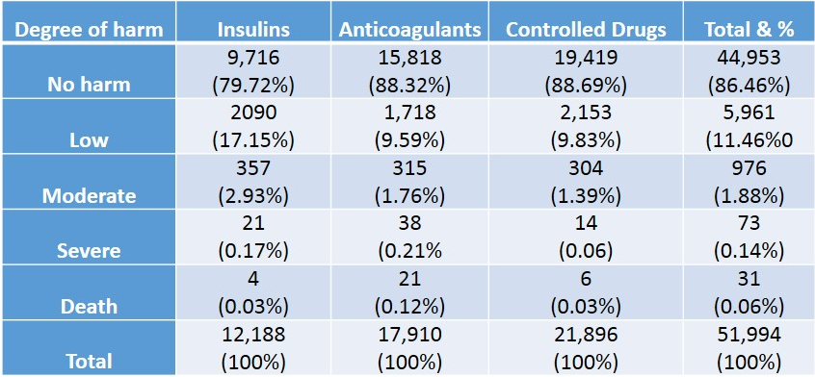

Table 5: Patients’ age range for the three studied categories of medication (n = 51,994).

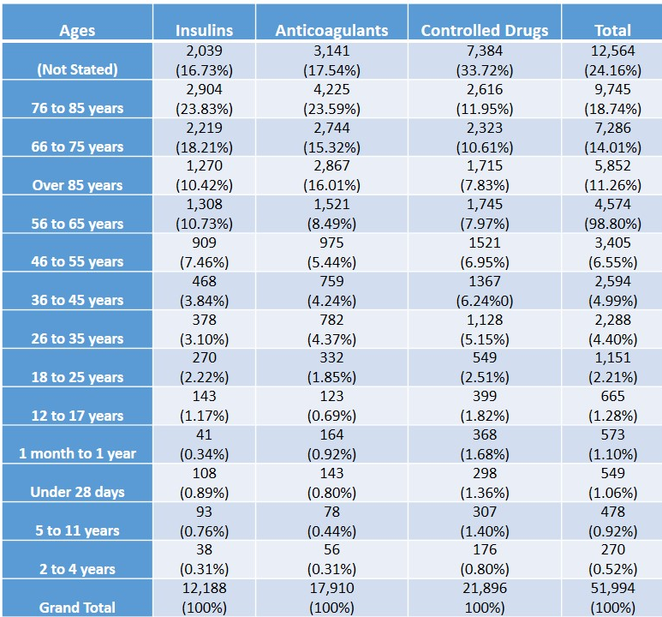
Table 6: Care settings of incidents occurrence for the three categories of medication (n=51,994).
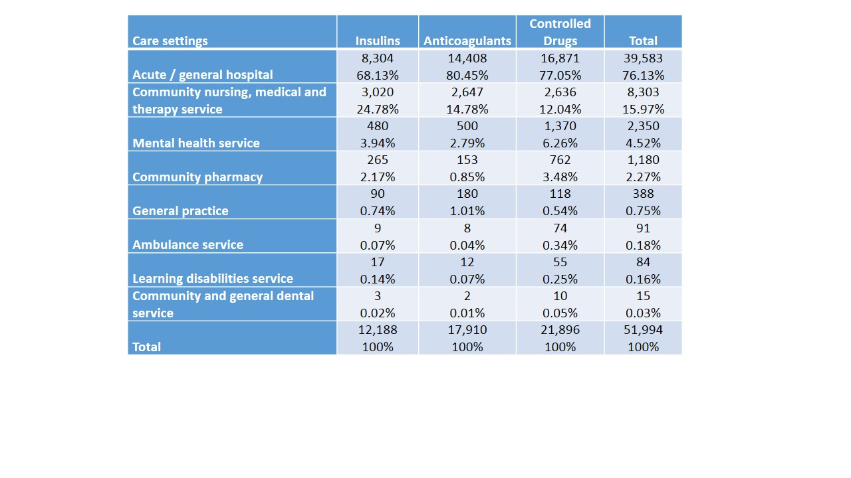
Table 7: Types of medication errors for the main drug categories (n = 1,330 reports)
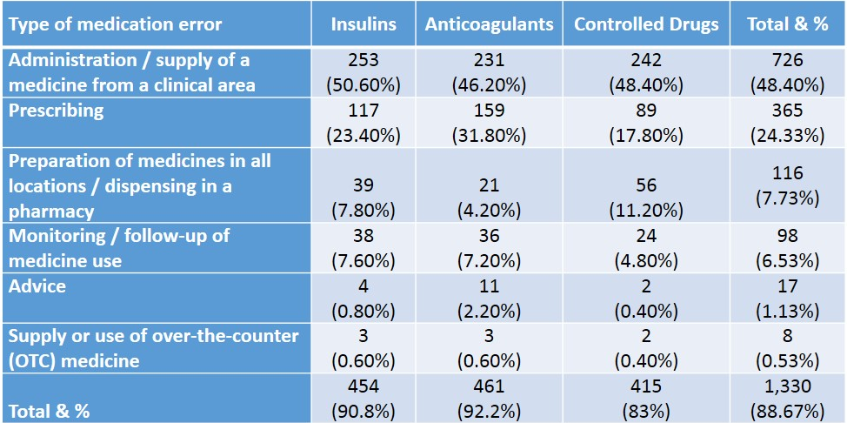

Table 8: The highest sub-types of medication errors (n = 1,192 reports)

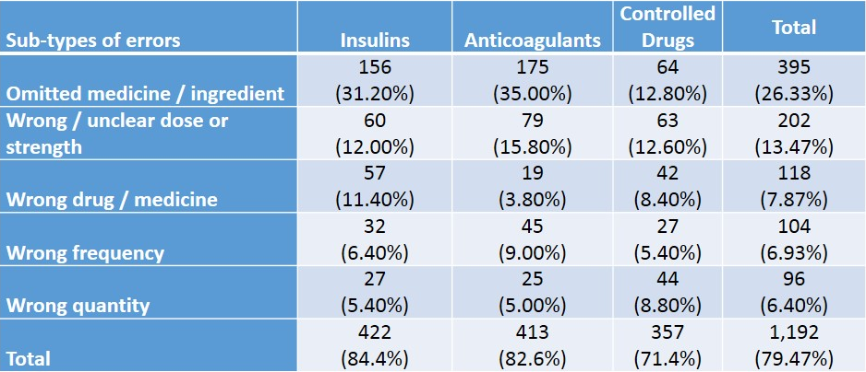

Table 9: Degree of harm for the three categories of studied medication (n = 1,352)
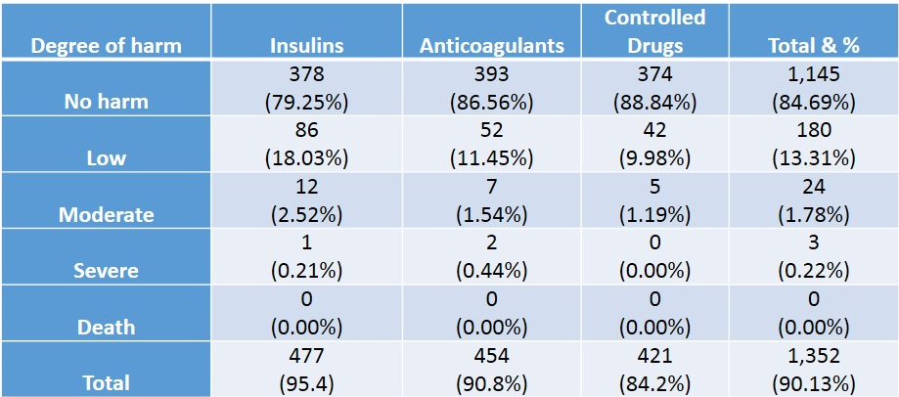

Table 10: Nature of errors across the three categories of medications (n = 1,223 reports)
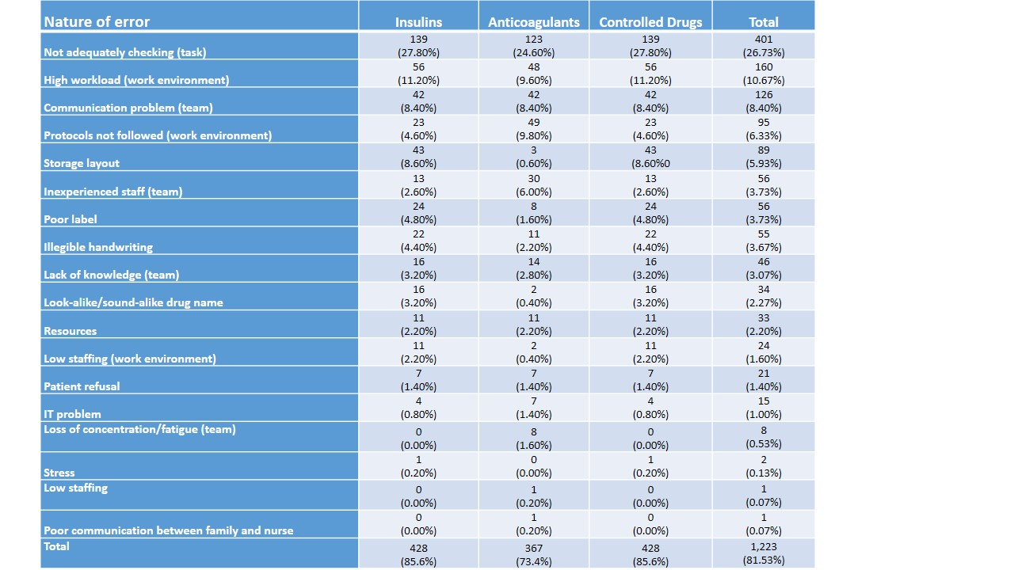

Table 11: Quality of learning for the three categories of medication (n = 1,367 reports).

