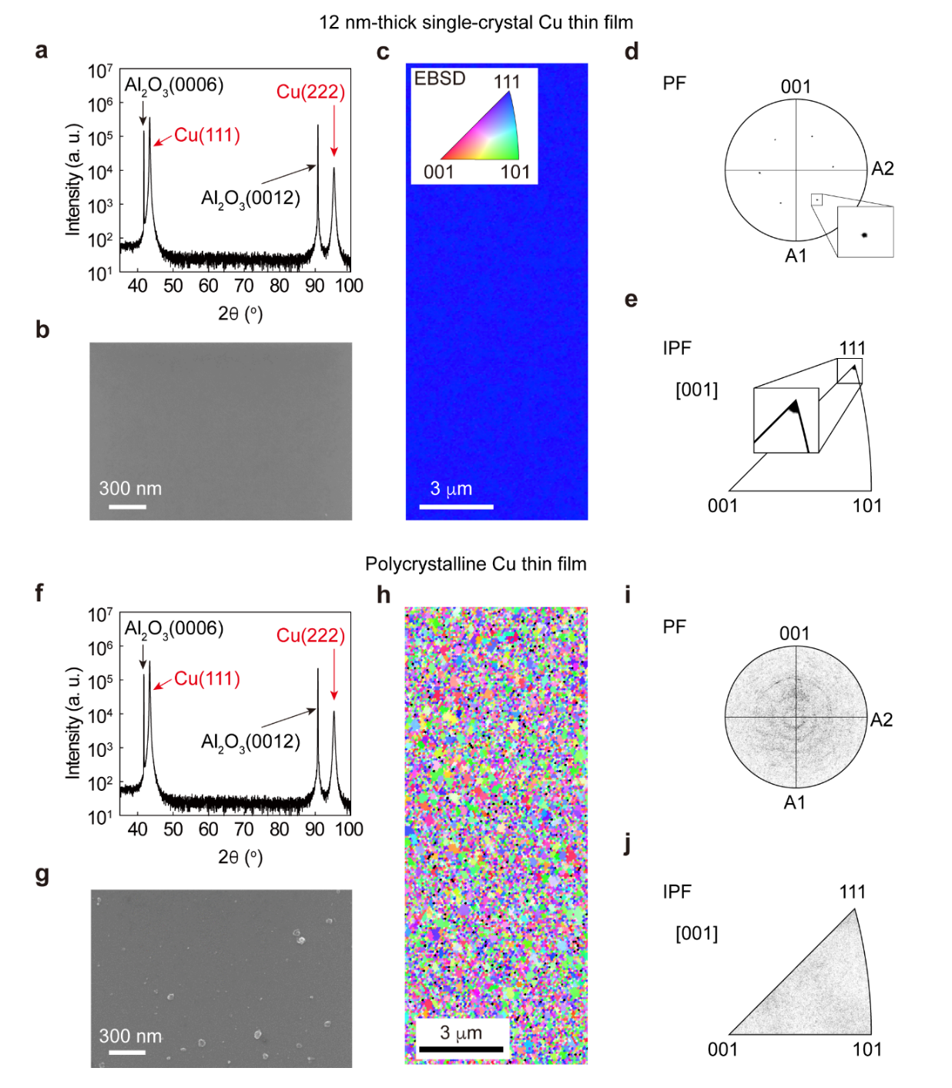
Extended Data Fig. 1 | Structural comparison of 12 nm-thick single-crystal Cu(111) with polycrystalline Cu with the same thickness. a, θ–2θ X-ray diffraction data, b, SEM image showing no grain boundaries, c, EBSD map showing perfect alignment along the (111) crystallographic orientation, d, [100] pole figure showing the sixfold symmetry of the {100} plane, e, Inverse pole figure with a sole spot associated with the (111) plane of 12 nm-thick single-crystal Cu(111). The inset image in a is the log-scale diffraction data. f, θ–2θ X-ray diffraction data showing two different peaks, g, SEM image showing grain boundaries and rough surface, h, EBSD map showing grains with all crystallographic orientations and distributed in random directions, i, [100] pole figure showing grains with no symmetry and aligned in random directions, and j, Inverse pole figure with spots spread in all possible crystallographic directions of the 12 nm-thick polycrystalline Cu.
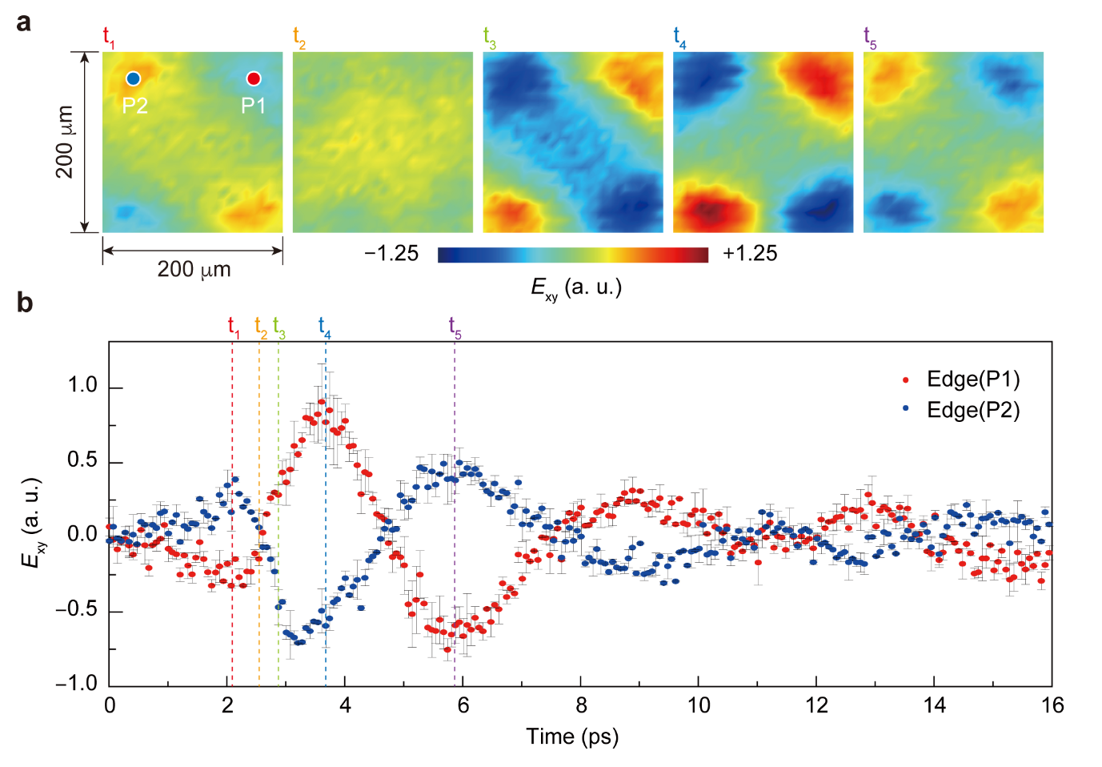
Extended Data Fig. 2 | Quantum oscillation dynamics measured under cross-polarization. a, Real-space snapshots (200 μm × 200 μm) of quantum oscillation at various times (t₁–t₅). b, Corresponding time-domain oscillatory signal at 0 $\text{≤}$ t $\text{≤}$ 16 ps.

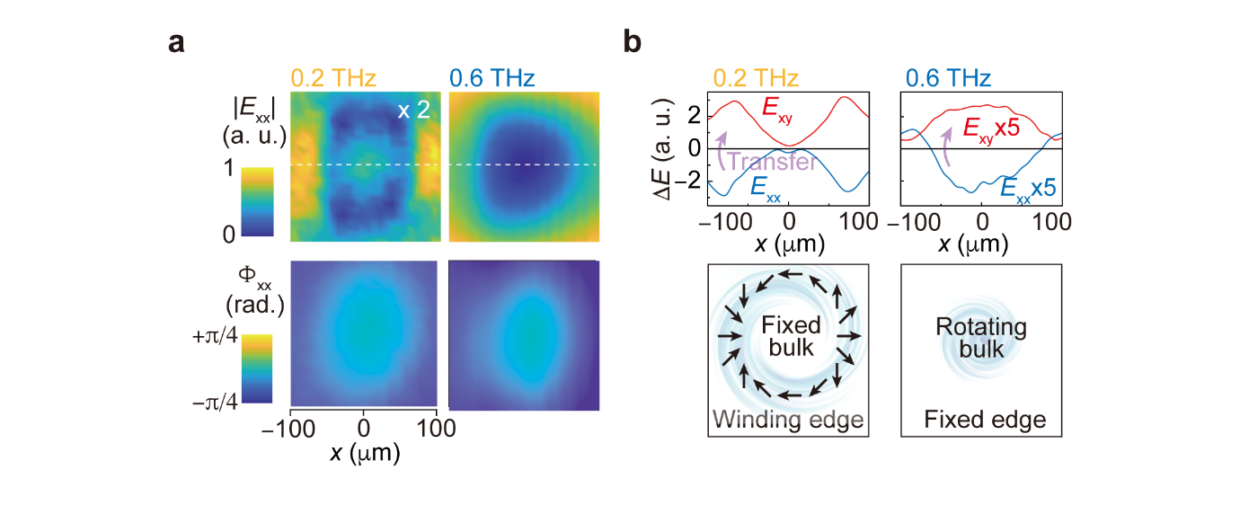
Extended Data Fig. 3 | Longitudinal flow of the electrons and their conversion to vortical electrons. a, |E_{xx}| and Φ_{xx} images measured at 0.2 THz and 0.6 THz under co-polarization where the source and detector are collinear in the x direction. The time domain E_{xx} (t) is converted to |E_{xx} (ω)| and Φ_{xx} (ω) through fast Fourier transformation. b, Intensity change (ΔE) of the edge mode (top left panel) and that of the centre mode (top right panel). The spectral weight of the longitudinal charges (|E_{xx}|) transverse charges (|E_{xy}|), verifying charge conservation (along the white dashed line in a). The bottom panels show the edge electron flow at 0.2 THz and the bulk electron flow at 0.6 THz.
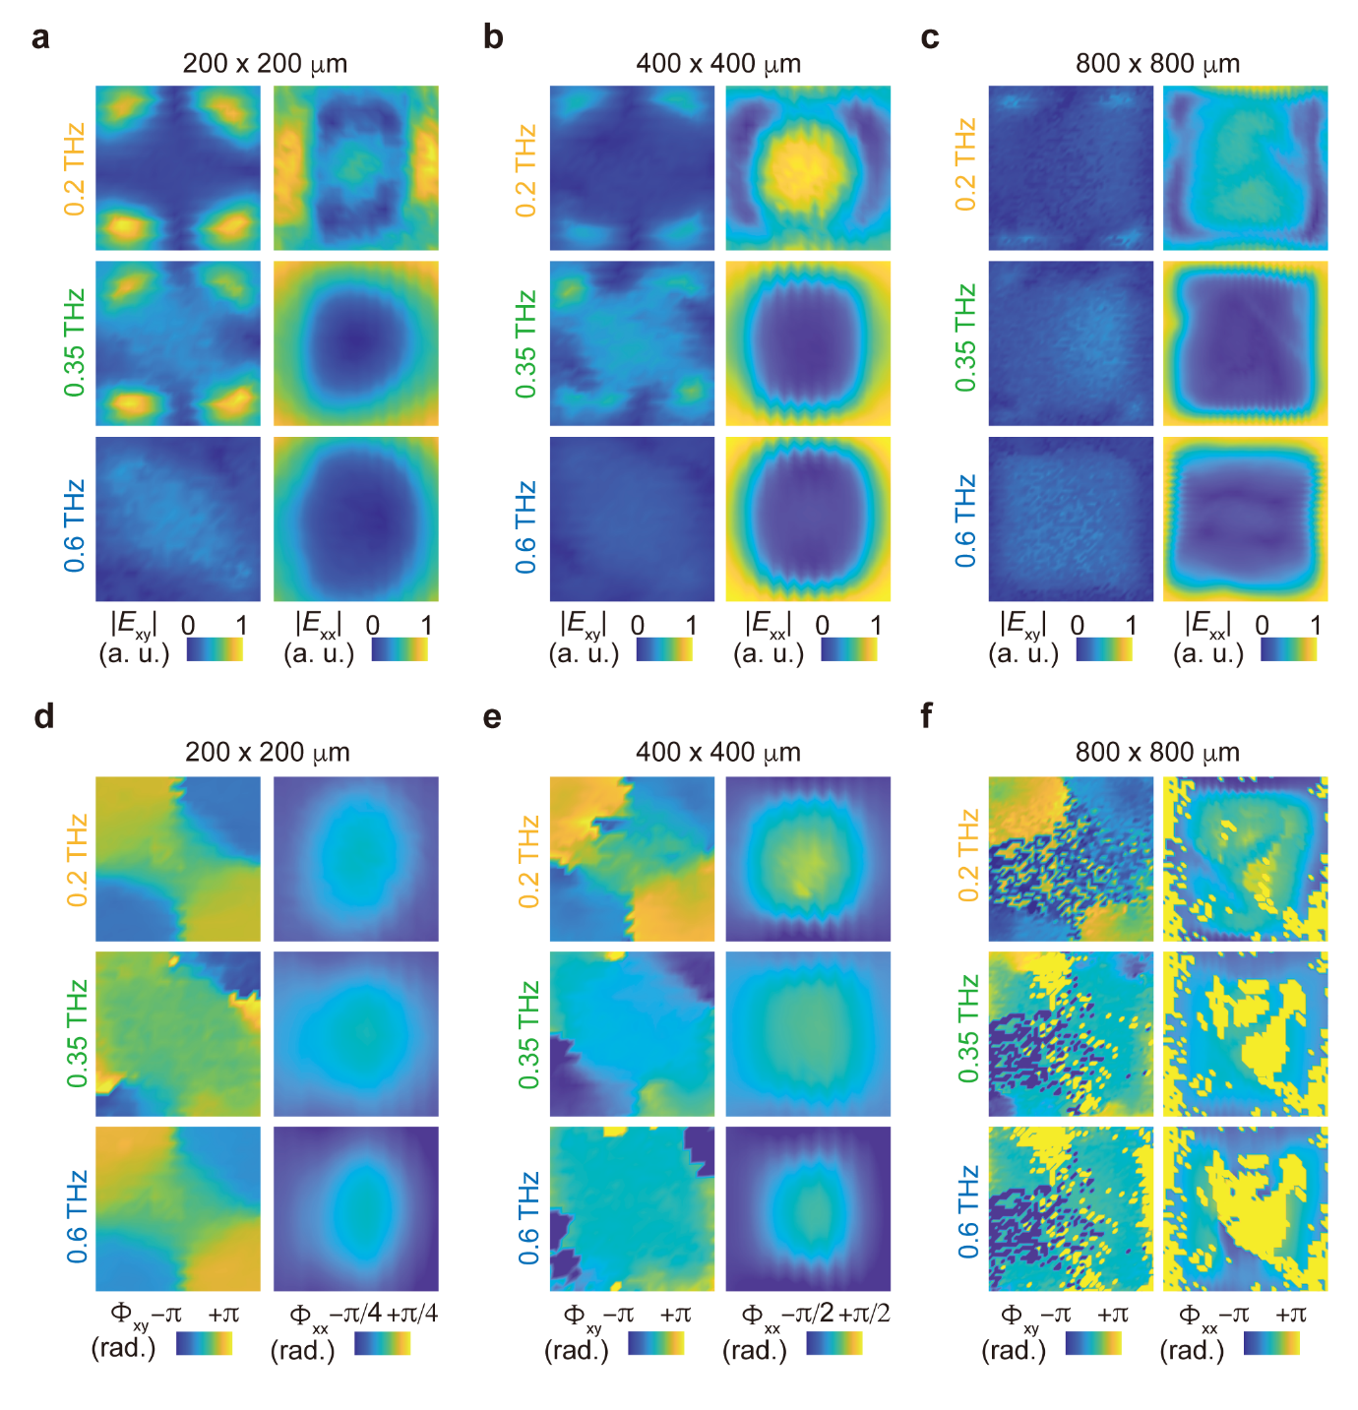
Extended Data Fig. 4 | Amplitude and phase images for different-sized Cu(111) films. |E_{xy}| and |E_{xx}| images at 0.2 THz, 0.35 THz, and 0.6 THz for a, 200 μm × 200 μm, b, 400 μm ×400 μm, and c, 800 μm × 800 μm. Φ_{xy} and Φ_{xx} images at 0.2 THz, 0.35 THz, and 0.6 THz for d, 200 μm × 200 μm, e, 400 μm × 400 μm, and f, 800 μm × 800 μm.

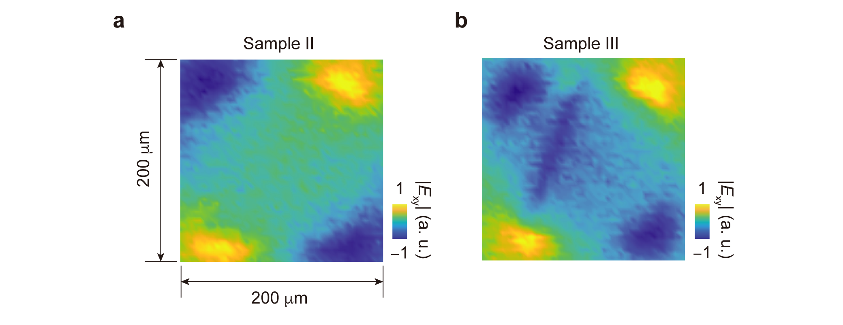
Extended Data Fig. 5 | Reproducibility of the data for three 200 μm × 200 μm samples. a, Sample II and b, Sample III.

