SUPPLEMENTARY
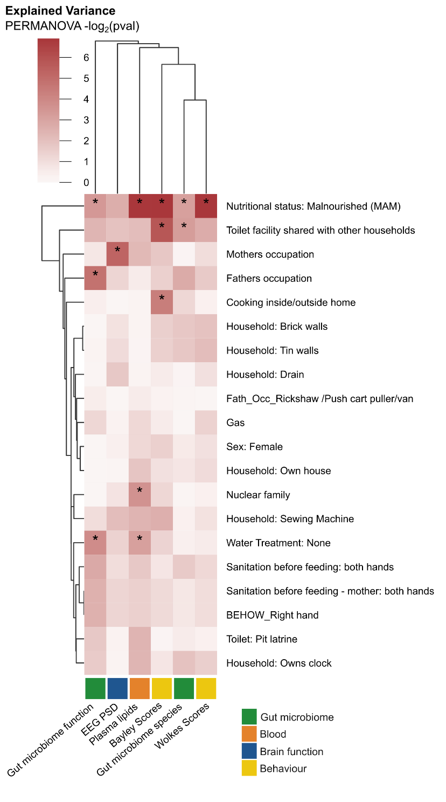
Figure S1: Clustermap of explained variance analysis of gut microbiome profiles, EEG PSD, Plasma lipids, Bayley and Wolke's score composition based on recorded covariates. Row and column dendrograms are hierarchical clustering. * = PERMANOVA p < 0.05.

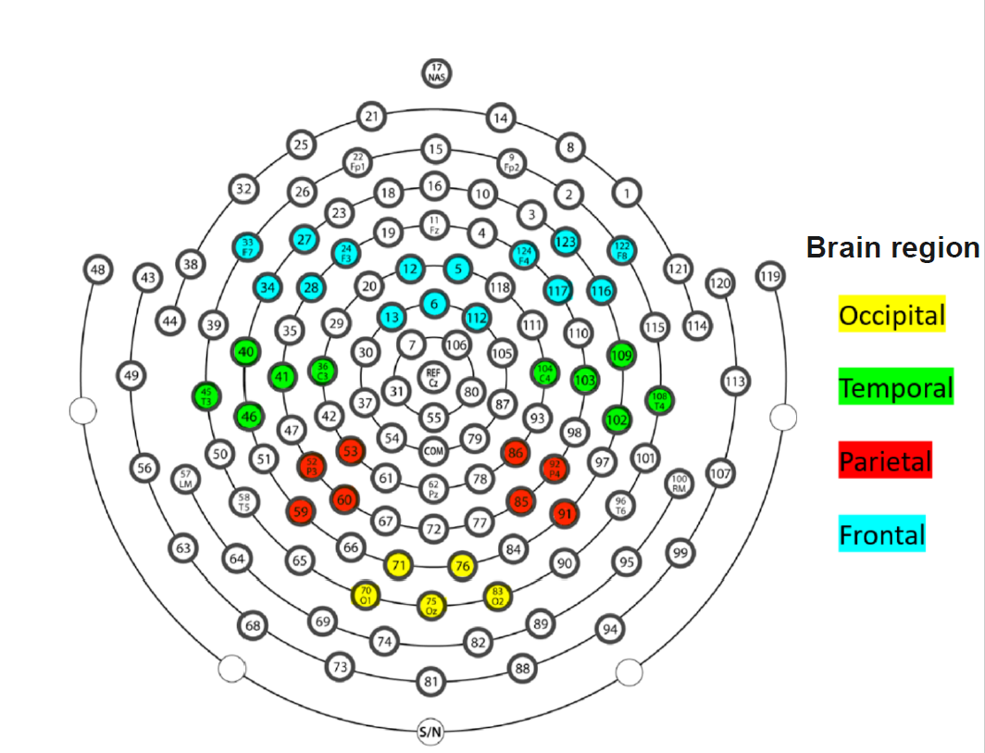
Figure S2: Electrode Configuration of 128-channel Hydrocel Geodesic Sensor Nets used for EEG recordings with brain regions of interest used for the analyses highlighted. Numbers identify the net detectors.

Table S1: Baseline child characteristics. Plus, minus values are mean values +- SD from continuous variables and their p-values are calculated using MWU. All other variables are categorical (True/False) with their p-values calculated using Fishers Exact test.
Table S2: Changes to gut microbial diversity associated with MAM.
Table S3: Changes to gut microbial taxa associated with MAM.
Table S4: Changes to gut microbial functional pathways associated with MAM.
Table S5: Changes to EEG PSD associated with MAM.
Table S6: Changes to Bayley score associated with MAM.
Table S7: Changes to Wolke’s score associated with MAM.
Table S8: Changes to plasma lipids associated with MAM.
Table S9: Changes to plasma lipid classes associated with MAM.
Table S10: Mean SHAP score measure of important features by Random Forest classification.
Table S11: Spearman correlation between features.

