Supplementary file
Figure S1: Colorimetric data for the functionalized cotton fabrics; [a, b] absorbance and [c, d] color strength.

[a] | 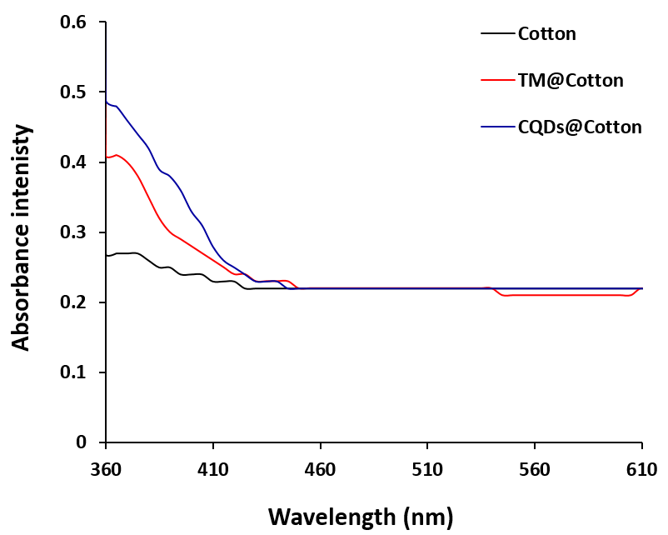 | [b] | 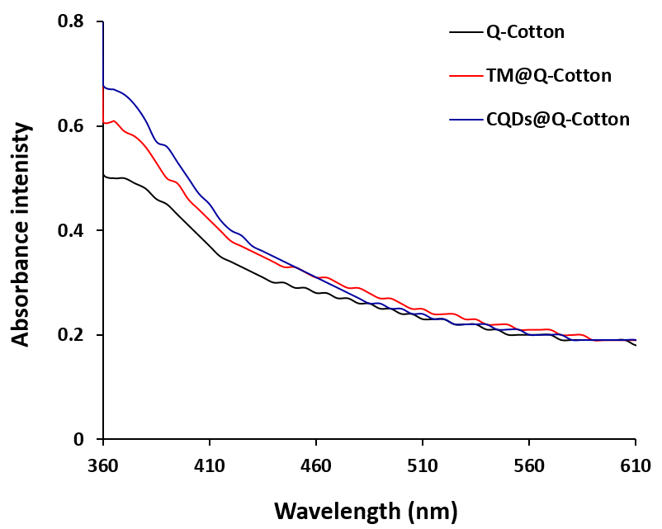
[c] | 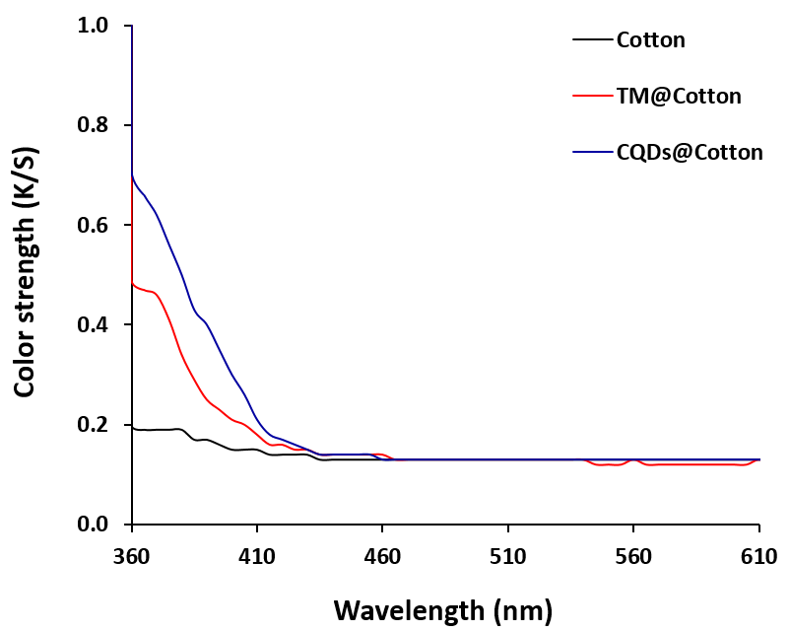 | [d] | 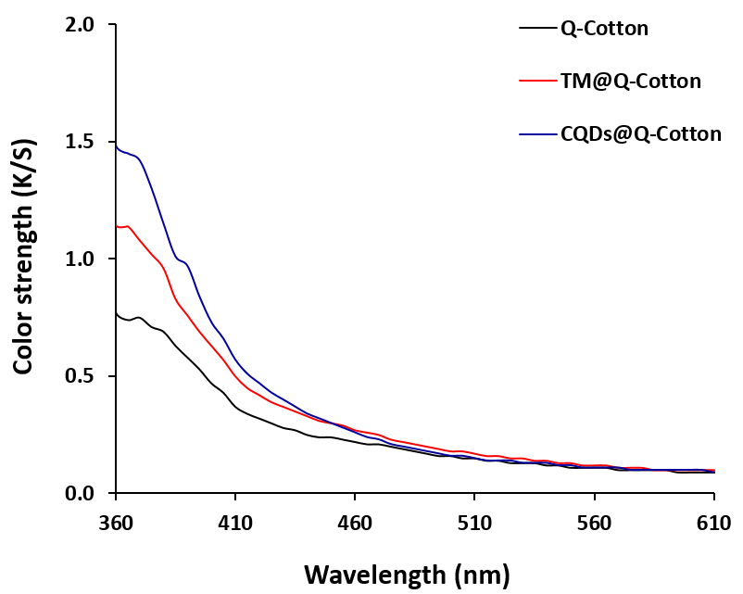

Figure S2: Transmission through the functionalized cotton fabrics after 5 and 10 washings; [a, b] cotton, [c, d] cationized cotton, [a, c] 5 washings and [b, d] 10 washings.

[a] | 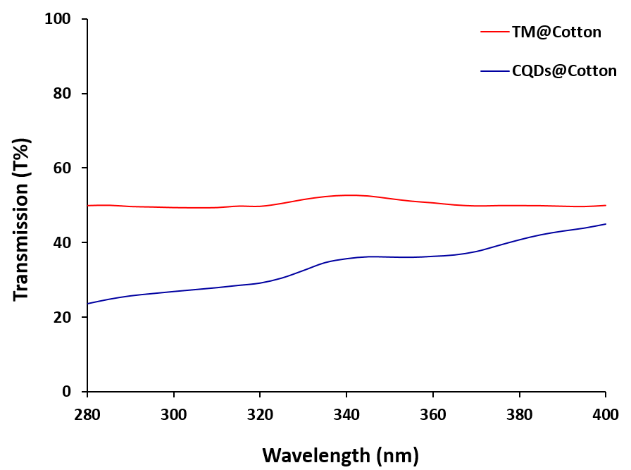 | [b] | 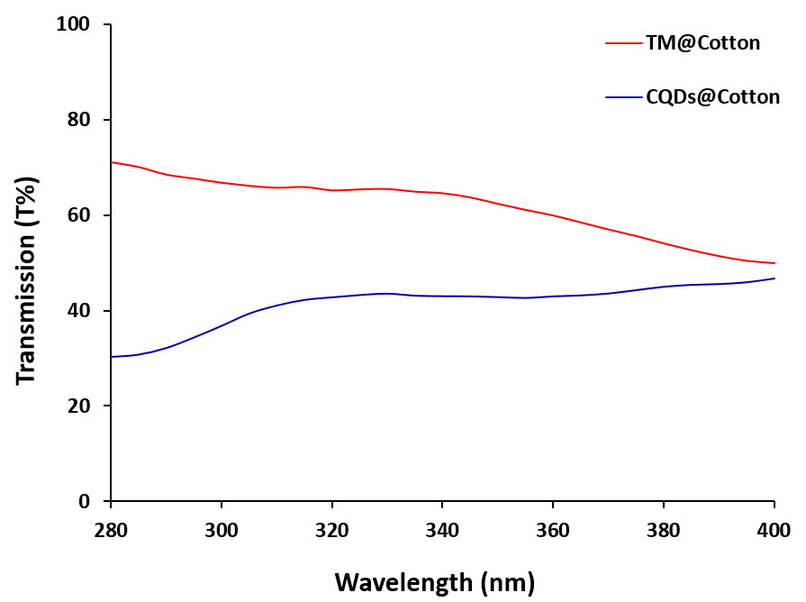
[c] | 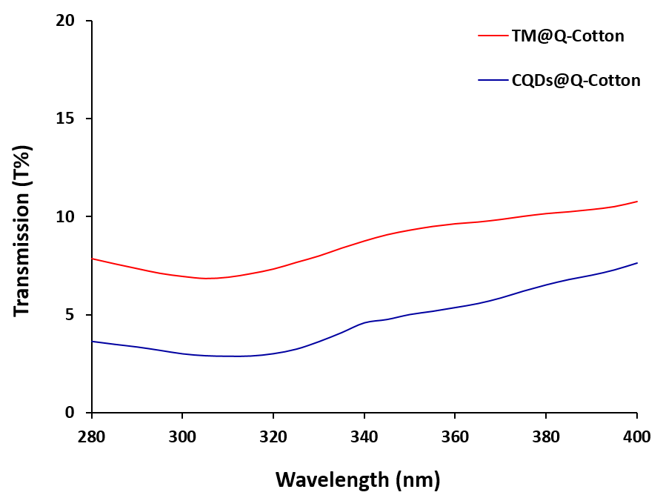 | [d]

