Supplementary Information
Gram-Scale Synthesis of Heterogeneous Cu-MOFs Catalyst with Dual Functionalities for Late-stage Dicarbofunctionalization of Alkenes

Lu Dong,^{[a],#} Hu Chen,^{[a],#} Xiaoli Tan,^{[a],#} Wei Sun, ^{[b]} Rui Feng, ^{[c]} Yanyuan Jia ^{[a],*} and Shuo Guo^{[a],*}

[a] College of Chemistry and Chemical Engineering, Inner Mongolia University, Hohhot 010021, P. R. China
[b] Department of Chemistry, University of Michigan, Ann Arbor, MI 48109, USA
[c] School of Materials Science and Engineering, Smart Sensing Interdisciplinary Science Center, Nankai University & TKL of Metal and Molecule Based Material Chemistry, Tianjin 300350, P. R. China

Table of Contents
1 General information S1
2 Synthesis and characterization of IMU-108 S2
2.1 Solvothermal synthesis of IMU-108 [Cu₃(5,5'-dsdibdc)_{1.5}(H₂O)₂ DMA]·
(solvents)_{n} S2
2.2 Gram scale synthesis of microcrystals of IMU-108 S2
2.3 Single crystal X-ray crystallography of IMU-108 S2
3 Basic performance test of IMU-108 S4
3.1 Stability evaluation, structure and optical characterization of IMU-108 S4
3.2 Solid state cyclic voltammetry of IMU-108 S6
3.3 Photoelectrochemical measurements of IMU-108 S7
4 Preparation of substrates S8
5 Reaction optimization tables S11
5.1 Optimization of bases S11
5.2 Optimization of reaction time S12
5.3 Optimization of the reaction concentration S12
6 Experimental procedures and spectral data S13
7 Mechanistic studies S31
7.1 Radical inhibition experiments S31
7.2 Stern-Völmer quenching experiment S32
7.3 Light on/off experiment S34
8 Stability studies of IMU-108 S35
8.1 Cyclic experiments S35
8.2 Leaching experiments S35
8.3 PXRD patterns of IMU-108 S36
8.4 The unit-cell parameters of IMU-108 before and after catalysis S37
9 Scale up of three-component coupling reactions S37
10 References S38
11 ¹H NMR, ¹³C NMR and ¹⁹F NMR Spectra S40

1 General information
Materials
Unless otherwise mentioned, all reactions were carried out in oven dried glassware under a nitrogen (purity ≥ 99.999%) atmosphere. All solvents were dried and purified by refluxing with CaH₂ (2g/L) for 1 hour followed by fractional distillation. The purified solvents were stored over 4Å molecular sieves. Commercially available reagents were purchased from Adamas-beta, TCI, Aladdin, Macklin, J&K Chemical, Innochem, and Sigma Aldrich. Organic solutions were concentrated under reduced pressure on a Yarong RE-2000B rotary evaporator. Reactions were monitored by thin-layer chromatography (TLC) and the spots on TLC plates were visualized using a UV light. The LED lamps were purchased from Kessil 427 nm. 5-mercaptoisophthalic acid (H₂5-mbdc) was synthesized according to the literature method^{[1]}.
Instruments
¹H, ¹⁹F, and ¹³C NMR spectra were recorded on Bruker AVANCE NEO 600 MHz NMR spectrometer. Chemical shifts (δ) were reported in parts per million (ppm) relative to deuterated chloroform (7.26 ppm for ¹H NMR; 77.16 ppm for ¹³C NMR). ¹⁹F NMR chemical shifts were calibrated wiht trifluoromethoxy benzene as an internal standard (-57.40 ppm for ¹⁹F NMR). Coupling constants (J) were reported in Hz. The following abbreviations are used to represent the multiplicities in NMR spectra: singlet (s), doublet (d), triplet (t), quartet (q), multiplet (m), and broad (b).
Thermogravimetric analyses (TGA) were performed at a ramp rate of 5 ℃/min under a nitrogen flow with an STA449 FJupiter. Scanning electron microscopy (SEM) images were collected on a Hitachi S-4800 scanning electron microscope. Powder X-ray diffraction (PXRD) data were collected in the reflection mode at room temperature on a Malvern Panalytical Empyrean diffractometer with a Cu source (8.04 keV, wavelength = 1.5406 Å). The X-ray tube was operated at a voltage of 40 kV and a current of 40 mA. Simulation of the PXRD pattern was carried out based on the single-crystal data by diffraction crystal module of the Mercury program version 1.4.2 available free of charge via the Internet at http://www.iucr.org. The solid state UV-Vis spectra were measured by a Perkin Elmer LAMBDA 750 Spectrophotometer. Fluorescence spectra were recorded on a Hitachi F-4700 fluorescence spectrophotometer. The HR-MS results were obtained on a Waters G2-XS QToF mass spectrometer. GC-MS measurements were conducted on an Agilent 8860/5977B system.

2 Synthesis and characterization of IMU-108

2.1 Solvothermal synthesis of IMU-108 [Cu₃(5,5'-dsdibdc)_{1.5}(H₂O)₂ DMA]·(solvents)_{n}
IMU-108 was synthesized by the solvothermal reaction of H₂5-mbdc (0.08 mmol) and Cu(NO₃)₂·3H₂O (0.15 mmol) in DMA (1 mL) and ethanol (4 mL) at 70 ℃ for 3 days to give blue polyhedral shape crystals (Figure S1). The crystals were washed repeatedly with DMA followed by ethanol and dried in air. (Yield: ~ 70% based on ligand). (H₂5-mbdc = 5-mercaptoisophthalic acid, H₄5,5'-dsdibdc = 5,5'-disulfanediyldiisophthalic acid).
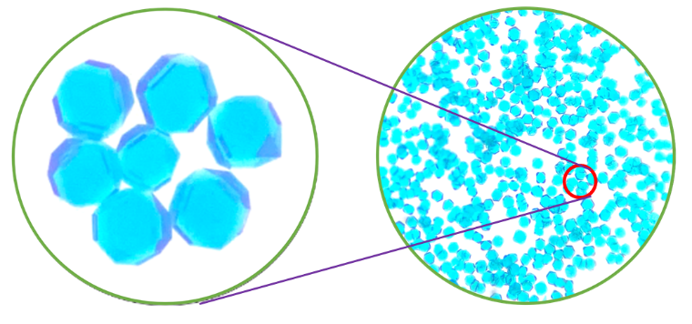
Fig. 1 Optical images of IMU-108 under a microscope

2.2 Gram scale synthesis of microcrystals of IMU-108
A mixture of Cu(NO₃)₂·3H₂O (11.95 mmol), H₂5-mbdc (5.66 mmol), DMA (30 mL) and ethanol (120 mL) were added to a 250 mL round-bottom flask and refluxed for 12 hours. After natural cooling to ambient temperature, blue powdery microcrystals of IMU-108 were obtained. The resulting products were rinsed with fresh DMA and ethanol, then dried in air (Yield: ~60% based on ligand).

2.3 Single crystal X-ray crystallography of IMU-108
Single-crystal X-ray diffraction test was produced on a Bruker APEX-II CCD with Cu K\α (λ = 1.54178). The crystal was kept at 293 K during data collection. The structure of IMU-108 was solved by direct methods and the full matrix least square method was used to refine the crystal structure. All non-hydrogen atoms were refined through anisotropic displacement parameters, and all hydrogen atoms were generated theoretically based on the calculated positions^{[2]}. Detailed crystallographic data and structure refinement details for IMU-108 are listed in Table S1. The CCDC number for IMU-108 is 2293138.
Fig. 2 The coordination environment of Cu (II) ions in IMU-108
Table 1. Crystallographic data and refinement parameters of IMU-108
Chemical formula | C₃₂H₃₁Cu₃N₂O₁₆S₃
Formula weight | 986.39
Crystal system | Tetragonal
Space group | I4/m
a/(Å) | 26.4385(2)
b/(Å) | 26.4385(2)
c/(Å) | 32.7064(5)
α/(°) | 90
β/(°) | 90
γ/(°) | 90
V/(Å³) | 22861.6(5)
Z | 16
ρ_{calc} / g cm⁻³ | 1.146
F(000) | 8000.0
T / K | 293(2)
Reflections collected | 156024
R_{int} | 0.1664
GOF on F² | 1.040
R₁ / wR₂ [I > 2σ (I)] ª | 0.0560/0.1529
R₁ / wR₂ [(all data)] ^{b} | 0.0743/0.1641
ª R₁ = Σ||F_{o}| – |F_{c}|| / Σ|F_{o}|; ^{b} wR₂ = {Σ[w(F_{o}² – F_{c}²)²] / Σw (F_{o}²)²}^{1/2}

3 Basic performance test of IMU-108

3.1 Stability evaluation, structure and optical characterization of IMU-108
To evaluate the stability of IMU-108, thermogravimetric analyses (TGA) were carried out. The thermal weight loss of IMU-108 (purple line) is divided into two stages. The weight loss in the first stage (before 120 °C) is attributed to the removal of solvent molecules. The weight loss (260 − 320 °C) in the second stage is due to the structure of the frameworks begins to collapse and decompose. Activated frameworks IMU-108 were successfully obtained through solvent exchange of the as-synthesized samples with fresh ethanol absolute followed by the activation under vacuum at 180 °C for 6 hours to remove the guest solvent molecules. TGA of IMU-108 after activated was carried out (green line) to further evaluate the thermal stability of IMU-108. The preliminary weight loss before 100 °C is attributed to the escape of residual solvent molecules. Further raising the temperature above 300 °C will bring about gradual weight loss that represents the decomposition of the framework. The results indicate that IMU-108 is stable up to 260 °C.
Fig. 3 Thermogravimetric analyses of IMU-108
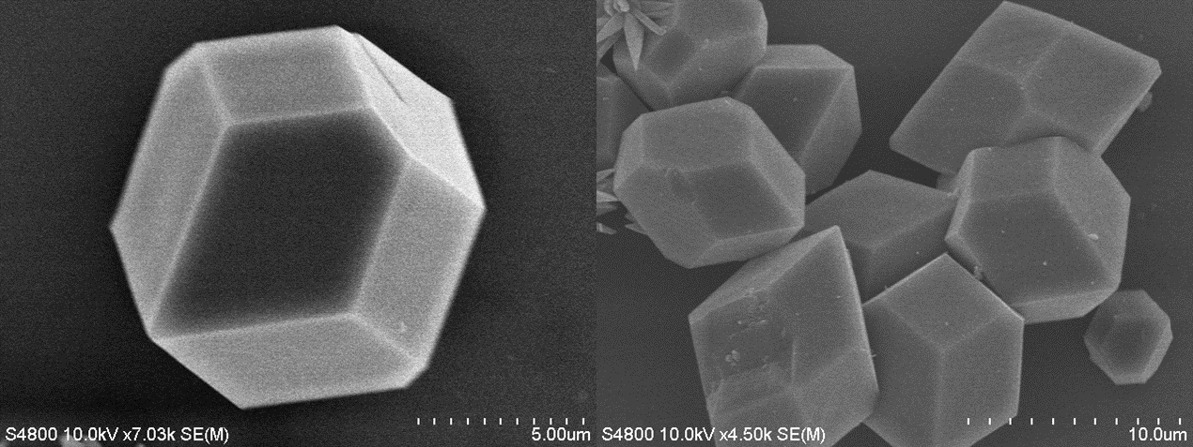
Fig. 4 The SEM images of IMU-108 synthesized by reflux

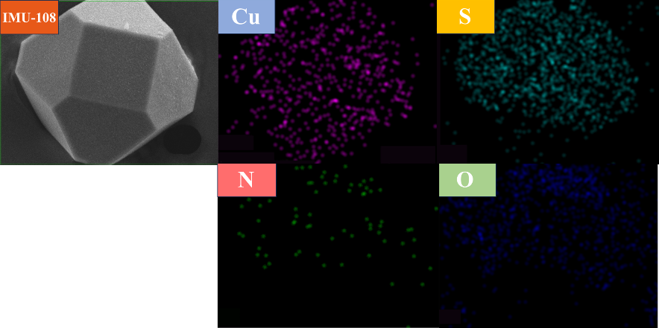
Fig. 5 Elemental mapping images of the IMU-108

Fig. 6 PXRD patterns of IMU-108

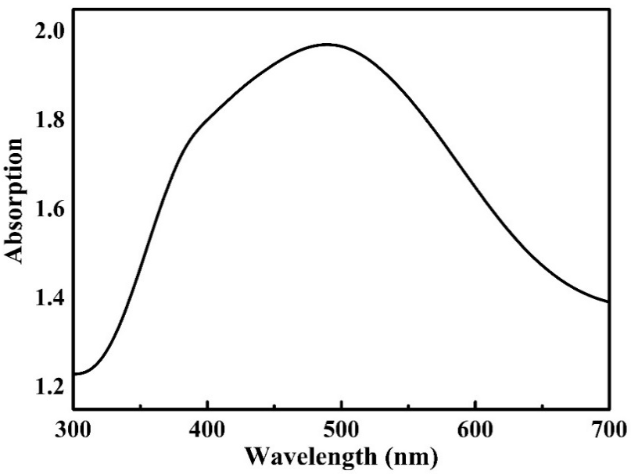
Fig. 7 Solid state UV-Vis absorption spectrum of IMU-108

3.2 Solid state cyclic voltammetry of IMU-108
Solid state cyclic voltammetry (CV) was measured on CHI 760E (Chenhua, Shanghai) electrochemical workstation with a three-electrode system. The carbon paper loaded with the catalyst IMU-108 as the working electrode, a platinum wire and Ag/AgCl electrode served as the counter electrode and reference electrode, respectively. Catalyst suspension solution were prepared via mixing 5 mg catalyst, 400 µL ethanol and 100 μL Nafion solution. Then it was sonicated for 30 mins to form a stable suspension. The obtained suspension was dropped onto the carbon paper and the catalyst loading area was 1*1 cm² to contact with electrolyte. CV measurements was conducted in a tetrabutylammonium hexafluorophosphate solution (0.1 M, acetonitrile) with a scan rate of 100 mV s⁻¹.
Fig. 8 Solid state cyclic voltammetry of IMU-108
The Methods of Calculation of the Excited-State Reduction Potential E_{red}*: As an approximation, the excited-state potentials of a catalyst are related to its ground state potentials (E_{1/2} (Cu^{Ⅱ}/Cu^{Ⅰ}) = 0.67 V) and its free energy (zero-zero excitation energy, E⁰⁻⁰ = 3.42 V, the E⁰⁻⁰ of the IMU-108 was calculated by the solid-state UV-vis and fluorescence spectra^{[3]} (Fig. S7).
E_{red}* = E_{1/2} (Cu^{II}/Cu^{I}) – E⁰⁻⁰ = 0.67 V – 3.42 V = –2.75 (V vs. Ag/AgCl)

3.3 Photoelectrochemical measurements of IMU-108
Photoelectrochemical measurements were performed on a CHI 760E (Chenhua, Shanghai) electrochemical workstation using a standard three-electrode system with tetrabutylammonium hexafluorophosphate acetonitrile solution (0.05 M) as the electrolyte. Ag/AgCl and platinum flake were used as reference electrode and counter electrode, respectively. The carbon paper loaded with the catalyst IMU-108 as the working electrode. Catalyst stable suspension solution were prepared via mixing 5 mg catalyst, 400 µL ethanol and 100 μL Nafion solution. Then it was sonicated for 30 mins to form the stable suspension solution. The obtained stable suspension solution was dropped onto the surface of the carbon paper and the catalyst loading area was 1*1 cm² to contact with electrolyte. Added IMU-108 (3 mol%), dtbpy (20 mol%), p-tert-butylstyrene (0.1 mmol), p-fluorophenylboronic acid (2.5 equiv.), methyl 2-bromoisobutyrate (2.0 equiv.), Et₂NH (0.5 equiv.), Cs₂CO₃ (2.0 equiv.) in a 50ml beaker with 0.05M electrolyte. The photocurrent responses were measured at room temperature under the irradiation of a 427 nm LED lamp.The photocurrent responses were measured at room temperature under the irradiation of a 427 nm LED lamp.
Fig. 9 Photoelectrochemical measurements of IMU-108 (red), HKUST-1 (black), H₂5-mbdc (blue), Cu(NO₃)₂·3H₂O (pink)

4 Preparation of substrates
Scheme 1. Commercially available substrates

Scheme 2. Preparation of styrene derivative substrates
Note: Substrates 1i^{[4]}, 1j^{[5]}, 1k^{[6]}, 1l^{[7]}, 1m^{[8]}, 1n^{[9]}, 1o^{[10]}, 1p^{[11]}, 1q^{[12]}, 1r^{[13]}, 1s^{[14]}, 1t^{[15]} were prepared according to the literature.

Scheme 3. Preparation of α-carbonyl alkyl bromides substrates
Note: Substrates 2b^{[16]}, 2c^{[17]}, 2d^{[18]}, 2e^{[19]}, 2g^{[20]} were prepared according to the literature. Other substrates are prepared from commercially available compounds, described in the following section.
Preparation of α-carbonyl alkyl bromides substrates
In a 50 mL round bottom flask with a magnetic stir bar, alcohol (1.0 equiv., 5 mmol) were added and dissolved in DCM (12.5 mL, 0.4 M). Subsequently, Et₃N (1.4 equiv., 1.0 mL) was added at room temperature, the above compounds were stirred for 15 mins and then cooled down to 0°C. 2-Bromoisobutyryl bromide (1.3 equiv., 0.81 mL) was added dropwise at low temperature. The progress of the reaction was monitored by TLC and when the reaction was completed, quenched by the addition of water, after which it was extracted with DCM, washed with saturated saline and dried with anhydrous sodium sulfate. The filtrate was concentrated in vacuum to give the crude products. The crude mixture was purified by silica gel column chromatography and the corresponding pure products were obtained using petroleum ether : ethyl acetate mixture as eluent.
Compound 2f
Following the above methods, the product was isolated by flash chromatography (Petroleum ether/EtOAc = 30:1) as a white solid (342 mg, 18% yield).
R_{f} = 0.5 (Petroleum ether/EtOAc = 10:1). NMR Spectroscopy: ¹H NMR (600 MHz, CDCl₃) δ 2.45 – 2.46 (m, 1H), δ 2.11 – 2.08 (m, 1H), δ 2.01 – 2.00 (m, 4H), 1.89 (s, 6H), 1.80 (t, J = 11.2, 9.7 Hz, 1H), δ 1.70 – 1.64 (m, 2H), 1.55 (s, 3H), 1.50 – 1.46 (m, 1H), 1.41 – 1.36 (m, 2H), 1.31 – 1.25 (m, 1H), 1.17 (s, 3H), 0.98 (s, 3H), 0.84 (d, J = 7.1 Hz, 3H). ¹³C NMR (151 MHz, CDCl₃) δ 170.3, 89.0, 58.1, 57.5, 56.8, 54.1, 43.6, 41.5, 41.4, 37.1, 33.0, 31.5, 31.1, 30.9, 28.6, 27.7, 25.4, 25.1, 15.6. HRMS (ESI) m/z: [M+Na]⁺ Calcd for C₁₉H₃₁BrO₂Na⁺, 393.1399, found, 393.1404.
Compound 2h
Following the above methods, the product was isolated by flash chromatography (Petroleum ether/EtOAc= 5:1) as a white solid (831 mg, 38%).
R_{f} = 0.2 (Petroleum ether/EtOAc = 5:1). NMR Spectroscopy: ¹H NMR (600 MHz, CDCl₃) δ 5.73 (s, 1H), 4.67 (t, J = 8.7 Hz, 1H), 2.48 – 2.33 (m, 3H), 2.29 (t, J = 14.5 Hz, 1H), 2.2 – 2.2 (m, 1H), 2.03 (d, J = 13.4 Hz, 1H), 1.93 (d, J = 2.3 Hz, 6H), 1.84 (t, J = 12.7 Hz, 2H), 1.72 (t, J = 13.4, 6.9 Hz, 2H), 1.60 (t, J = 13.5 Hz, 3H), 1.5 – 1.3 (m, 2H), 1.26 – 1.22 (m, 1H), 1.20 (d, J = 2.3 Hz, 3H)., 1.14 – 1.00 (m, 2H), 1.00 – 0.94 (m, 1H), 0.91 (s, 3H).¹³C NMR (151 MHz, CDCl₃) δ 199.3, 171.8, 124.2, 83.9, 56.4, 53.8, 50.4, 43.1, 38.8, 36.8, 35.9, 35.6, 34.1, 32.9, 31.6, 30.9, 30.9, 27.2, 23.6, 20.7, 17.6, 12.1. HRMS (ESI) m/z: [M+Na]⁺ Calcd for C₂₃H₃₃BrO₃Na⁺, 459.1505, found, 459.1513.
Compound 2i
Following the above methods, the product was isolated by flash chromatography (Petroleum ether/EtOAc = 5:1) as a white solid (1154 mg, 55% yield).
R_{f} = 0.2 (Petroleum ether/EtOAc = 5:1). NMR Spectroscopy: ¹H NMR (600 MHz, CDCl₃) δ 8.36 (d, J = 8.8 Hz, 1H), 7.99 (s, 1H), 7.51 – 7.50 (m, 2H), 7.33 (d, J = 2.2 Hz, 1H), 7.22 – 7.20 (m, 1H), 6.98 (d, J = 8.6 Hz, 2H), 3.85 (s, 3H), 2.10 (s, 6H). ¹³C NMR (151 MHz, CDCl₃) δ 175.8, 169.7, 159.9, 156.8, 154.6, 152.8, 130.3, 128.2, 125.4, 123.9, 122.8, 119.0, 114.2, 110.7, 55.5, 55.0, 53.6, 30.6. HRMS (ESI) m/z: [M+Na]⁺ Calcd for C₂₀H₁₇BrO₅Na⁺, 439.0151, found, 439.0151.
Compound 2j
Following the above methods, the product was isolated by flash chromatography (Petroleum ether/EtOAc= 5:1) as a white solid (923 mg, 69% yield).
R_{f} = 0.2 (Petroleum ether/EtOAc = 5:1). NMR Spectroscopy: ¹H NMR (600 MHz, CDCl₃) δ 4.79 – 4.66 (m, 1H), 2.00 (s, 2H), 1.93 (s, 1H), 1.91 (s, 6H), 1.87 – 1.79 (m, 2H), 1.79 – 1.72 (m, 1H), 1.68 – 1.60 (m, 2H), 1.58 – 1.47 (m, 3H), 1.45 – 1.38 (m, 1H), 1.37 – 1.24 (m, 8H), 1.23 – 1.17 (m, 2H), 1.16 – 1.04 (m, 6H), 1.05 – 0.94 (m, 3H). 0.90 (d, J = 6.5 Hz, 3H), 0.89 – 0.84 (m, 6H), 0.84 (s, 3H), 0.65 (s, 3H). ¹³C NMR (151 MHz, CDCl₃) δ 171.2, 75.6, 56.5, 56.5, 56.4, 54.3, 44.8, 42.7, 40.1, 39.6, 36.8, 36.3, 35.9, 35.6, 33.6, 32.1, 30.8, 30.1, 28.7, 28.3, 28.1, 27.1, 24.3, 23.9, 22.8, 22.6, 21.3, 18.8, 12.3, 12.1. HRMS (ESI) m/z: [M+Na]⁺ Calcd for C₃₁H₅₃BrO₂Na⁺, 559.3121, found, 559.3126.

5 Optimization of the reaction

5.1 Optimization of bases
Table 2. Optimization of bases
ªReaction conditions: IMU-108 (3 mol%), dtbpy (20 mol%), p-tert-butylstyrene (1a) (0.1 mmol), p-fluorophenylboronic acid (2a) (2.5 equiv.), methyl 2-bromoisobutyrate (3a) (2.0 equiv.), base (0.5 equiv.), Cs₂CO₃ (2.0 equiv.), DCM (0.03 M), room temperature, 20 h, 427 nm LED. Yields were determined by ¹⁹F NMR spectroscopy using trifluoromethoxy benzenes as an internal standard. Comment: Et₂NH performed better than the other screened bases. dtbpy = 4,4'-di-tert-butyl-2,2'-bipyridine, ^{b}TBD = 1,5,7-Triazabicyclo [4.4.0]dec-5-ene, ^{c}TMEDA = N, N, N', N'-tetramethylethylenediamine, ^{d}DMIPA = N-dimethylisopropylamine.

5.2 Optimization of reaction time
Table 3. Optimization of reaction time
Reaction conditions: IMU-108 (3 mol%), dtbpy (20 mol%), p-tert-butylstyrene (1a) (0.1 mmol), p-fluorophenylboronic acid (2a) (2.5 equiv.), methyl 2-bromoisobutyrate (3a) (2.0 equiv.), Et₂NH (0.5 equiv.), Cs₂CO₃ (2.0 equiv.), DCM (0.03 M), room temperature, 427 nm LED. Yields were determined by ¹⁹F NMR spectroscopy using trifluoromethoxy benzenes as an internal standard. Comment: 20 hours afforded the highest yield of 4a.

5.3 Optimization of the reaction concentration
Table 4. Optimization of the reaction concentration
Reaction conditions: IMU-108 (3 mol%), dtbpy (20 mol%), p-tert-butylstyrene (1a) (0.1 mmol), p-fluorophenylboronic acid (2a) (2.5 equiv.), methyl 2-bromoisobutyrate (3a) (2.0 equiv.), Et₂NH (0.5 equiv.), Cs₂CO₃ (2.0 equiv.), DCM, room temperature, 427 nm LED. Yields were determined by ¹⁹F NMR spectroscopy using trifluoromethoxy benzenes as an internal standard. Comment: 0.03 M gave the best yield of 4a.

6 Experimental procedures and spectral data
General procedure for the three-component reaction
In an N₂ glovebox, to a 100 mL thick-walled pressure bottle equipped with a magnetic stir bar was added IMU-108 (3.0 mmol%, 0.018 mmol, 18.0 mg), dtbpy (20.0 mmol%, 0.12 mmol, 32.2 mg), (4-fluorophenyl)boronic acid (2.5 equiv., 1.5 mmol, 208.5 mg), Cs₂CO₃ (2.0 equiv., 1.2 mmol, 391.0 mg) in dry DCM (18.0 mL, 0.03M), followed by styrene derivatives (1.0 equiv., 0.6 mmol), α-carbonyl alkyl bromides (2.0 equiv., 1.2 mmol), diethylamine (0.5 equiv., 0.3mmol, 31.0 µL). The reaction mixture was stirred vigorously at room temperature and exposed to 427 nm LED for 20 hours. The reaction mixture was diluted with dichloromethane (~ 50 mL) and filtered through a plug of celite®, the filter cake being further washed with dichloromethane (~ 50 mL). The filtrate was concentrated in vacuo to yield the crude products. The crude mixture was purified by column chromatography on silica gel (200~300 mesh) with hexanes : ethyl acetate mixtures as eluent.
Methyl-4-(4-(tert-butyl)phenyl)-4-(4-fluorophenyl)-2,2-dimethylbutanoate (4a)
General procedure was used with IMU-108 (3.0 mmol%, 0.018 mmol, 18.0 mg), dtbpy (20.0 mmol%, 0.12 mmol, 32.2 mg), (4-fluorophenyl)boronic acid (2.5 equiv., 1.5 mmol, 208.5 mg), Cs₂CO₃ (2.0 equiv., 1.2 mmol, 391.0 mg) in dry DCM (18.0 mL, 0.03M), followed by 1-(tert-butyl)-4-vinylbenzene (1.0 equiv., 0.6 mmol, 109.8 µL), methyl-2-bromo-2-methylpropionate (2.0 equiv., 1.2 mmol, 155.3 µL), diethylamine (0.5 equiv., 0.3 mmol, 31.0 µL). Purification by column chromatography on silica gel using hexanes and ethyl acetate (10:1 (v/v)) as eluent afforded 4a as a colorless oil (186.1 mg, 87% yield).
R_{f} = 0.4 (Hexanes /EtOAc = 10:1). NMR Spectroscopy: ¹H NMR (600 MHz, CDCl₃) δ 7.33 – 7.28 (m, 2H), 7.27 – 7.22 (m, 2H), 7.18 (d, J = 8.2 Hz, 2H), 6.94 – 6.97 (m, 2H), 4.01 (t, J = 7.0 Hz, 1H), 3.22 (s, 3H), 2.40 (d, J = 7.0 Hz, 2H), 1.30 (s, 9H), 1.22 (s, 3H), 1.21 (s, 3H). ¹³C NMR (151 MHz, CDCl₃) δ 177.5, 161.4 (d, J = 244.4 Hz), 149.0, 142.0, 140.9, 129.5 (d, J = 7.9 Hz), 127.4, 125.4, 115.2 (d, J = 21.0 Hz), 51.3, 46.9 (d, J = 45.3 Hz), 42.0, 34.4, 31.4, 26.3, 26.1. ¹⁹F NMR (470 MHz, CDCl₃) δ -117.15 – -117.20 (m, 1F). HRMS (ESI) m/z: [M+Na]⁺ Calcd for C₂₃H₂₉FO₂Na⁺, 379.2044, found, 379.2055.

Methyl-4-(4-fluorophenyl)-2,2-dimethyl-4-(4-(trifluoromethyl)phenyl)butanoate (4b)
General procedure was used with IMU-108 (3.0 mmol%, 0.018 mmol, 18.0 mg), dtbpy (20.0 mmol%, 0.12 mmol, 32.2 mg), (4-fluorophenyl)boronic acid (2.5 equiv., 1.5 mmol, 208.5 mg), Cs₂CO₃ (2.0 equiv., 1.2 mmol, 391.0 mg) in dry DCM (18.0 mL, 0.03 M), followed by 1-(trifluoromethyl)-3-vinylbenzene 1.0 equiv., 0.6 mmol, 89.0 µL), methyl-2-bromo-2-methylpropionate (2.0 equiv., 1.2 mmol, 155.3 µL), diethylamine (0.5 equiv., 0.3 mmol, 31.0 µL). Purification by column chromatography on silica gel using hexanes and ethyl acetate (20:1 (v/v)) as eluent afforded 4b as a colorless oil (205.6 mg, 93% yield).
R_{f} = 0.4 (Hexanes/EtOAc = 10:1). NMR Spectroscopy: ¹H NMR (600 MHz, CDCl₃)) δ 7.51 (s, 1H), 7.43 (d, J = 7.8 Hz, 2H), 7.39 – 7.37 (m, 1H), 7.23 – 7.20 (m, 2H), 6.98 – 6.95 (m, 2H), 4.10 (t, J = 7.1 Hz, 1H), 3.24 (s, 3H), 2.43 – 2.41 (m, 2H), 1.21 (s, 6H). ¹³C NMR (151 MHz, CDCl3) δ 177.3, 161.6 (d, J = 245.2 Hz), 146.1, 139.9 (d, J = 3.4 Hz), 131.5, 130.9 (q, J = 32.0 Hz), 129.4 (d, J = 7.8 Hz), 129.1, 124.9 (q, J = 271.8 Hz), 124.5 (q, J = 3.9 Hz), 123.3 (q, J = 3.7 Hz), 115.5 (d, J = 21.3 Hz), 77.2, 51.4, 47.4, 46.3, 42.1, 26.2. ¹⁹F NMR (470 MHz, CDCl₃) -116.31 – -116.36 (m, 1F), δ -62.49 (s, 3F). HRMS (ESI) m/z: [M+Na]⁺ Calcd for C₂₀H₂₀F₄O₂Na⁺, 391.1291, found, 391.1296.
Methyl-4-(4-acetoxyphenyl)-4-(4-fluorophenyl)-2,2-dimethylbutanoate (4c)
General procedure was used with IMU-108 (3.0 mmol%, 0.018 mmol, 18.0 mg), dtbpy (20.0 mmol%, 0.12 mmol, 32.2 mg), (4-fluorophenyl)boronic acid (2.5 equiv., 1.5 mmol, 208.5 mg), Cs₂CO₃ (2.0 equiv., 1.2 mmol, 391.0 mg) in dry DCM (18.0 mL, 0.03M), followed by 4-vinylphenyl acetate (1.0 equiv., 0.6 mmol, 92.4 µL), methyl-2-bromo-2-methylpropionate (2.0 equiv., 1.2 mmol, 155.3 µL), diethylamine (0.5 equiv., 0.3mmol, 31.0 µL). Purification by column chromatography on silica gel using hexanes and ethyl acetate (10:1 (v/v)) as eluent afforded 4c as a yellow oil (219.5 mg, 96% yield).
R_{f} = 0.2 (Hexanes/EtOAc = 10:1). NMR Spectroscopy: ¹H NMR (600 MHz, CDCl₃) δ 7.24 – 7.17 (m, 4H), 7.03 (s, 4H), 4.00 (t, J = 7.0 Hz, 1H), 3.23 (s, 3H), 2.37 (d, J = 7.0 Hz, 2H), 2.26 (s, 3H), 1.19 (s, 3H), 1.18 (s, 3H). ¹³C NMR (151 MHz, CDCl₃) δ 177.5, 169.6, 161.5 (d, J = 244.9 Hz), 149.1, 142.6, 140.5, 129.5 (d, J = 7.7 Hz), 128.8, 121.6, 115.3 (d, J = 21.1 Hz), 51.5, 46.9,
46.7, 42.0, 26.2, 21.2. ¹⁹F NMR (470 MHz, CDCl₃) δ -116.82 – -116.88 (m, 1F). HRMS (ESI) m/z: [M+Na]⁺ Calcd for C₂₁H₂₃FO₄Na⁺, 381.1478, found, 381.1483.
Methyl 4-(2-bromophenyl)-4-(4-fluorophenyl)-2,2-dimethylbutanoate (4d)
General procedure was used with IMU-108 (3.0 mmol%, 0.018 mmol, 18.0 mg), dtbpy (20.0 mmol%, 0.12 mmol, 32.2 mg), (4-fluorophenyl)boronic acid (2.5 equiv., 1.5 mmol, 208.5 mg), Cs₂CO₃ (2.0 equiv., 1.2 mmol, 391.0 mg) in dry DCM (18.0 mL, 0.03M), followed by 1-bromo-2-vinylbenzene (1.0 equiv., 0.6 mmol, 75.2 µL), methyl-2-bromo-2-methylpropionate (2.0 equiv., 1.2 mmol, 155.3 µL), diethylamine (0.5 equiv., 0.3mmol, 31.0 µL). Purification by column chromatography on silica gel using hexanes and ethyl acetate (10:1 (v/v)) as eluent afforded 4d as a yellow oil (209.3 mg, 87% yield).
R_{f} = 0.6 (Hexanes/EtOAc = 10:1). NMR Spectroscopy: ¹H NMR (600 MHz, CDCl₃) δ 7.51 (d, J = 8.0 Hz, 1H), 7.39 (d, J = 7.9 Hz, 1H), 7.32 – 7.21(m, 3H), 7.03 – 6.99 (m, 1H), 6.96 – 6.83(m, 2H), 4.65 (t, J = 7.0 Hz, 1H), 3.27 (s, 3H), 2.37 (ddd, J = 50.0, 14.2, 6.9 Hz, 2H), 1.22 (s, 3H), 1.20 (s, 3H). ¹³C NMR (151 MHz, CDCl₃) δ 177.5, 161.5 (d, J = 245.1 Hz), 143.8, 139.4 (d, J = 3.0 Hz), 133.3, 129.7 (d, J = 7.9 Hz), 128.8, 127.9, 127.7, 124.9, 115.2 (d, J = 21.2 Hz), 51.5, 46.5, 42.2, 26.5, 25.7. ¹⁹F NMR (470 MHz, CDCl₃) δ -116.57 – -116.60 (m, 1F). HRMS (ESI) m/z: [M+Na]⁺ Calcd for C₁₉H₂₀BrFO₂Na⁺, 401.0528, found, 401.0530.
Methyl 4-(benzo[d][1,3]dioxol-5-yl)-4-(4-fluorophenyl)-2,2-dimethylbutanoate (4e)
General procedure was used with IMU-108 (3.0 mmol%, 0.018 mmol, 18.0 mg), dtbpy (20.0 mmol%, 0.12 mmol, 32.2 mg), (4-fluorophenyl)boronic acid (2.5 equiv., 1.5 mmol, 208.5 mg), Cs₂CO₃ (2.0 equiv., 1.2 mmol, 391.0 mg) in dry DCM (18.0 mL, 0.03M), followed by 5-vinylbenzo[d][1,3]dioxole (1.0 equiv., 0.6 mmol, 76.0 µL), methyl-2-bromo-2-methylpropionate (2.0 equiv., 1.2 mmol, 155.3 µL), diethylamine (0.5 equiv., 0.3mmol, 31.0 µL). Purification by column chromatography on silica gel using hexanes and ethyl acetate (10:1 (v/v)) as eluent afforded 4e as a yellow oil (152.0 mg, 69% yield).
R_{f} = 0.3 (Hexanes/EtOAc = 10:1). NMR Spectroscopy: ¹H NMR (600 MHz, CDCl₃) δ 7.21 – 7.14 (m, 2H), 7.01 – 6.86 (m, 2H), 6.78 – 6.63 (m, 3H), 5.89 (d, J = 3.4 Hz, 2H), 3.92 (t, J = 7.0 Hz, 1H), 3.30 (s, 3H), 2.33 (qd, J = 14.1, 7.0 Hz, 2H), 1.18 (s, 3H), 1.17 (s, 3H). ¹³C NMR (151 MHz, CDCl₃) δ 177.6, 161.4 (d, J = 244.6 Hz), 147.8, 146.0, 141.0, 139.2, 129.3 (d, J = 7.7 Hz), 120.8, 115.3 (d, J = 21.2 Hz), 108.3, 108.2, 101.0, 51.5, 47.2, 46.6, 42.1, 26.3, 26.0. ¹⁹F NMR (470 MHz, CDCl₃) δ -116.95 – -117.03 (m, 1F). HRMS (ESI) m/z: [M+Na]⁺ Calcd for C₂₀H₂₁FO₄Na⁺, 367.1322, found, 367.1314.
Methyl-4-(4-fluorophenyl)-2,2-dimethyl-4-(4-((trimethylsilyl)ethynyl)phenyl)-butanoate (4f)
General procedure was used with IMU-108 (3.0 mmol%, 0.018 mmol, 18.0 mg), dtbpy (20.0 mmol%, 0.12 mmol, 32.2 mg), (4-fluorophenyl)boronic acid (2.5 equiv., 1.5 mmol, 208.5 mg), Cs₂CO₃ (2.0 equiv., 1.2 mmol, 391.0 mg) in dry DCM (18.0 mL, 0.03M), followed by trimethyl((4-vinylphenyl)ethynyl)silane (1.0 equiv., 0.6 mmol, 132.0 µL), methyl-2-bromo-2-methylpropionate (2.0 equiv., 1.2 mmol, 155.3 µL), diethylamine (0.5 equiv., 0.3mmol, 31.0 µL). Purification by column chromatography on silica gel using hexanes and ethyl acetate (20:1 (v/v)) as eluent afforded 4f as a yellow oil (163.5 mg, 65% yield).
R_{f} = 0.5 (Hexanes/EtOAc = 10:1). NMR Spectroscopy: ¹H NMR (600 MHz, CDCl₃) (the mixture of isomers) δ 7.36 (d, J = 8.0 Hz, 2H), 7.18 – 7.14 (m, 4H), 6.95 – 6.91 (m, 2H), 3.99 (t, J = 7.1 Hz, 1H), 3.25 (s, 3H), 2.36 (d, J = 6.8 Hz, 2H), 1.18 (s, 3H), 1.17 (s, 3H), 0.23 (s, 9H) ¹³C NMR (151 MHz, CDCl₃) (the mixture of isomers) δ 177.5, 177.4, 161.4 (d, J = 244.6 Hz), 145.9, 145.5, 140.4, 140.3, 132.4, 132.2, 129.4 (d, J = 7.8 Hz), 127.9, 127.8, 121.2, 120.2, 115.4, 115.4, 115.3, 115.2, 105.0, 94.1, 83.6, 51.5, 51.5, 47.4, 47.4, 46.3, 46.2, 42.1, 26.3, 26.2, 26.1, 26.0, 0.1. ¹⁹F NMR (470 MHz, CDCl₃) (the mixture of isomers) δ -116.79 – -116.81 (m, 1F). HRMS (ESI) m/z: [M+Na]⁺ Calcd for C₂₄H₂₉SiFO₂Na⁺, 419.1819, found, 419.1823.
Methyl-4-(4-fluorophenyl)-2,2-dimethyl-4-(4-(4,4,5,5-tetramethyl-1,3,2-dioxaborolan-2-yl)phenyl)butanoate (4g)
General procedure was used with IMU-108 (3.0 mmol%, 0.018 mmol, 18.0 mg), dtbpy (20.0 mmol%, 0.12 mmol, 32.2 mg), (4-fluorophenyl)boronic acid (2.5 equiv., 1.5 mmol, 208.5 mg), Cs₂CO₃ (2.0 equiv., 1.2 mmol, 391.0 mg) in dry DCM (18.0 mL, 0.03M), followed by 4,4,5,5-tetramethyl-2-(4-vinylphenyl)-1,3,2-dioxaborolane (1.0 equiv., 0.6 mmol, 138.0 µL), methyl-2-bromo-2-methylpropionate (2.0 equiv., 1.2 mmol, 155.3 µL), diethylamine (0.5 equiv., 0.3 mmol, 31.0 µL). Purification by column chromatography on silica gel using hexanes and ethyl acetate (20:1 (v/v)) as eluent afforded 4g as a white solid (212.9 mg, 79% yield).
R_{f} = 0.25 (Hexanes/EtOAc = 10:1). NMR Spectroscopy: ¹H NMR (600 MHz, CDCl₃) δ 7.71 (d, J = 7.7 Hz, 2H), 7.27 – 7.23 (m, 2H), 7.21 – 7.15 (m, 2H), 6.95 – 6.88 (m, 2H), 4.01 (t, J = 7.0 Hz, 1H), 3.23 (s, 3H), 2.46 – 2.32 (m, 2H), 1.31 (s, 12H), 1.17 (s, 6H) ¹³C NMR (151 MHz, CDCl₃) δ 177.6, 161.4 (d, J = 244.5 Hz), 148.4, 140.5, 140.6, 135.2, 129.4 (d, J = 8.0 Hz), 127.3, 115.2 (d, J = 21.1 Hz), 83.8, 51.5, 47.7, 46.2, 42.1, 26.6, 25.7, 25.0. ¹⁹F NMR (470 MHz, CDCl₃) δ -117.11 – -117.16 (m, 1F). HRMS (ESI) m/z: [M+Na]⁺ Calcd for C₂₅H₃₂NaFO₄Na⁺, 449.2275, found, 449.2284.
Methyl 4-(dibenzo[b,d]thiophen-3-yl)-4-(4-fluorophenyl)-2,2-dimethylbutanoate (4h)
General procedure was used with IMU-108 (3.0 mmol%, 0.018 mmol, 18.0 mg), dtbpy (20.0 mmol%, 0.12 mmol, 32.2 mg), (4-fluorophenyl)boronic acid (2.5 equiv., 1.5 mmol, 208.5 mg), Cs₂CO₃ (2.0 equiv., 1.2 mmol, 391.0 mg) in dry DCM (18.0 mL, 0.03M), followed by 3-vinyldibenzo[b,d]thiophene (1.0 equiv., 0.6 mmol, 126.2 mg), methyl-2-bromo-2-methylpropionate (2.0 equiv., 1.2 mmol, 155.3 µL), diethylamine (0.5 equiv., 0.3mmol, 31.0 µL). Purification by column chromatography on silica gel using hexanes and ethyl acetate (20:1 (v/v)) as eluent afforded 4h as a yellow oil (200.8 mg, 78% yield).
R_{f} = 0.6 (Hexanes/EtOAc = 10:1). NMR Spectroscopy: ¹H NMR (600 MHz, CDCl₃) δ 8.18 (d, J = 7.0 Hz, 1H), 8.04 (s, 1H), 7.84 (d, J = 7.3 Hz, 1H), 7.76 (d, J = 8.3 Hz, 1H), 7.48 – 7.42 (m, 2H), 7.36 (d, J = 8.3 Hz, 1H), 7.33 – 7.26 (m, 2H), 7.09 – 6.87 (m, 2H), 4.24 (t, J = 7.0 Hz, 1H), 3.21 (s, 3H), 2.54 (t, J = 5.6 Hz, 2H), 1.27 (s, 3H), 1.26 (s, 3H). ¹³C NMR (151 MHz, CDCl₃) δ 177.5, 161.4 (d, J = 244.7 Hz), 141.5, 140.9, 140.0, 137.5, 135.8, 135.5, 129.4 (d, J = 7.8 Hz), 127.1, 126.8, 124.4, 123.0, 122.9, 121.7, 120.6, 115.3 (d, J = 21.2 Hz), 51.4, 47.5, 46.7, 42.1, 26.3, 26.1. ¹⁹F NMR (470 MHz, CDCl₃) δ -116.74 – -116.80 (m, 1F). HRMS (ESI) m/z: [M+Na]⁺ Calcd for C₂₅H₂₃SFO₂Na⁺, 429.1300, found, 429.1306.
Methyl-4-(4-(1H-pyrazol-1-yl)phenyl)-4-(4-fluorophenyl)-2,2-dimethylbutanoate (4i)
General procedure was used with IMU-108 (3.0 mmol%, 0.018 mmol, 18.0 mg), dtbpy (20.0 mmol%, 0.12 mmol, 32.2 mg), (4-fluorophenyl)boronic acid (2.5 equiv., 1.5 mmol, 208.5 mg), Cs₂CO₃ (2.0 equiv., 1.2 mmol, 391.0 mg) in dry DCM (18.0 mL, 0.03M), followed by 1-(4-vinylphenyl)-1H-pyrazole (1.0 equiv., 0.6 mmol, 102.1 mg), methyl-2-bromo-2-methylpropionate (2.0 equiv., 1.2 mmol, 155.3 µL), diethylamine (0.5 equiv., 0.3 mmol, 31.0 µL). Purification by column chromatography on silica gel using hexanes and ethyl acetate (5:1 (v/v)) as eluent afforded 4i as a white solid (168.1 mg, 72% yield).
R_{f} = 0.3 (Hexanes/EtOAc = 5:1). NMR Spectroscopy: ¹H NMR (600 MHz, CDCl₃) δ 7.86 (d, J = 2.4 Hz, 1H), 7.69 (d, J = 1.8 Hz, 1H), 7.59 (d, J = 8.2 Hz, 2H), 7.31 (d, J = 8.3 Hz, 2H), 7.21 (dd, J = 8.5, 5.4 Hz, 2H), 6.97 – 6.92 (m, 2H), 6.43 – 6.42 (m, 1H), 4.05 (t, J = 7.0 Hz, 1H), 3.27 (s, 3H), 2.40 (d, J = 7.0 Hz, 2H), 1.20 (s, 6H).¹³C NMR (151 MHz, CDCl₃) δ 177.5, 161.5 (d, J = 245.1 Hz), 143.3, 141.1, 140.6, 138.6, 129.4 (d, J = 7.8 Hz), 128.9, 126.7, 119.4, 115.3 (d, J = 21.2 Hz), 107.6, 51.5, 47.0, 46.4, 42.1, 26.3, 26.1. ¹⁹F NMR (470 MHz, CDCl₃) δ -117.69 – -117.72 (m, 1F). HRMS (ESI) m/z: [M+Na]⁺ Calcd for C₂₂H₂₃N₂FO₂Na⁺, 389.1641, found, 389.1648.
Methyl-4-(4-fluorophenyl)-4-(6-methoxypyridin-3-yl)-2,2-dimethylbutanoate (4j)
General procedure was used with IMU-108 (3.0 mmol%, 0.018 mmol, 18.0 mg), dtbpy (20.0 mmol%, 0.12 mmol, 32.2 mg), (4-fluorophenyl)boronic acid (2.5 equiv., 1.5 mmol, 208.5 mg), Cs₂CO₃ (2.0 equiv., 1.2 mmol, 391.0 mg) in dry DCM (18.0 mL, 0.03M), followed by 2-methoxy-5-vinylpyridine (1.0 equiv., 0.6 mmol, 79.5 µL), methyl-2-bromo-2-methylpropionate (2.0 equiv., 1.2 mmol, 155.3 µL), diethylamine (0.5 equiv., 0.3mmol, 31.0 µL). Purification by column chromatography on silica gel using hexanes and ethyl acetate (5:1 (v/v)) as eluent afforded 4j as a yellow oil (150.8 mg, 78% yield).
R_{f} = 0.4 (Hexanes/EtOAc = 5:1). NMR Spectroscopy: ¹H NMR (600 MHz, CDCl₃) δ 8.01 (d, J = 2.6 Hz, 1H), 7.40 (dd, J = 8.7, 2.6 Hz, 1H), 7.17 (dd, J = 8.4, 5.3 Hz, 2H), 6.94 – 6.91 (m, 2H), 6.63 (d, J = 8.6 Hz, 1H), 3.94 (t, J = 7.1 Hz, 1H), 3.86 (s, 3H), 3.25 (s, 3H), 2.33 (d, J = 7.1 Hz, 2H), 1.16 (s, 3H), 1.17 (s, 3H). ¹³C NMR (151 MHz, CDCl₃) δ 177.3, 162.9, 161.4 (d, J = 245.0 Hz), 145.7, 140.3 (d, J = 3.1 Hz), 138.2, 132.9, 129.2 (d, J = 7.8 Hz), 115.3 (d, J = 21.2 Hz), 110.7, 53.4, 51.5, 46.2, 44.2, 41.9, 26.2, 26.0. ¹⁹F NMR (470 MHz, CDCl₃) δ -116.59 – -116.64 (m, 1F). HRMS (ESI) m/z: [M+H]⁺ Calcd for C₁₉H₂₂NFO₃H⁺, 332.1662, found, 332.1665.
Methyl-4-(4-fluorophenyl)-2,2-dimethyl-4-(thiophen-2-yl)butanoate (4k)
General procedure was used with IMU-108 (3.0 mmol%, 0.018 mmol, 18.0 mg), dtbpy (20.0 mmol%, 0.12 mmol, 32.2 mg), (4-fluorophenyl)boronic acid (2.5 equiv., 1.5 mmol, 208.5 mg), Cs₂CO₃ (2.0 equiv., 1.2 mmol, 391.0 mg) in dry DCM (18.0 mL, 0.03M), followed by 2-vinylthiophene (1.0 equiv., 0.6 mmol, 63.0 µL), methyl-2-bromo-2-methylpropionate (2.0 equiv., 1.2 mmol, 155.3 µL), diethylamine (0.5 equiv., 0.3mmol, 31.0 µL). Purification by column chromatography on silica gel using hexanes and ethyl acetate (50:1 (v/v)) as eluent afforded 4k as a yellow oil (142.2 mg, 72% yield).
R_{f} = 0.4 (Hexanes/EtOAc = 10:1). NMR Spectroscopy: ¹H NMR (600 MHz, CDCl₃) δ 7.30 – 7.25 (m, 2H), 7.15 (d, J = 5.1 Hz, 1H), 7.04 – 6.97 (m, 2H), 6.94 – 6.88 (m, 1H), 6.82 (d, J = 3.5 Hz, 1H), 4.29 (dd, J = 8.1, 5.6 Hz, 1H), 3.34 (s, 3H), 2.45 (ddd, J = 54.8, 14.2, 7.0 Hz, 2H), 1.25 (s, 3H), 1.21 (s, 3H). ¹³C NMR (151 MHz, CDCl₃) δ 177.4, 161.6 (d, J = 244.9 Hz), 149.8, 140.0 (d, J = 3.2 Hz), 129.6 (d, J = 8.0 Hz), 126.6, 123.8, 123.8, 115.3 (d, J = 21.2 Hz), 51.5, 48.0, 43.0, 42.0, 26.8, 25.2. ¹⁹F NMR (470 MHz, CDCl₃) δ -116.20 – -116.23 (m, 1F). HRMS (ESI) m/z: [M+Na]⁺ Calcd for C₁₇H₁₉SFO₂Na⁺, 329.0987, found, 329.0994.
Phenyl-4-(4-fluorophenyl)-2,2-dimethyl-4-phenylbutanoate (4l)
General procedure was used with IMU-108 (3.0 mmol%, 0.018 mmol, 18.0 mg), dtbpy (20.0 mmol%, 0.12 mmol, 32.2 mg), (4-fluorophenyl)boronic acid (2.5 equiv., 1.5 mmol, 208.5 mg), Cs₂CO₃ (2.0 equiv., 1.2 mmol, 391.0 mg) in dry DCM (18.0 mL, 0.03 M), followed by styrene (1.0 equiv., 0.6 mmol, 69.3 µL), phenyl-2-bromo-2-methylpropanoate (2.0 equiv., 1.2 mmol, 291 mg), diethylamine (0.5 equiv., 0.3mmol, 31.0 µL). Purification by column chromatography on silica gel using hexanes and ethyl acetate (30:1 (v/v)) as eluent afforded 4l as a white solid (182.7 mg, 84% yield).
R_{f} = 0.2 (Hexanes/EtOAc = 20:1). NMR Spectroscopy: ¹H NMR (600 MHz, CDCl₃) δ 7.34 (d, J = 8.0 Hz, 2H), 7.30 – 7.27 (m, 2H), 7.26 (s, 1H), 7.23 – 7.21 (m, 4H), 7.13 – 7.11 (m, 1H), 7.08 – 7.06 (m, 1H), 6.90 – 6.97 (m, 2H), 4.06 (t, J = 7.0 Hz, 1H), 2.52 – 2.43 (m, 2H), 1.23 (s, 3H), 1.22 (s, 3H). ¹³C NMR (151 MHz, CDCl₃) δ 175.2, 161.5 (d, J = 244.6 Hz), 145.1, 140.9, 137.8, 129.4 (d, J = 8.0 Hz), 128.9, 128.8, 127.8, 126.5, 124.4, 120.1, 115.4 (d, J = 21.2 Hz), 48.0, 47.1, 43.6, 27.0, 26.4. ¹⁹F NMR (470 MHz, CDCl₃) δ -117.02 – -117.07 (m, 1F). HRMS (ESI) m/z: [M+Na]⁺ Calcd for C₂₄H₂₃FO₂Na⁺, 385.1574, found, 385.1577.

Adamantan-1-yl 4-(4-fluorophenyl)-2,2-dimethyl-4-phenylbutanoate (4m)
General procedure was used with IMU-108 (3.0 mmol%, 0.018 mmol, 18.0 mg), dtbpy (20.0 mmol%, 0.12 mmol, 32.2 mg), (4-fluorophenyl)boronic acid (2.5 equiv., 1.5 mmol, 208.5 mg), Cs₂CO₃ (2.0 equiv., 1.2 mmol, 391.0 mg) in dry DCM (18.0 mL, 0.03 M), followed by styrene (1.0 equiv., 0.6 mmol, 69.3 µL), compound 2c (2.0 equiv., 1.2 mmol, 361.8 mg), diethylamine (0.5 equiv., 0.3mmol, 31.0 µL). Purification by column chromatography on silica gel using hexanes and ethyl acetate (20:1 (v/v)) as eluent afforded 4m as a colorless oil (247.3 mg, 98% yield).
R_{f} = 0.4 (Hexanes/EtOAc = 10:1). Spectroscopy: ¹H NMR (600 MHz, CDCl₃) 7.29 – 7.27 (m, 3H), 7.26 – 7.24 (m, 3H), 7.18-7.15 (m, 1H), 6.97 – 6.94 (m, 2H), 4.03 (t, J = 6.6 Hz, 1H), 2.38 (d, J = 6.7 Hz, 2H), 2.15 (s, 3H), 2.03 (s, 3H), 2.03 (s, 3H), 1.68 – 1.64 (m, 6H), 1.05 (s, 3H), 1.05 (s, 3H). ¹³C NMR (151 MHz, CDCl₃) δ 176.5, 161.3 (d, J = 244.1 Hz), 145.7, 141.5, 129.2 (d, J = 7.7 Hz), 128.5, 127.7, 126.1, 115.2 (d, J = 21.1 Hz), 80.0, 48.0, 46.2, 43.4, 41.2, 36.2, 30.8, 26.4, 26.1. ¹⁹F NMR (470 MHz, CDCl₃) δ -117.38 – -117.40 (m, 1F). HRMS (ESI) m/z: [M+Na]⁺ Calcd for C₂₈H₃₃FO₂Na⁺, 443.2357, found, 443.2368.
4-(4-Fluorophenyl)-2,2-dimethyl-N, 4-diphenylbutanamide (4n)
General procedure was used with IMU-108 (3.0 mmol%, 0.018 mmol, 18.0 mg), dtbpy (20.0 mmol%, 0.12 mmol, 32.2 mg), (4-fluorophenyl)boronic acid (2.5 equiv., 1.5 mmol, 208.5 mg), Cs₂CO₃ (2.0 equiv., 1.2 mmol, 391.0 mg) in dry DCM (18.0 mL, 0.03 M), followed by styrene (1.0 equiv., 0.6 mmol, 69.3 µL), compound 2d (2.0 equiv., 1.2 mmol, 291 mg), diethylamine (0.5 equiv., 0.3 mmol, 31.0 µL). Purification by column chromatography on silica gel using hexanes and ethyl acetate (10:1 (v/v)) as eluent afforded 4n as a colorless oil (182.2 mg, 84% yield).
R_{f} = 0.5 (Hexanes/EtOAc = 10:1). Spectroscopy: ¹H NMR (600 MHz, CDCl₃) δ 7.34 (d, J = 8.0 Hz, 2H), 7.30 – 7.27 (m, 2H), 7.26 – 7.24 (m, 2H), 7.23 – 7.21 (m, 4H), 7.13 – 7.09 (m, 1H), 7.08 – 7.07 (m, 1H), 6.90 – 6.87 (m, 2H), 4.06 (t, J = 7.0 Hz, 1H), 2.52 – 2.43 (m, 2H), 1.23 (s, 3H), 1.22 (s, 3H). ¹³C NMR (151 MHz, CDCl₃) δ 175.2, 161.4 (d, J = 244.4 Hz), 145.1, 140.9, 137.8, 129.4 (d, J = 7.8 Hz), 128.9, 128.7, 127.8, 126.5, 124.4, 120.1, 115.4 (d, J = 21.2 Hz), 48.0, 47.0, 43.5, 27.0, 26.4. ¹⁹F NMR (470 MHz, CDCl₃) δ -117.00 – -117.07 (m, 1F). HRMS (ESI) m/z: [M+Na]⁺ Calcd for C₂₄H₂₄FNONa⁺, 384.1734, found, 384.1748.
Methyl-4-(1-(4-fluorophenyl)-4-methoxy-3,3-dimethyl-4-oxobutyl) benzoate (4o)
General procedure was used with IMU-108 (3.0 mmol%, 0.018 mmol, 18.0 mg), dtbpy (20.0 mmol%, 0.12 mmol, 32.2 mg), (4-(methoxycarbonyl)phenyl)boronic acid (2.5 equiv., 1.5 mmol, 270 mg), Cs₂CO₃ (2.0 equiv., 1.2 mmol, 391.0 mg) in dry DCM (18.0 mL, 0.03 M), followed by 1-fluoro-4-vinylbenzene (1.0 equiv., 0.6 mmol, 72 µL), methyl-2-bromo-2-methylpropionate (2.0 equiv., 1.2 mmol, 155.3 µL), diethylamine (0.5 equiv., 0.3 mmol, 31.0 µL). Purification by column chromatography on silica gel using hexanes and ethyl acetate (20:1 (v/v)) as eluent afforded 4o as a colorless oil (146.2 mg, 68% yield).
R_{f} = 0.4 (Hexanes/EtOAc = 10:1). NMR Spectroscopy: ¹H NMR (600 MHz, CDCl₃) δ 7.93 (d, J = 8.0 Hz, 2H), 7.30 (d, J = 8.0 Hz, 2H), 7.20 – 7.18 (m, 2H), 6.95 – 6.92 (m, 2H), 4.06 (t, J = 7.0 Hz, 1H), 3.87 (s, 3H), 3.24 (s, 3H), 2.39 (d, J = 6.9 Hz, 2H), 1.18 (s, 6H). ¹³C NMR (151 MHz, CDCl₃) δ 177.4, 167.0, 161.5 (d, J = 245.3 Hz), 150.3, 140.0, 129.9, 129.4 (d, J = 7.8 Hz), 128.3, 127.9, 115.4 (d, J = 21.2 Hz), 52.1, 51.5, 47.5, 46.1, 42.1, 26.2, 26.0. ¹⁹F NMR (470 MHz, CDCl₃) δ -116.48 – -116.53 (m, 1F). HRMS (ESI) m/z: [M+Na]⁺ Calcd for C₂₁H₂₃FO₄Na⁺, 381.1472, found, 381.1476.
Methyl-4-(4-fluorophenyl)-4-(4-methoxyphenyl)-2,2-dimethylbutanoate (4p)
General procedure was used with IMU-108 (3.0 mmol%, 0.018 mmol, 18.0 mg), dtbpy (20.0 mmol%, 0.12 mmol, 32.2 mg), (4-methoxyphenyl)boronic acid (2.5 equiv., 1.5 mmol, 228 mg), Cs₂CO₃ (2.0 equiv., 1.2 mmol, 391.0 mg) in dry DCM (18.0 mL, 0.03 M), followed by 1-fluoro-4-vinylbenzene (1.0 equiv., 0.6 mmol, 72 µL), methyl-2-bromo-2-methylpropionate (2.0 equiv., 1.2 mmol, 155.3 µL), diethylamine (0.5 equiv., 0.3 mmol, 31.0 µL). Purification by column chromatography on silica gel using hexanes and ethyl acetate (20:1 (v/v)) as eluent afforded 4p as a colorless oil (166.5 mg, 84% yield).
R_{f} = 0.4 (Hexanes/EtOAc = 10:1). NMR Spectroscopy: ¹H NMR (600 MHz, CDCl₃) δ 7.20 – 7.17 (m, 2H), 7.13 (d, J = 8.6 Hz, 2H), 6.94 – 6.92 (m, 2H), 6.80 (d, J = 8.6 Hz, 2H), 3.95 (t, J = 7.0 Hz, 1H), 3.75 (s, 3H), 3.25 (s, 3H), 2.35 (d, J = 7.0 Hz, 2H), 1.18 (s, 6H). ¹³C NMR (151 MHz, CDCl₃) δ 175.2, 161.5 (d, J = 242.7 Hz), 145.1, 140.9, 137.8, 129.4 (d, J = 7.8 Hz), 128.9, 128.7, 127.8, 126.5, 124.4, 120.1, 115.4 (d, J = 21.2 Hz), 48.0, 47.0, 43.5, 27.0, 26.4. ¹⁹F NMR (470 MHz, CDCl₃) δ -117.25 – -117.30 (m, 1F). HRMS (ESI) m/z: [M+Na]⁺ Calcd for C₂₀H₂₃FO₃Na⁺, 353.1523, found, 353.1532.
Methyl-4-([1,1'-biphenyl]-4-yl)-4-(4-fluorophenyl)-2,2-dimethylbutanoate (4q)
General procedure was used with IMU-108 (3.0 mmol%, 0.018 mmol, 18.0 mg), dtbpy (20.0 mmol%, 0.12 mmol, 32.2 mg), [1,1'-biphenyl]-4-ylboronic acid (2.5 equiv., 1.5 mmol,297.1 mg), Cs₂CO₃ (2.0 equiv., 1.2 mmol, 391.0 mg) in dry DCM (18.0 mL, 0.03 M), followed 1-fluoro-4-vinylbenzene (1.0 equiv., 0.6 mmol, 72 µL), methyl-2-bromo-2-methylpropionate (2.0 equiv., 1.2 mmol, 155.3 µL), diethylamine (0.5 equiv., 0.3mmol, 31.0 µL). Purification by column chromatography on silica gel using hexanes and ethyl acetate (20:1 (v/v)) as eluent afforded 4q as a colorless oil (178.4 mg, 79% yield).
R_{f} = 0.4 (Hexanes/EtOAc = 10:1). NMR Spectroscopy: ¹H NMR (600 MHz, CDCl₃) δ 7.54 (d, J = 7.6 Hz, 2H), 7.50 (d, J = 7.9 Hz, 2H), 7.42 – 7.40 (m, 2H), 7.33 – 7.29 (m, 3H), 7.26 – 7.24 (m, 2H), 6.98 – 6.95 (m, 2H), 4.05 (t, J = 7.0 Hz, 1H), 3.24 (s, 3H), 2.43 (d, J = 7.0 Hz, 2H), 1.22 (s, 3H), 1.21 (s, 3H). ¹³C NMR (151 MHz, CDCl3) δ 177.6, 161.5 (d, J = 244.6 Hz), 144.2, 140.9, 139.3, 129.5 (d, J = 7.9 Hz), 128.9, 128.3, 127.3, 127.1, 115.3 (d, J = 21.3 Hz), 51.5, 47.2, 46.6, 42.1, 26.3, 26.1. ¹⁹F NMR (470 MHz, CDCl₃) δ -117.02 – -117.07 (m, 1F). HRMS (ESI) m/z: [M+Na]⁺ Calcd for C₂₅H₂₅FO₂Na⁺, 399.1731, found, 399.1735.
Compound 4r
General procedure was used with IMU-108 (3.0 mmol%, 0.018 mmol, 18.0 mg), dtbpy (20.0 mmol%, 0.12 mmol, 32.2 mg), (4-fluorophenyl)boronic acid (2.5 equiv., 1.5 mmol, 208.5 mg), Cs₂CO₃ (2.0 equiv., 1.2 mmol, 391.0 mg) in dry DCM (18.0 mL, 0.03M), followed by 4-vinylphenyl (S)-2-(4-isobutylphenyl)propanoate (1.0 equiv., 0.6 mmol, 178.3 µL), methyl-2-bromo-2-methylpropionate (2.0 equiv., 1.2 mmol, 155.3 µL), diethylamine (0.5 equiv., 0.3mmol, 31.0 µL). Purification by column chromatography on silica gel using hexanes and ethyl acetate (20:1 (v/v)) as eluent afforded 4r as a yellow oil (230.9 mg, 73% yield).
R_{f} = 0.4 (Hexanes/EtOAc = 10:1). NMR Spectroscopy: ¹H NMR (600 MHz, CDCl₃) δ 7.28 (d, J = 7.8 Hz, 2H), 7.21 – 7.16 (m, 4H), 7.14 (d, J = 7.8 Hz, 2H), 6.96 – 6.88 (m, 4H), 4.00 (t, J = 7.0 Hz, 1H), 3.91 (q, J = 7.1 Hz, 1H), 3.24 (s, 3H), 2.47 (d, J = 7.2 Hz, 2H), 2.41 – 2.31 (m, 2H), 1.86 (hept, J = 6.8 Hz, 1H), 1.59 (d, J = 7.2 Hz, 3H), 1.19 (s, 6H), 0.92 (s, 3H), 0.91 (s, 3H). ¹³C NMR (151 MHz, CDCl₃) δ 177.6, 173.4, 161.5 (d, J = 244.4 Hz), 149.4, 142.4, 141.0, 140.7, 137.4, 129.7, 129.5 (d, J = 7.7 Hz), 128.8, 127.4, 121.5, 115.4 (d, J = 20.9 Hz), 51.6, 47.0, 45.4, 45.3, 42.1, 30.4, 26.3, 26.2, 22.6, 18.7. ¹⁹F NMR (470 MHz, CDCl₃) δ -116.88 – -116.91 (m, 1F). HRMS (ESI) m/z: [M+Na]⁺ Calcd for C₃₂H₃₇FO₄Na⁺, 527.2574, found, 527.2583.
Compound 4s
General procedure was used with IMU-108 (3.0 mmol%, 0.018 mmol, 18.0 mg), dtbpy (20.0 mmol%, 0.12 mmol, 32.2 mg), (4-fluorophenyl)boronic acid (2.5 equiv., 1.5 mmol, 208.5 mg), Cs₂CO₃ (2.0 equiv., 1.2 mmol, 391.0 mg) in dry DCM (18.0 mL, 0.03M), followed by compound 1o (1.0 equiv., 0.6 mmol, 275.1 µL), methyl-2-bromo-2-methylpropionate (2.0 equiv., 1.2 mmol, 155.3 µL), diethylamine (0.5 equiv., 0.3mmol, 31.0 µL). Purification by column chromatography on silica gel using hexanes and ethyl acetate (20:1 (v/v)) as eluent afforded 4s as a yellow oil (299.3 mg, 79% yield).
R_{f} = 0.3 (Hexanes/EtOAc = 10:1). NMR Spectroscopy: ¹H NMR (600 MHz, CDCl₃) δ 7.23 (dd, J = 8.4, 5.4 Hz, 2H), 7.00 – 6.87 (m, 2H), 6.81 (s, 1H), 6.74 (s, 1H), 3.88 (t, J = 7.0 Hz, 1H), 3.24 (s, 3H), 2.72 – 2.69 (m, 2H), 2.41 (dd, J = 14.0, 8.0 Hz, 1H), 2.29 (dd, J = 14.1, 6.0 Hz, 1H), 2.13 (s, 3H), 1.83 – 1.68 (m, 2H), 1.58 – 1.50 (m, 3H), 1.50 – 1.26 (m, 12H), 1.26 – 1.15 (m, 12H), 1.11 – 1.06 (m, 3H), 0.90 (s, 3H), 0.89 (s, 3H), 0.87 (s, 3H), 0.86 (s, 3H). ¹³C NMR (151 MHz, CDCl₃) δ 177.7, 161.3 (d, J = 244.1 Hz), 150.6, 141.4, 135.4, 129.5 (d, J = 7.8 Hz), 127.7, 126.1, 125.9, 120.2, 115.1 (d, J = 20.9 Hz), 76.0, 51.3, 46.9, 46.8, 42.0, 40.4, 39.5, 37.6, 37.4, 32.9, 32.8, 31.4, 28.1, 26.6, 25.8, 24.9, 24.6, 24.4, 22.9, 22.8, 22.5, 21.1, 19.9, 19.8, 16.3. ¹⁹F NMR (470 MHz, CDCl₃) δ -117.62 – -117.65 (m, 1F). HRMS (ESI) m/z: [M+Na]⁺ Calcd for C₄₀H₆₁FO₃Na⁺, 631.4502, found, 631.4508.
Compound 4t
General procedure was used with IMU-108 (3.0 mmol%, 0.018 mmol, 18.0 mg), dtbpy (20.0 mmol%, 0.12 mmol, 32.2 mg), (4-fluorophenyl)boronic acid (2.5 equiv., 1.5 mmol, 208.5 mg), Cs₂CO₃ (2.0 equiv., 1.2 mmol, 391.0 mg) in dry DCM (18.0 mL, 0.03 M), followed by 4-vinylphenyl 5-(2,5-dimethylphenoxy)-2,2-dimethylpentanoate (1.0 equiv., 0.6 mmol, 202.0 µL), methyl-2-bromo-2-methylpropionate (2.0 equiv., 1.2 mmol, 155.3 µL), diethylamine (0.5 equiv., 0.3mmol, 31.0 µL). Purification by column chromatography on silica gel using hexanes and ethyl acetate (10:1 (v/v)) as eluent afforded 4t as a yellow oil (281.1 mg, 82% yield).
R_{f} = 0.3 (Hexanes/EtOAc = 10:1). NMR Spectroscopy: ¹H NMR (600 MHz, CDCl₃) δ 7.27 – 7.20 (m, 4H), 7.04 (d, J = 7.5 Hz, 1H), 7.02 – 6.86 (m, 4H), 6.70 (d, J = 7.5 Hz, 1H), 6.66 (s, 1H), 4.05 (t, J = 7.0 Hz, 1H), 4.00 (q, J = 3.6, 2.6 Hz, 2H), 3.29 (s, 3H), 2.41 (dd, J = 7.0, 2.4 Hz, 2H), 2.34 (s, 3H), 2.21 (s, 3H), 1.90 (d, J = 3.0 Hz, 4H), 1.38 (s, 6H), 1.23 (s, 6H). ¹³C NMR (151 MHz, CDCl₃) δ 177.5, 176.4, 161.4 (d, J = 244.7 Hz), 157.0, 149.4, 142.3, 140.6, 136.6, 130.4, 129.4 (d, J = 7.8 Hz), 128.8, 123.7, 121.5, 120.9, 115.2 (d, J = 21.2 Hz), 112.0, 67.9, 51.5, 46.9, 46.6, 42.5, 42.0, 37.2, 26.2, 26.1, 25.4, 25.2, 21.5, 15.9. ¹⁹F NMR (470 MHz, CDCl₃) δ -116.88 – -116.90 (m, 1F). HRMS (ESI) m/z: [M+Na]⁺ Calcd for C₃₄H₄₁FO₅Na⁺, 571.2836, found, 571.2842.
Compound 4u
General procedure was used with IMU-108 (3.0 mmol%, 0.018 mmol, 18.0 mg), dtbpy (20.0 mmol%, 0.12 mmol, 32.2 mg), (4-fluorophenyl)boronic acid (2.5 equiv., 1.5 mmol, 208.5 mg), Cs₂CO₃ (2.0 equiv., 1.2 mmol, 391.0 mg) in dry DCM (18.0 mL, 0.03M), followed by compound 1q (1.0 equiv., 0.6 mmol, 164.4 µL), methyl-2-bromo-2-methylpropionate (2.0 equiv., 1.2 mmol, 155.3 µL), diethylamine (0.5 equiv., 0.3mmol, 31.0 µL). Purification by column chromatography on silica gel using hexanes and ethyl acetate (10:1 (v/v)) as eluent afforded 4u as a yellow oil (246.3 mg, 86% yield).
R_{f} = 0.5 (Hexanes/EtOAc = 5:1). NMR Spectroscopy: ¹H NMR (600 MHz, CDCl₃) δ 7.20 (ddd, J = 9.0, 5.2, 1.8 Hz, 2H), 7.10 (d, J = 8.3 Hz, 2H), 7.03 – 6.87 (m, 2H), 6.79 (d, J = 8.3 Hz, 2H), 3.99 – 3.92 (m, 2H), 3.23 (s, 3H), 2.35 (d, J = 7.0 Hz, 2H), 2.23 – 2.06 (m, 2H), 1.73 – 1.68 (m, 2H), 1.51 – 1.39 (m, 2H), 1.19 (d, J = 5.0 Hz, 6H), 1.14 – 1.03 (m, 1H), 1.00 – 0.94 (m, 1H), 0.94 – 0.87 (m, 7H), 0.75 (dd, J = 7.0, 3.4 Hz, 3H). ¹³C NMR (151 MHz, CDCl₃) δ 177.6, 161.3 (d, J = 244.3 Hz), 156.8, 141.2, 136.9 (d, J = 7.7 Hz), 129.4, 129.4, 128.8 (d, J = 2.9 Hz), 115.8, 115.2 (d, J = 21.2 Hz), 77.6, 51.4, 48.2, 46.9, 46.7, 42.0, 40.4, 34.6, 31.5, 26.2, 26.1, 23.8, 22.3, 20.9, 16.7. ¹⁹F NMR (470 MHz, CDCl₃) δ -117.30 – -117.33 (m, 1F). HRMS (ESI) m/z: [M+Na]⁺ Calcd for C₂₉H₃₉FO₃Na⁺, 477.2781, found, 477.2787.
Compound 4v
General procedure was used with IMU-108 (3.0 mmol%, 0.018 mmol, 18.0 mg), dtbpy (20.0 mmol%, 0.12 mmol, 32.2 mg), (4-fluorophenyl)boronic acid (2.5 equiv., 1.5 mmol, 208.5 mg), Cs₂CO₃ (2.0 equiv., 1.2 mmol, 391.0 mg) in dry DCM (18.0 mL, 0.03M), followed by 4-vinylphenyl (S)-2-(6-methoxynaphthalen-2-yl)propanoate (1.0 equiv., 0.6 mmol, 193.3 mg), methyl-2-bromo-2-methylpropionate (2.0 equiv., 1.2 mmol, 155.3 µL), diethylamine (0.5 equiv., 0.3mmol, 31.0 µL). Purification by column chromatography on silica gel using hexanes and ethyl acetate (5:1 (v/v)) as eluent afforded 4v as a yellow oil (267.9 mg, 81% yield).
R_{f} = 0.2 (Hexanes/EtOAc = 5:1). NMR Spectroscopy: ¹H NMR (600 MHz, CDCl₃) δ 7.81 – 7.73 (m, 3H), 7.51 (dd, J = 8.6, 2.0 Hz, 1H), 7.24 – 7.11 (m, 6H), 6.98 – 6.91 (m, 4H), 4.09 (q, J = 7.1 Hz, 1H), 4.01 (t, J = 7.0 Hz, 1H), 3.92 (s, 3H), 3.26 (s, 3H), 2.37 (dd, J = 6.9, 2.2 Hz, 2H), 1.70 (d, J = 7.3 Hz, 3H), 1.21 (s, 6H). ¹³C NMR (151 MHz, CDCl₃) δ 177.3, 173.2, 161.3 (d, J = 244.6 Hz), 157.8, 149.2, 142.3, 140.5, 135.2, 133.9, 129.3 (d, J = 2.8 Hz), 129.3, 129.0, 128.7, 127.4, 126.2, 126.2, 121.3, 119.2, 115.2 (d, J = 21.2 Hz), 105.7, 55.3, 51.4, 46.8, 46.5, 45.6, 41.9, 26.1, 26.1, 18.6. ¹⁹F NMR (470 MHz, CDCl₃) δ -116.86 – -116.88 (m, 1F). HRMS (ESI) m/z: [M+Na]⁺ Calcd for C₃₃H₃₃FO₅Na⁺, 551.2210, found, 551.2214.

Compound 4w
General procedure was used with IMU-108 (3.0 mmol%, 0.018 mmol, 18.0 mg), dtbpy (20.0 mmol%, 0.12 mmol, 32.2 mg), (4-fluorophenyl)boronic acid (2.5 equiv., 1.5 mmol, 208.5 mg), Cs₂CO₃ (2.0 equiv., 1.2 mmol, 391.0 mg) in dry DCM (18.0 mL, 0.03M), followed by compound 1s (1.0 equiv., 0.6 mmol, 203.6 mg), methyl-2-bromo-2-methylpropionate (2.0 equiv., 1.2 mmol, 155.3 µL), diethylamine (0.5 equiv., 0.3mmol, 31.0 µL). Purification by column chromatography on silica gel using hexanes and ethyl acetate (5:1 (v/v)) as eluent afforded 4w as a yellow oil (291.4 mg, 87% yield).
R_{f} = 0.5 (Hexanes /EtOAc = 3:1). NMR Spectroscopy: ¹H NMR (600 MHz, CDCl₃) δ 7.44 – 7.29 (m, 5H), 7.21 – 7.16 (m, 2H), 7.13 (d, J = 7.7 Hz, 2H), 6.99 (d, J = 7.8 Hz, 2H), 6.97 – 6.85 (m, 2H), 5.19 (dd, J = 8.5, 3.1 Hz, 1H), 5.07 (s, 1H), 4.65 – 4.59 (m, 1H), 3.96 (t, J = 7.0 Hz, 1H), 3.70 (s, 3H), 3.20 (d, J = 2.5 Hz, 3H), 3.10 – 2.99 (m, 2H), 2.41 – 2.28 (m, 2H), 1.99 (s, 1H), 1.17 (s, 3H), 1.16 (s, 3H). ¹³C NMR (151 MHz, CDCl₃) δ 177.5, 172.1, 161.4 (d, J = 244.6 Hz), 155.7, 144.0, 140.6, 136.3, 133.7, 129.4 (d, J = 8.2 Hz), 128.6, 128.3, 128.2, 128.1, 115.2 (d, J = 20.9 Hz), 67.1, 54.8, 52.4, 51.4, 47.1, 46.5, 42.0, 37.7, 26.4, 25.9. ¹⁹F NMR (470 MHz, CDCl₃) δ -116.90 – -116.93 (m, 1F). HRMS (ESI) m/z: [M+Na]⁺ Calcd for C₃₁H₃₄NFO₆Na⁺, 558.2268, found, 558.2271.
Compound 4x
General procedure was used with IMU-108 (3.0 mmol%, 0.018 mmol, 18.0 mg), dtbpy (20.0 mmol%, 0.12 mmol, 32.2 mg), (4-fluorophenyl)boronic acid (2.5 equiv., 1.5 mmol, 208.5 mg), Cs₂CO₃ (2.0 equiv., 1.2 mmol, 391.0 mg) in dry DCM (18.0 mL, 0.03M), followed by methyl 7-vinyl-3,4-dihydroquinolin-2(1H)-one (1.0 equiv., 0.6 mmol, 103.8 mg), methyl-2-bromo-2-methylpropionate (2.0 equiv., 1.2 mmol, 155.3 µL), diethylamine (0.5 equiv., 0.3mmol, 31.0 µL). Purification by column chromatography on silica gel using hexanes and ethyl acetate (3:1 (v/v)) as eluent afforded 4x as a yellow oil (152.9 mg, 65% yield).
R_{f} = 0.3 (Hexanes/EtOAc = 1:1). NMR Spectroscopy: ¹H NMR (600 MHz, CDCl₃) δ 7.87 (s, 1H), 7.19 (dd, J = 8.4, 5.4 Hz, 2H), 7.03 (d, J = 8.2 Hz, 1H), 7.00 (s, 1H), 6.97 – 6.91 (m, 2H), 3.93 (t, J = 7.0 Hz, 1H), 3.26 (s, 3H), 2.91 (t, J = 7.6 Hz, 2H), 2.59 (t, J = 7.6 Hz, 2H), 2.40 – 2.29 (m, 2H), 1.18 (s, 3H), 1.17 (s, 3H). ¹³C NMR (151 MHz, CDCl₃) δ 177.5, 172.0, 161.4 (d, J = 244.7 Hz), 140.8, 140.0, 135.7, 129.3 (d, J = 7.8 Hz), 127.4, 126.7, 123.8, 115.6, 115.3 (d, J = 21.1 Hz), 51.5, 46.9, 46.5, 42.1, 30.8, 26.3, 25.9, 25.5. ¹⁹F NMR (470 MHz, CDCl₃) δ -116.88 – -116.90 (m, 1F). HRMS (ESI) m/z: [M+Na]⁺ Calcd for C₂₂H₂₄NFO₃Na⁺, 392.1638, found, 392.1638.
Compound 4y
General procedure was used with IMU-108 (3.0 mmol%, 0.018 mmol, 18.0 mg), dtbpy (20.0 mmol%, 0.12 mmol, 32.2 mg), (4-fluorophenyl)boronic acid (2.5 equiv., 1.5 mmol, 208.5 mg), Cs₂CO₃ (2.0 equiv., 1.2 mmol, 391.0 mg) in dry DCM (18.0 mL, 0.03M), followed by styrene (1.0 equiv., 0.6 mmol, 69.3 µL), compound 2e (2.0 equiv., 1.2 mmol, 145.5 µL), diethylamine (0.5 equiv., 0.3 mmol, 31.0 µL). Purification by column chromatography on silica gel using hexanes and ethyl acetate (40:1 (v/v)) as eluent afforded 4y as a colorless oil (192.7 mg, 76% yield).
R_{f} = 0.4 (Hexanes /EtOAc = 20:1). NMR Spectroscopy: ¹H NMR (600 MHz, CDCl₃) (the mixture of isomers) 7.28 – 7.21 (m, 6H), 7.18 – 7.15 (m, 1H), 6.96 – 6.93 (m, 2H), 4.70 – 4.39 (m, 1H), 4.03 – 4.00 (m, 1H) 2.45 – 2.41 (m, 2H), 2.32 – 1.85 (m, 1H), 1.74 – 1.66 (m, 2H), 1.56 – 1.52 (m, 1H), 1.29 – 1.27 (m, 1H), 1.17 – 1.01 (m, 8H), 0.91 (d, J = 7.2 Hz, 3H), 0.85 (d, J = 27.9 Hz, 3H), 0.80 (s, 3H). ¹³C NMR (151 MHz, CDCl₃) (the mixture of isomers) δ 177.7, 176.8, 161.5 (d, J = 244.4 Hz), 145.7, 145.7, 145.6, 145.5, 141.5, 141.4, 141.3, 129.4 (d, J = 7.9 Hz) 129.4 (d, J = 7.9 Hz), 128.7, 128.7, 127.9, 127.9, 127.8, 127.8, 126.4, 115.3 (d, J = 21.1 Hz) 115.3 (d, J = 21.2 Hz), 81.1, 80.0, 77.2, 53.5, 49.0, 48.9, 48.0, 47.9, 47.9, 47.0, 46.3, 46.3, 46.2, 45.2, 45.1, 43.1, 42.8, 39.0, 39.0, 37.0, 37.0, 33.9, 28.2, 27.4, 27.2, 26.6, 26.5, 26.5, 26.4, 26.2, 26.1, 26.0, 26.0. 20.2, 20.1, 19.8, 19.0, 13.8, 11.6. ¹⁹F NMR (470 MHz, CDCl₃) -117.29 – -117.38 (m, 1F). HRMS (ESI) m/z: [M+Na]⁺ Calcd for C₂₈H₃₅FO₂Na⁺, 445.2513, found, 445.2515.
Compound 4z
General procedure was used with IMU-108 (3.0 mmol%, 0.018 mmol, 18.0 mg), dtbpy (20.0 mmol%, 0.12 mmol, 32.2 mg), (4-fluorophenyl)boronic acid (2.5 equiv., 1.5 mmol, 208.5 mg), Cs₂CO₃ (2.0 equiv., 1.2 mmol, 391.0 mg) in dry DCM (18.0 mL, 0.03M), followed by styrene (1.0 equiv., 0.6 mmol, 69.3 µL), compound 2f (2.0 equiv., 1.2 mmol, 445.6 mg), diethylamine (0.5 equiv., 0.3mmol, 31.0 µL). Purification by column chromatography on silica gel using hexanes and ethyl acetate (20:1 (v/v)) as eluent afforded 4z as a white solid (255.6 mg, 83% yield).
R_{f} = 0.5 (Hexanes/EtOAc = 20:1). NMR Spectroscopy: ¹H NMR (600 MHz, CDCl₃) δ 7.29 – 7.21 (m, 6H), 7.19 – 7.10 (m, 1H), 7.05 – 6.82 (m, 2H), 4.04 (t, J = 6.6 Hz, 1H), 2.44 – 2.33 (m, 3H), 2.12 – 2.07 (m, 1H), 1.96 – 1.85 (m, 2H), 1.78 (t, J = 8.1 Hz, 1H), 1.71 – 1.63 (m, 2H), 1.56 – 1.51 (m, 1H), 1.48 (s, 3H), 1.45 – 1.34 (m, 4H), 1.32 – 1.25 (m, 1H), 1.14 (s, 3H), 1.03 (s, 3H), 1.01 (s, 3H), 0.97 (s, 3H), 0.84 (d, J = 7.1 Hz, 3H). ¹³C NMR (151 MHz, CDCl₃) δ 176.8, 162.2 (d, J = 244.7 Hz), 146.0, 142.0, 129.3 (d, J = 7.6 Hz), 128.7, 127.9, 126.3, 115.3 (d, J = 21.1 Hz), 87.1, 57.8, 56.7, 54.0, 47.9, 46.0, 43.7, 43.5, 41.5, 41.3, 37.1, 33.0, 31.5, 28.7, 27.9, 26.3, 26.0, 25.6, 25.4, 15.7. ¹⁹F NMR (470 MHz, CDCl₃) δ -117.25 – -117.28 (m, 1F). HRMS (ESI) m/z: [M+Na]⁺ Calcd for C₃₃H₄₃FO₂Na⁺, 513.3145, found, 513.3143.
Compound 4aa
General procedure was used with IMU-108 (3.0 mmol%, 0.018 mmol, 18.0 mg), dtbpy (20.0 mmol%, 0.12 mmol, 32.2 mg), (4-fluorophenyl)boronic acid (2.5 equiv., 1.5 mmol, 208.5 mg), Cs₂CO₃ (2.0 equiv., 1.2 mmol, 391.0 mg) in dry DCM (18.0 mL, 0.03M), followed by styrene (1.0 equiv., 0.6 mmol, 69.3 µL), compound 2g (2.0 equiv., 1.2 mmol, 502.2 mg), diethylamine (0.5 equiv., 0.3 mmol, 31.0 µL). Purification by column chromatography on silica gel using hexanes and ethyl acetate (10:1 (v/v)) as eluent afforded 4aa as a white solid (319.9 mg, 95% yield).
R_{f} = 0.3 (Hexanes/EtOAc = 5:1). NMR Spectroscopy: ¹H NMR (600 MHz, CDCl₃) 7.70 – 7.65 (m, 6H), 7.61 (d, J = 8.6 Hz, 1H), 7.59 – 7.55 (m, 1H), 7.36 – 7.33 (m, 2H), 6.95 (d, J = 8.5, 2.5 Hz, 1H), 6.78 (s, 1H), 4.54 (t, J = 6.8 Hz, 1H), 3.27 – 3.25 (m, 2H), 3.00 – 2.88 (m, 3H), 2.80 – 2.77 (m, 1H), 2.70 – 2.64 (m, 1H), 2.57 – 2.51 (m, 1H), 2.47 – 2.35 (m, 4H), 2.04 – 1.97 (m, 2H), 1.91 – 1.89 (m, 2H), 1.85 – 1.81 (m, 1H), 1.70 (s, 3H), 1.69 (s, 3H)., 1.31 (s, 3H) ¹³C NMR (151 MHz, CDCl₃) δ 220.9, 176.1, 161.5 (d, J = 244.7 Hz), 148.8, 145.4, 137.9, 137.2, 129.5 (d, J = 8.0 Hz), 128.8, 127.9, 126.5, 126.3, 121.5, 118.6, 115.5 (d, J = 21.2 Hz), 50.6, 48.1, 47.8, 46.3, 44.3, 42.9, 38.2, 36.0, 31.7, 29.5, 26.6, 26.5, 26.1, 25.9, 21.7, 14.0. ¹⁹F NMR (470 MHz, CDCl₃) δ -117.02 – -117.04 (m, 1F). HRMS (ESI) m/z: [M+Na]⁺ Calcd for C₃₆H₃₉FO₃Na⁺, 561.2775, found, 561.2786.
Compound 4ab
General procedure was used with IMU-108 (3.0 mmol%, 0.018 mmol, 18.0 mg), dtbpy (20.0 mmol%, 0.12 mmol, 32.2 mg), (4-fluorophenyl)boronic acid (2.5 equiv., 1.5 mmol, 208.5 mg), Cs₂CO₃ (2.0 equiv., 1.2 mmol, 391.0 mg) in dry DCM (18.0 mL, 0.03M), followed by styrene (1.0 equiv., 0.6 mmol, 69.3 µL), compound 2h (2.0 equiv., 1.2 mmol, 524.9 mg), diethylamine (0.5 equiv., 0.3mmol, 31.0 µL). Purification by column chromatography on silica gel using hexanes and ethyl acetate (5:1 (v/v)) as eluent afforded 4ab as a yellow oil (309.3 mg, 89% yield).
R_{f} = 0.4 (Hexanes/EtOAc = 5:1). NMR Spectroscopy: ¹H NMR (600 MHz, CDCl₃) δ 7.29 – 7.20 (m, 6H), 7.17 (d, J = 7.1 Hz, 1H), 6.99 – 6.84 (m, 2H), 5.75 (s, 1H), 4.39 (t, J = 8.2 Hz, 1H), 3.99 (t, J = 6.8 Hz, 1H), 2.47 – 2.35 (m, 5H), 2.34 – 2.28 (m, 1H), 2.15 – 2.07 (m, 1H), 2.05 (dd, J = 13.0, 5.3 Hz, 1H), 1.85 (dd, J = 12.3, 6.0 Hz, 1H), 1.75 – 1.65 (m, 3H), 1.61 – 1.56 (m, 2H), 1.39 – 1.27 (m, 4H), 1.20 (s, 3H), 1.14 – 1.10 (m, 6H), 1.07 – 1.01 (m, 2H), 0.98 – 0.94 (m, 1H), 0.78 (s, 3H). ¹³C NMR (151 MHz, CDCl₃) δ 199.4, 177.3, 170.9, 161.5 (d, J = 244.3 Hz), 145.6, 141.4, 129.4 (d, J = 7.9 Hz), 128.7, 127.8, 126.4, 124.1, 115.3 (d, J = 21.3 Hz), 82.5, 53.9, 50.4, 48.0, 46.2, 43.0, 42.8, 38.8, 37.0, 35.9, 35.6, 34.1, 32.9, 31.7, 27.6, 26.7, 26.4, 26.3, 26.0, 23.7, 20.7, 17.6, 12.2. ¹⁹F NMR (470 MHz, CDCl₃) δ -117.20 – -117.24 (m, 1F). HRMS (ESI) m/z: [M+Na]⁺ Calcd for C₃₇H₄₅FO₃Na⁺, 579.3250, found, 579.3256.
Compound 4ac
General procedure was used with IMU-108 (3.0 mmol%, 0.018 mmol, 18.0 mg), dtbpy (20.0 mmol%, 0.12 mmol, 32.2 mg), (4-fluorophenyl)boronic acid (2.5 equiv., 1.5 mmol, 208.5 mg), Cs₂CO₃ (2.0 equiv., 1.2 mmol, 391.0 mg) in dry DCM (18.0 mL, 0.03M), followed by styrene (1.0 equiv., 0.6 mmol, 69.3 µL), compound 2i (2.0 equiv., 1.2 mmol, 500.7 mg), diethylamine (0.5 equiv., 0.3mmol, 31.0 µL). Purification by column chromatography on silica gel using hexanes and ethyl acetate (10:1 (v/v)) as eluent afforded 4ac as a colorless oil (267.2 mg, 83% yield).
R_{f} = 0.2 (Hexanes/EtOAc = 5:1). NMR Spectroscopy: ¹H NMR (600 MHz, CDCl₃) δ 8.23 (d, J = 9.2 Hz, 1H), 7.97 (s, 1H), 7.50 (d, J = 8.4 Hz, 2H), 7.28 – 7.26 (m, 7H), 7.20 – 7.17 (m, 1H), 6.99 – 6.94 (m, 4H), 6.79 – 6.78 (m, 2H), 4.14 (t, J = 6.9 Hz, 1H), 3.85 (s, 3H), 2.64 – 2.54 (m, 2H), 1.37 (s, 6H). ¹³C NMR (151 MHz, CDCl₃) δ 175.9, 175.0, 160.4 (d, J =246.1 Hz), 156.7, 154.7, 152.7, 144.9, 140.9, 130.3, 129.4 (d, J = 8.1 Hz), 128.9 (d, J = 3.1 Hz), 128.0, 127.6, 126.8, 125.3, 124.1, 122.3, 119.2, 115.6 (d, J = 21.0 Hz), 114.2, 110.7, 55.5, 47.7, 46.3, 43.0, 26.3, 26.2. ¹⁹F NMR (470 MHz, CDCl₃) -115.87 – -115.97 (m, 1F). HRMS (ESI) m/z: [M+Na]⁺ Calcd for C₃₄H₂₉FO₅Na⁺, 559.1891, found, 559.1902.
Compound 4ad
General procedure was used with IMU-108 (3.0 mmol%, 0.018 mmol, 18.0 mg), dtbpy (20.0 mmol%, 0.12 mmol, 32.2 mg), (4-fluorophenyl)boronic acid (2.5 equiv., 1.5 mmol, 208.5 mg), Cs₂CO₃ (2.0 equiv., 1.2 mmol, 391.0 mg) in dry DCM (18.0 mL, 0.03M), followed by styrene (1.0 equiv., 0.6 mmol, 69.3 µL), compound 2j (2.0 equiv., 1.2 mmol, 645.2 mg), diethylamine (0.5 equiv., 0.3mmol, 31.0 µL). Purification by column chromatography on silica gel using hexanes and ethyl acetate (10:1 (v/v)) as eluent afforded 4ad as a yellow oil (375.1 mg, 92% yield).
R_{f} = 0.5 (Hexanes/EtOAc = 10:1). NMR Spectroscopy: ¹H NMR (600 MHz, CDCl₃) δ 7.27 – 7.20 (m, 6H), 7.18 – 7.12 (m, 1H), 7.03 – 6.78 (m, 2H), 4.43 – 4.34 (m, 1H), 3.99 (t, J = 6.7 Hz, 1H), 2.38 (dt, J = 5.6, 2.7 Hz, 2H), 1.97 (dt, J = 12.7, 3.5 Hz, 1H), 1.87 – 1.77 (m, 1H), 1.73 – 1.63 (m, 3H), 1.59 – 1.46 (m, 4H), 1.41 – 1.29 (m, 6H), 1.26 – 1.19 (m, 5H), 1.16 – 1.06 (m, 12H), 1.03 – 0.96 (m, 4H), 0.91 (d, J = 6.5 Hz, 3H), 0.87 (dd, J = 6.6, 2.8 Hz, 6H), 0.79 (s, 3H), 0.65 (s, 4H).¹³C NMR (151 MHz, CDCl₃) δ 176.9, 161.4 (d, J = 244.4 Hz), 145.6, 141.4, 129.4 (d, J = 7.9 Hz), 128.6, 127.9, 126.3, 115.3 (d, J = 21.1 Hz). 73.9, 56.6, 56.4, 54.3, 47.9, 46.4, 44.7, 42.7, 42.6, 40.1, 39.7, 36.9, 36.3, 36.0, 35.6, 33.9, 32.2, 28.8, 28.4, 28.2, 27.4, 26.4, 26.1, 24.4, 24.0, 22.7, 21.4, 18.8, 12.4, 12.2. ¹⁹F NMR (470 MHz, CDCl₃) δ -117.15 – -117.21 (m, 1F). HRMS (ESI) m/z: [M+Na]⁺ Calcd for C₄₅H₆₅FO₂Na⁺, 679.4866, found, 679.4868.

7 Mechanistic studies

7.1 Radical inhibition experiments
i) Radical capture by BHT
According to general procedure for the three-Component Coupling with the addition of BHT (44.1 mg, 0.20 mmol, 2.0 equiv.). The reaction mixture was irradiated with a 427 nm LED light and was allowed to cool after the reaction was completed. The reaction mixture was analyzed via HR-MS. Comment: the addition of BHT shut down the desired reaction and BHT-adducts were observed. HRMS (ESI) m/z: [M+Na]⁺ Calcd for C₂₀H₃₂O₃Na⁺, 343.2243, found, 343.2253.
ii) Radical capture with 1,1-diphenylethylene
According to general procedure for the three-Component Coupling with the addition of 1,1-diphenylethylene (35.4 μL, 0.20 mmol, 2.0 equiv.). The reaction mixture was irradiated with a 427 nm LED light and was allowed to cool after the reaction was completed. The reaction mixture was analyzed via HR-MS. Comment: The addition of 1,1-diphenylethylene shut down the desired reaction and 1,1-diphenylethylene adducts were observed. HRMS (ESI) m/z: [M+Na]⁺ Calcd for C₁₉H₂₀O₂Na⁺, 303.1355, found, 303.2508.
iii) Radical capture by allyl sulfone
According to general procedure for the three-Component Coupling with the addition of ((2-phenylallyl)sulfonyl)-benzene (48.9 mg, 0.20 mmol, 2.0 equiv.). The reaction mixture was irradiated with a 427 nm LED light and was allowed to cool after the reaction was completed. The reaction mixture was analyzed via GC-MS. Comment: the addition of ((2-phenylallyl)sulfonyl)-benzene shut down the desired reaction and ((2-phenylallyl)sulfonyl)-benzene adducts were observed.
Fig. 10 Detection of 7 by GC-MS

7.2 Stern-Völmer quenching experiment
Stern-Völmer quenching experiments were carried by F-4700 fluorescence spectrophotometer. 1 mg IMU-108 was dispersed in 3 mL DCM after grinding (named 0.33 mg/mL IMU-108 suspension), after which the above mixture was ultrasonicated for 10 mins to ensure even dispersion. The fluorescence quenching test was carried out in 3 mL of 0.33 mg/mL IMU-108 suspension, adding different concentrations of Et₂NH, TBAB or substrate 1a sequentially to the above suspension, and the corresponding fluorescence intensity changes were recorded. The intensity of the emission peak at 370 nm (λ ex = 298 nm) expressed as the ratio I₀/I, where I₀ is the emission intensity of IMU-108 at 375 nm in the absence of a quencher and I is the observed intensity, as a function of the quencher concentration was measured (Fig. S10 (a). (b). (c)). 1 mg dtbpy was dissolved in 2 mL DCM (named 0.5 mg/mL dtbpy). The fluorescence quenching test was carried out in 1.5 mL of 0.33 mg/mL IMU-108 and 1.5 mL.0.5 mg/mL dtbpy, adding different concentrations of Et₂NH, TBAB or substrate 1a sequentially to the above suspension, and the corresponding fluorescence intensity changes were recorded. The intensity of the emission peak at 346 nm (λ ex = 298 nm) expressed as the ratio I₀/I, where I₀ is the emission intensity of IMU-108 and dtbpy at 346 nm in the absence of a quencher and I is the observed intensity, as a function of the quencher concentration was measured (Fig. S10 (d). (e). (f)).
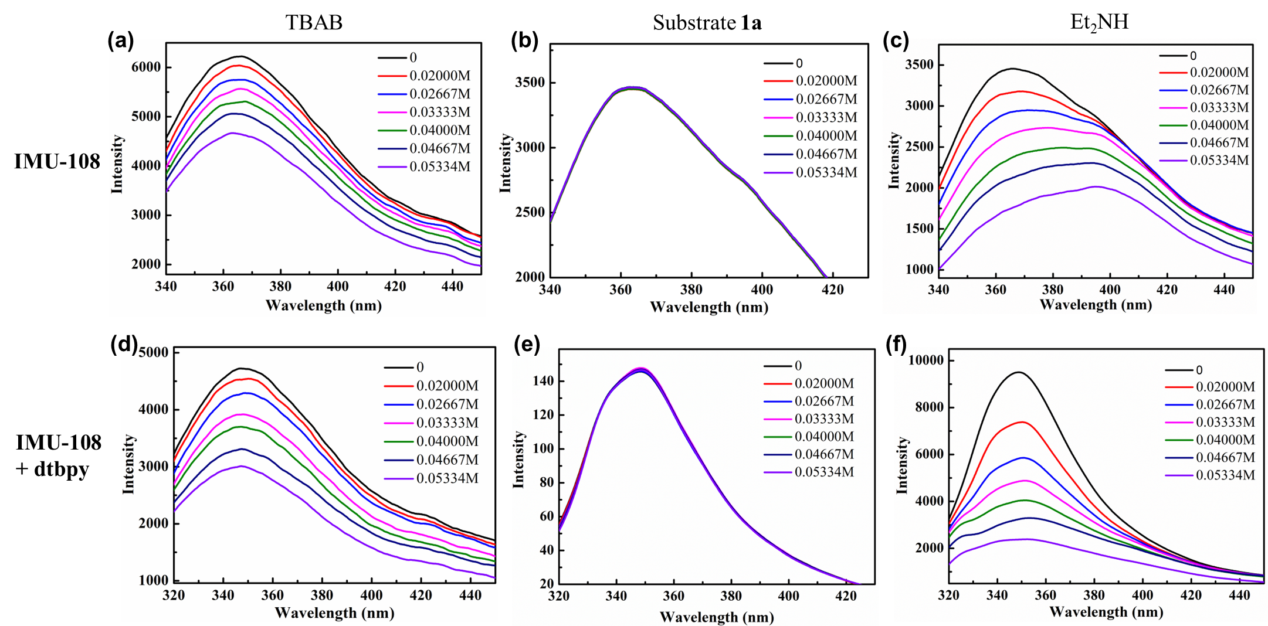
Fig. 11 Family of luminescence spectra of IMU-108 in DCM upon addition of the different concentrations of TBAB (a), 1a (b) and Et₂NH (c). Family of luminescence spectra of IMU-108 and dtbpy in DCM upon addition of the different concentrations of TBAB (d), 1a (e) and Et₂NH (f)
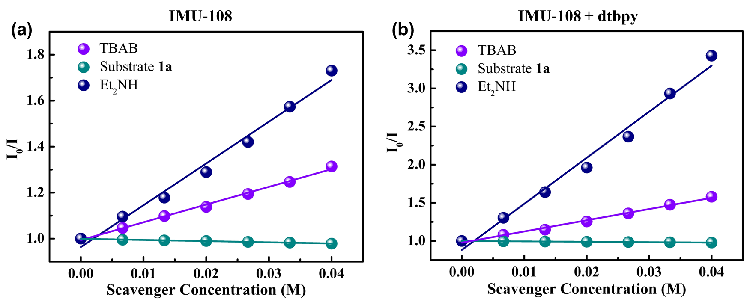
Fig. 12 (a) The corresponding Stern-Völmer curve of IMU-108 in DCM TBAB (purple), 1a (dark cyan) and Et₂NH (navy), respectively; (b) The corresponding Stern-Völmer curve of IMU-108 and dtbpy in DCM TBAB (purple), 1a (dark cyan) and Et₂NH (navy), respectively

Table 5. Comparison of K_{sv} between IMU-108 and IMU-108 + dtbpy
 | K_{sv} (Et₂NH) (M⁻¹) | K_{sv} (TBAB) (M⁻¹) | K_{sv} (Substrate 1a) (M⁻¹)
IMU-108 + dtbpy | 60.39 | 14.66 | -0.52
IMU-108 | 18.16 | 7.71 | 3.02

7.3 Light on/off experiment
Several standard reactions according to General Procedure were parallelly set up on a 0.10 mmol scale and irradiated with 427 nm LEDs at a distance of 3 cm and/or in the absence of light. From the 10th hour, every 2 hours, one reaction was worked up and analyzed by ¹⁹F NMR to determine the yield of the corresponding products using (trifluoro-methoxy)benzenes as an internal standard. The corresponding results revealed that light is a necessary component of the reaction.
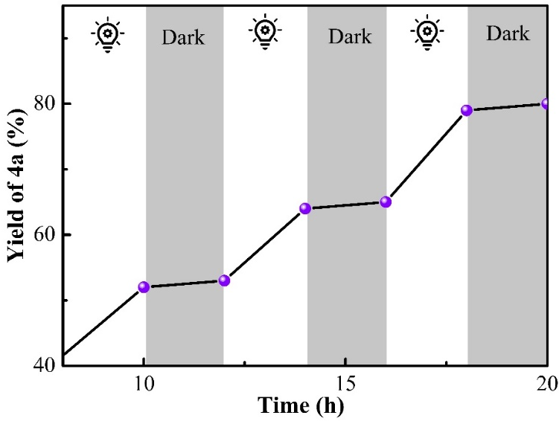
Fig. 13 The light On/Off experiment

8 Stability studies of IMU-108

8.1 Cyclic experiments
Cycling tests were performed in two parallel light reaction vessels containing standard reactants under N₂ atmosphere at room temperature for 20 h under irradiation with a 427 nm LED (standard conditions), one of the reactors contained 3 mol% of IMU-108 (Reactor A) and the other contained 60 mol% IMU-108 (Reactor B). After the reaction, (trifluoromethoxy)benzenes as an internal standard was added to the reaction solution in Reactor A and the yield was calculated by ¹⁹F NMR; the IMU-108 in Reactor B was centrifuged, washed, and dried without additional activation steps. For each subsequent cycle, IMU-108 (3 mol%) was weighed from reactor B and added to reactor A, and reactors A and B were placed under standard conditions for cycle experiments.

8.2 Leaching experiments
Several standard reactions according to General Procedure were parallelly set up on a 0.10 mmol scale and irradiated with 427 nm LEDs at a distance of 3 cm. The solid catalyst and the liquid phase of the reaction mixture were separated by centrifugation after a time interval of 10 h, then the supernatant solution was seated at the exactly the same reaction conditions for extra 2, 6, and 10 hours, the conversions were found to be 49, 50, and 48% respectively by ¹⁹F NMR spectral analysis. In contrast, in the presence of IMU-108, the yield reached 86% after 20 hours.
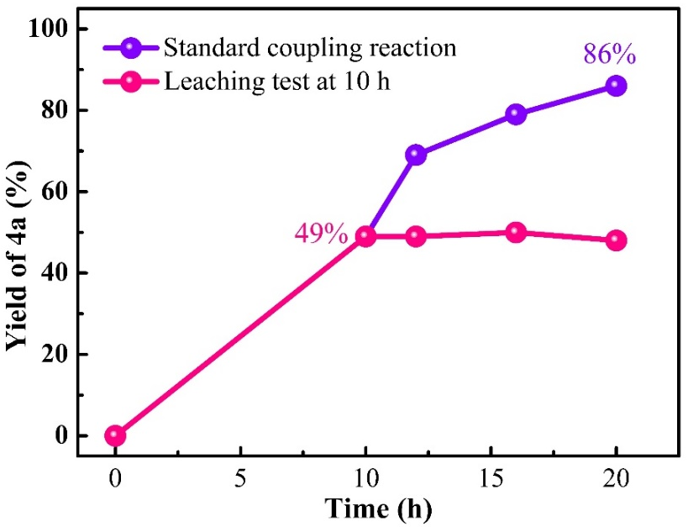
Fig. 14 Line graph of leaching test for IMU-108 in three-component reaction mixtures at different time intervals
Several standard reactions according to General Procedure were parallelly set up on a 0.10 mmol scale and irradiated with 427 nm LEDs at a distance of 3 cm. The solid catalyst and the liquid phase of the reaction mixture were separated by centrifugation after a time interval of 10 h, then the supernatant solution was seated at the exactly the same reaction conditions for extra 5 hours, the conversions were found to be 56% by ¹⁹F NMR spectral analysis. Afterwards, the solid phase obtained by centrifugation was added to the reaction system again and subjected to additional illumination for 3 hours and 5 hours, respectively, with conversion rates of 67% and 72%.
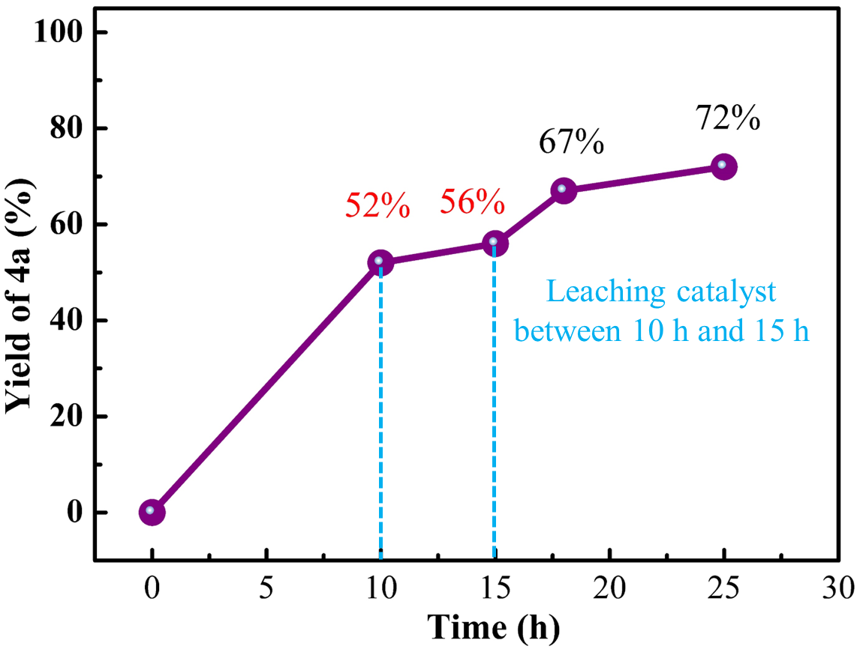
Fig. 15 Line graph of leaching test for IMU-108 in three-component reaction mixtures at different time intervals

8.3 PXRD patterns of IMU-108
Fig. 16 PXRD patterns of IMU-108 after treated under various conditions
Fig. 17 PXRD patterns of IMU-108 after soaking in various organic solvents for three days

Fig. 18 PXRD patterns of IMU-108 after reaction

8.4 The unit-cell parameters of IMU-108 before and after catalysis
Table 6. The unit-cell parameters of IMU-108 before and after catalysis
IMU-108 | Before catalysis |  | After catalysis
unit-cell parameters | 1 | 2 | 1 | 2
a [Å] | 26.566(3) | 26.699(7) | 26.43(4) | 26.61(2)
b [Å] | 26.530(5) | 26.672(6) | 26.40(4) | 26.62(2)
c [Å] | 34.077(5) | 33.576(7) | 31.54(5) | 31.40(3)
α [°] | 89.960(14) | 89.987(17) | 89.94(13) | 90.01(8)
β [°] | 89.951(12) | 89.941(19) | 89.96(12) | 89.95(8)
γ [°] | 89.971(12) | 89.840(19) | 90.06(13) | 89.99(7)

9 Scale up of three-component coupling reactions
A gram-scale synthesis was achieved by mixing p-tert-butylstyrene (1a), p-fluorophenylboronic acid (2a), and methyl 2-bromoisobutyrate (3a) at a 5.0 mmol scale relative to 1a, resulting in 1.63 g (92% isolated yield) of the corresponding 1,1-diarylalkane product 4a. (Ar = p-fluorophenyl)
Fig. 19 A gram-scale synthesis

10 References
[1] a) A. Dahan, A. Weissberg, M. Portnoy, Chem. Commun. 2003, 10, 1206-1207; b) T. Tsuboi, Y. Takaguchi, S. Tsuboi, Bull. Chem. Soc. Jpn. 2008, 81, 361-368.
[2] G. M. Sheldrick, 1997.
[3] J. W. Tucker, C. R. J. Stephenson, J. Org. Chem. 2012, 77, 1617-1622.
[4] X. Y. Dong, J. T. Cheng, Y. F. Zhang, Z. L. Li, T. Y. Zhan, J. J. Chen, F. L. Wang, N. Y. Yang, L. Ye, Q. S. Gu, X. Y. Liu, J. Am. Chem. Soc. 2020, 142, 9501-9509.
[5] T. Miura, T. Nakamuro, S. G. Stewart, Y. Nagata, M. Murakami, Angew. Chem. Int. Ed. 2017, 56, 3334-3338.
[6] M. Koy, P. Bellotti, F. Katzenburg, C. G. Daniliuc, F. Glorius, Angew. Chem. Int. Ed. 2020, 59, 2375-2379.
[7] N. L. Frye, A. Bhunia, A. Studer, Org. Lett. 2020, 22, 4456-4460.
[8] H. Cao, H. Jiang, H. Feng, J. M. C. Kwan, X. Liu, J. Wu, J. Am. Chem. Soc. 2018, 140, 16360-16367.
[9] J. Liu, S. Wu, J. Yu, C. Lu, Z. Wu, X. Wu, X. S. Xue, C. Zhu, Angew. Chem. Int. Ed. 2020, 59, 8195-8202.
[10] G. S. Lee, D. Kim, S. H. Hong, Nat. Commun. 2021, 12, 991-1002.
[11] W. Xiao, L. Ning, S. Xin, S. Dong, X. Liu, X. Feng, Angew. Chem. Int. Ed. 2022, 61, e202211596.
[12] W. Yu, S. Wang, M. He, Z. Jiang, Y. Yu, J. Lan, J. Luo, P. Wang, X. Qi, T. Wang, A. Lei, Angew. Chem. Int. Ed. 2023, 62, e202219166.
[13] C. Wu, X. Hui, D. Zhang, M. Zhang, Y. Zhu, S. Wang, Green Chem. 2022, 24, 1103-1108.
[14] B. N. Bhawal, J. C. Reisenbauer, C. Ehinger, B. Morandi, J. Am. Chem. Soc. 2020, 142, 10914-10920.
[15] J. Li, Z. Guo, X. Zhang, X. Meng, Z. Dai, M. Gao, S. Guo, P. Tang, Green Chem. 2023, 25, 9292-9300.
[16] X. Ren, C. Shen, G. Wang, Z. Shi, X. Tian, K. Dong, Org. Lett. 2021, 23, 2527-2532.
[17] C. Feng, Y. Zhu, Z. Liu, F. Yang, Y. Wu, Org. Chem. Front. 2023, 10, 2517-2525.
[18] J. A. Leitch, C. L. McMullin, A. J. Paterson, M. F. Mahon, Y. Bhonoah, C. G. Frost, Angew. Chem. Int. Ed. 2017, 56, 15131-15135.
[19] X. Lv, Y. Cheng, Y. Zong, Q. Wang, G. An, J. Wang, G. Li, ACS. Catal. 2023, 13, 7310-7321.
[20] P. Gandeepan, J. Koeller, K. Korvorapun, J. Mohr, L. Ackermann, Angew. Chem. Int. Ed. 2019, 58, 9820-9825.

11 ¹H NMR, ¹³C NMR and ¹⁹F NMR Spectra
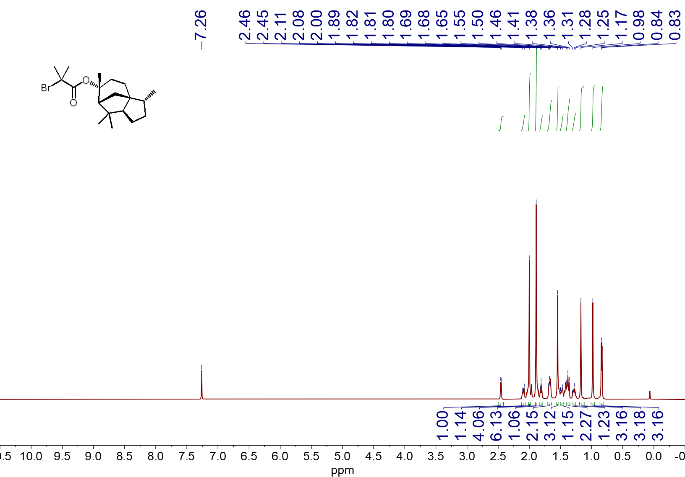
¹H NMR spectrum (600 MHz, CDCl₃, 23 ºC) of 2f
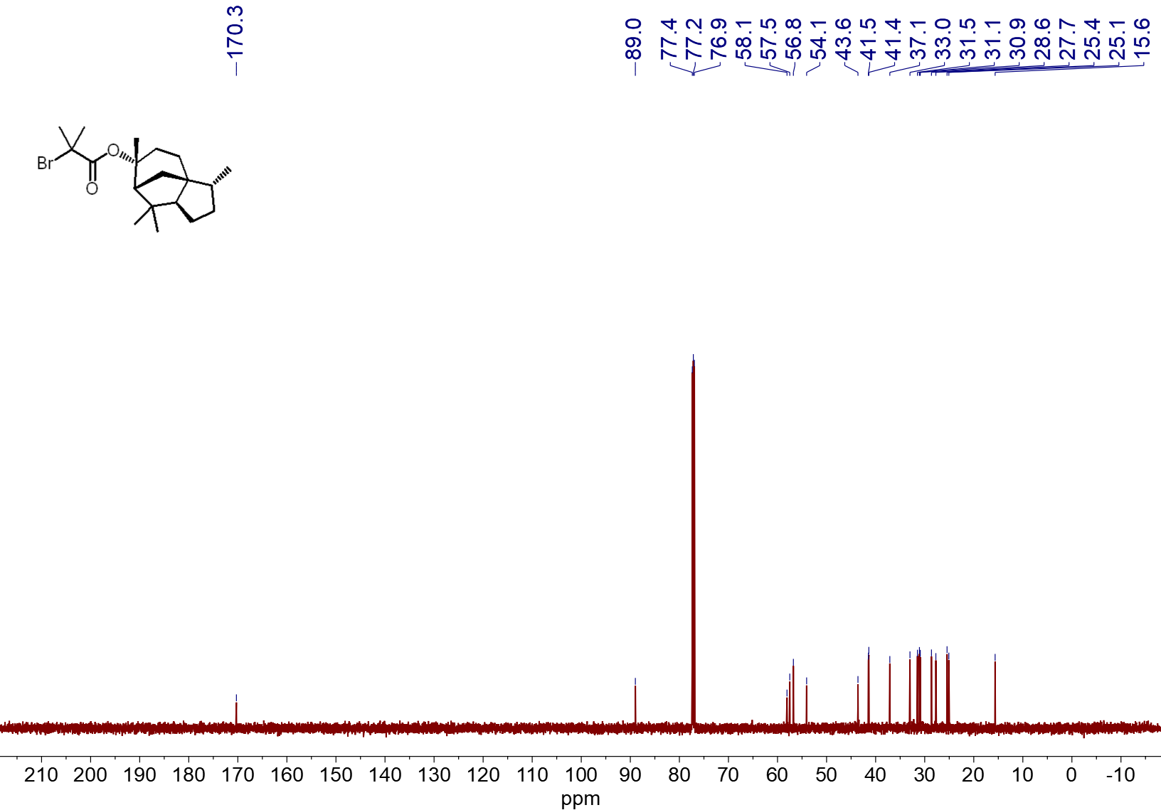
¹³C NMR spectrum (151 MHz, CDCl₃, 23 ºC) of 2f
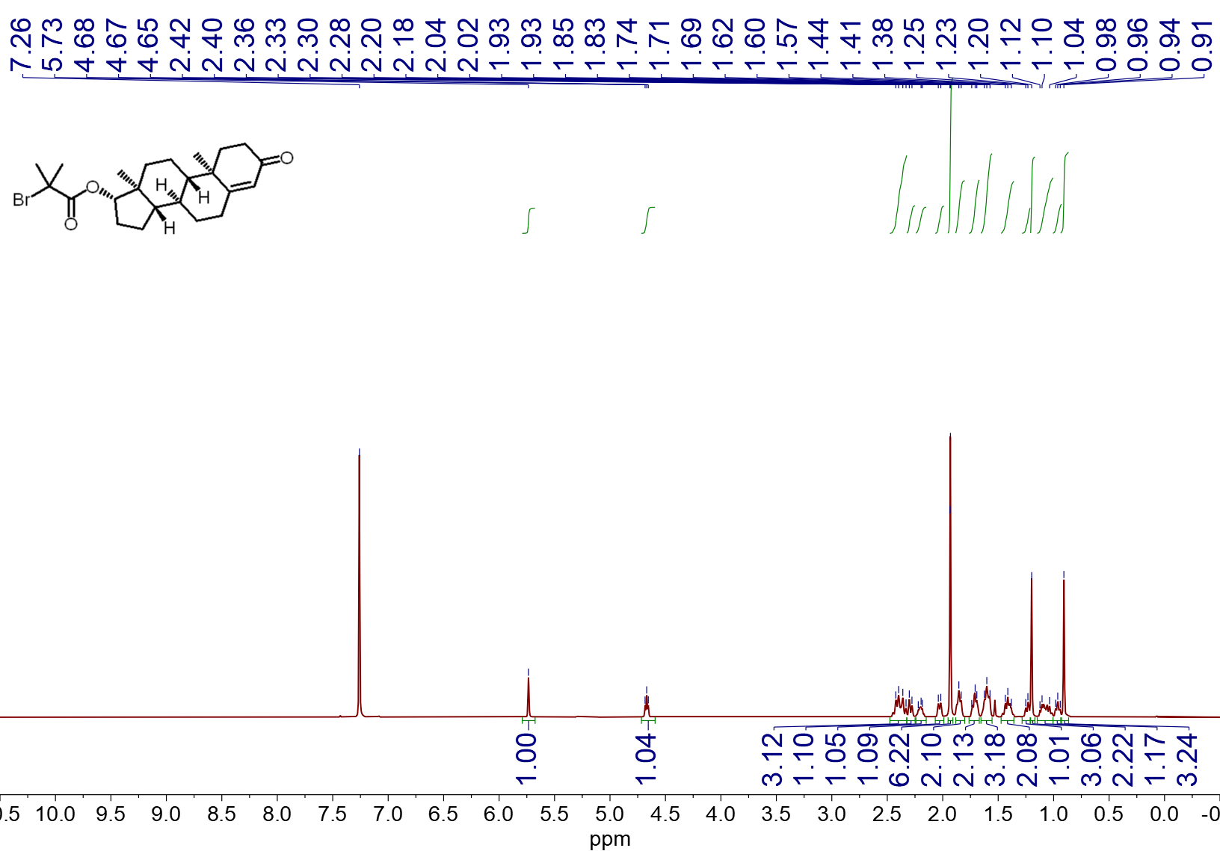
¹H NMR spectrum (600 MHz, CDCl₃, 23 ºC) of 2h
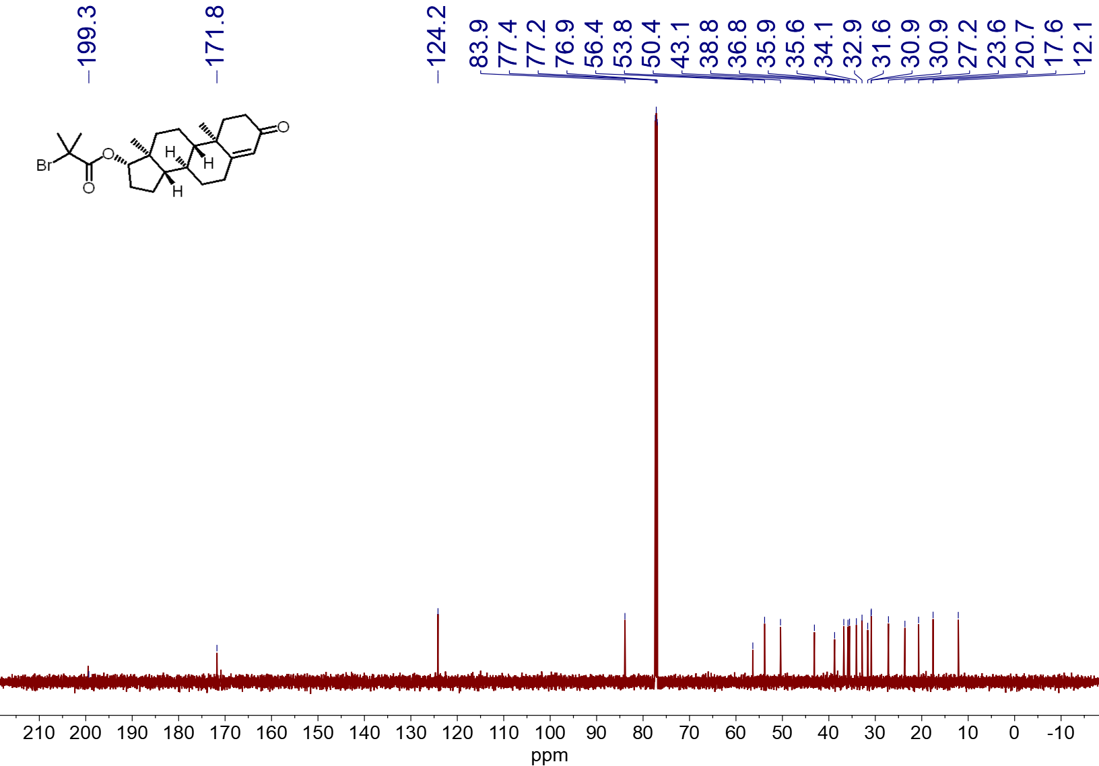
¹³C NMR spectrum (151 MHz, CDCl₃, 23 ºC) of 2h
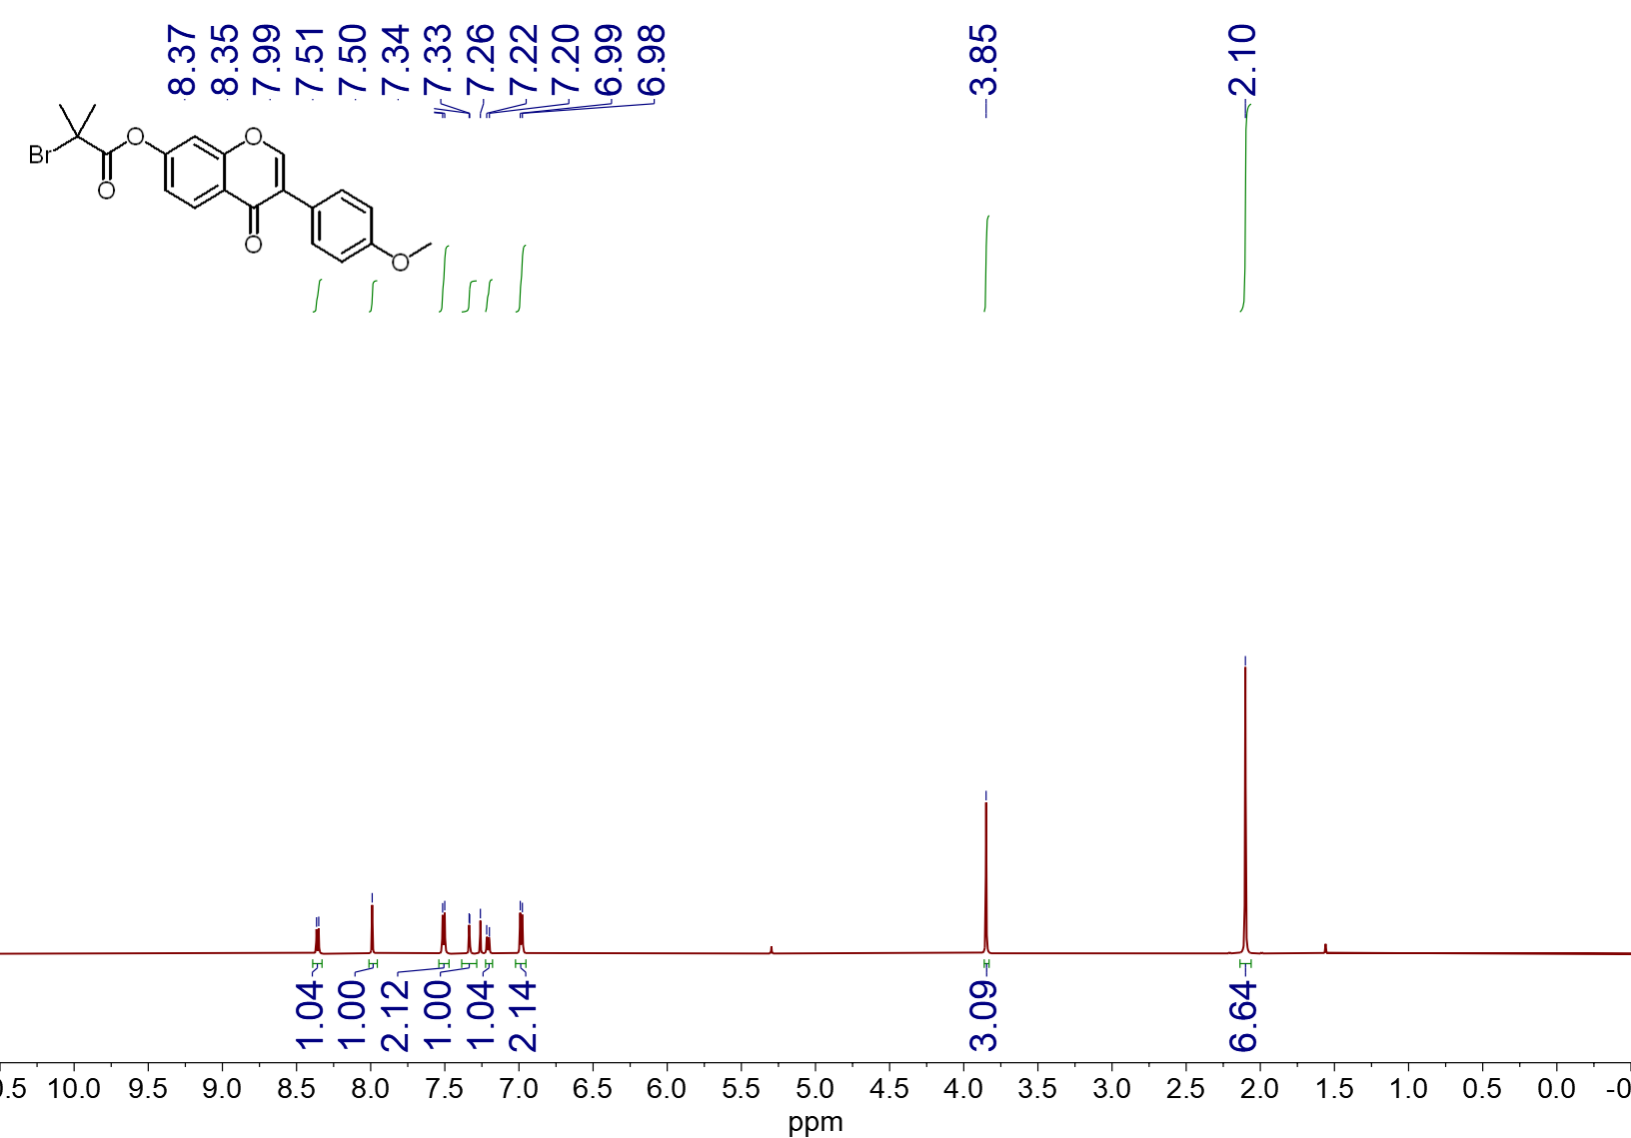
¹H NMR spectrum (600 MHz, CDCl₃, 23 ºC) of 2i
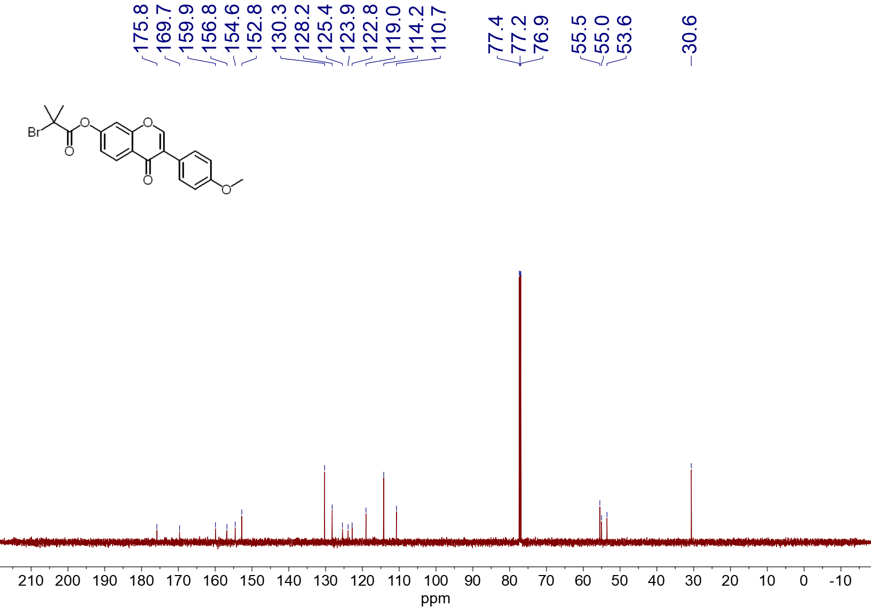
¹³C NMR spectrum (151 MHz, CDCl₃, 23 ºC) of 2i
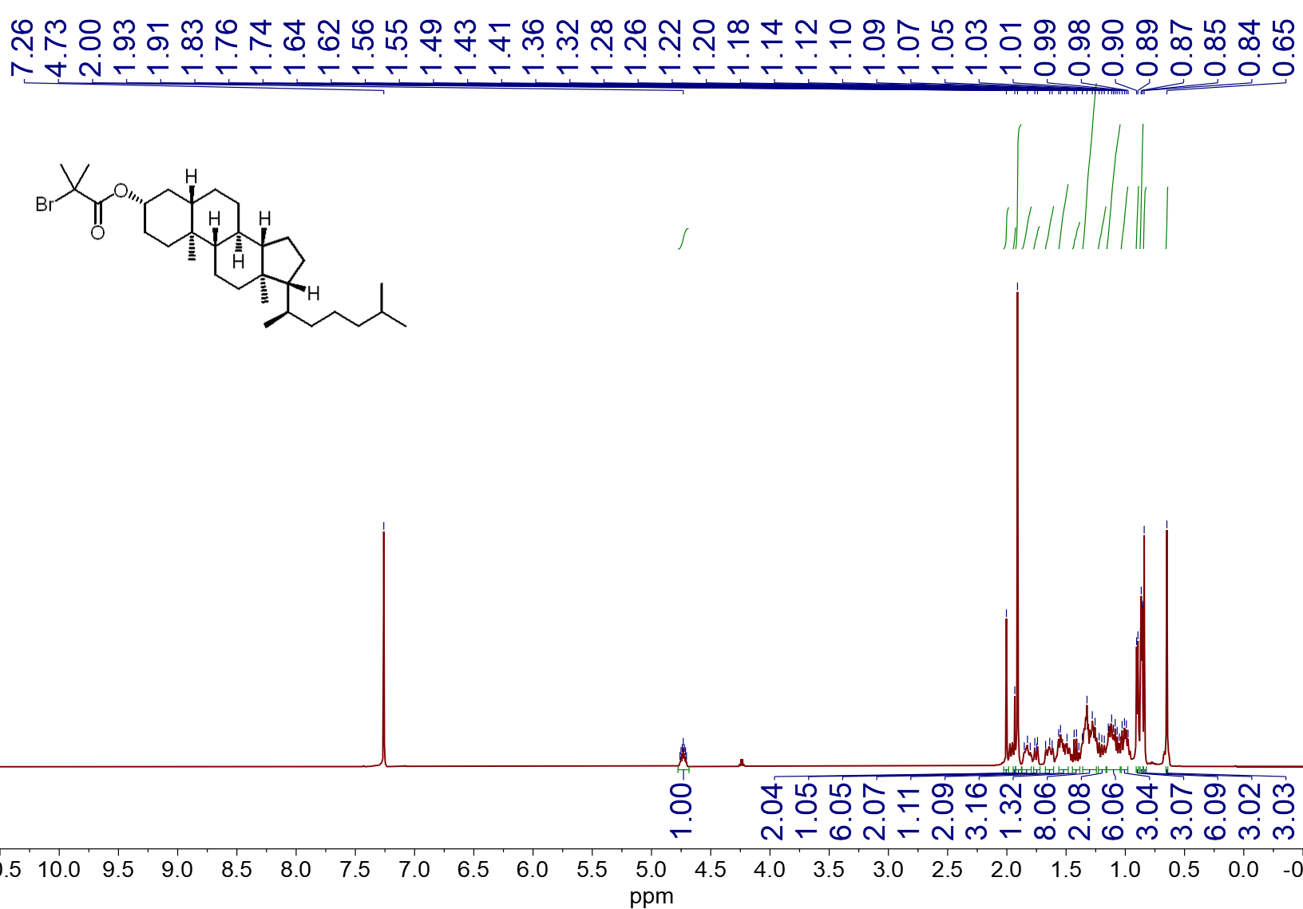
¹H NMR spectrum (600 MHz, CDCl₃, 23 ºC) of 2j
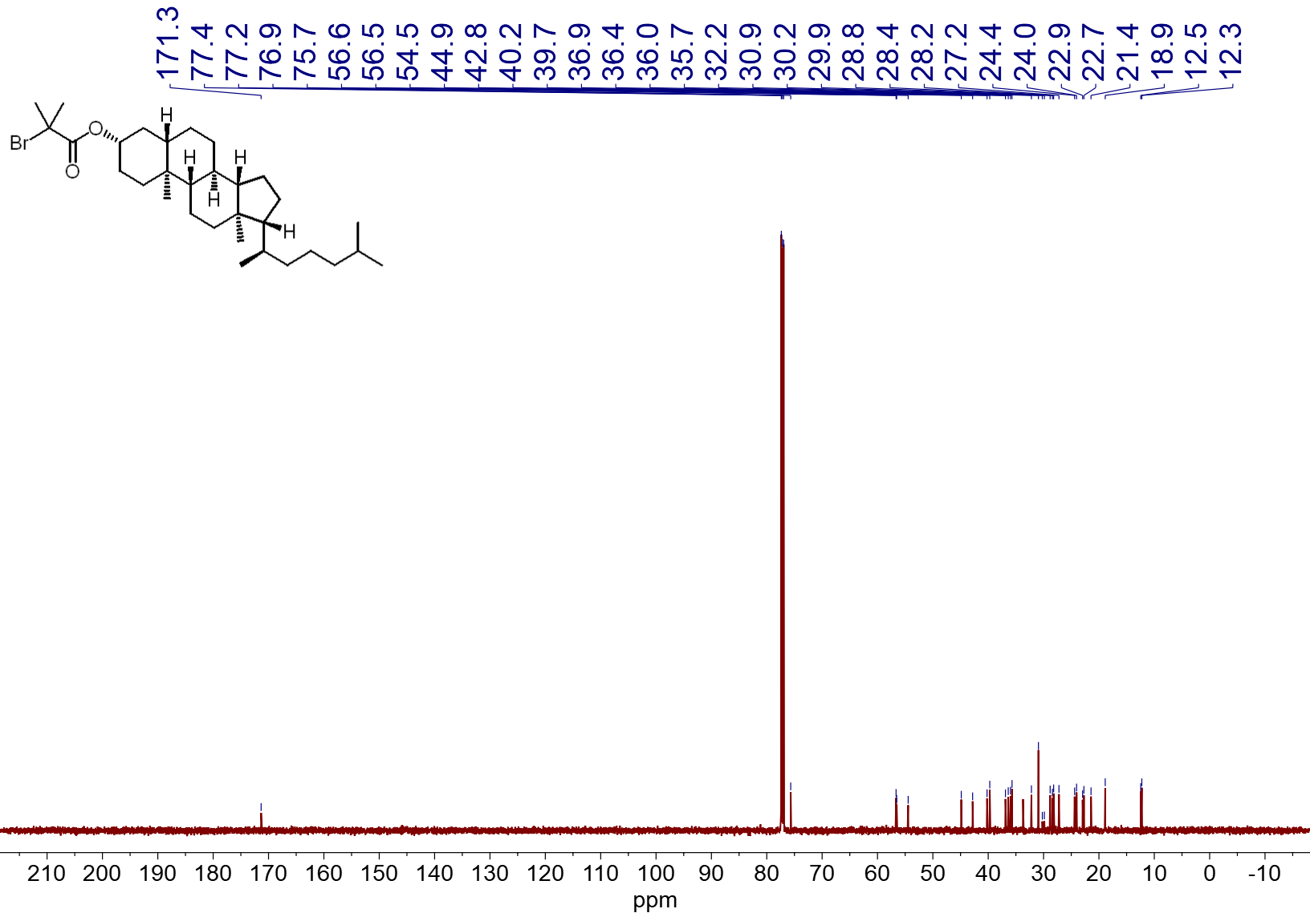
¹³C NMR spectrum (151 MHz, CDCl₃, 23 ºC) of 2j
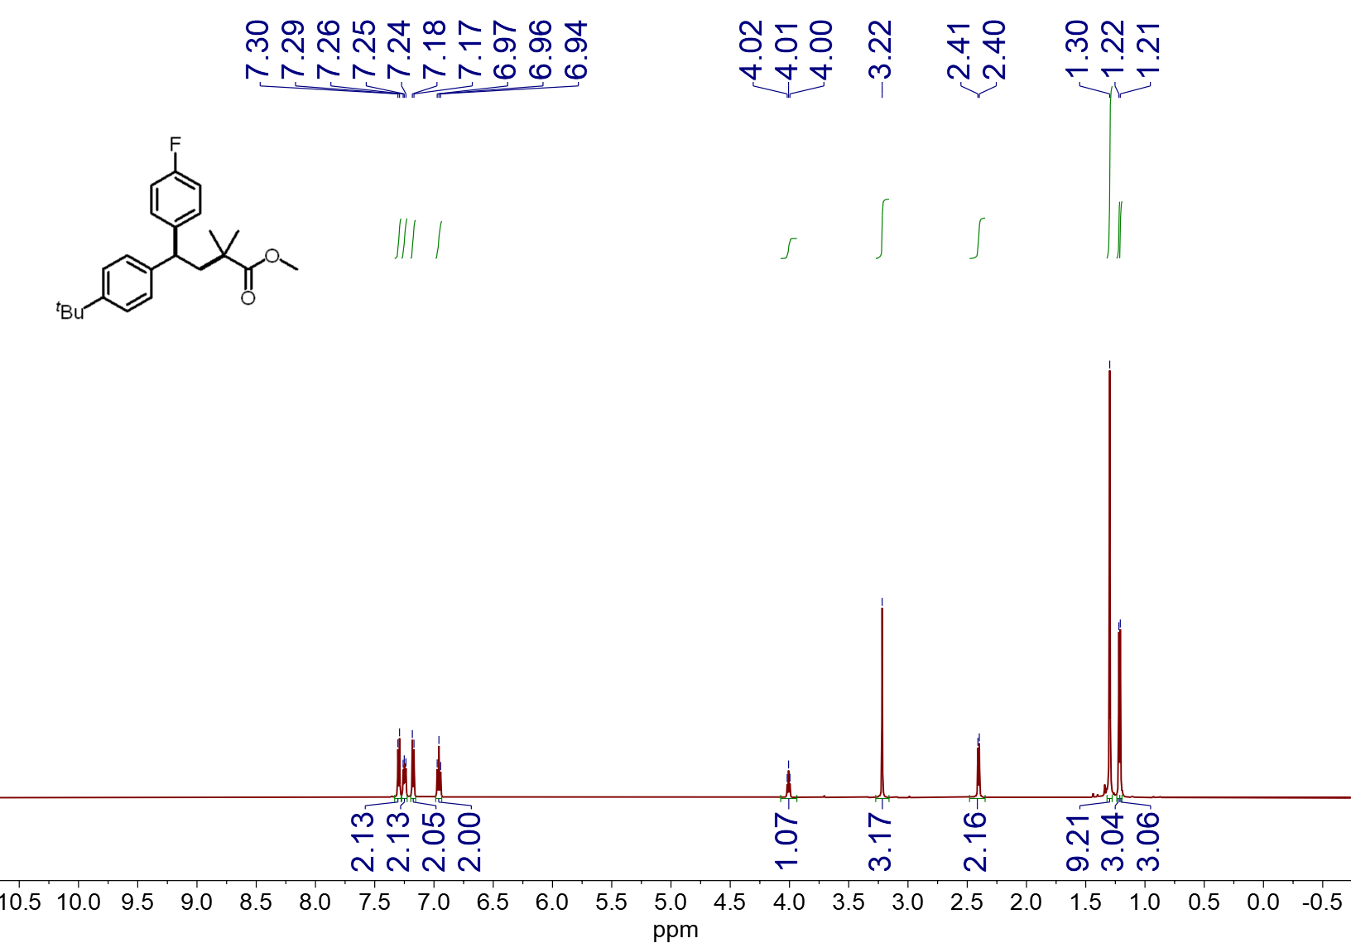
¹H NMR spectrum (600 MHz, CDCl₃, 23 ºC) of 4a
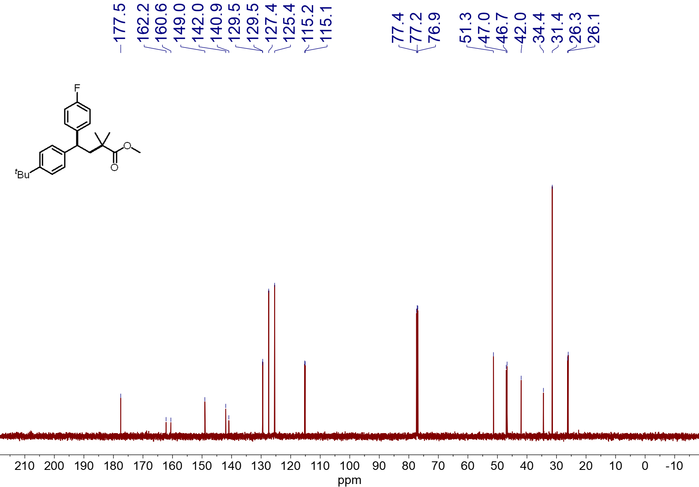
¹³C NMR spectrum (151 MHz, CDCl₃, 23 ºC) of 4a
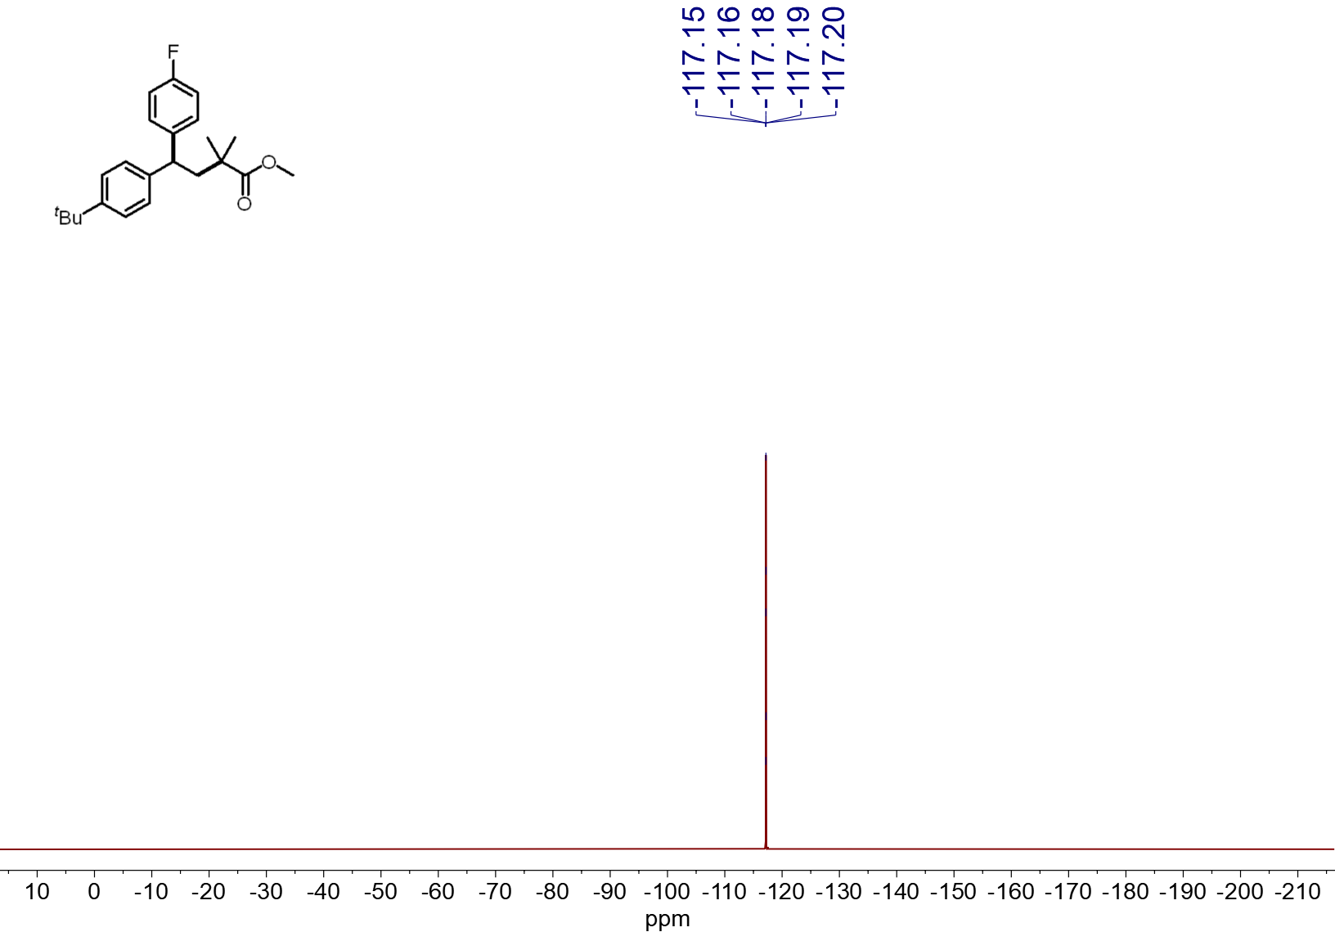¹⁹F NMR spectrum (565 MHz, CDCl₃, 23 ºC) of 4a
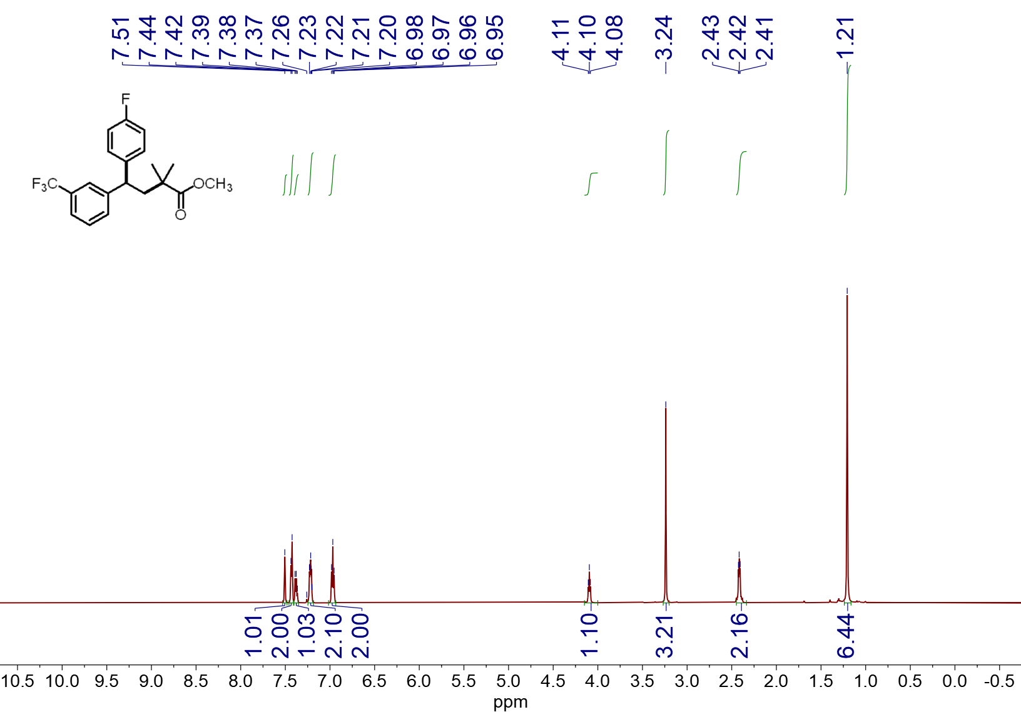
¹H NMR spectrum (600 MHz, CDCl₃, 23 ºC) of 4b
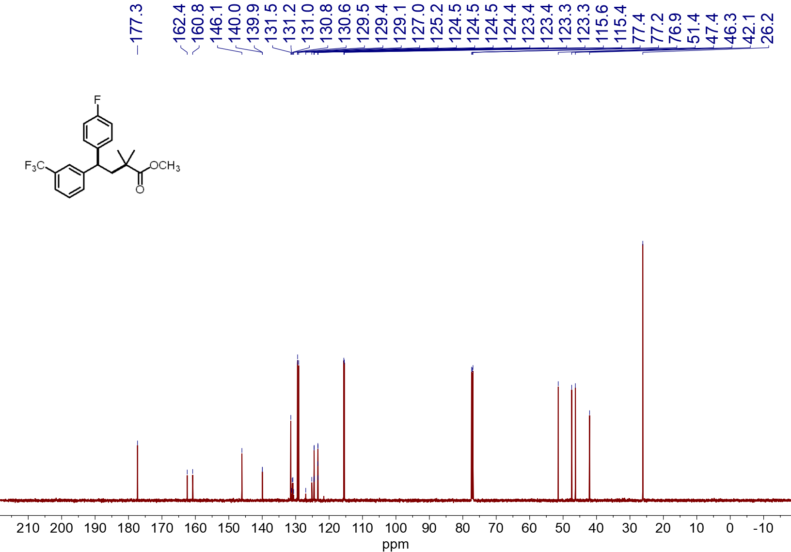
¹³C NMR spectrum (151 MHz, CDCl₃, 23 ºC) of 4b
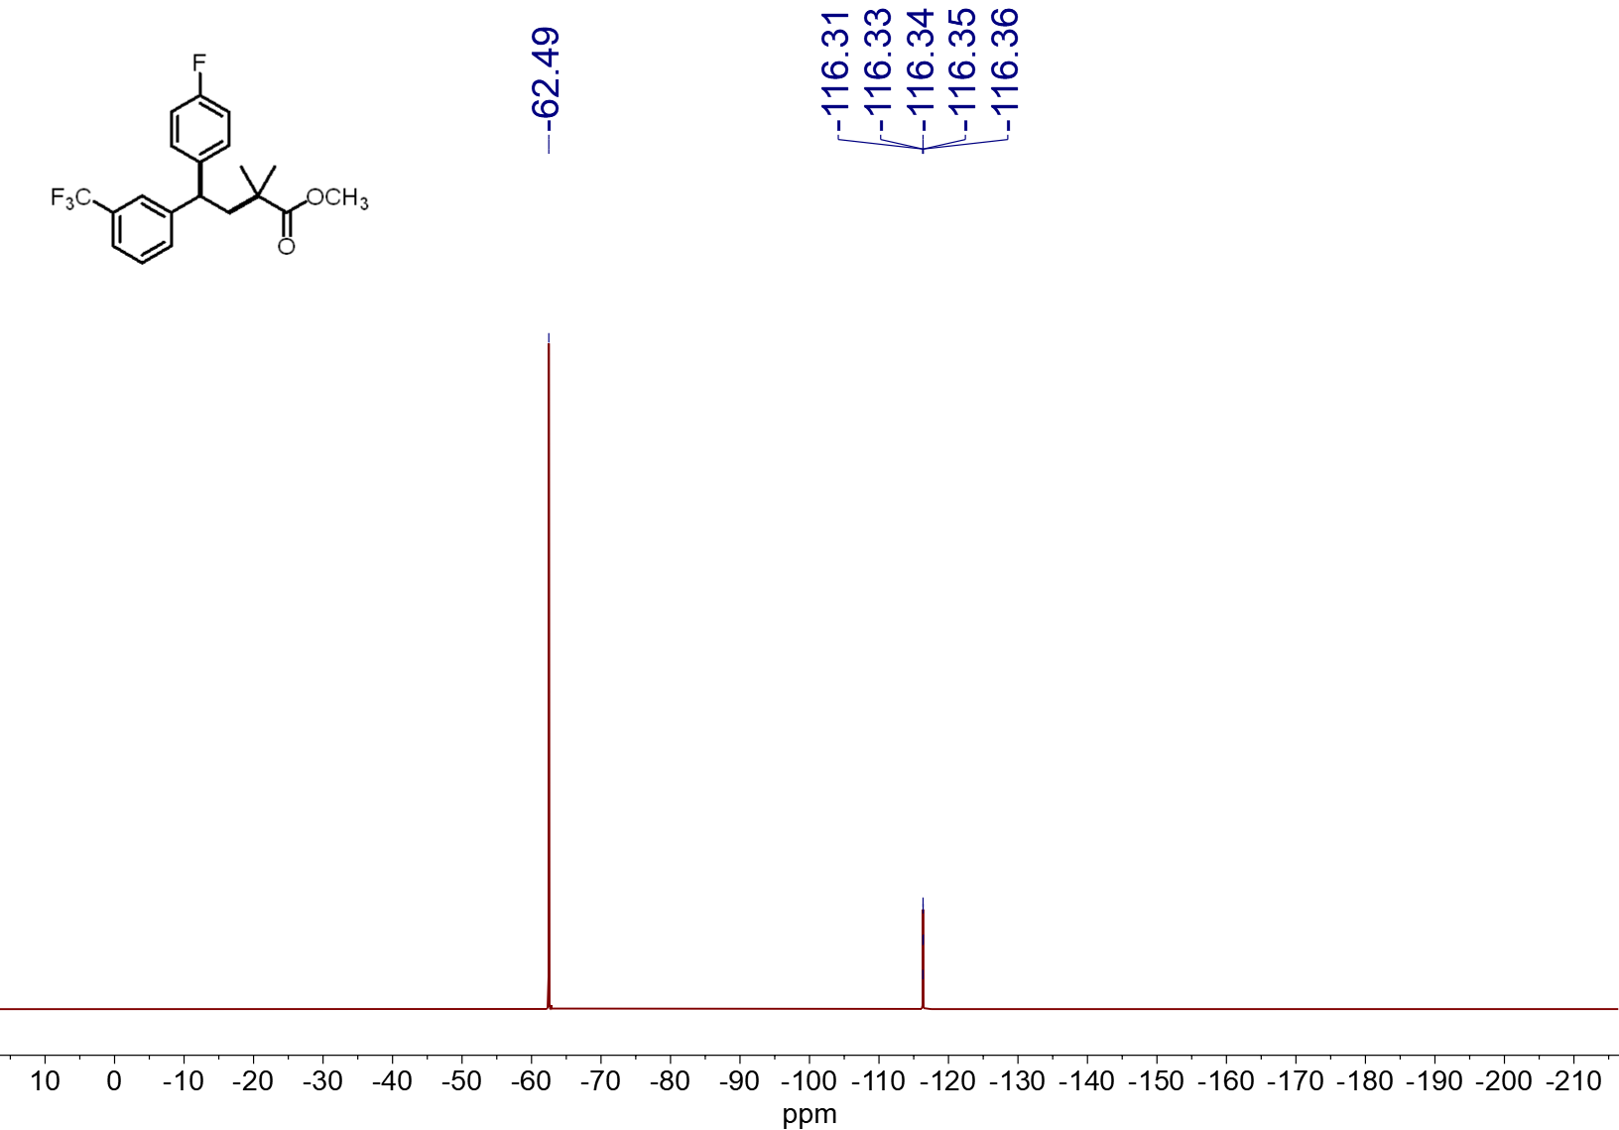
¹⁹F NMR spectrum (565 MHz, CDCl₃, 23 ºC) of 4b
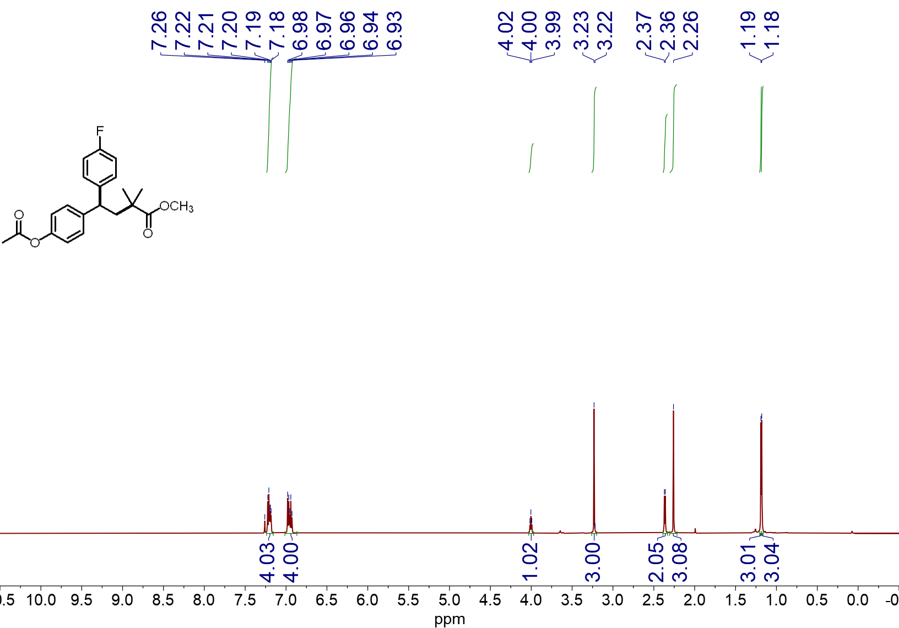
¹H NMR spectrum (600 MHz, CDCl₃, 23 ºC) of 4c
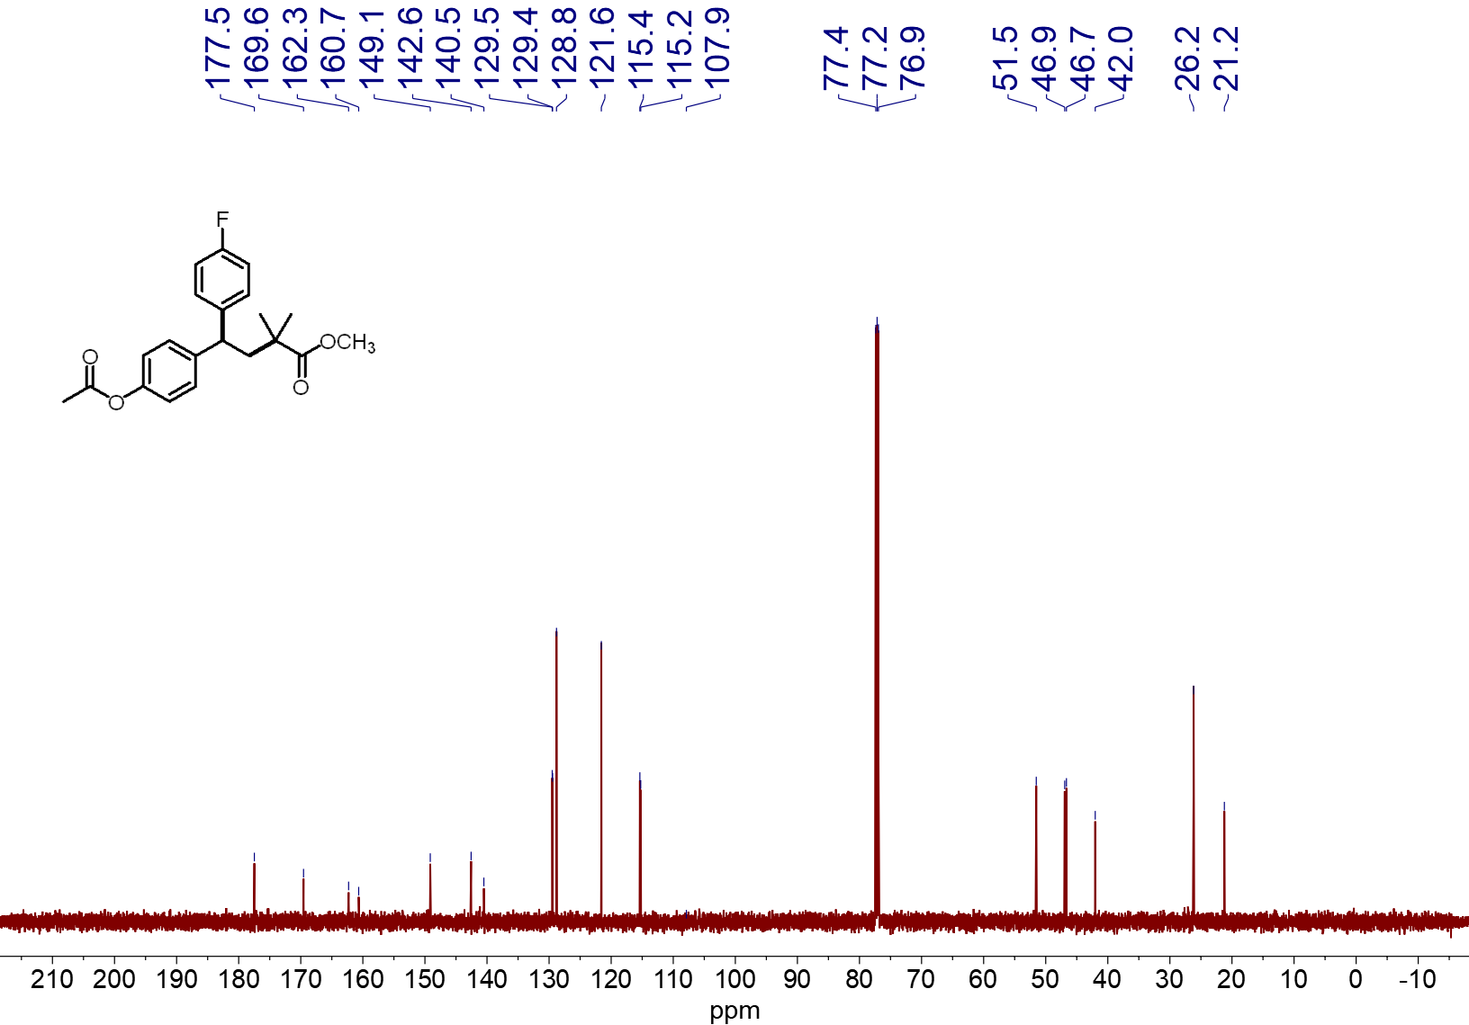
¹³C NMR spectrum (151 MHz, CDCl₃, 23 ºC) of 4c

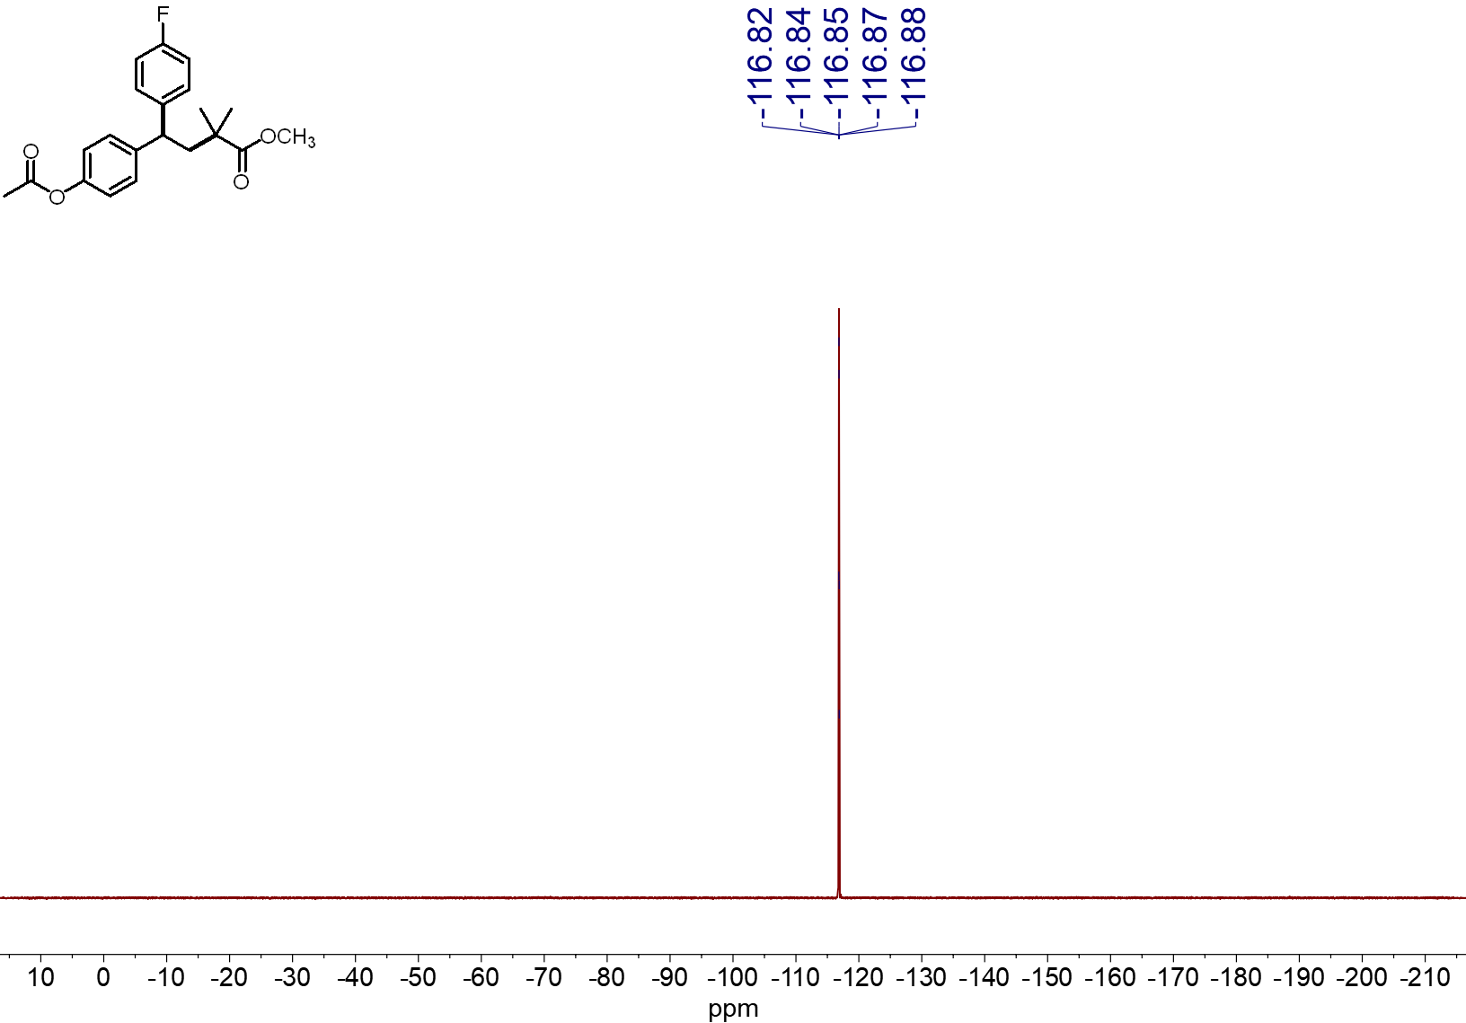
¹⁹F NMR spectrum (565 MHz, CDCl₃, 23 ºC) of 4c

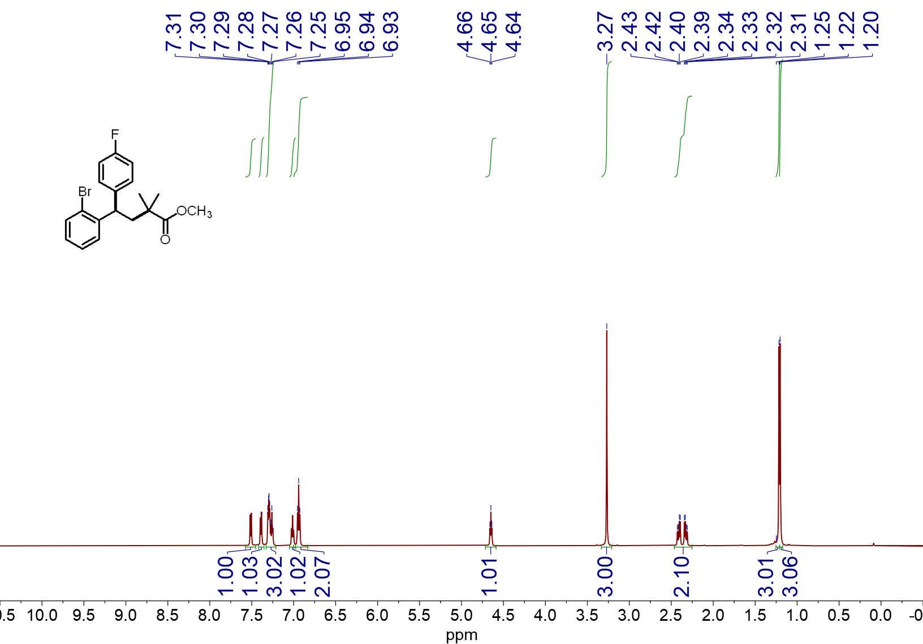
¹H NMR spectrum (600 MHz, CDCl₃, 23 ºC) of 4d
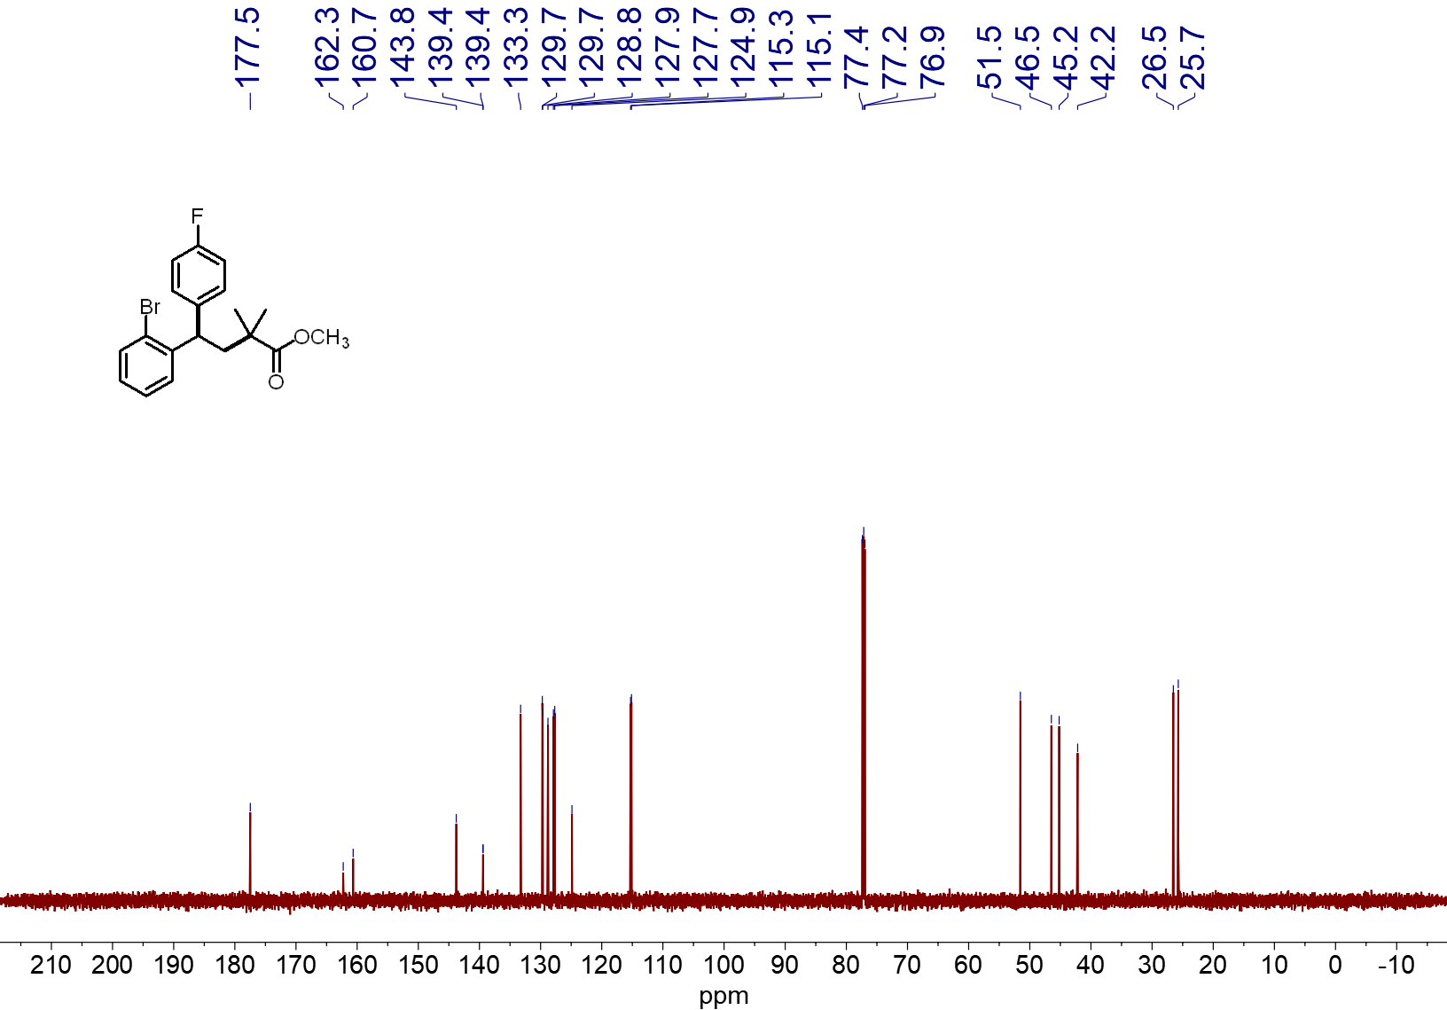
¹³C NMR spectrum (151 MHz, CDCl₃, 23 ºC) of 4d

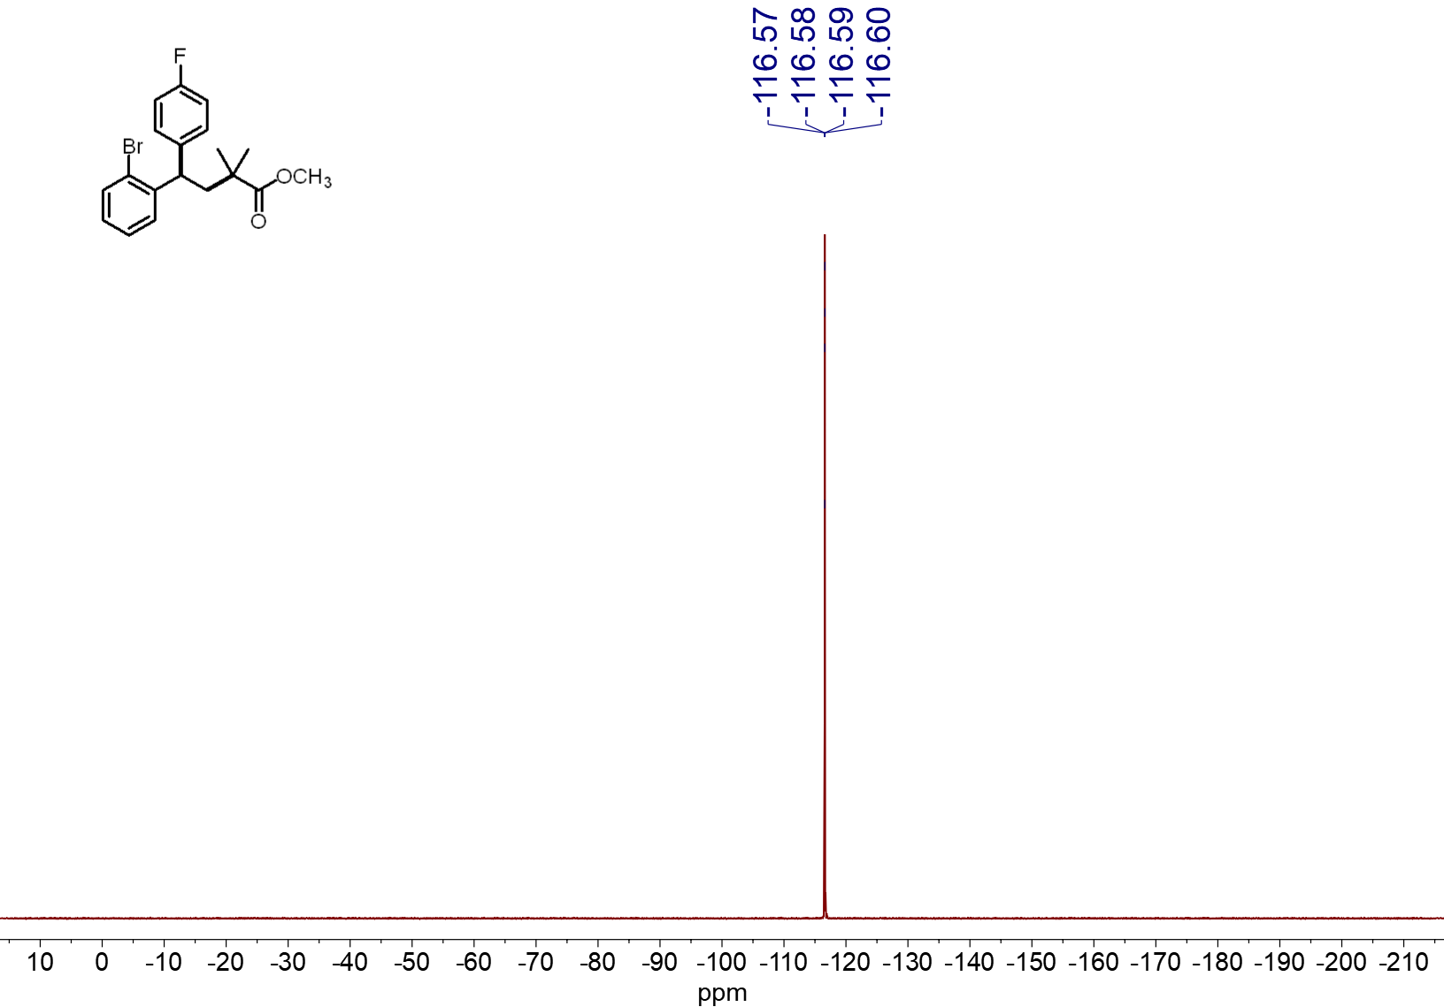
¹⁹F NMR spectrum (565 MHz, CDCl₃, 23 ºC) of 4d

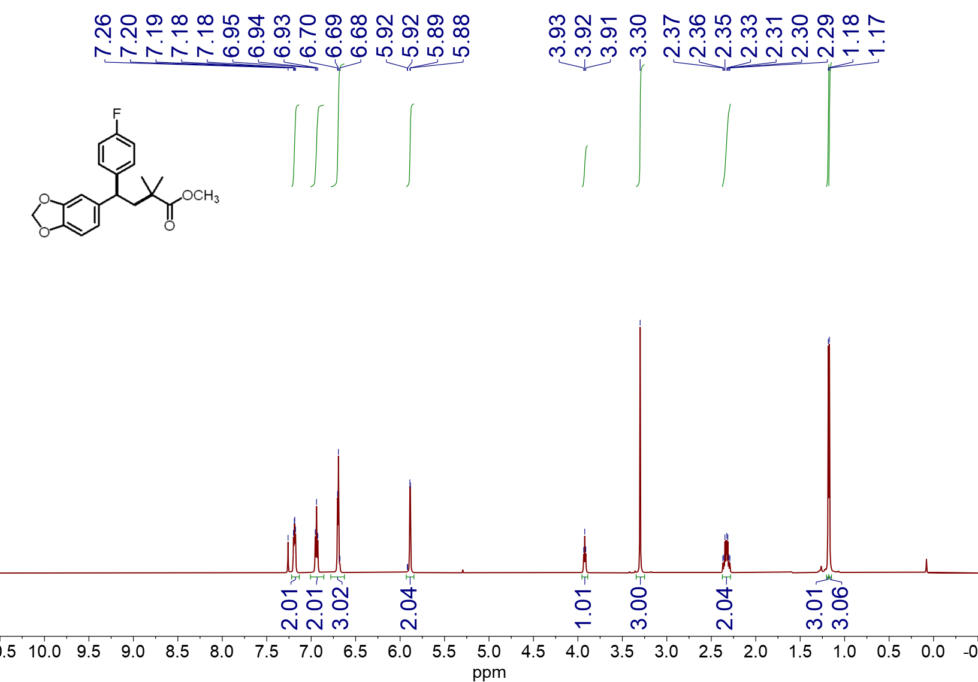
¹H NMR spectrum (600 MHz, CDCl₃, 23 ºC) of 4e
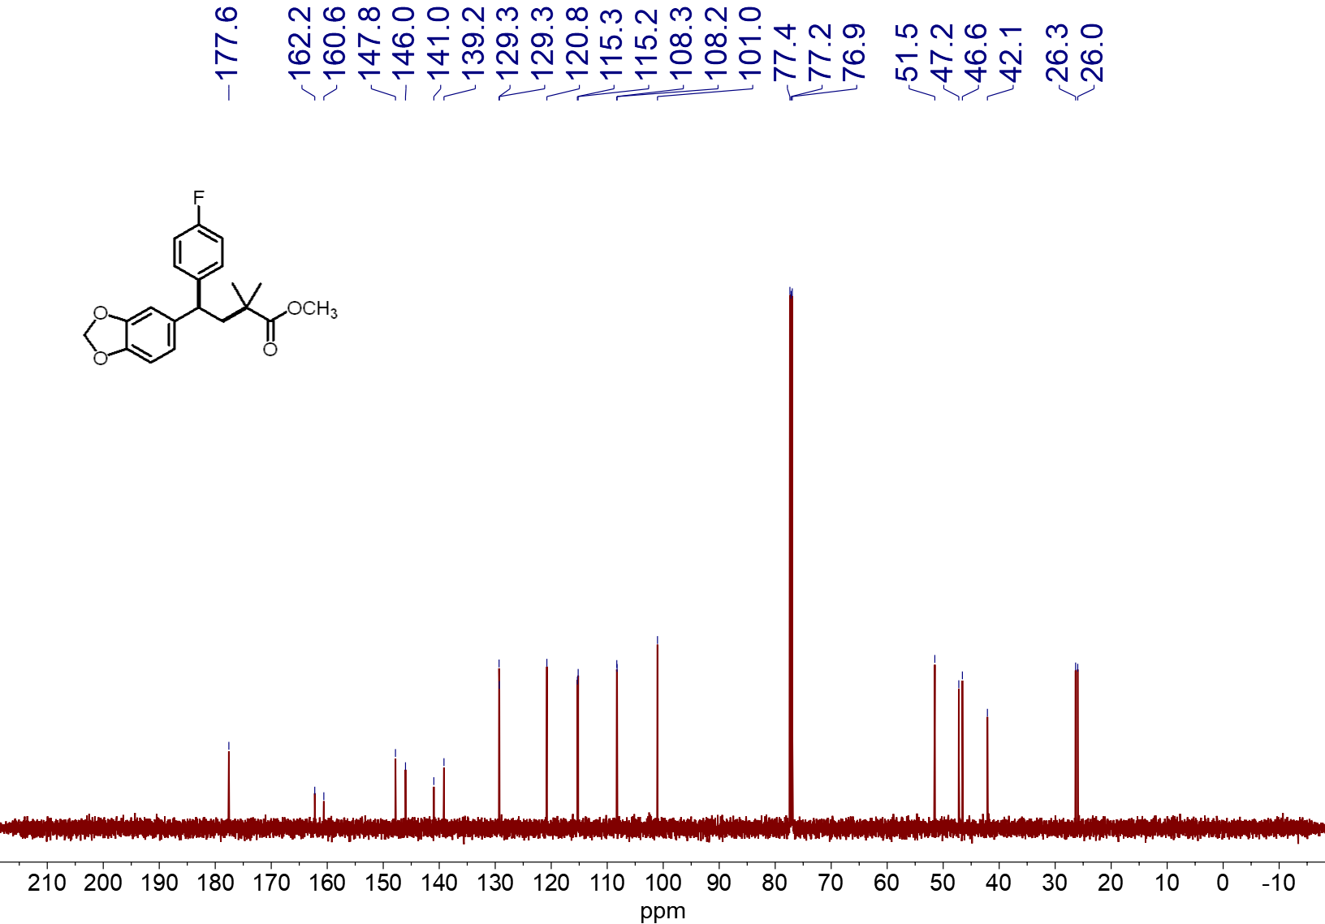
¹³C NMR spectrum (151 MHz, CDCl₃, 23 ºC) of 4e

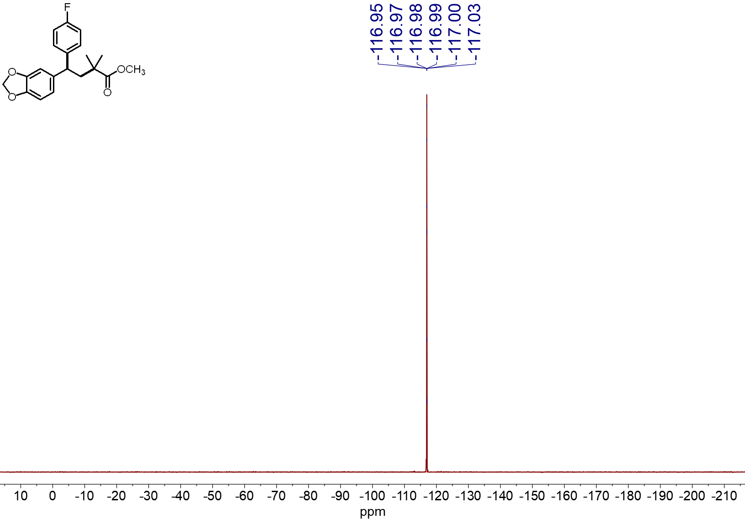
¹⁹F NMR spectrum (565 MHz, CDCl₃, 23 ºC) of 4e
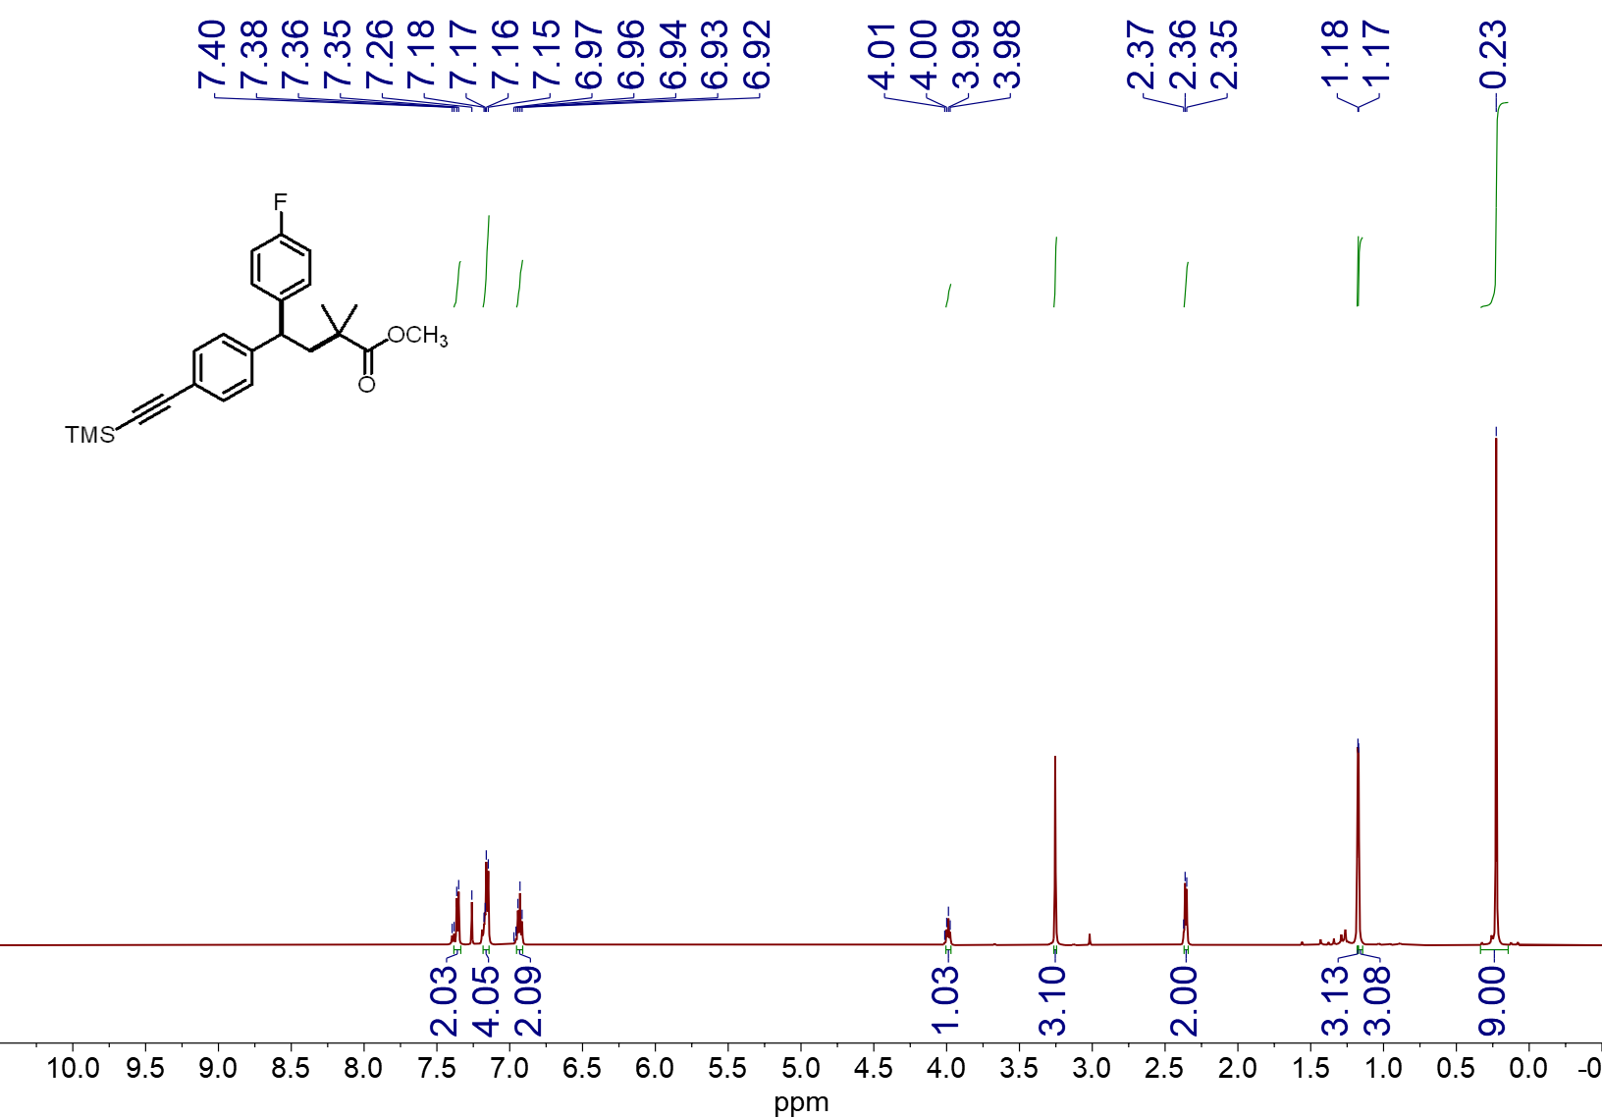
¹H NMR spectrum (600 MHz, CDCl₃, 23 ºC) of 4f

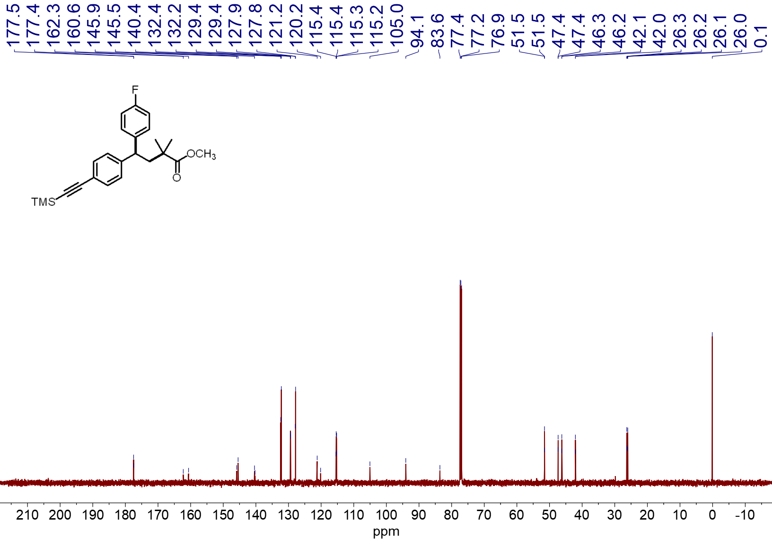
¹³C NMR spectrum (151 MHz, CDCl₃, 23 ºC) of 4f
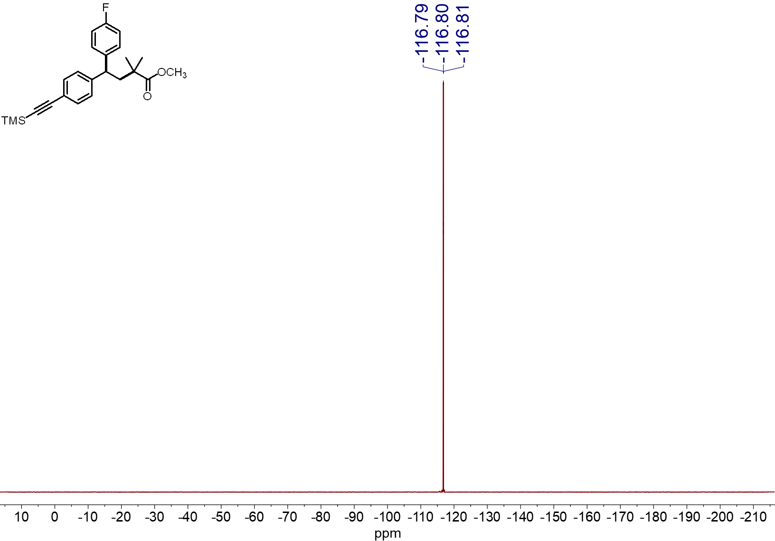
¹⁹F NMR spectrum (565 MHz, CDCl₃, 23 ºC) of 4f
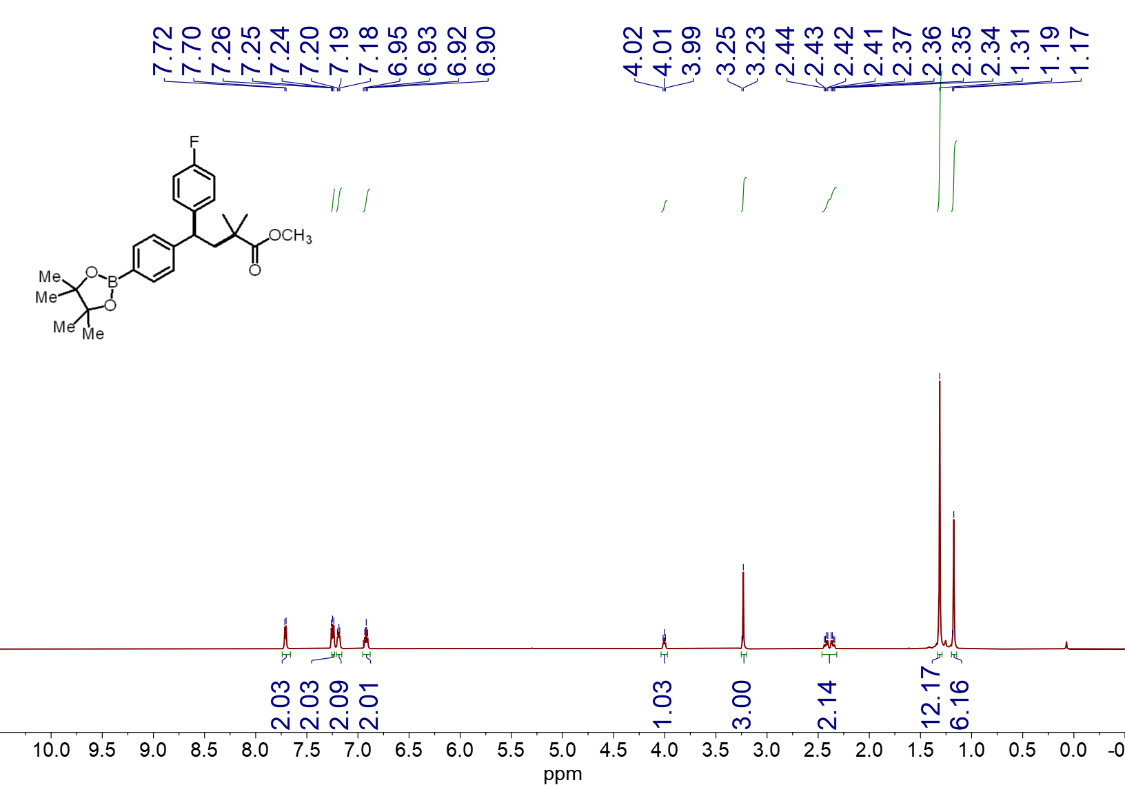
¹H NMR spectrum (600 MHz, CDCl₃, 23 ºC) of 4g
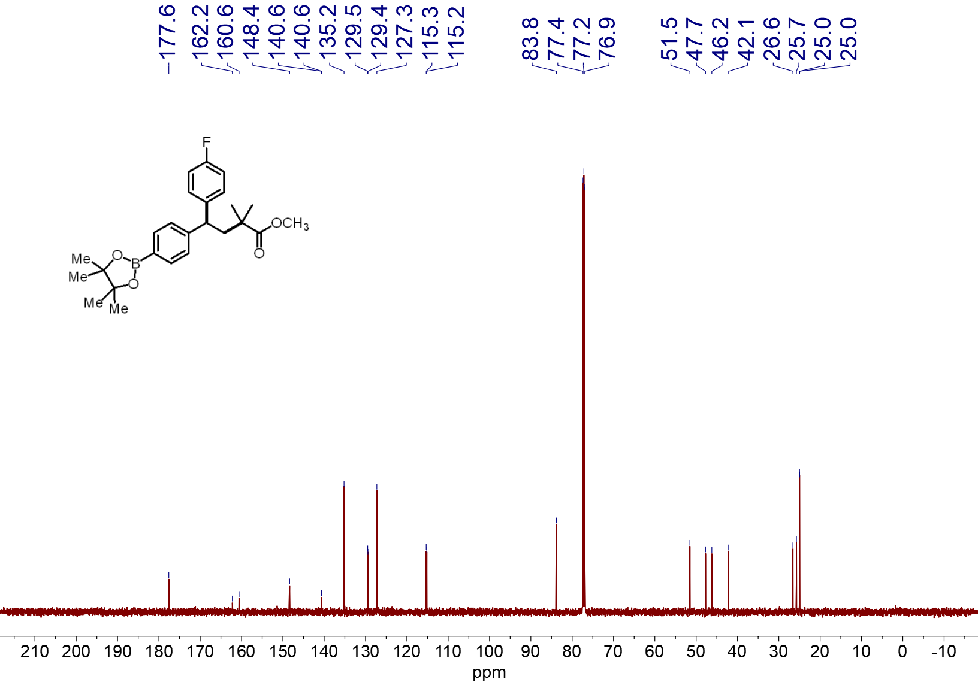
¹³C NMR spectrum (151 MHz, CDCl₃, 23 ºC) of 4g
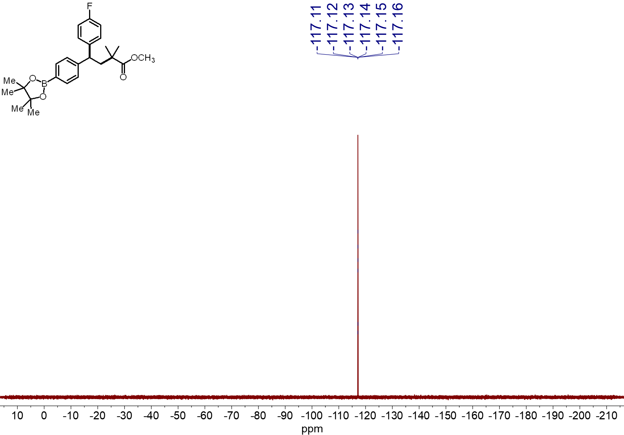
¹⁹F NMR spectrum (565 MHz, CDCl₃, 23 ºC) of 4g

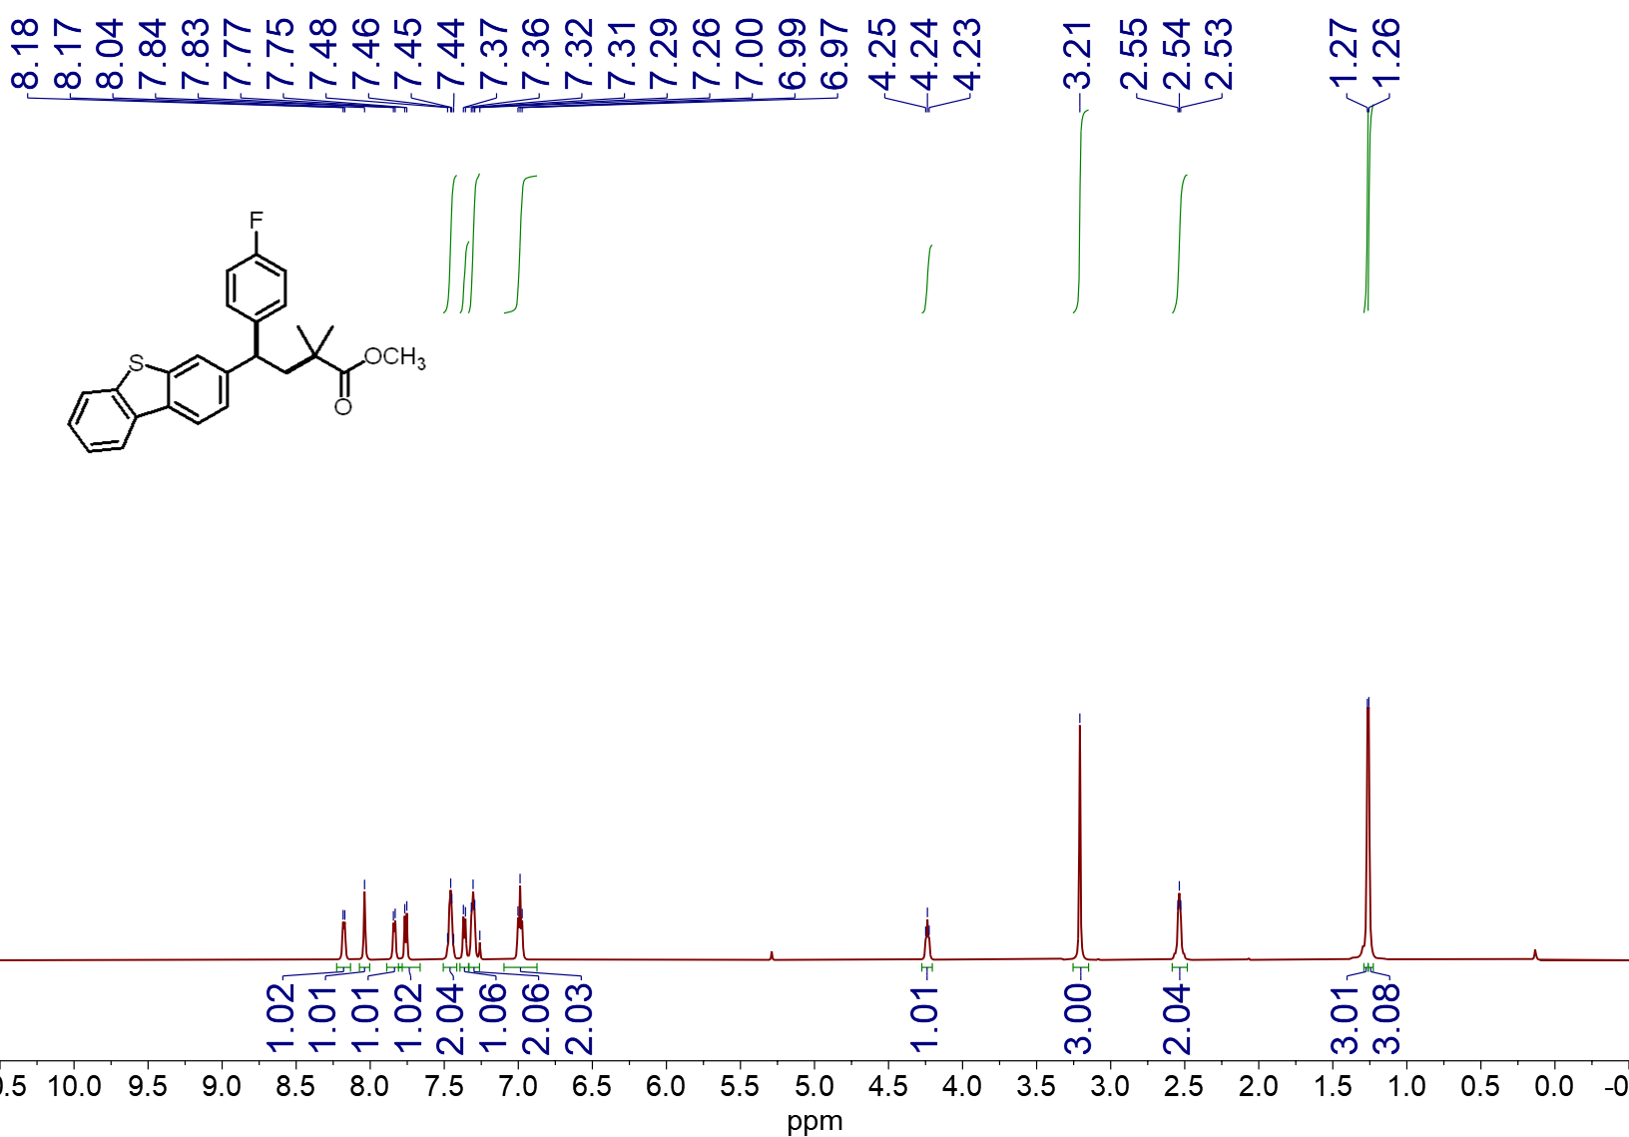
¹H NMR spectrum (600 MHz, CDCl₃, 23 ºC) of 4h
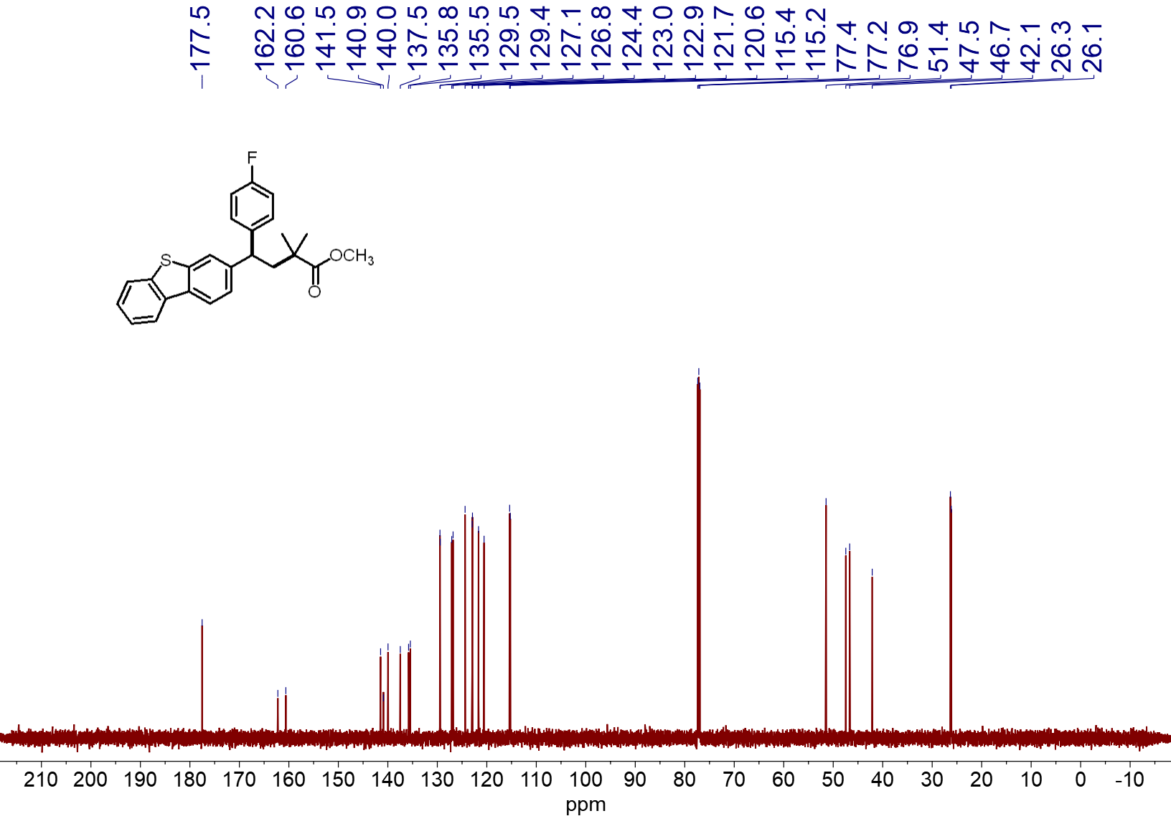
¹³C NMR spectrum (151 MHz, CDCl₃, 23 ºC) of 4h
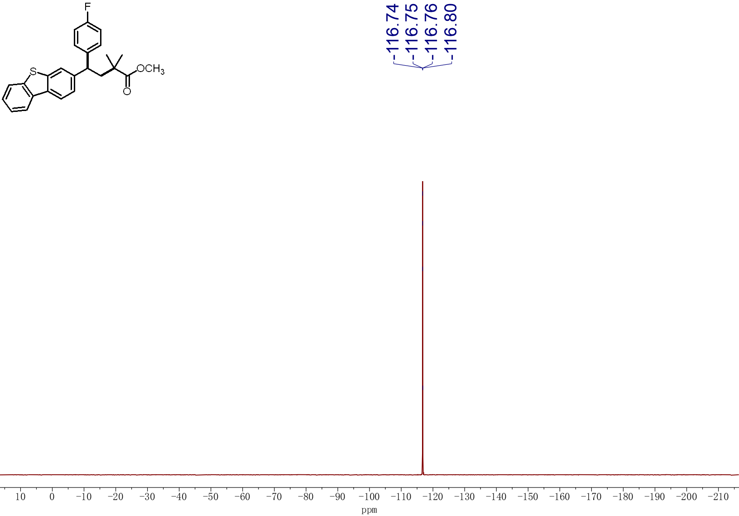
¹⁹F NMR spectrum (565 MHz, CDCl₃, 23 ºC) of 4h

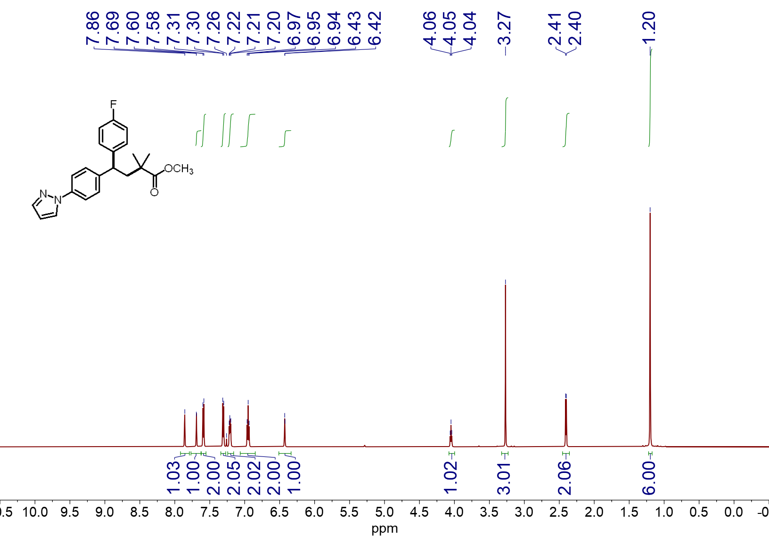
¹H NMR spectrum (600 MHz, CDCl₃, 23 ºC) of 4i
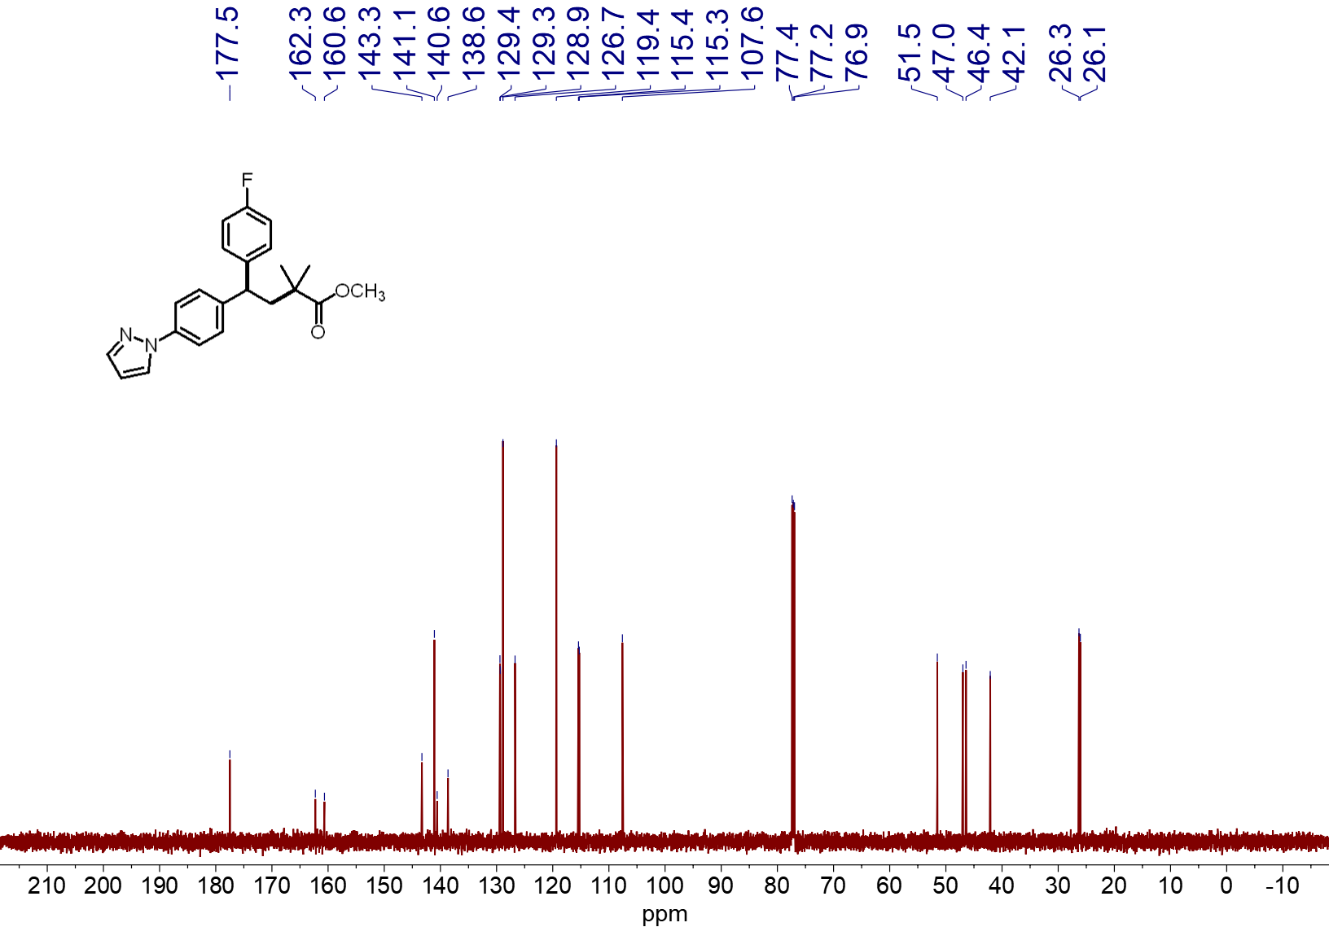
¹³C NMR spectrum (151 MHz, CDCl₃, 23 ºC) of 4i
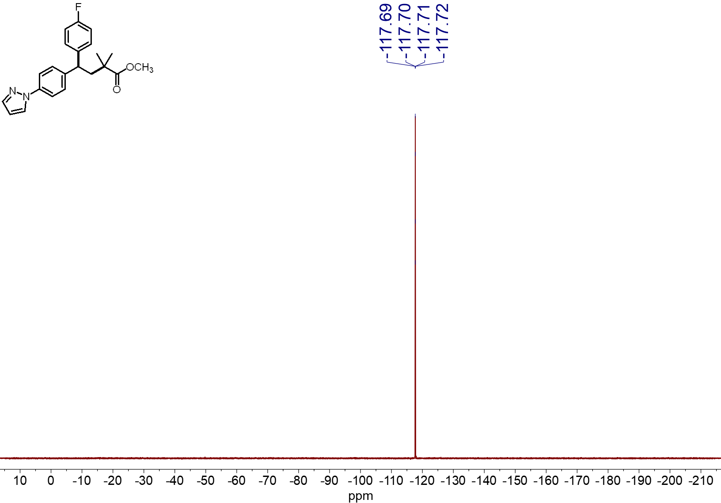
¹⁹F NMR spectrum (565 MHz, CDCl₃, 23 ºC) of 4i
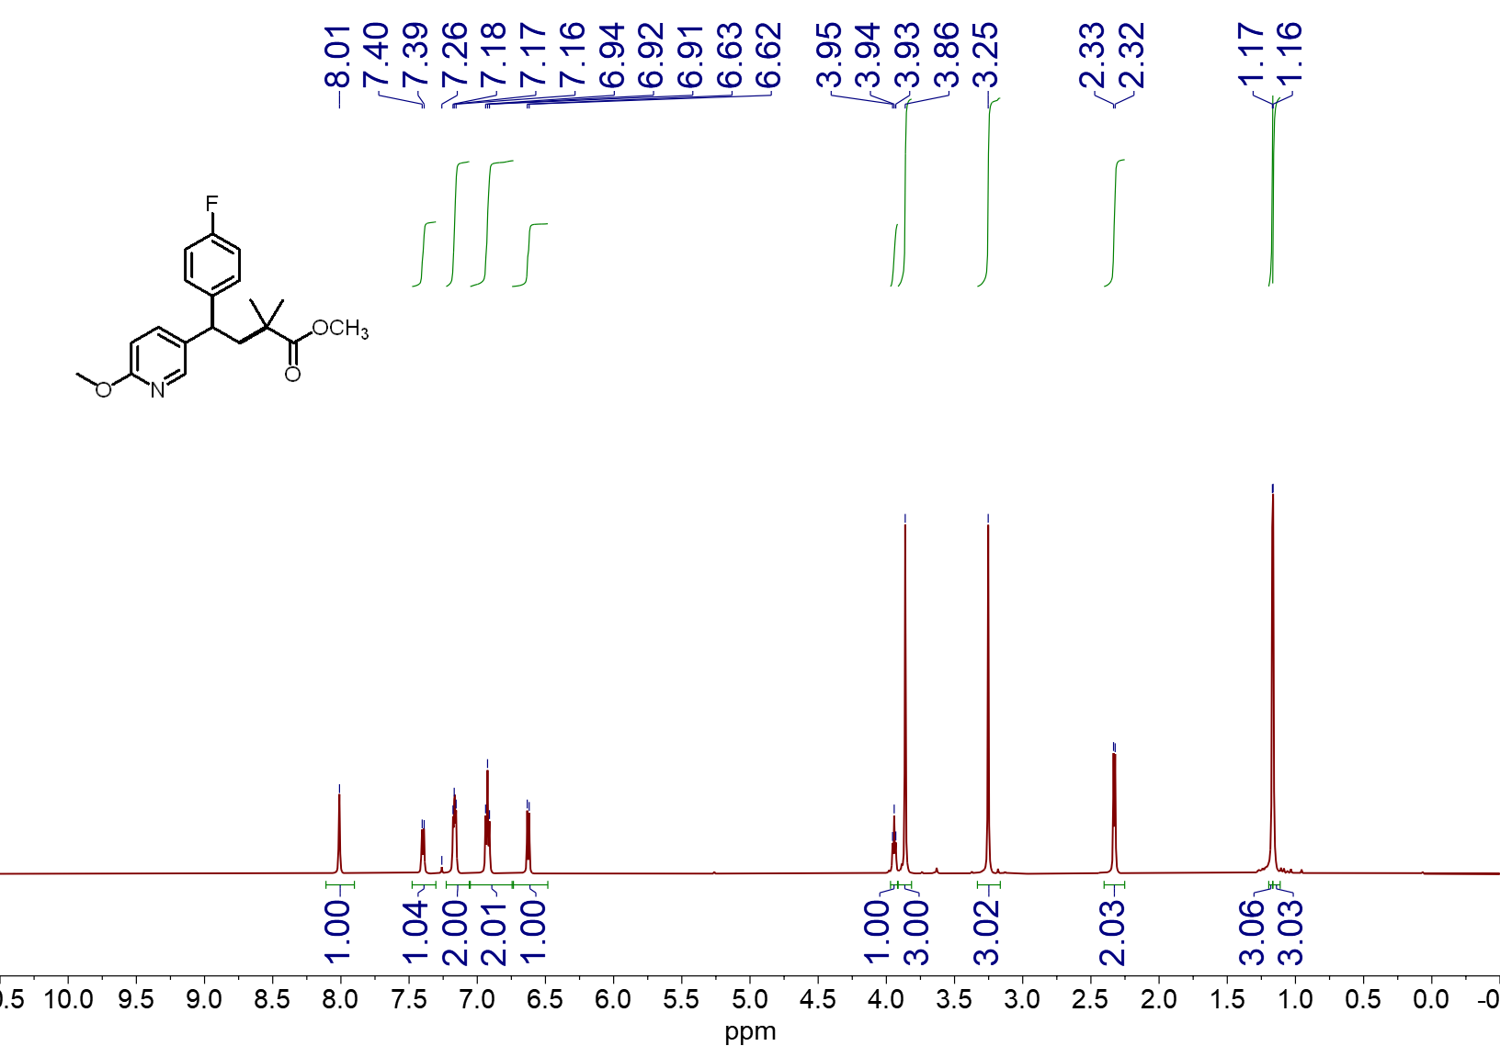
¹H NMR spectrum (600 MHz, CDCl₃, 23 ºC) of 4j
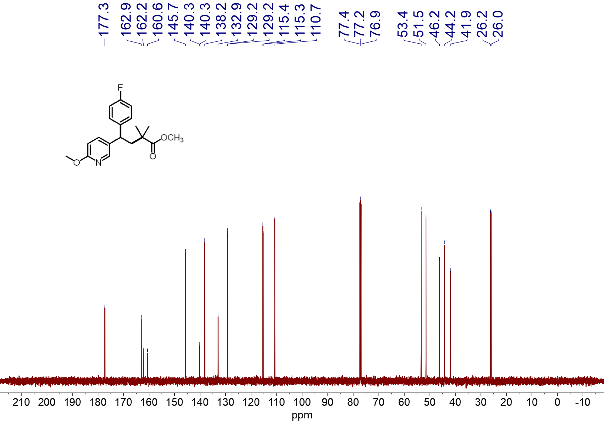
¹³C NMR spectrum (151 MHz, CDCl₃, 23 ºC) of 4j
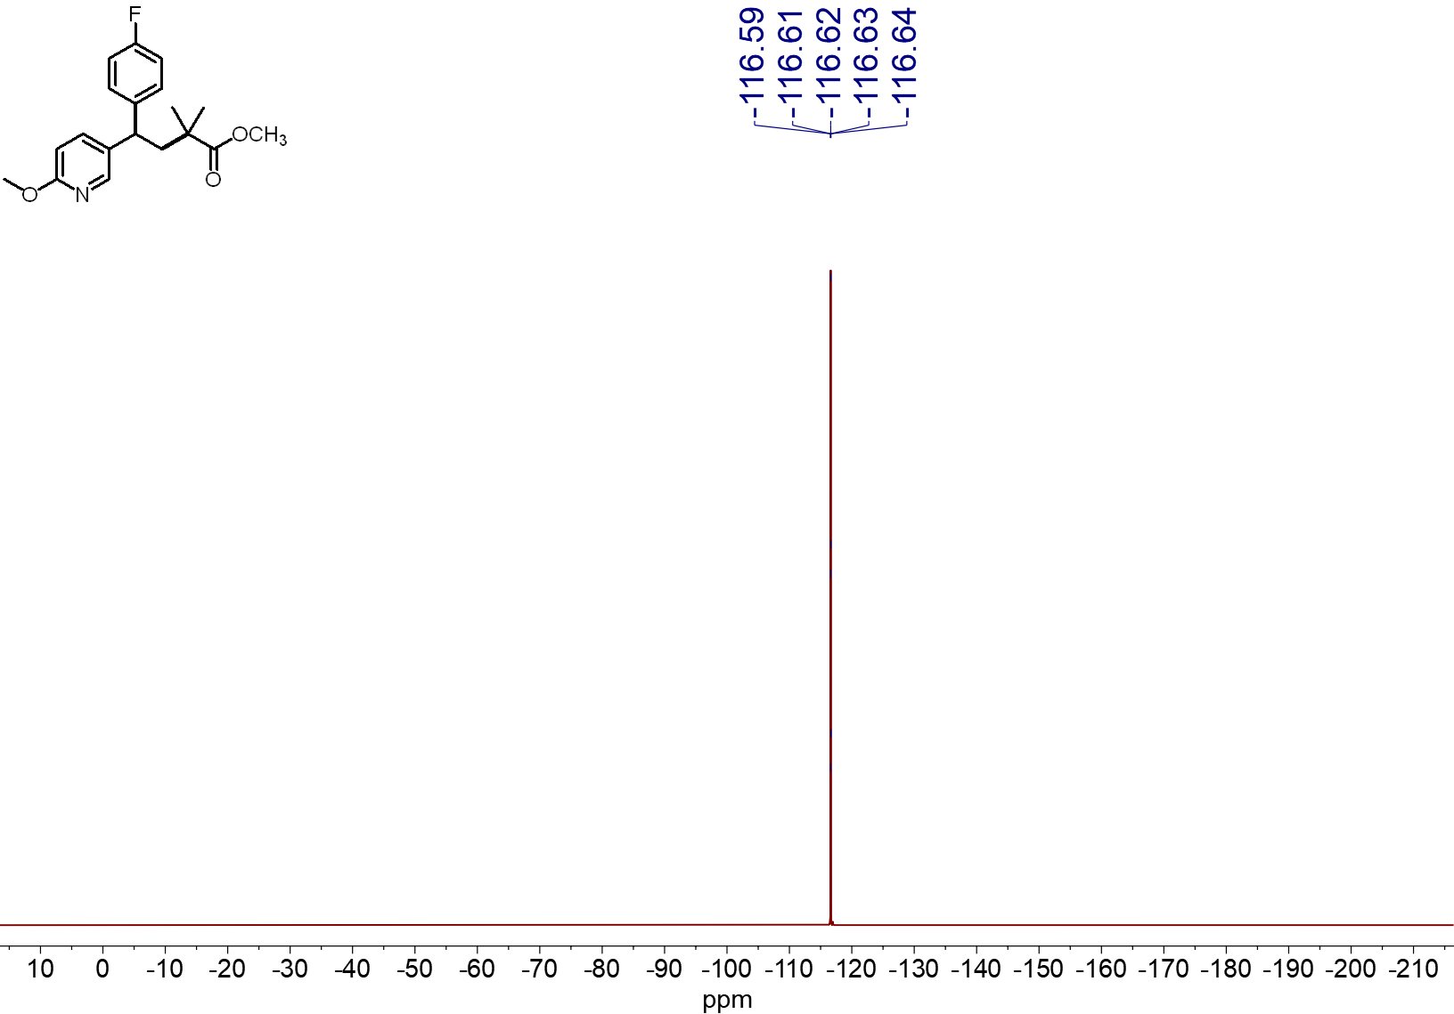
¹⁹F NMR spectrum (565 MHz, CDCl₃, 23 ºC) of 4j
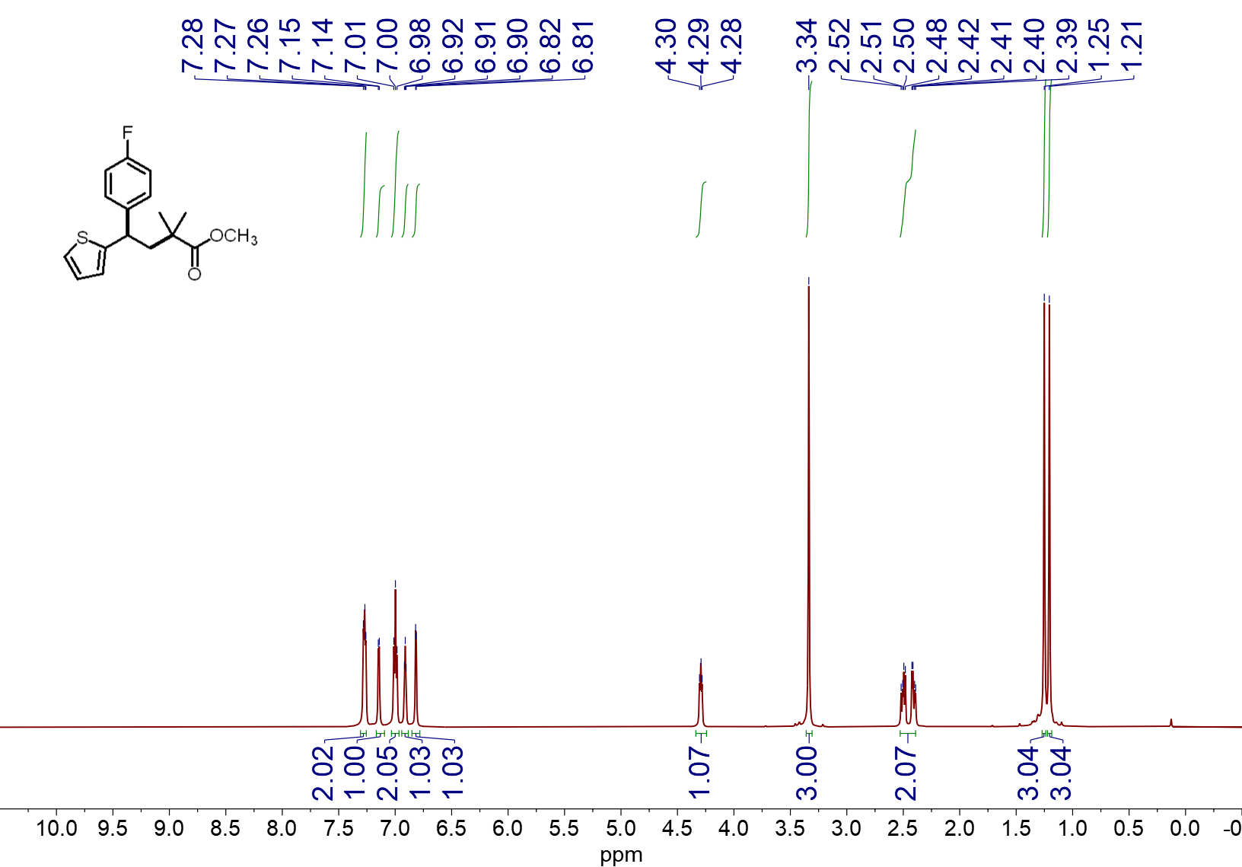
¹H NMR spectrum (600 MHz, CDCl₃, 23 ºC) of 4k
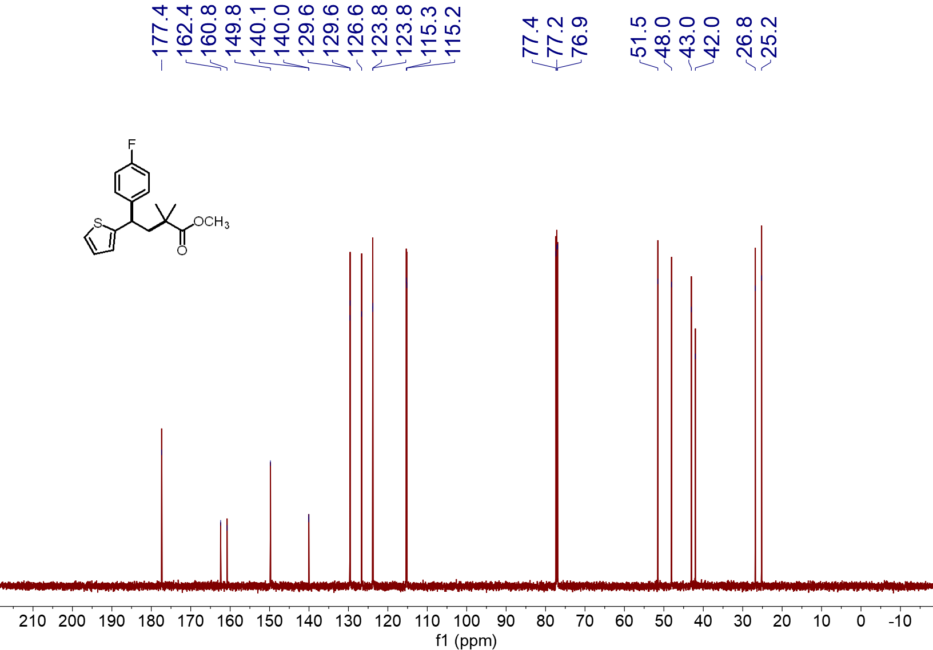
¹³C NMR spectrum (151 MHz, CDCl₃, 23 ºC) of 4k
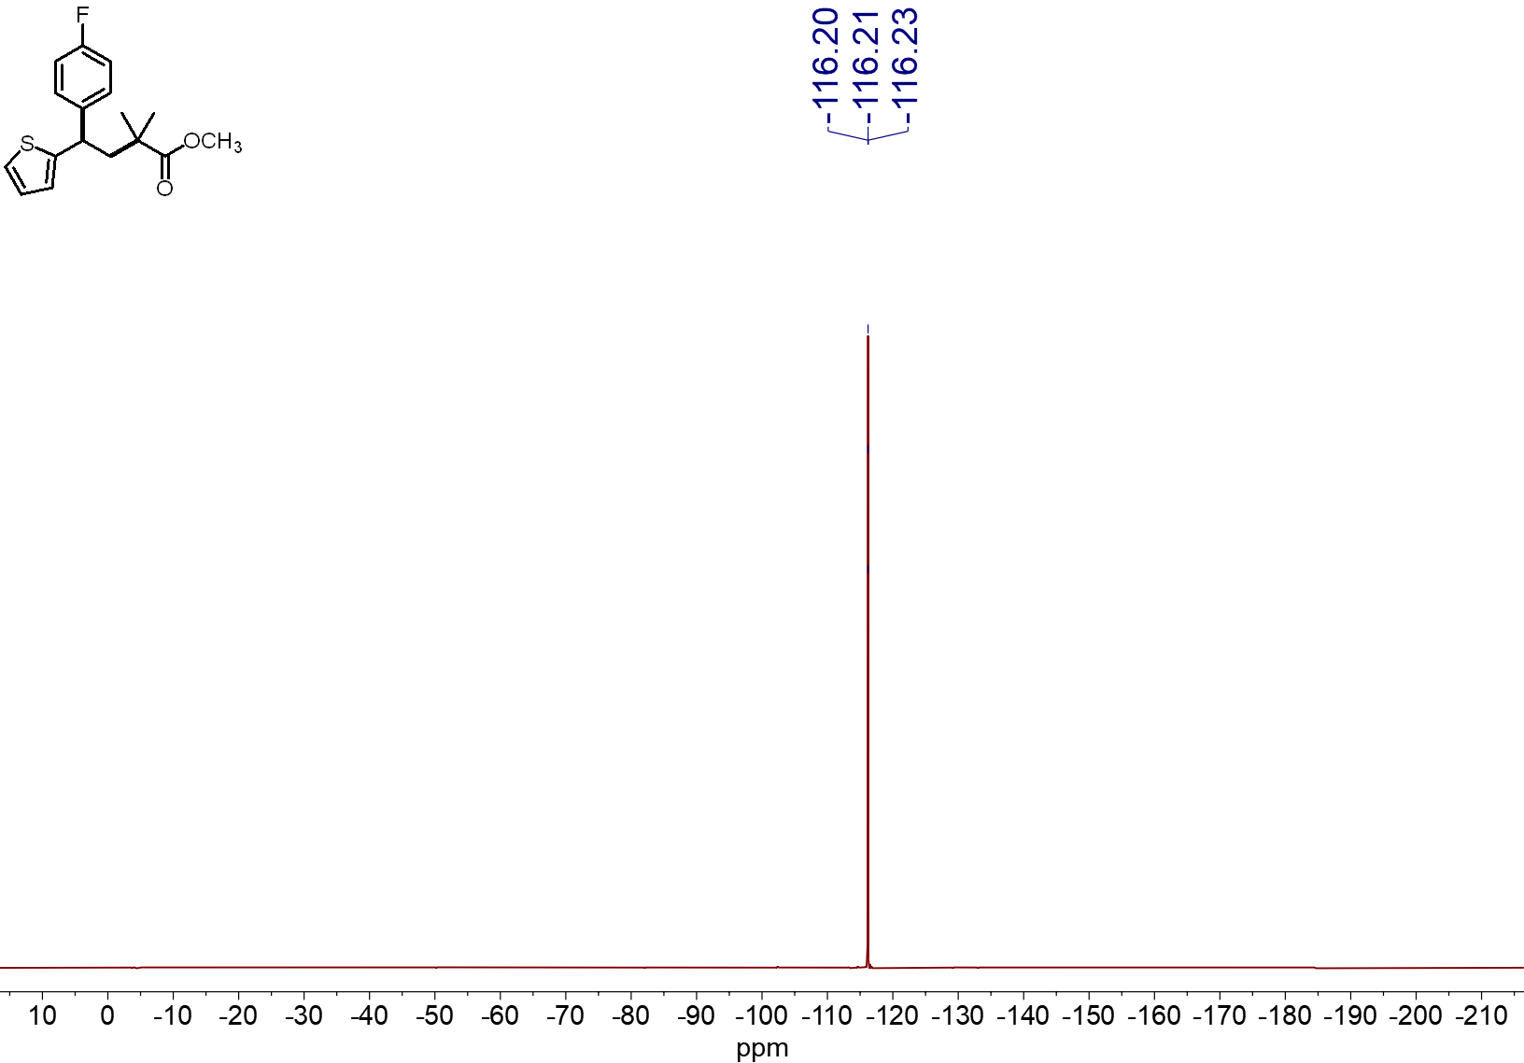
¹⁹F NMR spectrum (565 MHz, CDCl₃, 23 ºC) of 4k
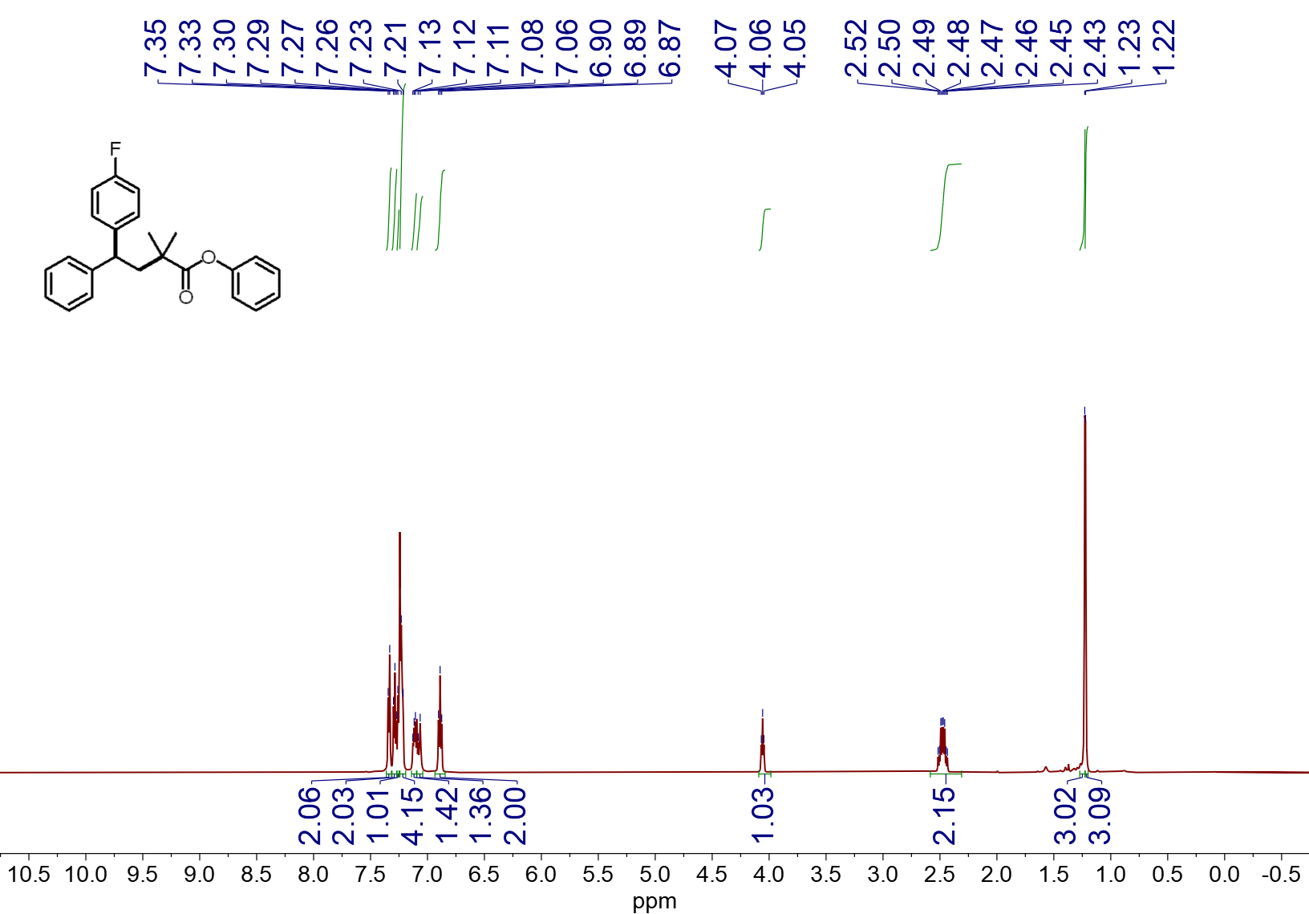
¹H NMR spectrum (600 MHz, CDCl₃, 23 ºC) of 4l
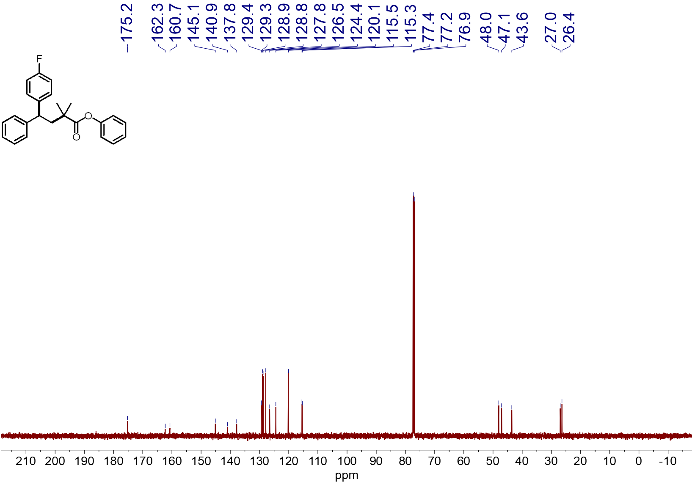
¹³C NMR spectrum (151 MHz, CDCl₃, 23 ºC) of 4l
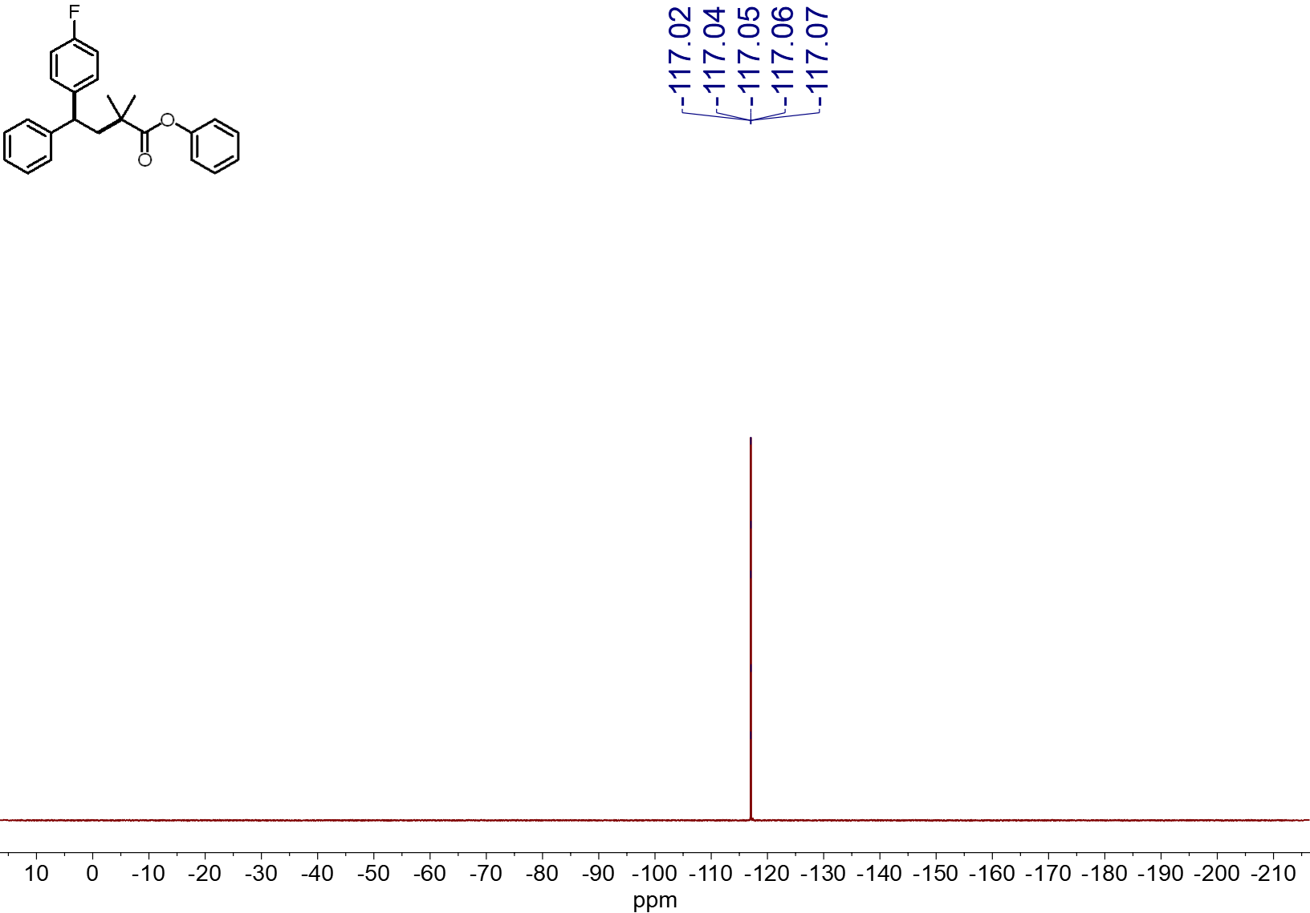
¹⁹F NMR spectrum (565 MHz, CDCl₃, 23 ºC) of 4l
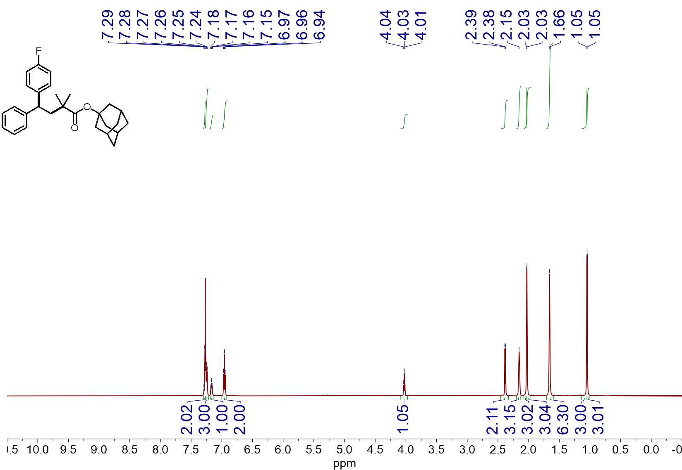
¹H NMR spectrum (600 MHz, CDCl₃, 23 ºC) of 4m
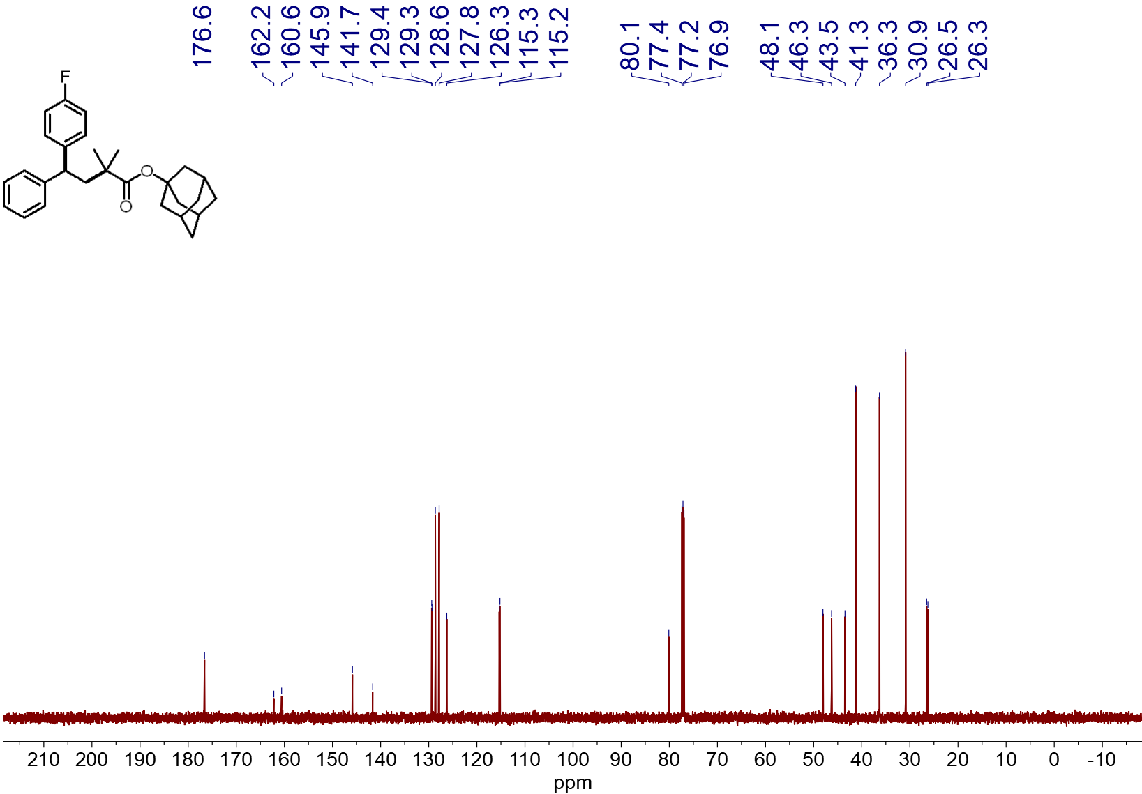
¹³C NMR spectrum (151 MHz, CDCl₃, 23 ºC) of 4m
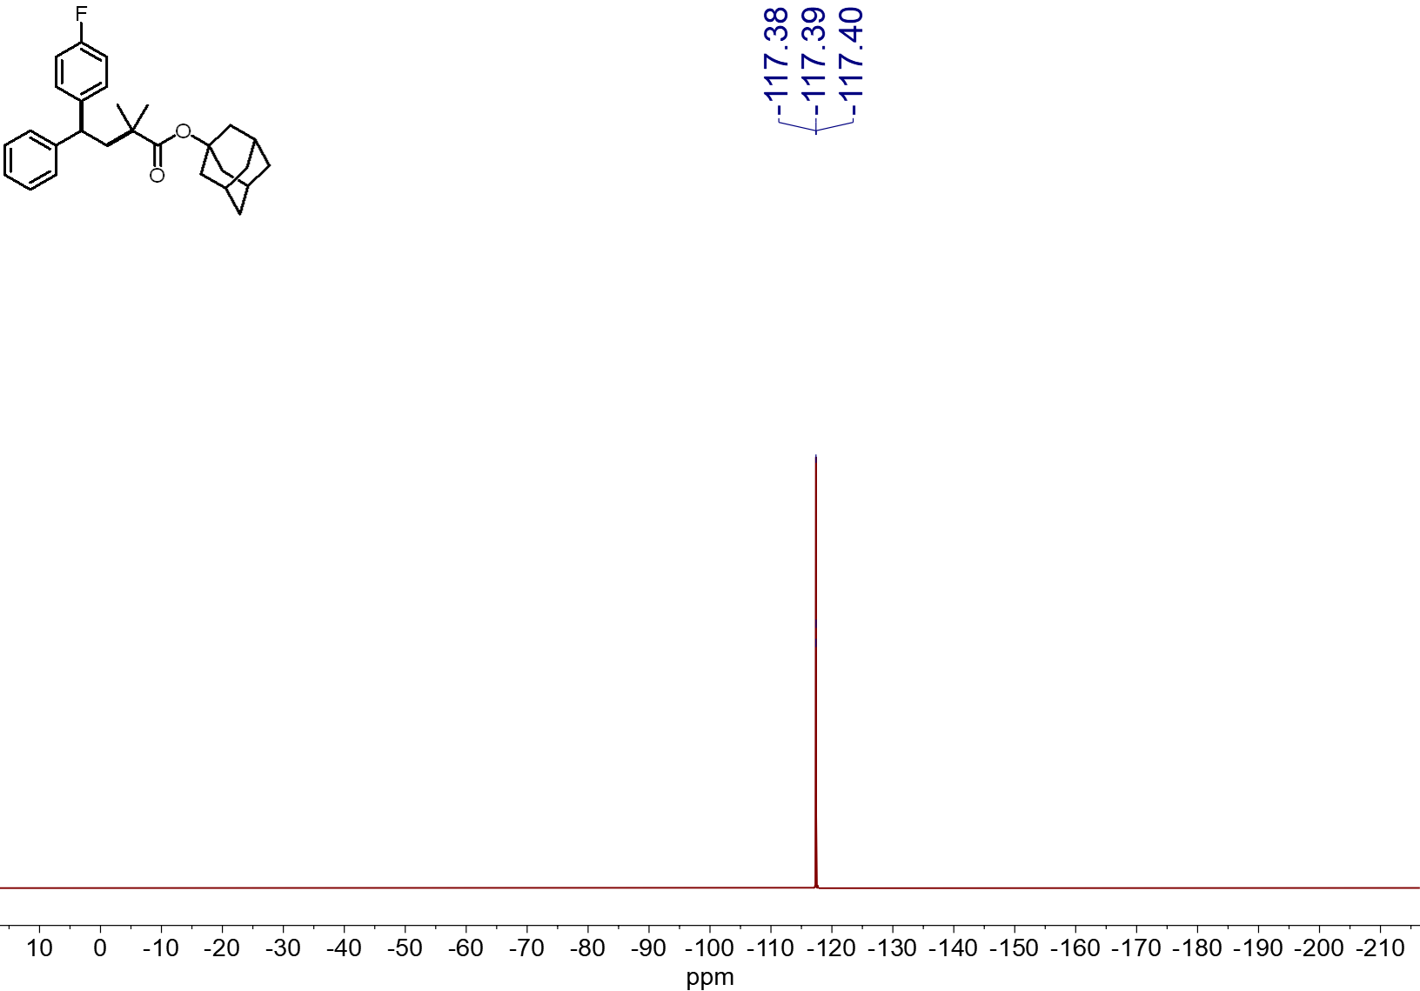
¹⁹F NMR spectrum (565 MHz, CDCl₃, 23 ºC) of 4m
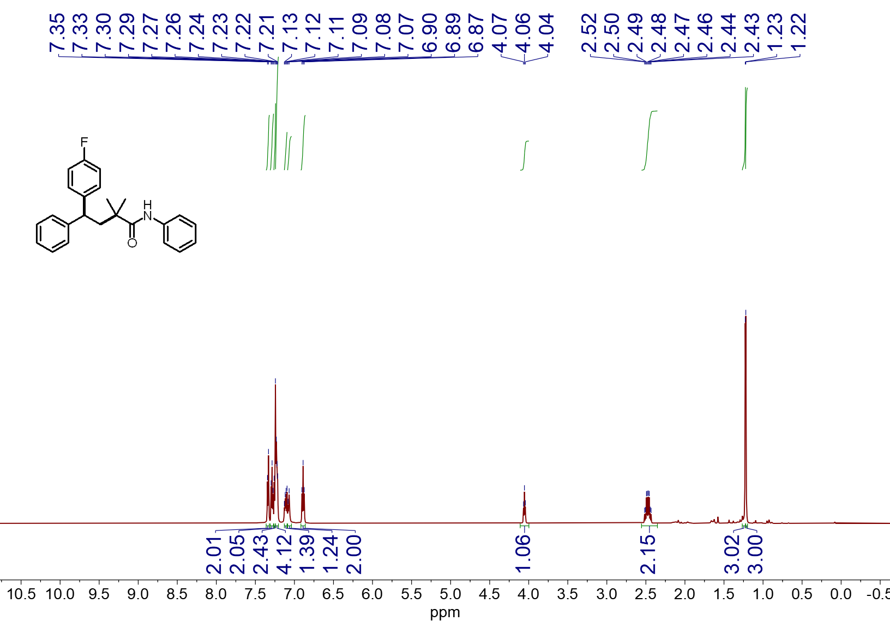
¹H NMR spectrum (600 MHz, CDCl₃, 23 ºC) of 4n
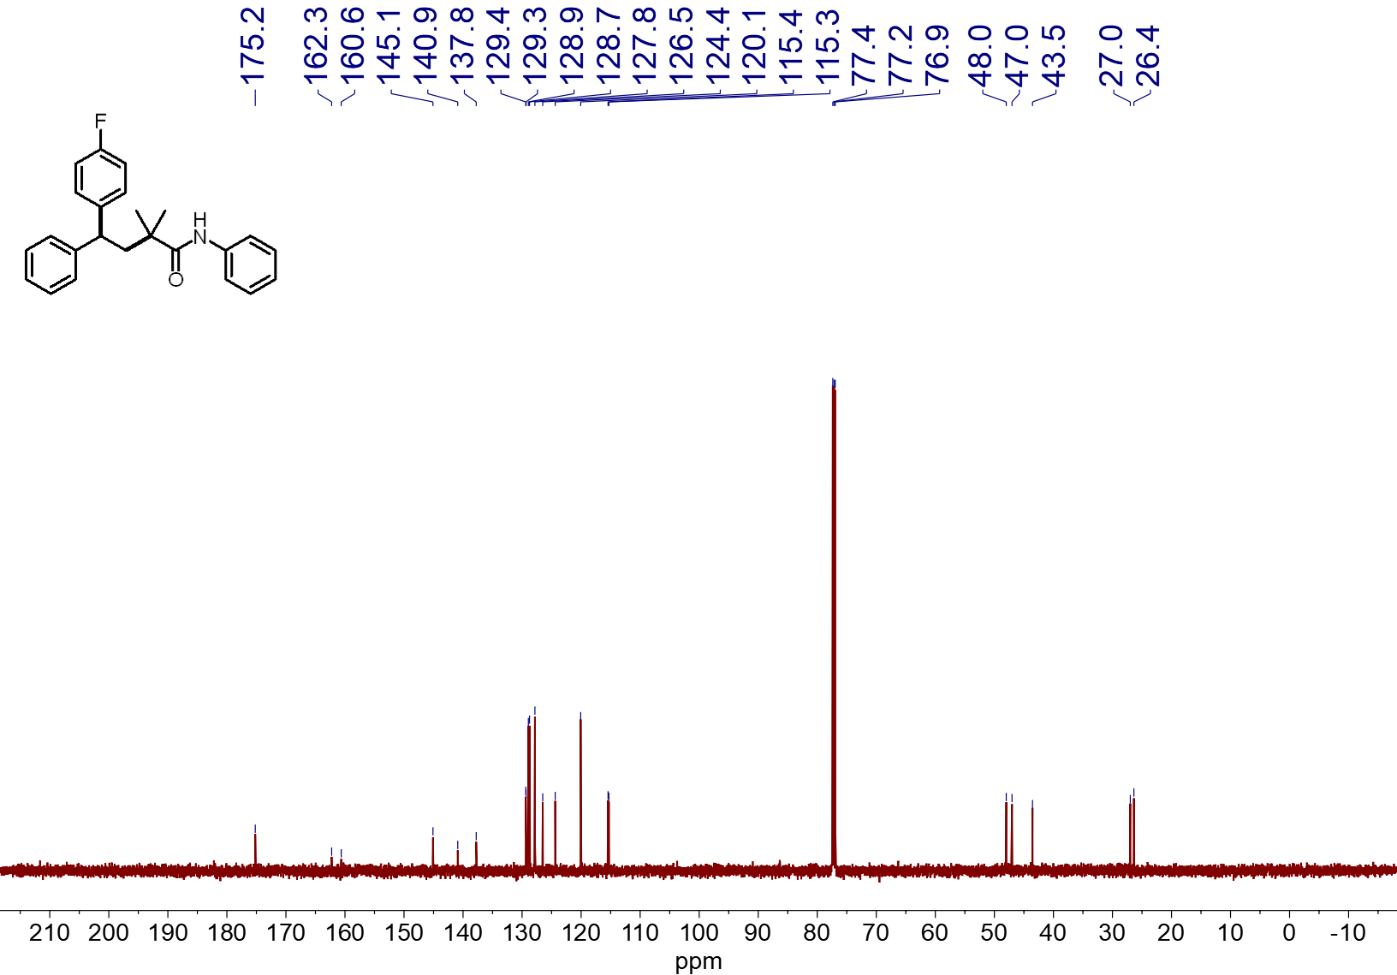
¹³C NMR spectrum (151 MHz, CDCl₃, 23 ºC) of 4n

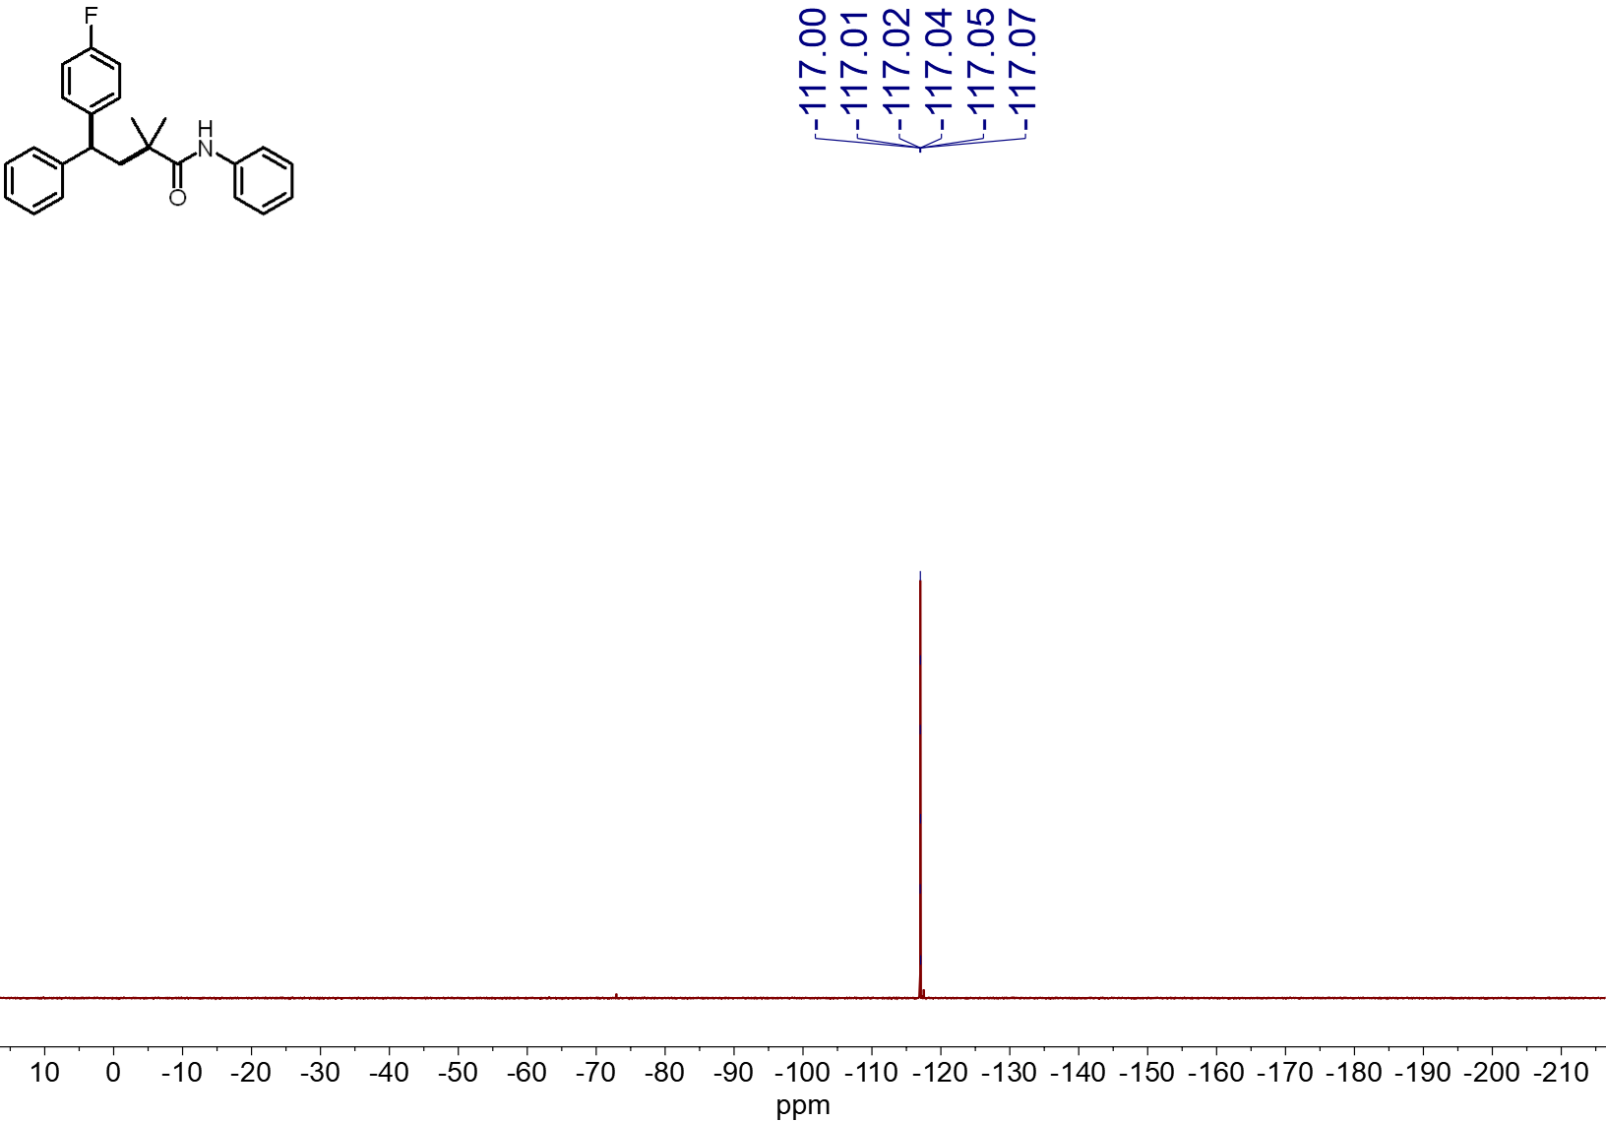
¹⁹F NMR spectrum (565 MHz, CDCl₃, 23 ºC) of 4n
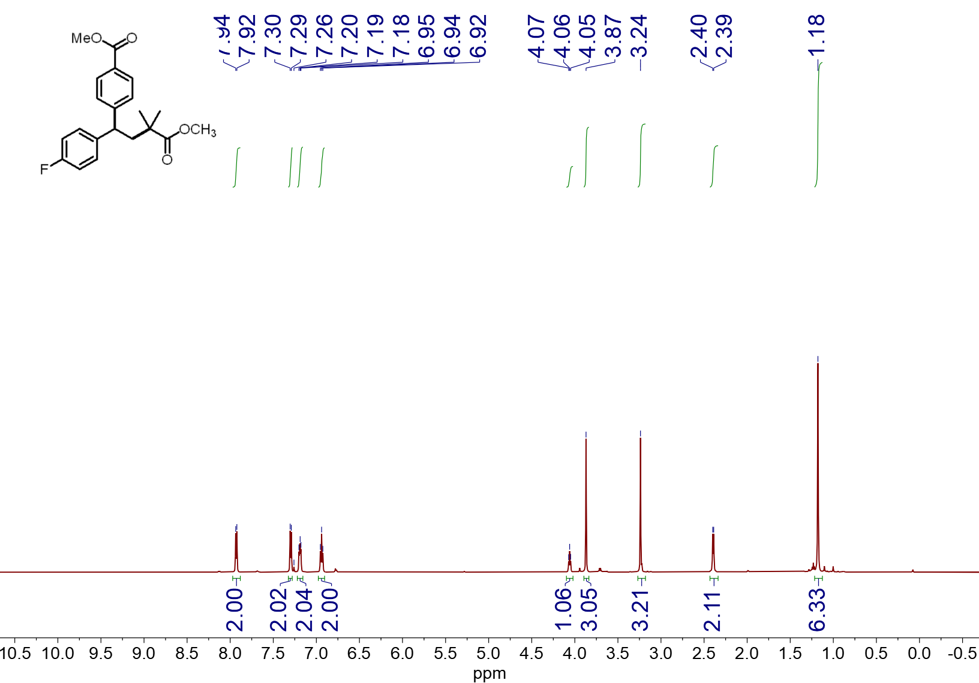
¹H NMR spectrum (600 MHz, CDCl₃, 23 ºC) of 4o
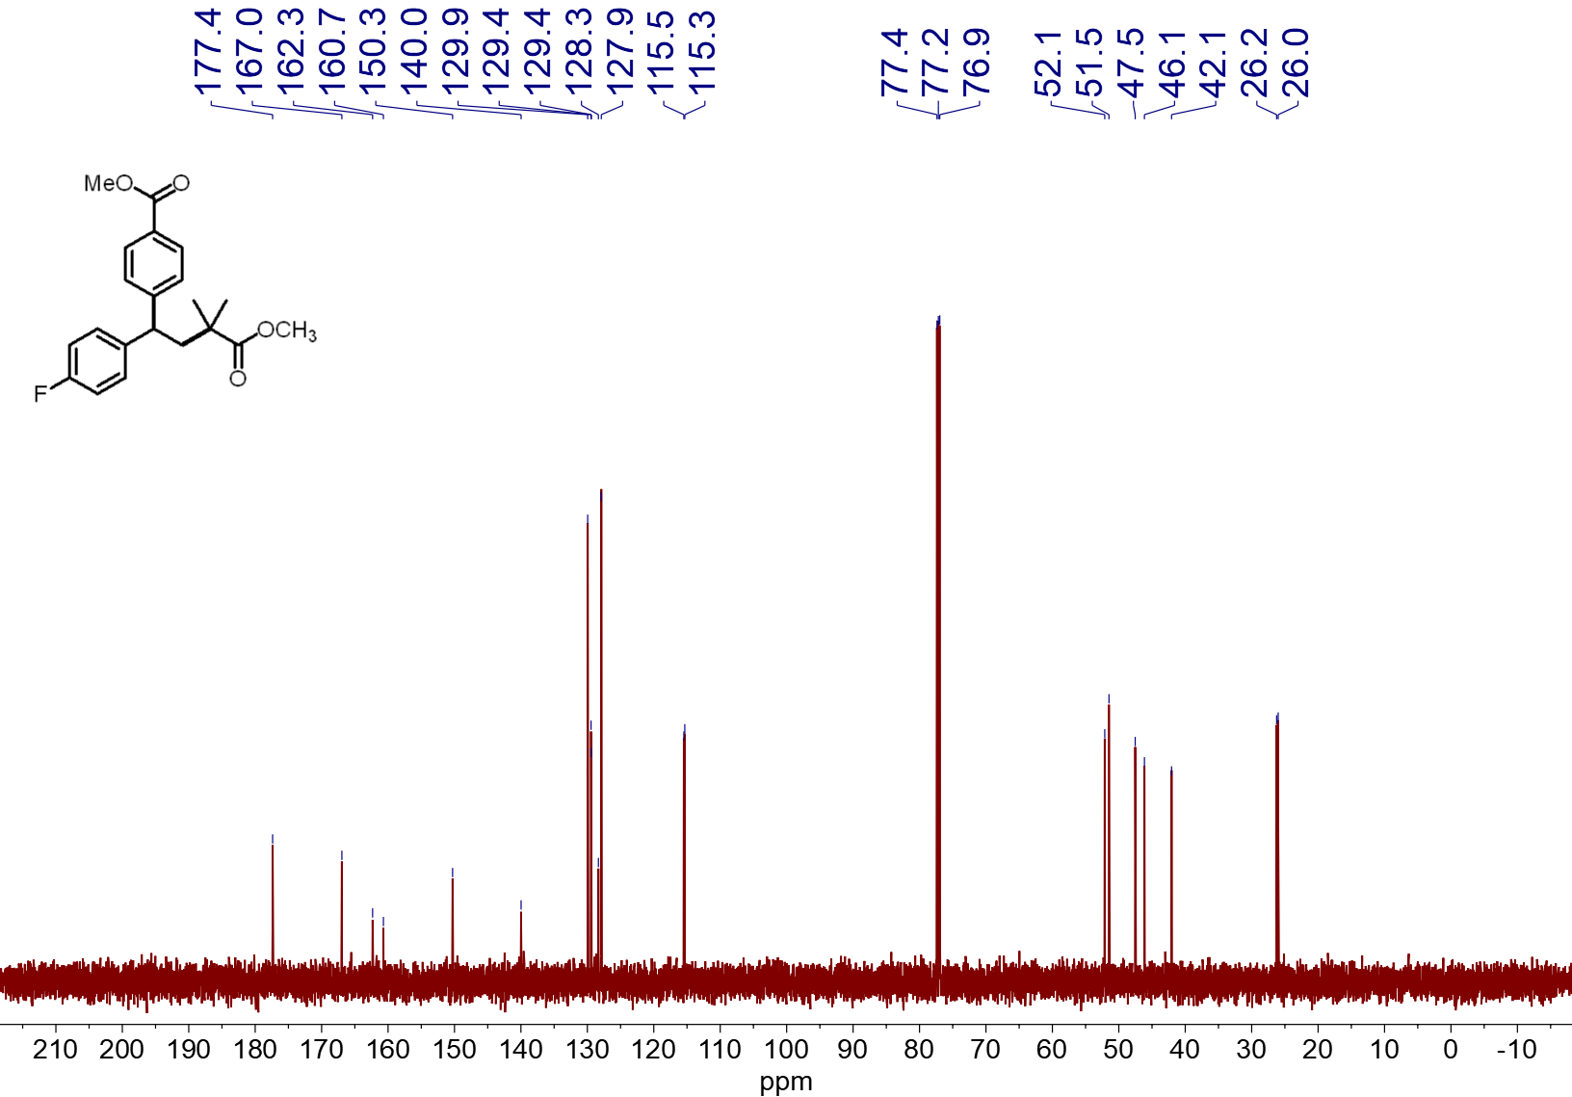
¹³C NMR spectrum (151 MHz, CDCl₃, 23 ºC) of 4o
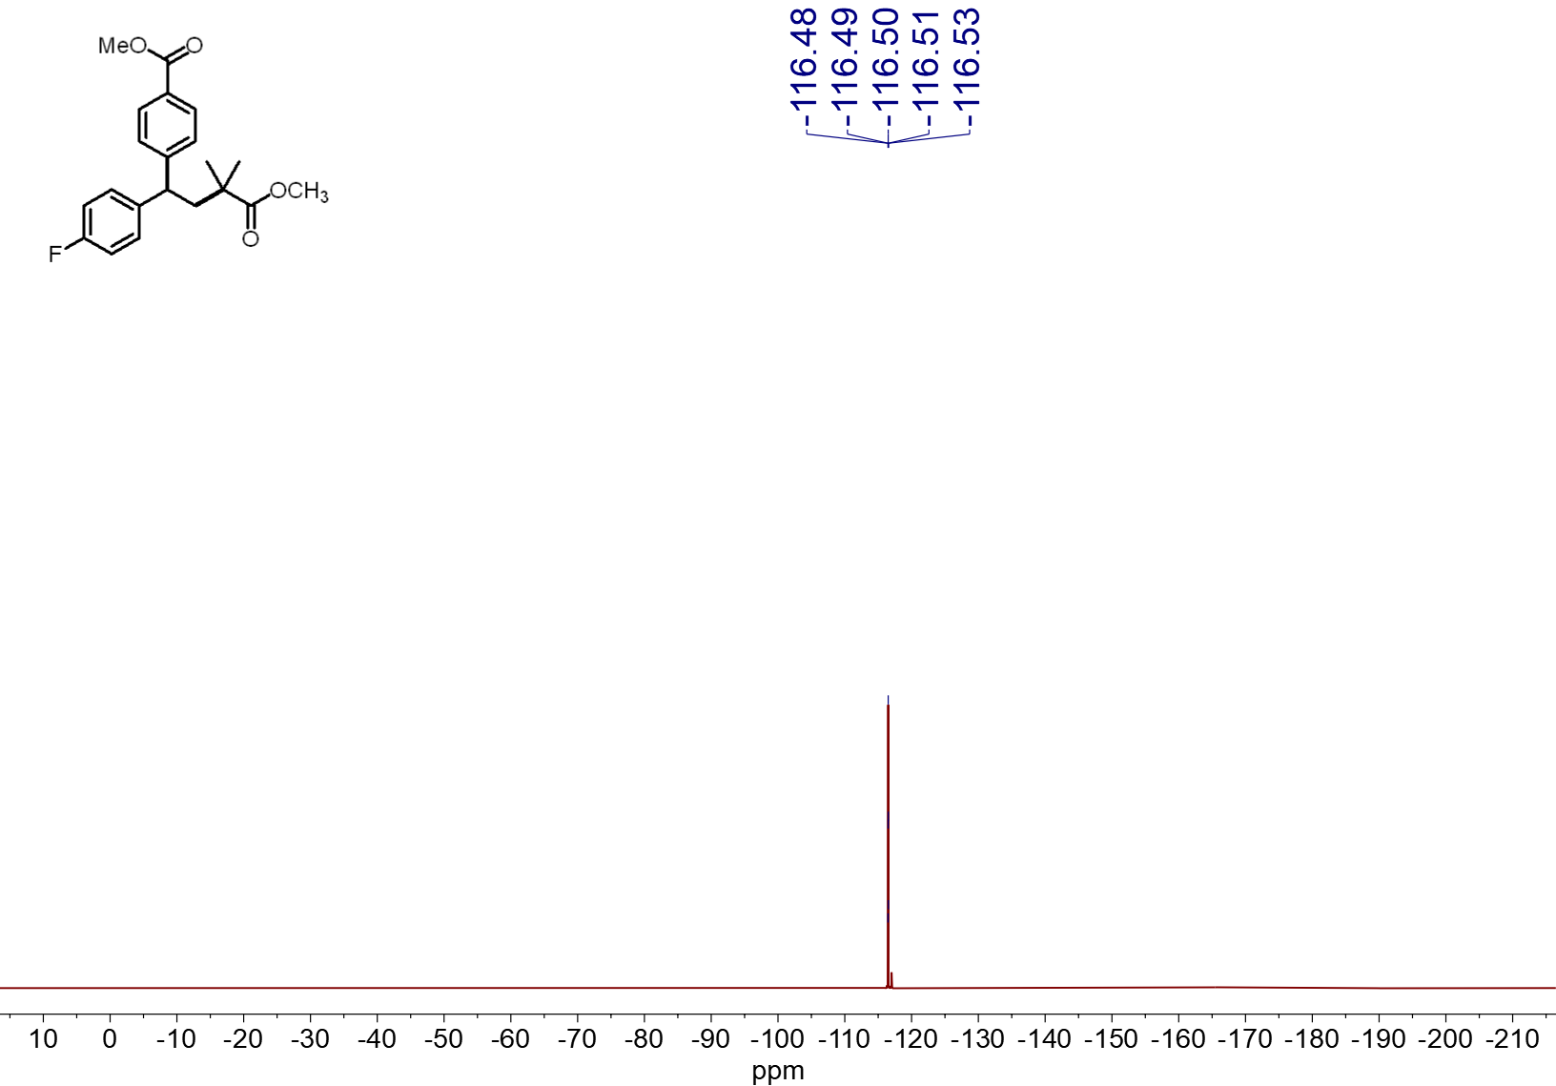
¹⁹F NMR spectrum (565 MHz, CDCl₃, 23 ºC) of 4o
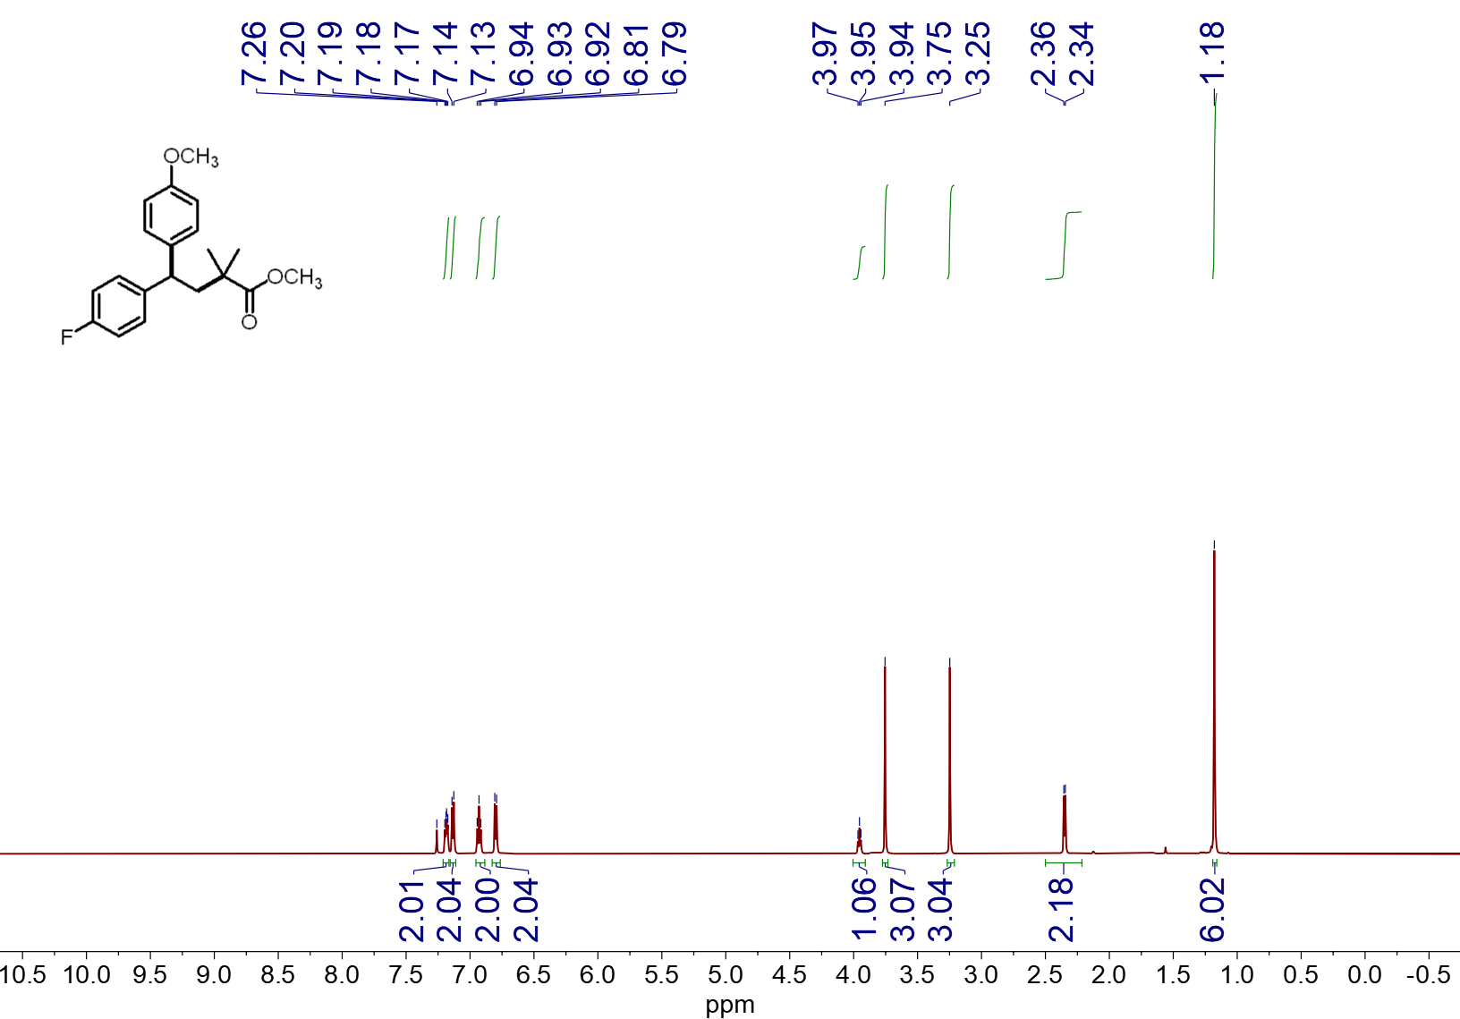
¹H NMR spectrum (600 MHz, CDCl₃, 23 ºC) of 4p
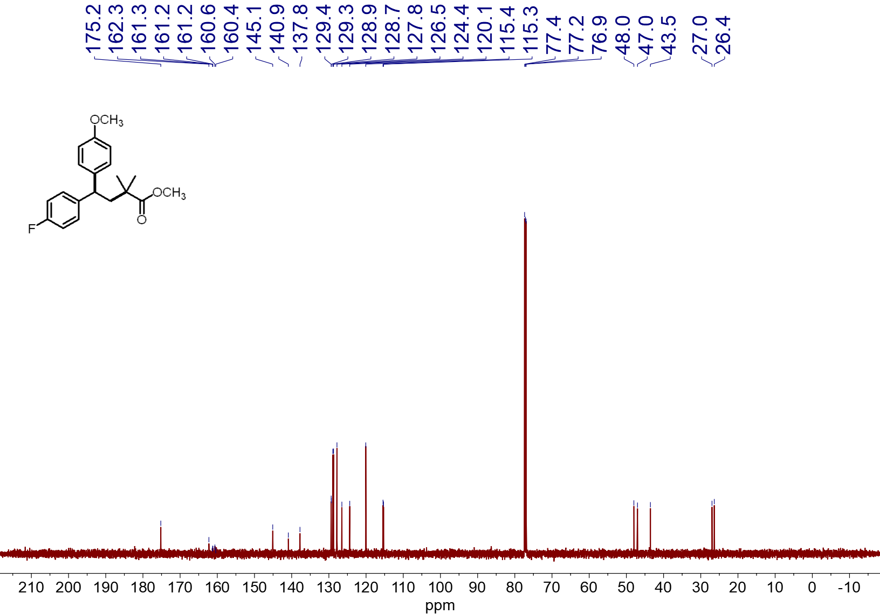
¹³C NMR spectrum (151 MHz, CDCl₃, 23 ºC) of 4p
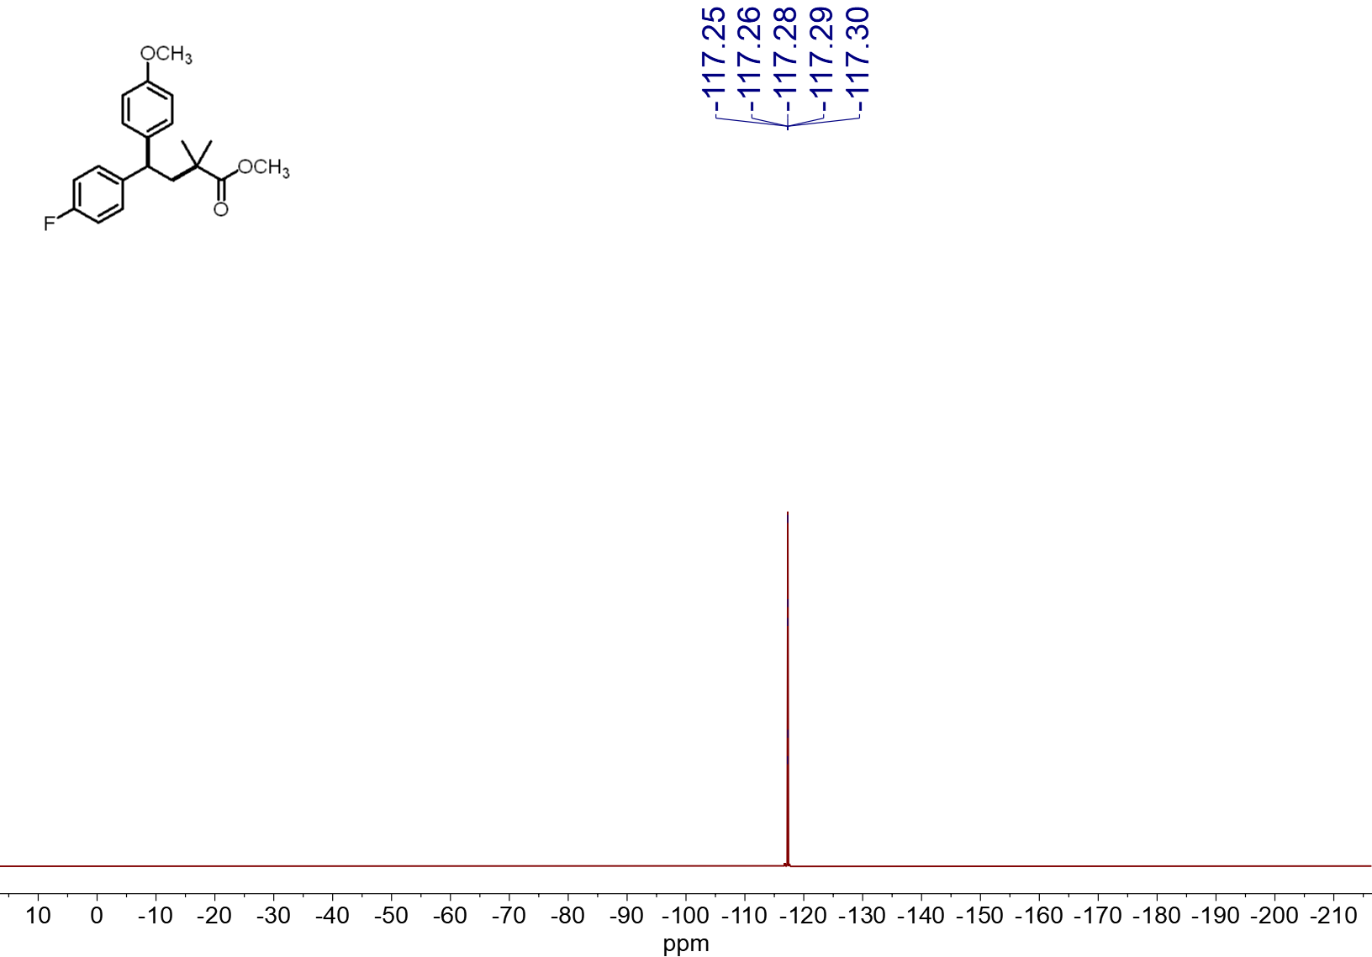
¹⁹F NMR spectrum (565 MHz, CDCl₃, 23 ºC) of 4p
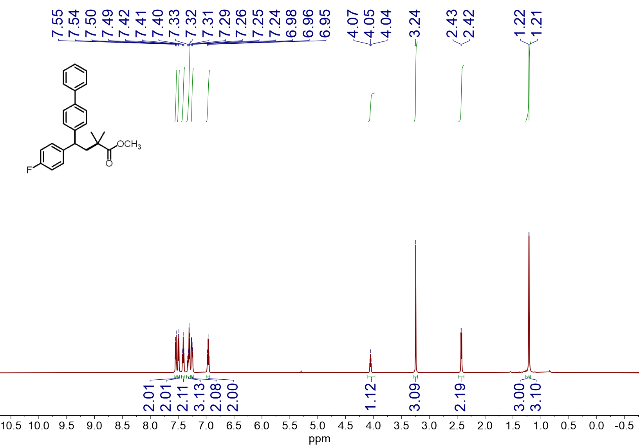 ¹H NMR spectrum (600 MHz, CDCl₃, 23 ºC) of 4q
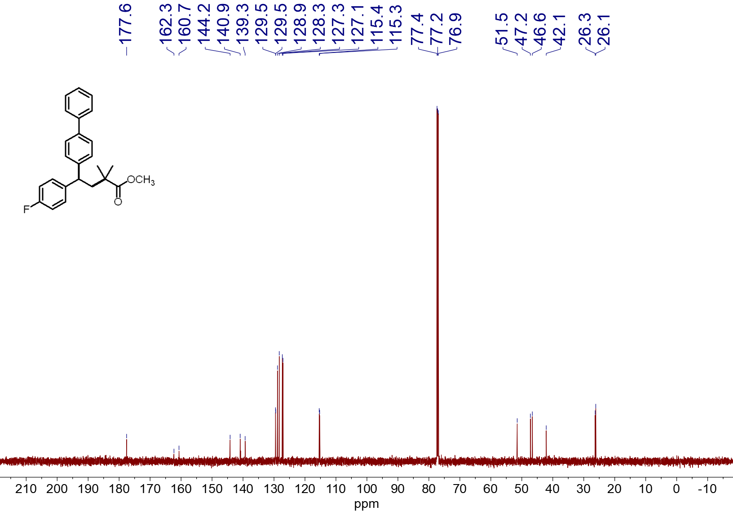
¹³C NMR spectrum (151 MHz, CDCl₃, 23 ºC) of 4q
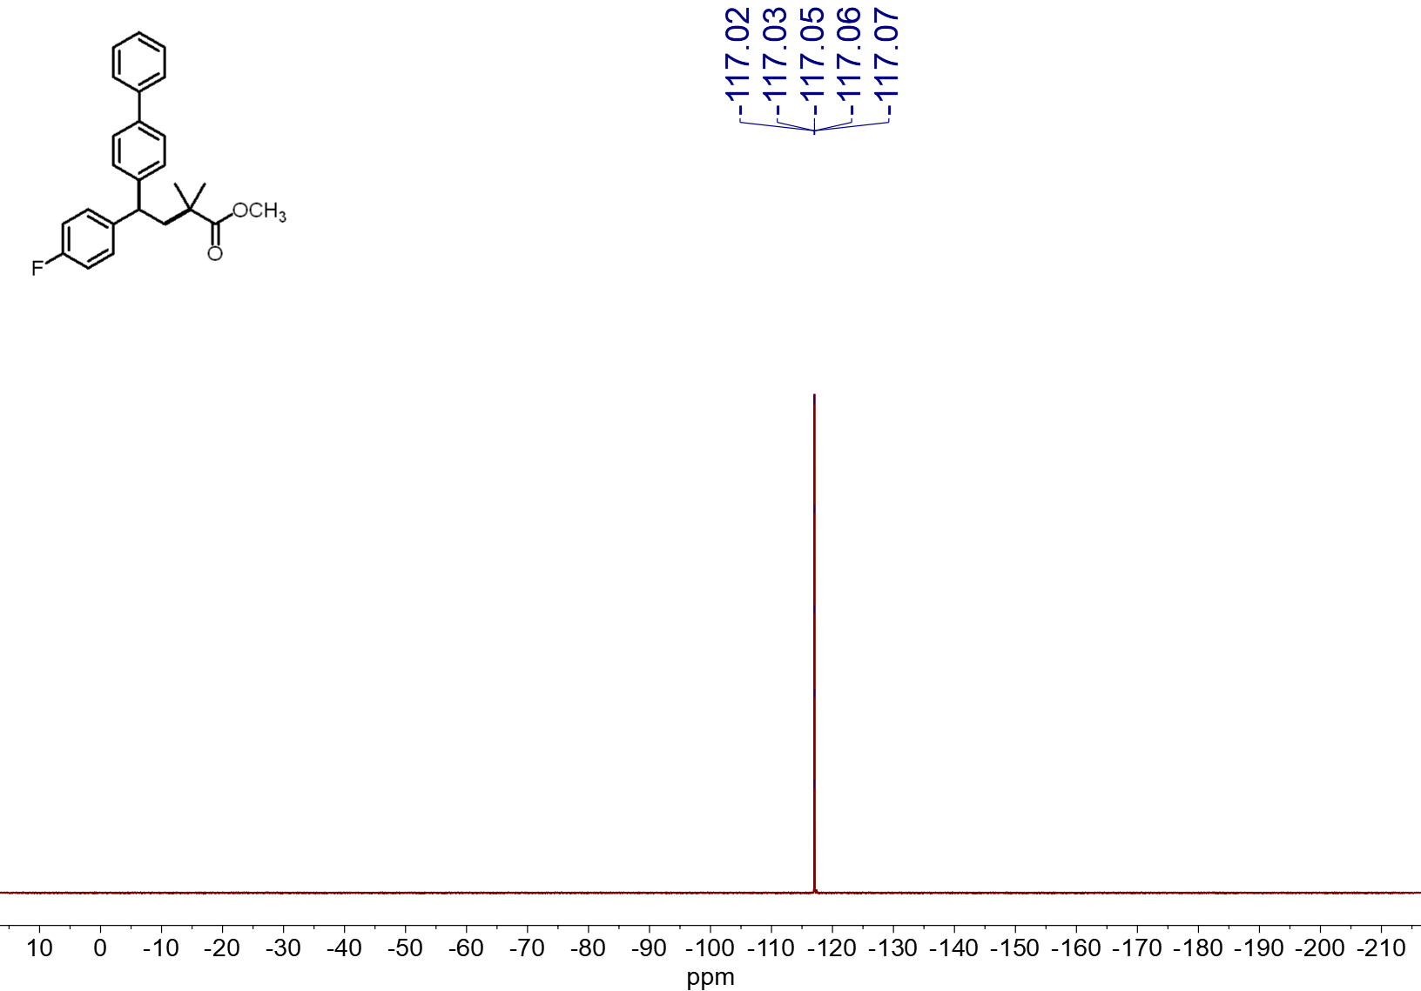
¹⁹F NMR spectrum (565 MHz, CDCl₃, 23 ºC) of 4q
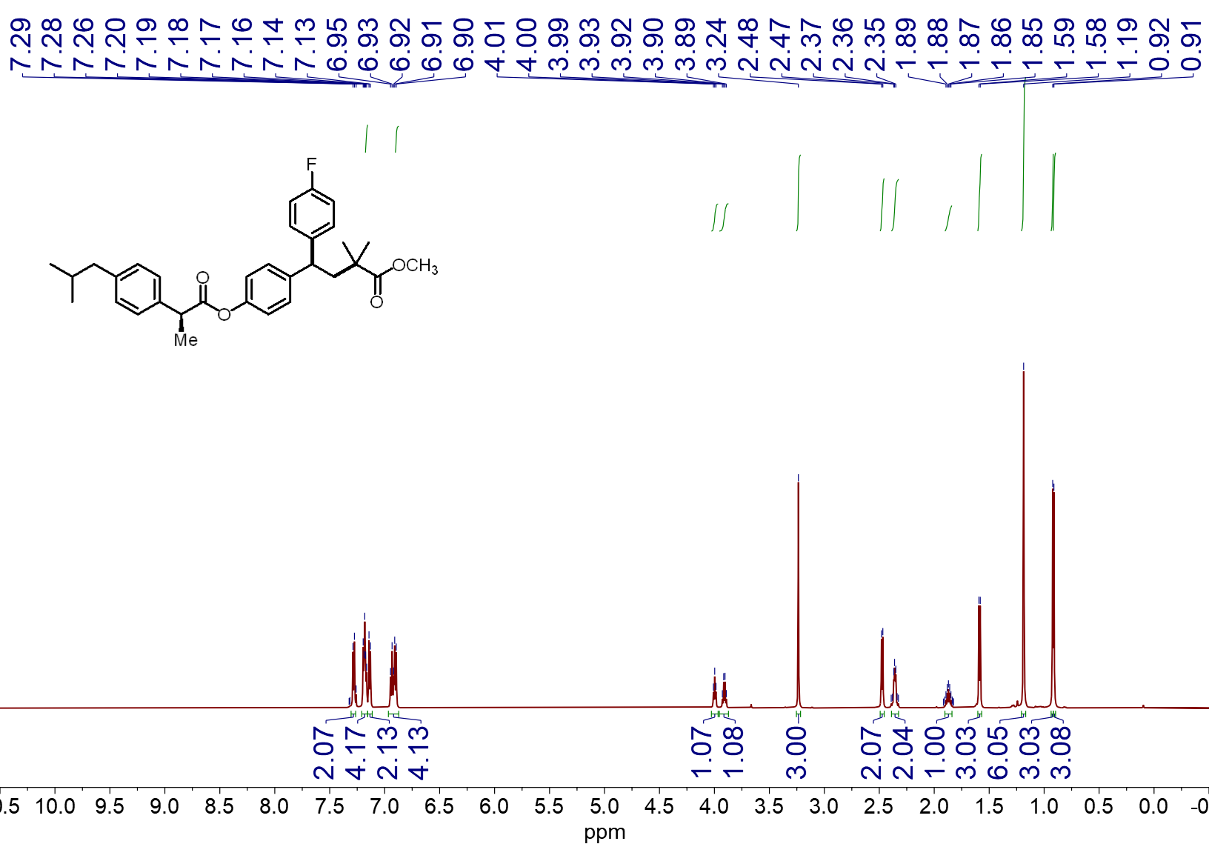
¹H NMR spectrum (600 MHz, CDCl₃, 23 ºC) of 4r

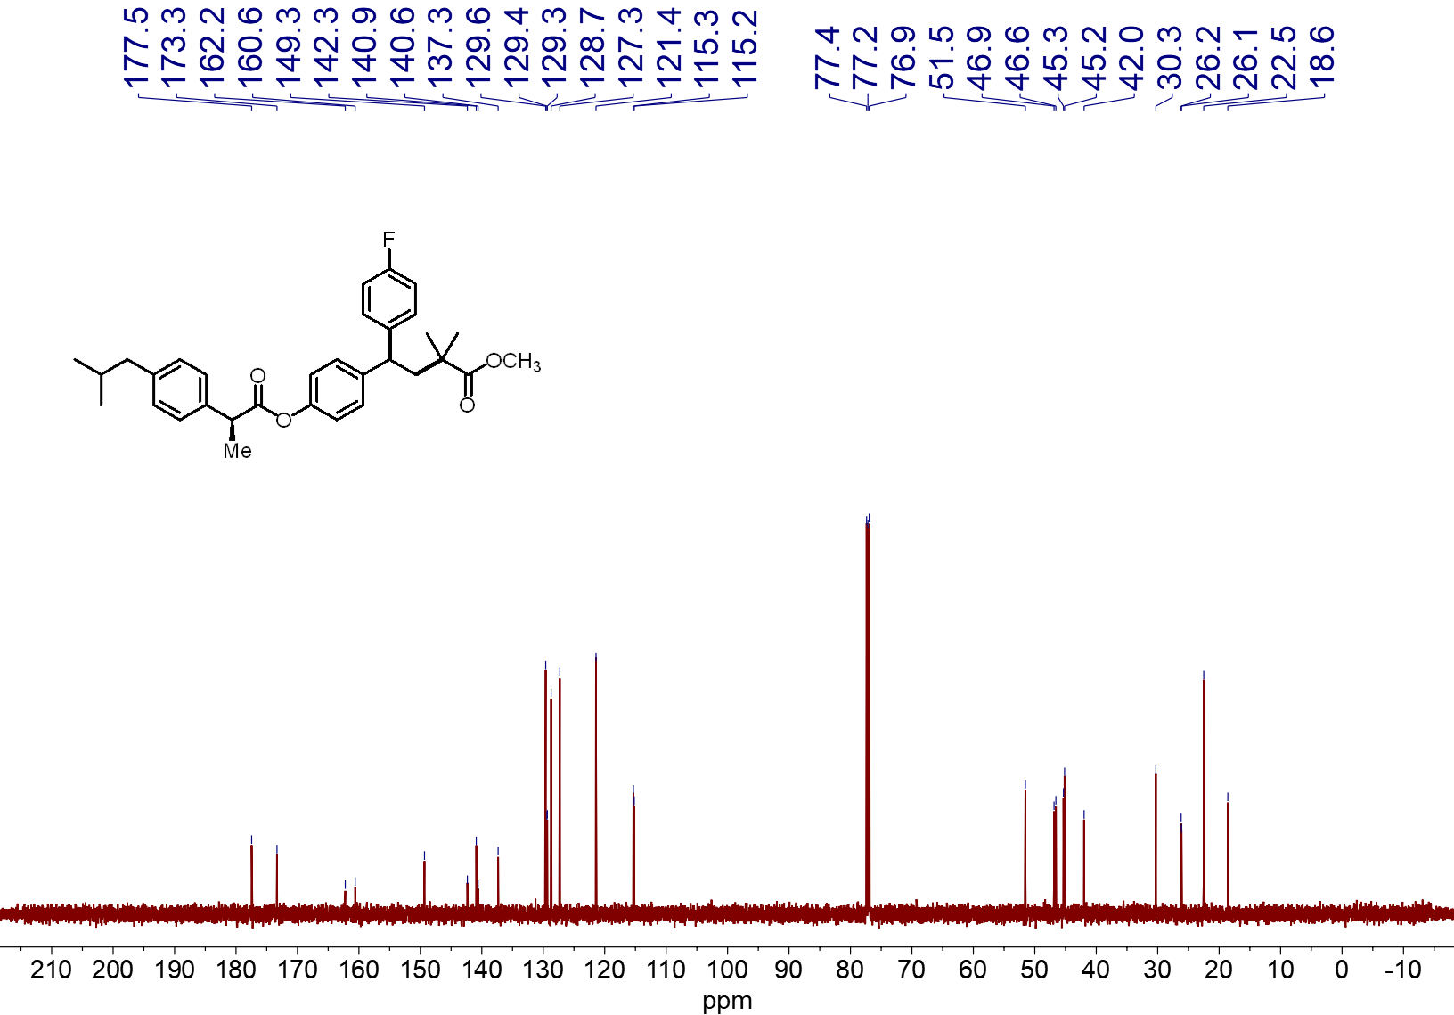¹³C NMR spectrum (151 MHz, CDCl₃, 23 ºC) of 4r

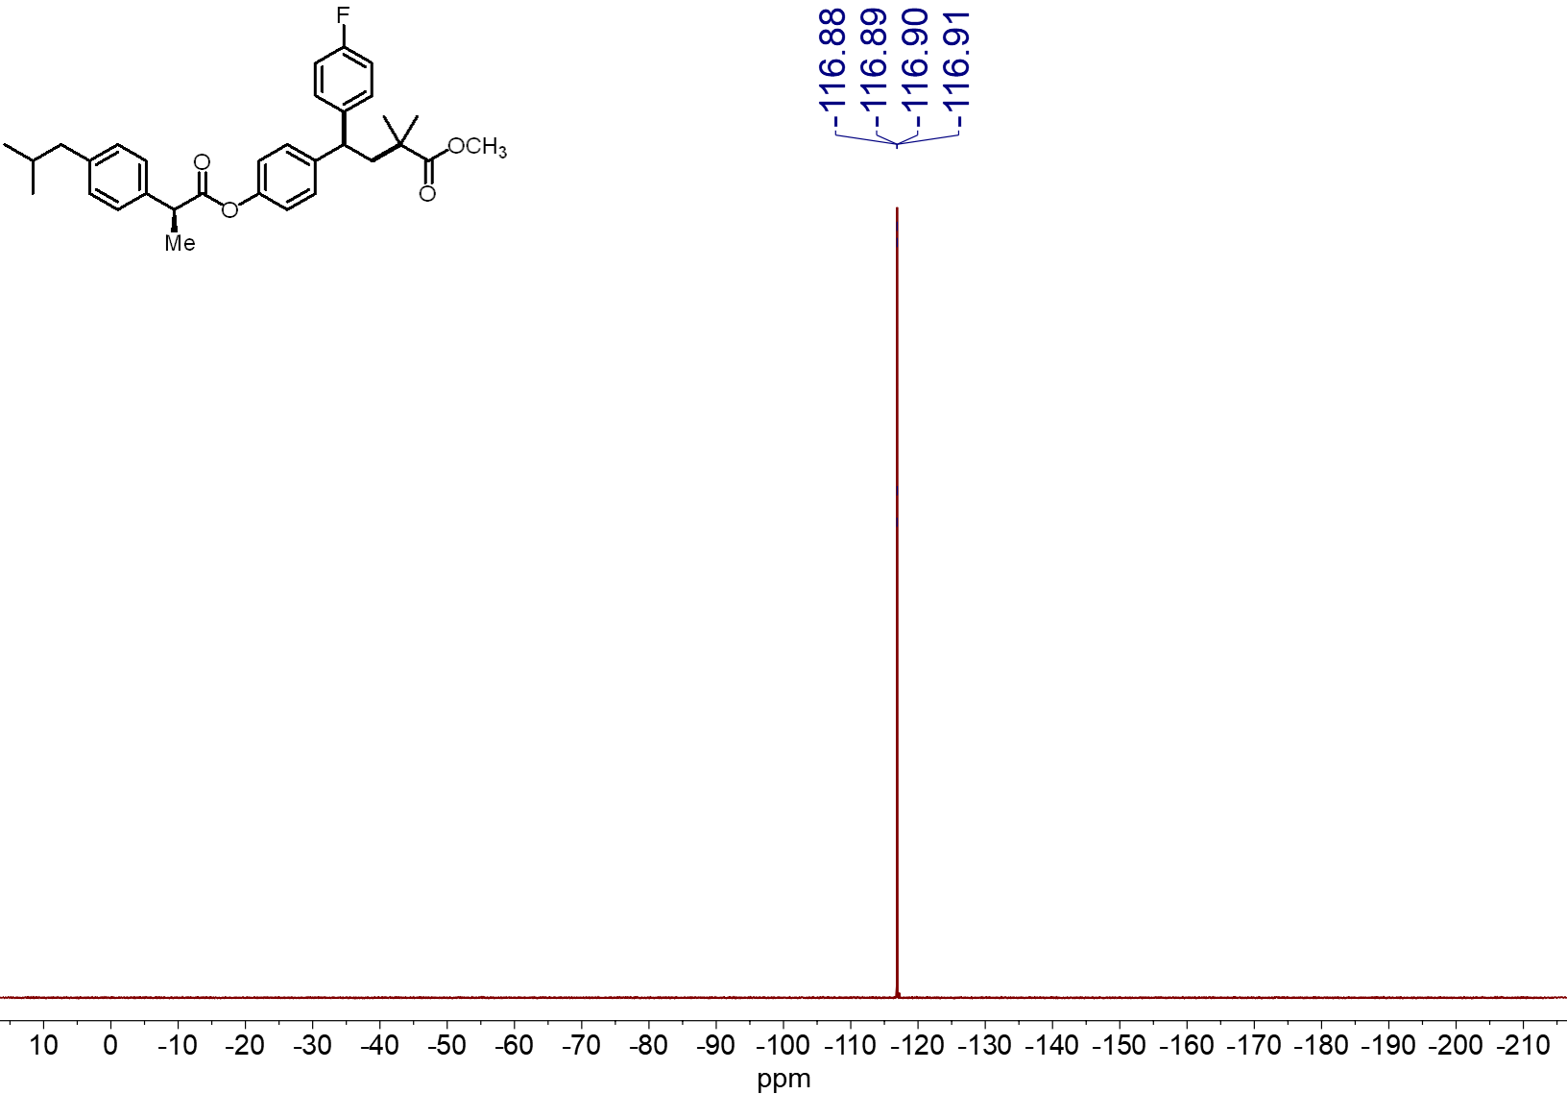¹⁹F NMR spectrum (565 MHz, CDCl₃, 23 ºC) of 4r

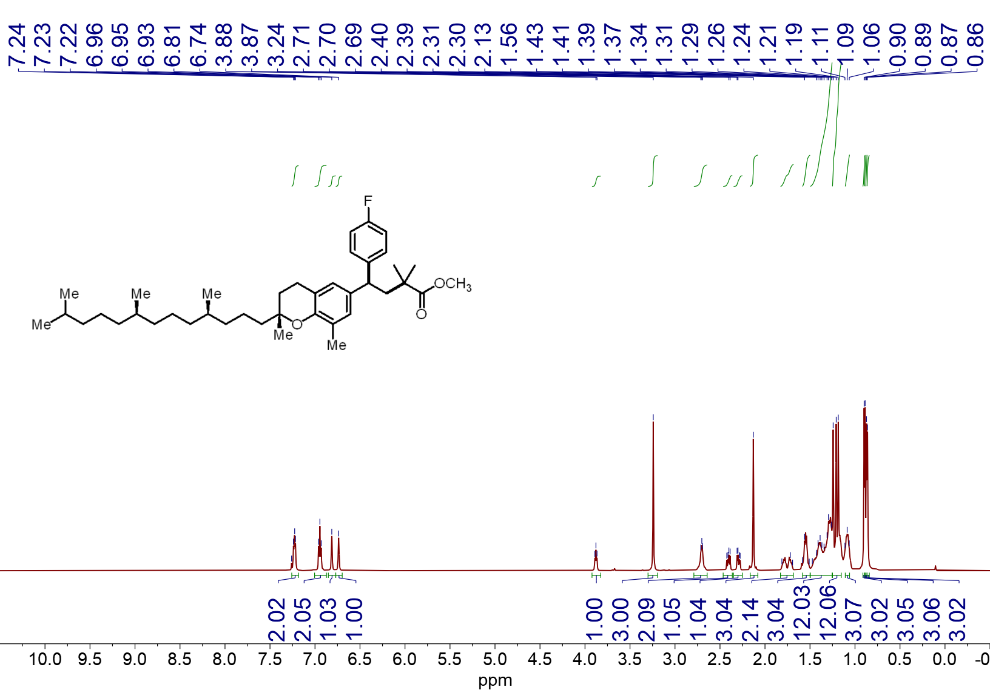¹H NMR spectrum (600 MHz, CDCl₃, 23 ºC) of 4s

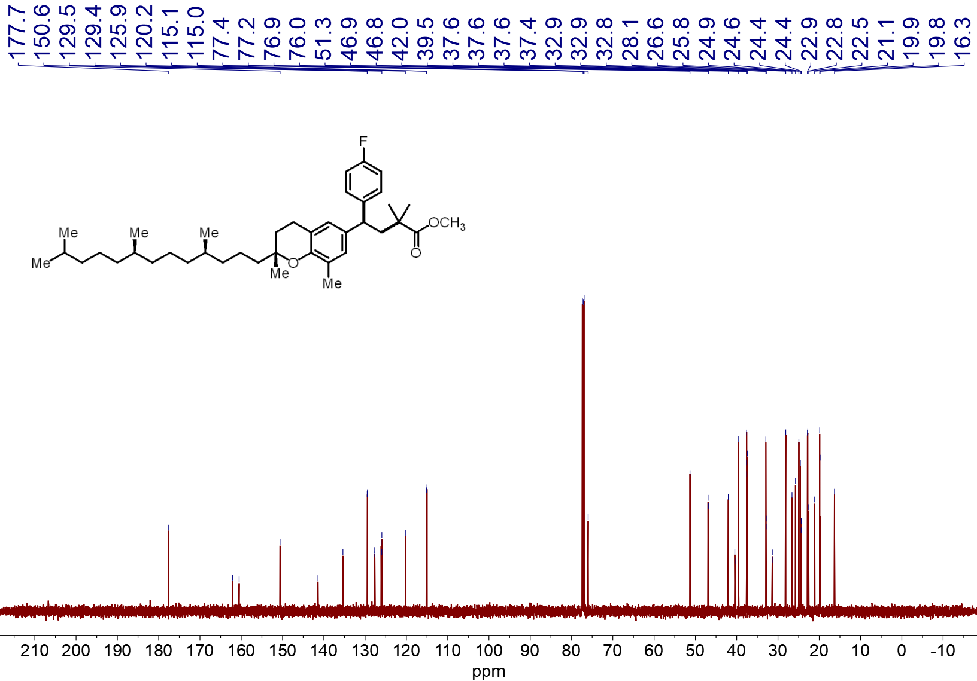¹³C NMR spectrum (151 MHz, CDCl₃, 23 ºC) of 4s

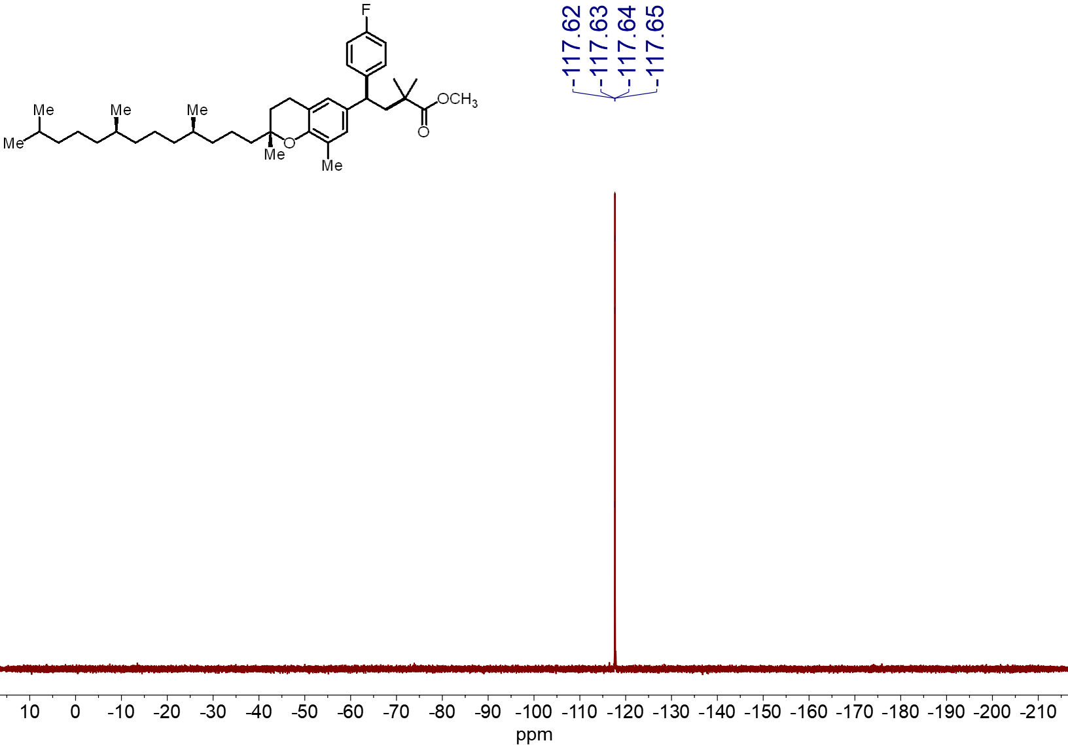¹⁹F NMR spectrum (565 MHz, CDCl₃, 23 ºC) of 4s
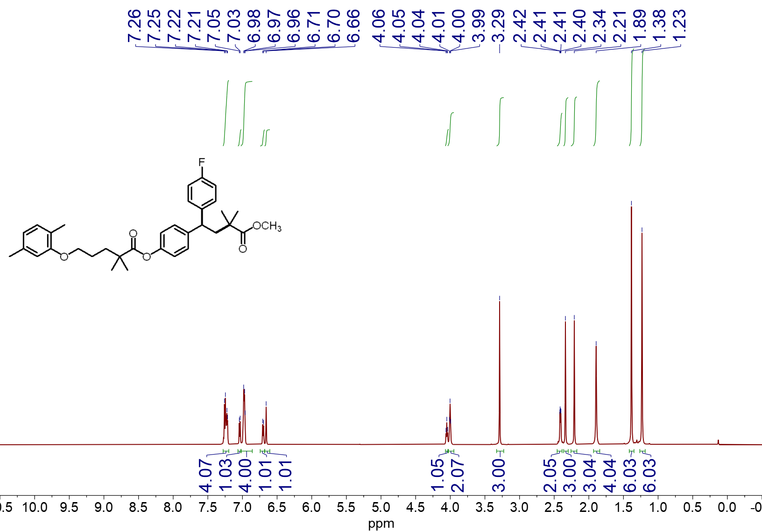¹H NMR spectrum (600 MHz, CDCl₃, 23 ºC) of 4t

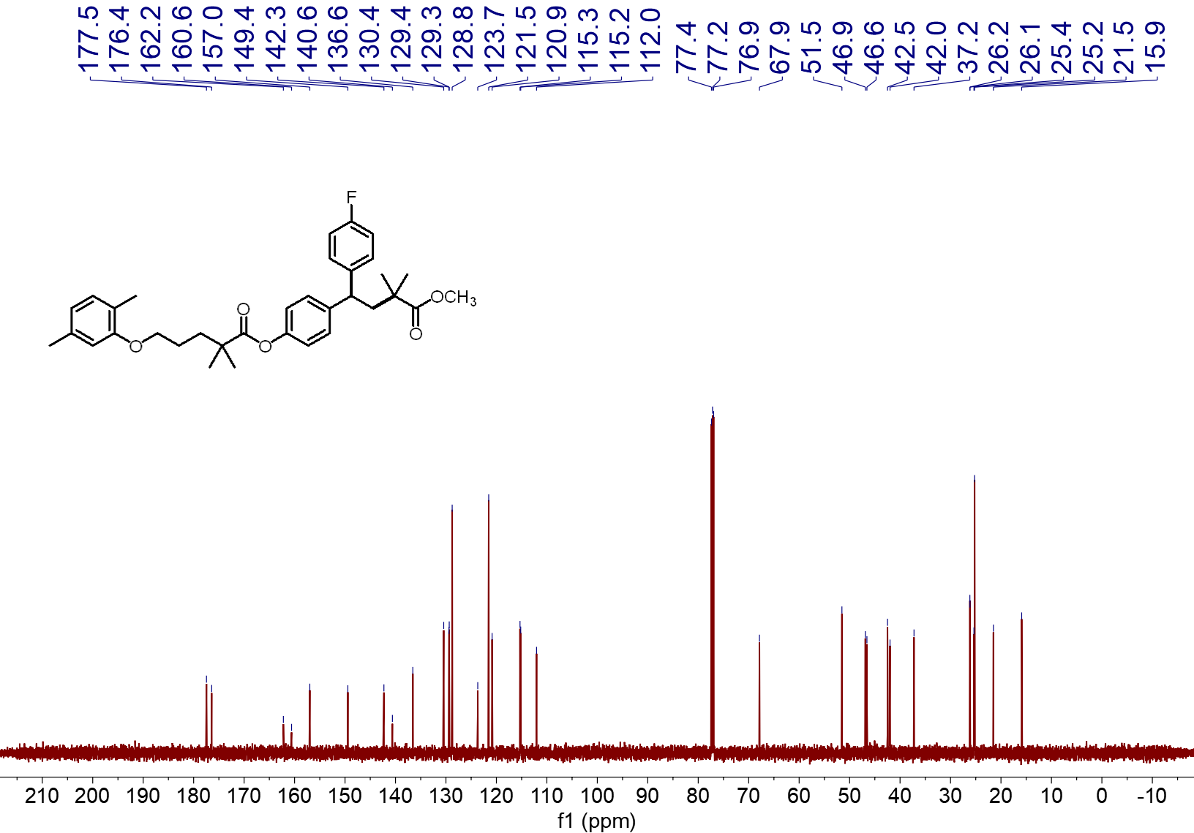¹³C NMR spectrum (151 MHz, CDCl₃, 23 ºC) of 4t
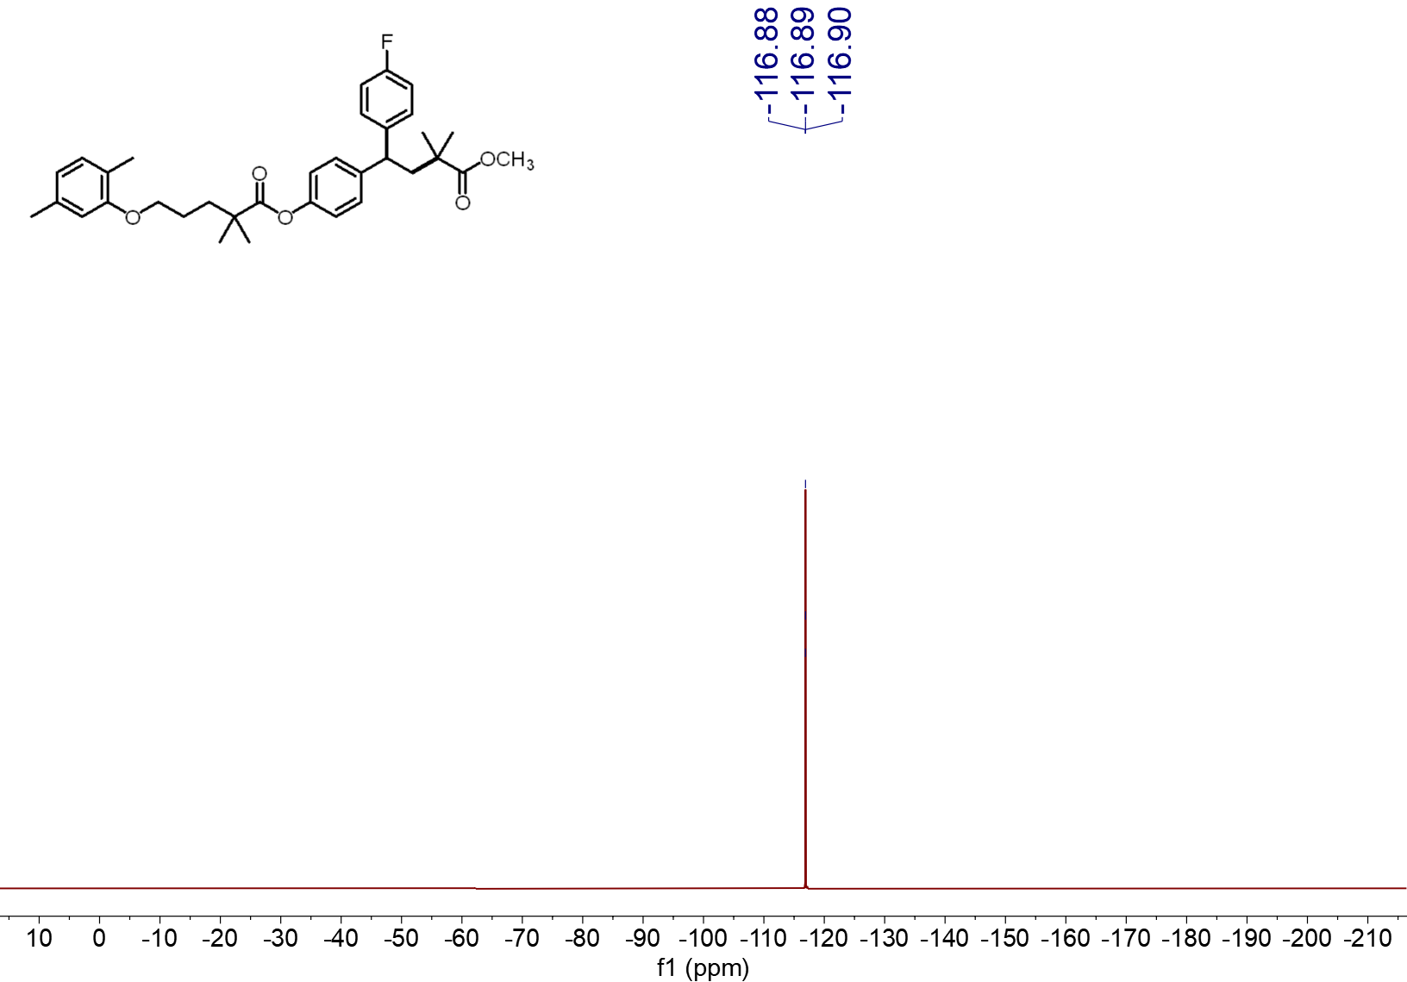 ¹⁹F NMR spectrum (565 MHz, CDCl₃, 23 ºC) of 4t

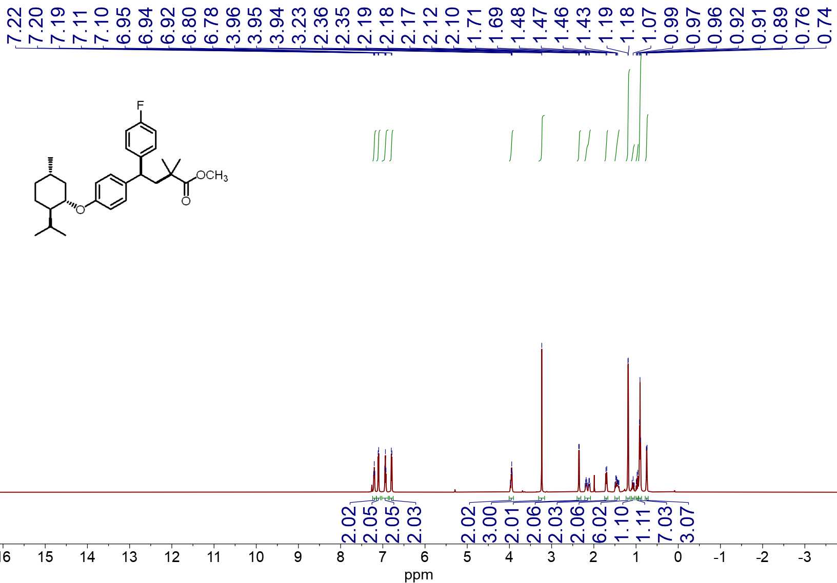 ¹H NMR spectrum (600 MHz, CDCl₃, 23 ºC) of 4u
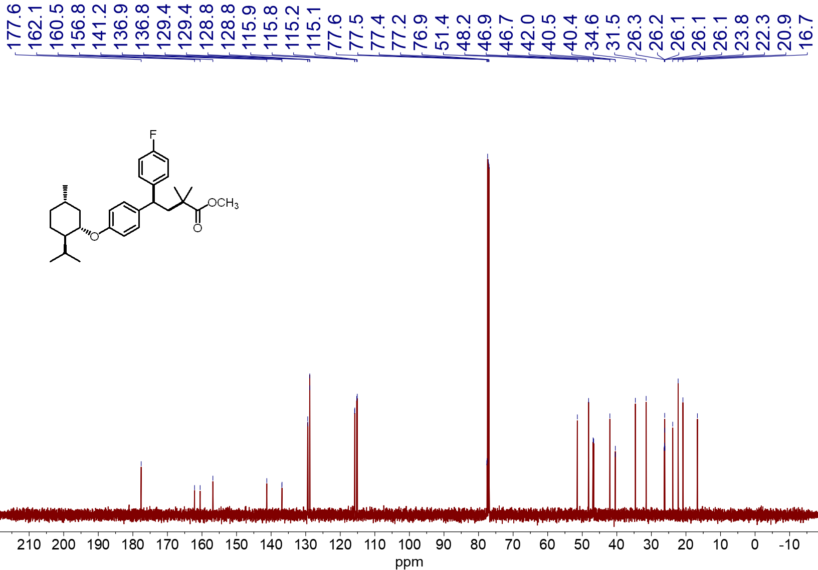¹³C NMR spectrum (151 MHz, CDCl₃, 23 ºC) of 4u

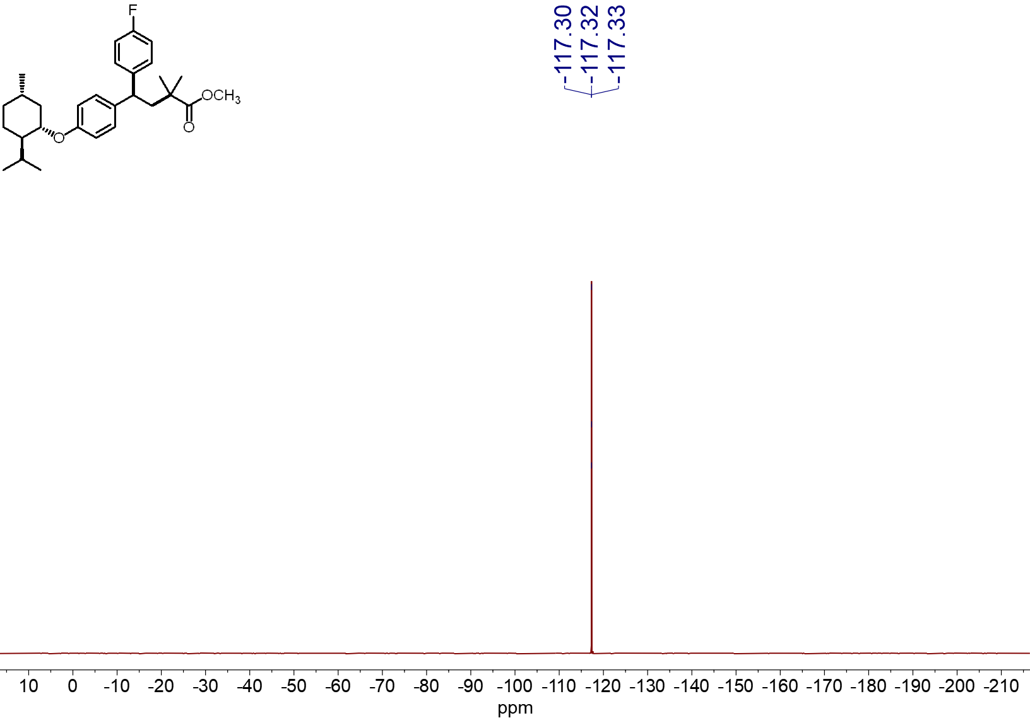
¹⁹F NMR spectrum (565 MHz, CDCl₃, 23 ºC) of 4u
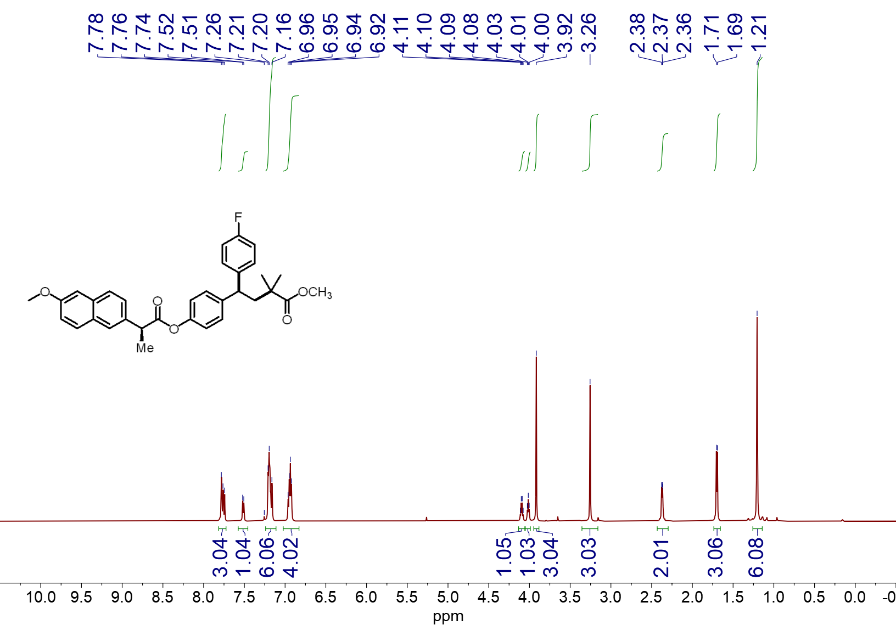
¹H NMR spectrum (600 MHz, CDCl₃, 23 ºC) of 4v
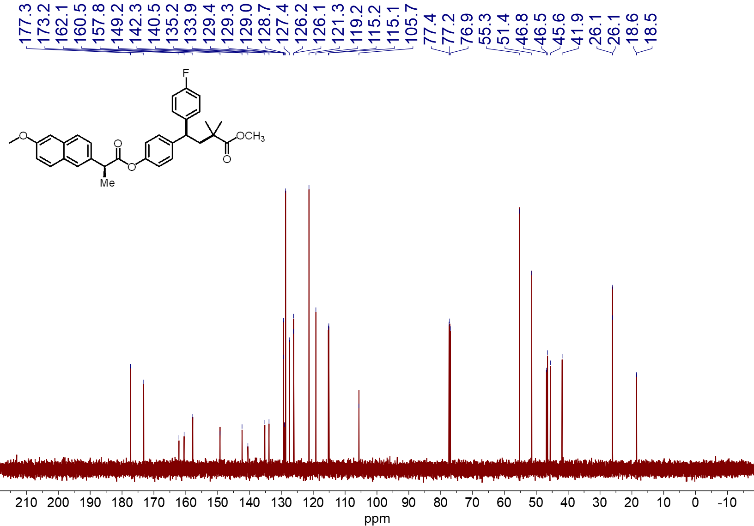
¹³C NMR spectrum (151 MHz, CDCl₃, 23 ºC) of 4v
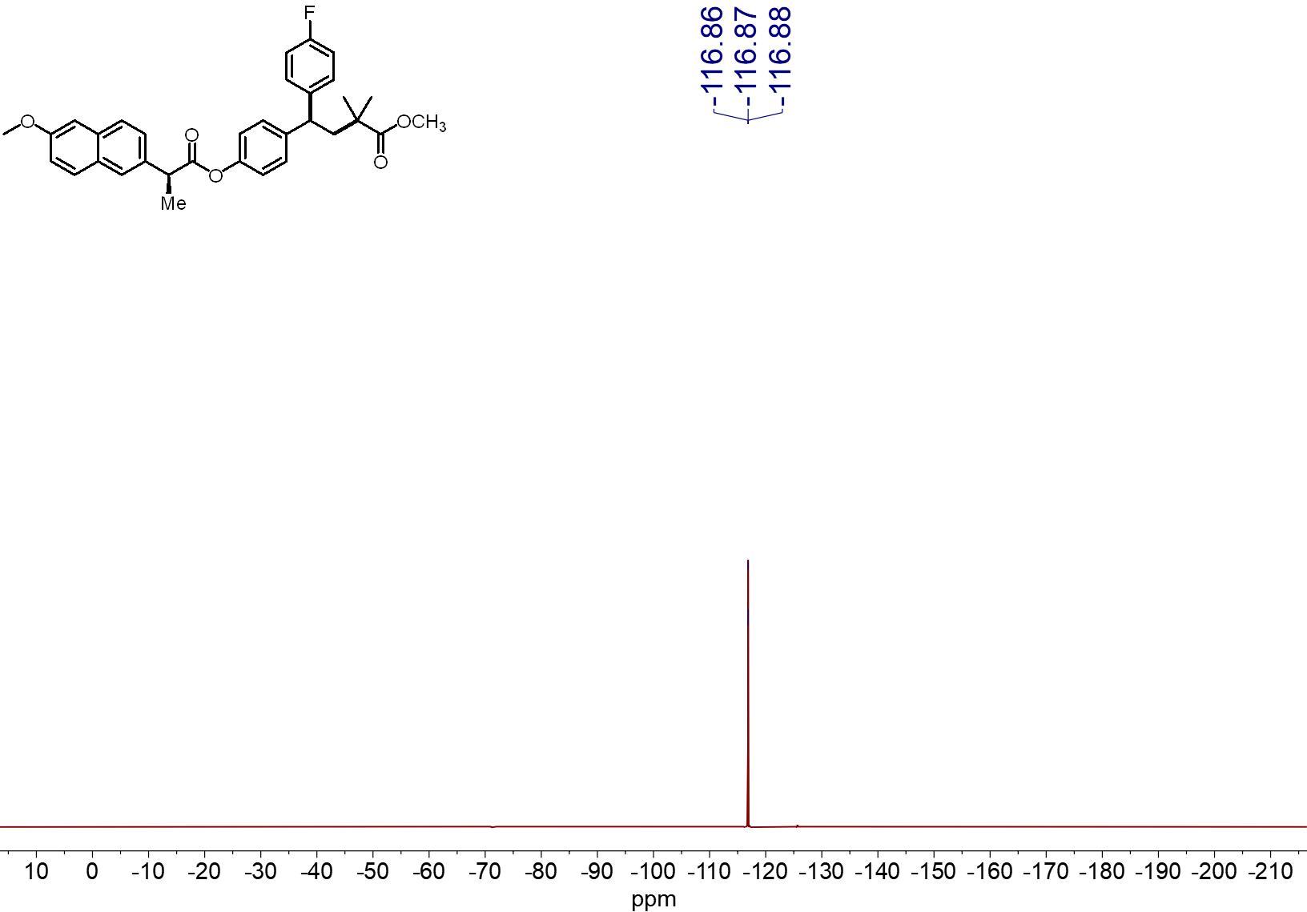
¹⁹F NMR spectrum (565 MHz, CDCl₃, 23 ºC) of 4v

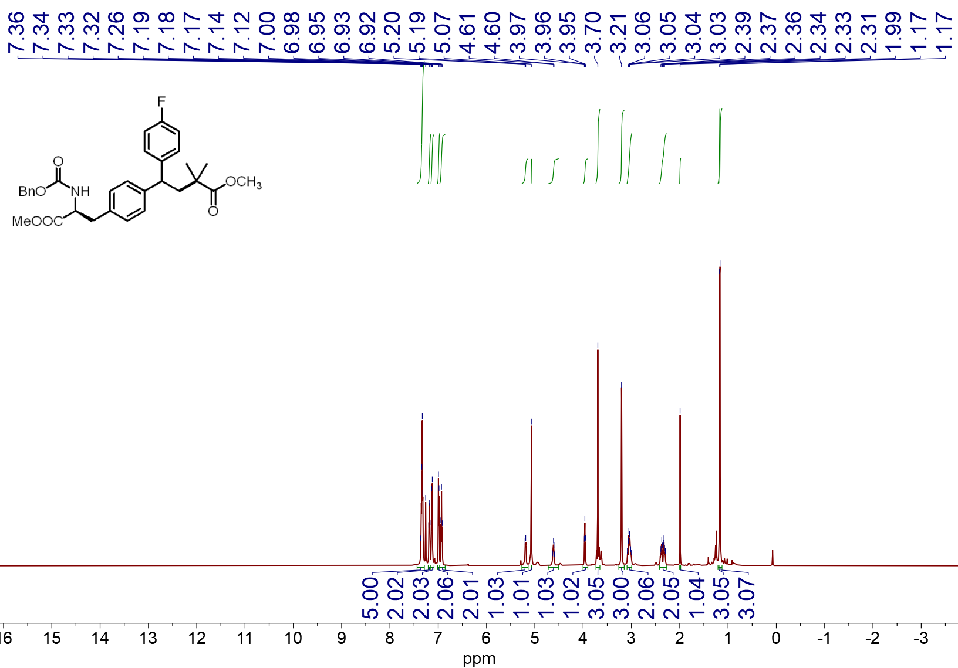
¹H NMR spectrum (600 MHz, CDCl₃, 23 ºC) of 4w
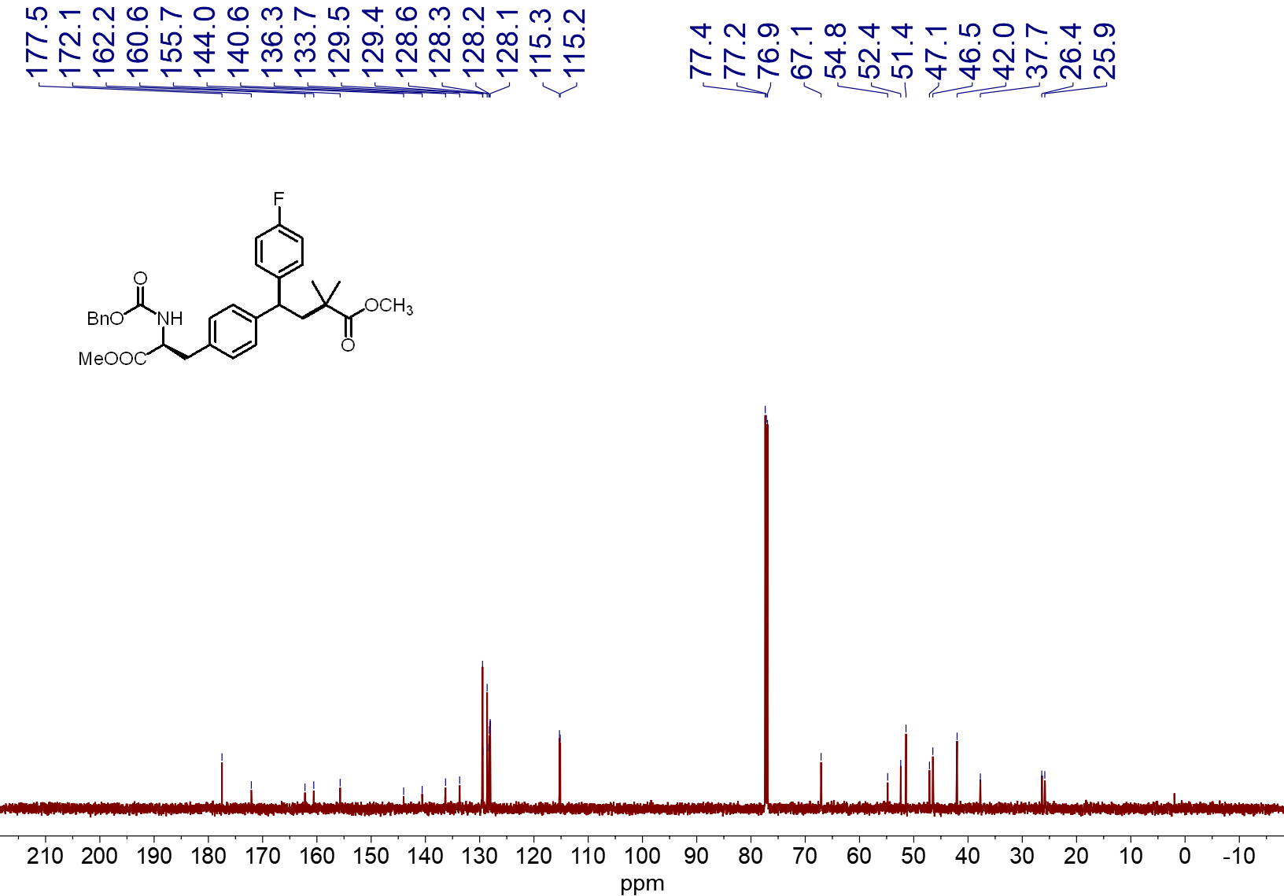
¹³C NMR spectrum (151 MHz, CDCl₃, 23 ºC) of 4w
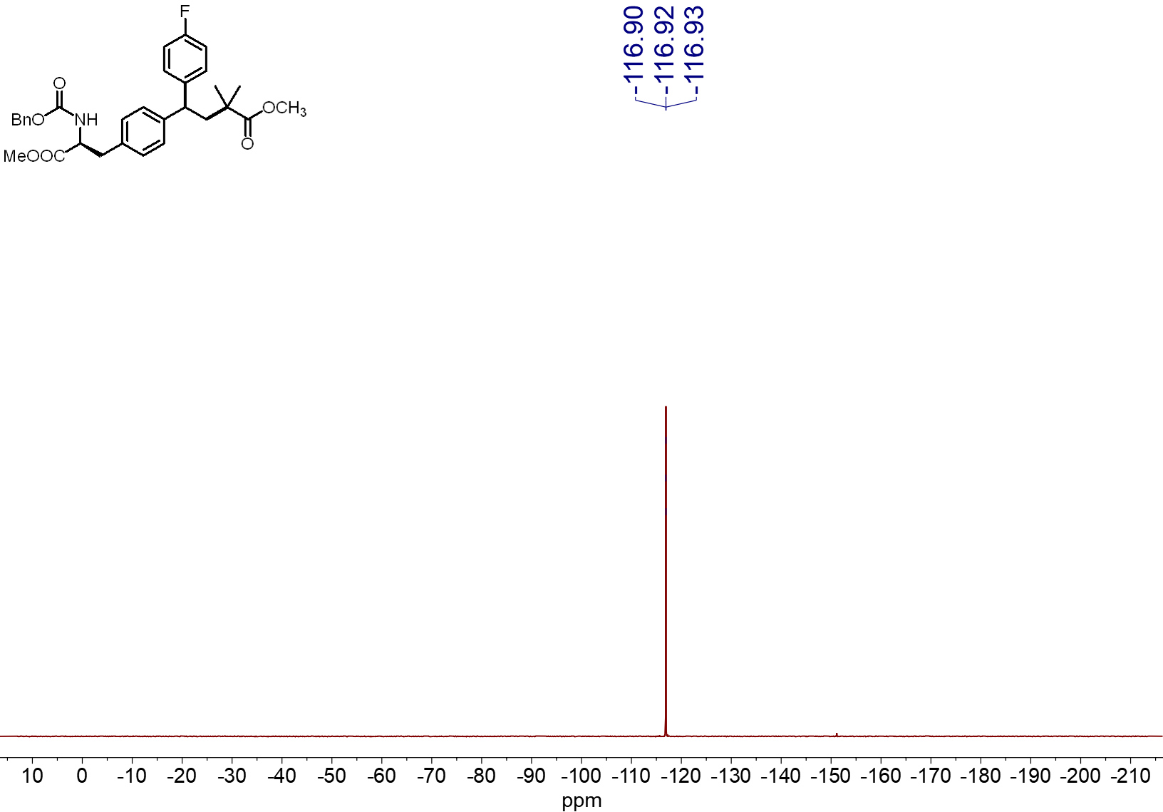
¹⁹F NMR spectrum (565 MHz, CDCl₃, 23 ºC) of 4w
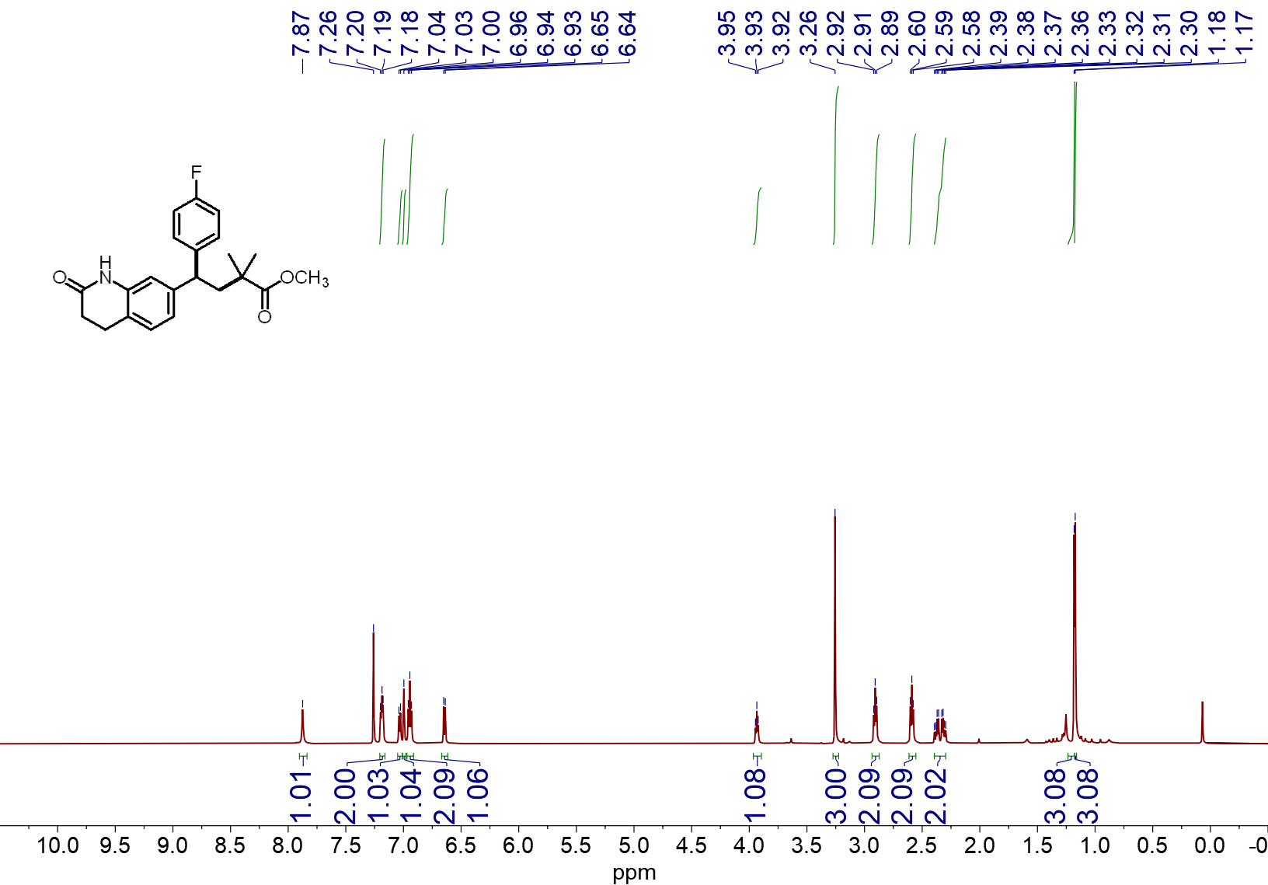¹H NMR spectrum (600 MHz, CDCl₃, 23 ºC) of 4x
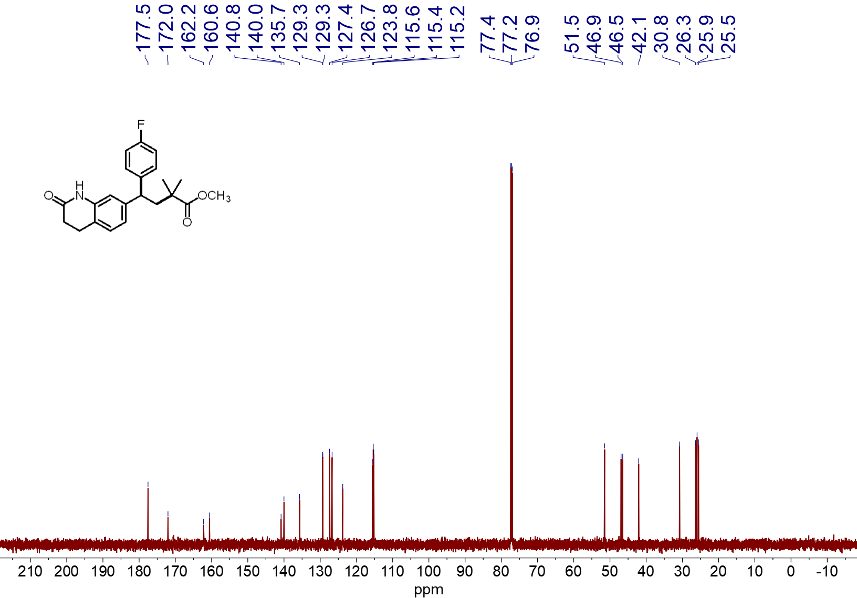¹³C NMR spectrum (151 MHz, CDCl₃, 23 ºC) of 4x
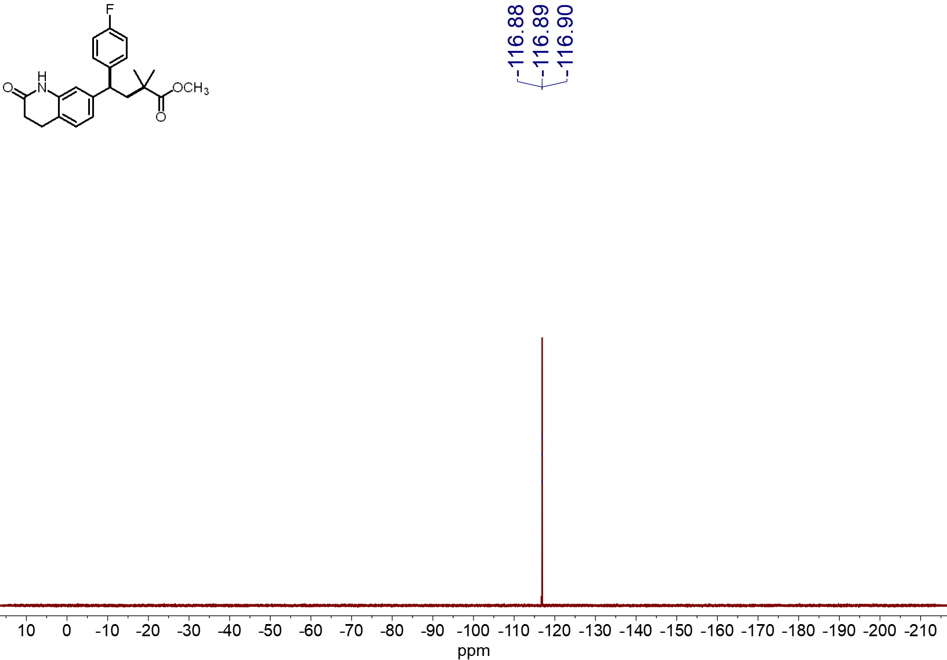
¹⁹F NMR spectrum (565 MHz, CDCl₃, 23 ºC) of 4x
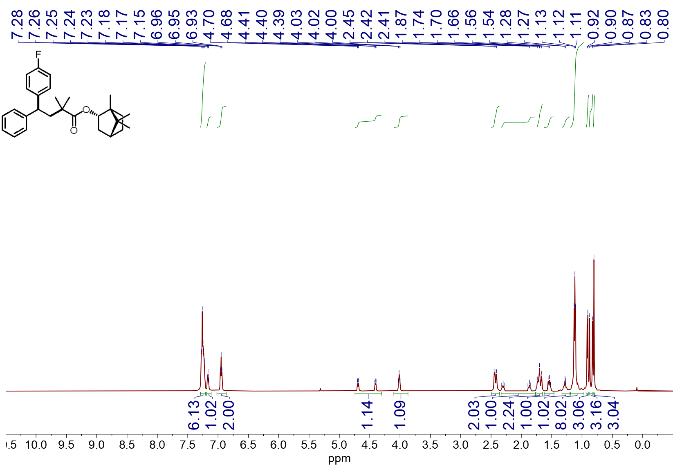
¹H NMR spectrum (600 MHz, CDCl₃, 23 ºC) of 4y

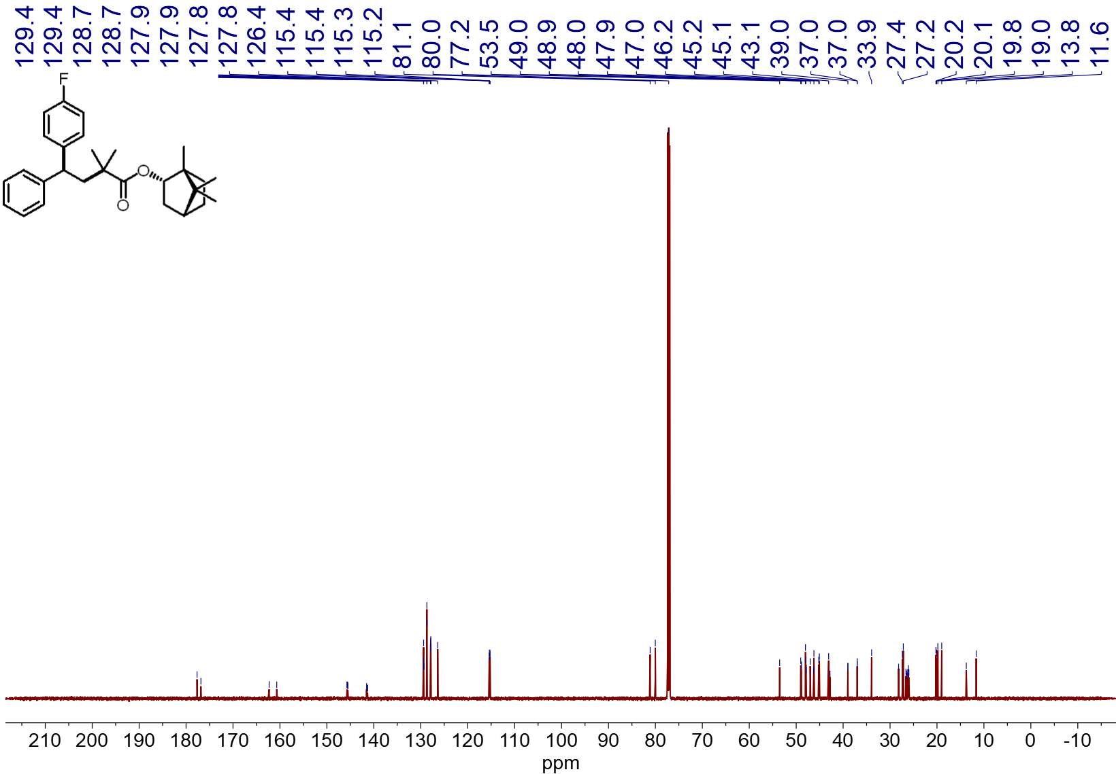
¹³C NMR spectrum (151 MHz, CDCl₃, 23 ºC) of 4y
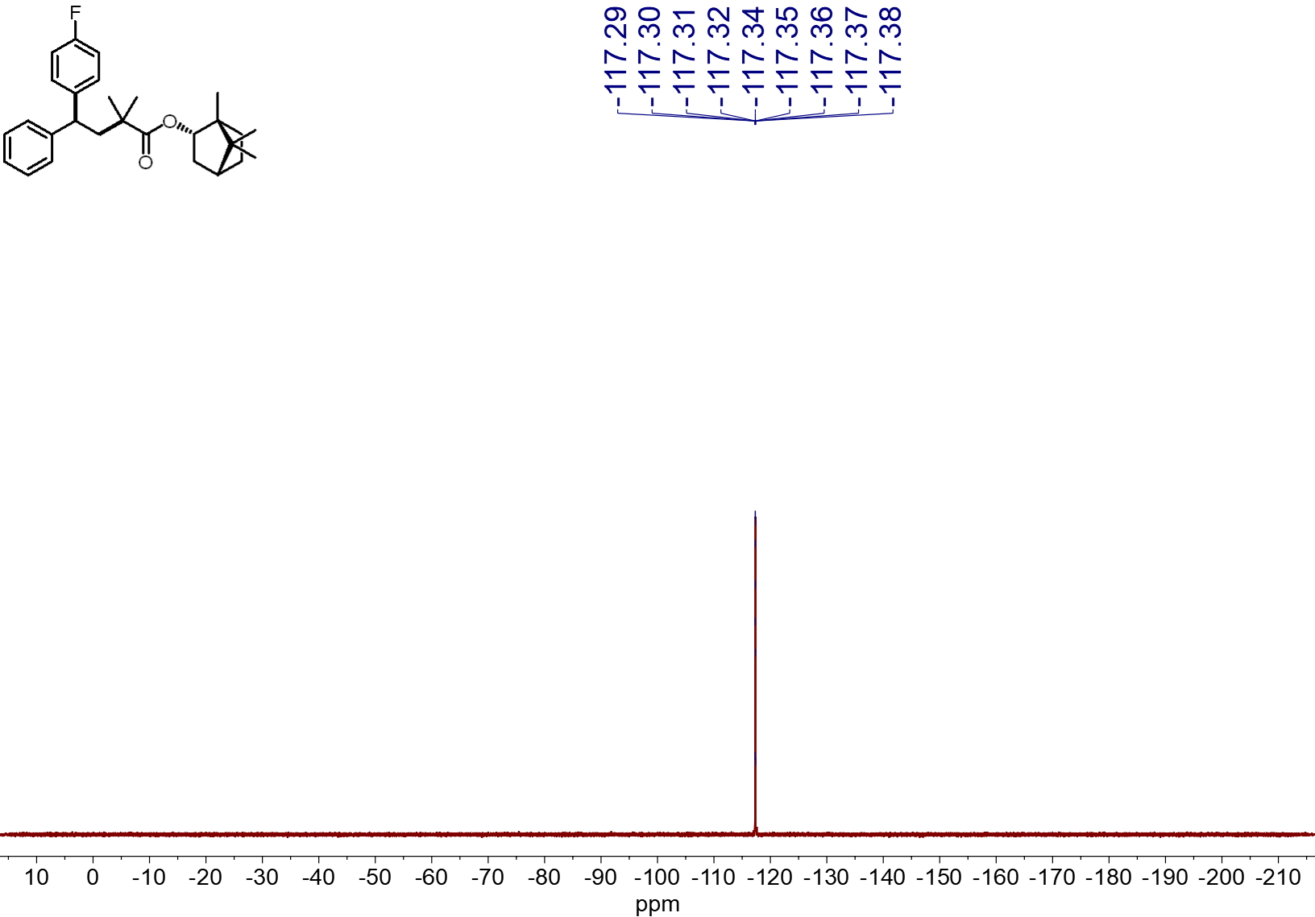
¹⁹F NMR spectrum (565 MHz, CDCl₃, 23 ºC) of 4y
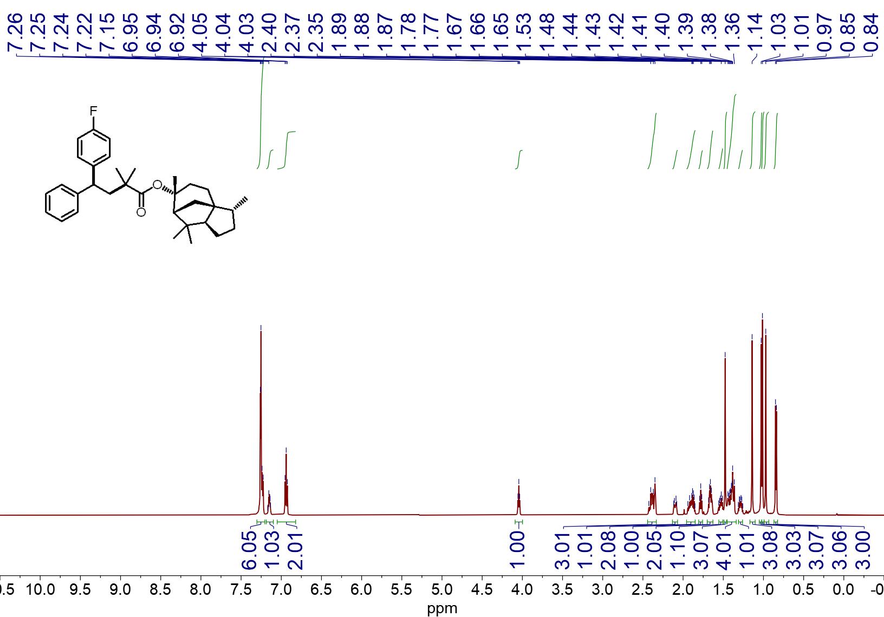
¹H NMR spectrum (600 MHz, CDCl₃, 23 ºC) of 4z
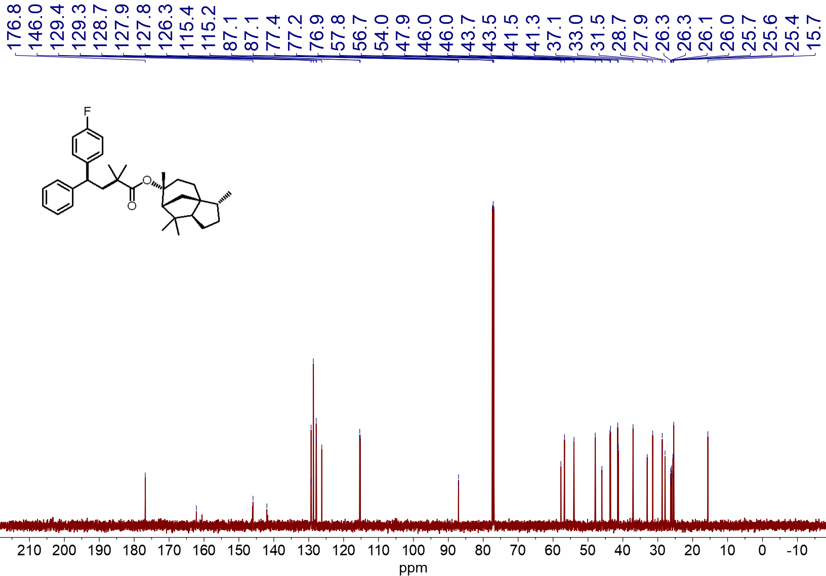
¹³C NMR spectrum (151 MHz, CDCl₃, 23 ºC) of 4z
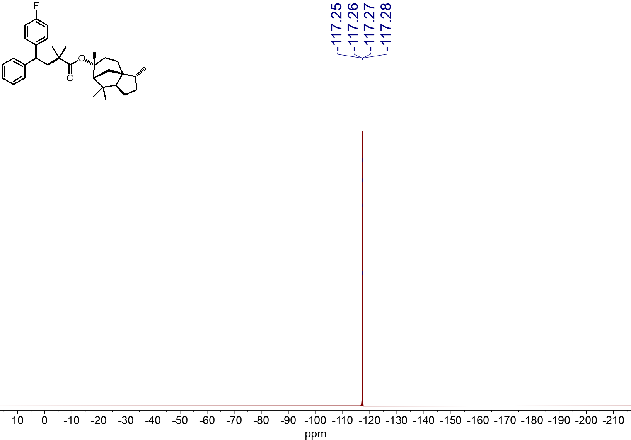
¹⁹F NMR spectrum (565 MHz, CDCl₃, 23 ºC) of 4z
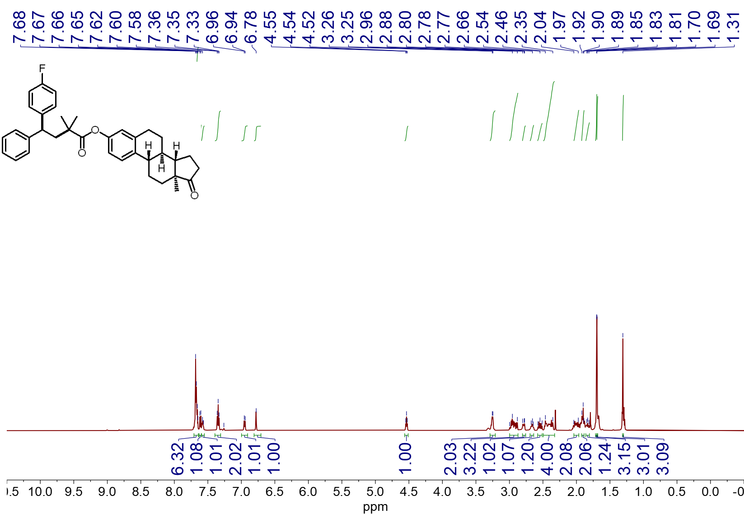
¹H NMR spectrum (600 MHz, CDCl₃, 23 ºC) of 4aa
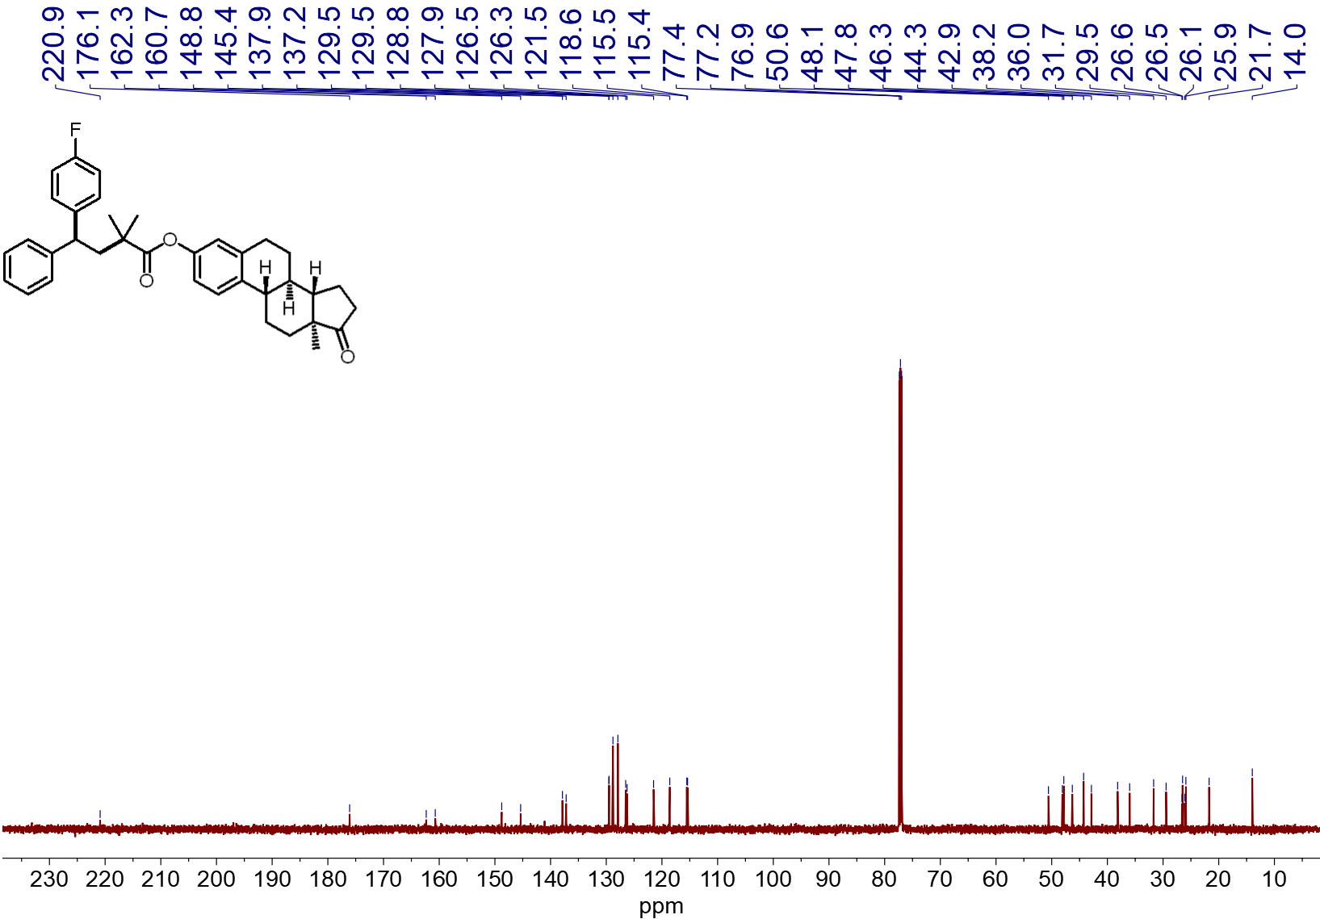
¹³C NMR spectrum (151 MHz, CDCl₃, 23 ºC) of 4aa
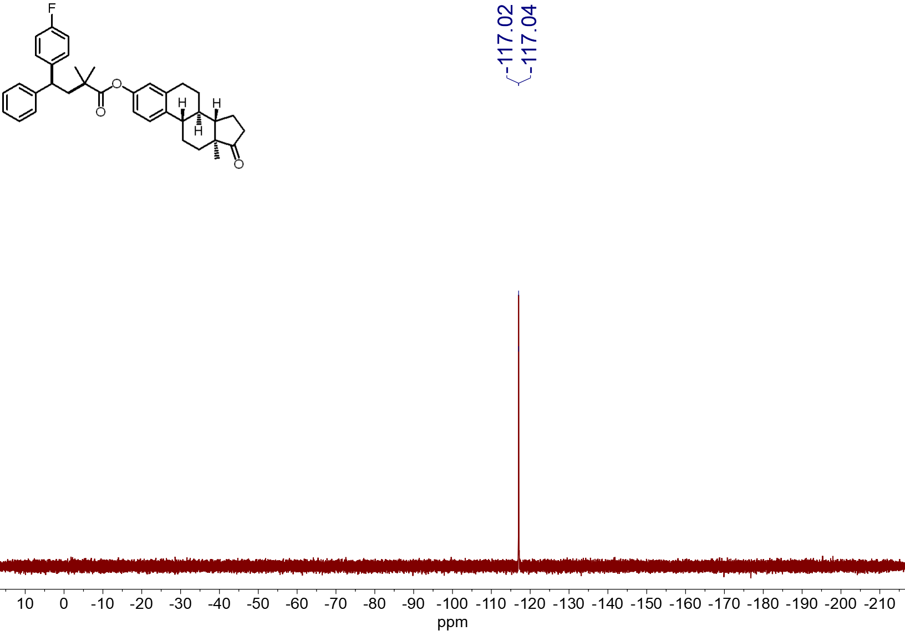
¹⁹F NMR spectrum (565 MHz, CDCl₃, 23 ºC) of 4aa
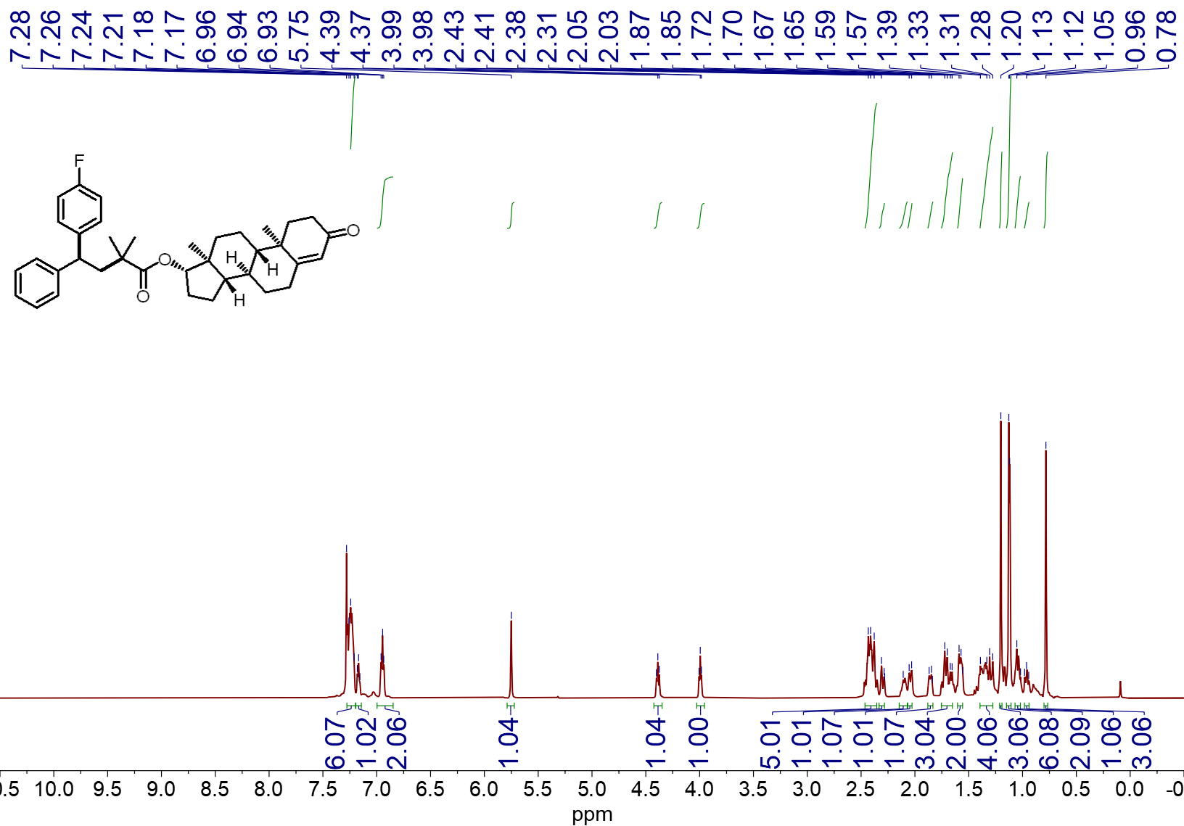
¹H NMR spectrum (600 MHz, CDCl₃, 23 ºC) of 4ab
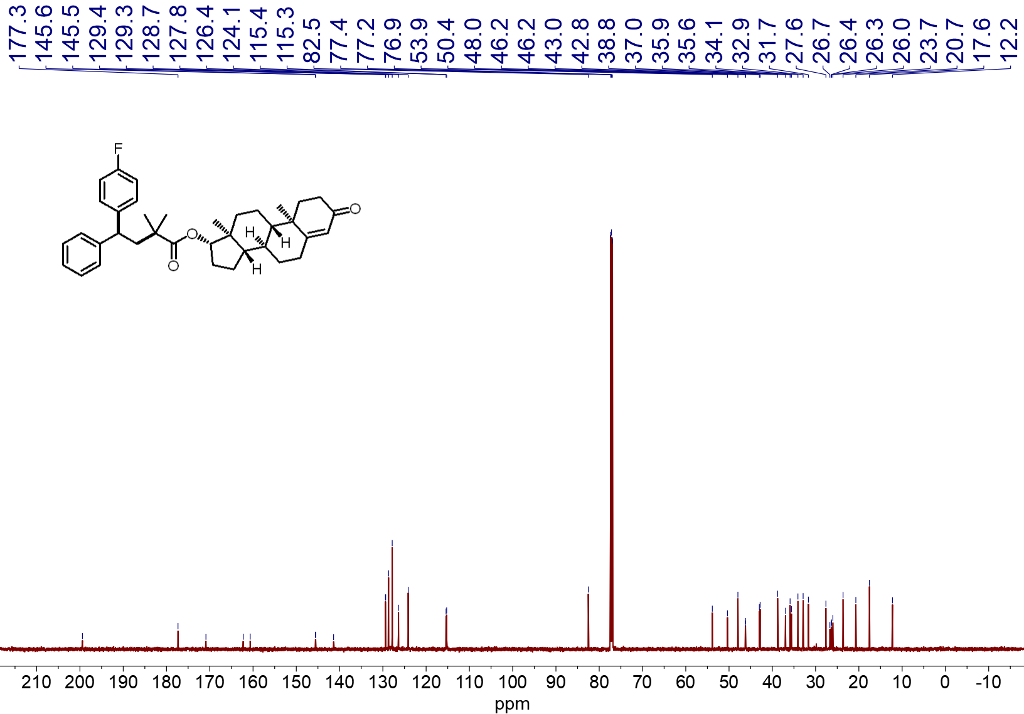
¹³C NMR spectrum (151 MHz, CDCl₃, 23 ºC) of 4ab
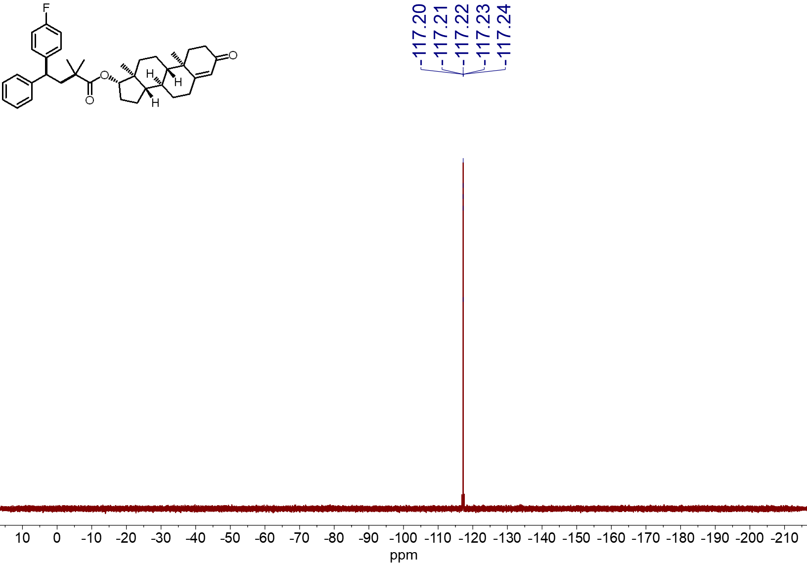
¹⁹F NMR spectrum (565 MHz, CDCl₃, 23 ºC) of 4ab
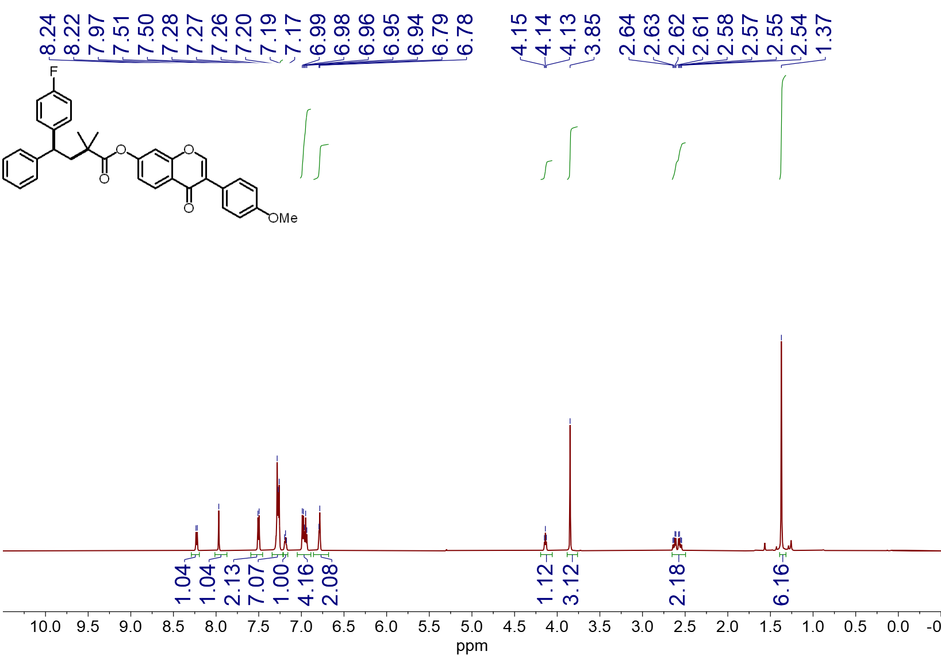
¹H NMR spectrum (600 MHz, CDCl₃, 23 ºC) of 4ac
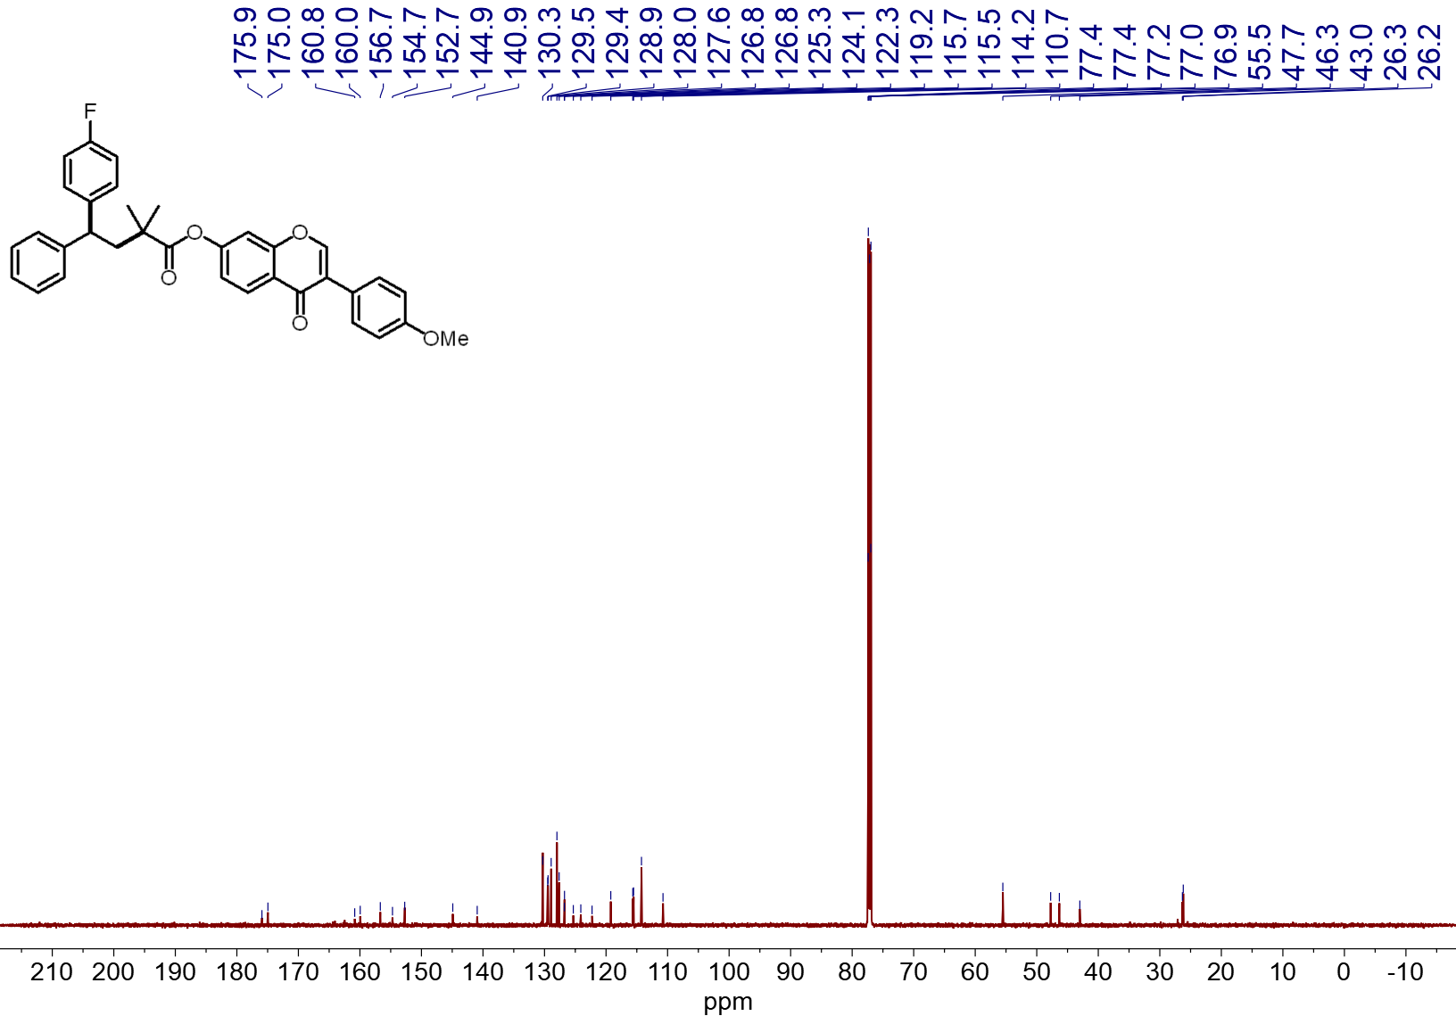
¹³C NMR spectrum (151 MHz, CDCl₃, 23 ºC) of 4ac
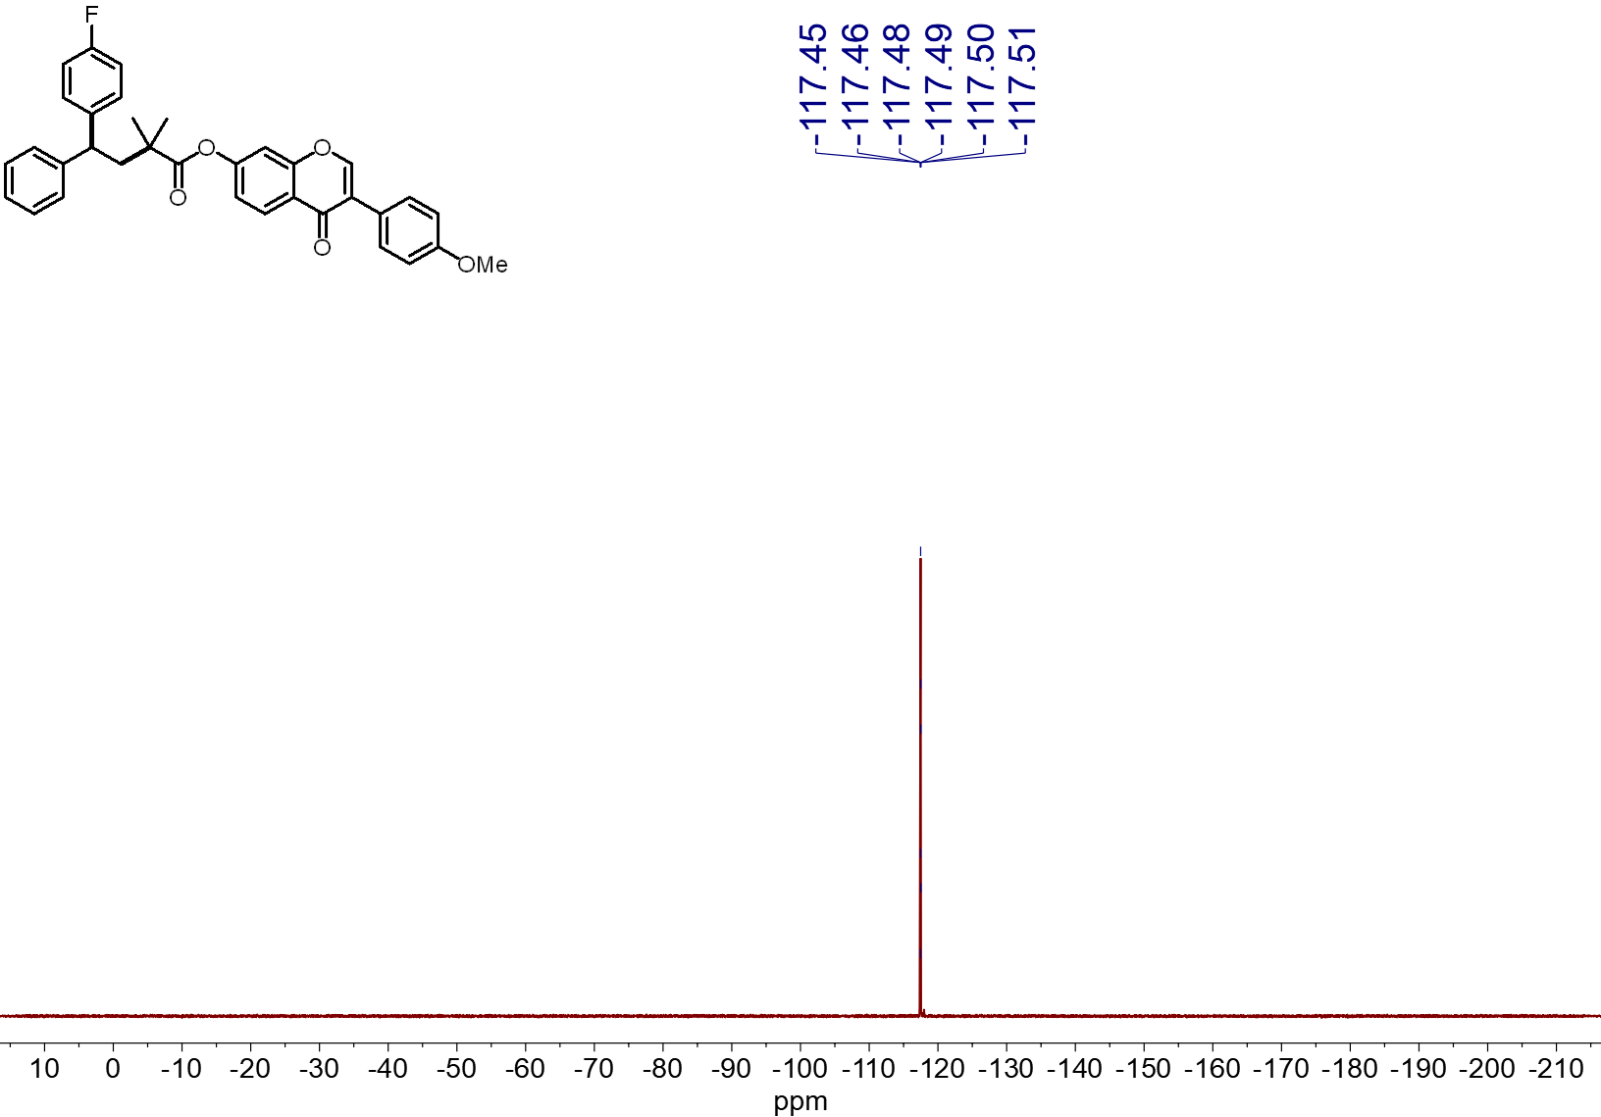
¹⁹F NMR spectrum (565 MHz, CDCl₃, 23 ºC) of 4ac

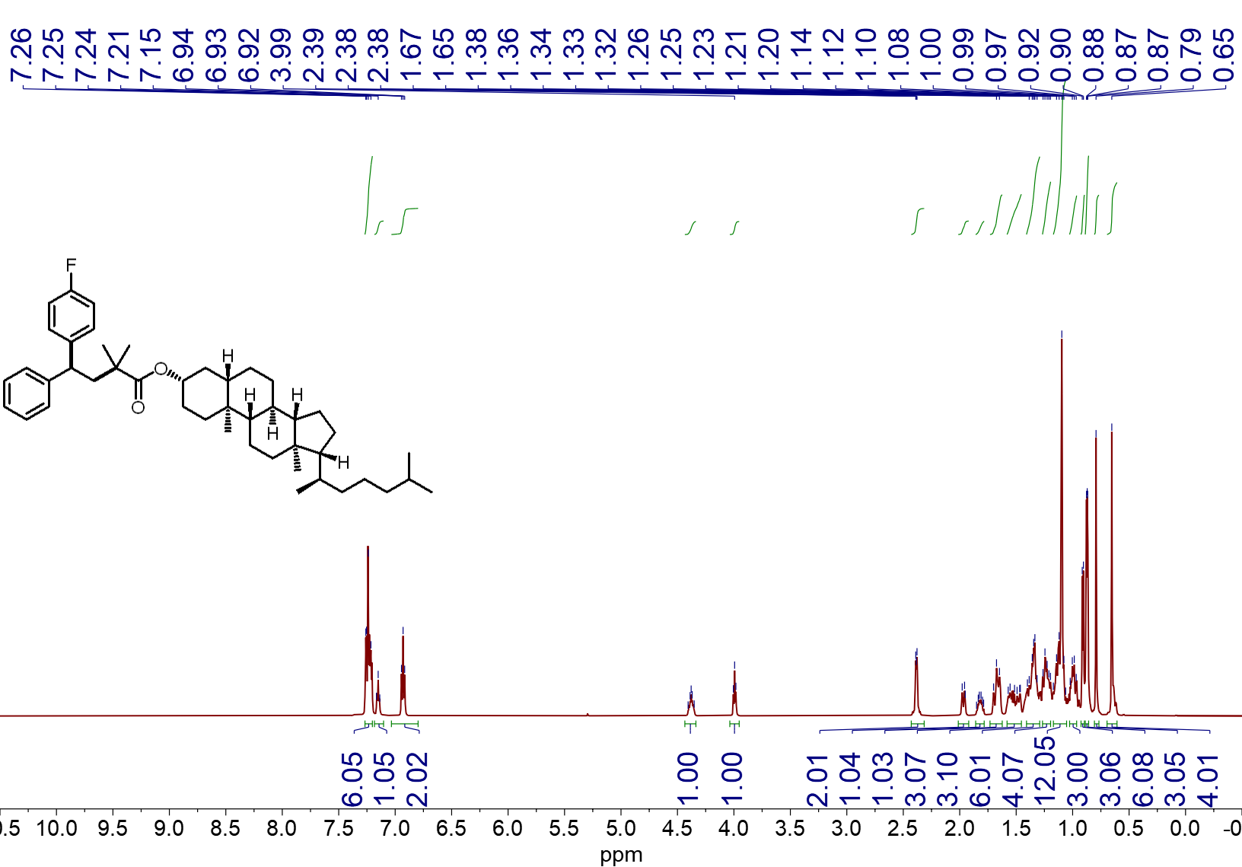
¹H NMR spectrum (600 MHz, CDCl₃, 23 ºC) of 4ad
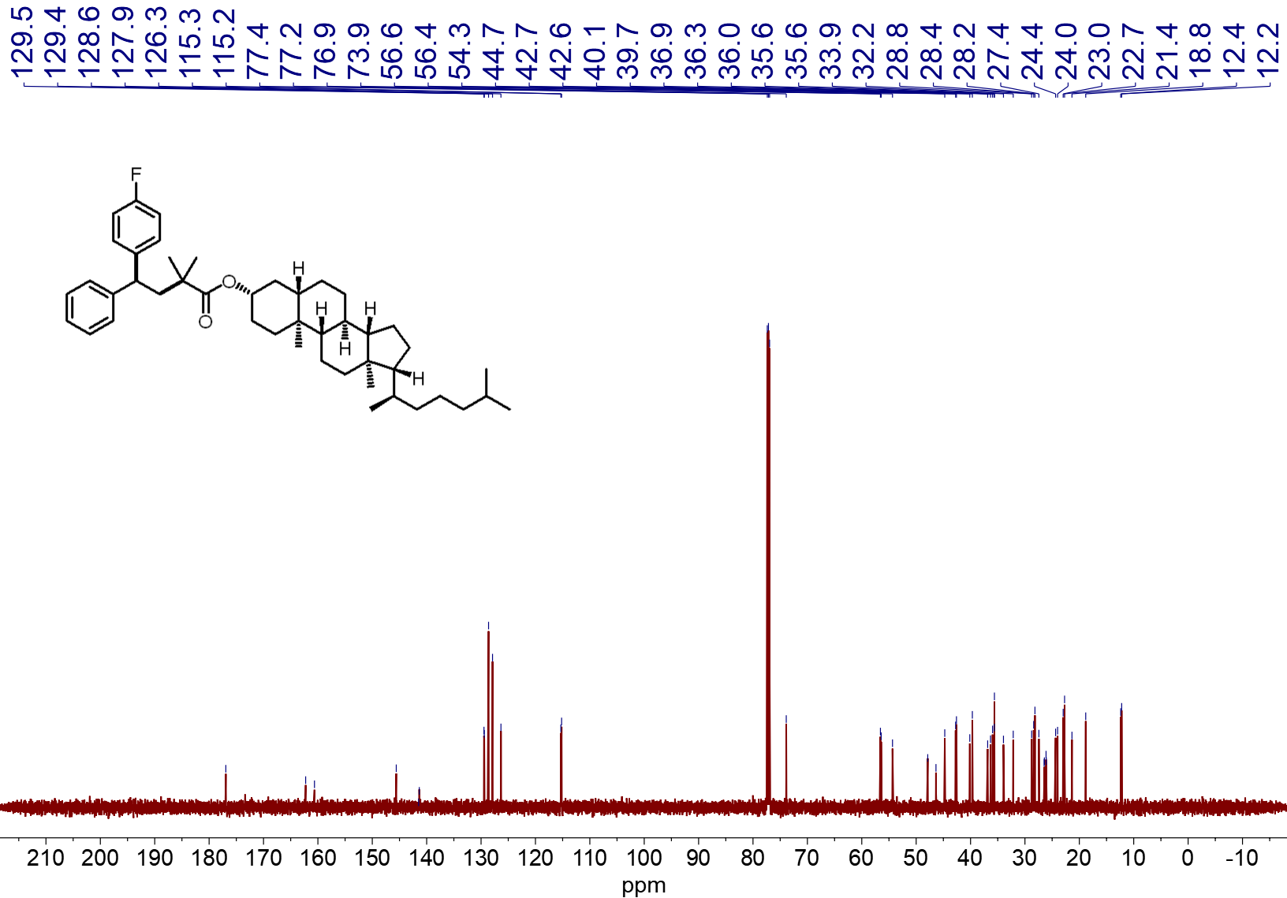
¹³C NMR spectrum (151 MHz, CDCl₃, 23 ºC) of 4ad
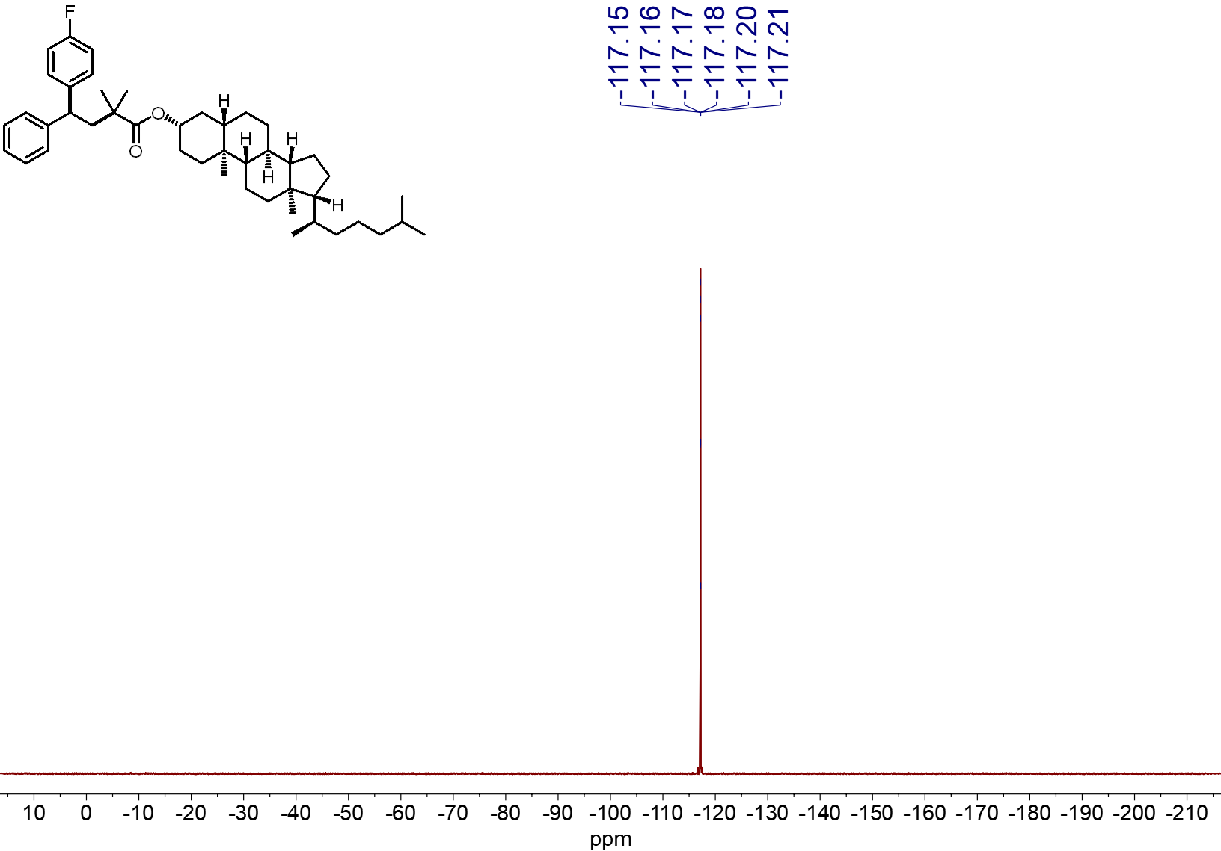
¹⁹F NMR spectrum (565 MHz, CDCl₃, 23 ºC) of 4ad

