Entry for the Table of Contents
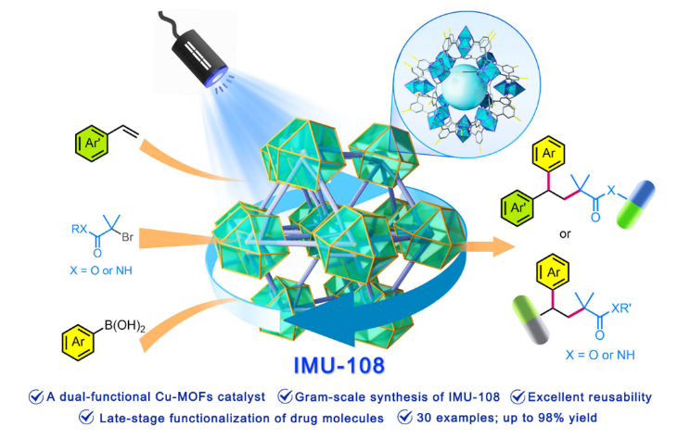
A novel dual-functional Cu-MOFs catalyst, synthesized using a simple reflux device, demonstrates remarkable versatility in enabling late-stage functionalization of multiple drug molecules. Thirty 1,1-diaryl compounds were successfully synthesized with yields ranging from favorable to excellent, reaching up to 98%. Notably, the catalyst exhibits excellent reusability, retaining its effectiveness for up to six cycles with consistent desired yields. Furthermore, the reaction conditions remain mild, allowing compatibility with a diverse range of functional groups and complex molecules.

